PURPOSE
The purpose of this report is to address the basic construction specifics of T2015 Classroom Prep Building located at Palm Beach State School: 13 Nineteenth Ave, Palm Beach QLD
ITEMS TO ADDRESS
- Building Class shown in the drawings with brief explanation as to how you have reached this conclusion.
  - T2015 Classroom Prep Building located at Palm Beach State School: 13 Nineteenth Ave, Palm Beach 4221 satisfies the requirements for Class 9b. The ABCB and NCC stipulate that a Class 9b building is a building of public nature. The subclassifications a)b)c) refer to a)hospitals, b)assembly buildings in which people may gather for social, theatrical, political, religious or civil purposes eg:schools, universities, child care centres, sporting facilities, night clubs etc and c) aged care buildings. The assessment from Building and Asset Services Department of Housing and Public Works also mention this on page 2 of the Building Code Assessment Notification.
- Determine construction Type based on construction class and floor area of construction project
  - Type C construction has been designated to this project as per NCC Volume 1 Table C1.1 & Table C2.2 with regard to the building height being a single story and floor area less than 3000m2 (273m2 actual)
- Required FRL of the building shown in the drawings based on building class and type of construction
  - NCC Volume 1 Schedule 5 to determine FRL. Specification C1.10, Specification C1.12a, Specification C1.1 to be consulted
  - Building classed as Type C. Building materials will mainly comprise of timber framework with fibre cement sheeting and colourbond cladding. Specification C1.1 Table 5 advises FRL of building elements. Assumption has been made that the trees to the North & East are between 1.5-3m of the building. As such the following FRL’s are to be adhered to
    - External Walls 60/60/60
    - External Columns 60/-/-
    - Common Walls & Fire Walls 90/90/90
    - Internal Walls bounding public corridors -/-/-
    - Internals Walls bounding a rated stair 60/60/60
    - Roofs -/-/-
- Total floor area of the building shown in the drawings
  - 273m2
- Distance from building to each boundary and potential fire source feature.
  - Northern Boundary – 12.2m approx.
  - Eastern Boundary – 4m
  - Southern Boundary – 2.5m from existing concrete path & 3m total from existing prep classroom
  - Western Boundary – 17m approx.
There are trees on both the Northern & Eastern boundaries within 4m of the building that would be classed as potential fire sources
- Location of project in relation to ‘Bushfire prone areas’ as specified in AS3959
  - Palm Beach State School is in a suburban locality on the Gold Coast. Google images shows there are some trees located in and around the school grounds. AS3959 would classify this location in relation to Bushfire Attack Level (BAL) as BAL-Low due to Table 2.1 advising of a Fire Danger Index (FDI) in Qld of 40 as well as clause 2.2.3.2 stating the exclusions for low threat vegetation to which this situation applies.
Referring to Figure 1.1 and following the flowchart through we can conclude that BAL-Low has no impact on construction requirements
- Types of passive fire protection used in the construction of the building, specifically the materials used for the external walls.
  - External walls comprised of Compressed Fibre Cement Façade System as well as Colourbond Steel
- Select a product and supplier for the materials required for the construction of the external walls and detail the fire resistance level of this product and its compliance with the performance requirements outlined in BCA Vol 1
  - External wall cladding supplied by Colorbond Steel has been classified as non combustible as per datasheet
  - 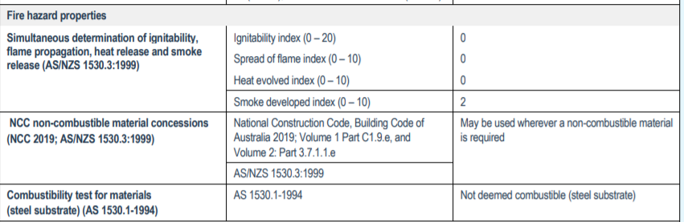

- Types of active fire protection required in the construction of the building as detailed in BCA Vol 1
  - Part E1 of BCA Vol 1 details the requirements for active fire protection of Class 9b buildings
    - Fire Hose Reels
    - Fire Extinguishers
    - Fire Hydrants
    - Automatic Fire Suppression Systems (Sprinklers)
    - Automatic Smoke Detection & Alarm Systems

CONCLUSION
Palm Beach State School is a 273m2 dwelling that satisfies the requirements for a Class 9b dwelling. There are no additional requirements in relation to fire resistance levels other than that set out in the NCC for standard building construction

