Activity 1D:

Polka Dot
Telephone: 707707

Miss Smith
12 Parrot Parade
Tree Lane
The Forest

19th March 2018
Dear Miss Smith
It was great to speak to you earlier at Polka Dot. I would like to take this opportunity to welcome you on behalf of everyone at Polka Dot insurance. Here at Polka Dot, we know how important it is to have a friendly, helpful voice at the end of the phone.
To show you how much we value your custom, we are giving you $100 when you refer a friend.
See you soon,
Claire Bird

Activity 2B:

Meeting Minutes

Date: [Space for text]

Attendees:
[Space for text]

Agenda:
- [Space for text]
- [Space for text]
- [Space for text]
- [Space for text]
- [Space for text]

Action Items | Owner | Deadline
- [Space for text] | - [Space for text] | - [Space for text]
- [Space for text] | - [Space for text] | - [Space for text]
- [Space for text] | - [Space for text] | - [Space for text]

Activity 2D:

Staff Name | Department | Start Date
Sharon Wise
Daniel Parker
Graham Pat
Tyler Rust

Activity 2E:
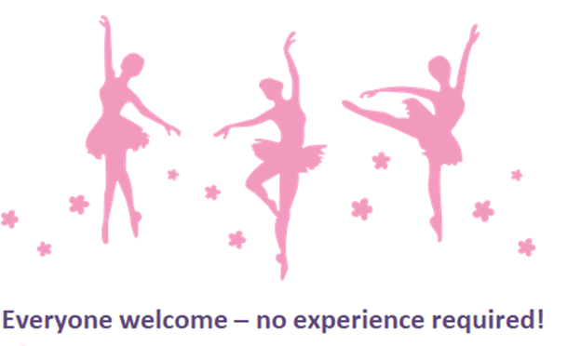
Every Tuesday evening
17:30- 18-30pm
DANCE CLASS

Activity 3A:

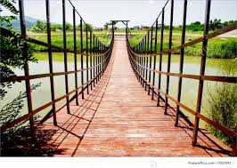

Activity skills and knowledge:
Section A:

Totem Pole Productions
A new set of policies and rules are being introduced which govern when and where employees have lunch.

This has become a problem due to extras wanting to talk and have lunch with A-list film stars, who have now communicated their wish to be undisturbed during lunch hours.

- Extras must eat their lunch in the main restaurant between 12:00 and 14:00
- The Lobster Café is exclusively for actors, directors, and producers
- Extras must not disturb actors when they are having lunch
- Selfies with actors are not permitted on set
- Extras must not pursue autographs, unless the actor has given their permission at the beginning of filming.

Managers have also clearly stated that extras will not be used again if they break these rules.

State Cashmere Men's 100% Pure Cashmere Jumper Long Sleeve Pullover Crew Neck Sweater

100% Genuine 2-ply Inner Mongolian Cashmere
• Ribbed Crew Neck, cuffs and hem. Superior softness with easy fit comfort
• 100% Pure Sustainable Mongolian Cashmere
• The care label may read "dry clean only," but hand washing a cashmere sweater will actually make it softer over time. Be sure to: wash it Inside out in cold water; use baby or Wool and Cashmere shampoo; press out the excess water, but do not wring the sweater; lay it flat on a towel and reshape it as it dries. Fold to store. Never hang.
• Himmlisch weich, warm und leicht
• Super versatile; Light weight; Relax fit. Classical design. Wearing with shirt shows formal for working, and wearing with jeans shows leisure at home and party.
• Densely knitted with the finest and long staple cashmere which provides best anti-pilling performance
• Model Measurements: height: 6'2"/ waist: 32". Model is wearing size:Large.
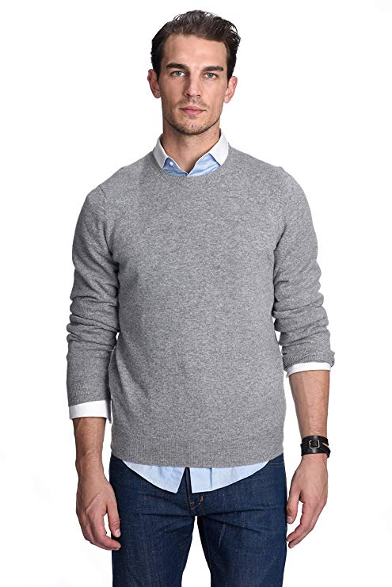

Brave Soul Men's Tame Casual Shirt

• Heavy brushed checked shirt
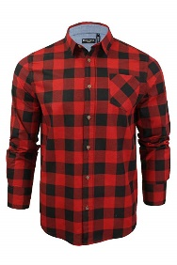
• 100% Cotton
• Machine wash - Cold (30° max)
• Fastening: Buttoned
• Collar Style: Classic
• Regular Fit
• Regular Fit
•Long Sleeve
•MSH-69TAME

OCHENTA Mens Casual Slim-Tapered Flat-Front Trousers Khaki Lable 33

Breathable chino pants, as they are slim fit trousers, may slight tight when first time wear, please choose one size larger than you usualy wear if prefer more room
• Fleece lined are now available for cold weather, Ideal for casual & formal wear
• 100% Cotton
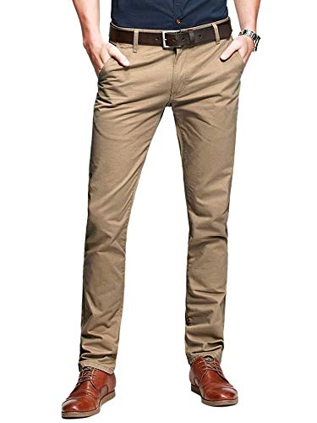
• Fastening: Zip
• Casual
• Slim
• R8-01-Khaki-33
•2 front slash pockets, 2 back pockets
•Slim fit style/ Hand/Machine cold wash separately
•Kind Notice: belt not included,shipping time: 1-3days fulfilled by Amazon,5-12 fulfilled by Seller

