
AHCLSC302
Construct landscape features using concrete

Copyright © 2020 CSTC Pty Ltd

All rights reserved. No part of the contents of this publication may be reproduced or used in any form or by any means – graphic, electronic, or mechanical including photocopying, digitising, recording, or information storage-and-retrieval systems – without the written permission of CSTC Pty Ltd.
ASSESSMENT FOR AHCLSC302

Student name | Morgan Anstee
Date of assessment submission | Click here to enter a date.

Trainer/Assessor’s name
Date of assessment marking | Click here to enter a date.
Outcome for unit | ☐ Competent  ☐ Not Yet Competent

TASK INSTRUCTIONS

- As part of the assessment for this unit of competency, you are required to complete a series of activities.
  - Some of these activities will require you to provide a response within this document, others will require you to gather evidence to demonstrate your knowledge and skills.
- At all times, the responses in your assessment must reference Australian (Queensland or Federal) documentation, including legislation, regulations, codes of practice, standards and guidance publications.

ACTIVITIES

Identify/list the scope of the work to be carried out from the concept plan shown.

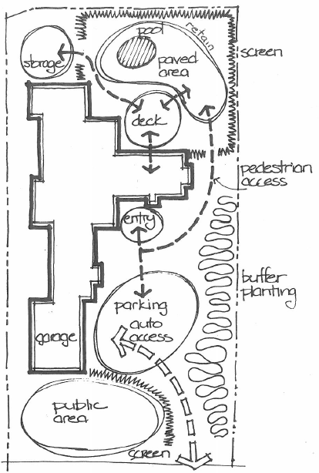

Response
- Install screening in the backyard around the pool area
- Install screening between the public access and auto access area.
- Install plants as a buffering
- Construct a retaining wall behind the pool area
- Build a deck in the back yard
- Install a pool and pave around the pool area
- Install pathways for pedestrian access
- Install a storage area behind screening in back yard

Outcome for Activity 1 | ☐ Satisfactory  ☐ Not satisfactory
Trainer/Assessor comments

Identify/list the detail on the landscape plan shown.

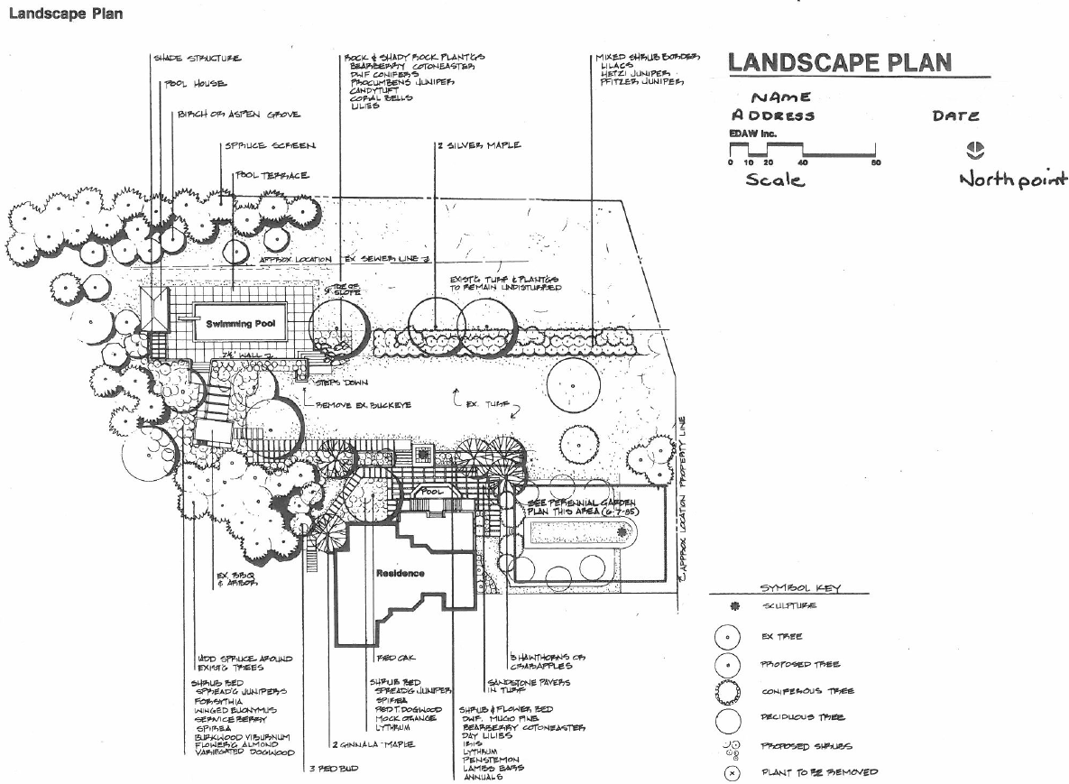

Response
* Symbol Key
* Scale
* Date
* Structures
* North Point
* Plant Species
* Name
* Address
* Landscape Layout
* Plant species

Outcome for Activity 2 | ☐ Satisfactory  ☐ Not satisfactory
Trainer/Assessor comments

List the materials required to complete the water feature, by using the wall and water feature construction plan shown.

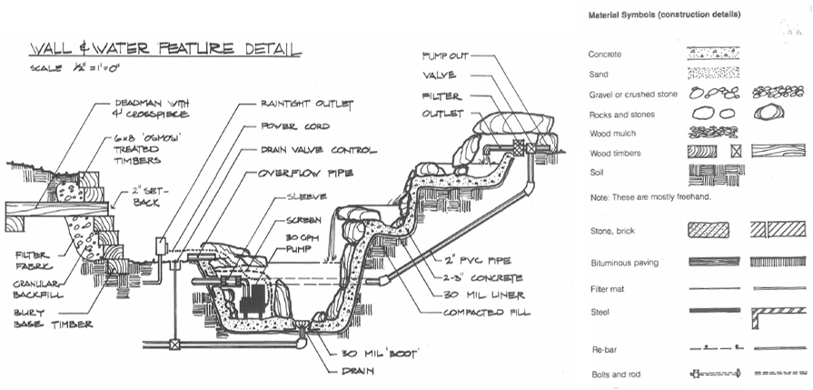

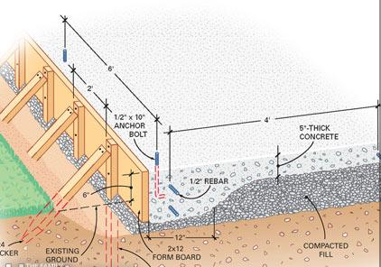

Response
- Concrete
- Sand, Gravel or crushed stone
- Rocks, Stones, Wood Mulch, Soil, Fill
- Wood timbers
- Filter fabric
- Re-bar
- Anchor bolts
- Form work
- PVC pipe
- Overflow pipe
- Pump, Outlets, Filter, Power, Drain valve control
- Stone Bricks and Bituminious paving
- Drain, sleeve, bolts and rods, steel

Outcome for Activity 3 | ☐ Satisfactory  ☐ Not satisfactory
Trainer/Assessor comments

Research and list relevant laws and standards relating to concreting works
(e.g. Building Codes, Australian Standards, Codes of Practice)

 | Name of document
- Laws | Building Act 1975  Building Regulation 2006
- Standards | AS 1012 methods of testing concrete  AS 1379 specification and supply of concrete  AS 1478 chemical admixtures for concrete, mortar and grout  AS 3600 concrete structures  AS 2870 Residential slabs and footings  AS 3700 masonry structures  AS 4773 masonry for small structures  AS 2890 parking facilities  AS 4586 slip resistance classification of new pedestrian surface materials  AS 3727 guide to residential pavements
- Codes | Building code of Australia 2019 edition volume 2  National Construction Code

Outcome for Activity 4 | ☐ Satisfactory  ☐ Not satisfactory
Trainer/Assessor comments

List the components for four (4) common surface drainage systems used in landscape construction.

System | Components
- Spoon | Machinery is used to shape the land to channel excess water (e.g. into sub-surface drain or storm water drain)  these are used in smaller landscape areas.
- Channel and grate | An indivually designed drain which intercepts a surface run-off and direct it to a known water course.  An example includes diverting storm water.
- Pit | A water collection pit or storage container  it is not designed to hold all the runoff, but needs to be large enough to contain the water pouring into it long enough to allow it to drain through the drainage pipes at a rate that keeps up with the flow of water.
- Contour | A water carrying or water holding channel or ridge constructed of earth, located on or near a contour line  They are used to slow down the flow of water across a slope.

Outcome for Activity 5 | ☐ Satisfactory  ☐ Not satisfactory
Trainer/Assessor comments

List the advantages and disadvantages of drainage behind and through the build wall (as shown).

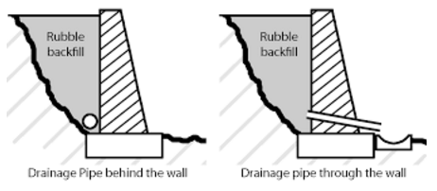

Drainage pipe behind the wall
Advantages
Simple to install, cost effective, simplicity
Aesthetically pleasing as hidden behind the wall
Disadvantages
Water build up behind the wall if fill and filters are not used adequately
water has to travel along behind the wall to escape

Drainage pipe through the wall
Advantages
Simple to install, cost effective, water can escape through the wall instead of building up behind.
Disadvantages
Could get blocked, therefore allowing water to build up
regular cleaning of pipe required
not as aesthetically pleasing
Have to ensure water coming through the wall can not get waterlogged on the land below.

Outcome for Activity 6 | ☐ Satisfactory  ☐ Not satisfactory
Trainer/Assessor comments

Explain the purpose of a cone test. Describe the process of how such a test is conducted.

Response
The cone/slump test is done to make sure the concrete mix is consistent and workable. The measured slump must be within a set range, or tolerance from the specified slump.
To conduct a slump test you need:-
Materials:- Standard slump cone, small scoop, bullet-nosed ord, ruler and slump plate.
Method:- Clean the cone. Dampen with water and place on the slump plate. The slump plate should be clean, firm, level and non-absorbent.
2. Collect a sample
3. Stand firmly on the foot-pieces and fill 1/3 the volume of the cone with the sample. Compact the concrete by pushing the steel rod in and out of the concrete 25 times.
4. now fill to 2/3 and again use the steel rod to push in and out of the concrete to compact it but only do it into the top of the first layer.
5. Fill to overflowing. Use the steel rod again, this time just into the top of the second layer. Top up the cone until it overflows.
6. Level off the surface with the steel rod using a rolling action. Clean any concrete from around the base and top of the cone, push down on the handles and step off the foot-pieces.
7.Carefully lift the cone straight up making sure not to move the sample.
8. Turn the cone upside down and place the rod across the upturned cone.
9. Take several measurements and report the average distance to the top of the sample.
10. If the same fails by being outside the tolerance (ie the slump is too high or too low), another must be taken. If this also fails, the remainder of the batch should be rejected.

Outcome for Activity 7 | ☐ Satisfactory  ☐ Not satisfactory
Trainer/Assessor comments

Research and list a range of curing compounds and the advantages of using each type

Curing compound | Advantages
- Synthetic resin compound | Seals the concrete by forming membrane. The membrane can be removed by washing with hot water if you want to provide plastering. It possesses high mechanical strengths, long durability and resistance to chemical attack.
- Acrylic compound | Made up of polymers of acrylic acid. Acrylic also seals the concrete.  Acrylic doesn’t need to be washed with hot water if you want to provide plastering.  Reduction in permeability of the concrete  Eliminates the need for costly impractical curing methods  Improves strength and durability.  Increased abrasion resistance.
- Wax compound | Reduction in incidence of shrinkage caking.  Improved strength and durability.  Reduction in surface dusting.  Increased abrasion resistance.
- Chlorinated rubber compound | It forms a thick layer when applied. It seals the concrete tightly and also fills minute pores that maybe present in the concrete.  Improves strength and wear resistance  Reduces surface moisture loss  Can also be burnished to an attractive finis and act as a concrete sealer.

Outcome for Activity 8 | ☐ Satisfactory  ☐ Not satisfactory
Trainer/Assessor comments

List environmentally safe products for cleaning.

Response
1. EP concrete cleaner
2. EP Rust stain remover
3. ACT concrete cleaner
4. On-Crete general purpose concrete cleaner
5. TERMINATOR-HSD

Outcome for Activity 9 | ☐ Satisfactory  ☐ Not satisfactory
Trainer/Assessor comments

Have team members take photos and videos of your involvement with concrete features.

Identify each photo / video with a letter label and describe each photo / video in the table below. Submit the photo / video files along with this workbook.

Advantages
A
B
C
D
E
F
G
H
I
J
K
L
M
N
O
P
Q
R
S
T
U
V
W
X
Y
Z

Outcome for Activity 10 | ☐ Satisfactory  ☐ Not satisfactory
Trainer/Assessor comments

