Workplace Assessment 3 – Assessor’s Checklist
(This form is for the assessor’s use only)

Purpose
This Assessor’s Checklist lists the practical skills that the candidate must demonstrate/perform while completing Workplace Assessment 3.
This form is to be completed by the candidate’s assessor to document the candidate’s performance in Workplace Assessment 3.

Task Overview
For this task, the candidate is required to procure the finalised building materials from Task 2.
In this task, the candidate will be assessed in their:
- Practical knowledge in procuring and ordering building materials
- Practical skills in procuring and ordering building materials

Instructions to the Assessor

During the assessment
- For each practical skill listed in this Assessor’s Checklist:
  - Tick YES if you confirm you have assessed the candidate demonstrate/perform the practical skill.
  - Tick NO if you have not assessed the candidate demonstrate/perform the practical skill.
- If you ticked YES, provide the date when you assessed the candidate demonstrate the skill.
- Write specific comments on the candidate’s performance in each criterion. Your feedback/insights will help address any area/s for improvement.

After the assessment
- Complete all parts of the Assessor’s Checklist, including the Assessor Declaration on the last page of this form. Your signature must be handwritten.

Candidate Details
Candidate name | Dawei Yang

Assessor Details
Candidate is assessed by | Steve zhu

Context of the Assessment
Workplace/organisation | Dawn construction
Resources required for the assessment | - A construction project for a residential or commercial building up to a maximum of two storeys.  - Procurement team members  - Opportunities to procure and order the selected building materials  - Policies and procedures relevant to procuring and ordering the selected building materials

Assessor’s Checklist
During the procurement of the building materials: | YES/NO | Assessor’s comments
- The candidate follows the organisation’s purchasing requirements for procuring materials.
- The candidate follows the organisation’s purchasing requirements for ordering materials.
- The candidate collects evidence of suitability of materials from the corresponding suppliers and/or manufacturers, e.g. relevant certification, reports from testing agencies, etc. | YES NO
- The candidate uses digital tools to communicate with the suppliers or manufacturers, e.g. communication applications such as emails, chats, etc. | YES NO
- The candidate uses varied ways of communication with the suppliers and manufacturers, including:
- Verbal communication (e.g. face-to-face communication, phone call conversation, video call conversation, etc.) | YES NO
- Written communication (e.g. email correspondence, chat messages, etc) | YES NO

Assessor Declaration
By signing here, I confirm that I have assessed the candidate, whose name appears above, procure and order the building materials for the building project.
I confirm that the information recorded on this Assessor’s Checklist is true and accurately reflects the candidate’s performance during their completion of the workplace task.
Assessor’s signature | 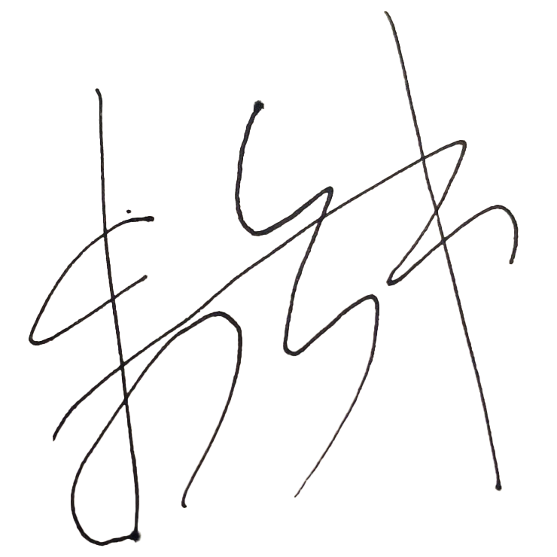
Assessor’s name | Yanzhong Zhu
Date signed | 25/03/23
End of Workplace Assessment – Assessor’s Checklist

