Case Study G
Staff Name | Department | Start Date
Sharon Wise
Daniel Parker
Graham Pat
Tyler Rust


DANCE CLASS

EVERY TUESDAY
17:30 – 18:30pm

EVERYONE WELCOME
NO EXPERIENCE REQUIRED

New Rules at Totem Pole

Totem Pole has produced a series of new policies and rules which govern when and where employees have lunch.
The new rules are:
- Extra’s must eat their lunch in the main restaurant between 12:00 and 14:00
- The Lobster Café is exclusively for actors, directors, and producers
- Extras must not disturb actors when they are having lunch
- Selfies with actors are not permitted on set
- Extras must not pursue autographs, unless the actor has given their permission at the beginning of filming
Extras will not be used again if they break these rules.

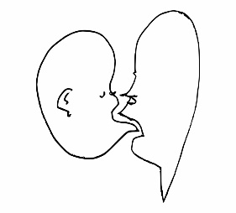
Talking Heads
123 Fun Lane
Sydney 2000

22/10/19

Dear Staff of Talking Heads

There have been three accidents in the last year, resulting from use of faulty soldering equipment.

Accidents have resulted in minor injuries to three staff members and as a result all soldering tasks have been suspended and new soldering equipment has been ordered.

Extensive training on how to safely use the equipment will be given before soldering tasks resume.

The management would like to thank staff for their patience and apologise for the delay on projects.

Thanks,

Olivia Torrisi

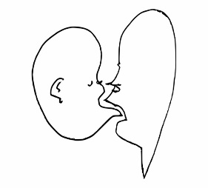
Talking Heads
123 Fun Lane
Sydney 2000

22/10/19

Dear Staff of Talking Heads,

There have been three accidents in the last year, resulting from use of faulty soldering equipment.

Accidents have resulted in minor injuries to five staff members, one of which is a serious injury.

As a result all soldering tasks have been suspended and new soldering equipment has been ordered.

Extensive training on how to safely use the equipment will be given before soldering tasks resume.

The management would like to thank staff for their patience and apologise for the delay on projects.

Thanks,

Olivia Torrisi

Talking Heads
123 Fun Lane
Sydney 2000

22/10/19

To Staff,

In regards to the last letter on the soldering equipment injuries, all workers should attend a group tutorial on the 18 December 2019 at 15:00.
The tutorial will describe how to use new soldering equipment safely.
The tutorial will be followed by two weeks of close supervision, in order to ensure soldering equipment is being used safely.

Thanks,

Olivia Torrisi

