
AHCLSC307
Implement a retaining wall project

Copyright © 2021 CSTC Pty Ltd

All rights reserved. No part of the contents of this publication may be reproduced or used in any form or by any means – graphic, electronic, or mechanical including photocopying, digitising, recording, or information storage-and-retrieval systems – without the written permission of CSTC Pty Ltd.
ASSESSMENT FOR AHCLSC307

Student name | Kelly Thorpe
Date of assessment submission | Click here to enter a date.

Trainer/Assessor’s name
Date of assessment marking | Click here to enter a date.
Outcome for unit | ☐ Competent  ☐ Not Yet Competent

TASK INSTRUCTIONS

- As part of the assessment for this unit of competency, you are required to complete a series of activities.
  - Some of these activities will require you to provide a response within this document, others will require you to gather evidence to demonstrate your knowledge and skills.
- At all times, the responses in your assessment must reference Australian (Queensland or Federal) documentation, including legislation, regulations, codes of practice, standards and guidance publications.

ACTIVITIES

Draw a simple concept plan for a proposed landscape design which includes a retaining wall.

Response
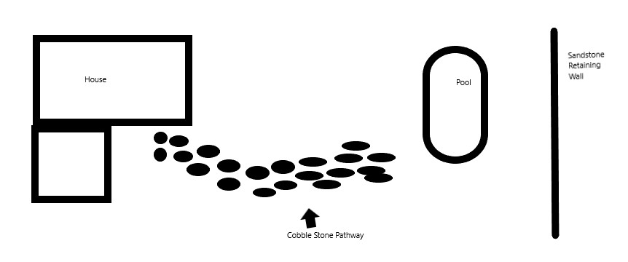

Outcome for Activity 1 | ☐ Satisfactory  ☐ Not satisfactory
Trainer/Assessor comments

Identify/list the detail on the landscape plan shown.

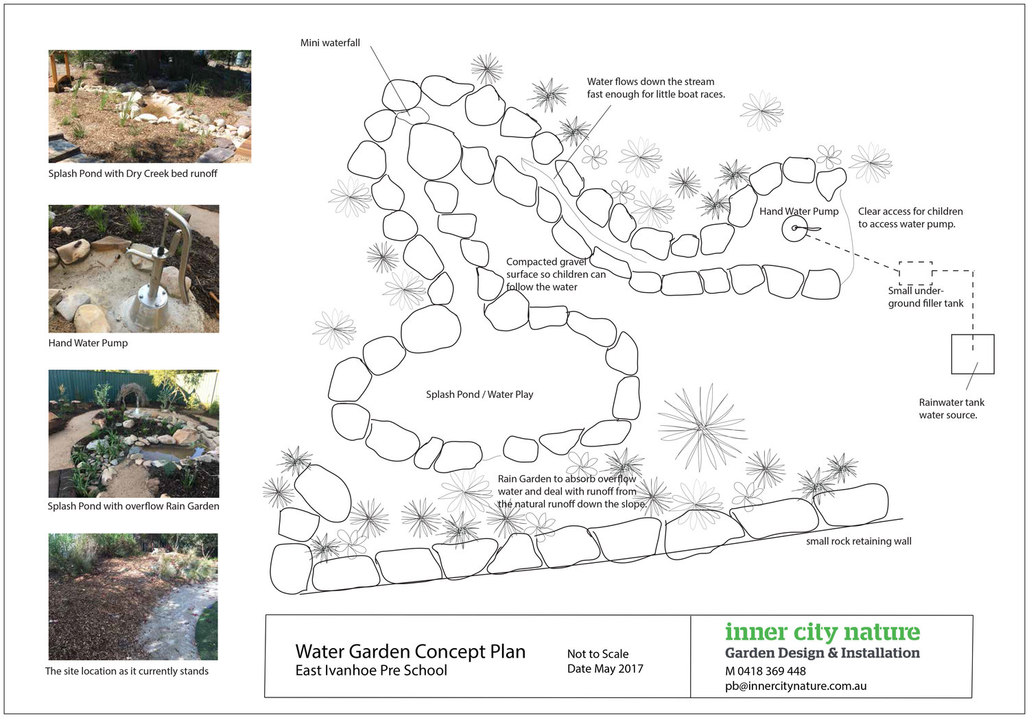

Response
Plant locations, materials (in pictures) to be used. Rainwater collection details. Scale (scale bar) and direction (north point)
Title block, which includes plan/drawing number, date of preparation and version and plan/drawing author

Outcome for Activity 2 | ☐ Satisfactory  ☐ Not satisfactory
Trainer/Assessor comments

List the materials required to complete the retaining wall, by using the wall and water feature construction plan shown.

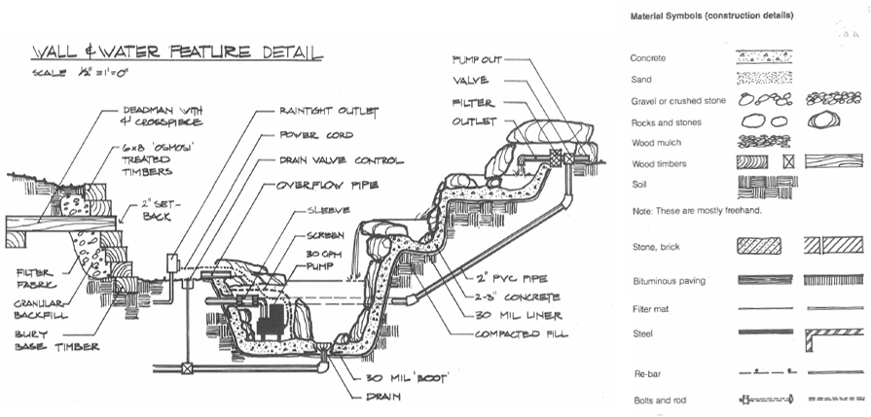

Response
Wall – concrete, rocks and stones, wood timbers, soil, pvc pipes, filter fabric
Pump – Powercord, valve, filter
Extras – rain tight outlet, screen, concrete

Outcome for Activity 3 | ☐ Satisfactory  ☐ Not satisfactory
Trainer/Assessor comments

Identify the requirements of your local council with regards to retaining walls.

Response
Toowoomba Regional Council
Development approvals area required where;-
-: the wall is retaining fill having a height greater than 1 metre in height above the walls natural ground surface;
-: the wall is located within 1.5metres of a building or another retaining wall;
-: there is a load or surcharge imposed above the retaining wall (i.e driveway, batter or building)

Outcome for Activity 4 | ☐ Satisfactory  ☐ Not satisfactory
Trainer/Assessor comments

What strategies could you implement to address environmental impacts, including:
- Spillages
- Dust
- Site cleanliness
- Noise

Impact | Strategy
- Spillages | 1 – Communicate the hazard – immediately notify other workers, supervisors and 000 if necessary.  2 – Control the spill – stop or minimize the spill (close valve or pick up container if safe) Appropriate PPE should be worn, suits, respirators, signage and shut down any sources of ignition.  3 – Contain the hazard – ensure the spill doesn’t go further. Use a spill kit including absorbent material and/or neutralizer.  4 – Clean up spill and damage – dispose of correctly (small plastic bags or drums) according to environmental regulations and local laws.
- Dust | Covering stockpiles, use dust catchers, place sweepings in a bag or box before disposing, use water to suppress dust, install dust screens around site edges.
- Site cleanliness | 1 – Clean up debris – organise rubbish to be recycled if possible  2 – Pay attention to proper storage – store tools and materials correctly  3 – Eliminate hazards – provide adequate lighting, clear away protruding pipes, timber etc that could cause injury.  4- Keep extension cords clear of walkways and store correctly when not using.
- Noise | Measure noise levels, provide correct PPE (ear plugs, ear muffs), use silencers, barriers, enclosures, erect warning signs, use time restrictions and adopt quieter, alternative techniques.

Outcome for Activity 5 | ☐ Satisfactory  ☐ Not satisfactory
Trainer/Assessor comments

List the components for four (4) common surface drainage systems used in landscape construction.

System | Components
- Spoon | Is a concrete drain formed in line with the ground surface and used to collect rainwater, generally 1 metre wide and 80-120mm deep.
- Channel and grate | Plastic, usually rectangular bases with grate on the top to stop blockages, comes in a variety of sizes and shapes, used to collect water and direct away.
- Pit | Is a rectangular box with a grate on top used to collect rainwater or excess water
- Contour | Contour banks are used to slow/break overland water flow on slopes, by reducing the slope of the land, one can reduce problems such as erosion and water speed.

Outcome for Activity 6 | ☐ Satisfactory  ☐ Not satisfactory
Trainer/Assessor comments

List the advantages and disadvantages of drainage behind and through the built wall (as shown).

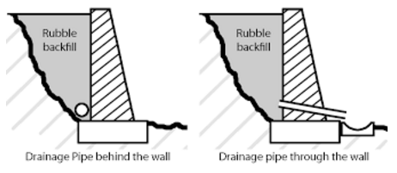

Drainage pipe behind the wall
Advantages
Relieves hydrostatic pressure preventing the wall from falling over and/or moving
Disadvantages
Water seeping through can cause the soil behind the wall to stain the colour of the blocks

Drainage pipe through the wall
Advantages
Relieves hydrostatic pressure preventing the wall from falling over and/or moving
Disadvantages
Pests such as rats and mice can enter through weep holes/ ends of pipe. Blockages can occur

Outcome for Activity 7 | ☐ Satisfactory  ☐ Not satisfactory
Trainer/Assessor comments

Explain the following terms:
- Batter
- Angle of repose

Term | Definition
- Batter | To batter a wall is to angle the slopes of the wall at an angle greater than 90 degrees. Battering of a retaining wall means that the face of the wall will slope away from the front of the wall and towards the material being retained.
- Angle of repose | Angle of repose of granulae material is the steepest angle of descent relative to the horizontal plane to which material can be piled without it slumping.

Outcome for Activity 8 | ☐ Satisfactory  ☐ Not satisfactory
Trainer/Assessor comments

Describe what is happening the in sketched diagram and the photograph shown below.

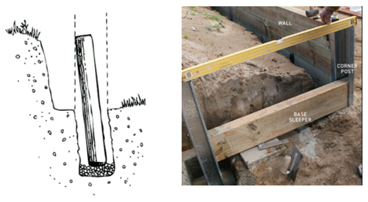

 | Description
- Sketched diagram | Vertical logs are been used to attach the horizontal logs, the vertical logs haven’t been set in concrete yet..
- Photograph | In the photograph the workers are checking that the corner posts are level, this will help ensure the sleepers are level. l

Outcome for Activity 9 | ☐ Satisfactory  ☐ Not satisfactory
Trainer/Assessor comments

Have team members take photos and videos of your involvement with retaining wall projects.

Identify each photo / video with a letter label and describe each photo / video in the table below. Submit the photo / video files along with this workbook.

Advantages
A | 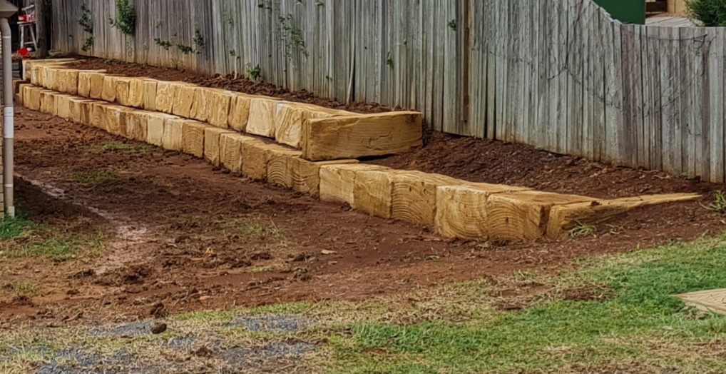  Retaining wall – made of sandstone blocks
B | 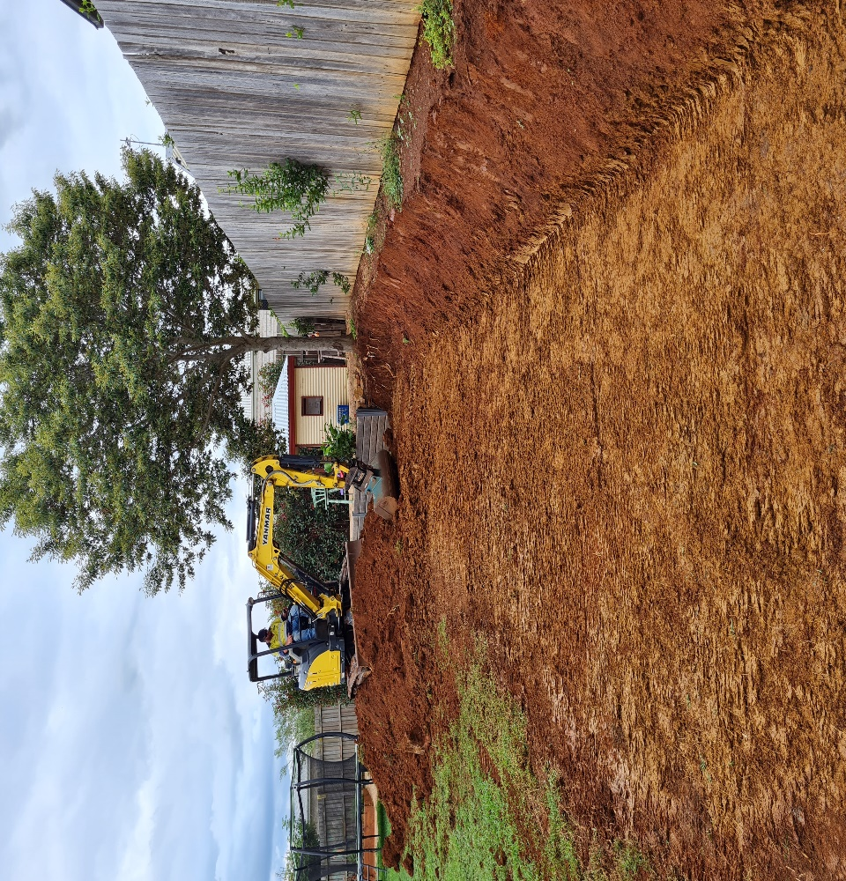  Cutting the levels for the retaining wall in A
C | 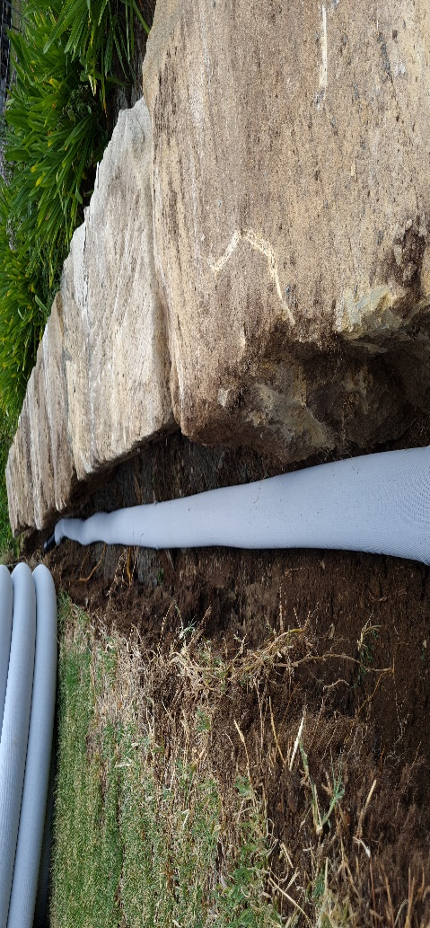  Drainage Ag pipe behind a sandstone block retaining wall
D | 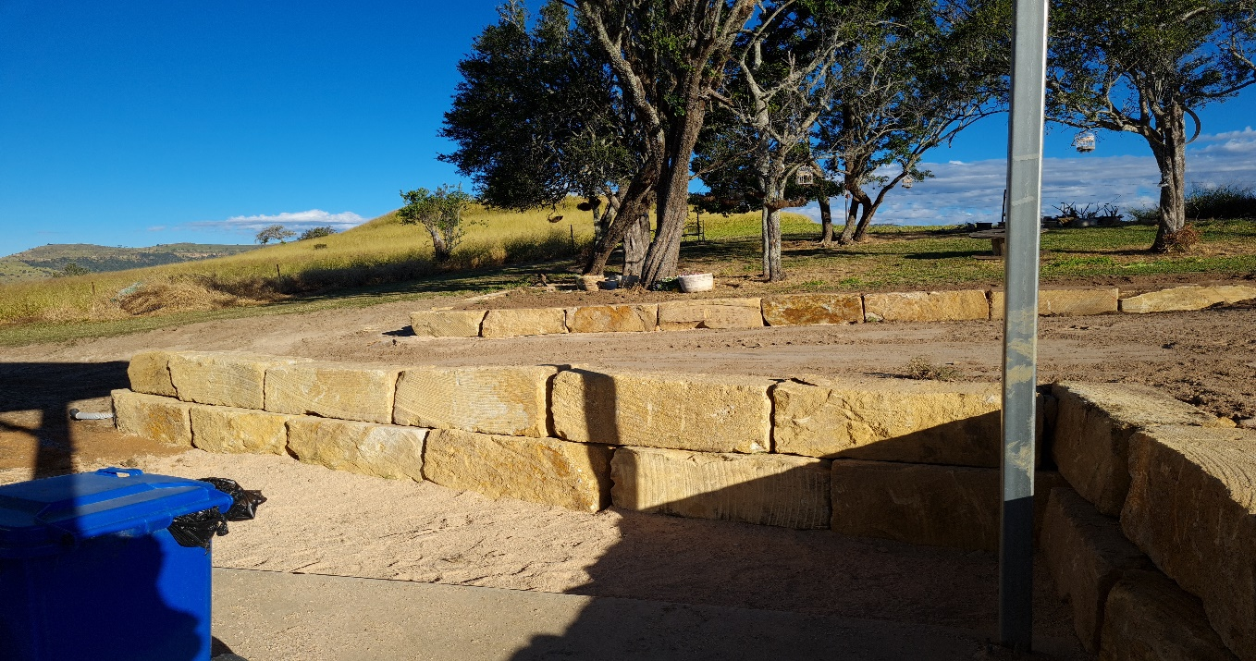  Retaining wall running beside a shed and driveway
E | 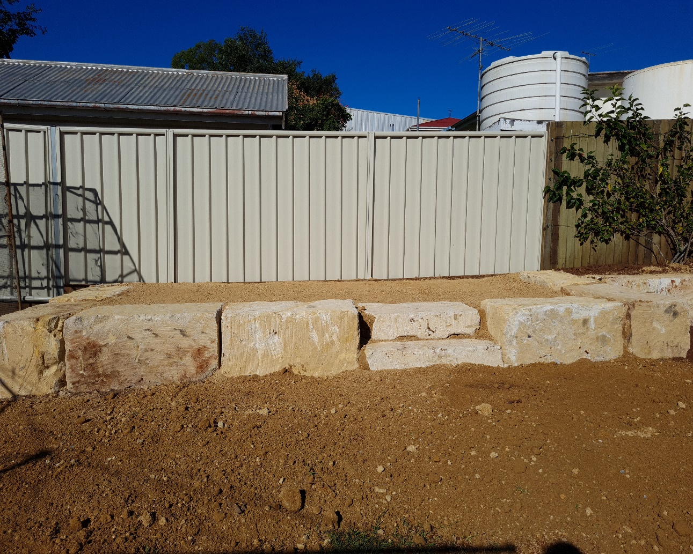  Retaining wall around a levelled seating area – area has been filled with decomposed granite and vibe compacted
F | 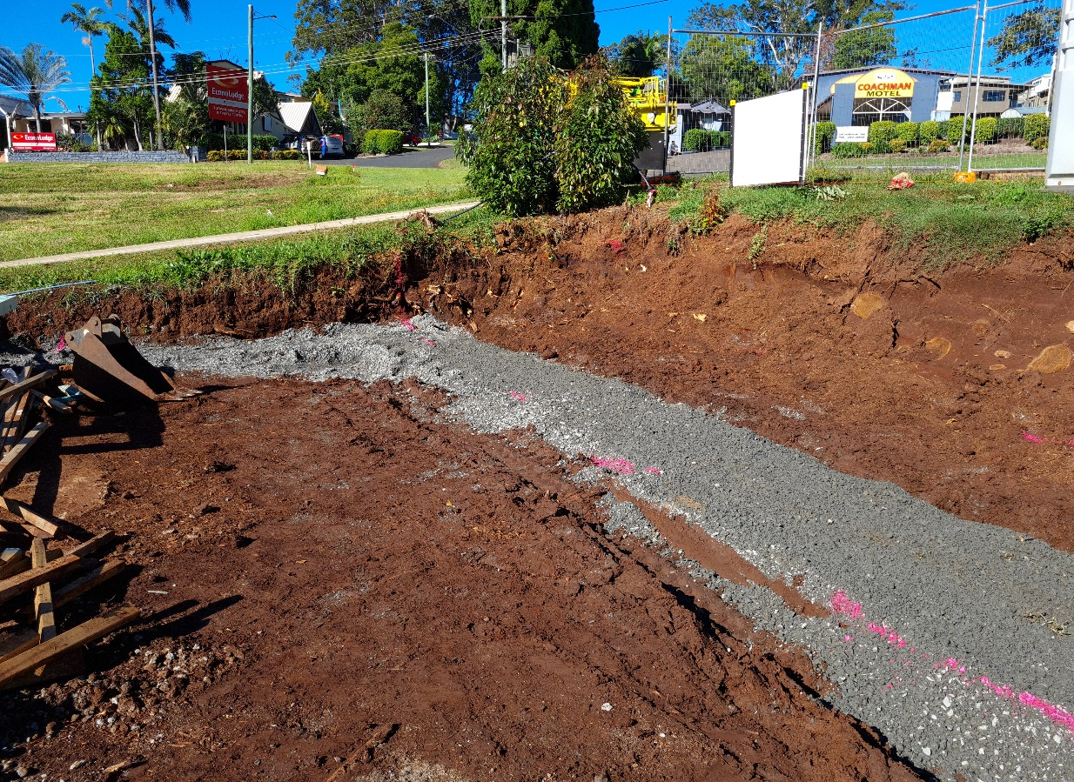  Laying of roadbase to bed sandstone blocks in after marking the area out (pink lines)
G | 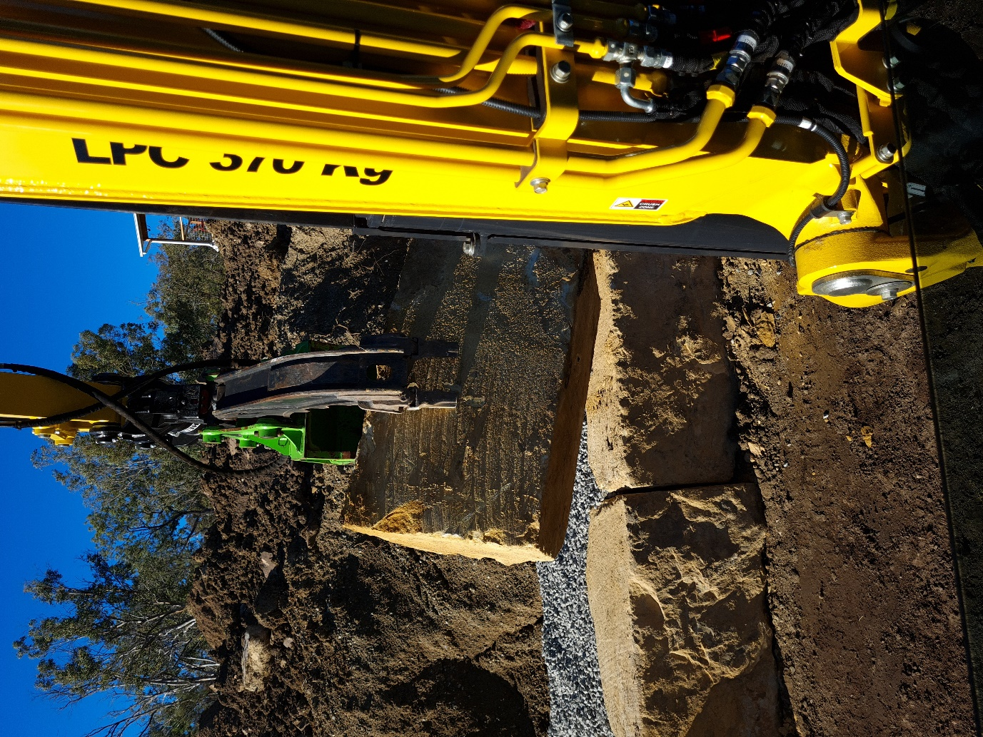  Installing sandstone blocks with an excavator.
H
I
J
K
L
M
N
O
P
Q
R
S
T
U
V
W
X
Y
Z

Outcome for Activity 10 | ☐ Satisfactory  ☐ Not satisfactory
Trainer/Assessor comments

