
AHCLSC305
Construct stone structures and features

Copyright © 2021 CSTC Pty Ltd

All rights reserved. No part of the contents of this publication may be reproduced or used in any form or by any means – graphic, electronic, or mechanical including photocopying, digitising, recording, or information storage-and-retrieval systems – without the written permission of CSTC Pty Ltd.
ASSESSMENT FOR AHCLSC305

Student name | Kelly Thorpe
Date of assessment submission | Click here to enter a date.

Trainer/Assessor’s name
Date of assessment marking | Click here to enter a date.
Outcome for unit | ☐ Competent  ☐ Not Yet Competent

TASK INSTRUCTIONS

- As part of the assessment for this unit of competency, you are required to complete a series of activities.
  - Some of these activities will require you to provide a response within this document, others will require you to gather evidence to demonstrate your knowledge and skills.
- At all times, the responses in your assessment must reference Australian (Queensland or Federal) documentation, including legislation, regulations, codes of practice, standards and guidance publications.

ACTIVITIES

Draw a simple concept plan for a proposed landscape design which includes stone structures/features.

Response
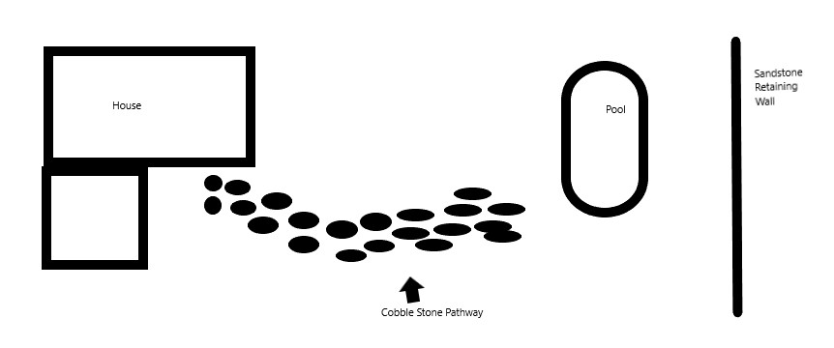

Outcome for Activity 1 | ☐ Satisfactory  ☐ Not satisfactory
Trainer/Assessor comments

Identify/list the detail on the landscape plan shown.

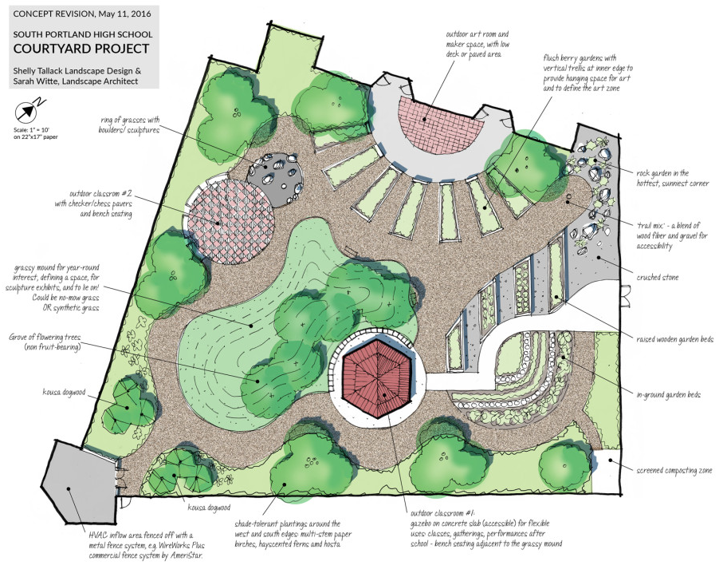

Response
Plant Details ie types of plants/grasses
Other materials to be used, ie rocks, timbers etc
Areas to be created ie. Outdoor classrooms.
Scale
Where (Location), date plan designed and by whom
Outdoor classroom materials

Outcome for Activity 2 | ☐ Satisfactory  ☐ Not satisfactory
Trainer/Assessor comments

List the materials required to complete the water feature, by using the wall and water feature construction plan shown.

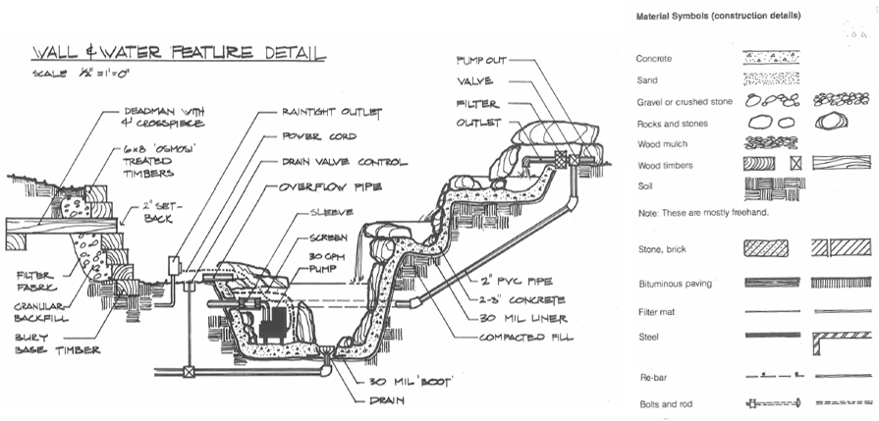

Response
Wall – concrete, rocks and stones, wood timbers, soil, pvc pipes, filter fabric
Pump – Powercord, valve, filter
Extras – rain tight outlet, screen, concrete,

Outcome for Activity 3 | ☐ Satisfactory  ☐ Not satisfactory
Trainer/Assessor comments

Identify formal and informal stone structures and describe their features.

 | Features
- Formal stone structures | Reduction of all natural elements to geometric shapes. Formal stone structures can include stairs, walls and patios, so long as they are created symmetrically, usually using geometrical shapes
- Informal stone structures | Untouched wilderness, natural surroundings… Informal stone structures may include water features, garden edging, structures that are created but with the natural surrounding area in mind, complementing it rather than been over processed.

Outcome for Activity 4 | ☐ Satisfactory  ☐ Not satisfactory
Trainer/Assessor comments

List the components for four (4) common surface drainage systems used in landscape construction.

System | Components
- Spoon | Is a concrete drain formed in line with the ground surface and used to collect rainwater. Generally one metre wide and 80-120mm deep.
- Channel and grate | Plastic bases with a grate on the top to stop blockages, comes in a variety of shapes and sizes
- Pit | Is a rectangular box with a grate on top, used to collect rainwater or excess water.
- Contour | Contour banks are used to slow/break overland water flow on slopes., by reducing the slope of the land one can reduce problems such as erosion and water speed

Outcome for Activity 5 | ☐ Satisfactory  ☐ Not satisfactory
Trainer/Assessor comments

List the advantages and disadvantages of drainage behind and through the stone wall (as shown).

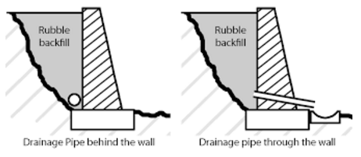

Drainage pipe behind the wall
Advantages
Relieves hydrostatic pressure preventing the wall from falling over or leaning.
Disadvantages
Water seeping through can take dirt with staining blocks/ timber. Pests such as rats, mice and frogs can enter through the pipe ends.

Drainage pipe through the wall
Advantages
Relieves hydrostatic pressure preventing the wall from falling over or leaning.
Disadvantages
The drainage rock and/or soil can weep through the holes. Pests such as rats, mice and frogs can enter through weep holes and/or blockages can occur.

Outcome for Activity 6 | ☐ Satisfactory  ☐ Not satisfactory
Trainer/Assessor comments

Research and list a variety of admixes.

Admix | Description
- Set Retarding | Delays the chemical reaction that takes place when the concrete starts the setting process.
- Air entrapment | Increases the freeze thaw durability and creates a more workable concrete
- Corrosion inhibiting | Slows the corrosion of the reinforcing steel, used in concrete
- Mineral | Include natural products such as volcanic ash, fly ash and silica fume, to create a more economical and durable product.

Outcome for Activity 7 | ☐ Satisfactory  ☐ Not satisfactory
Trainer/Assessor comments

Research other methods of damp proofing (excluding DPC and base course) and identify the materials used.

Damp proofing method | Materials
- Integral | Water proofing compounds such as permo, silka, chalk, talc, soap and petroleum are mixed with the concrete to fill any voids.
- Cavity Wall | A cavity wall is used to separate the inner and outer walls, ensuring that moisture doesn’t transfer from the outside to the inside.
- Surface treatment | Water resistant substances or compounds such as sodium or potassium sulphates, barium hydroxide are applied to the areas.
- Guniting | An impervious layer of cement mortar is deposited under pressure using compressed air. Usually around pipes and cisterns, to ensure waterproofing.

Outcome for Activity 8 | ☐ Satisfactory  ☐ Not satisfactory
Trainer/Assessor comments

Research and describe suitability of various patterns for stone work projects.

Pattern | Suitability
- Ledgestone | Flat stone used mostly for stacking, i.e fireplaces, around pillars and walls
- Mosaic | Stones placed in various patterns, generally used for large projects due to the cheapness in construction costs, used for patios and paths.
- Square and Rec | Used to provide structure to a project, i.e pillars and gate posts Stones are manufactured to be mostly square or rectangular
- Rounds | Not necessarily considered a pattern, most manufacturers supply them. Some can be naturally created from the weather. Used for walls and paths.

Outcome for Activity 9 | ☐ Satisfactory  ☐ Not satisfactory
Trainer/Assessor comments

List the advantages and disadvantages of mortared and dry stone features.

Mortared stone features
Advantages
Cheap, good thermal regulation, attractive, low maintenance, durable, strong
Disadvantages
Poor insulation and can be difficult to build

Dry stone features
Advantages
Flexible enough to adapt to the surrounding environment, economical, minimal maintenance, low carbon footprint – completely recyclable, self draining, no expansion joints
Disadvantages
Poor insulation and can be difficult to build.

Outcome for Activity 10 | ☐ Satisfactory  ☐ Not satisfactory
Trainer/Assessor comments

Research the different types of stone work finishes.

Response
Sawn – a diamond blade is used to saw the sides
Split – natural quarry look
Honed – smooth satin appearance
Antique – aged aesthetic look using acid wash
Bush hammered – high impact machine used to pit the stones surface
Sand blasted – textural finish not as harsh as bush hammered
Exfoliated (flamed) – used to increase slip resistance on granites and bluestone making them suitable for paving and around wet areas
Tumbled – stones edges are softened in a drum, with sand/grit and/or acid

Outcome for Activity 11 | ☐ Satisfactory  ☐ Not satisfactory
Trainer/Assessor comments

List environmentally safe products for cleaning.

Response
Mild dish soap
Vinegar Solutions
Steam mop
Dust daily
High pressure washer.

Outcome for Activity 12 | ☐ Satisfactory  ☐ Not satisfactory
Trainer/Assessor comments

Have team members take photos and videos of your involvement with stone features.

Identify each photo / video with a letter label and describe each photo / video in the table below. Submit the photo / video files along with this workbook.

Advantages
A | 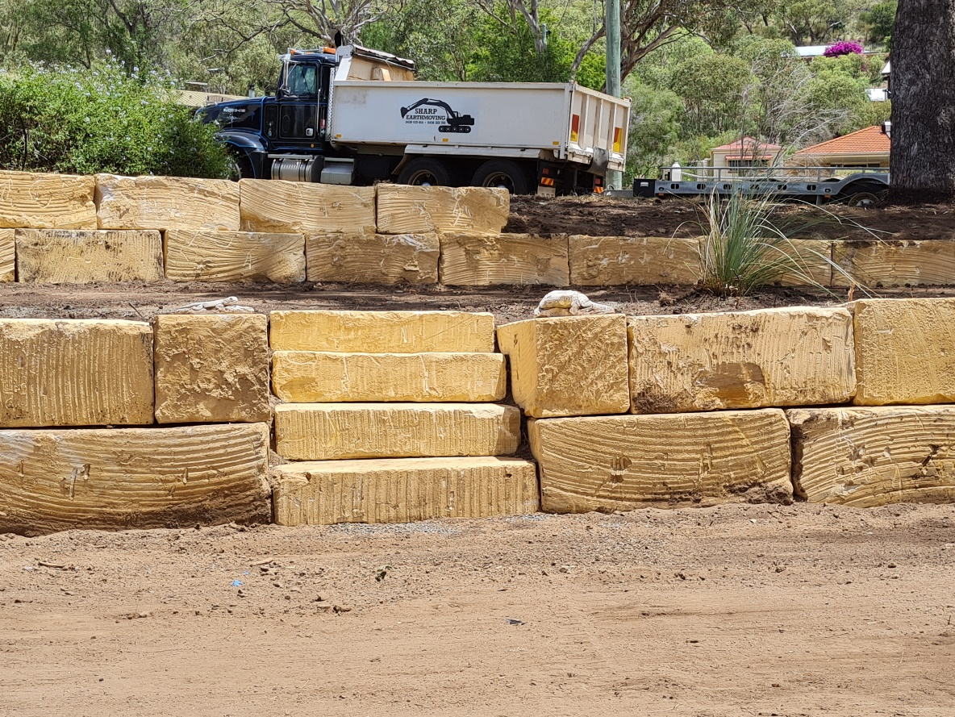  Sandstone Wall with steps
B | 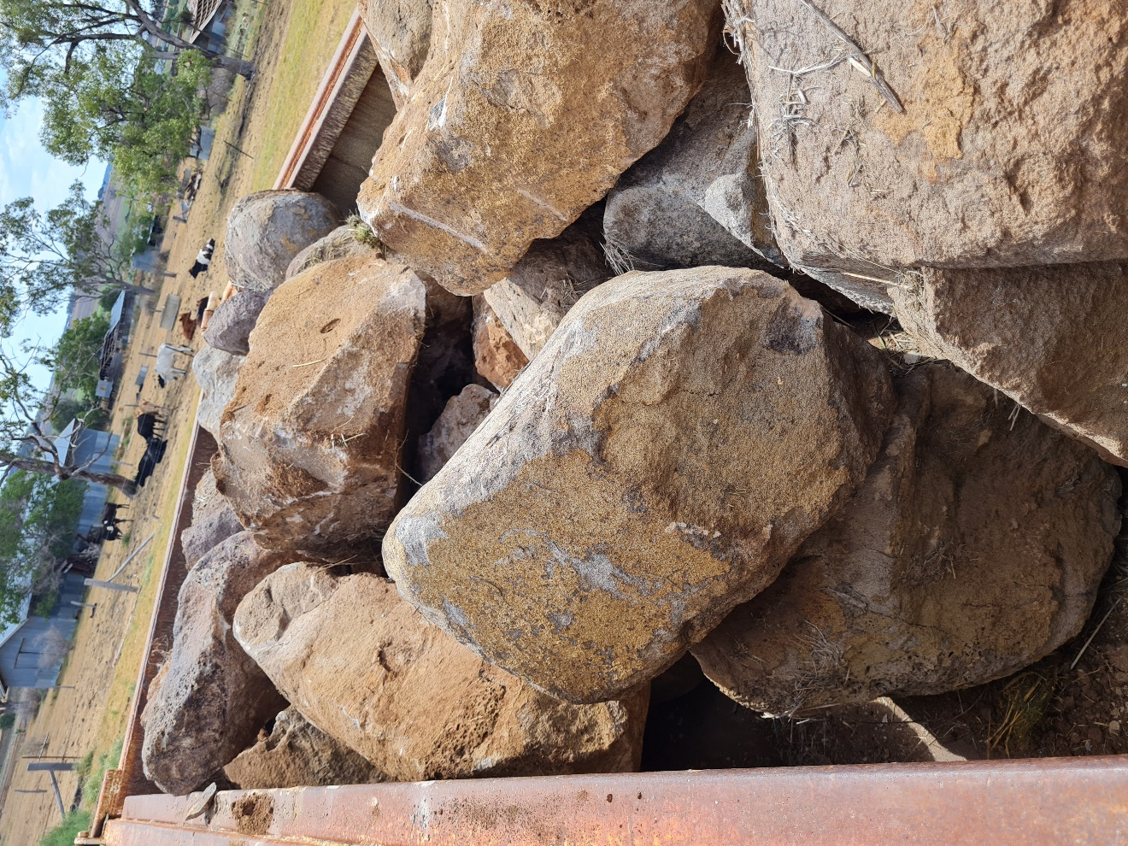  Naturally round stones removed from a property,
C | 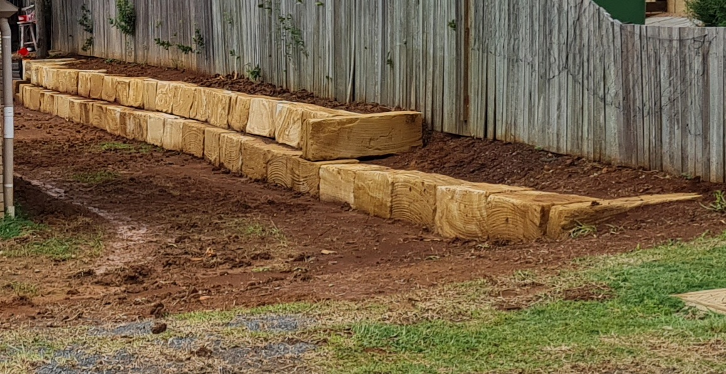  Another sandstone retaingwall
D
E
F
G
H
I
J
K
L
M
N
O
P
Q
R
S
T
U
V
W
X
Y
Z

Outcome for Activity 13 | ☐ Satisfactory  ☐ Not satisfactory
Trainer/Assessor comments

