CHCECE018
Nurture creativity in children
Learner Workbook



Table of Contents

Table of Contents 1
Candidate Details 2
Assessment – CHCECE018: Nurture creativity in children 2
Competency Record to be completed by Assessor 3
Activities 5
Activity 1A 5
Activity 1B 6
Activity 2A 9
Activity 2B 10
Activity 2C 11
Activity 2D 13
Activity 3A 15
Activity 3B 16
Activity 3C 17
Activity 3D 19
Activity 3E 20
Activity 3F 22
Activity 4A 23
Activity 5A 26
Activity 5B 28
Skills and Knowledge Activity 29
Major Activity 31

Candidate Details

Assessment – CHCECE018: Nurture creativity in children
Please complete the following activities and hand in to your trainer for marking. This forms part of your assessment for CHCECE018: Nurture creativity in children.
Name: _____________________________________________________________
Address: _____________________________________________________________
_____________________________________________________________
Email: _____________________________________________________________
Employer: _____________________________________________________________
Declaration
I declare that no part of this assessment has been copied from another person’s work with the exception of where I have listed or referenced documents or work and that no part of this assessment has been written for me by another person.
Signed: ____________________________________________________________
Date: ____________________________________________________________
If activities have been completed as part of a small group or in pairs, details of the learners involved should be provided below:
This activity workbook has been completed by the following persons and we acknowledge that it was a fair team effort where everyone contributed equally to the work completed. We declare that no part of this assessment has been copied from another person’s work with the exception of where we have listed or referenced documents or work and that no part of this assessment has been written for us by another person.
Learner 1: ____________________________________________________________
Signed: ____________________________________________________________
Learner 2: ____________________________________________________________
Signed: ____________________________________________________________
Learner 3: ____________________________________________________________
Signed: ____________________________________________________________

Competency Record to be completed by Assessor
Learner Name: _______________________________________________________
Date of Assessment: _______________________________________________________
The learner has been assessed as competent in the elements and performance criteria and the evidence has been presented as:
Assessor Initials
Authentic
Valid
Reliable
Current
Sufficient

Learner is deemed: COMPETENT NOT YET COMPETENT (Please circle)

If not yet competent, date for re-assessment: ____________________________________

Comments from Trainer / Assessor:
__________________________________________________________________________________________________________________________________________________________________________________________________________________________________________________________________________________________________________________________________________________________________________________________________________________________
Assessor Signature: ________________________________________________________
Observation/Demonstration

Throughout this unit, you will be expected to show your competency of the elements through observations or demonstrations. Your instructor will have a list of demonstrations you must complete or tasks to be observed. The observations and demonstrations will be completed as well as the activities found in this workbook. An explanation of demonstrations and observations:
Demonstration is off-the-job
A demonstration will require:
- Performing a skill or task that is asked of you
- Undertaking a simulation exercise
Observation is on-the-job
The observation will usually require:
- Performing a work based skill or task
- Interaction with colleagues and/or customers
Your instructor will inform you of which one of the above they would like you to do. The demonstration/observation will cover one of the unit’s elements.
The observation/demonstration will take place either in the workplace or the training environment, depending on the task to be undertaken and whether it is an observation or demonstration. Your instructor will ensure you are provided with the correct equipment and/or materials to complete the task. They will also inform you of how long you have to complete the task.
You should be able to demonstrate you can:
- Foster creativity through the physical environment
- Foster creativity through the human environment
- Foster creativity through a learning framework
- Provide experiences
- Evaluate experiences
You should also demonstrate the following skills:
- Oral Communication
- Reading

Activities

Activity 1A
Estimated Time | 50 Minutes
Objective | To provide you with an opportunity to select and promote the use of a range of open-ended, natural and found materials and make them available to children and to choose and promote the use of a range of materials to encourage creative expression and make them accessible to children.
Activity | Select a range of open-ended, natural and/or found materials appropriate to the age group of the children in your care and set them a creative task to produce a piece of work with the materials, encouraging them to be as creatively expressive as possible.  The task may be set for groups or individuals.  Explain the nature of the task, the materials selected and the outcome of the exercise. Where possible, attach a copy of the work produced to your work book.  The task to be set will be an art project to construct a house using cardboard and waste paper materials. The children will work in groups of 3 and each group will work together to build their own house creation.  Groups are encouraged to use any of the above listed materials. Consideration is given that children use glue, scissors correctly following the childcare health and safety policies.  It was observed that children really enjoyed the freedom of their own choice.

Activity 1B
Estimated Time | 60 Minutes
Objective | To provide you with an opportunity to introduce children to a range of examples of creative expression in art, architecture, inventions, music and dance, and promote the use of creative expression.
Activity | For each of the following mediums of expressing creativity, identify how you intend to introduce examples of it to the children in your care:  - Art  - Architecture  - Inventions  - Music  - Dance.  Ways of introducing art may include:  - Showing them examples of art on the internet  - Displaying art in the educational setting  - Looking at art in books within the library  - Visiting art galleries and museums locally, nationally and internationally  - Inviting artists into the educational setting to exhibit their work.  Ways of introducing architecture may include:  - Walking around the building you occupy  - Viewing architectural plans and designs  - Visiting historical monuments and buildings locally, nationally and internationally  - Viewing on the internet well-known international buildings and constructions such as Sydney Opera House, the Houses of Parliament, the White House, the Golden Gate Bridge etc.  - Comparing the architecture of different styles and time periods.  Ways of introducing inventions may include looking at everyday objects and inventions and discussing the following questions:  - What is the purpose of the invention?  - Why was it needed?  - What existed before it was invented, if anything?  - How does it benefit humans or the environment?  - Is it harmful to humans and/or the environment and why?  - What is it made of and why?  - What does it do that is different to other similar inventions and how?  Ways of introducing music may include:  - Playing recorded music as an audio exercise  - Showing films that are accompanied by music  - Combining dance with music  - Giving them musical instruments to play with  - Teaching them to play musical instruments properly  - Teaching them to read music  - Singing  - Dancing  - Nursery rhymes  - Watching music videos and musicals  - Visiting theatres to watch musical performances  - Listening to the radio  - Advertising jingles  - Using music as part of an activity such as musical chairs, musical statues and musical bumps.  Ways of introducing dance may include:  - Incorporating freestyle dancing into activities such as musical bumps and musical statues  - Teaching them a choreographed dance for them to perform  - Dancing as part of physical activity  - Watching dancers on the television/internet  - Visiting the theatre  - Using computer games that involve dancing.  For each of the creative mediums design an activity that encourages and promotes children in your care to express their creativity.  - Art – taking the children into the garden of the educational setting to look at flowers and then tasking them to recreate a flower/flowers of their choice with a range of materials with which you provide them. The learner may also provide the children with existing examples of art work and art styles to give them ideas  - Architecture – children are split into teams of four or five and are provided with a range of materials such as cardboard, paper, straws, string and sticky tape and tasked to build a tower upon which an item of the learner’s choice can sit/stand unaided  - Inventions – children are split into pairs and given a range of fabrics and materials and tasked to make a hat for a superhero with an explanation of the superpower and its connection to the hat  - Music – a film in which tribal music is being played is shown to the children as a group. The children are then divided into groups of four and given relevant musical instruments. Their task is to create a short piece of tribal music that may or may not include singing  - Dance – moving on from the music activity, two groups are joined together and each is tasked to choreograph and perform a dance routine to the other’s music.

Activity 2A
Estimated Time | 20 Minutes
Objective | To provide you with an opportunity to support children to feel a sense of ownership and responsibility for equipment and materials.
Activity | How can you support children to take responsibility and ownership for their equipment and materials?  - Start young – the earlier children are expected to become independent and given the opportunities to do so the earlier it will become the norm  - Let them help you – let them see you looking after your equipment and materials and where appropriate, invite them to help you. By inviting them to participate, children feel valued  - Demonstrate how they should look after their equipment and materials at their level of ability and skill and use relevant vocabulary such as responsibility and ownership so they know what they are doing  - Model responsibility – if you expect children in your care to look after their equipment and materials then you need to look after your own and the resources of the establishment  - Praise them whenever possible using phrases such as “Well done for keeping your pencil case tidy, I’m proud of you,” and thank them when they complete a task for you or for a peer. We all thrive on praise, especially children, and the more we receive the more we crave because it makes us feel like we’ve done a good job and are valued  - Don’t criticise – children will not always be able to complete tasks to your standard so be appropriate with your expectations  - Avoid rewards – taking ownership and responsibility of their equipment and materials should be expected and therefore nothing out of the ordinary  - Provide a structure and routine – if children know the processes they must go through on a daily basis in order to take responsibility for their equipment and materials it will become engrained and just a part of their basic routine. For example, complete an equipment check with the whole class at the start of the day to ensure that the necessary pieces of equipment are in working order  - Use consistent consequences – make sure that failure to look after their equipment and materials results in the same consequence for all. For example, if a child does not wash out the paint pallet at the end of an art activity, they will not be allowed to participate in the next art activity. Make these consequences known to all children in your care.

Activity 2B
Estimated Time | 30 Minutes
Objective | To provide you with an opportunity to role-model creativity by improvising with equipment and materials.
Activity | Create an activity that uses existing equipment and/or materials to make something else and demonstrate how the transformation is undertaken. Attach a copy or a picture of your creation to your work book.  - Instructions for potato printing:  - Materials needed: paper and pencil, sharp knife – for adult use only, templates, scissors, cereal box and PVA glue, large and small potatoes, paints, paintbrush, plates or something with a flat bottom, paper towels – for wiping the paint off the potato if you want to change the colour of paint you are using, card/paper to print on  - Step one:  cut the sides off the cereal box  draw the shapes you intend to use on the cereal box and cut them out  - Step two:  peel and cut the potatoes into slices about 2cm thick  wash and dry the potatoes to get rid of as much of the starch as possible so they are not too wet for marking  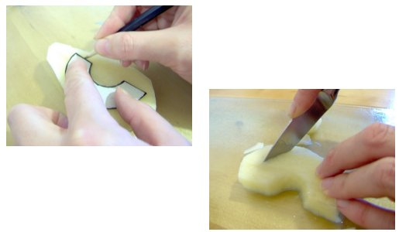  - Step three:  place the shiny side of the templates you have made from the cereal box on the potato slices and draw around them with a pencil or a pen  cut them out with a sharp knife – adults only  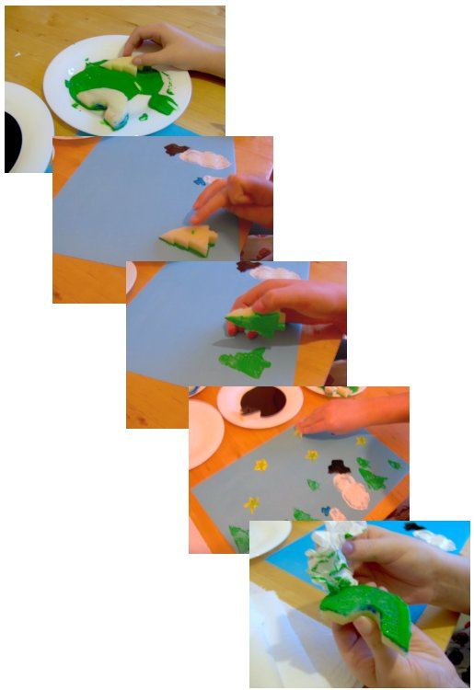  - Step four:  pour some paint (tube paint is best) onto a flat surface such as a plate or palette  spread the paint out  dip the potato shapes into the paint  place them firmly in the correct location on the cardboard/paper, press down and lift off  to change the colour of the paint, wipe the potatoes with a paper towel and repeat the process.  Images taken from http://www.things-to-make-and-do.co.uk/painting-and-pictures/potato-printing/potato-printing.html

Activity 2C
Estimated Time | 30 Minutes
Objective | To provide you with an opportunity to encourage children to pursue their own original ideas, interpretations and expressions and to invite children to ask questions and assist them to find their own answers.
Activity | What activities could you use to encourage children to pursue their own original ideas?  - Role playing and dressing up such as:  - doctor’s office  - veterinary clinic  - medieval times  - fairy tales  - outer space  - restaurant  - store  - Drama, dance and/or musical performance  - Creating their own town, farm, castle, space, beach etc.  - Create their own game  - Messy play such as:  - sand pit  - water activities  - painting and Playdough (Play-doh)  - Construction.  How do you encourage children to ask questions and find their own answers?  The educator needs to be encouraging in all questions asked from all children and guiding them to think about the question they have asked and potential answers. It may also involve class discussion and assistance from peers.

Activity 2D
Estimated Time | 30 Minutes
Objective | To provide you with an opportunity to engage children in talking about their creations and ask them open-ended questions, share enthusiasm for creative work with children and to encourage children to respect and appreciate the creative effort of their peers.
Activity | Give an example of a creative activity you could use to engage children in talking about their creative work.  - Role playing and dressing up  What specific questions could you ask them to help them to talk about the work they produce?  Educators should ask open-ended questions, meaning that you are not looking for a specific answer from them, but genuinely want to hear their opinion. For example, ‘what did you enjoy most about this activity?’  How can you share enthusiasm for creative work with children?  - Show interest in their work throughout the creative process  - Ask questions about their work  - Actively listen to them talking about their work  - Present their work to the class  - Display their work  - Share their work with their parents/carers  - Join in with the activity.  How can you encourage children to respect and appreciate the creative efforts of their peers?  - Sharing creative work with peers can be quite a daunting prospect  - It is important to teach children to accept and appreciate developmental criticism  - Also as important to teach those giving it to be polite and respectful when doing so  - Encourage children to think about what they say regarding the creative  work of others before they say it  - Consider how they would feel if someone said the same about their work.

Activity 3A
Estimated Time | 30 Minutes
Objective | To provide you with an opportunity to allow time for children to be creative and encourage efforts to extend over days or weeks.
Activity | Design a creative project for the group of children in your care that extends over a period of days or weeks and document the schedule and plan, identifying which of the key elements of the approved learning framework are met by each activity.  Learning outcomes include:  - Children have a strong sense of identity  - Children are connected with and contribute to their world  - Children have a strong sense of wellbeing  - Children are confident and involved learners  - Children are effective communicators.  Principles include:  - Secure, respectful and reciprocal relationships  - Partnerships with families  - High expectations and equity  - Respect for diversity  - Ongoing learning and reflective practice.  Practices include:  - Holistic approaches  - Responsiveness to children  - Learning through play  - Intentional teaching  - Learning environments  - Cultural competence  - Continuity of learning and transitions  - Assessment for learning.

Activity 3B
Estimated Time | 30 Minutes
Objective | To provide you with an opportunity to teach children techniques when using materials and equipment.
Activity | Plan an activity that teaches the children in your group a creative technique and document the materials and equipment you will require in order to complete the activity.  Creative techniques may include:  - Painting  - Collage  - Papier-mâché  - Sculpting  - Stencilling  - Textile work  - Playing musical instruments  - Resistant materials  - Information and communication technology  - Cooking.  Equipment and materials may include:  - Painting supplies  - Illustration supplies  - Sculpting and modelling supplies  - Craft supplies  - Musical instruments  - Resistant materials technology  - Computers  - Food  - Cooking equipment.

Activity 3C
Estimated Time | 30 Minutes
Objective | To provide you with an opportunity to plan and create opportunities for children to collaborate creatively with each other.
Activity | Plan an opportunity for children to collaborate creatively with each other within the limits of your organisation and the equipment and materials to which you have access, in the following areas:  - Singing  - Composing  - Dancing  - Drama  - Invention.  - Singing  - give each group a choice of five songs to sing and let them select one as a group  - give reasons for their choice  - choose who will sing which part(s) of the song  - choose whether or not it will be sung to music  - choose whether or not they will play musical instruments to the song and who will play which  - Composing  - put children into pairs/trios/groups  - give them a selection of musical instruments from which to choose  - give them a picture/selection of words/poem and task them to compose a short piece of music that represents their interpretation of the stimulus  - record their performance and play it back to them  - Dancing  - teach several different dance moves to the whole group  - split the cohort into groups of a number of your choosing  - task each group to use all of the moves that have been taught in a sequence of their choosing to the piece of music you have played them  - Drama  - put children into groups of four or five  - give each group a different object or number of objects  - give each group the same theme and task them to create a short scene with the object(s) and the theme  - have each group perform their drama to the rest of the group  - Inventive collaboration  - in groups of five task children to invent a new flavour of ice-cream, the packaging for the ice-cream, and an advertisement for it  - in pairs, task children to invent a new ending to a book or story they have all been reading in class  - in groups of four or five task children to design a new building to replace the existing learning environment

Activity 3D
Estimated Time | 30 Minutes
Objective | To provide you with an opportunity to involve children in critical reflection and solving real problems.
Activity | Design an activity that requires children to undertake critical reflection during and after the activity.  - Baking Biscuits  - Have the recipe for a simple vanilla biscuit printed out for everyone to follow.  - Print off pictures of each step being shown.  - Talk about each ingredient we will be using.  - Ask the children whether they have ever tried a biscuit like this before.  - Some children will be excited with the activity of baking and others might be apprehensive as they have never tried it before.  - Going through each step in the recipe together as a group before moving on to the next instruction will give them the confidence to continue.  - Ask the children whether baking cupcakes next time would be a more fun and challenging experience.

Activity 3E
Estimated Time | 30 Minutes
Objective | To provide you with an opportunity to display children’s work in meaningful ways.
Activity | Why is it important to display children’s work?  It is visually appealing to see art work and essays in learning environments and communal areas of the learning establishment  - Communication for:  - parents – parents like to know what their children are producing and learning about whilst in the care of educators. Displaying their children’s work not only evidences the topics covered but also their progress and participation  - peers – displaying work in communal areas allows others to see what their peers in different areas of the educational establishment are producing and learning about  - visitors – the display work should depict a story about the learning culture of the whole establishment  - Value:  - classroom notice boards should focus on the children rather than the educators so that they can learn about one another  - displaying children’s work fills them and their friends with a sense of pride and achievement and encourages them and others to produce work to the best of their ability in order to have it displayed again or in the future  - knowing that adults value their work encourages children to work hard and helps to develop their self-esteem  - Processes:  - whilst it is important to display the finished product it is also important to show the processes the child undertook to achieve the end result, and this is especially so in creative works  - displaying processes also helps children to see how their peers are learning and can inspire ambition and ideas within them  - Inspiration:  - displaying children’s work encourages thought and consideration of the work of others and can enhance the social interactions between children as they discuss their opinions of the work of others  - seeing accomplished work by other children can inspire individuals to achieve the same  - educators can also be inspired by the work produced by children in the care of their colleagues and this can lead to new ways of working.  What ways could you display children’s work in your learning environment?  - On the walls of the learning environment  - Notice boards in the learning environment and communal areas  - In the dinner hall  - In the reception area of the establishment  - In corridors of the establishment  - In public libraries  - Having an exhibition for parents/carers to attend  - Putting on a dramatic/musical performance for peers and/or parents/carers  - Children presenting their own work to their peers.

Activity 3F
Estimated Time | 30 Minutes
Objective | To provide you with an opportunity to design a flexible framework that can respond to children’s interests as they arise.
Activity | Using the appropriate approved learning framework for your role in your organisation, plan the activities for your group of children for the next six weeks.  State the approved framework you are using and for each activity state how it relates to the key elements of the framework.  - Nationally approved frameworks are:  - Belonging, Being and Becoming—The Early Years Learning Framework for Australia  - My Time, Our Place—Framework for School Age Care in Australia.  Activities  Toss the Ball  {Large Group}  This is a simple getting-to-know-you game that we play several times. Children toss a ball to each other (we have one of those soft, stuffed globes from Hugg-a-Planet that we use). As they catch it, they tell their name and a favourite thing (ice cream, colour, TV show, etc.)  Painting with Water Colour  Children paint using a water cup and water colour paint set. The children learn how to wet the brush and the paint, and clean the brush in the water cup before getting a new colour. They learn to wash their brush at the sink before storing it in the paint box.  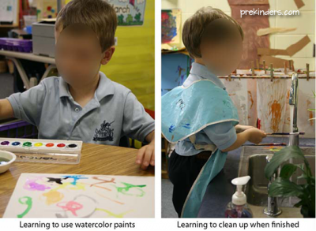  Painting with Tempera  We use the tempera paint cups (which are available in the art centre every day). We discuss rules for painting and cleaning up.  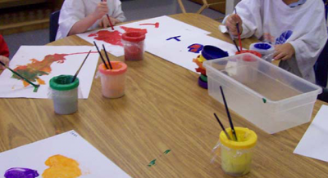  Dry Erase Boards  Children explore with dry erase boards. They learn procedures for using the markers and cleaning and storing the lap boards.  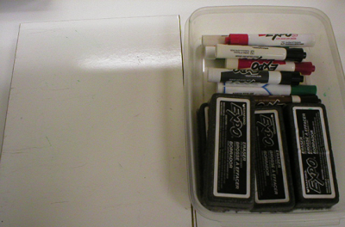  Bookmaking  Children learn how to make a book with coloured or white paper and a stapler. They draw pictures on the pages. Many children make their own books in the Writing Centre during the year once they learn how.  **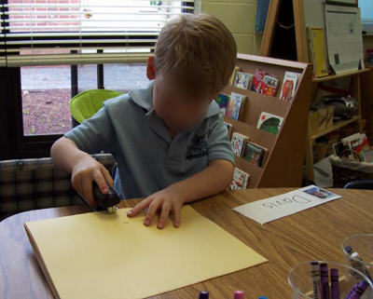  First Letter with Stickers  Children stick mini stickers on the first letter of their name.  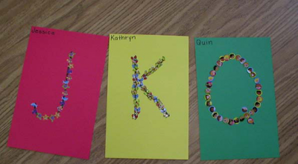  Wax Resist Names  Children trace over their name with an oil pastel crayon then paint over the paper with water colour paint. The waxy crayon resists the paint, so that the name shows through.  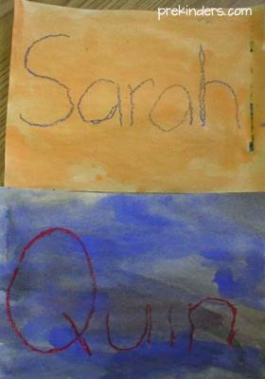  Cereal Necklace  Children string fruit loops onto a piece of yarn to make a necklace. We do this on the first day of school because it is an early dismissal day and lunch is not served that day. This gives them a snack if they are hungry.  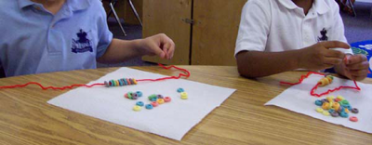  Play-Dough  Children play with play-dough and cookie cutters. We discuss rules for using play-dough, cleaning up and storing materials. To clean up, children separate play-dough tools and cookie cutters into containers. There are hand brooms for the children to sweep play-dough bits from the floor and table.  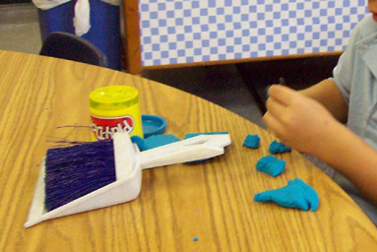  Mosaic  Children use 1-inch strips of coloured paper, cut them into small squares, and glue them on black paper to make a Mosaic. We talk about safety rules for using scissors and how to use glue.  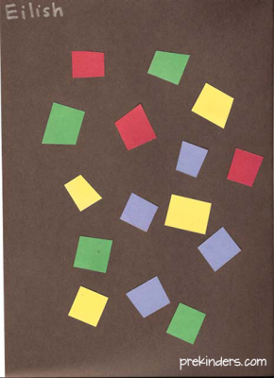  Magazine Picture Cutting  Children cut out pictures from magazines and glue them on paper. We review scissor safety rules.  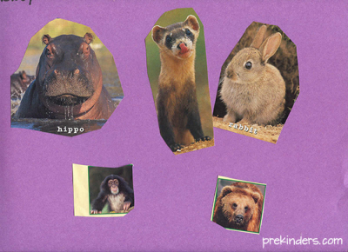  Puzzles  We practice putting simple wooden puzzles together, emphasizing that all pieces must be put in the puzzle correctly before storing it.  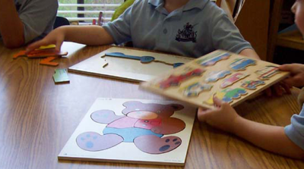  Math Materials  Children explore with geoboards, and other basic math materials, such as pattern blocks, Unifix cubes, bear counters, etc.  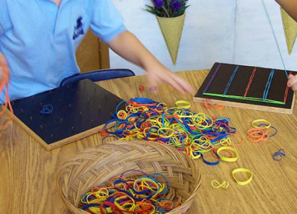  Cooking Activity  This is a very simple cooking activity for the first days of school. Children mix food colouring in white icing, spread the icing on graham crackers or a bagel half and add sprinkles.  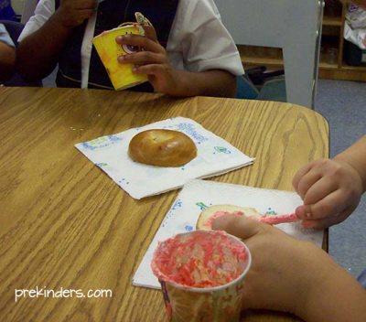  Colour Mixing  Children experiment with mixing coloured water. We use the primary colours (red, blue, yellow) to make new colours. We use paint trays with 6 small bowls to mix the coloured water in and eye droppers. Children can dump their water into a bucket once they have filled the 6 bowls and start again.  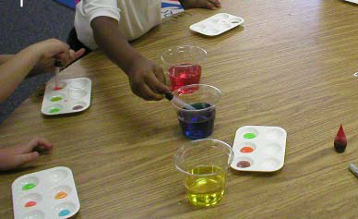

Activity 4A
Estimated Time | 60 Minutes
Objective | To provide you with an opportunity to identify and provide a range of experiences used to nurture creativity and to provide opportunities for children to practise developing skills in music, movement, construction, visual art and dramatic play in both indoor and outdoor environments.
Activity | Identify all of the different experiences you intend to use to provide children with the opportunity to develop their creativity.  - Singing activities  - Access to musical instruments  - Recording music  - Live musical performances  - Conducting music  - Experimenting with different styles of music  - Visits to theatres to watch musical performances  - Dancing activities  - Choreography  - Puppet shows  - Mime  - Juggling  - Costume design  - Making props for performances  - Construction activities  - Visual arts  - Textile work  - Graphic design  - Role play and drama  - Monologues  - Performance poetry  - Improvisation  - Set design.  What indoor environments have you access to in your role?  - Classroom  - Music room/recording suite  - Theatre/dance studio  - Gymnasium/sports centres and facilities  - Technology work shop  - Kitchen  - ICT suite  - Scientific laboratory  - Museums  - Libraries.  What outdoor environments have you access to in your role?  - Playground  - Parks and woodland areas  - Beach/sandpit  - Swimming pool  - Local community  - Multi-sensory gardens  - Mazes  - Visits to historical monuments  - Field trips.  How do you intend to use both indoor and outdoor environments in the activities you have planned in the first part of this activity?  We will be teaching theatre/dance and will be able to access an indoor space in order to practice. we also have available an outdoor covered area which we could use to rehearse as well.

Activity 5A
Estimated Time | 30 Minutes
Objective | To provide you with an opportunity to use a range of methods to evaluate children’s learning from the implemented creative experiences.
Activity | What methods of assessment do you use to evaluate children’s learning from the creative experiences you implement into your educational plan  - Written assessments  - Question papers  - Multiple choice tests  - Picture tests  - Oral assessment  - Practical assessment  - Listening tests  Evaluate the same two children’s learning from two different creative experiences you have implemented and document your findings.  Singing activity  Sally was introduced to a new song that we needed to learn. To help her achieve this we wrote the words on large pieces of paper and put them up on the wall. Then we introduced the music and learnt the chorus first as this was easier for her to grasp.  Josh learnt the song in a different way by me singing and having him repeat after me word for word.  Dancing activity  Carl needed to learn a new dance routine as we were arranging our christmas party. He did not want to learn something new and I had to take him by the hand and help him go over the steps. He was very shy and did not want to try. This took alot of encouragement from me and the children. in the end I was very proud of him as he overcame his fear of performing infront of people.  Jilly on the other hand was really keen to get going and learn the new Christmas dance. She listened to the music and was able to keep time and before long had picked up the steps by watching and dancing infront of the mirror.

Activity 5B
Estimated Time | 30 Minutes
Objective | To provide you with an opportunity to reflect on the evaluations and make ongoing modifications to the curriculum to stimulate interest and involvement in creative activities.
Activity | What modifications do you need to make to your creative activities following the evaluations you have undertaken and why?  - Learning environments  - Number of children in a group  - Ratio of educator to child  - Duration of activity  - Difficulty of activity  - Number of tasks within an activity  - Assessment methods  - Materials and equipment used  - Topics and subject matter  - Type of expressive art

Skills and Knowledge Activity
Estimated Time | 2-3 Hours
Objective | To provide you with an opportunity to demonstrate your knowledge of the foundation skills, knowledge evidence and performance evidence.
Activity | Complete the following individually and attach your completed work to your workbook.  The answers to the following questions will enable you to demonstrate your knowledge of:  - Oral Communication  - Reading  - How to access:  - the National Quality Framework  - the National Quality Standards  - the relevant approved learning framework  - How to navigate through framework and standards documents to find areas relevant to this unit of competency  - Stages of children’s development, in planning and delivering a range of appropriate activities to stimulate an interest and love of learning in children  - Music, movement, construction, visual art and dramatic play sufficient to engage children and assist them to implement their ideas  - Aesthetic, safe, interesting, challenging environments to encourage curiosity, experimentation, active learning, literacy and choice  - Organisational standards, policies and procedures  Answer each question in as much detail as possible, considering your organisational requirements for each one.  - Present three portfolios that demonstrate you have planned and provided three learning environments for children of varying ages under the following headings:  - Fostering creativity through the physical environment  - Fostering creativity through the human environment  - Fostering creativity through a learning framework.  For each portfolio you should include evidence of the ways you have  provided and facilitated:  - Creative experiences initiated by children  - Dramatic and imaginative play opportunities  - Creative approaches to routines  - Opportunities for each child to develop self-expression and skills  - Participation of at least three children of varying ages through encouragement, appropriate interactions and communications.  You should also include evidence of your knowledge and ability to:  - Access and implement the:  - National Quality Framework  - National Quality Standards  - Relevant approved learning framework  - Plan and deliver a range of age appropriate activities to stimulate a love of learning in children  - Implement music, movement, construction, visual art and dramatic play into creative activities to engage children and to help them implement their own ideas, interpretations, and expression  - Provide interesting and safe learning environments to encourage curiosity, exploration, active learning, literacy and independent thought and learning  - Implement a learning program in accordance with organisational standards, policies and procedures.  Fostering creativity through the physical environment  The following refers to the National Quality Standard and Belonging, being & becoming: the Early Years Learning Framework for Australia. National Quality Standard  Quality Area 1: Educational program and practice  Quality Area 2: Children’s health and safety  Quality Area 3: Physical environment  Quality Area 4: Staffing arrangements  Quality Area 5: Relationships with children  Quality Area 6: Collaborative partnerships with families and communities  Quality Area 7: Leadership and service management Early Years Learning Framework Principles Secure, respectful and reciprocal relationships Partnerships High expectations and equity Respect for diversity  Ongoing learning and reflective practice Practice Holistic approaches Responsiveness to children Learning through play Intentional teaching Learning environments Cultural competence Continuity of learning and transitions Assessment for learning Outcomes Children have a strong sense of identity Children are connected to and contribute to their world Children have a strong sense of wellbeing  Children are confident and involved learners  Children are effective communicators  Using creative expression Children are naturally creative.  The experiences they have during their first years of life can significantly enhance the development of their creativity. One of the most rewarding parts of working with children is watching them create. Children find it satisfying and fulfilling to be able to express themselves openly and without judgment. The ability to be creative – to create something from personal feelings and experiences – can reflect and nurture children’s emotional health.  Creativity is an outlet for expression. It is an ingredient of play that allows children to imagine, communicate, learn, experiment, develop skills and create. The National Quality Framework (NQF) supports the development of children’s creativity in the following ways. Further examples are shown in Chapter 4. Standards and frameworks Description National Quality Standard (NQS) Elements • 3.2.1 Outdoor and indoor spaces are designed and organised to engage every child in quality experiences in both built and natural environments.  • 3.2.2 Resources, materials and equipment are sufficient in number, organised in ways that ensure appropriate and effective implementation of the program and allow for multiple uses. Early Years Learning Framework (EYLF) and My Time, Our Place – Framework for School Age Care in Australia (MTOP) Outcome 4  • Children are confident and involved learners. Children develop dispositions for learning such as curiosity, cooperation, confidence, creativity, commitment, enthusiasm, persistence, imagination and reflexivity.  • Active involvement in learning builds children’s understandings of concepts and the creative thinking and inquiry processes that are necessary for lifelong learning. These NQF examples help you see how creativity links with other developmental aspects to extend a child’s abilities and allow them to participate fully in play and leisure.  Encouraging original ideas  When children come up with their own ideas for an activity they are usually more committed to it as it relates to their own interests and what they are thinking about and exploring at the time. Sometimes children come up with their own ideas, interpretations and expressions spontaneously; at other times, you may help spark these ideas.  • Encourage children to do whatever they feel like doing with the materials and situation you provide.  • Give children sufficient time to work out their ideas. Never hurry them. Let them know they can leave their work and come back to it later.  • Don’t judge their efforts, as this is likely to stifle their creativity.  • Support them to think of new ideas by prompting them or asking questions.  • Ensure safety is always a consideration  Case study  Zeek is 4 years old and is playing with Evan. They have used blocks to make steering wheels. They excitedly ask me, the educator, to watch them. They make loud car noises as if they are racing and changing gears. As I watch, Zeek says to Evan, ‘Go faster. I’ve got lots of power. I have lots of hot wheel cars and they have rocket power’. Evan responds by saying he has a Lamborghini car at home and it also goes fast. Zeek says he knows that a big engine makes a car go fast. Zeek then asks me if he can build a car. When I says yes, the boys look at each other with huge smiles and say ‘Yeah, cool’.  I asks them what materials they will need to do this and encourage them to look around the room and in the collage trolley to see what they may need. Zeek picks a small box, some round milk bottle tops, soft piping and coloured matchsticks. Evan selects a large box with three smaller boxes and some milk bottle tops. Zeek tries to solve the problem of how to keep the wheels on the box.  At first, the glue isn’t holding, so he decides to use masking tape. Evan is unsuccessfully using glue too, so Zeek shows him how he is using tape. He then pokes a hole in the box to place a matchstick. Zeek tells Evan that the match stick is the car’s antenna. Zeek is very proud of himself and tells me what he was thinking when he designed the car.  He explains where the door is to get inside, how he made the steering wheel from the piece of pipe and the antenna. Zeek rushes off to ask another friend to come and look at what he has made  Fostering creativity through the human environment  Support children’s independent thinking  A child’s independent thought, original ideas, interpretations and expressions can be actively encouraged from infancy. Young children will be continually reacting to stimuli in their environment, experimenting and learning about cause and effect. They will soon learn how to attract another person’s attention to satisfy basic needs such as nourishment and love and, as they develop, how they can move and cause things to happen.  For example, if they swing their arms, they will make items on their play gym move. If they move faster or slower, they will cause a different reaction. They are beginning to develop their own form of creative and independent thinking. If adults in their environment ensure their safety but also make it possible for them to explore, investigate and act independently, a developing child will ‘develop dispositions for learning such as curiosity, cooperation, confidence, creativity, commitment, enthusiasm, persistence, imagination and reflexivity’ (EYLF p. 34)  Case study  Tommy (three years old) is showing a keen interest in music and singing. His grandfather, Frank, has always been a keen Frank Sinatra fan and has taken part in several public performances, some of which Tommy has attended.  Tommy often uses props, such as parts of construction kits for substitute microphones, to perform familiar songs. He is thrilled when I manage to provide a microphone, headphones and a tape recorder  Case study  I feel it is important that children are encouraged to persevere with their creative endeavours. I like to encourage their independent thinking by ensuring they have the resources and time to develop their ideas.  Children need to be able to concentrate, try things out and solve problems. If, however, I notice that a child is becoming frustrated, I will encourage the child to discuss options and will offer assistance when it is required.  I noticed three-year-old Julia starting to become upset trying to make a get well card for her mother. By offering physical and verbal reassurance and holding the edge of the card, I was able to sensitively support Julia.  Encourage children’s perseverance  Children will obviously benefit from an educator’s care and attention. Some children will show more self-confidence than others, and, by observations over a period of time and being aware of an individual child’s needs, we will learn when to intervene and support and when to give a child time to try to solve issues themselves.  We need to be sensitive to a child’s feelings and to be available to ‘value and build on children’s strengths, skills and knowledge to ensure their motivation and engagement in learning’ (EYLF p. 14).  We can support a child through a difficult part of a process; for example, if a child needs several short lengths of a material for their collage but does not have the required scissor skills, we can provide some pre-cut samples for them to select.  We can offer assistance in the development of using scissors as a separate activity at a later date so that the child will not suffer frustration on this occasion and will be able to continue with their collage. In this way the child will be able to ‘follow and extend their own interests with enthusiasm, energy and concentration’ (EYLF p. 34).  Fostering creativity through a learning framework  When resourcing creative experiences, we need to ensure a child can make choices and decisions and is not over-directed. The experiences should be more child-focused than adult-focused and we need to ‘demonstrate in the program that we value children’s ideas, thinking and interests’ (NQS 1.1)  You need to provide rich and varied opportunities for children to expand their knowledge which they can use to creatively represent their ideas. I never ask children to colour in shapes or stencils as I realise that could make a child feel that they are not able to draw yet.  Children are instead able to have concrete experiences, such as seeing and touching real animals, which the children may then choose to draw, paint or model and colour or texturise in their own way. There may be times when I specifically and intentionally teach techniques or demonstrate how materials and equipment could be used but this is with the intention of developing the children’s skill levels and extending their ideas, which they can then take to their own creative endeavours.  Case Study  Jim, the Day Care Centre’s gardener, has brought some plants into the preschool room. The children are 5 years old and have been involved in growing these plants from seeds and Jim has stayed for a short time to talk with the children, to answer their questions and to ask them what they would like to do with them now that they are flowering.  Millie and Sandy are particularly interested and Millie is seen to be in almost a dream state as she lingers over one of the tiny flowers. I recognise that the two girls need time to incubate their ideas and do not intervene at this stage.  Millie and Sandy are later seen to be selecting drawing materials and standing next to the table with the flowers attempting to capture their image. They explain to their educator that the flowers will die soon and they want to be able give Jim a memory of them.  Over the next few weeks, following discussions with each other, Jim, myself and the other educators and their families, the girls are supported in their efforts to represent the flowers in a variety of ways.  They explore:  • digital photography  • a variety of drawing tools and papers  • paint mixing  • pressing the flower heads and making a card  • collage  Daily routines can cause disruptions to a child’s need for time and space to develop their creations. Expectations that a particular experience can be neatly parcelled into a set period, such as between morning tea and lunch, are not always realistic or fair to a child.  Children will need to leave their projects on some occasions but as much flexibility as possible (such as a place to move the project to temporarily so a child can return to it at a later stage) will show respect and consideration.  If children’s efforts are treated this way, they will be encouraged to become immersed in their learning and not feel the need to hurry, knowing that they will be able to complete it at a later stage.  Case Study  Four-year-old Tracey’s favourite story from home is The Elves and the Shoemaker. She searches through the materials box for suitable resources to make a pair of shoes, decides against using cotton wool as she has tried this before and knows that it breaks up easily, then looks around for some support.  I approach her and start a discussion about the best materials to make shoes. We look at the different shoes worn by children in the room and search through the materials box together. We eventually choose a piece of flexible mock leather, some strong cardboard and some Velcro.  In all learning areas, children will develop in a predictable and set sequence but at individual rates and may be seen to be operating at different levels at the same time. It is useful to be aware of a possible stage of development but necessary to realise that a child’s development must be considered holistically as all learning areas are ‘interwoven and interrelated’ (EYLF p. 9).  Although a child’s development through these stages will be individual as they seek to represent the meaning of their environment, there are certain techniques that can be introduced to facilitate a child’s skills and knowledge. Appropriate timing and considered requirements for intentionally teaching art techniques will be very much dependent on a child’s stage of development.  For example, we need to take account of their fine motor skills, their past experiences and how often they have had time to practise. The focus should be on encouraging self-expression rather than teaching them art.  Displaying children’s work  The ways that we display children’s creative works will demonstrate the value we place on them. The main priority is that respect is shown for the children’s representations and our purpose is that children’s work is displayed in meaningful ways.  The children’s learning should be clearly evident in the displays and children should be involved when possible. Care should be taken with display techniques to ensure that they add to the aesthetic environment of the service.  I have displayed the children’s works after their experiments with colour mixing. The paintings were clipped to string and hung across the room. I also recorded the children’s comments during and after the process which added to make the learning more visible.  Their two-dimensional works were neatly mounted with narrow single or double strips of paper/card on noticeboards in colours which complement the pictures.  When displaying on Noticeboards they need to be clean and well-maintained surfaces and pictures are attached so they are not crooked or the fasteners (usually staples) do not overwhelm the pictures. The displays were at a child’s eye level as much as possible. I sometimes use double-sided tape is an alternative.  The consideration of space between pictures is very important to avoid clutter and also to set off individual pictures better.  Three-dimensional objects such as models constructed by the children, books and natural objects (e.g. wood, flowers, plants, shells and seed heads) which are relevant to the display’s theme were also added.  - For each portfolio evaluate the success of the learning environment in terms of children’s learning through creative experiences and identify modifications required to improve the learning experience.  Modifications may include:  - Learning environments  - Number of children in a group  - Ratio of educator to child  - Duration of activity  - Difficulty of activity  - Number of elements/tasks within an activity  - Assessment methods  - Materials and equipment used  - Topics and subject matter of activities  - Type of expressive art.

Major Activity
Estimated Time | 1 Hour 30 Minutes
Objective | To provide you with an opportunity to demonstrate your knowledge of the entire unit.
Activity | This is a major activity – your instructor will let you know whether you will complete it during class or in your own time.  Attach your completed answers to the workbook.  You must individually, answer the following questions in full to show your competency of each element:  - Foster creativity through the physical environment  - Foster creativity through the human environment  - Foster creativity through a learning framework  - Provide experiences  - Evaluate experiences  - What open-ended materials do you use with children in your care to promote creative expression?  - Old clothing and other materials such as curtains, carpet off cuts, towels, bedding, cushion covers, wool, leather  - Empty and discarded packaging such as egg boxes, cereal boxes, match boxes, toilet roll tubes, plastic bottles, bottle tops, bubble wrap and other package filling, plastic boxes, take-away packaging, etc.  - Waste paper such as newspapers, magazines, scrap paper, wallpaper leftovers, cardboard boxes, old greeting cards etc.  - Kitchen wares such as tin foil, baking paper, cling film, food bags, food bag ties, tooth picks,  - Adhesives and connecting materials including sticky tape, glue, string, rope, elastic bands, bungee cords, hair accessories  - Natural materials including leaves, feathers, sticks, wood, water, stones and pebbles, etc.  - Dried food substances such as pasta, rice, beans, lentils, candy, rock salt, peppercorns etc.  - Found materials such as buttons, items washed up on beaches, items found in pockets and handbags  - Paints, crayons, clay, plasticine, pencils etc.  - How has using open-ended materials supported children in your care to develop their own creative expression? Give examples of activities and outcomes.  Developments in children may include:  - Sense of well-being and competence  - Understanding is enhanced by direct experience  - Creative group work supports team work and learning from peers  - Children learn literacy, maths and science whilst experimenting with materials  - Children learn to make their own connections.  - Give an example of how you have introduced architecture to children in your care in order to promote their own creative expression.  - Walking around the building you occupy  - Viewing architectural plans and designs  - Visiting historical monuments and buildings locally, nationally and internationally  - Viewing on the internet well-known international buildings and constructions such as Sydney Opera House, the Houses of Parliament, the White House, the Golden Gate Bridge etc.  - Comparing the architecture of different styles and time periods.  - What routines have you put in place to support children to take responsibility for equipment and materials?  Encouraging children to build a sense of expectation that children look after equipment.  For example, if children have the choice on the materials they use, they will pick them themselves which automatically builds independence.  Educators may demonstrate how to look after equipment on a regular basis to show children how to behave themselves. For example, before painting the educator may demonstrate how to set up the paints and how to wash the brushes afterwards – then the children can do this themselves.  - State the three most innovative improvisations with equipment and/or materials you have seen produced by the children in your learning environment.  You could manipulate equipment and change the purpose. For example, using their imagination to turn a tennis racket into a guitar or a sieve.  - Identify an activity you use that best encourages children in your care to pursue their own original ideas, interpretations and expressions, and explain how it does this.  - Role playing and dressing up such as:  - doctor’s office  - veterinary clinic  - medieval times  - fairy tales  - outer space  - restaurant  - store  - Drama, dance and/or musical performance  - Creating their own town, farm, castle, space, beach etc.  - Create their own game  - Messy play such as:  - sand pit  - water activities  - painting and Playdough (Play-doh)  - Construction.  - Give three examples of questions asked by children in your care when participating in a creative activity and explain how you assisted each child to find their own answer.  Children asking how to pretend to be a doctor but the educator could encourage them to continue a role play activity with other children to work out how to act like a doctor  - Give an example of a set of open-ended questions you used to engage a child/children in talking about a piece of their own creative work and document the answers given by the child.  This would involve asking questions such as: ‘how did you think of this idea?’ or ‘what do you like most about your work?’  - How do you share your enthusiasm for creative work with children?  - Show interest in their work throughout the creative process  - Ask questions about their work  - Actively listen to them talking about their work  - Present their work to the class  - Display their work  - Share their work with their parents/carers  - Join in with the activity.  - How do you enable children to share their thoughts on the creative work of their peers in a respectful manner?  May include specific ways of giving feedback and rules about the type of feedback given. This may involve asking for three positive comments and one piece of constructive criticism.  - How do you factor time for creativity in the daily activities you plan for the children in your group?  Encourage independent thought and don’t be too rigid in instructions for tasks. For example, some activities should be introduced by the educator or the educator may wish to set some basic ground rules then allowing the children to come up with their own ideas about what they want to do.  - What creative techniques have you taught the children in your care and what equipment and materials have you used?  Creative techniques may include:  - Painting  - Collage  - Papier-mâché  - Sculpting  - Stencilling  - Textile work  - Playing musical instruments  - Resistant materials  - Information and communication technology  - Cooking.  Equipment and materials may include:  - Painting supplies  - Illustration supplies  - Sculpting and modelling supplies  - Craft supplies  - Musical instruments  - Resistant materials technology  - Computers  - Food  - Cooking equipment.  - What problems have you experienced when children have had the opportunity to collaborate creatively with one another?  Differences of opinion and creative ideas. Children may find it difficult to work collaboratively as they may not have developed mature social skills and the ability to share a difference of opinion. They may have insignificant fall outs so it can be difficult to resolve when children experience conflict.  - How did you use or could you have used critical reflection to address the problems you described in question 13?  I could resolve matters by using the following method:  - The what?  - So what?  - Now what?  - Talk to the children in your care and ask them which method of displaying their work gives them the most pride and satisfaction and why.  Ways of displaying work may include:  - On the walls of the learning environment  - Notice boards in the learning environment and communal areas  - In the dinner hall  - In the reception area of the establishment  - In corridors of the establishment  - In public libraries  - Having an exhibition for parents/carers to attend  - Putting on a dramatic/musical performance for peers and/or parents/carers  - Children presenting their own work to their peers.  - How have you had to vary your planned activities to respond to children’s interests as they arise?  Tasks may vary depending on what children enjoy. For example, allocating time for children to pursue something they enjoy keeps them interested whilst allowing the educator time to intercept this with activities that they may need to include in their planning.  - Which of the experiences you provided the children in your care were the most popular with the children and why?  Should demonstrate that the educator knows the children and can prove that they are aware of the activities that work well.  - Which of the outdoor learning environments posed the most challenges for you as an educator and why?  Supervision difficulties, hazards in a natural environment, medical accidents and incidents, children getting lost etc.  - What method of evaluating children’s learning from the implemented creative experiences is most useful and why?  Practical assessment may demonstrate most effectively that children have gained necessary skills whereas a written assessment of learning may give a more concrete base of evidence of which to analyse.  - Identify the creative activity that required the most modifications and explain why. Document the modifications made.  Modifications may require changing the amount of children in a group as the activity caused too much conflict where there were a number of children working closely together. Modifications may include breaking down an activity into a number of sessions to make it more manageable.

