
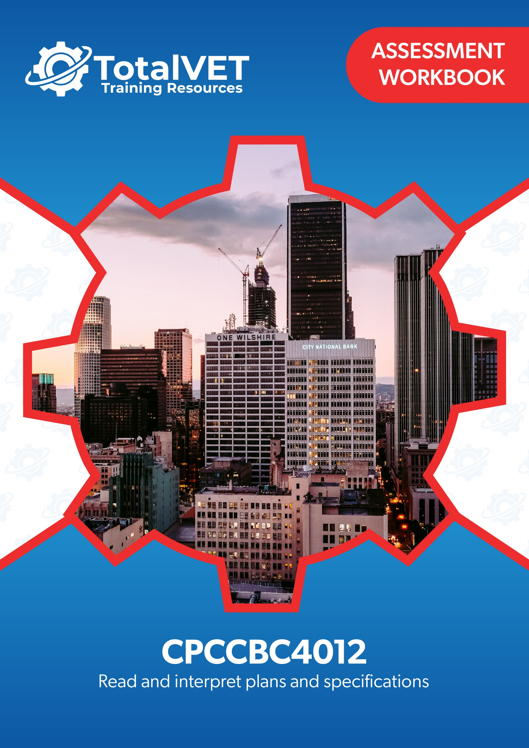
Copyright
This document was developed by TotalVET Training Resources.
© 2021 TotalVET Training Resources.
All rights reserved.
No part of this publication may be reproduced, stored in a retrieval system, or transmitted in any form or by any means, electronic, mechanical, photocopying, recording, or otherwise without the prior written permission of TotalVET Training Resources.

Version Control & Document History
Date | Summary of Modifications | Version
9 February 2021 | Version 1.0 released for publishing | 1.0
28 October 2022 | Revision of Practical Assignment, Workplace Assessment and Practical Plans Assignment | 1.1

Table of Contents
Table of Contents 3
Introduction 5
Competency-Based Assessments 6
Assessing Nationally-Recognised Training 7
Dimensions of Competency 8
Reasonable Adjustment 9
The Unit of Competency 10
The Context of Assessment 10
Assessment Methods 11
Resources Required for Assessment 12
Assessment Workbook Cover Sheet 13
Knowledge Assessment 14
Practical Assessment 34
Candidate Instructions 34
Preliminary Assessment Information 35
Practical Assignment 36
Overview 36
Workplace Assessment 40
Overview 40
Task 1 Confirm Currency of Plans, Specifications, and Amendments 41
Task 2 Confirm Details on Plans Comply with the Specifications 43
Task 3 Examine Detail Drawings to Determine Sizes and Thickness 47
Task 4 Discuss Details During the Planning Phase 49
Practical Plans Assignment 51
Overview 51
Task 1 Types of Plans and Aspects 53
Task 2 Construction Plans 56
Task 3 Materials from Specifications 60
Task 4 Concrete Footing and Slab 61
Task 5 Load Bearing Points 62
Task 6 Load Bearing Information 64
Task 7 Wind Bracing and Tie-Down Requirements 65
Task 8 Wind Bracing Materials and Tie-Down Methods 66
Task 9 Provisional Sum and Prime Cost Items 67
Task 10 Installation and Connection Points of Services 68
Task 11 Location of Fixtures 71
Task 12 Details of Finishes 73
Assessment Workbook Checklist 74
Record of Assessment (Assessor’s Use Only) 78

Introduction
The assessments in this workbook are divided into three categories: Knowledge Assessment and Practical Assessment.
The Knowledge Assessment is a set of general and workplace questions testing your knowledge and understanding of the general theory behind the unit.
You must answer all Knowledge Assessment Questions using your own words. However, you may refer to your Learner Guide and other relevant resources and learning materials to complete this assessment.
Some questions cover processes you would likely encounter in a workplace. Ideally, you should be able to answer these questions based on the processes that are currently in place in your workplace. However, if you do not currently have access to a workplace, then answer the questions based on processes that should be implemented in a typical workplace setting.
The Practical Assessment is made up of the Practical Assignment, Workplace Assessment, and Practical Plans Assignment. This assessment tests your practical skills with respect to the requirements of the unit of competency relevant in this workbook.
The Practical Assessment requires you to complete and submit workplace documents and other documentation relevant to the unit of competency.
The evidence you submit must be your own work except where due reference is made and where you are required to submit supplementary workplace documents such as policies and procedures.
When completing the assessments included in this workbook:
- Read the instructions provided in each task carefully before attempting to complete the task. The instructions will guide you on how to answer the question or complete the task satisfactorily.
- Follow the steps provided in each task.
  - If the question instructs you to describe, provide a description as your response. If the question instructs you to list, provide a list as your response.
  - Where there is a number of required responses, provide the required number of responses. For example, if you are asked to list three responses, provide three responses.
- Ensure that all your submissions for this assessment indicate your first and last name and that these submissions have been named according to the file naming convention prescribed in each task.

Competency-Based Assessments
Definition of Competency
Assessment in this context can be defined as the fair, valid, reliable, and flexible gathering and recording of evidence to support the judgement on whether competency has been achieved. Skills and knowledge (developed in a structured learning situation, at work, or in some other context) are assessed against national standards of competence required by industry, rather than compared with the skills and knowledge of other candidates.

The features of a competency-based assessment system are:
- It is focused on what candidates can do and whether it meets the criteria specified by the industry as competency standards.
- Assessment should mirror the environment the candidate will encounter in the workplace.
- Assessment criteria should be clearly stated to the candidate at the beginning of the learning process.
- Assessment should be holistic. That is, it aims to assess as many elements and/or units of competency as is feasible at one time.
- In competency assessment, a candidate receives one of only two outcomes – ‘competent’ or ‘not yet competent.’
- The basis of assessment is in applying knowledge for some purpose. In a competency system, knowledge for the sake of knowledge is seen to be ineffectual unless it assists a person in performing a task to the level required in the workplace.
- The emphasis in assessment is on assessable outcomes that are clearly stated for the trainer and candidate. Assessable outcomes are tied to the relevant industry competency standards where these exist. Where such competencies do not exist, the outcomes are based upon those identified in a training needs analysis.

Assessing Nationally-Recognised Training
Developing and conducting assessment, in an Australian Vocational Education and Training (VET) context, is founded on the Principles of Assessment and the Rules of Evidence:
Principles of Assessment
- Assessment must be valid
  - Assessment must include the full range of skills and knowledge needed to demonstrate competency.
  - Assessment must include the combination of knowledge and skills with their practical application.
  - Assessment, where possible, must include judgements based on evidence drawn from a number of occasions and across a number of contexts.
- Assessment must be reliable
  - Assessment must be reliable and must be regularly reviewed to ensure that assessors are making decisions in a consistent manner.
  - Assessors must be trained in national competency standards for assessors to ensure reliability.
- Assessment must be flexible
  - Assessment, where possible, must cover both the on- and off-the-job components of training within a course.
  - Assessment must provide for the recognition of knowledge, skills, and attitudes regardless of how they have been acquired.
  - Assessment must be made accessible to candidates through a variety of delivery modes, so they can proceed through modularised training packages to gain competencies.
  - Assessment must be mutually developed and agreed upon between assessor and the assessed.
  - Assessment must be able to be challenged. Appropriate mechanisms must be made for reassessment as a result of challenge.
- Assessment must be fair
  - Assessment process must consider the individual needs of the candidate.
  - Assessment must provide for reasonable adjustments, where appropriate, to consider the individual candidate’s needs.
(Source: Standards for RTOs 2015, Clauses 1.8 – 1.12)

Rules of Evidence
When collecting evidence, certain rules apply to that evidence. All evidence must be valid, sufficient, authentic, and current:
- Valid
Evidence gathered should meet the requirements of the unit of competency. This evidence should match, or at least reflect, the type of performance that is to be assessed, whether it covers knowledge, skills, or attitudes.
- Sufficient
This rule relates to the amount of evidence gathered. Enough evidence must be gathered to satisfy the requirements that the candidate be competent in all aspects of the unit of competency.
- Authentic
When evidence is gathered, the assessor must be satisfied that evidence is the candidate’s own work.
- Current
This relates to the recency of the evidence and whether the evidence relates to current abilities.
(Source: Training in Australia by M Tovey, D Lawlor)

Dimensions of Competency
The national concept of competency includes all aspects of work performance and not only narrow task skills. The four dimensions of competency are:
- Task skills
- Task management skills
- Contingency management skills
- Job or role environment skills

Reasonable Adjustment
‘Reasonable adjustment’ in VET is the term applied to modifying the learning environment or making changes to the training delivered to assist a candidate with a disability. A reasonable adjustment can be as simple as changing classrooms to be closer to amenities or installing a particular type of software on a computer for a person with vision impairment.
Why make a reasonable adjustment?
We make reasonable adjustments in VET to make sure that candidates with a disability have:
- The same learning opportunities as candidates without a disability, and
- The same opportunity to perform and complete assessments as those without a disability.
Reasonable adjustment applied to participation in teaching, learning, and assessment activities can include:
- Customising resources and assessment activities within the training package or accredited course
- Modifying the presentation medium
- Learner support
- Use of assistive/adaptive technologies
- Making information accessible both before enrolment and during the course
- Monitoring the adjustments to ensure candidate needs continue to be met
Assistive/Adaptive Technologies
Assistive/Adaptive technology means ‘software or hardware that has been specifically designed to assist people with disabilities in carrying out daily activities’ (World Wide Web Consortium - W3C). It includes screen readers, magnifiers, voice recognition software, alternative keyboards, devices for grasping, visual alert systems, digital note-takers.
(Adapted Reasonable Adjustment in teaching, learning and assessment for learners with a disability - November 2010 - Prepared by - Queensland VET Development Centre)
IMPORTANT:
Reasonable adjustment made for collecting candidate assessment evidence must not impact on the standard expected by the workplace, as expressed by the relevant unit(s) of competency. For example, if the assessment were gathering evidence of the candidate’s competency in writing, allowing the candidate to complete the assessment verbally would not be a valid assessment method. The method of assessment used by any reasonable adjustment must still meet the competency requirements.

The Unit of Competency
The units of competency specify the standards of performance required in the workplace.
This assessment addresses the following unit of competency:
CPCCBC4012 – Read and interpret plans and specifications (Release 1.0)
- Identify types of plans
- Read and interpret the plan
- Identify structural details
- Identify non-structural details
A complete copy of the above unit of competency can be downloaded from the TGA website:
https://training.gov.au/Training/Details/CPCCBC4012

The Context of Assessment
To complete the assessments in this workbook, students need to have access to their learning materials and the Internet. The Knowledge Assessment may be completed wholly at the candidate’s home or chosen place of study. The Practical Assessment must be completed in a workplace or a simulated environment.

Assessment Methods
This workbook uses the following assessment method/s:
- Knowledge Assessment
A set of general and workplace questions testing the candidate’s general knowledge and understanding of the general theory behind the unit.
- Practical Assignment
A series of written practical tests assessing the candidate’s practical knowledge and understanding of the unit of competency.
- Workplace Assessment
A set of tasks or activities completed according to set instructions and guidelines to meet the requirements of the relevant unit. These tasks and activities require you to have access to a workplace or a similar environment.
- Practical Plans Assignment
A series of assessment tasks testing the candidate’s practical knowledge and understanding of the unit of competency. The candidate needs to provide their responses to these assessment tasks, sometimes working with an appropriately experienced person in your workplace.

Resources Required for Assessment
The Training Organisation to provide/organise candidate with access to:
- Assessor to supervise and observe candidate as they complete assessments, where required.
- Workplace, or a similar environment, where the candidate can complete the assessments, and that will allow them access to:
  - Building and construction project
  - Relevant construction personnel whom the candidate will be verifying details on the construction plans and specifications with.
  - Construction plans
  - Construction specifications
  - Detail drawings
  - Documentation templates, including:
    - Construction Plan Details Verification Checklist
    - Material Quantity Takeoff Form
  - Relevant government building and construction and contract legislation
  - Current building and construction codes and standards
  - The National Construction Code (NCC)
  - Computers, applications and software to access CAD.

The candidate will need access to:
- Computer with Internet, email access, and a working web browser
- Installed software: MS Word, Adobe Acrobat Reader

Assessment Workbook Cover Sheet
To the candidate: Print this cover sheet and complete it by filling in all the required information and signing in the space provided. Your signature must be handwritten. Scan the completed cover sheet and submit it along with your evidence submissions. Use the filename: CPCCBC4012 Cover Sheet
Workbook | CPCCBC4012
Title | Read and interpret plans and specifications (Release 1.0)
First and Last Name | Carla Crawford
Phone | 0406 06 0428
Email | Info@mcphersonconstructions.com

Please read the Candidate Declaration below and if you agree to the terms of the declaration, sign and indicate the date in the spaces provided.
By submitting this work, I declare that:
- I have been advised of the assessment requirements, have been made aware of my rights and responsibilities as an assessment candidate, and choose to be assessed at this time.
- I am aware that there is a limit to the number of submissions that I can make for each assessment, and I am submitting all documents required to complete this Assessment Workbook.
- I have organised and named the files I am submitting according to the instructions provided. I am aware that my assessor will not assess work that cannot be identified and may request the work be resubmitted according to the correct process.
- This work is my own and contains no material written by another person except where due reference is made. I am aware that a false declaration may lead to the withdrawal of qualification or statement of attainment.
- I am aware that there is a policy of checking the validity of qualifications that I submit as evidence as well as the qualifications/evidence of parties who verify my performance or observable skills. I give my consent to contact these parties for verification purposes.
Name: Carla Crawford | Signature: | Date signed:

Knowledge Assessment
- Answer the following questions about concept drawing/sketches.
- What is the significance of concept drawing/sketches?
Concept drawing is the first step to a project. A concept drawing shows the initial thoughts, design or ideas, which can then be built upon as the design process progresses. Concept drawings and sketches are often free hand.
- What are sketch plans?
Sketch plans are the next step up from concept drawings. Usually to scale and with more detail than a concept drawing.
- How do you create presentation drawings?
Presentation drawings are usually created using computer software, as they are scaled, detailed, and show different aspects.

- Answer the following questions about architectural plans.
- What is an architectural plan?
Architectural plans are usually a set of drawings, used to convey the details of a building project for clients, contractors and approvals. They are drawn to scale and include a lot of information on the project from multiple perspectives.
- List down four details contained in an architectural plan.
- Site plan
- Floor plan
- Elevations
- Sections

- Answer the following questions about structural plans.
- What is a structural plan?
Structural plans are prepared by Structural Engineers and include technical information and specification relating to the structural aspect of the project, including footings, slabs and framing.

- How is a structural plan different from an architectural plan?
Architectural plans are prepared by Licenced Architects and are mostly focussed on the look and layout of a building. Structural plans are prepared by Engineers and are not about how the building looks, but its structural integrity and strength.

- List four details that can be found in a structural plan.
- Footing Plan
- Slab Plan
- Sections
- Materials

- Answer the following questions about civil plans.
- What is a civil plan?
Civil plans are related to the project site. They include earthworks, drainage, sewer, water and landscape contours.
- List two details contained in a civil plan that can be found in an architectural plan.
- Land contours
- Services points
- List two details contained in a civil plan that can be found in a structural plan.
- Footings
- Building footprint

- Answer the following questions about mechanical plans.
- What is a mechanical plan?
Mechanical plans provide the layout and specification of mechanical related equipment, including heating, cooling, ventilation, etc.
- List down two types of equipment included in a mechanical plan.
- Air conditioning
- Lift
- List down three details that are included in a mechanical plan.
- Size, type and layout of ducting
- HVAC layout
- Thermostat type and location

- Answer the following questions about electrical plans.
- What is an electrical plan?
Electrical plans outline the electrical aspect of a build, including wiring, lighting, circuits, power, switches, GPOs and communication. Relied on by project electricians and used as reference for other trades.
- List down three details contained in an electrical plan.
- Wiring layout
- Light locations
- GPO & switch locations

- Answer the following questions about plumbing and drainage plans.
- What is a plumbing and drainage plan?
Drawings that show the details of the hydraulic aspect of a project, including water, drainage, hot water, sewer, and plumbing fixtures.

- What is the purpose of a plumbing and drainage plan?
Provide information to the plumber and other trades relating to the size and location of water pipes, plumbing fittings, hot water systems, etc.

- What are the two primary concerns addressed by a plumbing and drainage plan?
- Water supply system
- Drainage system
- List down two details contained in a plumbing and drainage plan that are related to water supply system.
- Size and layout of pipes
- Pump capacity
- List down two details contained in a plumbing and drainage plan that are related to drainage system.
- Location of sanitary fixtures
- Slope of drainage pipes

- Answer the following questions about parts of a plan.
- What is a site plan?
An overview plan of the project site from a top view, at a smaller scale.
- List five key features of a site plan.
- Boundaries
- Roads
- Building Location
- Easements
- Contours
- What is a floor plan?
A top view plan showing the proposed layout of a building, including walls, doors, windows, etc.
- What information can be acquired from a floor plan? List five.
- Layout of walls
- Number of doors and windows
- Location and width of stairs
- Proposed furniture layout
- Location of appliances
- What are two key differences between elevation view and section view?
- Elevations show the building from the outside (multiple perspectives)
- Sections show an interior cross section of the building at multiple points
- List three types of information that can be found in an elevation view.
- Heights
- External finishes
- Building orientation
- List three types of information that can be found in a section view.
- Interior heights
- Interior finishes
- Locations of doors and windows
- What is the purpose of detail views?
Larger scale drawings of a particular component of the project to show additional construction detail.

- Answer the following questions about datum and reduced levels (RL).
- What is the purpose of a datum in construction?
A reference point (physical or non-physical) that can then be used as a basis for all vertical levels.
- List two ways of how datum can be established in construction drawings.
- Setting the datum at Ground Floor (RLs can be positive or negative)
- Setting the datum at the lowest part of the building (all RLs are positive)
- What are reduced levels (RL)?
Positive (above) or negative (below) vertical measurements from the datum
- List two ways of establishing reduced levels in construction drawings.
- Using positive or negative symbols in front of the number to dictate if it is above or below the datum
- Stating that the measurement is above or below the datum

- Answer the following questions about title blocks.
- What is a title block?
A section of the plan which references the general information about the plans (ie. project name and client) and identifies the particular drawing in the set (ie. number and description)
- Where is a title block usually located?
Usually across the bottom of the drawing sheet.
- List five types of information that can be obtained from the title block.
- Project name
- Project reference number
- Client
- Who prepared the plan
- Plan revision

- Answer the following questions about scale and dimension drawing conventions.
- What are scale drawings used for?
Scale drawings show an accurate representation of a building, its components are how they relate to each other. They are also used to take true measurements.
- Describe each ratio of standard scale ranges below.
Ratio | Description
- 1:100 | The real size is 100 times bigger than on the plan.
- 1:2 | The real size is twice as big as on the plan.
- 1:1000 | The real size is 1000 times bigger than on the plan.
- 1:50 | The real size is 50 times bigger than on the plan.

- What is the importance of dimensions in construction drawings?
To determine the size of an object, including length, width and height.

- What system of measurement is used for dimensions in Australian construction drawings?
Metric system (metres and millimetres)

- List three ways of how dimensions can be displayed in construction drawings.
- Decimal points, comma or space.
- Dimension terminators
- Length x width x height

- Listed below are the different types of plans. Identify the corresponding terminologies used and the equivalent abbreviation for the type of plan indicated.
Type of Plan | Building and construction terminology | Abbreviation
- Architectural | Downpipe | DP
- Architectural | Plasterboard | PB
- Structural | Wall Tie | WT
- Structural | Rectangular Hollow Section | RHS
- Mechanical | Air Conditioning Unit | ACU
- Mechanical | Fan Coil Unit | FCU
- Electrical | Main Switch Board | MSB
- Electrical | General Power Outlet | GPO
- Plumbing and drainage | Water Closet | WC
- Plumbing and drainage | Polyvinylchloride Pipes | PVC PIPES

- Answer the following questions about utilities and services plans and specifications.
- What is the difference between a utilities plan and a services plan in the context of building construction?
Utility plans relate to the supply of electricity, water, gas sewerage, etc. Services plans relate to systems including lighting, security and alarms.
- What is the importance of utilities specifications?
It provides more information on the utilities than can be provided on the drawing, designed to be referenced in conjunction with the plans.
- What is the importance of services specifications?
Provides more detailed information in relation to the services that can not be shown on the drawings.

- Describe the aspects of drawings provided below.
Aspects of Drawings | Description
- Isometric drawings | A 3D drawing of an object, on a 2D surface.  Same scale used for all axes.
- Oblique drawings | A 2D drawing of a 3D object.  Front side of the object is a true depiction, at scale.  Third axis can be at a suitable angle.
- Perspective drawings | A 3D drawing showing a realistic view of a building from a particular perspective.
- Orthographic drawings | A 2D drawing of a 3D object, shown from multiple perspectives. eg. top view, side view, front view, etc.

- Answer the following questions about CAD drawings.
- What does CAD stands for?
Computer Aided Design

- What are CAD drawings?
Drawings that are created and modified on a computer using speciality software, that allow detail and accuracy. Can be 2 dimensional or 3 dimensional.

- How is CAD used in building and construction?
CAD drawings are used by Architects and Engineers to produce detailed project drawings. CAD drawings have replaced hand drawn building plans, due to their ability and efficiency in creating and modifying building plans.

- Provide a brief description of the given classes of buildings according to the National Construction Code.
Building Class | Description
- Class 1a building | A residential building – a detached house, or one of a group of attached dwellings, ie. townhouse
- Class 1b building | One of more buildings, such as a boarding house, or a hostel, with a floor area less than 300m2 accommodating less than 12 people, or 4 or more single dwellings in one allotment, used for short term holiday accommodation.
- Class 2 building | Residential apartment buildings with 2 or more sole occupancy units where people live above, beside and below each other.
- Class 3 building | Residential building that doesn’t fall into Class 1 or Class 2. Commonly long term / transient living for unrelated people, eg. Boarding house or hostel larger than limits of Class 1b, workers accommodation, etc.
- Class 4 building | A residence within a non residential building (Class 5-9).  eg. caretakers residence in a hospital
- Class 5 building | Office buildings – professional or commercial (excluding Class 6-9).  eg. Government office, accountant, lawyers
- Class 6 building | Commercial places for the sale of retail goods or services direct to the public.  eg. Shops, restaurants, cafes, hairdressers, etc.
Building Class | Description
- Class 7a building | Carparks
- Class 7b building | Warehouses & storage buildings
- Class 8 building | Buildings used for production, assembling, packing, repairing, or cleaning of goods.  eg. Factories, workshops, laboratories
- Class 9a building | Public building – Healthcare  eg. hospitals / day clinics
- Class 9b building | Public building – Social, religious or educational  eg. churches, schools, universities, sports clubs
- Class 9c building | Public building – Aged care facilities  Eg. nursing home
- Class 10a building | Not habitable building / structure –  Garage, carport, shed, etc

Building Class | Description
- Class 10b building | Not habitable building / structure –  Fence, retaining wall, pool, etc
- Class 10c building | Not habitable building / structure –  Bushfire shelter

- The Building Code of Australia is divided into three volumes. Briefly describe the scope of each volume.
Volume | Description
- Volume One | Covers technical design and construction requirements for Class 2 – 9 Buildings
- Volume Two | Covers technical design and construction requirements for Class 1 & 10 Buildings
- Volume Three | Covers technical design and construction requirements for Plumbing & Drainage in new and existing buildings

- Explain how the Building Code of Australia is relevant to construction drawings.
The Building Code of Australia sets minimum required standards for design and construction relating to a buildings safety, integrity, sustainability and functionality.

- Answer the following questions about NCC requirements.
- Explain what the General Requirements of buildings are.
A guide for complying with and applying the NCC requirements.
- Explain what the Performance Requirements of buildings are.
Outline a minimum level of performance for buildings and plumbing/drainage.
- Explain the relationship between a building’s Performance Requirements and compliance options (e.g. performance solutions, deemed-to-satisfy solutions).
Building performance requirements can be met by either a performance solution, which directly complies with the requirement; or a deemed to satisfy solution which is a verified alternative.

- Answer the following questions about standards applicable to building and construction projects.
- Explain the importance of complying with standards during a building and construction project.
To ensure the building meets the minimum thresholds for safety, functionality, integrity and sustainability, as well as passes assessment.

- List two current standards relevant to the specification and interpretation of engineering drawings.
- AS 1100.101-1992 – Technical Drawing - general principles
- AS ISO 128.20-2005 – Technical Drawing – general principles of presentation

- Specify your state/territory, and:
  - Identify three building and construction regulations that apply in your state/territory.
  - Summarise the regulatory requirements relevant to building drawings and sketches under each regulation you identified.
  - Provide a URL where you sourced your responses.
State/territory | Queensland

Regulations | Regulatory requirements | URL/Source
Building  Regulation  2021 | A 1:100 scale drawing of the building or structure showing floor plans and elevations. | https://www.legislation.qld.gov.au/view/pdf/inforce/current/sl-2021-0126
Building  Regulation  2021 | A site plan of a scale enabling the local government to provide water supply, sewerage and stormwater drainage for the land on which the building work is to be carried out. | https://www.legislation.qld.gov.au/view/pdf/inforce/current/sl-2021-0126
Queensland  Development  Code | Buildings to provide adequate daylight and ventilation to habitable rooms  Buildings to meet side, rear, and front setbacks as per tables in QDC.  Adequate open space is provided for recreation and landscaping.  Sufficient space for onsite carparking. | https://www.epw.qld.gov.au/__data/assets/pdf_file/0010/4303/mp1-1.pdf

- Answer the following questions about building information modelling (BIM).
- What is building information and modelling (BIM)?
A collaborative planning and design process to create a digital visual 3D representation of a building and its elements.
- What is BIM used for?
Used to create 3D designs for analysis and review by clients, engineers and contractors. Can bring to light any problems and allow for these to be resolved prior to construction.

- Listed in the table below are common building and construction methods you usually encounter when reading and interpreting plans. Briefly describe each method.
Building and construction methods | Description
- Paintworks | Relating to the painting and coating of materials for aesthetic and/or protective purposes
- Tilework | Relating to tiling, blockwork, brickwork, and other masonry.
- Steelworks | Relating to the construction of steel building elements and reinforcing, incl. structural steel, reinforcing steel, tie downs, welding, etc.
- Concrete works | Relating to construction of concrete building elements, incl concrete pouring, formwork, etc.

Practical Assessment

Candidate Instructions
The Practical Assessment is a set of tasks that must be completed in a workplace, or in an environment with conditions similar to that of a real workplace.
This assessment will help you demonstrate skill requirements relevant to reading and interpreting plans and specifications.
The Practical Assessment includes the following:
- Practical Assignment
A series of written practical tests assessing the candidate’s practical knowledge and understanding of the unit of competency.
- Workplace Assessment
A set of tasks or activities completed according to set instructions and guidelines to meet the requirements of the relevant unit. These tasks and activities require you to have access to a workplace or a similar environment.
- Practical Plans Assignment
A series of assessment tasks testing the candidate’s practical knowledge and understanding of the unit of competency. The candidate needs to provide their responses to these assessment tasks, sometimes working with an appropriately experienced person in your workplace.

Preliminary Assessment Information
The tasks in this practical assessment must be completed in a workplace (or a similar environment) and in the context of a building and construction project which you are currently a part of.
E.g. You are a builder, a site manager in training, foreperson, or an apprentice in this project, etc.
Before starting the practical assessment, record the following information for your assessor’s reference.
When completing the tasks in this practical assessment ensure that your responses and performance must align with the information you have provided below.
For example (but not limited to):
- If the task asks you to refer to building and construction legislation and regulatory requirements, refer to the requirements that apply to the state/territory where your nominated building and construction project is undertaken.
- If the task requires you to follow organisational policies and procedures, refer to the policies and procedures in your nominated organisation/workplace.
Work role/title | Project Administrator
Organisation/workplace | McPherson Constructions
Building and construction project | 42 Pelican Street, Peregian Beach
Project overview | New architectural home
Building classification | 1A
Project site address | 42 Pelican Street, Peregian Beach
State/territory where this project is being undertaken | Queensland

Practical Assignment

Overview
The goal of this assessment is to assess your practical knowledge of:
- Workplace safety requirements
- Workplace processes
- Environmental requirements
This assessment has three tasks:
- Task 1 – Workplace Safety Requirements
- Task 2 – Workplace Processes
- Task 3 – Environmental Requirements
This task must be completed in the context of the workplace you have nominated in the “Preliminary Assessment Information” section.
You are required to:
- Review your workplace’s safety requirements relevant to safety when preparing for building and construction
- Review and briefly explain your workplace’s processes for accessing the latest copies of building construction plans
- Review the task instructions included in this Practical Assignment.
- Record your response as required in the instructions.
Resources required for assessment
- Workplace documents:
  - Workplace safety requirements in planning building and construction

- Review your workplace’s safety requirements relevant to building and construction and answer the following questions.
- List three (3) local and/or state/territory safety requirements that your workplace must meet to conduct building and construction work.
- All workers and visitors to wear required PPE
- Display site safety signs
- Organise and store tools properly
- Explain your workplace’s processes when plans outline tasks that require high risk work (e.g. scaffolding, rigging etc.)
Identify the high risk work and note any related hazards and associated risks.
Prepare relevant Safe Work Method Statements describing measures to be implemented to control the risks.
Ensure all workers have reviewed and signed off on the SWMS.
Work is stopped if not carried out in accordance with the SWMS.
Ensure work site is secure from unauthorised access.

- Review your workplace’s processes for implementing building construction plans and answer the following questions.
- What types of building construction documents does your workplace implement?
Architectural plans
Architectural specifications
Structural drawings
Building approvals
Site safety management plan
Safe work method statements
Hazardous material checklists
Toolbox meeting records
- Summarise below your workplace’s processes for receiving and confirming building construction plans, including drawings and sketches.
New plans and revisions received are logged into a plan register.
Electronic drawings are replaced, and any previous versions superseded.
Hardcopy plans are printed and replaced in any hardcopy sets in circulation.

- List three (3) local and or state/territory environmental requirements that your workplace must meet to conduct building and construction work.
- Contamination control
- Noise reduction
- Waste management

Workplace Assessment

Overview
The goal of this assessment is to assess your practical knowledge and skills in:
- Identifying types of plans
- Reading and interpreting the plan
This workplace assessment is made up of five workplace tasks:
Task 1 – Confirm Currency of Plans, Specifications, and Amendments
Task 2 – Confirm Details on Plans Comply with the Specifications
Task 3 – Examine Detail Drawings to Determine Sizes and Thickness
Task 4 – Discuss Details During the Planning Phase
You are required to:
- Review the instructions in each task.
- Identify types of plans.
- Read and interpret the plan.
- Perform the workplace task according to the instructions provided
- Complete and submit any required documentation.
Resources required for assessment:
To complete this assessment, you will need access to the following:
- A workplace or a similar environment that will allow you access to:
  - Building and construction project
  - Relevant construction personnel whom the candidate will be verifying details on the construction plans and specifications with.
  - Construction plans
  - Construction specifications
  - Detail drawings
  - Relevant government building and construction and contract legislation
  - Current building and construction codes and standards
  - The National Construction Code (NCC)
  - Computers, applications and software to access CAD.

Task 1 Confirm Currency of Plans, Specifications, and Amendments
Through an email confirmation with relevant construction personnel, confirm the currency of plans, specifications and amendments. The construction personnel to be consulted with must have suitable experience (e.g. supervisor):
You will be assessed on:
- Practical knowledge of building and construction plans
- Practical skills in confirming the currency of plans, specifications and amendments with relevant construction personnel
Before starting this task, review the Workplace Assessment Task 1 – Assessor Checklist provided along with this workbook. This form lists all the practical skills you need to demonstrate while completing this task.
After completing this task, submit the following to your assessor:
- Email evidence of your discussion with relevant construction personnel

Insert email screenshot below
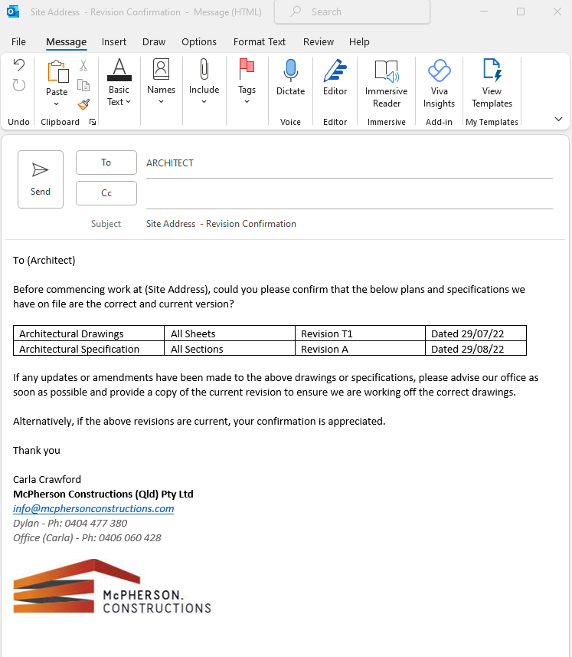

Task 2 Confirm Details on Plans Comply with the Specifications
Use Construction Plan Details Verification Checklist below to verify whether details on the construction plans comply with the specifications.
You will be assessed on:
- Practical knowledge of building and construction plans and specifications
- Practical skills in confirming the compliance of the details specified in construction plans with the construction specifications
Before starting this task, review the Workplace Assessment Task 2 – Assessor’s Checklist provided along with this workbook. This form lists the criteria your Construction Plan Details Verification Checklist submission must address to complete this task satisfactorily.
After completing this task, submit the following to your assessor:
- Three (3) examples of how the plans refer to and confirm the specifications.

Example 1
Provide excerpt (screenshot) of plans | 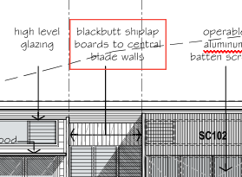
Provide excerpt (screenshot) of specifications | 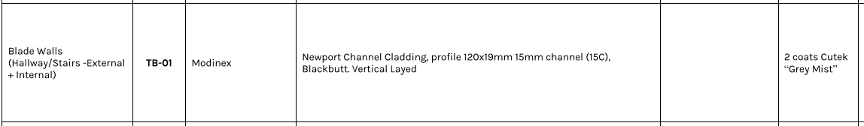
Confirm that plans comply with specifications | YES  NO (Explain why): Blackbutt cladding is Newport Channel, not Shiplap

Example 2
Provide excerpt (screenshot) of plans | 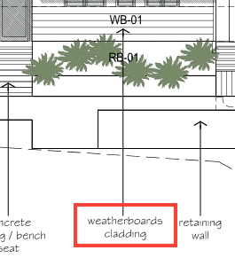
Provide excerpt (screenshot) of specifications | 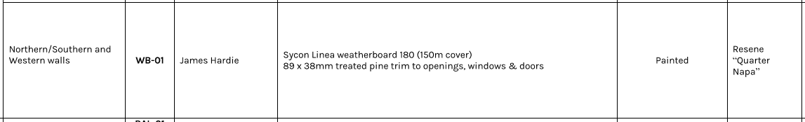
Confirm that plans comply with specifications | YES  NO (Explain why):

Example 3
Provide excerpt (screenshot) of plans | 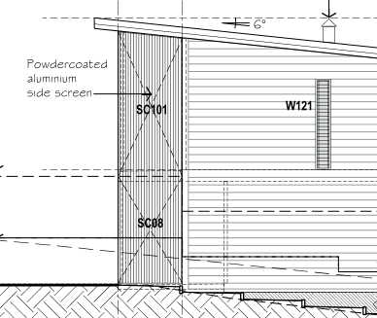
Provide excerpt (screenshot) of specifications
Confirm that plans comply with specifications | YES  NO (Explain why):

Task 3 Examine Detail Drawings to Determine Sizes and Thickness
Record the sizes, thickness, and quantity of the three (3) different materials listed on the detail drawings used on the building and construction project.
You will be assessed on:
- Practical knowledge of the sizes, thickness and quantity of construction items
- Practical skills in examining detail drawings to determine sizes and thickness
- Practical skills in interpreting two-dimensional and three-dimensional drawings and applying to estimation
Before starting this task, review the Workplace Assessment Task 3 – Assessor’s Checklist provided along with this workbook. This form lists the criteria your Material Quantity Takeoff Form submission must address to complete this task satisfactorily.
After completing this task, submit the following to your assessor:
- Completed Material Quantity Takeoff Form
- Detail drawings you used as basis in determining the sizes, thickness and quantity of materials

Material Quantity Takeoff Form

Completed by | Carla Crawford
Date completed | 8/12/22

Items | Size |  | Thickness (mm) | Quantity (pcs)
Items | Length(mm) | Width (mm) | Thickness (mm) | Quantity (pcs)
1. Powdercoated Steel Plate Stringer with Welded Plate Supports x 18 | 1800 | 250 | 20 | 2
2. Blackbutt Timber Treads | 900 | 320 | 65 | 9
3. Blackbutt Edge Strip | 900 | 100 | 75 | 1

Task 4 Discuss Details During the Planning Phase
In the role of a supervisor, email the details of your estimates from Workplace Assessment Task 3 to subordinate construction personnel to order materials.
You will be assessed on:
- Practical knowledge of two-dimensional and three-dimensional drawings
- Practical skills in interpreting two-dimensional and three-dimensional drawings and applying to planning
Before starting this task, review the Workplace Assessment Task 4 – Assessor Checklist provided along with this workbook. This form lists all the practical skills you need to demonstrate while completing this task.
After completing this task, submit the following to your assessor:
- Email to those requiring your direction with regards to ordering materials

Insert email screenshot below
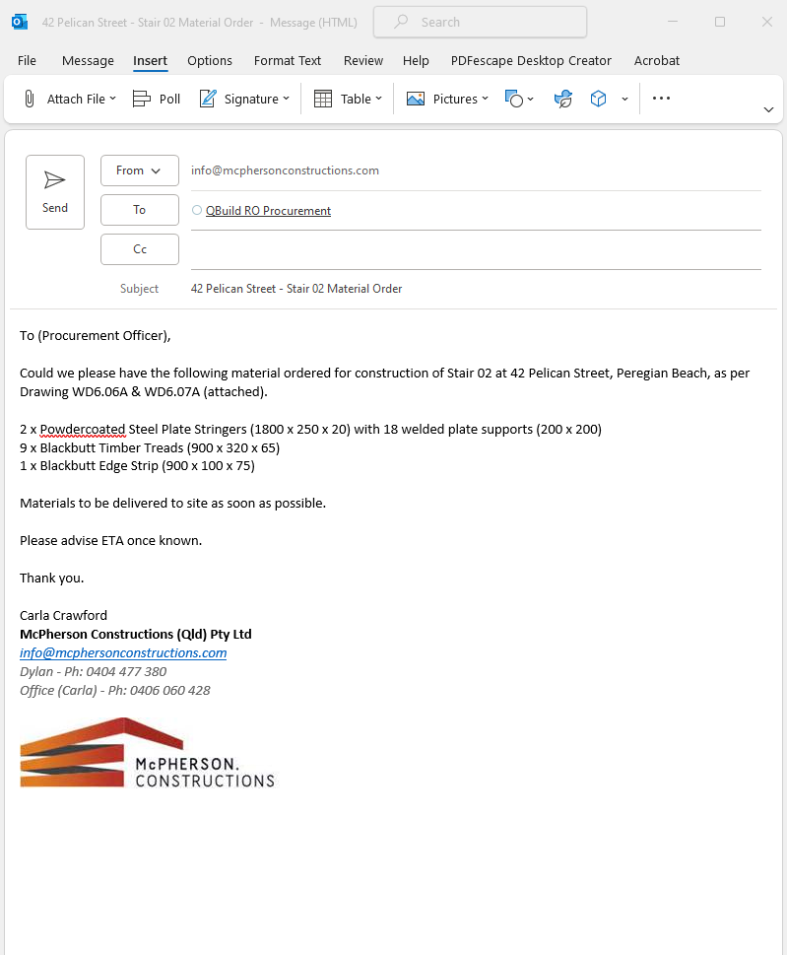

Practical Plans Assignment

Overview
The goal of this assessment is to assess your practical knowledge and skills in:
- Identifying types of plans
- Reading and interpreting plans
- Identifying structural details
- Identifying non-structural details
This assessment is divided into 12 assessment tasks.
Task 1 – Types of Plans and Aspects
Task 2 – Construction Plans
Task 3 – Materials from Specifications
Task 4 – Concrete Footing and Slab
Task 5 – Load Bearing Points
Task 6 – Load Bearing Information
Task 7 – Wind Bracing and Tie-Down Requirements
Task 8 – Wind Bracing Materials and Tie-Down Methods
Task 9 – Provisional Sum and Prime Cost Items
Task 10 – Installation and Connection Points of Services
Task 11 – Location of Fixtures
Task 12 – Details of Finishes
The assessment items included in this assessment will require you to demonstrate your knowledge and skills relevant to reading and interpreting plans.
You will record your responses in this workbook when completing the assessments.
Resources required for assessment:
To complete this assessment, you will need access to the following:
- Construction plans, including:
  - Site plan
  - Floor plan
  - Detail drawings
  - Structural drawings
- Construction specifications
- Wind bracing table
- Construction contract

Task 1 Types of Plans and Aspects
Provide examples of three (3) of the listed types of construction plans and briefly identify what they contain.
Record your responses in the spaces provided in each item.
You will be assessed on:
- Practical knowledge of the types of plans and aspects of drawings
- Practical skills in identifying the types of plans and aspects of drawings specific for the intended purpose

- Provide examples of three (3) of the listed types of construction plans and briefly explain their purpose:
  - Concept drawing/sketches
  - Architectural plans
  - Structural plans
  - Civil plans
  - Mechanical plans
  - Electrical plans
  - Plumbing and drainage plans

Type of Plan |  | Purpose
1 | Architectural  File Name: 42P Architectural Drawings | Has all the information relating to the design and layout of the build, as well as finishes, fittings and fixtures - to be read in conjunction with the Architectural Specification.
2 | Structural  File Name: 42P Structural Drawings | Provides layout, construction details and materials for the structural aspects of the build.
3 | Plumbing & Drainage  File Name: 42P Hydraulic Drawings | Provides all the information for the plumbing and drainage system. Including pipe layout, sizes, HWS location, location of plumbing fixtures, etc.

- Provide examples of three (3) of the listed aspects of drawings and briefly explain their purpose:
  - Site plan
  - Floor plan
  - Elevations
  - Sections
  - Details
  - Isometric drawings
  - Oblique drawings
  - Perspective drawings
  - Orthographic drawings

Aspects of Drawings |  | Purpose
1 | Floor Plan  42P Floor Plan | An overview of the ground floor, showing layout, walls, windows, doors, floor finishes, and approximate location of furniture and fixtures.
2 | Elevation  42P Elevation | An external view of the façade to show the design, arrangement and heights of the building and its aspects with references to the specification for the relevant finishes.
3 | Section  42P Section | An internal view of the building at a designated point to show the internal structure and design at that cut through point.

Task 2 Construction Plans
Review the construction plans for the project you are undertaking for this assessment.
You will be assessed on:
- Practical knowledge of the construction plans
- Practical skills in reading and interpreting the plans

- Identify one key feature for each of the plans you identified in Task 1:
Explain how each indicated key feature distinguishes the plan from other types of plans.

Type of Plan |  | Key Feature | How does this key feature distinguish the plan from the other types of plans?
1 | Architectural  Plan | Floor Plan | No other plan shows building layout, windows, doors, fixtures and floor finishes as per the architectural floor plan.
2 | Structural Plan | Footing Detail | Only plan to show detail, including size and materials of required footings to meet structural engineering requirements.
3 | Plumbing & Drainage | Pipe Layout | This plan shows where all of the pipes relating to water, drainage and sewer run throughout the building.

- Refer to an example of a site plan and outline the detail requested below. Ensure you supply the plan with your submission.

Questions | Candidate Responses
What is the address of the building project? | 42 Pelican Street, Peregian Beach
What is the block number of the land where the building is to be constructed? | Lot 174
What is the name of the road adjacent to the block of land? | Pelican Street
Based on the north point, describe the orientation of:
- The proposed building | East facing
- The road used to access the entrance of the property | Pelican Street
What is the elevation of the datum? | RL38.77
What are the elevations (reduced levels) of the site contours? | 29 - 38
Describe the contour of the land based on the site contour. | The land slopes evenly down towards the western end of the block

Questions | Candidate Responses
What are the site features to be removed? | NA
What are the site features to be retained? | Trees at western end of block

- Refer to an example of a floor plan and outline the detail requested below. Ensure you supply the plan with your submission.

Questions | Candidate Responses
Describe the shape of the layout of the building. | Mostly rectangular, with the south western corner cut back for external living area.
Identify all the building spaces in the floor plan and their corresponding dimensions. | Building Space: Garage  Dimensions: 7900mm x 6100mm
Building Space: Workshop
Dimensions: 4100mm x 2000mm
Building Space: Bed 3
Dimensions: 5750mm x 4180mm
Building Space: Office / Bed 4
Dimensions: 7890mm x 4180mm
Building Space:
Dimensions:
Building Space:
Dimensions:
- Refer to an example of a plan outlining details about internal linings, external cladding and roof materials and outline the detail requested below. Ensure you supply the plan with your submission.

Questions | Candidate Responses
What materials are used for the internal linings of the building? | Plasterboard Sheet (PB-01)
 | Timber Board Lining (TB-01)
What materials are used for the external cladding of the building? | Weatherboard (WB-01)
 | Rendered Blockwork (RB-01)
What are the different roof materials used in the building project? | Lysaght Kliplok Sheeting (RS-01)
 | Lysaght Smoothline 150 Concealed Gutter (EG-01)
 | Colourbond Flashings (FL-01)
 | PVC Downpipe (DP)

- Refer to an example of detail drawings and outline the detail requested below. Ensure you supply the drawings with your submission.

Stair treads to be 320mm wide x 65mm deep
Stair treads to have a vertical gap of 102mm
250mm x 20mm steel stringer flat plate, powdercoat finish
Timber plank stair treads to slide onto concealed steel plates, as shown
Tread to be plugged with matching timber

Task 3 Materials from Specifications
Refer to an example of specifications and outline the detail requested below. Ensure you supply the specifications with your submission.
You will be assessed on:
- Practical knowledge of the specifications document
- Practical skills in identifying materials from the specifications document

Questions | Candidate Responses
What materials are used for the internal linings of the building? | Plasterboard Sheet (PB-01)
 | Timber Board Lining (TB-01)
What materials are used for the external cladding of the building? | Weatherboard (WB-01)
 | Rendered Blockwork (RB-01)
What are the different roof materials used in the building project? |  | Lysaght Kliplok Sheeting (RS-01)
 |  | Lysaght Smoothline 150 Concealed Gutter (EG-01)
 |  | Colourbond Flashings (FL-01)
 |  | PVC Downpipe (DP)

Task 4 Concrete Footing and Slab
Refer to an example of plan addressing footings, slabs and reinforcing and outline the detail requested below. Ensure you supply the plan with your submission. Alternatively, refer to:
    - Practical Plans Assignment Task 4 Footing and Ground Floor Slab Plan – 1
    - Practical Plans Assignment Task 4 Footing and Ground Floor Slab Plan – 2

- Describe the position of one (1) footing and slab-on-ground in the plans.
- Identify the following:
  - Size of footing
  - Size of slab-on-ground
  - The type of reinforcing applied
You will be assessed on:
- Practical knowledge of concrete footing and slab sizes and position and type of reinforcing
- Practical skills in identifying the concrete footing and slab sizes and position and type of reinforcing

Footing
Position | Size | Type of reinforcing
Grid Reference P10 | 1000 x 1000 x 350 DP | N12-200

Slab-on-ground
Position | Size | Type of reinforcing
Warehouse | 125mm Thick | SL72 Mesh Top, 30 Cover

Task 5 Load Bearing Points
Refer to an example of a plan which identifies load bearing points (or columns). Alternatively, refer to Practical Plans Assignment Task 5.
Provide three (3) screenshots from the plans that identify load bearing points.
You will be assessed on:
- Practical knowledge of the load bearing points of the building
- Practical skills in identifying the load bearing points of the building

Load bearing points (or columns)
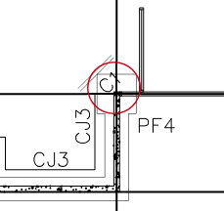
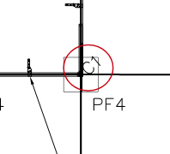
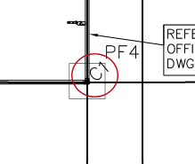

Task 6 Load Bearing Information
Refer to an example of structural drawings of structural members (e.g. columns, beams) and outline the detail requested below. Ensure you supply the plan with your submission.
Ensure to:
- Identify the strength of steel and concrete from the structural drawings.
- Indicate whether the strength of steel and concrete identified from the structural drawings are consistent with the information in the project specifications.
If your answer is NO, explain why the information in the structural drawings are not consistent with the specifications.
You will be assessed on:
- Practical knowledge of load bearing information from plans and specifications
- Practical skills in identifying structural load bearing information of the building and comparing information from specifications

Strength of Steel: | 450MPa
Is the strength of steel specified in the structural drawings, consistent with the information in the project specifications?
YES NO
Explanation (Candidate to explain if their response is no)

Strength of Concrete: | 25MPa
Is the strength of concrete specified in the structural drawings, consistent with the information in the project specifications?
YES NO
Explanation (Candidate to explain if their response is no)

Task 7 Wind Bracing and Tie-Down Requirements
Refer to an example of plans and specifications which outline wind bracing and tie-down requirements and outline the detail requested below. Ensure you supply the plans and specifications with your submission.
You will be assessed on:
- Practical knowledge of wind bracing and tie-down requirements
- Practical skills in identifying wind bracing and tie-down requirements

What are the wind bracing requirements?
Sheet bracing - 4.0mm F27 Ply nailed to frame in accordance with the drawings

Bracing wall to external wall – 2/30 x 0.8mm GI straps

What are the tie-down requirements?
Plywood nailed to frame using 30 x 2.8 dia. galvanised flat head nails

GI straps secured with 6/2.8mm nails at each end

Task 8 Wind Bracing Materials and Tie-Down Methods
Confirm whether the wind bracing materials and tie-down methods found in the plans and specifications from Practical Assessment Task 7 are accurate against the wind bracing table.
You will be assessed on:
- Practical knowledge of wind bracing and tie-down requirements
- Practical skills in identifying wind bracing and tie-down requirements

Wind bracing materials  (Student to list wind bracing materials below) | Candidate’s confirmation to whether the wind bracing material is accurate against the wind bracing table
4.0mm F27 Plywood | Yes
30 x 0.8mm GI straps | Yes

Tie-down methods  (Student to list tie-down methods below.) | Candidate’s confirmation to whether the tie-down method is accurate against the wind bracing table
2.8 dia. galvanised flat head nails | Yes

Task 9 Provisional Sum and Prime Cost Items
Refer to an example of a construction contract and outline the detail requested below. Ensure you supply the extract of the construction contract with your submission.
Identify the following based on the documents you reviewed:
- Provisional sum (PS) items
- Prime cost (PC) items
You will be assessed on:
- Practical knowledge of provisional sum and prime cost items
- Practical skills in identifying provisional sum and prime cost items

What are the prime cost items?
N/A to this contract.
Could be appliances, light fittings, door hardware, etc
What are the provisional sums items?
Stair screen
Stormwater
Retaining walls

Task 10 Installation and Connection Points of Services
Provide screenshots from construction plans to:
- Locate the installation points of services
- Locate the connection points of services
You will be assessed on:
- Practical knowledge of the installation and connection points of building services
- Practical skills in locating the installation and connection points of building services

Installation Points of Services
(Student to provide a screenshot example of three (3) installation points of services, such as gas supply, air conditioning)
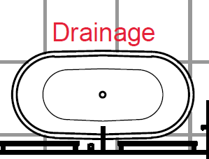
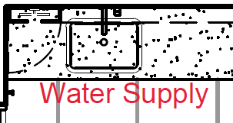
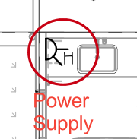

Connection Points of Services
(Student to provide a screenshot example of three (3) connection points of services, such as sewer connection, water supply connection point)
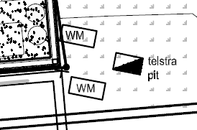
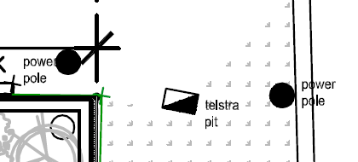

Task 11 Location of Fixtures
Provide screenshots of examples from plans which locate three (3) fixtures in plans.
You will be assessed on:
- Practical knowledge of fixtures
- Practical skills in identifying the location of fixtures from plans

Fixtures
(Student to provide a screenshot example of three (3) fixtures, such as toilet, ceiling fan, sprinkler system)
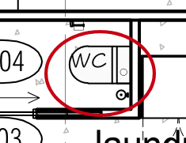
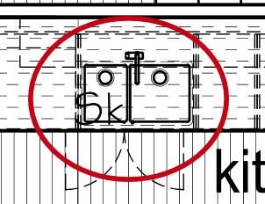
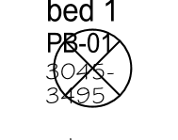

Task 12 Details of Finishes
Provide screenshots of examples from specifications which identify the details of three (3) finishes.
You will be assessed on:
- Practical knowledge of details of fixtures
- Practical skills in identifying details of fixtures

Finishes
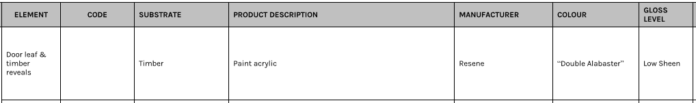
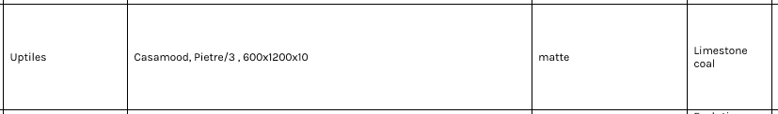
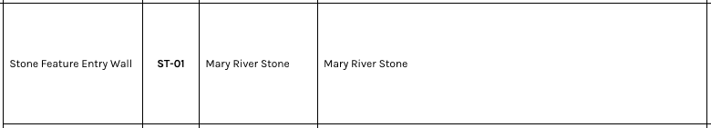

Assessment Workbook Checklist
TO THE CANDIDATE
When you have completed this assessment workbook, review your work, and ensure that:
- You have completed all the Knowledge Assessments Questions.
- You have completed the Practical Assessments in this workbook
- Practical Assignment
- Workplace Safety Requirements
- Workplace Processes
- Environmental Requirements
- Workplace Assessment
- Confirm Currency of Plans, Specifications, and Amendments
- Confirm Details on Plans Comply with the Specifications
- Examine Detail Drawings to Determine Sizes and Thickness
- Discuss Details During the Planning Phase
- Practical Plans Assignment
- Types of Plans and Aspects
- Construction Plans
- Materials from Specifications
- Concrete Footing and Slab
- Load Bearing Points
- Load Bearing Information
- Wind Bracing and Tie-Down Requirements
- Wind Bracing Materials and Tie-Down Methods
- Provisional Sum and Prime Cost Items
- Installation and Connection Points of Services
- Location of Fixtures
- Details of Finishes
- You have saved and submitted the following evidence:
- This completed workbook
- Assessment Workbook Cover Sheet signed and scanned
- Plans used for Practical Plans Assignment Tasks 1, 2, 3, 4, 5, 6, 7 and 9

IMPORTANT:
You must achieve a satisfactory result in ALL assessment tasks to be deemed COMPETENT for the unit/s relevant to this workbook.
To be deemed competent in the unit/s of competency relevant to this workbook, you must successfully complete all the requirements listed above according to the prescribed benchmarks provided to the assessor.

TO THE ASSESSOR
When you have completed assessing the assessment workbook, review the candidate’s submission against the checklist below:
- The candidate has completed all the Knowledge Assessments Questions.
- The candidate has completed the Practical Assessments in this workbook
- Practical Assignment
- Workplace Safety Requirements
- Workplace Processes
- Environmental Requirements
- Workplace Assessment
- Confirm Currency of Plans, Specifications, and Amendments
- Confirm Details on Plans Comply with the Specifications
- Examine Detail Drawings to Determine Sizes and Thickness
- Discuss Details During the Planning Phase
- Practical Plans Assignment
- Types of Plans and Aspects
- Construction Plans
- Materials from Specifications
- Concrete Footing and Slab
- Load Bearing Points
- Load Bearing Information
- Wind Bracing and Tie-Down Requirements
- Wind Bracing Materials and Tie-Down Methods
- Provisional Sum and Prime Cost Items
- Installation and Connection Points of Services
- Location of Fixtures
- Details of Finishes
- The candidate has saved and submitted the following evidence:
- This completed workbook
- Assessment Workbook Cover Sheet signed and scanned
- Plans used for Practical Plans Assignment Tasks 1, 2, 3, 4, 5, 6, 7 and 9

IMPORTANT:
The candidate must achieve a satisfactory result in ALL assessment tasks to be deemed COMPETENT for the unit/s relevant to this workbook.
To be deemed competent in the unit/s of competency relevant to this workbook, the candidate must successfully complete all the requirements listed above according to the prescribed benchmarks.

Record of Assessment (Assessor’s Use Only)
RECORD OF ASSESSMENT
Candidate’s Name
RTO Name
RTO Contact Number
RTO Email Address
Assessor’s Name
Unit of Competency | CPCCBC4012 - Read and interpret plans and specifications (Release 1.0)

Knowledge Assessment | S | NYS
Question 1
Question 2
Question 3
Question 4
Question 5
Question 6
Question 7
Question 8
Question 9
Question 10
Question 11
Question 12
Question 13
Question 14
Question 15
Question 16
Question 17
Question 18
Question 19
Question 20
Question 21
Question 22
Question 23

Practical Assessment
Practical Assignment | S | NYS
Task 1
Task 2
Task 3
Workplace Assessment | S | NYS
Task 1
Task 2
Task 3
Task 4
Practical Plans Assignment | S | NYS
Task 1
Task 2
Task 3
Task 4
Task 5
Task 6
Task 7
Task 8
Task 9
Task 10
Task 11
Task 12

Rules of Evidence | S | NYS
All knowledge and skills evidence submissions are valid
All knowledge and skills evidence submissions are authentic
All knowledge and skills evidence submissions are sufficient
All knowledge and skills evidence submissions are current

Signature Authentication Checklist
This checklist will guide you in authenticating the signatures provided by the candidate in their assessment workbook and evidence submissions.
Read each checklist item and tick the box only if you confirm that the item is a true and accurate reflection of the signature authentication you have conducted.
Checklist | Completed
I have checked the signature provided by the candidate in the Assessment Workbook Cover Sheet against the signature they provided to the Training Provider.
I confirm the signature provided by the candidate in the Assessment Workbook Cover Sheet matches the signature they provided to the Training Provider.
I confirm ALL signatures provided by the candidate in their evidence submissions match with the signature they provided to the Training Provider.

Third-Party Verification Log
Instructions for the Assessor:
You are required to contact all third-party personnel involved in the candidate’s assessment to verify the candidate’s performance and evidence submissions and to confirm with them whether the candidate’s evidence submissions are true and accurate.
Complete this Third-Party Verification Log to document your completion of this process. When completing this log, provide all of the following required information for each third-party personnel:
- Name of third-party personnel contacted
- Role in the candidate’s assessment (e.g. workplace supervisor, observer, or candidate)
- Contact details (phone number or email address)
- Date contacted
You must also confirm that third-party personnel have verified the candidate’s evidence submissions are true and accurate.

Name of Third-party Contacted | Role in the Candidate’s Assessment | Contact Details (Phone number or email address) | Date contacted | Third-Party verifies evidence submissions of the candidate are true and accurate?
Yes No
Assessor’s Notes

Yes No
Assessor’s Notes

Yes No
Assessor’s Notes

Yes No
Assessor’s Notes

Overall Result for this Workbook | S | NYS
Overall Result

Assessor’s comments/feedback

Assessor Declaration
I declare that the results recorded in this Record of Assessment are true and accurate.
Assessor’s name | Assessor’s signature
Date signed | Assessor’s signature
End of Record of Assessment (For the Assessor’s Use Only)

End of Document

