

BSBITU401
Design and develop complex text documents
Learner Guide

BSBITU401
Design and develop complex text documents

Table of Contents

Table of Contents 3
Unit of Competency 7
Performance Criteria 8
Foundation Skills 9
Assessment Requirements 10
Housekeeping Items 11
Objectives 11
1. Prepare to produce word processed documents 12
1.1 – Use safe work practices to ensure ergonomic, work organisation, energy and resource conservation requirements are met 13
Addressing ergonomic requirements 13
Examples of workplace policy requirements 15
Clean work area 15
Work surface height 16
Chair 16
Keyboard placement 16
Screen placement 17
Desk-top layout 17
Document holder 17
Posture and environment 17
Lighting 17
Glare and reflection 18
Using a mouse 18
Keyboard equipment and radiation 18
Keyboard and telephone operations 19
Posture during Keying 19
Typing technique 19
Speed of keying 19
Length of time on the keyboard 20
Activity 1A 22
1.2 – Identify document purpose, audience and presentation requirements, and clarify with relevant personnel as required 23
Complex documents may include: 23
Activity 1B 24
Meeting agenda 25
Minutes 25
Press release 25
Project proposal 25
Technical documentation and user documentation 26
1.3 – Identify organisational requirements for text-based business documents to ensure consistency of style and image 27
Example of matching details 28
Ensure consistency of style and image 28
Activity 1C 29
1.4 – Evaluate complex technical functions of software for its usefulness in fulfilling requirements of the task 30
1.5 – Match document requirements with software functions to provide efficient production of documents 30
Activity 1D 31
2. Design complex documents 32
2.1 – Design document structure and layout to suit purpose, audience and information requirements of task 33
Alignment 34
Graphics 34
Header and/or footer 35
Activity 2A 36
2.2 – Design document to enhance readability and appearance, and to meet organisational and task requirements for style and layout 37
Use unique images 37
Some options 37
Layout arranged according to related topics and logical sequences 38
Design document to enhance readability and appearance 38
Colour combinations 39
White space 39
Additional options 39
Appendices and Annexes 40
Activity 2B 41
2.3 – Use complex software functions to enable efficient manipulation of information and other material, and ensure consistency of design and layout 42
Efficient manipulation of information 42
Some pros and cons 44
Use complex software functions to enable efficient manipulation of information 45
PDF files are an example 45
Word documents 45
Excel documents 45
Annotated references 45
Consistency with other business documents 46
Activity 2C 47
2.4 – Use manuals, user documentation and online help to overcome problems with document design and production 48
User documentation quality check list 49
Outsourcing technical documentation and help 50
Activity 2D 51
3. Add complex tables and other data 52
3.1 – Insert a standard table into document, changing cells to meet information requirements 53
3.2 – Format rows and columns as required 55
3.3 – Insert images and other data, formatting as required 59
Activity 3A 60
4. Produce documents 61
4.1 – Use complex operations to develop documents, and achieve required results 62
Activity 4A 64
4.2 – Preview, adjust and print documents in accordance with organisational and task requirements 65
Preview, adjust and print documents 65
Functions 66
Activity 4B 69
4.3 – Name and store documents in accordance with organisational requirements and exit application without information loss/damage 70
File names 70
File name issues 71
Characters 71
File names which are easily identifiable in relation to the content 71
What are Your Storage Needs? 72
Avoid large folder structures 73
Use shortcuts and shortcut links instead of multiple copies 73
Colour-code your folders 73
Quickly get to the items you use every day 73
Consider storing documents online 74
Activity 4C 76
4.4 – Prepare documents within designated timelines and for speed and accuracy 77
Organisational timeline 77
Activity 4D 79
Skills and Knowledge Activity 80
Major Activity – An opportunity to revise the unit 81
References 83

Unit of Competency

Application

This unit describes the skills and knowledge required to design and develop business documents using complex technical features of word processing software.

It applies to individuals who work in a range of business environments and have skills which may be applied in the provision of administrative support within an enterprise, or by technical/knowledge experts responsible for producing their own word processed documents.

No licensing, legislative or certification requirements apply to this unit at the time of publication.

Unit Sector

Information and Communications Technology – IT Use

Performance Criteria
Element  Elements describe the essential outcomes. | Performance Criteria  Performance criteria describe the performance needed to demonstrate achievement of the element.
- Prepare to produce word processed documents | - Use safe work practices to ensure ergonomic, work organisation, energy and resource conservation requirements are met  - Identify document purpose, audience and presentation requirements, and clarify with relevant personnel as required  - Identify organisational requirements for text-based business documents to ensure consistency of style and image  - Evaluate complex technical functions of software for its usefulness in fulfilling requirements of the task  - Match document requirements with software functions to provide efficient production of documents
- Design complex documents | - Design document structure and layout to suit purpose, audience and information requirements of task  - Design document to enhance readability and appearance, and to meet organisational and task requirements for style and layout  - Use complex software functions to enable efficient manipulation of information and other material, and ensure consistency of design and layout  - Use manuals, user documentation and online help to overcome problems with document design and production
- Add complex tables and other data | - Insert a standard table into document, changing cells to meet information requirements  - Format rows and columns as required  - Insert images and other data, formatting as required
- Produce documents | - Use complex operations to develop documents, and achieve required results  - Preview, adjust and print documents in accordance with organisational and task requirements  - Name and store documents in accordance with organisational requirements and exit application without information loss/damage  - Prepare documents within designated timelines and for speed and accuracy

Foundation Skills
This section describes language, literacy, numeracy and employment skills incorporated in the performance criteria that are required for competent performance.

Skill | Performance  Criteria | Description
Reading | 1.3, 2.2, 2.4, 4.3, 4.4 | - Recognises and interprets textual information from a range of resources to determine and confirm requirements and to assist with document issues
Writing | 2.1-2.4, 3.3, 4.2-4.4, | - Develops material using required format and incorporating technical functions to meet business needs
Oral Communication | 1.2 | - Uses specific and relevant language to confirm understanding of requirements and listens carefully to verbal instructions and discussions
Numeracy | 1.4, 3.3 | - Recognises and inputs numerical information according to requirements
Navigate the world of work | 1.1-1.3, 1.5, 2.1-2.3, 3.1-3.3, 4.1-4.4 | - Recognises and follows explicit and implicit protocols and meets expectations associated with own role
Interact with others | 1.2 | - Collaborates with others to achieve joint outcomes
Get the work done | 1.4, 1.5, 2.1-2.4, 3.1-3.3, 4.1-4.4 | - Applies formal processes when planning more complex/unfamiliar tasks, producing plans with logically sequenced steps  - Uses advanced features within applications to access, store, organise data and perform routine and complex work tasks

Assessment Requirements
Performance Evidence

Evidence of the ability to:

- Follow organisational and safe work practices including:
- ergonomic requirements
- energy and resource conservation techniques
- Adhere to organisational requirements for:
- producing documents within designated timelines
- naming and storing documents
- Adhere to task requirements when producing complex documents including:
- using appropriate styles and layout consistently throughout the document
- using correct formatting and document structure
- Resolve issues by referring to user documentation and online help
- Use appropriate data storage options
- Apply knowledge of complex operation and functions of industry software applications
- Communicate with relevant personnel.

Knowledge Evidence

To complete the unit requirements safely and effectively, the individual must:

- Outline various formatting styles and their effect on formatting, readability and appearance of documents
- Explain organisational requirements for ergonomics, work periods and breaks, and conservation techniques
- Describe purpose and contents of an organisational style guide.

Assessment Conditions

Assessment must be conducted in a safe environment where evidence gathered demonstrates consistent performance of typical activities experienced in the information and communications technology – IT use field of work and include access to:

- Organisational policies and procedures
- Relevant workplace documentation and resources
- Industry software packages and user instructions.

Assessors must satisfy NVR/AQTF assessor requirements.

Links

Companion volumes available from the IBSA website: http://www.ibsa.org.au/companion_volumes

Housekeeping Items
Your trainer will inform you of the following:
- Where the toilets and fire exits are located, what the emergency procedures are and where the breakout and refreshment areas are.
- Any rules, for example asking that all mobile phones are set to silent and of any security issues they need to be aware of.
- What times the breaks will be held and what the smoking policy is.
- That this is an interactive course and you should ask questions.
- That to get the most out of this workshop, we must all work together, listen to each other, explore new ideas, and make mistakes. After all, that’s how we learn.
- Ground rules for participation:
  - Smile
  - Support and encourage other participants
  - When someone is contributing everyone else is quiet
  - Be patient with others who may not be grasping the ideas
  - Be on time
  - Focus discussion on the topic
  - Speak to the trainer if you have any concerns

Objectives
- Learn how to prepare to produce word processed documents
- Know how to design complex documents
- Understand how to add complex tables and other data
- Discover how to produce documents
- Gain the skills and knowledge required for this unit.

1. Prepare to produce word processed documents

1.1 Use safe work practices to ensure ergonomic, work organisation, energy and resource conservation requirements are met
1.2 Identify document purpose, audience and presentation requirements, and clarify with relevant personnel as required
1.3 Identify organisational requirements for text-based business documents to ensure consistency of style and image
1.4 Evaluate complex technical functions of software for its usefulness in fulfilling requirements of the task
1.5 Match document requirements with software functions to provide efficient production of documents


1.1 – Use safe work practices to ensure ergonomic, work organisation, energy and resource conservation requirements are met

Ergonomic requirements may include: | Work organisation requirements may include: | Energy and resource conservation requirements may include:
- Avoiding radiation from computer screens  - Chair height, seat and back adjustment  - Document holder  - Footrest  - Keyboard and mouse position  - Lighting  - Noise minimisation  - Posture  - Screen position  - Workstation height and layout  - Equipment that is reasonably adjusted to meet personal needs, in appropriate circumstances | - Exercise breaks  - Mix of repetitive and other activities  - Rest periods | - Double-sided paper use  - Recycling used and shredded paper  - Re-using paper for rough drafts (observing confidentiality requirements)  - Using power-save options for equipment

Addressing ergonomic requirements
Any assessment of ergonomic conditions that exists in the workplace would normally be handled through the HR (Human Resource) department under a Risk Assessment as part of OH&S (Occupational Health and Safety) or by a system that evaluates risk potential to employees.
- Some of the areas suggested in the EXAMPLES would be more suitably handled by employees as part of a daily or periodic self-check of equipment, the workstation and work area before work commences and during work.
Example check list
Question | Response/Action
Are you keying and using mouse activities interspersed with a variety of other work tasks?
Do you include pauses such as deliberate breaks to reduce stress and tension?
Do you conduct regular pause exercises during computer operation at least every hour?
Do you alter your posture when seated, stand or move throughout the day?

For areas that may be covered under WPH&S and awards or Human Resource policies, responsibility of the employer to provide a safe workspace would be documented and form part of regular risk management checks.
- Supervisors, managers, team leaders etc are generally designated OH&S officers so that there is a standard and policy driven culture present to the checks.
- Responsibilities include hazard reporting procedures, job procedures and safe work instructions, emergency procedures, accident and near miss reporting and recording procedures, consultation on OH&S issues, correct selection, use & storage and maintenance procedures for use of personal protective equipment, control of risks under direct supervision.
- Awareness of relevant legislation from all levels of government (State or Federal) which affect business operation, especially in regard to OH&S and environmental issues, equal opportunity, industrial relations, anti-discrimination and diversity.
- Compliance to behaviour that contributes to a safe working environment, identifying and reporting risks or hazards, using business equipment according to guidelines, listening to the ideas and opinions of others in the team, sharing opinions, views, knowledge and skills.
- Formal and informal health and safety meetings, meetings called by health and safety representatives, suggestions, requests, reports and concerns put forward to management.
- Workstation height and layout, chair height, seat and back adjustment, footrest, screen position, keyboard and mouse position, document holder, posture, avoiding radiation from computer screens, noise minimisation.
- Mix of repetitive and other activities, rest periods, exercise breaks, VDU eye testing.
- A range of environmental conditions including: noise, light, gas, smoke, odour, vapour, liquids/solids, particles and fumes.
If a particular office layout design is needed this would be a matter of personal and working circumstances.
For example:
Discuss as this applies to your WORKPLACE

- Does the workspace provide acoustical privacy (for example, can people talk in privacy, according to the level of confidentiality required; do noises and conversations interfere with their concentration; do noises or conversations make it difficult to hear or understand speech if much of their work involves using the telephone?)
- Are the walls permanent (i.e., fixed) or is the workspace in an open office environment?
- Does the workspace provide visual privacy?
- Can an employee personalise his or her individual work space?
- Is there access to natural light or only artificial lighting?
- Is the workplace layout designed to facilitate interpersonal contact?

Examples of workplace policy requirements
- Maintain work areas in a safe, uncluttered and organised manner according to policy and procedures.
- Carry out all procedures safely, effectively and efficiently with minimum inconvenience to staff according to policy.
- Apply policy and procedures for tidying work areas and placing items in designated areas.

Clean work area
- Apply policy and procedures for personal hygiene.
- Apply policy and procedures for cleaning of work area.
- Sort, recycle, remove and dispose of waste promptly according to policy requirements.
- Safely remove and clean spills of food, waste or other potential hazards in compliance with OH&S requirements and policy.
- Maintain equipment and consumable materials and store correctly after use.
- Use and clean equipment according to manufacturer instructions and policy requirements.
Consideration should be given to:
- The accessories required to operate properly
- The layout of equipment on the desk
- The location of furniture in the room

Work surface height
- Adjust the height of the work surface and/or the height of the chair so that the work surface allows your elbows to be bent at 90 degrees, forearms parallel with the floor, wrist straight, shoulders relaxed.

Chair
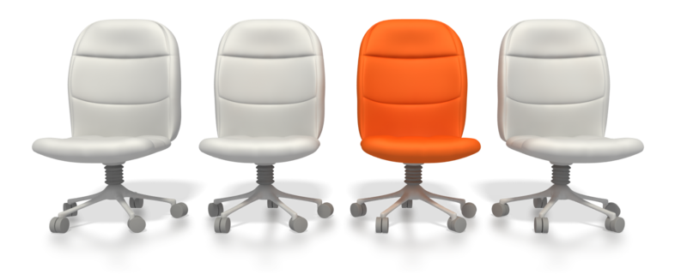
- Adjust the seat tilt so that you are comfortable when you are working on the keyboard. Usually, this will be close to horizontal but some people prefer the seat tilted slightly forwards. Your knees should be bent at a comfortable angle and greater than 90 degrees flexion. If this places an uncomfortable strain on the leg muscles or if the feet do not reach the floor then a footrest should be used. The footrest height must allow your knees to be bent at 90 degrees. Therefore the height of the footrest may need to be adjustable. Adjust the backrest so that it supports the lower back when you are sitting upright.

Keyboard placement
- Place the keyboard in a position that allows the forearms to be close to the horizontal and the wrists to be straight. That is, with the hand in line with the forearm. If this causes the elbows to be held far out from the side of the body then re-check the work surface height. Some people prefer to have their wrists supported on a wrist desk or the desk. Be careful not to have the wrist extended or bent in an up position.

Screen placement
- Set the eye to screen distance at the distance that permits you to most easily focus on the screen. Usually this will be within an arm's length. Set the height of the monitor so that the top of the screen is below eye level and the bottom of the screen can be read without a marked inclination of the head. Usually this means that the centre of the screen will need to be near shoulder height. Eyes level with the tool bar. People who wear bifocal or multi focal lenses will need to get a balance between where they see out of their lenses and avoid too much neck flexion.

Desk-top layout
- Place all controls and task materials within a comfortable reach of both hands so that there is no unnecessary twisting of any part of the body. Most people prefer the document holder to be between the keyboard and the monitor. There are many different types of document holders available.

Document holder
- Place this close to the monitor screen in the position that causes the least twisting or inclination of the head.

Posture and environment
- Change posture at frequent intervals to minimise fatigue. Avoid awkward postures at the extremes of the joint range, especially the wrists. Take frequent short rest breaks rather than infrequent longer ones. Avoid sharp increases in work rate. Changes should be gradual enough to ensure that the workload does not result in excessive fatigue. After prolonged absences from work the overall duration of periods of keyboard work should be increased gradually if conditions permit.

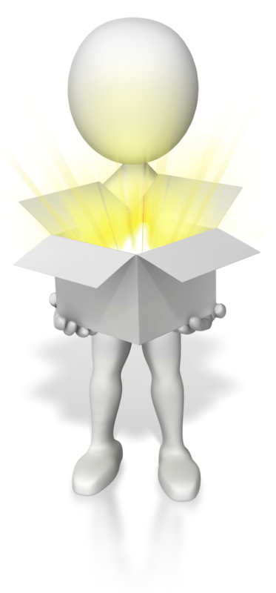
Lighting
- Place the monitor to the side of the light source/s, not directly underneath. Try to site desks between rows of lights. If the lighting is fluorescent strip lighting, the sides of the desks should be parallel with the lights. Try not to put the screen near a window. If it is unavoidable ensure that neither the screen nor the operator faces the window.
- If the monitor is well away from windows, there are no other sources of bright light and prolonged desk-work is the norm, use a low level of service light of 300 lux. If there are strongly contrasting light levels, then a moderate level of lighting of 400 – 500 lux may be desirable.

Glare and reflection
- It is important to detect the presence of glare and reflection. To determine whether there is glare from overhead lights whilst seated worker should hold an object such as a book above the eyes at eyebrow level and establish whether the screen image becomes clearer in the absence of overhead glare. To detect whether there are reflections from the desk surface, the worker should hold the book above the surface and assess the change in reflected glare from the screen.
A number of ways are available to eliminate or reduce the influence of these reflections:
- Tilt the screen (top part forwards) so that the reflections are directed below eye level.
- Purchase an LCD screen.
- Cover the screen with a light diffusing surface or anti-glare screen.
- Negative contrast screen (dark characters on light background) will reduce the influence of these reflections.
If you experience eye discomfort when using a bright screen you should make the following adjustments:
- Turn the screen brightness down to a comfortable level.
- Look away into the distance in order to rest the eyes for a short while every ten minutes or so.

- Change the text and background colours. Recommended are black characters on white or yellow background, or yellow on black, white on black, white on blue and green on white. Avoid red and green and yellow on white.

Using a mouse
- A well designed mouse should not cause undue pressure on the wrist and forearm muscles. A large bulky mouse may keep the wrist continuously bent at an uncomfortable angle. Pressure can be reduced by releasing the mouse at frequent intervals, by selecting a slim-line, low-profile mouse. Keep the mouse as close as possible to the keyboard, elbow bent and close to the body.

Keyboard equipment and radiation
- Computer screens emit visible light which allows the characters on the screen to be seen. Weak electromagnetic fields and very low levels of other radiation, not visible to the human eye, can be detected by sensitive instruments. Similar emissions are produced by television receivers.
- The levels of most radiations and electromagnetic fields emitted from computers are much less than those from natural sources, such as the sun or even the human body and are well below levels considered to be harmful by responsible expert bodies such as the International Radiation Protection Association (IRPA).

Keyboard and telephone operations
- Avoid cradling the phone between your head and shoulder when answering calls. If needing to access the computer at the same time a headset is recommended. Hands free/speaker phone is another option if the environment is suitable.

Posture during Keying

- Good posture is essential for all users of computers. It comprises of a natural and relaxed position, providing opportunity for movement, and from which the operator can assume a number of alternative positions. It is not a single, rigidly defined position.

Typing technique
Typing is a physical activity, and using a keyboard requires skill, hence the need to learn correct typing technique. Unskilled ('hunt and peck') typists are particularly at risk of Occupational Overuse Injury because they:
- Often use only one or two fingers which may overload the finger tendons;
- Are constantly looking from keyboard to screen to keyboard, which may strain neck muscles;
- Often adopt a tense posture (wrists bent back and fingers 'poised to strike')

Speed of keying
- The efficiency and speed of modern computers makes it possible for a skilled operator to type extremely quickly. This capability, reinforced by workload pressures means the potential exists for operators to key at speeds which may cause or contribute to Occupational Overuse Syndrome.
The role of the repetitive movement in injury is not fully understood, but is believed to interfere with the lubrication capacity of tendons, and the ability of muscles to receive sufficient oxygen supplies.
10,000 – 12,000 keystrokes per hour is considered an acceptable standard.

Length of time on the keyboard
- The maintenance of a fixed posture for long periods is tiring and increases the likelihood of muscular aches and pains. In addition, long periods of repetitive movement and sustained visual attention can also give rise to fatigue-related complaints.
- It is recommended that operators avoid spending more than five hours a day on keyboard duties and no longer than 50 minutes per hour without a postural/stretching break.
Employees newly engaged in keyboard work, and staff returning from an absence of two or more weeks, need a period of adjustment. The adjustment may be achieved through reduced work rates, or provision of alternate duties with gradual re-introduction to keyboard work.
Jobs should be designed and organised so that either:
- Computer related tasks can be interspersed with non computer related, or
- Computer based tasks can be rotated amongst several staff (task/job sharing).

- It is not the change of task per se, but the change to using different movements and postures that is important. The whole purpose of task variety is to give the overloaded structures a necessary break.
Conservation requirements may include:
- Double-sided paper use
- Recycling used and shredded paper
- Re-using paper for rough drafts (observing confidentiality requirements)
- Using power-save options for equipment
Supervisors should ensure that workload controls are exercised using the following strategies:
- Planning ahead to avoid peaks, and rushed jobs
- Delegating fairly to all staff not just the best workers
- Considering the total workload of the individual (often comes from a number of sources)
- Clearly defining each operator's workload
- Implementing systems of prioritisation e.g. Work request forms, waiting lists
- Using relief staff
- Applying strict tests to the use of 'urgent' labels
- Discouraging 'endless' drafts
- Discouraging the use of typed internal minutes and memoranda
- Encouraging authors to have realistic expectations
- Teaching authors keyboard skills
- Teaching operators how to be assertive, and how to prioritise
- Supporting operators when authors impose unrealistic expectations
- Refusing illegible drafts

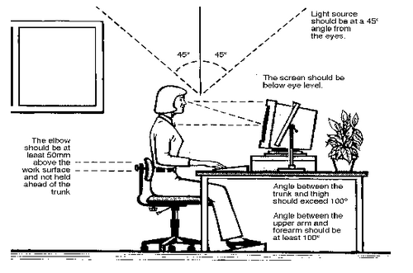

Activity 1A


1.2 – Identify document purpose, audience and presentation requirements, and clarify with relevant personnel as required

Complex documents may include:
- Call outs  - Captions  - Concordance files  - Different odd and even pages  - Document protection  - Drawing  - Forms with fields  - Hyperlinks  - Linked and/or embedded objects | - Long documents  - Mail merge data documents  - Master documents  - MS Word art  - Multiple headers and footers  - Multiple sections  - Multiple users  - Primary mail merge documents  - Subdocuments  - Templates

Identify document purpose, audience and presentation requirements
- Sounds logical and simple.
- Be sure you know what the various aspects of a document life is and the usage intent before using it.


Activity 1B
Other complex documents may include:

Meeting agenda
- A meeting agenda usually consists of a list of topics to be discussed in an upcoming meeting.
- Agendas are usually distributed to the participants prior to meeting.
- Agendas can be prepared on a Word document or other suitable medium, e.g., an Email or as an attachment to an email.

Minutes
- Minutes are a written or typed report of a particular meeting or an action as part of a meeting.
- They can be hand written or recorded live on a laptop or PC into a Word or Excel document.
- Formal minutes are a legal record of what was said or a direction given.
- Minutes in very large organisation may be recorded either as audio or vision and stored in that format for later reference or review.
- Minutes are generally taken by someone dedicated to that job to avoid error.


Press release
- A press release is a written communication directed at the news media.
- Its purpose is to announce something that presumably has news value.
- It is usually written by marketing or press staff member as what is said in a press release can be damaging or legally costly if stated incorrectly.
- A press release is usually written on a Computer in Word and then reviewed by several people or distributed as an attachment to an email or posted on a website.

Project proposal
- A written project proposal helps to clarify the aim and objectives of the project.
- It often includes the work plan, timetable, tentative outcomes, budget, etc.

Technical documentation and user documentation
- Technical documentation includes the description of mechanical systems or technical processes, and it is usually written for experts in a specific field.
- User documentation, on the contrary, is written for a large audience of users of a particular product or a programme.
- Such documents as technical papers may well be accompanied by a presentation format such as PowerPoint.


1.3 – Identify organisational requirements for text-based business documents to ensure consistency of style and image

Organisational requirements may include:
- Company colour scheme
- Company logo
- Consistent corporate image
- Content restrictions
- Established guidelines and procedures for document production
- House styles
- Observing copyright legislation
- Organisation name, time, date, document title, filename, etc. In header/footer
- Templates
Identify organisational requirements for text-based business documents
Each organisation will have its own set of policies and guidelines to ensure consistency and compliance to company image and standards of recognition.
- Across the examples provided, documents include purpose, audience and presentation requirements.
- There is usually an organisational need to keep those areas within a standard for a variety of reasons which each organisation will have as a policy or procedure to follow.
- The best way to understand this concept is to examine your own set of organisation requirements for your particular text-based business documents.
- Before investigating your own workplace for the standards in place there, consider these options for creating a policy and guideline for corporate standards to document purpose, audience and presentation requirements.
- Guideline Title
- The policy statement
- The purpose of having a guideline/policy
- Scope that it covers
- Objective the company wishes to achieve by the use of the policy
- The guidelines/policy details

Example of matching details
Company colour scheme  Company logo  Consistent corporate image  Content restrictions  Established guidelines and procedures for document production  House styles  Etc | Applies to all | - Brochures  - Calendars  - Faxes  - Flyers  - Forms  - Mail merge  - Documents  - Labels  - Memos/emails  - Multi-page letters  - Promotional material  - Reports  - Schedules  - Tables

Ensure consistency of style and image
- Everything should have the same “look” and “feel”
- Use the same types of materials such as paper, packaging, business card, etc
- Use and insist on the same logo at all times
- Consistency of packaging and signage, using the same colours, fonts etc, will create a uniformity in your branding
Report templates, forms, documents, memos, promotional material and letters all need to be consistent with producing image and professionalism.
Identify YOUR organisational requirements for text-based business documents
Example
Your company templates
- A template is a master copy of a document for publication used as a starting point to design new documents
- A template may be as simple as a blank document in the desired size and orientation or as elaborate as a nearly complete design with placeholder text, fonts, and graphics that need only a small amount of alteration to meet organisational and task requirements

Activity 1C

1.4 – Evaluate complex technical functions of software for its usefulness in fulfilling requirements of the task

1.5 – Match document requirements with software functions to provide efficient production of documents

Complex technical functions may include:
- Alignment  - Data transfer  - Display features  - Embedding  - Exporting  - Fields  - Form fields  - Formulae  - Importing | - Index  - Linking  - Macros  - Merge criteria  - Page and section breaks  - Sort criteria  - Style sheets  - Table of contents  - Templates
Evaluate complex technical functions of software for its usefulness in fulfilling requirements of the task
- What are your document requirements?
- What is the software to be used?
- What are the technical functions of the software?
- Can you evaluate the software for its usefulness for the task requirements?
- How will you conduct this evaluation?
Match document requirements with software functions to provide efficient production of documents


Activity 1D

2. Design complex documents

2.1 Design document structure and layout to suit purpose, audience and information requirements of task
2.2 Design document to enhance readability and appearance, and to meet organisational and task requirements for style and layout
2.3 Use complex software functions to enable efficient manipulation of information and other material, and ensure consistency of design and layout
2.4 Use manuals, user documentation and online help to overcome problems with document design and production

2.1 – Design document structure and layout to suit purpose, audience and information requirements of task

Design choices may include:
- Balance
- Diversity

- Relative positioning of graphics and headings
- Simplicity
- Text flow
- Typography
Structure and layout may include:
- Boxes
- Colour
- Columns
- Drawing
- Graphics
- Headings
- Letter and memo conventions
- Page layout
- Photographs
- Typeface
- White space
Design document structure and layout to suit purpose, audience and information requirements of the task
Good document design uses balance with form and consistency with contrast
- Do not forget that successful communication with the reader is the most important goal above all other considerations.
- Think of design document structure and layout as a jigsaw puzzle. Every piece fits together to make the whole.
- Balance is about symmetry and asymmetry. Symmetry provides stability and rest for the eye
In a newsletter, for instance, a horizontal text running along the top of the page contrasts against the vertical columns of text, adding an element of asymmetry to the page.
Design, structure and layout – examples

Alignment
- This can be achieved, for example, in document structure and layout by aligning the various elements on individual pages with the tops of say, photographs or images, being in ‘alignment’ with the top of the first line of corresponding text.
- Using headlines in the same alignment from page to page is another example.

Be relevant – suit the purpose
...consider:
- Proportion
- Direction
- Consistency
- Contrast
- The “total picture”
- Restraint
- Attention to detail

Graphics
- Graphics are considered pictures in the context of document structure and layout.
- They can be realistic, cartoons, drawings of people, places, or objects.
- Graphics can be photographs taken with a digital camera or scanned from print photos.
- A graphic can be a decorative border around a page, the bullet symbols in front of a list of items, icons, a graph, or a pie chart... they are all graphics.
The terms clip art and graphics are often used interchangeably even though clip art is usually a more specific type of non-photographic image.
- Almost every document will have some basic features you will need to address in design and application.
- In today’s workplace, your computer will assist you in this task as almost all software applications that run text, such as Windows, have templates and models in Office Suites or similar that will do the design job.
The standard structure could include, depending on the need:
- A header and/or footer
- An image or identity
- A title page
- A table of contents or index
- An introduction or preface
- The body of the document
- Appendices and annexes

Header and/or footer
May include design aspects of:
- Balance
- Simplicity
- Graphics
An image or identity
- Documents can be designed with watermarks, logos and a host of other ‘identities’.


Activity 2A

2.2 – Design document to enhance readability and appearance, and to meet organisational and task requirements for style and layout


Meet organisational and task requirements for style and layout

Use unique images
How can you accomplish this when there are ‘hundreds’ of visuals associated with your products or services and that of your competitor?
- If you are pulling your images from some of the most popular clip art packages or from shareware and free collections on the Web then chances are that you will see the same images popping up on fliers, in ads, or gracing newsletters and Web pages.
- Royalty free illustrations and stock photography are inexpensive if not absolutely FREE.
- It is this feature which makes them attractive and what makes it likely that someone else will use that same image as well.
- How likely it is then that your competitors will use the exact same image and how much will it matter if they do?

Some options
Hire a professional
- Using an external consultant or graphics expert will obviously cost something but the results may well be worth it.
- If you are purchasing graphics make sure that you are purchasing exclusive use of that artwork or otherwise it’s like paying for clip art!
Do it yourself
- Design or produce your own documents
- Do your own photography
- Produce your own templates
Change it
- Modify art by combining several individual pieces into one.
- Break apart images and use just smaller parts.
- Stretch, shrink, flip or rotate clip art.
- Add new colour, change colour to black & white images.
Keep it simple
- Combine simple shapes into unique custom images.

- Use symbols and basic shapes to construct images. For example, a stack of three circles with a few dots and sticks becomes a snowman.
- This is something even non-artists can accomplish.
Plug it in
- Using special effect software for special effects in graphics, e.g., software to enhance or distort stock photos.

Layout arranged according to related topics and logical sequences
- Sketch or use a PC to start laying out the content structure in a logical sequence
- Arrange any text into boxes, columns or sets of bullets
- Gather all your photos and graphics
Maybe arrange the featured display elements in columns or rows from left to right or from top to bottom, or place them in a circular fashion around a central idea, to allow you a range of options for a ‘logical’ sequence.

Design document to enhance readability and appearance
Choose your text content design elements:
These will include:
- Typeface style
- Font size
Enhance readability and appearance by choosing a clear, dark font and your typeface should be simple, clean and professional.
- A well chosen font lets the meaning of the text shine through and is not confused with the graphics or images as it should compliment them.
- Avoid ornate or italic fonts and where possible the temptation to use different font styles. Select one or two and use them consistently.

Colour combinations
- Stick to black or dark letters if your design task is white or has a light background.
- White letters on a black background are more difficult to read and so are texts in light colours.
Use colour sparingly and thoughtfully. Too much colour is confusing–“less is more.”
- One or two accent colours that are eye-catching and appealing can emphasise your subject and clarify the different sections of your desktop published document.
Complimentary images to text
Choose photos, tables and other graphic elements that enhance the meaning of the text, not confuse it.

White space
Remember the 1/3rd – 2/3rd rule:
- 1/3rd of white space with 2/3rd text and graphics. Make sure it all flows in a pleasing format that is balanced around a central idea. All the components should work together.

Additional options
A title page

A title page is usually added in desktop documents that are in a report style format with multiple pages.
For example, it would include:
- The title of a report,
- The document number,
- The document status,
- The date
Create logical transitions from one section to the next
- Try putting a heading or a one sentence statement at the beginning of each major section. Or you may want to add numbers or arrows to the sections to assist the reader.

A table of contents
- You can add a table of contents to any report template that you design. Tables of contents contain headings as specified throughout the document, such as a report or longer document. In a report longer than several pages a table of contents should be included as it assists the reader to locate information quickly.
The Introduction
- The purpose of the introduction is to explain why the document was designed or created and clarifies where the following information fits into the overall project or report.
- It is best to design the introduction in a logical sequence, such as:
  - Scope

  - Background
  - Approach
Body of the document
- The body of the document includes all the relevant information to be included.
- Sections, titles or sub-titles in the body of a document are best designed in a format such as alphabetically or numerically.
Example:
- Section
- Title
      - Sub-title

Appendices and Annexes
- An Appendix or Annexure consists of supplementary material supporting and complementing the various elements in the body of the document.
- It contains information that is necessary for a full understanding of the document and complete justification of the recommendations.
Note:
The word "Appendix" is used for additions bound within the same document
- Appendices are numbered 1, 2, 3, etc.
- The word "Annexure" is used for additional information that is provided in a separate volume. Annexes are labelled A, B, C, etc.

Activity 2B

2.3 – Use complex software functions to enable efficient manipulation of information and other material, and ensure consistency of design and layout

Consistency of design and layout may include:
- Annotated references
- Borders
- Bullet/number lists
- Captions
- Consistency with other business documents
- Footnotes/endnotes
- Indentations
- Page numbers
- Spacing
- Typeface styles and point size

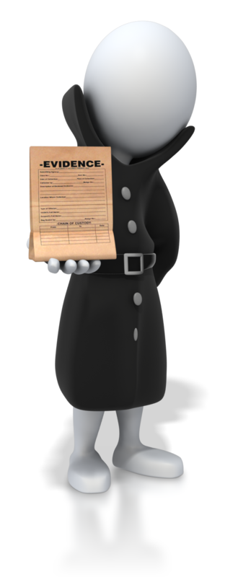
Efficient manipulation of information
- Manipulation, in the context of document design of complex documents, represents the ‘sometimes’ comprehensive process a document goes through from beginning to end
- Manipulation can include its creation and distribution, the options for storage and ongoing document modification
- Document manipulation of information and other material may include modification tools and software functions which would play an important role in how you revise your documents
- Information compliance is one example where manipulation of documents using complex software functions would apply
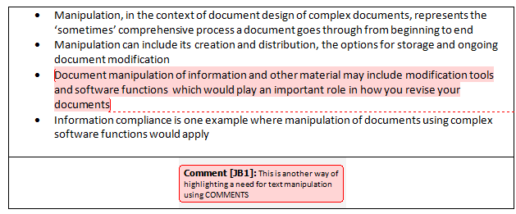
- If you are qualified or have need to MANIPULATE HTML code in a web site, this may also be a requirement to enable efficient manipulation of information and other material, and ensure consistency of design and layout.
BODY TEXT
<!DOCTYPE html>
<html>
<body>

<h1>My First Heading</h1>

<p>My first paragraph.</p>

</body>
</html>
Manipulate text HTML to modify a web page.
Word docs do not need HTML manipulation
HEADINGS
<!DOCTYPE html>
<html>
<body>

<h1>This is heading 1</h1>
<h2>This is heading 2</h2>
<h3>This is heading 3</h3>
<h4>This is heading 4</h4>
<h5>This is heading 5</h5>
<h6>This is heading 6</h6>

</body>
</html>

IMAGES
<!DOCTYPE html>
<html>
<body>

<img src="w3schools.jpg" width="104" height="142"></body>
</html>

Some pros and cons
- The need to view or present your documents in different circumstances may require you to ‘manipulate’ or alter the document functionality to suit the application.
- Using the correct software functions, many documents may be revised or modified in part while preserving the original context and meaning.
- When addressing a need for manipulation you would need to also address a thorough legal review and establish clearly what cannot be altered without being referred legally.
- Manipulated documents may need re-titling, new codes or reference numbers added before being added to the document storage facilities in your organisation.

Use complex software functions to enable efficient manipulation of information
- Being able to manipulate documents can be very useful or indeed essential and the majority of manipulation requirements can be performed on a PC using standard applications.
- However, there is an increasing call for manipulating documents that previously may have been ‘locked’ from that possibility.


PDF files are an example
There is currently an increasing requirement to manipulate Adobe PDF documents
- In most cases, to do this you would have needed to have owned a full Adobe Acrobat product which is relatively expensive for small organisations.
- There are now software programs that are both online and can be purchased to manipulate a PDF file.

Word documents
- Open XML Format API is online and you can use this to access and manipulate Microsoft Office Word 2007 files.

Excel documents
- With minimal instruction, you can learn how to manipulate data files using simple MACROS
- Such files can be in Excel already or may be Comma Separated Values (CSV) files.
- Most computers default to opening CSV files as a single worksheet in Excel so, apart from remembering to save them as an Excel workbook they can be treated the same.
- With adequate knowledge you can also manipulate every cell in an Excel document file
More actions that may require ‘manipulation’

Annotated references
- An annotated reference example would be a bibliography.
- A bibliography can be created or ‘manipulated’ after a document has been produced by adding a list of citations to the document.
- Each citation is followed by a brief descriptive annotation.
- The purpose of the annotation is to inform the reader of the relevance, accuracy, and quality of the sources cited.

Consistency with other business documents
- Consistency of design includes uniform use of fonts, colours, alignment, and other design elements which have been addressed earlier.
- Manipulation of documents may be required to alter these design elements throughout a page or a section of a document.
- The need for clearer consistency manipulation may be as a result of repetition in a document not noticed until a review or draft reading.

Activity 2C

2.4 – Use manuals, user documentation and online help to overcome problems with document design and production

Most applications, design programs or any form of current computer software will have a form of ‘user manual’ for reference.

Manuals are found:
- Online
- On your computer
- A website
- Physically in a box or folder
- On a CD or DVD
- etc
The function and applicability of a manual is usually directly related to the skills or ‘attitude’ of the user.
- Many users will not refer to manuals, user documentation and online help as a matter of pride...others find that manuals and help services online are incredibly hard to navigate to the question you want answered!
- Most manuals and information guides will not speak your exact language so some form of pre-investigation and assessment is the best option.
The sections of a user manual often include:
- A cover page
- A title page and possibly a copyright page
- A preface, containing details of related documents and information on how to navigate the user guide
- A contents page
- A guide on how to use at least the main functions of the system
- A troubleshooting section detailing possible errors or problems that may occur, along with how to fix them
- A FAQ (Frequently Asked Questions)
- Where to find further help, and contact details
- A glossary and, for larger documents, an index
User manuals and user guides for most ‘professional’ software applications are book-like documents with contents similar to the above list.

User documentation quality check list
One element of evaluation for software is the quality of the user documentation supplied with the software. User documentation may be provided as a user manual in electronic form, as a paper insertion in the submission, or in the form of online help.
- Does the document contain decipherable lists of error codes?
- Does the document use current terminology?
- Does the document use full names prior to the use of an abbreviation or acronym?
- Operates exactly as stated
- Clearly describes all toolbars, menus, commands and options

- Toolbars, menus, commands and options operate exactly as stated
- Documents differences between OS or Windows versions
- Consistent with previous tables, graphs and figures
- Consistent captioning and numbering
- Referenced in text
- Consistent with list or table of tables, graphs and figures
Some documents have a more fluid structure with many internal links. The term guide is often applied to a document that addresses a specific aspect of a software product.
- Some usages are Installation Guide, Getting Started Guide, and various How to guides.
- In some business software applications, where groups of users have access to only a sub-set of the application's full functionality, a user guide may be prepared for each group.
- An example would be a user guide or manual document, which contains separate Administrator Guides, User Guides, and a Developer's Guide.
- These types of guides are a valuable tool for on-the-job training.
Online help is topic-oriented, procedural or reference information delivered through computer software.
- It is a form of user assistance
- Most online help is designed to give assistance in the use of a software application or operating system, but can also be used to present information on a broad range of subjects
- When online help is linked to the state of the application (what the user is doing), it is called Context-sensitive help
- Help and Support Centre is an electronic reference manual on Microsoft Windows that tries to answer queried problems while troubleshooting. It provides both offline and online manuals, and has been included with Windows since Windows ME

Outsourcing technical documentation and help
- The rates charged for an external documentation service provider may be high
- However, you only have to pay for time that was actually spent on the request
- An external help or user guide service contractor will have to learn a lot about all products whereas using a single manual for one application can narrow down the issues

Advantages:
- Quality
- Service
- Time saved
- Expertise
- Flexibility
- Training

Activity 2D

3. Add complex tables and other data

3.1 Insert a standard table into document, changing cells to meet information requirements
3.2 Format rows and columns as required
3.3 Insert images and other data, formatting as required

3.1 – Insert a standard table into document, changing cells to meet information requirements

A standard Word table is an object you can add to your document to help organise text and other content on a page.
- It is simply a container that works very much like a series of drawers providing separate space for each of your important items so that things are easy to find
- Tables help you fit more into a given space without crowding
- Tables allow you to summarise and emphasise information
- You can easily change table cells to meet your information requirements
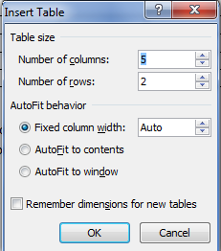
You can use existing table styles or create your own
A Table
Cell

City or Town | Point A | Point B | Point C | Point D | Point E
Point A | —
Point B | 87 | —
Point C | 64 | 56 | —
Point D | 37 | 32 | 91 | —
Point E | 93 | 35 | 54 | 43 | —

Split a table
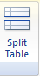 | - Select split table in LAYOUT (Word 2007)  - Select the row  - The selected row will become the first row of the newtable

Cell

Uses – many examples
- Display text and data
- Create simple and professional forms that others can complete via a link
- Organise the elements on a page for complex documents like presentations and reports

Tables used as blocks or groups of information

3.2 – Format rows and columns as required

Formatting rows and column may include:
- Auto distribute
- Fills/shading
- Lines and borders
- Merge cells
- Sorting contents
- Split cell
- Text direction
Auto distribute | 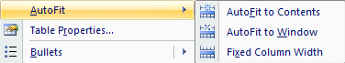
Long text | Longer, longer text | Text

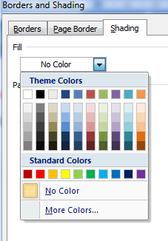
Fills/shading

Lines and borders
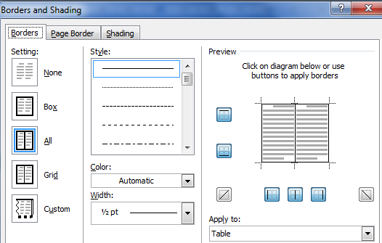

Merge cells
EXAMPLE SEPARATE CELLS
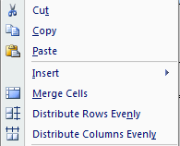
Highlight the table above and select MERGE CELLS from the selection below:

RESULT MERGED CELLS

Sorting contents
- Under Layout tab, in the Data group, click Sort.
- In the Sort dialog box, select the options that you want.
CONTENTS | CONTENTS | CONTENTS
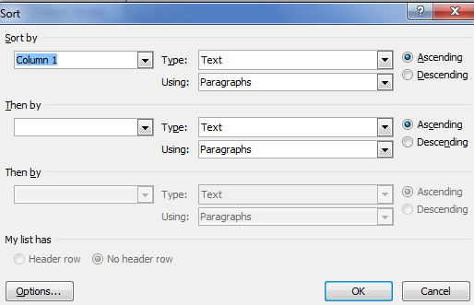

Split cell
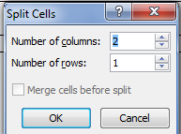

See 3.1. Insert a standard table into document, changing cells to meet information requirements

Text direction

This is right to left
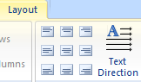
This is top
to bottom

text | text | text | text

3.3 – Insert images and other data, formatting as required

Other data may include:
- Clip art
- Data from other software applications
- Digital photographs
- Files
- Graphics
- Quotes
- References
- Scanned photographs and logos
- Tables, graphs and charts
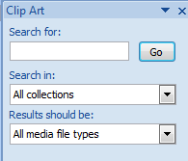  Clip art   |   

Activity 3A

4. Produce documents

4.1 Use complex operations to develop documents, and achieve required results
4.2 Preview, adjust and print documents in accordance with organisational and task requirements
4.3 Name and store documents in accordance with organisational requirements and exit application without information loss/damage
4.4 Prepare documents within designated timelines and for speed and accuracy

4.1 – Use complex operations to develop documents, and achieve required results

- Complex operations to develop documents could include a variety of options and functions
- Many, you have already covered
What do you consider a ‘complex’ document operation to be?
Your Answer:

Another view:
- Complex documents are usually documents that result from or contribute to some WORKPLACE process which is reflected in their operational structure.
- Complex document operations are often assembled in parts or sections containing many kinds of document sub-structures such as tables, footnotes, equations, graphics, watermarks, etc.
- Here is a short list of some pertinent operations that in some cases could be viewed as ‘complex’ and to others as straight forward.
Function | What it does
Data transfer | Transferring data between two applications or importing data into any application. The speed with which data can be transmitted from one device to another. Data rates are often measured in megabits (million bits) or megabytes (million bytes) per second. These are usually abbreviated as Mbps and MBps, respectively.
Display features | The Document Map in Word 2007 provides easy navigation in long documents. You can jump around your document by headings or pages. It also provides a bird’s-eye view of your document’s structure.
Embedding | Instead of linking files together, you can include one or more documents directly into another file.
Exporting | Very often it's needed to view or print a document on different computers and platforms. In this case you can export the document in PDF format. By exporting the document, you can easily share it with many people.
Fields | A space allocated for a particular item of information. In database systems, fields are the smallest units of information you can access. In spreadsheets, fields are called cells.
Form fields | When you integrate web forms on your site to a CRM you start by creating Form Fields records in CRM to represent the various fields you have on your web site.
Formulae | Formulas in spreadsheet programs such as Excel are used to perform calculations.  Formulas can range from basic mathematical operations – such as addition and subtraction – to complex engineering and statistical calculations.
Importing | The flip side of exporting is importing. Importing refers to the ability of an application to read and use data produced by a different application. Importing implies that the receiving application does the reformatting.
Index | A database index is a data structure that improves the speed of data retrieval operations on a database table at the cost of slower writes and increased storage space. Indices can be created using one or more columns of a database table, providing the basis for both rapid random lookups and efficient access of ordered records
Linking | To paste a copy of an object into a document in such a way that it retains its connection with the original object. Updates to the original object can be reflected in the duplicate by updating the link.  In spreadsheet programs, linking refers to the ability of a worksheet to take its data for particular cells from another worksheet. Two or more files are thus linked by common cells. A database link defines a one-way communication path from one Database server to another database server.
Macros | A symbol, name, or key that represents a list of commands, actions, or keystrokes. Many programs allow you to create macros so that you can enter a single character or word to perform a whole series of actions. Suppose, for example, that you are editing a file and want to indent every third line five spaces.
Merge criteria | To combine two files in such a way that the resulting file has the same organisation as the two individual files. For example, if two files contain a list of names in alphabetical order, merging the two files results in one large file with all the names still in alphabetical order.
Sort criteria | Sorting is one of the most extensively researched subjects because of the need to speed up the operation on thousands or millions of records during a search operation. The main purpose of sorting information is to optimise its usefulness for specific tasks. In general, there are two ways of grouping information.
Table of contents | A table of contents is a list of the headings in a document. You can use a table of contents to get an overview of the topics discussed. If you are creating a document for the Web, you can put the table of contents in a Web frame so that you can easily navigate through the document.

Activity 4A

4.2 – Preview, adjust and print documents in accordance with organisational and task requirements

Printing may include:
- Print merge
- Print to file
- To fit specific number of pages
- With comments
- With drawing objects
- With field codes
- With hidden text

Preview, adjust and print documents
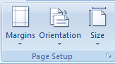
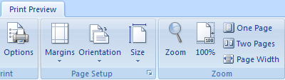
Preview

Adjust

Print
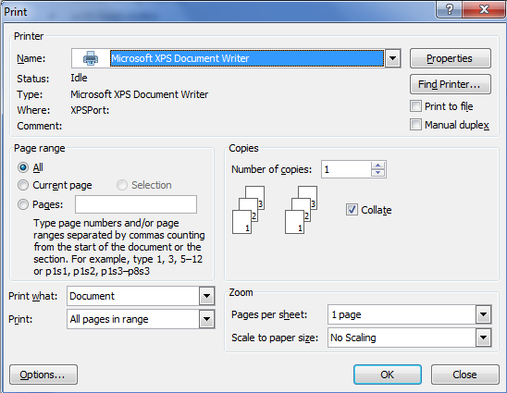

Functions
- Print Merge is a function of Corel DRAW.
- Ideal for creating and printing tickets, labels, certificates, or similar documents with serial numbers.
- With Print Merge, Corel DRAW can automatically merge a drawing with information in a text file and send the result to a printer.
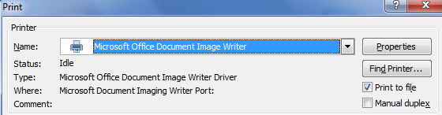
Print to file
- When you print to file, you save spacing and other layout information so a printer can reproduce the on-screen version of a file without access to the program or computer used to create it.
- You can print to file, for example, when you want to send a document or photo to a commercial printer to be printed in larger quantities or at a higher resolution than you usually print at home.
- In most programs, a "print to file" option is available from the Print dialog box for the program that you're using. To see steps for printing an item to a file, check the information that came with the program you are using.
Print with comments
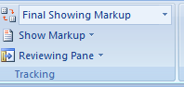
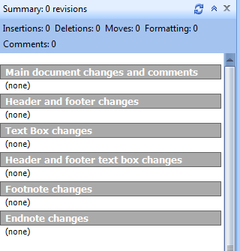
Print with hidden text
Office button|Word Options|Display|Printing Options|Print Hidden Text
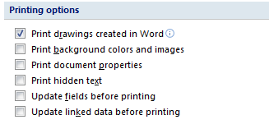
Insert check mark for this option

Activity 4B

4.3 – Name and store documents in accordance with organisational requirements and exit application without information loss/damage

Naming and storing documents may include:
- Authorised access
- File names according to organisational procedure e.g. Numbers rather than names
- File names which are easily identifiable in relation to the content

- File/directory names which identify the operator, author, section, date etc.
- Filing locations
- Organisational policy for backing up files
- Organisational policy for filing hard copies of documents
- Security
- Storage in folders/sub-folders
- Storage on hard/floppy disk drives, cd-rom, tape back-up

File names
- A file name extension is a set of characters added to the end of a file name that determine which program should open it.
- It is called an extension because it appears at the end of the file name, following a full stop.
- In the file name myfile.txt, the extension is txt.
- It tells Windows that this is a text file that can be opened by programs associated with that extension, such as WordPad or Notepad.
- By default, Windows Explorer hides file name extensions in Windows 7 and earlier versions of Windows.
- However, you can make file name extensions visible.

File name issues
- Windows usually limits file names to 260 characters.
- But the file name must actually be shorter than that, since the complete path (such as C:\Program Files\filename.txt) is included in this character count. This is why you might occasionally encounter an error when copying a file with a very long file name to a location that has a longer path than its current location.

Characters
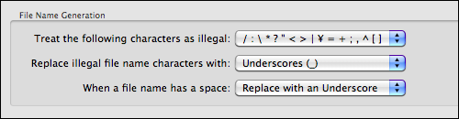

File names which are easily identifiable in relation to the content
Consider:
- Using file names that begin with an alphabetic code or keyword that identifies you as the owner.
- Use your initials or your name and should be consistent for all of your files.
- Because your initials or name are not likely to vary, they make an excellent front-end identifier for your files.
- Include the date which will be used to sort files or images chronologically.
- If content is important, include a descriptor such as, Sales, Mkt, Prod or "MTG" for meeting or "ACTG" for accounting.
- This makes the file names more descriptive, and you can more easily find files through the search function.
- The degree by which you identify the file name is what will be important to you for ease of identification, but watch for issues with FILE LENGTH.
It is a good idea to make your file names descriptive through the use of keywords
- Keywords in file names should follow the date and should appear with the broadest keyword first, narrowing in specificity with each subsequent keyword.
- Keywords should be separated by underscores.
- Use common names. Name your files and folders with easily found names, such as model numbers, project names, or the project lead in the title.
For example:
Marketing newspapers
For image files, as there are likely to be many more, end the file name with a three or four-digit sequence, e.g., 0001, 0002, 0003 etc.

What are Your Storage Needs?
- All organisations, large and small, need more space for data storage.
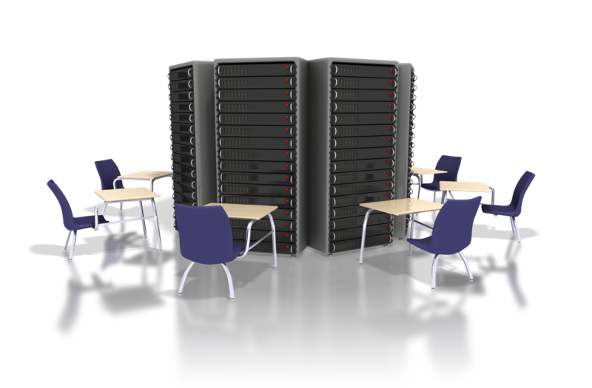
- Documentation in the form of e-mails, word documents, presentations, databases, graphics, audio files and excel spreadsheets is the lifeblood of most organisations.
- As the applications that run and protect your business require more and more memory and space so does the growth of storage options and storage protocols.
- The protocols and procedures for saving files, storing and backup are usually part of an operating policy so the organisation can minimise loss of data.
- Assess your storage needs associated with each application, the data it is producing and how and where you will access that data.
Store like with like.
- Restricting folders to a single document type (or predominantly one type) makes it easier for you to find files.
For example:
- With all of your graphics or photos files in a single directory—or in a single library in Windows 7—it's easy to use the slide show feature in Windows Explorer to find the right picture for your newsletter.
- You can also use libraries in Windows 7 to group files together for easier searching without moving them into the same place or use the Arrange by command to sort files by criteria, such as author, date modified, and type.
- These criteria can change based on the file type (documents have different Arrange by criteria than photos, for example).

Avoid large folder structures
- If you need to put so many subfolders in a folder that you can't see all of them at a glance, consider creating an alphabetic menu.
- Don't save unnecessary files. Be selective about the files you keep.
- You probably don't need to keep them all.
- With email, for example, you don’t need to keep everything you receive.

Use shortcuts and shortcut links instead of multiple copies
- If you need to get to the same file from multiple locations, don't create copies of the file, create shortcuts to it instead.

- Shortcuts are links to files or programs and are represented by icons with an arrow in the lower-left corner.
- To create a shortcut, right-click the file and then click Create Shortcut. You can drag the shortcut to other locations.
- Put Documents on the desktop using a shortcut to the file.
- To create a shortcut, right-click the Documents folder and then click Create Shortcut.
- With a shortcut you will save time and get to where you want to sooner.

Colour-code your folders
- Use a third-party program which allows you to "colour" certain folders in Documents. This helps you find your documents even more quickly and is especially useful with folders that you use every day.

Quickly get to the items you use every day
- RECENT lists or in trendy jargon, “Jump Lists” is a feature in Windows 7, and are lists of recently opened items, such as files, folders, or websites that are organised by the program that you use to open them.
- You can use RECENT view to open items and you can even pin favourites to a recent view list.
- To see a list of those files you have recently opened, for a particular program, right-click the program listed on the taskbar.

Consider storing documents online
- You can also keep documents online using a variety of ‘cloud’ style storage options. Microsoft SharePoint 2010 site or Windows Live SkyDrive
- Windows Live SkyDrive allows you to create folders on the site and upload files to it. You can share any of your folders with colleagues, as well. The site's design is simple and straightforward.
- You can easily access them from outside the office, share them, and edit them online by using Office Web Apps.
Microsoft Office 2010 includes some built-in shortcuts with the new Backstage view. To see Backstage view, open an Office file and then click the File tab.
- In Backstage view, click the Recent tab for a list of links to your recent documents.
- The Recent tab even includes a Recover Unsaved Documents option.
- In Backstage view, you can create, save, and send documents, inspect documents for hidden metadata or personal information, set options, and more.
Storage on hard/floppy disk drives, Thumb Drives, CD-ROM, tape back-up and other devices
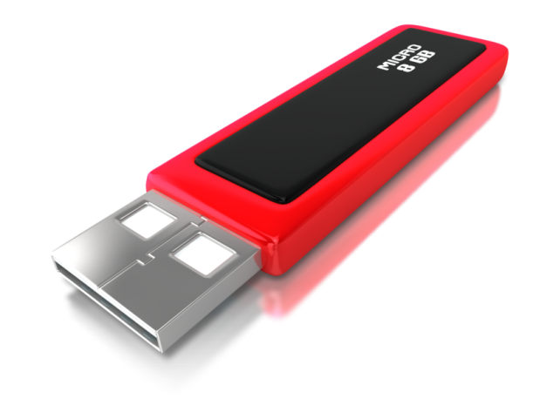
Develop a Plan
- Before investing in a data storage solution, consult with a trusted IT advisor on which option--or options--will best meet your business's current and future needs. Then create a plan for storage at your organisation and base it on the likely needs you will have and most importantly, when and where it will be needed.
Flash memory thumb drives
- These types of drives are particularly appealing to mobile professionals because they consume little power, are small enough to fit on a keychain and have no moving parts.
External hard drives
- A simple and relatively inexpensive way to add more storage is to connect an external hard disk drive to your computer.
- The danger is that files stored on the external drive but not elsewhere will need to be backed up.
- Remember...you will need to take the external drive with you or remember to copy the required files to a USB thumb drive.
CD or some other storage media
- Not very safe, can easily be damaged or lost.
- Small storage capacity compared to thumb drives, or external drives
Online storage
- Online storage is a far easier method of storing and more easily accessible as long as you have internet connection.
- By backing up your most important files to a secure, remote server, you are protecting the data stored at your organisation.


Activity 4C

4.4 – Prepare documents within designated timelines and for speed and accuracy


Designated timelines may include:
- Timeline agreed with internal/external client
- Timeline agreed with supervisor/person requiring spreadsheet
- Organisationaltimeline e.g. Deadline requirements

Organisational timeline
The application and discipline of compliance to timelines are like other organisation specifications and will depend entirely on your organisation requirements.
To please the client
- Timelines are often made because the client wants a particular piece of work by a certain point in time.
- Sometimes timelines are almost impossible to meet. If it really is impossible to meet, then you should point this out as early as possible in the process so that adjustments can be made.
- One of the reasons for setting a timeline is to ensure that a particular project is completed before another is started.
- If you don’t manage to meet one deadline the other may not be able to proceed or is delayed which can cause unnecessary expense.
The impact on this is totally dependent on the ‘task’ as a one page Word doc is not likely to bring down the company if it’s late.
Designated timelines may be:
- Daily
- As requested
- By month end
- Monthly
- Within agreed period
- Within organisational deadline
General administration timelines can be met if you observe common sense principles:
- Determine when the task must be accomplished by you.
- This becomes your end point on the timeline.
- Calculate how long you have from the current date until the deadline arrives.
- Write down specifically what needs to be done by the deadline.

Using technology to complete documents in designated timelines
- Using online or computer diaries
- Exchange of emails between those who need the documentation and you
- This will produce the fastest way of complying with timelines without any errors
- Commit to memory or schedule in a manner that you feel comfortable with


Activity 4D

Skills and Knowledge Activity

Nearly there...

Major Activity – An opportunity to revise the unit

At the end of your Learner Workbook, you will find an activity titled ‘Major Activity’. This is an opportunity to revise the entire unit and allows your trainer to check your knowledge and understanding of what you have covered. It should take between and 1-2 hours to complete and your trainer will let you know whether they wish for you to complete it in your own time or during the sessions. Once this is completed, you will have finished this unit and be ready to move onto the next, well done!

Congratulations!

You have now finished the unit ‘Design and develop complex text documents’


References

These suggested references are for further reading and do not necessarily represent the contents of this Learner Guide

- Microsoft Word 2010 Plain & Simple [Paperback], Katherine Murray (Author)

- Microsoft Word 2010 Step by Step (Step by Step (Microsoft)) [Paperback], Joyce Cox (Author), Joan Lambert III (Author)

- Special Edition Using Microsoft Office Word 2007 [Paperback], Faithe Wempen (Author)

- Microsoft® Office Word 2007 Step by Step (Step By Step (Microsoft)) [Paperback], Joyce Cox (Author), Joan Preppernau (Author)

- Word Processing Applications: Basic Activities [Spiral-Bound], Jo Ann Lee (Author), Shelley Gaskin (Author)

- Word Processing (Gem) [Illustrated] [Paperback], Marjorie Lazaro (Author)

