CPCCBC4010B
Apply structural principles to residential low rise constructions

CPCCBC4011B
Apply structural principles to commercial low rise constructions

THEORY EXAM INSTRUCTIONS

- This exam will occur under standard assessment conditions.
  - An oral examination may be allowed under certain circumstances.
Answers will be documented and FT003 (Oral examination declaration form) must be completed.
- Participants must provide enough detail in their responses to demonstrate their knowledge and skills.
- Please fill in the details below, providing your name, signature and date of assessment.
  - Your signature acknowledges that this is your own work.
- If a participant initially answers a question incorrectly but modifies their response, they must follow the instructions below:
  - If a participant changes their response in writing, they must put their initials next to the written change.
  - If a participant changes their response verbally, this must be noted on the exam paper by the assessor.

Participant name | Karl Lemiszczuk
Participant signature | 

Assessor name
Assessor signature | 

Date | 5/12/2018

Number of questions | Number of questions answered correctly | Satisfactory?
134 |  | Yes | No
Assessor Comments
- What are the four (4) primary loads which a structure must resist?

Answer | Dead loads (fixed vertical)  Live loads (variable but mostly vertical)  Negative and Positive wind loads (variable but mostly horizontal)  Hydrostatic pressure from water pressure in the ground

Refer to the table shown below to respond to Q2. to Q3.

Live loads for floors as per building usage | Uniformly distributed load (kPa or kN/m²)
Houses | 1.5
Flats, motel bedrooms, apartments | 2.0
Offices | 3.0
Workshops | 5.0
Parking, vehicle >2.5t | 5.0
Hospitals, school assembly areas with fixed seating | 3.0
Dance halls, bars, lounges | 5.0

- Calculate the live load of a dance hall measuring 23m x 8m.
Show your calculations.

Answer | Area of floor = 23 m x 8 m = 184 m2  Live load rating of a dance hall = 5.0 kPa  Therefore, live load of floor = 184 m2 x 5.0 kPa = 920 kN

- Calculate the live load of a commercial office premises floor measuring 33m x 11m. Show your calculations.

Answer | Area of floor = 33 m x 11 m = 363 m2  Live load rating of a office = 3.0 kPa  Therefore, live load of floor = 363 m2 x 3.0 kPa = 1089 kN

- What happens when wind flows around a building?

Answer | Wind flows onto the building with positive pressure, flows over the building an can create negative pressure which can cause suction on the building.

- Explain the difference in pressure exerted by wind on a building, as compared to a wind vortex.
What must be done to the building structure to prevent it being blown away?

Answer | Wind causes horizontal loads on the building, where wind vortex causes up and down (vertical)  So building to prevent all these wind loads causing damage u need to install bracing, and anchor it to the ground eg- Knee bracing, K-bracing, cross bracing. Installing shear walls/ lift shafts. Tie down bolts, metal strapping or bracing timber studs.

- What are some of the factors to be considered for wind loadings?

Answer | Wind loads on components/cladding are calculated on the basis of fluctuating wind forces acting on a small part. Wind resistant design for components/cladding has been inadequate until now. They play an important role in protecting the interior space from destruction by strong wind

- Explain the term ‘load path’ in reference to a building.

Answer | The load path is simply the direction in which each consecutive load will pass through connected members. The sequence commences at the highest point of the structure working all the way down to the footing system, ultimately transferring the total load of the structure to the foundation.  Ultimately, the lowest structural member must be strong enough to support all members above it. This is why engineers often design the uppermost members first and progressively work their way down the structure following the load path.

Please refer to the information below in responding to Q8. to Q14.

There is a building 21 metres long x 10 metres wide x 8 metres high with a 25⁰ pitched gable roof.
The rafter line on the metal clad roof measures 5.5 metres on the rafter line, that is, from the fascia/gutter line up to the ridge line.

The wind load rates are as follows:
- Windward wall is 21 metres long x 8 metres high with a wind load rate of +1.5KN/m²;
- Leeward wall 21 metres long x 8 metres high with a wind load rate of -0.8kN/m²;
- Windward roof with a wind load rate of +0.8kN/m²; and
- Leeward roof with a wind load rate of -1.5kN/m²

- What is the wind load rate for the windward wall? Tick your response.

Answer | Choice | Possible Answers
 | ☐ | +1.5kN/m²
 | ☐ | -1.5kN/m²
 | ☒ | +0.8kN/m²
 | ☐ | -0.8kN/m²

- What is the wind load rate for the leeward wall? Tick your response.

Answer | Choice | Possible Answers
 | ☐ | +1.5kN/m²
 | ☒ | -1.5kN/m²
 | ☐ | +0.8kN/m²
 | ☐ | -0.8kN/m²

- What is the wind load of the windward wall (Area of wall x wind load rate)? Tick your response.

Answer | Choice | Possible Answers
 | ☐ | -252kN
 | ☐ | 134.4kN
 | ☒ | 252kN
 | ☐ | 86.4kN

- What is the wind load for the leeward wall (Area of wall x wind load rate)? Tick your response.

Answer | Choice | Possible Answers
 | ☒ | -134.4kN
 | ☐ | -94.2kN
 | ☐ | 252kN
 | ☐ | 134.4kN

- What is the wind load rate for the windward roof? Tick your response.

Answer | Choice | Possible Answers
 | ☒ | +0.8kN/m²
 | ☐ | -43.2kN/m²
 | ☐ | -1.5kN/m²
 | ☐ | +1.5kN/m²

- What is the wind load for the leeward roof? (Area of roof x wind load rate). Tick your response.

Answer | Choice | Possible Answers
 | ☒ | -173.25kN
 | ☐ | 92.4kN
 | ☐ | 173.25kN
 | ☐ | -134.4kN

- What is the wind load for the windward roof? (Area of roof x wind load rate). Tick your response.

Answer | Choice | Possible Answers
 | ☐ | 252kN
 | ☐ | -92.4kN
 | ☐ | -252kN
 | ☒ | 92.4kN

- What are the main structural principles that apply to residential and commercial low rise structure erection and demolition?

Answer | You must carry out all demolition work of existing structures in accordance with legislative and planning requirements. And follow the building Act 1993 of which the following arises.  You must get a demolition permit  Assistance to complete the application process by a building surveyor  Get a planning permit (if within a heritage overlay)  Structural principles - Demolition  Any work that is connected with the demolition of a structure is classified as ‘construction work’ under the WHS Regulations. When carrying out demolition work, the requirements relating to construction work must be complied with. Refer to the Demolition work – Code of Practice  For hazardous chemicals, exposure standards must not be exceeded. These are set out in the Workplace Exposure Standards for Airborne Contaminants, and should also be listed in the manufacturer’s Safety Data Sheet (SDS).

- How is the classification of a building (or part of a building) determined?

Answer | The classification of a building or part of a building is determined by the purpose for which it is designed, constructed or adapted to be used.

- Refer to the BCA A3.2 building classes and give the classification definition for the classes of buildings listed in the table below.

Answer | Class | Classification definition
 | 1 | Class 1:  one or more buildings which in association constitute—  - Class 1a — a single dwelling being—  - a detached house; or  - one of a group of two or more attached dwellings, each being a building, separated by a fire-resisting wall, including a row house, terrace house, town house or villa unit; or  - Class 1b —  - a boarding house, guest house, hostel or the like—  - with a total area of all floors not exceeding 300 m2 measured over the enclosing walls of the Class 1b; and  - in which not more than 12 persons would ordinarily be resident; or  4 or more single dwellings located on one allotment and used for short-term holiday accommodation, which are not located above or below another dwelling or another Class of building other than a private garage.
 | 2 | Class 2:  a building containing 2 or more sole occupancy units each being a separate dwelling
 | 3 | Class 3: a residential building, other than a building of Class 1 or 2, which is a common place of long term or transient living for a number of unrelated persons, including—  - a boarding house, guest house, hostel, lodging house or backpackers accommodation; or  - a residential part of a hotel or motel; or  - a residential part of a school; or  - accommodation for the aged, children or people with disabilities; or  a residential part of a health-care building which accommodates members of staff; or a residential part of a detention centre.
 | 4 | Class 4: a dwelling in a building that is Class 5, 6, 7, 8 or 9 if it is the only dwelling in the building.
 | 5 | Class 5: an office building used for professional or commercial purposes, excluding buildings of Class 6, 7, 8 or 9.
 | 6 | Class 6: a shop or other building for the sale of goods by retail or the supply of services direct to the public, including-  - an eating room, café, restaurant, milk or soft-drink bar; or  - a dining room, bar area that is not an assembly building, shop or kiosk part of a hotel or motel; or  - a hairdresser’s or barber’s shop, public laundry, or undertaker’s establishment; or  - market or sale room, showroom, or service station.
 | 7 | Class 7:  a building which is—  Class 7a — a carpark; or (b) Class 7b — for storage, or display of goods or produce for sale by wholesale.
 | 8 | Class 8:  a laboratory, or a building in which a handicraft or process for the production, assembling, altering, repairing, packing, finishing, or cleaning of goods or produce is carried on for trade, sale, or gain.
 | 9 | Class 9:  a building of a public nature—  - Class 9a — a health-care building, including those parts of the building set aside as a laboratory; or  - Class 9b — an assembly building, including a trade workshop, laboratory or the like in a primary or secondary school, but excluding any other parts of the building that are of another Class; or  Class 9c — an aged care building.
 | 10 | Class 10:  a non-habitable building or structure—  - Class 10a — a non-habitable building being a private garage, carport, shed, or the like; or  - Class 10b — a structure being a fence, mast, antenna, retaining or free-standing wall, swimming pool, or the like; or  Class 10c — a private bushfire shelter.

- What is the purpose of understanding loads on a building?

Answer | Structural loads are an important consideration in the design of buildings. Building codes require that structures be designed and built to safely resist all actions that they are likely to face during their service life, while remaining fit for use. An to understand the types of loads brought onto the building, For example. Dead loads: Such as the fixtures and structural elements.  Live loads: Such as occupants, furniture, traffic.  Environmental loads: Such as wind, snow, earthquake, settlement.

- Forces are represented as vectors and have three (3) properties.
Name these properties.

Answer | Magnitude: The size of the force.  Direction: The direction in which the force is acting.  Position: The position on which the force acts.

- How can you best visualise where a building’s loads are being transmitted (felt) on the structural elements of the building?

Answer | Dead loads: Such as the fixtures and structural elements.  Live loads: Such as occupants, furniture, traffic.  Environmental loads: Such as wind, snow, earthquake, settlement.

- What do the structural members of a building consist of?

Answer | Structural members are the primary load bearing components of a building, and each have their own structural properties which need to be considered. Such members include:  Beams: Horizontal members which transfer loads to supports.  Columns: Vertical members which transfer compressive loads to the ground.  Bracing: Members that interconnect and stiffen columns and beams.  Roof trusses: Load-bearing frames constructed of connected triangular shapes.  Retaining walls: Support soil where a sloping site requires excavation.  Concrete slabs: Span horizontally between supports, used as floors and sometimes as roof systems.  Footings: Transfer load from the structure to the foundations.

- What are the two (2) main principles of structural effectiveness for structural members when considering the shape and type of material to use?

Answer | In any building design, the strength and stability of an overall building and its individual components must be considered

- Explain the beam types listed in the table below.

Answer | Type | Explanation
 | Simply supported beam | Simply supported – a beam supported on the ends which are free to rotate and have no moment resistance.
 | Continuously supported beam | A beam extending over more than two supports.
 | Cantilevered beams | Cantilevered beam is fixed at one end allow the rest of the beam to continue unsupported

- Explain the terms listed in the table below.

Answer | Term | Explanation
 | Strength | the capacity of an object or substance to withstand great force or pressure
 | Hardness | the quality or condition of being hard.
 | Toughness | the state of being strong enough to withstand adverse conditions or rough handling
 | Elasticity | the ability of an object or material to resume its normal shape after being stretched or compressed; stretchiness.
 | Plasticity | the quality of being easily shaped or moulded
 | Ductility | Ductility is a physical property of a material associated with the ability to be hammered thin or stretched into wire without breaking. A ductile substance can be drawn into a wire. Examples: Most metals are good examples of ductile materials, including gold, silver, copper, erbium, terbium, and samarium
 | Brittleness | A material is brittle if, when subjected to stress, it breaks without significant plastic deformation. Brittle materials absorb relatively little energy prior to fracture, even those of high strength. Breaking is often accompanied by a snapping sound.
 | Malleability | Malleability is the quality of something that can be shaped into something else without breaking, like the malleability of clay. Malleability — also called plasticity — has to do with whether something can be molded

- Discuss the terms compression, tension and shear forces when applied to materials and structural members of a building.

Answer | Term | Explanation
 | Compression | Two pushing (opposing) forces that squeeze an object trying to compress it (for example, standing on a soda can, squeezing a piece of wood in a vise – both the can and the wood are in compression or are "being subjected to a compressive load"
 | Tension | Two pulling (opposing) forces that stretch an object trying to pull it apart (for example, pulling on a rope, a car towing another car with a chain – the rope and the chain are in tension or are "being subjected to a tensile load"
 | Shear | Two pushing or pulling adjacent forces, acting close together but not directly opposing each other. A shearing load cuts or rips an object by sliding its molecules apart sideways (for example, pruning shears cutting through a branch, paper-cutter cutting paper - the branch and paper are "subjected to a shear loading"

- What is a column and how does it transmit load forces?

Answer | Walls, like columns, transmit loads by compressive force to the floor below, another wall, or earth through the foundation wall. The wall unit will react to force like a long slender column. A wall may also be required to act like a beam, resisting flexing force such as a wind load.

- Is a column, stump or post in compression, tension or shear?
Explain your answer.

Answer | Gerenally a column is Vertical an is under compression, with the forces transferring from the top to bottom.

- Explain the letters ‘CHS’ and ‘SHS’ with reference to columns, pillars, posts/stumps and stanchions as vertical (usually steel or concrete pipe) support members subjected to compressive loads.

Answer | CHS is Circular hollow section  SHS is square hollow section

- Explain the terms listed in the table below with relation to structural performance of columns.

Answer | Term | Explanation
 | Axially load column | The Axial loaded column transmits the compressive force without an explicit design requirement to carry lateral loads or end moments. Or when the line action of the load passes through from the centre of gravity of the column, it is called Axially loaded column.
 | Non-axially loaded column | When the load acting on the column is offset from the centre of the column, then it establishes the bending of column along with the axial stress. ... Eccentric loading will not be at the middle of cross-section of the column
 | Buckling | When a structure is subjected to compressive stress, buckling may occur. Buckling is characterized by a sudden sideways deflection of a structural member.
 | Slenderness ratio | Slenderness ratio is the ratio of the length of a column and the least radius of gyration of its cross section. Often denoted by lambda. It is used extensively for finding out the design load as well as in classifying various columns in short/intermediate/long.
 | End fixity and effective length | The term for the type of end fixing is end fixity and this affects the way a column buckles. The length of a column which may buckle is defined as the effective length. ... The equation used to calculate the effective length of the column is L = 2 h. Notice that the less a structure is fixed, the more it will buckle.

- How will bearers, joists, lintels, beams or girders transmit load forces?

Answer | All the bearers, joist, lintels, beams or girders transmit load forces down into the footings.

- How do floor boards transmit load forces? Explain with reference to residential and commercial low rise structures.

Answer | Loads on floor boards in res or commercial low rise structures spread there load across the floor, so the joist will pick that load up an send it down the bearer and into the foundation.

- How do walls, floors, and roofs transmit load forces?

Answer | Loads work there way down the roof trusses, into the supporting walls, onto the floor, which the joist an bearers pick it up, sending it down into the foundations.

- Explain what load imposition from torsion (twisting) can do to a building’s structure.

Answer | Torsion produces shear stresses inside the material. Created when a moment or "turning force" is applied to a structural member (or piece of material) making it deflect at an angle. Thus shift the structure outa shape. Can cause the load in the area to be not transmitted into the foundation, an cause major issue to the structure in the area of the torsion material.

- Explain what retaining walls are and what is critical to their sufficiency of structure.

Answer | A retaining wall is a structure built to retain a difference in ground level. An the critical point for been a great structure is the foundation, so to have a plan in place. Get approvals if needed over 1m… An get engineer designs done if retaining over 1m,

- Draw two separate hand sketches to explain the difference between a batter and a retaining wall.

Answer
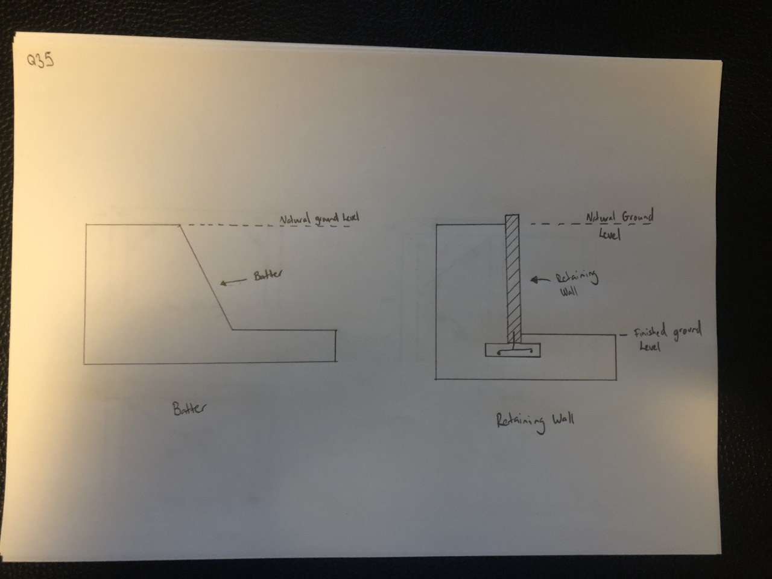

- Explain the differences between an inclined retaining wall, a gravity retaining wall and a cantilevered retaining wall.

Answer | Inclined retaining wall design is a very economical solution to retain earth. They are a gravity retaining that has less mass due to the inclined design.  A gravity retaining wall resists the earth pressures by it’s self-weight. The front edge of the gravity wall to the COG x the weight determines the resistance to over-turning.  A cantilever retaining wall uses the counter-moment produced by the toe of the wall which must be sunk into the ground at a depth suitable to resist the opposing earth pressure.

- What is a ground level concrete slab floor?

Answer | Slab on ground- A ground level slab is a large flat stretch of concrete, usually between 100 – 500mm thick which forms the foundation of your house.

- What is a slab subfloor made of?

Answer | Reinforced rebar and mesh and concrete

- What should you consider when selecting the type of slab floor?

Answer | There are several different variations in slabs. The type of slab you’ll need will depend on the type of soil you’re building on, and how reactive it is.

- Name and describe each of the general soil classifications that are followed in Australia.

Answer | Class A - This denotes very 'stable' ground - mostly sand and rock, not affected by moisture  Class S - Slightly reactive soil, slight movement due to moisture  Class M - Moderately reactive soil, moderate movement due to moisture  Class H - Highly reactive soil, a high amount of movement due to moisture  Class E - Extremely reactive soil, extreme movement due to moisture  Class P - 'Problem' soil, which experiences land slip, mine subsidence and so forth. If you are building on Class P site you will typically need to consult an engineer.

- What purpose does the soil report serve? Who prepares a soil report?
Which Australian Standard (AS) will be relevant to the soil report?

Answer | Soil testing is an absolutely fundamental step before the commencement of any construction project. Getting your soil tested not only gives you useful information about what exactly you are building on, but it also ensures that you do not encounter any hazardous risks or complications in your project in the long run.  Soils reports, also called “geotechnical soils reports” are prepared by a licensed geotechnical engineer or a registered civil engineer experienced in soils engineering.  AS 1726:2017

- There are many different types of on-the-ground concrete slabs. Write a brief description for those listed in the table below.

Answer | Term | Explanation
 | Slab on ground | The slab on the ground is constructed similar to the stiffened raft, however, it does not require internal stiffening beams and can only be constructed on Class A or Class S sites
 | Stiffened raft slab | The stiffened raft slab is the same as a slab on ground, but with a centre stiffing beam. The stiffened raft configuration can be used on all classes of sites (except problem sites - Class P)
 | Waffle raft slab  (aka waffle pod slab) | Waffle raft slab construction is quite different from stiffened raft and footing slab structures. The slab ribs are formed on top of the ground using a grid of polystyrene void forms. These are laid out on a levelled area. The construction is ideally suited to very reactive clay sites. It does not have the problems associated with stiffened raft slabs, which have their beams embedded in the reactive clays.
 | Pier and slab | On sites with more reactive soils, it's common for concrete piers to be sunken into the soil to improve stability. This is normally done by digging holes at intervals and depths determined by an engineer, then pouring concrete into them and attaching the slab to these piers.

- Briefly explain how a concrete slab sub-floor is installed.

Answer | For a standard slab on the ground, first the site is scraped back to the soil, keeping it as level as possible and ridding it of all plant matter. Then, formwork is put up around the edges of the slab to prevent the concrete from spreading. Trenches are dug around the edges for all stiffening beams, and bedding sand is laid down to level things out. A plastic vapour barrier is used to coat the site and prevent dampness from rising through the slab. Rebar or mesh is then spread out to cover the area. In some situations a layer of gravel may be laid down to provide a solid base. The concrete is then poured on top, spread out and levelled.

- Where are ground-level concrete slab sub-floors used?
What are the advantages and disadvantages concrete slab sub floors over conventional timber or steel sub-floor framing on stumps/posts with strip or sheet flooring?

Answer | Ground slabs are very common these days and can be found almost anywhere in Australia where there is ready access to concrete. These foundations are generally used to support heavier building materials like brick and steel.  Advantages  Extremely durable and hardy base for a floor  Typically well insulated, because the underside of the floor is not exposed  No maintenance once the concrete has cured  Disadvantages  Impossible to access piping once the slab has cured  Cracks can cause major structural damage, and may be unrepairable  Can increase unwanted noise

- Explain the terms listed in the table below.

Answer | Term | Explanation
 | Foundation movement | Movement caused by loading is typically associated with the foundation transmitting the load to the soils than the soils can support. The movement is similar to settlement, downward movement.
 | Slab bending | When there is foundation movement because of reactive soils, the slab will bend. The resulting movement is classified as either dishing or doming. The type of bending will determine where steel reinforcement needs to be placed in the concrete slab.  A ground slab may experience dishing in very wet conditions. The soil expands with the extra moisture which exerts stress on the slab. A ground slab is most likely to experience doming. As the sun dries the soil, moisture moves under the slab and creates an area of soil expansion. Diagram of doming occurring to a slab.  Doming of a slab results in tensile stress in the upper surface of the slab. This means that the steel reinforcement should be placed in the upper area of the slab.
 | Stiffening beams | The design of the arrangement of stiffening beams is influenced by the reactivity of the foundation soils. Ground slabs are typically constructed with stiffening beams which are placed along the perimeter of the slab.  Alternatively ground slabs form a grid pattern which is spaced along the entire length and width of the concrete slab.

- Buildings are usually designed to support the vertical loads created by dead and live loads. They also need to be able to resist lateral loads from wind and vortex loads. In building we use numerous techniques to overcome this problem.
Briefly explain the three common cable bracing techniques and sketch diagrams to explain your answer.

Answer | Most buildings are designed strongly enough to support the vertical loads created by dead loads and live loads. However, they also need to be able to resist lateral loads from wind loads. Wind can blow against (positive pressure) and can create a vortex by pulling (negative pressure). Numerous techniques can be used to counter the force from wind.  Diagonal bracing  Diagonal components of bracing interconnect and stiffen columns and beams. The main types of bracing are shown. Two cables must be used for cross bracing to stabilise the structure. Can use Knee Bracing, K Brace and Cross bracing.

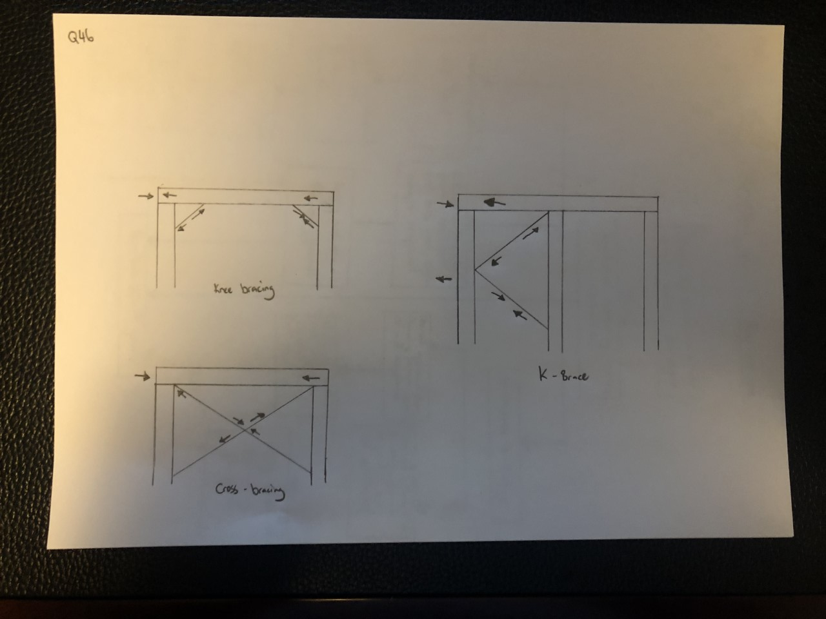

- Different bracing systems are used in residential and commercial construction which when operating together contribute to bracing a building against lateral wind, vortex and other forces.
Explain the bracing systems listed in the table below.

Answer | Term | Explanation
 | Rigid frame | A rigid frame in structural engineering is the load-resisting skeleton constructed with straight or curved members interconnected by mostly rigid connections which resist movements induced at the joints of members. Its members can take bending moment, shear, and axial loads
 | Shear wall | Shear wall is a structural member used to resist lateral forces i.e. parallel to the plane of the wall. For slender walls where the bending deformation is more, Shear wall resists the loads due to Cantilever Action. In other words, Shear walls are vertical elements of the horizontal force resisting system.
 | Braced frame | A braced frame is a structural system designed to resist wind and earthquake forces. Members in a braced frame are not allowed to sway laterally, which can be done using shear wall or a diagonal steel sections, similar to a truss.
 | Horizontal floor | In most commercial buildings, floor  and roof diaphragms are used to distribute loads  in the horizontal plane of the structure to the lateral load resisting system. Due to the open nature  of most industrial structures, diaphragms are  not present, and horizontal bracing is often used  to distribute the loads in the horizontal plane.  Horizontal bracing is also used in heavily-loaded  commercial structures, where a diaphragm is not  present, or where the strength or stiffness of the  diaphragm is not adequate.
 | Lift shaft with solid walls | Most office blocks are made stiff by using an internal concrete shaft as a stiff central core to which all the floors are rigidly fixed.  The floors act as horizontal diaphragms which transfer the stiffness from the core to the whole building.
 | Theory of triangulation | Triangulation involves the use of triangular shapes to give stability to structures. It relates particularly to pinned or hinged structures. Usually these types of structures offer no resistance to bending moments when a force is applied. Members trying to resist bending do not need to be as strong. However they can easily be pushed out of shape by external forces and hence are not in equilibrium

- What are important considerations when undertaking demolition work?

Answer | The following need to be considered before demolition commences to decide which of these are necessary depending on the nature of the demolition:  details of the demolisher and appropriate licence  method of demolition - either manual or mechanised  extent of temporary fencing and hoardings  protection of adjoining properties, existing buildings and infrastructure  disconnection notices for the service authorities, electricity, water, gas and telecommunications  the order in which the structural systems will be removed (the sequence of operations)  details of any hazardous materials and notification of these to relevant authorities  on-site amenities such as toilet, first aid, fire services  control measures for dust, noise and vibration  vermin control for rats and mice  traffic control on and off the site  truck wash bays  environmental considerations such as recycling.

- What must be included in an application for a permit to demolish or remove a building?

Answer | An application for a permit to demolish or remove a building must include the following information:  a description of the building  a site plan showing the building in relation to boundaries, other buildings on the site and adjacent sites, streets, footpaths and crossings  structural computations demonstrating the structural adequacy of the building if it is only to be partially demolished  details of protection, hoardings, barricades and protective awnings  a written description of the demolition procedure  evidence that the demolisher has the necessary knowledge, experience, equipment and facilities to properly conduct the demolition operations.  Refusal of a demolition permit is mandatory where a planning permit is required and has not been issued.

- Describe the process of applying for a demolition permit using a simple flow diagram.

Answer
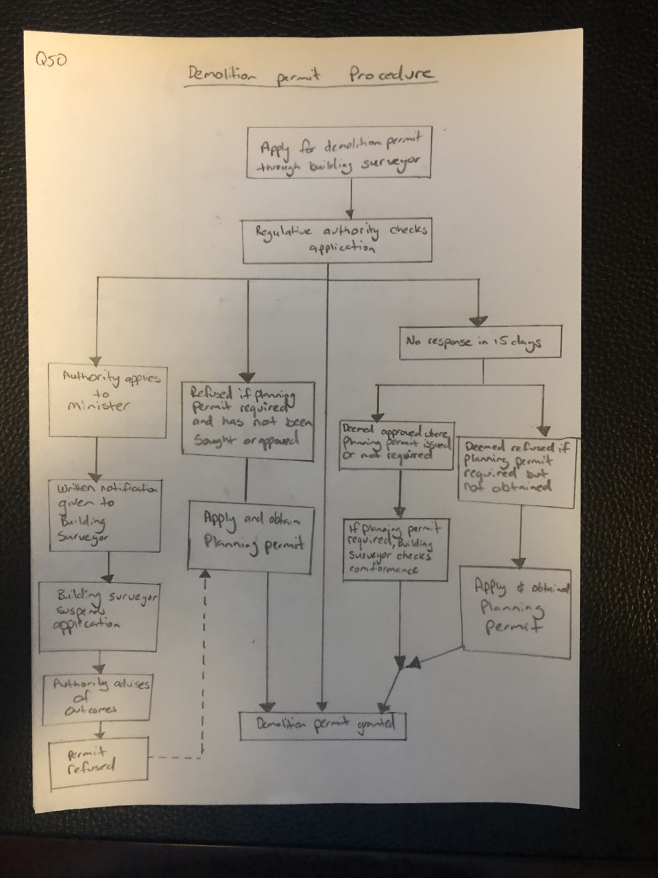

- Name the primary Australian Standard and codes of practice to be followed when performing demolition of structures.

Answer | All demolition operations are to be in accordance with Australian standards and codes of practices. These are:  AS 2601: The demolition of structures  code of practice - Demolition 1991  code of practice for the safe removal of asbestos, second edition 2005.

- When performing demolishing what are some of the agencies which might be accessed for information and guidance?

Answer | Australian Safety and Compensation Council  www.ascc.gov.au  National Occupational Health and Safety Commission  www.nohsc.gov.au

- Name some of the people included in the construction process, from professionals involved in building design to specialist tradespeople.

Answer | Architects, Drafts people, Engineers, Building Surveyors, Land Surveyors, Quantity Surveyors, electricians, plumbers, carpenters, Glazier, Cabinet makers, plaster, landscaper, painters

- Who would you consult to gain insight to using the right sized and right shaped materials for a project?

Answer | Structural Engineer

- Briefly describe the role of an architect.

Answer | Architects are tertiary qualified professionals who are registered with a professional organisation or institution. They must satisfy strict licensing requirement. An architect is mainly concerned with the design of buildings, but other skills are often required. Architects may be employed on a project to provide full or partial services. Full services include concept design, design development, contract documentation, tendering procedures and contract administration. Partial services are employed most often on domestic constructions and this includes concept design, design development and possible tendering procedures.  Developing a client design brief  Preparing concept sketches and working out what is possible  Preparing site analysis reports including documentation of site constraints  Preparing contract documentation, including the contract, specifications and working drawings  Organising tendering  Overseeing contract administration  Organising design development and permit application

- Briefly describe the role of a structural engineer.

Answer | structural engineers who design the structural components of a building such as the concrete slab or the footings.  Preparing reports on how to protect neighbouring properties  Designing the structure of retaining walls, columns, beams and loading walls in building projects  Preparing reports on the structural adequacy of existing buildings

- What is the difference between a building surveyor and a land surveyor?

Answer | A building surveyor checks that new buildings comply with the Building Code of Australia (BCA). A building surveyor also checks the maintenance, repair, alteration and renovation of existing buildings against the BCA. They employ building inspectors to be their eyes and ears on the site to ensure that the minimum requirements of the BCA are being met.  Building surveyors advise on and interpret laws and regulations controlling building construction and safety.  They may undertake structural surveys, draw up schedules of dilapidations (related to buildings which are in a state of poor repair) and reports for necessary repairs. They also negotiate with local authorities and obtain approvals required under the town and country planning acts, building regulations and by-laws and other relevant legislation.  Assessing building plans which have been submitted for approval to ensure they conform to building regulations and codes of practice  Providing advice and assistance to builders and owners before finalisation and lodging plans so that potential problems can be avoided  Making recommendations on providing amenities for the community  Pre-purchase inspecting of all types of buildings  Inspecting buildings during construction to ensure that proper methods and materials are used, paying particular attention to conformity with building regulations  Keeping records and writing reports of building progress and instances where regulations have been breached and plans have been altered  Giving evidence in court when prosecutions are necessary for breaches of building regulations  Inspecting existing buildings to assess conditions  Giving advice on building matters  Issuing compliance certificates on completion  Land surveyors are licensed professionals who conduct on-site measurements of building sites and buildings. They measure distances, angles and levels.  Taking levels on a site to produce detailed contour plans  Determining location of existing buildings and other features on a site  Setting out the building line, marking the location of columns or the external perimeter of a building  Checking the vertical alignment of a building during construction  Conducting boundary surveys and re-establishment of survey pegs  Checking the positioning and overall height of a structure at completion to ensure compliance with the conditions of permits

- What is a quantity surveyor and work do they perform?

Answer | Quantity surveyors are mostly employed on major construction projects as consultants to the client. As advisers, they estimate and monitor construction costs from the feasibility stage of a project through to the completion of the construction period. Their name comes from the bill of quantities, a document which itemises the quantities of materials and labour required in a construction project. The bill of quantities is prepared using measurements from the contract drawings and is used by the contractors for tendering, progress payments and variations. During construction the quantity surveyors are called on to determine fair progress payments at regular intervals. They will also cost the changes to the design or to quantities which may arise throughout the construction process by referring to appropriate bill of quantities rates.  Initial cost advice during the pre-contract stage including preparing approximate estimates  Costing planning information concerned with the development of a design  Preparing the necessary tender documents, critically examining the tenders and priced bill of quantities when lodged for tender  Valuing the work during the construction stage at required intervals  Recommending the amounts to be paid to the main contractors including assessment of any variations  Controlling costs during the construction stage  Outlining the economics of alternative methods of construction

- Name some of the building approval plans that will be necessary to see a project through its construction.

Answer | permits  specifications  title  plans  engineering reports

- What is a land title and what would you expect it to contain?

Answer | A title is a legal document which clearly defines a block of land. The title can be used by a land surveyor to reinstate survey pegs. The north point, property boundary distances and bearings are provided on the title.

- Why would you need a construction permit or building permit?

Answer | A building permit is the document which shows that your plans have been approved by a building surveyor. The building surveyor checks that the plans meet building regulations.

- What is a building permit and what does it show and record?

Answer | Owners name and address, address for serving or giving of documents, property details, title details, builder, details of relevant permits, planning permits and inspection requirements, occupation or use of building, commencement and completion, and building surveyor

- What other permits could be required? Give two examples.

Answer | asset protection - this includes payment of a bond to cover repair to council assets and is approved prior to beginning construction  road opening - required prior to installing crossovers for tucks to go over paths or pipes of the councils  Road closures – to close off a road for materials been delivered to site

- What would be reasonable to expect to see in a project specification?

Answer | If all the information relating to a project was shown on the drawings, they would be very difficult to read. The specification provides supplementary information to the drawings, and takes precedence over any notations on the drawings.  The sections included in a project specification are:  a description of the job, the site, the proprietor and any other parties in the contract arrangement  a trades section detailing standards and quality of work. This may be set by the Australian Standards or by samples constructed for the architect's approval  the schedules containing detailed information in tabular form on  windows, showing frame material and type of glass  doors, specifying size, material and the swing on the door  finishes to walls, floors and ceilings  door types and models of locks, latches, hinges, push plates and pull handles.

- What is a sub-division plan and what is its purpose?

Answer | A plan of subdivision allows an applicant to divide land into two or more new parcels of land that can be disposed of separately. The only new parcels that can be created by a plan of subdivision are lots, roads, reserves or common property.

- What would a site plan tell you?

Answer | Such a plan of a site is a graphic representation of the arrangement of buildings, parking, drives, landscaping and any other structure that is part of a development project. A site plan is a set of construction drawings that a builder or contractor uses to make improvements to a property. Sometimes show amenities, exits an pathways and emergency meeting points.

- Explain what a floor plan will tell you.

Answer | In architecture and building engineering, a floor plan is a drawing to scale, showing a view from above, of the relationships between rooms, spaces, traffic patterns, and other physical features at one level of a structure. Dimensions are usually drawn between the walls to specify room sizes and wall lengths.

- What is the purpose of a cross sectional drawing?

Answer | A sectional elevation is a combination of a cross section, with elevations of other parts of the building seen beyond the section plane The purpose of a sectioned view is to improve the reader's ability to visualize completely the object being drawn..

- What information would you expect Municipal (Council) drainage plans and Water Authority documentation to provide you?

Answer | Drainage Plans will have the following –  The plan must be drawn in black pen to an acceptable  industry standard for example:  • All lines shall be drawn using a ruler  • All text shall be uniform size and clearly legible  • Curved lines shall not be drawn freehand  The plan shall be drawn approximately to scale and show the  street name, property boundary and outline of the building  The plan shall show the location, including dimensions of each  connection point to the service providers water supply,  sewerage system or on site sewerage facility.  The plan shall show the location on the premises of all fixtures,  using the legend below, water supply pipes and sanitary  drains, including dimensions from buildings and approximate  depths.  The plan shall show the location of:  • Each access point for cleaning and maintaining the  plumbing and drainage  • Each reflux valve installed in the drainage  • Any testable backflow prevention devices  • All vent pipes  • Overflow relief gullies  Water Authority guidelines are to get approval for-  What is a satisfactory point of connection  What works must be provided/ funded be applicants  What different development/ property types require for connection  Where connection requirement may be changed.

- Briefly discuss the purpose of footing design and name the Australian Standard (AS) which applies for low rise commercial building projects.

Answer | Footings are the construction that transfers the load from the building to the foundation. There are many things to consider such as the type of the foundation soil and the choice of an appropriate footing system. The common footing types - stump pads, strip, slabs - can be used for most housing construction. They can be selected from AS 2870 by appropriately qualified practitioners. However, two soil classifications require a qualified professional engineer to assess the footing requirements. These are Class E and Class P.

- What are contour plans? Describe their purpose in building and construction projects.

Answer | Every building project needs a site plan before it can move forward, and unless your project is set to break ground on an entirely flat parcel, your site plan needs to have contours. Contour lines illustrate variations of elevation throughout your property. They take your site plan and turn it into a topographical map.

- What is a site condition report and what is its purpose?

Answer | A Site Condition Report is a supporting document that describes and records the condition of the land and groundwater at a site at particular points in time.

- What does the AS3959 refer to?

Answer | AS3959 is an Australian Standard for construction of homes in bushfire prone zones

- Australia is zoned into four regions for high winds. What and where are these regions?

Answer | AUSTRALIAN WIND REGION- A, B, C, D  ULTIMATE DESIGN WIND SPEED Km/h- 162, 205, 248, 316  TERRAIN CATEGORY- 2, 2, 2, 2  REFERENCE HEIGHT- 10m, 10m, 10m, 10m  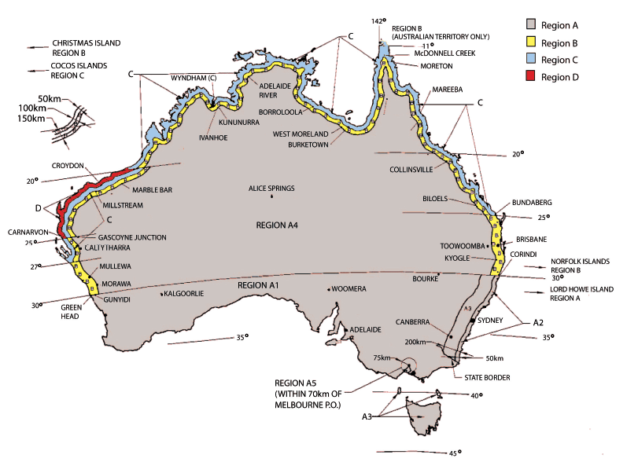  Image supplied by https://www.domeshelter.com.au/wind-regions-of-australia

- The acceleration coefficient is a number which indicates the expected severity of the earthquake ground movement. Which Australian Standard should be referenced for this information?

Answer | AS1170.4

- What defines an alpine area in Australia?

Answer | Alpine areas are defined as those areas which are 1,200 m or more above Australian height datum (AHD) for NSW, ACT and Victoria and 900 m or more above AHD for Tasmania. Sub-alpine areas are those areas 600 - 1,200 m in NSW, ACT and Victoria and between 300 - 900 m in Tasmania.

- Where in the Building Code of Australia (BCA) can you find information relating to alpine and sub-alpine areas in which the snow loads could play a significant part in design and construction?

Answer | Refer to the BCA, Section 3.7.5 Alpine areas

- What can we reference when intending to use new and emerging building technologies in the construction of a building?

Answer | The BCA has requirements to allow for new and emerging building technologies. Any new technology must satisfy performance requirements and this can be determined by using the following assessment methods:  documentary evidence  verification methods  expert judgement  comparison to 'deemed to satisfy provisions'.  Further information on these assessment methods can be found in Section 1 of the BCA.

- What are some of the critical considerations to be made about footings and the transfer of loads from the building to its footing foundations?

Answer | The selection of the size and type of footings depends on:  the weight and type of house construction  the site class.

- What codes and standards should be checked to ensure footings specified within the building plan are compliant?

Answer | They can be selected from AS 2870 by appropriately qualified practitioners.

- Name the relevant Australian Standard for protection against subterranean termites.

Answer | The Australian Standard AS 3660.1-1995

- What should be considered when constructing a floor system?

Answer | When constructing the floor system it is important to take into consideration the type of flooring, the laying of pipes and reinforcement. The type of flooring in a house must be adequately supported by the flooring structure below.

- When designing and installing a concrete residential slab and footings what Australian Standard applies?

Answer | AS 2870

- What are bearers in a sub floor framing system?

Answer | Bearers are the first of the sub-floor frame members to be installed. They are positioned over stumps, piers or other supports. In most cases they are timber, however, a wide variety of engineered timber products are available. As well, mild steel and cold-formed steel sections may be used to achieve greater spans.

- What are floor joists in a sub-floor framing system?

Answer | Floor joists are the next series of members for the sub-floor frame. They are supported by the bearers. Typically the floor joists run over the tops of bearers, however, they may be attached to the sides of bearers. Like bearers, floor joists may be single span or continuous span. They can be made of timber or steel.

- Sketch free hand compact simple drawing in section to show the following floor system components of the external load bearing wall and bottom plate, joist and bearer to include:
- Wall frame
- Sheet flooring
- Floor joist
- Bearer
- Brick pier with stump cap

Answer
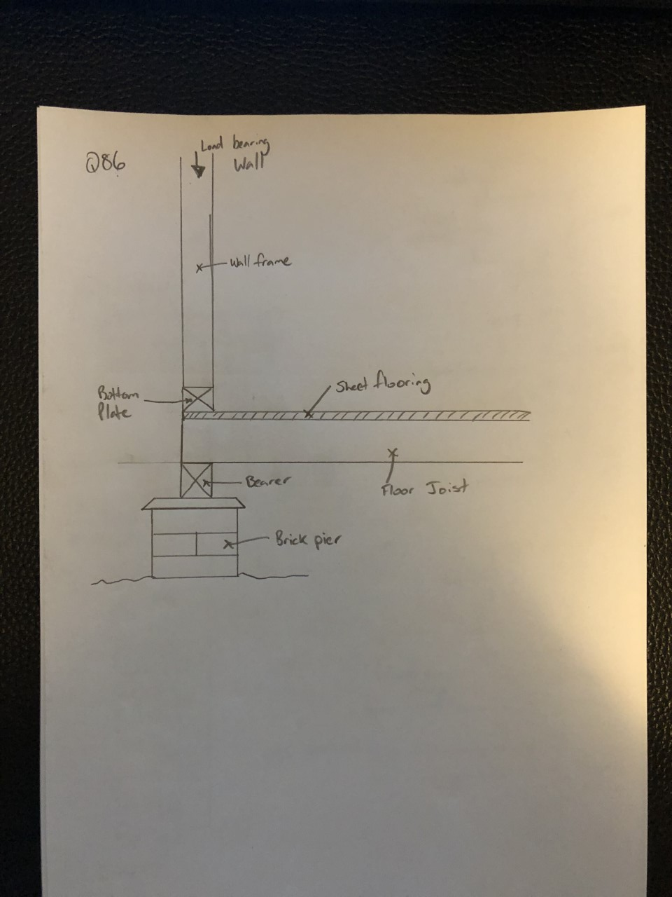

- What is a strip timber flooring system (also sometimes referred to as a fitted floor)?

Answer | Fitted floors are installed after walls have been erected and after roofing, wall cladding, doors and windows have been installed. Where boards are laid parallel with walls, a minimum 10 mm gap shall be provided between the board adjacent to the bottom plate and the bottom plate.

- Explain the benefit or otherwise of a platform floor.

Answer | A platform floor provides a working platform for the builder as the floor is laid before erecting the wall and roof framing. However, this method is not recommended for feature floors because the flooring is exposed to the weather during construction.  The platform floor should be protected from getting wet by rain and/or wet trades, however, as it is difficult to provide adequate protection, degradation due to the effects of sunlight, wetting or work practices may occur.

- Briefly explain drilled or driven piles as a footing system for commercial/industrial type buildings.

Answer | Power driven galvanised steel columns are an alternative pier system to timber piles. The piles have a helix auger on the ends, which enables the pile to drill itself into the ground. This engineered system requires an accreditation certificate to ensure acceptance by building authorities.

- Which section of the Building Code of Australia addresses piling as a foundation system?

Answer | AS 2159—2009

- Explain the term ‘screw piles’. What must preface to approve the use of screw piles as a foundation system?

Answer | Screw piles are a steel screw-in piling and ground anchoring system used for building foundations. They are manufactured using varying sizes of tubular hollow sections for the pile or anchors shaft. They are wound into the ground much like a screw into wood. Screw piles are installed using various earthmoving equipment fitted with rotary hydraulic attachments.

- What does a concrete pier typically consist of?

Answer | For homes and light commercial buildings, concrete piers are concrete columns that are formed by pouring liquid concrete into holes drilled into the ground. A reinforced rebar cage is generally installed into the hole before concrete.

- Where could you use a bulk pier and beam system?

Answer | Bulk pier and beam. Bulk pier and beam systems are satisfactory where good bearing soil is located between 800 and 1,200 mm below the natural ground level.

- What is the construction method for bulk pier and beam?

Answer | Bulk pier and beam system. Bulk pier and beam systems are satisfactory where good bearing soil is located between 800 mm and 1,200 mm below the NGL. These systems are an alternative to blinding concrete. Bulk piers are excavated using a simple backhoe.

- Name the framing system shown below.

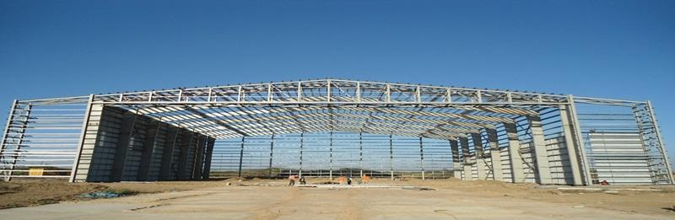

Answer | Portal frame construction: Portal frame construction using steel or steel-reinforced precast concrete

- Name the framing system shown below.

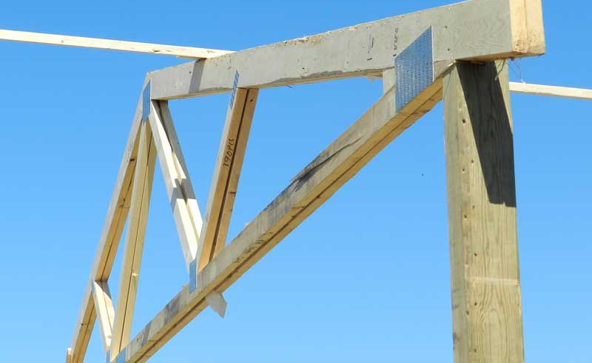

Answer | Pole and truss wall, Post and beam - horizontal and vertical support members subjected to loads.

- Name the building system shown below.

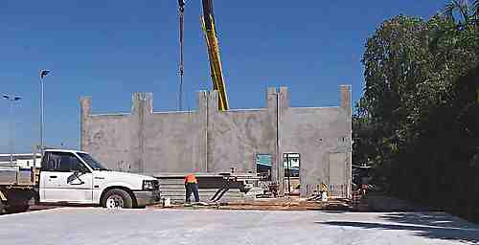

Answer | Pre cast concrete panels  Tilt-slab construction: Tilt up is a pre-cast concrete system of building walls.

- Which section of the Building Code of Australia addresses masonry components for a building?

Answer | (a) AS 3700 — Masonry structures; or  (b) AS 4773 — Masonry for small buildings, Parts 1 and 2.

- What are masonry coatings?

Answer | Masonary coatings are designed to protect the masonry for the harsh Australian conditions. Helps protect the structure from, splitting, cracking an flaking. Masonry Coatings is a generic term for any wall or masonry covering. This could be a exterior wall coatings, masonry paints, wall rendering, textured coatings or even pebble dashing.

- A ‘wythe’ or ‘leaf’ is the building and masonry term given to the width of a single brick or concrete block unit. A brick or block masonry wall might incorporate any of cavity brick, single-leaf masonry (brick or block) or lightweight autoclaved (aerated) concrete block (AAC). The cavity between ‘wythes’ can be anything from 50mm to 110mm.
Draw freehand sketches of the following and label your sketches:
- A single masonry wall founded on a cavity brick base with engaged pier,
- A cavity brick masonry wall with 50mm cavity
- A brick veneer and timber framed wall with 50mm cavity
- A masonry retaining wall one (1) metre high

Answer
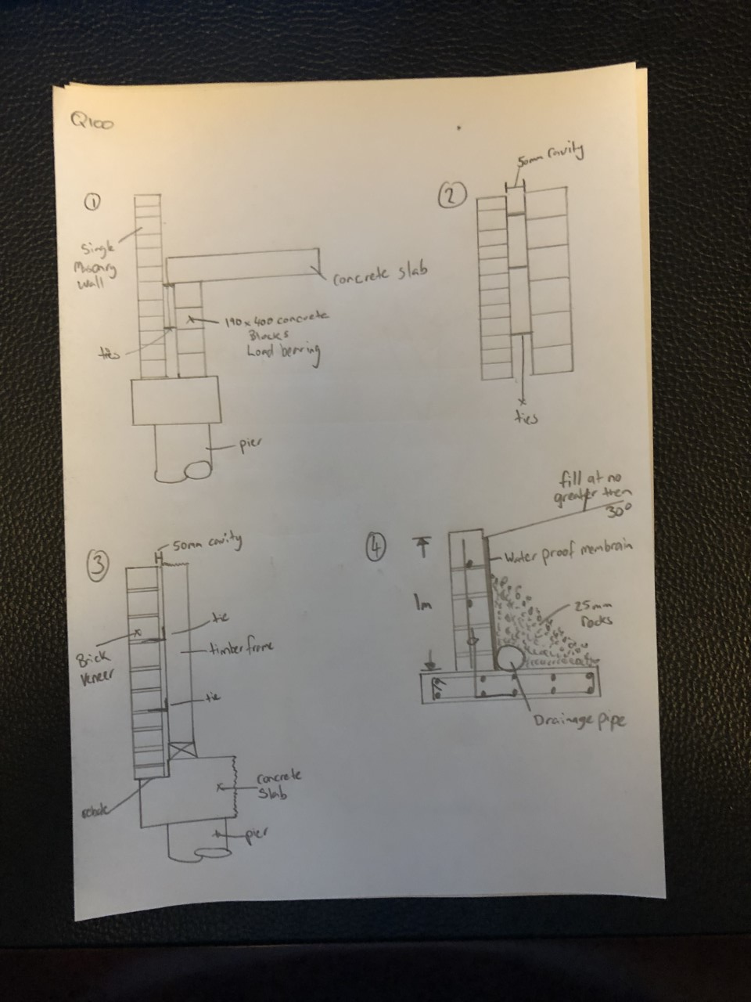

- What is cladding? What BCA section and Australian Standard address specific aspects of cladding?

Answer | They enclose the building and provide protection from the weather. External cladding contributes to the comfort, structural adequacy and aesthetics of a building. 3.5.3 Wall cladding in BCA following the Australia standards for each type of wall cladding.

- Explain timber cladding systems like chamfer boards and weatherboards.

Answer | Timber is a classic choice for exterior wall cladding, and is normally installed by hanging planks or boards either vertically or horizontally. Other terms for weatherboard include wood cladding, clapboard, bevel siding and lap siding. Wooden shingles may also be used as an exterior wall finish.

- Describe plywood cladding.

Answer | Exterior Plywood is intended for use in non structural, exterior applications where a high quality aesthetic finish is required. A bonded exterior plywood must be used for applications involving long term full exposure. All A bonded, exterior plywood should be treated against fungal attack and should be surface finished to minimise surface checking.

- Describe exterior hardboard cladding.

Answer | Hardboard, also called high-density fiber board (HDF) is a type of fiber board, which is an engineered wood product. It is similar to particle board and medium-density fiber board, but is denser and much stronger and harder because it is made out of exploded wood fibers that have been highly compressed.

- Many additional services can be installed in a building and the building plans and relevant standards and codes must be identified and adhered to ensure appropriate allowances are made for the installation of these services.
Name some of the services that can fall under this scope of additional installations.

Answer | Plumbing and Electrical.  Other services to be considered include:  Ducting for heating and cooling  Communication systems  Extractive vacuum and exhaust systems  Passive and active fire detection and prevention systems  Powered systems for operating doors and windows  Smoke control and containment systems

- What is a roof system? Name some roof types and what a roof might be built from.

Answer | A roof system is the structure that forms the roof of a building. In Australia the roof system may be made up of:  A timber frame roof built on-site  A prefabricated truss roof in which major components are constructed in a factory and then assembled on-site.  Types of roof systems include:  Gable  Hip  Skillion

- Draw simple line diagrams to represent a gable roof, a hipped roof, hip and valley roof and a skillion roof.

Answer
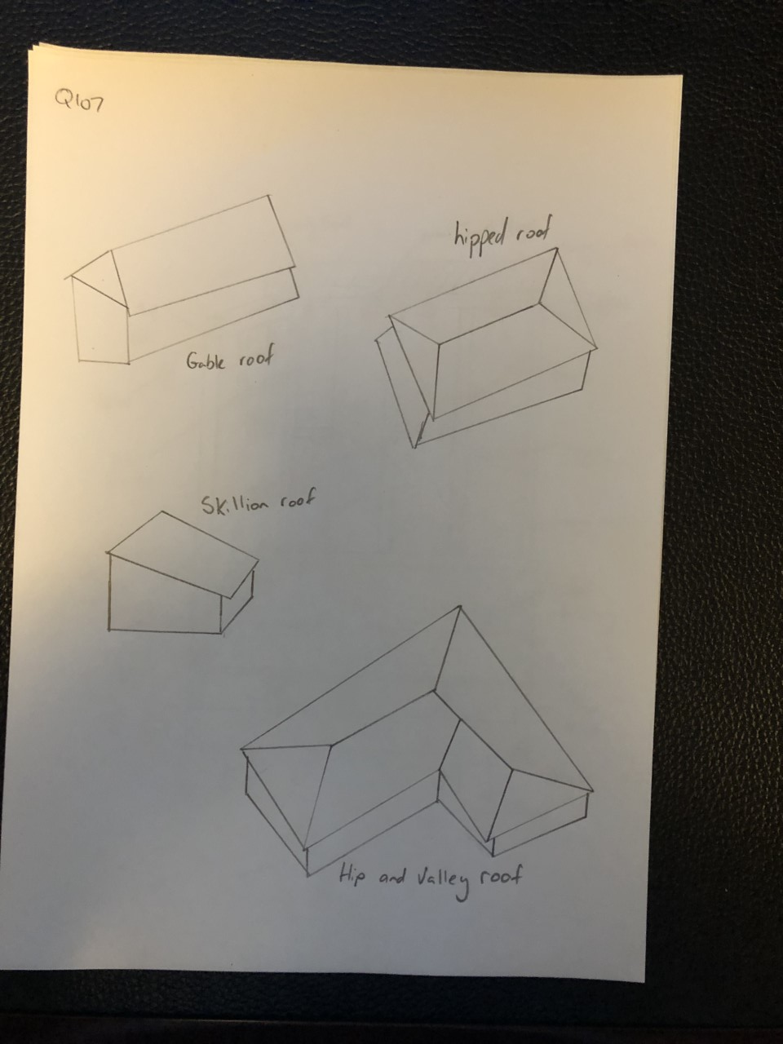

- Name at least eight (8) practical advantages of using prefabricated roof trusses.

Answer | The advantages of trusses include the following:  They are strong, but light to erect  They can be made to suit most roof shapes  There is less on-site fabrication, therefore less site labour is required  They are less affected by bad weather  Factory production allows automated production  Better quality control is possible  Trusses make maximum structural use of the timber  Trusses are capable of long spans  Internal walls are usually non-load bearing, therefore lighter weight internal walls are possible

- What is roof cladding? What are the two most common materials used in Australia?

Answer | Roof cladding is the material used to protect the building from the extremes of the weather. The two most common options are roof tiles and metal roof sheeting

- What pitch of roof should roof tiles be applied? Are there exceptions?

Answer | Roof tiles can generally be used on roofs of 15º or greater pitch, however, some materials and methods of manufacture require 25º or greater pitch.

- Describe the materials listed in the table below.

Answer | Term | Description
 | Terracotta tile | The tile is formed in wet clay and then fired to give a hard, long-life roofing product. They come in a number of profiles. Terracotta tiles have a roof life greater than 50 years in most environments, however, salt atmospheres sometimes cause premature fretting
 | Concrete tile | Concrete roof tiles are generally modelled on terracotta tiles. Modern concrete tiles have roof lives approaching those of terracotta. They are stable, warp-free and have the same basic profiles as terracotta tiles. The colour on the concrete tiles is an applied coating. Although some colours fade quickly (within five years), most of the popular red/brown/charcoal colours have long colour retention.
 | Slate tile | These are a naturally occurring rock.
 | Fibre cement shingles | Fibre cement shingles are slate-like products manufactured from fibre-reinforced. cement
 | Timber shingle/shake | Timber shingles/shakes are made of sawn or split timber boards
 | Aluminium or steel pressed tile | These are metal that is shaped to imitate a tile. They are often covered with coloured sand glued to the metal.

- Devise a useful roof framing checklist for ensuring the quality of the roof frame once it is installed.

Answer | The following is a checklist for ensuring the quality of the roof frame:  Rise and pitch of roof against plan  Correct propping of ridge, hips, valleys, rafters and under purlins at correct centres  Adequate collar ties  Line of rafter, hips and valleys  Support to strutting beams  Fascia and barge boards  All tie-downs and fixings  Ceiling joist and alignment with rafters  Hanging beams  Trimmers for location  Trimming to manhole

- Describe the intent of wall systems and the materials they are typically made from.
What part of the BCA and the AS reference wall systems?

Answer | Wall systems  Provide structural support to roof systems  Allow for installation of services  Provide a means to apply external and internal linings  Materials used for wall systems include:  Cavity brick  Concrete block  Structural steel  Timber  NCC Volume : Part 3.4.3 Timber Framing  AS 1684.2 — Residential timber-framed construction — Non-cyclonic areas.  AS 1684.4 — Residential timber-framed construction — Simplified — Non-cyclonic areas.

- Explain the purpose of bracing.

Answer | Bracing enables framework to resist horizontal forces (load resistance of live, dead, wind loads) particularly wind loads as buildings must transmit the load through the structure to the foundation.

- You are to provide a pictorial sketch with labels to show a common timber stud or steel wall and ceiling frame and include the following members:
- Hanging Beam
- Ceiling joists
- Top plate
- Lintel
- Common stud
- Jamb stud
- Jack stud
- Nogging
- Bottom plate
- Timber or metal bracing
- Sheet flooring
- Floor joists
- Bearers
- Stumps

Answer

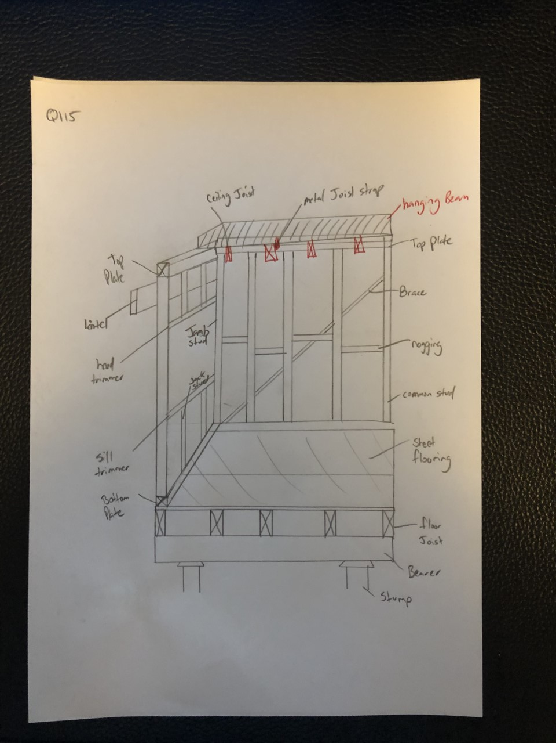

- Name the relevant volume and part in the Building Code of Australia (BCA) as well as the two (2) relevant Australian Standards that apply to the design, application and installation of timber framing for residential housing.

Answer | NCC Volume : Part 3.4.3 Timber Framing  AS 1684.2 — Residential timber-framed construction — Non-cyclonic areas.  AS 1684.4 — Residential timber-framed construction — Simplified — Non-cyclonic areas.

- What might be a typical checklist to be used for ensuring the quality of the frame members and the frame as a whole?

Answer | The following is a checklist for ensuring the quality of the frame members and the frame as a whole. Check each of the items listed below:  Walls for plumb, square, straight and level  Top and bottom plates have a tight fit on studs  Bracing and tie-downs in accordance with plan  Noggings at correct centres and support for fixtures  Corner blocking  Walls tied together  Room sizes and ceiling heights with plan  Window and door clearances and openings  Jamb studs to all openings  Concentrated load bearing studs  Lintels for adequate bearing  Block under studs if timber floor  Any excessive notching  Provisions for plumbing services and fixtures  Safety of frame  Adequacy of temporary bracing

- What is sarking? What purpose does it serve?

Answer | Sarking is a waterproof, vapour-permeable, flexible sheet material fixed directly behind timber cladding or under flooring material. It directs any water that may have penetrated the cladding back to the outside of the structure and provides a draught proof barrier to keep wind-driven rain or dust out of the wall cavity. Sarking is not a substitute for well-chosen and properly installed cladding and should never be regarded as the principal means of weatherproofing

- What is flashing?

Answer | Flashings are used at corners and vertical joints and around openings to ensure that water is prevented from penetrating the wall frame cavity. As flashing does not extend fully behind the cladding, non-permeable materials may be used.

You are to refer to the roof section diagram below in responding to Q120. to Q126.

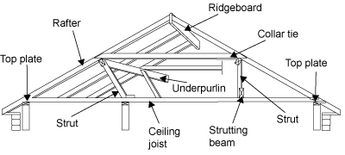

- What is a ceiling joist?

Answer | The ceiling joists have a double function:  they provide the structure onto which the ceiling is fixed  they are the member that connects or ties the lower ends of rafter couples (pairs). Therefore, they prevent the rafters spreading and causing the roof to sag or collapse.

- What is the purpose of a hanging beam?

Answer | A 'hanging beam' is generally a deep timber beam located perpendicular (at right angles or 90º) to ceiling joists and directly above them. The function of a hanging beam is to reduce the span of the ceiling joists. This allows for a more economic joist size and consistent section. Hanging beams must only support ceiling joists and the attached ceiling materials.

- What is the purpose of roof struts?

Answer | The struts are needed in the roof frame to transfer the loads from under purlins and other beams to the load bearing walls. Struts should be adequately supported over studs in timber walls. They should have anti-slip blocks, where necessary, to prevent them sliding horizontally. Struts are generally more efficient the closer they are to the vertical. Struts must be either vertical, perpendicular to the rafters or at an angle to the vertical which does not exceed 35o

- What is the ridge board in a conventional framed roof?

Answer | The ridge board in a conventional framed roof is not so much a structural member as a set-out member. It makes sure that rafter couples meet at a consistent height giving a horizontal ridgeline free from sags. Ridge boards locate and stabilise rafter ends. Opposing pairs of rafters must not be staggered by more than their own thickness at either side of their ridge junction.

- What function do rafters perform in a roof?

Answer | In a conventionally framed roof, the rafters are fixed on a slope and run in the same direction as the roof slope. Rafters are generally erected in opposing pairs or couples. They meet each other directly at their apex on the ridge of the roof. The rafters give the roof its required slope and provide the structure onto which the roof covering is fixed.

- Explain the role of under purlins in a conventional roof frame system.

Answer | Under purlins are so called because they are fixed under the rafters. They are fixed horizontally and perpendicular to the direction of the roof slope. In a conventional roof frame the under purlins support the underside of the rafters. This allows for the most economic rafter size and prevents the roof from sagging and collapsing.

- What are collar ties used for in a conventional roof frame system?

Answer | Collar ties must be provided in all coupled roof construction. They supplement the ceiling joists and prevent the rafter couples spreading.  Where the rafter span is such that it requires support from under purlins, collar ties are fitted to opposing common rafters at a point immediately above the under purlins.  Collar ties must be fitted to every second pair of common rafters.

- What advantages can be gained from installing roof trusses as against a conventional stick framed roof?

Answer | Manufactured timber roof trusses provide a structurally efficient alternative to timber beams. They place greater emphasis on axial loading of members and less on bending.  The advantages of trusses include the following:  They are strong, but light to erect  They can be made to suit most roof shapes  There is less on-site fabrication, therefore less site labour is required  They are less affected by bad weather  Factory production allows automated production  Better quality control is possible  Trusses make maximum structural use of the timber  Trusses are capable of long spans  Internal walls are usually non-load bearing, therefore lighter weight internal walls are possible

- What must the design of a timber roof truss adhere to?

Answer | The design of a timber roof truss must accord with engineering principles and with AS 1720.1. This includes the wind design. AS 4440 'Installation of nail plated timber roof trusses' provides details for correct practices when installing roof trusses.  Trusses are usually spaced at regular intervals, typically 600 mm, 900 mm or 1,200 mm apart depending on the mass of the roofing material and local practice.

- Discuss timber cladding and reference the relevant Australian Standard as it applies to the specific cladding. Be sure to name what part of the BCA deals with cladding.

Answer | PART 3.5.3 WALL CLADDING  (a) Metal wall cladding: AS 1562.1.  (b) Autoclaved aerated concrete: AS 5146.1.  3.5.3.3 Wall cladding boards  Wall cladding boards must—  (a) for 7.5 mm (minimum) thick fibre-cement — comply with AS/NZS 2908.2 or ISO 8336;  and  - for 9.5 mm (minimum) thick hardboard — comply with AS/NZS 1859.4  3.5.3.4 Sheet wall cladding  (a) Fibre-cement sheet wall cladding must—  (i) comply with AS/NZS 2908.2  Hardboard sheet wall cladding must—  - comply with AS/NZS 1859.4  Structural plywood wall cladding must—  - comply with AS/NZS 2269  3.5.3.5 Eaves and soffit linings  External fibre-cement sheets and linings used as eaves and soffit linings must—  - comply with AS/NZS 2908.2  3.5.3.6 Flashings to wall openings  Openings in external wall cladding exposed to the weather must be flashed as follows:  (a) All openings must be adequately flashed using materials that comply with AS/NZS 2904.

- What must be checked when installing skylights, windows and doors?

Answer | Installing windows and external doors in compliance with relevant codes, manufacturer specifications and industry construction principles

- What is the relevant Australian Standard to be referenced for glazing of windows and doors?

Answer | NCC Volume 1: B1.4, F1.13, J3.4  AS 1288, AS 2047

- Write a descriptive interpretation of the extract of the window schedule shown below.

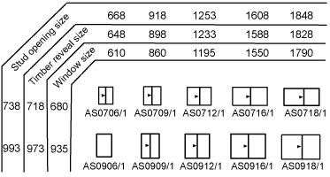

Answer | Window schedules  Window frame manufacturers produce a range of readily available frames. Their sizes are detailed on a schedule. A typical schedule details the appearance of the window frame when viewed from the outside. It also shows the finished height and width of the frame.  Note: Aluminium window schedules differ from those for timber window frames. The timber reveals fitted to the windows for brick veneer and weatherboard construction are an additional size over the window size. This appears as an extra row of figures on a schedule

- Illustrate by sketch the correct positioning of flashings and sarking for timber cladding.
Your sketches should reflect the use of weatherboard stops for installation of timber chamfer boards or timber weather boards where the internal and external corner joins has the cladding butting up to the weatherboard stop.
Alternate installations still require flashings and sarking for man-made manufactured boards such as HardiePlank or PrimeLine in which case sketches would reflect the use of internal and external corner jointers supplied by the manufacturer.

Answer

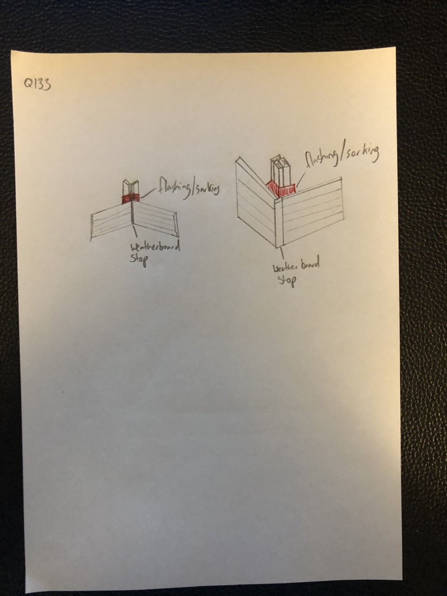

- Briefly describe each of the building materials listed below and outline the related construction methods used for low rise commercial projects.

Answer | Term | Explanation
 | Brick veneer construction | A single skin of brickwork is laid on the outside of a building to form a barrier against the weather. This single skin of brickwork is not load bearing, that is, it does not support any roof loads. However, it must be strong enough to resist lateral loads from wind.  The brick veneer is attached to the timber frame using a series of brick ties. These provide sufficient support against wind loads.  A gap, referred to as a 'cavity', is maintained between the brickwork and the timber frame. The cavity is necessary as bricks are extremely porous and absorb a lot of water. This water has the potential to cause serious damage to the timber wall frame. The cavity prevents migration of moisture through to the timber frame
 | Cavity brick construction | Cavity walls consist of two "skins" separated by a hollow space (cavity). The skins are commonly masonry, such as brick or concrete block. Masonry is an absorbent material, and therefore will slowly draw rainwater or even humidity into the wall, as well as from the inside of the house as from outside. A cavity wall is two wythes of masonry, separated by a cavity of varying dimension.  The masonry wythes may consist of:  Solid brick  Structural clay tile  Concrete masonry units  Bonded together with masonry ties  The cavity may or may not contain insulation
 | Earth wall construction | Earth building has been around for 11,000 years and is used worldwide. The common feature in all earth building techniques is that the earth material is subsoil that is composed of clay, silt, and sand where clay is the binder or cementing ingredient and the drying process is through the evaporative effect of sun drying.  Earth building uses unfired earth material to construct:  walls  floors  roofs  fireplaces  ovens.  Methods of earth building  There are at least 12 methods of earth building used and these can be further divided into a total of 18 techniques.  Two of the best known methods are earth brick (mud brick) and rammed earth.  Earth brick (mud brick)  Mud brick is the most popular name used in Australia to describe bricks made from various compositions of soil that are dried at air temperature during brick production.  There are many ways of making mud brick. One major distinction however is the consistency and water content of the material at the time of forming into bricks. With puddled mud bricks, the moisture content is high and the texture is that of mud or dough. With pressed mud bricks the moisture content is lower and the consistency is that of damp soil.  Rammed earth  Rammed earth is damp or moist earth, with or without any additive, that is rammed in place between a temporary moveable formwork. It is a solid masonry wall that does not have, and does not need any cavity.
 | Autoclaved aerated concrete block construction | Autoclaved aerated concrete is a lightweight, precast, foam concrete building material suitable for producing concrete masonry unit like blocks. Composed of quartz sand, calcined gypsum, lime, cement, water and aluminium powder, AAC products are cured under heat and pressure in an autoclave. Autoclaved aerated concrete (AAC) is made with fine aggregates, cement, and an expansion agent that causes the fresh mixture to rise like bread dough. In fact, this type of concrete contains 80 percent air. In the factory where it is made, the material is moulded and cut into precisely dimensioned units.  AAC wall opening Cured blocks or panels of autoclaved aerated concrete are joined with thin bed mortar. Components can be used for walls, floors, and roofs. The lightweight material offers excellent sound and thermal insulation, and like all cement-based materials, is strong and fire resistant. In order to be durable, AAC requires some type of applied finish, such as a polymer-modified stucco, natural or manufactured stone, or siding
 | Pole frame construction | Pole framing or post-frame construction (pole building framing, pole building, pole barn) is a simplified building technique adapted from the labor intensive traditional timber framing technique. It uses large poles or posts buried in the ground or on a foundation to provide the vertical structural support, along with girts to provide horizontal support. The method was developed and matured during the 1930s as agricultural practices changed, including the shift toward engine-powered farm equipment and the demand for cheaper, larger barns and storage areas.
 | Portal frame construction | Portal frame structures are designed to span between supports and rely on fixed joints with moment resisting capacity where vertical supports connect to horizontal beams or trusses. Portal frame structures can be constructed using a variety of materials and methods. These include steel, reinforced concrete and laminated timber such as glulam. The connections between the columns and the rafters are designed to be moment-resistant, i.e. they can carry bending forces, and have now become the most common form of enclosure for spans of 20 to 60 m.  Because of these very strong and rigid joints, some of the bending moment in the rafters is transferred to the columns. This means that the size of the rafters can be reduced or the span can be increased for the same size rafters.  Portal frame construction is therefore typically seen in warehouses, barns and other places where large, open spaces are required at low cost and a pitched roof is acceptable.
 | Post and beam construction | Timber post and beam construction is a building method that comprises vertical structural posts and horizontal beams, jointed to form a structural frame into which walls are ‘placed’. As this frame is structural, and carrying the roof load, the number of interior walls can be reduced, making it suitable for creating open plan spaces.  Timber post and beam construction differs from the technique referred to as ‘timber frame’ construction, which is a system of panelised structural walls and floors constructed from small section timber studs and clad with board products.
 | Post and truss construction | King post truss. One of the simplest truss styles to implement, the king post consists of two angled supports leaning into a common vertical support.  The queen post truss, sometimes queen post or queens post, is similar to a king post truss in that the outer supports are angled towards the centre of the structure. The primary difference is the horizontal extension at the centre which relies on beam action to provide mechanical stability. This truss style is only suitable for relatively short spans
 | Single leaf concrete masonry construction | Single Leaf Masonry Construction is defined as small masonry units jointed together with mortar. A leaf is as thick as the width of one brick, but a wall is said to be one brick thick if it as wide as the length of a brick. Accordingly, a single-leaf wall is a half brick thickness; a wall with the simplest possible masonry transverse bond is said to be one brick thick, and so on.
 | Tilt panel or tilt slab construction | Tilt-up, tilt-slab or tilt-wall is a type of building and a construction technique using concrete. With the tilt-up method, concrete elements (walls, columns, structural supports, etc.) are formed horizontally on a concrete slab; this normally requires the building floor as a building form but may be a temporary concrete casting surface near the building footprint. After the concrete has cured, the elements are "tilted" to the vertical position with a crane and braced into position until the remaining building structural components (roofs, intermediate floors and walls) are secured.

