BSBSMB406A
Manage small business finances
ASSESSMENT SUMMARY

The assessment activities for BSBSMB406A Manage small business finances cover all aspects of the unit of competency required. To demonstrate competence in this unit, a participant must undertake all tasks and complete them satisfactorily and consistently. For Apprentices and Trainees, this includes employer completion of the Employer Record Book (ERB).

Participants must read all the information given before starting any assessment task. The assessment tasks are intended to be equitable, fair and flexible. If a participant has any questions or requires alternative arrangements to be made such requests should be directed to their Trainer/Assessor, who should note such arrangements in the ‘Assessor Comments’ on the affected assessment. If a participant feels they are not yet ready to be assessed, they should discuss their options with their Trainer/Assessor.

To satisfactorily complete the assessment, the participant is required to answer all questions correctly and demonstrate their skills to industry standards. If a participant does not answer some questions or perform some tasks, they will be deemed ‘Not Satisfactory’ for the task and ‘Not Yet Competent’ for the unit of competency. The Trainer/Assessor is able to provide the participant with additional information on interpreting the assessment outcomes and provide guidance on the participant’s options. Should a participant still be deemed ‘Not Satisfactory’ they will have the opportunity to undertake a supplementary assessment or appeal the result.

By signing the cover page for each assessment item, the participant acknowledges they understand the assessment instructions and requirements and consent to being assessed. The participant also verifies and assures the RTO that the work submitted is their own work.

Participant Name | Murray Jackwitz

Task | Assessment Results
Theory Exam | Satisfactory | Not Yet Satisfactory
Practical Assessment | Satisfactory | Not Yet Satisfactory
Outcome for Unit of Competency | Competent | Not Yet Competent

Assessor Name
Assessor Signature | 
Unit Competence Determination Date | 15/05/2020

BSBSMB406A
Manage small business finances

THEORY EXAM INSTRUCTIONS

- This exam will occur under standard assessment conditions.
  - An oral examination may be allowed under certain circumstances, whereby the Participant’s answers will be documented by a party other than the Participant. This must be acknowledged in writing (e.g. FT001 and Assessor Comments)
- Participants must provide enough detail in their responses to demonstrate their knowledge and skills.
- Please fill in the details below, providing your name, signature and date of assessment.
  - Your signature acknowledges that this is your own work.
- Assessors are to complete marking in pen of a different colour to the Participant.
- If a Participant initially answers a question incorrectly but modifies their response, they must follow the instructions below:
  - If a Participant changes their response in writing, they must put their initials next to the written change.
  - If a Participant changes their response verbally, this must be noted on the exam paper by the assessor.

Participant name | Murray JAckwitz
Participant signature | 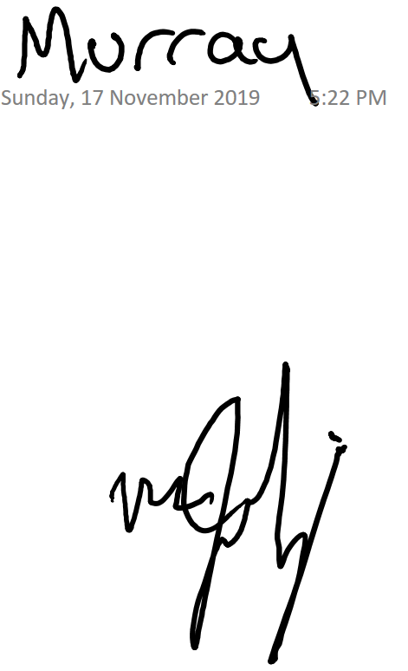
Date | 17/11/2019

Assessor name
Assessor signature
Date | 15/05/2020

Number of questions | Number of questions answered correctly | Task outcome (Tick)
45 |  | Satisfactory | Not Yet Satisfactory

ASSESSOR Comments
- What does a financial plan enable you to do in your business?

Answer | 1.Control the finances of the business  2. Measure the business success  3. Evaluate the success of the business to make profit or loss  4. Forecast your profitability, Financial needs and financial viability

- List five (5) types of financial information you might need to profitably operate and extend your business in accordance with the business plan.

Answer | 1.Asset Registers  2. Bookkeeping, Accounting, Stock, job costing records  3. Business Activity Statements  4. Cashflow forecast  5. Financial Budgets.

- Match the following specialists and the services they can provide to a business by writing the appropriate letter next to each number in the centre column.

Answer | Specialist |  | Answers | Services
 | 1 | Accountant | 1 - D | A | Provides assistance and direction across a variety of business areas, working closely with management.
 | 2 | Broker | 2 - B | B | Works with clients to determine their borrowing needs and ability, selects a loan suited to their circumstances.
 | 3 | Financial advisor | 3 - C | C | Provides advice and services in the form of investment and capital raising advice, insurance and income protection.
 | 4 | Legal advisor | 4 - E | D | Keeps financial records for a business, traditionally in the form of ledgers and journals.
 | 5 | Mentor | 5 - A | E | Can draft contract, provide advice of regulatory issues or protection of intellectual property.

- Briefly explain how personal net worth calculated. Give an example.

Answer | Personal Asset minus personal Liability  If you own a house worth $490, 000 and you owe $190,000, You have a personal net worth of $300,000

- Identify the information required when calculating a budget.

Answer | When Calculating a budget, you require;  1.Timeframe  2. Fixed Costs  3. Variable Costs  4. Estimated Income

- Explain the process for preparing a cash flow forecast.

Answer | I would require;  Understanding the Starting Cash, plus the cash in (forecast), minus cash out = the “Ending Cash”.

- True or False (Tick your response): Cash flow forecasts are usually carried out at least once during a twelve month period.

Answer |  | True
 |  | False

- Refer to the anticipated figures in the table below to calculate the break even sales amount. Determine whether this business is viable.

Total sales | $180,000
Fixed costs | $ 64,800
Variable costs | $ 78,300
Total costs | $143,100

Answer | Viable based on Nett Profit of $36,900

- Refer to the anticipated figures in the table below to calculate the break even sales amount. Determine whether this business is viable.

Total sales | $ 800,000
Fixed costs | $ 559,800
Variable costs | $ 243,300
Total costs | $ 803,100

Answer | Not Viable based on the Costs outweighing the Sales by $3,100

- The cost of goods sold (COGS) is the total expense associated with the goods sold in a reporting period.
James has a business selling books on eBay. An inventory count at the beginning of November shows that he has $50,000 worth of inventory on hand. Over the month, he purchases another $14,000 worth of books. His inventory count at the end of November shows that he has $22,000 of inventory on hand.
Using the calculation for COGS (Beginning Inventory + Purchases - Ending Inventory = Cost of Goods Sold) determine the cost of goods sold for James’ business.

Answer | $42,000 Sold in inventory

- Identify the three (3) main methods of pricing products/services by writing the appropriate letter next to each number in the centre column.

Answer | Structure |  | Answers | Taxation requirements
 | 1 | Competition-based pricing | 1 - C | A | Adding together direct costs, indirect costs, profit margin and market price.
 | 2 | Cost-based pricing | 2 - A | B | Consider how much customers are prepared to pay.
 | 3 | Demand-based pricing | 3 - B | C | Charging a price as per market price.

- Name three (3) individuals/parties who should receive financial budgets/projections.
Answer | - Bank  - Share Holders  - Accountant

- Provide three (3) reasons why you may need to raise business capital.
Answer | Starting a business  Entering New Markets  Payment of creditors

- Which of the following could be a potential financial backer?
Tick all that apply.

Answer | Choice | Possible Answers
 |  | Banks
 |  | Family and friends
 |  | Private investors
 |  | Shareholders

- Which of the following are relevant when negotiating, securing and managing business capital? Tick all that apply.

Answer | Choice | Possible Answers
 |  | Contingency plans
 |  | Necessary experience
 |  | Tested business model
 |  | Tested marketing approach

- True or False (Tick your response): Tax obligations will differ depending on your business structure.

Answer |  | True
 |  | False

- Identify two (2) strategies that could be implemented to make sure your taxation liabilities are met when they are due.
Answer | 1. Assessing the overall state of your business.  2. Identify how much money you owe.

- Tax obligations will differ, depending on the business’s structure. Match the structures and their taxation requirements by writing the appropriate letter next to each number in the centre column.

Answer | Structure |  | Answers | Taxation requirements
 | 1 | Company | 1 - B | A | Declare business income (or loss) in their personal income tax return and pay tax at individual tax rates.
 | 2 | Partnership | 2 - D | B | A separate legal entity with its own income tax liability. No tax-free threshold.
 | 3 | Sole Trader | 3 - A | C | Must lodge a tax return, but doesn’t pay tax. Those involved pay tax on their share of the income according to individual tax rates.
 | 4 | Trust | 4 - C | D | Holds income for the benefit of others. Generally has no tax liability where the whole of the net income is distributed to adult resident beneficiaries. Each beneficiary pays tax on their share of the income according to individual tax rates.

- What is a credit policy? Identify three (3) points that may be included in a credit policy.
Answer | 1.Debt Collection  2. Credit Limits.  3. Collaterall

- Explain how a credit policy can maximise cash flow.
Answer | It allows you to purchase materials prior to paying for them and then therefore having the money to pay you bills before they are due and collect income as you get paid.

- Describe one (1) method you may use to address debtors in default.
Answer | Debt Collector

- What purpose do Key Performance Indicators (KPIs) play in managing and monitoring a business?
Answer | They establish ways to monitor performance and analyse stability

- True or False (Tick your response): Financial plans, strategies and objectives develop over time, so it is inappropriate to continue reporting on the same KPIs as in previous periods.

Answer |  | True
 |  | False

- Explain the seven (7) general characteristics of an effective KPI.
Answer | Characteristic | Explanation
 | Non-Financial | Non financial measures not expressed in dollars
 | Timely | Measured frequently
 | Management Focus | Acted upon by management
 | Simplicity | All staff understand the kpi and what corrective action is required
 | Team Orientated | Responsibility can be assigned to a team who works closely together.
 | Significant Impact | Has a noteworthy effect on the business’s outcomes
 | Encourage Appropriate Action | Has been tested to ensure it has positive impact on performance.

- Why should you consult with relevant stakeholders when developing financial procedures?
Answer | To ensure the procedures are relevant and understood

- Explain how you should communicate financial procedures to facilitate implementation of the business plan.
Answer | It is best to put them in writing and make readily available to all. Training programs would also be recommended

- True or False (Tick your response): The best way to maintain control of your business is to continuously monitor its financial performance targets.

Answer |  | True
 |  | False

- Identify four (4) points that a financial report should be able to address.
Answer | 1. How do assets stack up against liabilities.  2.Where did the business gets its capital and is it making good use of the money.  3. Did the business reinvest all its profits  4. Does the business have enough capital for future growth.

Refer to the following financial report to respond to Q29. to Q31.

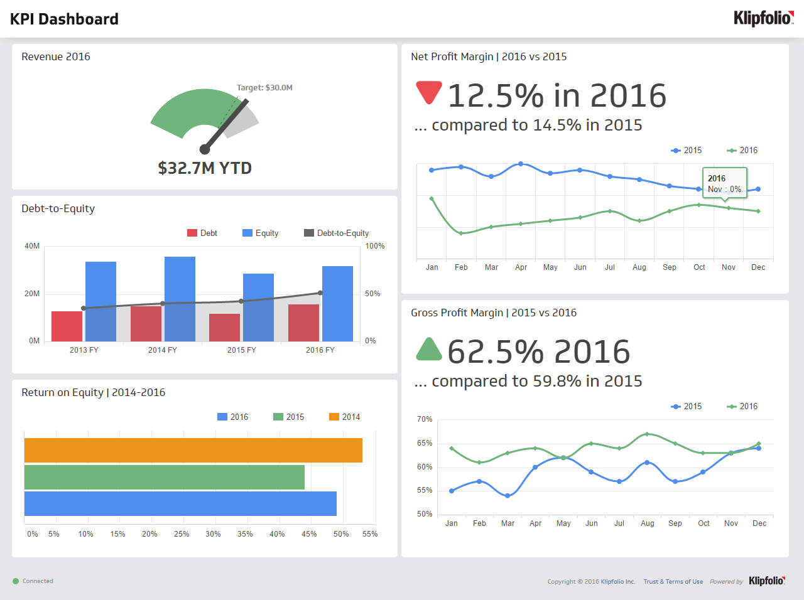
Source: https://www.klipfolio.com/resources/dashboard-examples/executive/kpi-dashboard

- True or False (Tick your response): The target revenue in 2016 was met.
Answer |  | True
 |  | False

- True or False (Tick your response): The gross profit margin for 2016 is better than 2015.
Answer |  | True
 |  | False

- True or False (Tick your response): The net profit margin for 2016 is better than 2015.
Answer |  | True
 |  | False

- How is gross profit determined for a profit and loss statement?
Answer | Total Sales / Revenue minus your Costs

- Name six (6) expenses considered in a profit and loss statement.
Answer | 1. Accounting Fees  2. Advertising and marketing  3. Bank Interest  4. Repairs and maintenance  5. Insurance  6. Superannuation

- How is net profit calculated on a profit and loss statement?
Answer | Gross profit minus total expenses

- Name two (2) current assets and two (2) fixed assets that would be considered when compiling a balance sheet.
Answer | Asset | Examples
 | Current | Cash
 | Fixed | Property and land

- Name two (2) long-term liabilities and two (2) short-term liabilities that would be considered when compiling a balance sheet.
Answer | Liability | Examples
 | Long-term | Loans
 | Short-term | Credit Cards

- How are net assets calculated on a balance sheet?
Answer | Total assets minus total liabilities

- True or False (Tick your response): You may be legally obligated to perform an annual stocktake based on the stock and size of your business.
Answer |  | True
 |  | False

- You should be able to track in item in your stock by which of the following details? Tick all that apply.

Answer | Choice | Possible Answers
 |  | Applicable tax
 |  | Cost
 |  | Point-of-sale details
 |  | Quantity
 |  | Selling price
 |  | Source of supply
 |  | Stock number
 |  | Stored location
 |  | Unique item number

- Describe the effects that marketing strategies can have on the financial plan.
Answer | It can set specific, measurable goals and timeframes and map out a strategy and reaching your target audience.

- Describe the effects that operational strategies can have on the financial plan.
Answer | It has affect on the supply chain, inventory, forecasting and scheduling as well as Product management will relate to quality outcomes.

- There are some common financial ratios used which allow the financial position of a business to be compared over time. Three (3) of these are working capital, current ratio and quick ratio (or acid test ratio).
The equations and explanations for these follow in the table below:
Financial ratio | How to calculate It | What it tells you
Working Capital | = Current Assets - Current Liabilities | An indicator of whether the company will be able to meet its current obligations (i.e. pay its bills & meet its payroll, make a loan, etc.) If a company has current assets exactly equal to current liabilities. The greater the amount of working capital the more likely it will be able to make its payment on time
Current Asset Ratio | = Current Assets ÷ Current Liabilities | This tells you the relationship of current assets to current liabilities. A ratio of 3:1 is better than 2:1. A 1:1 ratio means there is no working capital
Quick Asset Ratio  (Acid Test) | = (Cash + Temp. Investments + Accounts Receivable) ÷ Current Liabilities : 1 | This ratio is similar to the Current Asset Ratio except that Inventory, Supplies and Prepaid Expenses are excluded. This indicates the relationship between the amount of assets that can be quickly turned to cash versus the amount of liabilities
Using the example company balance sheet on the following page, determine:
- Working Capital
- Current Asset Ratio
- Quick Asset Ratio (Acid Test)

Answer | Item | Calculations
 | Working Capital | Current Assets of $89,000 – Current Liabilities of $61,000, giving working capital of $28,000
 | Current Asset Ratio | Current Assets / Current Liabilities needs to be a ratio of 3:1 and the business has $89,000 / 28,000 is greater than 3.
 | Acid Test | We have $2,100 plus $10,000 in temp investments plus $40,500 / in current liabilities :1 This gives us a ratio of 0.86:1

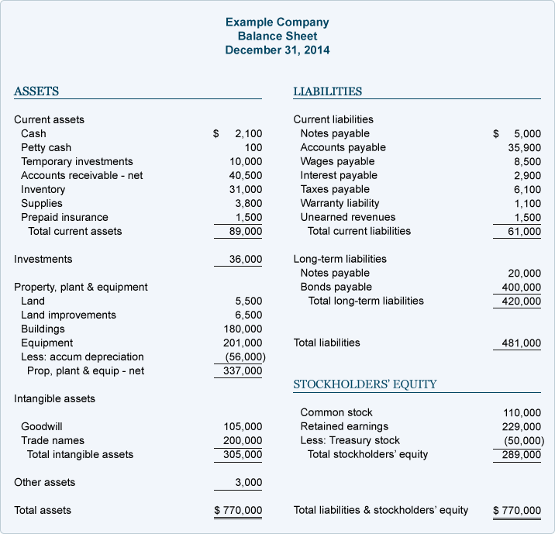

- Name and describe the two (2) types of benchmarks provided by the Australian Tax Office.
Answer | Benchmark | Explanation
 | Performance | These relate to Income tax and Activity Statements
 | Input | These are for labour and materials

- True or False (Tick your response): Comparing your ratios to the benchmark will give you a better idea of how your business is tracking and whether change might be required.

Answer |  | True
 |  | False

- Provide two (2) reasons that might cause you to alter your financial plan.
Answer | 1. Change in the Market  2. Change in Customers

BSBSMB406A
Manage small business finances

PRACTICAL ASSESSMENT INSTRUCTIONS

- The following practical assessment will require the Participant to complete work related activities.
- The Assessor will conduct observations of the Participant’s work to determine whether they display sufficient practical skills and knowledge.
- Please fill in the details below – providing your name, signature and date of assessment.
  - The Participant’s signature acknowledges that the Assessor provided clear instructions and the Participant understood what was required to complete this assessment.
- The Assessor may substitute a Practical Task with an alternate task of equal value.
  - Alternate tasks must be fully documented by the assessor in the Assessor Comments area.

Participant name | Murray Jackwitz
Participant signature
Date | 17/11/2019

Assessor name
Assessor signature
Date | Click here to enter a date.

Task | Task outcome (Tick)
Task | Satisfactory | Not Yet Satisfactory
Task 1

ASSESSOR Comments
BSBSMB406A
Manage small business finances

Practical Task 1
Description of task:
A suitable observer is to verify the participant’s ability to implement, monitor and review strategies for the ongoing management of a small business’s finances. The participant is to gather evidence of how they have completed each component of the Practical Task, which is to be submitted with this Practical Assessment sheet.

Evidence to be submitted may include:
- A cash flow forecast or budget
- Evidence of bookkeeping and transaction recording processes including accounting system/s used, for example MYOB, QuickBooks, Excel.
- Copies of transaction records
- Business loan agreements or Lease agreements
- Supplier account notices with trading terms
- Copy of invoice noting trading terms
- A letter from their accountant, etc. that acknowledges their association
- Copy of a Business Activity Statement
- A copy of a Profit and Loss Statement or Balance Sheet
- A copy of a financial plan if available

The observer is to provide detailed comments on the tasks completed by the participant. The assessor is to verify the observer’s comments and provide the outcome for the practical task on the front cover of the Practical Assessment.
Resources required:
Business financial data, business plan.
Assessment of task
Name of participant: | Murray Jackwitz
Name of observer: | Wade Jackwitz
Role of observer  (Confirm suitability to sign) | Senior Project Manager
Email address of observer | wade.jackwitz@mcnab.net.au
Signature of observer: | 
Date: | 15/05/2020
When completing the task, did the participant: |  | Tick if satisfactorily completed.  Provide comments if left unticked.
- Collate/prepare documentation of existing business financial information, including:
- Balance sheets
- Profit and loss statements
- Stock records
- Identify financial information requirements and obtain specialist services, as required, to profitably operate the business in accordance with the business plan.
- Produce financial budgets or projections, including cash flow estimates, as required for each forward period, and distribute to relevant people in accordance with legal requirements.
- Verbally negotiate, secure and manage business capital to best enable implementation of the business plan to meet requirements of financial backers.
- Develop and maintain strategies to enable adequate financial provision for taxation in accordance with legal requirements.
- Develop, monitor and maintain client credit policies, including contingencies for debtors in default, to maximise cash flow.
- Select key performance indicators to enable ongoing monitoring of financial performance.
- Record and verbally communicate financial procedures to relevant people to facilitate implementation of the business plan, confirming audience understanding through questioning and listening.
- Regularly monitor and report (verbally and in writing) on financial performance targets, and analyse data to establish the extent to which the financial plans has been met.
- Monitor marketing and operational strategies for their effects on the financial plan.
- Calculate and evaluate financial ratios according to own or industry benchmarks.
- Assess financial plan to determine whether variations or alternative plans were needed, and changed as required.
The Participant’s performance was: Satisfactory Not Satisfactory

observer Comments
Murray understands the importance of setting budgets and forecasting forward. Maintaining and tracking against a budget is a vital role of building and the relationship this has with understanding your cashflow.

