-

BSBITU307
Develop keyboarding speed and accuracy
Learner Guide



BSBITU307
Develop keyboarding speed and accuracy

Table of Contents

Table of Contents 3
Unit of Competency 5
Performance Criteria 6
Foundation Skills 7
Assessment Requirements 8
Housekeeping Items 9
Objectives 9
1. Use safe work practices 10
1.1 – Adjust workspace, furniture and equipment to suit ergonomic requirements 11
Keyboard skills 11
Adjusting workspace and equipment 11
Safe working practices 14
Activity 1A 15
1.2 – Ensure work meets organisational and work health and safety (WHS) requirements for computer operation 16
WHS requirements 16
Responsibilities for WHS requirements 17
Activity 1B 20
2. Identify and develop keyboard skills 21
2.1 – Identify and apply keyboard functions for both alpha and numeric strokes 22
Keys on keyboard 22
Special keys 22
Activity 2A 24
2.2 – Apply touch-typing technique to complete tasks 25
Touch-typing 25
Activity 2B 27
2.3 – Develop speed and accuracy in accordance with workplace requirements for level of responsibility 28
Speed and accuracy 28
Workplace requirements 28
Dvorak keyboard 29
Activity 2C 30
3. Check accuracy 31
3.1 – Proofread document carefully to identify errors 32
3.2 – Amend document, correct errors and complete a final accuracy check 32
Proofreading 32
Amending mistakes 33
Activity 3A 34
Skills and Knowledge Activity 35
Major Activity – An opportunity to revise the unit 36
References 38

Unit of Competency

Application

This unit describes the skills and knowledge required to develop keyboard skills with speed and accuracy using touch-typing techniques.

It applies to individuals who work in a range of environments and are required to enter text and data with speed and accuracy. They may work as individuals who provide administrative support within an enterprise, or may be technical/knowledge experts responsible for production of their own word processed documents.

On successful completion of this unit, individuals must be assessed in accordance with the current version of AS 2708: 2001 and issued with a speed statement.

No licensing, legislative or certification requirements apply to this unit at the time of publication.

Unit Sector

Information and Communications Technology – IT Use

Performance Criteria
Element  Elements describe the essential outcomes. | Performance Criteria  Performance criteria describe the performance needed to demonstrate achievement of the element.
- Use safe work practices | - Adjust workspace, furniture and equipment to suit ergonomic requirements  - Ensure work meets organisational and work health and safety (WHS) requirements for computer operation
- Identify and develop keyboard skills | - Identify and apply keyboard functions for both alpha and numeric strokes  - Apply touch-typing technique to complete tasks  - Develop speed and accuracy in accordance with workplace requirements for level of responsibility
- Check accuracy | - Proofread document carefully to identify errors  - Amend document, correct errors and complete a final accuracy check

Foundation Skills
This section describes language, literacy, numeracy and employment skills incorporated in the performance criteria that are required for competent performance.

Skill | Performance  Criteria | Description
Reading | 2.3, 3.1, 3.2 | - Reviews information to be typed and recognises variations and inconsistencies with spelling and format
Writing | 2.2, 2.3, 3.2 | - Types numerical and textual information following a simple and defined format
Navigate the world of work | 1.1, 1.2, 2.3, | - Recognises and adheres to legislative and organisational requirements and meets expectations associated with own role
Get the work done | 2.1-2.3, 3.1, 3.2 | - Utilises a broad range of features and functions within applications in performing routine and complex tasks

Assessment Requirements
Performance Evidence

Evidence of the ability to:

- Develop keyboard speed and accuracy in accordance with workplace requirements
- Apply ergonomic and work health and safety requirements
- Accurately proofread documents.

Note: If a specific volume or frequency is not stated, then evidence must be provided at least once.

Knowledge Evidence

To complete the unit requirements safely and effectively, the individual must:

- Outline key provisions of work health and safety (WHS) legislation that impact developing keyboard skills
- Outline ergonomic requirements applicable to developing keyboard skills.

Assessment Conditions

Assessment must be conducted in a safe environment where evidence gathered demonstrates consistent performance of typical activities experienced in the information and communications technology – IT use field of work and include access to:

- Organisational policies and procedures
- Relevant legislation
- Relevant workplace documentation and resources
- Industry software packages.

Individuals must be assessed in accordance with the current version of AS 2708: 2001 and issued with a speed statement.

Assessors must satisfy NVR/AQTF assessor requirements.

Links

Companion volumes available from the IBSA website: http://www.ibsa.org.au/companion_volumes

Housekeeping Items
Your trainer will inform you of the following:
- Where the toilets and fire exits are located, what the emergency procedures are and where the breakout and refreshment areas are.
- Any rules, for example asking that all mobile phones are set to silent and of any security issues they need to be aware of.
- What times the breaks will be held and what the smoking policy is.
- That this is an interactive course and you should ask questions.
- That to get the most out of this workshop, we must all work together, listen to each other, explore new ideas, and make mistakes. After all, that’s how we learn.
- Ground rules for participation:
  - Smile
  - Support and encourage other participants
  - When someone is contributing everyone else is quiet
  - Be patient with others who may not be grasping the ideas
  - Be on time
  - Focus discussion on the topic
  - Speak to the trainer if you have any concerns

Objectives

- Discover how to use safe work practices
- Learn how to identify and develop keyboard skills
- Know how to check accuracy
- Gain the skills and knowledge required for this unit

1. Use safe work practices

1.1. Adjust workspace, furniture and equipment to suit ergonomic requirements
1.2. Ensure work organisation meets organisational and work health and safety (WHS) requirements for computer operation



1.1 – Adjust workspace, furniture and equipment to suit ergonomic requirements

Keyboard skills
Keyboards are used in many work environments for typing and the ability to use one quickly, accurately and safely is often required by employers. As well as improving work efficiency and reducing mistakes, this will prevent injuries to the user.

Adjusting workspace and equipment
Hours of repetitive actions such as typing can cause injuries. Therefore, it is important to employ safe work practices when using a keyboard, including having the correct work environment setup and carrying out work properly. Poorly designed workplaces can lead to a 3% loss in productivity through illness and strains.
Ergonomics is the science of understanding how the body relates to the environment. This includes everything it comes into contact, from the chair and desk you use to your equipment layout. Although this may seem trivial, it can have a severe impact over an extended period. A poor layout can cause pain such as headaches and musculoskeletal problems in the lower back, neck, arms and wrists.

Factors that affect ergonomics are:
- Chair positioning, height and adjustment
- Desk height and position
- Computer positioning
- Keyboard style
- Posture
- Your individual measurements.
Ergonomics also include non-physical factors such as:
- Lighting
- Noise
- Cleanliness.
Chair
Your chair is one of the most important ergonomic factors and is the cause of most injuries. It should be adjustable so adjust the height and angle of it can be changed. If it is not, you should request one as soon as possible. It is important to be able to customise it to your preference so unnecessary strain isn’t placed on your body.
The chair should provide good lumbar support at the bottom of your back. Sit as far back in it as possible so your back is resting against the back of the chair. You may need to adjust the tilt to be either straight upright or slightly forward in order to ensure you are comfortable. Don’t tilt it backwards; this will lead to poor posture and more difficulty using the keyboard.
Adjust the height of the chair so that your feet rest flat on the floor. If this isn’t possible, use a footrest. Your upper legs should be parallel to the floor, and there should be a gap between the back of your knees and the edge of the chair.
If your chair has armrests, adjust them so you can rest your forearms on them when not typing. This should allow you to drop your shoulders. However, don’t use them to slouch back in your chair; try to maintain upright at all times.
Go here to calculate your ideal seating position for your height: http://www.thehumansolution.com/ergonomic-office-desk-chair-keyboard-height-calculator.html
Desktop
Your desk should be about elbow height with everything within easy reach so you do not have to twist unnecessarily. When you are working with a document holder, place it between the keyboard and screen. It is important you feel relaxed when seated at your desk; if you are uncomfortable or aching, you will need to change your position.
Ideally, you should be able to see everything on your desk without turning your head.
Keyboard and mouse
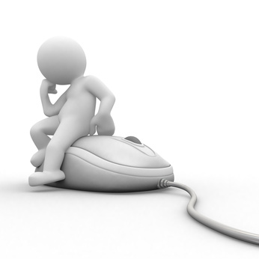
Your keyboard should be positioned so your wrists are neutral, not bending up or down, and your forearms are parallel with the desk. Check the height of your chair if this forces your elbows out to the side. Ensure your wrists are relaxed and not bent at an angle. Some people have a wrist rest to support them while they are typing.
Laptops place more strain on wrists than conventional keyboards as they are usually higher, so make relevant compensations with your posture.
Your mouse should also be within easy reach. Large, bulky mice may cause your wrist to bend upwards. If you feel your wrist hurting while using it, consider getting a mouse pad with a foam rest or a smaller mouse. This may also vary depending on your hand size. Reduce the pressure placed on your wrist by releasing the mouse as often as possible and keeping it close to the keyboard.
Monitor
The monitor should be just over an arm’s length away, with the top of it slightly below eye level. However, you may have to make compensations if you have problems with your sight and adjust it to wherever you can focus on it best. People with bifocal or multifocal lenses will need to find a position where they can see out of both lenses. If you have two monitors, ensure they are placed close together so you don’t have to turn your head when changing screens.
Consider how large the icons and text on the screen are. If it doesn’t decrease your productivity, it may be advisable to enlarge them to avoid straining your eyes. This is particularly relevant when looking at typing for long periods of time.

Lighting
Poor lighting can cause damage and strain to eyes. If possible, there should be natural light in your work environment. Light levels are measured in lux, with 300 lux being the ideal amount of artificial light. However this it will vary depending on the work environment.
Light can also cause glare or reflection on the screen, which may damage your eyes and make it more difficult to work. To determine if there is glare on your screen, place a book above your eye level and see if the screen changes and becomes clearer. This is particularly prominent when working directly under a light. You should try to eliminate glare whenever possible.
Glare can be reduced by:
- Moving work stations to a better location
- Closing nearby curtains or blinds
- Purchasing an anti-glare surface to put over the screen
- Changing the contrast. White writing on a black background may be easier to see
- Tilting your screen forward so less light falls on it
- Placing a folder or book overhanging the screen by around three inches
- Purchasing an LCD screen which eliminates glare.
If you experience discomfort when looking at a bright screen, trying reducing the brightness or changing the contrast again. Take short breaks to look away from the computer every ten minutes. Even if you don’t suffer from discomfort, short visual breaks every hour or so can still help you reduce stain on your eyes.
Noise
Excessive noise can cause hearing damage and poor work productivity. If noise interferes with your concentration or you struggle to hear speech, talk to your supervisor or HR representative. The National Code of Practice for Noise Management in Australia commits employees to keep noise to an acceptable level in the workplace.


Safe working practices
Your work practices will also contribute to your health and safety while using a keyboard. You are responsible for ensuring you carry these out or, if you feel that you are unable to, talking to a relevant member of staff about them.
Posture
Your posture, or body position, is just as important as your workplace layout. Keep it relaxed and maximise your comfort by adjusting your work environment. Sit upright with your keyboard and mouse an arm’s length away.
After an extended break from work, (e.g. for sickness or a holiday) try to reduce your workload while your body adapts to the posture again. Avoid sharp changes in workload during day-to-day work as well.
Movement
When you are seated, try to keep moving so you aren’t stationary for too long in order to avoid tight muscles in your back and legs. Constantly changing posture is known as dynamic sitting. Good ergonomic chairs are designed to facilitate this and allow movement.
If you have control over your working times, try to take several shorter breaks rather than one long break. This will reduce fatigue and keep your muscles in better condition. Talk to your supervisor to see if this would be possible in your workplace.
Reducing repetitive movement
Typing often requires repetitive movement. You should try and reduce the time spent doing this continuously by taking breaks whenever possible. See Chapter 1.2 for the working time restrictions when typing.
While sat at your desk, intersperse typing and using a mouse with other activities whenever possible, such as tidying your desk or writing by hand. Try to incorporate ‘micro pauses’ into your work routine to reduce tension. For example, when waiting for a document to load, relax your hands into your lap momentarily instead of leaving them on the keyboard and mouse. These pauses give your muscles time to relax without lowering your work productivity.
Phone calls
If you have to make long phone calls in your role, avoid holding the phone between your shoulder and ear. Always use a hand to hold it. If you need to write or type while on the phone, use a headset or speakerphone instead to leave your hands free. Reclining whilst on the phone will also give you a chance to change your posture. If you don’t have this equipment and feel that you should, speak to your supervisor or HR representative.
Continually reassess your working conditions and posture during the day. If you feel they have become uncomfortable or unsuitable for the work you are performing, inform the relevant people within your organisation.

Activity 1A

Estimated Time | 10 Minutes
Objective | To provide you with an opportunity to adjust workspace, furniture and equipment to suit ergonomic requirements
Activity | - What problems can light cause and how would you deal with these?

1.2 – Ensure work meets organisational and work health and safety (WHS) requirements for computer operation

WHS requirements
Your employer is obliged to follow certain workplace health and safety (WHS) regulations in order to ensure that you are not at risk from injury while working.
WHS requirements may include:
- Providing you with the correct workplace environment
- Ensuring you have regular breaks
- Ensuring you have a good typing technique
- Offering a visual display unit (VDU) eye testing
- Varying typing with other less repetitive tasks.
Typing technique

Using a keyboard correctly takes skills which you should put effort into developing. You should be able to type without looking at the keyboard and use more than two fingers.
Unskilled typists who only use two fingers (also known as ‘hunt and peck’ typists) are at increased risk of injury because they put additional strain on the fingers they do use. In addition, if they can’t find the keys without looking, they may be forced to constantly look from screen to keyboard and back again, which could cause strain to the neck muscles. If they adopt a tense pose, leaning over the keyboard, this will make it worse.
Skilled typists can type extremely quickly, but it is believed continual high-speed typing can cause Occupational Overuse Syndrome. Ten to twelve thousand key strokes an hour (or two thousand words per hour) is recommended as the maximum.
Regular breaks
Try to limit your time spent continuously typing. Keeping a fixed posture for long times will make it more likely they you will develop pain in your muscles. Take regular, short breaks whenever possible, or at least mix typing with less repetitive activities.
Although this area hasn’t been conclusively studied, it is recommended that experienced staff should only spend five hours a day typing, and no more than 50 minutes at a time. Less experienced staff will require a period of adjustment in order to build their typing time up.

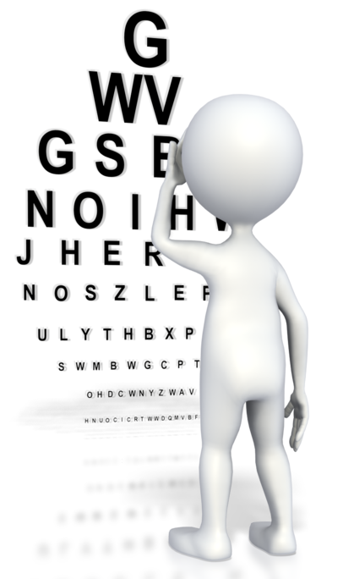
Eye tests
Some employers may offer eye tests to ensure that employer’s eyes aren’t unnecessarily strained by work. Display screen equipment, such as computers, may cause eye strain after long periods of time. If your employer doesn’t offer free tests, you may need to book tests in your own time and take relevant measures such as wearing prescribed glasses.

Responsibilities for WHS requirements
It is important you know who in your organisation to bring WHS concerns to.
People responsible for WHS may include:
- Your supervisor
- The HR department
- WHS officers.
Each will have their own responsibilities to make sure the workplace meets your ergonomic needs. The organisation is required to have a WHS plan to demonstrate they are aware of their legal responsibilities and are taking steps to meet them. For example:
Number | WHS action | Responsibility
1 | Write WHS codes and policies | Management/WHS officer
2 | Make the codes available in all departments | Supervisors
3 | Hold monthly WHS meetings to discuss issues. All employees welcome | WHS officer
4 | Implement a yearly training plan for employees | Supervisors/management
5 | Ensure all employees are introduced to organisation WHS policy during induction | Supervisors/WHS officer

General responsibilities
Employees are an organisation’s most important resource, and employers should ensure they are protected and looked after whenever possible. They should follow all relevant legislation to make the workplace safe and suitable for them to work in, including modifications to the workplace for disabilities.
Supervisors
Each supervisor is required to ensure that WHS legislation is enforced in their area. This may include making sure their team have received relevant training and consulting employees whenever necessary on WHS matters. They should also try to ensure that employees follow advice on taking regular breaks and varying activities that has been mentioned previously. They may also decide to implement eye testing schemes to protect their employees’ health.
Supervisors should plan and manage employees’ workloads. They should plan ahead to avoid busy periods when employees are overloaded whenever possible, as well as balancing the workload out between employees. They may decide to define how much each employee can handle to avoid exceeding that limit. Prioritisation systems can also reduce pressure on employees and encourage them to have realistic expectations.
WHS Officer/HR Department
Large companies may have a designated WHS officer whose responsibility it is to ensure the workplace follows codes and implement new regulations. WHS officers may be supervisors or managers, and are usually responsible for calling formal or informal WHS meetings, which deal with concerns put forward by employees or management. They should be aware of all relevant legislation which will affect the business.
They may also take responsibility for:
- Hazard reporting
- Emergency plans
- Accident/near miss reports
- Consulting with employees on WHS issues, which may include:
  - listening to opinions
  - listening to knowledge and skills
  - exploring recommendations
- Storage and maintenance of PPE (personal protective equipment).
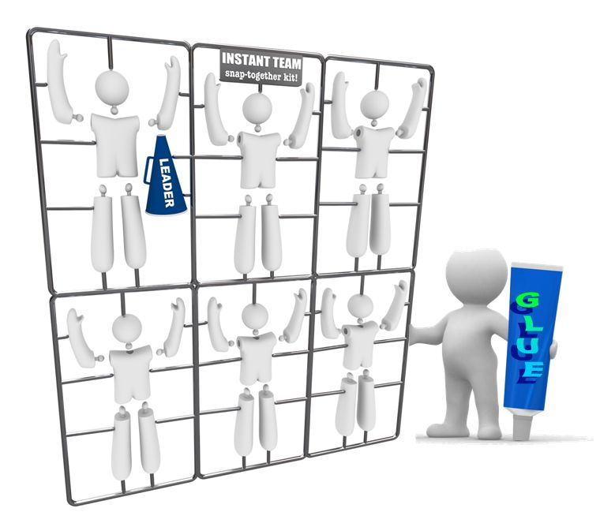
In other companies, this role may be performed by the HR department. If your organisation has neither of these, find out who performs the HR paperwork.
Employees
Employees have a responsibility to follow WHS requirements. They should also speak to their supervisor, HR department or WHS officer if they believe that their workplace is unsuitable. For example, their chair may be too low to work at their desk. If this request is ignored or isn’t fulfilled quickly, employees should follow-up or escalate the claim.
Employees should be aware of their organisation’s WHS plan and participate whenever necessary, such as making suggestions, giving feedback or raising points.
Contractors that are hired to perform work on site are also required to comply with WHS policies. They must observe the same procedures as regular employees and follow instructions from WHS officers. This will be detailed in their contract; not following the policies will be ground for termination.


2. Identify and develop keyboard skills

2.1. Identify and apply keyboard functions for both alpha and numeric strokes
2.2. Apply touch-typing technique to complete tasks
2.3. Develop speed and accuracy in accordance with workplace requirements for level of responsibility

2.1 – Identify and apply keyboard functions for both alpha and numeric strokes

Keys on keyboard
There are several sets of keys that you should be aware of in order to find them without looking at the keyboard.
The groups are:
- Alphanumeric keys
Alphanumeric keys are the keys with letters or numbers. These take up the majority of the keyboard and will be the most regular keys you use. On most keyboards, letters are positioned in the middle to be easier to reach, with number on the second-to-top row, and on the right hand side. However, the keys on the right only act as numbers if Num (number) Lock is on. Otherwise, they perform functions like special keys. Num Lock can usually be found near the Backspace key.
- Punctuation keys
Punctuation keys provide the punctuation for text, such as periods (full stops), commas, colons, semicolons and brackets. They are generally located towards the bottom and right hand side of the keyboard. The most commonly used ones (periods and commas) are located in the bottom-right corner. Mathematical symbols such as plus and minus also count as punctuation keys. Some punctuation can only be accessed when holding down the Shift key and pressing a number.
- Special keys
There are various special keys that don’t produce text or punctuation but have an effect on the writing.


Special keys
CTRL or Control Key
This produces an effect when pressed at the same times as other keys. For example CTRL and C copies any text that is highlighted, which saves time using the mouse. These combinations are known as shortcuts.
ALT or Alternative Key
This functions like a second CTRL key. Some shortcuts only work when CRTL and ALT are pressed together.
Arrow keys
The four arrow keys move the cursor up, down, left or right, one character or line at a time. When pressed at the same time as CTRL, they move it more than one position, such as a word or a paragraph. However the exact details depend on the programme that is running.
Backspace and delete key
The backspace key deletes characters to the left, and the delete key deletes characters to the right. Backspace is more commonly used as it is able to delete text that has just been written.
Shift key
When held down, the shift key causes letter keys to become uppercase and number keys to have the upper function. For example, the number 1 becomes an exclamation mark, which you will see written at the top of the key. Shift keys are sometimes represented by an upwards arrow rather than the word shift. There are two shift keys to allow you to use whichever one is easiest.
Caps Lock key
When pressed, the Caps Lock key causes all letters to become uppercase. However, unlike the Shift key, it doesn’t need to be held down and the effect will last until it is next pressed. Capslock doesn’t affect numbers, only letters.
Enter or Return key
The largest key on the keyboard, it moves the cursor to the next line. It may also be used instead of left-clicking on a function.
Function keys
The top row of keys, labelled F1 to F12, have different functions depending on the programme that is running when they are pressed. For example, Alt and F4 attempts to close the programme that is open.
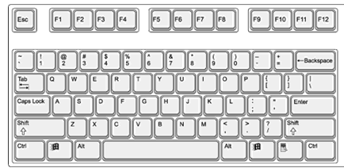
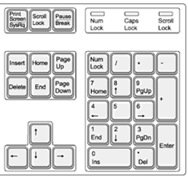

Source: www.gcclc.org

2.2 – Apply touch-typing technique to complete tasks

Touch-typing
Some people can type without looking at the keys. This is known as touch-typing. This allows them to type much faster than either people writing by hand or ‘hunt and peck typists’. Touch-tying provides increased speed and efficiency and has proved to be the fastest method to type.
Technique
The most important part of touch typing is knowing your way around the keyboard by feel alone. You should always rest your fingers on the home row. (This is two rows above the space bar, and on a QWERTY keyboard contains the letters A, S, D and F.) Most keyboards will have small bumps of the F and J where your index fingers rest to show that you are in correct position without looking.
When typing, you should gently press the correct key and then move your fingers back to the home row. It is also important to use the nearest finger to the key when they are resting on the home row. For example, it would be easier to press the Q key with your little finger than your index finger. This makes the process quicker and prevents you from putting additional strain on your fingers. Try not to move the rest of your fingers anymore than is necessary. Keep them on the home row whenever possible, which will reduce strain to your fingers.
If you are doing it correctly, you fingers will ‘glide’ across the keyboard, never actually leaving it. This saves time lifting and repositioning your fingers for every stroke. Keeping a constant rhythm will help you to adjust to this method of typing and increase your speed.
Try not to look at the keyboard as you are typing. If you constantly move your eyes between the monitor and keyboard, you will to slow down and stop focusing on what you are typing. Eventually, your fingers will learn to find the keys without thinking about it. This known as muscle memory.
When using the Shift Key, press the key on the opposite side of the keyboard to the letter. For example, if you are typing P, use the Shift on the left. This prevents your fingers from overstretching. Similarly, you can use either thumb to press the space key.
Many people find that their speed initially slows down when they begin touch typing and they have to force themselves to use the technique; however it will eventually become natural and their speed increases to more than it was before. The technique takes many hours of practice to build up speed.
Keyboard layout
In touch typing, the keyboard is divided into sections, with each finger responsible for a different ‘column’. Although there are different methods, this one is most popular.
On the left hand:
- The little finger is responsible for the 1, Q, A and Z keys. (The Tab, Caps and Shift keys are used infrequently enough that they aren’t considered to be part of that column)
- The ring finger is responsible for the 2, W, S and X keys
- The middle is responsible for the 3, E, D and C keys
- The index finger, being the most dextrous and central on the keyboard, is responsible for two rows: 4, 5, R, T, F, G, V and B. (Some of these may be interchangeable with the thumb, which also operates the Space Key.)
On the right hand:
- The index finger operates the 6, 7, Y, U, H, J, N and M keys
- The middle finger uses the 8, I, K and comma keys
- The ring finger is responsible for the 9, O, L and period keys
- The little finger rests on the 0, P and punctuation keys, such as the colon, forward slow, apostrophe, and Backspace.
The individual typing method will rely on the user’s hand size and ability to reach the keys, as well as the keyboard size. Purpose-made touch typing keyboards will allow skilled typists to work faster, but may slow down those unfamiliar with the layout.
Workplace requirements
Touch type classes used to be necessary to get a job using typing; however with children now using them from a younger age, typing is second nature to many people. The downside is that people learn inefficient ‘hunt and peck’ typing techniques, making it difficult to learn more sophisticated ones. Classes may be useful if you want to commit to increasing your speed in the long term.
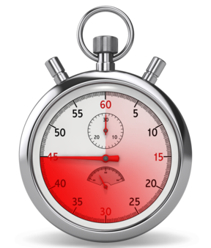

2.3 – Develop speed and accuracy in accordance with workplace requirements for level of responsibility

Speed and accuracy
Although speed is important, it must be balanced by accuracy, as mistakes will take additional time. Therefore, typists should be able to type quickly but with confidence that they are accurate.
40 wpm (words per minute) is considered to be the minimum speed for professional typists. Good speeds will take time to develop. To calculate this, the average word is assumed to be five letters long, so divide the number of characters (letters, numbers and punctuation) by five, divide it by how long they took to write in seconds, and finally multiply by 60.
Calculating words per minute
Number of characters = Number of words
5

Number of words = Words per second
Time

Words per second x 60 = Words per minute

Workplace requirements
The wpm speed required will vary depending on the job specifications. Some may require basic typing skills, while others will look for the ability to type quickly and accurately for long periods.
Some jobs that will require accurate typing skills are:
- Data entry and processing
People whose jobs require them to enter large amounts of data often type 60 or 70 wpm in order to enter data quickly, particularly when they are transcribing material from hard copy or voice recordings.
- Receptionists
Receptionists are required to record details quickly while on the phone or speaking to customers in person. These may be extremely important, such as medical information for a doctor’s receptionist, so they need to ensure their notes are accurate.
- Court reporters
Court reporters are required to transcribe everything that is said in court for legal reasons. This requires them to type extremely quickly and accurately, with attention to detail.
Other jobs that require strong typing skills are paralegals, writers, web coders and salesman. However, typing skills come in useful in all sorts of jobs and make day to day work significantly easier and quicker.

Dvorak keyboard
The Dvorak keyboard, created by Dr. August Dvorak in the 1930’s, is sometimes recommended for increasing typing speed. The most used keys are placed in the home row, with the vowels under the left hand and common constantans under the right. This requires less stretching for the fingers as 70% of the key strokes will already be under the fingers. 15% are on the top row and 15% on the bottom. By contrast, the traditional QWERTY keyboard has the keystrokes evenly distributed between the rows, requiring constant manoeuvring.
Typists who adopt this keyboard may increase their speed more easily than on a traditional one, however it will require ‘unlearning’ years of traditional typing. Also be aware that most organisations won’t have a Dvorak keyboard, so you will need to provide your own.
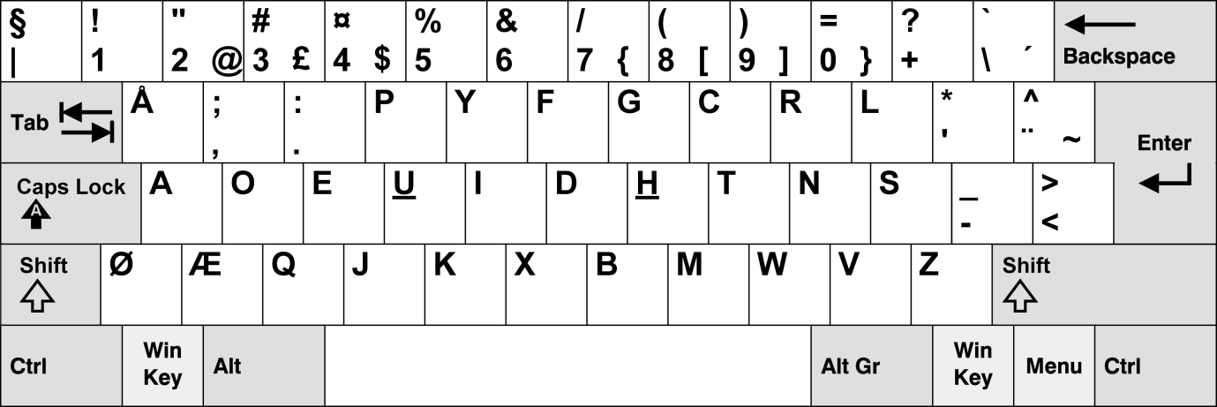
Source: dvorak.doomtech.net

Activity 2C

Estimated Time | 20 Minutes
Objective | To provide you with an opportunity to develop speed and accuracy in accordance with workplace requirements for level of responsibility
Activity | - In your own time, practise increasing your speed and accuracy while touch typing for twenty minutes

3. Check accuracy

3.1. Proofread document carefully to identify errors
3.2. Amend document, correct errors and complete a final accuracy check

3.1 – Proofread document carefully to identify errors

3.2 – Amend document, correct errors and complete a final accuracy check

Proofreading
Proofreading involves checking a document to ensure that there no errors in it.
This may include:
- Spelling errors
- Grammatical errors
- Whether the document makes sense.
Check the document carefully before you hand it in. It may not be checked again before it is sent out to a customer or shown to management, so it is your responsibility to make sure that it is accurate and mistake-free.
Where possible, it is advisable to leave the document a while before proofreading it. This will allow you to look at it with ‘fresh eyes’, having forgotten what it is supposed to say, which will allow you to notice mistakes. A day is preferable, but an hour is also acceptable. Some typists also prefer to swap with a partner to achieve the same effect.
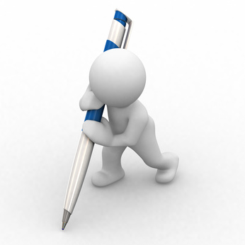
Proofread the document multiple times. Focus first on spellings, then grammatical mistakes and then typos.
In some cases, errors may have been present in an original document that you transcribed. In these cases, use your judgement on whether to change them or ask your manager whether you should leave them.
Spellings
Remember that spellcheckers aren’t perfect; they may get confused between tenses and can’t choose between homonyms such as their and there. Don’t assume it is always correct and blindly accept suggestions, particularly when using the grammar checker. Read the sentence through to see if it makes sense.
Furthermore, when the red and green error lines have gone, continue to read the passage through to see if it has missed anything. Spellcheckers can often lull people into a false sense of security. Proofreading the document multiple times will allow you to identify additional spelling mistakes.

Amending mistakes
Make changes to correct the errors you have noticed. It may be useful to print the amended document out and make a final accuracy check before submitting it. The more you see of a document, the more you will notice.
Remember that mistakes will present a negative view of your work and make you look unprofessional. Even if your work is 99% mistake free, the 1% that is mistakes will stand out.

Some people find that proofreading and amending documents is difficult in a noisy work environment. If you have nowhere quiet to go where you can fully concentrate on this task, consider speaking to your supervisor about it, or if you are allowed, use headphones to block out other noise. You should try to fully concentrate on the task without distractions.

Skills and Knowledge Activity


Nearly there...

Major Activity – An opportunity to revise the unit

At the end of your Learner Workbook, you will find an activity titled ‘Major Activity’. This is an opportunity to revise the entire unit and allows your trainer to check your knowledge and understanding of what you have covered. It should take between and 1-2 hours to complete and your trainer will let you know whether they wish for you to complete it in your own time or during the sessions. Once this is completed, you will have finished this unit and be ready to move onto the next, well done!

Congratulations!
You have now finished the unit ‘Develop keyboarding speed and accuracy’



References

These suggested references are for further reading and do not necessarily represent the contents of this Learner Guide

- Championship Keyboarding Drills: An Individualized Diagnostic and Prescriptive Method for Developing Accuracy and Speed w/ Success Breends Success (pckg. edition) [Misc. Supplies]
Cortez Peters (Author)

- 10-Key Touch Key: Developing Speed and Accuracy [Paperback]
Jo Burton (Author), David Burton (Author)

- Proofreading Plain and Simple (In Plain English Series) [Paperback]
Debra Hart May (Author)

- Proofreading and Editing Precision (with CD-ROM) [Paperback]
Larry G. Pagel (Author)

Websites:
Office ergonomics - http://www.ergonomics.org.uk/office-ergonomics/
Ergonomics -http://www.ors.od.nih.gov/sr/dohs/HealthAndSafety/Ergonomics/atwork/Pages/default.aspx
Working with display screen equipment - http://www.hse.gov.uk/pubns/indg36.pdf
Noise in the workplace - http://www.safeworkaustralia.gov.au/sites/swa/about/publications/Documents/279/NationalCodeOfPractice_NoiseManagementAndProtectionOfHearingAtWork_3rd%20Edition_NOHSC2009-2004_PDF.pdf

