CPCCBC6018
Manage processes for complying with legal obligations of a building and construction contractor

ASSESSMENT SUMMARY

The assessment activities for CPCCBC6018 Manage processes for complying with legal obligations of a building and construction contractor cover all aspects of the unit of competency. For Apprentices/Trainees, this includes supervisor completion of the Apprentice/Trainee Record (ATR).

Participants must read all the information given before starting any assessment task. The assessment tasks are intended to be fair, flexible, valid and reliable. If a Participant has any questions or requires alternative arrangements to be made such requests should be directed to their Trainer/Assessor, who should note such arrangements in the ‘Assessor Comments’ on the affected assessment. If a Participant feels they are not yet ready to be assessed, they should discuss their options with their Trainer/Assessor.

To satisfactorily complete the assessment, the Participant is required to answer all questions correctly and demonstrate their skills to industry standards. If a Participant does not answer all questions or perform all tasks, they will be deemed ‘Not Satisfactory’ for the task and ‘Not Yet Competent’ for the unit of competency.

The Trainer/Assessor can provide the Participant with additional information on interpreting the assessment outcomes and guide the Participant’s options. If a Participant is still deemed ‘Not Satisfactory’ they will have the opportunity to undertake a supplementary assessment or appeal the result as per the process in the Student Handbook.

By signing below, the Participant acknowledges:
- They understand the assessment instructions and requirements, and consent to being assessed.
- The work submitted is to be their own work – with the work of/with others needing to be clearly acknowledged and documented.
- They consent to any photo/video recording of their work that occurs during assessment.

Participant name | Alan Leeder
Participant signature | 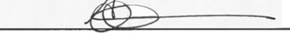

Pre-requisite unit(s) to be achieved and authenticated prior to undertaking assessment
Not applicable

Task | Date completed | Assessment Results
Theory Exam | Select Date. | Satisfactory | Not Satisfactory
Workbook | Select Date. | Satisfactory | Not Satisfactory
Practical Assessment | Select Date. | Satisfactory | Not Satisfactory
Outcome for CPCCBC6018 | Select Date. | Competent | Not Yet Competent

Evidence requirements checklist (ticked by assessor and evidence supplied to RTO)
Theory Exam  Workbook  Practical Assessment  Copy of contract reviewed  Screenshot/ doc. of management system introduced and managed | 1 x ea. Policy & procedure - record & legal documents storage  Screenshot/ doc. system managed re: insurance and taxation  1 x ea. Policy & procedure re: payments  Code of conduct developed  Screenshot / copy of EMP compliance actions.

Assessor name
Assessor signature | 

CPCCBC6018
Manage processes for complying with legal obligations of a building and construction contractor

THEORY EXAM

Participant name | Alan Leeder

FOR THE PARTICIPANT
Instructions
- You will complete written questions as outlined on the following pages. You must attempt all questions and provide enough detail in your responses to demonstrate your knowledge.
- It is anticipated that you should complete this assessment within two (2) hours, but additional time may be allowed upon negotiation with the Assessor.
- You must complete all questions unassisted by the Assessor or other personnel but may refer to reference material as needed. All questions must be answered correctly for a ‘Satisfactory’ assessment outcome to be awarded.
  - An oral examination may be allowed under certain circumstances, whereby your answers will be documented by another party.
  - Any written questions that are incomplete, or not answered satisfactorily will need to be completed again after further training support.
    - If you answer a question incorrectly but modify your response, put your initials next to the written change (or the Assessor must initial a verbal change).
Resources required
Pen

FOR THE ASSESSOR
Instructions
- Where oral examination has occurred, ensure that this is acknowledged in writing (e.g. FT001 and Assessor Comments)
- All questions must be satisfactorily demonstrated by the Participant for a Satisfactory determination (indicated by an Assessor tick to the right of the question).
- Assessors are to complete marking in pen of a different colour to the Participant.
- If the Participant verbally modifies their response, write in the modified response verbatim and put your initials next to the written change.

ASSESSOR COMMENTS
As necessary, outline:
- Details on reattempts, alternative arrangements or reasonable adjustments made.
- Where a Participant is deemed ‘Not Satisfactory’, provide recommendations for future training.

- Discuss the following types of building contract and identify provisions relating to these in the State/Territory you are working.

 | State/Territory: QLD
Answer | Contracts | Purpose/requirement
 | Commercial contract | A non-residential building and used for office space stores or a hotel and used exclusively for commercial buildings
 | Residential contract | Used to give the minimum rights for homeowners builders and contractors, including warranties , payments, deposits and insurance  This gives the ability to trans act with the builder
 | Lump Sum contract | Lump sum contract is the agreed fixed price to build this type of contract is risky as cost can blow out it can be used on commercial; and residential buildings
 | Sub-contract agreement | Is an agreement between main contractor and subcontractors performing construction works on site
 | Cost-plus contract | This a contract used to complete works were costing of the project is to risky for subcontractor or builder, and allows contractor to start works with reduced risk

- Discuss contract terms, conditions, and inclusions you are likely to encounter.

Answer | Contract terms are used to ensure that completion of construction works are done to a compliant standard and ensure projects are completed on time  - Site Access  - Provision of Documents  - Delays incl. inclement weather delays  - Extension of Time Claims  - Commissioning  - Fire compliance  - Quality of works  - Insolvency  - Practical completion  - Provision of securities  - Disruption resolution  - Contract cost  - PM and admin administration  - Variations’ that may be required and impact on program  - Warranties & HOTO requirements  - Defects

- Discuss the importance of adding variation clause to the contract and what you may need to include in the contract documents.

Answer | In any building design there may be issues that have been missed by the design team (errors & omissions) and/or not captured in the documentation this would be a potential cost to a subcontractor or builder and a variation.  Any client requested changes that deviate from origin design and have cost implications could be seen as a variation for which the contractor may be entitled to recover costs.  Any construction sequences that have not been advise and may cost the subcontractor money could be seen as a variation.  Provides flexibility in construction and construction contracts, provides a safe guard for parties to the contract, and a mechanism to adjust the contract sum when and where appropriate.

- Discuss why builders should keep and maintain records of subcontractors, site supervisors and managers qualifications, competencies, and licences.

Answer | To ensure that competent and knowledgeable persons are supervising and managing the works and on-site staff are constructing to design and AS/NZ standards  If builder is audited he will need to prove that all persons on site working are competent and have the correct qualifications to supervise workers or complete works.  This could be important if there are any issues during DLP and achieving PC where warranties and other statutory and legislative requirements are enforced.  Also for WHS perspective.

- Why would you access the Australian Business Licence and Information Service (ABLIS)?

Answer | It is resources used for existing business and anyone considering starting up to help with staying on top of compliance duties,  Users can quickly find there business activities  ABLIS can help you find applicable state and territory and local licenses , permits approvals , rules and codes of practice

- How can you ensure you respond to changes to licensing arrangements in a timely manner?

Answer | You must notify if there are any changes in your licensing arrangements with in seven days of any changes in you r circumstances that impact your capabilities to do your works as required under your licensing conditions  - If you are going bankrupt  - Changes in nominated supervision ‘  - Directorship changes  - Changes in your address  - If you have committed an offence

- Discuss areas of a building contract that may require you to organise professional legal advice.

Answer | As a building contract is legally binding it would always be in your best interest to have it looked at by a qualified legal consultant.  Any terminations of contract would need to legal advice as it could have penalties  Any agreed changes need to be documented form a legal perspective related to termination  Any delay agreements would need to be confirmed as delays not related to your works could send you broke  Any formal disputes between subs and builder  Legal counsel can find any legal concerns arising from you r contract  Process of obtaining any compensation  Any intellectual property needs ot be protected from a legal perspective  Obtain any legal advice about any terms of your contract  Deciding on your company structure  Contract particulars including implication and risk of damages, LD’s, financial and legal obligations, insurances, and the like should all be reviewed by legal representative to identify imbalances and protect the interests of the party executing.

- What processes can you introduce and manage to enable the organisation to obtain effective legal advice relating to contract law?

Answer | Before signing any contracts you need to understand what you are signing – legal review.  Terms and condition of the binding agreement need to have process of review by legal counsel to ensure that you can meet your obligations under the agreement.  Any characteristic under the contract like Proposal, Legal Relationship, Acknowledgement, and pricing need to have process in place to manage

- Discuss the benefits of having a contract management system in place.

Answer | Introduction of a management to help with legal interpretation of contracts  Understanding of contract meanings and phrases to ensure that you have a full understanding of your obligations contractually  It will also provide evidence that you have taken all steps to ensure that you can comply with achieving the obligations and understand your obligations  If is in your best interest to have a good understanding of the wording in your contract from a legal perspective and having a management system in place helps with this.  Streamline business procurement model.

- What mechanisms can you put in place to improve communication and dialogue with the client?

Answer | Improving communication with client can be done in a number of ways weather it be verbal our through email correspondence, you need to build a relationship with these people to ensure that you can be maintain  Talking to your clients to understand what is needed  Get to know them on a personal level so you can build a repour with this person  Be accommodating with what they require to a point where it dose not cost you money  Shair milestones and goals together celebrate your wins  Consult each other on any changes before moving forward formulae

- Describe what happens in conciliation.

Answer | It is an alternative to mediation and arbitration and gives each party an opportunity to resolve contractual disputes, it can speed up the process reduce cost and can be efficient.  All of these options are a better alternative than going through the court systems as it does not involve a judge or a lawyer

- Why would the builder change/adapt workplace procedures and workplace safety requirements at a new site?

Answer | Because not every job site or construction project is the same and will require some procedures and SWMS to be changed.  This is always an ongoing thing in construction and will always need reviewing to maintain safe work practises  Access to site, location of construction site all play a part in developing procedures  Like working around the public or over water, these procedures will be different to building a house

- Discuss strategies you can apply that ensure all workers are inducted, informed, and regularly updated of their on-site safety responsibilities.

Answer | On our work site it is a requirement that everyone working is inducted, site team keep a register of all inducted persons, once inducted they are given a sticker so site teams know they have been inducted  We have daily prestart with all site workers to advise of any changes across the site for the day all sign onto a day sheet  We also have weekly toolbox meeting to review and updated safety alerts or changes to SWMS  All subcontractors also do weekly and daily, prestart meetings

- A worker you have employed on the site has been injured and has lodged a request for workers compensation to reimburse their medical expenses. Explain the process you must follow in your State or Territory for claiming on behalf of the worker.

Answer | You would go to the workers compensation and Rehabilitation Act 2003  Before making a claim the employer must visit a doctor and get a work capacity certificate  Make a claim as soon as posable  You will also need to get a statement from the worker involved and also from the employer  Then fill in the work cover Queensland Claim Form with all required information about expenses and time off work, also wages

- What is inherent risk in construction? Discuss the factors to be considered in assessing risks inherent in building and construction projects.

Answer | Inherent risk on our project are  - Working at heights  - Electrocution  - Struck or crushed by plant  - Traffic management  - Repetitive strain injures  - Incorrect PPE  - Safety compliance  - Hot works  - Working over water  All the risk identified above can be managed with the correct training, inspections and supervision.  Supervision and monitoring site changes during construction are critical to ensuring a safe job site

Read the scenario below to respond to Q16. and Q17.

The subcontractor (first-tier subcontractor) you hired for this project is carrying on a business that is primarily in the building and construction industry. He has engaged another subcontractor (second-tier subcontractor) to assist with their current workload.

- What subcontractor payments are you required to report to the Australian Taxation Office (ATO)?

Answer | Sole Trades/Contractors and ABN Holders – first tier subcontractor only.

- Will the first-tier subcontractor also be required to report to the Australian Taxation Office (ATO)? Explain your answer.

Answer | First tier contractor undertaking works individually for the principal contractor are also required to have a satisfactory tax records. In some instances, may be required to provide evidence of satisfactory tax record prerequisite to being engaged.  Any reports will be a summery of payments made to contractors for building works and services provided any payments to suppliers also need to be reported

- As the principal contractor, you will be withholding tax from the payments you make to your workers and contractors through PAYG withholding. Provide the four (4) activities that you must complete in compliance with the Australian Taxation Office’s (ATO) requirements for those who make payments subject to withholding.

Answer  1.  2.  3.  4. | - Annual reporting you must lodge PAYG reports at the end if each financial year Reporting complete and accurate information  - When worker leaves need to be reported to the ATO  - Purpose of transaction need to be documented Paying and reported to ATO  - Lodgment of tax on time  - Relationship between parties for the transaction

- Discuss the following types of insurance and the purpose that builders or building companies need to organise them.

Answer | Insurance | Purpose/requirement
 | Workers compensation | Workers compensation is a form of insurance payment to employees if they are injured at work or become sick due to their work. Workers compensation includes payments to employees to cover their: wages while they're not fit for work. medical expenses and
 | Contract/Construction Works insurance | Contract Work insurance covers for Contractors material damage and legal liability covers physical ;oss and damage to there building projects during construction period  Also covers things fire, theft, malicious damage, storm, cyclones, flood and accidental damage
 | Public liability | Public liability insurance covers you for third party death or injury. It helps protect you and your business when you're liable for negligence. For example, if your business causes: injury or death, such as your food making a customer sick
 | Professional indemnity | Professional Indemnity Insurance can provide cover in the event of a breach of contract, or a mistake from professional services provided, such as a mistake made in the course of providing professional services or advice, or recommendations to a client.
 | Commercial Motor Vehicle | Commercial Motor Insurance is a comprehensive insurance policy that is intended to provide cover for unintentional damage to your business motor vehicle or unintentional damage to a third party motor vehicle or third party property that is caused by your business motor vehicle.

- Discuss how you can improve the organisational industrial relations climate while enforcing the company codes of conduct for employees and subcontractors.

Answer | On our projects we have all our subcontractors are EBA (enterprise bargaining agreement ) and we comply with the requirements under these agreements  We also work closely with subcontractor and with comping with all safety standard and procedures used by union with our industrial relations  At the end of the day its all about ensuring that principal contractor and subcontractor complies with all codes of conduct across the site, from wages to safety

- What do the basic rights known as ‘consumers’ guarantees’ cover?

Answer | Consumers have the right to expect certain things when they buy a product or service. These rights are protected under Consumer Law.  As per the ACCC;  - Business must meet a set of basic rights when they sell or provide services,  - these basic rights are called consumer guarantees,  - customers automatically receive these consumer guarantees when buying googs or services  - it is unlawful for a business to mislead a consumer about these rights

Read the scenario below to respond to Q22.

A Brisbane consumer hires a builder to undertake repairs on an outdoor patio. The consumer and the builder agree on a cost of $4,200 but don't discuss the completion date. The builder starts the repairs but doesn’t return for a month. The consumer claims that the service hasn’t been supplied within a reasonable time even though heavy rain occurred during one (1) week of the month.

- Discuss the compliance issues related to this activity and how this can be rectified.

Answer | This will be determined by what is contained and agreed in the contract between the builder and the consumer  Construction time frames and completion dates are generally predetermined and written into the contract. Management of delays, including weather related delays, may also be detailed in the agreed contract.  If there are rain delays then the builder need to document these day and advise the customer that this has delayed the construction works  If the builder has breached any of the contract agreement with completion dates the consumer may have a right to recover cost related to this delay

- Discuss how waste avoidance actions can be encouraged and monitored on-site.

Answer | Wast avoidance is something that has been in construction for a long time, on our project all waste being removed from site is sent to a recicaling facility and any recyclable waste is removed any processed.  On site we have steel recycling bins for trades to use to help with recovering materials  Consulting and planning around construction maireals and a waste management plane are critically achieving a good waste avoidance

CPCCBC6018
Manage processes for complying with legal obligations of a building and construction contractor

WORKBOOK

Participant name

FOR THE PARTICIPANT
Instructions
- You will complete written activities as outlined on the following pages. You must attempt all questions and provide enough detail in your responses to demonstrate your knowledge.
- The timeframe for these tasks will be established by your Assessor or Training Plan, but additional time may be allowed upon negotiation with the Assessor.
- You must complete all questions unassisted by the Assessor or other personnel but may refer to reference material as needed. All questions must be answered correctly for a ‘Satisfactory’ assessment outcome to be awarded.
  - An oral examination may be allowed under certain circumstances, whereby your answers will be documented by another party.
  - Any written questions that are incomplete, or not answered satisfactorily will need to be completed again after further training support.
    - If you answer a question incorrectly but modify your response, put your initials next to the written change (or the Assessor must initial a verbal change).
Resources required
Pen

FOR THE ASSESSOR
Instructions
- Where oral examination has occurred, ensure that this is acknowledged in writing (e.g. FT001 and Assessor Comments)
- All questions must be satisfactorily demonstrated by the Participant for a Satisfactory determination (indicated by an Assessor tick to the right of the question).
- Assessors are to complete marking in pen of a different colour to the Participant.
- If the Participant verbally modifies their response, write in the modified response verbatim and put your initials next to the written change.

ASSESSOR COMMENTS
As necessary, outline:
- Details on reattempts, alternative arrangements or reasonable adjustments made.
- Where a Participant is deemed ‘Not Satisfactory’, provide recommendations for future training.

NOTE

At times, you will be provided with a specific business context to which you must respond, otherwise it is anticipated that you will use a workplace of your choosing (your own, or hypothetical) to provide the context to the task.

At all times, the responses in your assessment must reference Australian (Queensland or Federal) documentation, including legislation, regulations, codes of practice, standards and guidance publications.

Access the Queensland Building and Construction Commission to respond to the following questions.
- What is required to gain a Builder - medium rise licence?
- What is required to gain a Builder - low rise licence?
- Describe the scope of work for a Builder restricted to special structures (shade sails).

- What is required to gain a Builder - medium rise licence?
Technical qualifications for licensing QBCC

Any one of the following— (a) successful completion of Diploma of Building and Construction (Building) CPC50220;

(b) successful completion of a course the commission considers is at least equivalent to the course mentioned in paragraph (a);

(c) a recognition certificate as a builder qualified to carry out the scope of work for the class;

(d) a qualification or statement of attainment of required competency for the class of licence

- What is required to gain a Builder - low rise licence?
Technical qualifications for licensing QBCC

Any one of the following—

(a) successful completion of Certificate IV in Building and Construction CPC40120;

(b) successful completion of a course the commission considers is at least equivalent to the course mentioned in paragraph (a);

(c) a recognition certificate as a builder qualified to carry out the scope of work for the licence class;

(d) a qualification or statement of attainment of required competency for the class of lice
- Describe the scope of work for a Builder restricted to special structures (shade sails).
- Construction, installation, maintenance or repair of membrane shade structures including metal brackets, cables and structural members for the structures.
- Concreting work for footings for the structures, and
- Prepare plans and specifications for membrane shade structures that are:
  - for the licensee's personal use, or
  - for use in building work to be performed by the licensee personally.
- Incidental work of another class.

Satisfactory Outcome

Access the Fair Work Ombudsman website at https://www.fairwork.gov.au/about-us/legislation#fair-work-legislation and respond to the following questions.
- What is the purpose for the Fair Work Act 2009 and the Fair Work Regulations 2009?
- What actions are taken by the Fair Work Ombudsman in relation to compliance and enforcement?
- Describe the type of issues workers may contact the Fair Work Ombudsman about.

- What is the purpose of the Fair Work Act 2009 and the Fair Work Regulations 2009?
The purpose of the Fair Work Act is to introduce a national workplace relations system that sets minimum standards and conditions for employees and provides the legal framework for employer-employee relations for the majority of workplaces in Australia.
- What actions are taken by the Fair Work Ombudsman in relation to compliance and enforcement?
Fair Work Inspectors are able to use statutory compliance powers for a ‘compliance purpose’, which includes determining whether a person is complying with the FW Act or a fair work instrument, or, in certain circumstances, whether a safety net contractual entitlement has been contravened. 4 Where a provision of the Fair Work Regulations 2009 (Cth) (FW Regulations) or another Act confers powers on Fair Work Inspectors, compliance powers can also be used for the purposes of that provision or Act.5
Entering Premises
Inspect any work, process or object;

- Describe the type of issues workers may contact the Fair Work Ombudsman about.
Ombudsman can help with
- underpayment of minimum entitlements under the Fair Work Act, a modern award or an enterprise agreement. This includes issues about: pay rates. notice of termination. redundancy. general employment conditions under these instruments.
- breaches of the National Employment Standards (NES)

Satisfactory Outcome

Provide information that you would include in an email or memo to communicate to company employees and contractors:
- licencing and contract requirements for your State or Territory
- the consequences of non-compliance with relevant legal obligations and licensing requirements.

Answer:
QBCC License Requirement:
- Individuals (such as sole traders, partners, and trustees) and companies must hold a Queensland Building and Construction Commission (QBCC) license to carry out building work.
- The license is mandatory for the following scenarios:
  - Building work valued over $3,300.
  - Building work valued over $1,100 involving Hydraulic Services Design.
  - Building work of any value involving:
    - Drainage
    - Plumbing and drainage
    - Gas fitting
    - Termite management (chemical)
    - Fire protection
    - Completed residential building inspection
    - Building design (low rise, medium rise, and open site classification)
    - Mechanical services¹.

- Direction to Rectify: If a client believes the work you’ve done is defective, they can submit a complaint to the QBCC.
- Demerit Points: For defective or non-compliant work, the QBCC may issue demerit points to a licensee.
- Fines: Penalty infringement notices (fines) are issued for non-compliant or unlicensed work.
- Judgment Debts: These are amounts accepted by a court as being owed by a QBCC licensee to another person under a contract.
- License Suspension or Cancellation: If you don’t meet current licensing requirements, your license may be suspended or canceled.
Remember, staying informed about compliance rules is crucial to avoid these consequences. If you’re unsure, consider contacting the QBCC or seeking legal advice².

Satisfactory Outcome

Search the internet to locate information and training that you can organise that provide human resources administration staff information to assist them in understanding their responsibilities in relation to:
- insurance
- taxation matters.

- Insurance
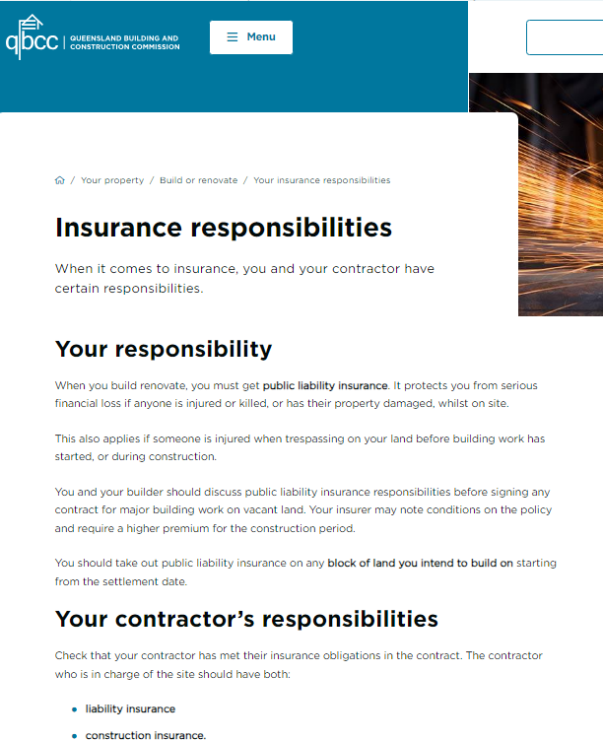
- Taxation matters
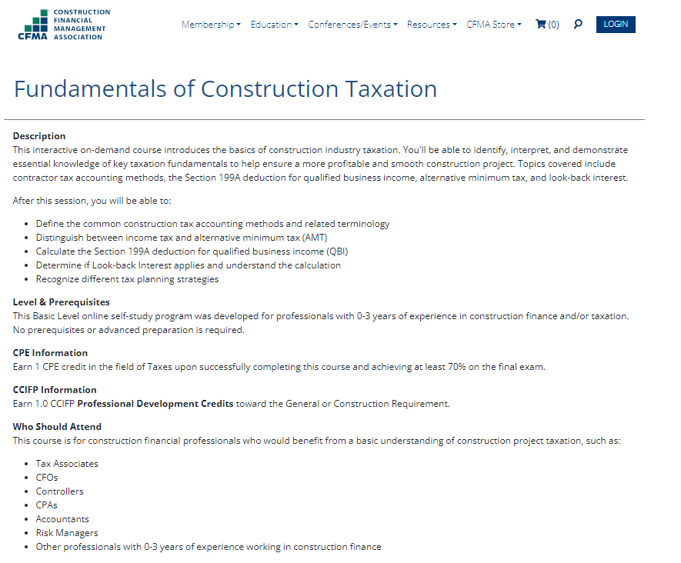

Satisfactory Outcome

Write a Code of Conduct for all employees and subcontractors engaged in a building and construction company that outlines specific principles and standards of behaviour that underpin best practice and co-operation. Use the following headings for your Code of Conduct.
- Objectives
- Responsibilities
- Ethical principles
- Continuous improvement
- Project planning and contract documentation
- Management and administration of contracts
- Environmental management
- Security of payments
- Training and development
- Work health and safety
- Compliance

- Objectives
Our Code of Conduct aims to foster a positive work environment, uphold ethical standards, and promote collaboration. It guides our behavior and ensures best practices in all aspects of our work.
- Responsibilities
It is the responsibility of all staff to conduct them selves
Professionalism: All employees and subcontractors must act with integrity, honesty, and respect towards colleagues, clients, and stakeholders.
Compliance: Adhere to legal requirements, company policies, and contractual obligations.
Quality: Deliver work that meets or exceeds industry standards.
Timeliness: Complete tasks promptly and efficiently.
Thes responcabiltys are to be complied with at all times when conducting business for our compon

- Ethical principals
Ethical principles are to be always maintained by complying with below standards.
Transparency: Be open and honest in all communications.
Fairness: Treat everyone equitably, regardless of position or background.
Confidentiality: Safeguard sensitive information.
Avoid Conflicts of Interest: Disclose any personal or financial interests that may affect the

- Continuous improvement
Continuous improvements to be monitored and improved with collaboration of all staff throiugh
Learning: Stay informed about industry trends and best practices.
Feedback: Provide constructive feedback to improve processes.
Adaptability: Embrace change and seek innovative solutions.

- Project planning and contract documentation
Project planning and contract documentation
Thoroughness: Create detailed project plans and accurate contract documentation.
Risk Management: Identify and mitigate risks during planning.

- Management and administration of contracts
Management and administration of contracts
Communication: Maintain clear communication with all parties involved.
Contract Compliance: Ensure adherence to contract terms.
Dispute Resolution: Resolve conflicts promptly and professionally

- Environmental management
Environmental management to be complied with through following
Sustainability: Minimize environmental impact through responsible practices.
Compliance with Regulations: Follow environmental laws and regulations.

- Security of payment
Security of payment requirements to be followed and have a commitment to high integrity at all times
Timely Payments: Pay subcontractors promptly and fairly.
Transparency: Clearly communicate payment terms.

- Training and development
Training and development to be implemented through
Skill Enhancement: Encourage ongoing learning and skill development.
Safety Training: Prioritize safety training for all employees.

- Work health and safety
Work health and safety underpins our compony and is to be complied with at all time ensure that all construction works are completed safely.
Safety First: Follow safety protocols to prevent accidents.
Reporting: Report any safety concerns promptly.

- Compliance
Compliance requirements are critical tour business and must be adhered to at all times
Legal and Regulatory Compliance: Abide by all relevant laws and regulations.
Internal Policies: Follow company policies and guidelines.
Remember, this Code of Conduct reflects our commitment to excellence, collaboration, and ethical conduct. Let’s work together to create a positive and productive workplace!

Satisfactory Outcome

Access the website for your State or Territory environmental regulator and respond to the following questions:
- What environmental authority conditions apply in relation to noise or dust at a sensitive place?
- Discuss guidelines regarding waste and waste avoidance that you can include in the site Environmental Management Plan (EMP).

- What environmental authority conditions apply in relation to noise or dust odour, at a sensitive place?

Noise 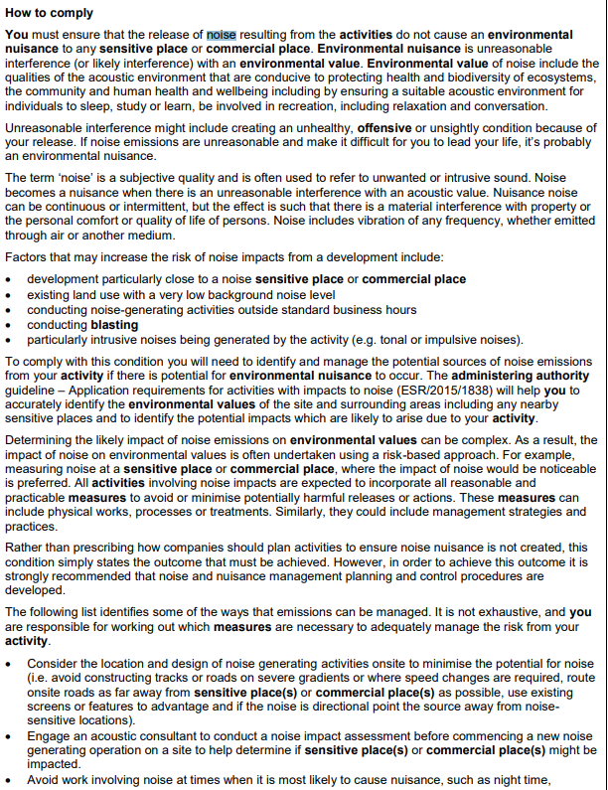

Dust

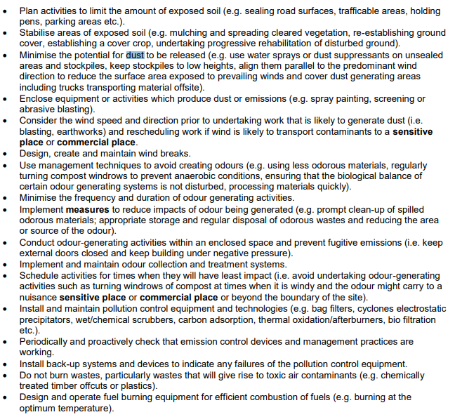

- Discuss guidelines regarding waste and waste avoidance that you can include in the site Environmental Management Plan (EMP).
Waste segregation is the sorting and separation of waste types to facilitate recycling and correct onward disposal. When waste is sorted correctly, it can save your company money. Waste segregation should be based on: The type of waste. The most appropriate treatment and disposal.

The waste management hierarchy needs to be implemented to help reduce waste during construction
Prevent
Reduce
Reuse
Recycle
Recover

Satisfactory Outcome

CPCCBC6018
Manage processes for complying with legal obligations of a building and construction contractor

PRACTICAL ASSESSMENT

Participant name | Alan Leeder

FOR THE PARTICIPANT
Instructions
- The tasks outlined on the following pages will require performance of normal workplace activities, as a result of a structured activity set by an Observer in the workplace or a simulated activity set by your Assessor/Observer.
- The timeframe for these tasks will be established by your Assessor/Observer, in consideration of location conditions and industry requirements.
- You must complete all tasks unassisted by the Assessor or other personnel unless the steps note this assistance.
- You must attempt all tasks (and itemised steps) for a ‘Satisfactory’ assessment outcome to be awarded.
  - For any observation conducted that is incomplete, or without satisfactory performance, the observation will need to be completed again after further training support.

FOR THE ASSESSOR/OBSERVER
Instructions
- The following observation record should be used to judge and record your observations of the Participant as they complete the task(s) set. You must record your observations of the Participant’s performance.
  - For each occasion, indicate the task performed and whether it was a simulation or workplace-based task.
    - Any simulated assessment must ensure the Participant still performs under workplace conditions which reflect industry standards.
  - In the comments, provide clear detail regarding the task that the Participant was required to do (e.g. PPE used, materials handled, attachments connected, plant types).
- All steps must be satisfactorily demonstrated by the Participant for a ‘Satisfactory’ determination (indicated by an Assessor tick to the right of each itemised step, or an Observer tick to the right of each itemised step, and confirmation by an Assessor in the Assessor Comments).
  - Where you have determined that one or more task steps have not been satisfactorily demonstrated, provide the Participant with additional support and outline details of such assistance in the Assessor/Observer Comments. Allow the Participant two (2) further opportunities to demonstrate the task again to allow an opportunity for a ‘Satisfactory’ assessment outcome to be achieved.
  - If after three (3) attempts the Assessor determines that the Participant cannot demonstrate the required steps, a ‘Not Satisfactory’ outcome is to be determined.

TASK OUTCOME
Task | Date | Task Type (Tick) | Location | Task outcome (Tick)
 |  |  |  | Satisfactory | Not Satisfactory
Task 1 | 7/08/2024 | Workplace  Simulation

ASSESSOR COMMENTS: GENERAL
As necessary, outline:
- Details on reattempts, alternative arrangements or reasonable adjustments made.
- Where a Participant is deemed ‘Not Satisfactory’, provide recommendations for future training.

ASSESSOR COMMENTS: PRACTICAL TASK 1
Individual student (as named on cover page)
Multiple students [ All from Attendance Report, Specific students involved – identify students]
Task | Provide detail
1.1A. | Specify type of building contract reviewed where provisions of the contract, terms, conditions, inclusions and variations were correctly identified:  T062 HMAS Cairns – Managing Contractor Contract (MCC-1 2003) – Defence Form Contract. Unable to provide a copy for defence security purposes. Templates are available from DEQMS website.
1.1B. 1.1E. | Specify how building contractor licencing and contract requirements were reviewed for compliance:  Not applicable to MCC-1 – relevant to Subcontract Agreements only. On this particular project, the EOI and Defence Procurement Process defined successful short-list tenderers having to hold licence relevant and suitable with proposed contract scope (QBCC licence check) and acceptance of contract terms and conditions at the time of tendering to avoid lengthy negotiations and undesirable departures from Defence standard form contract.
1.1C. | Specify how contractor licensing and contract requirements and non-compliance were communicated to workplace employees and others:  Communicated to all relevant project team and stakeholders through the EOI process, Defence Procurement process, and BW internal procurement process.
1.1F. | Specify where the application for necessary building or construction licenses was made:  Not applicable.
1.2A. | Specify which areas of the contract reviewed required professional legal advice.  MCC-1 Managing Contractor Contract reviewed in its entirety, but with particular attention drawn to elements of exposure to commercial legal risks. Subcontractors (MASC 2004) undertake their own legal review.
1.2B. | Specify processes managed to enable the workplace to obtain such legal advice.  Not applicable, undertaken at a much higher commercial level. In the event legal advice post contract award is necessary, it is sought through management channels as appropriate and in accordance with company policy and procedure.
1.2C. | Specify contracts management system introduced and managed:  Definition of “Contracts Management System” to be advised by RTO. Not a term I’m familiar with in the industry. Practical Task 1 description references “may be obtained before submission”, before what submission?
1.2D. | Specify how the efficiency and performance of the contract management systems and users was maintained:  Please provide further detail above. I would assume it would depend on how the efficiency and performance of the contracts management system was measured in the first instance.
1.2E. | Specify mechanisms applied and maintained to facilitate improved communications and dialogue with client:  Aconex is used to coordinate all site communications for record keeping purposes, site meeting are minted and emailed out after all meetings
1.3A. | Specify administration systems developed and managed that facilitate conforming with workplace WHS responsibilities:  Site mate used to record all inductions and required SWMS electronically  Site inspections of works  being completed are also reviewed
1.3A. 1.3B. 1.6A. | Specify administration systems developed and managed that facilitate conforming with workplace Environmental responsibilities:  - Compliance  Within 24 hours (or such other period notified by the MCC Contract Administrator or the Contractor’s Representative in its request) of receipt of a request by the MCC Contract Administrator or the Contractor’s Representative, at any time, the Subcontractor must:  - provide the Contractor’s Representative with:  - evidence of the Subcontractor’s and all Recipients’ compliance with clause Error! Reference source not found. (including any Separation Arrangements and the Confidential Information Requirements), including all arrangements that the Subcontractor and all Recipients have in place; and  - a statutory declaration in a form approved by the Contractor’s Representative from an authorised officer whose identity and position is approved by the Contractor’s Representative (acting reasonably) in respect of the Subcontractor’s and all Recipients’ compliance with clause Error! Reference source not found. (including any Separation Arrangements and the Confidential Information Requirements);  by the time and date specified in the request; and  as directed by the MCC Contract Administrator or the Contractor’s Representative in the request, provide the Commonwealth, the MCC Contract Administrator, the Contractor and the Contractor’s Representative with access to the Subcontractor’s and all Recipients’ premises, records, information technology environments and equipment to enable the Commonwealth, the MCC Contract Administrator, the Contractor and the Contractor’s Representative to monitor and assess the Subcontractor’s and all Recipients’ compliance with clause Error! Reference source not found. (including any Separation Arrangements
1.4A. 1.4B. | Specify systems introduced and managed to ensure insurance and taxation requirements are met:  - the Commissioner of Taxation issues a notice to any creditor of a person under the Taxation Administration Act 1953 (Cth) requiring that creditor to pay any money owing to that person to the Commissioner in respect of any tax or other amount required to be paid by that person to the Commissioner (whether or not due and payable) or the Commissioner advises that creditor that it intends to issue such a notice;  Professional Indemnity Insurance  A policy of insurance to cover claims made against the insured for:  - civil liability for breach of professional duty (whether owed in contract or otherwise); and  - unintentional breaches of third party intellectual property,  by the Subcontractor or its sub subcontractors in carrying out the Subcontractor’s Activities.  Proforma Building Code 2016 Subcontract Provisions  - The proforma tender and subcontract provisions for the Building Code 2016 available on DEQMS (or any alternative location notified by the Commonwealth), as amended from time to time by the Commonwealth
1.4C. | Specify problems, symptoms and causes of non-compliance recognised and solutions generated:  Construction defects are found during construction, a NCO will be issued to the subcontractor, all rectification works completed are reviewed and inspected when completed, photos and any corresponding information provide and signed off b engineer or consultant.
1.5C. | Specify remedial action undertaken where evidence of non-compliance with consumer protection principles is identified:
1.6B. | Specify how supply and removal of subcontract works and materials are monitored for compliance with EMP:  - the procedure for regularly reviewing, updating and amending the Environmental Management Plan under clause Error! Reference source not found. (including as a result of any complaint, incident (including Environmental Incidents), near misses and other situations or accidents on Commonwealth property or the Site during the Subcontractor’s Activities and the Subcontract Works);  - the procedure for ensuring subsubcontractor compliance with the Environmental Management Plan;  - the procedure for regularly auditing or other monitoring of Subcontractor and subsubcontractor compliance with the Environmental Management Plan, including the procedures for recording, reporting, responding to and finalising:  - matters arising out of or in connection with such audits or other monitoring; and  - complaints, incidents (including Environmental Incidents), near misses and other situations or accidents regarding the Environment during the Subcontractor’s Activities and the Subcontract Works;
1.6C. | Specify changes to legislation or environmental requirements recorded and relevant organisational activities and systems altered to ensure ongoing compliance:  - the procedure for regularly reviewing, updating and amending the Environmental Management Plan under clause Error! Reference source not found. (including as a result of any complaint, incident (including Environmental Incidents), near misses and other situations or accidents on Commonwealth property or the Site during the Subcontractor’s Activities and the Subcontract Works);  - the procedure for ensuring subsubcontractor compliance with the Environmental Management Plan;  - the procedure for regularly auditing or other monitoring of Subcontractor and subsubcontractor compliance with the Environmental Management Plan, including the procedures for recording, reporting, responding to and finalising:

CPCCBC6018
Manage processes for complying with legal obligations of a building and construction contractor

Practical Task 1
Description of task:
The participant must demonstrate and provide evidence to demonstrate the skills and ability to ensure the compliance of contactor’s legal obligations for one building and construction project including:

- Determine contract compliance and licensing requirements
  - Read the building contract, confirm the type of contract and identify provisions of the contract, terms, conditions, inclusions and variations.(attach copy of contract reviewed)
  - Review and confirm whether building contractor licensing and contract requirements are current and suitable to the work.
  - Communicate contractor licensing and contract requirements to company employees to ensure contract and licensing requirements are met.
  - Inform employees of the consequences of non-compliance with licence and contract requirements.
  - Recognise changes to licensing arrangements in a timely manner.
  - Appy for and take necessary steps to obtain the necessary building or construction licenses.
- Manage relationships on legal matters
  - Determine the areas of the contract requiring professional legal advice.
  - Organise and manage processes to enable workplace to obtain legal advice in relation to contract..
  - Introduce and manage a contracts management system through which legal interpretations of contract or tender documents may be obtained before submission.(screenshot or documentation of management system introduced and managed)
  - Manage the efficiency and performance of the contract management systems and individuals involved in the process
  - Apply and maintain mechanisms to improve communications and dialogue between the workplace and the client to facilitate conciliation.
- Administer organisation’s obligations.
  - Develop and manage administration systems that facilitate conforming with organisation’s obligations and meeting WHS and welfare, workers' compensation, noise abatement and working hours’ regulations.
  - Maintain and manage records demonstrating organisational compliance with legal obligations.
  - Develop and maintain policies, procedures and facilities for the proper and secure storage of organisational legal documentation. .(attach copy of policy and procedure developed)
- Manage compliance with government legislation.
  - Introduce and manage systems that support and maintain organisational capacity to meet legal obligations with regard to insurance and taxation. .(screenshot or documentation of system introduced and managed)
  - Organise training and instruction for relevant personnel regarding insurance and taxation responsibilities.
  - Investigate problems, symptoms and causes of non-compliance and recognise key issues and synthesise information to generate solutions
- Apply and manage consumer protection practices.
  - Develop and implement practices and policies which facilitate the organisation meeting its obligations to its clients, subcontractors and employees. (attach copy of 1 policy and 1 procedure developed)
  - Establish and enforce codes of conduct for all employees and subcontractors. (attach copy of code of conduct developed)
  - Take remedial action where evidence of non-compliance with consumer protection principles is identified.
- Manage compliance with environmental legislation.
  - Develop and manage systems to gather information in relation to the organisational environmental management plan.
  - Manage the supply and removal of subcontract works and materials and constantly scrutinise to ensure compliance with environmental standards.
  - Record relevant changes to legislation or environmental requirements and alter organisational activities and systems to ensure ongoing compliance.
These tasks may be simulated or real. The Participant is to gather evidence of how they have completed each component of the Practical Task, which is to be submitted with this Practical Assessment sheet. The Observer is to provide detailed comments on the tasks completed by the Participant (on the Observer Comments, overleaf). The Assessor is to verify the Observer’s comments, noting their findings in the Assessor Comments (on the back of the Practical Assessment cover page) and provide the assessment outcome.
Resources required:
Residential or commercial worksite; Access to legislation and regulations relating to building and construction contractors; workplace policies, procedures and quality documentation, building and construction contract for project, EMP; business equipment, technology, applications and software systems.
Observer details
Name of observer: | Ross
Role of observer  (Confirm suitability to sign) | Senior Contract Administrator
Email address of observer | rheaver@besixwatpac.com
Signature of observer: | 
Date: | 7/08/2024

When completing the task, did the Participant: | Tick if satisfactorily completed.  Provide comments if left unticked.
1 Determine contract compliance and licensing requirements.
- Read the building contract, confirm the type of contract and identify provisions of the contract, terms, conditions, inclusions and variations.(attach copy of contract reviewed)
- Review and confirm whether building contractor licensing and contract requirements are current and suitable to the work.
- Communicate contractor licensing and contract requirements to company employees to ensure contract and licensing requirements are met.
- Inform employees of the consequences of non-compliance with licence and contract requirements.
- Recognise changes to licensing arrangements in a timely manner.
- Appy for and take necessary steps to obtain the necessary building or construction licenses.
2 Manage relationships on legal matters.
- Determine the areas of the contract requiring professional legal advice.
- Organise and manage processes to enable workplace to obtain legal advice in relation to contract.
- Introduce and manage a contracts management system through which legal interpretations of contract or tender documents may be obtained before submission.(attach screenshot or documentation of management system introduced and managed)
- Manage the efficiency and performance of the contract management systems and individuals involved in the process
- Apply and maintain mechanisms to improve communications and dialogue between the workplace and the client to facilitate conciliation.
3 Administer organisation’s obligations.
- Develop and manage administration systems that facilitate conforming with organisation’s obligations and meeting WHS and welfare, workers' compensation, noise abatement and working hours’ regulations.
- Maintain and manage records demonstrating organisational compliance with legal obligations.
- Develop and maintain policies, procedures and facilities for the proper and secure storage of organisational legal documentation.(attach 1 copy of policy and procedure developed)
4 Manage compliance with government legislation.
- Introduce and manage systems that support and maintain organisational capacity to meet legal obligations with regard to insurance and taxation. .(screenshot or documentation of system introduced and managed)
- Organise training and instruction for relevant personnel regarding insurance and taxation responsibilities.
- Investigate problems, symptoms and causes of non-compliance and recognise key issues and synthesise information to generate solutions.
5. Apply and manage consumer protection practices.
- Develop and implement practices and policies which facilitate the organisation meeting its obligations to its clients, subcontractors and employees. (attach copy of 1 policy and 1 procedures re payments and confidentiality developed)
- Establish and enforce codes of conduct for all employees and subcontractors. (attach copy of code of conduct developed)
- Take remedial action where evidence of non-compliance with consumer protection principles is identified.
6. Manage compliance with environmental legislation
- Develop and manage systems to gather information in relation to the organisational environmental management plan. (attach screenshot / copy of EMP compliance)
- Manage the supply and removal of subcontract works and materials and constantly scrutinise to ensure compliance with environmental standards.
- Record relevant changes to legislation or environmental requirements and alter organisational activities and systems to ensure ongoing compliance.

Observer comments:
1.1A I observed the Participant correctly identify a number of the provisions of the MCC-1 and MASC contract terms and conditions.

1.1B/1.1E I observed the Participant thoroughly review subcontractor EOI and Tender Submissions for details of contractor licences and compliance with project and contract requirements. Internal processes identify expiring licences prompting submission from relevant subcontractors.

1.1C I observed the Participant review trade package tender recommendations noting instances of assessment and determination of contractor suitability that was undertaken and successfully completed.

1.2A As correctly identified by the Participant, generally all aspects of a contract should be reviewed and legal advice sought prior to entering an agreement. In this regard I observed the Participant identify key commercial risks (time and cost) including; delays and extension of time claims, variation claims, insurance obligations, liability of damages, securities provisions, contract default, and dispute resolution mechanisms, etc.

1.2B Participant correctly identified internal process and commercial delegated authority to contact and liaise in the event legal advice is required. Internal then external.

1.2C Not relevant to this assessment.

1.2D Not relevant to this assessment.

1.2E Participant demonstrated client / contractor forms of communication, as organised and maintained on Aconex Platform AU2.

1.6C Participant demonstrated to the satisfaction of the Assessor.

In all relevant aspects of this assessment, the observer is satisfied with the Participants ability and knowledge in identifying obligations and implementing and managing processes for legal compliance in the Construction industry.

