

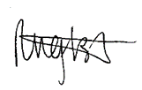
CPCCBC4031
Process client requirements
STUDENT PACK
Version Control
Unit code | Document version | Release date | Comments/actions
CPCCBC4031 | 10.1 | 13/04/2022 | First edition
CPCCBC4031 | 10.2 | 28/11/2022 | Minor amendments

Copyright
Copyright ©2021 by CAQA Resources.
Copyright protects this material. No part of this publication may be reproduced, distributed, or transmitted in any form or by any means, including photocopying, recording, or other electronic or mechanical methods, without the prior written permission of the publisher, except in the case of brief quotations embodied in critical reviews and certain other non-commercial uses permitted by Copyright Act 1968 (Cth). For permission requests, write to the publisher, addressed “Attention: Permissions Coordinator,” at the address below.
Enquiries should be addressed to:
CAQA Resources
2/10 Lawn Ct
Craigieburn, Victoria – 3064
Australia
www.caqaresources.com.au
Disclaimer
Although the author and publisher have made every effort to ensure that the information in this book was correct at press time, the author and publisher do not assume and hereby disclaim any liability to any party for any direct, indirect, incidental, or consequential loss, damage, or disruption caused by errors or omissions, whether such errors or omissions result from negligence, accident, or any other cause. Data and case study examples are intended to be fictional. Any resemblance to real persons or organisations is coincidental.
If you believe that information of any kind in this publication is an infringement of copyright, in material in which you either own copyright or are authorised to exercise the rights of a copyright owner, and then please advise us by contacting CAQA Resources, 2/10 Lawn Ct, Craigieburn, Victoria - 3064 or email copyright@careercalling.com.au.
Acknowledgement
This remains the property of CAQA Resources, a Career Calling initiative.

Student Pack

What is the purpose of this document?
The Student Pack is the document you, the student, needs to complete to demonstrate competency. This document includes the context and conditions of your assessment, the tasks to be completed by you and an outline of the evidence to be gathered.

The information includes the following:

- Information related to the unit of competency
- Guidelines and instructions to complete each task and activity

Link to other unit documents

- The Student Pack is a document for students to complete to demonstrate their competency. This document includes context and conditions of assessment, tasks to be administered to the student, and an outline of the evidence to be gathered from the student.
- The Unit Mapping is a document that contains information and comprehensive mapping with the training package requirements.

Student and trainer details
Student details
Full name: | Anya Eden English
Student ID: | 13784668
Contact number: | 0478 944 719
Email address: | anya@cogetnscaffolding.com.au
Trainer details
Full name:

Qualification and unit of competency
Qualification/Course/Program Details
Code:
Name:
Unit of competency
Code: | CPCCBC4031
Name: | Process client requirements
Releases: | 1.0
Release date: | 27/Nov/2020

Assessment Submission Method
☐ By hand to trainer/assessor ☐ By email to trainer/assessor
☒ Online submission via Learning Management System (LMS)
☐ Any other method _________________________________________________
(Please describe here)

Student declaration
- I have read and understood the information in the Unit Requirements prior to commencing this Student Pack
- I certify that the work submitted for this assessment pack is my own. I have clearly referenced any sources used in my submission. I understand that a false declaration is a form of malpractice;
- I have kept a copy of this Student Pack and all relevant notes, attachments, and reference material that I used in the production of this Student Pack;
- For the purposes of assessment, I give the trainer/assessor permission to:

  - Reproduce this assessment and provide a copy to another member of staff; and
  - Take steps to authenticate the assessment, including communicating a copy of this assessment to a plagiarism checking service (which may retain a copy of the assessment on its database for future plagiarism checking).

Student signature: ________________________________

Date: ___4_/__4__/_______2023____

Assessment Plan
The student must be assessed as satisfactory in each of the following assessment methods in order to demonstrate competence in a variety of ways.
Evidence number/ Task number | Assessment method/ Type of evidence/ Task name |  | Sufficient evidence recorded/Outcome
Assessment task 1 | Knowledge Test (KT) |  | S / NS (First Attempt)  S / NS (Second Attempt)
Assessment task 2 | Skill Test (ST) |  | S / NS (First Attempt)  S / NS (Second Attempt)
Outcome | C ☐ NYC ☐ | Date assessed: | Trainer signature:

Completion of the Assessment Plan
Your trainer is required to fill out the Assessment Plan Outcome records above, when:
- You have completed and submitted all the requirements for the assessment tasks for this cluster or unit of competency.
- Your work has been reviewed and assessed by your trainer/assessor.
- You have been assessed as either satisfactory or unsatisfactory for each assessment task within the unit of competency.
- You have been provided with relevant and detailed feedback.
Every assessment has a “Feedback to Student” section used to record the following information. Your trainer/assessor must also ensure that all sections are filled in appropriately, such as:
- Result of Assessment (satisfactory or unsatisfactory)
- Student name, signature and date
- Assessor name, signature and date
- Relevant and detailed feedback
Pre-Assessment Checklist: Task 1 - Knowledge Test
The purpose of this checklist
The pre-assessment checklist helps students determine if they are ready for assessment. The trainer/assessor must review the checklist with the student before the student attempts the assessment task. If any items of the checklist are incomplete or not clear to the student, the trainer/assessor must provide relevant information to the student to ensure they understand the requirements of the assessment task. The student must ensure they are ready for the assessment task before undertaking it.
Section 1: Information for Students
☒ Make sure you have completed the necessary prior learning before attempting this assessment.
☒ Make sure your trainer/assessor clearly explained the assessment process and tasks to be completed.
☒ Make sure you understand what evidence is required to be collected and how.
☒ Make sure you know your rights and the Complaints and Appeal process.
☒ Make sure you discuss any special needs or reasonable adjustments to be considered during the assessment (refer to the Reasonable Adjustments Strategy Matrix - Appendix A and negotiate these with your trainer/assessor).
☒ Make sure that you have access to a computer and the internet (if you prefer to type the answers).
☒ Make sure that you have all the required resources needed to complete this assessment task.
☒ The due date of this assessment task is in accordance with your timetable.
☒ In exceptional (compelling and compassionate) circumstances, an extension to submit an assessment can be granted by the trainer/assessor. Evidence of the compelling and compassionate circumstances must be provided together with your request for an extension to submit your assessment work.
☒ The request for an extension to submit your assessment work must be made before the due date.
Section 2: Reasonable adjustments
I confirm that I have reviewed the Reasonable Adjustments guidelines and criteria as provided in Appendix A and attached relevant evidence as required and select the correct checkbox.
☐ I do require reasonable adjustment
☒ I do not require reasonable adjustment
Declaration (Student to complete)
☒ I confirm that the purpose and procedure of this assessment task has been clearly explained to me.
☒ I confirm that I have been consulted about any special needs I might have in relation to the assessment process.
☒ I confirm that the criteria used for this assessment has been discussed with me, as have the consequences and possible outcomes of this assessment.
☒ I confirm I have accessed and understand the assessment information as provided in the Training Organisation’s Student Handbook.
☒ I confirm I have been given fair notice of the date, time, venue and/or other arrangements for this assessment.
☒ I confirm that I am ready for assessment.

Student Name: _Anya English ________________

Student Signature: ___________________________________

Assessment method-based instructions and guidelines: Knowledge Test
Assessment type

- Written Questions

Instructions provided to the student:

Assessment task description:

- This is the first assessment task you must successfully complete to be deemed competent in this unit of competency.
- The Knowledge Test is comprised of seven (7) written questions
- You must respond to all questions and submit them to your Trainer/Assessor.
- You must answer all questions to the required level, e.g. provide an answer within the required word limit, to be deemed satisfactory in this task
Applicable conditions:

- All knowledge tests are untimed and are conducted as open book assessment (this means you can refer to your textbook during the test).
- You must read and respond to all questions.
- You may handwrite/use a computer to answer the questions.
- You must complete the task independently.
- No marks or grades are allocated for this assessment task. The outcome of the task will be Satisfactory or Not Satisfactory.
- As you complete this assessment task, you are predominately demonstrating your written skills and knowledge to your trainer/assessor.
Resubmissions and reattempts:

- Where a student’s answers are deemed not satisfactory after the first attempt, a resubmission attempt will be allowed.
- The student may speak to their trainer/assessor if they have any difficulty in completing this task and require reasonable adjustments.
- For more information, please refer to the Training Organisation’s Student Handbook.
Location:

- This assessment task may be completed in:

☐ a classroom
☐ learning management system (i.e. Moodle),
☐ workplace,
☐ or an independent learning environment.
Instructions for answering the written questions:

- Complete a written assessment consisting of a series of questions.
- You will be required to answer all the questions correctly.
- Do not start answering questions without understanding what is required. Read the questions carefully and critically analyse them for a few seconds; this will help you to identify what information is needed in the answer.
- Your answers must demonstrate an understanding and application of the relevant concepts and critical thinking.
- Be concise, to the point and write answers within the word-limit given to each question. Do not provide irrelevant information. Remember, quantity is not quality.
- You must write your responses in your own words.
- Use non-discriminatory language. The language used should not devalue, demean, or exclude individuals or groups based on attributes such as gender, disability, culture, race, religion, sexual preference or age. Gender-inclusive language should be used.
- When you quote, paraphrase, summarise or copy information from other sources to write your answers or research your work, always acknowledge the source.
Purpose of the assessment

This assessment task is designed to evaluate student’s knowledge essential to process client requirements in a range of contexts and industry settings and knowledge regarding the following:
- Knowledge of the government building and construction legislation, codes and standards
- Knowledge of the relevant sections of the National Construction Code (NCC)
- Knowledge of the building and construction industry planning processes:
- town planning and building application requirements
- certifications from local authorities
- building permits and approvals
- Knowledge of the various types of building contracts and their application and legal requirements
- Knowledge of the development of project plans and specifications:
- site plans and sketches
- design details
- material specifications
- Knowledge of the financial and business principles related to dealing with clients
- Knowledge of the site evaluation and site works:
- site location and suitability for intended use
- site aspect, slope, drainage and surrounding sites
- site access and egress during construction
- site preparation, excavation and earthmoving.
Task instructions
- This is an individual assessment.
- To ensure your responses are satisfactory, consult a range of learning resources and other information such as handouts, textbooks, learner resources etc.
- To be assessed as Satisfactory in this assessment task, all questions must be answered correctly.

Assessment Task 1: Knowledge Test
Provide your response to each question in the box below.

Q1: | Answer the following questions regarding relevant government building and construction regulations, codes and standards.  1.1. Discuss the relevant government building and construction regulations. Write your answer in 100-150 words.  1.2. Discuss the relevant government building and construction codes and standards. Write your answer in 100-150 words. |  |  |  |  |  | Satisfactory response
Q1: |  |  |  |  |  |  | Yes  |  |  |  | No ☐
1.1. The relevant government building and construction regulations address a variety of topics which include contract formalities, licences, registration, insurances and statutory implied warranties in contracts. A few example of others include occupational health and safety and the Fair Work Act as well as each state has a payment security legislation. This is in place for the Contractors and Subcontractors because it guarantees payment on time for building work. The Rehabilitation and Compensation Act is another example, which provides insight for rehabilitation managers to make decisions across the Comcare scheme, which lets them know what needs to be thought about when implementing thic Act and its specific elements.

1.2. The two main relevant government building and construction codes and standards are the Australian Building and Construction Commisiion (ABCC) and the National Construction Code (NCC). The national construction code is made up of three parts; Volume One, Voulme 2, Voulme 3 which sets out the requirements for the technical design and construction of aspects of a building, in a performance-based way. While the Australian Building Codes Board publishes it and maintains it in alliance with the Australian, State and Territory Government. The ABCC is aimed to protect the law and modify behaviour in the building and construction sector in order to make it more fair, efficient and productive. The Australian Business Licence and Informaion Services are a resource for businesses to find applicable state, territory, local and Australian government licences, permits, approvals, rules and codes of practice. This helps businesses get precise information and to stay on top of compliance.
Q2: | Give a brief explanation of what the National Construction Code (NCC) is and describe what the three (3) volumes of the NCC include? Write answer in 200-300 words |  |  |  |  |  | Satisfactory response
Q2: |  |  |  |  |  |  | Yes |  |  |  | No ☐
The National Code of Conduct is requirements for the design, construction and plumbing and drainage systems of the construction of a building. It is broken up into Three Sections. Volume One which sets out the design and construction requirements for all Class 2 to 9 buildings, which include multi-residential, commercial, industrial and public assembly builings. Voulme Two, which are the design and construction requirements for certain residential and non-habitable builds. Volume Three which are the design and construction requirements for plumbing and drainage systems. The NCC is a performance based system that sets out the requirements for the design and construction of a building through Performance requirements, which can be accomblished by the deemed-to-satisfy provisions, the creation of a high-performance solution or a combination of both. This is done to ensure that the design and installation of the products and services function safely, reliably and as intended. In addition, all the equipment and materials used must be fit for purpose with evidence of appropriateness which must be established to show that the material, design or construction meets the performance requirement or deemed to satisfy provision. When processing the document, it should include identification and version control, employee in charge, the policy or goal and must always keep record of this. When tasks are not completed or legal obligations are not met, then a breach of statutory duty occurs.
Q3: |  | Answer the following questions with respect to building and construction industry planning processes:  3.1. Explain town planning and building application requirements for building and construction industry planning processes? Write answer in 100-200 words  3.2. What are the requirements for certifications of building and construction planning processes from local authorities in Australia? Write answer in 100-150 words  3.3. What are building permits and approvals? How do you apply for building permit? Write answer in 100-200 words |  |  | Satisfactory response
 |  |  |  |  | Yes |  |  |  |  | No ☐
3.1.
Town planning, also known as urban planning, plays a critical role in preserving the long-term viability of Australian cities as it is the design of how attractive as well as convenient buildings, roads and parks are for the people that live there. When in the planning process for a building and construction project, you must take into consideration urban planning, which is done at all levels of the government. Urban planning and building application is important in the planning process because it must be taken in consideration whether it is a heritage building, how it will affect the community nearby, climate adaptation and much more.

3.2.
When completed, a licenced plumber issue a compliance certificate to state whether the plumbing work is complinat with plumbing standards, norms and regulations. In the planning process, you must have a licenced plumber to be able to hand over this certificate, a registered plumber is not permitted to do so. This is a requirement in the building and construction planning process because it is part of understanding and noting down what sort of approval documentation is needed to have a compliant building after construction, otherwise things start to spiral out of control. If these aren’t determined in the planning process and it is decided that the plumber is terminated before the plumbing work is complete, you may not realise that you are entiltied to a compliance certificate for incomplete work. This could result in a new plumber not completing the work and your plumbing remaining uncompliant.

3.3.
Building permits and approvals, done by a surveyor certify whether or not your planned building is compliant with the applicable building codes. This ensures that all approved plans, specifications and other required documents are followed as well as protects you by ensuring that none of the professionals working on the project arnt licenced and insured, all documentation is complete and follows building codes inspections are completed at important stages of project and if your building is ready to be occupied or used. To apply for a building permit, which must be done before building work can begin, you must acquire all required documentation including plans of your work, estimation of value of work and other important information, then you must complete the form and pay any fees you may need before elodging your application. Only when you have been approved will a certifier sign off on your plans and you can beign construction work.
Q4: | Define the following types of building contracts and their application and legal requirements in 150-200 words  - Item rate contract  - Lump sump contract |  |  |  |  | Satisfactory response
Q4: |  |  |  |  |  | Yes |  |  | No ☐
An Item rate contract is also known as a unit price contract, is when the quantity of materials and labour required is unknown and instead goes off a rate for each items. In this case, a bill of quantities are prepared and made accurately as possible. In comparison to Item rate contract, Lump sum contracts is a sum of the total contract amount going off the plans and specifications exactly. A lump sum contract can be used for both residential and commercial and is agreed on before the works commences. These construction contracts must have a range of different legal requirements, which follow The Domestic Building Contracts Act 1995 (if price is more than $10 000), which includes but not limited to, all of the contracts conditions are spelled out, the cost of the deal, information of parties included (name and addresses), definition on main terms, the licence number of builder, warranty details and more.
Q5: | Give a brief description of each item listed below and how they relate to the development of project plans and specifications. Write your answer for each point in 50-100 words  - Site plans and sketches  - Design details  - Material specifications |  |  |  |  | Satisfactory response
Q5: |  |  |  |  |  | Yes |  |  | No ☐
a) Site plan and sketches are a layout out of the entire site, which is typically set out in a birds eye point of view. The main features in a site plan includes boundaries, access points and other surrounding buildings or structures and must include the utility connections. This aids the development of the project plans and specifications because these features like utility connections are vital to include in drawings to ensure they match.

b) Design details depict the constructions projects smaller details. Detailed drawings differ from finishing drawings, where detailed drawings focus on the structural aspects of a plan. Working drawings can be presented in a plan, section or elevation and specify items such as plaster texture, floor patterns, wall paint colour and general construction terminology. This relates to the development of project specifications because these need to be detailed in the specifications to relate back to this information.

c) Material specifications are specifications of the materials to be used in the projects construction process. The materials used must meet a certain criteria to comply with the NCC to be safe, healthy and long lasting. They relate to the development of the projects plans and specifications because the correct people invloved are able to do performance based testing to conclude if they meet the criteria and whether they will be will or will not be used in the final plans and specifications.

Q6: |  |  | Discuss the financial and business principles related to dealing with clients. Write answer in 100-150 words | Satisfactory response
 |  |  |  | Yes |  |  |  | No ☐
The financial and business principles include the operations management, people management, accounting for decision making, corporate finance, strategic management and marketing management. These help with the business strategy, finance and marketing skills which help with dealing with clients as makes your organisation look more reliable and have less problems when going through the planning phase of a project. Financial principles guide investment and finance decisions. Under the business principles there should be a strategy or plan that is presented in an easily accessible format, should be practical, should be adaptable, should be used to check and control the project and should be all-encompassing.
Q7: |  |  | Answer the following questions related to site evaluation and site works:  7.1 What should be considered when determining the site location? Discuss the factors used for suitability for intended use in general construction? Write answer in 100-200 words  7.2 Explain how the following factors are considered during site evaluation:  - site aspect,  - slope,  - drainage and surrounding sites  7.3 Explain the purpose of site access and egress during construction site works. Write your answer in 100-200 words  7.4 Explain site preparation procedure during construction site works in 100-200 words  7.5 How are excavation and earthmoving used in construction? Write answer in 100-200 words | Satisfactory response
 |  |  |  |   Yes |  |  |  | No ☐
7.1. When determining the location, rigorous planning and management are required, which will result in our cities stay appealing and habitable and maintain ecological services. It is influenced by population expansion as well as settlement patterns, transportation and consumption patterns, which should all be considered when determining the site location. For example, logistics is the planning and execution of transportation for people and materials as well as other resources for the ability to achieve objections of a construction project. Logistics should be considered when determining a site location as it is vital to know what transportation will be used and how it will be delivered. If there is insufficient access for logistics, this also needs to be taken into account during the planning phase.

7.2.During the site evaluation, the site aspect is determined and if the site has a gradient of more than 30 degrees then it is considered a steep site. This is important to note down in the evaluation because if the slope is steep then there is a few strategies that may come into play; retaining wall over 1m to be avoided, create an earth-sheltered home, balance cut and fill and to build along the contours. The slope impacts many things that include the materials utilised economically, sun access, wind exposure and access for cars, pedestrians and disable access. When a building is not at the highest elevation, there needs to be consideration on how water will shed away from the building without damaging the surrounds nor the building. If the site is steep then drainage is important as the surrounding accesses need maximum and minimum slopes.

7.3.It is important to have safe site access and egress because construction sites are particularly dangerous with the high volume of people, vehicles and machineral, meaning it is crucial to plan throughout the design phase to minimise risks and dangers. The purpose of site access and egress is to ensure that people can enter and exit the construction site safely as per the Health and Safety at Work Act. To ensure safety, each entry and egress must have a risk assessment that includes any dangers relating, to aim to minimise risk not only for the users but for the passers-by as well.

7.4. Site preparation is preparing the land or site ready for the building part of construction to begin. After a site observation and evaluation, any trees, debris or other obstructions need to be removed. This could be via a bulldozer or a excavator. They will then dig out the basement using eathmoving equipment, such as excavation, to remove all the dirt, muck, rock and topsoil. This is done to prepare it for the development of building construction phase in the basement, however, before they begin, they will do soil testing to examine the properties as well as condition. This is done to ensure that there is understanding of the soil and if it will hold the weight of the building as well as how well it absorbs water. Only after these steps do they begin the pour of the first basement.

7.5. Excavation and earthmoving equipment are used in the construction of a building for the preparation of the project. They remove any trees, rocks or other features as well as dirt soil and muck to clear out the site to prepare the construction of the building structure. They also are used for the basement excavation to remove all the soil from beneath ground floor to prepare the pour for the basement levels. Another type of excavation is trench excavation which is excavating the area that exceeds the depth for the purpose of installing service lines including pipeines and sewer systems.

Assessment Results Sheet
Outcome | Outcome (make sure to tick the correct checkbox):  Satisfactory (S) ☐ or Not Satisfactory (NS) ☐  Date: _______(day)/ _______(month)/ _______(year)  Feedback:  Outcome (please make sure to tick the correct checkbox):  Satisfactory (S) ☐ or Not Satisfactory (NS) ☐  Date: _______(day)/ _______(month)/ _______(year)  Feedback:
  First attempt:
  Second attempt:
Student Declaration | - I declare that the answers I have provided are my own work. Where I have accessed information from other sources, I have provided references and/or links to my sources.  - I have kept a copy of all relevant notes and reference material that I used as part of my submission.  - I have provided references for all sources where the information is not my own. I understand the consequences of falsifying documentation and plagiarism. I understand how the assessment is structured. I accept that the work I submit may be subject to verification to establish that it is my own.  - I understand that if I disagree with the assessment outcome, I can appeal the assessment process, and either re-submit additional evidence undertake gap training and or have my submission re-assessed.  - All appeal options have been explained to me.
Student Signature
Date | 4/4/23
Trainer/Assessor Name | Michelle Gomersall
Trainer/Assessor Declaration | I hold:  ☐ Vocational competencies at least to the level being delivered  ☐ Current relevant industry skills  ☐ Current knowledge and skills in VET, and undertake  ☐ Ongoing professional development in VET  I declare that I have conducted an assessment of this student’s submission. The assessment tasks were deemed current, sufficient, valid and reliable. I declare that I have conducted a fair, valid, reliable, and flexible assessment. I have provided feedback to the student.
Trainer/Assessor Signature
Date | 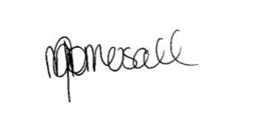  5/4/23
Office Use Only | The outcome of this assessment has been entered into the Student Management System  on _________________ (insert date)  by (insert Name) __________________________________

Pre-Assessment Checklist: Task 2 – Skill Test
The purpose of this checklist
The pre-assessment checklist helps students determine if they are ready for assessment. The trainer/assessor must review the checklist with the student before the student attempts the assessment task. If any items of the checklist are incomplete or not clear to the student, the trainer/assessor must provide relevant information to the student to ensure they understand the requirements of the assessment task. The student must ensure they are ready for the assessment task before undertaking it.
Section 1: Information for Students
☒ Make sure you have completed the necessary prior learning before attempting this assessment.
☒ Make sure your trainer/assessor clearly explained the assessment process and tasks to be completed.
☒ Make sure you understand what evidence is required to be collected and how.
☒ Make sure you know your rights and the Complaints and Appeal process.
☒ Make sure you discuss any special needs or reasonable adjustments to be considered during the assessment (refer to the Reasonable Adjustments Strategy Matrix and negotiate these with your trainer/assessor).
☒ Make sure that you have access to a computer and the internet (if you prefer to type the answers).
☒ Make sure that you have all the required resources needed to complete this Assessment Task (AT).
☒ The due date of this assessment task is in accordance with your timetable.
☒ In exceptional (compelling and compassionate) circumstances, an extension to submit an assessment can be granted by the trainer/assessor. Evidence of the compelling and compassionate circumstances must be provided together with your request for an extension to submit your assessment work.
☒ The request for an extension to submit your assessment work must be made before the due date.
Section 2: Reasonable adjustments
I confirm that I have reviewed the Reasonable Adjustments guidelines and criteria as provided in Appendix A and attached relevant evidence as required and select the correct checkbox.
☐ I do require reasonable adjustment
☒ I do not require reasonable adjustment
Declaration (Student to complete)
☐ I confirm that the purpose and procedures of this assessment task has been clearly explained to me.
☐ I confirm that I have been consulted about any special needs I might have in relation to the assessment process.
☐ I confirm that the criteria used for this assessment has been discussed with me, as have the consequences and possible outcomes of this assessment.
☐ I confirm I have accessed and understand the assessment information as provided in the Training Organisation’s Student Handbook.
☐ I confirm I have been given fair notice of the date, time, venue and/or other arrangements for this assessment.
☐ I confirm that I am ready for assessment.

Student Name: Anya English _____________________

Student Signature: ___________________________________

Assessment method-based instructions and guidelines: Skill Test
Assessment type

- Skill Test - Process client requirements
Instructions provided to the student:

Assessment task description:

- This is the second assessment task you must successfully complete to be deemed competent in this unit of competency.
- This assessment task is a Skills Test.
  - This assessment task consists of four (4) practical demonstration activities.
- Activity 1: Identify client requirements.
- Activity 2: Prepare preliminary documentation.
- Activity 3: Establish client satisfaction.
- Activity 4: Finalise contract requirements.
- You must attempt all activities of the project for your trainer/assessor to assess your competence in this assessment task.
Applicable conditions:

- This skill test is untimed and is conducted as an open book assessment (this means you are able to refer to your textbook or other learner materials during the test).
- You will be assessed independently on this assessment task.
- No marks or grades are allocated for this assessment task. The outcome of the task will be Satisfactory or Not Satisfactory.
- As you complete this assessment task, you are predominately demonstrating your skills, techniques and knowledge to your trainer/assessor.
- Your trainer/assessor may ask you relevant questions during this assessment task
Resubmissions and reattempts:

- Where a student’s answers are deemed not satisfactory after the first attempt, a resubmission attempt will be allowed.
- The student may speak to their trainer/assessor if they have any difficulty in completing this task and require reasonable adjustments.
- For more information, please refer to the Training Organisation’s Student Handbook.
Location:

- This assessment task may be completed in:

☐ a classroom
☐ learning management system (i.e. Moodle),
☒ workplace,
☐ or an independent learning environment.
Purpose of the assessment

The purpose of this assessment task is to assess the student’s knowledge and skills essential to process client requirements in a range of contexts and industry settings.
- Skills to identify client requirements.
- Skills to prepare preliminary documentation.
- Skills to establish client satisfaction.
- Skills to finalise contract requirements.
Task instructions
- This is an individual assessment.
- The purpose of this assessment task is to prepare contract documentation, drawings and specifications for a construction project that meets client requirements.
- The student must asess the NCC codes for relevant class of the building to perform the activities specified in the assessment task.
- The student must supervise the various aspects of the construction.
- The trainer/assessor must assess the performance as per the performance criteria and checklist provided.

Assessment Task 2: Skills Test
This assessment task requires the student to prepare contract documentation, drawings and specifications for a construction project that meets client requirements. This includes:
- Researching current and relevant local government building design requirements and approval processes
- Selecting, completing and presenting construction contract and related project documentation to client for approval and formal acceptance.
Note: The above specifications for the building are compulsory to meet the requirements of the National Construction Code (NCC).
During the completion of this assessment task, you will be required to coordinate with and gather the input of a range of skilled professionals, including architects and engineers.
To process client requirements, you are required to complete the following activities:
- Activity 1: Identify client requirements.
- Activity 2: Prepare preliminary documentation.
- Activity 3: Establish client satisfaction.
- Activity 4: Finalise contract requirements.

Instructions for trainer/assessor:
- The workplace must be:
  - An actual workplace
  - A close simulation of the workplace environment provided that simulated or project-based assessment techniques replicate construction workplace conditions, materials, activities, responsibilities and procedures
Note: The requirements for a simulated workplace environment are given below.
- The role of the Supervisor (trainer/assessor) is to allocate the tasks, activities and responsibilities that you will be required to undertake to complete these assessments.
- The worksite must meet the requirements given in the ‘Simulated workplace environment requirements’ section given below.
- The trainer/assessor must ensure that if the assessment task is to be conducted in a simulated environment, it must replicate workplace conditions, materials and equipment, interactions with others and workplace irregularities and meets industry standards for safety and environmental practices.
Instructions for the student:
- The student will be required to bring all necessary PPEs required to complete this activity.
- The student must follow the instructions provided by the Supervisor.
- The student must complete the activities specified.

Simulated workplace environment requirements
The trainer/assessor or training organisation is required to provide a workplace or a close simulation of the workplace environment to replicate construction workplace conditions and standards, materials, activities, responsibilities, procedures, safety requirements and environmental considerations to each student.
Further, the training organisation must ensure the construction site must meet the requirements given in the table below.
The training organisation must ensure that the student has access to the following:
- WHS legislation and regulations
  - Model WHS Act (Provide along with this assessment task)
  - Model WHS Regulations (Provide along with this assessment task)
- Building Act
https://www.mbqld.com.au/services-and-advice/laws-codes-and-regulations/building-act
- Current building and construction codes and standards
  - https://www.abcb.gov.au/
  - https://ncc.abcb.gov.au/editions/2019-a1/ncc-2019-volume-one-amendment-1/contents-and-introduction/introduction-ncc-volume
  - https://ncc.abcb.gov.au/editions/2019-a1/ncc-2019-volume-two-amendment-1/contents-and-introduction/copyright-and-licence
  - https://ncc.abcb.gov.au/editions/2019-a1/ncc-2019-volume-three-amendment-1/contents-and-introduction/introduction-ncc
- NCC Volume 1 – Volume 3 (Provided along with this assessment)
- Organisational quality policies and procedures
- Site plans and project contracts
- Workplace safety requirements
- Project plans and specifications
- Manufacturer specifications and installation instructions
- Business equipment and technology, applications and software to prepare client contracts, drawings, costings and other documentation to meet client requirements.
  - Webuild
  - Computers
  - Internet
  - MS Word/MS PowerPoint
  - Printer
  - Zoom/Google Hangout
  - BIM360
  - Autodesk
The worksite must have realistic tasks or simulated tasks, relevant specifications and work instructions, standard work practices, safety requirements and environmental constraints.
The site and its surroundings are accessible and clear of hazards, so far as reasonably practicable.
The site must have realistic workplace conditions, standards, materials, activities, responsibilities, procedures, safety requirements, and environmental considerations.
An experienced employee is available to provide adequate guidance and supervision to less experienced employees.
The students have the clothing and footwear required. In addition, the clothing and footwear are in good condition and suitable for the task.

Workplace Scenario
A client has approached you company to construct a residential or commercial building. You are a building sales consultant for the project.
The senior management of the your company wants you to obtain, confirm and process client requirements from project inception through the contract and documentation development process.
This includes:
- Researching current and relevant local government building design requirements and approval processes.
- Conveying client requirements to those developing the contract and related documentation.
- Selecting, completing and presenting construction contract and related project documentation to client for approval and formal acceptance.
Task requirements:
For a building construction project, you are required to:
- Identify client requirements.
- Prepare preliminary documentation.
- Establish client satisfaction.
- Finalise contract requirements
You will be required to demonstrate your skills and knowledge in the following areas:
- Read, understand, and apply relevant government construction legislation.
- Determine the requirements of the local government, restrictive covenants, required permits, and planning requirements.
- Give the client accurate legal, technical, and product information.
- Arrange for a site investigation to identify site features and factors that may contribute to or influence building design.
- Collect and discuss with the client any site and building information that may influence or affect the design requirements.
- Determine and confirm the needs of the client.
- Identify and adhere to organisational processes for document preparation.
- Identify and address risks associated with documentation, design, and copyright.
- Accurately communicate requirements for sketch plans and drawings to drafting personnel.
- Complete the preliminary contract, agreement, and estimated processing costs.
- Submit documents to the appropriate department or person for verification and recording.
- Forward plans, developed documentation, and estimated costs are submitted to the client for review, amendment, and approval.
- Confirm that the client understands the scope and cost of the required site work.
- Identify variations and problem areas, then analyse and correct problems in consultation with the client.
- Check the accuracy of the amended documentation and ensure that the client's requirements are met.
- Check that all plans, documents, and specifications viewed by the client have been signed or initialled.
- Compile all signed documents and send them to the appropriate person for verification and processing for the next stage.
- Use communication tools and devices to communicate and collaborate effectively with others
- Use equipment and programs to access and extract information and develop relevant project schedules and documentation.
Roles and responsibilities (Supervisor):
The Supervisor must:
- Ensure that the student is clear about the task requirements.
- Supervise the student performing the task.
- Observe them against the observation checklist provided after each activity.

Task:

This assessment task requires the student to prepare contract documentation, drawings and specifications for a construction project that meets client requirements. This includes:
- Researching current and relevant local government building design requirements and approval processes
- Selecting, completing and presenting construction contract and related project documentation to client for approval and formal acceptance.
Note: The above specifications for the building are compulsory to meet the requirements of the National Construction Code (NCC).
During the completion of this assessment task, you will be required to coordinate with and gather the input of a range of skilled professionals, including architects and engineers.
To process client requirements, you are required to complete the following activities:
- Activity 1: Identify client requirements.
- Activity 2: Prepare preliminary documentation.
- Activity 3: Establish client satisfaction.
- Activity 4: Finalise contract requirements.

Activity 1: Identify client requirements.
This activity requires you to identify client requirements for the building and construction project.
To complete this activity, you are required to:
- Complete the steps given in the ‘Checklist 1’ provided.
- Access and interpret NCC codes and relevant Australian Standards referenced in the NCC.
- Complete Template 1.
While completing each step, you must place a tick mark against each step given in the checklist once completed.
Instructions for trainer/assessor:
- The student should have access to the following documents:
  - Organisational quality policies and procedures
  - Site plans and project contracts
  - Workplace safety requirements
  - Project plans and specifications
  - Manufacturer specifications and installation instructions
  - Site plans
  - Workplace safety requirements
  - Project plans and specifications
  - Manufacturer specifications and installation instructions
  - Business equipment and technology, applications and software to prepare client contracts, drawings, costings and other documentation to meet client requirements.
Instructions for the student:
- The student must:
  - Access, read and interpret relevant government construction legislation.
  - Determine the requirements of the local government, restrictive covenants, required permits, and planning requirements.
  - Give the client accurate legal, technical, and product information.
  - Arrange for a site investigation to identify site features and factors that may contribute to or influence building design.
  - Collect and discuss with the client any site and building information that may influence or affect the design requirements.
  - Determine and confirm the needs of the client.
After completing this task, submit the following to your assessor:
- A completed Checklist and Template 1
- A completed Performance Criteria/Checklist – Activity 1
- Email evidence that you have provided correct legal, technical and product indormation to the client.
- Email evidence from the Building Site Supervisor identyfing any site features and factors that may impact of the building design.
- Email evidence of site and building information that may influence or affect the design requirements has been sent to client.

Checklist 1: Identify client requirements.
Steps |  | Tick mark, once completed
Step 1: Determine and confirm the needs of the client.
- Analysed the project contracts to determined the needs of the client and documented using template 1.
- Ensured that the client's requirements are met in accordance with government construction legislation and documented it using template 1.
- Consult the client to determine the requirements related to the project design and costs associated with site work via email.
- Confirm client's understanding of extent and cost of required site works and the required design via email.
Step 2: Access, read and interpret relevant government construction legislation relevant to undertaking the building construction.
- Conduct research and access relevant government construction legislation.
- Document the key requirements from government construction legislation related to the project using Template 1.
Step 3: Determine the requirements of the local government, restrictive covenants, required permits, and planning requirements relevant to undertaking the building construction.
- Use equipment and programs to access and extract information related to local government, restrictive covenants, required permits, and planning requirements.
- For your building project, identify and document the following using Template 1.
- Requirements of the local government  - Restrictive covenants | - Required permits  - Building planning requirements
Step 4: Give the client accurate legal, technical, and product information.
- Provide correct legal, technical and product information to the client.
- Email the legal, technical and product information to the client.
Step 5: Arrange for a site investigation to identify site features and factors that may contribute to or influence building design.
- Arrange site investigation. This can be evidenced by an email from the Building Site Supervisor identyfing any site features and factors that may impact of the building design.
- Identify site features and factors that may contribute to or influence building design.
Note: This task can be simulated with your supervisor.
Step 6: Collect and discuss with the client any site and building information that may influence or affect the design requirements.
- Collate the following site and building information that may influence and effect the design requirements with client.
  - Documentation and design risks
  - Site costs
- Email site and building information that may influence or affect the design requirements to the client.
Note: This task can be simulated with your supervisor.

Template 1: Identify client requirements
Identify the client requirements for the construction project (200-250 words)
Determined and confirmed the needs of the client.  - Analysed the project contracts to determined the needs of the client and documented.  - Ensured that the client's requirements are met in accordance with government construction legislation and documented. | After reviewing the contract with designs attached, the client requires the supply, install and dismantle of the following:  - Stairs for access and egress from Basement 3 to Level 3 as well as Pool Deck and Upper Roof Deck.  - Perimeter Edge protection around levels 2 and 3 as well as Pool Deck and Upper Roof Lid.  - Handrails to all levels for edge protection  The clients requirements meet the government construction legislation and documentation:  - Health and Safety at Work Act; to provide safe access and egress to and from site. This is shown for stair access on applicable levels.  - AS 1576.1; Handrails in areas to prevent fall from 2m or higher. Handrails and edge protection perimeter is supplied around the whole building as well as in stairs and around cores to ensure no fall over 2m high.  - Building Regulation 2021; Plans are certified by competent person. Plans are signed off by AMC.  - NCC Volume 1; Structrual provisions perform adequately under all reasonably expected design actions, extreme/frequent repeated design actions. This is proved when it is certified by AMC.  - NCC V1; Avoid damage to surrounding properties. Edge protection perimeter prevents this from happening.  - NCC V1; Access and Egress. Stair wells must be slip resistant. Scaffold boards are slip resistant, have suitable handrails to assist people and have suitable landings with no trip hazards.
Document the key requirements from government construction legislation related to the project. | National Construction Code  - Provide safe access and egress to and from site  - Handrails to prevent fall  - Certified to maintain and stand under any circumstances  AS 1576.1 Scaffold Standard  - Handrails to prevent fall 2m or higher  - Must have handrail, midrail and mesh or kickboards (guardrails, midrails and toeboards)  - All designs created in English  - Must jave bay size, lift height, bracing and tie requirements stated  - Guardrails are at a minimum 900mm standard  - Midrail gaps do not exceed 500mm  - Stairs to not be smaller than width 500mm  - Stairs to have a landing after every change of direction  Building Regulation 2021  - Designs to be certified by competent person  - Accepted development (self assessable) must inspect to comply
For your building project, identify and document the following using Template 1.  - Requirements of the local government  - Restrictive covenants  - Required permits  - Building planning requirements | Brisbane City Council (requirements of local government and building planning requirements)  - Heritage Properties can be found online at Brisbane City Council’s Local Heritage Places to check if your property has heritage protection.  - Infrastructure Charges  - Must need planning approval for excavating and filling needs assessment against the city plan if it is proposed to increase the depth and the height of ground level by no more than on vertical meter.  - City Reach Waterfront Maser Plan - to ensure there is a certain amount of space for pedestrians and cyclists to use, improve shade, seating, lighting, manage of noise impacts and collaboration between government and development.  - Must comply with the Brisbane City Plan, which will cover the neighbour planning.  Restrictive covenant  - If the building is a heritage property there is limits to what can be done to the property.  Required Permits  - Must have a council condition compliance assessment and approved before starting any type of development.  - Must have environmental authority application by the QLD Government or Brisbane City Council if potential damage to the environment which could include the air, land, water and noise.  - Building Approval (permit) is required. It covers the assessment against the building Code of Australia.
Observer Sign off:
Date:5/4/23

Performance Criteria/Performance Checklist: Activity 1
This task must address the following performance criteria/ performance checklist.
To be assessed as satisfactory (S) in this assessment task, the participant needs to demonstrate competency in the following critical aspects of evidence | S |  | N/S | Trainer/Assessor to complete  (Comment and feedback to students)
Determined and confirmed the needs of the client.
- Analysed the project contracts to determined the needs of the client and documented using template 1.
- Ensured that the client's requirements are met in accordance with government construction legislation and documented it using template 1.
- Consult the client to determine the requirements related to the project design and costs associated with site work via email.
- Confirm client's understanding of extent and cost of required site works and the required design via email.
Read, understood, and applied relevant government construction legislation.
Further documented the following using template 1.
- Read and analysed relevant government construction legislation to determined client requirements.
- Applied relevant government construction legislation as per the project plan and specifications.
- Analysed workplace communication plan to interpreted government construction legislation on the comstruction site.
Determined the requirements of the local government, restrictive covenants, required permits, and planning requirements.
- Determined local government requirements, restrictive covenants, necessary permits and planning requirements and documented using template 1.
Gave the client accurate legal, technical, and product information.
- Analysed the project specification to determined the product information and documented.
- Ensured that the information is accurate, legal and technical according to the client requirements and documented.
- Emailled the legal, technical and product information to the client.
Arranged for a site investigation to identified site features and factors that might contributed to or influenced building design.
- Analysed the project plan and specifications to conducted a site investigation and documented.
- Identified site features and factors that may contributed to or influenced building design and documented.
- Ensured that the site features and factors that may influenced building design are in accordance with the client's requirements.
- Arrange site investigation. This can be evidenced by an email from the Building Site Supervisor identyfing any site features and factors that may impact of the building design.
Note: This task can be simulated with your supervisor.
Collected and discussed with the client any site and building information that may influenced or affected the design requirements.
- Analysed the site plans and project contracts to collected any site and building information that may influenced or affected the design requirements and documented.
- Discussed site and building information with the client via email.
Note: This task can be simulated with your supervisor.
The student’s performance was: | - Not satisfactory  - Satisfactory
Feedback to student:
Student signature
Trainer/Assessor signature
Activity 2: Prepare preliminary documentation.
This activity requires you to prepare preliminary documentation.
To complete this activity, you are required to:
- Complete the steps given in the ‘Checklist 2’ provided.
- Access and interpret NCC codes and relevant Australian Standards referenced in the NCC.
- Complete Template 2.
While completing each step, you must place a tick mark against each step given in the checklist once completed.
Instructions for trainer/assessor:
- The student should have access to the following documents:
  - Organisational quality policies and procedures
  - Site plans and project contracts
  - Workplace safety requirements
  - Project plans and specifications
  - Manufacturer specifications and installation instructions
  - Site plans
  - Workplace safety requirements
  - Project plans and specifications
  - Manufacturer specifications and installation instructions
  - Business equipment and technology, applications and software to prepare client contracts, drawings, costings and other documentation to meet client requirements.
Instructions for the student:
- The student must:
  - Identify and address risks associated with documentation, design, and copyright.
  - Accurately communicate requirements for sketch plans and drawings to drafting personnel.
  - Prepare and complete the preliminary contract, project schedule, agreement, and estimated processing costs.
  - Submit relevant documentation for verification and recording.
After completing this task, submit the following to your assessor:
- A completed Checklist and Template 2,
- A completed Performance Criteria/Checklist – Activity 2
- Email confirmation with the relevant sketches/drawings attached to the drafting department determining all client requirements for the construction project
- Email confirmation of all preliminary documentation that has been prepared for the construction project has been sent to the relevant department and/or person for verification and recording (ensure that the documents listed in Step 5 are attached to the email)

Checklist 2: Prepare preliminary documentation.
Steps | Tick mark, once completed
Step 1: Identify organisational processes for the following document preparation and document using Template 1.
- Risk management including documentation, design and copyright risks.
- Preliminary contract, agreement and estimated processing costs.
Step 2: Identify and address risks associated with documentation, design, and copyright.
- Adhere to organisational processes for preparation of risk management document.
- Identify four (4) risks associated with documentation, design, and copyright.
- Calculate risk rating.
- Take actions to address risks associated with documentation, design, and copyright.
- Further, document the following using Template 2.
  - Four (4) risks associated with documentation, design, and copyright
  - Actions taken to address risks associated with documentation, design, and copyright.
Step 3: Accurately communicate requirements for sketch plans and drawings to drafting personnel.
- Determine client requirements for sketch plans and drawings and document using Template 3.
- Communicate requirements for sketch plans and drawings to drafting personnel.
Note: Email confirmation with the relevant sketches/drawings attached to the drafting department determining all client requirements for the construction project
Step 4: Prepare and complete the preliminary contract, project schedule, agreement, and estimated processing costs.
Adhere to organisational processes for preparation of preliminary contract, agreement, and estimated processing costs.
Step 5: Email the following documents to the appropriate department or person for verification and recording.
- Risk management.
- Preliminary contract
- Project schedule
- Agreement
- Estimated processing costs.
Note: Email confirmation with the documents listed above as attachments to the relevant department and/or person for verification and recording.

Template 2: Prepare preliminary documentation and Risk management
Prepare preliminary documentation
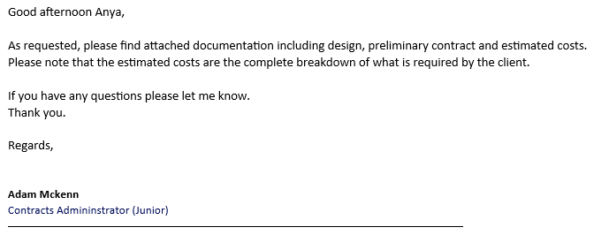
Insert email confirmation with the relevant sketches/drawings attached to the drafting department determining all client requirements for the construction project here
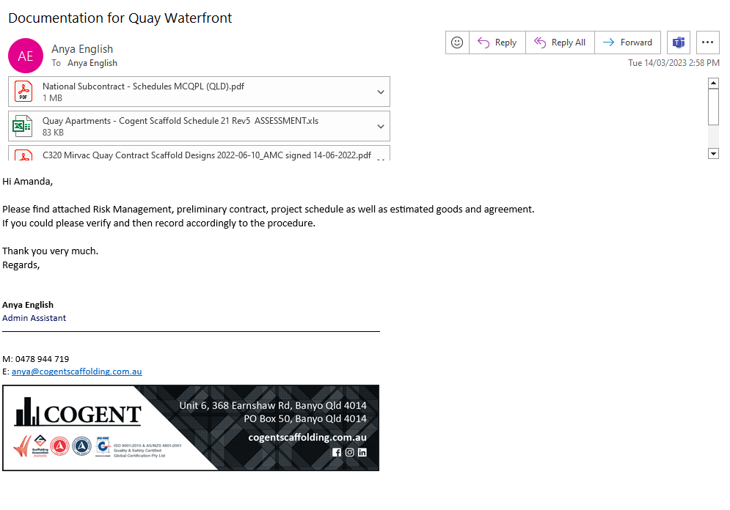
Insert email confirmation with the documents listed above as attachments to the relevant department and/or person for verification and recording here

Risk management
Four (4) risks | Risk likelihood | Risk consequence | Risk rating | Control measures
Mirvac or other company uses Cogents scaffolding designs and breaches the copyright laws | Unlikely | Cogents designs are used by another company, resulting in court cases. | Medium / High | Copy right is stated clearly on the designs, and stated on each one individually as well as stated clearly on the contract that the client signs that, Cogent are to supply the designs at a rate and are protected by copyright laws.
Documentation is not saved correctly | Likely | Staff are not able to find documentation if needed in situations were it is crucial | Medium / high | Staff are trained right in where and when to save what srt of documentation. As well as, ensure there are procedures and processes in place and ensure they are followed with regular management meeting and reviews.
Documentation and designs do not match the modified versions | Unlikely | Result in misinformation and works not completed properly | Low / medium | Ensure that there are procedures in place and that are followed through management meetings and reviews. Enusre that when a design or document is modified that it is sent out for approval before it is finalised.  Previous copies are archived correctly.
Designs are not updated correctly when modified | Likely | Result in the wring designs getting sent out to the boys on site and incorrectly erected | High | Ensure all procedures are followed and management reviews are done regularly. There are drafts sent out to multiple people in that department to ensure that everything is correct before finalising and being sent out.

Performance Criteria/Performance Checklist: Activity 2
This task must address the following performance criteria/ performance checklist.
To be assessed as satisfactory (S) in this assessment task, the participant needs to demonstrate competency in the following critical aspects of evidence | S | N/S | Trainer/Assessor to complete  (Comment and feedback to students)
Identify organisational processes for the following document preparation and document using Template 1.
- Risk management including documentation, design and copyright risks.
- Preliminary contract, agreement and estimated processing costs.
Identified and addressed risks associated with documentation, design, and copyright.
- Identified four (4) risks associated with documentation, design, and copyright.
- Calculated risk rating.
- Took actions to address risks associated with documentation, design, and copyright.
- Further, documented the following.
  - Four (4) risks associated with documentation, design, and copyright
  - Risk assessment
  - Actions taken to address risks associated with documentation, design, and copyright.
Accurately communicated via email the requirements for sketch plans and drawings to drafting personnel.
- Determined client requirements for sketch plans and drawings and document using Template 3.
- Communicated requirements for sketch plans and drawings to drafting personnel.
Note: Email confirmation with the relevant sketches/drawings attached to the drafting department determining all client requirements for the construction project
Prepared and completed the preliminary contract, agreement, and estimated processing costs.
Via email, submit the following documents to the appropriate department or person for verification and recording.
- Risk management.
- Preliminary contract
- Project schedule
- Agreement
- Estimated processing costs.
Note: Email confirmation with the documents listed above as attachments to the relevant department and/or person for verification and recording.
The student’s performance was: | - Not satisfactory  - Satisfactory
Feedback to student:

Student signature
Trainer/Assessor signature

Activity 3: Establish client satisfaction.
This activity is a continuation of Activity 2.
This activity requires you to establish client satisfaction.
To complete this activity, you are required to:
- Complete the steps given in the ‘Checklist 3’ provided.
- Access and interpret NCC codes and relevant Australian Standards referenced in the NCC.
- Complete Template 3.
While completing each step, you must place a tick mark against each step given in the checklist once completed.
Instructions for trainer/assessor:
- The student should have access to the following documents:
  - Organisational quality policies and procedures
  - Site plans and project contracts
  - Workplace safety requirements
  - Project plans and specifications
  - Manufacturer specifications and installation instructions
  - Site plans
  - Workplace safety requirements
  - Project plans and specifications
  - Manufacturer specifications and installation instructions
  - Business equipment and technology, applications and software to prepare client contracts, drawings, costings and other documentation to meet client requirements.
- The student should have access to a range of skilled professionals, including those developing the contract and related documentation.
Instructions for the student:
- The student must:
  - Forward the following plans, developed documentation, and estimated costs developed in Activity 2 to the client for review, amendment, and approval via e-mail.
  - Confirm that the client understands the scope and cost of the required site work.
  - Identify variations and problem areas, then analyse and correct problems in consultation with the client.
  - Check the accuracy of the amended contract documentation and ensure that the client's requirements are met.
After completing this task, submit the following to your assessor:
- A completed Checklist and Template 3,
- A completed Performance Criteria/Checklist – Activity 3
- Email confirmation with the documents listed above as attachments have been sent to the client for review, amendment and approval.
- Email confirmation with the client to ensure that they understand the scope and cost of the required site work.
- Email confirmation with the client to ensure that they were consulted when rectifying any problems.
- Email confirmation (with supervisor) clearly stating the client’s requirements have been met with the amended contract.
- Copies of the construction project documents you sourced in completion of this activity.

Checklist 3: Establish client satisfaction.
Steps | Tick mark, once completed
Step 1: Forward the following documentation, and estimated costs developed in Activity 2 to the client for review, amendment, and approval via e-mail.
- Preliminary contract
- Project schedule
- Agreement
- Estimated processing costs.
Note: Email confirmation with the documents listed above as attachments have been sent to the client for review, amendment and approval.
Step 2: Confirm that the client understands the scope and cost of the required site work, including the following.
Note: Email confirmation with the client (can be simulated with supervisor) to ensure that they understand the scope and cost of the required site work.
Step 3: Identify variations and problem areas, then analyse and correct problems in consultation with the client.
- Identify variations and problem areas based on costing and variation requests.
- Take actions to rectify problems in consultation with the client.
- Further, document the following Template 3.
  - Variations and problem areas
  - Actions taken to rectify problems
Note: Email confirmation with the client to ensure that they were consulted when rectifying any problems.
Step 4: Check the accuracy of the amended contract documentation and ensure that the client's requirements are met.
Instructions:
- Check the accuracy of the amended documentation.
- Ensure that the client’s requirements are met with project contracts.
Note: Email confirmation (can be simulated with supervisor) clearly stating the client’s requirements have been met with the amended contract.

Template 3: Establish client satisfaction.
Establish client satisfaction.
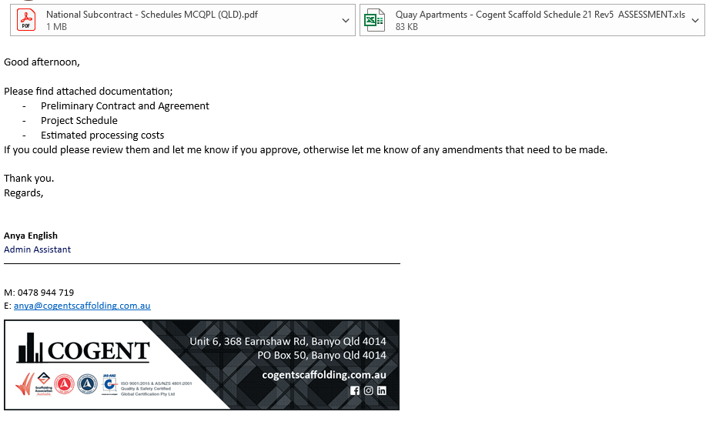
Insert email confirmation with the documents listed above as attachments have been sent to the client for review, amendment and approval here…
Insert email confirmation with the client to ensure that they understand the scope and cost of the required site work here…
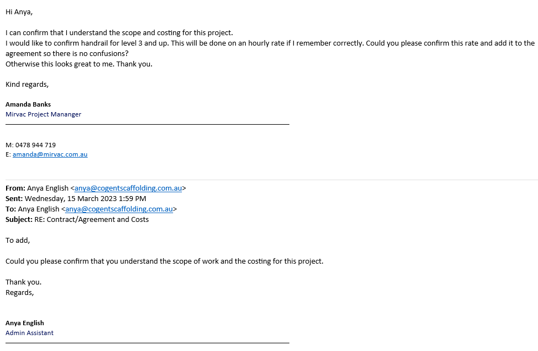

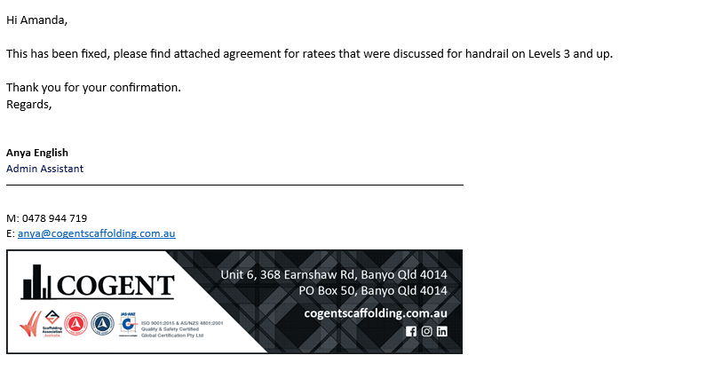
Insert email confirmation with the client to ensure that they were consulted when rectifying any problems here…
Variations and problem areas. | - Construction stair to basement 3  - Handrail tolevel 3 upwards on a day rate as a variation
Actions taken to rectify problems | Variation quote sent to client to confirm and added to the contract as a variation as it were agreed on before signing the contract.
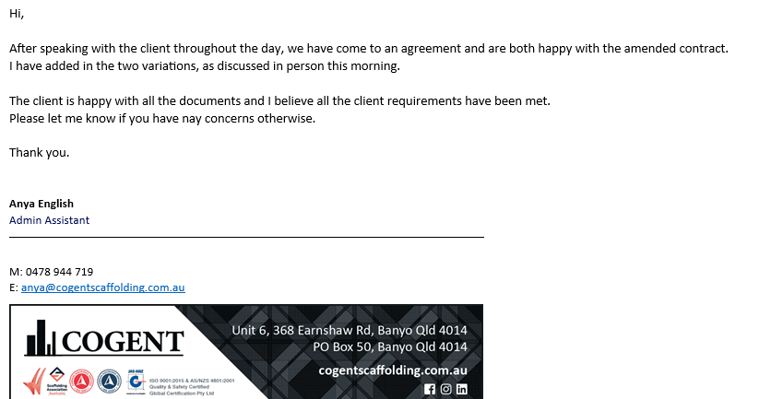
Insert email confirmation (with supervisor) clearly stating the client’s requirements have been met with the amended contract here…
Sign off:
Date: 15/03/23

Performance Criteria/Performance Checklist: Activity 3
This task must address the following performance criteria/ performance checklist.
To be assessed as satisfactory (S) in this assessment task, the participant needs to demonstrate competency in the following critical aspects of evidence | S | N/S | Trainer/Assessor to complete  (Comment and feedback to students)
Forwarded the following plans, developed documentation, and estimated costs developed in Activity 2 to the client for review, amendment, and approval via e-mail.
- Preliminary contract
- Project schedule
- Agreement
- Estimated processing costs.
Note: Email confirmation with the documents listed above as attachments have been sent to the client for review, amendment and approval.
Seek email confirmation that the client understands the scope and cost of the required site work, including the following.
Note: Email confirmation with the client to ensure that they understand the scope and cost of the required site work.
Identified variations and problem areas, then analyse and corrected problems in consultation with the client.
- Identified variations and problem areas based on costing and variation requests.
- Took actions to rectify problems in consultation with the client.
- Further, documented the following.
  - Variations and problem areas
  - Actions taken to rectify problems
Note: Email confirmation with the client to ensure that they were consulted when rectifying any problems.
Checked the accuracy of the amended contract documentation and ensured that the client's requirements are met.
- Checked the accuracy of the amended documentation.
- Ensured that the client’s requirements are met with project contracts.
Note: Email confirmation clearly stating the clinet’s requirements have been met with the amended contract.
The student’s performance was: | - Not satisfactory  - Satisfactory
Feedback to student:

Student signature
Trainer/Assessor signature

Activity 4: Finalise contract requirements
This activity requires you to finalise contract requirements.
To complete this activity, you are required to:
- Complete the steps given in the ‘Checklist 4’ provided.
- Access and interpret NCC codes and relevant Australian Standards referenced in the NCC.
- Complete Template 4.
While completing each step, you must place a tick mark against each step given in the checklist once completed.
Instructions for trainer/assessor:
- The student should have access to the following documents:
  - Organisational quality policies and procedures
  - Site plans and project contracts
  - Workplace safety requirements
  - Project plans and specifications
  - Manufacturer specifications and installation instructions
  - Site plans
  - Workplace safety requirements
  - Project plans and specifications
  - Manufacturer specifications and installation instructions
  - Business equipment and technology, applications and software to prepare client contracts, drawings, costings and other documentation to meet client requirements.The student should have access to a range of skilled professionals, including those developing the contract and related documentation.
Instructions for the student:
- The student must:
  - Check that all plans, documents, and specifications viewed by the client have been signed or initialled.
  - Compile all signed documents and send them to the Supervisor assigned for verification and processing for the next stage.
After completing this task, submit the following to your assessor:
- A completed Checklist 4,
- A completed Performance Criteria/Checklist – Activity 4
- Email confirmation (can be simulated with supervisor) that all signed documents have been sent to the appropriate person for verification, so that the project can move onto the next stage.
- Copies of the signed construction project documents you sourced in completion of this activity.

Checklist 4: Finalise contract requirements
Steps | Tick mark, once completed
Step 1: Check that all plans, documents, and specifications viewed by the client have been signed or initialled.
Step 2: Compile all signed documents and send them to the Supervisor assigned for verification and processing for the next stage.
- Compile all the signed documents.
- Forward all the signed documents to the appropriate person for verification and processing for the next stage via email.
Note: Email confirmation (can be simulated with supervisor) that all signed documents have been sent to the appropriate person for verification, so that the project can move onto the next stage.

Performance Criteria/Performance Checklist: Activity 4
This task must address the following performance criteria/ performance checklist.
To be assessed as satisfactory (S) in this assessment task, the participant needs to demonstrate competency in the following critical aspects of evidence | S | N/S | Trainer/Assessor to complete  (Comment and feedback to students)
Checked that all plans, documents, and specifications viewed by the client have been signed or initialled.
Compiled all signed documents and send them to the Supervisor assigned for verification and processing for the next stage.
- Compiled all the signed documents.
- Forwarded all the signed documents to the appropriate person for verification and processing for the next stage via email.
Note: Email confirmation (can be simulated with supervisor) that all signed documents have been sent to the appropriate person for verification, so that the project can move onto the next stage.
The student’s performance was: | - Not satisfactory  - Satisfactory
Feedback to student:

Student signature
Trainer/Assessor signature

Assessment Results Sheet
Outcome | Outcome (make sure to tick the correct checkbox):  Satisfactory (S) ☐ or Not Satisfactory (NS) ☐  Date: _______(day)/ _______(month)/ ____________(year)  Feedback:  Outcome (make sure to tick the correct checkbox):  Satisfactory (S) ☐ or Not Satisfactory (NS) ☐  Date: _______(day)/ _______(month)/ ____________(year)  Feedback:
  First attempt:
  Second attempt:
Student Declaration | - I declare that the answers I have provided are my own work. Where I have accessed information from other sources, I have provided references and or links to my sources.  - I have kept a copy of all relevant notes and reference material that I used as part of my submission.  - I have provided references for all sources where the information is not my own. I understand the consequences of falsifying documentation and plagiarism. I understand how the assessment is structured. I accept that the work I submit may be subject to verification to establish that it is my own.  - I understand that if I disagree with the assessment outcome, I can appeal the assessment process, and either re-submit additional evidence undertake gap training and or have my submission re-assessed.  - All appeal options have been explained to me.
Student Signature
Date | 4/4/23
Trainer/Assessor Name | Michelle Gomersall
Trainer/Assessor Declaration | I hold:  ☐ Vocational competencies at least to the level being delivered  ☐ Current relevant industry skills  ☐ Current knowledge and skills in VET, and undertake  ☐ Ongoing professional development in VET  I declare that I have conducted an assessment of this student’s submission. The assessment tasks were deemed current, sufficient, valid and reliable. I declare that I have conducted a fair, valid, reliable, and flexible assessment. I have provided feedback to the student.
Trainer/Assessor Signature
Date | 5/4/23
Office Use Only | The outcome of the assessment has been entered into the Student Management System  on _________________ (insert date)  by (insert Name) __________________________________

Appendix A: Reasonable Adjustments

Write (task name and number) where reasonable adjustments have been applied:

Reasonable Adjustments

- Students with carer responsibilities, cultural or religious obligations, English as an additional language, disability etc. can request for reasonable adjustments.
- Please note, academic standards of the unit/course will not be lowered to accommodate the needs of any student, but there is a requirement to be flexible about the way in which it is delivered or assessed.
- The Disability Standards for Education requires institutions to take reasonable steps to enable the student with a disability to participate in education on the same basis as a student without a disability.
- The trainer/assessor must complete the section below “Reasonable Adjustment Strategies Matrix” to ensure the explanation and correct strategy have been recorded and implemented.
- The trainer/assessor must notify the administration/compliance and quality assurance department for any reasonable adjustments made.
- All evidence and supplementary documentation must be submitted with the assessment pack to the administration/compliance and quality assurance department.
Reasonable Adjustment Strategies Matrix (Trainer/Assessor to complete)

Category | Possible Issue | Reasonable Adjustment Strategy  (select as applicable)
LLN | Speaking  Reading  Writing  Confidence | Verbal assessment  Presentations  Demonstration of a skill  Use of diagrams  Use of supporting documents such as wordlists
Non-English Speaking Background | Speaking  Reading  Writing  Cultural background  Confidence | Discuss with the student and supervisor (if applicable) whether language, literacy and numeracy are likely to impact on the assessment process  Use methods that do not require a higher level of language or literacy than is required to perform the job role  Use short sentences that do not contain large amounts of information  Clarify information by rephrasing, confirm understanding  Read any printed information to the student  Use graphics, pictures and colour coding instead of, or to support, text  Offer to write down, or have someone else write, oral responses given by the student  Ensure that the time available to complete the assessment, while meeting enterprise requirements, takes account of the student’s needs
Indigenous | Knowledge and understanding  Flexibility  Services  Inappropriate training and assessment | Culturally appropriate training  Explore understanding of concepts and practical application through oral assessment  Flexible delivery  Using group rather than individual assessments  Assessment through completion of practical tasks in the field after demonstration of skills and knowledge.
Age | Educational background  Limited study skills | Make sure font size is not too small  Trainer/Assessor should refer to the student’s experience  Ensure that the time available to complete the assessment takes account of the student’s needs  Provision of information or course materials in an accessible format.  Changes in teaching practices, e.g. wearing an FM microphone to enable a student to hear lectures  Supply of specialised equipment or services, e.g. a note-taker for a student who cannot write  Changes in lecture schedules and arrangements, e.g. relocating classes to an accessible venue  Changes to course design, e.g. substituting an assessment task  Modifications to the physical environment, e.g. installing lever taps, building ramps, installing a lift
Educational background | Reading  Writing  Numeracy  Limited study skills and/or learning strategies | Discuss with the Student previous learning experience  Ensure learning and assessment methods meet the student’s individual need
Disability | Speaking  Reading  Writing  Numeracy  Limited study skills and/or learning strategies | Identify the issues  Create a climate of support  Ensure access to support that the student has agreed to  Appropriately structure the assessment  Provide information or course materials in an accessible format, e.g. a textbook in braille  Changes in teaching practices, e.g. wearing an FM microphone to enable a student to hear lectures  Supply of specialised equipment or services, e.g. a note-taker for a student who cannot write  Changes in lecture schedules and arrangements, e.g. relocating classes to an accessible venue  Changes to course design, e.g. substituting an assessment task  Modifications to the physical environment, e.g. installing lever taps, building ramps, installing a lift
Explanation of reasonable adjustments strategy used

Trainer/Assessor Name | Michelle Gomersall
Trainer/Assessor Declaration | I declare that I have attached all relevant evidence to provide reasonable adjustment. The training package guidelines and criteria have not been compromised in the process of providing reasonable adjustment to the student. I declare that I have conducted a fair, valid, reliable, and flexible assessment. I have provided explanation of reasonable adjustments strategy used, as required.
Trainer/Assessor Signature
Date | 5/4/23

Appendix B: Third-Party Verification Log
Third-Party Verification Log
Instructions for the Assessor:
You are required to contact all third-party personnel involved in the candidate’s assessment to verify the candidate’s performance and evidence submissions and to confirm with them whether the candidate’s evidence submissions are true and accurate.
Complete this Third-Party Verification Log to document your completion of this process. When completing this log, provide all of the following required information for each third-party personnel:
- Name of third-party personnel contacted
- Relevant qualifications and/or experience of Third-party personnel contacted
- Role in the candidate’s assessment (e.g. workplace supervisor, observer, or candidate)
- Contact details (phone number or email address)
- Date contacted
You must also confirm that third-party personnel have verified the candidate’s evidence submissions are true and accurate.

Contact No.1
Name and job title of Third-party Contacted | Gavin Keeffe Project Manager/Site assist
Relevant Qualifications/experience of Third-party | Cert IV Project Management
Role in the Candidate’s Assessment | Contact Details  (Phone number or email address) | Date contacted | Third-Party verifies evidence submissions of the candidate are true and accurate?
Observer | 0420610115  gavin@cogentscaffolding.com.au | 5/4/23 | Yes No  Assessor’s Notes

Contact No.2
Name and job title of Third-party Contacted
Relevant Qualifications/experience of Third-party
Role in the Candidate’s Assessment | Contact Details  (Phone number or email address) | Date contacted | Third-Party verifies evidence submissions of the candidate are true and accurate?
Yes No
Assessor’s Notes

Contact No.3
Name and job title of Third-party Contacted
Relevant Qualifications/experience of Third-party
Role in the Candidate’s Assessment | Contact Details  (Phone number or email address) | Date contacted | Third-Party verifies evidence submissions of the candidate are true and accurate?
Yes No
Assessor’s Notes

Assessor Declaration
I declare that the information recorded in this Third-Party Verification Log is true and accurate.
Assessor’s name Michelle Gomersall | Assessor’s signature
Date signed 5/4/23
End of Third-Party Verification Log (For the Assessor’s Use Only)

