
PLAN
CPCCBC4007A
BUILDING
OR
CONSTRUCTION
WORK
ASSESSMENT SUMMARY

The assessment activities for CPCCBC4007A Plan building or construction work cover all aspects of the unit of competency required. To demonstrate competence in this unit, a participant must undertake all tasks and complete them satisfactorily and consistently. For Apprentices and Trainees, this includes employer completion of the Employer Record Book (ERB).

Participants must read all the information given before starting any assessment task. The assessment tasks are intended to be equitable, fair and flexible. If a participant has any questions or requires alternative arrangements to be made such requests should be directed to their Trainer/Assessor, who should note such arrangements in the ‘Assessor Comments’ on the affected assessment. If a participant feels they are not yet ready to be assessed, they should discuss their options with their Trainer/Assessor.

To satisfactorily complete the assessment, the participant is required to answer all questions correctly and demonstrate their skills to industry standards. If a participant does not answer some questions or perform some tasks, they will be deemed ‘Not Satisfactory’ for the task and ‘Not Yet Competent’ for the unit of competency. The Trainer/Assessor is able to provide the participant with additional information on interpreting the assessment outcomes and provide guidance on the participant’s options. Should a participant still be deemed ‘Not Satisfactory’ they will have the opportunity to undertake a supplementary assessment or appeal the result.

By signing the cover page for each assessment item, the participant acknowledges they understand the assessment instructions and requirements and consent to being assessed. The participant also verifies and assures the RTO that the work submitted is their own work.

UAA Darshika
Participant Name

Theory Exam | ◻ Satisfactory | ◻ Not Yet Satisfactory
Practical Assessment | ◻ Satisfactory | ◻ Not Yet Satisfactory
 | ◻ Competent | ◻ Not Yet Competent

Assessor Name | Myles Walder
Assessor Signature |   Click here to enter a date.
Unit Competence Determination Date


PLAN
CPCCBC4007A
BUILDING
OR
CONSTRUCTION
WORK

THEORY EXAM INSTRUCTIONS

- This exam will occur under standard assessment conditions.
  - An oral examination may be allowed under certain circumstances, whereby the Participant’s answers will be documented by a party other than the Participant. This must be acknowledged in writing (e.g. FT001 and Assessor Comments)
- Participants must provide enough detail in their responses to demonstrate their knowledge and skills.
- Please fill in the details below, providing your name, signature and date of assessment.
  - Your signature acknowledges that this is your own work.
- Assessors are to complete marking in pen of a different colour to the Participant.
- If a Participant initially answers a question incorrectly but modifies their response, they must follow the instructions below:
  - If a Participant changes their response in writing, they must put their initials next to the written change.
  - If a Participant changes their response verbally, this must be noted on the exam paper by the assessor.

Participant name UAA Darshika Participant signature Dars³ika
Date 28/03/2021

Assessor name Myles Walder Assessor signature

Date Click here to enter a date.

Number of questions | Number of questions answered correctly | Task outcome (Tick)
45 |  | Satisfactor y | Not Yet Satisfactor y
45 |  | ◻ | ◻

ASSESSOR COMMENTS

Q1. Name one (1) document you might read alongside the contract to identify the following aspects:
- Material requirements
- Plant requirements
- On-site labour requirements
- Any unusual aspects of construction

Answe r
project schedule
◻

Q2. Name the Act and identify the section that outlines the maximum deposit amounts that may be accepted by a builder before services are provided. Identify the maximum deposit amounts and the penalties for breaching such requirements.

Answer ◻
Section of Act | Requirements and penalties
Queensland Building and Construction Commission Act 1991 (Qld) -  Division 2 Payments relating to contracts - 33 Deposits | - The building contractor under a regulated contract must not, before starting to provide the contracted services at the building site, demand or receive a deposit under the contract of more than—  - for a level 1 regulated contract (other than a contract mentioned in paragraph (c))—10% of the contract price; or  - for a level 2 regulated contract (other than a contract mentioned in paragraph (c))—5% of the contract price; or  - for a level 1 or 2 regulated contract under which the value of the off-site work is more than 50% of the contract price—20% of the contract price.  Maximum penalty—100 penalty units
Level 1 contracts (priced at $3301 -
$19999);
and
Level 2 contracts (priced at $20000 or more),

Q3. Identify three (3) subcontractors you may engage for a job and the type of work they may undertake.

Answer ◻
Subcontractor | Work
Carpentry | Installs flooring, wall frames, roof trusses, windows, external doors and frames, decking and steps; attends to joinery and mouldings.

Bricklaying | Installs brick base (sub-base brickwork, dwarf walls and piers); installs walls.
Plastering | Installs internal linings.

Q4. Which of the following methods may be used to find subcontractors for a project? Tick all that apply.

Answer ◻
Choice | Possible Answers
x | Advertising
x | Networking
x | Online searches
x | Tenders
x | Word of mouth

Q5. Explain the importance of determining subcontractor or plant availability for a job.

Answe r
Planning of the labour requirements is of utmost importance and trades must be logically organised. For example, don’t organise for the painter if the plasterer has not started the walls.

High quality workmanship of the subcontractors. Subcontractors specialise in a single trade and are generally more efficient and knowledgeable about their work than a jack-of-all-trades

Referring to the Gantt Chart, it is able to determine exactly when subcontractors need to be on site. Check that your contractors are available when you need them. Even if a contractor suits your requirements there is no point in employing them if they are not available to work in the timeframe required.

So, selecting quality subcontractors for the right time is more important to avoid delays of the project and deliver a quality product.
Also, needs to organize with suppliers about the correct plants for the right time.
◻

Q6. Identify two (2) methods you might use to find a supplier for materials.

Answe r
- Phone around to find out who has good supplies
- Liaise with known suppliers that are resourceful and reliable
◻

Q7. Name two (2) factors that may impact on the availability of materials.

Answe r
- Political events
- Natural disaster
◻

Q8. Australian Standards must be considered when selecting materials.
Identify the Australian Standard (referenced in the National Construction Code) which relates to the requirements for interior lighting.

Answe r
AS/NZS 1680
◻

Q9. Identify two (2) types of plant that may be used for a building project and identify the type of work they may be used for.

Answer ◻
Plant | Work
Tower lift | To lift heavy materials such as steel and concrete. Large devices like acetylene torches, motors and generators are also transported using this plant.
Compressor | To circulate the refrigerant in the system under pressure, this concentrates the heat it contains.

Q10. Identify two (2) types of equipment that may be used for a building project and identify the type of work they may be used for.

Answer ◻
Equipment | Work

Ladders | to reach high places and points safely
Wheelbarrows | enabling the convenient carriage of heavier and bulkier loads

Q11. Identify two (2) of the records you should keep when hiring plant and/or equipment.

Answe r
- Invoices
- Receipts
◻

Q12. Name five (5) temporary services that need to be organised for a building site.

Answe r
- Water tapping
- Temporary fencing
- Barricades
- Waste bin
- Temporary electrical pole
◻

Q13. True or False (Tick your response): Site accommodation should be provided where construction work occurs in a remote area.

Answer ◻
x | True
◻ | False

Q14. What is required of a builder before any person is allowed on a building site? Tick all that apply.

Answer ◻
Choice | Possible Answers
x | To check the person has a Construction Induction Card

◻ | To check the person has the approval of the local council
x | To check the person is wearing appropriate signage
x | To keep a record of all inductions and all personnel on the site

Q15. Who issues a construction induction card? Tick your response.

Answer ◻
Choice | Possible Answers
◻ | Australian Parliament upon fee payment
◻ | Each site at the conclusion of a site induction
x | Registered Training Organisations at the conclusion of training

Q16. Identify one (1) action you might take to facilitate site access for machinery.

Answe r
Barriers may be required for additional protection of footpaths against water, mud and soil.
◻

Q17. Identify the Volume and Sections of the NCC that relate to access to buildings for Classes 1 and 10, and Classes 2 to 9.

Answer ◻
Classes 1 and 10 | Classes 2 to 9
Volume 2 -  PART 2.5 SAFE MOVEMENT | Volume 1 -
AND ACCESS | D3.2 Access to buildings
SA 5.2.2 Access to buildings

Q18. You should contact your local council to be approved for out of hours construction. Identify the required documentation for an application and the timeframe for approval.

Answe r
Compliance assessment application

A minimum of 10 working days is required for Council to assess an application.
◻

Q19. In addition to the permit from Q18. identify two (2) other permits you may need to obtain to undertake a building project.

Briefly describe the documents required for approval and who these should be submitted to for approval.

Answer ◻
Permit | Documentation and approval body
electricity supply
rubbish/waste disposal

Q20. True or False (Tick your response): Project commencement date is always at the date the contract is signed.

Answer ◻
◻ | True
x | False

Q21. What document should be developed when purchasing supplies or construction materials?

Answe r
purchase order
◻

Q22. True or False (Tick your response): Every delivery should be physically checked against the delivery sheet.

Answer ◻
X | True
◻ | False

Q23. Who should be contacted if items are missing from a delivery?

Answe r
the supplier
◻

Q24. Name the Act and identify the section that outlines the requirement to implement hazard and risk management on site. Briefly describe the
requirements.

Answer ◻
Section of Act | Requirements
 | Indicates that risks should be identified and eliminated, so far as is reasonably practicable (or otherwise minimised so far as is reasonably practicable).
The Work Health and Safety Act 2011 (Qld)  -  Sections 17-18 of the Act | 17 Management of risks  A duty imposed on a person to ensure health and safety requires the person:  (a) to eliminate risks to health and safety, so
 | far as is reasonably practicable; and
 | (b) if it is not reasonably practicable to
 | eliminate risks to health and safety, to minimise those risks so far as is reasonably practicable.

Q25. Identify one (1) regulation that an organisation’s WHS policies and procedures must comply with.

Answe r
Work Health and Safety Regulation 2011(Qld)
◻

Q26. What document should be followed when disposing of hazardous materials?

Answe r
Safety Data Sheets (SDS)
◻

Q27. An asbestos removal control plan is required when more than m² of asbestos containing material is to be removed.

Answe r
10
◻

Q28. True or False (Tick your response): A site assessment should be undertaken if contamination is known or likely to be present from the removal of existing services.

Answer ◻
X | True
◻ | False

Q29. True or False (Tick your response): Multiple projects can be planned using a single Gantt Chart.

Answer ◻
X | True
◻ | False

Q30. What are the advantages of hiring subcontractors to work across multiple nearby projects? Explain with an example.

Answe r
When hiring subcontractors, if they work across multiple nearby projects, this can save a great deal of time. Reason is subcontractors can work on the next job while waiting for another to complete.
If sub-contractors move to another location it can be difficult to ensure their return for the next stage of the project.
◻

Q31. Provide one (1) example to explain why construction operations must be sequenced.

Answe r
Sequencing is used for include all activities into the task list.
It allows for a break up of activities where trades are required on more than one occasion - such as electrical, for the initial wiring, and then later, after the internal linings and finishes have been installed, for the final fix(e.g. power points, switches, light fittings, etc)
This has the advantage of saving total job time and therefore saving money.
◻

Q32. Which of the following should be considered as part of task sequencing? Tick all that apply.

Answer ◻
Choice | Possible Answers
x | Holidays
x | Labour availability
x | Plant availability

Q33. Order the following construction operations from 1 to 6 to form the most efficient sequence.

Answer ◻
Step Number | Steps
2 | Excavation of footings
4 | Floor frame
3 | Installing brick base
6 | Roof trusses
1 | Set out
5 | Wall frames

Q34. Refer to the table below to complete the chart shown. Label the blank boxes with the appropriate Task ID letters.

Task ID | Task | Preceding  event | Nodes
A | Make enquiries and order all materials  required | Start | 1
B | Wait for bricks, sand and cement to arrive | A | 2
C | Clear vegetation from the site | A | 2
D | Order concrete to be delivered | A | 2
E | Dig the trench | C | 4
F | Pour the footings | E | 5
G | Footings curing time | F | 6
H | Load the bricks on the site | B | 3
I | Mix the mortar and lay the bricks | H | 7
J | Clean rubbish from the area | I | 8
 | Finish | J | 9

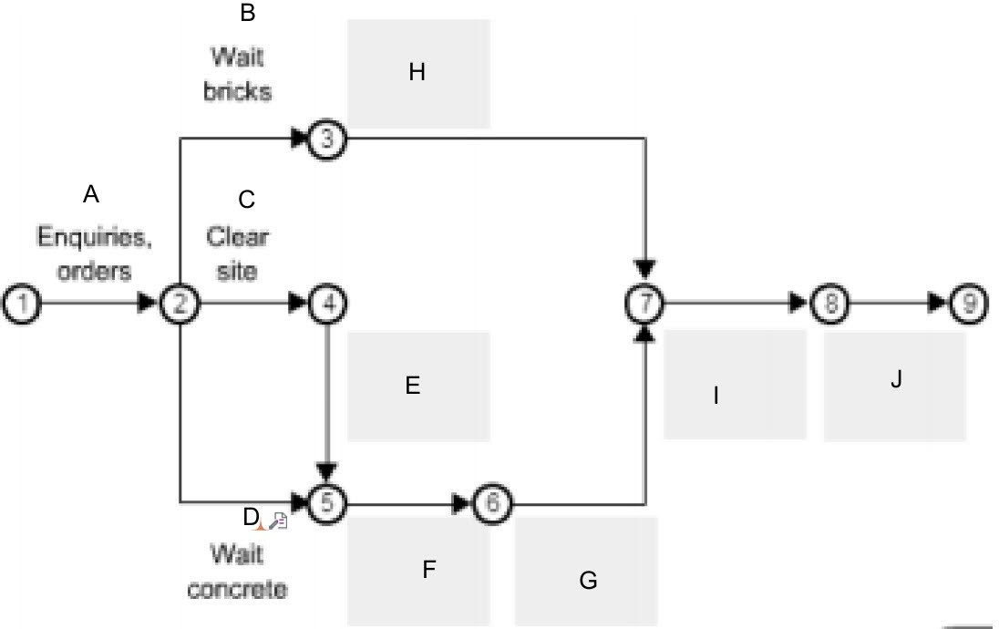

Answe r
◻

Q35. Name one (1) computer-based software package that may be used to prepare a project schedule.

Answe r
Microsoft Project
◻

Refer to the chart below to respond to Q36. to Q40. This chart shows the task sequence for building a brick fence.
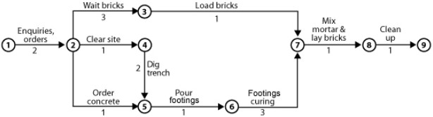

Q36. What is the total time for the process if the top path is taken?
Tick your response.

◻
Choice | Possible Answers
x | 8 days
◻ | 9 days
◻ | 11 days

Q37. What is the total time for the process if the path through nodes 2, 4 and 5 is taken? Tick your response.

◻
Choice | Possible Answers
◻ | 8 days
◻ | 9 days
x | 11 days

Q38. What is the total time for the process if the path through nodes 2, 5 and 6 is taken? Tick your response.

◻
Choice | Possible Answers
◻ | 8 days
x | 9 days
◻ | 11 days

Q39. Describe the critical path.

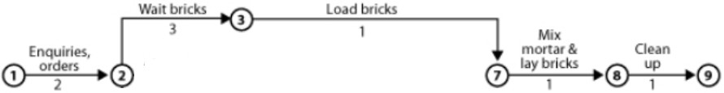Answe r
According to study materials:

The ‘critical path’ is the shortest completion time possible to complete a job.

According to web:

The critical path is the longest sequence of tasks that must be completed to successfully conclude a project, from start to finish.
a

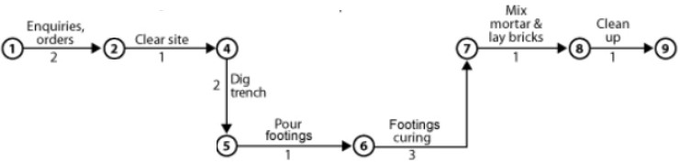

Q40. True or False (Tick your response): Even if the brick delivery in the top path was late by two (2) days, it is possible that the job will still run on schedule.

Answer ◻
x | True
◻ | False

Q41. Identify three (3) factors that may impact on the critical path of a project and cause it to need revision.

Answe r
- Inclement weather cycles
- Deferring supply of materials and labour
- Unexpected delays: Strikes, illness, mistakes
◻

Q42. Which major point(s) should you note when carrying out an inspection of neighbouring properties? Tick all that apply.

Answer ◻
Choice | Possible Answers

◻ | If the neighbours drive the right kind of car for that neighbourhood
X | Structure and condition of any boundary fences
X | Type and condition of all structures on the boundary
◻ | Whether the houses are of Victorian heritage

Q43. Why should you take photographs of site boundaries with neighbouring properties?

Answe r
If work is to affect neighbouring properties, you are required to compile a report on the condition of existing buildings and structures on adjacent site boundaries. Take photos to support your report – it will be helpful in the event of a dispute with a neighbour.
◻

Q44. When should a condition report be given to owners of adjacent buildings? Tick your response.

Answer ◻
Choice | Possible Answers
X | Before construction commences
◻ | During construction
◻ | After construction completes

Q45. When might a neighbouring property owner be required to refer to a condition report?

Answe r
If any damage has occurred through the construction process.
◻


PLAN
CPCCBC4007A
BUILDING
OR
CONSTRUCTION
WORK

PRACTICAL ASSESSMENT INSTRUCTIONS

- The following practical assessment will require the Participant to complete work related activities.
- The Assessor will conduct observations of the Participant’s work to determine whether they display sufficient practical skills and knowledge.
- Please fill in the details below – providing your name, signature and date of assessment.
  - The Participant’s signature acknowledges that the Assessor provided clear instructions and the Participant understood what was required to complete this assessment.
- The Assessor may substitute a Practical Task with an alternate task of equal value.
  - Alternate tasks must be fully documented by the assessor in the Assessor Comments area.

Participant name UAA Darshika Participant signature Dars³ika
Date 28/03/2021

Assessor name Myles Walder Assessor signature

Date Click here to enter a date.

Task | Task outcome (Tick)
Task | Satisfactory | Not Yet Satisfactory
Task 1 (Occasion 1) | ◻ | ◻
Task 1 (Occasion 2) | ◻ | ◻

ASSESSOR COMMENTS

CPCCBC4007A
PLAN
BUILDING
OR
CONSTRUCTION
WORK

Practical Task 1 (2X)
Description of task:
On two (2) occasions, a suitable observer is to verify the participant’s ability to plan on-site activities, including the employment of physical and human resources and the development of documentation and advice for relevant authorities:
- Occasion 1: Residential projects
- Occasion 2: Commercial projects

The participant is to gather evidence of how they have completed each component of the Practical Task, which is to be submitted with this Practical Assessment sheet. Evidence to be submitted may include:
- A construction program/schedule for a project showing:
  - The sequencing of the trades, etc.
  - Working and non-working days, etc.
- Local authority construction commencement notices
- Pre-construction site inspection reports or dilapidation reports
- WHS policy

The observer is to provide detailed comments on the tasks completed by the participant. The assessor is to verify the observer’s comments in the Assessor Comments section, and provide the Practical Assessment outcome on the front
cover of this document.
Resources required:
Computer (ideally with project scheduling software), Building Contract, Organisational policies, Telephone, Facsimile.
Assessment of task
Name of participant: | UAA Darshika
Name of observer:
Role of observer
(Confirm suitability to sign)
Email address of observer
Signature of observer:
Date: | 28/03/2021
When completing the task, did the participant: |  | Tick if satisfactorily completed.  Provide comments if left unticked.
 |  | 1st  Occasion | 2nd  Occasion
1 Appraise contract documentation
1.1A. Review contract documentation, codes, standards and regulations to  identify any unusual aspects of construction, use of materials or penalties. |  | ◻ | ◻
1.1B. Determine availability of selected subcontractors to suit the job requirements. |  | ◻ | ◻
1.1C. Assess availability of materials and confirm with suppliers. |  | ◻ | ◻
1.1D. Identify site access requirements and limitations, taking action to  facilitate entry. |  | ◻ | ◻

1.1E. | Prepare documentation for authorities controlling construction work and  determine project commencement date. | ◻ | ◻
1.1F. | Implement procedures for controlling and recording site deliveries. | ◻ | ◻
2 Construction operation strategies
1.2A. | Identify organisational strategies for implementing construction. | ◻ | ◻
1.2B. | Implement procedures for recording the hire of plant and equipment. | ◻ | ◻
1.2C. | Implement organisational WHS policies and procedures, including  hazard and risk management. | ◻ | ◻
1.2D. | Implement procedures for the removal of existing services and hazardous materials, in accordance with Environmental Protection Agency requirements. | ◻ | ◻
1.2E. | Follow procedures for the control of multiple projects. | ◻ | ◻
3 Project schedule
1.3A. Sequence construction operations. |  | ◻ | ◻
1.3B. | Enter operation details into a manually prepared project schedule or computer-based software package. | ◻ | ◻
1.3C. | Define critical path of the project, revising as required. | ◻ | ◻
1.3D. | Adjust project timeframes to account for anticipated delays. | ◻ | ◻
4 Required resources
1.4A. Determine and document temporary services and site accommodation  requirements. |  | ◻ | ◻
1.4B. | Determine and document plant requirements and availability, with  reference to contract documentation. | ◻ | ◻
1.4C. | Determine and document on-site labour requirements, with reference to  contract documentation. | ◻ | ◻
5 Condition reports
1.5A. Complete reports on the condition of existing buildings and structures  on adjacent site boundaries. |  | ◻ | ◻
1.5B. | Forward copies of condition reports to the owners of adjacent buildings  prior to commencing construction. | ◻ | ◻
1.5C. | Effectively communicate using the following methods:  - Telephone, facsimile, email and in writing  - Language/concepts appropriate to cultural differences  - Non-verbal communication | ◻ | ◻
The Participant’s performance was: ◻ Satisfactory ◻ Not Satisfactory

OBSERVER COMMENTS

