CHCECE002
Ensure the health and safety of children
Learner Guide

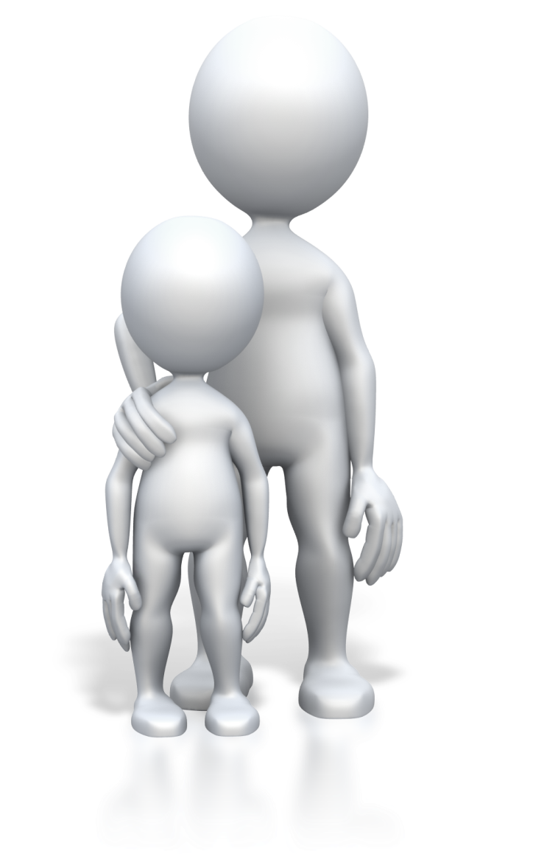
Table of Contents

Unit of Competency 6
Application 6
Performance Criteria 7
Foundation Skills 9
Assessment Requirements 10
An introduction to the National Quality Framework (NQF) 12
1. Support each child’s health needs 14
1.1 – Communicate with families about children’s health needs 15
Knowledge of children’s health needs 15
Communicating with families 15
The National Quality Standard 17
Activity 1A 19
1.2 – Maintain confidentiality in relation to children’s individual health needs 20
Confidentiality requirements 20
Handling medical information 20
Health plans 21
Medication management plans (MMPs) 21
Activity 1B 23
1.3 – Assist others to implement appropriate practices when administering medication 24
Persons authorised to administer medication 24
Service requirements for administration of medication 25
Duty of care 26
The National Quality Standard – Children’s health and safety (quality area 2) 27
Activity 1C 28
1.4 – Check the written authorisation form to administer medication from the parent or guardian 29
1.5 – Check the medication does not exceed the use-by date, is supplied in its original packaging and displays the child’s name 29
Making appropriate checks with administering medication 29
Medication checks 30
Interpreting medication packaging and information 30
Following dosage instructions 31
Activity 1D 33
1.6 – Store medication appropriately 34
Storing children’s medication 34
A service medical/first aid room 35
Activity 1E 36
2. Provide opportunities to meet each child’s need for sleep, rest and relaxation 37
2.1 – Ensure sleep and rest practices are consistent with approved standards and meet children’s individual needs 38
Requirements for sleep and rest 38
Environments that promote sleep and rest 38
Standards for sleep and rest practices 39
Activity2A 42
2.2 – Provide appropriate quiet play activities for children who do not sleep or rest 43
Quiet play 43
Quiet play activities 44
Conducting quiet play 44
Activity 2B 45
2.3 – Respect children’s needs for privacy during any toileting and dressing and undressing times 46
Addressing personal care needs of children 46
Privacy 47
Good toileting principles 47
Dressing and undressing 48
Activity 2C 49
2.4 – Ensure children’s and families’ individual clothing needs and preferences are met, to promote children’s comfort, safety and protection within the scope of the service requirements for children’s health and safety 50
Children’s comfort and safety in clothes 50
Activity 2D 52
2.5 – Share information about individual children’s rest and sleep with families as appropriate 53
Sharing information with the child’s family 53
Meeting with families 54
Activity 2E 55
3. Implement effective hygiene and health practices 56
3.1 – Consistently implement hygiene practices that reflect advice from relevant health authorities 57
3.2 – Support children to learn personal hygiene practices 57
Assess service hygiene practices 57
Cleaning at the service 58
Using and maintaining service areas 59
Personal hygiene learning for children 59
The importance of oral hygiene 60
Activity 3A 62
3.3 – Implement the service health and hygiene policy and procedures consistently 63
3.4 – Ensure that service cleanliness is consistently maintained 63
Service health and hygiene policy 63
Service health and hygiene procedures 64
Maintain service cleanliness 64
Activity 3B 65
3.5 – Observe and respond to signs of illness and injury in children and systematically record and share this information with families 66
Signs of illness in children 66
Signs of injury in children 67
Responding to the needs of sick or injured children 67
Workplace sickness and incident records 67
Activity 3C 69
3.6 – Consistently implement the service policies for the exclusion of ill children 70
Excluding sick children 70
Activity 3D 71
3.7 – Discuss health and hygiene issues with children 72
Learning opportunities with health and hygiene 72
Personal hygiene topics 72
Situations for discussions 74
Activity 3E 75
4. Supervise children to ensure safety 76
4.1 – Supervise children by ensuring all are in sight or hearing distance at all times 77
4.2 – Adjust levels of supervision depending upon the area of the service and the skill, age mix, dynamics and size of the group of children, and the level of risk involved in activities 77
Supervising children 77
Levels of supervision 78
Activity 4A 81
4.3 – Exchange information about supervision with colleagues to ensure adequate supervision at all times 82
Maintaining supervision 82
Information exchange 82
Discussions with colleagues 83
Activity 4B 84
5. Minimise risks 85
5.1 – Assist in the implementation of safety checks and the monitoring of buildings, equipment and the general environment 86
Managing risks in and around the service 86
Fire safety 87
Conducting safety checks 88
Risk assessment tools 88
Activity 5A 91
5.2 – Consistently implement policy and procedures regarding the use and storage and labelling of dangerous products 92
Using dangerous products 92
Policy and procedures for handling dangerous products 92
Activity 5B 95
5.3 – Follow service procedures for the safe collection of each child, ensuring they are released to authorised people 96
Procedures for releasing children from the service 96
Activity 5C 98
5.4 – Assist in the supervision of every person who enters the service premises where children are present 99
Security of premises 99
Risks to children 100
Activity 5D 101
5.5 – Discuss sun safety with children and implement appropriate measures to protect children from over-exposure to ultraviolet radiation 102
Sun safety 102
Discussing sun safety with children 102
The SunSmart program 103
Activity 5E 104
5.6 – Check toys and equipment are safe for children and safe to use in their proposed area 105
Toy safety standards 105
Equipment for children 106
Risk assessment of toys 106
Activity 5F 108
5.7 – Remove any hazards immediately or secure the area to prevent children accessing the hazard 109
Controlling hazards 109
Securing a hazardous area 110
Develop children’s awareness to safety 110
Activity 5G 111
6. Contribute to the ongoing management of allergies 112
6.1 – Identify and recognise signs, symptoms and key characteristics of allergies and anaphylaxis 113
Allergies 113
Anaphylaxis 114
Food allergies 115
Activity 6A 116
6.2 – Apply organisational risk-management strategies for children with severe allergies 117
6.3 – Follow organisational policies and legislative requirements in relation to medication for anaphylaxis 117
Use strategies for managing allergies in children 117
Adrenalin auto-injectors 118
Storing Adrenalin (epinephrine) 119
Activity 6B 120
7. Contribute to the ongoing management of asthma 121
7.1 – Identify signs, symptoms and triggers of asthma 122
Asthma 122
Asthma triggers 123
Activity 7A 124
7.2 – Identify children who have an asthma management plan and follow that plan 125
7.3 – Follow organisational policies and legislative requirements in relation to medication for asthma 125
The asthma management/action plan 125
Organisational and legislative requirements for asthma 126
Medication for asthma 126
Activity 7B 128
Summative Assessments 129
References 130

Unit of Competency

Application

This unit describes the skills and knowledge to ensure the health and safety of children.

This unit applies to educators working in a variety of education and care services.

The skills in this unit must be applied in accordance with Commonwealth and State/Territory legislation, Australian/New Zealand standards and industry codes of practice.

Unit Mapping Information

No equivalent unit.

Unit Sector

None stated

Performance Criteria
Element  Elements describe the essential outcomes. | Performance Criteria  Performance criteria describe the performance needed to demonstrate achievement of the element.
- Support each child’s health needs | - Communicate with families about children’s health needs  - Maintain confidentiality in relation to children’s individual health needs  - Assist others to implement appropriate practices when administering medication  - Check the written authorisation form to administer medication from the parent or guardian  - Check the medication does not exceed the use-by date, is supplied in its original packaging and displays the child’s name  - Store medication appropriately
- Provide opportunities to meet each child’s need for sleep, rest and relaxation | - Ensure sleep and rest practices are consistent with approved standards and meet children’s individual needs  - Provide appropriate quiet play activities for children who do not sleep or rest  - Respect children’s needs for privacy during any toileting and dressing and undressing times  - Ensure children’s and families’ individual clothing needs and preferences are met, to promote children’s comfort, safety and protection within the scope of the service requirements for children’s health and safety  - Share information about individual children’s rest and sleep with families as appropriate
- Implement effective hygiene and health practices | - Consistently implement hygiene practices that reflect advice from relevant health authorities  - Support children to learn personal hygiene practices  - Implement the service health and hygiene policy and procedures consistently  - Ensure that service cleanliness is consistently maintained  - Observe and respond to signs of illness and injury in children and systematically record and share this information with families  - Consistently implement the service policies for the exclusion of ill children  - Discuss health and hygiene issues with children
- Supervise children to ensure safety | - Supervise children by ensuring all are in sight or hearing distance at all times  - Adjust levels of supervision depending upon the area of the service and the skill, age mix, dynamics and size of the group of children, and the level of risk involved in activities  - Exchange information about supervision with colleagues to ensure adequate supervision at all times
- Minimise risks | - Assist in the implementation of safety checks and the monitoring of buildings, equipment and the general environment  - Consistently implement policy and procedures regarding the use and storage and labelling of dangerous products  - Follow service procedures for the safe collection of each child, ensuring they are released to authorised people  - Assist in the supervision of every person who enters the service premises where children are present  - Discuss sun safety with children and implement appropriate measures to protect children from over-exposure to ultraviolet radiation  - Check toys and equipment are safe for children and safe to use in their proposed area  - Remove any hazards immediately or secure the area to prevent children accessing the hazard
- Contribute to the ongoing management of allergies | - Identify and recognise signs, symptoms and key characteristics of allergies and anaphylaxis  - Apply organisational risk-management strategies for children with severe allergies  - Follow organisational policies and legislative requirements in relation to medication for anaphylaxis
- Contribute to the ongoing management of asthma | - Identify signs, symptoms and triggers of asthma  - Identify children who have an asthma management plan and follow that plan  - Follow organisational policies and legislative requirements in relation to medication for asthma

Foundation Skills
The Foundation Skills describe those required skills (language, literacy, numeracy and employment skills) that are essential to performance.

- Reading – in order to accurately read and interpret medication packaging and dosage instructions
- Numeracy – in order to correctly calculate medication dosages for common measurements including milligrams (mg) and millilitres (ml).

The remaining foundation skills essential to performance are explicit in the performance criteria of this unit.

Assessment Requirements
Performance Evidence

The candidate must show evidence of the ability to complete tasks outlined in elements and performance criteria of this unit, manage tasks and manage contingencies in the context of the job role. There must be demonstrated evidence that the candidate has completed the following tasks at least once:

- Consistently supported the health needs of the children in the service, including the following activities:
- contributing to the provision of a clean and safe environment
- recognising and responding to signs of illness of children, including signs and symptoms of asthma and anaphylaxis
- reading and interpreting authorisation forms, medication labels, medical management plans and other relevant medical information
- developing children’s awareness of safety.

Knowledge Evidence

The candidate must be able to demonstrate essential knowledge required to effectively do the task outlined in elements and performance criteria of this unit, manage the task and manage contingencies in the context of the work role.

These include knowledge of:

- How to access:
- the National Quality Framework
- the National Quality Standards
- the relevant approved learning framework
- How to navigate through framework and standards documents to find areas relevant to this unit of competency
- How to undertake a risk analysis of toys and equipment
- Potential hazards to children, including medical conditions
- Children’s requirements for sleep and rest
- Environments that promote rest and sleep including light, noise, temperature and ventilation requirements
- Signs, symptoms and key characteristics of allergy/anaphylaxis
- Signs, symptoms and key characteristics of asthma
- How to use an adrenalin auto injector for anaphylaxis
- How children’s oral health impacts on their general health and well-being, including signs of tooth decay
- Safety issues and risk management strategies for children’s health and safety in a variety of contexts
- Basic home fire safety including high-risk groups, behaviour that contributes to fire injury and fatalities, and smoke alarm placement, installation and maintenance
- Organisational standards, policies and procedures.

Assessment Conditions

Skills must be demonstrated in a regulated education and care service.

In addition, simulations and scenarios must be used where the full range of contexts and situations cannot be provided in the workplace or may occur only rarely. These are situations relating to emergency or unplanned procedures where assessment in these circumstances would be unsafe or is impractical.

Simulated assessment environments must simulate the real-life working environment where these skills and knowledge would be performed, with all the relevant equipment and resources of that working environment.

Asthma and anaphylaxis aspects of this unit are best assessed in conjunction with HLTAID004 Provide an emergency first aid response in an education and care setting

Assessment must ensure use of:

- National Quality Framework for Early Childhood Education and Care
- The relevant approved learning framework under the National Quality Framework for Early Childhood Education and Care

Assessors must satisfy the Standards for Registered Training Organisations (RTOs) 2015/AQTF mandatory competency requirements for assessors.

Links

Companion volumes are available from the CS&HISC website - http://www.cshisc.com.au/

Companion Volume implementation guides are found in VETNet - https://vetnet.education.gov.au/Pages/TrainingDocs.aspx?q=5e0c25cc-3d9d-4b43-80d3-bd22cc4f1e53

An introduction to the National Quality Framework (NQF)

The National Quality Framework (NQF) was established in 2012 by the government as a measure to raise the quality and standards of early childhood education and care across the whole of the Commonwealth by introducing consistency in the regulation and assessment of Australian education and care services. This is overseen by the Australian Children’s Education and Care Quality Authority (ACECQA), in conjunction with the individual state and territory regulatory bodies.
The NQF applies to most of the following services:
- Long day care
- Family day care
- Preschool/kindergarten
- Outside school hours care.
The need for a national approach is to ensure that all children in the early stages of childhood access quality education and care in their formative years in order to give them the best possible start in development and learning. Research shows that the higher the quality of education and care in these early years, the higher the quality of health, educational attainment, and employment in later life.
Note: the NQF applies to children from birth to thirteen years of age.
It aims to raise the quality of education and care services by:
- Changes in educator-to-child ratios – as of 1 January 2016, some states and territories have seen changes in their ratios, depending on the type of service and age group of children. Educator-to-child ratios have already been put in place for Tasmania and Western Australia and these remain unchanged. Information on ratios can be accessed at the following website link, ‘Improved educator to child ratios’ at ACECQA: http://www.acecqa.gov.au/Improved-educator-to-child-ratios
- Improved educator qualifications – the NQF has established minimum qualification requirement which is approved by ACECQA. If a qualification is not on ACECQA’s list of approved educator qualifications, it is possible to have this assessed with ACECQA to determine if this is deemed equivalent. Information on educator qualifications can be found at the following website link, ‘Qualifications’ at ACECQA: http://www.acecqa.gov.au/educators-and-providers1/qualifications
- Provision of information on educators, providers and services in the national registers – this service is updated weekly and enables access to find approved education and care services, and certified supervisors. This can be found at the following website link, ‘National Registers’ at ACECQA: http://acecqa.gov.au/national-registers
- Support for learning through approved learning frameworks – these are designed to assist the role of educators in providing for learning and development needs of children. The following are the two nationally approved learning frameworks:
- ‘Belonging, Being and Becoming’: the early years learning framework for Australia
- ‘My Time, Our Place’: the framework for school age care in Australia.
There also exist jurisdictional approved learning frameworks for Tasmania (the Tasmanian Curriculum, the Department of Education of Tasmania), Victoria (the Victorian Early Years Learning and Development Framework) and Western Australia (the Curriculum Framework for Kindergarten to Year 10). Information on learning frameworks can be accessed at the following website link, ‘Approved Learning Frameworks’ at ACECQA: http://www.acecqa.gov.au/national-quality-framework/national-law-and-regulations/approved-early-learning-frameworks.
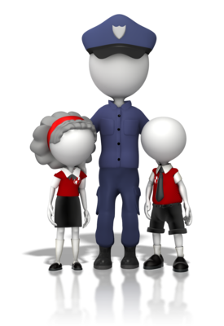
The NQF includes the following aspects:
- The National Law and National Regulations
- The National Quality Standard (NQS)
- National learning frameworks
- Assessment and quality rating process.
All information on the National Quality Framework (NQF) has been accessed and taken or modified from the Australian Children’s Education and Care Quality Authority (ACECQA) website: http://www.acecqa.gov.au/national-quality-framework/explaining-the-national-quality-framework
(All of the above website links have been accessed on 17.03.2017.)
More information on the NQF will be covered in the relevant unit sections of this unit, as applicable to the performance criteria.

1. Support each child’s health needs
1.1. Communicate with families about children’s health needs
1.2. Maintain confidentiality in relation to children’s individual health needs
1.3. Assist others to implement appropriate practices when administering medication
1.4. Check the written authorisation form to administer medication from the parent or guardian
1.5. Check the medication does not exceed the use-by date, is supplied in its original packaging and displays the child’s name
1.6. Store medication appropriately


1.1 – Communicate with families about children’s health needs
By the end of this chapter, the learner should be able to:
- Identify essential factors for communicating with families on health needs
- Recognise communication policies and determine corresponding procedures
- Choose appropriate questions to confirm children’s health needs.

Knowledge of children’s health needs
To confirm the health needs of children in your care, you will need to engage in communications with families. This ensures that any needs are fully discussed and checked directly with the family involved.
This may be done as part of a child’s initial enrollment or in their first session (depending on your organisation’s processes); this should be done at the start of a child’s attendance and also when a change to a child’s health occurs. This is so that any specific health needs can be managed with immediate effect.
The essential factors for communicating with families in regards to children’s health will be:
- To determine if the child has a health condition or concern
- To clarify any specific health care needs
- To take all possible steps to enable full participation of the child.
It is important to determine any health needs with the families, as children may not necessarily be able to communicate this themselves. For example, they may not have an understanding of their own situation of health, they may not be aware of the risks to them in certain activities, they may not know when they are in a situation of need or be able to explain how they feel. Having this information first-hand from the family will enable you to plan suitable care and activities which fully support the child.


Communicating with families
To communicate with families, you will need to have an understanding of how to interact professionally and with consideration to the different types of people you will meet. Families will vary in culture, beliefs and outlooks; they may have different lifestyles and expectations. Understanding the many differences will help you to take the right approach in your communications. Never presume all people are alike; take the time to get to know the types of families in your community and at your service. Build a rapport so you can understand family needs.
Communicating professionally will mean representing your organisation’s values and commitment to providing quality education and care. You will be expected to interact with others positively and in accordance with your organisation’s communication policies and procedures.

This can include:
- How you address people, e.g., greetings, acceptable style of language and use of industry terminology
- Information disclosure, i.e., how you convey information, when and how this is done, and observances to confidentiality and privacy requirements
- How you respond to requests and instructions
- How you are able to assist others
- Timeframes for conducting communications and providing responses and answers.
Communication policies provide guidance on how professional communications should be conducted; procedures provide you with the steps to take and a consistent approach.
You may have set methods for communicating with others at work, including your communications with families. This may depend on factors such as the particular need or situation and the availability of the required person(s).
Communication methods you can use:
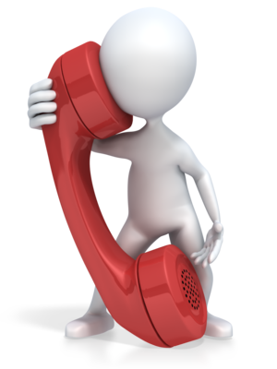
- Face-to-face communications – this method allows participants to conduct a direct two-way conversation; speaking face-to-face allows you to confirm and clarify meaning and can provide you with visual clues as to how another person is feeling
- Telephone communications – this also allows you to speak in a two-way conversation but without seeing the other person’s reaction; this method can be used effectively in general interactions such as arranging appointments, seeking clarification or checking on needs
- Written communications – this is good for relaying facts and information as it allows the recipient to refer back to the written message; it provides physical evidence of a communication.
Consideration in communications is about having respect for others, no matter what the situation, and acting in the best interests of all concerned. It is treating others fairly and equally, and understanding that differences exist and should be factored into discussions. It is making sure that families are included and are listened to in regards to the education and care needs of their child.
You should:
- Take time to fully discuss or communicate with families
- Be non-judgemental about others and any differences
- Listen and answer queries and concerns
- Address needs fairly and efficiently.

To determine specific health needs of children, you should ensure that you gain the right information which allows you to provide the right level of education and care. You should determine what information you need to know before your communication. To do this, it can be beneficial to develop a checklist of items or questions that are specific to the situation. This ensures you do not forget important details or miss out on special requirements.
Questions to ask families when confirming children’s health needs should include:
- Is there a diagnosis?
- Is medication taken, if so, how much and when should it be administered during service hours?
- Are there specific requirements for providing care?
- Are there specific requirements for inclusion in activities?
- Are there activities that require the child to have additional support?
- Are there any risks to the child’s health (e.g., with the condition itself, and when participating in activities)?

The National Quality Standard
As mentioned in the introduction to the National Quality Framework, the National Quality Standard is an integral part of the National Quality Framework for education and care. There are seven quality areas under the National Quality Standard, which seek to provide industry guidance and best practice.
The seven quality areas under the National Quality Standard are:
- Educational program and practice
- Children’s health and safety
- Physical Environment
- Staffing arrangements
- Relationships with children
- Collaborative partnerships with families and communities
- Governance and leadership.
For the purpose of this unit, we will be looking primarily at the following quality areas, ‘Children’s health and safety’ quality area 2 (in section 1.3 and 2.1 of this unit) and ‘Collaborative partnerships with families and communities’, quality area 6. Although it is important to note, all quality areas should be addressed within services delivering education and care as each area works with the next in providing effective and safe education and care.

Collaborative partnerships with families and communities – quality area 6

Quality area 6 lists two standards; these are Standard 6.1 Supportive relationships with families, and Standard 6.2 Collaborative partnerships.
Standard 6.1 – This looks at engaging with families, so that the service supports them to become involved in their child’s education and care. It is also about the service showing respect for the differences of children and their families.
Standard 6.2 – This is about collaborating to enhance children’s education and care experiences. It is also about inclusion and participation within the program, and building relationships with the community.
Information on quality area 6 has been sourced from ‘Quality Area 6 – Collaborative partnerships with families and communities’ at the ACECQA website: http://www.acecqa.gov.au/Collaborative-partnerships-with-families-and-communities (access date: 05.02.2018).
Further information on quality area 6 can be found at the above website page, along with links to resources associated with this area.
ACECQA has also produced a factsheet on building partnerships with families; this can be found at the following pdf website link: http://files.acecqa.gov.au/files/QualityInformationSheets/QualityArea6/QualityArea6BuildingPartnershipsWithFamilies.pdf (access date: 22.03.2017).


Activity 1A

1.2 – Maintain confidentiality in relation to children’s individual health needs
By the end of this chapter, the learner should be able to:
- Determine how to maintain confidentiality on individual children’s health needs
- Recognise how information on the child and their family is stored confidentially
- List three elements contained in a health plan and in a medication management plan.

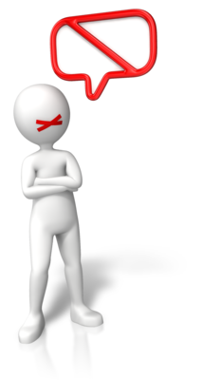
Confidentiality requirements
Confidentiality of information is required by law; it is also an important part of working ethically at work and with those who share information with you.
Information should be treated with the utmost respect in all situations, i.e., this should not be made available to others who are not required to have this, information should be confirmed and understood, information should be acted upon as required by the situation, and information should be documented and stored safely and securely.
All families should be made aware of their confidentiality rights and be assured that their information will be looked after securely and not disclosed to third parties without first obtaining their permission. In the case of a medical emergency, it may be required to disclose information on a child’s health needs to medical services; in such a situation, disclosure is required to maintain the health and wellbeing of the child.
Maintaining confidentiality means:
- Not disclosing information to those who should not have this
- Discussing health and personal matters away from others so you are not overheard
- Storing information safely and securely (e.g., restricted access to electronic records and paper records kept under lock and key).
Confidentiality in law
Records and information collected by your organisation will need to be kept for conducting service activities; this is also required by law for your organisation’s reporting requirements (which provides evidence of all organisational business activities). Information must be stored and held securely; this information should not be disclosed to any other persons who do not have permission to access or use this. Confidentiality and privacy of information is governed by the Privacy Act 1988, which regulates the handling of personal information. Your organisation should include this law in their confidentiality of information policies and procedures.

Handling medical information
In your work role, you may be required to have knowledge of, and to handle, information on specific children’s health needs. This may include details about a child’s condition, the risks of this and how to maintain the wellbeing of the child. This may include handling and referring to medical information. You should ensure that medical information and terminology are understood clearly and any specific instructions are carried out. If you are unsure of the meaning or relevance of information, speak with your supervisor or manager in the first instance. You may need to check details with the person who documented the child’s health requirements or speak with the child’s family directly.
Information on medical and health needs may be recorded specifically to your organisation’s requirements, i.e., using specific document templates and forms, and electronic records. It may also be supplied as a specific health plan or medication management plan.

Health plans

This type of plan is used to provide information to others on the healthcare needs of a child. This should be created by the relevant health professional in conjunction with the parent(s) or carer(s) in order to manage conditions and any medical needs. It should clearly reference the child involved and also the parent(s)/carer(s) responsible for the wellbeing of the child. It should also provide details of the health service and health professional responsible for the treatment/healthcare of the child.
This should contain details of the requirements for everyday health and care needs, and also for handling a situation of emergency. For example, it will contain details of the child’s situation of health, any condition that has been diagnosed and the recommended actions to manage this. It can also contain information about triggers and risks to health, and how to avoid or manage these accordingly and if a situation occurs. If medication is being taken, it will provide all relevant information on how to manage health needs in this way and instructions on how to use these. It may also contain advice on managing health and the best methods to integrate health needs within an education and care environment.

Medication management plans (MMPs)
This type of plan is used by health professionals as a way to standardise how information on medications is presented within the health profession. It is an initiative of the Australian Commission on Safety and Quality in Health Care and is specifically used to reconcile medication requirements of an individual to show their medical history and ongoing needs as managed between health services. Plans may differ slightly in content depending on the specific needs of health services and jurisdictions; they may be adapted for use in specific environments and for different situations of care.
Information on MMPs has been modified from the following source, ‘Medication Management Plan’ at the Australian Commission on Safety and Quality in Health Care website: https://www.safetyandquality.gov.au/our-work/medication-safety/medication-reconciliation/medication-management-plan/ (access date: 05.02.2018).
From the perspective of a medication management plan, as may be used in children’s education and care service environments, this will contain information on the current medications being taken by a child. This ensures information is documented in a set way and is interpreted accurately and consistently by those who need to use this.
A medication management plan as used in an education and care service environment will contain information such as:
- The name of the person to which the plan applies to
- Medication currently prescribed
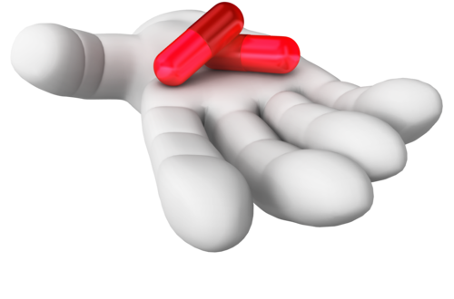
- What the medication is prescribed for
- Dosage of medication and when this should be taken
- How medication should be administered
- Whether the medication is a short-term requirement or ongoing
- Any known allergic reactions to medications
- Any medication interactions with other medications or foods
- A signature of the authorising doctor and a date – the plan must be current and may contain a review date to confirm its eligibility.

Activity 1B

1.3 – Assist others to implement appropriate practices when administering medication
By the end of this chapter, the learner should be able to:
- Identify the persons who are authorised to administer medication to the child
- Determine service practices for the administration of medication
- Identify their duty of care requirements.

Persons authorised to administer medication
At your service, medications may need to be administered during service hours, if so, it is important to know which persons are able to administer these. The health plan of the child, or your own service records should state who is able to administer medication.
Obtain authorisation to administer medication from the parent(s)/carer(s)
The service will need to obtain authorisation from the parent(s)/carer(s) responsible for the wellbeing of the child before being able to administer medication or an agreed health procedure. This should be obtained in writing so both the service and parent(s)/carer(s) are aware of the agreement made and have a physical copy of this. Verbal agreements can be made but to ensure accountability and evidence of the agreement, a written agreement provides a clear record of those involved. The parent(s)/carer(s) should also provide you with evidence of the authorised prescription or procedure as prescribed by the health professional. This ensures that you have checked and confirmed health needs are correct.
Service staff authorised to administer medication

As part of your health and safety policy and procedures to administer medication to children in your care, staff within the service should be asked if they would agree to administer medication. Those that agree to perform this should be given the correct training in the areas that they will need to deal with. This training should be a recognised course that fulfils the needs of your state/territories health requirements; this may need to be undertaken at regular intervals to maintain currency and to ensure staff are kept up-to-date with medication needs.
Your service should identify the minimum number of staff to be trained for administering medication; this should ensure that each service period has one or more trained member of staff to perform this. A member of staff has the right to refuse to administer medication if they do not feel confident to do this or do not feel that they have received the correct training. However, in a situation where a child’s life or health is at risk, trained staff will need to administer medication or an agreed procedure even if they are reluctant to do this.
Self-administration
In some situations such as with the care of an older child, it may be agreed that self-administration of medication is carried out. The parent(s)/carer(s) should notify you of this in writing so you are made aware of the management of a particular condition. This may be more applicable to taking prescribed drugs, where the child can be monitored as they self-administer; this allows you/your service to maintain a duty of care to ensure the safety of the child.
Parents/carers and medical practitioners administering medication
It may also be possible to have a parent or carer administer medication to their child; this may be feasible at the start or end of the day before service activities commence, or if medication is only required on a more infrequent basis. Generally speaking, it may not be a practical solution for more frequent medication administration as service activities may be disrupted, or the parent/carer may not always be able to attend when medication is needed, and times to administer medication may not be maintained at the stipulated times.
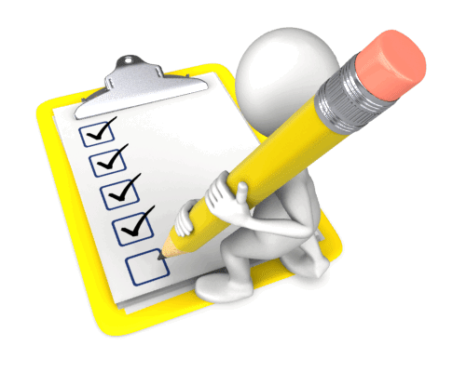
It should also be noted, that in the case of a health emergency, when the parent(s)/carer(s) is (or are) not available, a medical practitioner may need to be contacted to provide urgent assistance or to provide treatment.

Service requirements for administration of medication
Your service should follow clear practices and procedures for staff administering medication. These will include aspects such as working with another member of staff to witness administering medication and also documenting medications that have been taken. This provides clear steps to staff on what is required and ensures that best practice is carried out.
Staff administering medication should maintain hygiene at all times, this includes working with medications in a clean and sterile environment, maintaining their own hygiene by washing hands and ensuring clothing, jewellery and hair do not touch medications or surfaces, and keeping medication bottles/equipment, etc., clean. They should also work confidentially with the child so they are not watched by others and follow strict administrative processes to follow the correct procedures and to document each medication administration.
Procedures should be clearly documented and made available to staff, both those who administer medications and those who do not. This provides a common understanding to all and ensures that staff follow and assist in organisational health practices throughout the service.
A procedure for administering medications will include:
- Accessing the correct health plan or medication record for the child and checking the information it contains
- Obtaining the child’s medication and dispensing equipment
- Taking the appropriate child to a safe area for administering medication
- Requesting another member of staff to witness administration of the medication
- Washing of hands before handling medication and equipment
- Preparing the medication, checking that the medication clearly states the child’s name and is in-date
- Recording administering of medication on organisational records/the medication record and requesting the witness to check and confirm this
- Administering the medication
- Both the staff member administrating medication and the witness sign the medication record as evidence of this
- Returning the child back into service activities
- Removing and storing medication back into the correct area and washing any equipment items and returning these to the correct area.
Medication should be returned back to the parent(s)/carer(s) at the end of the child’s service attendance each day or attendance; this should be brought into the service each time it will need to be administered. You should also ask the parent/carer or person made responsible for the child to sign the medication record as proof of their knowledge of administration for that day.
ACECQA have sample forms and templates available from their website, visit the following link to access a copy of their medication record sample form, ‘Sample forms and templates now available’ at http://www.acecqa.gov.au/sample-forms-and-templates-now-available (access date: 23.03.2017).

Duty of care
Duty of care is a legal duty that you have as a worker to take all reasonable care to avoid others from being harmed when in your care and supervision. You also have an obligation to make sure that your colleagues (and other workers) provide a good standard of care, with due attention.
This involves the application of and adherence to ethical standards, codes of practice, industry standards and organisational policy. It acknowledges that people have a right to have care in safe environments which are free from neglect and abuse. It also involves identifying risks and responding to these in the most appropriate way to either eliminate or manage these at safe levels.

Reasonable care includes considering the safety, privacy, confidentiality and any specific needs for participation with children and any other relevant persons.
You must ensure that all of your work meets the duty of care requirements; this includes following:
- Legal requirements, including:
- Education and Care Services National Law and Regulations
- Anti-discrimination legislation
- Confidentiality and data privacy
- Work Health and Safety legislation/Occupational Health and Safety legislation
It also includes applying knowledge and understanding of:
- Ethical standards and codes of conduct/practice
- Industry standards
- Organisational policy and procedures.

The National Quality Standard – Children’s health and safety (quality area 2)
As mentioned in section 1.1 of this unit, the National Quality Standard details an area dedicated to children’s health and safety. This covers maintaining children’s health through appropriate care, healthy eating and physical activity, and child protection.
Quality area 2 – Children’s health and safety, includes the following guiding principles:

- Standard 2.1 – Each child’s health is promoted:
- element 2.1.1 – Each child’s wellbeing and comfort is provided for, including appropriate opportunities to meet each child’s need for sleep, rest and relaxation
- element 2.1.2 – Effective illness and injury management and hygiene practices are promoted and implemented.
Information on quality area 2 has been sourced from ‘Quality Area 2 – Children’s health and safety’ at the ACECQA website: http://www.acecqa.gov.au/Childrens-health-and-safety (access date: 05.02.2018).
Further information on quality area 2 can be found at the above website page, along with links to resources associated with this area.

Activity 1C

1.4 – Check the written authorisation form to administer medication from the parent or guardian

1.5 – Check the medication does not exceed the use-by date, is supplied in its original packaging and displays the child’s name
By the end of this chapter, the learner should be able to:
- Access a sample written authorisation form for administering medication to children and identify the information that is required for authorisation
- Determine if medication is supplied in its original packaging
- Identify information on medication labels or packaging.

Making appropriate checks with administering medication
When a child’s medication is brought into an education and care service, certain checks should take place to ensure it is safely handled and used.
A record of written authorisation
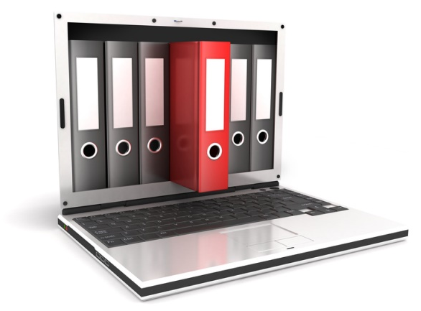
Before medication can be administered to a child, a written authorisation must be obtained from the parent or person legally responsible for the child. This ensures that the service has a clear record of authorisation; this must state each medication that the child needs to take and should include any non-prescription drugs.
This is so that all medications/drugs are verified with the parent/legal guardian before being given to the child. It also makes sure that a child is not given a drug by mistake or which they may be allergic to.
An authorisation form should contain information such as:
- The name of the child
- The medication that the child is authorised to be given
- The dosage and frequency of administering
- Signature of the parent or guardian and the date this was given.
This authorisation should be held securely and confidentially in service records and should be checked on a regular basis to ensure it remains current. The service should ensure that parents/guardians of children taking medication review these requirements at an agreed interval of time. This allows both the parents/guardians and service staff to monitor and maintain the health of the child.
When administering medication, the staff member administering medication should ensure this written authorisation is in place and is checked. Practically speaking, it may only be necessary to check this at agreed times, as stipulated in your service procedures, however, if a member of staff is new to administering medication to a child, they should always check this before they begin.
A sample authorisation form for both routine authorisation of administration of medication and for emergency administration of medication can be accessed and viewed at the website of Queensland Government, ‘Administration of Medications in Schools’ at the following link under the heading ‘Administering medications to students – School staff’: http://ppr.det.qld.gov.au/education/management/Pages/Administration-of-Medications-in-Schools.aspx (access date: 23.03.2017).

Medication checks

Checking medication not only includes identifying what is held within a container, it also means checking that the medication is a valid product to use for the specified child.
Medication should:
- Be in its original packaging and container
- Have the original label with the prescription clearly legible, including the name of the child this is for
- Have authorised instructions for administering
- Not be used after the expiry date shown on the packaging/container.
Determining if medication has been supplied in its original packaging will include assessing what packaging types exist and should be used for each type of medication. Medications are provided in a base container appropriate to hold its contents, e.g.., a blister containing tablet medication, a strip package containing sterile equipment such as a syringe, a bottle containing liquid medication or plastic container with dispensed tablets, etc.
This may then have an additional packaging, such as a box to hold blisters or items together; this also acts as a means to provide specific product information and space for prescription labels.
Items in their original packaging will display clear product information and contain medications in a safe and sterile/appropriate way. If medication is supplied in an unsecured container without clear product information or a prescription label attached, this can indicate that medication has been removed from its intended packaging.
Medication should be given to you in its original packaging for the following reasons:
- So you can identify the medication and any other equipment items
- You know this has been prescribed for the specified child and is a valid medication
- You know items are sterile or have not been tampered with in any way
- You can check the use-by date and product or prescription instructions.

Interpreting medication packaging and information
Information on medications should be clearly legible and in English, it should state the medication, the manufacturer/brand and the active ingredient(s). It should also state dosage amounts within individual tablets/doses and have identifiable batch and lot numbers so that these can be traced back to source. They should display an expiry date (usually near to the batch and lot numbers). There may be more than one space on packaging for such information, but all applicable details should be given.
Expiry (or use-by) dates should be clearly indicated on the outer product box/container or on the primary medication packaging; it may also be given on the prescription label.
Do not use medications after the expiry date as these may become unsafe to use or diminish in product quality and purpose.
Under the Therapeutic Goods Act 1989 – the Therapeutics Goods Order no. 91, standards for labels of prescription and related medications, information on medications must include:
- The name of the medicine
- The name(s) of all active ingredients in the medicine
- The quantity or proportion of all active ingredients in the medicine
- The name of the dosage form
- The quantity of the medicine
- The batch number of the medicine, preceded by the batch number prefix
- The expiry date of the medicine, preceded by the expiry date prefix
- The storage conditions applicable to the medicine
- The name and contact details of the sponsor or distributor of the medicine
- Relevant warning statements where required in relation to a specific medicine
- Instructions for preparing and allowed period of storage for use of prepared solutions/medicines
- Accurately interpret medication packaging
- Information contained on packaging and labels.

Information on the Therapeutic Good Order no. 91 has been sourced from the Federal Register of Legislation at: https://www.legislation.gov.au/Details/F2016L01285/Html/Text#_Toc457903818 (access date: 23.03.2017).
The name of the child should be given on the prescription label so that the service is given trusted and verifiable information on the intended recipient of a prescribed medication.

Following dosage instructions
Not only will you have clear dosage instructions on parent/guardian authorisation to administer medication forms and on individual child medication cards or records, you should also have dosage instructions on medication packaging or prescription labels. You may also receive instructions within medication packs, as supplied by the supplier/manufacturer for non-prescription medications. Always check that dosage instructions correspond to all service records and follow these implicitly.
For example, this may be stated as:
- Number of tablets to be taken each time the medication is to be administered, or over the entire day
- Number of puffs (e.g., as with an asthma inhaler)
- Dose in weight of the medication, i.e., in milligrams (mg)
- Dose volume of a liquid medication, i.e., in millilitres (ml).
Therefore, it is important not to confuse instructions between sources of information – always check the parent/guardian authorisation form and if in any doubt as to the correct dosage amount check this with your supervisor/manager in the first instance.
You may be supplied with a measuring cup with the correct scale of measurement given, but if you need to prepare doses, you should ensure you have received the correct training to do this part of the process.
Calculating doses
Doses should be easy to follow in most circumstances, as these will have been prescribed for use in a non-medical environment. However, some medications may require technical expertise to prepare and administer. This should be provided as part of your training to administer medication.
Tablets will most usually be supplied in the required dosage amount, or as close to as possible, for example, one tablet has a dose of 150 mg active ingredient; for a child requiring 150 mg each administration, one tablet will be given.
Equally, if the prescribed dosage is 225 mg that will mean one and a half tablets will be required in a dosage, i.e., (one tablet at 150mg + half a tablet at 75 mg = 225 mg). In dosage amounts, it may be necessary to half or quarter tablets.

All medications should state the measurement of the active ingredients/dosage and you should ensure each medication measurement is followed accordingly. Measuring cups and syringes will clearly state the measures with moulded or visible markings and should be provided by the parent/guardian alongside their child’s medication. This ensures that each child has their own equipment which is used solely for them, which also helps to maintain hygiene and ensures equipment and medications have corresponding measures.

Activity 1D

1.6 – Store medication appropriately
By the end of this chapter, the learner should be able to:
- Identify appropriate conditions for the storage of medication
- Recognise the need to establish a safe area for storing medications out of reach of children
- Identify conditions that are not appropriate for the storage of medication.

Storing children’s medication
Medication should always be stored in a designated safe area away from children and under lock and key. This ensures that children do not mistakenly access medications during service hours and prevents items from being mislaid. It is important to keep all medications away from children so they do not ingest these in error. Other factors will also need to be addressed for storing medications and accompanying equipment.
These are:
- Storing medications in the correct storage conditions as stated on medication packaging (e.g., in a cool, dry place)
- Storing medication and equipment in a designated marked place, reserved for a specific child (to prevent giving them or parents the wrong medication)
- Storing medication in clean and sterile areas
- Storing medication on flat surfaces with plenty of space so these are clearly visible to administering staff.
Medication items should be stored in a clean state, i.e., all bottles/containers wiped clean and equipment items washed and dried thoroughly and returned back to storage.

Factors that can affect the quality of medications include exposure to:
- Heat
- Air
- Light
- Moisture.
As a general rule, these conditions should be avoided.
Clear records of all medications held in the premises should be made. This ensures that items can be monitored and accounted for, and parents/carers are given medications back at the end of each service day/period.

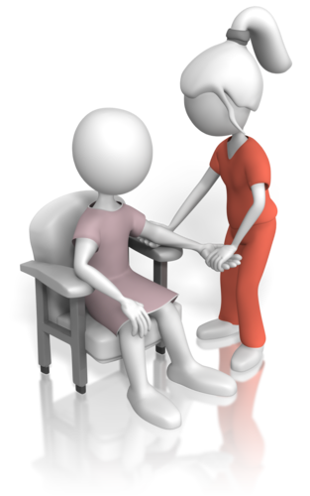
A service medical/first aid room
If your service premises allow, it is a good idea to establish a dedicated medical/first aid room or area which has storage space for children’s medications and also a quiet area for the administration of these. This gives the opportunity to make a comfortable and non-threatening space for children to use and can be decorated with colourful pictures or include a few soft furnishings which are welcoming to children.
This can also be equipped with a sink for cleaning and hold applicable medication records and information; this room/area should be made secure, and doors or cupboards locked when not in use. Keys should be kept in a secure place (e.g., with a trusted administrative staff member or under lock and key by the service manager). A secure area ensures accountability of actions when dealing with medications or any medical emergency.

Activity 1E

2. Provide opportunities to meet each child’s need for sleep, rest and relaxation
2.1. Ensure sleep and rest practices are consistent with approved standards and meet children’s individual needs
2.2. Provide appropriate quiet play activities for children who do not sleep or rest
2.3. Respect children’s needs for privacy during any toileting and dressing and undressing times
2.4. Ensure children’s and families’ individual clothing needs and preferences are met, to promote children’s comfort, safety and protection within the scope of the service requirements for children’s health and safety
2.5. Share information about individual children’s rest and sleep with families as appropriate

2.1 – Ensure sleep and rest practices are consistent with approved standards and meet children’s individual needs
By the end of this chapter, the learner should be able to:
- Access approved standards for sleep and rest practices in education and care services
- Determine good practices that support children’s needs for sleep and rest.

Requirements for sleep and rest
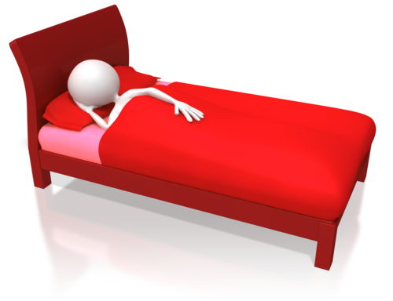
Children’s requirements for sleep and rest will vary depending on their age, temperament, needs and home life routines. For young children in an education and care environment, this still makes up an important aspect of their development and requirements for early years care and will need to be provided.
It is not necessarily easy to incorporate a standard sleep time, as children may have different sleep and rest requirements (and patterns), but establishing clear routines with different service activities will help children to respond in more appropriate ways to sleep and rest time.
It also helps to ensure children have engaged in active play and learning activities, and that other primary needs have been met (e.g., eating and toileting). Having active play sessions earlier in the day will help children to be ready for sleep and rest later on. You should follow your organisation’s policy and procedures on sleep and rest; these should meet the approved standards of care and seek to meet each child’s needs as far as practicable.
A good article to read on sleep and rest in child care can be accessed at the following website link, ‘Successful Sleep Strategies in Child Care’ at Care for Kids: https://www.careforkids.com.au/childcarenews/2011/december/sleep.html (access date: 23.03.2017).

Environments that promote sleep and rest
Your service should ensure a calm environment is achieved for sleep and rest periods. This can mean moving children to a quiet zone or altering the children’s room to one which promotes rest and sleep.
For example, changes to promote sleep and rest include:
- Dimming lights, or closing blinds or curtains to reduce light levels
- Providing clean bedding and appropriate beds and cots for comfortable sleep
- Preparing children for sleep and rest (e.g., toileting and changing children into sleep clothes)
- Speaking in quieter and softer tones to indicate the sleep/rest period has begun
- Reducing noise levels by closing windows/doors and partitioning space
- Adjusting room temperature so children are not too hot or cold; if using heaters, these should be switched off or cots and beds should be positioned well away from these
- Adjusting ventilation to the environment so that air quality remains clean and free-flowing
- Playing soft music to introduce a calm atmosphere
- Sitting quietly without speaking while the children settle and relax.

Sleep and rest time should be supervised; if not undertaken in the same space as the children, this should be done from another room/area nearby, with clear visibility of the entire space. Children should be watched to ensure they remain safe.
If children are not asleep after a designated period of time (e.g., 20 minutes), sleep time can be adjusted to rest time with quiet activities such as soft play or looking at picture books. Children who do not sleep should be taken quietly to another area of the zone or room and allowed to sit quietly with an appropriate quiet activity. This ensures that children are not forced into sleep and do not create negative associations with sleeping at an early age.

Standards for sleep and rest practices
With reference to the National Quality Framework (NQF); the National Quality Standard (NQS) ‘quality area 2 – Children’s health and safety’, ‘standard 2.1 – Each child’s health is promoted’, element 2.1.1 specifically applies to sleep and rest (as referenced in section 1.3 of this unit).
The Education and Care Services National Law and Regulations, as stipulated under the NQF, also make reference to children’s sleep and rest.
Regulation 81 states:
- ‘An approved service must take reasonable steps to ensure that children’s needs for sleep and rest are met, having regards to each child’s age, development and needs.’
(Sourced from the ACECQA publication ‘Guide to the Education and Care Services National Law and the Education and Care Services National Regulations 2011’ (page 58) at: http://files.acecqa.gov.au/files/National-Quality-Framework-Resources-Kit/NQF-Resource-02-Guide-to-ECS-Law-Regs.pdf (access date: 05.02.2018).
The NQF operates under an applied law system, the Education and Care Services National Law and the Education and Care Services National Regulations. The legislation and regulations may vary in each state/territory.

Education and Care Services Legislation in the states and territories:
State/Territory | Legislation | Act
Victoria | Education and Care Services National Law Act 2010
New South Wales | Education and Care Services National Law Act 2010 | Children (Education and Care Services National Law Application) Act 2010
Australian Capital Territory | Education and Care Services National Law Act 2010 | Education and Care Services National Law (ACT) Act 2011
Northern Territory | Education and Care Services National Law Act 2010 | Education and Care Services (National Uniform Legislation) Act 2011
South Australia | Education and Care Services National Law Act 2010 | Education and Early Childhood Services (Registration and Standards) Act 2011
Tasmania | Education and Care Services National Law Act 2010 | Education and Care Services National Law (Application) Act 2011
Queensland | Education and Care Services National Law Act 2010 | Education and Care Services National Law (Queensland) Act 2011
Western Australia | Education and Care Services National Law (WA) Act 2012
The above information on state/territory legislation has been sourced from the following website: http://www.acecqa.gov.au/national-law (all websites accessed on 05.02.2018).
SIDS and Kids safe sleeping
This is primarily concerned with babies and young children (from 0-2 years old), and seeks to promote awareness with safe sleeping and to prevent sudden infant death syndrome (SIDS) and sudden unexpected death in infancy (SUDI) – the guidelines also seek to promote safe sleeping with young children over 2 years old. This has been established by SIDS and Kids (now known as Red Nose).
The recommendations include the following:
- Place babies and young children on their back for sleeping
- Not covering babies faces (and not using soft toys or pillows)
- Not exposing babies to cigarette smoke
- Providing a safe sleep environment, including cots, beds, mattresses and bedding.
Text on safe sleeping has been researched and modified from the following source, and for further information, please visit, https://rednose.com.au/section/safe-sleeping (access date: 23.03.2017).

Cots used in education and care services must meet Australian standards – AS/NZS 2172:2010 cots for household use – safety requirements and AS/NZS 2195:2010 folding cots – safety requirements (as applicable). It is imperative that cot bars are not too wide for babies to become trapped between or fall through, that cots are high enough to prevent babies from climbing over, and that parts do not protrude so that clothing or bedding become caught. Cots should also be put together securely so that these are not able to come apart during use.
Mattresses should be in good repair, firm and flat, and fit snugly into the cot base so gaps between cot and mattress are minimal and prevent the mattress from moving. Cots and mattresses will be designed to be used together to prevent ill-fitment and the correct mattress should always be used in the corresponding cot.
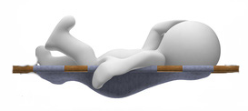
It is recommended that duvets are not used but lightweight sheets and covers instead, which can be tucked in to prevent the baby or young child from accidentally covering their faces with bedding. Pillows should not be used in cots and toys should not be placed in cots, for this reason also. Bedding, cots and sleep areas should always be clean and hygienic, ready for use.

Activity2A

2.2 – Provide appropriate quiet play activities for children who do not sleep or rest
By the end of this chapter, the learner should be able to:
- Recognise when a child is not sleeping and requires quiet play
- Identify appropriate quiet play activities
- Determine how to arrange quiet play so sleeping children are not disturbed.

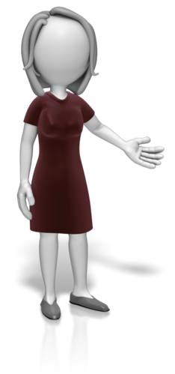
Quiet play
Quiet play activities allow children to have a degree of rest when they are not at sleep during the sleep and rest period. Some children may not always feel like sleeping or will be at an older age where sleep and rest are required less frequently. Other reasons for not sleeping may be down to different sleep routines at home and different sleep needs with individual development.
Children who do not want to sleep or stay at rest should be allowed to make that decision themselves and decide on their own needs. They should be allowed to engage in appropriate quiet activities.
If children are not asleep after a set period of time (as stipulated by your service policy and procedures on sleep and rest), they should be allowed to move away to a quiet play area. This ensures that children can be suitably engaged in an activity without causing a disturbance or waking other children.
The Early Years Learning Framework
The Early Years Learning Framework is about encouraging young children to connect to their world, it advocates belonging, becoming and being. There are five learning outcomes which act to provide appropriate guidance in early years’ education and care. With regards to health and safety of children in activities, learning outcome 3 focuses on children’s wellbeing.
Learning outcome 3: Children have a strong sense of wellbeing:
- Children become strong in their social and emotional wellbeing
- Children take increasing responsibility for their own health and physical wellbeing.
Within this framework, children are actively encouraged to develop independence and confidence in what they do; they should be allowed to develop as individuals to make choices that provide for their wellbeing and needs.
Information on the Early Years Learning Framework has been sourced from the following publication, ‘Belonging, Being & Becoming – The Early Years Learning Framework for Australia’ from the ACECQA website: http://files.acecqa.gov.au/files/National-Quality-Framework-Resources-Kit/belonging_being_and_becoming_the_early_years_learning_framework_for_australia.pdf (access date: 24.03.2017).
Areas in the service should be suitably arranged so that children are able to move in and around them safely; they should be able to choose a suitable quiet activity for themselves while being supervised. This encourages social and emotional development and helps reinforce that the service environment is a welcome and safe place for them to be in; it communicates the message that they belong. Toys and activity items should be clearly visible and attainable for the child, with adequate areas for them to play and use these.

Quiet play activities

Activities for quiet play will be those that a child can do either sitting or standing quietly; they may be activities that gently stimulate the mind or encourage thought or reflection. A child may be able to do this on their own or with another child; they may also require the participation of a service worker. This will depend on the chosen activity and nature of the child. The idea is to engage a child in an activity which does not disturb others and allows the child to rest.
Quiet play will include:
- Completing or solving simple puzzles
- Using colouring-in books
- Playing with sticker activity books
- Playing with building blocks or soft toys
- Reading or looking at picture books
- Simple crafts, such as making a collage.

Conducting quiet play
Quiet play should be conducted safely away from sleeping children. This may be within the same room (if the room is large, or has partitions to divide spaces) or in a different room. A quiet play area should be restful and may be furnished with floor cushions or soft seats; there may also be small retreats or dens so that children can arrange themselves comfortably in their space and feel safe in their surroundings.
The light should be appropriate to engage in quiet play activities (e.g., well-lit for reading) but should not be too bright so as to over-stimulate children. Toys and activities should be arranged so that incidental noise is minimal and children are able to locate and take these as chosen. This will help to ensure the area remains quiet while other children are asleep.

Activity 2B

2.3 – Respect children’s needs for privacy during any toileting and dressing and undressing times
By the end of this chapter, the learner should be able to:
- Recognise that each child will require different support for toileting and dressing requirements
- Identify three ways to encourage self-responsibility in toileting and with dressing requirements, while meeting the needs of the individual child
- Determine how to ensure privacy with toileting and dressing requirements.

Addressing personal care needs of children
The personal care needs of children should be approached from a position which seeks to help children develop their independence. They should be supported to learn the skills that they need in life, such as how to wash their hands, brush their teeth, use the toilet and dress themselves. This not only helps them to learn and develop their cognitive and fine motor skills it also builds on their confidence and interest to learn further. It can take time for children to learn such skills and this will be linked to their abilities and own particular stage of development. How they are taught at home and their own personal preferences will also affect their needs at the service.
Assisting children to learn the ability to look after their basic needs can be done progressively, i.e., as one skill is mastered, a new skill can then be learned. Within the education and cares service environment, you will need to show respect and support to children learning these life skills and adapt your approach to suit the individual child.
For example, some children may feel embarrassed when dressing or undressing with other children; in this case, the child should be shielded to give them privacy or dressed/undressed in a different area or room where they feel more comfortable and confidence can be built. Other children may not be concerned about dressing requirements at all, and they may need to learn the importance of appropriate clothing and dressing in a social environment. Each child will require observation and assessment so that their particular preferences and development needs can be understood and met.
Supporting children may include:

- Showing them what to do
- Helping them directly to do the activity
- Explaining they need to do
- Answering questions or giving advice
- Providing them with a safe place or the right environment to do the activity
- Giving encouragement to the child
- Taking time to allow the child to try out the activity on their own (under supervision as applicable to the activity)
- Not rushing the child into doing something they are not ready to do.

Privacy
Privacy is an important aspect of a social environment. It is about respecting the individual child’s privacy so that each child feels comfortable and safe in the routines and activities that they do; it is also about teaching privacy so children are aware that others have personal boundaries which may be different to their own. Privacy should be demonstrated so that young children can learn acceptable behaviours; this may also be introduced in conversations and simple fun learning activities.
Each child may have different privacy needs; you should take the time to assess each child and the level of privacy that they will need with their personal care tasks. You should also take time to observe the child and to listen to the child’s requests for privacy. Most notably, privacy will be required for toileting and dressing/undressing routines as these can make a child feel vulnerable in the presence of others.

Good toileting principles
ACECQA have developed a factsheet on toileting and nappy changes which links to the Early Years Learning Framework and the National Quality Standard (quality areas 1, 2 and 5).
This provides guidance on how to support children in toileting and expresses the need to work collaboratively with the family to use consistent approaches in toileting with each child, for example, using the same language when teaching toileting: It seeks to use positive means to make learning a natural experience while being sensitive to each child’s needs.
Regulation 155 (interactions with children) of the Education and Care Services National Regulations enforces the need for respect and privacy and includes the following:
- Allows the children to undertake experiences that develop self-reliance and self-esteem
- Maintains at all times the dignity and rights of each child.
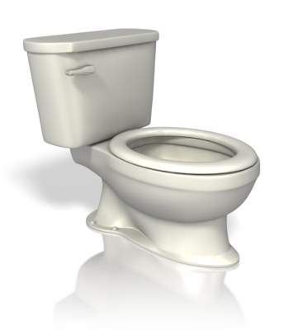
Text on toileting principles has been sourced from the ACECQA factsheet on ‘Toileting and nappy changing principles and practices’ pdf at the following website link: http://files.acecqa.gov.au/files/QualityInformationSheets/QualityArea2/EffectiveToiletingandNappyChangingProcedure.pdf (access date: 24.03.2017).
Toileting requirements will include:
- Training young children to transition from nappies to potty and toilet
- Assisting with undressing/dressing needs
- Helping children to sit on/access toilets safely

- Assisting with toilet flushing
- Attending to personal hygiene (i.e., helping children to wipe themselves and washing of hands).
Self-responsibility can be encouraged to help further a child’s ability to toilet on their own. For example, you can encourage a child to do this on their own so they do not automatically presume you will help, you can praise a child when they have completed part or all of the task themselves, or you can use a step or child seat in the toilet so the child is able to feel confident in using this on their own.

Dressing and undressing
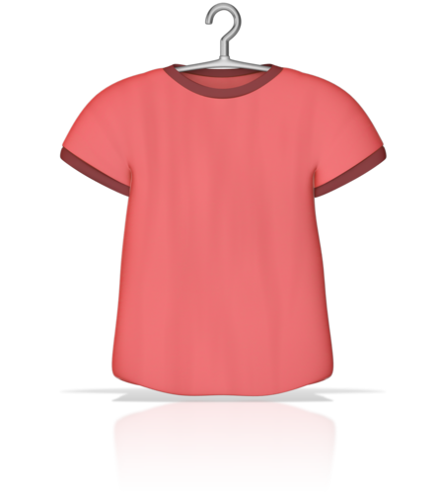
Equally, children should be assisted individually with dressing and undressing needs. Each child will have their own style of clothes, and their likes and dislikes. Routines to provide learning and development in this area should help support individual needs.
Dressing and undressing will include:
- Unbuttoning/buttoning clothing
- Using fasteners, such as Velcro, zips and press studs
- Removal of clothing items
- Putting on clothing items (checking these are positioned correctly)
- Putting on shoes and fastening these (e.g., tying laces and using Velcro strips).
Self-responsibility in dressing and undressing tasks should also be encouraged. For example, you can try making this a fun activity by counting buttons as they fasten/unfasten themselves or letting them choose their own clothes (from a small selection brought in by the parent/carer). You could also request the parent/carer dresses them in simple pull-up or pull-on clothes without tricky fasteners so children are able to learn this more easily, and you can limit dressing/undressing to one item each time so the child is not overwhelmed with the task. Children will become interested in their clothing as they get older and develop likes and dislikes, having a favourite item of clothing may also help encourage them to dress or undress accordingly.

Activity 2C

2.4 – Ensure children’s and families’ individual clothing needs and preferences are met, to promote children’s comfort, safety and protection within the scope of the service requirements for children’s health and safety
By the end of this chapter, the learner should be able to:
- Identify different clothing requirements for children at the service
- Determine three safe and three unsafe items of clothing for service activities.

Children’s comfort and safety in clothes
Clothing for children should be both practical and comfortable; this ensures that a child is suitably protected when involved in activities at the service.
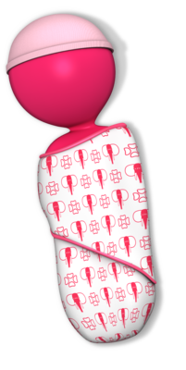
Clothing for activities should include outfits for:
- Active indoor play – clothing that protects, is hard-wearing and doesn’t catch or snag
- Active outdoor play – the same as in the above point, but additional thought must be put into making clothes appropriate to weather (e.g., a sun hat or a showerproof jacket)
- Outdoor recreation – if children go out on trips or excursions, clothes should reflect this (e.g., comfortable, sturdy shoes or long trousers for walking in nature environments)
- Indoor sleep and rest periods – loose, comfortable clothing which is warm or cool (depending on the external temperature); appropriate sleepwear or blankets for babies.
Your service should ensure that parents/carers are well-informed on which items of clothing will be required for children’s participation in service activities. This may also include requesting a change of clothing to support different stages of development (e.g., for toddlers who may be potty-training) or for different kinds of indoor and outdoor activities that may result in soiled clothing (e.g., spilling drinks or painting).
The enrolment or orientation processes are a good way to tell families about the type of environments children will be in and what they need to ensure clothing is safe, practical and durable. Conversations on clothing should also consider the cultural clothing customs of families; if families choose clothing that is appropriate to their culture/lifestyle, it is important to respect such choices. However, any items of clothing that do not meet the safety or comfort needs of children in activities should be discussed I a friendly manner with the parent/carer so this can be explained without cause of offence.
Service clothing items
Items such as aprons for crafts and sun hats may be available at the service for children to use; any specific item requirements should be requested from the families before they are needed. Otherwise, children may not be adequately protected and safe to join in certain activities.
If your service stocks items of clothing for children to use, you should check with parents/carers before changing children into these, this is so you can check they are happy for you to do so. Some parents/carers may be offended that their child’s clothing has been removed, even if the intention was well-placed.
It should be kept in mind that changing children out of their own clothing, in preference to service clothing more appropriate to the activity, should be done with caution. It is important not to send a negative message to either parent/carer or child that their clothing choice is wrong, especially when children begin to choose items they wear and are developing their own likes and dislikes.
Clothing to avoid:
- Decorations on clothing which may catch
- Long strings or necklaces that may cause a child to choke
- Delicate fabrics and best clothes which may spoil
- Long skirts and higher heeled shoes that my cause girls to trip
- Difficult or multiple fastenings which are difficult for a child to use.
Clothing that should be encouraged:
- Shoes that cover and protect the foot, with flat/small heels that support healthy foot development
- Shorts or trousers for active play which are practical and safe for girls as well as boys
- Long sleeved tops to protect from sun exposure (as well as sun hats and use of sun cream)
- Elasticated waistbands that pull-up and which support children to learn how to dress
- Fabrics that are fire resistant (e.g., dress-up clothes and sleepwear)
- Sleepwear that does not inhibit movement and covers a child or baby appropriately for comfort and temperature.
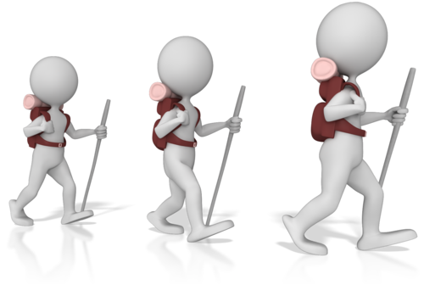

Activity 2D

2.5 – Share information about individual children’s rest and sleep with families as appropriate
By the end of this chapter, the learner should be able to:
- Decide on the information points that should be shared with families
- Identify what is meant by sharing information with the parent(s)/carer(s).

Sharing information with the child’s family
Working collaboratively with families will mean following a system to share information about each family’s child and how they are progressing. This will include providing feedback to families on how their child sleeps and rests. This ethos supports the NQF (as mentioned in the quality area 6 of the NQS – see section 1.1 of this unit) and the Early Years Learning Framework which states ‘Learning outcomes are most likely to be achieved when early childhood educators work in partnership with families’ (source: Educators – Belonging, Being & Becoming, Educators’ Guide to the Early Years Learning Framework for Australia, page 17: http://files.acecqa.gov.au/files/National-Quality-Framework-Resources-Kit/educators_guide_to_the_early_years_learning_framework_for_australia.pdf (access date: 27.03.2017).
The Early Years Learning Framework supports working together with families to provide knowledge between both home and care environments. This enables a consistent approach in development and learning so both parent/carer and the service can work towards achieving the same goals in the same ways. It also believes that when a child experiences differences in their home and early years learning that development is slower or may become limited.
Sharing information allows you to check if the child behaves differently at the service and when at home; it lets the parent(s)/carer(s) know if behaviour varies and opens up the avenue for discussions on the child. This can provide a better understanding and helps both parties recognise how best to support the child’s stage of development.

When sharing information, you should make sure this is relevant to the matter, that it informs on the habits and routines of the child when sleeping or resting and that it is done so in the best interest to assist the child’s development and needs.
Information you should share on sleep and rest includes:
- How well the child sleeps or rests at the service
- How long they sleep for
- Whether they prefer to engage in quiet play
- Their sleep routines at the service
- What strategies work best to help encourage sleep or rest
- If there are any problems or issues involving sleep and rest.

Meeting with families
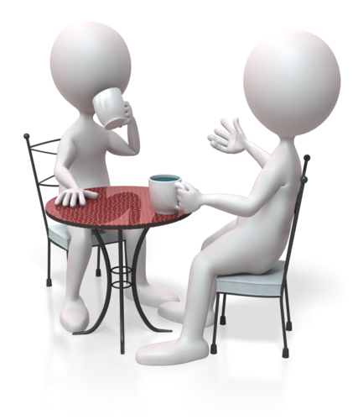
To work together, you will need to establish a good rapport and working relationship with the families involved (as mentioned in section 1.1 of this unit). This makes service communications easier and more natural; it also encourages an environment where frequent conversations take place and both families and staff feel able to initiate these, thus preventing the need to arrange long formal meetings.
Your service may prefer you to regularly discuss children’s progress with families when children are dropped off or picked up; they may prefer you to discuss children’s progress in arranged meetings or when parents come to participate in service activities. The way your service interprets the Early Years Learning Framework for working with families will depend on your service’s resources and set-up.
Sharing information is about:
- Giving details and facts that are relevant to the needs of the child
- Providing opinions and viewpoints
- Listening to families as they provide their own information in return
- Listening and responding to what you have heard in constructive and positive ways
- Identifying points to work on or issues to resolve
- Deciding courses of action together in order to best suit the needs of the child
- Agreeing on an outcome and approach for working with the child.
Discussions should be conducted in an equal manner of collaboration; this involves sharing methods used to support the child’s development and to inform on the child’s level of progress. Both parties can enlighten the other and also seek to plan and execute the same practices in their respective environments.

Activity 2E

3. Implement effective hygiene and health practices
3.1. Consistently implement hygiene practices that reflect advice from relevant health authorities
3.2. Support children to learn personal hygiene practices
3.3. Implement the service health and hygiene policy and procedures consistently
3.4. Ensure that service cleanliness is consistently maintained
3.5. Observe and respond to signs of illness and injury in children and systematically record and share this information with families
3.6. Consistently implement the service policies for the exclusion of ill children
3.7. Discuss health and hygiene issues with children

3.1 – Consistently implement hygiene practices that reflect advice from relevant health authorities

3.2 – Support children to learn personal hygiene practices
By the end of this chapter, the learner should be able to:
- Recognise the importance of carrying out hygienic practices
- Identify three service environments that require hygiene practices and describe what should be done
- Determine different ways that illness and infection may be introduced into a service
- State the importance of good personal hygiene practices
- Recognise the signs of tooth decay.

Assess service hygiene practices
Your service should use approved hygiene practices to maintain cleanliness and safety throughout its environments. This prevents the spread of bacteria and viruses, therefore limiting any potential situations of infection or illness.
As mentioned in section 1.3 of this unit, the NQS quality area 2 has the following stipulation:
- Element 2.1.2 – Effective illness and injury management and hygiene practices are promoted and implemented.

Your service should follow guidance on hygiene practices from the relevant state/territory health authority. This will include following strict procedures on cleaning areas, using areas and maintaining areas.
Service environments include:
- Toilet facilities – cleaning and disinfecting toilets, sinks, taps and floors, throwing away rubbish, replenishing toilet rolls and soap, maintaining clean hand towels and wiping surfaces used/touched by others
- Kitchen and eating area – sanitising surfaces, washing utensils, plates and other service ware, and cleaning food preparation and storage areas, removing and throwing away out-of-date foods, and emptying bins regularly
- Outdoor play area – sanitising equipment and toys, and maintaining outside spaces
- Indoor play area – cleaning and sanitising floors, surfaces, toys and equipment and tidying items away
- Sleep and rest area – washing bedding and wiping down/sanitising cots and beds, and sweeping, dusting, mopping floors and sanitising surfaces
- Quiet play area – washing soft furnishings and toys, and wiping down/sanitising hard toys and equipment

- Reception area for parents/carers – cleaning and sanitising communal areas, this includes dusting, sweeping, vacuuming, mopping floors, wiping down door handles and surfaces
- Administrative office – cleaning and sanitising office equipment and spaces, includes sweeping, vacuuming, mopping floors
- Medical/first aid area – disinfecting and sanitising spaces, floors, surfaces and equipment.
Environments that require cleaning and disinfecting/sanitising will be all indoor environments, but especially where food is handled in the kitchen area and in toilets where children are still learning how to use toilet facilities. The medical/first aid area must be thoroughly cleaned and left hygienic after use. All equipment items must be cleaned, dried and stored so they are ready for use the next time. Staff should wash their hands prior to using this area (and afterwards too) to ensure they work hygienically.
Not only do floors and surfaces need cleaning and disinfecting, but also equipment and toys that are shared continually. Cots/beds, bedding, linens, service clothing and soft furnishings should also be cleaned hygienically to ensure these are safe to use. It should also be noted that areas in constant use, such as door handles should also be sanitised to ensure the service is as hygienic as possible. A good cleaning routine should allow for hidden areas and ensure cleaning rotas include less obvious or priority concerns.
Outdoor environments will include sanitising play equipment, clearing debris and maintaining play and garden areas, for example, sweeping paths and ensuring sand is checked in sand pits for evidence of animals and raked or changed as necessary. Loose/small items of equipment should be cleaned and put away at the end of the day so these are kept hygienic.

Cleaning at the service
Your service may employ a separate cleaning service to undertake cleaning out of service hours, or it may appoint cleaning duties to its staff which need to be carried out through the day. If a separate cleaning service is used, staff will still need to perform cleaning duties to manage accidents and maintain the service environment. Cleaning should be done each day, and when it is required.
Cleaning includes:
- Cleaning away debris (e.g., sweeping floors and removing soiled nappies)
- Mopping floors and disinfecting surfaces
- Wiping down/sanitising equipment and toys
- Tidying service areas
- Spot cleaning (e.g., cleaning up spills or washing soiled clothing)
- Throwing debris into the correct bins (e.g., food items and waste paper)
- Washing hands before and after activities
- Using personal protective equipment (PPE) such as gloves and aprons.
To make sure the environment is safe and clean, your service should use clear procedures for cleaning. These should be communicated to all staff and duties shared and agreed. If staff require training on cleaning to health authority standards, this should be provided. Time to complete cleaning should be factored into staff working hours so that tasks can be completed thoroughly and children are always supervised according to children’s health and safety requirements.
Full cleaning facilities should be provided so that cleaning duties can be carried out effectively. This includes having a well-stocked cleaning cupboard and an area where staff can work safely with cleaning items away from children’s areas, for example, to discard used detergent and water from cleaning buckets.

Using and maintaining service areas
Hygiene is about working with awareness to what may be a potential source of illness or infection. This includes personal hygiene (staff and children), sources of contamination (such as leaving food exposed to the environment for too long or soiled nappies, and illness brought into the service by a member of staff, child or another person. It can also be caused by environmental factors such as dirt in soil or the presence of animals (especially with service pets).
Therefore, when using service areas, you will need to have an understanding of what is within the environment and how you can use this safely and manage any known hazards to health and safety. This will include maintaining the area as safely and hygienically as possible, for example, if you leave a soiled nappy in a discreet corner, if not discarded appropriately, another member of staff may be unaware to its presence when using the area at a later time, meaning that the threat of contamination to another child is made possible.

Personal hygiene learning for children
Supporting children to learn and use personal hygiene practices is essential for healthy living and participating in group environments.

Leading by example is an effective learning tool and you should use this opportunity as often as possible. This includes washing hands, taking rubbish to the appropriate bin, tidying and cleaning used equipment, and looking after your own clothing and personal items. Children will be able to watch these practices being carried out and will be able to learn from following these examples of good behaviours and with establishing routines, for example, always taking finished lunch plates to the designated area for cleaning.
Children need to learn to be responsible for themselves and to become independent and capable individuals, as advocated in learning outcome 3 of the Early Years Learning Framework – Children have a strong sense of wellbeing; Children take increasing responsibility for their own health and physical wellbeing.
Personal hygiene is an important requirement for healthy development, this includes:
- Washing hands after using the toilet and before eating food
- Throwing own items of rubbish into the bin (e.g., paper hand towels and apple cores)
- Washing faces and cleaning teeth (also bathing and washing hair regularly at home)
- Brushing hair and tying back long hair (hair hygiene includes an awareness to, and managing and preventing head lice).
As well as leading by example, introducing fun activities that include aspects of learning can be a great way to help children’s development and understanding of personal hygiene. These tasks can be associated to pleasant experiences, such as using music, song and dance to describe how to wash hands, brush hair or brush teeth. You can also use role play games and activities that use these skills as a means to reinforce essential hygiene habits. Explaining essential hygiene routines to older children can also introduce a further level of awareness. Some children may be taught these good routines in the home environment but not all children will have this exposure and it is important not to take it for granted that all children will have the same awareness to personal hygiene requirements.

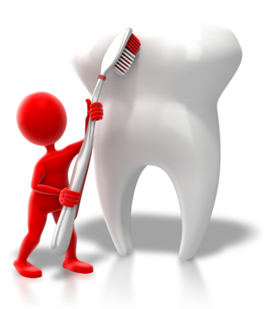
The importance of oral hygiene
In today’s society, sugar is used in many manufactured foods and drinks, and children’s oral health has suffered as a consequence. This is one area that children should be made aware of at an early age, as brushing teeth becomes more important to do well from an early age.
As children develop their fine motor skills, they can learn the essential techniques for brushing teeth. This will help prevent occurrences of tooth decay and will help guard against premature losing of baby teeth. If baby teeth are lost too early, adult teeth are more likely to come through in the wrong position as they have no pathway to follow. This can mean further dental issues and treatments through to adulthood as incorrect alignment is rectified so that teeth have space to come through.
Good brushing techniques for teeth:
- Place the bristles of the toothbrush against teeth, tilt to 45 degrees against the gum line, move the brush in small circular movements several times on all teeth surfaces
- Brush the outer surfaces of each tooth, upper and lower, keeping bristles angled against the gum line
- Brush in the saw way on inside teeth surfaces
- Place the bristles on the chewing surfaces and brush
- Inside surfaces of front teeth, tilt the brush vertically and make several small circular strokes with the front part of the brush
- Brushing the tongue gently will also help to eliminate bacteria.
Brushing technique sourced from ‘Teeth brushing’ at Health Direct: https://www.healthdirect.gov.au/teeth-cleaning (access date: 28.03.2017).

For babies, always ensure bottles are not left in the mouth after feeding and when they fall asleep, this helps to prevent milk collecting in the mouth; moving from bottle feeding to feeding cup by 12 months old is also recommended. Sugary drinks should be avoided for all children, using water instead alongside the appropriate form of milk.
Tooth decay can be very painful and prevent children from eating foods which are firmer or require chewing, this, in turn, can adversely affect a child’s diet and ability to eat a balanced selection of foods, as recommended in the Australian dietary guidelines by the National Health and Medical Research Council. This can affect a child’s healthy physical and mental development and may also establish a negative relationship with eating. As such, it is important to educate parents/carers and children on the importance of oral hygiene and the need to reduce intake of sugary foods and drinks.
Signs of tooth decay (or tooth caries) in children
Tooth decay largely goes unnoticed until it has become established in the tooth. Although sugar is contributed as being the main reason for tooth decay, it is bacteria in the mouth that reacts to the sugars which in turn causes tooth decay through the production of acid which erodes the teeth. Children are not born with this bacteria. It is something they get from their caregiver(s) through their own saliva, such as sharing the same spoon for feeding. Baby teeth are softer and have weaker enamel, meaning they are more susceptible to tooth decay.
Signs of tooth decay include:
- A dull white band on the tooth surface close to the gum line
- A yellow, brown or black band on the tooth surface close to the gum line
- Teeth that have turned brown/black
- Toothache and tooth sensitivity
- Pain when eating or drinking sweet, hot or cold foods.
Information on the signs of tooth decay has been modified from the following source, ‘Tooth decay – young children’ at the Victoria State Government website: https://www.betterhealth.vic.gov.au/health/conditionsandtreatments/tooth-decay-young-children (access date: 27.03.2017).

Activity 3A

3.3 – Implement the service health and hygiene policy and procedures consistently

3.4 – Ensure that service cleanliness is consistently maintained
By the end of this chapter, the learner should be able to:
- Identify their own policy for an aspect of health and hygiene
- Provide a procedure for a task to carry out health and hygiene
- Explain the importance of maintaining service cleanliness
- Describe what is meant by consistency in tasks.

Service health and hygiene policy
Service policy should cover health and hygiene; policy in this aspect of service should provide all staff with appropriate guidance on the requirements for maintaining health and hygiene. Your service manager/organisation is responsible for providing you with effective and safe health and hygiene policy; this is so all staff are able to follow a consistent approach at work. This may be made available to you in a service or employee handbook and should have been disseminated to you at your initial workplace induction. Your organisation should provide you with access to all its policy and this should be made available upon your request.
Policy may cover things such as:

- Health authority guidance
- The aims of health and hygiene
- Legal requirements for health and hygiene, e.g., immunisation records for children
- Routine hygiene
- Minimising risks of illness
- Managing situations of sickness and infection outbreaks
- Use of personal protective equipment (PPE)
- Training and education on health and hygiene
- Food handling
- Minimising contamination and cross-infection
- Responsibilities of staff in health and hygiene.

Service health and hygiene procedures
Service health and hygiene procedures will provide you with the necessary steps (or actions) for carrying out health and hygiene policy requirements. These must be carried out as described to ensure consistent management of health and hygiene and for best practice.
These procedures should be detailed clearly in tasks, such as end of day cleaning tasks, and may be provided in job role descriptions. To ensure you follow these correctly and in the same way each time, each step of a task should be written down in a list format which can be followed easily by all staff.
Your organisation may place health and hygiene procedural lists/guidance in relevant service environments to help reinforce good health and hygiene across staff, children and visiting families. This acts as a prompt to remind all of the required health and hygiene practices and also provides information on what staff should do to complete workplace hygiene tasks. For example, handwashing procedures may be pinned to walls above sinks for children and families, and cleaning tasks for the kitchen area may be listed and located in a cleaning manual or on a clipboard fixed to the wall in the kitchen for staff to use.

Maintain service cleanliness
No matter how busy the day is, it is essential that service cleanliness is maintained as stipulated in your organisation’s policy and procedures. This prevents the risk to health and safety through the use of ineffective hygiene practices.
Your service manager should ensure that time is given to health and hygiene, such as monitoring children as they interact with the service environments, providing suitable learning activities to help educate children and time for staff to carry out health and hygiene tasks. If this is not managed, staff may find unexpected daily occurrences take initial precedence, such as dealing with a sick child or a problem with service equipment.

Staff should work supportively with each other and if any difficulties in managing health and hygiene tasks arise, they should report this to the service manager or supervisor in order to determine how best to proceed. Discussing issues with fulfilling health and hygiene tasks will give the service time to assess priorities and to allocate additional help or supervision for children.
Have clear task routines
It can help to develop routines in your working day that allow for hygiene tasks to be scheduled in. This way, all service staff are aware of the routine tasks that need to be completed, and when. Having set times can help staff to organise additional staff help or cover, or to work with external cleaning services or service cleaning staff. These times may coincide when children are engaged in outdoor activities, or at quiet times during the day. Consistency in hygiene tasks ensures that hygiene standards are maintained and risks to health and safety are avoided.

Activity 3B

3.5 – Observe and respond to signs of illness and injury in children and systematically record and share this information with families
By the end of this chapter, the learner should be able to:
- Recognise signs of illness and injury in children
- Identify the appropriate action to take to manage situations of illness and injury
- Determine what information should be recorded on illness and injury in children.

Signs of illness in children
When children are sick, it is necessary to ensure they are looked after and attended to; this also provides the opportunity to separate the sick child away from others as a safety measure for isolation. Assessment of the child’s condition should be made to determine whether the child is in need of any care or specific medical attention and whether this may be contagious to others. It may also be possible to determine the source of sickness by asking the child questions, or through observing the symptoms and signs displayed.
The child should be taken to the medical/first aid room or area and made comfortable while your sickness policy and procedures are carried out. Health and safety policy and procedures will provide you with clear steps to follow when dealing with sickness or injury. This will include notifying the parent/carer, providing a safe place to take the child and attending to the child’s concern of health.

Signs of sickness may include:
- Feeling or being sick
- Having a stomach ache or stomach cramps
- Having a headache
- Having an upset stomach or diarrhoea
- Having a high temperature
- Displaying signs of a fever
- A sore throat
- A runny or blocked nose
- The child is feeling either very hot or very cold without environmental cause
- The child has a rash, spots or other skin changes
- The child is fatigued or unwilling to participate (behaviours that are out of character for the child).

Signs of injury in children
If a child is injured at the service or is noticed to have an injury, this will also need to be assessed to check the level of injury and the measures required to make this safe. This will mean checking if the affected area needs cleaning and dressing, whether a further underlying injury exists (e.g., a sprain or fracture) and whether medical attention is required.

First aid may be required to treat the injury and the appointed first aider should be obtained to provide first aid response. This may be the only requirement for a child who has fallen or tripped, i.e., the wound may require cleaning and the application of a plaster to protect this. However, first aid may be required for more serious injuries, such as a mild concussion, until medical services are able to arrive. First aiders will have skills to manage emergency situations and to administer basic first aid, but they will require medical service help for serious injuries or matters that need more medical expertise.
Signs of injury may include:
- Bruises, cuts and scratches
- Swollen or inflamed areas
- A child who is in pain, crying or showing signs of distress
- A child is holding a part of their body awkwardly or protectively
- A child tells you they have hurt themselves.
Health and safety protocols may exist for more emergency situations. Protocols are the steps that must be followed in the exact way they are given; they are developed to handle serious issues and situations.

Responding to the needs of sick or injured children
Responding is about ensuring the safety of the sick or injured child, as well as the safety of all others. This may take the form of medical assistance, arranging for the child to be taken home, isolating the child away from others, providing a quiet place for the child to rest, and giving care and support to the child.

Workplace sickness and incident records
A part of dealing with sickness and injuries is the need to record accounts of such incidents to workplace records. This ensures accuracy of detail is documented (in case a situation needs to be clarified or checked at a later date), that situations are reported to the right persons (i.e., parents/carers, medical persons and the regulatory authority as required) and to comply with your record-keeping requirements for work health and safety and the Education and Care Services National Law and Regulations.
Reporting requirements under the National Law
Under the Education and Care Services National Regulations, an incident, injury, trauma and illness record must be kept. This record should be accurate, confidential and stored for each child until they reach 25 years of age, any incident should be recorded within 24 hours of the occurrence. Parents/carers should also be notified as soon as possible and within 24 hours of any incident, injury, trauma or illness relating to their child.

Under the Education and Care Services National Law, regulatory authorities in each jurisdiction must be notified of any serious incident at an approved service.
A serious incident under the National Law means:
- The death of a child while at a service, or following an accident while attending a service.
- Any incident involving serious injury, trauma or illness of a child while being educated and cared for at an education and care service which a reasonable person would consider required urgent medical attention from a registered medical practitioner, or for which the child attended or ought reasonably to have attended a hospital.
- An incident at the service premises where the attendance of emergency services was sought, or should have been sought.
- If a child:
- appears to be missing or cannot be accounted for
- appears to have been taken or removed from the service premises in a way that breaches the national regulations
- is mistakenly locked in or locked out of any part of the service premises.
A serious incident must be documented as an incident, injury, trauma and illness record as soon as possible and within 24 hours of the event.
Information on a serious incident and reporting a serious incident has been modified from the following source, the Guide to the Education and Care Services National Regulations, Regulation 12): https://www.legislation.nsw.gov.au/#/view/regulation/2011/653/chap1/reg.12 (access date: 05.02.2018).

Activity 3C

3.6 – Consistently implement the service policies for the exclusion of ill children
By the end of this chapter, the learner should be able to:
- Determine when action needs to be taken to exclude a child who is ill
- Know how to implement exclusion practices as detailed in service policy and procedures.

Excluding sick children
When children feel unwell, it is imperative that service policies and procedures for dealing with illnesses are followed, even if children do not want to be excluded or tell you they are still well enough to participate. The priority is to maintain the health and safety of all children and service staff, and this will mean containing any source of infection/illness as soon as this is made known. It also means ensuring the child is well-looked after and is given access to the right care.
As mentioned in section 3.5 of this unit, signs and symptoms will indicate if a child may be feeling unwell. It is your duty to act on any signs or symptoms of illness, however minimal they may appear to be.
In order to prevent further risk of infection, the primary contact and legal guardian (parent/carer) must be notified and requested to pick up their child from the service. As legal guardian, they are responsible for the health of their child and must provide the necessary care that is required. In most cases, an unwell child will feel better in their own home and the parent/carer can take them to their GP if this is needed. This enables you and other service staff to resume normal service duties with minimal disruption to other children attending the service.
Consistently implementing policies for the exclusion of ill children will mean:
- Being vigilant to how children are feeling and behaving
- Observing and acting on any symptoms or signs of illness
- Making sure the health and safety of other children and staff are not put at risk
- Isolating ill children in case there is risk of infection to others
- Following service procedures and protocols to maintain children’s health and safety, and to ensure the sick child is taken care of appropriately.
If you require assistance from colleagues or other service staff, you should seek this immediately so you are able to contain the situation and make arrangements for the sick child’s immediate needs. This will include ensuring adequate supervision is made of the sick child and other children under your care.
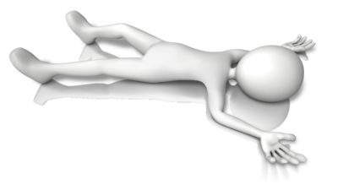

Activity 3D

3.7 – Discuss health and hygiene issues with children
By the end of this chapter, the learner should be able to:
- Decide topics of health and hygiene for discussion with children
- Determine situations for personal hygiene discussions with children.

Learning opportunities with health and hygiene
Talking to children about health and hygiene will help them to become aware of why they need to wash their hands, brush their teeth and take care of themselves in their environments. As mentioned in section 3.1/3.2 of this unit, learning both personal hygiene and hygiene in their environment helps them to become responsible for their own health and physical wellbeing (in reference to learning outcome 3 of the Early Years Learning Framework).
Talking about health and hygiene allows children to think about their surroundings and the external influences placed upon them. It introduces them to hygiene on a basic level and provides them with awareness to healthy living and being safe.
Topics for discussion will need to be chosen for their relevance to the children and the ages and stages of development they are at. Any topic that is chosen will need to be discussed in ways that children can understand and relate to; this may be as part of a group activity or individually when attending to personal hygiene needs.

Personal hygiene topics
Washing hands
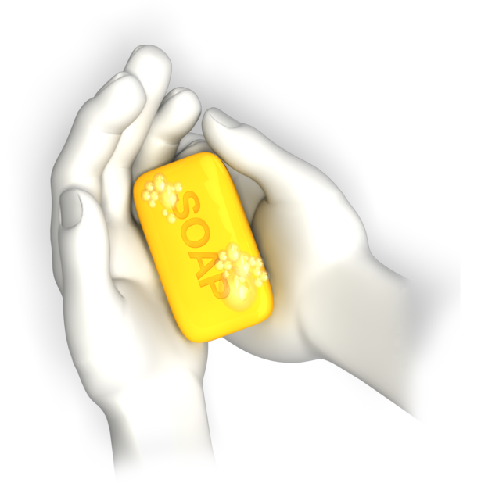
Washing of hands – this is something that children will become aware of at an early age and is most likely one of the first hygiene practices that they will consciously participate in. Children actively explore their environment with their hands as they learn to understand what things are; i.e., touching and picking up unknown objects. They also tend to put fingers in their mouth and it is important to educate them on the need for clean and hygienic hands to prevent the risk of germs and illness; it also is important to prevent spreading the risk of infection to others.
When to wash hands:
- Before eating food (and after if having finger foods which are messy)
- After using the toilet
- After playing outside
- After touching animals
- Whenever hands become dirty (e.g., after crafts when using paints or glues).
Hand washing includes washing with soap and attention to washing the entirety of the hands should be made. This includes washing in between fingers and where the hand meets the wrist. It is also about cleaning nails as dirt can become easily embedded; using nail brushes at the service is a good way to encourage children to follow good hand hygiene. Along with washing, you should include drying of hands; i.e., what to use to dry hands and how to dry them. Hands should be dried thoroughly to ensure water is not carried and dripped on the floor and to prevent skin from becoming irritated if left wet. Children should also be made aware of how to use cloth hand towels (e.g., not leaving them on the floor, or scrunched up so they cannot air and dry) and how to dispose of paper hand towels.
Oral hygiene
Teeth brushing – as mentioned in section 3.1/3.2 of this unit, looking after teeth prevents tooth decay and dental issues. This is not only about how to brush and floss teeth; this is about the foods and drinks that we ingest and the effects they have on our health and our teeth. This is an opportunity to talk about foods and what makes up a healthy diet.
It may also be a good idea to brush teeth as a group so that children are encouraged to join in by their peers and to let them have a try without this being done for them; this also helps you to assess children’s level of competence and skill (as appropriate to their stage of development).
Hair care
This may not be as applicable to boys or girls with short hair, but good hair care should be introduced as a subject. Personal hygiene is every aspect of a person and knowing how to brush hair and keep this clean is important. For those with longer hair, keeping hair tied or clipped back will help to protect them from the risk of head lice and to keep hair tidy. It also ensures hair does not get caught or tangled on play equipment, or matted if dipped in foods or craft paints.
Blowing noses
It can be difficult for children to understand how to blow their noses but is still important to prevent the spread of germs. Techniques to learn this skill can include activities that require children to blow; this helps them to understand the concept of what they need to do, for example, blowing balloons or bubbles.

It also applies to sneezing; children should be shown how to cover their nose and mouth with a tissue or their hand when sneezing. They should also wash their hands after sneezing to prevent the spread of germs. This is the same for coughing - if a child coughs they should cover their mouths and wash their hands afterwards.
Food hygiene
Introducing children to using cutlery helps to encourage good hygiene. Food is handled less by hands and dropping or spilling foods can be reduced when this skill is mastered. Some children may not like the feel of cutlery in their mouth and using the right size of cutlery to suit small mouths is more appropriate. If children do not like metal cutlery, try using reusable plastic cutlery which does not feel so cold or hard. This can also be made fun by using different coloured cutlery.
Showing children how to use and hold plates, bowls and other service ware is also important to maintain food hygiene, and also where food should not be left, i.e., in places where flies, bugs or other animals can reach this. Children have a tendency to wander away and then back to their food so an emphasis on not leaving food to spoil is essential.
Toileting
Although children may be at different stages (some may be potty training, while others are using the toilet), understanding toileting is a necessary subject. Children should be told and shown how to sit or use the toilet so that toilet seats are not messed, and they should be told how to wipe themselves clean. This subject may be best approached individually and in a gentle way to avoid embarrassing children and to suit each child’s needs.

Situations for discussions
Your discussions should always be encouraging; this helps children to respond positively to personal hygiene. Children should not be made to feel shame or embarrassment about their personal hygiene; therefore, understanding the nature and personalities of the children in your care is vital.
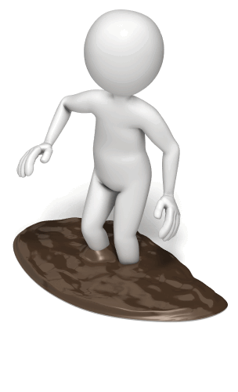
Some children will feel more open to learning and participating in personal hygiene, while others may have limited awareness or inclination. Those who are open may enjoy group discussions and fun activities which allow them to try out different personal hygiene care. Those who feel awkward or embarrassment may fare better in one-on-one activities and discussions that are more tailored to their situation and needs.
Your service will have goals and requirements for children’s personal hygiene learning; these should be aligned to children’s ages and development. Not all children learn or respond in the same way and they should not be rushed into this. Working at the pace of the individual child will ensure they do not build negative associations with personal hygiene and will encourage better progression, although providing opportunities for this learning in a must.
Situations for personal hygiene discussion may include:
- When learning about the human body
- When engaged in personal hygiene routines at the service
- Before or after messy play
- Before eating
- In personal hygiene learning activities
- When reading stories that involve personal hygiene learning.

Activity 3E

4. Supervise children to ensure safety
4.1. Supervise children by ensuring all are in sight or hearing distance at all times
4.2. Adjust levels of supervision depending upon the area of the service and the skill, age mix, dynamics and size of the group of children, and the level of risk involved in activities
4.3. Exchange information about supervision with colleagues to ensure adequate supervision at all times

4.1 – Supervise children by ensuring all are in sight or hearing distance at all times

4.2 – Adjust levels of supervision depending upon the area of the service and the skill, age mix, dynamics and size of the group of children, and the level of risk involved in activities
By the end of this chapter, the learner should be able to:
- Identify what is meant by supervision of children
- Determine the reasons for supervision of children at a service
- Specify educator-to-child ratios for their state or territory
- Assess supervision requirements for different groups and activities.

Supervising children

This requirement ensures that children are kept safe at the service; watching over children means never leaving children unattended for the duration of their stay.
Supervising is required for the following reasons:
- To ensure children do not hurt themselves or have an accident
- To direct planned activities
- To watch unplanned activities (e.g., outdoor play)
- To help children participate in activities
- To facilitate development and learning
- To attend to care needs (e.g., personal hygiene and health needs)
- To ensure children do not wander off, get lost or taken from the premises without prior arrangement and consent.
Supervising will mean keeping children in sight and/or within hearing distance. Activities which are outside or involve physical movement will require you to keep visual contact of all children in your care. Situations, where audible supervision can be used, are when children will not be at risk of harm through their own actions, the actions of others, or their environment. Some situations will also require consideration of privacy. Examples of audible supervision can include when at sleep or rest, or when a child is using the toilet.
It is important to bear in mind audible supervision should not be for long periods of time and children participating in quiet activities or at sleep or rest should always be checked by eye to ensure they are not at harm. You should check your organisational service policies and procedures on supervision to ensure you follow these correctly.
The Educational and Care Services National Regulations – child protection
Under the National Regulations (Regulation 84), education and care services must ensure that staff working with children are aware of and follow their obligations for child protection as provided under child protection law in the relevant state/territory. This ensures that children are given the best protection and care while at an education and care service.
A link to the applicable child protection laws in the states and territories can be found at the following, ‘Australian child protection legislation’ at the Australian Institute of Family Studies: https://aifs.gov.au/cfca/publications/australian-child-protection-legislation (access date: 28.03.2017)

Levels of supervision

With different ages and types of children, comes the need for adjustment to supervision. Factors that may impact on the level of supervision include the size of the group, age-ranges, development issues, group dynamics and the activity itself.
Size of the group
How many children you have in the group will affect the number of educators that are required for supervision.
Educator-to-child ratios (as stipulated by ACECQA):
- Centre-based services:
- from birth to 24 months old – 1 to 4 (note: some declared approved services in Queensland are approved to have a 1 to 5 ratio until January 2020)
- children older than 24 months and up to 36 months – 1 to 5 in all states/territories except Victoria which is 1 to 4
- children over 36 months and up to/including pre-school age – the following states/territories operate at a ratio of 1 to 10 – NSW and Western Australia; the following operate at a ratio of 1 to 11 – ACT, NT, QLD, Vic. For the remainder; SA, 1 to 10 for centre-based services other than a pre-school, for disadvantaged pre-schools 1 to 10 and for other pre-schools 1 to 11, and for TAS, a ratio of 1 to 10 and 2 to 25 for children at a pre-school program
Educator-to-child ratios have been sourced from ACECQA at ‘Educators to child ratios’: https://www.acecqa.gov.au/nqf/educator-to-child-ratios (access date: 05.02.2018).
Ages of the children
The ages of your children will alter the needs for supervision; young children will require more care needs, such as feeding with bottles and changing nappies, while older children will be more able to look after their own needs and to actively engage in helping and participating in activities. Supervision should be assessed for the needs of your ages and specific care requirements, alongside educator-to-child ratios, as mentioned in the previous text.

Development needs of the group
Your children may have varying skills and abilities which either limit or enable participation. Young children will not be able to participate as well on their own and children with special needs or additional health needs may require extra supervision and help. The development and ability of the child will influence supervision needs in activities; all children should be given the chance to participate in age and development-appropriate activities. To make activities inclusive your service may need additional educator expertise and supervision.
Group dynamics
How your group behaves can have a direct influence on the group itself and how well they participate in activities. This can affect how supervision is carried out and how educators work with the children in their group. For example, a group that has noisy or disruptive children will make the group unsettled and can stop or delay activities. If your group has such children, another educator may be required to handle more boisterous children or to continue activities while you work with these children. Educators need to be experienced in handling difficult situations and be trained in de-escalation skills to avoid the occurrence of incidents.
Alternatively, a group of children who interact well together or who are similarly minded will respond in a more harmonious way that makes supervision easier and possibly required at a lower level. When children interact with each other, group dynamics will come into play and children may change their behaviours depending on who they are with.
Activities

Different activities will require more or less organising, equipment, time and level of participation. Supervision should be planned to suit different activity types so that a more physical activity allows for direct supervision with enough educators to prevent children from being at risk. For example, if taking children on excursions, although educator-to-child ratios may dictate supervision requirements, taking account of the nature of the excursion, the children involved and the environment itself, supervision may need to be adjusted to ensure each child’s safety is maintained.
Areas of the service
When children are using different areas of the service, supervision may need adjusting to meet safety needs. For example, children who engage in a basic cooking activity will be in an area where equipment and kitchenware can be a cause of harm, supervision will need to be by sight and include monitoring hazards and using suitable control measures to protect the children. Children, who are engaged in a quiet activity such as story-telling, will be in an area of the service that is calm and safe; supervision will be minimal and less intrusive.

Activity 4A

4.3 – Exchange information about supervision with colleagues to ensure adequate supervision at all times
By the end of this chapter, the learner should be able to:
- Recognise points of information that need to be exchanged
- Provide details of activities to ensure continuity of service with children.

Maintaining supervision
During the course of the working day, supervision of the children may be shared between educators. To coordinate seamless supervision and care, information on activities should be shared with the relevant educators. This ensures that continuity of care and learning is provided and keeps all educators informed of any particular child issues or needs.
Supervision should be maintained at all times – if another colleague is due to take over supervision, you must ensure they are present before you leave the children unattended. It may be that a colleague is delayed and alternative supervision arrangements will need to be made.

Information exchange
Exchanging information will include providing details of any incidences that may have occurred during supervision, what was carried out in the activities that you supervised and where these were left.
Your service may have specific handover requirements for information exchanges, for example:
- How many children in attendance
- What occurred during your period of supervision
- Any concerns you may have had with the children
- Any requirements that need to be met with the children.
Record service activities

To help ensure all relevant points are disclosed to colleagues and the service, you may want to note down the significant occurrences or details of your period of supervision. This helps to maintain your focus, especially if the environment is noisy and distractions occur; this also ensures the right information is passed to your colleague(s) who are supervising, at the time this is required.
It may also be a requirement of your service that records of activities are made to help plot the progress of children and to record specific activity tasks as part of learning and development needs (along with any incident reporting). If so, this should be done to the requirements of your service; time should be allocated for reporting tasks so that you are able to perform this away from supervision duties of the children.

Discussions with colleagues
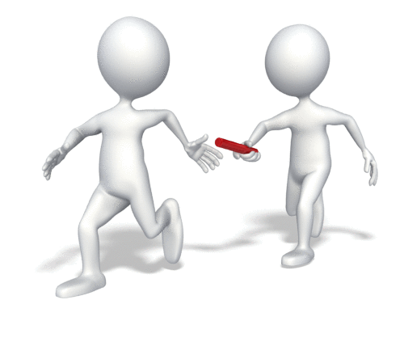
Working alongside your colleagues will require you to develop good working relationships which are supportive. This will mean having good channels of communication, which your service should enable. When staff communicate in a friendly and open manner with each other, it helps to promote a positive working environment; sharing information helps staff to work together to achieve service goals and targets.
Communications may include:
- Staff meetings
- Progress updates
- Handover discussions
- Activity planning
- Assessments.

Activity 4B

5. Minimise risks
5.1. Assist in the implementation of safety checks and the monitoring of buildings, equipment and the general environment
5.2. Consistently implement policy and procedures regarding the use and storage and labelling of dangerous products
5.3. Follow service procedures for the safe collection of each child, ensuring they are released to authorised people
5.4. Assist in the supervision of every person who enters the service premises where children are present
5.5. Discuss sun safety with children and implement appropriate measures to protect children from over-exposure to ultraviolet radiation
5.6. Check toys and equipment are safe for children and safe to use in their proposed area
5.7. Remove any hazards immediately or secure the area to prevent children accessing the hazard

5.1 – Assist in the implementation of safety checks and the monitoring of buildings, equipment and the general environment
By the end of this chapter, the learner should be able to:
- Recognise safety concerns for children within a service environment
- Determine how to conduct safety checks
- Plan how to monitor safety within a service environment.

Managing risks in and around the service
Your service should conduct risk management activities to ensure all risks to health and safety are identified and controlled. This will include conducting safety checks to determine exactly where risks and hazards are and how these may impact on those at the service.
Risks to safety are all physical and mental sources of harm, this includes:
- Potential causes of physical injury
- Threats to safety (e.g., fire hazards)
- Health hazards (e.g., exposure to sun or risk of infection).
Children are especially vulnerable to risks as they will have little understanding of the dangers in their environment. They are still developing the physical and mental skills needed to recognise and cope with such risks. Children are totally absorbed in their own activities and rarely see the dangers that may be in front of them.
Potential hazards (or safety concerns) for children will include:
- Medical conditions – for example, allergies to bee stings or a disability
- Trip and slip hazards – for example, mats on floors and toys left in walkways
- Falling hazards – for example, toy shelves or boxes that may be pulled over and changing tables

- Drowning – for example, when playing in pools, exposed to unguarded fish ponds or if left in a bath tub
- Choking hazards – for example, small toys, coins or hard sweets
- Strangulation hazards – for example, cords hanging from blinds or pull-strings on toys
- Poisons – for example, medication left out or cleaning chemicals
- Scalds and burns – for example, hot water from taps and hot plates
- Active play – for example, children may fall off climbing frames or run into doors or furniture
- Electric hazards – for example, damaged electric cords and uncovered power points
- Exposure to sources of infection – for example, animal droppings in outdoor areas or dirty surfaces
- Sun safety – when children are not adequately protected from sun exposure.

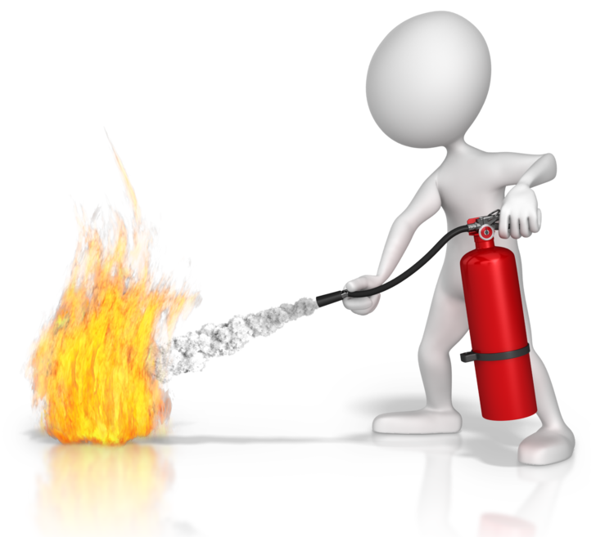
Fire safety
Your service needs to comply with health and safety standards for fire in your state/territory. This includes ensuring materials and buildings comply with fire safety standards, use of smoke alarms, regular safety checks on electrical and gas equipment (for example, ovens and electrical cleaning equipment), keeping access points and walkways clear, and having emergency fire exits sign posted. A fire blanket should also be located near to cooking equipment and fire extinguishers in easy to reach areas, for example, in corridors.
Smoke alarms should be placed within the service premises to ensure that any potential source of fire is sensed quickly. Hazardous areas, such as the kitchen, should have a smoke alarm fitted within the area or close by. If the service has more than one floor, smoke alarms should be fitted on each level, along with all bedrooms/sleep areas, play areas and exit routes. These should be fitted to ceilings so that as smoke quickly rises, smoke alarms will be triggered.
Hard-wired smoke alarms should be installed by an approved and registered electrician; battery operated smoke alarms can be fitted by a person competent in skills to do this, although your service may prefer to use a qualified electrician/installer. They should be checked periodically to ensure they remain in good working order and that battery replacement is made.
Smoke alarm checks should be carried out frequently (the longest period being once a month), and included in your service’s safety checking procedures. All fire safety checks must be recorded and include the time/date of the test and the name of the person who conducted this. The Australian standard AS 1851-2005 ‘Maintenance of fire protection systems and equipment’ deals with requirements for inspection, testing and maintenance of fire protection systems and equipment.
Children are known to be at high risk in fire safety (other groups in the high-risk category, will be the elderly, disabled and those working with flammable materials or within close proximity to fire sources). Children’s behaviour will be a factor of this risk as they will not have developed a full sense of awareness to the dangers. For example, children’s behaviours that put them at risk of fire related injuries or fatalities will include lack of guidance to the dangers of fire, natural curiosity with fire and not being able to look out for their own safety. Behaviours of adults that put people at risk include complacency (for example, not checking smoke alarms regularly), not being aware of the immediate dangers in their environment and using electrical or gas-operated equipment which is old or faulty.

Conducting safety checks
Safety checks should be carried out regularly, for example, checking outdoor areas each day before they are used, or checking play areas after each play session. Regular checks should be in place to maintain safety in all areas – these should be carried out before an area is used to ensure that children are able to interact freely and safely within the environment.
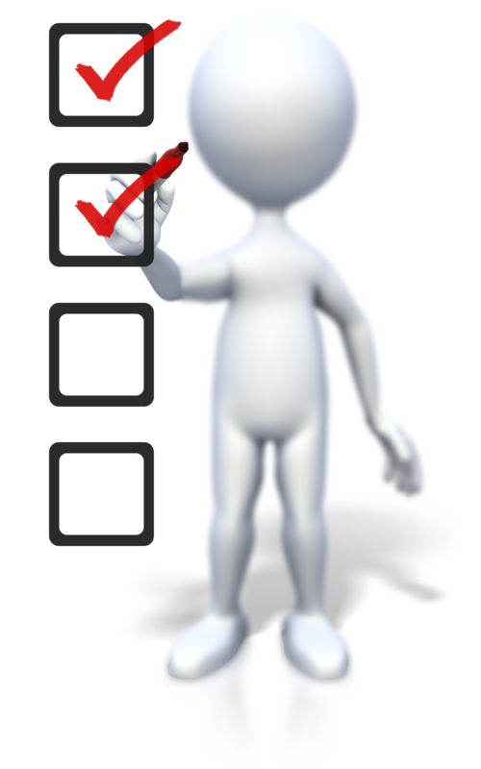
For example, play areas may need to be tidied, i.e., boxes put back into the appropriate spaces and small toys put out of reach of babies and young children. Surfaces may need sanitising and electrical cords moved out of reach of children.
When conducting safety checks, you should walk around the designated space in a methodical manner, looking around you to assess the potential hazards. Viewing areas from the perspective of a child can help you to identify the risks more quickly. All risks should be clearly documented for further risk management.
This is also known as a risk assessment or hazard check, using the following tools will help you to identify the risks.

Risk assessment tools
Risk assessment can be conducted on all aspects of the service this includes the buildings, the indoor environments, the outdoor environments of the service, the activities undertaken at the service, the equipment and toys used, and for conducting excursions out of the service. It also includes looking at specific service aspects such as risks involved in security at the service, the management of health and medical conditions of the children, and whether to keep service pets.
Risk checklists and questions
To conduct a risk assessment, your service will need to develop and use tools so that consistency is always achieved in checks. This can include the use of risk factor checklists and questions; these can be developed specifically to target the risks associated with each area or activity.
Checklists should be specific to the area, for example, an outdoor play checklist may include the following:
- Play equipment secured to floor
- Surfaces in good repair
- Damage to play equipment
- Fences/gates secured/locked
- Sand pit clean.

Questions to ask may include:
- Is play equipment clean and correctly set up?
- Has play equipment been damaged or become unsafe to use?
- Are there any trip hazards in the outdoor play area?
- Are there any sharp objects in the outdoor play area (e.g., a dropped earring stud or drawing pins)?
- Is security of the outside play area to the service’s safety requirements?
Risk assessments/safety checks will need to be carried out systematically; i.e., in a logical order and manner, and with a thorough look at all aspects that may be a risk to health and safety. These checks ensure that changes to safety are identified and can be monitored and made safe.
Risk matrix
A risk matrix is a risk prediction tool; this helps your service to analyse each risk for its likelihood of occurrence and the level of impact or consequence that this will have on the safety of others.
A simple risk matrix will look like this:
Likelihood of the risk | Consequence of the risk
Likelihood of the risk |  | High | Moderate | Low
Likelihood of the risk | Likely | H | H | M
Likelihood of the risk | Possible | H | M | L
Likelihood of the risk | Unlikely | M | L | L
Risk matrix key:
- H – high risk (immediate action must be taken to eliminate or control the risk safely)
- M – medium risk (action must be taken to monitor the risk factors and to put suitable controls in place)
- L – low risk (action not required at this time but risk will need to be monitored)
This helps to prioritise the risks so that action to eliminate or control these can be made in order of importance. Your service can (and should) design a matrix which is appropriate for its needs so that risks can be categorised as needed.
Risks should be:
- Eliminated entirely (when deemed as a high risk and likely to occur)
- Controlled (when risks are not as high and resources are available to manage these safely).

Risk management strategies
Risk management strategies will help your service to react quickly and efficiently to risks. This ensures that all staff know what they need to do and how they should work together to make sure that all children and persons on site are kept safe.
Risk management strategies will include:
- Risk assumption – letting others know there is an element of risk
- Risk avoidance – avoid the risk altogether
- Risk retention – accepting there are risks and using controls to manage these
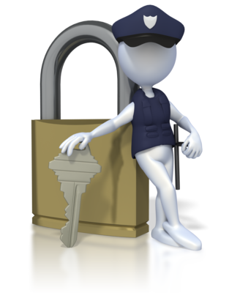
- Risk transfer – sharing the risk.
Actions that may be taken to support the above strategies may include:
- A central information point with guidance on managing and controlling known risks at the service
- Security lock down
- Staff fire training and fire drill practices with children
- Using an established agency to obtain cover staff as needed.

Activity 5A

5.2 – Consistently implement policy and procedures regarding the use and storage and labelling of dangerous products
By the end of this chapter, the learner should be able to:
- Recognise what is meant by a dangerous product
- Provide three safety requirements that should be included in service policy and procedures for each of the following – using, storing and labelling of dangerous products.

Using dangerous products
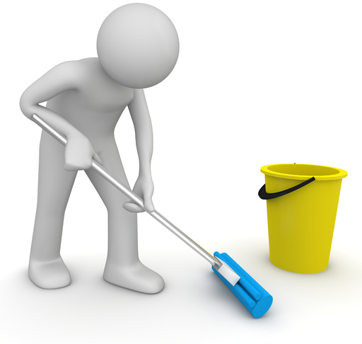
Dangerous products include chemicals, liquids, solids, and gases which are known to cause harm to people, animals and the environment. These can be found in many everyday products which may also be in existence at your service.
Dangerous products include:
- Cleaners and cleaning solutions
- Paints
- Glues
- Igniters
- Matches or lighters
- Aerosols
- Batteries.

Policy and procedures for handling dangerous products
Your service should have strict policy and procedures for the handling of any products which are known to be dangerous to children and adults. This will include how these products are used, stored and labelled.
Using dangerous products
Products which are considered dangerous should be used carefully and in accordance with service guidelines. As these products can be varied, product instructions and equipment manuals should be read and followed; chemicals will also have own safety data sheets to provide you with in-depth instructions for use and safe handling.
Instructions should specify:
- What the item is and what it should be used for
- How to prepare the item for use
- How to use the item
- How to store and clean the item (as applicable).
They may also provide information on additional equipment items that may be needed to use the product such as personal protective equipment (PPE). PPE should be used when it is required as this will ensure you are given the necessary protection from harm; for example, use protective gloves for handling chemicals and a face mask for aerosols. Keep items being used within sight and work in an area away from children so items are not accessible to them; young children will be curious about all objects in their surroundings and will very quickly want to touch or taste what they find.

You should ensure:
- You have plenty of space around you to work safely
- You have space to position items safely
- You have adequate light to work in
- You have adequate ventilation in case of chemical or noxious fumes
- The area is barricaded or sectioned off, for example, to clean floors or work with chemicals.
Storing dangerous products
When not being used, products should be stored in a safe area which is out of sight and out of reach of children. It is preferable to keep these items under lock and key, and this is essential for chemicals and combustibles.
Items should be kept in a designated storage area which is designed to hold the items in the correct conditions as per instructions. Shelving should be stable and flat so that bottles do not drip or leak and small items do not roll or fall off. Products should be placed in the same area each time so they are easily located and can be documented in stock and safety checks. Bottles and containers should be secured with the correct lid and stored in a clean condition so it may be necessary to wipe drips from containers after use. Always be aware of how items should or should not be stored together; for example, combustibles should be kept apart from other flammable sources and products with chemicals checked in case of potential chemical interactions.
Labelling of dangerous products
Labels should be retained on products so information is clearly displayed; if these peel off or rub away, it will be necessary to reproduce a new label to affix on – this can be a handwritten label which contains the essential information, such as product name, dangerous ingredients and how to use and store. This is to ensure that all persons using the products have the correct information to hand.
Storage areas should also be clearly labelled and signed to maintain health and safety within the service; this lets everyone know what type of products are being stored and whether the area is accessible to them. It also ensures that items are located easily and replaced correctly after use. Dangerous products also need to have the corresponding dangerous product labelling and signage; this acts to warn others of the potential harm.
The globally harmonised system of classification and labelling of chemicals (GHS) provides standard information and pictograms for businesses to use in the preparation of their safety data sheets and labelling of hazardous products. This has been developed under the Work health and Safety Regulations.
Safe Work Australia has produced a hazardous chemicals poster; this is available from their website at: https://www.safeworkaustralia.gov.au/doc/classification-and-labelling-workplace-hazardous-chemicals-poster (access date: 05.02.2018).
Some example hazard pictograms include:
Some hazard pictograms and their GHS hazard meanings
Explosives  Self-reactives  Organic peroxides | Flammables  Self-reactives  Pyrophorics  Self-heating  Emits flammable gas in contact with water  Organic peroxides | Oxidisers | Gases under pressure | Acute toxicity | Acute toxicity  Skin irritants  Eye irritants  Skin  sensitisers | Carcinogens  Respiratory sensitisers  Reproductive toxicants  Target organ toxicants  Germ cell mutagens

Activity 5B

5.3 – Follow service procedures for the safe collection of each child, ensuring they are released to authorised people
By the end of this chapter, the learner should be able to:
- Recognise why procedures for collecting children must be followed

- Determine the factors that should be included in procedures for collecting children.

Procedures for releasing children from the service
Policy and procedures relating to the collection of children for the service will be centred on ensuring that children are kept safe and secure while in their care; this includes to whom a child is handed over to at the end of the service period.
Every service will hold a record of the authorised persons who are allowed to collect children. The parent/legal guardian of each child should inform the service of the persons they allow to collect their child, if other than themselves. This can include other family members or close contacts.
On enrolment, the parent(s) or legal guardian(s) should provide written authorisation of those that they allow to collect their child. This should include the names of the persons, their home address, contact telephone number and their relationship to the child. It may also include information on the designated days/times when authorised persons may be in attendance to collect the child.
This information ensures that the child is collected by a known person and prevents children from being taken by someone who is not allowed.
Procedures should include the following factors:
- A verification of identity – for example, showing a picture ID such as a driving licence
- Checking unauthorised persons who come to collect and not allowing them to take the named child – if a parent or authorised person is unable to attend, they should be contacted to check the identity of the person who is present (it may be that the expected person is ill or has been delayed and they have asked for the person to attend in their place)
- Not allowing a child to leave with a parent or authorised person when they are under the influence of alcohol or drugs – the service has a duty of care to maintain and should comply with their state/territory child protection laws; if another authorised person cannot be contacted or attend, child protection authorities or the police will need to be notified and advice sought from them
- Acting in accordance with any court orders that may prevent a parent or previously authorised person from collecting a child, and ensuring such orders are checked and kept up-to-date in service records
- Contacting the parent/authorised contact if pick-up of their child has not been made at the specified time

- Applying a late fee, if the child has not been collected within a designated period of time, as agreed in the service’s policy and procedures.
Information on procedures for collecting a child has information included which has been modified from the following source, ‘Who can collect a child from child care? Legal issues in child care’ by Isabelle Crompton at the Early Childhood Australia website: http://www.earlychildhoodaustralia.org.au/our-publications/every-child-magazine/every-child-index/every-child-vol-17-1-2011/can-collect-child-child-care-legal-issues-child-care/ (access date: 30.03.2017).
Always read and follow your service’s procedures for the collection of children; these will follow the same principles as above but may vary in details.

Activity 5C

5.4 – Assist in the supervision of every person who enters the service premises where children are present
By the end of this chapter, the learner should be able to:
- Identify procedural requirements for persons entering a service
- Recognise the risks to children with visiting persons.

Security of premises
During service hours when children are present, it is important to check on any persons who visit or enter the grounds and premises of the service. Along with service staff, the people who may visit include parents/carers and other authorised persons dropping off or collecting children; it can also include delivery people and tradespeople.
Your service should ensure procedures are in place for checking visiting persons. These should enable service staff to identify who people are and why they are visiting. This should include using a system at the point of entry to the service, to ensure no one is able to wander around the site unchecked, and logging/recording names and times of entry into service grounds.
Procedures should support the working environment and the staff who are present, for example, larger services may employ security staff to patrol premises or attend access points at the main drop-off and collection times. Each member of staff should be fully trained in how to manage and supervise persons entering service premises. Training will ensure staff are confident with maintaining service safety and security of children.
For example, procedures may include:
- Meeting visitors at the gate or when opening a secured entrance door
- Checking the identity and reason for persons visiting through use of an entrance intercom
- Checking identification of persons collecting children with parents/carers or other authorised persons
- Checking forms of identification of work persons/tradespeople
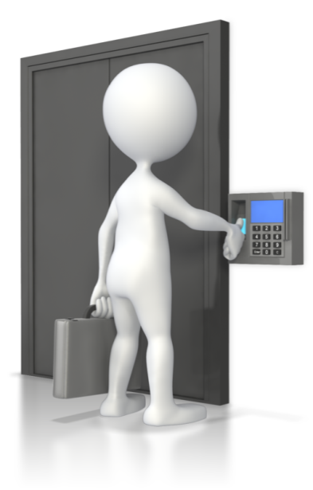
- Signing in visitors at the entrance
- Assisting the visitor in the purpose of their visit
- Supervising the visitor for the duration of their visit.
Features for secure service premises
Services can be equipped with security features which allow staff to manage people visiting more easily. For example, a gated service prevents persons from walking onto the grounds, and a locked entry system ensures that people announce themselves before entering or can be met at the point of entry. This ensures that the space and configuration of a service can be assessed and managed for its own security needs.
Security of premises can include:
- Access control systems (e.g., locked entry, buzzer and intercoms to allow people in)
- CCTV systems to monitor access and entry points within the service
- Secure fencing and premise boundaries
- Limiting areas available for access to people visiting the service
- Keeping clear records of visitors who enter and exit the premises.

Risks to children
When people visit the service, risks to children’s safety can exist; the attention of service staff may be distracted by visitors and children can be unintentionally put at risk. A service with procedures to supervise and manage visitors will ensure staff follow the correct guidelines and practice.
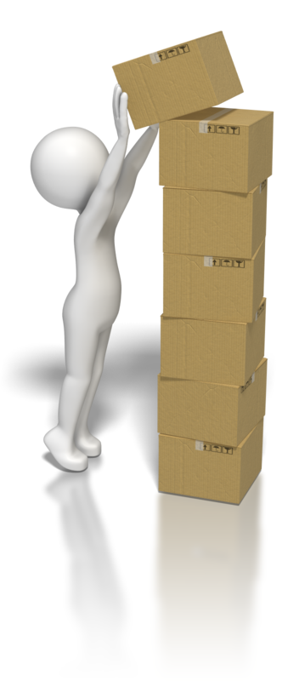
Children are less aware of the risks that may threaten their safety and are not able to react or respond to situations as quickly as an adult can. As well as threats from persons visiting, there are also threats to safety if a child wanders away from the service premises through an open door or gate; for example, they may become lost or wander into a busy road.
Risks to children can include:
- Unauthorised persons taking children from the premises (e.g., a parent with a court order restricting access to their child)
- A tradesperson delivering boxes, which may fall on or cause an accident for a curious child
- Children wandering off with a visiting person or through a door left open
- Children being snatched
- Dogs or other animals wandering into premises through open access points (e.g., children may be bitten by a dog).

Activity 5D

5.5 – Discuss sun safety with children and implement appropriate measures to protect children from over-exposure to ultraviolet radiation
By the end of this chapter, the learner should be able to:
- Identify what is meant by sun safety and the types of UV rays that the sun gives off
- Determine how children should be protected from over-exposure to the sun.

Sun safety
Sun safety is about making sure that you and the children at the service are protected from the harmful ultraviolet (UV) rays that emanate from the sun.
There are three main UV rays as follows:
- UVA rays – these age skin cells which can cause damage to their DNA; this is linked to some skin cancers (as well as premature ageing of the skin)
- UVB rays – these are stronger than UVA rays and can cause direct damage to the DNA of skin cells; this type of ray is believed to be the primary contributor of most skin cancers (as well as the main source of sunburn)
- UVC rays – these rays do not penetrate through the earth’s atmosphere and are not in the sunlight that we receive; as such these rays, although stronger than UVA and UVB rays, do not pose a threat.
Therefore, UVA and UVB rays are considered to be the cause of harm. It is important to consider the following aspects of sun safety; the time of day when the sun’s rays are at their strongest, the distance that you are from the equator (the position of the sun), and the altitude of the sun (when the sun is highest in the sky, more rays reach the ground). Even when the sky is cloudy, it is also possible to be exposed to the sun; therefore sun protection should be considered even when the sun does not appear. The sun can also be reflected off surfaces and cause sun exposure; for example, UV rays can be bounced off water, sand, snow and grass.
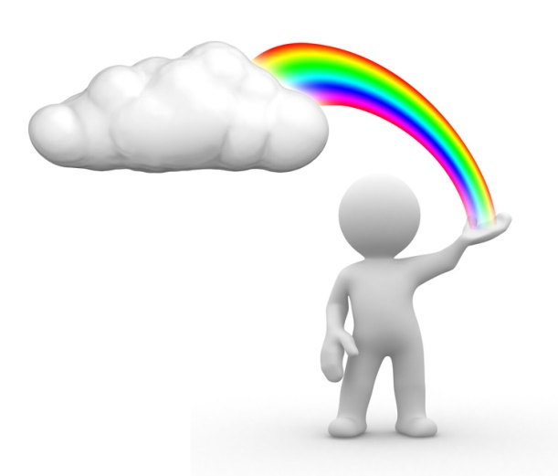
Information on ultraviolet radiation has been sourced from ‘What Is Ultraviolet (UV) Radiation?’ at the American Cancer Society: https://www.cancer.org/cancer/skin-cancer/prevention-and-early-detection/what-is-uv-radiation.html (access date: 03.04.2017).

Discussing sun safety with children
To raise awareness with children about sun safety, engage in fun discussions that let children know how to be safe in the sun. Your service should talk about the types of clothing that provide the best sun protection, and how and why to use sun protection lotion. They should also discuss when it is safest to be outside and how to counteract the dangers of sun exposure.

Sun protection includes:
- Wearing sun hats
- Applying a sun protection lotion
- Covering arms and legs with light clothing
- Wearing clothing with UV protection
- Wearing sunglasses
- Not being outside for prolonged periods of time in direct sunlight
- Not being outside during the hottest part of the day when the sun is at its highest
- Participating in outdoor activities in shaded areas.

Making sun protection a part of your service’s routines and activities will help children to incorporate good habits from an early age. The national SunSmart program for schools and early childhood services seeks to provide guidance and education.

The SunSmart program
SunSmart is an initiative of the Cancer Council Australia for early childhood care and schools. Programs may differ between states and territories but are about developing effective sun safe policy for services and schools so that activities can be conducted with the right awareness.
These will include the following aspects:
- How to engage in outside activities safely
- How to encourage safe sun behaviour in children
- Role-modelling good behaviours
- Providing information and education on how to be safe in the sun.
More information can be found at the Cancer Council Australia website, ‘SunSmart schools and early childhood programs’: http://www.cancer.org.au/preventing-cancer/sun-protection/sunsmart-schools/ (access date: 03.04.2017).
Some general good practice includes encouraging parents/carers to apply sunscreen to their child before arrival to the service, encouraging children to wear a hat and clothing that covers the trunk, tops of arms and tops of legs.
Clothing with UV protection is also available and provides effective protection for covered areas, but parents/carers should be aware to check the labelling/manufacturer for full details on the protection that these specific clothing items provide. You should also be mindful to ensure that children stay hydrated and drink enough water during hot weather periods.

Activity 5E

5.6 – Check toys and equipment are safe for children and safe to use in their proposed area
By the end of this chapter, the learner should be able to:
- Determine the type of information required for toy labelling
- Identify unsafe features of toys and equipment
- Determine where toys and equipment should be used within the service.

Toy safety standards
Toys should comply with the AS/NZS 8124 series of standards, although this is not compulsory, Australian Consumer Law (as managed by the Australian Competition and Consumer Commission) requires that toys are safe for children to use. This will include aspects such as materials used to make toys, for example, paints are non-toxic and parts are made durable so they do not pose a danger such as a choking hazard. It will also include how toys are labelled and designed for use by specific age-groups.
Information on toy safety has been modified from the following source, ‘Australian Toy Safety’ at the Australian Toy Association website: http://austoy.com.au/toy-safety/australian-toy-safety (access date: 04.04.2017).
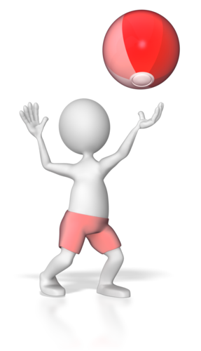
For example, aquatic toys must be permanently labelled with the following warning, written in block capitals, not less than 6mm in height:
- WARNING
AQUATIC TOY
USE ONLY UNDER SUPERVISION
The above warning has been sourced from ‘Aquatic toys’ at the Australian Competition and Consumer Commission website at: https://www.productsafety.gov.au/standards/aquatic-toys (access date: 04.04.2017).
Toys that comply with the above safety standards will be:
- Designed with safety in mind
- Made from materials that are safe for children to play with
- Tested for use
- Subject to recall if a product is later found to be unsafe.
To help ensure that the toys you use are appropriate for use, labelling on toys should be visible and provide you with information on the age-group that the toy is intended for. It should also give you details of any cautions or warnings for use, such as the danger of projectile toys hitting others in the face or small parts that may be sharp. The ISO standard ISO/TR 8124-8 provides guidance to manufacturers and regulators on age grading of toys.
Information on toy labelling has been modified from the following source, ‘Labelling Of Toys’ at the Australian Toy Association website: http://austoy.com.au/toy-safety/labeling-of-toys (access date: 04.04.2017).

Equipment for children
Equipment used by children can include large or fixed toys, such as climbing frames or paddling pools; it can also include bathing aids and walkers for young children and children’s furniture. Equipment in use by your service should also comply with Australian Consumer Law (ACL) and corresponding product safety requirements.

Risk assessment of toys
To help determine if new or existing toys and equipment are safe to use, your service can check that these meet Australian and Consumer product safety standards. They can also ensure that adequate safety checks are made to toys and equipment through risk assessment and analysis activities.
For example, toys and equipment may be unsafe to use when:
- Parts are small or loose

- There are hinges of fixings that may trap fingers or fall suddenly
- Edges or corners are sharp of jagged
- Batteries are easily accessible
- There are long strings and cords attached
- These are projectile toys (e.g., a toy bow and arrow set)
- Toys contain magnets which can be easily swallowed
- Stitching on fabrics is weak and may pose a risk to coming undone or tearing when used.
You should visually inspect and handle toys and equipment to ensure they are as expected, that no tears, breaks or damage has occurred, and that all components are fitted correctly and are safe to use. You may need to check the materials are appropriate for the children and age-range, labelling and instructions for use are followed, inflated toys are correctly secured, and all strings and cords are securely fastened or removed.
As mentioned in section 5.1 of this unit, risk assessment includes using risk management tools. In this instance, compiling toy and equipment safety checklists can help you to identify aspects which may be unsafe, along with using appropriate risk management strategies.
For example, a checklist may include the following:
- Are toys/equipment in good repair of show signs of damage or deterioration?
- Do toys have missing parts which make these unsafe to use?
- Are toys being used by the correct age-groups?
- Are toys with small parts being used near babies/young children?
- Does equipment have loose fittings or jagged edges?
- Are children using toys and equipment safely?
Risk management strategies may include:
- Supervision of children’s play
- Regular monitoring of toys and equipment
- Removal of toys or equipment that are unsafe to use
- Separating active play toy use from quiet play toy use
- Keeping age-grade toys in separate toy boxes or areas
- Introducing new or unfamiliar toys and equipment to children
- Keeping older children’s toys away from babies and young children.
Play areas
Toys and equipment should be used in appropriate areas of the service, for example, active play toys are best used where there is plenty of space so others are not put at risk of injury; for example, using a ball in a space away from other children to prevent the risk of hitting other children.
Babies and young children should play with age-appropriate toys in an area away from older children so that toys are not mixed between the two groups. Toys for young children should be simple in design, made from durable materials and be without decorations such as beads and fur; this prevents swallowing or choking on small parts.
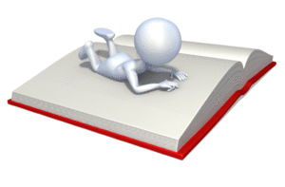
Water play should be conducted in an outside space so that spills do not cause slip hazards on floor surfaces or do not occur near sources of electricity. Quiet play should be in an area where children are able to relax and feel comfortable; smaller areas or partitioned spaces can encourage a more restful approach to playing and reading activities.

Activity 5F

5.7 – Remove any hazards immediately or secure the area to prevent children accessing the hazard
By the end of this chapter, the learner should be able to:
- Recognise different types of hazards which may affect children and how to manage these
- Determine how to secure an area so that hazards can be dealt with.

Controlling hazards
When working as an educator, you will always need to keep an eye out for any hazards to health and safety. These may occur during the course of the day and with a change in activities. Hazards are the things that may cause a person to injure themselves or which have an adverse effect on health.
For example, hazards to health and safety in a child care service may include:
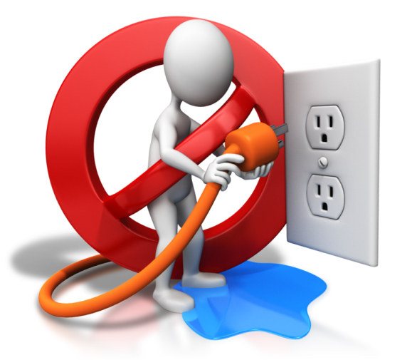
- Trip hazards from toys left out
- Fall hazards from incorrectly placed toys or stacked equipment
- Slip hazards from spilled drinks or craft paints
- Risk of infection from a child who is unwell or has been sick
- Leftover food that has not yet been cleared away
- Nappies and items of rubbish that have not been disposed of
- Cleaning equipment and chemicals that have been left out for use.
Children will not identify hazards to their health and safety easily and all services are required by law to ensure that the service environment is always safe for children. This is a part of your duty of care and service compliance with the NQF and appropriate education and care services legislation. The hazard should be removed or made safe immediately so that the risk to children and others is kept to the utmost minimum.
If this cannot be dealt with easily and quickly, the area should be secured so that you or another member of staff can then take the time that is required to remove this without risk to the health and safety of you or others.
If the hazard requires specific expertise to remove, the area should be left secured until the appropriate person can attend, for example, a vet or wildlife expert to remove a snake that has made its home at the service. Always ensure that you remain safe and use the appropriate equipment and methods to handle the hazard or, alternatively, seek the help of another who may be better able to do this.

Securing a hazardous area
To make an area secure, you will need to prevent others from accessing the hazardous area. This can be done by placing safety barriers or barricades around the area to prevent access and/or notifying colleagues of the hazard and moving children into another area which is safe for them to use (with appropriate supervision).
You should also place signs in and around the area to notify all persons that the area should not be used, for example, if cleaning and mopping the floor after a child has been sick, a sign to say ‘cleaning in progress’ or ‘caution wet floor’ may be used. If waiting for outside help, you should let others know not to enter the area by using something similar to the following: ‘do not enter the area’. If possible, you can close doors to the area to ensure no one wanders through by mistake.
Signs and barricades should only be removed after the threat to safety has been eliminated and/or controlled. The area should be in the safe condition that it was in before the hazard occurred. A check of the area should also be made before allowing children back in; this is so you can assess the entire area and ensure that nothing has been missed or forgotten.


Develop children’s awareness to safety
In the course of hazard and risks to health and safety, your service should help children to develop an awareness of how to recognise hazards so they are able to interact safely with their environments as they grow and develop. This can be addressed through learning activities and play, and in discussions; it is also something that may be approached through reading children’s stories which include this element of learning.
Your service can help children to:
- Identify common hazards and dangers
- Determine steps to take if confronted with a hazard
- Think about how to remain safe when spotting a hazard
- Understand what hazards are and how they can affect them and others.

Activity 5G

6. Contribute to the ongoing management of allergies
6.1. Identify and recognise signs, symptoms and key characteristics of allergies and anaphylaxis
6.2. Apply organisational risk-management strategies for children with severe allergies
6.3. Follow organisational policies and legislative requirements in relation to medication for anaphylaxis

6.1 – Identify and recognise signs, symptoms and key characteristics of allergies and anaphylaxis
By the end of this chapter, the learner should be able to:
- Determine what an allergy causes the body to do
- Identify common allergies
- List the signs and symptoms of allergies and anaphylaxis.

Allergies
Allergies in people are caused by exposure to an environmental factor (or factors), such as food, animal hair and pollen in grasses. People who have allergic diseases have an over-reactive immune system to a particular substance which would normally not affect someone or be a concern of health. This substance is known as an allergen and when a person is exposed to this, the immune system is triggered into thinking it is under threat. This makes the immune system attack the body in a bid to rid it of what it believes is a substance of harm.
Allergens can affect a person through skin contact, ingesting or breathing in the substance, through contact with the eyes (such as pollen exposure), or through direct application (e.g., a bee sting).
Common allergies include:
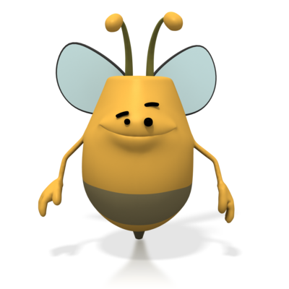
- Grass and tree pollen
- Foods
- Medications
- Dust mites
- Animal dander (skin flakes or animal hair)
- Insect bites and stings
- Latex
- Mould
- Chemicals (such as those used in cleaners, detergents and toiletries such as shampoos).
In most situations, allergic reactions are mild and do not pose a serious danger to health, although avoidance of the allergen is best followed in order to ensure a person maintains their equilibrium.
Signs and symptoms of allergies include:
- Blocked or runny nose
- Sneezing
- Red, itchy or watery eyes
- Facial swelling
- Wheezing or coughing
- A red and itchy rash on the skin
- Asthma or eczema symptoms
- Stomach pains and being sick.
Allergic reactions are usually mild and controlled with the use of specific medications such as antihistamines, decongestants, skin creams and even steroids. If a child has an allergy which is controlled by a medication, this should be included in the child’s medication record. In all possible situations, exposure to the known allergens should be avoided and in the case of a food allergy, the food should not be eaten.

Anaphylaxis
This is where a reaction to an allergen is extreme, causing the affected person to become dangerously ill; this is known as anaphylaxis or an anaphylactic shock. With a mild allergic reaction, the body’s immune system will respond to eradicate the allergen without causing serious harm to the individual; with anaphylaxis, the immune system is exacerbated and attacks more vigorously causing harm to normal body functioning. The immune system cannot discriminate between the allergen and healthy body cells.
Signs and symptoms of anaphylaxis can include:
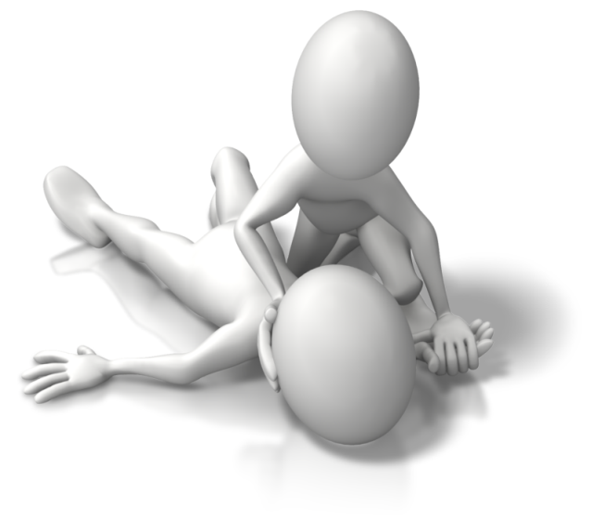
- Difficulty in breathing and wheezing
- Tightness or swelling of the throat
- Feeling faint or giddy
- Clammy skin
- Nausea, vomiting or diarrhoea
- Rapid heartbeat
- Experiencing confusion or anxiety
- Feeling or being sick
- Young children may go pale and floppy
- Collapsing
- Losing consciousness.
Information on allergies and anaphylaxis has been modified from the following source: ‘Allergy & Anaphylaxis’ at Allergy & Anaphylaxis Australia: https://allergyfacts.org.au/allergy-anaphylaxis (access date: 04.04.2017).

Food allergies
A food allergy is an allergy that a person has to a certain protein found in the make-up of a food. This triggers their immune system to behave as if their body is being attacked by the protein (either immediately after ingesting or sometime afterwards).
There are two types of food allergies. People may experience one or both of these:
- IgE-mediated food allergy – this is characterised by a fast reaction after the offending food has been ingested; the immune system produces the immunoglobulin E (IgE) antibody and this type has an increased risk of experiencing anaphylaxis (an anaphylactic reaction)
- Non-IgE-mediated food allergy – this takes a longer time to appear as a reaction (this can be several hours after ingesting the food); other cells within the immune system are activated to fight off what it believes is an attack on the body.
Information on the types of food allergies has been modified from the following source, ‘Food allergy/Types of food allergies’ at NHS UK: http://www.nhs.uk/conditions/food-allergy/Pages/Intro1.aspx (access date: 05.04.2017).
Some persons do not have to ingest a food for it to cause an allergic reaction; it can be caused by the food being present in the same area or being prepared alongside other foods that are considered safe to eat.
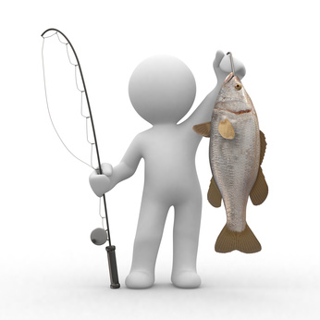
Foods associated with allergies include:
- Cow’s milk
- Fish and shellfish
- Peanuts and tree nuts
- Eggs
- Wheat
- Gluten
- Sesame
- Soy.

Activity 6A

6.2 – Apply organisational risk-management strategies for children with severe allergies

6.3 – Follow organisational policies and legislative requirements in relation to medication for anaphylaxis
By the end of this chapter, the learner should be able to:
- Identify strategies to manage allergies and anaphylaxis in children at the service
- Explain how to use an auto-injector for administering adrenalin
- Follow guidance on the storage of adrenalin.

Use strategies for managing allergies in children
Your organisation should ensure its health policies and procedures provide guidance on managing children with allergies, especially those with severe allergies where reactions may be easily induced or cause anaphylaxis. Policy and procedures to manage allergies and anaphylaxis should be in place even when the service does not have children with allergies in their care. Under the Education and Care Services National Law and Regulations, services must provide adequate care and medical first aid to those with allergies and other medical conditions such as asthma (see section 7.1-7.3 of this unit).
Risk management strategies should be developed to help all staff interact and work safely with children at risk. These actions help to manage children with allergies and help prevent anaphylaxis; this can also give staff the confidence to handle difficult situations.
All children with allergies should be recorded to workplace systems and the relevant information included in children’s records and medication records. Specific requirements of children should be discussed with the parents/carers on enrolment so that managing allergies and reactions can be done so safely and without cause of harm to the child.
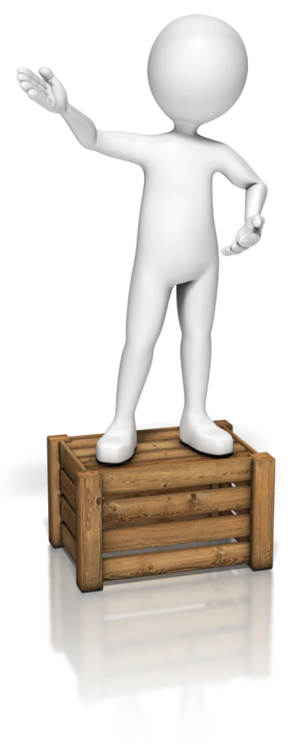
Organisational guidance should be reflected in the procedures at the service and follow safe strategies to manage the known risks.
Strategies to manage allergies in children may include:
- Placing information and posters around the service to educate about allergies
- Removing known food allergens from menus and foods at the service
- Making children aware of allergies and what causes these in discussions and activities
- Protecting children at risk from exposure to known allergens
- Monitoring children in activities to ensure they do not come into contact with a known allergen
- Scheduling activities at times to avoid exposure to allergens (e.g., outside trips at times of the year when tree or grass pollen pose no threat)

- Communicating emergency procedures for managing allergic reactions and anaphylaxis to all staff.
Medication for allergic reactions and anaphylaxis should be provided to you by the families and held securely on site; this ensures that in the case of a reaction, the correct medication can be located quickly and easily, and administered as prescribed.

Adrenalin auto-injectors
A child or person at risk from experiencing anaphylaxis may carry an auto-injector for their personal safety; this should be detailed in the particular child’s medication record so all staff are aware of this. Children will be prescribed adrenalin in an auto-injector specific to their weight, and this must be used by the child it has been prescribed for.
Using an auto-injector means that adrenalin can be injected as quickly as possible in the event of an anaphylaxis occurrence. Adrenalin prevents the immune system from over-reacting and eases the state of anaphylaxis. This should be given to the affected individual in a specific way and your service should ensure that a trained member of staff is always available to administer this if ever needed.
EpiPen
Currently, the type of auto-injector used by the majority of people in Australia is an EpiPen; this must be administered in a specific way to the thigh.
To administer the EpiPen auto-injector:
- Ensure the child/person is lying flat and preferably with legs raised
- If the child/person is having breathing difficulties, they should be allowed to sit up
- Form a fist around the EpiPen without touching either end of the pen
- Remove the blue safety cap
- Place the orange end against the outer mid-thigh
- Push down on the pen into the thigh until a click is heard or felt and hold firmly in place for 10 seconds
- Remove the pen from the thigh and massage injection area for 10 seconds.
The child/person should stay in their position without being moved until an ambulance arrives to take them to hospital. The child/person must be taken the hospital for an observation period of at least four hours afterwards. In extremely severe cases of anaphylaxis, if the child/person stops breathing, it is also necessary to administer CPR until medical help arrives.
The above information on administering an EpiPen auto-injector has been sourced and modified from Allergy and Anaphylaxis Australia, ‘Adrenalin (epinephrine) autoinjector use’ at: https://allergyfacts.org.au/allergy-management/risk/adrenaline-epinephrine-autoinjector-use (access date: 05.02.2018).
Anapen
Another type of auto-injector, the Anapen, may also be used in Australia. This is administered in a slightly different way once the child has been positioned as previously mentioned.
To administer an Anapen:
- Pull off the black needle shield
- Pull the grey safety cap off and away from the red button
- Place the needle end firmly against the outer mid-thigh on the skin or on clothing
- Press the red button so it clicks and hold for 10 seconds
- Remove pen and massage injection site for 10 seconds.
As previous, medical assistance will be required and the child should be taken to hospital for further assistance and observation.
Information on how to administer an Anapen has been sourced from ‘Using the Anapen Auto-Injector’ at Anapen: http://www.anapen.ie/ (access date: 05.02.2018).

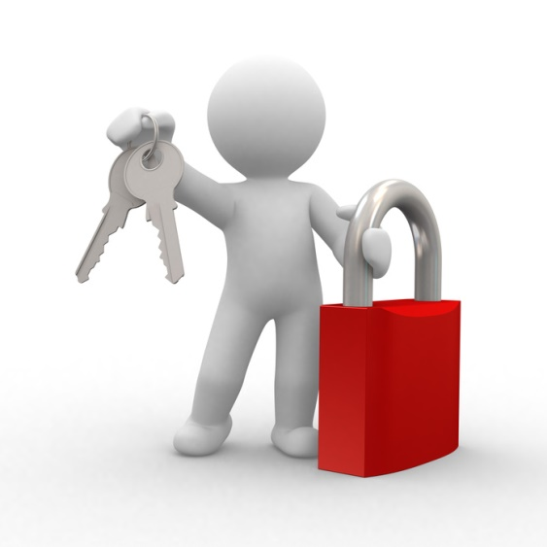
Storing Adrenalin (epinephrine)
The general advice given for storing adrenalin is that it should be kept between 15 degrees Celsius and 25 degrees Celsius, as far as possible with consideration to the weather.
Other considerations are:
- Keep out of the light (and sunlight) as this can degrade the strength of the adrenalin
- Do not place in the refrigerator or freezer and this may impair the mechanics of the pen
- Never use after the expiry date.
Information on storage of adrenalin has been sourced from ‘Anaphylaxis emergency medication (adrenaline [epinephrine] autoinjector) storage, expiry and disposal’ at the Australasian Society of Clinical Immunology and Allergy: https://www.allergy.org.au/health-professionals/anaphylaxis-resources/adrenaline-autoinjector-storage-expiry-and-disposal (access date: 05.02.2018).

Activity 6B

7. Contribute to the ongoing management of asthma
7.1. Identify signs, symptoms and triggers of asthma
7.2. Identify children who have an asthma management plan and follow that plan
7.3. Follow organisational policies and legislative requirements in relation to medication for asthma

7.1 – Identify signs, symptoms and triggers of asthma
By the end of this chapter, the learner should be able to:
- Determine when an individual has asthma symptoms
- Recognise potential asthma triggers.

Asthma
Asthma is a condition of the airways in the lungs; when a person has an asthma flare-up, the muscles of the airways tighten, and the airways swell and reduce in size, making breathing difficult. There may also be excess mucus in the airways. A flare-up can occur slowly over a long period of time or very fast; sudden flare-ups are also known as asthma attacks.
This condition can be controlled through developing and following an asthma management plan with the help of a GP or health professional. For example, to help you participate safely in exercise and to recognise and avoid personal triggers to asthma such as cigarette smoke.
Signs and symptoms of asthma:
- Breathlessness
- Wheezing
- Tight feeling in the chest
- Hayfever symptoms (e.g., runny or blocked nose, itchy eyes and sneezing)
- Prolonged coughing
- Unable to speak a full sentence

- May experience tugging of the skin between ribs or base of the neck.
When asthma is severe, the following symptoms can occur:
- Gasping for breath
- Unable to speak, or only one or two words per breath
- Exhaustion
- Turning blue
- Collapsing
- Not responding to reliever medication.
In children, asthma can be more difficult to spot as it worsens; a child may also complain of a sore tummy or chest.

Information on asthma has been sourced from ‘What is asthma?’ at Asthma Australia: https://www.asthmaaustralia.org.au/national/about-asthma/what-is-asthma, and ‘Asthma Emergency’ at Asthma Australia: https://www.asthmaaustralia.org.au/national/about-asthma/asthma-emergency (access date: 05.04.2017).

Asthma triggers
Triggers for asthma can vary from person to person and in their severity. What triggers one person to suffer an asthma flare-up or attack may not be the same for another person. Learning to recognise the triggers is an important aspect of asthma management for a person or parents/carers of young children. Asthma management is all about learning to live safely with these triggers, using both preventative and reliever medication and following a healthy lifestyle.
Triggers of asthma can include:
- Exercising
- Having allergies (e.g., a pet allergy, and allergies to dust mites or mould)
- Having an illness which affects the respiratory system (e.g., a cold or flu)
- Stress and emotions
- Pollution (e.g., car fumes ,cigarette smoke and smoke from open fires)
- Food or medication
- Chemicals
- Pollen
- Indoor air pollution (ensure spaces are well ventilated to prevent the build-up of fumes)
- Changes in weather conditions, particularly cold air, temperature and with thunderstorms.
Asthma can be more common at night or early morning and asthma symptoms may appear, e.g., shortness of breath.

Activity 7A

7.2 – Identify children who have an asthma management plan and follow that plan

7.3 – Follow organisational policies and legislative requirements in relation to medication for asthma
By the end of this chapter, the learner should be able to:
- Determine the purpose of an asthma management plan
- Identify which information is included in an asthma management plan
- Identify the importance of following organisational and legislative requirements to manage asthma
- Recognise the different types of medication used to manage asthma.

The asthma management/action plan
Children with asthma management plans should be identified at enrollment or when the plan first comes into existence. Parents/carers should be told that when a change to their child’s health occurs, this must be made known to the service and any health plans or information be provided.
This enables services to understand specific needs and concerns with managing health conditions such as asthma. As needs may vary, each child with a plan should be assessed for their own particular needs.
The management (or action) plan should be provided by the parent/carer in a written format; it should include the child’s name, details of their doctor and may include an emergency contact.

An asthma management plan will contain information such as:
- Maintenance and preventative medications
- Individual triggers and how to manage flare-ups
- Treating and adjusting treatment to manage symptoms
- Medications taken and to be used in a flare-up or attack
- Managing increased severity of asthma
- When to seek medical help.
Asthma management is about keeping symptoms under control, preventing flare-ups and attacks, maintaining a healthy life, and preventing asthma from affecting what the individual does, for example, attend school or an education and care service.
Information on asthma plans has been sourced from, ‘Asthma action plans’ at the National Asthma Council Australia: https://www.nationalasthma.org.au/health-professionals/asthma-action-plans (access date: 05.04.2017).

Organisational and legislative requirements for asthma
Your service should ensure that asthma management is included in managing health needs. Any child with this condition should be made known so that staff can work according to service health policies and procedures.
Services are required to comply with the Education and Care Service National Law and Regulations regarding medical care of children at the service; this includes ensuring that at least one medically trained member of staff is present during service hours (training on specific health conditions must be current and recognised, and first aid/medical kits available to deal with health emergencies). There must be a system for record keeping and risk management to ensure the service operates effectively in managing health conditions of children. This also requires services to work closely with families on the management of known health conditions.

Medication for asthma
Different medications exist to help in the management of asthma; these will be prescribed by the GP/health specialist as part of the child’s/person’s asthma management (or action) plan.
To help children use an inhaler/puffer, they should use a spacer which fits over the top to help direct the medication into the mouth. For small children, this includes a face mask which is placed over the child’s face to ensure they receive the correct medication dosage.
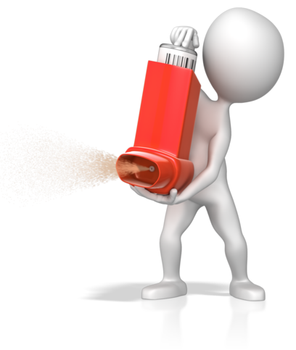
Services may contain an asthma emergency kit in case of a sudden asthma flare-up or attack; this should contain a spacer. Once this is used by a child, this should not be used again by another person or child; this should be given to the child or thrown away and replaced with a new spacer. Other elements of an asthma emergency kit include asthma first aid instructions, a medication log and equipment to administer medication. Reliever medication is not supplied and should be obtained independently or from affected children’s own medications.
Preventer medication
This is designed to help an asthma sufferer manage their condition with minimal cause for a flare-up or attack. They should be taken daily to reduce swelling in airways and to dry up excess mucus. Adults may use these to manage their condition if asthma interferes with their life; children are less likely to take this type of medication unless asthma causes frequent flare-ups. These medications are mainly inhalers/puffers but can also be in tablet form.
Reliever medication
This type of medication is used to relieve symptoms of asthma by relaxing the muscles around the outside of the airways. They are fast acting and are also used when giving asthma first aid; these will be via an inhaler/puffer.
Acute medication
This is a corticosteroid (tablet or liquid) taken for a short period to reduce inflammation in the airways. It is used to treat sudden and severe flare-ups or attacks.
Severe asthma treatment
Injectable medication can help those with severe asthma through decreasing the allergic and inflammatory reaction in the body. This medication is also a preventative medication and is prescribed by a respiratory doctor or specialist (and given every two to four weeks).
Information on asthma medication has been sourced from ‘Your asthma medication’ at Asthma Australia: https://www.asthmaaustralia.org.au/national/about-asthma/manage-your-asthma/your-asthma-medicine#Preventer%20medications%20information (access date: 05.04.2017).

Activity 7B

Summative Assessments
At the end of your Learner Workbook, you will find the Summative Assessments.
This includes:
- Skills Activity
- Knowledge Activity
- Performance Activity.
This holistically assesses your understanding and application of the skills, knowledge and performance requirements for this unit. Once this is completed, you will have finished this unit and be ready to move onto the next one – well done!

References

These suggested references are for further reading and do not necessarily represent the contents of this unit.
Websites
Information on educator-to-child ratios can be accessed at the following website link, ‘Improved educator to child ratios’ at the Australian Children’s Education and Care Quality Authority (ACECQA): http://www.acecqa.gov.au/Improved-educator-to-child-ratios
Information on educator qualifications can be found at the following website link, ‘Qualifications’ at ACECQA: http://www.acecqa.gov.au/educators-and-providers1/qualifications
Information on educators, providers and services in the national register can be found at the following website link, ‘National Registers’ at ACECQA: http://acecqa.gov.au/national-registers
Information on learning frameworks can be accessed at the following website link, ‘Approved Learning Frameworks’ at ACECQA: http://www.acecqa.gov.au/national-quality-framework/national-law-and-regulations/approved-early-learning-frameworks
Information on the National Quality Framework (NQF) has been accessed and taken or modified from the Australian Children’s Education and Care Quality Authority (ACECQA) website: http://www.acecqa.gov.au/national-quality-framework/explaining-the-national-quality-framework
Information on quality area 6 has been sourced from ‘Quality Area 6 – Collaborative partnerships with families and communities’ at the ACECQA website: http://www.acecqa.gov.au/Collaborative-partnerships-with-families-and-communities (access date: 05.02.2018)
Information on MMPs has been modified from the following source, ‘Medication Management Plan’ at the Australian Commission on Safety and Quality in Health Care website: https://www.safetyandquality.gov.au/our-work/medication-safety/medication-reconciliation/medication-management-plan/ (access date: 05.02.2018)
ACECQA sample forms and templates available from their website, visit the following link to access a copy of their medication record sample form, ‘Sample forms and templates now available’ at: http://www.acecqa.gov.au/sample-forms-and-templates-now-available (access date: 23.03.2017)
Information on quality area 2 has been sourced from ‘Quality Area 2 – Children’s health and safety’ at the ACECQA website: http://www.acecqa.gov.au/Childrens-health-and-safety (access date: 05.02.2018)
Information on the Therapeutic Good Order no. 91 has been sourced from the Federal Register of Legislation at: https://www.legislation.gov.au/Details/F2016L01285/Html/Text#_Toc457903818 (access date: 23.03.2017)
A good article to read on sleep and rest in child care can be accessed at the following website link, ‘Successful Sleep Strategies in Child Care’ at Care for Kids: https://www.careforkids.com.au/childcarenews/2011/december/sleep.html (access date: 23.03.2017)
Information on state/territory Education and Care Services Legislation has been sourced from the following website: http://www.acecqa.gov.au/national-law (access date: 05.02.2018)
Text on safe sleeping has been researched and modified from the following source, and for further information, please visit, https://rednose.com.au/section/safe-sleeping (access date: 23.03.2017)
Australian Guide to Healthy Eating, from Eat for Health: https://www.eatforhealth.gov.au/guidelines/australian-guide-healthy-eating (access date: 27.03.2017)
Brushing technique sourced from ‘Teeth brushing’ at Health Direct: https://www.healthdirect.gov.au/teeth-cleaning (access date: 28.03.2017)
Information on the signs of tooth decay has been modified from the following source, ‘Tooth decay – young children’ at the Victoria State Government website: https://www.betterhealth.vic.gov.au/health/conditionsandtreatments/tooth-decay-young-children (access date: 27.03.2017)
Guide to the Education and Care Services National Regulations, Regulation 12): https://www.legislation.nsw.gov.au/#/view/regulation/2011/653/chap1/reg.12 (access date: 05.02.2018)
Child protection laws in the states and territories can be found at the following, ‘Australian child protection legislation’ at the Australian Institute of Family Studies: https://aifs.gov.au/cfca/publications/australian-child-protection-legislation (access date: 28.03.2017)
Educator-to-child ratios have been sourced from ACECQA at ‘Educators to child ratios’: https://www.acecqa.gov.au/nqf/educator-to-child-ratios (access date: 05.02.2018)
Safe Work Australia, hazardous chemicals poster: https://www.safeworkaustralia.gov.au/doc/classification-and-labelling-workplace-hazardous-chemicals-poster (access date: 05.02.2018)
Information on procedures for collecting a child has information included which has been modified from the following source, ‘Who can collect a child from child care? Legal issues in child care’ by Isabelle Crompton at the Early Childhood Australia website: http://www.earlychildhoodaustralia.org.au/our-publications/every-child-magazine/every-child-index/every-child-vol-17-1-2011/can-collect-child-child-care-legal-issues-child-care/ (access date: 30.03.2017)
Information on ultraviolet radiation has been sourced from ‘What Is Ultraviolet (UV) Radiation?’ at the American Cancer Society: https://www.cancer.org/cancer/skin-cancer/prevention-and-early-detection/what-is-uv-radiation.html (access date: 03.04.2017)
Information on the SunSmart program from the Cancer Council Australia website can be found at ‘SunSmart schools and early childhood programs’: http://www.cancer.org.au/preventing-cancer/sun-protection/sunsmart-schools/ (access date: 03.04.2017)
Information on toy safety has been modified from the following source, ‘Australian Toy Safety’ at the Australian Toy Association website: http://austoy.com.au/toy-safety/australian-toy-safety (access date: 04.04.2017)
Aquatic toy warning information has been sourced from ‘Aquatic toys’ at the Australian Competition and Consumer Commission website at: https://www.productsafety.gov.au/standards/aquatic-toys (access date: 04.04.2017)
Information on toy labelling has been modified from the following source, ‘Labelling Of Toys’ at the Australian Toy Association website: http://austoy.com.au/toy-safety/labeling-of-toys (access date: 04.04.2017)
Information on allergies and anaphylaxis has been modified from the following source: ‘Allergy & Anaphylaxis’ at Allergy & Anaphylaxis Australia: https://allergyfacts.org.au/allergy-management/risk/adrenaline-epinephrine-autoinjector-use (access date: 05.02.2018)
Information on the types of food allergies has been modified from the following source, ‘Food allergy/Types of food allergies’ at NHS UK: http://www.nhs.uk/conditions/food-allergy/Pages/Intro1.aspx (access date: 05.04.2017)
‘Adrenalin (epinephrine) autoinjector use’ at: https://allergyfacts.org.au/allergy-management/risk/adrenaline-epinephrine-autoinjector-use (access date: 05.02.2018)
‘Using the Anapen Auto-Injector’ at Anapen: http://www.anapen.ie/ (access date: 05.02.2018)
Information on storage of adrenalin has been sourced from ‘Anaphylaxis emergency medication (adrenaline [epinephrine] autoinjector) storage, expiry and disposal’ at the Australasian Society of Clinical Immunology and Allergy: https://www.allergy.org.au/health-professionals/anaphylaxis-resources/adrenaline-autoinjector-storage-expiry-and-disposal (access date: 05.02.2018)
Information on asthma has been sourced from ‘What is asthma?’ at Asthma Australia: https://www.asthmaaustralia.org.au/national/about-asthma/what-is-asthma, and ‘Asthma Emergency’ at Asthma Australia: https://www.asthmaaustralia.org.au/national/about-asthma/asthma-emergency (access date: 05.04.2017)
Information on asthma plans has been sourced from, ‘Asthma action plans’ at the National Asthma Council Australia: https://www.nationalasthma.org.au/health-professionals/asthma-action-plans (access date: 05.04.2017)
Information on asthma medication has been sourced from ‘Your asthma medication’ at Asthma Australia: https://www.asthmaaustralia.org.au/national/about-asthma/manage-your-asthma/your-asthma-medicine#Preventer%20medications%20information (access date: 05.04.2017)
Publications
ACECQA factsheet on ‘Building partnerships with families’ pdf at the following website link: http://files.acecqa.gov.au/files/QualityInformationSheets/QualityArea6/QualityArea6BuildingPartnershipsWithFamilies.pdf (access date: 22.03.2017)
ACECQA factsheet on ‘Toileting and nappy changing principles and practices’ pdf at the following website link: http://files.acecqa.gov.au/files/QualityInformationSheets/QualityArea2/EffectiveToiletingandNappyChangingProcedure.pdf (access date: 24.03.2017)
‘Educators – Belonging, Being & Becoming, Educators’ Guide to the Early Years Learning Framework for Australia’: http://files.acecqa.gov.au/files/National-Quality-Framework-Resources-Kit/educators_guide_to_the_early_years_learning_framework_for_australia.pdf (access date: 27.03.2017)
ACECQA publication ‘Guide to the National Quality Standard’ at: http://files.acecqa.gov.au/files/National-Quality-Framework-Resources-Kit/NQF-Resource-03-Guide-to-NQS.pdf (access date: 05.04.2017)
‘Guide to the Education and Care Services National Law and the Education and Care Services National Regulations 2011’ at: http://files.acecqa.gov.au/files/National-Quality-Framework-Resources-Kit/NQF-Resource-02-Guide-to-ECS-Law-Regs.pdf (access date: 05.04.2017)
All references accessed on and correct as of 17.03.2017, unless other otherwise stated.

