Pre Start Meeting

Completed on
12 Jun 2020 06:54 PM

Job Name
Erub freezer upgrade

Job Number
PDRDAR1

Employee Name
Stacey Lui

Conducted on
12 Jun 2020 06:47 AM

Location
QLD 4875
Australia
(-9.597142823675677, 143.7606589258937)

Is this a new client?
No

Question |  | Response |  | Details
 |  | Do a Pre-Start
Were there any safety/environmental incidents yesterday? |  | No
Were there any near misses yesterday? |  | No
What was done to improve Safety yesterday? |  | Barricade temp fence  Safety glasses  Housekeeping
How do you rate the performance of everyone yesterday? |  | Green Day
Todays Activities and objectives: |  | Dismantling roof structure  Cut steel posts  Cover freezer unit with vinyl  Welcome sparky to site for rough in  Install vinyl cover  Remove all waste
Are there any new risks or hazards to be aware of : |  | Working at heights  Rust  Windy  Sharp objects  Uncontrolled movement
What additional safety measures will be implemented today : |  | Safety harness  Gloves  Hard hat  Spotter  Glasses  Traffic control
Any relevant TSIRC/Community Communications to be aware of: (eg: cultural event/sorry business) |  | Nil
Please get all staff to sign on.

Signature
Signature 1
Please enter your name and sign. | Ryan Tibbits |  | 12 Jun 2020 06:54 AM |  | 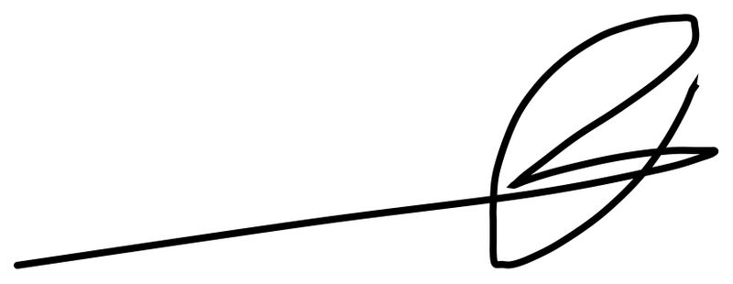
Signature 2
Please enter your name and sign. | Cedar Thaiday |  | 12 Jun 2020 06:54 AM |  | 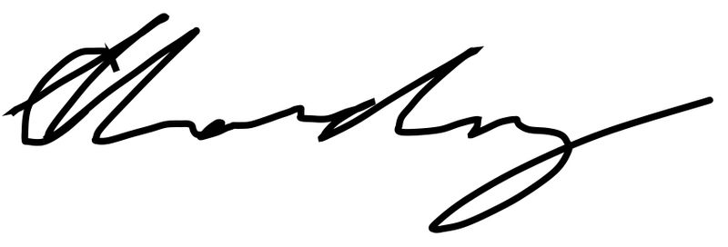
Signature 3
Please enter your name and sign. | Marlon Saylor |  | 12 Jun 2020 06:55 AM |  | 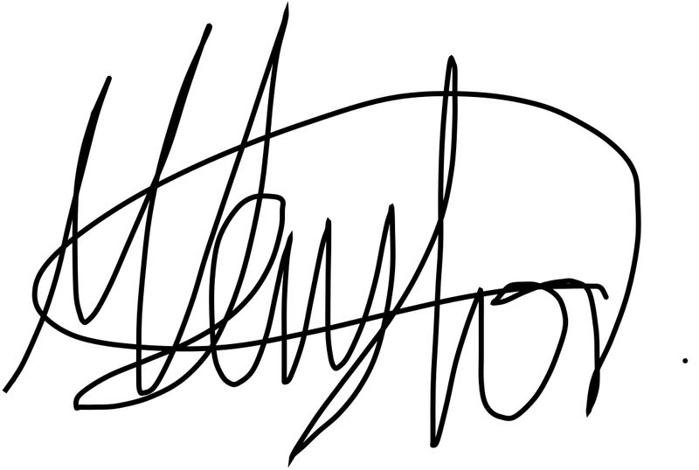
Any Safety / Environment / Community or other concerns |  | Traffic
Is there anyone new to site that hasn’t signed on to the initial site specific JSA? |  | No

