CPCCBC4006B
Select, procure and store construction materials for low rise projects

THEORY EXAM INSTRUCTIONS

- This exam will occur under standard assessment conditions.
  - An oral examination may be allowed under certain circumstances.
Answers will be documented and FT003 (Oral examination declaration form) must be completed.
- Participants must provide enough detail in their responses to demonstrate their knowledge and skills.
- Please fill in the details below, providing your name, signature and date of assessment.
  - Your signature acknowledges that this is your own work.
- If a participant initially answers a question incorrectly but modifies their response, they must follow the instructions below:
  - If a participant changes their response in writing, they must put their initials next to the written change.
  - If a participant changes their response verbally, this must be noted on the exam paper by the assessor.

Participant name | Annamarie Dorin
Participant signature | 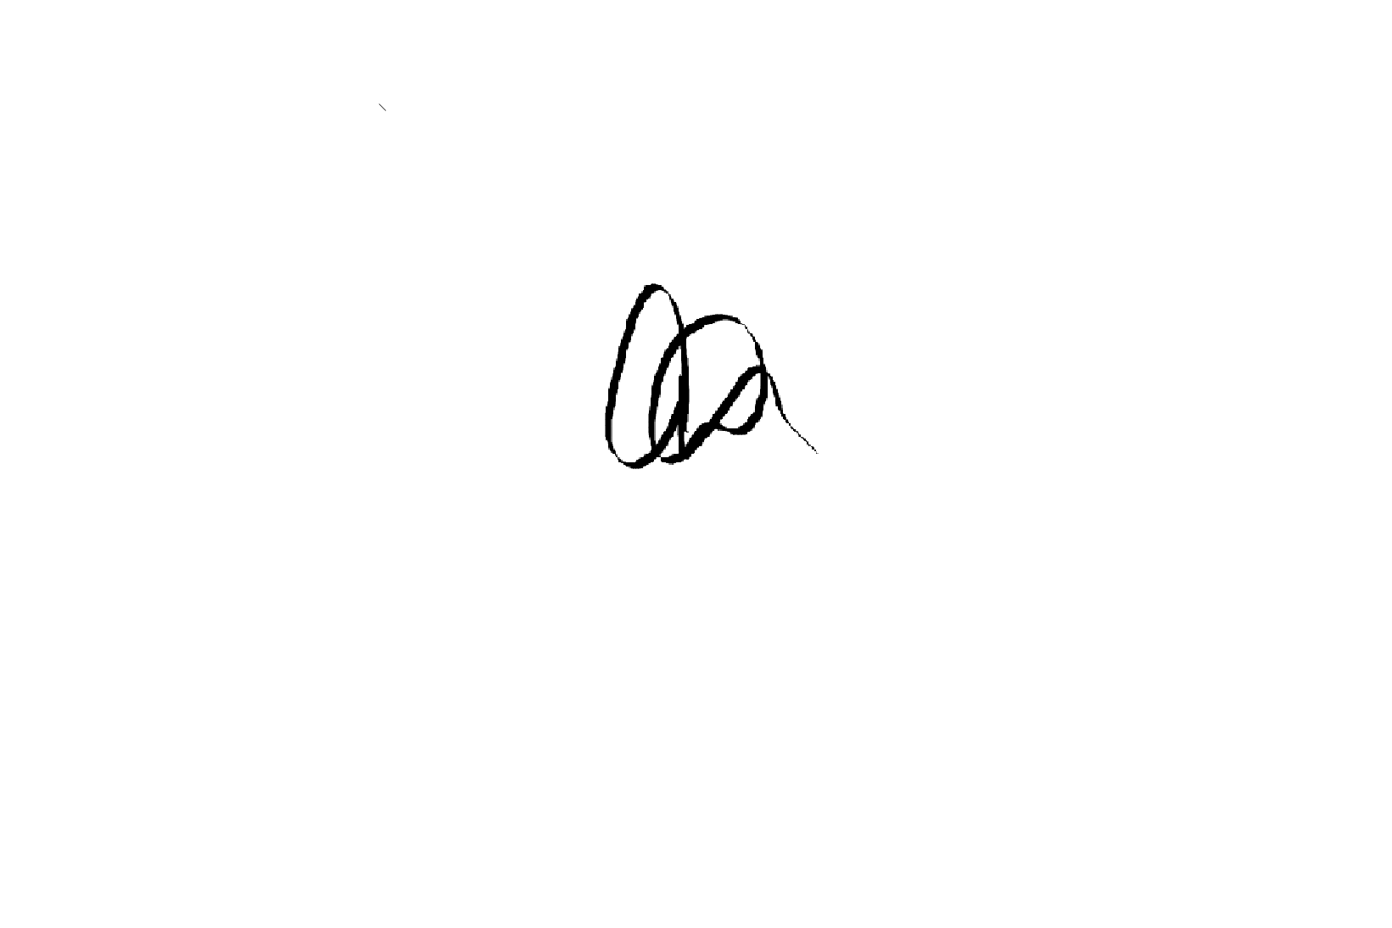

Assessor name | Brett Stoward
Assessor signature | 

Date | Click here to enter a date.

Number of questions | Number of questions answered correctly | Satisfactory?
44 |  | Yes | No
Assessor Comments
- Which of the following documents and/or people would you refer to when selecting materials for a building project? Tick all that apply.

Answer | Choice | Possible Answers
 | X | Australian Standards
 | X | Contract
 | X | Drawings
 | X | Manufacturer
 | X | National Construction Code
 | X | Specifications
 | X | Tolerances

- Identify the Volume and Parts of the NCC that relate to suitability of materials for Classes 1 and 10, and Classes 2 to 9.

Answer | Classes 1 and 10 | Classes 2 to 9
 | Volume Two – Part A5.0 | Volume One Part 5.0

- Identify the assessment methods used to verify a performance solution.

Answer | Evidence of suitability  Verification method  Expert judgement  Comparison with the deemed to satisfy provisions

- Which of the following solutions for material selection often references the Australian Standards? Tick your response.

Answer | Choice | Possible Answers
 | X | Deemed-to-Satisfy solution
 |  | Performance solution

- Identify five (5) materials commonly used for low rise buildings in your region. For each material, identify the following:
- Its name
- Properties of the material

Answer | # | Material name | Properties
 | 1 | Cement | Soundness, consistency, strength
 | 2 | Ceramics | High melting points, durability, low thermal conductivity
 | 3 | Concrete | Fire resistant, compressive strength, durable
 | 4 | Glass | Heat resistant, breakage resistance, chemical resistant
 | 5 | Mortars | Wind resistant, fire resistant, acoustic insulation

- For each of the materials in Q5. identify the following:
- Quality of the material (i.e. durability, serviceability, cost effectiveness)
- Compatibility and non-compatibility of the material (i.e. what it would/would not be suitable for)

Answer | # | Quality | Compatibility
 | 1 | Cement | Floor  Compatible with tiles ie used for grout  Not compatible with roofing
 | 2 | Ceramics | Roof  Compatible with tiles  Not compatible with fire (exposed to extreme high heat)
 | 3 | Concrete | Walls  Compatible with concrete slab  Not compatible with roofing
 | 4 | Glass | Windows  Compatible with window frames  Not compatible for flooring
 | 5 | Mortar | Bricks  Compatible with masonry materials  Not compatible with water

- Identify five (5) physical characteristics that may be considered when evaluating potential building materials.

Answer | Acoustics  conductivity  Insulation  Thermal  moisture

- Match the terms and definitions below by writing the appropriate letter next to each number in the centre column.

Answer | Term |  | Answers | Definition
 | 1 | Carbon footprint | 1 - B | A | The amount of energy required to manufacture a product
 | 2 | CO2e | 2 - E | B | Total GHD emissions produced during manufacture construction and use
 | 3 | Embodied energy | 3 - A | C | Greenhouse gas emissions
 | 4 | Embodied water | 4 - D | D | The amount of water required to manufacture a product
 | 5 | GHG | 5 - C | E | CO2equivalent tonnes emitted into the atmosphere

- Which of the following materials would be considered as ‘low energy content’? Tick all that apply.

Answer | Choice | Possible Answers
 |  | Bricks
 | x | By-products of other industrial processes
 |  | Cement
 |  | Glass
 |  | Metals
 |  | Plastics
 | x | Sand
 | x | Stone
 | X | Timber

- Refer to the table below and identify the wall material type that has the smallest embodied energy and emission impact.



Answer | Wall timber fibre clad

- Identify the Volume and Parts of the NCC that relate to energy efficiency of materials for Classes 1 and 10, and Classes 2 to 9.

Answer | Classes 1 and 10 | Classes 2 to 9
 | Volume 2, part 3.12 | Volume 1 part J

- Identify the relevant section of the Standards and Tolerances Guide and the associated Australian Standard that addresses residential slabs and footings.

Answer | Standards and Tolerances Guide | Australian Standard
 | QBCC 2.0 | AS 2870

- Identify the relevant section of the Standards and Tolerances Guide and the associated Australian Standard that addresses roof tiles.

Answer | Standards and Tolerances Guide | Australian Standard
 | QBCC Section 6.0 | AS 2049

- Identify the Volume and Parts of the NCC that relate to safety barriers for swimming pools for Classes 1 and 10, and Classes 2 to 9.

Answer | Classes 1 and 10 | Classes 2 to 9
 | Volume 2 Part 3.10.1.0 | Volume 1 Part G1.1 G1.3

- In some states, barriers and fences for swimming pools are not entirely regulated by the NCC, as noted in the Ancillary Provisions and State and Territory Variations. Identify the applicable Act and Regulation that regulate safety barriers for swimming pools in your jurisdiction.

Answer | Swimming Pools Act 1992 Review (North Sydney Council)

- Identify the Australian Standard that relates to safety barriers for swimming pools.

Answer | Australian Standard AS1926.1

- True or False (Tick your response): According to the Standard in Q16. all gates must be fitted with a self-closing device that will return the gate to a closed position from any position without the use of manual force.

Answer | X | True
 |  | False

- Identify the Volume and Parts of the NCC that relate to fire-resistance of building elements for Classes 1 and 10, and Classes 2 to 9.

Answer | Classes 1 and 10 | Classes 2 to 9
 | Volume 2 schedule 5 | Volume 1 schedule 5

- Identify the Australian Standard that relates to fire-resistance tests for elements of construction.

Answer | AS1530.4: 2005 Fire resistance tests of elements of building construction

- For all NCC Classes, where the ground or subfloor space is excessively damp or subject to frequent flooding, which durability class must the subfloor framing must be used where above ground?

Answer | NCC - F1.12 Subfloor ventilation  (A) - durability Class 1 or 2 timbers or H3 preservative treated timbers in accordance with AS 1684.2, AS 1684.3 or AS 1684.4; or  (B) - steel in accordance with NASH Standard 'Residential and Low-Rise Steel Framing' Part 2.

- Identify the Australian Standards that must be observed when meeting the requirements for Q20.

Answer | As 1684.2 or AS1684.3

- True or False (Tick your response): Where materials are not used as intended (or without considering NCC requirements), this can make a significant difference to the life or serviceability of the structure.

Answer | X | True
 |  | False

- Explain why durability and serviceability impact on the cost effectiveness of chosen materials.

Answer | The durability and serviceability will impact on costs. The material will equate to be cheaper (for the duration of it’s lifespan) due to it’s longevity and effectiveness. There will be less work required for maintenance etc of the building.

- Provide an example of short term degradation of materials and describe its effects on a building on structure.

Answer | Timber - When exposed to the weather it may suffer from weathering, causing splitting and crumbling or if it is unprotected and remains damp for long periods, it will rot. This may cause major issues including (worse case scenario), collapse of a building.

- Provide an example of long term degradation of materials and describe its effects on a building on structure.

Answer | Metal ie Iron – Iron can corrode/rust relatively quickly which may compromise the properties of the material as well as weakening the strength of the materials

- You have spoken to a supplier who has indicated that some of the client’s desired materials are unavailable. When considering alternative building materials what must be taken into consideration (i.e. other than the client’s requirements)?

Answer | Cost  Time  Alternative material

- Identify two (2) things that you should look for when receiving a delivery of materials.

Answer | Confirm the correct quantity/condition of delivery  Inspect deliver and ensure no damage is made to materials

- If you encounter issues with delivery, what two (2) options do you have?

Answer | Accept the shipment with conditions  Reject shipment

- Which of the following should be assessed before shifting materials? Tick all that apply.

Answer | Choice | Possible Answers
 | X | What needs to be relocated (e.g. size, weight)
 | X | The relocation area, site layout and obstacles
 | X | Distance and time to relocate load
 | X | Whether a team is available and/or appropriate
 | X | Whether PPE must be worn (e.g. for hazardous materials)

- What document should you refer to for guidance on how to handle and store hazardous chemicals?

Answer | SDS (Safety Data Sheet)

- Name three (3) ways you can reduce the risk of injury if a load is too heavy for one person to carry, push or pull.

Answer | Ask more people to assist with the load  Assess if a mechanical aid is required for the load  Lighten the load

- In the diagram below a person is lifting a tool box.
Filling in the table, indicate how each body part should be used/placed.

F. Hands
E. Knees
D. Shoulders
C. Feet
B. Back
A. Neck
Answer | Area of body (Letter) | How it should be placed
 | D | Level
 | A | Upright
 | F | Good grip
 | B | Natural curve
 | E | Bent
 | C | Flat, facing load

- How should construction materials and components be handled?
Tick all that apply.

Answer | Choice | Possible Answers
 | X | Sorted to suit material type and size, separating hazardous material
 | X | Stacked or stockpiled for ease of identification and retrieval
 |  | Stored in access ways for ease of retrieval
 | X | Stored clear of access ways
 | X | Handled and positioned ready for installation

- Identify the Australian Standard that relates to the storage and handling of LP gas.

Answer | AS/NZS 1596:2002 - The storage and handling of LP Gas

- List one (1) testing method for each of the building materials listed below.

Answer | Material name | Properties
 | Concrete | Concrete cylinders or cubes are normally tested in a hydraulic press. A universal machine for tension, compression and bending is also used.
 | Metals | Hardness is tested by indentation with a diamond or a hardened steel ball. If the tensile strength has been tested, then the hardness of the metal can be deduced.
 | Timber | A stress grading machine tests every individual piece of timber using a very fast and economical method. The test is based on the relationship between the strength and the deflection of timber. Each piece of timber is deflected at several points along its length, and the deflection category marked by means of a spot of dye. The timber is then classified visually by its colour markings.

- What Code gives detailed tables which state the required grade of timber for specific sizes and uses?

Answer | The Australian Timber Framing Code gives detailed tables which state the required grade of timber for specific sizes and uses. The grading is performed at the timber mills or at the wholesaler’s site.

- Name two (2) ways that defects may be seen in timber.

Answer | Knots  Slips

- Identify two (2) tests that may be performed to determine the durability of stone.

Answer | Acid immersion test  Hardness test

- Name two (2) ways that defects may be seen in stone.

Answer | Cracks  Fissures

- True or False (Tick your response): Under a contract, builders and other specialist tradespersons are the ones most likely to rectify or remedy problems that arise from incorrect installation, application or placement of materials.

Answer | X | True
 |  | False

- Name two (2) established methods that may be used to preserve timber.

Answer | Sodium silicate-based preservatives  Soil Poisoning

- Identify two (2) established methods that may be used to protect ferrous metals.

Answer | Corrosion inhibitors  Painting

- Explain why the corrosion resistance of non-ferrous metals is superior to that of ordinary steel.

Answer | This results of the production of a ceramic coating of oxide or salt on the metal which protects it from the further corrosion.

- When should aluminium be coated with bituminous paint?
Tick all that apply.

Answer | Choice | Possible Answers
 |  | At all times
 | X | When it is buried in soil
 | X | When it comes in contact with chemical materials
 | X | When it is immersed in water
 |  | When it is used on bitumen

