CPCCBC4018A
Apply site surveys and set-out procedures to building and construction projects

THEORY EXAM INSTRUCTIONS

- This exam will occur under standard assessment conditions.
  - An oral examination may be allowed under certain circumstances.
Answers will be documented and FT003 (Oral examination declaration form) must be completed.
- Participants must provide enough detail in their responses to demonstrate their knowledge and skills.
- Please fill in the details below, providing your name, signature and date of assessment.
  - Your signature acknowledges that this is your own work.
- If a participant initially answers a question incorrectly but modifies their response, they must follow the instructions below:
  - If a participant changes their response in writing, they must put their initials next to the written change.
  - If a participant changes their response verbally, this must be noted on the exam paper by the assessor.

Participant name
Participant signature | 

Assessor name
Assessor signature

Date | Click here to enter a date.

Number of questions | Number of questions answered correctly | Satisfactory?
39 |  | Yes | No
Assessor Comments
- In the context of site set out and levelling, what is a key attribute for a licensed builder to have and demonstrate? Explain its importance.

Answer

- Why is a grid a useful device for expressing design rules about the placement of elements on a plan or over the surface of land?

Answer

- In terms of site surveying what does ‘off-set’ mean?

Answer

- How would you set out a right angled corner on a building site?

Answer

- Using a diagram explain the Pythagorean Theorem to show how it works and is calculated practically.

Answer

- What is a set-out survey used for?

Answer

- Why are set-out procedures important?

Answer

- When are set-out surveys needed?

Answer

- What are some of the errors that can be encountered in the site set out process?

Answer

- How does error of collimation happen? Draw a diagram to support your response.

Answer

- What is cut and fill?

Answer

- What do cut and fill calculations include?

Answer

- How do you calculate cut and fill?

Answer

- Using sketch diagrams explain how you would determine cut and fill requirements from the contour map shown below.
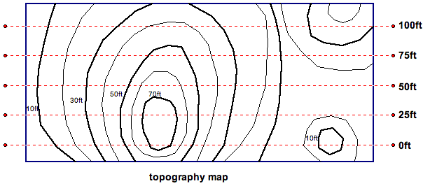
The map describes the existing slopes of the land, and will allow us to draw site elevations in our section cuts with a change in elevation every 10 feet or in metric about every 3 metres.

Answer

- Explain the terms listed in the table below.

Answer | Term | Definition
 | Vertical line
 | Horizontal plane
 | Datum
 | Mean Sea Level (MSL)
 | National Geodetic Vertical Datum (NGVD 29)
 | Elevation
 | Bench Mark (BM)

- Explain the functions of levelling. What is its purpose to set out a construction site?

Answer

- Name some levelling devices used in the building and construction and civil construction industries.

Answer

- What is the fundamental principle of levelling?

Answer

- Define ‘levelling’.

Answer

- Explain a two peg test of a levelling instrument.
Answer

- Provide sketches of how a two peg test of a levelling instrument would be set up and achieved.

- Explain a ‘traverse’ in levelling. Name the two methods of levelling used.

Answer

- Using the data from the survey information presented below plot the rise and fall profile on graph paper using a suitable scale.
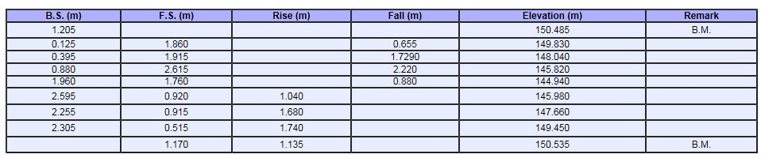

Answer

- What is direct levelling? Identify the common methods used.

Answer

- Explain the simple levelling technique.
Provide a sketch to support your response.

Answer

- Explain the concept ‘differential levelling technique’.

Answer

- Explain the Fly Levelling technique. Provide a sketch to support your response.

Answer

- What is precise levelling?

Answer

- What is profile levelling? Provide a sketch to support your response.

Answer

- Explain reciprocal levelling. Provide a sketch to support your response.

Answer

- Explain Stadia levelling. Describe what you see in the image below.

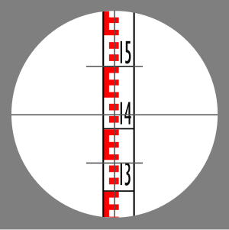

Answer

- What is a contour plan?

Answer

- Using the information on the contour drawing below, provide a brief explanation of the block of land’s topographical surface prior to any cut and fill as represented by the contour lines relative to the BM and North as your points of reference.

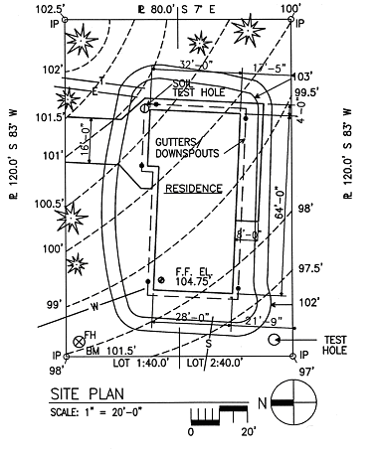

Answer

- How would a surveyor you go about creating a contour plan?

Answer

- In simple terms write an explanation of the contour map shown below.

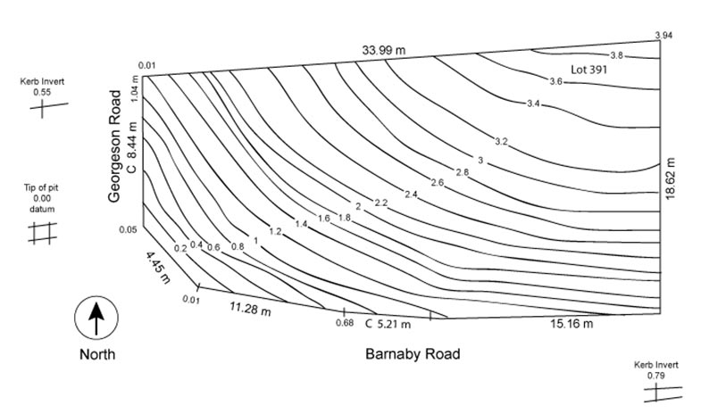
Answer

- Explain the terms listed in the table below.

Answer | Term | Definition
 | Surveying
 | Legal description
 | Property line
 | Monument
 | Set back
 | Flood Plain
 | Recorded
 | Hub and Tack
 | Site plan
 | Foot Print
 | Site heading
 | Utility Easement
 | Topography
 | As built
 | Tolerance
 | Construction survey
 | Station
 | Toe
 | Invert
 | Transit
 | Acre or hectare
 | Right of way
 | Covenants
 | Plat
 | Zoning
 | Lot
 | Laser
 | Zero lot line
 | Encroachment
 | Variance
 | Building Code of Australia
 | Australian Standards
 | Work Health and Safety Act 2011 (Qld)

- You are laying 120 metres of 100mm PVC sewer pipe and your plans nominate a fall of 1:55 which is expressed as 1.8%.
Using the formula below for calculating fall using either ratio or percentage, calculate the fall using the ratio method and then using the percentage method.
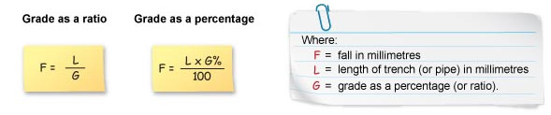
NOTE

Your answers will not necessarily match. Fall is calculated using the following formulae noting there is a slight difference in the formulae depending if the grade is expressed as a percentage or is expressed as a ratio.
Answer

- A sewerage pipe trench is being laid over 340 metres and the fall is expressed as a ratio of 1:90. Calculate the fall of the trench.

Answer

- Give the readings of the staff below:

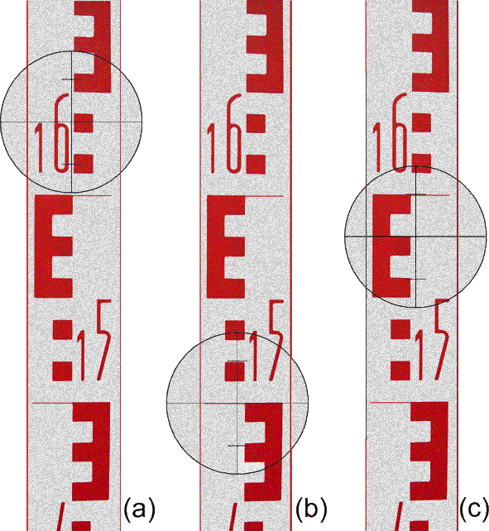

Answer | a)  b)  c)

