BSBITU306
Design and produce business documents
Learner Workbook



Table of Contents

Table of Contents 2
Candidate Details 3
Assessment – BSBITU306: Design and produce business documents 3
Competency Record to be completed by Assessor 4
Activities 6
Activity 1A 6
Activity 1B 7
Activity 1C 9
Activity 1D 11
Activity 2A 12
Activity 2B 13
Activity 2C 14
Activity 2D 15
Activity 3A 16
Activity 3B 17
Activity 3C 18
Activity 3D 19
Activity 4A 20
Activity 4B 21
Activity 4C 22
Activity 4D 23
Skills and Knowledge Activity 24
Major Activity 25

Candidate Details

Assessment – BSBITU306: Design and produce business documents
Please complete the following activities and hand in to your trainer for marking. This forms part of your assessment for BSBITU306: Design and produce business documents.
Name: Rani Doyle
Address: 94 Bald Hills Rd
Bald Hills, QLD 4036
Email: rani_doyle@hotmail.com
Employer: Securcom
Declaration
I declare that no part of this assessment has been copied from another person’s work with the exception of where I have listed or referenced documents or work and that no part of this assessment has been written for me by another person.
Signed: ____________________________________________________________
Date: ____________________________________________________________
If activities have been completed as part of a small group or in pairs, details of the learners involved should be provided below:
This activity workbook has been completed by the following persons and we acknowledge that it was a fair team effort where everyone contributed equally to the work completed. We declare that no part of this assessment has been copied from another person’s work with the exception of where we have listed or referenced documents or work and that no part of this assessment has been written for us by another person.
Learner 1: ____________________________________________________________
Signed: ____________________________________________________________
Learner 2: ____________________________________________________________
Signed: ____________________________________________________________
Learner 3: ____________________________________________________________
Signed: ____________________________________________________________

Competency Record to be completed by Assessor
Learner Name: _______________________________________________________
Date of Assessment: _______________________________________________________
The learner has been assessed as competent in the elements and performance criteria and the evidence has been presented as:
Assessor Initials
Authentic
Valid
Reliable
Current
Sufficient

Learner is deemed: COMPETENT NOT YET COMPETENT (Please circle)

If not yet competent, date for re-assessment: ____________________________________

Comments from Trainer / Assessor:
__________________________________________________________________________________________________________________________________________________________________________________________________________________________________________________________________________________________________________________________________________________________________________________________________________________________
Assessor Signature: ________________________________________________________
Observation/Demonstration

Throughout this unit, you will be expected to show your competency of the elements through observations or demonstrations. Your instructor will have a list of demonstrations you must complete or tasks to be observed. The observations and demonstrations will be completed as well as the activities found in this workbook. An explanation of demonstrations and observations:
Demonstration is off-the-job
A demonstration will require:
- Performing a skill or task that is asked of you
- Undertaking a simulation exercise
Observation is on-the-job
The observation will usually require:
- Performing a work based skill or task
- Interaction with colleagues and/or customers
Your instructor will inform you of which one of the above they would like you to do. The demonstration/observation will cover one of the unit’s elements.
The observation/demonstration will take place either in the workplace or the training environment, depending on the task to be undertaken and whether it is an observation or demonstration. Your instructor will ensure you are provided with the correct equipment and/or materials to complete the task. They will also inform you of how long you have to complete the task.
You should be able to demonstrate you can:
- Select and prepare resources
- Design document
- Produce document
- Finalise document
You will also need to show:
- Reading
- Writing
- Oral communication
- Navigate the world of work
- Interact with others
- Get the work done
Activities

Activity 1A
Estimated Time | 20 Minutes
Objective | To provide you with an opportunity to select and use appropriate technology and software applications to produce required business documents.
Activity | What is a business document?  Business documents are written or electronic documents that represent an organisation in relation to its external parties  Give examples of types of business documents.  - Accounts statements  - Client databases  - Newsletters  - Project reviews  - Proposals  - Reports  - Web pages.  When producing business documents, it essential to use the correct technology and software. Give examples of these.  Correct Technology may include:  - Computers  - Photocopiers  - Printers  - Scanners  Correct Software may include:  - Accounting Packages  - Database packages  - Presentation packages  - Word processing packages  In relation to your own organisation, decide on a business document. Describe what this document may include. What is the correct technology and software that you should use to produce your business document?  An example of a business document from Securcom can be project reviews that are formatted using a collection of information from our database once the project is completed.

Activity 1B
Estimated Time | 25 Minutes
Objective | To provide you with an opportunity to select layout and style of publication according to information and organisational requirements.
Activity | Give examples of different layouts and styles you may need to consider when developing business documents.  Different layouts and styles to consider can include:  - Page Orientation – whether the document is to be landscape or Portrait.  - Text Colours  - Fonts – Arial, Times New Roman  - Text six – 11,12,18,24 etc.  - Headings and Footers  - Margins  - Line spacing – single or double between lines.  - Page Numbering – if so where should the numbering be on the page? (Top left hand corner? bottom right hand corner? Etc.)  When selecting layouts and styles, you must take organisational requirements into consideration. What can these include?  Organisation requirements to consider when selecting layouts and styles can include:  - Budgets  - Correctly identifying and opening files  - Legal and organisational policies, guidelines and requirements  - Locating data  - Log-on procedures  - Manufacturers’ guidelines  - Occupational health and safety policies, procedures and programs  - Quality assurance and/or procedures manuals  - Saving and closing files  - Security  - Sorting data  What may organisational policies and procedures outline?  Organisational policies and procedures may outline:  - How to develop the documents  - Where to keep copies of the documents  - How much to spend when developing the documents  - Any quality assurance checks that may be required  - Any security issues that should be considered  - Any legal policies or procedures relating to documents  - The correct way to store any data  - The style guide to develop documents from.  Why is consistency important when developing business documents?  When developing business documents, consistency is important as it ensures that the content flows smoothly, it looks professional, the document is easy to follow and use and everything makes sense.  How can you ensure consistency?  To ensure consistency when producing business documents, you should create and used a template or style guide.  Using a business document that applies to your organisation as an example, outline the correct layouts and styles.  Title of document  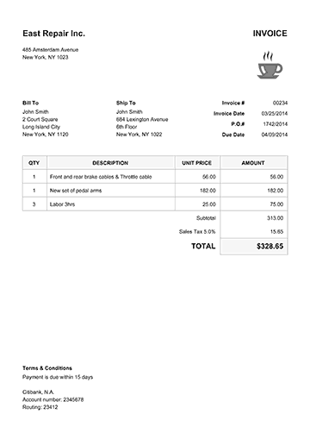  Business name/ logo  Main information Bolded to stand out and catch reader’s eye

Activity 1C
Estimated Time | 25 Minutes
Objective | To provide you with an opportunity to ensure document design is consistent with company and/or client requirements, using basic design principles.
Activity | What things should you remember when designing business documents?  Things to remember when designing a business document:  - People remember text information better with visual information  - The human eye can be easily overloaded and distracted with inappropriate colours and fonts  - When appropriate, funny and sexy things are remembered better  - Bad spelling, poor punctuation and bad grammar can be distracting and confuse the meaning of the document  - Images of humans are remembered better than images of objects.  Name the four principles you should consider. What do they involve?  - Contrast  Contrasting elements include lines, fonts, shapes and colours.  - Alignment  Each item on a page of a business document should have a visual connection with something else on the page. Allignment aids the overall coherence for the document, created an ordered design, eliminates mess and creates a visual connection between elements.  - Repetition  Visual elements should be repeated throughout the document as it can connect individual elements, strengthen a design, create associations and ensure consistency.  - Proximity  Related items within a business document should be grouped together or visually connected in order to help create organisation. It provides a focal point and creates a relationship between the elements within the group.  We often associate different colours with a variety of things. Choose three colours and outline what you associate these with.  - Pink: soft, femininity  - Yellow: cheerful, happiness, warmth  - Black: Darkness, dramatic, elegant  Using a business document that relates to your own organisation, show how you can apply the basic design principles to them.  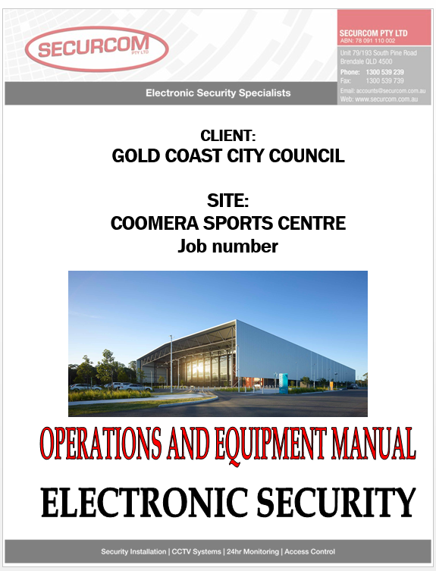  Proximity – relating to each other  Appropriate imagery to capture reader’s attention  Contrasting Colours and Font to make the title stand out – Black outline and Red fill  Use of Bold and text size to capture reader’s attention

Activity 1D
Estimated Time | 15 Minutes
Objective | To provide you with an opportunity to discuss and clarify format and style with person requesting document/publication.
Activity | When should you discuss and clarify the format and style of a business document with the person that has requested it?  The discussion and Clarification of the business document should be done in the process of creating the document.  Give examples of the things you may discuss and clarify.  Things that may need to be discussed or clarified may include:  - The size of text  - The size of images  - Colour scheme  - Positioning of information  Explain a situation in which you have had to seek clarification from the person that has requested the document you are about to develop.  Before printing a document I liaised with one person whom would be one of the readers of the document to clarify that it is set out okay and the information is easy to understand and it meets the criteria of an effective document.

Activity 2A
Estimated Time | 20 Minutes
Objective | To provide you with an opportunity to identify, open and generate files and records according to task and organisational requirements.
Activity | For TWO different types of business documents (that relate to your own organisation), give details on how you would identify, open and generate files and records.  Document 1: Credit card Policy, Open and Generate this file via the company common drive. Access is open to all staff.  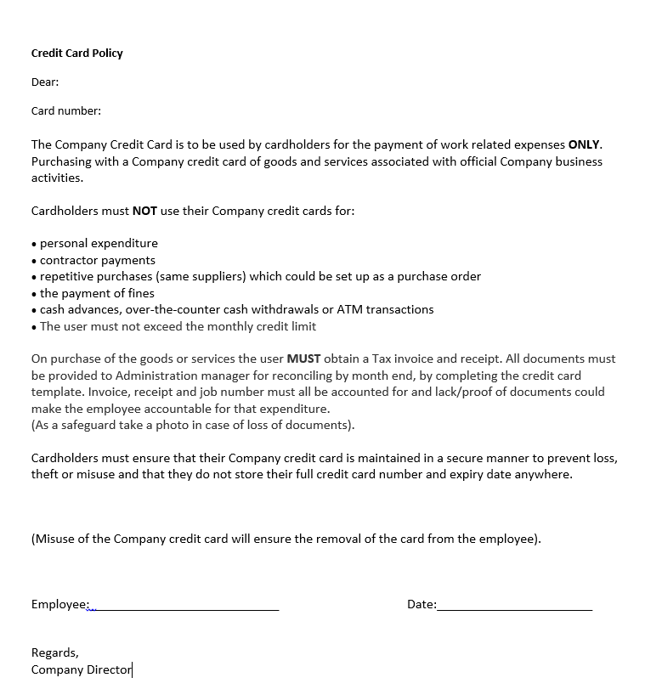  Document 2: Office Procedures, Open and generate this file via the company common drive. Access is open to all staff.  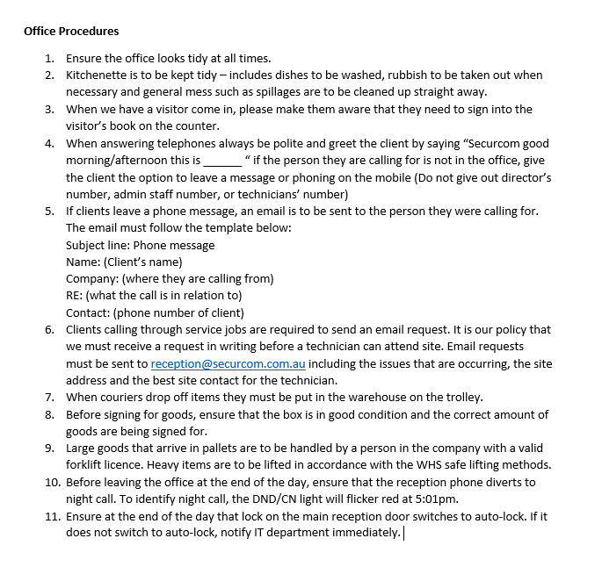

Activity 2B
Estimated Time | 20 Minutes
Objective | To provide you with an opportunity to design document to ensure efficient entry of information and to maximise presentation and appearance of information.
Activity | Why is the efficient entry of information important?  The information that is entered into a business document needs to be accurate in order to avoid being misleading and developing inappropriate analysis.  Outline ways in which you can design documents to minimise the chance of information errors occurring.  Ways to minimise the chance of information errors occurring can include:  - Using a pre-existing file to copy and paste information instead of having to retype.  - Put a system in place that recognises information errors.  Give an example of a document you have created and how you maximised the presentation and appearance.  I have created a manual for a project manager. To maximise presentation I used pictures of the site and a nice font coloured red with a black outline for boldness. The words were still readable and the layout of the manual was not overwhelming with different objects; it was set out to maximise the presentation and appearance efficiently.

Activity 2C
Estimated Time | 15 Minutes
Objective | To provide you with an opportunity to use a range of functions to ensure consistency of design and layout.
Activity | Give examples of the functions that may ensure consistency of the design and layout of your documents.  Functions that may ensure consistency of a design and layout of a documents can include:  - Alternating headers and footers  - Editing  - Merging documents  - Spell checking  - Table formatting  - Using columns  - Using styles.  Using one of the examples you have just given, describe the process of carrying it out.  Spell Checking  Carrying out a spell check is essential before finalising a business document.  To run a spell check on a word document and Excel document:  - Click the ‘Review’ tab  - Click the ‘Spelling & Grammar’ tab  - Correct the mistakes  *Note for Excel* if a particular cell is selected, it will only spell check that cell.

Activity 2D
Estimated Time | 20 Minutes
Objective | To provide you with an opportunity to operate input devices within designated requirements.
Activity | Define input devices.  An input device is any piece of equipment that feeds some sort of data into a computer  Give examples of input devices.  Input devices can include:  - Keyboard  - Mouse  - Numerical key pad  - Scanner  - Touch screen  - Webcam  - Joystick  - Microphone  - Barcode scanners  Choose one device and explain its function.  Scanner: A scanner works similarly to a photocopying machine and is used when the information you need to enter into a computer is available on paper. The scanner captures the image from the source; these images are then converted into a digital format that can be stored. These images can also be edited.  Choose a type of document and list the input devices you require to develop it.  Microsoft Word:  - Keyboard  - Mouse

Activity 3A
Estimated Time | 15 Minutes
Objective | To provide you with an opportunity to complete document production within designated timelines according to organisational requirements.
Activity | What is a timeline?  Timelines are where key planned events and tasks are marked in the required sequence of their occurrence on a suitable scale.  Give examples of good time management.  Examples of good time management can include:  - Recording your deadlines  - Prioritising your tasks  - Keeping track of your progress  - Ensuring you choose the best technology and software  - Knowing how to deal with possible problems that may arise.  Give an example of a time you needed to produce something within a designated timeline. How did you do this? How could improve this?  An example of when I had to produce something within a designated timeline is within the last week of a month I need to have entered all invoices ready for end of month reconciliation. By effectively completing this I managed my time effectively by prioritising my tasks and putting aside tasks that are not as urgent and can be completed at a later date. I also kept track of my progress by setting achievable goals if where I want to be by a certain time.

Activity 3B
Estimated Time | 10 Minutes
Objective | To provide you with an opportunity to check document produced to ensure it meets task requirements for style and layout.
Activity | Give examples of the things that you may need to check.  Things that may need to be checked may include:  - Line spacing  - Paragraph spacing  - Margin size  - Justification  - Text size  - Text colour  - Font  - Structure  - Use of bold  - Use of italics  - Page numbering  - Page breaks  - Table properties  - Image properties  For two different types of business documents, list the specific things you will need to check.  - Microsoft Word:  - Text Size  - Text colour  - Font  - Use of bold and italics  - Page numbering  - Line and paragraph spacing  - Excel  - Cell size  - Table properties  - Margins  - Image Properties  - Text size  - Text Colour  - Font  - Use of Bold and Italics

Activity 3C
Estimated Time | 15 Minutes
Objective | To provide you with an opportunity to store document appropriately and save document to avoid loss of data.
Activity | Outline the disadvantages of storing documents in their paper form.  Disadvantages of storing documents can include  - Limited space in the work place  - Can be difficult to find  - Expensive  - Harmful to the environment  - Poses risks of damage or loss.  Outline the advantages and disadvantages of storing documents electronically.  Advantages of electronic storage:  - Does take up physical space in the work area  - Can be easy to find (provided that the storage is done effectively)  - Not as harmful to the environment than paper form  Disadvantages of electronic storage:  - Devices can malfunction  - You can lose device  - Some devices aren’t compatible with all computers  - Possible for viruses to wipe out data  - Online storage may be hacked  - Online storage relies on good internet connection (not accessible at all times)  Outline the procedures in place within your organisation regarding saving and storing documents. Make suggestions on how to improve these procedures.  In regards to storing documentation, we have an electronic database which we can use to locate previous, completed jobs and projects. We must ensure that that correspondence between the client and our employees are saved and attached to the job also. After the job has been completed and invoices, we then print off a hard copy and file it away in our storage room.

Activity 3D
Estimated Time | 25 Minutes
Objective | To provide you with an opportunity to use manuals, training booklets and/or help-desks to overcome basic difficulties with document design and production.
Activity | Briefly describe what manuals are and what they include.  Manuals are documents that intend to give assistance to a person who is using a particular system.  What are training booklets? What are they used for?  Training booklets contain the instructions related to a specific action or task, aiming to improve the quality of the performance of this action or task  What makes a training booklet effective?  An effective training booklet:  - Uses illustrations to improve understanding  - Is easy to read  - Has easy to follow instructions  - Has an attractive design  - Can be used for future reference.  How can you get help-desk support?  Help-desk support is available via the following channels:  - Websites  - Instant messaging  - E-mails  - Free telephone numbers.  If a basic difficulty arose in the production of one of your business documents, how would you deal with this? Explain why you chose this method.  If a basic difficulty arose In the production of a business document, I would refer to training booklets as they would be the easiest to understand and give me a quick solution to resolve the issue.

Activity 4A
Estimated Time | 10 Minutes
Objective | To provide you with an opportunity to proofread document for readability, accuracy and consistency of language, style and layout prior to final output.
Activity | What is proofreading?  Proofreading is the process of rereading a document to detect any errors and correct them before finalising and printing the document.  What can proofreading help to detect errors in?  - Spelling  - Grammar  - Language  - Punctuation  - Style  - Elements of layout such as:  - Colours  - Headings  - images  Outline the steps needed to test readability.  The steps to test the readability of a word document as follows:  - Click the ‘File’ tab  - Click ‘Options’  - Click ‘Proofing’  - Tick the ‘Check grammar with spelling’ box  - Click ‘Show readability statistics’  - Open the file you want to test  - Run ‘spell check’  - After checking spelling and grammar, the reading level of your document will be displayed.

Activity 4B
Estimated Time | 10 Minutes
Objective | To provide you with an opportunity to make any modifications to document to meet requirements.
Activity | Give examples of the modifications you may need to make to your documents.  Examples of modification that may need to be made on a document can include:  - Correcting spelling, grammar and punctuation mistakes  - Improving the readability score of your document  - Making the style of your document consistent.  How can you improve the readability of your documents?  To improve the readability of your documents may include:  - Using words with one or two syllables  - Using illustrations, bullet points or graphs  - Using short, simple sentences wherever possible  - Highlighting important things in bold or italics  - Elaborating on difficult words  - Using connective words to help guide the reader.

Activity 4C
Estimated Time | 20 Minutes
Objective | To provide you with an opportunity to name and store document in accordance with organisational requirements and exit application without data loss/damage.
Activity | Give an example of a bad document name.  “The Business document”  Give an example of a good document name.  ”Joni’s & Co Pty Ltd Official Business Plan”  What tips should you consider when naming your documents?  Tips to consider when naming a business document:  - Use Keywords  - Use your name or initials  - Use date  - Use alphabetical codes  - Use version numbers  - Be detailed  - Be consistent  What issues may arise when naming and storing documents?  - To many characters – file names can only be up to 260 characters  - Restricted characters (<>?/;* are characters that cannot be used in file names)  - Compatibility issues  Outline the procedures in place within your organisation outlining how you should store your documents.  Documents are to be stored both electronically and physically so in the case of an incident and files get damaged either physically or electronically, there is a backup where we can still access the file.

Activity 4D
Estimated Time | 10 Minutes
Objective | To provide you with an opportunity to print and present document according to requirements.
Activity | Outline the steps for printing a document.  Steps to print are as follows:  - Click ‘File’  - Click ‘Print’  - Choose the amount of copies you need  - Alter the settings to the your requirements  - When you are satisfied, click ‘Print’  What are the requirements for how you should present your documents?  Requirements for how you should present a document can be:  - In a folder  - In plastic wallets  - Stapled  - In a ring binder

Skills and Knowledge Activity
Estimated Time | 1 Hour
Objective | To provide you with an opportunity to demonstrate your knowledge of the foundation skills, knowledge evidence and performance evidence.
Activity | Complete the following individually and attach your completed work to your workbook.  The answers to the following questions will enable you to demonstrate your knowledge of:  - Reading  - Writing  - Oral communication  - Navigate the world of work  - Interact with others  - Get the work done  - Appropriate technology for production requirements  - Functions and features of contemporary computer applications  - Organisational policies, plans and procedures  - Organisational requirements for document design  Answer each question in as much detail as possible, considering your organisational requirements for each one.  - Create three different documents using two different software applications in each. Ensure these follow any organisational policies or requirements that are in place, are correctly presented and can be printed for presenting at a meeting – write a brief dialogue for your presentation on each document, stating what they are and their purpose.

Major Activity
Estimated Time | 1 Hour
Objective | To provide you with an opportunity to demonstrate your knowledge of the entire unit.
Activity | This is a major activity – your instructor will let you know whether you will complete it during class or in your own time.  Attach your completed answers to the workbook.  You must individually, answer the following questions in full to show your competency of each element:  - Select and prepare resources  - Design document  - Produce document  - Finalise document  Using one type of business document as an example:  - Select the appropriate technology and software applications to use.  - Select the layout and style you would use and explain how this related to organisational requirements.  - Explain how you could use basic design principles to ensure design is consistent with requirements.  - Say you were to discuss and clarify this with the person that has requested this document; when would you do this? What would you discuss?  - Identify the files and records you would need to open and/or generate. Briefly describe this process.  - Outline ways in which you would design your document to ensure efficient entry of information.  - Outline the functions that you would use to ensure consistency of design and layout.  - List the input devices that you would need to use in order to develop your document.  - Describe the techniques you would use in order to meet the designated time line.  - List the aspects of the style and layout of your document that you would need to check meet the requirements.  - Outline how you would save and store your document in order to avoid loss of data.  - If you were to face basic difficulties, where would you turn?  - How would you proofread your document?  - If you were to find mistakes when proofreading, how would you rectify these?  - Describe how you would name and store your document.  - Give details on how you would print your document.

