CPCCBC4012B
Read and interpret plans and specifications

THEORY EXAM INSTRUCTIONS

- This exam will occur under standard assessment conditions.
  - An oral examination may be allowed under certain circumstances.
Answers will be documented and FT003 (Oral examination declaration form) must be completed.
- Participants must provide enough detail in their responses to demonstrate their knowledge and skills.
- Please fill in the details below, providing your name, signature and date of assessment.
  - Your signature acknowledges that this is your own work.
- If a participant initially answers a question incorrectly but modifies their response, they must follow the instructions below:
  - If a participant changes their response in writing, they must put their initials next to the written change.
  - If a participant changes their response verbally, this must be noted on the exam paper by the assessor.

Participant name | Justin Skehan
Participant signature | 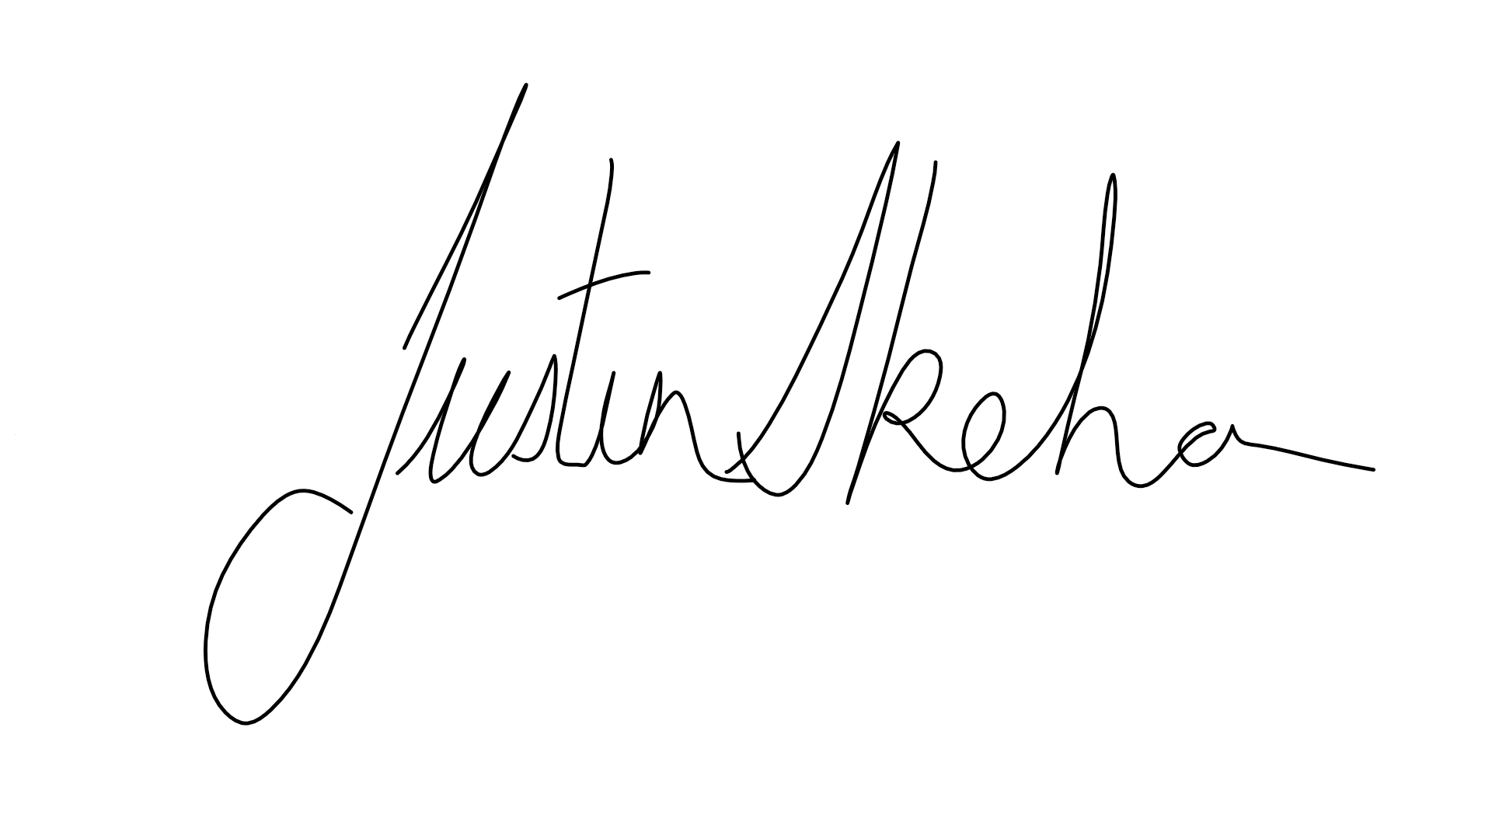

Assessor name
Assessor signature | 

Date | Click here to enter a date.

Number of questions | Number of questions answered correctly | Satisfactory?
77 |  | Yes | No
Assessor Comments
l
- What does the term ‘plan’ mean when referencing plans and drawings for construction purposes?

Answer | The term plan can be used in reference to all the drawings for a proposed construction and more accurately the plan is a view that shows the layout, room arrangements and interior of the house. Types of plans include,  - Block plans  - Site plans  - Floor Plans  - Elevations

- Name the people and organisations who will have an interest in plans and drawings for a construction project.

Answer | The interested parties are as follows  - Sub-contractors (carpenters, bricklayers, concreters, painters, plasterers)  - real estate agents  - neighbours  - kitchen manufacturers  - landscapers  - the client and lending body  - local council  - various material or product suppliers  - environmental agencies  - mechanical service installers, e.g. air conditioning, fire alarms  - supply authorities, (water, sewerage, drainage)  - Electrical, gas and cable supply companies  - builders and sub-contractors wanting to quote  - engineers

- What will plans show to the interested parties?

Answer | The Plans will show all interested parties what the proposed structure will look like when completed and how it is to be constructed. It will show the shape and size if the proposed building as well as its location on the site. It will also show selected material and how and where they are to be used. They will also include section and elevation drawings which will highlight heights and how various structural parts are to be built

- What types of plans is it necessary to be familiar with for building and construction projects?

Answer | You will need to be familiar with the final working drawing which will include plans such as,  - Block plans  - Site plans  - Floor plans  - Foundations plans  - Elevations  - Roof plans  - Section through the entire building  - Service Plans  You will also require any available engineering drawings for applicable structural application details

- All plans and drawings give a compass direction.
Which compass direction is always shown and on which drawings is it likely to be found?

Answer | The compass direction shown on plan is north this is likely to be shown on  - Key Plans  - Site Plans  - Block plans  - Floor Plans

- What does a location plan contain?

Answer | A location plan will contain  - North Point  - Lot Number/s  - Deposit plan Numbers  - Drawn to scale usually 1:5000

- What does a site or block plan contain?

Answer | A site or block plan is usually drawn in a scale of 1:500 and will include the following information  - A datum - reference height to other site levels  - Building orientation to north  - Contours and slopes  - Depths where they may occur  - Distance from boundaries to the building foot print  - Outline of site boundaries showing location of proposed building and existing dwellings  - Plan page number, client name, project address, scale, reference numbers and dates  - Major geological and topographical features (trees and vegetation)  - Paving  - Retaining walls  - Driveways, stormwater drainage, easements and right of carriage  - Soil and surface water drains, pipe sizes

- What features would you expect to look for and find on plans and drawings for a construction project?

Answer | The features you would expect to find are as follows  - Site Setout Details  - Key Site features  - Elevations  - External Wall Finishes  - Window and door Details  - Section drawings  - the height, position and bulk of the building so that council can determine compliance to its codes.  - Illustrations of the structure to be built  - position of piers, beams, openings  - Scale  - distance between finished floor and existing or proposed ground levels

- What do floor plans identify?

Answer | Floor plan will identify  - Room Setout  - Frame sizes  - Floor finishes  - Service Location  - Appliance locations  - Door and window locations  - Compass direction for building orientation  - Overall should give a detailed overhead view of the floor plan of the building.  - Size and thickness of structural members

- What are elevation views? What do they provide to the plan reader?

Answer | Elevation drawing will show a detailed view of all sides if the building from North, East, South and West aspects. They will show details such as  - External Finishes  - Sizes if windows and doors  - Top of Wall heights  - Window and door head heights  - Roof Type and Pitch  - External Features

- What is a section?

Answer | The section drawing will show a view of the house after it has been cut vertically through at a particular point it will details such as  - Under croft  - Floor Levels  - Top of wall heights  - Type of Roof Construction  - Roof Pitch  - Eave overhangs  - Internal linings  - Flooring Details  - Connections

- What are detailed drawings?

Answer | Detailed drawings show further details for items such as  - Pathways  - Stormwater Drainage  - Landscaping  - Carparks  - Site Plans Showing surrounding properties and boundaries  - Amendments

- What are specifications?

Answer | A specification is a comprehensive document containing a complete list of materials, fixings, finishes and fittings to be used in the construction it should also contain specific information on Brands, Colours makes and models of appliance etc.

- What information will you find in a title block to a drawing?

Answer | The title block give provides important document information. It includes the  - plan name  - designer name  - project title  - date  - date printed  - page number and scale  - Current revision details  - Client details  - Site Address  - Builder  - Job Phase

- What is the significance of the Australian Architectural Standards?

Answer | “Standards are published documents setting out specifications and procedures designed to ensure products, services and systems are safe, reliable and consistently perform the way they were intended to.it also ensures everybody is using the same system or formatt

- What will you find in the Waste Management Plans & Site Management plans?

Answer | These plans will show how all the waste will be dealt with on site such as  - Sewer lines and connections  - Main Line Connections  - Stormwater pits  - Drains  - Grease traps

- What is a landscape plan?

Answer | A landscape plan will show all the existing features that are to remain as well as all new proposed works such as.  - Paths and Walkway  - Garden beds and planting layouts  - New structures or features

- What is the purpose of a shadow diagram? Who primarily would seek one?

Answer | A shadow diagram is effectively an outline of the site and surrounding properties that shows the shadows that the house you’re building will cast at different times of the year – in particular, at times like the midwinter solstice, when the shadow it casts is likely to be at its longest.  Shadow diagrams are often required by the local council for planning purposes, to demonstrate that the structure you want to build won’t block sunlight to surrounding properties. This is particularly important in areas with smaller blocks, where houses are being built near boundaries or where you’re building a multi-storey home

- What is a bracing schedule?

Answer | A bracing schedule will outline the relevant bracing option required for that job and will include information on.  - Tiedown Values and location  - Cyclone rod locations  - Lintel sizes and locations  - Bracing wall types and associated ratings  - Strapping requirements

- What must we do with plans and drawings in our on-site environments? How often should plans and drawings be viewed on site?

Answer

- Explain the meaning of the abbreviations in the table below.

Answer | Abbreviation | Meaning
 | ACRYL | Acrylic
 | AS | Australian Standard
 | ASSD | Assumed Datum
 | B | Basin
 | BN | Bullnose
 | BTH | Bath
 | BWK | Brickwork
 | CB | Concrete Block
 | CF | Concrete Floor
 | CG | Clear Glass
 | CJ | Ceiling Joist
 | CORR | Corrugated
 | CWT | Cold Water Tank
 | DG | Double Glazing
 | DH | Double Hung
 | DPC | Damp Proof Course
 | DSB | Distribution Switch Board
 | DW | Dishwasher
 | EJ | Expansion Joint
 | FPBD | Fibrous Plasterboard
 | FFL | Finished Floor Level
 | FHR | Fire Hose Reel
 | GPO | General Purpose outlet
 | HBD | hardboard
 | HTR | heater
 | HWD | hardwood

- Why and when would you use presentation drawings?

Answer | Presentation Drawings can be used to show the basic design concept of the proposed building. These plans can be used to show the building team or the client. They also can used by Government and other businesses to determine impact on the community and could also be used to show compliance or to compliment floor plans to better show the building design and concept

- Service drawings provide information about a variety of different components and equipment. In order to identify individual items, it is usual to give them a reference number on drawings such as services layout drawings and location plans.
What details might we expect to see from service drawings?

Answer | The services you would likely find in the service drawings would include,  - Hot and cold-water supply  - Waste water drainage including sewer  - Electrical wiring diagram showing locations of light, fans, switches and GPO  - Air Conditioning  - Toilets, vanities and sinks  - Telecommunication points  - Smoke detectors  - Alarms  - Ventilation  - Heating

- What are working drawings? What do they record?

Answer | Working drawings are complete set of drawings used for the construction of a building. They should provide enough information to build the structure without the need for additional information

- What is an isometric view?

Answer | An Isometric drawing is a drawing showing three sides of an object. Isometric’ means equal measure, that is the three lines defining the three faces or planes produce three equal angles using vertical lines, and horizontal lines at 30 degrees to the horizontal. They will also be generally drawn in the same scale used for section and elevation drawings. An isometric view provides the same view would see from the naked eye or camera

- Sketch a concrete block in isometric view.

Answer

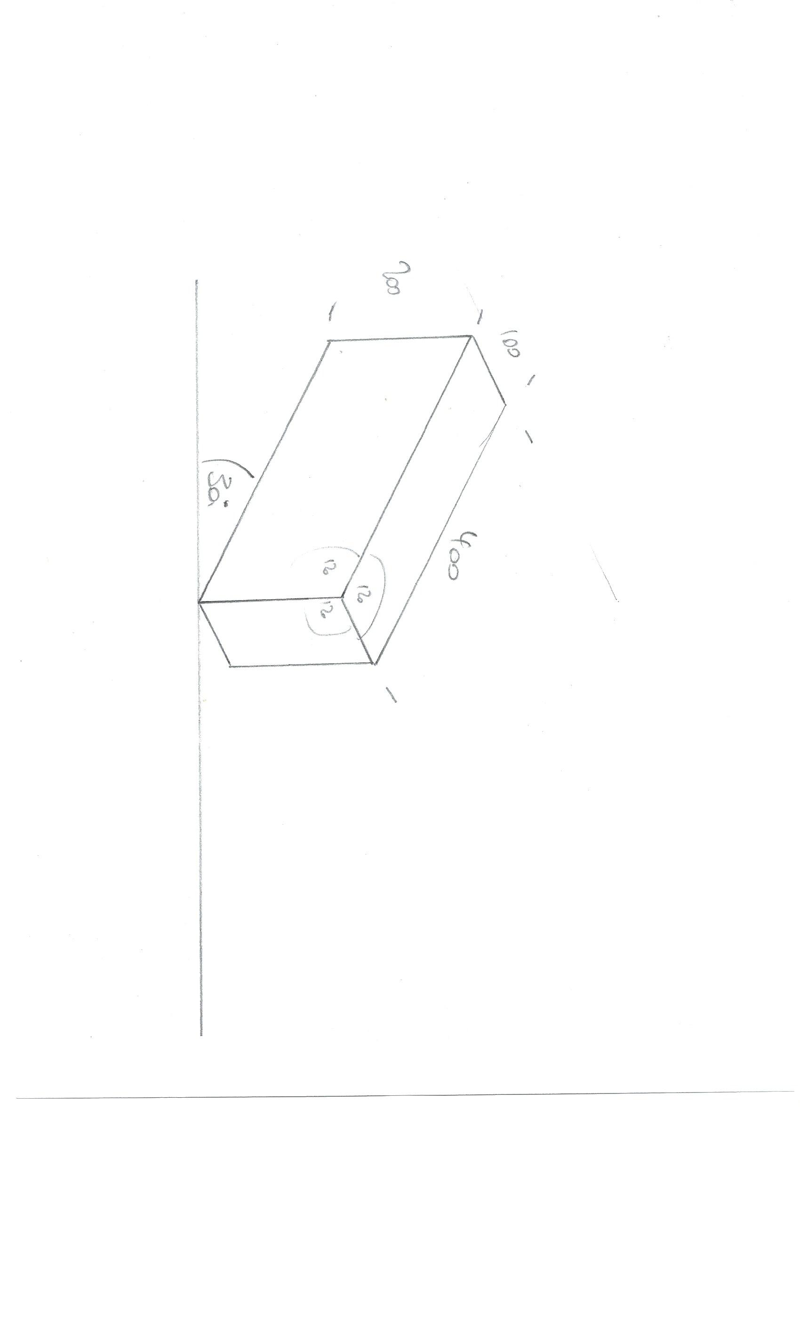

- What is the purpose of perspective projection and representation in drawing of architectural buildings and edifices?

Answer | The purpose of perspective is to show Different aspects of drawings are used to visually represent three-dimensional objects in two dimensions in technical and engineering drawings. These drawings are more complex and show section views and different projections.

- What is a topographical survey?

Answer | Topographic Surveys are used to identify and map the contours of the ground and existing features on the surface of the earth or slightly above or below the earth's surface (i.e. trees, buildings, streets, walkways, manholes, utility poles, retaining walls, etc.).

- What is an ecological survey?

Answer | An ecological survey will identify the habitats and species that currently exist within the area. Most developments have the potential to impact on the local biodiversity of the construction site either through the direct loss of habitats, the reduction in the value of the habitat or the ability of the habitat to support the species that depend on them. By identifying any ecological concerns in the area appropriated action can incorporated into the project sooner rather than later and may avoid construction or approval delays

- What is significant to keep in mind when developing the Schedule of Quantities (also known as a Bill of Quantities)?

Answer | To develop a detailed schedule of quantities you will require the following information to draw from  - Detailed drawings to scale  - Detailed specification  - Detailed scope of works  - -Finishes schedule  - Details of contract conditions

- What should be applied in consideration of stress, load and bearing calculations in the design, the drawings and the building of a structure?

Answer | Where any stress or load bearing calculations are to be applied in the design of a building consideration of the following should be sought  - The National Code of Compliance  - Relevant sections of the AS1684  - Engineers Drawings or recommendations  - Known material properties, limitations and recommended applications for materials available from the manufacturer

- What is a prime cost (PC) item? Give an example.

Answer | A prime cost amount is an agreed amount included in a contract for the purchase of specific items such as  - Door Furniture  - Tapware and fittings  - Tiles  - Doors  - Appliances  Under the Home Building Contracts Act (1991) a builder must estimate the cost of such items at or above the lowest amount these items could reasonably cost

- What is a provisional sum (PS) item? Give an example.

Answer | A provisional sum is an amount of money allocated in a contract for the completion of work not fully detailed at the time of contract. A typical use of a provisional sum would be for site works were obstructions such submerged rocks and tree trunks could cause a cost overrun.  The builder is still legally required to have taken reasonable steps to ensure the PS estimate is as accurate as possible

- Suggest when you would need to provide ‘additional’ plans.
Give some examples of such plans.

Answer | Additional plans may be required in instances when  - If Windows and doors are moved new Sections Drawings and Floor Plans maybe required  - Where walls may have been moved or room layouts changed new Floor plans may be required  - Any changes to the building location or building envelope may require new details Site Plans  - Any structural changes or connection changes may require new Engineering Drawings

- How do you identify and record customer variations?

Answer | A change to the scope of the work to be done under contract, which may involve an increase, decrease or substitution in the contracted work, is known as a variation.  To avoid any errors occurring, all variations to standard building plans require you to update the change on all:  - Building plans  - Contract documents  - Specification

- When reading and interpreting (or amending) variations project specifications, what documentation should you also refer to?

Answer | Any variation paperwork should be read along with the current  - Specifications  - Working Drawing  - Engineering Details  - Contract documents  - Relevant permits

- So you don’t end up in a dispute what strategies can you employ with your customer/client/home owners?

Answer | Some key strategies to out in place to help avoid or resolve a dispute are as follows  - Put all relevant communications in writing, the only exception for this is where it is not practical to produce a document prior to work commencing however it must be completed within 24 hours  - Clients and Subbies must agree to the changes before work commences  - Changes to any terms, including the cost, must be dated and signed by all the parties to the contract  - An extension of time must be submitted were any variations may cause an increase in time frame  - Changes to any terms, including the cost, must be dated and signed by all the parties to the contract

- Name each of the drawing symbol images shown in the table below.

Answer | Name | Image
 | Double brick | 
 | Brick veneer | 
 | Timber stud wall | 
 | Window in cavity wall | 
 | Window in single wall | 
 | Single Leaf 90 deg swung door | 
 | Double Leaf 90 Deg. swung door | 
 | Cavity sliding door | 
 | Wall mount or face sliding door | 
 | General power outlet | 

- Draw symbols for the following items.

Answer | Item | Drawing
 | Basin | 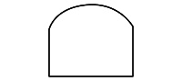
 | Bidet | 
 | Bath | 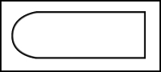
 | Drinking fountain | 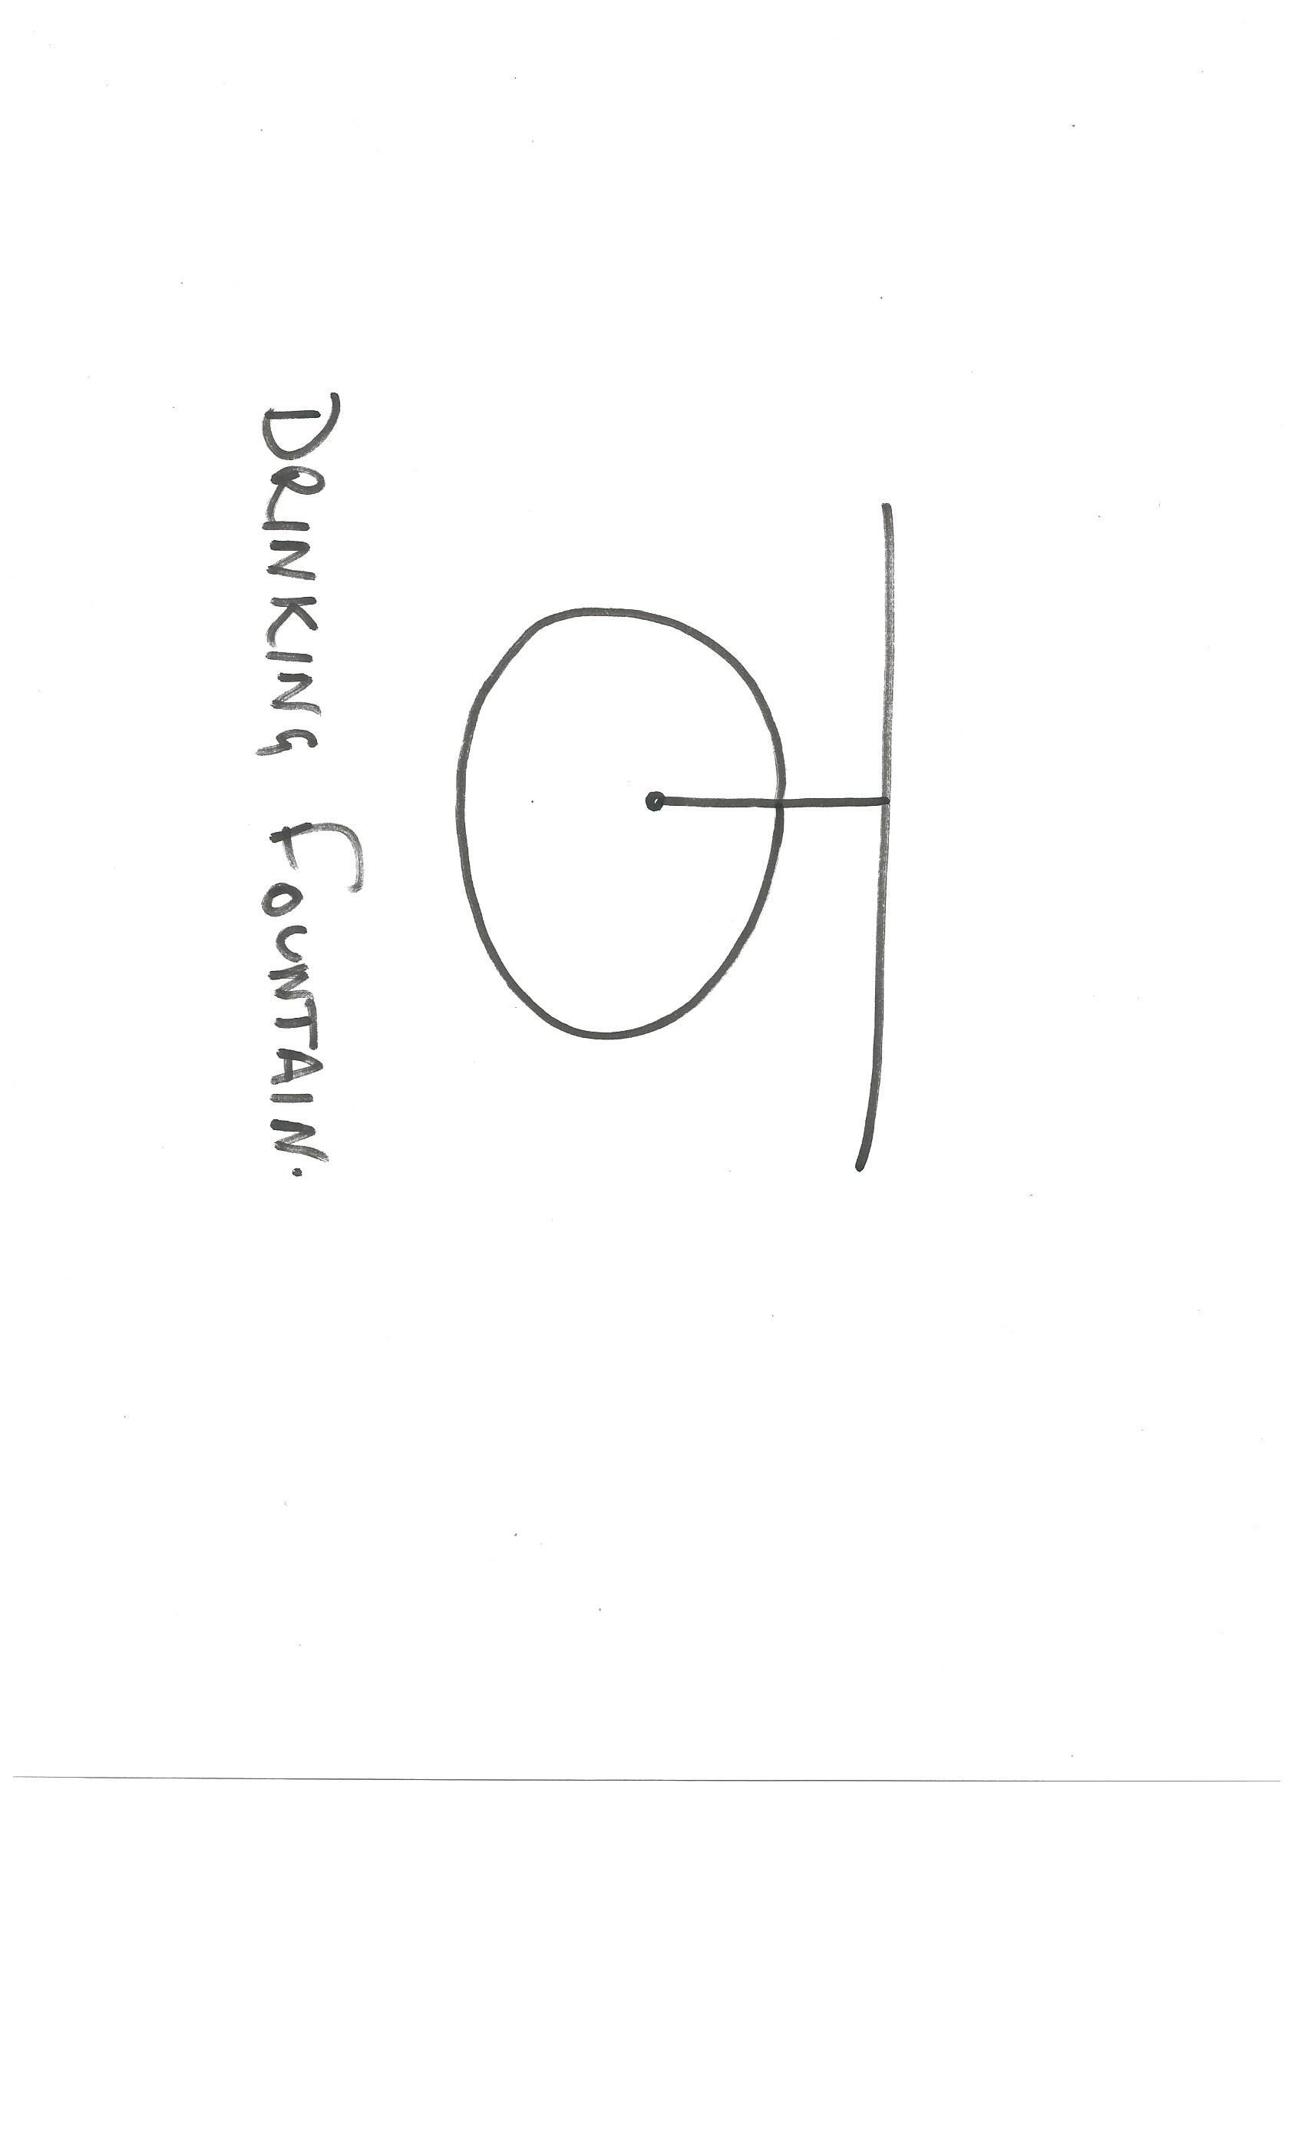
 | Sink: Single bowl | 
 | Sink: Double bowl | 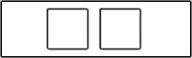
 | Tub: Double | 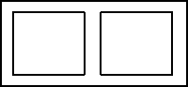
 | Tub: Single | 
 | Drinking trough | 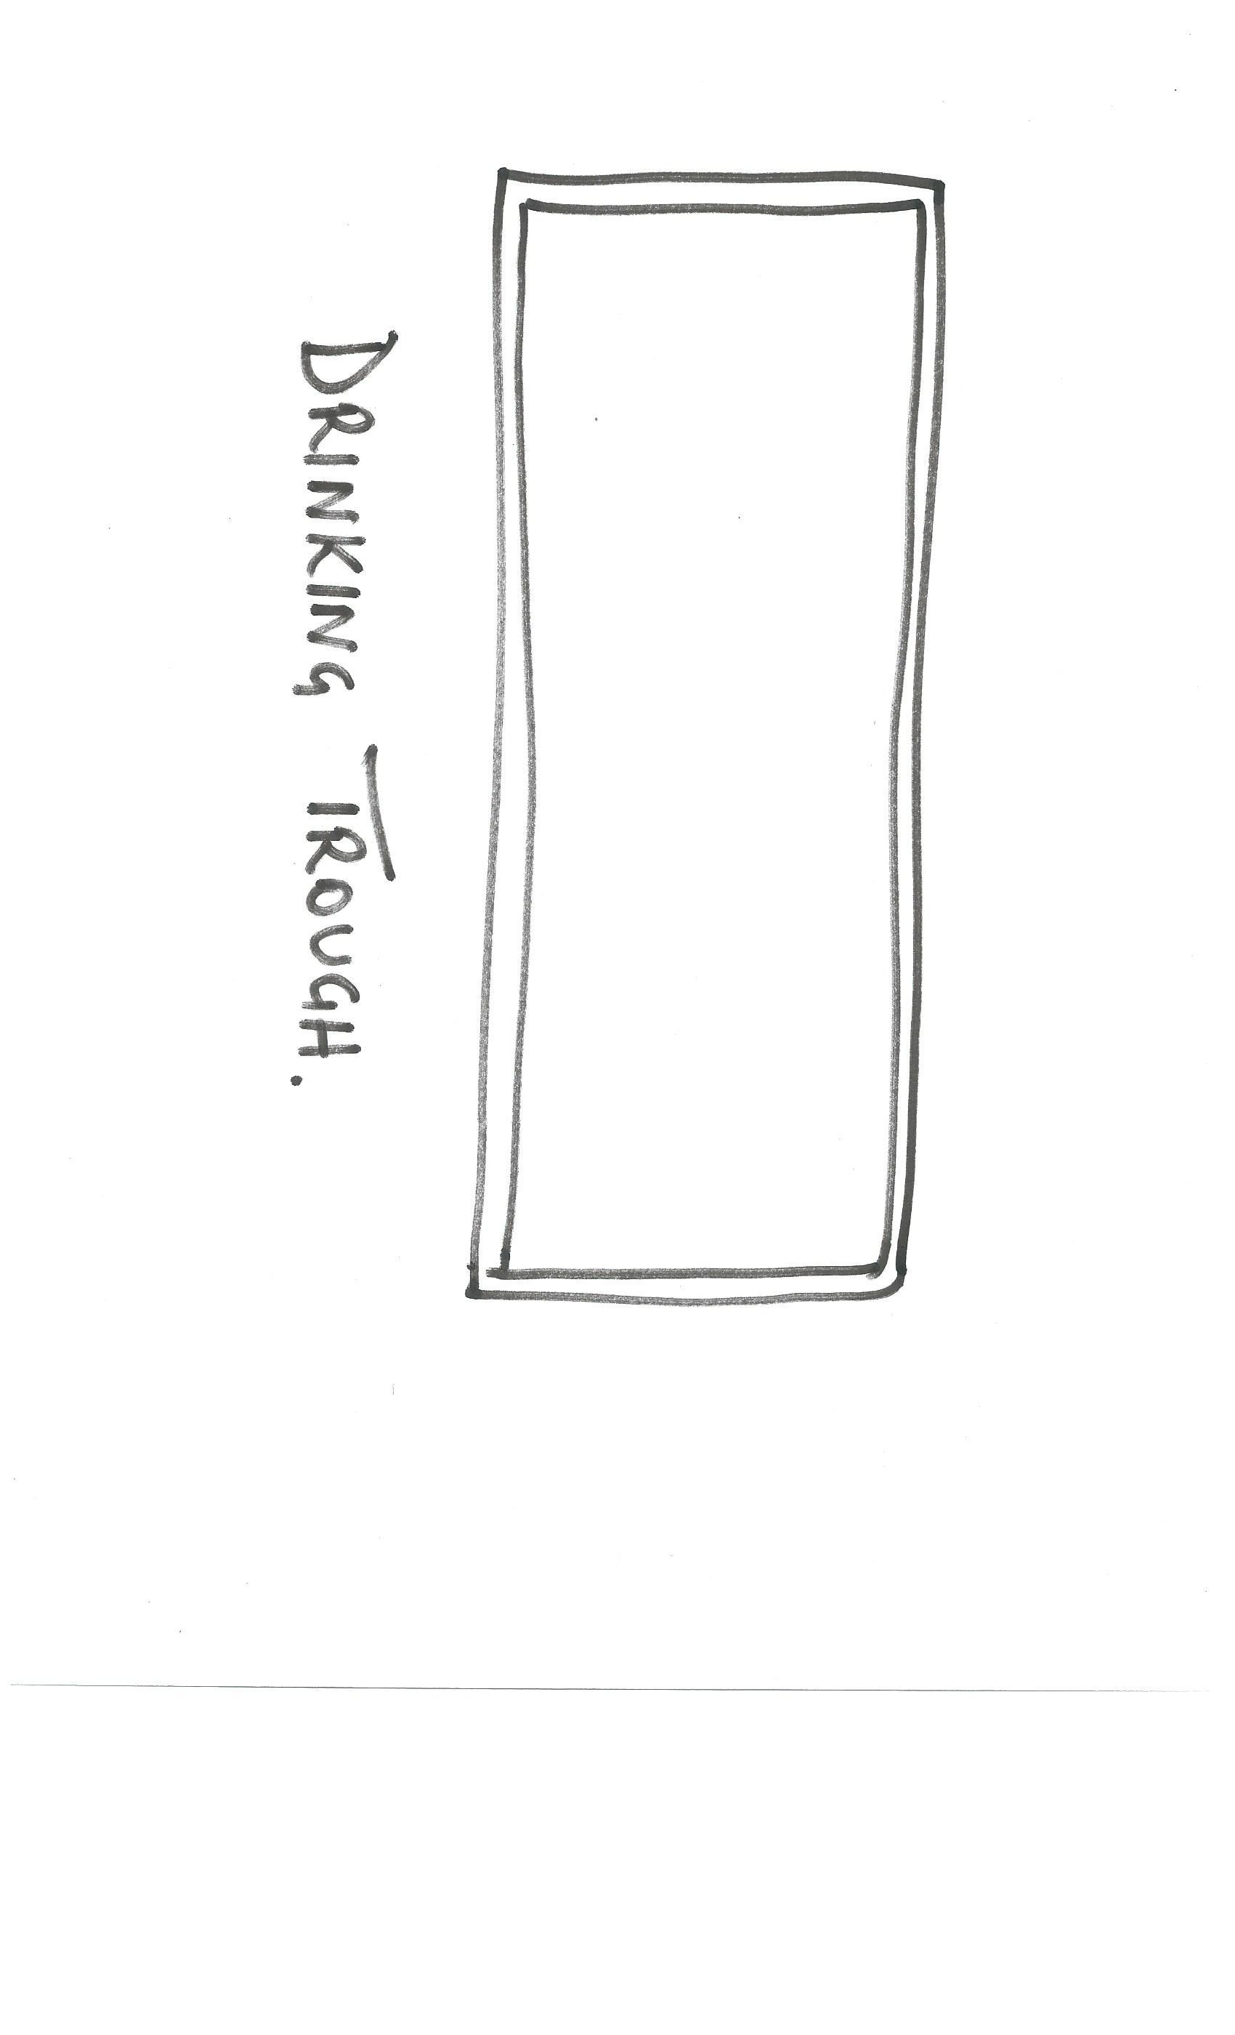
 | Hotplates | 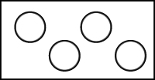
 | Shower | 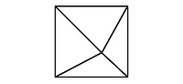
 | Shower bath | 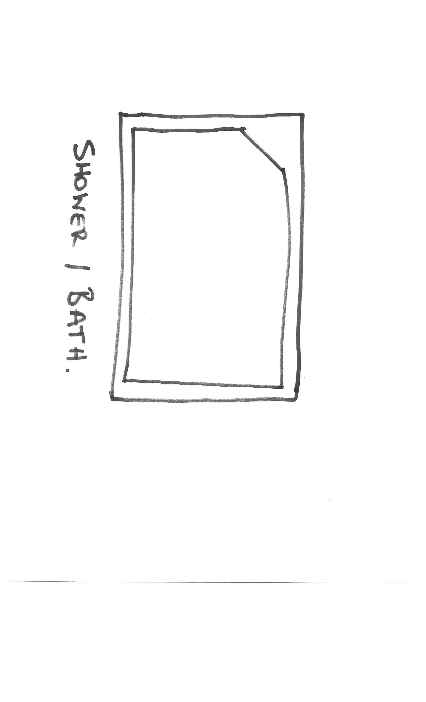
 | Urinal stall | 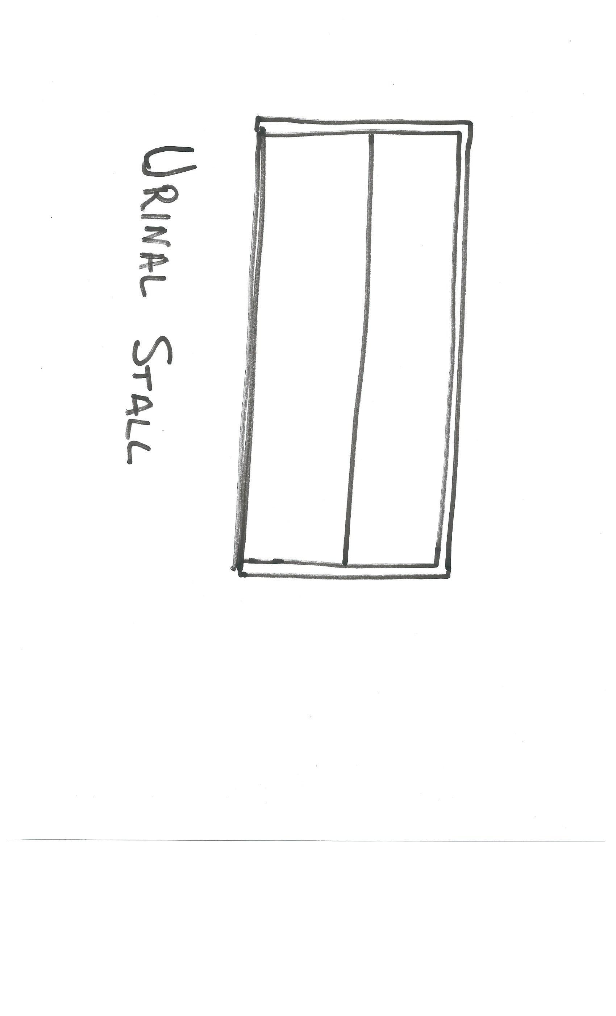
 | Vanity basin | 
 | Water Closet (Toilet) | 

- Draw the following window symbols in elevation.

Answer | Item | Drawing
 | Hinged at side | 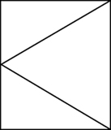
 | Hinged at top | 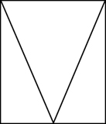
 | Sliding horizontally | 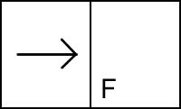
 | Fixed | 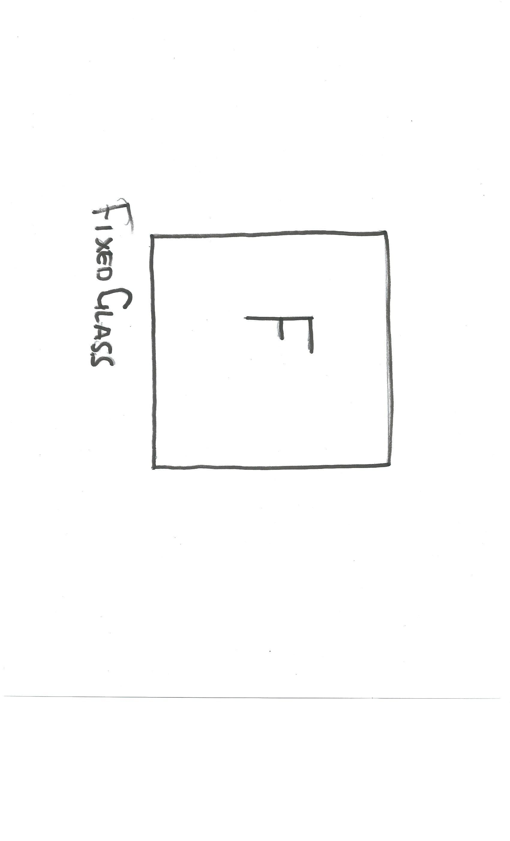

- Draw symbols for the following items.

Answer | Item | Drawing
 | Brickwork | 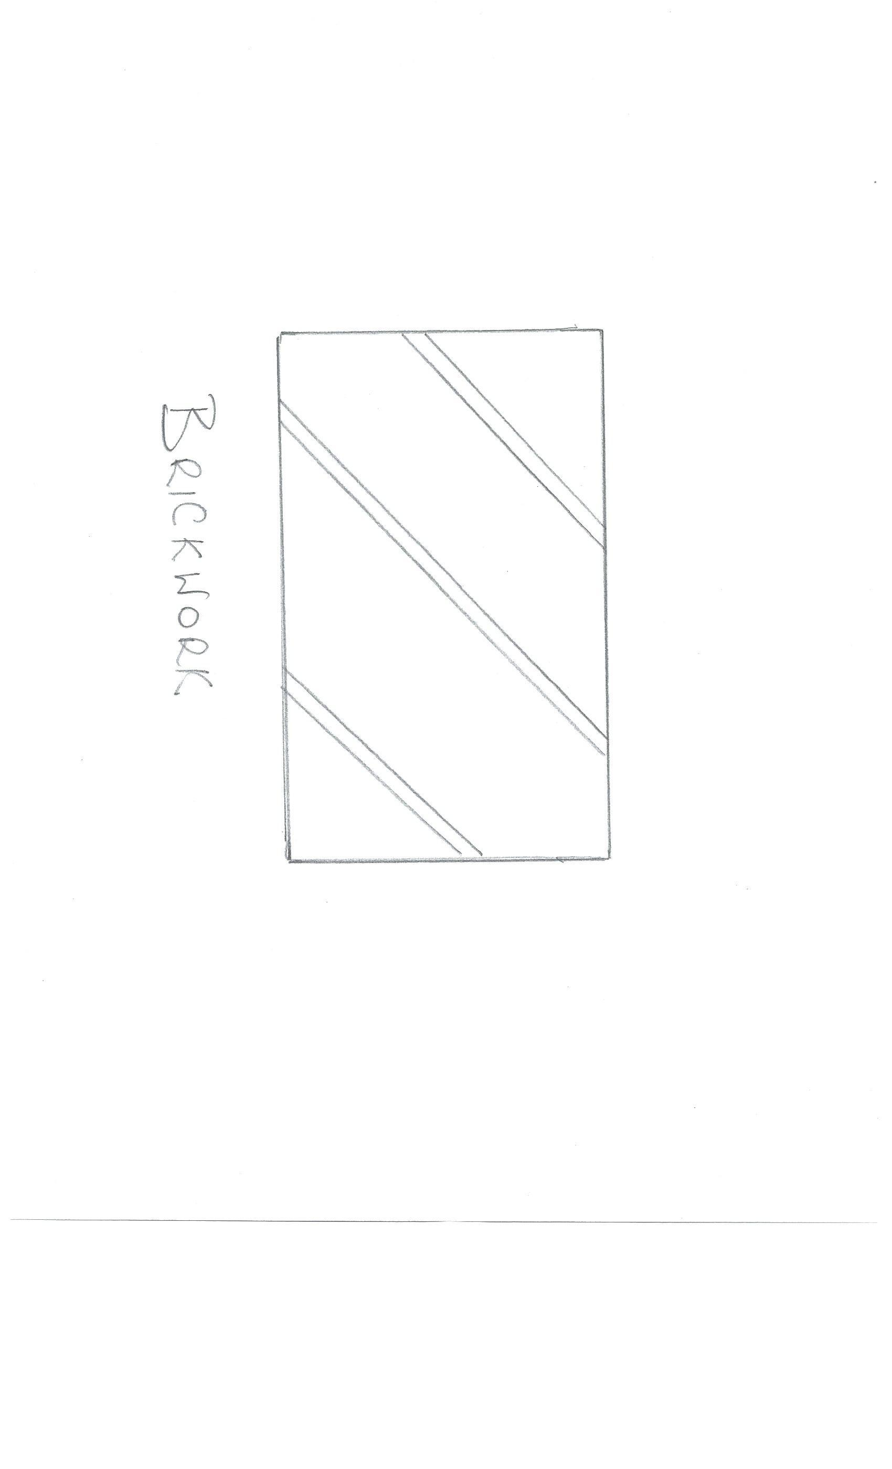
 | Blockwork | 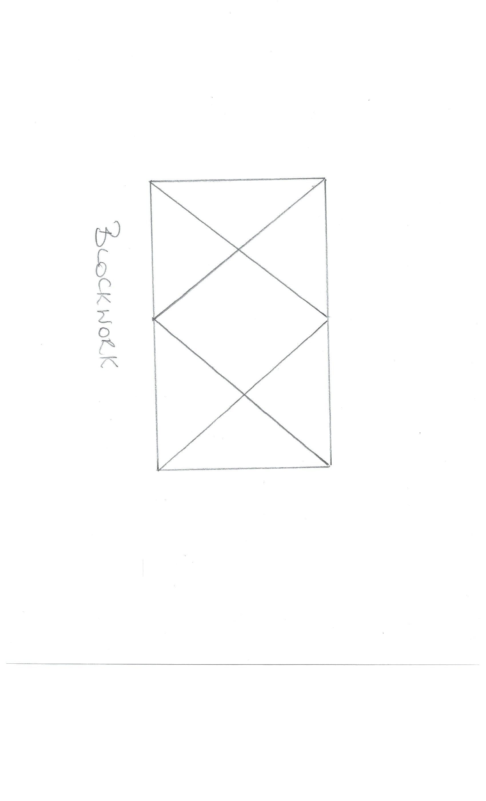
 | Concrete | 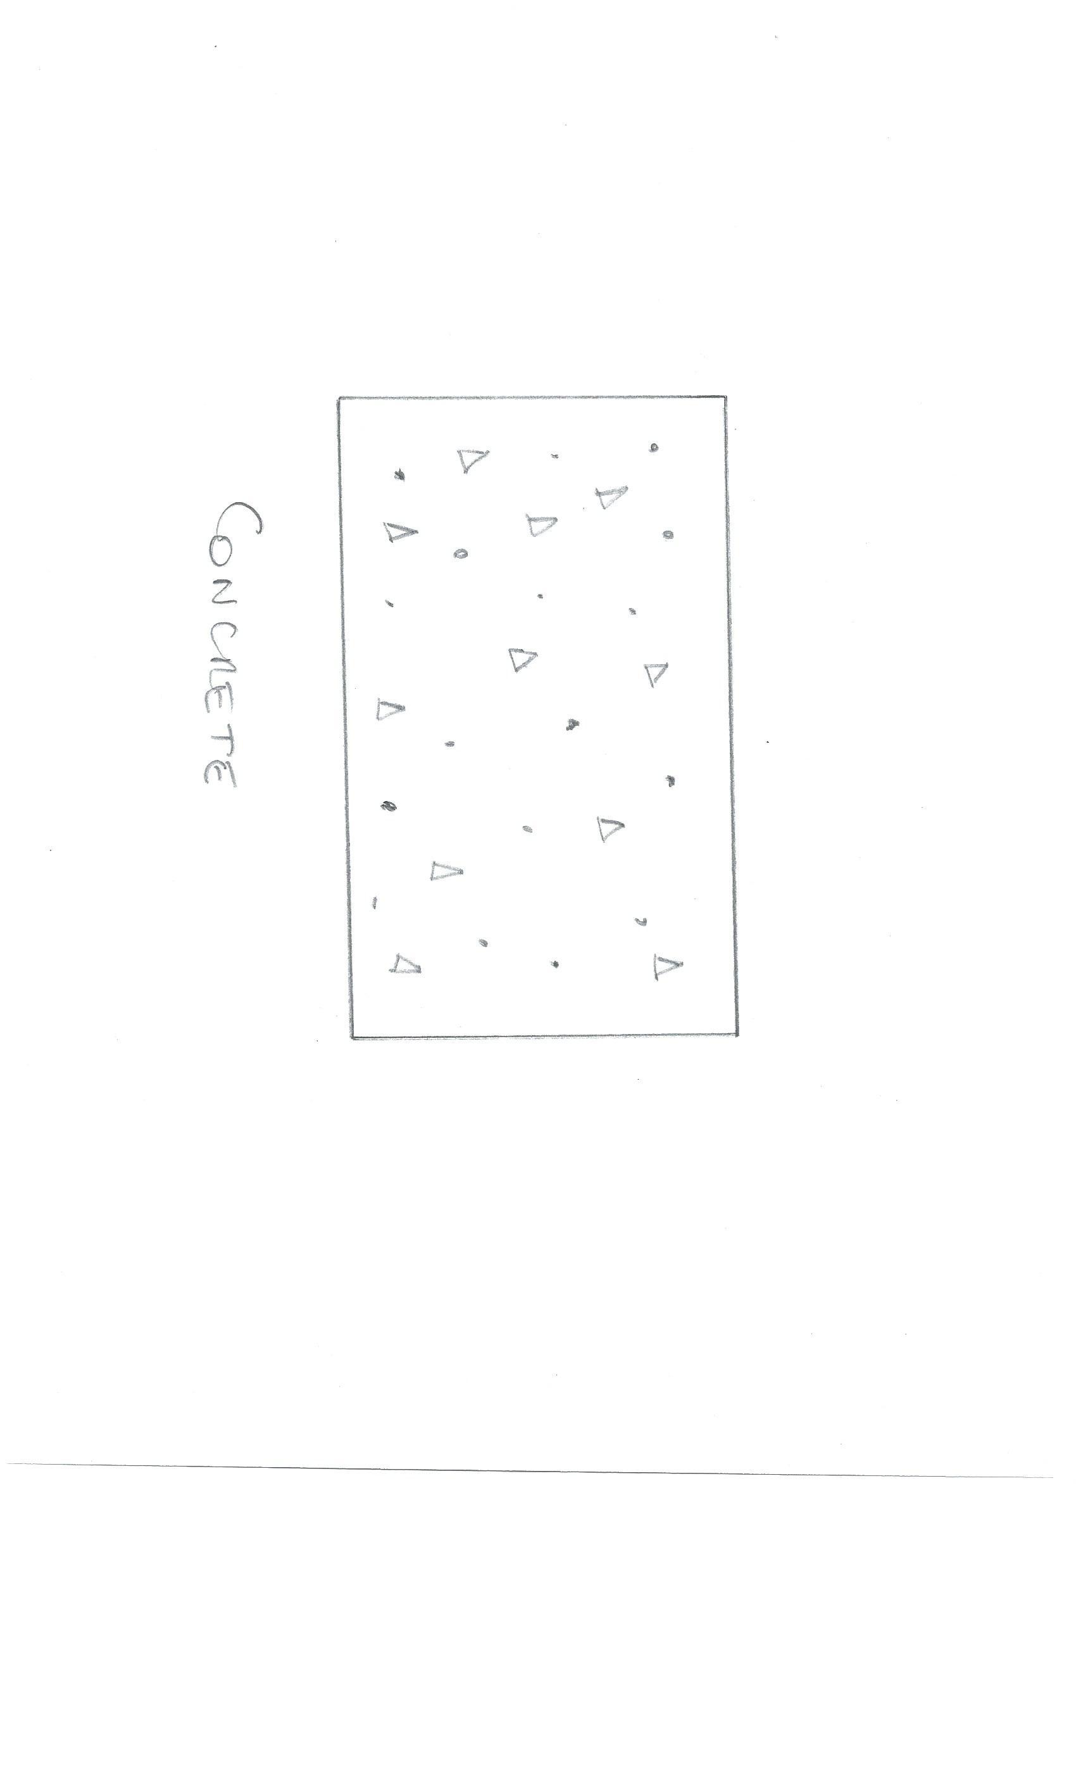
 | Plaster/Render | 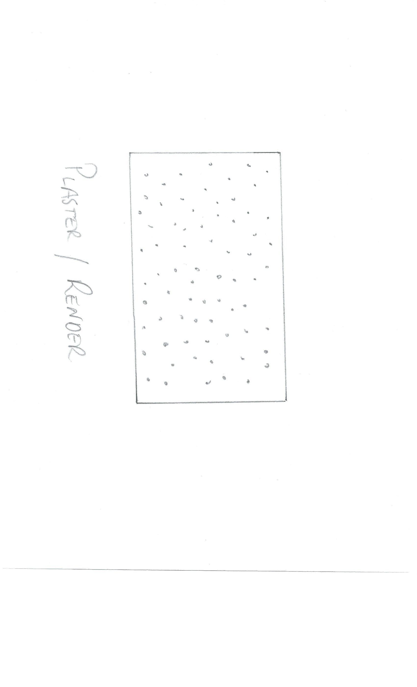

- Provide a description of the residence shown in the plan drawing below.

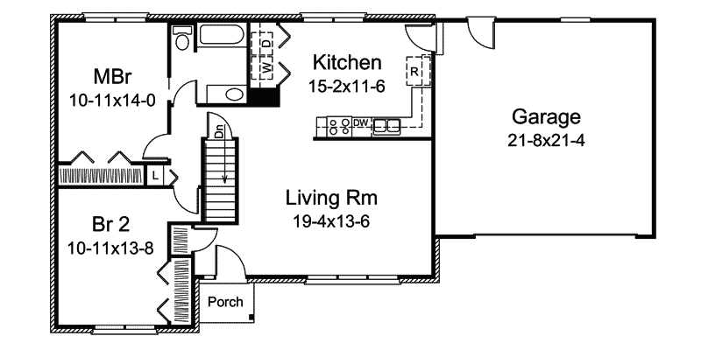

Answer | This is the ground floor of a dwelling containing (2) Bedrooms with built in robes, kitchen and living room with a (2) way bathroom and toilet it also has a garage with internal and external access. The lower walls are of brick veneer construction with the garage being externally clad timber frame.

Refer to the sectional drawing below to respond to Q43. to Q63.


- Give a brief description about the building from the detail available in the sectional drawing.

Answer | This is a (2) Storey dwelling the lower walls are of brick veneer construction. Ground floor is of slab construction with the first floor of engineered joist construction. The upper floor walls are 90mm timber construction clad with timber weatherboards and R1.5 insulation. Roof construction is of prefabricated scissor trusses with Colorbond metal roofing with. Ceiling and walls are line with 10mm Plasterboard and w.r board in wet areas. Ceiling have R2.5 bulk insulation

- Who is the client?

Answer | H & M Smith

- Where is this project to be built?

Answer | Lot 16 Glenvalley Road Richmond

- What are the contact details for the draftsman?

Answer | Joe Forman  Ph – 0395142311  Mob 0413113113  18 Fairview rd  Richmond

- What sheet number is this drawing?

Answer | Lot 16 the actual street number is not shown

- What timber is required for loading and non-load bearing walls?

Answer | Load bearing walls require 90x45 plate non-load bearings wall require 90x 35 plate studs are common and are 90x 35 jamb studs vary with opening sizes

- What spacing is recommended for common studs?

Answer | 600mm

- What type of roof truss is to be installed?

Answer | Prefabricated Scissor trusses with a 30 deg top chord and 20deg bottom chord relative wind speed not shown

- What centres are the trusses positioned at?

Answer | Trusses are at 900mm Centres

- What size are the veranda posts?

Answer | 90 x 90mm DAR Oregon posts

- What timber species are the veranda posts to come from?

Answer | Oregon

- What pitch is the roof?

Answer | 30 degrees

- What size are the noggings and at what spacing?

Answer | Noggings are listed as 70x 35 F5 at max 1350mm spacing

- What size are the ceiling joists?

Answer | The size of the intermediate ceiling joist is not listed on this section drawing

- What timber is used for roof battens and what spacing?

Answer | 70 x 35mm pine roof batten at 900mm centres

- What thickness is the plasterboard sheeting?

Answer | 10mm plasterboard to walls and ceilings

- What type of flooring is to be installed?

Answer | 15mm plywood flooring

- What is the roof cladding material?

Answer | Colorbond corrugated metal

- Where will you find information about the footings?

Answer | Engineers drawings

- What do the letters DAR refer when timber ordering?

Answer | Dressed all round

- Explain 240 x 63 LVL. What does it refer to on the section?

Answer | The 240mm high by 63mm wide laminated veneered lumber is to be used as the starting joist or ‘edge beam “on both sides of the building and is to be used as a continuous length

Refer to the drawing overleaf to respond to Q64. to Q75.

- What is the number of the drawing?

Answer | 2

- What is the Job Number?

Answer | OOR-112

- What is the scale of the drawing?

Answer | 1:100

- What does the drawing show?

Answer | This is primarily an elevation drawing showing  - Roof type and pitch  - Gable Feature  - Window and door types  - Roof height  It also has a small section drawing showing  - Wall height  - Soffit overhang and treatment  - Truss type  - Some linings detail

- Which view shows the front of the house?

Answer | East elevation

- How many motor vehicles can be parked in the garage?

Answer | 2

- What are the window and doors made from?

Answer | Selected timber entrance and side door. With aluminium windows and sliding door. Colorbond roller doors

- What is the size of the eaves?

Answer | 450mm

- What are the eaves lined with?

Answer | Hardiflex

- What type of roof structure is the roof built from?

Answer | 22.5-degree Prefabricated timber trusses at 600mm centres

- What is the roof cladding materials made from?

Answer | Concrete roof tiles

- What is the roof pitch?

Answer | 22.5 degrees



- You have spoken with a client on the phone and they are seeking to make amendments to some plans. They wish to add two more bedrooms to extend their home from the current four bedrooms to six bedrooms.
The two new bedrooms are to both have ensuites (including single shower in each, double bowl vanity unit and under cupboard and toilet) with walk in robes, including the extension of the existing hallway with built-ins for the existing Bed 1 and Bed 2. The Family Room is to be extended to the rear wall in line with kitchen rear wall.
The client has faxed through the image below. Re-sketch and redesign the drawing and add the two new bedrooms along with extended hallway, ensuites, walk-in robes and the Family Room extension for consideration by the client.
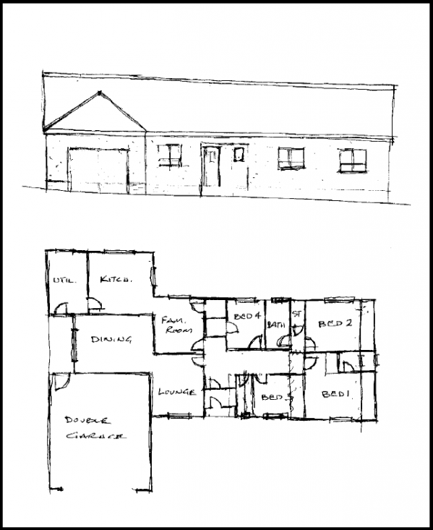
SKETCH
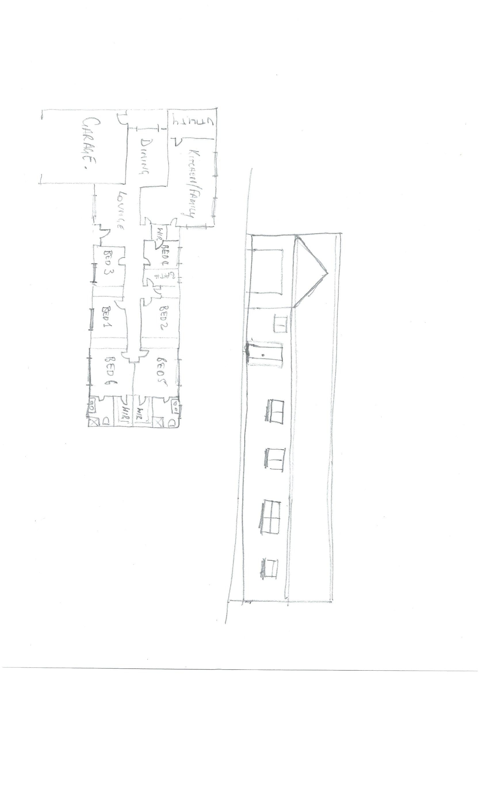

Answer

- Referring to Q76. compose an email to the client, providing an estimate of the additional labour hours/costs and material quantities/costs that have resulted from the their request.

Answer | Dear Client  Please find attached a revised sketch which now shows the Family Room extended to be inline with the rear Kitchen wall, the addition of Bedrooms 5 and 6 including an Ensuite and Walk in Robes to both bedrooms and the inclusion of Built in Robes to Bedrooms 1 and 2.  Please find listed below a preliminary cost estimate for the requested changes  Drawings and Engineering $ 2000.00  Excavation Provisional Sum $ 5000.00  Labour 150hrs @ $90 $ 13500.00  Materials $ 35000.00  Total $ 55500.00  Please note this is a Preliminary costing and may vary with Final Engineering Details and Final Product Sections.  If you have any queries or would like to discuss anything further, please don’t hesitate to contact me.  Kind Regards  Justin

