CPCCBC4002A
Manage occupational health and safety in the building and construction workplace
ASSESSMENT SUMMARY

The assessment activities for CPCCBC4002A Manage occupational health and safety in the building and construction workplace cover all aspects of the unit of competency required. To demonstrate competence in this unit, a participant must undertake all tasks and complete them satisfactorily and consistently. For Apprentices and Trainees, this includes employer completion of the Employer Record Book (ERB).

Participants must read all the information given before starting any assessment task. The assessment tasks are intended to be equitable, fair and flexible. If a participant has any questions or requires alternative arrangements to be made such requests should be directed to their Trainer/Assessor, who should note such arrangements in the ‘Assessor Comments’ on the affected assessment. If a participant feels they are not yet ready to be assessed, they should discuss their options with their Trainer/Assessor.

To satisfactorily complete the assessment, the participant is required to answer all questions correctly and demonstrate their skills to industry standards. If a participant does not answer some questions or perform some tasks, they will be deemed ‘Not Satisfactory’ for the task and ‘Not Yet Competent’ for the unit of competency. The Trainer/Assessor is able to provide the participant with additional information on interpreting the assessment outcomes and provide guidance on the participant’s options. Should a participant still be deemed ‘Not Satisfactory’ they will have the opportunity to undertake a supplementary assessment or appeal the result.

By signing the cover page for each assessment item, the participant acknowledges they understand the assessment instructions and requirements and consent to being assessed. The participant also verifies and assures the RTO that the work submitted is their own work.

Participant Name | Corey Passey

Task | Assessment Results
Theory Exam | Satisfactory | Not Yet Satisfactory
Practical Assessment | Satisfactory | Not Yet Satisfactory
Outcome for Unit of Competency | Competent | Not Yet Competent

Assessor Name
Assessor Signature | 
Unit Competence Determination Date | Click here to enter a date.

CPCCBC4002A
Manage occupational health and safety in the building and construction workplace

THEORY EXAM INSTRUCTIONS

- This exam will occur under standard assessment conditions.
  - An oral examination may be allowed under certain circumstances, whereby the Participant’s answers will be documented by a party other than the Participant. This must be acknowledged in writing (e.g. FT001 and Assessor Comments)
- Participants must provide enough detail in their responses to demonstrate their knowledge and skills.
- Please fill in the details below, providing your name, signature and date of assessment.
  - Your signature acknowledges that this is your own work.
- Assessors are to complete marking in pen of a different colour to the Participant.
- If a Participant initially answers a question incorrectly but modifies their response, they must follow the instructions below:
  - If a Participant changes their response in writing, they must put their initials next to the written change.
  - If a Participant changes their response verbally, this must be noted on the exam paper by the assessor.

Participant name | Corey Passey
Participant signature | 
Date | 23/05/2022

Assessor name | Mark Harris
Assessor signature | 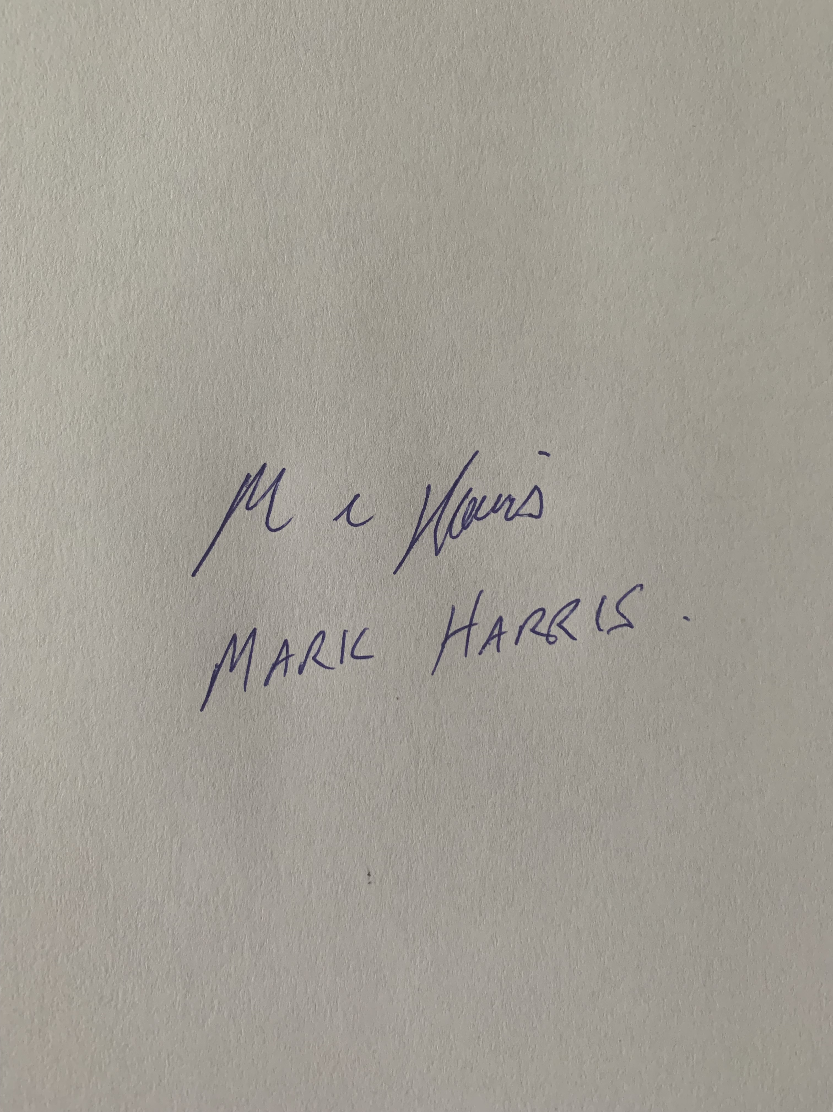
Date | 23/05/2022

Number of questions | Number of questions answered correctly | Task outcome (Tick)
28 |  | Satisfactory | Not Yet Satisfactory
Assessor Comments
- For each of the common building and construction jobs listed below, identify one (1) hazard specific to that job.

Answer | Job | Risks
 | Construction equipment use (e.g. power tools, concrete mixers) | noisy machinery  Sharp blades, machinery  Ensure guards are fitted and working  Lacerations/amputation due to contact with blade
 | High risk construction equipment use (e.g. lasers, EPT) | Anything electrical, sharp could cause injury or death, eyes sight protection
 | Crane use | Risk of things falling from above, powerlines
 | Demolition | Falling objects, dangerous environment, sharp objects, asbestos
 | Formwork | Collapse of formwork  Maybe working at heights depending on the construction
 | Scaffolding use | Falling from heights, causing injury  Scaffolding, edge protection, harness
 | Work at heights | Risk of falling to death or serious injury  Use of harnesses
 | Welding | Eye sight damage, possible burns

- Using the risk table below, determine the level of risk for each of the hazards identified in Q1. Identify how each risk level was determined, by identifying the likelihood and consequences of each hazard.
Matrix | A:  Death or permanent disability | B:  Serious injury | C:  Lost time injury | D:  Casualty Treatment | E:  First Aid
1: Very Likely | E | E | H | H | M
2: Likely | E | H | H | M | M
3: Possible | H | H | M | M | L
4: Unlikely | H | M | M | L | L
5: Very Unlikely | M | M | L | L | L

E: Extreme | H: High | M: Medium | L: Low

Answer | Job | Level of risk
 | Construction equipment use (e.g. power tools, concrete mixers) | 2 B Likely serious injury
 | High risk construction equipment use (e.g. lasers, EPT) | 1 A Anything high risk in construction could lead to death or permanent injury
 | Crane use | 3 B Possible serious injury or even death
 | Demolition | 3 C Just thinking about a small house demo
 | Formwork | 3 C Just imaging single story formwork
 | Scaffolding use | 1 A All scaffolding work is high risk
 | Work at heights | 1 A again all working from heights could result in a fall to someones death
 | Welding | 3 CD possible injury, burn or blinding

- Identify an appropriate control measure for each of the hazards identified in Q1.

Answer | Job | Control measure
 | Construction equipment use (e.g. power tools, concrete mixers) | Correct PPE gear is worn and power tools are tagged  Safety guards are working on saws
 | High risk construction equipment use (e.g. lasers, EPT) | Correct PPE worn
 | Crane use | Signage and person observing and making sure everyone is clear from the area
 | Demolition | PPE worn and site kept clean and tidy
 | Formwork | Depending on the job, correct PPE worn and
 | Scaffolding use | Use a licensed installer and make sure the site is clean  Ensure guards are fitted and working
 | Work at heights | PPE and use of harnesses
 | Welding | PPE welding mask and correct clothing is worn

- True or False (Tick your response): Risk control options can come from both internal sources (e.g. policies and procedures) and external sources (e.g. codes and standards).

Answer |  | True
 |  | False

- Name two (2) workplace personnel you may speak to for safety advice.

Answer | A Manager  B Supervisor

- Referring to the WHS Regulations, explain how the following documents contribute towards identifying hazards and risks in the workplace.

Answer | Document | Description
 | Safe Work Method Statements | To fully identify hazards, as well as assess and control risks, you need to access information and data to be fully informed about the range of occupations in your workplace.  SWMS (swims)  The primary purpose of a SWMS is to help supervisors, workers and any other persons at the workplace to understand the requirements that have been established to carry out the high risk construction work in a safe and healthy manner.  The SWMS:  - sets out the work activities in logical sequences  - identifies hazards  - describes control measures.
 | Site Safety Plan / WHS Management Plan | A work health and safety (WHS) management plan can assist principal contractors to manage their workplace health and safety obligations.  The principal contractor for a construction project must prepare a written WHS management plan for the workplace before work on the project commences, identifying any potential hazards and risks.

- Identify two (2) advisory standards you might refer to safely undertake building and construction work and briefly summarise their requirements.

Answer | Standard name | Requirements
 | Asbestos Advisory Standards | - the workplace's register of asbestos  - details of maintenance or service work on the asbestos including:  - who performed the work  - the dates it was done  - the scope of the work  - any clearance certificates (see clearance inspections, How to Manage and Control Asbestos in the Workplace Code of Practice 2021 (PDF, 1.1 MB)  - how people at risk are informed about asbestos in the workplace, the risks they pose and the control measures in place  - decisions about management options and the reasons for these decisions  - a timetable for action, including priorities and dates for reviewing risk assessments and specific circumstances that may affect the timetable  - monitoring arrangements  - the responsibilities of people involved in the plan  - training arrangements for workers and contractors  - a procedure for reviewing and updating the management plan and the register of asbestos, including a timetable  - safe work methods.
 | Demolition Advisory Standard | Demolition work code of practise 2021 outlines the guidelines and requirements.  Construction work requirements in the Work Health and Safety Regulation 2011 (WHS Regulation) apply to demolition work generally, however, where the structure to be demolished contains asbestos, there are some additional requirements that apply.

Building and construction industry contracts require building legislation and the National Construction Code to be observed. Refer to these documents when responding to Q8. to Q10.

- Identify the requirements in the National Construction Code Volume 1 with regards to air pressurisation for fire-isolated exits. Identify the relevant section of the Code and the Australian Standard referenced.

Answer | Code section(s) | Requirements and Standards
 | NCC Vol 1  Part D1.3 | (a)  Class 2 and 3 buildings — Every stairway or ramp serving as a required exit must be fire-isolated unless it connects, passes through or passes by not more than—  (i)  3 consecutive storeys in a Class 2 building; or  (ii)  2 consecutive storeys in a Class 3 building,  and one extra storey of any classification may be included if—  (iii)  it is only for the accommodation of motor vehicles or for other ancillary purposes; or  (iv)  the building has a sprinkler system (other than a FPAA101D system) complying with Specification E1.5 installed throughout; or  (v)  the required exit does not provide access to or egress for, and is separated from, the extra storey by construction having—  (A)  an FRL of –/60/60, if non-loadbearing; and  (B)  an FRL of 90/90/90, if loadbearing; and  (C)  no opening that could permit the passage of fire or smoke.  (b)  Class 5, 6, 7, 8 or 9 buildings — Every stairway or ramp serving as a required exit must be fire-isolated unless—  (i)  in a Class 9a health-care building — it connects, or passes through or passes by not more than 2 consecutive storeys in areas other than patient care areas; or  (ii)  it is part of an open spectator stand; or  (iii)  in any other case except in a Class 9c building, it connects, passes through or passes by not more than 2 consecutive storeys and one extra storey of any classification may be included if—  (A)  the building has a sprinkler system (other than a FPAA101D system) complying with Specification E1.5 installed throughout; or  (B)  the required exit does not provide access to or egress for, and is separated from, the extra storey by construction having—  (aa)  an FRL of –/60/60, if non-loadbearing; and  (bb)  an FRL of 90/90/90 for Type A construction or 60/60/60 for Type B or C construction, if loadbearing; and  (cc)  no opening that could permit the passage of fire or smoke.  SA D1.3(b)(iv)

- Identify the requirements in the National Construction Code Volume 2 with regards to smoke alarms. Identify the relevant section of the Code and the Australian Standard referenced.

Answer | Code section(s) | Requirements and Standards
 | Part 3.7.5.2 | Smoke alarms must—  (a)  be located in—  (i)  Class 1a buildings in accordance with 3.7.5.3 and 3.7.5.5; and  (ii)  Class 1b buildings in accordance with 3.7.5.4 and 3.7.5.5.  (b)  comply with AS 3786, except that in a Class 10a private garage where the use of the area is likely to result in smoke alarms causing spurious signals, any other alarm deemed suitable in accordance with AS 1670.1 may be installed provided that smoke alarms complying with AS 3786 are installed elsewhere in the Class 1 building; and  (c)  be powered from the consumer mains source where a consumer mains source is supplied to the building; and  (d)  be interconnected where there is more than one alarm.

- Name the building legislation (Act and Regulations) that apply within your jurisdiction.

Answer | Queensland Building and Construction Commission

- Which of the following should be considered when developing a risk control plan? Tick all that apply.

Answer | Choice | Possible Answers
 |  | How and when controls will be implemented
 |  | Evaluation processes for implemented controls
 |  | Consultation with individuals and parties
 |  | Responsibilities for implementation

- True or False (Tick your response): If control measures do not adequately control risks, they must be revised.

Answer |  | True
 |  | False

- Which of the following are appropriate techniques, tools and processes for identifying hazards and risks? Tick all that apply.

Answer | Choice | Possible Answers
 |  | Workplace inspections
 |  | Compensation claim information
 |  | Safe Work Method Statements
 |  | Information issued by WHS regulators

- Which of the following can be used to assist with workplace inspections? Tick all that apply.

Answer | Choice | Possible Answers
 |  | Hazard and risk checklists
 |  | Job Safety Analysis (JSA)
 |  | Manifests and registers
 |  | Surveys
 |  | Workplace walk-through

- Which of the following are limitations of using a generic hazard/risk assessment checklist? Tick all that apply.

Answer | Choice | Possible Answers
 |  | Specifics of the workplace are not considered
 |  | Not all checklist points will be applicable
 |  | Such checklists/processes must be completed on a computer
 |  | You always have to purchase these checklists

- Identify the applicable WHS Act in your jurisdiction. Identify its requirements for PCBUs with regards to identifying hazards and risks.

Answer | Act name and section(s) | Requirements
 | Sections 103E and 103F of the Work Health and Safety Act 2011 (Qld) | 103E Assessment reports (1) The work health and safety officer must— (a) prepare a report (an assessment report) for the assessment carried out under section 103D(1); and (b) if the assessment identifies any risks to health and safety arising from the work carried out as part of the conduct [s 103F] Work Health and Safety Act 2011 Part 5A Work health and safety officers Current as at 14 September 2020 Page 95 Authorised by the Parliamentary Counsel of the business or undertaking—include in the report recommendations about managing the risks. (2) The work health and safety officer must, within 30 days after the assessment has been carried out, give a copy of the assessment report to— (a) if the work health and safety officer is not the person conducting the business or undertaking—the person conducting the business or undertaking; and (b) if there is a health and safety committee at the business or undertaking—the committee. 103F General obligations of person conducting business or undertaking to work health and safety officer (1) This section applies to a person conducting a business or undertaking if the person has appointed another person as a work health and safety officer for the business or undertaking. (2) The person conducting the business or undertaking must— (a) give the work health and safety officer information that the person has about risks to the health and safety of workers and any other person at the business or undertaking; and (b) with the consent of a worker, allow the work health and safety officer to be present at an interview concerning work health and safety matters between the worker and the person; and (c) consult, so far as is reasonably practicable, with the work health and safety officer about any proposed changes to workplace practices that affect, or may affect, work health and safety at the business or undertaking; and (d) allow the work health and safety officer to inspect the business or undertaking and carry out assessments at the business or undertaking during normal working hours; and [s 103G] Work Health and Safety Act 2011 Part 5A Work health and safety officers Page 96 Current as at 14 September 2020 Authorised by the Parliamentary Counsel (e) take appropriate action to manage— (i) any hazards and risks notified to the person by the work health and safety officer or included in an assessment report prepared by the work health and safety officer; and (ii) any incidents or immediate or imminent risks that have been notified to the person by the work health and safety officer; and (f) provide resources and assistance to the work health and safety officer that are reasonably necessary to enable the officer to exercise the officer’s functions under this Act; and (g) keep an assessment report given to the person for at least 5 years. Maximum penalty—50 penalty units. (3) The person conducting the business or undertaking may instruct the work health and safety officer to take reasonable action to eliminate or minimise risks to health and safety.

- Identify the applicable WHS Regulation in your jurisdiction. Identify its requirements for PCBUs with regards to identifying hazards and risks.

Answer | Regulation name and section(s) | Requirements
 | Work Health and Safety Regulations 2011 | Step 1 – Identify Hazards  Step 2 – Assess the risk  Step 3 – Control the risks  Step 4 – Reviewing Controls

- Identify a relevant policy in your organisation with regards to identifying hazards and risks and briefly describe its requirements.

Answer | Policy name | Requirements
 | Hazard Co | We use Hazard Co APP for all of our WHS on site, it requires all the relevant subcontractors to sign into site and provide all their SWIMS and paper work , it also identifies any potential hazards on site etc.

- Identify the statutory requirements in your jurisdiction with regards to the completion of inspection reports.

Answer | Legislation name and section(s) | Requirements
 | Work Health and Safety Act 2011 (Qld) | Inspection reports must be completed as they are an important risk management tool that can assist you to:  Identify health and safety hazards (existing and potential)  Assess policies and procedures – progress and impact  Ensure staff from all levels are responsible for WHS  Check workplaces to sight real work in practical risk management activities  Recommend corrective actions using completed inspections (formal records)

- Which of the following individuals and parties may require information about workplace hazards and proposed risk controls?
Tick all that apply.

Answer | Choice | Possible Answers
 |  | Health and Safety Committees
 |  | PCBU
 |  | All members of the public
 |  | Workers

- Identify the requirements in the Code of Practice with regards to consulting parties when managing risks.

Answer | Legislation name and section(s) | Requirements
 | Code of Practice 2013 (Qld)

- Identify the requirements in the Code of Practice with regards to consulting parties when developing procedures for communicating WHS policy and practice requirements.

Answer | Legislation name and section(s) | Requirements
 | Code of Practice 2011

- Name three (3) parties who should consult to determine effective strategies for communicating WHS policy and practice.

Answer | - Management  - Health and Safety Representatives  - Designated work groups  - Health and safety committees

- Name two (2) communication strategies that may be used in the building and construction industry.

Answer | - Issued site specific instructions and signage  - Verbal communications

- Name two (2) education programs that may be implemented in the building and construction industry.

Answer | - General and site-specific induction training  Other forms of specialist and targeted training

- Fill in the blanks for the statement below:
The ‘How to manage work health and safety risks Code of Practice 2011’ identifies that control measures are more effective when ______________________ is provided and when workers are _____________________.
Consulted
Training

Answer

- Explain why it is important to review the effectiveness of communications and educational programs.

Answer |  identify hazards – find out what could cause harm  assess risks if necessary – understand the nature of the harm that could be caused by the hazard, how serious the harm could be and the likelihood of it happening  control risks – implement the most effective control measure that is reasonably practicable in the circumstances  review control measures to ensure they are working as planned.  How to manage work health and safety risks Code of practice 2011 (Qld):

- List three (3) methods for reviewing the effectiveness of communication and educational programs.

Answer | - Evaluating training programs for effectiveness  - For example: reviewing incident reports/trends  - Ensuring employees have an adequate understanding  - Reviewing training materials for accuracy of content, currency and suitability  - Conducting post-training surveys  Conducting regular reviews of training needs

CPCCBC4002A
Manage occupational health and safety in the building and construction workplace

PRACTICAL ASSESSMENT INSTRUCTIONS

- The following practical assessment will require the Participant to complete work related activities.
- The Assessor will conduct observations of the Participant’s work to determine whether they display sufficient practical skills and knowledge.
- Please fill in the details below – providing your name, signature and date of assessment.
  - The Participant’s signature acknowledges that the Assessor provided clear instructions and the Participant understood what was required to complete this assessment.
- The Assessor may substitute a Practical Task with an alternate task of equal value.
  - Alternate tasks must be fully documented by the assessor in the Assessor Comments area.

Participant name | Corey Passey
Participant signature
Date | 23/05/2022

Assessor name | Mark Harris
Assessor signature
Date | 23/05/2022

Task | Task outcome (Tick)
Task | Satisfactory | Not Yet Satisfactory
Task 1 (Occasion 1)
Task 1 (Occasion 2)

Assessor Comments
CPCCBC4002A
Manage occupational health and safety in the building and construction workplace

Practical Task 1 (2X)
Description of task:
On two (2) occasions, a suitable observer is to verify the participant’s ability to conduct and report on a WHS risk analysis, including workplace inspection.

The participant is to gather evidence of how they have completed each component of the Practical Task, which is to be submitted with this Practical Assessment sheet.

Evidence to be submitted may include:
- A copy of a Site Specific Safety Plan or Construction Safety Plan, including:
- Copies of Risk Assessments completed on a project
- Copies of Safety Work Method Statements used on a project
- A copy a workplace safety inspection checklist that has been used on a project

The observer is to provide detailed comments on the tasks completed by the participant. The assessor is to verify the observer’s comments in the Assessor Comments section, and provide the Practical Assessment outcome on the front cover of this document.
Resources required:
Computer.
Assessment of task
Name of participant: | Corey Passey
Name of observer: | Mark Harris
Role of observer  (Confirm suitability to sign) | General Manager Stroud Homes
Email address of observer | Mark.harris@stroudhomes.com.au
Signature of observer: | 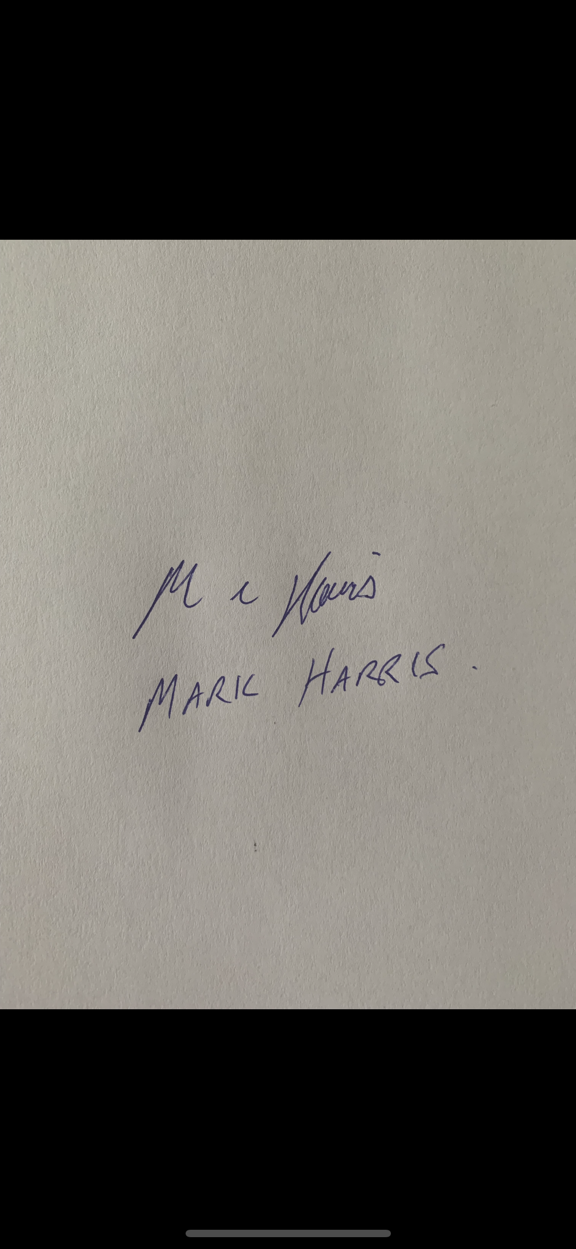
Date: | 23/05/2022
When completing the task, did the participant: |  | Tick if satisfactorily completed.  Provide comments if left unticked.
 |  | 1st  Occasion | 2nd  Occasion
- Conduct a workplace inspection to evaluate construction site safety for the range of occupations in the workplace according to WHS legislation and company policies, including:
- Identifying construction hazards and potential risk areas
- Identifying and prioritising hazards
- Identifying and prioritising risks
- Seek expert advice as appropriate, including:
- Advice from workplace personnel regarding the application of building codes and standards
- Consulting with relevant parties regarding compliance with statutory requirements (including SWMS and site safety plans)
- Consulting with appropriate personnel to determine effective strategies for communicating WHS policy.
- Complete an inspection report in accordance with best practice and statutory obligations: including:
- Recommendations from findings
- Required approaches to remediation
- Implement agreed control measures in conjunction with relevant workplace personnel, implementing negotiation and conflict resolution skills, as necessary.
- Monitor and review control measures, updating records with findings
- Establish communication strategies and educational programs specific to the building and construction industry in accordance with statutory requirements and best practice.
- Review the effectiveness of communication and educational programs, updating records with findings.
- Effectively communicate using the following methods:
- Verbally using language/concepts appropriate to cultural differences
- Non-verbal communication
The Participant’s performance was: Satisfactory Not Satisfactory

observer Comments
- I have observed Corey doing this task, and I believe he is competent and knows all about WHS in building and Construction. I believe he displays sufficient practical skills and knowledge in doing the tasks relating to this WHS.
- At Stroud Homes and Renovare, we recommend using our company procedures along side HAZARDCO.
- Corey is also well versed at using their systems for Health and Safety on our building sites.

This particular exercise, I supervised Corey working with the team at Renovare Mt Gravatt (Builder Adam Town 0401327752) Corey worked with Adam’s team filling out the Hazardco documentation which is attached to this assessment.
All Stroud Homes and Renovare builds use the following for each job.
The two jobs I have seen Corey work with the Renovare team are 3 Stoneyfell Court Holland Park and 7 Coolaroo Crescent Jindalee.

