Procedures conducted on-site to ensure that all workers are inducted, informed, and regularly updated on their on-site safety responsibilities.
Our company facilitates an engagement day (induction day) prior for work site personnel arriving to site. This induction would include primary standards set by the organisation, expectations, standards, policies and procedures, and a general overview of the site and what to expect. The induction day would also assist the workforce in understanding all safety responsibilities and strategies. Once an induction has been completed, another site-specific induction will be conducted on site upon arrival. This induction will focus on the current construction progress overview, general site amenities, first aid facilities, emergency evacuation points and muster points, general site layout/plan and ensuring that all relevant qualifications and competencies have been documented through to the company before operating/performing the tasks delegated. Once the general qualification/competency has been approved i.e., Construction Card, the worker is then ready to perform works on site. Between company on-site supervision and health and safety representatives, the onsite workforce will be daily monitored and inspected to ensure all safety responsibilities and standards are met and everyone is working in compliance.
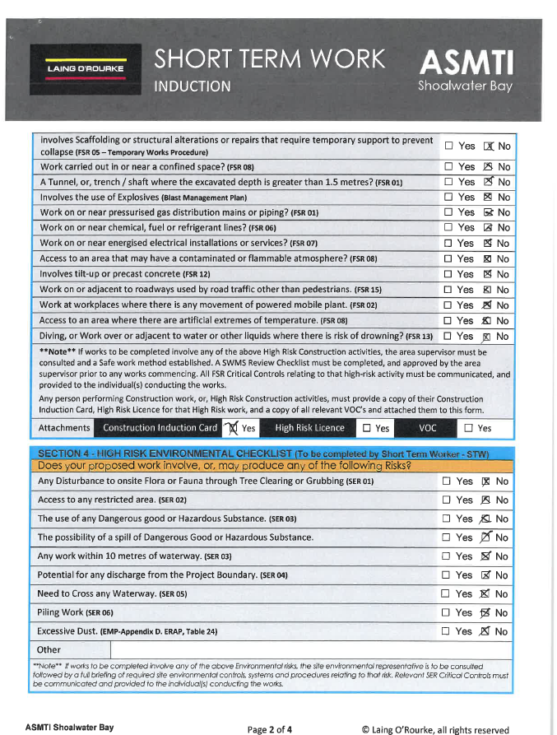
Below I have attached short term workers induction documentation, signed, and facilitated from myself and the inductee.

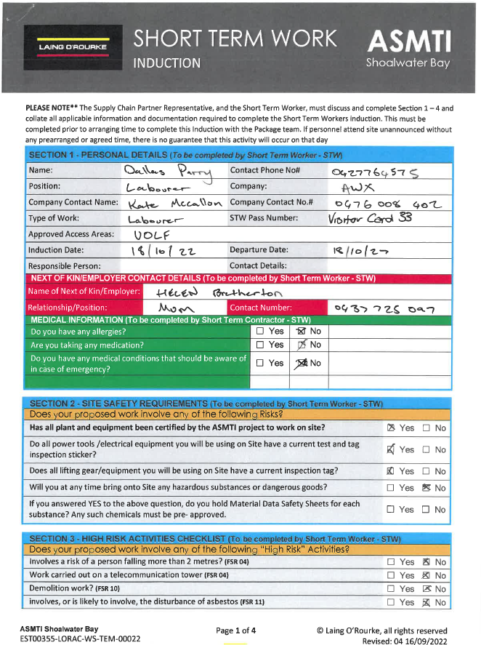

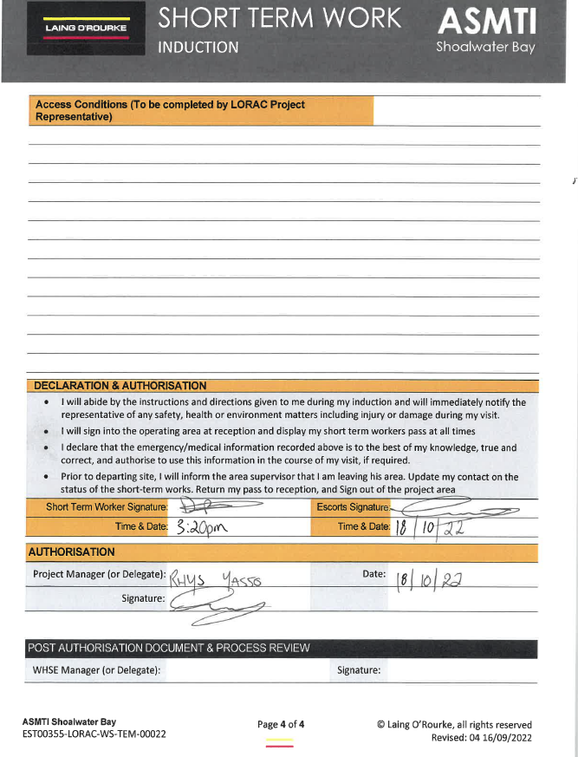
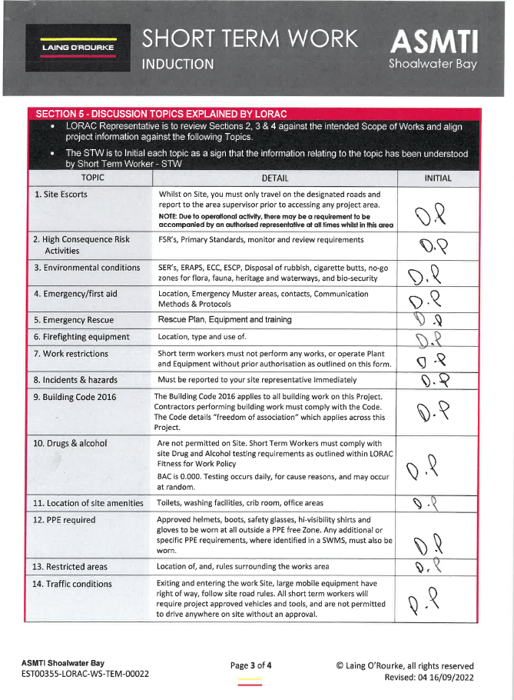
Facilitating these inductions on-site ensures that we are being compliant with legislative requirements under the WHS Regulation 2011. Example: - Part 6.5 (General Construction Induction Training Requirements) (316) – Duty to provide general construction induction training. Whilst the inductee is filling out this induction, I then asked for his current Drivers License and general construction white card. These licences or documentation is then scanned and placed within a WHS Folder within our systems for accessibility and visibility from all supervision or WHS personnel.
Qualification Documentation & Licence Checks
Prior to a sub-contractor commencing, it’s required that the sub-contractor is to inform us if the worksite personnel have or have not attended site before and have been inducted through our systems. Shown below is a snippet of an email sent from a sub-contractor containing a folder including the Personnel’s relevant qualifications and licencing.
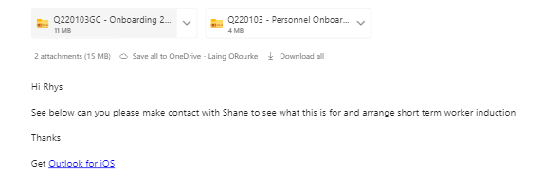

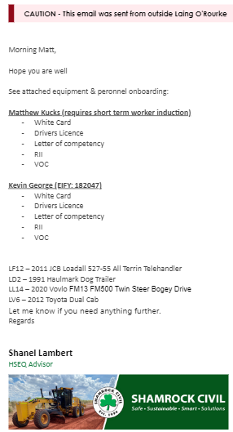

If the personnel have not been through an engagement (induction) day, the qualifications will be saved into our systems for keeping and record. However, if they have attended an engagement day, personnel would have an ‘EIFY’ Profile which should have all qualifications listed within their profile. (EIFY Is a system used through the company, to assist in accessing all qualifications, licensing, contact information and a platform to sign in/out on-site work personnel so everyone is accounted for in an unlikely case of an emergency evacuation). Having this system in place assists in confirming documented sub-contractors, site supervisors, managers, workers qualifications, competencies and licences that are current and meet legislated requirements.
Apart of general procedures and responsibility of looking after this sub-contractor, I also conducted a system and register check of all plant & machinery documentation that was sent through. If the plant & machinery has not yet been to site, all documentation involving Vehicle / Plant Registration, Weed and seed declaration forms, Service and Maintenance History and Risks assessment of the unit is required to be sent through prior to arriving to site OR having a hardcopy of these documents on hand during the visual inspection. It was found that during the system checks that all plant arriving had not yet been inspected or been to site before. All documentation sent from the sub-contractor all aligned with project and legal requirements (Registration, Serviced and Relevant equipment attached). Once all documentation and a visual inspection was undertaken and certified from myself, A Company pre-mobilisation sticker was attached to each piece of plant and all information uploaded within our systems.

All inductions held within Shoalwater Bay ensure that all sub-contractors and worksite personnel adhere to the contract agreements and meet all the conditions during construction of the project. This also includes the Australian Defence Force requirements and regulations within the bay.

