Description of task:
On two (2) occasions, a suitable observer is to verify the participant’s ability to read and interpret plans and specifications in order to inform estimation, planning and supervisory activities.

The participant is to gather evidence of how they have completed each component of the Practical Task, which is to be submitted with this Practical Assessment sheet. Evidence to be submitted may include:
- Any drawing with a cloud or mark-up you have inserted.
- Copy of the correspondence regarding mark up and any site management/authorising engineer response.

The observer is to provide detailed comments on the tasks completed by the participant. The assessor is to verify the observer’s comments in the Assessor Comments section, and provide the Practical Assessment outcome on the front cover of this document.
Resources required:
Drawings (including site plan), Specifications, Tender documentation, Telephone, Facsimile machine, Computer.

Below are examples of marked up drawings where egress doors needed to be identified and sent back to site

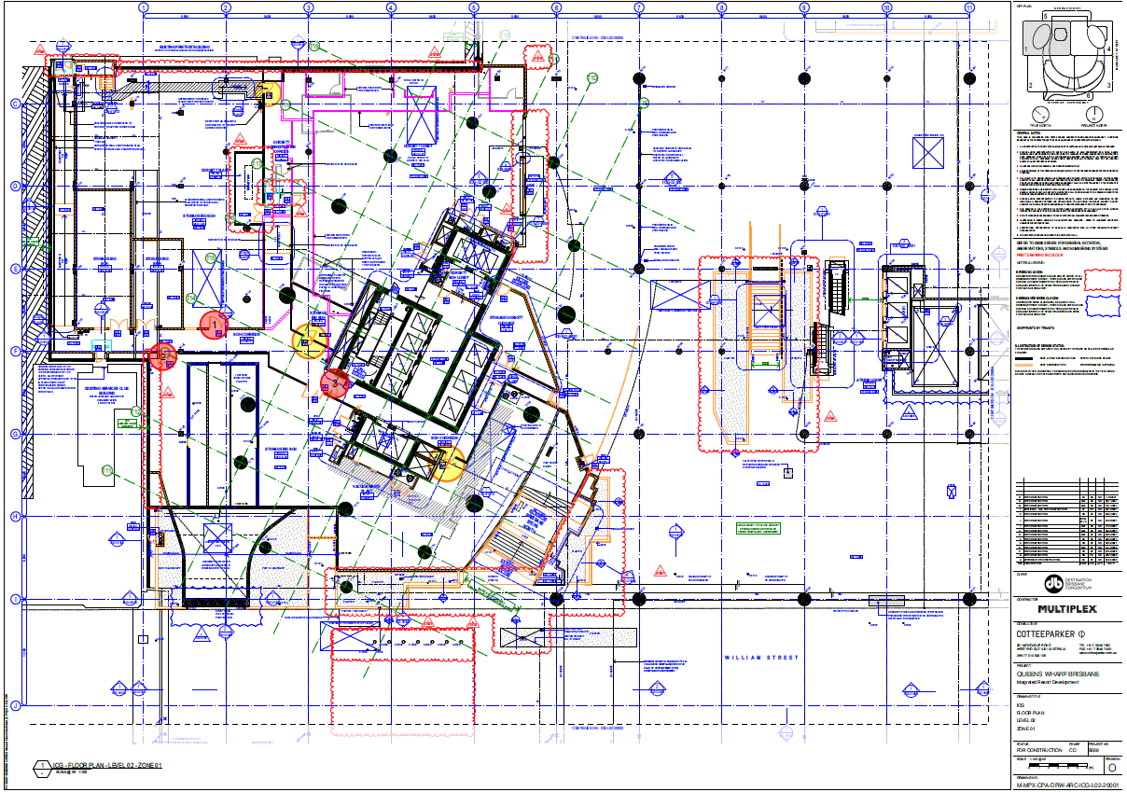

Below is an example of a marked up drawing to go with a variation to show changes in different revisions between architectural drawings in which we had to submit to make the changes on site.



