CPCCBC4004A
Identify and produce estimated costs for building and construction projects

THEORY EXAM INSTRUCTIONS

- This exam will occur under standard assessment conditions.
  - An oral examination may be allowed under certain circumstances.
Answers will be documented and FT003 (Oral examination declaration form) must be completed.
- Participants must provide enough detail in their responses to demonstrate their knowledge and skills.
- Please fill in the details below, providing your name, signature and date of assessment.
  - Your signature acknowledges that this is your own work.
- If a participant initially answers a question incorrectly but modifies their response, they must follow the instructions below:
  - If a participant changes their response in writing, they must put their initials next to the written change.
  - If a participant changes their response verbally, this must be noted on the exam paper by the assessor.

Participant name | Sheena Christine Reyes Mania
Participant signature | 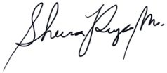

Assessor name
Assessor signature | 

Date | Click here to enter a date.

Number of questions | Number of questions answered correctly | Satisfactory?
24 |  | Yes | No

Assessor Comments
- What is the critical aspect of identifying and interpreting plans, drawings and specifications for a building project?

Answer | The critical aspect in interpreting plans, drawings, and specification is to determine and have an overview of the project, plan ahead, determine how big or small the project is, and limit its scope to what is only necessary. Such which, interpreting plans and specifications is necessary so to determine how the breakdown of trades would be, determine which has to be in-house take-off estimated, and to which trades quotes are to be requested whether from a supplier or a subontractor.

- What is the purpose for date stamping of plans, drawings and specifications?

Answer | It is important for a date stamping of plans, drawings and specifications, and marked-out whether plans are superseded, so to determine and have an accurate quantification for estimate purposes of to date information, and drawings / specification for future construction. It is also important so to have a back track of information history to when it has been received and superseded.

- Nominate at least six (6) people and/or entities that would use plans drawings and specifications on a building project.

Answer | 1. Project Manager  2. Construction Manager  3. Estimator  4. Subcontractor  5. Site Supervisor  6. Site Foreman

- Plans and drawings usually hold many and varied features.
Name some of the types of drawings and details you would expect to see on plans and drawings for a building project.

Answer | 1. Location plan  2. Site or Block plan  3. Topographic plan (for site with 5% or more gradient)  4. Demolition plan  5. Architectural Floor plans, elevations, sections  6. Architectural Doors and Window Schedule and details  7. Reflected Ceiling Plan  8. Structural drawings: foundation plan

- It is necessary to acquire all building plans and specifications at the beginning of the negotiation period so we know all building project details prior to commencing work (including dimensions, construction materials, door and window schedules, masonry control joint locations and smoke alarm locations).
What else would be expected to be provided?

Answer | 1. Building specification to know the types of materials to use, and determine standard of workmanship required, warranties and defect liabilities, provisional sums, and preferred subcontractors to ascertain the extent of pricing, and how much it can be adjusted during the negotiation period.  2. Footing construction report, and foundation soil assessment, ACM / Asbestos Report to determine inclusion of certified ACM contractor / licensed specialist.  3. soil elevation / topographic plan for project site with 5% or more gradient.  4. Framing plans including wind speed assessment, bracing / tie down provisions, roof and wall framing members.  5. ULS / SLS specification, or certification from design engineer to ensure material as specified in material specs (external cladding, glazing, roof structure) that are to be priced / estimated, are in compliance.  7. Roof truss computations  5. Energy efficiency assessment report with glazing calculation provided by design engineer certifying that the materials as specified in the specification are in accordance to the required U-value, R-value, or SHGC, ensuring materials to be priced are in compliance (BCA requirement)

- Drawings are usually arranged in the approximate order of construction.What might a set of drawings consist of?

Answer | 1. Civil Drawing Set  2. Structural Plans  3. Architectural Plans  4. Electrical Plans  5. Mechanical Plans  6. Plumbing

- Explain how to access the Building Code of Australia (BCA) and its relevance to estimating costs for building and construction projects.

Answer | Building Code of Australia (BCA) can be accessed through Australian Building Code Board (ABCB). It provides the minimum necessary requirements for safety, health, amenity, and sustainability not only in design, but also in construction that affects estimate.

- Explain how to access the Plumbing Code of Australia (BCA) and its relevance to estimating costs for building and construction projects.

Answer | Plumbing Code can be accessed through Building Code of Australia (BCA) volume 3. It is essential to understand its content when doing estimates to determine the basic requirements affecting the quantities namely water services requirements, sanitary plumbing and drainage system, sound transmission requirement, people with disability, and understanding the basic abbreviations and symbols in understanding the plumbing drawings for estimate

- Explain how to access Australian Standards and their relevance to estimating costs for building and construction projects.

Answer | Australian Standards can be accessed through Australian Building Code Board (ABCB) in 3 volumes. Volume 1 is for building class 2 to 9, volume 2 is for class1 and 10, and the 3rd volume is plumbing code.

- Identify two (2) standards that would be relevant to the industry sector.

Answer | 1. Craftsman National Construction Estimator  2. Cordells or Rawlinsons

- Explain the impact of WorkCover requirements on costs to the project.

Answer | WorkCover is complusory in Queensland for protection of workers for possible accident. It is an insurance policy that covers workers when accident happened at work site, and is usually covered by the contractor and therefore should be added in the project cost.

- Explain the impact of Environmental Protection Agency requirements on costs to the project.

Answer | Environmental Protection Agency requirements when under contractor's scope, contractor should provide a budget inclusive to the overall project cost. Example of these costs, depending on the type of project are: Waste Management and approvals, building licenses, plumbing licenses, gas fitting licenses, electrical licenses, development applications, zoning approvals, heavy vehicle license, water usage or constructing a bore or well, connection or work on sewerage/drain, carrying out high risk work, protecting trees and wildlife, fire management and safety, use of blasting and explosives, removal of asbestos, use of public land, work on heritage properties, building energy efficiency, and handling / storing / use of chemicals or dangerous substances.

- Calculate and cost the lineal timber order for 93 x 19 DAR Meranti and allow 5% wastage. The cost per lineal metre is $6.40.
The requirements are: 22 @ 2400; 30 @ 3600; 10 @ 4800; 12 @ 1880
Show your calculations.

Answer | 22 x 2.4m = 52.8m  30 x 3.6m = 108m  10 x 4.8 = 48m  12 x 1.88 = 22.56m  231.36 x 1.05 (for 5% wastage)  242.928 x $6.40  $1,554.74

- A building floor plan measures 24000 x 14000 and the specification states the sheet flooring is 3.6 x 0.9 x 19mm Yellow TERMIFLOR T&G H2 at $58.38 per sheet.
Calculate the area of floor sheeting required when an allowance of 2% is made for waste and cutting.Determine the number of sheets to order to the nearest whole sheet and calculate the cost for the flooring.
Show your calculations.

Answer | Floor plan: 24 x 14 = 336 sqm  Termiflor: 3.6 x 0.9 = 3.24 sqm  103.7 pcs x 1.02 (2% allowance for cutting)  106 pcs of yellow termiflor  106 x $58.38 = $6,188.28

- If a solid cavity brick wall is to be built 23000mm long and 2400mm high (no windows and no doors), how many bricks would be required if the number of bricks per square metre is 50? Show your calculations.

Answer | 23 x 2.4 = 55.2sq.m.  55.2 x 50 = 2,760 total pcs of bricks

- You are a QBCC licensed plasterer and a client (Owner Builder) Davey Jones-Locker of 100 Reef Avenue, Brisbane, Queensland wants you to quote for plastering an internal wall of his house build and has described to you the following information over the phone:
The Client tells you the Council approved plans and drawings state the finished ceiling height from the top of slab floor is 2400mm. There is one external solid timber door (D4) is 2340 x 870 x 35 in this wall and no other openings. The length of this house end wall is 11 metres.

The house is of brick veneer construction and includes a 50mm cavity and the load bearing external framing is 70 x 45 MGP12 (a Boral product “Pineguard Blue”). The bricks are standard bricks 230 x 76 x 100mm. (L x H x W).

The Client tells you that the door is positioned 2100mm from an internal corner (RHS in aerial view) and as seen from inside the house looking out. The specification and drawings state 10mm regular internal plasterboard. You know from experience regular plasterboard is supplied in the following sizes lengths 6M, 4.8M, 4.2M, 3.6M, 3M, 2.7M and 2.4M with recessed edge and widths of 1200mm and 1350mm.

The Client wants a quote to fix and finish this internal wall with plasterboard.

Your labour and on-costs are charged at $51.50 an hour per tradesman plus materials including sheets, fixing, finishing and sanding. You estimate ancillaries including stud glue, screws, base coat, top and finish coats at $315.00 and that there is two (2) days’ work.
Your business works a 38 hour week you allow workers a 15 minute morning tea break and half hour for lunch. You will need two (2) tradesmen first day and one (1) tradesman second day including materials and equipment supply, fixing, finishing and sanding.
You are to research or acquire plasterboard sheet prices and attach this price list to your email. You are not required to supply or fix cornice.
Sketch the wall in Plan View (not to scale), dimension it with relevant measurements, and position the door on the right side of your plan view sketch and then calculate the plasterboard required and approximate waste expressed as a percentage (%) for internally lining this wall.
Estimate the cost of the job, including supplying plasterboard materials fixing setting, finishing and sanding plus labour. Then write a covering email to be sent to the client. You must show your methods for calculating cost of sheets, waste, plus fixing, setting, finishing and sanding.
Attach your quote, sketch, calculations and pricing list and email this to your Trainer/Assessor (details provided by them).

DRAFT AREA

To: Davey Jones-Locker
Location: 100 Reef Avenue, Brisbane, Queensland
Date: 01/09/2018
Quote valid for 60days

Scope of Works: Internal Linings of 11 meter internal wall surface

INCLUSIONS:
- fixing, flushing & sanding of wall linings. Plasterboard is of 10mm for internal non-wet areas, to walls as per plan attached.
- allowances for travel, waste removal inclusive
EXCLUSIONS:
- supply and fix cornices
- wall framing and insulation
- price includes setting, finishing, and sanding

 | unit cost | unit | subtotal
Plasterboard (w/ 2.4m ceiling height, 1 recessed edge) with 5% wastage | $ 19.74 | 9 pcs. (2.4x1.350) | $ 177.66
Ancillaries (stud glue, screws, base coat, top and coat finish) |  |  | $ 315.00
labour cost (total 3 tradesmen in 2 days) | $ 391.40 | per day / tradesman | $ 1,174.20
Others (15%) |  |  | $ 250.03
TOTAL COST (excluding GST) |  |  | $ 1,916.89

DRAFT AREA

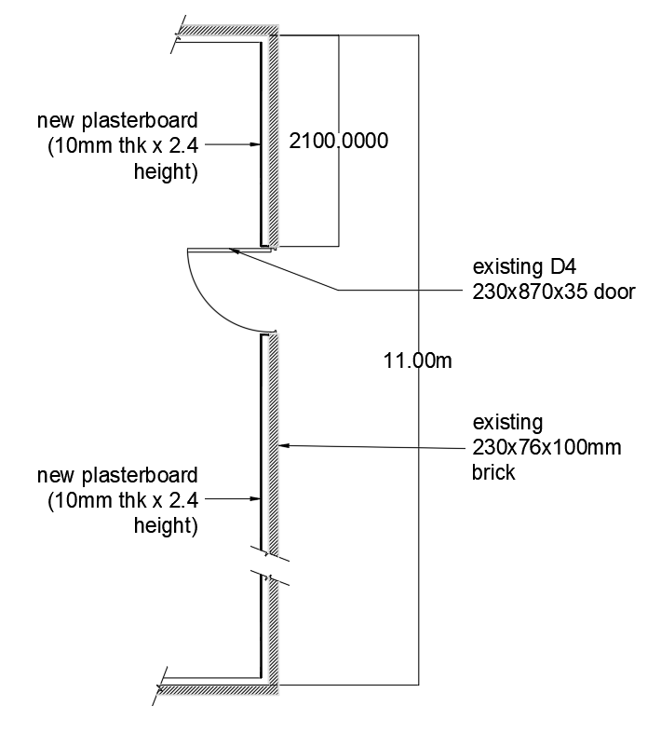

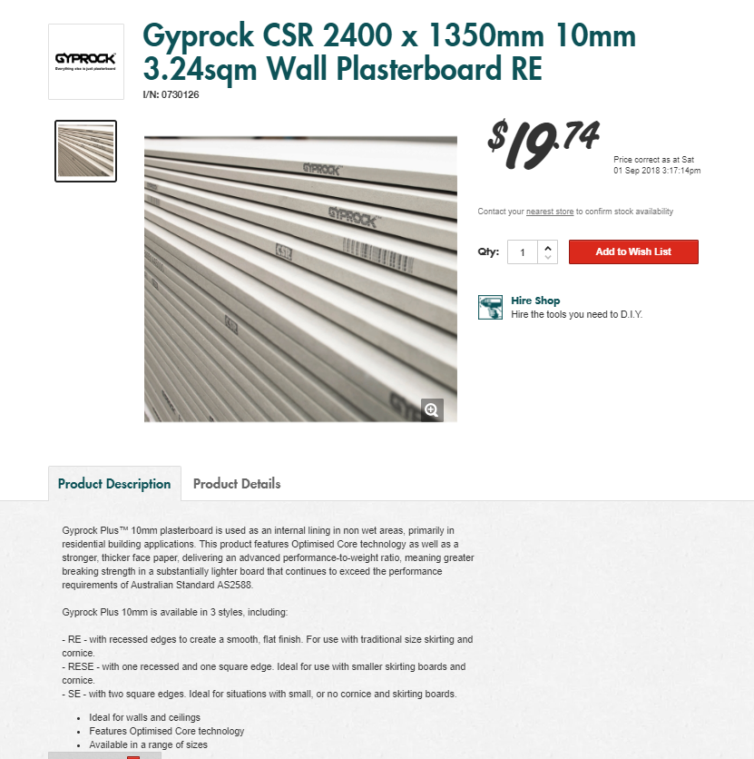

Answer

- There are many different ways of estimating project costs. You can use your past experience, or ‘square metre’ rates but if you are unfamiliar with estimating and pricing then you should resort to the materials and labour method of costing using an item-by-item approach which is considered as the best industry approach to estimating.
What are at least three of the nominated methods for estimating?

Answer | 1. Prepare a take-off for the project - a list of all materials and labour to be used in the project + associated activity that costs money  2. Get prices for each item in the take-off prices from suppliers, trade contractors (3 quotes each)  3. Total up all the items prices

- Name some of the circumstances to consider in relation to labour adjustment factors when estimating a project for construction.

Answer | 1. When working temperatures are below 40 degress or above 95 degrees  2. Working at areas with high risks such as crawl spaces, working in a scaffolding / ladder / high platform, or congested area or remote from the material storage point, and large open areas with good access and lighting  3. length of material when lifted above ground level  4. when tradesmen have below average skills, or highly motivated / highly skilled  5. when identical task is repeated many times for several days at the same time  6. When construction is a small fit-out where matching of materials to the existing is required, protection to adjacent existing surface, and when jobsite is occupied during construction.  7. When construction works are to be done after a disaster: major flood, fire, earthquake, hurricane, turnado, where tradesmen are not readily available, and when cost of construction materials have a higher rate than usual.  8. For a demanding specification, rigid inspection is required, unreliable suppliers, a difficult owner, or an inexperienced architect.

- If a bricklayer lays 600 bricks in an eight (8) hour day, what is the average number of bricks laid per hour by the bricklayer?
Tick your response.

Answer | Choice | Possible Answers
 | ☐ | 65
 | ☐ | 70
 | ☐ | 55
 | ☐ | 90
 | ☑ | 75
 | ☐ | 105
 | ☐ | 85

- What and where are some of the potential sources you could go to in choosing your suppliers for goods and services?

Answer | 1. Business and industry portal / Queensland government business and industry portal  2. yellow pages  3. Attending industry events  4. Networks

- What are some of the primary (key) factors for choosing your suppliers?

Answer | 1. Price  2. Reliability  3. Stability  4. Location  5. Supplier group

- What are some of the ways you could communicate with your suppliers for gaining quotes?

Answer | 1. written request  2. email request  3. faxed request  4. telephone request  5. verbal request  Nowadays, request for quotes can be done faster through BidContender

- Explain the concept of a ‘Labour Only’ quote?

Answer | 'Labour only' quotes are cost for manpower only, materials are not included. There are ways of quoting 'labour only' costs namely:  1. per unit installation  2. per linear meter where height is consistent  3. per square meter  4. per lump sum, completed project

You will be provided an allocated period by your instructor to complete this task.
You may use appropriate costing software programs in completing this task.

- Referring to the supplied set of house plans, you must do the following scheduling and costing:

- Identify and nominate a supplier/s and schedule the materials and cost the internal and external timber wall framing.
- Identify and nominate a supplier/s and schedule the materials and cost the foundations and lower floor concrete slab including the schedule and costing for reinforcement.
- Identify and nominate a supplier/s and schedule the materials and cost for the sub floor framing and the flooring for the upper floor plan.
- Calculate the architrave and skirting required for the fit out of the upper floor only in lineal metres.
- Calculate the wet area tiles for the upper floor only which are client chosen for both floors and walls with the wall tiles 250 x 100 and floor tiles 300 x 300.
- Estimate the labour only cost to tile all the wet areas only in the home.The tiler charges labour only $44.00 per square metre.
- Determine the roofing material and number of square metres of it that are required.
- Complete the aluminium windows and doors schedule and other external doors schedule for the lower floor only.
- Complete a full internal doors schedule for the lower floor only.
N.B. Assume all doors are flush panel 2040mm in height and 35mm thick.
- Estimate the labour only cost for hanging all doors on the lower floor – ifa tradesman takes 2 hours to jamb an opening, hang the door, fit the door furniture, door stops, architrave and fit a door-open-restraint. The hourly rate is $27.80 plus 20% on costs.

Answer | 1. Internal and external wall framing  a. Brick Supplier: Austral Bricks Townsville  b. Brick installer: Front Foot Construction  c. Brick supply and install: Yellow Block Road  d. Drywall trade (furring and lining) supply and install: CD Projects  2. Foundation and lower floor concrete slab  a. Concrete supply: Hanson Construction Materials  b. Reinforced Steel supply: JS Welding Services  c. Concretor / Steelman labour only: $100 per day per person  d. Concrete supply and install: Coastwide Concrete Pumping  e. Reinforced steel supply and install: Murphy Steel  3. sub floor framing and the flooring for the upper floor plan  a. Carpenter supply and install: CD Projects  4. Skirting and architrave required upper floor only in linear meters  a. Skirting in Lm  5. Calculate the wet area tiles for upper floor only, 250x100 wall tiles (0.025sq.m.), and 300x300 (0.09 sqm) floor tiles  a. Ensuite: 3 x 3m, floor = 9sqm, wall = 12 x 3m height = 36sq.m.  floor: 100 pcs, wall: 1440 pcs  b. Bathroom: 3 x 2.44, floor = 7.32sqm, wall = 10.88x3m height = 32.64sqm  floor: 82 pcs, wall = 1,306pcs  c. WC: 2.195 x 1m, floor = 2.195sqm, wall = 7.83 x 3m height = 23.5sqm  floor: 25 pcs, wall = 940 pcs  TOTAL FLOOR: 207 + 5% = 218pcs  TOTAL WALL: 3,686 + 5% = 3,871pcs  6. labor cost only to all wet areas, $44 per square meter  Ground Floor:  a. Laundry / Bath: (2.840 x 3.6) + (1.050 x 2.2) = 28.95 x $44 = $1,274  Upper Floor:  a. Ensuite: 9sqm x $44 = $396  b. Bathroom: 7.32sqm x $44 = $322.1  c. WC: 2.195 x $44 = $96.6  TOTAL LABOUR COST: $ 2088.66 + 5% = $2,193  7. Determine the roofing material and number of square metres of it that are required  Trimdek rib-and-pan Roofing  Complete the aluminium windows and doors schedule and other external doors schedule for the lower floor only  8. Complete a full internal doors schedule for lower floor (all doors are 2040mm height, 35mm thk)  9. labour cost only for hanging the doors (lower floor) $27.80 per hour / 2 sets of complete door installation, +20%  No of doors: 12*$27.80 = $333.60 * 1.20 (20%) = $400
   | SKIRTING |  | ARCHITRAVE
  Bedroom 1 | 19.32 | Lm | 10.848 | Lm
  Bedroom 2 | 15.6 | Lm | 7.392 | Lm
  Bedroom 3 | 16.04 | Lm | 1.6728 | Lm
  Bedroom 4 | 14.4 | Lm | 5.34 | Lm
  Common Area | 12.045 | Lm | 5.57 | Lm
  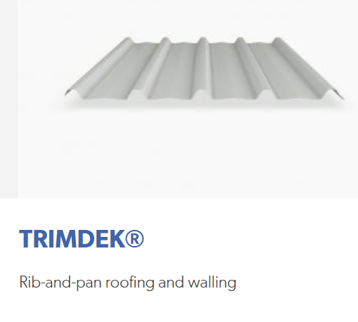
    A1 | A2 | A3
    15.6 | 4.056 | 9.16
    6.6 | 10.06 |  | 2.995
    102.96 | 40.80336 |  | 27.4342
    TOTAL: | 171.1976 |  |  | +5%
     | 179.757 |  |  | sq.m.
  no of sets | size (m) |  | specification
  no of sets | height | width | specification
  3 | 1.8 | 0.9 | aluminium framed window
  1 | 1.8 | 1.8 | aluminium framed window
  1 | 2.04 | 1.64 | double swing door
  1 | 2.2 | 5 | garage door
  1 | 0.9 | 1.5 | aluminium framed window
  2 | 2.04 | 0.82 | swing door
  1 | 1.2 | 2.1 | aluminium framed window
  1 | 1.2 | 0.9 | aluminium framed window
  2 | 2.1 | 1.5 | aluminium framed window
  2 | 2.1 | 3 | aluminium framed window
  1 | 2.1 | 3.6 | aluminium framed window
  1 | 2.1 | 1.6 | aluminium framed window
  no of sets | size (m) |  | specification
  no of sets | height | width | specification
  1 | 2.04 | 0.62 | swing door (35mm thk)
  1 | 2.04 | 0.72 | swing door (35mm thk)
  1 | 2.04 | 1.44 | double swing door (35mm thk)
  1 | 2.04 | 0.77 | swing door (35mm thk)
  3 | 2.04 | 0.82 | swing door (35mm thk)

Answer

