BSBITU301
Create and use databases
Learner Workbook



Table of Contents

Table of Contents 2
Candidate Details 3
Assessment – BSBITU301: Create and use databases 3
Competency Record to be completed by Assessor 4
Observation/Demonstration 5
Activities 6
Activity 1A 6
Activity 1B 8
Activity 1C 9
Activity 1D 10
Activity 2A 11
Activity 3A 12
Activity 3B 13
Activity 3C 14
Activity 3D 15
Activity 3E 16
Skills and Knowledge Activity 17
Major Activity 18

Candidate Details

Assessment – BSBITU301: Create and use databases
Please complete the following activities and hand in to your trainer for marking. This forms part of your assessment for BSBITU301: Create and use databases.
Name: Zoe Lwin
Address: 79 Waterview Avenue
Email: zoejade_98@hotmail.com
Employer: Simon Lwin
Declaration
I declare that no part of this assessment has been copied from another person’s work with the exception of where I have listed or referenced documents or work and that no part of this assessment has been written for me by another person.
Signed: ____________________________________________________________
Date: ____________________________________________________________
If activities have been completed as part of a small group or in pairs, details of the learners involved should be provided below:
This activity workbook has been completed by the following persons and we acknowledge that it was a fair team effort where everyone contributed equally to the work completed. We declare that no part of this assessment has been copied from another person’s work with the exception of where we have listed or referenced documents or work and that no part of this assessment has been written for us by another person.
Learner 1: ____________________________________________________________
Signed: ____________________________________________________________
Learner 2: ____________________________________________________________
Signed: ____________________________________________________________
Learner 3: ____________________________________________________________
Signed: ____________________________________________________________

Competency Record to be completed by Assessor
Learner Name: _______________________________________________________
Date of Assessment: _______________________________________________________
The learner has been assessed as competent in the elements and performance criteria and the evidence has been presented as:
Assessor Initials
Authentic
Valid
Reliable
Current
Sufficient

Learner is deemed: COMPETENT NOT YET COMPETENT (Please circle)

If not yet competent, date for re-assessment: ____________________________________

Comments from Trainer / Assessor:
__________________________________________________________________________________________________________________________________________________________________________________________________________________________________________________________________________________________________________________________________________________________________________________________________________________________

Assessor Signature

Observation/Demonstration

Throughout this unit, you will be expected to show your competency of the elements through observations or demonstrations. Your instructor will have a list of demonstrations you must complete or tasks to be observed. The observations and demonstrations will be completed as well as the activities found in this workbook. An explanation of demonstrations and observations:
Demonstration is off-the-job
A demonstration will require:
- Performing a skill or task that is asked of you
- Undertaking a simulation exercise
Observation is on-the-job
The observation will usually require:
- Performing a work based skill or task
- Interaction with colleagues and/or customers
Your instructor will inform you of which one of the above they would like you to do. The demonstration/observation will cover one of the unit’s elements.
The observation/demonstration will take place either in the workplace or the training environment, depending on the task to be undertaken and whether it is an observation or demonstration. Your instructor will ensure you are provided with the correct equipment and/or materials to complete the task. They will also inform you of how long you have to complete the task.
You should be able to demonstrate you can:
- Create a simple database
- Create queries and reports
- Use database
You should also demonstrate the following skills:
- Reading
- Writing
- Numeracy
- Navigate the world of work
- Get the work done
Activities

Activity 1A
Estimated Time | 30 Minutes
Objective | To provide you with an opportunity to design a simple database, with at least two tables, using a database application, basic design principles, software functions and simple formulae.
Activity | - Explain what the following database elements are and their purpose:  - Tables  Tables are used to arrange large amounts of information in a way this is easy to understand. When designing a database, consider which tables will be used and how these will relate to one-another, ensuring all relevant information is included.  - Forms  Forms, or ‘data entry screens’ allow you to enter and edit data within a table. While it is possible to enter data into a table without them, forms can group together specific information, using fields that are relevant to a task. For example, an ‘Order Form’ would include all necessary information relating to a customer purchase.  - Queries  A query is a request for information from within a database. It may retrieve specific information, or pull together data from multiple fields. After making a query, you can then add, change, review and delete data.  - Reports  Reports are a way of summarising information, allowing data from tables or queries to be presented in a clearer way.  - What expression would you use to find the average age of your customers in an Access database?  The average/mean of a set of numerical data (eg. ages) is calculated by dividing the sum of the numbers by the amount of numbers. When using an Access Database, the average value in the order field can be found using the expression: =Avg([Order])  - What are the benefits of relational databases?  Relational databases include tables that are connected through a relationship between pieces of data. These allow redundant information within a table to be excluded, and relationships between relevant information to be realised.

Activity 1B
Estimated Time | 15 Minutes
Objective | To provide you with an opportunity to develop a table with fields and attributes according to database usage, as well as data considerations and user requirements.
Activity | - What type of fields would the following data best be stored in?  - John Smith - Text field  Text fields can hold any type of characters, up to a limit of 255. Names are appropriate form of data for these fields as they don’t often exceed 20 characters, and don’t impair database speed.  - False - Yes/No field  A yes/no field can only accept one of two answers, whether that is yes/no, on/off or true/false.  - 22nd February 2014 - Date and Time field  These fields are used to store dates and times which can be displayed in various predefined formats. It is important to be consistent with the format used to avoid errors and improve readability.  - £18.99 - Currency field  A currency field used for calculations relating to money.  - What sort of field names would be relevant for a table about available cars in a car dealership’s database?  Previous owners, model, make, colour, price, No. in Stock.

Activity 1C
Estimated Time | 20 Minutes
Objective | To provide you with an opportunity to create a primary key for each table, modify table layout and field attributes as required and create a relationship between the two tables.
Activity | - Explain how a one-to-many relationship works in a database. Give an example.  A one to many relationship is when the data in one table is connected to its related field in another table by linking a primary and foreign key. This means that information entered into the linked field must exist in the original table allowing you to share data and maintain consistency and accuracy throughout the database.  An example of this is where a customer ID field is linked to an order table, showing which customers have made which orders. Multiple orders can be placed by the same customer; this is a one to many relationship.  - Why does a table need a primary key?  A primary key is a field which uniquely identifies each record within a table. This is needed to differentiate data accurately and ensure each row of data can be uniquely identified within the database.  - Why might AutoNumber be used to generate primary keys?  Using the Autonumber feature allows you to enter a large amount of numbers instantly, and ensures that each row of data has a unique number.

Activity 1D
Estimated Time | 1 Hour
Objective | To provide you with an opportunity to check and amend data entered, in accordance with organisational and task requirements.
Activity | - Create a simple database with at least related two tables using a software of your choice. Use at least one formula.  Sales Database:  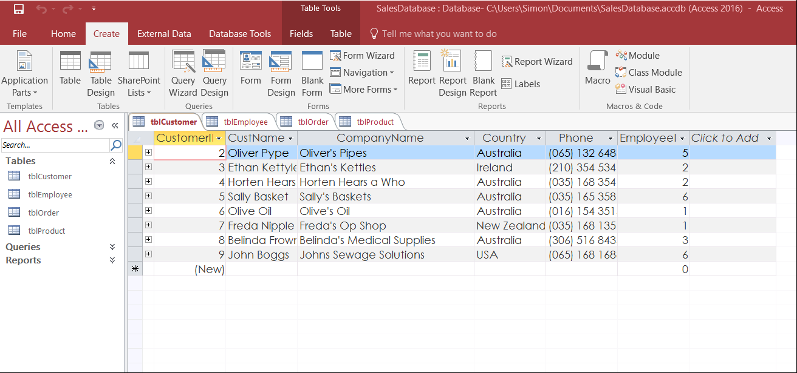  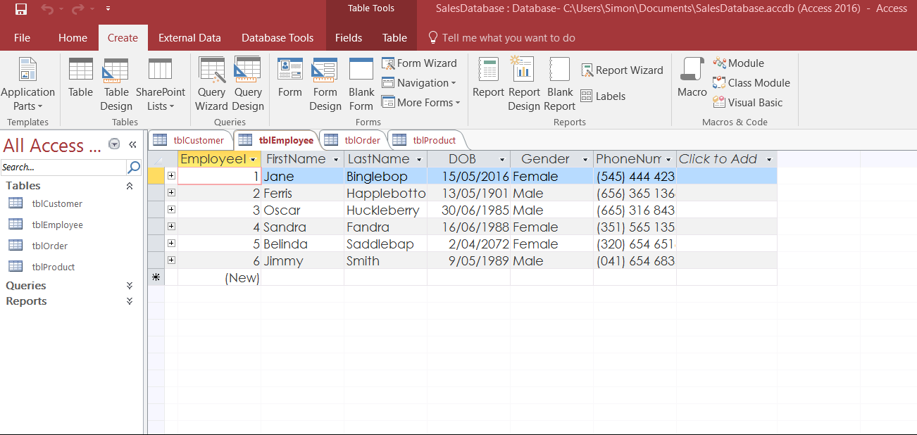  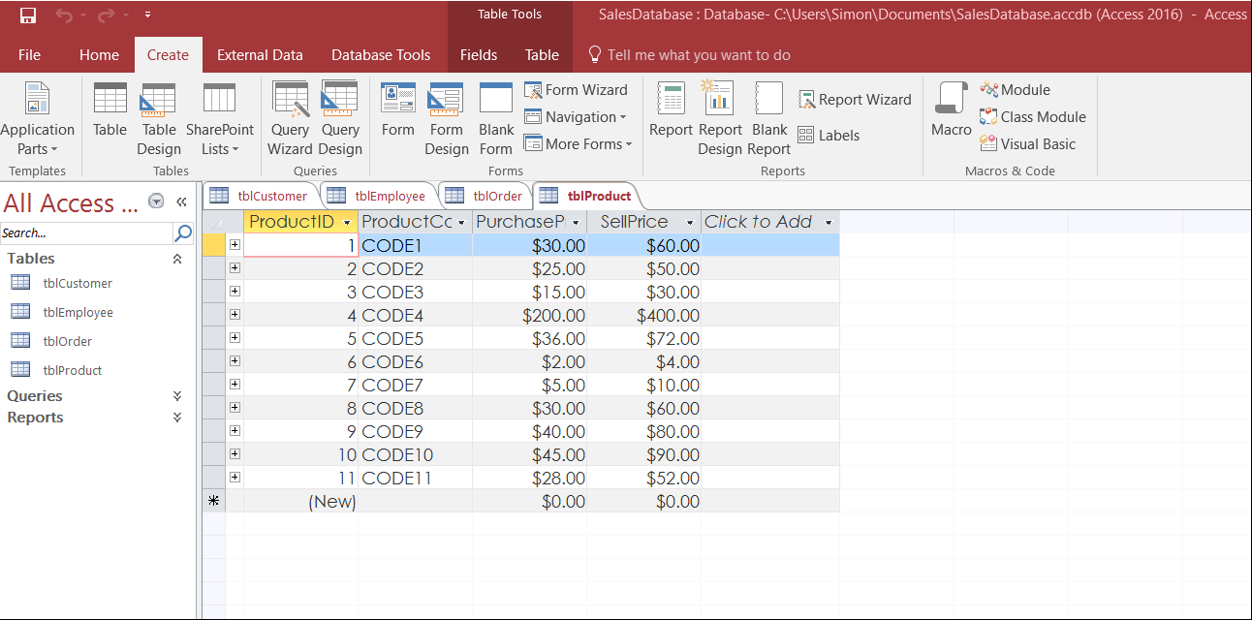  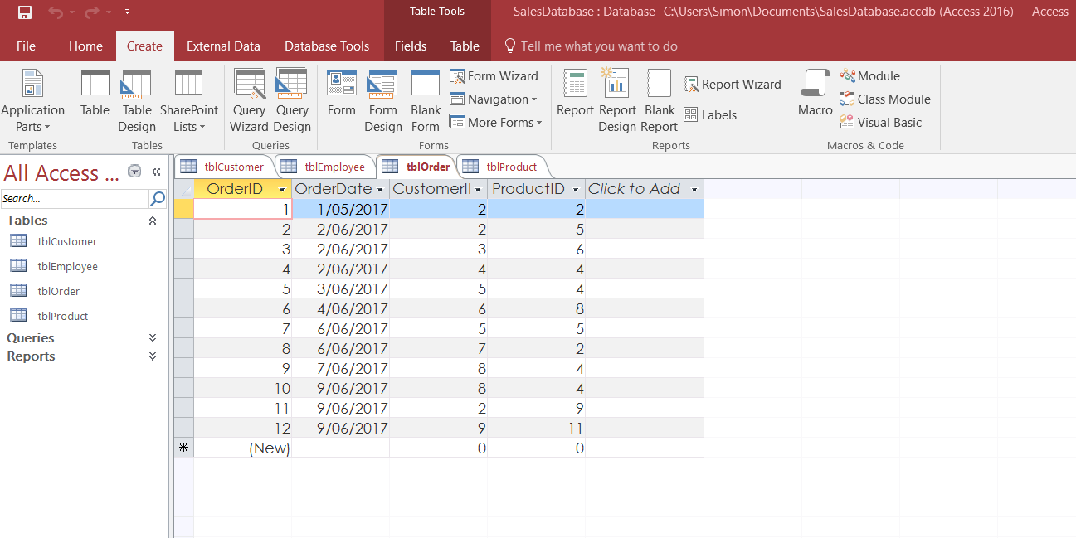  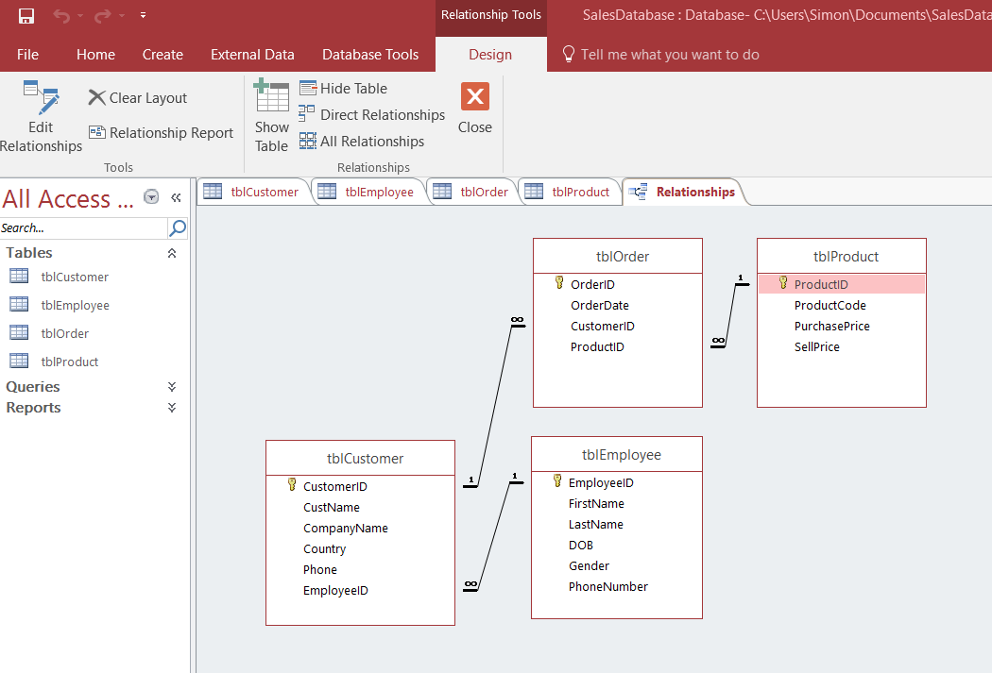

Activity 2A
Estimated Time | 1 Hour
Objective | To provide you with an opportunity to create reports and queries.
Activity | - Run a query on the database you built in Activity 1D to filter a subsection of a data. Sort it by at least one value.  Query: Customer Purchases. By using the fields ‘Customer Name’, ‘Order Date’ and ‘Sell Price’ from 3 different tables, we can see a summary of the purchase amounts of each customer as well as the dates of these purchases.  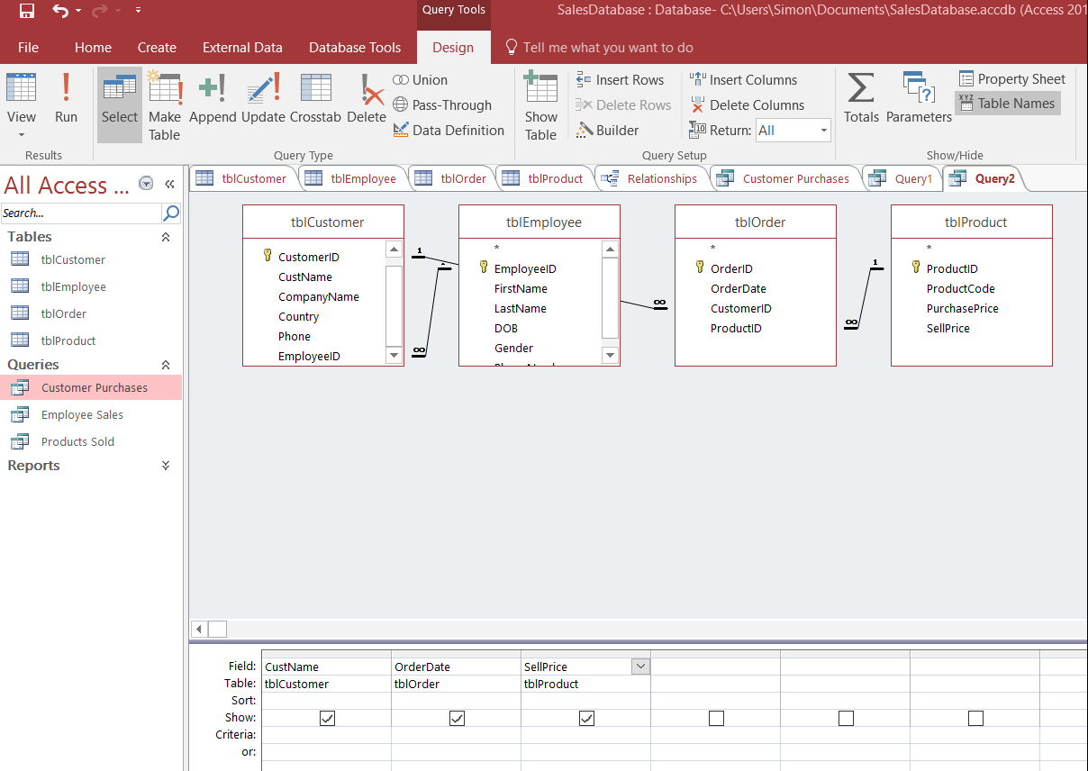  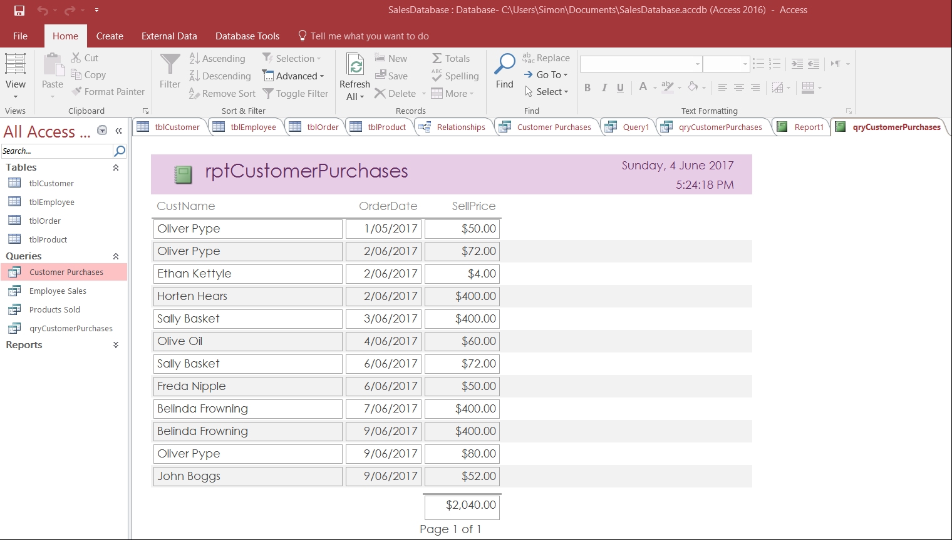  The following report is created from the query. The data is sorted by the order date.

Activity 3A
Estimated Time | 15 Minutes
Objective | To provide you with an opportunity to ensure data input meets designated timelines and organisational requirements for speed and accuracy.
Activity | - Role play with another learner what you would do if you believed you wouldn’t be able to meet a deadline.  College 1: What!? 3 Days? We’ll never finish this in time.  College 2: Ok. Don’t freak out. Let’s just think about this. First, what exactly are we required to complete within this time frame?  College 1: Well, the task involves… also, we need to think about how much time we will be able to devote to this task, considering other commitments and deadlines that are already in place.  College 2: I think you’re right. It doesn’t seem feasible that we can meet this deadline. Let’s explain this to our supervisor and request an extension as soon as possible.

Activity 3B
Estimated Time | 30 Minutes
Objective | To provide you with an opportunity to use manuals, user documentation and online help to overcome problems with database design and production.
Activity | - Using user manuals or online user documentation, take turns with another learner to look up solutions to problems.  E.g.: “What would you do if the software produced Error Code X?”  Online help in the form of manufacturers websites, help forums, video tutorials or software help functions are an effective way to find solutions to problems.  Error: "Action Failed Error Number: 2950"  Solution: This error is caused by the database not being trusted by Access. To resolve this error, you must trust the author of the Access database, switching from disabled mode to enable the content. The steps are as follows: …  Source: Manufactures Website (Help Section)  https://support.microsoft.com/en-us/help/931407/error-message-when-you-run-a-macro-that-calls-a-vba-function-in-an-access-2007-database-action-failed-error-number-2950  - Error: “Run-time error 3044. [Old Path] is not a valid path.”  Solution: This error can be caused by a corrupt download, virus, incomplete installation of the program or a variety of factors. It can be fixed by troubleshooting each possible cause. Some troubleshooting steps include  - Repair Registry Entries Associated with Error 3044  - Conduct a malware scan on PC  - Clean out system junk  - Update PC device drives  - Uninstall and reinstall program  Source: Online Forum  http://www.solvusoft.com/en/errors/runtime-errors/microsoft-corporation/microsoft-access/3044-is-not-a-valid-path/

Activity 3C
Estimated Time | 15 Minutes
Objective | To provide you with an opportunity to preview, adjust and print database reports or forms in accordance with organisational and task requirements.
Activity | 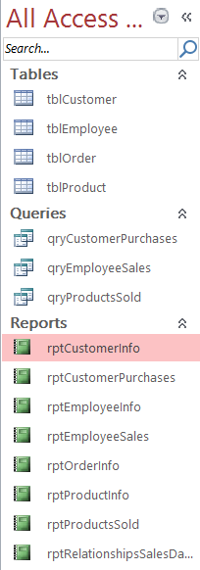  - Prepare your completed document for printing. Apply a theme and make any necessary adjustments.  A consistent theme was applied to all reports – these were saved as pdf’s, ready for printing.

Activity 3D
Estimated Time | 10 Minutes
Objective | To provide you with an opportunity to name and store databases, in accordance with organisational requirements, and exit application without data loss or damage.
Activity | - Save the report in a relevant folder, using Leszynski/Reddick guidelines, and create a backup.  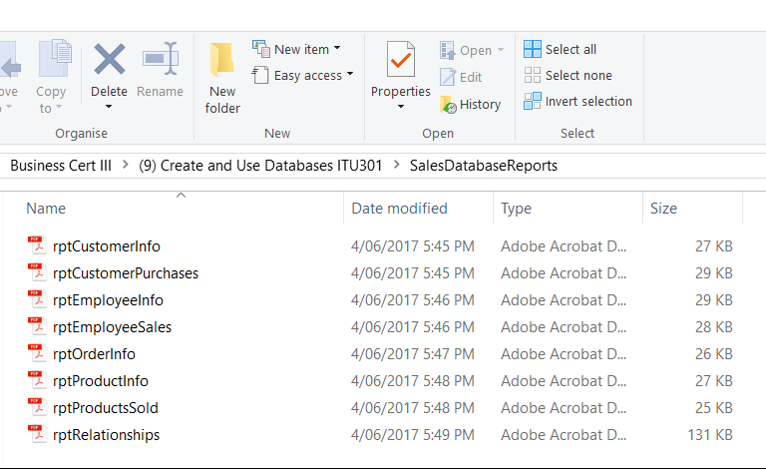  Backup:

Activity 3E
Estimated Time | 15 Minutes
Objective | To provide you with an opportunity to prepare and distribute reports to appropriate person in a suitable format.
Activity | 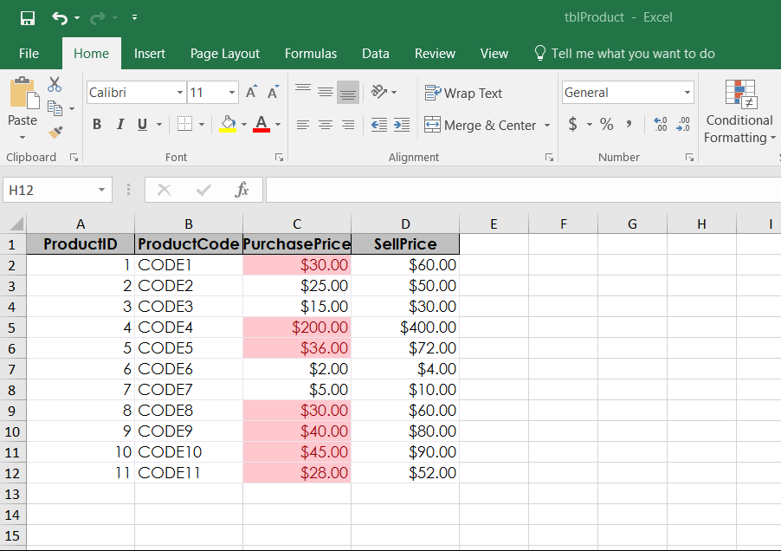  - Use conditional formatting to highlight information.  As shown above, conditional formatting has been used to highlight products where the purchase price exceeds $20.

Skills and Knowledge Activity
Estimated Time | 1 Hour
Objective | To provide you with an opportunity to demonstrate your knowledge of the foundation skills, knowledge evidence and performance evidence.
Activity | Complete the following individually and attach your completed work to your workbook.  The answers to the following questions will enable you to demonstrate your knowledge of:  - Reading  - Writing  - Numeracy  - Navigate the world of work  - Get the work done  - Key provisions of relevant legislation, standards and codes that may affect aspects of business operations  - Organisational requirements relating to data entry, storage and presentation  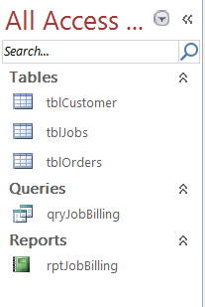  - Using data from your company, create a database with at least three connected tables and a formula. Run a query and a report on it to produce relevant information. Prepare the report up to company standards then print and attach it to the workbook.  Cust_Order_Database:  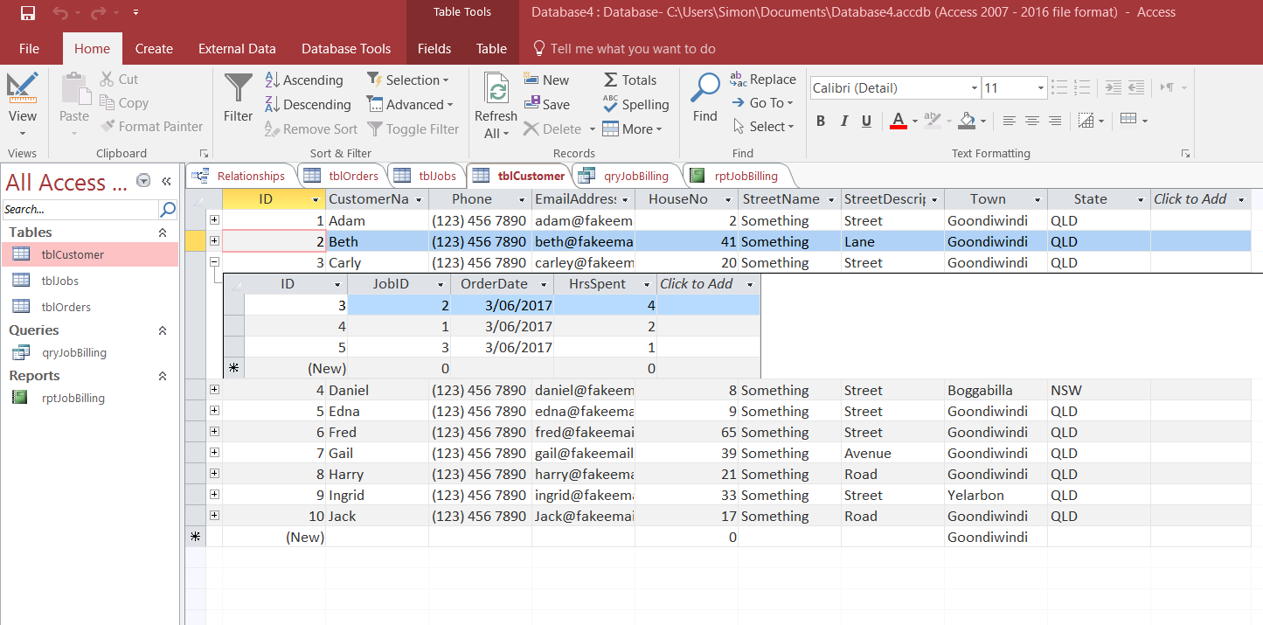  tblCustomers:  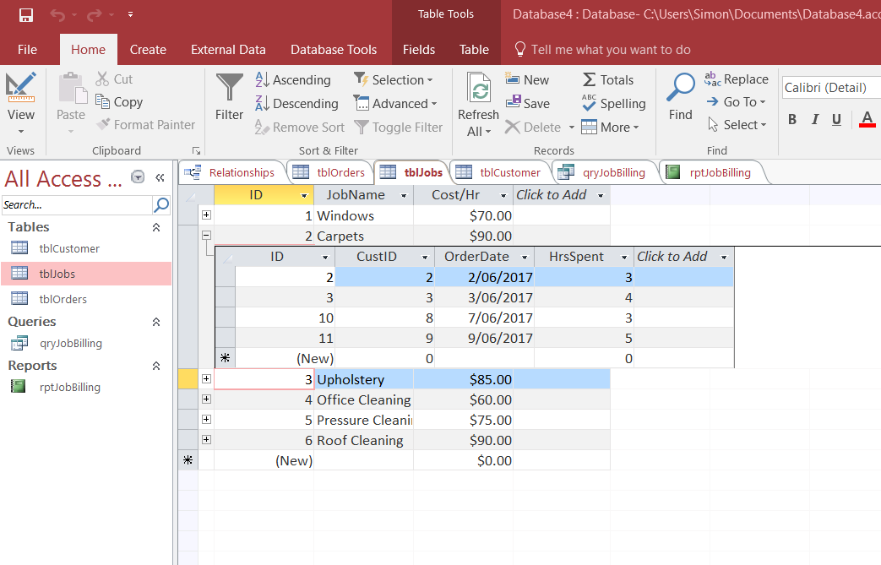  tblJobs:  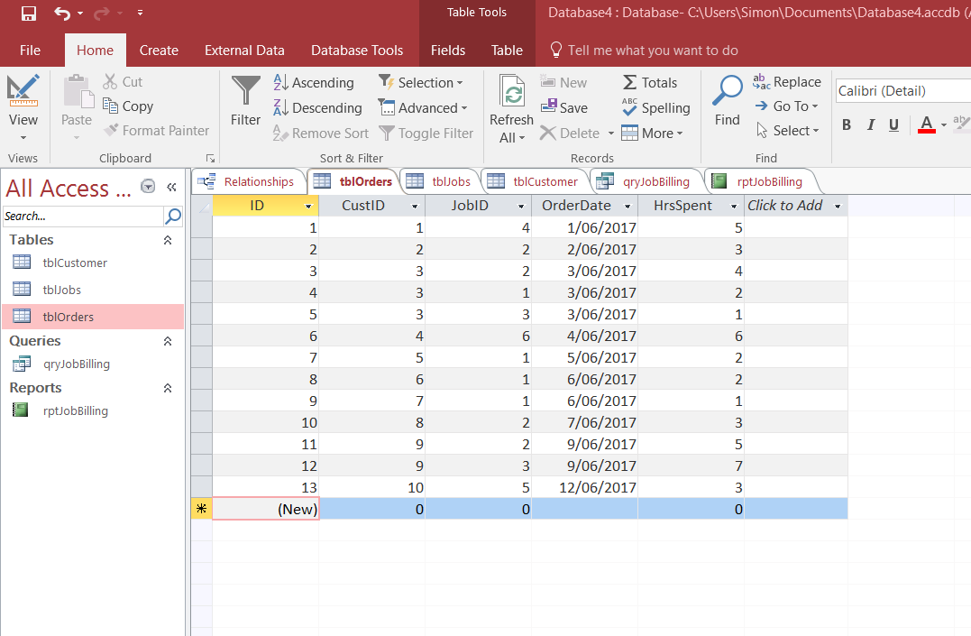  tblOrders:  Relationships:  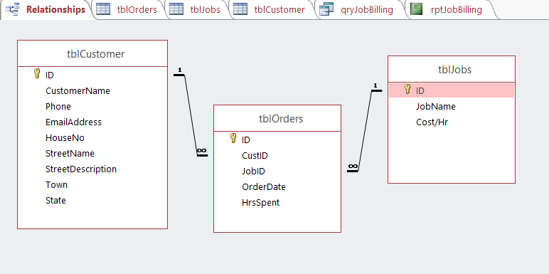  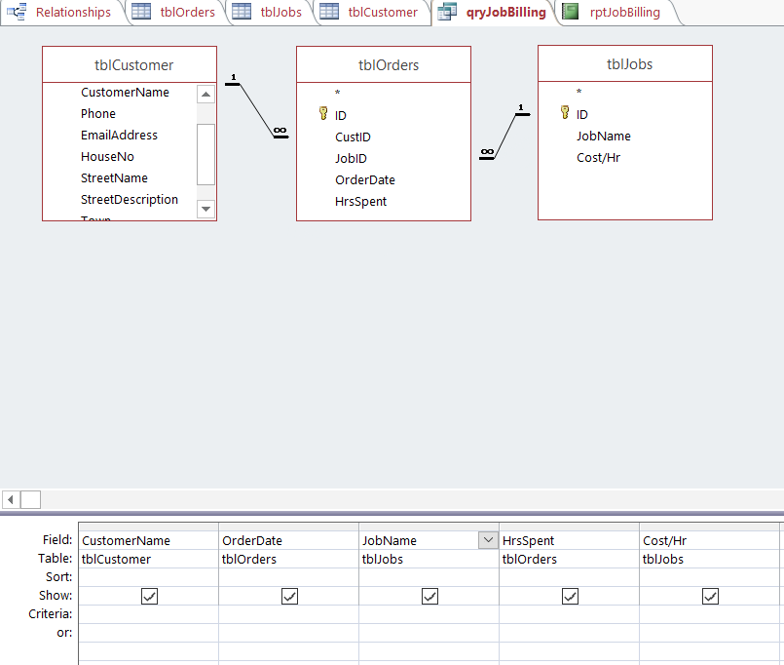  Query Design:  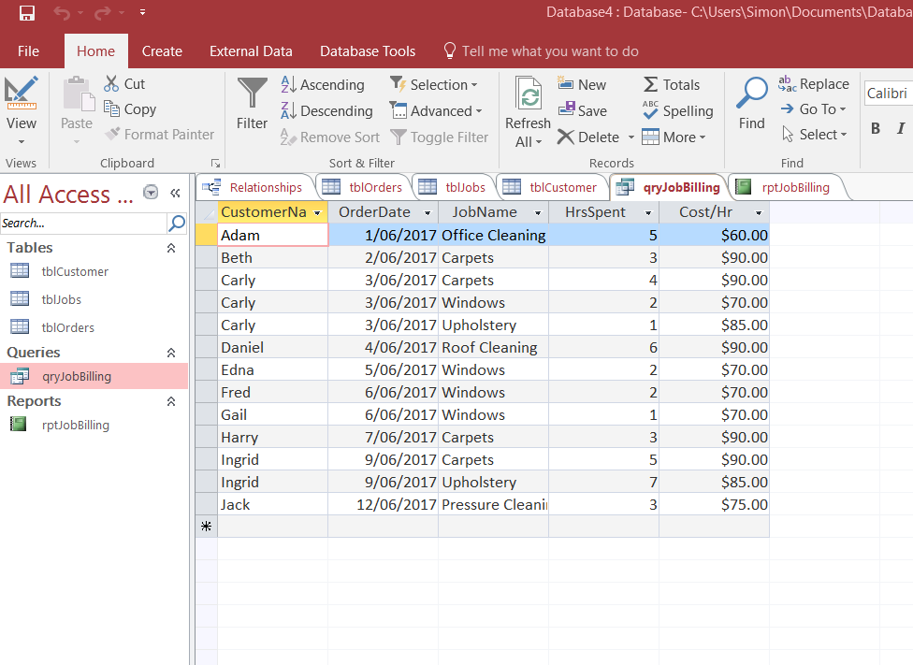  qryJobBilling  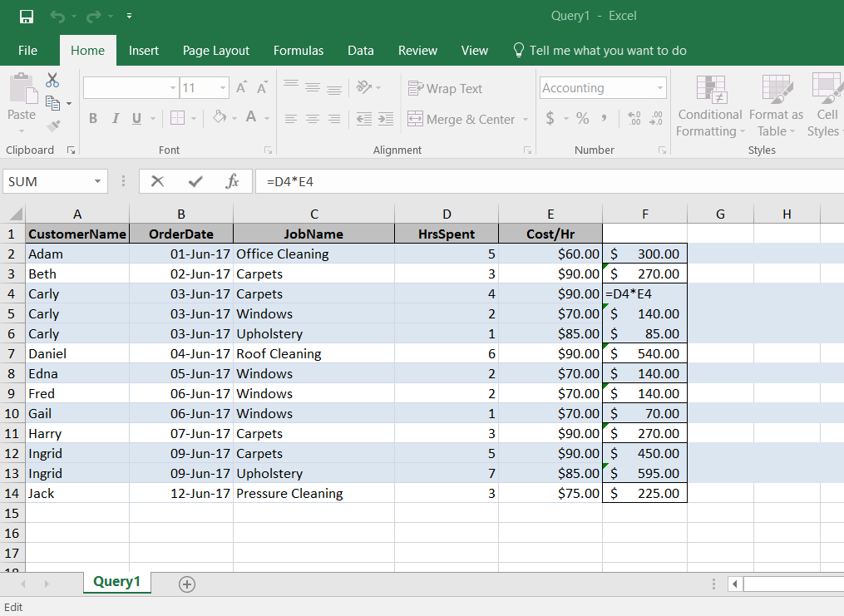  qryJobBilling - exported to excel spreadsheet (formula used for job calculations)  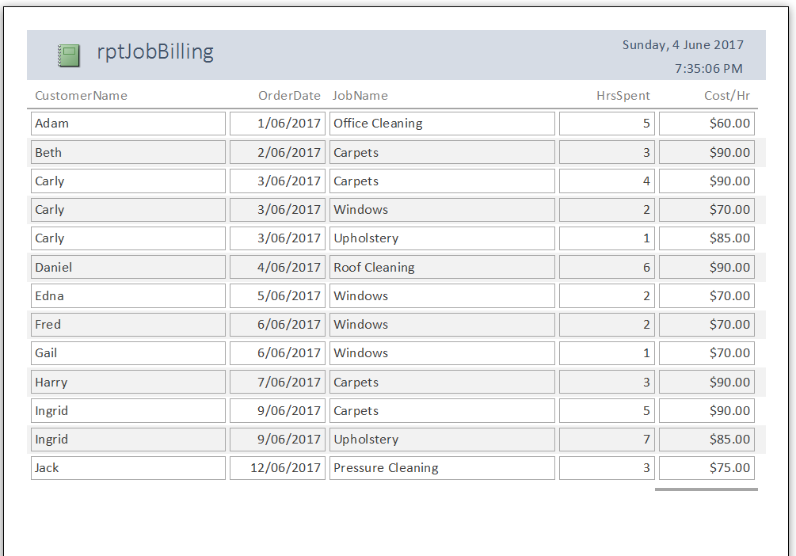  rptJobBilling

Major Activity
Estimated Time | 2 Hours
Objective | To provide you with an opportunity to demonstrate your knowledge of the entire unit.
Activity | This is a major activity – your instructor will let you know whether you will complete it during class or in your own time.  Attach your completed answers to the workbook.  You must individually, answer the following questions in full to show your competency of each element:  - Create a simple database  - Create reports and queries  - Use database  - What things should you consider when planning a database?  Before creating a database, it is important to consider what information the database will need to hold, and plan the tables and relevant fields that will be needed. Think about how the tables will be linked within the database to ensure it works consistently as a whole. Organisational standards regarding layouts and design principles will need to be taken into consideration. Since a database often holds personal information about staff/clients, it is necessary to consider the security/confidentiality requirements of your organisation. As you plan a database, also ensure that you remain on track with meeting deadlines.  - What things should you consider when creating a report?  Creating a report involves the consideration of questions such as; What information are you trying to find? Which fields are relevant and which are not? Does the formatting meet organisational standards?  - What things should you consider when finishing the report?  When finishing a report, it is vital to ensure that the formatting and layout make it is easy to read and understand, and that it meets organisational requirements. It is important to proofread the report to ensure there are no errors. Consideration must also be given to the distribution of the report.

