CPCCBC4005A
Produce labour and material schedules for ordering

THEORY EXAM INSTRUCTIONS

- This exam will occur under standard assessment conditions.
  - An oral examination may be allowed under certain circumstances.
Answers will be documented and FT003 (Oral examination declaration form) must be completed.
- Participants must provide enough detail in their responses to demonstrate their knowledge and skills.
- Please fill in the details below, providing your name, signature and date of assessment.
  - Your signature acknowledges that this is your own work.
- If a participant initially answers a question incorrectly but modifies their response, they must follow the instructions below:
  - If a participant changes their response in writing, they must put their initials next to the written change.
  - If a participant changes their response verbally, this must be noted on the exam paper by the assessor.

Participant name | SAMBARA SERLY
Participant signature | 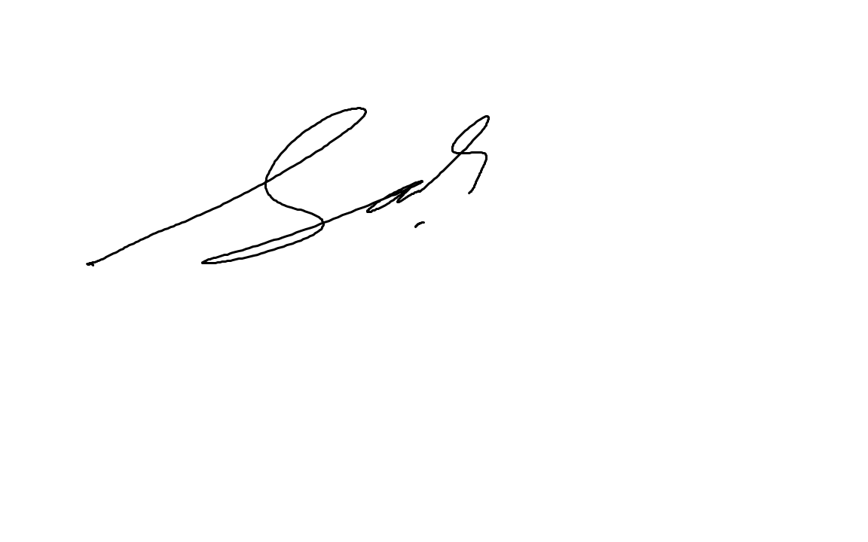

Assessor name | BRETT STOWARD
Assessor signature | 

Date | 18/06/2019

Number of questions | Number of questions answered correctly | Satisfactory?
30 |  | Yes | No
Assessor Comments
- Which of the following contractual requirements will influence orders and labour and material schedules? Tick all that apply.

Answer | Choice | Possible Answers
 |  | Commencement date
 |  | Completion date
 |  | Contract price

- Identify three (3) suppliers and three (3) contractors that you may need to work with when undertaking a building project.

Answer | Suppliers | Contractors
 | PPE Supplier | Labour
 | Concrete Supplier | Electrical
 | Material Supplier | Plumbing

- Explain the difference between employees and contractors and how they are influenced by scheduling.

Answer | Generally, a contractor is someone who runs their own business and provides services to other businesses or individuals. An employee works in and is part of a business.  - A builder can closely direct the work to be undertaken by an employee  - A contractor can decide what work they do, how it is to be carried out and the hours when the work is to be completed

- Identify one (1) local government authority and one (1) regulatory body that must be considered when producing schedules.

Answer | Local Council for the permits  And  ABCC

- Why should colour selections be included on the schedules?

Answer | There is a lot to consider within your schedule and so it is important to factor in the owners’ requirements for colour schemes and selections. Some colour requests may require a special order to be made.  You must ensure that your building contract covers matters such as colour selections for interior and exterior components, including:  - Whether any surfaces are to be painted (walls, trims)  - Colour and quality of paint to be used  - Colour choice for tiles  - Colour choice for roof  - Colour choices for carpets

- True or False (Tick your response): If a project is in a heritage protected area, the council may specify the colours that should be used.

Answer |  | True
 |  | False

- Identify your local council’s requirements regarding working hours and days. Explain how these requirements may affect your schedules.

Answer | Approved construction hours  7.30am–5.30pm Monday to Friday  7.30am–3.30pm Saturday  The City and other consent authorities can approve out-of-hours construction, when needed.  Work schedule needs to include task details, timelines and deliverables as we need to lock in all details to keep your building project on schedule. Fail to schedule correctly will cause in delays and extra cost. Fail to follow the local council requirement working hours may cause us issues in proceeding with work as per schedule.

- Identify three (3) common drawings/specifications commonly used in the industry. Explain what information is provided by each document and how this influences labour and material schedules for ordering.

Answer | Drawing/Specification | Information provided for labour and material schedules
 | Plans | Plans for the building from a bird’s eye view
 | Elevations | Drawings of the building showing what it looks like from north, south, east and west
 | Floor and wall covering specifications | Include details of the type and colour of material used for floors and walls

- What three (3) things should a builder do when variations are made to a contract for a project?

Answer | - It is their responsibility to put any variation in writing to you (the builder) as early as possible (to minimise cost and time delays) on paper or by email  - Always put variations in writing  - Changes to any terms, including the cost, must be dated and signed by all the parties to the contract  - Submit an extension of time (for significant change, such as delays caused by owner increasing scope of works)  - Variation payments should be made in accordance with the time stated in the variation document  Make sure that you:  - Make changes to your schedule accordingly  - Notify your major suppliers  Make changes to your call forward sheet\

- Identify two (2) variations that may be raised by the client and explain how it would affect the schedules.

Answer | Variation | Effect on schedules
 | - Changes to room sizes | Cost on Labour and delays
 | - Changes to colour schemes using cheaper or more expensive paints | Cost on Labour and delays

- Identify two (2) variations that may be raised by the builder and explain how it would affect the schedules.

Answer | Variation | Effect on schedules
 | Extra materials and equipment needed | Cost and delays in delivery time
 | Extra labour needed | Cost and delays in delivery time

- Order the following steps from 1 to 5 to outline how a builder should select a supplier/contractor.

Answer | Step Number | Steps
 | 1 | Builder to seek quotes from suppliers/contractors
 | 5 | Builder to note supplier/contractor details and ordering times on schedule
 | 3 | Builder to accept a tender
 | 2 | Suppliers/Contractors tender prices back to the builder
 | 4 | Parties to sign agreement

- What is an ‘overlay drawing’?

Answer | Overlay drawings are drawings that show further detail on top of any existing plans and specifications. Overlay drawings are generally designed to:  - Provide more visual clarity about a building process  - Provide advice if there have been changes that require subsequent engineering redesign/specialist changes (e.g. from architects, soil experts)

- Which of the following individuals may sketch overlay drawings?
Tick all that apply.

Answer | Choice | Possible Answers
 |  | Architects
 |  | Builder
 |  | Draftsmen
 |  | Engineers

- Identify three (3) details that should be included on a work order and reflected on the labour schedule.

Answer | WORK REQUIRED (INCL LOCATION AND EXTENT OF WORKS)  TIME PERIOD  AGREED RATES

- Identify nine (9) details that should be included on a purchase order.

Answer | - ORDER DATE  - DELIVERY DATE  - PO NUMBER  - SUPPLIERS DETAILS  - TERMS AND CONDITIONS  - PRODUCT DESCRIPTIONS  - TOTAL ORDER COSTS  - DELIVERY ADDRESS  - DELIVERY INSTRUCTIONS

- What is a ‘call forward sheet’?

Answer | A call forward sheet is a sheet used to track when materials are needed and when they should be ordered. This tool allows site personnel to schedule and coordinate activities that are to be undertaken on-site.

- True or False (Tick your response): A builder would usually complete all the purchase orders before preparing a call forward sheet.

Answer |  | True
 |  | False

- Identify two (2) approved plans that should be included with the site documents.

Answer | Design and Architectural Plans  Land Survey Plan

- Match the site files and definitions below by writing the appropriate letter next to each number in the centre column.

Answer | Document |  | Answers | Definition
 | 1 | Permits | 1 - B | A | May include engineering data
 | 2 | Quotes | 2 - E | B | Council inspectors may issue a stop work notice until these documents are produced
 | 3 | Reports | 3 - A | C | Changes requested using a standard form in writing. Need to be signed by both builder and client.
 | 4 | Specifications | 4 - D | D | List the materials to be used, fittings and fixtures to be installed, and types of finishing required.
 | 5 | Variations | 5 - C | E | Used to ensure purchase orders are developed using the correct price.

- In the table below, estimates for labour and actual costs for each trade are listed. Calculate the cost difference for each trade.

Answer | Trade | Estimate | Actual cost | Cost difference
 | Carpentry | 10,000 | 8,500 | -1,500
 | Electrical | 3,000 | 4,250 | 1,250
 | Painting | 4,000 | 3,900 | -100
 | Plumbing | 8,000 | 8,000 | 0
 | Tiler | 4,500 | 4,750 | 250

- In the table below, the Prime Cost (PC) sums from a contract and actual costs for items are listed. Calculate the cost difference for each item.

Answer | Item | PC sum | Actual cost | Cost difference
 | Basin taps | 100 | 130 | 30
 | Oven | 2,500 | 1,500 | -1000
 | Rangehood | 500 | 900 | 400
 | Shower bases | 250 | 265 | 15
 | Shower screen | 400 | 350 | -50
 | Shower taps | 150 | 120 | -30
 | Stove | 900 | 1,200 | 300

- Where the actual costs are higher than the estimated costs due to a client variation, who is responsible to pay the difference?
Tick your response.

Answer | Choice | Possible Answers
 |  | Builder
 |  | Client
 |  | Supplier

- Where the actual costs are higher than the estimated costs due to price increases of materials, who is responsible to pay the difference?
Tick your response.

Answer | Choice | Possible Answers
 |  | Builder
 |  | Client
 |  | Supplier

- You are given the following table containing the costs for each month of the project.
Month | Estimated cost | Actual cost
March | $36,450 | $38,980
April | $65,560 | $62,350
May | $62,450 | $64,960
June | $61,340 | $61,050
July | $40,590 | $38,990
August | $42,650 | $42,550
September | $35,780 | $34,750
Total | $344,820 | $343,630
Using the information in this table, how would you find out in which month the builder actually spent the most? Tick your response.

Answer | Choice | Possible Answers
 |  | Plot both the estimated and actual costs on a graph
 |  | Plot the actual cost on a graph
 |  | Work out the difference between the estimated and actual costs

- The following graph is a visual representation of the difference in each month.

By looking at this graph can you see if the overall project was overestimated or underestimated? Tick your response.

Answer | Choice | Possible Answers
 |  | No, you cannot see this directly from the graph
 |  | Yes, you can see this from the graph

- The following graph is a visual representation of the accumulated difference across the project.

Overall, was the project overestimated or underestimated?
Tick your response.

Answer | Choice | Possible Answers
 |  | Overestimated
 |  | Underestimated

Refer to the following scenario and house plan to respond to Q28. to Q30.

SCENARIO

You are a site supervisor of a small residential project, as outlined below:
- The building is to be constructed using brick veneer.
- The building has a floor area of 133 square metres including garage.
- The concrete slab floor with garage floor is incorporated.
- The building will be constructed using hand built wall frame and prefabricated roof trusses.
- The building will have a cement tiled roof and powder coated aluminium windows in timber reveals.
- The driveway and landscaping are to be provided.
- Services are available directly in front of the site.
- The site is almost flat and will only need a scrape with minimal excavation.
- The contract period is 120 days.
- The total job has been pre-costed at $136,500.

Note: You are not required to estimate the quantity required.


- Using the list of materials prepared, find the following information for four (4) materials of your choice:

Answer | Material | Lead-in time | Delivery date | Order date | Delivery requirements/ special considerations
 | Brick Veneer | 2 Weeks | 15/08/2019 | 01/08/2019 | Must wear PPE
 | Concrete | 3 Day | 15/08/2019 | 12/08/2019 | Must wear PPE
 | Trusses | 7 days | 15/08/2019 | 08/08/2019 | Must Wear PPE
 | Sand 20kg | 7 Days | 15/08/2019 | 08/08/2019 | Must wear PPE

- Describe the process of ordering the following materials for your project. Be sure to consider the things that need to be considered:

Answer | Material | Ordering process | Considerations
 | External cladding | Get the best price  Tender a price  Accept tender  Issue PO | Specification, Lead in time, Delivery Charge, Non-returnable item / not
 | Wall frame |  | Specification, Lead in time, Delivery Charge, Non-returnable item / not
 | Windows | Get the best price  Tender a price  Accept tender  Issue PO | Specification, Lead in time, Delivery Charge, Non-returnable item / not

- While excavating one corner of the project, you find the soil below is unsuitable for supporting the foundation. Refer to the relevant Building Regulator and complete their standard builder variation request documentation to be presented to the client.

Answer | DOCUMENTATION TO BE SUBMITTED BY STUDENT (EG. FORM 5 QBCC)

