

Learner Guide
RIICPL401D Apply the principles for the installation of underground service using open excavation

Version | Originator | Authorised | Date | Notes
1.2 | Advanced Solutions | Anthony Nairn | Mar 2016

Contents
Study Guide Overview 3
Introduction: Unit Description 6
Chapter 1: Plan and prepare tasks 10
1.1 Legislation 10
1.2 Review the installation and identify required tasks 12
1.3 Access, interpret and clarify the specific task information and requirements 17
1.4 Ensure a job plan is available 26
Chapter 2: Leadership and Supervision 35
2.1 Confirming resources 37
2.2 Communication 39
2.3 Assigning Tasks 42
Chapter 3: Oversee the execution of tasks 46
3.1 Monitoring the installation and identifying performance gaps 46
3.2 Continuous improvement processes 48
3.3 Tools, Plant, and Equipment Maintenance 50
Chapter 4: Reporting on the execution of tasks 52
4.1 Writing reports 52
4.2 Recommending changes 54
Appendix 55
SAMPLE: Presentation Plan 55
SAMPLE: Workplace Inspection Checklist 57
SAMPLE: Safe Work Method Statement (SWMS) 63
SAMPLE: Safe Work Instruction 66
Glossary 72
References 73

Study Guide Overview
About your study course
As a student or In-service worker, you most likely have already come to the understanding of the practical skills and knowledge required to work within the industry standards that are part of the engineering field. This course seeks to guide you towards developing those skills and knowledge. In addition, you have both a time and financial investment that makes it a personal challenge. As such, help us to help you take ‘responsibility’ for your own learning. Talk to the trainer and request student support if desired.
Be receptive towards your learning process and reinforce your studies with self-learning wherever possible.
Getting the most out of your study
- Talk to your trainer / facilitator and ask questions. They are experienced and able to assist you with your enquiries where possible
- Carefully choose your time and place to study outside of the class or in an environment that is comfortable and effective for learning
- Make a schedule to study and talk about your studies with your peers (many hands make light work and there is often value in collaboration)
- Consider how the learner guide information relates to what you are doing
- Seek feedback on your work and study to ensure you are on the right track and re-affirm your effective studying habits
- Make notes, use highlighters, use colours (for the visual learners), underline stuff, scribble memos, and decorate your desk with post-its – whichever approach works best for you
- Read your work examples aloud (to yourself – sometimes as a potential strategy it helps you to understand something by reading it aloud and also to identify areas for consideration)
- Consider the student activities in the learner guide to reinforce your learning as you go
- Please advise if you are having issues. We would like to assist you to make this a positive learning experience.
Required texts and recommended readings
Throughout your course you may be introduced to texts and recommended reading materials for your studies from your trainer. Take note of these. In the meantime, we have a compiled a list of resources (see the Table of Contents for the ‘recommended further readings’ page that follows the conclusion).
The learner guide and experienced trainers are generally sufficient to help you meet the requirements though it never hurts to have further materials that you might like to seek out for your own purposes and continued learning.

Referencing Guide
Information has a source and referencing provides the pathway to that source. You will be required to reference if you are providing written submissions that includes work which has been sourced from copyrighted materials that are not your own. In many cases you will be simply referring to your learner guide to provide a written response to a question. In such a case, refer briefly to the page of the guide (e.g. Learner guide P.23).
In all other cases, we would recommend using a referencing system. There are two accepted types in Australia (APA & Harvard).
For your convenience, we have provided the following links to download either document for use in your studies.
https://www.library.uq.edu.au/help/referencing-style-guides
APA Referencing guide link
https://libraryguides.vu.edu.au/apa-referencing/getting-started-in-apa-referencing
Harvard Referencing guide link
http://guides.lib.monash.edu/citing-referencing/harvard
https://guides.lib.monash.edu/ld.php?content_id=8481587

Introduction: Unit Description
Required Texts / Reading
The only required text for this course is the learner guide and any additional hand-outs / text resources your trainer provides during your classes.
The Learner guide
This learner guide provides the required information to engage in class activities and explains in detail, the processes by which to use the applied knowledge correctly. It is essential that you learn from both the guide and your trainer in order to complete the related assignments. The learner guide can be used by students as a supporting resource for both the class and workshop environment.
Purpose of the unit
The purpose of this learner guide and in-class training is to provide the necessary background to:
- Apply the principles of civil concrete structures construction in the civil construction industry
This unit is appropriate for those working in supervisory or technical specialist roles.
No licensing, legislation or certification requirements apply to this unit at the time of publication.
In-class work and Assessment
For each course you will engage in any number of written and some practical assessments.


Unit Outline Information for students
Unit Title | Apply the principles for the installation of underground service using open excavation
Training Package Unit Code | RIICPL401D
Unit Summary
This unit describes a participant’s skills and knowledge required to apply the principles for the installation of underground service using open excavation in Civil construction.
This unit is appropriate for those working in supervisory or technical specialist roles.
No licensing or certification requirements apply to this unit at the time of publication.
Prerequisites
Nil
Assessment Method
Delivery:
- Classroom based
- Workplace based
Assessment Tasks:
- Test
- Practical Observation
Re-Assessment: Re-assessment for a completed assessment that is deemed Not Satisfactory will be rescheduled as soon as practical.
Prescribed reading
Nil

Performance Evidence:
Evidence is required to be collected that demonstrates a candidate’s competency in this unit. Evidence must be relevant to the roles within this sector’s work operations and satisfy all of the requirements of the performance criteria of this unit and include evidence that the candidate:
• Locates and applies relevant legislation, documentation, policies and procedures
• Implements appropriate procedures and techniques for the safe, effective and efficient supervision of installation of underground service using open excavation tasks including:
- identifying and interpreting relevant information and data
• Calculating quantities for the execution of tasks, including:
- volumes
- grades
- percentages
- areas
- resource consumption figures, including required supply rates
• Works effectively with others to plan, prepare and conduct for the installation of underground service using open excavation tasks including:
- providing clear and timely instruction and supervision using a range of communication techniques to those involved
- preparing for and conducting briefings, toolbox and site meeting
- maintaining clear and legible written records and reporting systems
• Demonstrates completion of the principles for the installation of underground service using open excavation that safely, effectively and efficiently meets all of the required outcomes on more than one (1) occasion including:
- supervising others in the installation of underground service using open excavation tasks
- organising availability of necessary resources
- monitoring required outcomes and identifying performance gaps
- recommending changes to improve the execution of tasks

Knowledge Evidence
The candidate must demonstrate knowledge in applying the principles for the installation of underground service using open excavation through:
• applying organisation, site requirements and procedures for:
• risk assessment and management
• Statutory compliance
• Work health and safety
• Environmental management
- Shoring and slope management
• Quality management
• Work zone traffic management
• Contract management
• Managing open excavation underground service installation
• Plant and equipment capabilities and application
• Implementing plant, equipment and tools maintenance requirements and procedures
• Assessing operational techniques
• Assessing resource requirements and procedures
• Scheduling tasks/activities
• Scheduling materials delivery requirements and procedures
• Implementing workplace relationship requirements and procedures
• Managing client and site operational requirements
• Identifying relationship between various areas of civil works
• Using team leadership techniques
• Using works planning techniques
• Identifying engineering survey principles
• Using estimating principles
• Using civil works construction sequencing and terminology
• Identifying related underground services and utilities

Chapter 1: Plan and prepare tasks
By the end of this chapter you will understand how to:
- Access, interpret and apply underground service documentation and ensure the work activity is compliant
- Review the installation and identify relevant tasks
- Access, interpret and clarify the specific task information and requirements
- Ensure a job plan is available which makes best use of the available resources and meets task requirements

1.1 Legislation
There are a number of pieces of legislation that apply to this type of work, and this depends on the environment you are working within. This may be a footpath or road, park, house, mine or quarry.
Area Involved | Legislation
Road | Workplace Health and Safety Act 2011  Workplace Health and Safety regulation 2011  Electrical Safety Act 2002  Electrical Safety Regulation 2013  Excavation work Code of Practice 2013
Park | Workplace Health and Safety Act 2011  Workplace Health and Safety regulation 2011  Electrical Safety Act 2002  Electrical Safety Regulation 2013  Excavation work Code of Practice 2013
House | Workplace Health and Safety Act 2011  Workplace Health and Safety regulation 2011  Electrical Safety Act 2002  Electrical Safety Regulation 2013  Excavation work Code of Practice 2013

Area Involved | Legislation
Coal mine | Coal Mining Safety and Health Act 1999  Coal Mining Safety and Health Regulation 2001  Electrical Safety Act 2002  Electrical Safety Regulation 2013  Excavation work Code of Practice 2013 (can be used to develop Standard Operating Procedure)
Metalliferous mine | Mining and Quarrying Safety and Health Act 1999  Mining and Quarrying Safety and Health 2001  Electrical Safety Act 2002  Electrical Safety Regulation 2013  Excavation work Code of Practice 2013 (can be used to develop Standard Operating Procedure)
Quarry | Mining and Quarrying Safety and Health Act 1999  Mining and Quarrying Safety and Health 2001  Electrical Safety Act 2002  Electrical Safety Regulation 2013  Excavation work Code of Practice 2013 (can be used to develop Standard Operating Procedure)
Each of these Acts and Regulations includes specific requirements that must be complied with, and these are generally the higher level requirements as opposed to the Code of Practice which has very specific requirements and very detailed guidance around what is required.
Legislation for each state in Australia can be found the following location:
State | Website
Qld | www.legislation.qld.gov.au
NSW | www.legislation.nsw.gov.au
VIC | www.legislation.vic.gov.au
SA | www.legislation.sa.gov.au
WA | http://www.slp.wa.gov.au/legislation/statutes.nsf/default.html
TAS | http://www.thelaw.tas.gov.au/
NT | http://dcm.nt.gov.au/strong_service_delivery/supporting_government/current_northern_territory_legislation_database
In addition to the legislation, each company or business may have a procedure (may be called a Safe Work Procedure, Standard Operating Procedure etc.) that addresses the installation of services, trenching or excavation. Prior to commencing any excavation, trenching or installation work, you must document and understand all of these requirements
Source: www.suggestkeyword.com

1.2 Review the installation and identify required tasks

The installation of underground services involves a number of specific tasks. These include:
- Establishing the work area
- Transporting materials to site and unloading
- Locate existing underground services
- Excavation of the trench
- Treatment of the trench with appropriate control to make safe
- Placement of services in the trench
- Installation of the required markers/locators
- Removal of the trench treatments
- Backfilling of the trench
- Modify existing plans with updated information
No person should be within the swing radius of the plant while it is operational, due to the risk of injury.

Establishing the work area may include the following:
- Communicating with others who may be affected by the work with timeframes and associated risks
- Establishing a physical barricade of the area to restrict entry by unauthorised people. This may be a fence, bollards or demarcation/barricading placed around the work area
- Installation of signage to warn people of the risks, and the rules or process for entry to the work area
- Contact details of the responsible people for the work

Transporting materials to site and unloading may include the following:
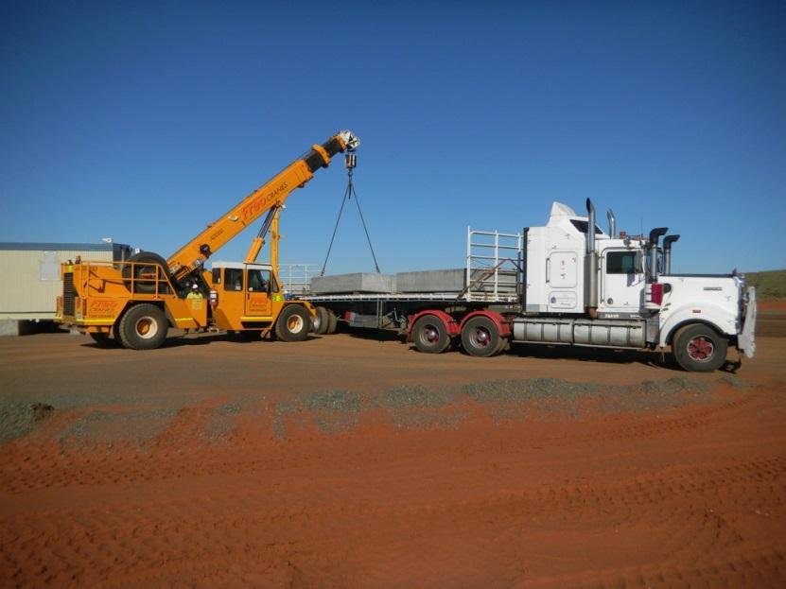
- Ensuring the area for the unloading is safe
- Using plan/equipment to unload the vehicle, such as a forklift, integrated tool carrier, or franna crane
- Where a crane is used, the load will be required to be ‘dogged’ to the crane by a qualified Dogger
- Storing the material in a secure area for use in the project
- Installation of signage to restrict unauthorised people from accessing the area (Source: http://flickrhivemind.net/blackmagic )

Locate existing underground services
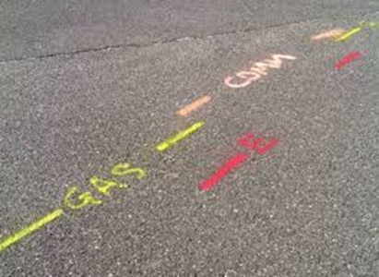
- Locating existing underground services is carried out through contacting DBYD and requesting maps of services in the area, as well as:
- Potholing either through manual digging by hand or vacuum excavation
- Using Ground Penetrating Radar (GPR)
- Once the underground service has been located, it needs to be physically marked on the ground so that the plant operator can ensure the existing services are not interfered with. Survey paint or short pegs can be used to mark out the location and the direction of these services.

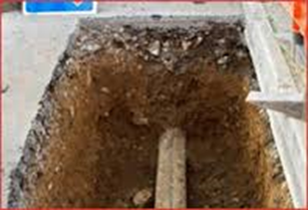
Excavation of the trench
Excavating trenches may involve:
- Using a suitable plant which may be a loader, an excavator or a dedicated trenching machine
- Placing the removed material to the side of the excavation
- Digging or excavating to the required depth

Treatment of the trench with appropriate control to make safe may include:
- Battering
- Benching
- A combination of battering and benching
- Shoring
In Queensland, the Excavation Work Code of Practice allows for people to enter a trench without battering, benching or shoring only where the trench is less than 1.5m deep (at its deepest point)
An example of benching  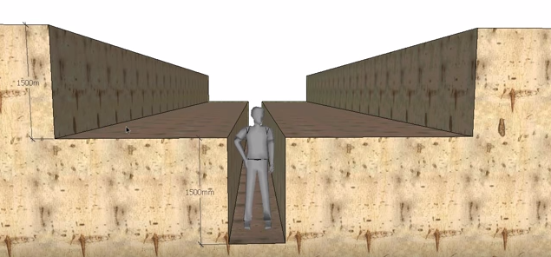 |  | An example of battering  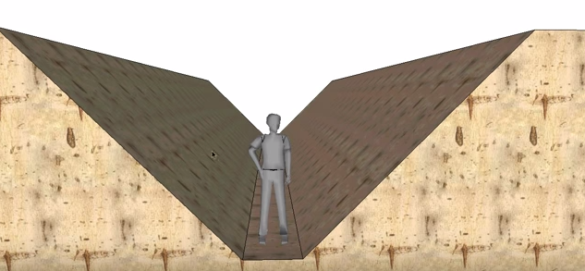
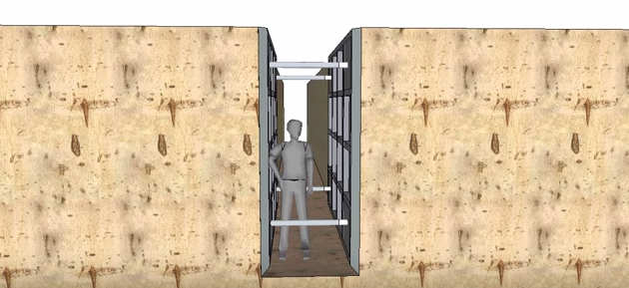  An example of combined benching and battering  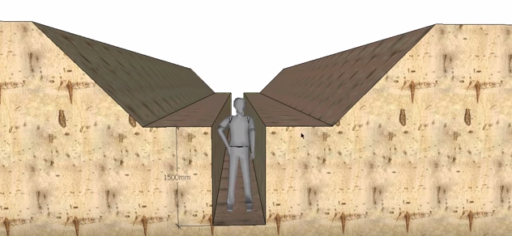 |  | An example of shoring using a trench box
An example of trenching using steel sheet piles
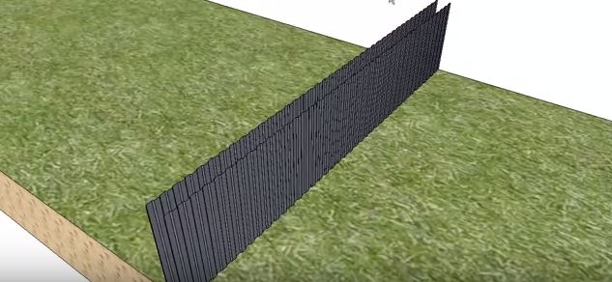

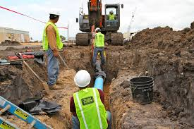
Placement of services in the trench
This may include:
- Installation of the required bedding or supporting sand or gravel in accordance with the clients or manufacturers design or specification
- Using an excavator to lift the services into the trench
- Using a dedicated machine to place the services

Installation of the required markers/locators
Installation may include the need to source the correct marker or locator for the project. Types available are:
- Non detectable underground warning tapes
- Detectable mesh underground warning tape
- Detectable wave underground warning tape
AS5488-2013 Classification of Subsurface Utility Information defines the following
Asset Type | Colour | Symbol Examples
Gas | Yellow | HPGM or GM
Sewer | Green | SE
Stormwater | Purple | SS
Telecommunications | Telstra Orange | TE
ETSA | Red | E (H/V & L/V)
Traffic Signals | Red | TS
Street Lighting | Red | SL, SPL
Railways | Orange | TA
Railways (ARTC) | Orange | ARTC
Railways (G&W) | Orange | G&W
Water | Blue | W
Fibre Optic | Orange | TE
Reclaimed Water | Purple | RW

Removal of the trench treatments
When there is no further need for people to be within the trench, the shoring can be removed. A qualified rigger must be used to attach the shoring to the plant that will lift it out. The shoring, once removed, should be stored in a location out of the way of the work area so that it does not congest or become an obstacle in the work area.

Backfilling the trench
Backfilling is equally as important as the excavation. Care must be taken to ensure:
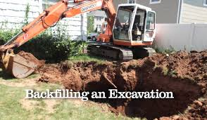
- The initial ground level has been recorded,
- A sample of the materials for backfilling has been accepted by the site Engineer,
- All of the necessary marking and reference points have been established for the final level of back filling,
- The backfilling process is completed in sub-grade layers (15-20cm),
- Required watering and compacting is completed, and
- The required density is tested and achieved

Modify existing plans with updated information
It is critical to ensure that any modifications to the route of underground services or location of new services are recorded on a map and that information sent to Dial Before You Dig (DBYD). This is so that DBYD can update their systems with the new information.

1.3 Access, interpret and clarify the specific task information and requirements
Planning requires the time and space to think about what is needed to be done. “Thinking is difficult, as it calls not only for recall but for patient analysis. It means questioning assumptions and considering alternatives.” (Burns, 2003, p51).
- It helps people who have to work to the plan,
- It leads to a better us of resources,
- It gets things done faster,
- It helps identify problems before they occur, and
- It is usually one part of supervision that receives a positive response.
One technique that helps identify everything that needs to be planned for and sort these into relevant categories of work is a thought processing technique known as ‘Mind Mapping’. Mind Mapping helps you break large projects or topics down into manageable chunks, so that you can plan effectively without getting overwhelmed and without forgetting something important.

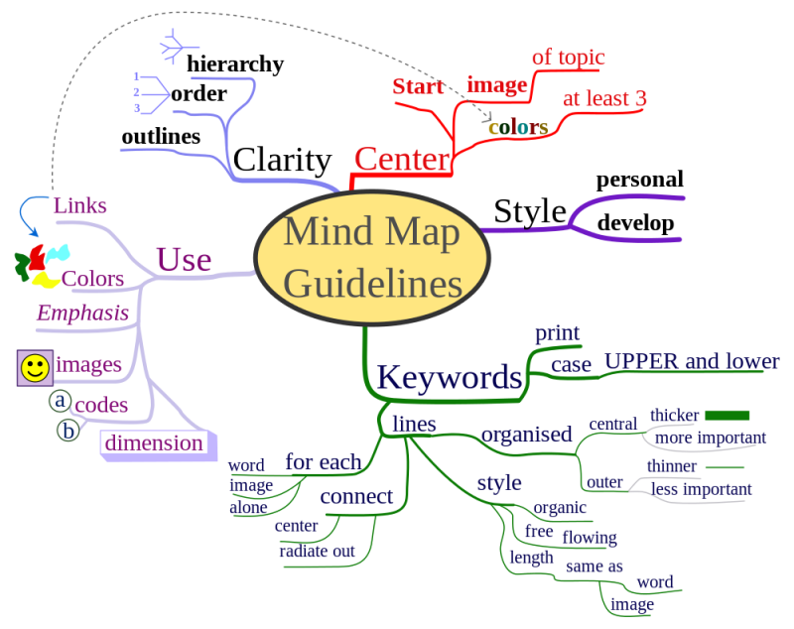
7 Steps to Making a Mind Map
- Start in the CENTRE of a blank page turned sideways. Why? Because starting in the centre gives your Brain freedom to spread out in all directions and to express itself more freely and naturally.
- Use an IMAGE or PICTURE for your central idea. Why? Because an image is worth a thousand words and helps you use your Imagination. A central image is more interesting, keeps you focussed, helps you concentrate, and gives your Brain more of a buzz!
- Use COLOURS throughout. Why? Because colours are as exciting to your Brain as are images. Colour adds extra vibrancy and life to your Mind Map, adds tremendous energy to your Creative Thinking, and is fun!
- CONNECT your MAIN BRANCHES to the central image and connect your second- and third-level branches to the first and second levels, etc. Why? Because your Brain works by association. It likes to link two (or three, or four) things together. If you connect the branches, you will understand and remember a lot more easily.
- Make your branches CURVED rather than straight-lined. Why? Because having nothing but straight lines are boring to your Brain.
- Use ONE KEY WORD PER LINE. Why? Because single key words give your Mind Map more power and flexibility.
- Use IMAGES throughout. Why? Because each image, like the central image, is also worth a thousand words. So if you have only 10 images in your Mind Map, it’s already the equal of 10,000 words of notes!
(http://www.tonybuzan.com/about/mind-mapping/ )
It is critically important that all supervision tasks are conducted with knowledge of the all the relevant information and requirements for the task have been reviewed and understood. Legally, you have an important role in supervising construction works; therefore, it is important that you know where to locate all the necessary information and requirements for each job you are supervising.
For example, you need to know where to find the following information in your workplace:
- Legislation, Codes of Practice, and other compliance documentation,
- Company policies and procedures; e.g. contract management, environmental management,
- Risk assessments and controls,
- Plant and equipment specifications,
- Site plans and processes,
- Work instructions; e.g. shoring and slope management,
- Materials suppliers, and
- Site traffic management and access requirements.

Following is a snapshot of the types of information you need to know and be aware of.

CMS&H Regulations
Plans of surface services
(1) The site senior executive must ensure current plans identifying and showing the location of surface services, including buried services, are kept in a location at the mine that is easily accessible by each coal mine worker at the mine.

Using plant near electricity

(1) A surface mine must have a standard operating procedure for using fixed and mobile plant near electrical cables, overhead electrical conductors, or electrical equipment.
Trenches
(1) A surface mine’s safety and health management system must provide for protecting persons from risks from trenches at the mine.
(2) The system must include provision for the following— (a) the use of barricades; (b) ground support; (c) water ingress and hazardous atmosphere in the trench.

Mining and quarrying safety and health regulations
Electrical plans and data
(1) The site senior executive must ensure the following are kept at the mine for the safe operation of each electrical installation at the mine— (a) up-to-date plans identifying and showing the location of electrical installations at the mine, including buried electrical services;
Excavations
(1) If an excavation exists on a mine site, the site senior executive must ensure appropriate facilities are provided to minimise the risk to persons from falling into the excavation.

WHS Act
Division 3 Excavation work 304 Excavation work—underground essential services information
(1) This section applies in relation to a part of a workplace where excavation work is being carried out and any adjacent areas.
(2) A person with management or control of the workplace must take all reasonable steps to obtain current underground essential services information about the areas mentioned in subsection (1) before directing or allowing the excavation work to commence.
(3) The person with management or control of the workplace must provide the information obtained under subsection (2) to any person engaged by the person to carry out the excavation work.
(4) The person with management or control of the workplace and any person conducting a business or undertaking who is given information under subsection (3) must have regard to the information mentioned in subsection (2) in carrying out or directing or allowing the carrying out of the excavation work
The person with control or management of the workplace must ensure that the information mentioned in subsection (2) is available for inspection under the Act for the period stated in subsection (6).
(6) The information must be available— (a) if a notifiable incident occurs in connection with the excavation work to which the information relates—for at least 2 years after the incident occurs; and (b) in every other case—until the excavation work is completed.
Additional controls—trenches
(1) A person conducting a business or undertaking, who proposes to excavate a trench at least 1·5m deep must ensure, so far as [s 306] Work Health and Safety Regulation 2011 Chapter 6 Construction work Part 6.3 Duties of person conducting business or undertaking Current as at 1 July 2015 Page 247 is reasonably practicable, the work area is secured from unauthorised access (including inadvertent entry).
(2) In complying with subsection (1), the person must have regard to all relevant matters including— (a) risks to health and safety arising from unauthorised access to the work area; and (b) the likelihood of unauthorised access occurring. (3) In addition, the person must minimise the risk to any person arising from the collapse of the trench by ensuring that all sides of the trench are adequately supported by doing one or more of the following— (a) shoring by shielding or other comparable means; (b) benching; (c) battering.
(4) Subsection (3) does not apply if the person receives written advice from a geotechnical engineer that all sides of the trench are safe from collapse. (5) An advice under subsection (4)— (a) may be subject to a condition that stated natural occurrences may create a risk of collapse; and (b) must state the period of time to which the advice applies.

Dial before you dig

Dial Before You Dig (DBYD) provides a single Australia wide point of contact between excavators and major utilities that own buried pipes and cables, as well as the owners of other buried services.
Using DBYD makes it easier and safer for people undertaking excavation activities by enabling them to determine what services exist in the area of proposed work.
Enquiries need to be lodged at least two (2) working days in advance of your intention to excavate.
Enquiries can be lodged by:
- Website: www.1100.com.au ;
- Phone: 1100; or
- Facsimile: 1300 652 077.
NOTE: The requested information needs to clearly identify the precise location where the excavation is proposed. If you have not received your requested information from DBYD members after two working days from the date of your request, contact the member directly as listed on your DBYD Request Confirmation.

Excavation Work Code of Practice 2013
Information on the location of underground services may be obtained by contacting the Dial Before You Dig organisation in your state or territory. Any underground service plans that are obtained including information on underground essential services must be provided to the principal contractor and/or the excavation contractor. Other relevant parties including any subcontractors and plant operators carrying out the excavation work should also be provided with information about essential services and other plans so the information is considered when planning all work in the area.

Underground essential services information obtained must be:
- Made available to any worker, principal contractor and subcontractors,
- Readily available for inspection, as required under the WHS Act, and
- Retained until the excavation work is completed or, if there is a notifiable incident relating to the excavation work, 2 years after the incident occurs.
Planning the excavation work
Excavation work should be carefully planned before work starts so it can be carried out safely. Planning involves identifying the hazards, assessing the risks and determining appropriate control measures in consultation with all relevant persons involved in the work, including the principal contractor, excavation contractor, designers and mobile plant operators. Structural or geotechnical engineers may also need to be consulted at this stage.
Consultation should include discussions about:
- Nature and/or condition of the ground and/or working environment,
- Weather conditions,
- Nature of the work and other activities that may affect health and safety,
- Static and dynamic loads near the excavation,
- Interaction with other trades,
- Site access,
- SWMS’s,
- Management of surrounding vehicular traffic and ground vibration,
- Type of equipment used for excavation work,
- Public safety,
- Existing services and their location,
- The length of time the excavation is to remain open,
- Provision of adequate facilities, and
- Procedures to deal with emergencies.

Securing the work area WHS Regulation (S306):

A person conducting a business or undertaking who proposes to excavate a trench at least 1.5 m deep, must ensure, so far as is reasonably practicable, that the work area is secured from unauthorised access (including inadvertent entry). In securing the trench or excavation, you must consider: ∙ risks to health and safety arising from unauthorised access to the work area and the likelihood of unauthorised access occurring.
This requirement aims to protect other workers on site who may be at risk by restricting access to the excavation area. It applies in addition to the duty that the person with management or control of the construction site has to ensure, as far as is reasonably practicable, that the site is secured from unauthorised access from members of the public (e.g. when the site is near schools, parks, shops or other public places).

Emergency plan WHS Regulation (S43):
A person conducting a business or undertaking must ensure that an emergency plan is prepared for the workplace. The excavation contractor must ensure that the emergency plan deals with unexpected incidents, such as ground slip, flooding, gas leaks and the rescue of workers from an excavation. To ensure a co-ordinated response to an emergency, the plan should be incorporated as part of the broader construction project emergency plan prepared by the principal contractor.

Falls WHS Regulation (S78):
A person conducting a business or undertaking must manage the risk of a fall from one level to another that is reasonably likely to cause injury to the person or another person.
In managing the risks of falls, the WHS Regulation requires the following specific control measures to be implemented where it is reasonably practicable to do so:
- carry out the work on solid construction that includes a safe means of access and egress’
- if a fall risk cannot be eliminated, minimise the risk of fall by providing and maintaining a safe system of work including:
  - Using fall prevention devices (e.g. temporary work platforms and guard rails),
  - Work positioning systems (e.g. industrial rope access systems, and
  - Fall arrest systems such as catch platforms.

Control measures include:

- The support system itself (e.g. using trench box extensions or trench sheets longer than the trench depth),
- Installing guard rails or covers on trench shields,
- Inserting guard rails and toe boards into the ground immediately next to the supported excavation side,
- Installing landing platforms or scaffold towers inside deep excavations,
- Securing ladders to trench shields,
- Installing effective barriers or barricades,
- Providing clearly defined pedestrian detours,
- Provision of alternative access and egress points to the excavation for emergency use,
- Backfilling the excavation as work progresses.

Safe work method statements
If the excavation work is or involves high risk construction work, a person conducting a business or undertaking must prepare a SWMS before the high risk construction work starts.
The SWMS must:
- Identify the type of high risk construction work being done,
- Specify the health and safety hazards and risks arising from that work,

- Describe how the risks will be controlled,
- Describe how the control measures will be implemented, monitored and reviewed, and
- Be developed in consultation with workers and their representatives who are carrying out the high risk construction work.
In some circumstances one SWMS can be prepared to cover more than one high risk construction work activity being carried out at the workplace by contractors and/or subcontractors.
For example, where there is:
- A risk of a person falling more than 2 metres, or
- A trench with an excavated depth greater than 1.5 metres. In this case, the contractors or subcontractors can consult and cooperate to prepare one SWMS.
Alternatively they can prepare separate SWMS. If they choose to do this they must consult with each other to ensure all SWMS are consistent and they are not creating unintended additional risks at the workplace.

Understanding Engineering Survey Principles
Some of the data you may need to consult could be important information, relating to the engineer’s survey results. Therefore, it is important that you gain a basic understanding of the principles that underpin their work and the data they produce.
Principle | Description
Providing a Framework | Provision of an initial framework before observing and fixing the detail of a survey This process is often known as providing control. It is essential to ensure that the positions of the control points are known to a higher order of accuracy than those of the subsidiary points. By satisfying this principle it is possible to ensure that errors, which inevitably occur, do not accumulate but are contained within the control framework.
Planning | Of particular importance is the need to define a job specification. This is indispensable since the relationship between cost and accuracy is not linear and an increase in accuracy may have a disproportionate effect on cost. For example, if a distance of 50Om is to be determined to an accuracy of either 5 or 0.5 mm, the cost ratio of the respective accuracies may be of the order of 1:300. It is important, therefore, to choose techniques and instruments appropriate to the survey specification. Of equal importance is the need to plan the reconnaissance stage. Before starting a task it is essential to examine the area carefully, considering all the possible ways of doing the survey and then selecting the most suitable method.
Independent Checks | Ensure that sufficient independent checks are incorporated into the survey to eliminate or minimise errors. It is important that the checking system is included at all stages of the survey from fieldwork and computations to the final plotting. In addition, the checking system should be independent and not solely a repeat of the initial measurement.

Principle | Description
Safeguarding | Safeguarding is equally important at all stages of the survey, and refers to the process of ensuring that the survey results can be replicated if accidental, or other, damage occurs to the survey markers or field observations. Thus, it is important when constructing permanent survey markers to take ‘witness or reference measurements’ to points of prominent detail in the vicinity of the point. Linear measurements of this type enable the point to be relocated if it is damaged, or alternatively if it is difficult to find.
(Source: http://theconstructor.org/surveying/principles-of-surveying/6353/ accessed 9 October 2015)

Understanding Environmental management Principles
Each organisation will have specific policies and procedures relating to how the environmental factors are to be addressed and managed throughout a construction project; it is important that you know where to access this information and you understand your role in the management process. Following are the basic principles that may impact on the installation of underground services, using open excavation.
Principle | Description
During Installation: | The civil works during this time can have considerable consequences for the environment. Trenches need to be excavated and access to the construction site has to be cleared for heavy machinery needed for cable transportation and trenching. Animals such as beetles, amphibians, reptiles and bats, as well as plants, such as ferns and seed plants, are particularly affected by the construction works. The construction may also cause soil compaction, which in turn can have considerable negative impacts on biodiversity.
Sensitive areas: | From an environmental point of view, wetlands, swamps and bogs should be avoided when planning underground cables as these habitats may suffer severe or even irreparable harm. Also, sensitive water flows and archaeological sites should factor into the route planning process.
Land use: | After the installation is done there are only minor limitations regarding land use. Agriculture and farming are generally possible on top of the cable trench. However, deep-rooting plants and vineyards have to be avoided to prevent the cables from damage.

1.4 Ensure a job plan is available

Developing the plan
One of the most important responsibilities of construction project management is the planning and scheduling of construction projects.
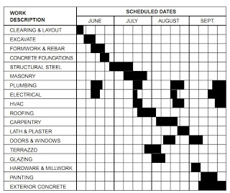
Every construction project is a unique undertaking, project managers must plan and schedule their work utilising their experience with similar projects and applying their judgment to the particular conditions of the current project.
Using a bar chart was, and still is, quite useful for illustrating the various items of work, their estimated time durations, and their positions in the work schedule as of the report date represented by the bar chart. However, the relationship that exists between the identiﬁed work items is by implication only. On projects of any complexity, it is difﬁcult, if not virtually impossible, to identify the interrelationships between the work items, and there is no indication of the criticality of the various activities in controlling the project duration. A sample bar chart for a construction project is shown here.
The development of the critical path method (CPM) is the basis for a more formal and systematic approach to managing a job/project. The Critical path methods involve a graphical display (network diagram) of the activities on a job and their interrelationships; it identiﬁes the relative importance of each activity in the overall project schedule. It is often reflected in a Work Breakdown Schedule (WBS), within the project plan and/or project management tool/method.
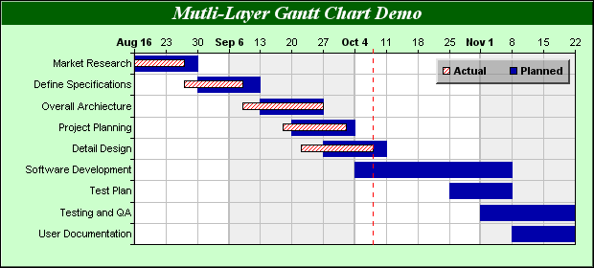
It can provide a much needed basis for performing some of the other vital tasks of the construction project manager, such as resource scheduling, ﬁnancial planning, and cost control. Today’s construction manager who ignores the use of critical path methods is ignoring a useful and practical management tool.
Example: Gantt chart
Planning for construction projects involves the logical analysis of a project, its requirements, and the plan (or plans) for its execution. This will also include consideration of the existing constraints and available resources that will affect the execution of the project. Considerable planning is required for the support functions for a project, material storage, worker facilities, ofﬁce space, temporary utilities, and so on. Planning, with respect to the critical path method, involves the identiﬁcation of the activities for a project, and the ordering of these activities with respect to each other.
It is here that the construction planner must actually build the project on paper. This can only be done by becoming totally familiar with the project plans, speciﬁcations, requirements, resources, and constraints.
The most difﬁcult planning aspect to consider, especially for beginners, is the level of detail needed for the activities. The best answer is to develop the minimum level of detail required to enable the user to schedule the work efﬁciently. For instance, general contractors will normally consider two or three activities for mechanical work to be sufﬁcient for their schedule. However, to mechanical contractors, this would be totally inadequate because they will need a more detailed breakdown of their activities in order to schedule their work. Therefore, the level of activity detail required depends on the needs of the user of the plan, and only the user can determine his or her needs after gaining experience in the use of critical path methods.
Therefore, when developing your plan, you must ensure you know who will be using this plan and make sure it includes sufficient detail that the tasks can be planned and executed safely, efficiently, and effectively.
The remaining planning function is the estimation of the time durations for each activity. The estimated activity time should reﬂect the proposed method for performing the activity, plus consider the levels at which required resources are supplied. The estimation of activity is always a tough task for the beginner in construction because it requires a working knowledge of the production capabilities of the various crafts in the industry, which can only be acquired through many observations of actual construction work. Therefore, the beginner will have to rely on the advice of superiors for obtaining time estimates for work schedules.
Scheduling of construction projects involves the determination of the timing of each work item, activity, in a project within the overall time span of the project. Scheduling, with respect to the critical path methods, involves the calculation of the starting and ﬁnishing times for each activity and the project duration, the evaluation of the available ﬂoat for each activity, and the identiﬁcation of the critical path or paths. In a broader sense, it also includes the more complicated areas of construction project management such as ﬁnancial funds, ﬂow analyses, resource scheduling and levelling, and inclement weather scheduling.
The planning and scheduling of construction projects using critical path methods have been discussed as two separate processes. Although the tasks performed are different, the planning and scheduling processes normally overlap. The ultimate objective of the project manager is to develop a working plan with a schedule that meets the completion date requirements for the project. This requires an interactive process of planning and replanning, and scheduling and rescheduling, until a satisfactory working plan is obtained

Resourcing / Scheduling
Being resourceful includes:
- Realistic planning and estimating
- Clean goal setting and planning
- Smart and hard work
- Efficient use of ready resources
- Creative use of associated/allied resources
- Effective management of time
(Lombardo & Eichinger, 2006, p424)

The following process will help to provide the best opportunity for a successful outcome.
- List the tasks to complete the job | Having a clear objective helps you make sure all tasks/steps are developed for the plan and that all the information and data needed can be included in the plan.
- Develop a list of actions for each task | Brainstorm a list of actions with others, if you can, and make sure you have someone else check your list as a way of ensuring you haven’t missed anything.  When planning, you will achieve a better and more efficient outcome if you involve others who have knowledge and experience in the areas of work you are planning for.
- Prepare a timeline/schedule | Starting from the point of ‘Now’ and ending at ‘Job Completed’, build a timeline that includes dates for the completion of the tasks and actions you developed in your list.  It is important you get the sequence and timing right so that the job goes smoothly and achieves the timeframes required.
- Allocate resources | All resources need to be allocated to your plan, this includes:  - Financial (e.g. budget)  - Physical (e.g. plant & equipment)  - Human (e.g. work crews with specific skill sets for the task)  If you don’t have sufficient resources, you may need to consider contracting the resources you require. This will impact on your financial resources so careful planning is needed.
- Identify possible problems | Make a list of all the things, you can think of, that could go wrong; then identify the causes and suitable actions to resolve them. This will be the start of your ‘Issues Register’ for the job. Over time, you may need to add more entries as the job progresses.
- Develop strategies for monitoring progress | Make a list of ways in which the progress of the job can be monitored. These monitoring events should also be included on your timeline.
- Assign tasks | For each point you have on your timeline, ask:  - Who will do that?  - When will it be completed?  - What needs to be achieved?  These questions will help you make sure the right information is provided to the right person or group when it comes time to assign tasks to your crew.
- Estimate costs | All costs have to be taken into account and if the funds are not available you will have to review the tasks and look for more cost effective and efficient ways of getting the job done.  Identify all of the materials needed for the job, where you will get them from, and when they need to be available for the job. This will also form part of your schedule of activities.
- Implement the plan | When you are happy with the plan and it includes all of the information needed for the job, to be completed safely, efficiently, and effectively, you need to make sure it is available to all involved in the project; e.g.  - Contractors via email, site inductions, pre-starts, work instructions, and access to site office documents  - Work crews via site inductions, pre-starts, work instructions, and access to site office documents  - Management receiving a copy of the plan and all of its updates , email, and the organisational records management system  - Suppliers via email, purchase order, and phone calls  - Councils or other governing bodies via receiving a copy of the plan and all of its updates
- Continuously improve | Through your monitoring you may need to update or make changes to the plan. Every time the plan is updated and/or changed you must ensure all stakeholders are made aware of what has changed and how it will impact them.  Also, you will need to complete a report at the end of the job; this is where you make recommendations for improvements, based on the outcomes of your plan and the job performance.

What goes in a plan?
- Introduction/Purpose
- Scope of work
  - Task requirements
  - Operational Techniques
  - Cost estimates
- Schedules /Work Breakdown Schedules (WBS)/Gantt Chart
- Environmental management
- Human resource requirements
  - Numbers needed/Number of crews/Shifts
  - Skills matrix
  - Rosters
- Communication strategies
- Risk management processes/plans
- Compliance related plans
- Procurement plans
  - Materials, quantities, and delivery schedules
  - Contracted labour and/or plant and equipment requirements
- Tools, Plant, and Equipment
  - Maintenance plans
- Issues management strategies
- Attachments/Appendices

NOTE: It is important that you comply with your organisation’s quality control processes for the development and updating of your plan. This way you will a historical record of the job and documented evidence of the improvements that were made and recommended. It is also evidence that is used in internal and external audits or safety investigations.

Estimating Costs
One of your first tasks will be to estimate costs for materials and resources required for the job. Cost estimates need to be accurate, transparent, and reliable as these will impact on the financial outcome of your job. Therefore, you need to know how to calculate quantities, including:
- Volumes,
- Grades,
- Percentages,
- Areas, and
- Resource consumption figures; including required supply rates.
When you calculate costs effectively, you will be able to allocate resources and develop schedules to successfully manage the job.

Principles of Cost Estimation
A structured estimating process should produce:
- Quality estimates,
- Consistency – checks and balances,
- Improved accuracy and confidence,
- Improved competency and contracting of personnel,
- Alignment with all stakeholders,
- Reduce uncertainty,
- Reduce costs,
- Reduce cost over-runs, and
- Save time.
The Key steps in Estimating:
- Overview total estimating process,
- Review estimating requirements,
- Planning the estimate,
- Structuring the estimate,
- Developing the estimate,
- Analysing cost risk and contingency allocation,
- Documenting,
- Review and issue estimate, and
- Balance estimate against actuals for reconciliation.

Basic Calculations
To calculate the volume of something you multiply the length (L) by the width (W) and the depth (D) – V = L x W x D E.G. 300m x 700m x 250m = 52,500,000 cubic metres (Total Volume Amount)
To calculate the surface area of something you simply multiply the length (L) by the width (W) – A = L x W
E.G. 300m x 700m = 210,000 square metres (Total Area)
To calculate a percentage, we look at the whole as equal to 100%. For example, say you have 10 spanners (=100%). If you lose 2 spanners, then you have lost 2/10 × 100% = 20% of your spanners and you are left with 80% of your original tools set of spanners.
Sometimes you're given the percentage of an amount and need to know the numerical value of the percent. Examples include calculating total cost of something, including the GST, or working the contingency amount of the materials you need to order (+10%).
For example, you are getting a labourer, from a labour hire company, to work the entire next week. The cost is $650.00 per day, plus a 15% hire fee for the 5 days.
So, $650 / 5 days / 15% hire fee = $XXX Total cost
15.% = 0.15 [convert the percentage into a decimal by moving the decimal point LEFT 2 spaces]
First multiply the daily hire fee of $650.00 by the number of days you need the labourer for (5 days) - $650.00 x 5 = $3,250.00
Now multiply $3,250.00 by 0.15 - $3,250.00 x 0.15 = $487.50
That means it will cost you $3,250.00 + $487.50 for the week (TOTAL $3,737.50)
To calculate the grade of something you need to first establish the distance (run) the slope is to span. Then you need to determine the height of slope, which will give you the amount of rise there will be on the slope. Then all you do is write this as a fraction and work it out to the lowest common denominator.
For example, a ramp is being constructed over an area of 500 metres and the rise is 50m.
Rise  Ramp (slope) = | 50
Run | 500
Therefore the total grade amount is 1:10 – you drop 1m every 10m.
50m
SURFACE
500m
1:10

To calculate consumption quantities you first need to establish the unit of measure; e.g. number of days. Next you determine what consumables you need to calculate and the quantity they come in; e.g. 6 litres of milk are being replaced every morning in the mess hall fridge. So all you need to do now is multiply what you are using (6 Litres of milk) by the unit of measure (7 days) to work out how much milk you are consuming in a week. You are using 42 Litres of milk per week.
ESTIMATION PRINCIPLE | DESCRIPTION
What:  Scope definition | - Equipment required  - Layout  - Material requirements  - Engineering standards
How:  Execution strategy | - Project organisation  - Contracting requirements  - Constraints
When:  Schedule | - Delivery timeline and date  - Escalation of costs  - Currency conversions
Where:  Location specifics | - Supply sources  - Import regulations  - Cost of local sourcing  - Productivity  - Engineering and approvals processes
Resource Costs
After you have listed the required resources for the job, you can calculate the relevant costs by using price lists from suppliers the organisation uses frequently, or you can go out to tender and seek bids from suppliers for the job. To do this, you will need to ensure you have sufficient time to review the tenders and you will need to comply with organisational policy and procedure in the selection of the successful bid.
Resources, typically, include:
- Equipment,
- Materials, and
- Services.
Unit Costs
Smaller jobs can be estimated by using the cost per unit method; examples of this type of methodology include cubic metres or square metres. Examples of the types of materials or resources this method would be applied to are:
- Building costs,
- Telecommunication cable,
- Services tape quantities, or
- Soil quantities
Costs are calculated to a dollar amount per unit with the total cost based on the total surface or construction area.
Other Methods
Other methods can include:
- Use of software - if your organisation uses computer generated cost estimates, then you would also need to know how to use the software to calculate the costs for your job. Some software used is as simple as using a Microsoft Excel Spreadsheet that has the formulas already embedded into the document for you.
Estimating is both an art and science.
- Historical costing – one of the most transparent methods is to base your cost estimates on previous successful jobs. As long as the data is recent, readily available, similar or identical to your current job, and the supplier is accessible; you can use this information to estimate costs for your job

Common Estimating Mistakes
- Misread or misinterpreted specifications, drawing, or any other contract document,
- Takeoff omissions or overlaps,
- Missing quotes,
- Using the percentage method to establish the cost of certain systems,
- Crumbling under pressure to procure work,
- Cutting prices to meet or beat someone else’s quote,
- Underestimating the complexity of a job,
- Expecting and excessive amount of favourable changes,
- Over emphasising volume purchasing,
- Undertaking a project with incomplete bid documents, and
- Scaling drawings.

Improving your estimating processes
- Company labour tables and current material prices should be stored in your database,
- Manual estimating is not cost effective and it is subject to more errors and omissions,
- Computerised estimating should automate and expedite the manual estimating process,
- Establish the company labour units and labour factoring tables,
- Maintain current material pricing lists, and
- Establish an estimate review procedure.

Chapter 2: Leadership and Supervision
By the end of this chapter you will understand how to:
- Confirm the necessary resources are available for the safe, effective, and efficient conduct of tasks,
- Ensure clear and timely instructions are communicated to team members and others involved, and
- Set out tasks as required for the Job Plan.
There are many characteristics of an effective Leader, Manager or Supervisor on any construction Project, primary amongst the responsibilities of anyone in such a role is the safety of others – in fact this is a legislative obligation under Australia WHS law.
The balance of productivity with safety is what makes a difference to the bottom line, the business future and the safety of all persons associated with the work site.

Six (6) Principles for Construction Leadership:
- The demonstration of safety leadership – Ensure that this is clear to all parties through effective and regular communication methods and is linked to performance expectations.
- Promote the design for safety in all engineering solutions – ‘fail to safe’ and work to minimise the risk to the safety of others who may come into contact with the structure.
- Communicate safety & project related information – keep people in the loop and welcome comments and the sharing of ideas and lessons learnt.
- Manage risk – more than just safety, there is environmental, financial, sovereign, corporate responsibility, company reputation and many more aspects.
- Seek continuous improvement – always remain vigilant to look for better, more safer, efficient, effective and innovative ways of doing core jobs.
- Embed safety practices – walk the talk and lead by example. Remembering that the standard that you walk past is the standard that you accept.
Other leadership skills that provide positive outcomes are:
- Know yourself and seek self-improvement. In order to know yourself, you have to understand your "be", "know", and "do" attributes. This is possible by continually strengthening your attributes by reading and self-study.
- Be technically proficient. As a leader, you must know your job and have a solid familiarity with your employees' jobs.
- Seek responsibility and take responsibility for your actions. Search for ways to guide your organization to new heights. And when things go wrong, do not blame others.
- Make sound and timely decisions. Use good problem solving, decision-making, and planning tools.
- Set the example. Be a good role model for you employees. They will believe what they see - not what they hear.
- Know your people and look out for their well-being. Know human nature and the importance of sincerely caring for your workers.
- Keep your people informed. Know how to communicate with your people, seniors, and other key people within the organisation.
- Develop a sense of accountability, ownership and responsibility in your people. These traits will help them carry out their professional responsibilities.
- Ensure tasks are understood, supervised, and accomplished. Communication is the key to this responsibility.
- Train your people as a team. By developing team spirit, you will be able to employ your organisation, department, section, etc. to its fullest capabilities.
- Communicate a vision: Formulate a clear and persuasive vision and communicate it to all members of your team.
- Think and act strategically: Set forth a pragmatic strategy for achieving that vision both short and long-term, and ensure that it is widely understood; consider all the players, and anticipate reactions and resistance before they are manifest.
- Honour the room: Frequently express your confidence in and support for those who work with and for you.
- Take charge: Embrace a bias for action, for taking responsibility even if it is not formally delegated, particularly if you are well positioned to make a difference.
- Act decisively: Make good and timely decisions, and ensure that they are executed.
- Communicate persuasively: Communicate in ways that people will not forget; simplicity and clarity of expression help, as do elements ranging from personal actions to grand events.
- Motivate the troops: Appreciate the distinctive intentions that people bring, and then build on those diverse motives to draw the best from each.
- Embrace the front lines: Delegate authority except for strategic decisions, and stay close to those most directly engaged with the work of the enterprise.
- Build leadership in others: Develop leadership throughout the organisation.
- Manage relations: Build enduring personal ties with those who look to you, and work to harness the feelings and passions of the workplace.
- Identify personal implications: Help everybody appreciate the impact that the vision and strategy are likely to have on their own work and future with the firm.
- Convey your character: Through gesture, commentary, and accounts, ensures that others appreciate that you are a person of integrity.
- Dampen over-optimism: Counter the hubris of success, focus attention on latent threats and unresolved problems, and protect against the tendency for managers to engage in unwarranted risk.
- Build a diverse top team: Leaders need to take final responsibility, but leadership is also a team sport best played with an able roster of those collectively capable of resolving all the key challenges.
- Place common interest first. In setting strategy, communicating vision, and reaching decisions, common purpose comes first, personal self-interest last.

2.1 Confirming resources
One of the responsibilities of a supervisor is to ensure correct and sufficient resources are organised and scheduled for the project/civil works activities. The phases of any civil construction project tend to follow a general process – with the finer details being unique and specific to each individual scope.
Before the resources are selected, the supervisor must first determine the most appropriate operating techniques for the job. To do this they must be able to evaluate the job and its requirements by considering the follow contributing factors:
- The ground conditions; such as, soil types, drainage capacity, potential movement, etc. This is often done by inspecting the site and consulting the survey data for the job.
- Proximity to other services by consulting plans and inspecting the site.
- The site area and any restrictions that will impact on equipment movement and the safety of everyone in the locality. Again, this is done by consulting plans and inspecting the site.
- The depth and length of the actual installation, which is also done by consulting plans and inspecting the site.
- The type of installation required or needed; e.g. culvert, pipe, conduit, etc. Consulting plans and the project managers will assist the supervisor with determining these specifications.
The selection of the most appropriate resources can depend on several identifying factors; these can include:
- The type or types of utilities to be installed; e.g. electrical, telecommunications, data, water, etc.,
- The expected duration or life of the resource,
- The installation housing; e.g. concrete, poly-pipe, etc.,
- Availability of the tools, plant, and equipment,
- The location/environment; e.g. high traffic area, remote location, near water, etc., and
- Access to appropriately qualified/skilled and licenced personnel.
Therefore, it is important that you have a clear schedule of:
- What resources are required,
- How many off each is required, and
- When they are required.

Principles of Scheduling
We have already discussed how your work plan will determine the sequence of events, based on your planning processes and the information related to the job and its specifications. The project plan will also provide specific information relating to the scheduling of tasks/activities and may impact directly on the job you are responsible for.
Planning establishes what, how, where and in what order work will be performed, while scheduling sets forth who and when. Construction planning is the development of a feasible operational design for completing the work. The process involves the selection of work sequence and methods, and provides information for the scheduling process.
The site and work schedules are determined by any or all of the following factors:
- Tasks for the job,
- Sequence of tasks to get the job done,
- Relationship of the tasks to other site activities,
- Deliveries and suppliers,
- Access to site,
- The risk assessments for the site and the specific job,
- Timeframes for completion,
- Availability of resources and equipment, and
- Client/organisational requirements.
Scheduling determines the timing and specific sequence of tasks necessary to carry out the plan. The schedule is a result of the planning process and reflects the selected plan. The steps to developing a schedule are:
- Estimating the time required for each activity
- Computing the time required for project completion
- Establishing time intervals in which each activity must start and finish
- Identifying the activities crucial to timely project completion

Your schedule will be the ‘source’ or ‘master’ document from which you will coordinate site activities for safe, effective, and efficient execution of tasks. You will need to ensure you are aware of what is happening and maintain regular communication with all stakeholders involved in the construction activities. This way you will be sure to know that all of the resources for the job are confirmed and available, as per the scheduled times and dates.
Keeping a record of confirmation is a way you can check what has been ordered, for when, how much, and who is supplying it. These records should be kept on site and be part of the Records Management System for your organisation. All communication relating to resources must be kept in writing and re-confirmed prior to the day and time it is expected.

2.2 Communication
The way information is communicated has a significant impact on how that information is received. When information is not understood as it was intended, the result can be very costly in terms of rework, missed deadlines and time wastage.
The table below contains tips and recommendations to improve verbal and written communication:
Type of communication | Effectiveness factor | Tips and recommendations to help improve
Verbal | Clear | - Speak at a pace that’s easy for someone to understand. The most common problem effecting communication is speaking too fast  - Avoid mumbling  - Speak about an issue in a logical manner, making sure that you provide adequate and relevant background and context so the receiving person is able to establish a clear picture of what you are talking about
Verbal | Concise | - Talk only about the issue at hand and only give enough information for the receiving person to understand what you are talking about. Giving more information than is required can be very frustrating to the receiving person
Written | Clear | - Choose words deliberately  - Construct sentences carefully and thoughtfully  - Using correct grammar.  - Writing clearly allows your audience to easily comprehend your message
Written | Concise | - Remove words that are not needed in a sentence  - Remove sentences that are not needed in a paragraph  - Be aware of needing to ensure clauses or phrases are constructed in a way that is simple and as short as possible.

Type of communication | Effectiveness factor | Tips and recommendations to help improve
Verbal and Written | Timely | - When responding to an issue or a discussion, your response needs to follow soon after. When this doesn’t occur, the receiving person may be confused about what you are talking about as they may not be able to link your response to the issue or discussion that prompted it.

Work Instructions
The use of Work Instruction can be used to ensure the team members are informed in how to complete a certain task or activity. It breaks the task into logical steps from the start to the completion of the task or activity and makes sure the task is completed safely, efficiently, and effectively.
Please refer to the appendices towards the end of the document for examples.
Making sure you have these Work Instructions documented in your plan, provide them to the work crews/team members, and made accessible to all on site; is an investment in successfully completing the job.
Work Instructions may come from the following sources:
- From your Supervisor
- From your Manager
- From an engineer within your organisation
- From the Quality Management System if your organisation has one
It is important to ensure you understand all of the information within the Work Instruction before you proceed with the work. Where you are not sure, you need to clarify the information with your Supervisor, Manager, or other technical person (for example engineer) within your organisation.

Safe Work Method Statements (SWMS)
A SWMS (pronounced: Swims) is designed to enable supervisors, workers and any other persons at the workplace to understand the requirements that have been established to carry out construction work in a safe and healthy manner. The SMWS sets out the work activities in a logical sequence, identifying hazards and their control measures.
Any activity, no matter how simple or complex, can be broken down into a series of basic steps that will permit a systematic analysis of each part of the activity for hazards and potential accidents. The description of the process should not be so broad that it leaves out activities with the potential to cause accidents and prevents proper identification of the hazards, nor is it necessary to go into fine detail of the tasks.
The SWMS must be able to be easily read by those who need to know what has been planned
to manage the risks, implement the control measures and ensure the work is being carried out
in accordance with the SWMS. Relevant persons include:
- The supervisor of the high risk construction work
- The worker carrying out the construction work
- The Principal Contractor or the person who has management and control over the risk construction work, such as the Project Manager.
Please refer to the appendices towards the end of the document for examples.

Presenting Information
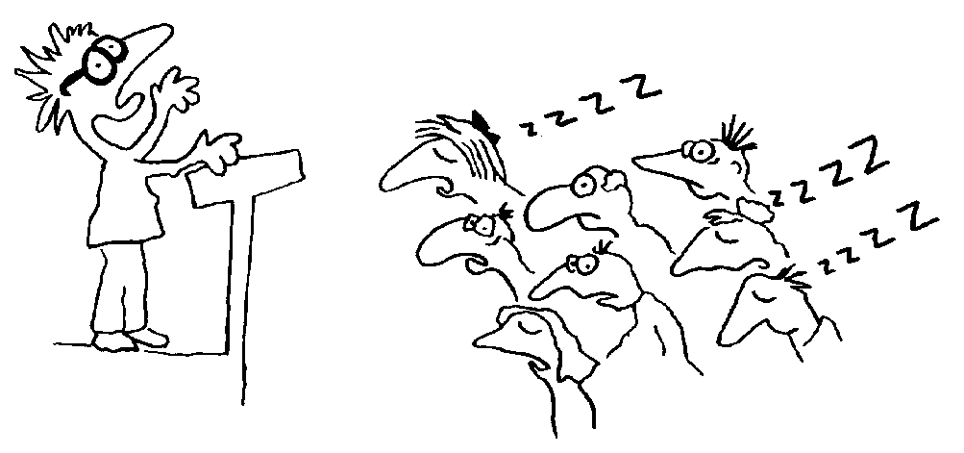
Conducting Site Inductions, Pre-Start meetings, and other meetings is an effective method of communicating important information. When you are planning to communicate in this way, it is important that you take the time prepare.
The information you need to communicate is important. So it is critical that you communicate it clearly and in an engaging way so that you are listened to and the information is understood. Preparation is the key to a successful presentation. Things to consider are:
- The purpose and objectives of the training is clearly explained
- The workplace application and the activities to be done are clearly defined
- Clear language is used and time is allowed to check that the message has been understood
- A safe environment is selected
- Documents or technology, appropriate to the location and audience, is used to assist in communicating the key messages
- Information and topics were delivered in a logical sequence
- Key points were emphasised and summarised
- Attendees are encouraged to ask questions and to be involved in the discussion
- Attendees are given clear feedback about job progress and work being undertaken
- Attendees are given the opportunity to provide feedback on the quality of the job and work being undertaken
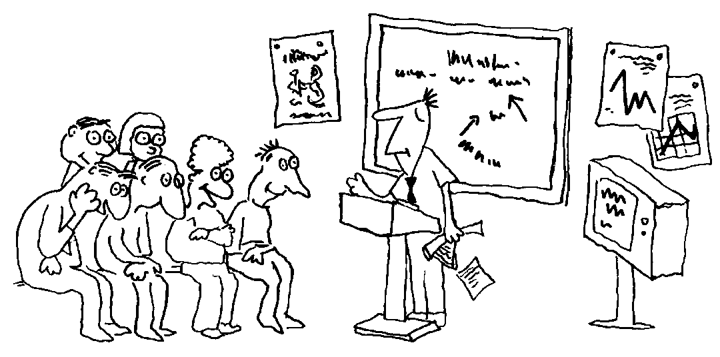
Knowing who your audience will be is an important factor to consider because you will need to prepare the presentation to ensure it is engaging and interesting for that group. You need to ask yourself:
- Why will they be attending?
- Have they worked for this company before?
- What job do they do?
- What level of experience do they already have?
- How much detail of information do they need?
- Why do they need to know this information?
- Do they have any special needs that you need to consider when planning your presentation? For example; Do they need to see the plan? Do they want a written report to be provided? Do they need to be shown where to find the site procedures?
You should also consider:
- Where is the best place to conduct your presentation?
- Is the location available?
- Will attendees be able to easily find the location?
- Will attendees be able to easily enter the location?
- Are there any OH&S or other workplace requirements?
Effective workplace presentations include:
- Accurately identifying the needs of attendees.
- Providing effective methods and techniques to engage the attendees.
- Structuring the information in a clear and logical way

2.3 Assigning Tasks
“Empowered people work harder and longer.” They like to have control over their own work and work out their own method of getting things done. They feel more in control and empowered if they are left to make their own decisions and solve their own problems.
The trick for the Supervisor is to give away as much as they can, along with the authority that goes along with it, and just monitor the progress and outputs of their workers. Your key focus should be on your ‘weakest links’; the workers who work remotely, the contractor or supplier, those that you have the least contact with. (Lombardo & Einchinger, 2006, p425)
The fundamental issue here is ‘trust’; you need to trust that you have selected the best person for the job/task: at the end of the day, it all comes back to decisions you have made.

Delegation is an art – and done well, it can prove a most effective tool for a manager to multi-task and complete work in a highly efficient and engaging manner. There are two important factors to consider when making a decision about who does what.
- The tasks that need to be completed; and
- The people who are able to complete them.
The aim is to find the most appropriate person for each task, so that the desired result will be produced.
To enable clear and concise instruction to be given to team members, it is important to understand that job steps within a task or activity. A single task or activity may contain many important job steps or sub-tasks that need to be completed for the main task or activity to be completed as desired. When only information relating to the main task is given to people to be completed, there is the opportunity for the key sub-tasks or job steps to be missed which may result in a poorly completed job.
To enable the work to be completed within the time that is desired, a timeframe for completion needs to be established. A timeframe for each sub-task or activity throughout the task can be defined by working backwards from the time completion is due.
Is there a specialist location where the activity needs to be completed? For example, in a workshop with tools available. The location is important as it may be some distance from where the other work is to be completed. This may impact on driving time and total time to complete the task.
To enable the task to be completed to the level of quality and outcome required it is important that is given to the person who has the required skills, knowledge and training to be able to adequately complete the task.
Those team members who are currently in training can be utilised to support another team member who does have the required skills, knowledge or training. Team members who are in training should not be tasked with work alone and without supervision.
A simple skills matrix can be developed that shows which person has what training and how much experience. This is normally available through the Human Resources department of organisations and may be called a Training Needs Analysis (TNA) or Training Matrix.

Competency | Induction | Work at Height | Confined Space | Trade Qual | Excavator Licence | Skid steer Licence | HR Licence | MR Licence | HC Licence | Car Licence
Personnel
Bob
Mike
Jim
Tom
Key
 | Completed, has the required item/licence/ticket etc.
 | In training for the item/licence/ticket etc.
Priority is an important factor to consider when deciding what needs to be done by when and in what order. Priority can be decided or based on a number of criteria including:
- The risk of not doing it (the resulting consequence and the likelihood of that consequence occurring). Priority needs to be given to the items that will cause the greatest negative impact if they are not addressed.
- The level of importance for the task from your line management. Your manager may have a very different view of what is important, is critical for their view to be understood.
- What is achievable in the time you have and with the resources you have.

80% of the issues are caused by 20% of the factors (The Pareto Principle). This means finding the ‘big ticket items’ that cause most of the ‘strife’.
Remember


Chapter 3: Oversee the execution of tasks
By the end of this chapter you will understand how to:
- Monitor the installation against required outcomes and identify performance gaps,
- Initiate adjustments to work practice/job plan and ensure achievement of required outcomes, and
- Ensure plant, equipment, and tools maintenance requirements are carried out and recorded in writing.

3.1 Monitoring the installation and identifying performance gaps
Cole (2006) argues that “just knowing clearly what you are responsible for achieving and how to monitor and measure your success will go a long way towards helping you stay ‘on top’ of your job and do it well. However, you will still need an effective daily or weekly plan, with clearly defined priorities, and the self-discipline to carry it out.” (p214)
As the Supervisor, it is essential that you are aware of everything that occurs on site with materials being delivered, sub-contractors performing different tasks, movements of loads, traffic with heavy machinery and much more. This is a very complex responsibility that can sometimes become overwhelming; so, apart from using your delegation authority, you can also do the following tasks regularly/daily to ensure you stay on top of what is happening on your site:
- Site inspection for hazards, damage or other issues of concern
- Inventory control to ensure no unexpected overuse of materials
- Authorising overtime
- Providing required explanations for the builders and other professionals associated with the project,
- Coordinating and collaborating with the architects, engineers, client and specialists.
- Pre-start meeting attendance
- Review of previous days reports, progress and incidents
- Maintain open communication with authorities and the client
In the civil construction industry the activities, related to installation of underground services tasks, will vary from site-to-site and project-to-project; such as:
- Environmental conservation,
- Infrastructure development,
- Commercial development,
- Lifting and carnage,
- Road construction and maintenance,
- Pipeline construction,
- Industrial development, or
- Rail construction.
What this means to the supervisor of these jobs is that they need to be vigilant in how they monitor and inspect the works as they occur due to each job potentially varying from the last.
Monitoring during task completion and overall project completion is critical to give the best possible likelihood of task or project success. Monitoring can be conducted in a number of ways including:
- On the job supervision
- Formal Quality Assurance inspections against the specification and drawings
- Formal general inspection of the work using a checklist
- Informal inspection of the work

Key aspects of managing the process of installing services, using open excavation include:
- Ensuring all permits for work are in place before the work commences. Permit requirements may be related to:
  - Risk assessments,
  - Council by-laws,
  - Site requirements,
  - Legislation, or
  - Organisational requirements.
- Locate existing services; e.g. using plans and/or Dial Before You Dig.
- Using appropriate equipment that has the capabilities to dig the trench; e.g. Excavator, Auger, or Drill.
- Checking and ensuring trench depths are accurate and safely supported.
- Public safety.
- Locating spoil dumps.

The purpose of monitoring is to:
- Engineering (hard) controls – to check the quality of design and materials
- Personnel (soft) controls – to check the progress by culture and behaviours
- Check that the structure is being completed in accordance with the plans, drawings and specifications
- Check that the people on the job are complying with the safety requirements
- Identify any hazards that place people at risk and have not been controlled
- Identify any issues that may negatively impact the job and cause delay
- Track usage of materials to avoid running out
In order to identify performance gaps, you must first have a clear, quantifiable standard to measure the level of performance against; e.g. SWMS, work instructions, compliance documentation, plans, job specifications, etc.
A Performance Gap is the difference between what is expected and what is actually occurring.
“Common performance shortfalls can involve attendance and timekeeping, safety, behaviour towards others, supply of materials/resources, care of tools and equipment, productivity, and the quality of the work. Before you can address them, you need to identify the performance gap.” (Cole, 2005, p398)
Using workplace documents as the benchmark standard for ‘good’ performance to monitor site activities is one way you are able to identify and address the performance gaps. Therefore, your monitoring plan should include regular monitoring activities that use suitable benchmarking documentation (e.g. procedures/plans).

3.2 Continuous improvement processes
During the conduct of monitoring the task or work being carried out, there may be issues identified that create a need to change or modify the work plan. Examples of these include:

- Plant and equipment breakdowns
- Personnel being absent from work
- Materials not arriving on time
- Materials being delivered that don’t meet the specification required by the designs
When it is recognised that the schedule or Job Plan will no longer be able to be complied with, these will need to be updated to reflect the change that is needed to be applied.
Any change to the schedule or Job Plan needs to be communicated to those people involved in the work, and possibly suppliers and contractors also involved in the work. This is done by updating the plan and re-circulating it to all stakeholder groups and at the end of the job in the final report recommendations.
Having a systematic process for improvements will assist with ensuring the success of the job completion and provide you with data and/or information that will be useful when you have to report on the job execution.

Steps to improving performance
- Look and listen | - Use observing and active listening techniques to identify what is going wrong and where – what is the root cause of this occurring?  - Ask questions so you can understand the root cause of the problem and see it from another perspective  - Opinions need to be heard objectively
- Analyse your information | - Be clear on what the performance gap is  - Document and describe the performance gap clearly, ensuring it is compared to the expected standard  - It helps organise your thinking  - It makes the gap ‘real’ and based on fact  - It will be used as evidence if legal action is required or management/the client require a status report  - Use a language that is non-confrontational or accusatory – statements need to be fair and objective
- Address the problem immediately | - Make it clear that the primary objective is satisfactory work performance and a safe, effective, and efficient completion of the job  - Make sure the information provided is constructive, describing the performance gap clearly, and explaining why it is important that the work is /undertaken completed to the required standard  - Use language that shows you are taking a ‘we’ approach and that you trying to sort the problem out together in a cooperative, win-win way
- Solutions / Recommendations | - Base your recommendations/solutions on facts, data, and operational constraints  - Present them logically  - Consider the operational and financial impacts to ensure the recommendations remain realistic and plausible  - Make the necessary changes to all relevant documentation; e.g. works plan, work instructions, SWMS, etc.
- Follow up | - Conduct your checks again after sufficient time has passed for improvements to be adopted as common practice  - Obtain feedback on the recommendations you provided  - Use observing and active listening techniques to identify if the improvements have worked  - Ask questions so you can understand how the improvements have impacted on the work and see it from another perspective  - Listen to opinions objectively

3.3 Tools, Plant, and Equipment Maintenance
The role of the supervisor is to ensure the most appropriate tools, plant, and equipment is used for each task. When checking the capabilities of each piece of plant or equipment the supervisor must be able to make the right decision in the selection of plant and equipment for the job. Therefore, they need to be able access information that provides them with the correct information that describes each piece of plant and equipment’s capabilities so they can match that to the job specifications.
The most ideal places to find tools, plant, and equipment specifications and capability information are:
- The project plan – includes relevant information relating to pre-planning, the process of works, and post-project works.
- The OEM that comes with each piece of plant and equipment – these can either be found with the equipment or in the maintenance area where each piece of plant and equipment is maintained.
- The organisation’s records management system – often documents relating to equipment, tools, and plant are saved, electronically, to ensure anyone is able to access the information from a central information point in the organisation.
- The manufacturer’s representatives/trainers – they will have all of this information because they are required to ensure the purchaser is able to operate the plant or equipment.
Regular planned inspection and adequate maintenance must be carried out in accordance with the manufacturer’s recommendations to ensure safe operation of mobile plant used on excavation work, whether leased, hired or owned. Both mechanical and electrical testing should be done.
Maintaining tools, plant, and equipment
Plant and equipment is to be maintained in accordance with the Original Equipment Manufacturer (OEM) requirements, specifications and service schedule, as well as some high risk plant requiring compliance checks at intervals by Engineer’s and Regulators.
Plant & Equipment is to be checked each time prior to operation for the first time of each shift, or when handed over to another operator – with any defects reported immediately for action and rectification as appropriate.
The following checks should also be carried out:
- Daily pre-start checks by the plant operator on the general condition and maintenance of the plant
- Regular inspections of the plant by a competent person in accordance with the manufacturer/supplier’s specifications or relevant Australian Standards. Any plant defects should be reported immediately to the person conducting business or undertaking.
The purpose of establishing maintenance programs for plant and equipment is to primarily ensure that risks associated with their operation are identified and managed.
Plant and equipment are usually scheduled in for regular maintenance and service checks as part of the program provided by the OEM, and as fits in with their utilisation.
- Records from maintenance checks are essential for a number of reasons:
- Provide historical data of work applied to the machine
- Examination of total utilisation
- Provide an audit trail in the event of an incident
- Track misuse of equipment and identify corrective actions
Please refer to the appendices towards the end of the document.

Chapter 4: Reporting on the execution of tasks
By the end of this chapter you will understand how to:
- Complete and submit written reports
- Recommend changes to improve safety, efficiency, and effectiveness of task execution

4.1 Writing reports
There is an old saying ‘If you measure something, then you can control it’… the results of your measuring and monitoring must be kept for historical purposes for a number of reasons, including:
- To provide an audit trail in the case of a query or investigation
- To provide a reference point for future works and comparison
- To comply with legislation, corporate and client requirements

- To enable the Project Manager to maintain effective control of the project
The reports that are completed may be comprised of different types of data, including:
- The measurements used for the ordering of materials
- The test results of materials
- Photographs of the project under completion
- Diary notes of the Project Manager providing insight into daily tasks, events and attainment of milestones
Reports are usually based on common templates and should be completed in a legible, non-emotional based and concise manner – remember, you’re not writing ‘War and Peace’, and the person reading the report needs to get sufficient information from the report to have a clear understanding of the information be relayed.
In recent times, the use of ‘info-graphics’ is becoming more and more popular, in order to present a great expanse of critical information in a simple, engaging and attractive manner. They are graphic visual representations of information, data or knowledge intended to present information quickly and clearly. They can improve understanding by utilising graphics to enhance the reader’s ability to see patterns and trends.
Reports may be submitted to various entities and for different reasons, including (but not limited to):
- Incident reports to Corporate Office, Client and Regulators
- Budget expenditure reports to finance department
- Company Senior Management / Client
- Sub-Contractors
- Principal Contractor
- Suppliers of goods

What information goes into a report?
Reporting requires a factual account of what happened throughout the job and what was not planned for. Therefore, you need to ensure you stick to the facts, set the information out logically, and are able to back up your statements with documented evidence. Following is a basic structure of a reporting format:
- Executive Summary – this provides a ‘snapshot’ or shortened version of what is contained within the report. It focusses on the key outcomes of the report and is generally not any longer than one page.
- Introduction – this is where the background information and context of the topic is described.
- Project Plan Documentation – this section describes the project execution as per the documented plan and how the plan was maintained.
- Site management – describes the methods used to manage all aspects of the project/site activities
- Lessons Learned – is where you focus on the things that went well and those that didn’t. This forms the basis for your recommendations and continuous improvement analysis.
- Conclusions – this is a brief summary of the content of your report where it highlights the final outcome of the activity.
- Summary of Recommendations – this is where recommendations are made and described concisely in how, when, and why they are being made.
- Appendices – are used to attach supporting documentation or additional, more detailed, information that is referred to throughout the report.

4.2 Recommending changes
Recommendations are often included with a report’s conclusion, although they serve different purposes. Whereas a conclusion offers you the opportunity to summarise or review your reports main ideas, recommendations suggest actions to be taken in response to the findings of a report. You can regard recommendations as a prompt to action for the reader/s.
The content of reports should be able to assist the Project Manager or other interested Stakeholders in analysing data to identify various aspects, including:
- Cost over-runs
- Deviation from the plan
- Incident causation & contributing factors
- Trends in hazards reporting, incident occurrences and control actions
- Opportunities for gaining greater efficiency
- Opportunities for gaining greater effectiveness
- Opportunities for improving the overall project performance
Your recommendations as the ‘man-on-the-ground’ carry a great deal of weight and are respected by those who may not be intimately familiar with the works or project. Keep emotions out of your recommendations and base them on fact and research, not conjecture or guessing.
Effective recommendations:
- Describe a suggested course of action to be taken to solve a particular problem;
- Are written as action statements without justification;
- Are stated in clear, specific language;
- Should be expressed in order of importance;
- Are based on the case built up in the body of the report; are written in parallel structure.
A word of caution about writing recommendations: you should always consider your relationship with the reader first, if you have no authority to make recommendations, the reader may not appreciate them.

Appendix

SAMPLE: Presentation Plan
Presentation Plan
Presentation Title | Project Commencement
presenter’s name | Ima Citizen
Number of workers | 8
presentation approach | Commencement of project briefing – Pre-Start Meeting for entire site
General resource requirements presentation: | Laptop and data projector (for PowerPoint presentations)  Project Works Plan  Site Risk Assessment Plan
OHS issues identified | Induction Procedures:  - safe access and exit requirements  - incident / hazard reporting  - emergency procedures  - PPE  Prior to start of presentation, check meeting area for trip hazards and electrical hazards.  Brief workers on emergency procedures for training room at start of each session.
Strategies for addressing OHS issues | All identified hazards to be removed from presentation/meeting environment where possible or controlled to an acceptable level

Presentation
Estimated presentation length | 45 minutes
Presentation date and time | 12 June, 9:00 am
Objectives: | - Project commencement briefing  - Scope of works  - Safety requirements  - Deliveries / Site access  - Location of all SWMs and Site Procedures  - Emergency evacuation
Other information | Nil
Topic/Key Points | Details | Documentation
Project Scope | - Outline the details of the Works Plan and the tasks sequence  - Allocate work | Works Plan
Health and Safety | - Safety signs  - Emergency response  - Health and safety personnel  - First aid  - Compliance & Reporting | SWMS
Services Installation & Excavation | - Discuss the tasks for services installation  - Compliance & safety requirements for the job | Task Plans  Specifications
Conclusion | - Check that everyone understands their tasks  - Handout Personal Risk Assessment Books to every worker | Personal Risk Assessment Books

SAMPLE: Workplace Inspection Checklist
Site/Project: |  | Department/Area: |  | Date:
Conducted By: |  |  |  | Time:

CHECK ITEM | Area Name: |  |  | Area Name: |  |  |  | Area Name: |  |  | CORRECTIVE ACTION / COMMENTS | By Whom | By When | Closed  (Yes/No)
CHECK ITEM | Y | N | NA | Y | N | NA |  | Y | N | NA
Section 1: Emergency Planning & Amenities
Fire extinguishers clearly marked and serviced every 6 months
Access to fire equipment and emergency exits not obstructed
Emergency exists clearly signed and easily opened from inside
Emergency alarm freely accessible and tested periodically
Spill kits freely accessible & well stocked – spills promptly cleaned up
Sprinkler heads not obstructed (at least 50cm clearance from any object)
Build-up of combustible items (boxes/paper) kept to as low as possible
First aid kit accessible, clearly marked & well stocked
Safety showers & eye wash stations clean & in good working order
Lunch room and toilets kept clean & tidy
Bins emptied – no litter, cigarette butts etc.
Cool drinking water freely available
Section 2: PROCEDURAL COMPLIANCE
Walkways/roadways clear of obstructions & trip hazards
PPE correctly worn & freely accessible (e.g. high-vis vest)
Machine guarding fitted correctly at all times during use
Plant/equipment isolated & tagged-out during maintenance/repair
Danger Tags & Out-of-Service Tags freely accessible
Fall restraint/prevention systems used for work above 1.8m
Substances labelled & stored correctly (e.g. away from ignition sources / bulk volumes bunded)
SDSs available in areas where substances are used/stored
Relevant procedures, SWMS, Work Instructions freely accessible
Site speed limits & traffic controls adhered to
Pedestrian walkways adhered to
Smoking restrictions adhered to
OHS Notice board displays name of WHSO, First Aiders and OHS Committee meeting minutes.

CHECK ITEM |  | Area Name: |  |  |  |  |  |  |  | Area Name: |  |  |  |  |  |  |  |  | Area Name: |  |  |  |  |  |  |  | CORRECTIVE ACTION / COMMENTS |  |  | By Whom |  |  |  | By When |  |  | Closed  (Yes/No)
 |  | Y |  | N |  |  | NA |  |  | Y |  |  | N |  | NA |  |  |  | Y |  | N |  |  | NA
Section 3: PLANT & EQUIPMENT
Electrical Equipment:
Electrical equipment tagged & tested
Residual Current Device tested periodically
Electrical equipment/cords free from damage and kept away from water
Electrical switch boards locked
Mobile Plant:
Documented pre-start inspection completed each day before use
Plant in good working order with clean and tidy cabin
Flashing light, reversing alarm and fire extinguisher fitted and operable
Lifting Equipment:
Inspection tag attached and SWL clearly displayed
Free from damage & properly stored
Welding Equipment:
Welding screens used correctly
Gas bottles upright and secured
Flash-back arrestors fitted and hoses/fitting in good condition
Fire extinguisher in immediate area
Section 4: Physical Work Environment
Appropriate ventilation and air quality within work area
Lighting appropriate for the nature of work conducted
Noise levels kept within reasonable limits (except for designated hearing protection zones)
General housekeeping maintained to acceptable standard

CHECK ITEM |  |  | Area Name: |  |  |  |  |  | Area Name: |  |  |  |  |  | Area Name: |  |  |  |  |  |  | CORRECTIVE ACTION / COMMENTS |  |  |  | By Whom |  |  | By When |  | Closed  (Yes/No)
 |  |  | Y |  |  | N | NA |  | Y |  | N |  | NA |  | Y |  | N |  |  | NA
Section 5: Environmental Management
Printer defaults: B&W & double sided
Plant/equipment turned off when not needed for work/safety/security
Waste segregated/recycled.
Regulated waste (e.g. oils) properly disposed of & tracked
Total # Complying (A): |  |  |  | Total # Non-Complying (B): |  |  |  |  |  |  |  |  |  |  |  |  |  |  |  |  |  |  |  | % Compliance: | (A x 100) / (A+B)
Outstanding Actions entered in Site Risk Register: Yes No Entered into Risk Register by:
Name of Site Manager: |  | Signature: |  | Date:
Comments:

SAMPLE: Safe Work Method Statement (SWMS)
ORGANISATION DETAILS
Principal contractor: | ABLE 2 CONSTRUCTIT4U PTY LTD | Contact number: | 0404 772 277
Project manager or supervisor: | JACK SMART | Contact number: | 0404 771 177
Other contractors (PCBUs): | NAUTILUS PLUMBING P/L and SUPERIOR SCAFFOLDING P/L | Contact number: | 6462 2222 and 0418 300 300
Person completing the SWMS: | JACK SMART | Contact number: | 0404 771 177
Position: | SITE SUPERVISOR | Reviewed by: | TOM WISE (Project Manager)
Date prepared: | 17/6/2012 | Review date: | 20/10/2012
PROJECT DETAILS
What is the scope of the work? | Excavation work associated with plumbing of sewerage and storm water from connection at boundary into new residence.
Who else was consulted / involved in preparing this SWMS? | Tom Wise Project Manager for Able 2 Constructit4u P/L  Stinky Jones from Nautilus Plumbing
What high risk work activities are covered by this SWMS? | Powered mobile plant in operation. Work adjacent to a road used by traffic other than pedestrians
References: Legislation, Australian Standards, Codes of Practice, MSDS and SOPs. | WHS Act and Regulations 2012  Codes of practice: Risks of plant at workplaces, Excavation work
Plant involved in the scope of work: | 3 tonne rubber tracked CAT excavator, 10 yard dump truck, delivery vehicles, worker vehicles, Utilities components (electrical, data and tele-communication cabling) and portable hand tools
What high risk licence classes will be required to do the work? | nil

RISK MANAGEMENT
Identify each task in order | Specify the hazards you have identified | What are the risks to health and safety? | Describe your control measures, list as many as possible |  | Who is responsible for implementing and monitoring controls?
Delivery of materials to site | - Mobile machinery  - Manual handling Storage of materials associated with the work site | - Crush or impact with body  - Muscular skeletal injuries Trips and falls  - Cuts on sharp edges  - Objects falling from above  - Striking body against materials | - Segregate stored materials away from work areas  - Hard hats, gloves and safety glasses to be worn during all work |  | - Jack Smart to supervise Dirk and his crew to wear PPE as designated
Unloading excavator on site | - Manual handling (ramps)  - Mobile machinery proximity to workers  - Other vehicles moving in the area | - Muscular skeletal injuries  - Cuts and bruising  - Tipping over during unloading causing injuries to excavator operator and crush injuries for workers | - Excavator will place its own ramps into position and operator to hold industry accreditation  - Advance warning traffic signs to be used  - Able 2 constructit4u provide traffic management for pedestrians and vehicles during unloading excavator from 10 yard truck  - All personnel to maintain a 6 metre clearance |  | - Jack Smart to co-ordinate unloading activity  - Jack Smart to manage traffic management of people and vehicles
Excavate and backfill utility trenches | - Moving machinery  - Noise  - Open excavations | - Struck/crushed by machine  - Excavator undermines or knocks down scaffold  - Fall into open excavations  - Buried in trench collapse | - Maintain safe distance from operating machinery  - Complete excavation in scaffold area and backfill before scaffolding work starts  - Machine has reverse beeper and flashing light  - All workers to wear high visibility garments  - Operator to blast horn twice prior to tramming  - Trench edges delineated with para-web fence  - Trench in stages and backfill each day  - Bench and batter edges over 1.5m |  | - Jack Smart to co-ordinate works program  - Stinky Jones to install para-web  - Excavator operator to alert others when tramming  - All workers wear designated PPE
This SWMS has been developed in consultation and has been read, understood and signed by all workers undertaking the scope of works:
Print Names: |  | Signatures: |  | Dates:
John Brown |  |  |  | 17 June 2012
Sam Smith |  |  |  | 17 June 2012
Bill Robinson |  |  |  | 17 June 2012

SAMPLE: Safe Work Instruction

Excavation, Trenching, Ground or Wall Penetration in and Around Concealed Services
Safe Work Instruction

Issue | Date | Description | Initial
Draft | 12/10/10 |  | DL
1 | 14/10/10 | Final | DL

Authorisation
I Billy Bloggs as Project Manager for Flatchat Construction approve this procedure for use

Billy Bloggs
14 October 2010
Excavation, Trenching, Ground or Wall Penetration in and Around Concealed Services SWI
Purpose
To control risks associated with excavation and ground or wall penetration where there may be concealed services and for people who may have to enter open excavations or trenches; and to make provision for the location and nature of concealed services (pipes, cables, etc.) to be accurately recorded on site plans and drawings.
To comply with legislation and appropriate codes of practice.
Scope
This SWI provides guidance and procedures for the management of risks associated with:
- cutting or drilling into a building or structure, or excavating ground, where there may be a concealed service; or
- person(s) required to enter an open excavation or trench where there is potential for engulfment.
Definitions
Excavation | the digging of ground by hand or machine to a depth greater than 150mm.
Ground  Penetration | penetration of ground, to a depth greater than 150mm by drilling, installation of star pickets or ripping the ground with a grader, Skid Steer Loader or Excavator
Wall or Floor Penetration | penetration of a building wall, ceiling or floor by cutting or drilling.
Procedure
4.1 Controlling Excavation / Penetration Risks
4.1.1 Concealed Services
Person(s) will inspect the work site, check site plans / drawings and consult with site Supervisors to identify the presence of concealed services, e.g.: electrical, communications, water, sewerage, fuel, etc. Once identified, the location of the services shall be marked.
Job Supervisor is required to undertake a risk assessment (JSA) prior to commencing the task.
Energy sources and the means of control / isolation shall be identified on the JSA.
Isolations, including testing for zero potential, shall be conducted as per company Isolation and Tagging procedure.
Prior to performing any back-filling operations where concealed services are installed or modified, the Site Surveyor shall be contacted to verify location of the services for the purpose of updating site drawings and plans, and to ensure the services are correctly delineated for future location and identification.
 | Personnel should not rely on previous plans being 100% accurate in terms of location and placement of submerged / concealed services.  Due care must always be exercised whilst digging / excavating. The uncovering of marking tape or change in material (eg: sand, or other backfill material) may indicate that submerged services are present.

4.1.2 Work in Open Excavation / Trench
If an excavation or trench is to be deeper than 1.5 metres and is to be occupied, the following guidelines shall apply:
If any person is to enter, occupy or work within the excavation or trench, within a distance 1.5 times the height of the excavation from the toe of any vertical wall exceeding 1.5 metres in height – approval shall be required by the works Supervisor and a permanent spotter implemented to ensure safety.

However, if any person is to enter, occupy or work within the excavation or trench, outside a distance 1.5 times the height of the excavation from the toe of any vertical wall exceeding 1.5 metres in height, then the requirement to use a Spotter may be exempted, provided that:
- a safe means of access and egress is provided, other than down a vertical wall, eg: a ramp is cut into the excavation or trench to provide personnel access within the safe work zone;
- an exclusion zone is clearly barricaded and sign posted restricting personnel from entering the excavation within 1.5 times the excavation wall height from the toe of any wall;
- the excavation or trench is not cut across a slope or incline whereby there is potential for subsidence of the slope above the excavation / trench into the excavation.

 | If at any time a person has to enter the exclusion zone, for any reason whatsoever, a Spotter shall be in place prior to entry.

Benching or battering techniques may be used as a safeguard to reduce the height of the vertical side walls.
If these techniques are applied and the height of the vertical side walls are reduced below 1.5m a Permit to Work in Open Excavation or Trench may not be required.

Risk to personnel due to the collapse of an excavation wall may be reduced by completing as much of the work as possible without requiring people to enter the excavation (danger area).
Similarly, exposure may be reduced by limiting the time an excavation remains open, and through the application of a dedicated Spotter.

Shoring, Battering or Benching
Shoring, Battering and Benching are methods of securing or stabilising the walls of an excavation to prevent cave-in.
Excavations less than 1.5m in depth: If a person is required to enter the excavation, the walls should be shored, battered or benched if the soil or rock is unstable and may be prone to collapse.
Excavations greater than 1.5m in depth: If a person is required to enter the excavation, the walls shall be shored, battered or benched before any person enters the excavation.
Shoring
Shoring is a system of temporary supports and sheeting material used to maintain the stability of the sides of an excavation.
Benching and Battering
Benching is the creation of stepped sides to an excavation. Benching is used to reduce the depth of an excavation to a series of steps of no greater than 1.5 metres in height.
A batter is where the wall of an excavation is sloped back at an angle. A batter can commence at the bottom of an excavation or may start higher up. If the latter is chosen, the vertical wall below the battered portion should not exceed 1.5 metres in height.

Benching Example: | Battering Example:
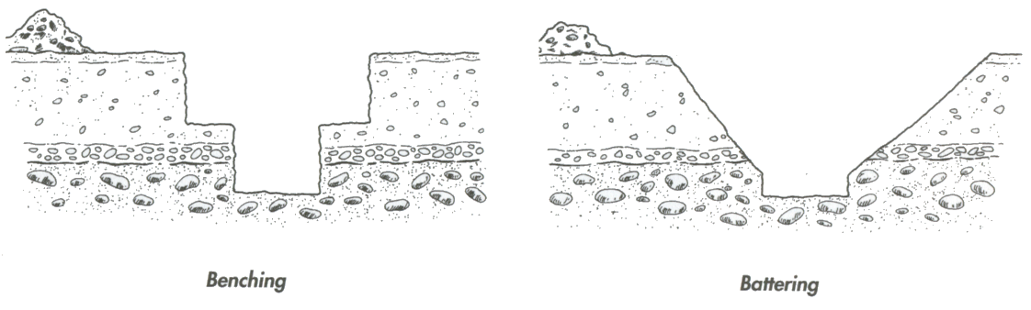
Barriers
A secure fence or barricade, set at a minimum height of one metre, must be erected around any accessible part of all open or exposed excavations. Excavations must be delineated during the hours of darkness with flashing lights.
Excavated soil or other materials must not be placed within 1 metre of the side of any part of the excavation.
When operating vehicles close to open excavations, stop blocks, berms or barriers must be erected to prevent vehicles over-running or endangering the stability of the excavation.
4.1.3 Hazardous Atmosphere in Trench
Potential for a hazardous atmosphere shall be considered when assessing risk of working / entering an excavation or trench. Where potential is identified, allowance for gas testing / monitoring and establishment of controls shall be identified within work permits. Consideration shall be given to applying for a confined space work permit.
Note: There may be potential for inherent gas or introduced gas (fuel gas / oxygen, etc.)
4.1.4 Water Inrush
Consideration shall be given to the potential for water ingress or inrush into excavations or trenches where person(s) may have to enter. Where potential exists, controls shall be identified within JSA, e.g. allowance for drainage and / or pumps.
Secondary risks of water ingress shall also be considered where electrical equipment, welders, etc. are to be used.
4.1.5 Routine Inspection
An excavation, including installed shoring, batter or bench of the excavation should be examined by a competent person each day, before people commence work in the excavation.
If unsafe conditions are found either during the inspection or during the normal course of work, work in the excavation should cease immediately and persons should not enter the excavation until the unsafe condition has been rectified.

4.1.6 Work in Excavation – Stand-by Person
Where required by risk assessment, an assistant / Spotter who has been trained in site communications and emergency response procedures shall keep the worker(s) and work area under constant observation. Effective communication procedures must be established between the worker(s) and the observer.
The assistant / observer shall be made aware of the Procedures and / or Work Instructions to make certain compliance is maintained.
Communication and Training
All personnel affected by the content of this document will receive instruction or explanation on the relevant parts of the document.
Personnel requisitioning, issuing, or conducting work under a Work Permit will receive formal instruction in this procedure and other relevant documents.
References
- Work Health & Safety Act – Qld. (2012).
- Work Health & Safety Regulation – Qld. (2012)
Review
This procedure shall be reviewed in 3 years or after a major change in operation or after a notifiable incident

Glossary
TERMINOLOGY | DEFINITION
BACKFILL | To fill the earth, any remaining space after placing concrete, brickwork, timber, pipes etc in an excavation.
BATTER | The slope of a wall of buttress built at an inclination to the vertical plane.
BENCHMARK (BM) | A fixed point of reference, the elevation of which is known and referred to during levelling operations.
BRACE | A member, usually a diagonal, which resists lateral loads and/or movements of a structure
CAST IN-SITU | Concrete cast or poured in its permanent position in prepared forms (eg concrete steps, hearth slabs, floors, beams, lintels)
COMPRESSIVE STRENGTH | Resistance of a material to a crushing force.
CONCRETE | Artificial rock of cement, sand and aggregate
CONTOUR LINE | A line drawn on a site plan joining points of the same elevation
CROSS BRACE | Any crosspiece which diverts, transmits, or resists the pressure of a load
CURING | Treatment of concrete or cement rendering to facilitate hardening
DATUM | A predetermined level on a site from which all other levels are established.
EXCAVATION | A hole made by removing earth
FOOTING | The construction whereby the weight of the structure is transferred from the base structure to the foundation
FORMS | Prepared forms of timber or other material for the casting of concrete
FOUNDATION | The ground upon which the footings of a building are constructed.
GROUND LINE | The ground level or natural grade line
GROUND PLAN (FLOOR) | Plan view of a horizontal section of a building showing the layout of rooms on the ground floor
HOIST | Any device or machine used in building for lifting materials.

References
Glossary of Terms www.hsc.csu.edu.au/construction/glossary/3246/common_terms.htm
APA Referencing guide link http://www.cqu.edu.au/about-us/service-and-facilities/referencing/which-referencing-style-do-i-use
Harvard Referencing guide link http://www.usq.edu.au/library/referencing/apa-referencing-guide
Burns, James MacGregor, 2003. “Transforming Leadership”. Atlantic Monthly Press. USA.
Lombardo, Michael. M. and Eichinger, Robert W. (2006) “FYI: For Your Improvement. 4th Edition”. Lominnger International.
Mind Mapping http://www.tonybuzan.com/about/mind-mapping/
About Mind Maps https://www.mindtools.com/pages/article/newISS_01.htm
Flanagan, Neil and Finger, Jarvis. (2006) “The Management Bible”. Plum Press, Toowong, Queensland, Australia.
Cole, Kris. (2005). “Management: Theory and Practice”. Pearson Education Australia. NSW, Australia.
Estimating Costs:
http://smallbusiness.chron.com/project -management-cost-estimating-techniques-40508.html; and
http://www.slideshare.net/tbunio/estimating-101?next_slideshow=1
Engineering Principles http://theconstructor.org/surveying/principles-of-surveying/6353/
Other useful links:
www.suggestkeyword.com
http://flickrhivemind.net/blackmagic
http://theconstructor.org/practical-guide/sequence-of-works-for-excavation-and-backfilling/7370/
http://mosttutorials.blogspot.com.au/2012/04/construction-planning-scheduling.html
Leadership:
http://www.actioncoach.com/Ten-Principles-of-Leadership?pressid=665
http://www.forbes.com/sites/forbesleadershipforum/2011/06/24/the-leaders-checklist/

