
BSBRSK401 Identify risk and apply risk management processes

HLTWHS001 Participate in workplace health and safety

SISXFAC001 Maintain equipment for activities

Copyright © 2021 CSTC Pty Ltd

All rights reserved. No part of the contents of this publication may be reproduced or used in any form or by any means – graphic, electronic, or mechanical including photocopying, digitising, recording, or information storage-and-retrieval systems – without the written permission of CSTC Pty Ltd.
ASSESSMENT FOR BSBRSK401, HLTWHS001 & SISXFAC001
Student name | Eva Geraghty
Date of assessment submission | Idk

Trainer/Assessor’s name
Date of assessment marking | Click here to enter a date.
Outcome for units | ☐ Competent  ☒ Not Yet Competent

TASK INSTRUCTIONS

- The assessment for these units of competency consists of the following:
  - Case studies: You are required to provide written responses to a series of case study scenarios to demonstrate your knowledge and skills.
  - Practical tasks: You will be required to put your knowledge and skills into practice, through observed tasks and work experience.
- At times, you will be provided with a specific context to which you must respond, otherwise it is anticipated that you will use a scenario of your choosing to provide context to the task.

CASE STUDIES

Examine the picture below.
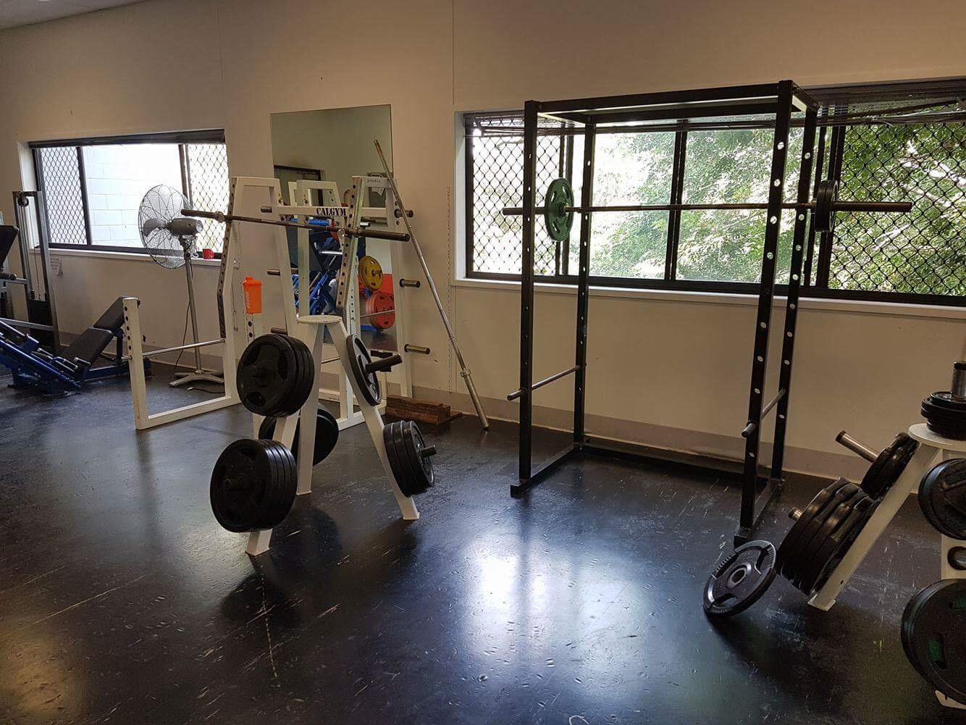

- Identify five (5) hazards present in the picture, completing a risk analysis for each.
- Rank the hazards from 1 to 5 (1 = most serious; 5 = least serious).

EXAMPLE HAZARD
Describe hazard
Dumbbells left on gym floor
Possible consequence(s)
- Trip and fall
- Possible bruising, broken bones, graze, cuts
Control measure(s)
- Erect signs around the gym
- Remind patrons to return weights
- Workers should consistently check gym floor
Determine the level of risk
Matrix | A:  Death or permanent disability | B:  Serious injury | C:  Lost time injury | D:  Casualty Treatment | E:  First Aid
1: Very Likely | E | E | H | H | M
2: Likely | E | H | H | M | M
3: Possible | H | H | M | M | L
4: Unlikely | H | M | M | L | L
5: Very Unlikely | M | M | L | L | L

E: Extreme | H: High | M: Medium | L: Low

Consequence rating: Serious injury (B)
Likelihood rating: Possible (3)
Level of risk: High (H)

HAZARD 1
Describe hazard
Different weight’s on each side of the squat press and not put away.
Possible consequence(s)
Barbells bend when left on bar
One side going to be heavier
Harder to control

Control measure(s)
Check floor consistently
Put signs up

Determine the level of risk
Matrix | A:  Death or permanent disability | B:  Serious injury | C:  Lost time injury | D:  Casualty Treatment | E:  First Aid
1: Very Likely | E | E | H | H | M
2: Likely | E | H | H | M | M
3: Possible | H | H | M | M | L
4: Unlikely | H | M | M | L | L
5: Very Unlikely | M | M | L | L | L

E: Extreme | H: High | M: Medium | L: Low

Consequence rating: Casualty Treatment (D)
Likelihood rating: Possible (3)
Level of risk: Medium (M)

HAZARD 2
Describe hazard
Bar leaning against wall.
Possible consequence(s)
Trip and fall
Bar fall and hit someone
Control measure(s)
Remind people to return items
Check the gym all the time
Determine the level of risk
Matrix | A:  Death or permanent disability | B:  Serious injury | C:  Lost time injury | D:  Casualty Treatment | E:  First Aid
1: Very Likely | E | E | H | H | M
2: Likely | E | H | H | M | M
3: Possible | H | H | M | M | L
4: Unlikely | H | M | M | L | L
5: Very Unlikely | M | M | L | L | L

E: Extreme | H: High | M: Medium | L: Low

Consequence rating: Serious injury (B)
Likelihood rating: Possible (3)
Level of risk: High (H)

HAZARD 3
Describe hazard
Protein shaker left on machine
Possible consequence(s)
Spill and slip
Knocked over and hit someone
Control measure(s)
Have a water area
Tell people to not forget their belongings
Determine the level of risk
Matrix | A:  Death or permanent disability | B:  Serious injury | C:  Lost time injury | D:  Casualty Treatment | E:  First Aid
1: Very Likely | E | E | H | H | M
2: Likely | E | H | H | M | M
3: Possible | H | H | M | M | L
4: Unlikely | H | M | M | L | L
5: Very Unlikely | M | M | L | L | L

E: Extreme | H: High | M: Medium | L: Low

Consequence rating: First Aid (E)
Likelihood rating: Very Likely (1)
Level of risk: Medium (M)

HAZARD 4
Describe hazard
Leaning bar on squat rack
Possible consequence(s)
Fall and hurt someone
Roll off

Control measure(s)
Make sure you put it back correctly
Determine the level of risk
Matrix | A:  Death or permanent disability | B:  Serious injury | C:  Lost time injury | D:  Casualty Treatment | E:  First Aid
1: Very Likely | E | E | H | H | M
2: Likely | E | H | H | M | M
3: Possible | H | H | M | M | L
4: Unlikely | H | M | M | L | L
5: Very Unlikely | M | M | L | L | L

E: Extreme | H: High | M: Medium | L: Low

Consequence rating: Casualty Treatment (D)
Likelihood rating: Likely (2)
Level of risk: Medium (M)

HAZARD 5
Describe hazard
Weight left on the floor
Possible consequence(s)
Trip and fall
Lose the weight (not in correct spot)
Control measure(s)
Put weight in right spot

Determine the level of risk
Matrix | A:  Death or permanent disability | B:  Serious injury | C:  Lost time injury | D:  Casualty Treatment | E:  First Aid
1: Very Likely | E | E | H | H | M
2: Likely | E | H | H | M | M
3: Possible | H | H | M | M | L
4: Unlikely | H | M | M | L | L
5: Very Unlikely | M | M | L | L | L

E: Extreme | H: High | M: Medium | L: Low

Consequence rating: Casualty Treatment (D)
Likelihood rating: Very Likely (1)
Level of risk: High (H)

RANK HAZARDS (1 = most serious; 5 = least serious)
Hazard 1 | 2
Hazard 2 | 1
Hazard 3 | 5
Hazard 4 | 3
Hazard 5 | 4

Outcome for Case Study 1 | ☐ Satisfactory  ☐ Not satisfactory
Trainer/Assessor comments

It is important to maintain items in the gym environment to maintain a safe environment.
  - Create a maintenance schedule for four (4) items regularly seen in a gym environment – one from each of the following categories:
- Gym floor
- Resistance training equipment item
- Cardiovascular machine
- Gym environment
Include daily, weekly and monthly functions, as well as maintenance/repair procedures that may only take place a limited number of times per year.
  - Locate two (2) instruction booklets for common items in a gym. Within each booklet, identify two (2) points with regards to safety and minimising risk for gym patrons.
  - What should an employee do if they cannot repair a piece of gym equipment?
- Who should they report the matter to?
  - Identify three (3) pieces of equipment that are essential to the safety of patrons in an emergency situation.
- For each equipment item, describe the procedures required to check the currency of their servicing history.

Example:
Name equipment item |  | Lat pulldown
Maintenance requirements
Daily | Weekly |  | Monthly | 6+ months | Other
- Check cleanliness  - Ensure security of safety clips  - Wipe down with anti-bacterial | - Ensure pin is safely secured to stack  - Check seats for tearing |  | - Check plate stack for smooth function  - Check smooth rotation of pulleys  - Check cable for signs of fraying | - Check pulleys and cables for major wear and tear | Nil

ITEM 1: GYM FLOOR ITEM
Name equipment item |  | Dumbbells
Maintenance requirements
Daily | Weekly |  | Monthly | 6+ months | Other
- Wipe down any bacteria  - Ensure there in a safe spot  - Check cleanliness | - Put them in the right spot  - Check for mold |  | - Check for dust  - Check bell for signs of fraying | - Check dumbbells aren’t bending | Nil

ITEM 2: RESISTANCE TRAINING EQUIPMENT ITEM
Name equipment item |  | Resistance Band
Maintenance requirements
Daily | Weekly |  | Monthly | 6+ months | Other
- Check cleanliness  - Check and wipe for bacteria | - Ensure it is not broken |  | Check if it’s in the right spot | Check band for tearing | Nil

ITEM 3: CARDIOVASCULAR MACHINE
Name equipment item |  | Cycle
Maintenance requirements
Daily | Weekly |  | Monthly | 6+ months | Other
- Check cleanliness  Ensure there is no bacteria | - Check seats for tearing  Ensure its stable to sit on |  | - Check fan and clean dust | - Check seat signs of tearing | Nil

ITEM 4: GYM ENVIRONMENT ITEM
Name equipment item |  | Rubber tiles
Maintenance requirements
Daily | Weekly |  | Monthly | 6+ months | Other
Check cleanliness  Ensure there is no bacteria | Sweep floor for dust |  | Check they look good | Check for tearing and damage towards the rubber tiles | Nil

INSTRUCTION BOOKLET 1
Name equipment item | Chest bar
Instruction booklet requirements | Grip the bar with hands just wider than shoulder-width apart, so when you’re at the bottom of your move your hands are directly above your elbows. This allows for maximum force generation. Bring the bar slowly down to your chest as you breathe in.
Instruction booklet requirements | To do the chest bar correctly

INSTRUCTION BOOKLET 2
Name equipment item | Dum Bells
Instruction booklet requirements | Stand up right and keep the back straight  Hold a Dum bell in each hand at the shoulders with an overhand grip  Raise the weights above the head in a controlled motion while exhaling  Return the dumbbells to the shoulders while inhaling and repeat
Instruction booklet requirements | Procedure of doing dumbbells

Code of Practice name | Work place health and safety
Requirements | To ensure everything is safe
Requirements | Make sure everything an everyone is safe to the best of your ability

EMERGENCY EQUIPMENT 1
Name equipment item | First Aid Kit
Checking servicing currency | Checking it has everything needed

EMERGENCY EQUIPMENT 2
Name equipment item | Water
Checking servicing currency | Checking it daily fresh

EMERGENCY EQUIPMENT 3
Name equipment item | Food
Checking servicing currency | Check it’s healthy and edible

Outcome for Case Study 2 | ☒ Satisfactory  ☐ Not satisfactory
Trainer/Assessor comments

You have received the following the following client complaint via email:

To whom it may concern,

During the last few sessions at the gym, I have noticed a worrying trend. Of an afternoon, the area around the drink tap is becoming increasingly flooded; it is creating a slippery surface that I have very nearly fallen on at least three times. This leaking tap is a health hazard!

The gym floor workers have acknowledged my complaints, however they are yet to rectify the situation. I fear the next time I go to the gym could result in serious injury. It is disappointing that so far my complaints have fallen on deaf ears. I do not want to go to another gym, but if I continue to feel unheard and unsafe I will begin to look at your competitors.

Please tell me what you are going to do about this.

Regards,
Jim Patron

Respond to this client complaint. Ensure your response meets the following requirements:
- Shows empathy
- Acknowledges recording of the incident
- Discusses the duty of care
- Identifies the relevant chain of command in the resolution and reporting process
- Provides a resolution, including an improvement of organisational policies and procedures to minimise the likelihood of this occurring again

Your response
Dear Jim Patron,
Thank you for your email and for letting me know about this dangerous hazard at the gym. I agree it must have been very unpleasant to have a fooled floor at the gym.It is not safe to have a flooded floor area at the gym and it is our duty of care to keep our customers safe. I’m sorry that this has happened. Safety at the gym is a high priority for us.

I have looked at the records and they have confirmed your three reports of the leaking drink tap. Our complaint process requires staff to inform management of health and safety risks at the gym. On this occasion, the process was not followed because a junior staff member was a trainee and was not a wear of the process. A plumber has now repaired the leaking drink tap. I have also arranged training for all staff including the trainee about the complaints policy and the importance of health and safety of clients and staff at the gym. I hope this resolves the problem and that this won’t happen again. Thank you again for bringing this to my attention. I hope you will stay with the gym as you are a very valued customer.

Kind Regards,
Eva Geraghty

Outcome for Case Study 3 | ☐ Satisfactory  ☐ Not satisfactory
Trainer/Assessor comments

Consider your safety requirements in a gym environment.
  - Describe ways that the following signs could be used in a gym:
- Dangerous goods classification
- Emergency equipment
- Personal Protective Equipment (PPE)
- Hazard
  - Outline the legal requirements with regards to safety
- Identify the legislation that outlines the safety requirements for a gym
- Identify two (2) legal requirements outlined under safety legislation/regulations
- Identify the regulatory authority who would check that legal requirements are being met
  - In situations where an employee cannot repair a piece of gym equipment, who should they refer the repair task to?
  - What role do clients and staff have in reducing or preventing the spread of infectious diseases?
- How can a gym regulate these practices?
  - What reporting processes can be put in place to ensure injuries are appropriately reported?
  - Describe how an employee may reflect on their own levels of stress and fatigue. Who should employees report to?
  - Explain the best process for undertaking hazardous manual tasks.

Safety signs
Dangerous goods classification sign could be next to very dangerous machines

Legal requirements
The Legal requirements for the gym is to have a towel
Referring repair tasks
The employee should refer their repair task to the mangers or a staff member
Infectious diseases
The that clients and staff have is keeping the hygiene clean and the gym can regulate these practices by using signs and keeping 1.5 meters away from people.
Reporting processes
A reporting processes that can be put in place to ensure injures are appropriately reported is having good and effective system.
Stress and fatigue
The employee should report to the manger to reflect on their own levels of stress and fatigue.
Hazardous manual tasks
The correct PPE also make sure your following the correct procedures.

Outcome for Case Study 4 | ☒ Satisfactory  ☐ Not satisfactory
Trainer/Assessor comments

PRACTICAL TASKS

You are required to have a suitable observer verify your ability to complete the following tasks. These tasks may be simulated or real.

TASKS | VERIFIED
- Conduct a safety inspection of your work area, completing a risk register:  - Identify hazards and associated risks (including hazardous manual tasks)  - Consult with relevant stakeholders to analyse and evaluate risks  - Identify and evaluate control measures  - Develop and implement treatment plans for your area of responsibility  - Report hazards as per workplace procedures  - Refer hazards that are beyond your own area of responsibility  - Maintain risk management documentation  [Evidence: Risk Register] | ☒
- Respond to a (simulated) fire emergency/drill:  - Provide information needs to emergency response personnel during reporting, arrival and in response to emergency  - Checking and accounting for people during an evacuation  - Debriefing with an appropriate person, as per workplace procedures, to identify personal levels of stress and fatigue | ☒
- Over five (5) service periods, safely conduct six (6) of the following minor maintenance tasks on equipment (i.e. equipment used within the facility, participant/client-specific equipment, emergency equipment, large items requiring lifting and assembly):  - Cleaning  - Lubrication  - Reinflating  - Checking for damage  - Restocking or refilling  - Repairing  - Calibration  - Storage (ensuring entry and exit in the case of an emergency situation)  - Completing maintenance records and forms (e.g. logbook) | ☒

Outcome for Practical Tasks | ☒ Satisfactory  ☐ Not satisfactory
Trainer/Assessor comments

