CPCCBC4009B
Apply legal requirements to building and construction projects
ASSESSMENT SUMMARY

The assessment activities for CPCCBC4009B Apply legal requirements to building and construction projects cover all aspects of the unit of competency required. To demonstrate competence in this unit, a participant must undertake all tasks and complete them satisfactorily and consistently. For Apprentices and Trainees, this includes employer completion of the Employer Record Book (ERB).

Participants must read all the information given before starting any assessment task. The assessment tasks are intended to be equitable, fair and flexible. If a participant has any questions or requires alternative arrangements to be made such requests should be directed to their Trainer/Assessor, who should note such arrangements in the ‘Assessor Comments’ on the affected assessment. If a participant feels they are not yet ready to be assessed, they should discuss their options with their Trainer/Assessor.

To satisfactorily complete the assessment, the participant is required to answer all questions correctly and demonstrate their skills to industry standards. If a participant does not answer some questions or perform some tasks, they will be deemed ‘Not Satisfactory’ for the task and ‘Not Yet Competent’ for the unit of competency. The Trainer/Assessor is able to provide the participant with additional information on interpreting the assessment outcomes and provide guidance on the participant’s options. Should a participant still be deemed ‘Not Satisfactory’ they will have the opportunity to undertake a supplementary assessment or appeal the result.

By signing the cover page for each assessment item, the participant acknowledges they understand the assessment instructions and requirements and consent to being assessed. The participant also verifies and assures the RTO that the work submitted is their own work.

Participant Name | Lauren Wilson

Task | Assessment Results
Theory Exam | Satisfactory | Not Yet Satisfactory
Practical Assessment | Satisfactory | Not Yet Satisfactory
Outcome for Unit of Competency | Competent | Not Yet Competent

Assessor Name
Assessor Signature | 
Unit Competence Determination Date | Click here to enter a date.

CPCCBC4009B
Apply legal requirements to building and construction projects

THEORY EXAM INSTRUCTIONS

- This exam will occur under standard assessment conditions.
  - An oral examination may be allowed under certain circumstances, whereby the Participant’s answers will be documented by a party other than the Participant. This must be acknowledged in writing (e.g. FT001 and Assessor Comments)
- Participants must provide enough detail in their responses to demonstrate their knowledge and skills.
- Please fill in the details below, providing your name, signature and date of assessment.
  - Your signature acknowledges that this is your own work.
- Assessors are to complete marking in pen of a different colour to the Participant.
- If a Participant initially answers a question incorrectly but modifies their response, they must follow the instructions below:
  - If a Participant changes their response in writing, they must put their initials next to the written change.
  - If a Participant changes their response verbally, this must be noted on the exam paper by the assessor.

Participant name | Lauren Wilson
Participant signature | 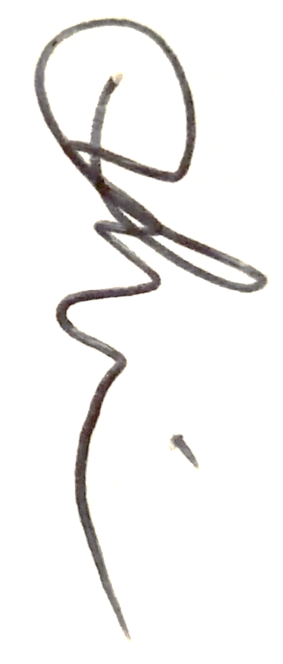
Date | 20/05/2020

Assessor name
Assessor signature
Date | Click here to enter a date.

Number of questions | Number of questions answered correctly | Task outcome (Tick)
48 |  | Satisfactory | Not Yet Satisfactory
ASSESSOR Comments
- Identify the legislation (Act and/or Regulation) in your region relating to builder licensing or registration.

Answer | Queensland Building and Construction Commission Act 1991 QLD

- Select one (1) licence class and identify the scope of work that is allowed by a builder in this class. List the section(s) of the legislation that identifies these requirements.

Answer | Section(s) of legislation | Scope of work
 | Part 5 Page 95 – Builder Medium Rise Licence | Building work on a class 1 or class 10 building  Building work to a maximum of 3 storeys, but not including type A construction on classes 4 to 9 buildings  Prepare plans and specifications that are for the licensee’s Work personal use or for use in building work to be performed by the licensee personally

- Select one (1) licence class and identify the requirements under the legislation for supervisors. List the relevant section(s) of the legislation.

Answer | Section(s) of legislation | Requirements
 | Nominee Supervisor Licence – Act’s 32 ref page 27 | Technical qualifications, managerial qualifications

- Select one (1) licence class and identify the requirements under the legislation for managers. List the relevant section(s) of the legislation.

Answer | Section(s) of legislation | Requirements
 | Part 6 Page 97 – Builder Open Licence and or Project Management Services | Building work on all classes of buildings  Prepare plans and specifications for licensee’s personal use or to be performed by the licensee  Perform functions of a superintendent if appointed under a building contract

- Name the Act and identify the section that outlines the primary duty of care regarding safety on site. Briefly describe the requirements.

Answer | Section of Act | Requirements
 | Work Place Health and Safety Act 2011 – Part 2 – Health and Safety Duties – Division 2 – Primary Duty of Care | Ensure the health and safety of workers engaged  Ensure the health and safety of persons is not put at risk  Ensure the provisions and maintenance of a healthy and safe work environment  Ensure the provisions and maintenance of safe plant and structures

- Name the Act and identify the section that outlines the duties of workers regarding safety on site. Briefly describe the requirements, including those for monitoring.

Answer | Section of Act | Requirements
 | Work Place Health and Safety Act 2011 – Part 2 – Health and Safety Duties – Division 4 – Duty of Officers, Workers and other persons - 28 | A worker must – Take reasonable care of his or her on health and safety  Take reasonable care that his or her acts or omissions do not adversely affect the health and safety of others  Comply with reasonable instruction  Co Operate with and reasonable policy or procedure

- Name the Regulation and identify the section that outlines the requirements regarding compliance with safe work method statements. Briefly describe the requirements.

Answer | Section of Regulation | Requirements
 | Work Cover Queensland – Construction industry home – Health and well being at work – Safe Work Method Statements | The PCBU carrying out any high risk work is required to ensure that a Safe Work Method Statement is prepared prior to the proposed works starting onsite  Make sure all high-risk works are carried out in accordance with the SWMS  Ensure that a copy of the SWMS is provided to the principal contractor prior to the works taking place  Review the SWMS and amend if necessary  File the SWMS for that project

- Name the Regulation and identify the section that outlines the requirements for site signage when undertaking construction work. Briefly describe the requirements.

Answer | Section of Regulation | Requirements
 | Work Health and Safety Regulations – Section 308 | Site signage bust be erected on all construction projects over $250 000 or more  ‘The sign must show the principal contractors name and telephone numbers – including after hours  Show the location of the sire office – if applicable  Must be clearly visible form outside the workplace or the work area where the construction is taking place.

- Name the Regulation and identify the section that outlines the requirements for signage in confined spaces. Briefly describe the requirements.

Answer | Section of Regulation | Requirements
 | Confined Spaces – Code of Practice 2011 – Measures to control the risk – Page 21 | Installation of relevant site signage  List the control measures that must be implements or continued while the works is being done in the space ( PPE, respiratory equipment, ventilation, continuous monitoring)

- Identify a relevant Code of Practice relating to traffic management safety signage. Briefly describe the requirements.

Answer | Code of Practice name | Requirements
 | Traffic Management for Construction or Maintenance work – Code of Practice 2008 | Implement and erect of temporary traffic signs for the duration of the works  Signs must be appropriate to the worksite and be displayed prior to the commencement of the works  Signs must be maintained and checked regularly  Signs must be removed from site as soon as the works are completed

- Identify the Volume and Parts of the NCC that relate to energy efficiency of building fabric for Classes 1 and 10, and Classes 2 to 9.

Answer | Classes 1 and 10 | Classes 2 to 9
 | Handbook: Energy Efficiency NCC – Volume 1 - 8.4.2 Building – Fabric – Proposed and reference building – Ref page 54 | Handbook: Energy Efficiency NCC – Volume 1 – 8 Part 3.12.0 – Building Fabric – Ref page 82

- Which Australian Standard is referenced in the NCC with regards to the requirements for building fabric thermal insulation?

Answer | Acceptable construction practice 3.12.1.1 Building Fabric thermal insulation - AS/NZS 4859.1

- Identify the legislation (Act and/or Regulation) in your region relating to sustainable housing.

Answer | Queensland’s Development Code Mandatory – Part 4.1 Sustainable Buildings Guideline – Reference page 14 – Elemental provisions

- Identify the legislation (Act and/or Regulation) in your region relating to noise standards when undertaking building work.

Answer | Planning Regulation 2017 – Reference Cairns Regional Council Local Laws

- Briefly describe the Local Council requirements with regards to building work noise.

Answer | Building work, including altering or demolishing a building – Monday -Saturday 6.30 am – 6.30 pm work permitted.  Monday – Saturday 6.30 pm – 6.30 am – No audible noise permitted  Sundays and public holidays – No audible noise permitted

- Briefly describe the insurance that a builder must obtain to insure the residential building work over $10,000.

Answer | Contract works insurance to designated to cover works onsite in the event of a floor, fire vandalism or theft.  This insurance is to pay for the damages and the cost of re doing the works.

- Identify the legislation (Act name and relevant section) that requires an employer to insure workers in the event of accidents or illness.

Answer | Workers Compensation and Rehabilitation Act 2003 – Chapter 2 - Part 2 Employers Insurance Requirements – Division 1 – General Obligations – Ref page 65

- To ensure that a legally binding contract exists between yourself and a client, what must exist?

Answer | The 4 essential elements to make the contract legally binding  The offer by 1 party  Acceptance by the part 2  Intention by both parties to create legal obligations  Consideration – Money exchanged for goods and services  Both parties must sign the document acknowledging each page and in return be issued with a fully signed copy each.

- What federal and state/territory fair trade legislation should be referred to for guidance on the following:
- Consumer transactions (e.g. payment of supplier invoices)
- Issues where the client is unhappy with the work undertaken

Answer | Federal | State or territory
 | Australian Competition and Consumer Commission | Fair Trading Act 1989

- Identify the legislation (Act name and relevant section) that identifies that an employer is to pay payroll tax.

Answer | Payroll Tax Act 1971  Reference page 26  12 – Employer to pay payroll tax

- Payroll tax is a self-assessed tax on the wages that employers pay to their Queensland employees when the total wages are more than $___________.

Answer | $25 000.00 a week in Australian taxable wages

- Identify the legislation (Act name and relevant division) that identifies who is required to be registered and who may be registered for Goods and Services Tax (GST).

Answer | The Australian Taxation Office – Reference a New Tax System (Goods and Services Tax) Act 1999  A non for-profit organisation, if you provide taxi or ride share travel or you want to claim fuel tax credits

- Business owners should register for GST if their business’ gross income is more than $___________.

Answer | $75 000.00

- Identify the two legislative Acts that identify the rights and entitlements of contractors.

Answer | Independent Contractors Act 2006  Queensland Building and Construction Commission (QBCC)

- Identify one (1) standardised domestic building contract that may be used for renovation jobs under $15,000 that do not affect footings or foundations.

Answer | HIA Small Works Contract

- Identify one (1) standardised commercial building contract that may be used where a lump sum price cannot be established.

Answer | Master Builders Commercial Cost Plus Contract

- Identify the legislation (Act name and relevant section) that identifies when development under a development approval may start.

Answer | Planning Act 2016 – Section 72 – Reference page 92

- True or False (Tick your response): The bank lending you money will sometimes have special requirements for progress payments, this may be included as additional clauses in the contract.

Answer |  | True
 |  | False

- Identify the Parts of the Fair Work Act 2009 (Cth) that address Awards and Enterprise agreements.

Answer | Awards | Enterprise Agreements
 | Division 3—Interaction between the National Employment Standards, modern awards and enterprise agreements – ref page 112  Subdivision B—Interaction between modern awards and enterprise agreements  Part 2 – 3 Modern Awards – ref page 192 | Chapter 2—Terms and conditions of employment – Ref page 101  Subdivision D—Terms and conditions of employment provided by an enterprise agreement - ref page 108  Division 3—Interaction between the National Employment Standards, modern awards and enterprise agreements – ref page 112

- True or False (Tick your response): Awards set out the minimum wages and conditions an employee is entitled to.

Answer |  | True
 |  | False

- Identify two (2) awards that may apply to those working in the building and construction industry.

Answer | Building and Construction General Onsite Award  Plumbing and Fire Sprinklers Award  https://www.fairwork.gov.au/awards-and-agreements/awards/list-of-awards#b

- True or False (Tick your response): When a workplace has a registered agreement the award doesn’t apply, but the base pay rate can’t be less than that in the award.

Answer |  | True
 |  | False

- True or False (Tick your response): Award an agreement free employees may have an employment contract.

Answer |  | True
 |  | False

- True or False (Tick your response): Subcontract companies do not need to comply with your company’s policy and obligations.

Answer |  | True
 |  | False

- Identify the subcontractors who still need to hold a licence.

Answer | Building / Carpentry  Plumbing  Concreting  Pest Control  Painting  Block Laying  Electrical – Electrical Contractor Licence  Landscaping  Glazing  Waterproofing / tiling  Plastering

- List two (2) proactive measures that may be taken to ensure discrimination and harassment are not practiced in the workplace.

Answer | Implement an Equal Rights, Bullying and Harassment and Zero Tolerance Policy the work place, ensure that all involved are aware for these policies and procedures.  Observe and implement principles and dynamics of equal opportunity employment – team building activities outside of the workplace, celebrate cultural days etc

- Identify the section of the Racial Discrimination Act 1975 (Cth) that identifies that racial discrimination is unlawful. Briefly explain the section.

Answer | Section of Act | Requirements
 | Part 2 – Prohibition of Racial Discrimination – Ref Page 6 | A – A person requires another person to comply with a term, condition or requirement which is not reasonable having regard to the circumstances of the case  B – The other person does not or can not comply with the term, condition or requirement  C – The requirement to comply has the purpose or effect of nullifying or impairing the recognition, enjoyment or exercise on an equal footing.

- Identify the section of the Sex Discrimination Act 1984 (Cth) that identifies that sexual harassment is unlawful. Briefly explain the section.

Answer | Section of Act | Requirements
 | Division 3 – Sexual Harassment | 2 – It is unlawful for a person to sexually harass:  A – a commissioning agent or contract worker of the person,  B – a person who is seeking to be a commission agent or contract workers of the person

- Identify the legislation (Act name and relevant section) that identifies the wages and employment conditions for apprentices and trainees.

Answer | Fair Work Act 2009  Division – 13 Miscellaneous  https://www.legislation.gov.au/Details/C2019C00270

- True or False (Tick your response): An apprentice or trainee is not entitled to the same employment conditions as other employees in the workplace.

Answer |  | True
 |  | False

- Identify the legislation (Act name and relevant section) that requires consultation with workers on matters relating to work health or safety.

Answer | Work Health and Safety Act 2011  Part 5 – Consultation, representation and participation  Division 2 – Consultation with workers – ref page 51  47 - Duty to Consult Workers - 51  48 – Nature of Consultation - 51  49 – When Consultation is required - 52

- List three (3) ways that reference material on industrial relations or legal information may be made available to employees.

Answer | Newsletters  Toolbox talks  Formal in house training sessions

- Which of the following are good processes for addressing disputes? Tick all that apply.

Answer | Choice | Possible Answers
 |  | Act quickly
 |  | Discuss options for fixing the problem
 |  | Follow up with the customer
 |  | Get all the facts
 |  | Keep your promises
 |  | Listen to the complaint
 |  | Record details of the complaint

- When handling a dispute, what document should you refer to for details on the obligations of each party to an agreement?

Answer | The signed contract

- Which of the following should be addressed in a company’s policy for handling customer complaints? Tick all that apply.

Answer | Choice | Possible Answers
 |  | Explanation of how to make a formal complaint
 |  | Information about commitment to continuous improvement
 |  | Some of the solutions offered to resolve complaints
 |  | Steps to be taken in discussing, addressing and resolving complaints

- True or False (Tick your response): Dispute resolution procedures should be based on company policies.

Answer |  | True
 |  | False

- What are the benefits of documenting disputes and their outcomes?

Answer | To ensure you clearly understand what the dispute is about  To allow you to review disputes and identify and trends or reoccurring issues and to provide guidance on solutions for disputes

- True or False (Tick your response): You should keep records of all complaints in one central place or register.

Answer |  | True
 |  | False

CPCCBC4009B
Apply legal requirements to building and construction projects

PRACTICAL ASSESSMENT INSTRUCTIONS

- The following practical assessment will require the Participant to complete work related activities.
- The Assessor will conduct observations of the Participant’s work to determine whether they display sufficient practical skills and knowledge.
- Please fill in the details below – providing your name, signature and date of assessment.
  - The Participant’s signature acknowledges that the Assessor provided clear instructions and the Participant understood what was required to complete this assessment.
- The Assessor may substitute a Practical Task with an alternate task of equal value.
  - Alternate tasks must be fully documented by the assessor in the Assessor Comments area.

Participant name | Lauren Wilson
Participant signature | 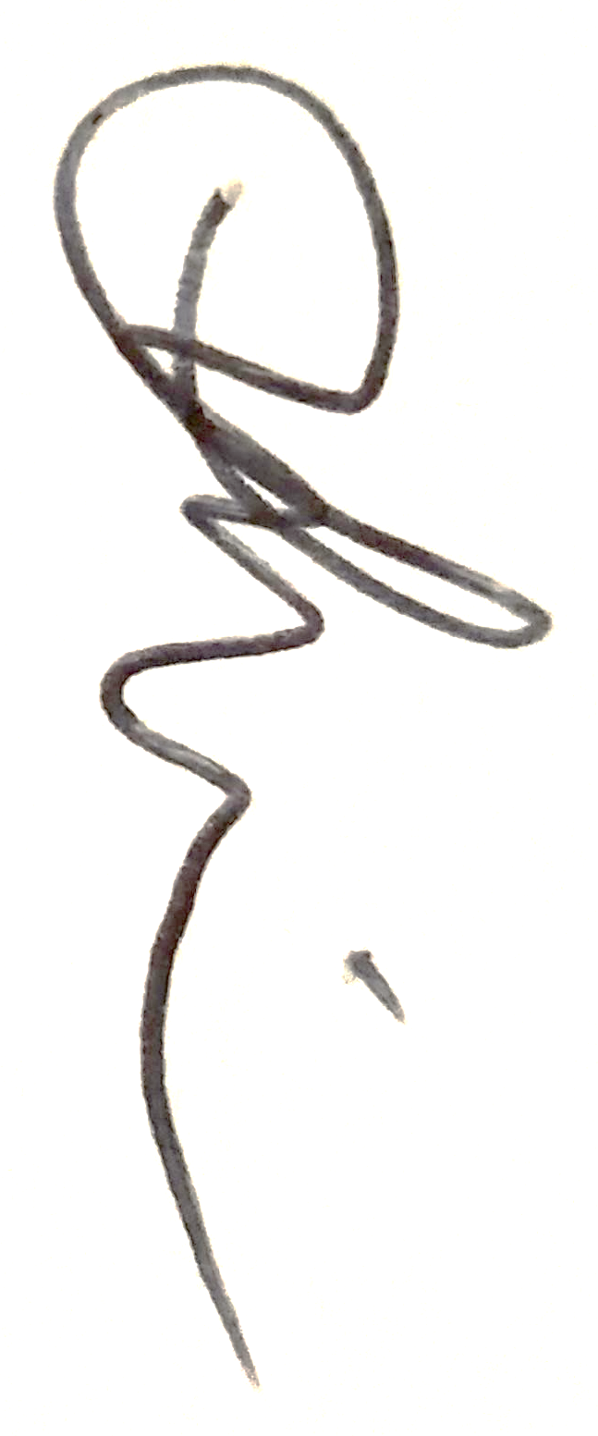
Date | 20/05/2020

Assessor name
Assessor signature
Date | Click here to enter a date.

Task | Task outcome (Tick)
Task | Satisfactory | Not Yet Satisfactory
Task 1 (Occasion 1)
Task 1 (Occasion 2)

Assessor Comments
CPCCBC4009B
Apply legal requirements to building and construction projects

Practical Task 1 (2X)
Description of task:
On two (2) occasions, a suitable observer is to verify the participant’s ability to apply legal requirements to building and construction projects:
- Occasion 1: Residential buildings
- Occasion 2: Low rise commercial buildings (Class 1 and 10 construction and Classes 2 to 9 with a gross floor area not exceeding 2000 square metres, not including Type A or Type B construction)

The participant is to gather evidence of how they have completed each component of the Practical Task, which is to be submitted with this Practical Assessment sheet. Evidence to be submitted may include:
- Copies of any licences
- Business insurance Certificates of Currency
- A copy of a WHS Policy
- A copy of an Environmental Policy
- If an employer - copies of employee records, apprenticeship papers
- Sub-contractor agreements or a copy of a sub-contract
- A copy of a Business Activity Statement
- A copy of a business tax invoice that references relevant legislation
- A copy of a Dispute Resolution Procedure or documentary evidence of a dispute

The observer is to provide detailed comments on the tasks completed by the participant. The assessor is to verify the observer’s comments in the Assessor Comments section, and provide the Practical Assessment outcome on the front cover of this document.
Resources required:
Computer, Telephone, Building Contract.
Assessment of task
Name of participant:
Name of observer:
Role of observer
(Confirm suitability to sign)
Email address of observer
Signature of observer:
Date: | Click here to enter a date.
When completing the task, did the participant: |  | Tick if satisfactorily completed.  Provide comments if left unticked.
 |  | 1st  Occasion | 2nd  Occasion
1 Legal obligations
- Research and apply licensing or registration legislation relevant to the region, including classifications for builders, supervisors and managers.
- Research, apply and monitor safety legislation and regulations applicable to on-site construction, including site safety signage requirements.
- Research and apply codes, Acts, regulations, by-laws and standards applicable to:
- Construction of the particular building project
- Insurance
- Sustainability
- Environmental matters
- Set up and administer financial systems in compliance with legislation, including:
- Payroll, including payment of wages, and subcontractor and supplier invoices
- GST systems in compliance with legislation
- Meet building contract obligations through:
- Observing common law principles, legislation, regulations, fair trading requirements
- Selecting the correct form of contract for the project
- Carrying out the work in accordance with contractual obligations
- Meeting contractual conditions, including communicating with local or regulatory authorities on matters regarding approvals and financial matters
2 Industrial relations obligations
- Research and apply relevant industrial relations policies and obligations, referring to relevant authorities
- Identify and contract subcontract companies that comply with company policy and obligations.
- Apply relevant awards to contracts.
- Use workplace agreements in accordance with company policy.
- Take proactive measures to ensure discrimination and harassment and not practiced in the workplace, referring to anti-discrimination and equal employment opportunity legislation.
- Identify and apply provisions of training agreements.
- Make available to employees any reference material on access to industrial relations or legal information.
3 Dispute resolution processes
- Apply organisational dispute resolution processes.
- Deal with customer complaints according to company policy.
- Document disputes, recording and maintaining outcomes.
- Effectively communicate using the following methods:
- Language/concepts appropriate to cultural differences
- Non-verbal communication
- Written skills – using memo, letter, facsimile or email
The participant’s performance was: Satisfactory Not Satisfactory

observer Comments

