BSBLDR403
Lead team effectiveness
ASSESSMENT SUMMARY

The assessment activities for BSBLDR403 Lead team effectiveness cover all aspects of the unit of competency required. To demonstrate competence in this unit, a participant must undertake all tasks and complete them satisfactorily and consistently. For Apprentices and Trainees, this includes employer completion of the Employer Record Book (ERB).

Participants must read all the information given before starting any assessment task. The assessment tasks are intended to be equitable, fair and flexible. If a participant has any questions or requires alternative arrangements to be made such requests should be directed to their Trainer/Assessor, who should note such arrangements in the ‘Assessor Comments’ on the affected assessment. If a participant feels they are not yet ready to be assessed, they should discuss their options with their Trainer/Assessor.

To satisfactorily complete the assessment, the participant is required to answer all questions correctly and demonstrate their skills to industry standards. If a participant does not answer some questions or perform some tasks, they will be deemed ‘Not Satisfactory’ for the task and ‘Not Yet Competent’ for the unit of competency. The Trainer/Assessor is able to provide the participant with additional information on interpreting the assessment outcomes and provide guidance on the participant’s options. Should a participant still be deemed ‘Not Satisfactory’ they will have the opportunity to undertake a supplementary assessment or appeal the result.

By signing the cover page for each assessment item, the participant acknowledges they understand the assessment instructions and requirements and consent to being assessed. The participant also verifies and assures the RTO that the work submitted is their own work.

Participant Name | Corey Passey

Task | Assessment Results
Theory Exam | Satisfactory | Not Yet Satisfactory
Practical Assessment | Satisfactory | Not Yet Satisfactory
Outcome for Unit of Competency | Competent | Not Yet Competent

Assessor Name
Assessor Signature | 
Unit Competence Determination Date | Click here to enter a date.

BSBLDR403
Lead team effectiveness

THEORY EXAM INSTRUCTIONS

- This exam will occur under standard assessment conditions.
  - An oral examination may be allowed under certain circumstances, whereby the Participant’s answers will be documented by a party other than the Participant. This must be acknowledged in writing (e.g. FT001 and Assessor Comments)
- Participants must provide enough detail in their responses to demonstrate their knowledge and skills.
- Please fill in the details below, providing your name, signature and date of assessment.
  - Your signature acknowledges that this is your own work.
- Assessors are to complete marking in pen of a different colour to the Participant.
- If a Participant initially answers a question incorrectly but modifies their response, they must follow the instructions below:
  - If a Participant changes their response in writing, they must put their initials next to the written change.
  - If a Participant changes their response verbally, this must be noted on the exam paper by the assessor.

Participant name | Corey Passey
Participant signature | 
Date | 23/11/2021

Assessor name
Assessor signature
Date | Click here to enter a date.

Number of questions | Number of questions answered correctly | Task outcome (Tick)
23 |  | Satisfactory | Not Yet Satisfactory

ASSESSOR Comments
- Identify a team that may exist in the workplace. Consider the purpose of the team, its goals and objectives. Name and describe the roles and responsibilities for at least three (3) team members. Finally, identify at least one (1) method that will assist with monitoring progress towards the team goals.

Answer | Point | Detail
 | Team purpose | monitoring WHS
 | Goals and objectives | Agreed goal/s  These should be clearly defined, understood and agreed upon by all team members. There needs to be commitment to achieving something together  Roles and responsibilities of each of the team members  Everyone should be actively involved and gain satisfaction from team accomplishments
 | Team members | Role | Description | Responsibilities
 | Team members | 1 | Planter | Introduces new ideas and brings innovation to the team
 | Team members | 2 | Coordinator | Focusses on the team’s objectives, delegates work to team members
 | Team members | 3 | Specialist | Brings in-depth knowledge of a key area to the team
 | Progress monitoring | Regular meetings with team members, clear communication , brainstorming sessions, making sure each team member has the resources and tools they need to do their job correctly and effectively

- True or False (Tick your response): A team leader is more of a mentor than overseer who checks work.

Answer |  | True
 |  | False

- Match the leadership styles and definitions by writing the appropriate letter next to each number in the centre column.

Answer | Style |  | Answers | Definition
 | 1 | Authoritarian | 1 - B | A | Leaders who let the team function without much interference
 | 2 | Democratic | 2 - C | B | Leaders who fully control their team
 | 3 | Laissiz-Faire | 3 - A | C | Leaders who try to include everyone in the decision-making process

- Why is it important for team leaders to include team members in the planning process?

Answer | It allows for improved practises such as Innovation and Productivity. When you involve team members from the start of a project they “buy in” to it and take more responsibility and ownership and in the end more team work and everyone is on the same page, which will result in a happier project and team culture and better experience for the clients and the team members,

- For each of the listed activities in the table below, identify two (2) methods that team leaders can use to involve team members.

Answer | Activity | Method/s to involve team members
 | Goal setting | Specific and Attainable, make sure the goal is clear and specific and  make sure the goal is attainable or realistic  Brainstorming team meetings
 | Decision making | encouraging team members to plan the team outcomes, opportunities should be provided to team members to be involved in other work team aspects, including:  Decision making – To improve productivity, a manager should not be consulted each time a decision is to be made  Operational aspects – including organising its own activities
 | Work allocation | Try to allocate work according to skills and abilities to get the most out of team members  Do not force relationships or working groups that will cause conflict

- True or False (Tick your response): Diverse teams produce more creative results than teams in which members are from a similar background.

Answer |  | True
 |  | False

- Provide two (2) examples of how the knowledge, skills and background of team members can enhance team practices.

Answer | Innovation – Application of better solutions to meet requirements  Productivity – Improved output of work (e.g. through streamlining processes)

- Provide two (2) reasons that responsibilities must be carefully delegated within the work team.

Answer | Try to allocate work according to skills and abilities to get the most out of team members  Do not force relationships or working groups that will cause conflict

- Describe what innovation brings to the workplace. Provide one (1) example of innovative practice.

Answer | It brings better solutions to meet requirements… you can often find better ways to do things through innovation, work smarter not harder. Eg the invention of concrete pumps, happier workers not having to shovel concrete.  Innovation – Application of better solutions to meet requirements.

- Explain how encouraging team members to assist each other in undertaking their roles and responsibilities can improve productivity.

Answer | Everyone should be actively involved and gain satisfaction from team accomplishments  A team leader should encourage team members to work together to establish these objectives  Consultation methods include: Meetings, interviews, brainstorming sessions, and email.  The type of communication method chosen will depend on the information being shared

- Which of the following are likely outcomes from involving team members in all aspects of a job? Tick all that apply.

Answer | Choice | Possible Answers
 |  | Causes members to resent the team
 |  | Makes the work more meaningful
 |  | Improves self-esteem of team members
 |  | Improves team morale
 |  | Team members take more responsibility for their individual work

- Explain how providing feedback to team members can encourage and motivate team members – building trust and positive working relationships.

Answer | A valued team will be inspired to keep working towards its goals – as well as remain focussed, energetic and cohesive in its actions  Feedback whether it be positive or negative is a constructive way to build a team and gain trust, sometimes when you need to give someone negative feedback on their work or attitude, they may not be aware they have been doing anything wrong and in the long run will help everyone in the team.

- Identify one (1) issue, concern or problem that may be identified by team members. Describe the signs that you would recognise to identify the issue and how the matter could be resolved by internal team negotiation.

Answer | Question | Response
 | Signs | If the team requires additional training to complete their job
 | Solution via negotiation | management may need to provide opportunities for professional development. The team leader may provide guidance on the type of training needed.

- Identify one (1) issue, concern or problem that would need to be resolved by an external party. Describe the signs that you would recognise to identify the issue and who the matter should be referred to.

Answer | Question | Response
 | Signs | Disrespect within the team
 | Referred to | Counselling offered internally or externally

- Identify three (3) ways that the team leader can serve as a role model to, and motivate, the team.

Answer | Encouraging team member involvement  Providing feedback to the team  Modelling expected behaviours  In other words lead by example , you are their mentor

- For each of the following areas, provide one (1) example of how the team leader’s contributions to the work team can enhance the organisation’s image:
- Internally, within the work team and the organisation
- Externally, with clients/customers

Answer | Question | Response
 | Within the work team and organisation | a team leader is a mentor, advisor and team member themselves. As such, they must ensure that their own contribution to the work team serves a role model for other team members.
 | With clients and customers | Team leaders should enhance the organisation’s image within the work team, the organisation and with clients/customers.

- Provide three (3) communication methods that a team leader may encourage the team to use and situations that each communication method would be suitable for.

Answer | Method | Suitability
 | One on one face to face | Interview style, something private and important
 | Team meeting | For a general team meeting, progress on a job, fill everyone in on an issue or brainstorming session
 | Via email | This might just be to follow up on something, or a reminder to do a task

- Identify two (2) ways that the team leader can maintain open communication with management.

Answer | They must maintain open communication with management at all times  For example: Having meeting with management, delivering regular reports)  Both good and bad news must be reported – problems will not be avoided by only reporting good news  They should communicate information from management to the team and vice versa  Information should be handled sensitively, honestly and accurately

- Identify two (2) issues, concerns and problems that may be raised by the team to management.

Answer | If the team requires additional training to complete their job, management may need to provide opportunities for professional development. The team leader may provide guidance on the type of training needed  Underperformance by team members  - Review and amend work plan  - Closer management to ensure that deadlines are met  - Impacts of external problems flagged with management

- For the matters raised in Q19. , identify how the team leader could ensure follow-up action is taken.

Answer | Depending on the matter raised, there may be face to face meetings needed, further training, and follow up. In all my years as a business leader, you lead by example and give clear instruction and communication.  In addition to the team member recognising and addressing issues, concerns and problems, the team leader should also give the team support to identify and resolve its problems, where possible  Team leaders should direct team members to:  Invite individuals to self-examine behaviour  Allow for the frank expression of feelings  Focus on the problem, rather than the person  Suggest positive solutions without using loaded and emotional language  Listen with empathy and without judging  Illustrate points with examples

- Identify two (2) issues, concerns and problems related to the team that may be raised by management back to the team.

Answer | For example: If the team requires additional training to complete their job, management may need to provide opportunities for professional development. The team leader may provide guidance on the type of training needed.  For example: Underperformance may be flagged by management. The team leader may need to guide the team to enable it to work as more effective unit. Alternatively, the team leader may be required to negotiate the level of performance expected, if too high.

- For the matters raised in Q21. , identify how the team leader could ensure follow-up action is taken.

Answer | They must maintain open communication with management at all times  For example: Having meeting with management, delivering regular reports)  Both good and bad news must be reported – problems will not be avoided by only reporting good news  They should communicate information from management to the team and vice versa  Information should be handled sensitively, honestly and accurately

- Describe one (1) situation where the team leader may have to negotiate with management on behalf of the team.

Answer | Underperformance may be flagged by management. The team leader may need to guide the team to enable it to work as more effective unit. Alternatively, the team leader may be required to negotiate the level of performance expected, if too high.

BSBLDR403
Lead team effectiveness

PRACTICAL ASSESSMENT INSTRUCTIONS

- The following practical assessment will require the Participant to complete work related activities.
- The Assessor will conduct observations of the Participant’s work to determine whether they display sufficient practical skills and knowledge.
- Please fill in the details below – providing your name, signature and date of assessment.
  - The Participant’s signature acknowledges that the Assessor provided clear instructions and the Participant understood what was required to complete this assessment.
- The Assessor may substitute a Practical Task with an alternate task of equal value.
  - Alternate tasks must be fully documented by the assessor in the Assessor Comments area.

Participant name | Corey Passey
Participant signature
Date | 23/11/2021

Assessor name | Mark Harris
Assessor signature | 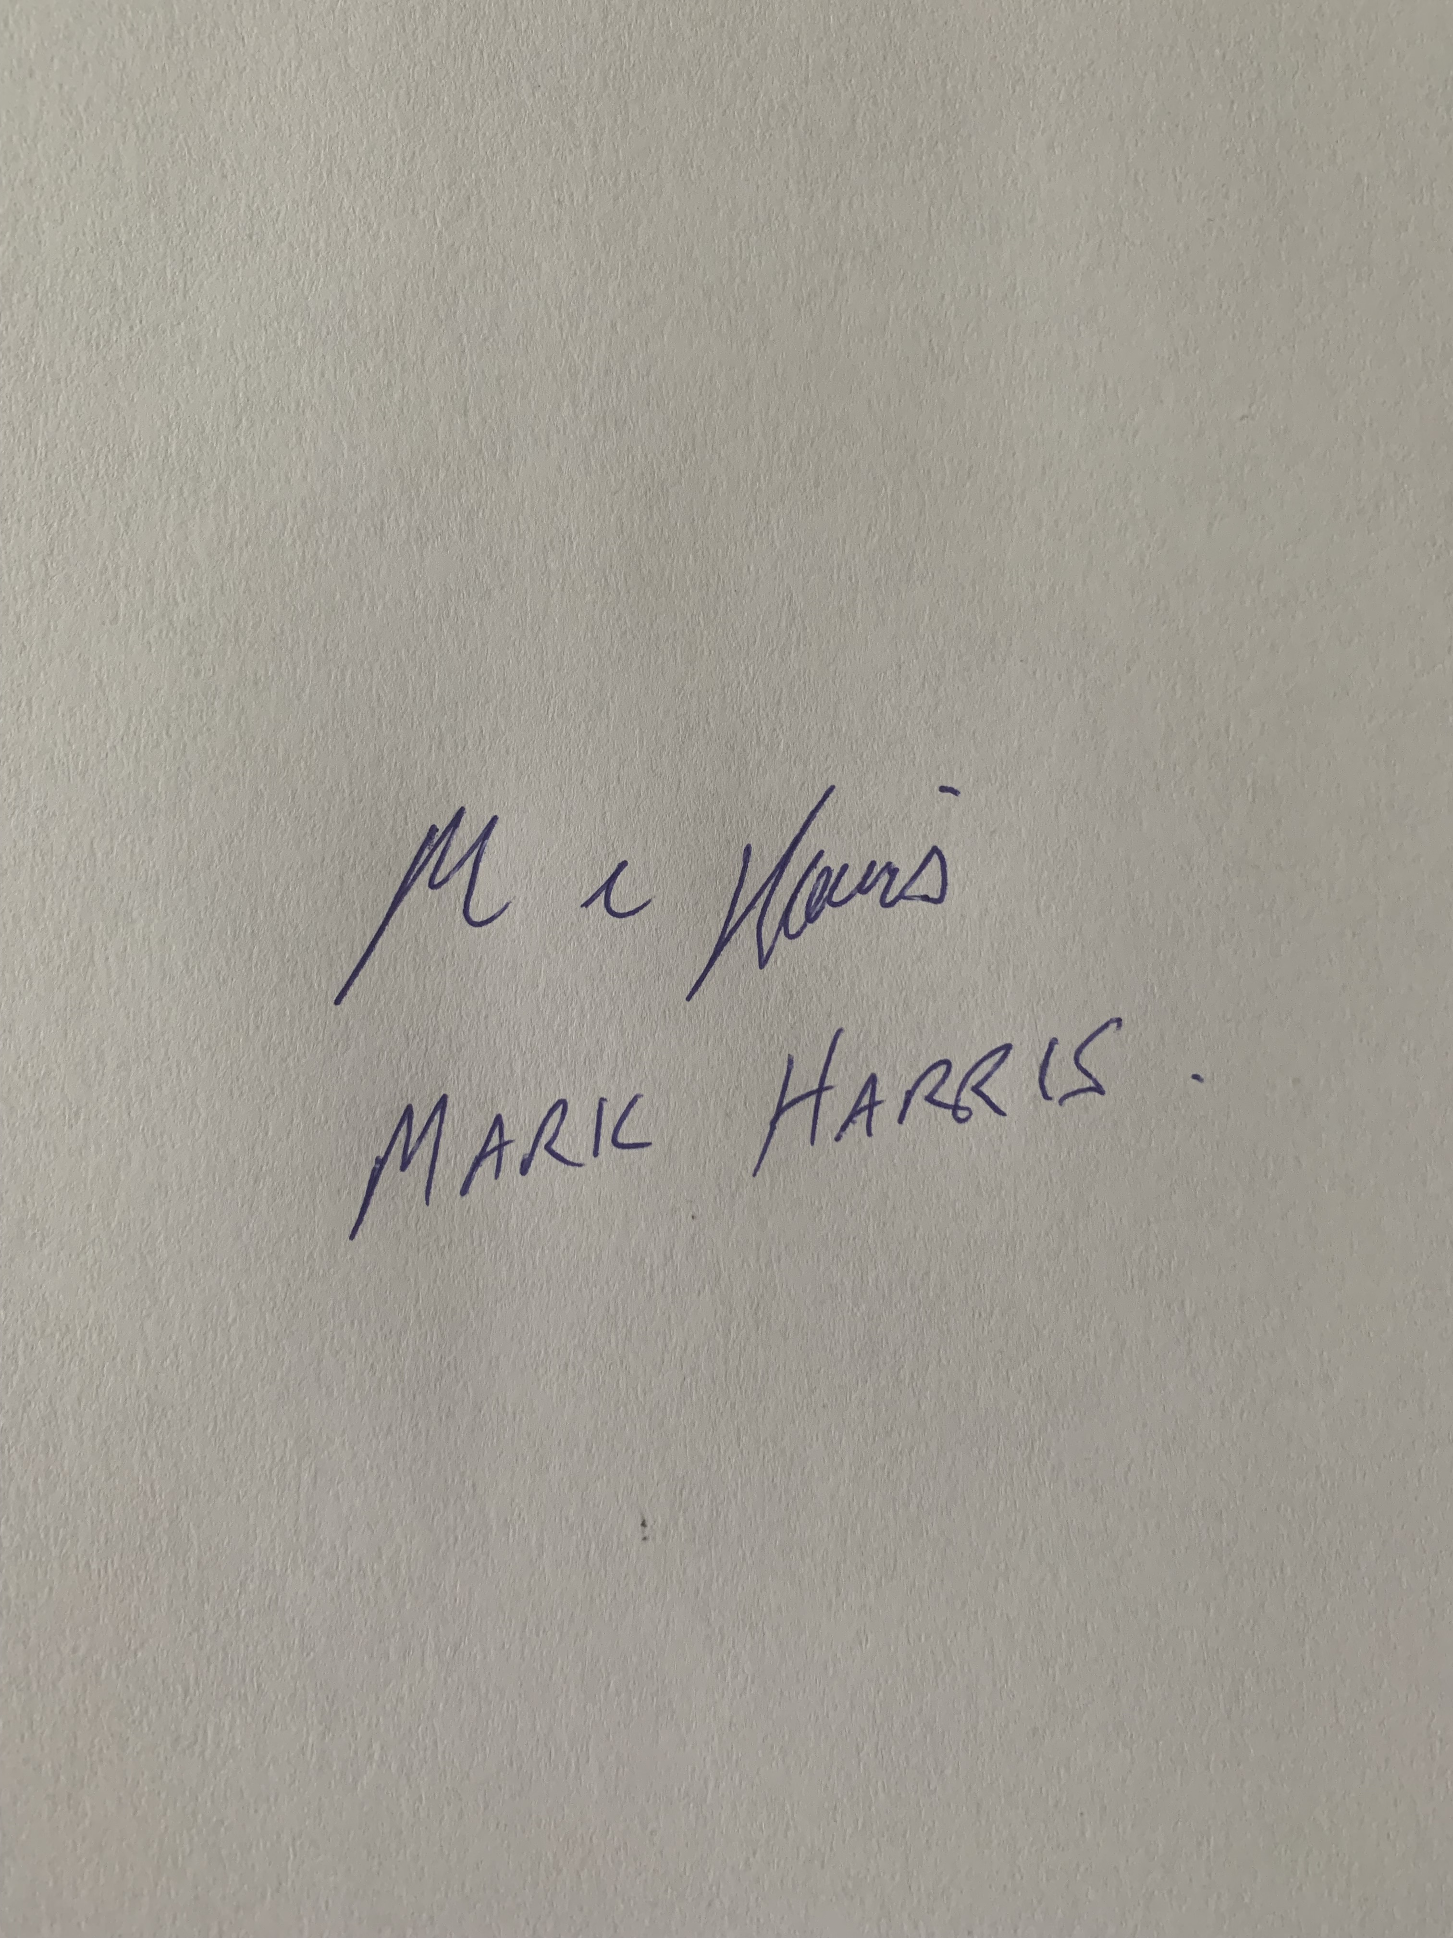
Date | 23/11/2021

Task | Task outcome (Tick)
Task | Satisfactory | Not Yet Satisfactory
Task 1 (Occasion 1)
Task 1 (Occasion 2)

Assessor Comments
BSBLDR403
Lead team effectiveness

Practical Task 1 (2X)
Description of task:
On two (2) occasions, a suitable observer is to verify the participant’s ability to lead team effectiveness, including:
- Developing a team work plan that provides –
  - Documentation of how it was generated and how it will be monitored
  - Incorporation of innovation and productivity measures
- Communicating with team members and management to –
  - Identify and establish the team purpose, roles, responsibilities, goals plans objectives
  - Consult, encourage, support and provide feedback
  - Model team leadership behaviours and approaches
  - Resolve problems

The participant is to gather evidence of how they have completed each component of the Practical Task, which is to be submitted with this Practical Assessment sheet. Evidence to be submitted may include:
- Meeting minutes (e.g. subcontractor meeting, HSE committee meeting)

The observer is to provide detailed comments on the tasks completed by the participant. The assessor is to verify the observer’s comments in the Assessor Comments section, and provide the Practical Assessment outcome on the front cover of this document.
Resources required:
Nil
Assessment of task
Name of participant: | Corey Passey
Name of observer: | Mark Harris
Role of observer  (Confirm suitability to sign) | Supervisor / team manager
Email address of observer | Mark.harris@stroudhomes.com.au
Signature of observer:
Date: | 23/11/2021
When completing the task, did the participant: |  | Tick if satisfactorily completed.  Provide comments if left unticked.
 |  | 1st  Occasion | 2nd  Occasion
- Lead and consult with the team to document work plan, incorporating:
- Team purpose, roles, responsibilities, goals, plans and objectives
- Innovation and productivity measures
- Notes on how the work plan was generated and how it would be monitored
- Lead team to develop cohesion, including:
- Providing opportunities for input of team members into planning, decision making and operational aspects
- Encouraging and supporting team members to take responsibility for own work and to assist each other
- Providing feedback to team members to encourage, value and reward individual and team efforts and contributions
- Participate in and facilitate work team, including:
- Leading and supporting team members in meeting expected outcomes, through delegation and work allocation
- Actively encouraging team members to participate in and take responsibility for team activities and communication processes
- Giving the team support to identify and resolve problems, issues and concerns
- Acting as a role model to enhance the organisation’s image
- Maintain open communication by passing information from management to the team and vice versa (including issues, concerns and problems) and ensuring follow-up action was taken.
The Participant’s performance was: Satisfactory Not Satisfactory

observer Comments
Corey was recently observed leading our quarterly team sales meeting via zoom. He had organised the time and zoom link and sent out the agenda items to all involved and then ran the meeting. 15th October
Each quarter we review our teams sales and slabs and set targets and goals and discuss next quarters goals and objectives.
Corey clearly has a strong background in leadership being the CEO for a building company for over 10 years and also running his own construction company in NZ for 10 years. When he speaks, people listen and he leads in a professional manner one would expect from someone with his experience. (See attached agenda he put together and ran the meeting)

On another occasion I observed Corey lead a smaller team, when we recently visited the Rockhampton team, Corey arranged the time to meet and the agenda and followed up with detailed minutes (See attached) This was a performance review meeting and he ran this very professionally.

I have no doubt Corey is a natural born leader and he has the skills to run his own construction company, I would like to work under his leadership and I have no hesitation to speak to anyone who wishes to speak to me about this observation.

Sincerely Mark Harris

