

STUDENT PACK
CPCCBC4017
Arrange resources and prepare for the building and construction project
Version Control
Unit code | Document version | Release date | Comments/actions
CPCCBC4017 | 10.1 | 27/04/2022 | First edition
CPCCBC4017 | 10.2 | 02/12/2022 | Minor amendments

Copyright
Copyright ©2021 by CAQA Resources.
Copyright protects this material. No part of this publication may be reproduced, distributed, or transmitted in any form or by any means, including photocopying, recording, or other electronic or mechanical methods, without the prior written permission of the publisher, except in the case of brief quotations embodied in critical reviews and certain other non-commercial uses permitted by Copyright Act 1968 (Cth). For permission requests, write to the publisher, addressed “Attention: Permissions Coordinator,” at the address below.
Enquiries should be addressed to:
CAQA Resources
2/10 Lawn Ct
Craigieburn, Victoria – 3064
Australia
www.caqaresources.com.au
Disclaimer
Although the author and publisher have made every effort to ensure that the information in this book was correct at press time, the author and publisher do not assume and hereby disclaim any liability to any party for any direct, indirect, incidental, or consequential loss, damage, or disruption caused by errors or omissions, whether such errors or omissions result from negligence, accident, or any other cause. Data and case study examples are intended to be fictional. Any resemblance to real persons or organisations is coincidental.
If you believe that information of any kind in this publication is an infringement of copyright, in material in which you either own copyright or are authorised to exercise the rights of a copyright owner, and then please advise us by contacting CAQA Resources, 2/10 Lawn Ct, Craigieburn, Victoria - 3064 or email copyright@careercalling.com.au.
Acknowledgement
This remains the property of CAQA Resources, a Career Calling initiative.

Student Pack

What is the purpose of this document?
The Student Pack is the document you, the student, needs to complete to demonstrate competency. This document includes the context and conditions of your assessment, the tasks to be completed by you and an outline of the evidence to be gathered.

The information includes the following:

- Information related to the unit of competency
- Guidelines and instructions to complete each task and activity

Link to other unit documents

- The Student Pack is a document for students to complete to demonstrate their competency. This document includes context and conditions of assessment, tasks to be administered to the student, and an outline of the evidence to be gathered from the student.
- The Unit Mapping is a document that contains information and comprehensive mapping with the training package requirements.

Student and trainer details
Student details
Full name: | Anya English
Student ID: | 13784668
Contact number: | 0478 944 719
Email address: | anya@cogentscaffolding.com.au
Trainer details
Full name:

Qualification and unit of competency
Qualification/Course/Program Details
Code: | CPCCBC4017
Name: | Anya English
Unit of competency
Code: | CPCCBC4017
Name: | Arrange resources and prepare for the building and construction project
Releases: | 1.0
Release date: | 27/Nov/2020

Assessment Submission Method
☐ By hand to trainer/assessor ☐ By email to trainer/assessor
☒ Online submission via Learning Management System (LMS)
☐ Any other method _________________________________________________
(Please describe here)

Student declaration
- I certify that the work submitted for this assessment pack is my own. I have clearly referenced any sources used in my submission. I understand that a false declaration is a form of malpractice;
- I have kept a copy of this Student Pack and all relevant notes, attachments, and reference material that I used in the production of this Student Pack;
- For the purposes of assessment, I give the trainer/assessor permission to:

  - Reproduce this assessment and provide a copy to another member of staff; and
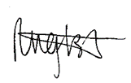
  - Take steps to authenticate the assessment, including communicating a copy of this assessment to a plagiarism checking service (which may retain a copy of the assessment on its database for future plagiarism checking).

Student signature: ________________________________

Date: 12/7/2023

Assessment Plan

The student must be assessed as satisfactory in each of the following assessment methods in order to demonstrate competence in a variety of ways.
Evidence number/ Task number | Assessment method/ Type of evidence/ Task name |  | Sufficient evidence recorded/Outcome
Assessment task 1 | Knowledge Test (KT) |  | S / NS (First Attempt)  S / NS (Second Attempt)
Assessment task 2 | Skill Test (ST) |  | S / NS (First Attempt)  S / NS (Second Attempt)
Outcome | C ☐ NYC ☐ | Date assessed: | Trainer signature:

Completion of the Assessment Plan

Your trainer is required to fill out the Assessment Plan Outcome records above, when:
- You have completed and submitted all the requirements for the assessment tasks for this cluster or unit of competency.
- Your work has been reviewed and assessed by your trainer/assessor.
- You have been assessed as either satisfactory or unsatisfactory for each assessment task within the unit of competency.
- You have been provided with relevant and detailed feedback.
Every assessment has a “Feedback to Student” section used to record the following information. Your trainer/assessor must also ensure that all sections are filled in appropriately, such as:
- Result of Assessment (satisfactory or unsatisfactory)
- Student name, signature and date
- Assessor name, signature and date
- Relevant and detailed feedback

Pre-Assessment Checklist: Task 1 - Knowledge Test
The purpose of this checklist
The pre-assessment checklist helps students determine if they are ready for assessment. The trainer/assessor must review the checklist with the student before the student attempts the assessment task. If any items of the checklist are incomplete or not clear to the student, the trainer/assessor must provide relevant information to the student to ensure they understand the requirements of the assessment task. The student must ensure they are ready for the assessment task before undertaking it.
Section 1: Information for Students
☐ Make sure you have completed the necessary prior learning before attempting this assessment.
☐ Make sure you understand what evidence is required to be collected and how.
☐ Make sure you know your rights and the Complaints and Appeal process.
☐ Make sure you discuss any special needs or reasonable adjustments to be considered during the assessment (refer to the Reasonable Adjustments Strategy Matrix - Appendix A and negotiate these with your trainer/assessor).
☐ Make sure that you have access to a computer and the internet (if you prefer to type the answers).
☐ Make sure that you have all the required resources needed to complete this assessment task.
☐ The due date of this assessment task is in accordance with your timetable.
☐ In exceptional (compelling and compassionate) circumstances, an extension to submit an assessment can be granted by the trainer/assessor. Evidence of the compelling and compassionate circumstances must be provided together with your request for an extension to submit your assessment work.
☐ The request for an extension to submit your assessment work must be made before the due date.
Section 2: Reasonable adjustments
I confirm that I have reviewed the Reasonable Adjustments guidelines and criteria as provided in Appendix A and attached relevant evidence as required and select the correct checkbox.
☐ I do require reasonable adjustment
☒ I do not require reasonable adjustment
Declaration (Student to complete)
☒ I confirm that the purpose and procedure of this assessment task has been clearly explained to me.
☒ I confirm that I have been consulted about any special needs I might have in relation to the assessment process.
☒ I confirm that the criteria used for this assessment has been discussed with me, as have the consequences and possible outcomes of this assessment.
☒ I confirm I have accessed and understand the assessment information as provided in the Student Handbook.
☒ I confirm I have been given fair notice of the date, time, venue and/or other arrangements for this assessment.
☒ I confirm that I am ready for assessment.

Student Name: _Anya English ____________________

Student Signature: ___________________________________

Assessment method-based instructions and guidelines: Knowledge Test
Assessment type

- Written Questions

Instructions provided to the student:

Assessment task description:

- This is the first assessment task you must successfully complete to be deemed competent in this unit of competency.
- The Knowledge Test is comprised of five (5) written questions
- You must respond to all questions and submit them to your Trainer/Assessor.
- You must answer all questions to the required level, e.g. provide an answer within the required word limit, to be deemed satisfactory in this task
Applicable conditions:

- All knowledge tests are untimed and are conducted as open book assessment (this means you can refer to your textbook during the test).
- You must read and respond to all questions.
- You may handwrite/use a computer to answer the questions.
- You must complete the task independently.
- No marks or grades are allocated for this assessment task. The outcome of the task will be Satisfactory or Not Satisfactory.
- As you complete this assessment task, you are predominately demonstrating your written skills and knowledge to your trainer/assessor.
Resubmissions and reattempts:

- Where a student’s answers are deemed not satisfactory after the first attempt, a resubmission attempt will be allowed.
- The student may speak to their trainer/assessor if they have any difficulty in completing this task and require reasonable adjustments.
- For more information, please refer to the Student Handbook.
Location:

- This assessment task may be completed in:

☐ a classroom
☐ learning management system (i.e. Moodle),
☐ workplace,
☐ or an independent learning environment.
Instructions for answering the written questions:

- Complete a written assessment consisting of a series of questions.
- You will be required to answer all the questions correctly.
- Do not start answering questions without understanding what is required. Read the questions carefully and critically analyse them for a few seconds; this will help you to identify what information is needed in the answer.
- Your answers must demonstrate an understanding and application of the relevant concepts and critical thinking.
- Be concise, to the point and write answers within the word-limit given to each question. Do not provide irrelevant information. Remember, quantity is not quality.
- You must write your responses in your own words.
- Use non-discriminatory language. The language used should not devalue, demean, or exclude individuals or groups based on attributes such as gender, disability, culture, race, religion, sexual preference or age. Gender-inclusive language should be used.
- When you quote, paraphrase, summarise or copy information from other sources to write your answers or research your work, always acknowledge the source.
Purpose of the assessment

This assessment task is designed to evaluate student’s knowledge essential to arrange resources and prepare for the building and construction project in a range of contexts and industry settings and knowledge regarding the following:
- Knowledge of the external service authorities, including:
- electricity authorities
- environmental protection agencies
- local government agencies
- road traffic authorities
- water authorities
- electronic communications
- Knowledge of the relevant government building and construction regulations, codes and standards
- Knowledge of the local council requirements:
- consent matters
- heritage protection
- tree conservation
- environmental requirements
- Knowledge of the organisational quality documentation:
- resource procurement processes
- policies and procedures
- knowledge of the workplace safety requirements
- knowledge of the relevant employee and contractor industrial relations and licensing requirements.
Task instructions
- This is an individual assessment.
- To ensure your responses are satisfactory, consult a range of learning resources and other information such as handouts, textbooks, learner resources etc.
- To be assessed as Satisfactory in this assessment task, all questions must be answered correctly.

Assessment Task 1: Knowledge Test
Provide your response to each question in the box below.

Q1: | Discuss the roles and responsibilities of following external service authorities:  - electricity authorities  - environmental protection agencies  - local government agencies  - road traffic authorities  - water authorities  - electronic communications  Write your answers in 100-200 words each. | Satisfactory response
Q1: |  | Yes  | No ☐
a) Electricity authorities roles and reposnibilities in construction and demolition sites include requirements that are addressed in AS/NZS 3012:2010 Electrical installations – construction and demolition sites and Central Electricity Authority Regulations 2010. It is the Electricity authorities role and responsibility to adhere to these codes. This sets out the minimum requirements for the design, construction and testing of all electrical supply and installations. It is also the electrical authority to ensure that the electrical work that needs notification, has been approved by the local authority’s building control body or if the electrical installation is not connected to a an operated electrical network, a notice must be sent to Building and Energy. .

b) Environmental protection officials roles and responsibilities include ensuring that the Main Contractor in the building and construction project has a Construction Environmental Management Plan The Environmental protection officials ensure they adhere to the following; a description of the receiving environment and site location including sensitive receiver locations, a description of the project’s construction work including timeframes and construction hours, they have identified and analyised potential environmental consequences such as envoironmental hazards and risk, proposed mitigation measures and any residual risk and has identified and described the management measures that will be put in place to mitigate linked source receptor exposure pathways.

c) Local government is responsible for the Development Approvals, Material Change of Use and Envicronmentally Relevant Activitie. One Environmentally Relevant Activities include the heritage management that is set out in two acts which are the Heritage Act of 1977 and the Environmental Protection Act of 1990 and the 1979 Planning and Assessment Act (EP&A) and they work together to create a legislative framework. They also are responsible for town and land planning, building approvals, provision of local roads, water sewerages services and animal control services. Thgeir responsibilities and roles fall under the following legislation; Local Government Act 2099 (LGA), the Local Government Regulation 2012 (LGR).

d) The road traffic authorities are responsible for giving permission to contractors and subcontractors to work within the road reserve. These permissions / approvals need to be clearly and appropriately stated on their Traffic Management Plan which must include a mandatory condition requiring traffic management to be carried out following the requirements of this Code, which is subjected to be agreed upon variations. The Road Authorities must also consult with other important agencies, such as emergency services, the local police, public transportation and the road reserve when giving permission or approval to a person for the works within the road reserve.

e) Water authorities have the role and responsibility of ensuring that the contractor has permits and approvals, as well as issuing them out, for any development that impacts water access or quality. The Environmental Protection Act 1994 and the Integrated Planning Act 1997 outlines the approvals that must be obtained, specifically the ERAs and Development Approvals. The water authorities also have the responsibility of water servicing for different types of water supply connection. For example, water service is required for less than two years for vegetation i.e. a roundable or construction camp or less than one calendar month for a circus or festival.

f) Electronic communications authorities must ensure that each jurisdiction in Australia has enacted uniform electronic transactions legislation based on UNCITRAL’s Model Law on Electronic Commerce 1996. This addresses some fo the legal uncertainties that have arisen that is due to increased use of electronic communications conduct transactions. They maintain the Queensland legislation Electronic Transactions (Queensland) Act 2001 (ETQA) which when determining the legal risks associated with electronic contracting, it is good to consider the ETQA as well general law contractual principles. According to the judicial trends, fundamental principles of contract law will apply to all contracts whether formed electronically, orally, or through paper-based communications.

Q2: | Answer the following questions regarding relevant government building and construction regulations, codes and standards.  2.1. Identify and briefly describe the relevant government building and construction regulations relevant to on-site facilities and services. Write your answer in 200-300 words.  2.2. Discuss the relevant Workplace Health and Safety codes with regards to Council requirements for temporary site set-up. Write your answer in 100-150 words.  2.3 Identify two (2) standards that you need to reference when checking received materials | Satisfactory response
Q2: |  | Yes | No ☐
2.1. When arranging, receiving and positioning site offices, storage sheds and on-site toilets and facilities you must consider all relevant government building and construction regulations that relate to these on site facilities and services. When determining site offices, you must ensure that the office is comfortable, attractive and versatile, and robust and secure. As stated in the Construction work Code of Practice that ‘a construction sute must have adequate working space and be designed to be suitable for any person working or likely to work there, taking into account any mecessary work equipment likey to be used there to the greatest extend reasonably practicable.’ The temporary facilities must be well planned by ensurng that they result in increased productivity and are safe, they reduce areas required for temporary construction and maximise utilisation. You should consider the fire prevention, fire extinguisers are required on any construction site, medical services, first aid kits are required on ever construction site and a well equipped medical room with a doctor or first aider on some sites. Signage of site map, traffic regulations, labour related policy and safety rules and emergency routes and underground servies must be put up through out the construction site and must have safe entrance, lighting, fencing and have documentation of all site visits from all personel.

2.2. The Workplace Health and Safety requirements and Councils have made it a requirement when obtaining a building contract for certain temporary services to be installed and supplied at the beginning of construction. This includes temporary electrical pole or power box that is in its permanent position, chemical toilet, waste bin, temporary fencing around the site, which the public does not have access to, water tapping to supply water to site, bvarriers across the front of the site to stop water and soil running into the public footpath, tiger strips if work is to take place close to overhead power lines, barricade to meet local municipals by-laws.

2.3. The order must be attached to a PO. Quality of received material is exactly what is expected.

Q3: | Answer the following questions regarding local council requirements:  - Discuss the following local council requirements on the following matters:  - consent matters  - heritage protection  - tree conservation  - environmental requirements  Write your answer in 100-200 words for each part. | Satisfactory response
Q3: |  | Yes | No ☐
a) A report and consent, as stated in the Building Act and Regulations, is the process of consulting with and obtaining approval from a reporting authority when building work may affect community assets, infrastructure or amenity. This reporting authority would be the local council, mean their requirement would be to approve the building work if it may affect the community in any way. To add to this, local council also has the responsibility and requirement to approve or reject certain designs that affects the public infrastructures and amenity, they have the authority to consent or reject on the building report. .

b) The local council or government requirements for the protection and management of heritage buildings is set out in two acts, which are the Heritage Act of 1977 and the Environmental Protection Act of 1990, and they work together to create the legislative framework. To add to these acts, the 1979 Planning and Assessment Act (EP&A) also mentions throughout the act about how heritage buildings are to be protected by promoting sustainable management of built and cultural heritage which includes Aboriginal cultural heritage. The local government or council must make decisions on the care and protection of heritage places and buildings.

c) It is the local councils responsibility to ensure that the trees are protected during the construction and building process of a project. As stated in the South Australia’s Development Act, there is two different typews of trees that are in Adelaide metro area and the Adelaide Hills which are ‘regulated ‘ and ‘significant’. These are defined as, regulated – 2+ metre trunk circumference ar one metre above ground level and signicant – 3+ metre trunk circumference at one metre above ground. When constructing and building set up a fence around each remaining tree to provide protection from below and above ground.

d) Local government and / or council reposnsiblities and requirements involve Environmentally Relevant Activities which can be identified in schedule 2 of the Environmental Protection Regulation 2019. They must ensure that a CEMP is followed by ensuring that it covers the description of the receiving environment and site location that includes the sensitive receiver location, a description of the project’s construction work which includes the timeframes and construction hours, identifying and analysing potential environmental consequences which includes environmental hazards and risks, proposed mitigation measures and any residual risks and identifying and describing the management measures that will be put in place to mitigate lined source receptor exposure pathways.

Q4: | Answer the following questions regarding organisational quality documentation:  4.1. Discuss what should be contained within the organisational resource procurement processes. Write your answer in 100-200 words.  4.2 Name one (1) policy and one (1) procedure that should exist in relation to preparing for building construction processes. | Satisfactory response
Q4: |  | Yes | No ☐
4.1. In a organisational resource procurement processes should include how work is to be done in an organisation, and they increase the transparency, accountability, uniformity and stability of works when they are clear and well written. They should include key business processes and standard operating procedures (SOPs), and include critical procedures like first aid and emergency exits. They should also include how to place an order create material lists, material and planning costs which includes budgeting that helps the buisness kkeep track of information like material costs, inventory management to ensure no waste, delivery procedures and any policies that must be adhered by.

4.2. One Policy is excellent customer service and staff attire and one procedure is first aid and emergency exits, visible.
Q5: | 5.1 What industrial relations requirements need to be considered when organising on-site human resources? Write your answer in 100-200 words.  5.2 What licencing may need to be held by workers on a construction site? Write your answer in 100-200 words. | Satisfactory response
Q5: |  | Yes | No ☐
5.1. When organising on-site human resources, the following industrial relations requirements should be considered; if the employees have a general construction induction training card, also known as a white card, if the work that is being undertaken needs a high risk work licence, this includes scaffolding, dogging or forklift operation, to know what skills and knowledge the employees have and if there are any skill gaps that need to be filled before construction work begins. A job evaluation should be done to break down the job into its parts, to help understand what tasks, duties and responsibilities are to come with the job.

5.2. There are many licences that must be held by employees when they are on a construction site doing certain works. One example is a general construction induction training card, also known as a white card. This course is with the Registered Training Organisation under the unit CPCCWHS1001 Prepare to work safely in the construction industry that covers the basic knowledge of work health and safety laws, common site hazards and how to control the associated risks. This must be obtained to enter a construction site and to complete basic construction tasks on a site. Another example is the high risk work licence that is required if undertaking any of the following tasks: scaffolding work, dogging and rigging work, crane and hoist operation, reach stackets, fork operation and pressure equipment operation.

Assessment Results Sheet
Outcome | Outcome (make sure to tick the correct checkbox):  Satisfactory (S) ☐ or Not Satisfactory (NS) ☐  Date: _______(day)/ _______(month)/ _______(year)  Feedback:  Outcome (please make sure to tick the correct checkbox):  Satisfactory (S) ☐ or Not Satisfactory (NS) ☐  Date: _______(day)/ _______(month)/ _______(year)  Feedback:
  First attempt:
  Second attempt:
Student Declaration | - I declare that the answers I have provided are my own work. Where I have accessed information from other sources, I have provided references and/or links to my sources.  - I have kept a copy of all relevant notes and reference material that I used as part of my submission.  - I have provided references for all sources where the information is not my own. I understand the consequences of falsifying documentation and plagiarism. I understand how the assessment is structured. I accept that the work I submit may be subject to verification to establish that it is my own.  - I understand that if I disagree with the assessment outcome, I can appeal the assessment process, and either re-submit additional evidence undertake gap training and or have my submission re-assessed.  - All appeal options have been explained to me.
Student Signature
Date | 17/7/23
Trainer/Assessor Name | Michelle Gomersall
Trainer/Assessor Declaration | I hold:  ☐ Vocational competencies at least to the level being delivered  ☐ Current relevant industry skills  ☐ Current knowledge and skills in VET, and undertake  ☐ Ongoing professional development in VET  I declare that I have conducted an assessment of this student’s submission. The assessment tasks were deemed current, sufficient, valid and reliable. I declare that I have conducted a fair, valid, reliable, and flexible assessment. I have provided feedback to the student.  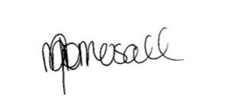
Trainer/Assessor Signature
Date | 11/8/23
Office Use Only | The outcome of this assessment has been entered into the Student Management System  on _________________ (insert date)  by (insert Name) __________________________________

Pre-Assessment Checklist: Task 2 – Skill Test
The purpose of this checklist
The pre-assessment checklist helps students determine if they are ready for assessment. The trainer/assessor must review the checklist with the student before the student attempts the assessment task. If any items of the checklist are incomplete or not clear to the student, the trainer/assessor must provide relevant information to the student to ensure they understand the requirements of the assessment task. The student must ensure they are ready for the assessment task before undertaking it.
Section 1: Information for Students
☐ Make sure you have completed the necessary prior learning before attempting this assessment.
☐ Make sure you understand what evidence is required to be collected and how.
☐ Make sure you know your rights and the Complaints and Appeal process.
☐ Make sure you discuss any special needs or reasonable adjustments to be considered during the assessment (refer to the Reasonable Adjustments Strategy Matrix and negotiate these with your trainer/assessor).
☐ Make sure that you have access to a computer and the internet (if you prefer to type the answers).
☐ Make sure that you have all the required resources needed to complete this Assessment Task (AT).
☐ The due date of this assessment task is in accordance with your timetable.
☐ In exceptional (compelling and compassionate) circumstances, an extension to submit an assessment can be granted by the trainer/assessor. Evidence of the compelling and compassionate circumstances must be provided together with your request for an extension to submit your assessment work.
☐ The request for an extension to submit your assessment work must be made before the due date.
Section 2: Reasonable adjustments
I confirm that I have reviewed the Reasonable Adjustments guidelines and criteria as provided in Appendix A and attached relevant evidence as required and select the correct checkbox.
☐ I do require reasonable adjustment
☒ I do not require reasonable adjustment
Declaration (Student to complete)
☒ I confirm that the purpose and procedures of this assessment task has been clearly explained to me.
☒ I confirm that I have been consulted about any special needs I might have in relation to the assessment process.
☒ I confirm that the criteria used for this assessment has been discussed with me, as have the consequences and possible outcomes of this assessment.
☒ I confirm I have accessed and understand the assessment information as provided in the Student Handbook.
☒ I confirm I have been given fair notice of the date, time, venue and/or other arrangements for this assessment.
☒ I confirm that I am ready for assessment.

Student Name: __Anya English

Student Signature: ___________________________________

Assessment method-based instructions and guidelines: Skill Test
Assessment type

- Skill Test - Arrange resources and prepare for the building and construction project
Instructions provided to the student:

Assessment task description:

- This is the second assessment task you must successfully complete to be deemed competent in this unit of competency.
- This assessment task is a Skills Test.
- This assessment task consists of six (6) practical demonstration activities.
  - Activity 1: Complete preliminary construction requirements.
  - Activity 2: Organise on-site services and facilities.
  - Activity 3: Arrange public protection.
  - Activity 4: Organise on-site delivery.
  - Activity 5: Organise on-site human resources
- You must attempt all activities of the project for your trainer/assessor to assess your competence in this assessment task.
Applicable conditions:

- This skill test is untimed and is conducted as an open book assessment (this means you are able to refer to your textbook or other learner materials during the test).
- You will be assessed independently on this assessment task.
- No marks or grades are allocated for this assessment task. The outcome of the task will be Satisfactory or Not Satisfactory.
- As you complete this assessment task, you are predominately demonstrating your skills, techniques and knowledge to your trainer/assessor.
- Your trainer/assessor may ask you relevant questions during this assessment task
Resubmissions and reattempts:

- Where a student’s answers are deemed not satisfactory after the first attempt, a resubmission attempt will be allowed.
- The student may speak to their trainer/assessor if they have any difficulty in completing this task and require reasonable adjustments.
- For more information, please refer to the Student Handbook.
Location:

- This assessment task may be completed in:

☐ a classroom
☐ learning management system (i.e. Moodle),
☐ workplace,
☐ or an independent learning environment.
Purpose of the assessment

The purpose of this assessment task is to assess the student’s knowledge and skills essential to arrange resources and prepare for the building and construction project in a range of contexts and industry settings.
- Skills to complete preliminary construction requirements.
- Skills to organise on-site services and facilities.
- Skills to arrange public protection.
- Skills to organise on-site delivery.
- Skills to organise on-site human resources
- Skills to questioning record.
Task instructions
- This is an individual assessment.
- The purpose of this assessment task is to identify and procure the necessary on-site physical and human resources and systematically apply the supply process for a building and construction project.
- The student must asess the NCC codes for relevant class of the building to perform the activities specified in the assessment task.
- The student must supervise the various aspects of the construction.
- The trainer/assessor must assess the performance as per the performance criteria and checklist provided.

Assessment Task 2: Skills Test
This assessment task requires the student to arrange resources and prepare for the building and construction project. This includes:
- procuring sufficient on-site facilities and materials to support the project requirements
- scheduling temporary services and human resources
- sequencing delivery of materials and equipment and allocation of human resources
- recording and maintaining information from local council, external authorities, employees and contractors
During the completion of this assessment task, you will be required to coordinate with and gather the input of a range of local council, external authorities, employees and contractors.
The building or construction project will be one of the following National Construction Code (NCC) classifications:
- Residential - Class 1 and 10 buildings, maximum two storeys
- Commercial - Class 2 to 9, Type C only constructions.
Note: The above specifications for the building are compulsory to meet the requirements of the National Construction Code (NCC).
To arrange resources and prepare for the building and construction project, you are required to complete the following activities:
- Activity 1: Complete preliminary construction requirements.
- Activity 2: Organise on-site services and facilities.
- Activity 3: Arrange public protection.
- Activity 4: Organise on-site delivery.
- Activity 5: Organise on-site human resources
Instructions for trainer/assessor:
- The workplace must be:
  - An actual workplace
  - A close simulation of the workplace environment provided that simulated or project-based assessment techniques replicate construction workplace conditions, materials, activities, responsibilities and procedures
Note: The requirements for a simulated workplace environment are given below.
- The role of the Supervisor (trainer/assessor) is to allocate the tasks, activities and responsibilities that you will be required to undertake to complete these assessments.
- The worksite must meet the requirements given in the ‘Simulated workplace environment requirements’ section given below.
- The trainer/assessor must ensure that if the assessment task is to be conducted in a simulated environment, it must replicate workplace conditions, materials and equipment, interactions with others and workplace irregularities and meets industry standards for safety and environmental practices.
Instructions for the student:
- The student will be required to bring all necessary PPEs required to complete this activity.
- The student must follow the instructions provided by the Supervisor.
- The student must complete the activities specified.

Simulated workplace environment requirements
The student must have access to a workplace or a close simulation of the workplace environment to replicate construction workplace conditions and standards, materials, activities, responsibilities, procedures, safety requirements and environmental considerations to each student.
The training organisation will take you to the location of the construction worksite.
Further, the training organisation must ensure the construction site must meet the requirements given below.
The commercial or residential project must meet any of the following National Construction Code (NCC) classifications:
- Residential - Class 1 and 10 buildings, maximum two storeys
- Commercial - Class 2 to 9, Type C only constructions.
The training organisation must ensure that the student has access to the following:
- WHS legislation and regulations
  - Model WHS Act (Provide along with this assessment task)
  - Model WHS Regulations (Provide along with this assessment task)
- Government building and industrial relations legislation
  - https://www.abcc.gov.au/about/what-we-do/overview/legislation
- Current building and construction codes and standards
  - https://www.abcb.gov.au/
  - https://ncc.abcb.gov.au/editions/2019-a1/ncc-2019-volume-one-amendment-1/contents-and-introduction/introduction-ncc-volume
  - https://ncc.abcb.gov.au/editions/2019-a1/ncc-2019-volume-two-amendment-1/contents-and-introduction/copyright-and-licence
  - https://ncc.abcb.gov.au/editions/2019-a1/ncc-2019-volume-three-amendment-1/contents-and-introduction/introduction-ncc
- NCC Volume 1 – Volume 3 (Provided along with this assessment)
- Organisational quality policies and procedures
- Workplace safety requirements
- Project plans and specifications
- Business equipment and technology to facilitate arranging resources and preparing for a construction project.
The worksite must have realistic tasks or simulated tasks, relevant specifications and work instructions, standard work practices, safety requirements and environmental constraints.
The site and its surroundings are accessible and clear of hazards, so far as reasonably practicable.
The site must have realistic workplace conditions, standards, materials, activities, responsibilities, procedures, safety requirements, and environmental considerations.
An experienced employee is available to provide adequate guidance and supervision to less experienced employees.
The students have the clothing and footwear required. In addition, the clothing and footwear are in good condition and suitable for the task.
Workplace Scenario
You are working as a site manager in a construction company. Your organisation has received a project to construct a building.
As a senior manager, you must identify and procure the necessary on-site physical and human resources and systematically apply the supply process for a building and construction project. This includes:
- Notifying external agencies, employees and contractors and coordinating activities to meet scheduled timeframes
- Completing preliminary construction requirements.
- Organising on-site services and facilities.
- Arranging public protection.
- Organising on-site delivery.
- Organising on- site human resources.
Task requirements:
For the building and construction project, you are required to:
- Procure sufficient o- site facilities and materials to support the project requirements
- Schedule temporary services and human resources
- Sequence delivery of materials and equipment and allocation of human resources
- Record and maintain information from local council, external authorities, employees and contractors.
You will be required to demonstrate your skills and knowledge in the following areas:
- Find, read, and interpret project documentation.
- Set a site handover date with the client once the appropriate fees have been confirmed paid with the appropriate people.
- Establish insurance and security requirements and provide them.
- Notify authorities of the start of scheduled work.
- Determine and notify those who need to know about work, parking, and other restrictions.
- Determine the needs for on-site facilities and services.
- Set up, receive, and position the site office, storage sheds, and on-site restrooms and facilities.
- Identify and create processes to protect or make use of existing services on the site.
- Make arrangements with service providers for temporary power and water connections.
- Determine and meet the requirements of the council for temporary site setup.
- For site setup, adhere to work health and safety (WHS) regulations as well as local authority approvals.
- Install legal hoardings, fencing, and signage.
- To meet local authority requirements, arrange for temporary site access and egress.
- Organise waste disposal and disposal facilities.
- Confirm and order materials in order to meet delivery deadlines.
- Examine the availability of physical resources and, if necessary, schedule delivery.
- Materials, plant, and equipment must be received, secured, and protected.
- Address any issues concerning industrial relations and on-site safety that may have an impact on the preparation and human resourcing for building work.
- Determine and allocate on-site human resource needs.
- Engage or appoint a construction project manager.
- Engage the appropriate employees or contractors for the project's requirements.
Roles and responsibilities (Supervisor):
The Supervisor must:
- Ensure that the student is clear about the task requirements.
- Supervise the student performing the task.
- Observe them against the observation checklist provided after each activity.

Task:

This assessment task requires the student to arrange resources and prepare for the building and construction project. This includes:
- procuring sufficient on-site facilities and materials to support the project requirements
- scheduling temporary services and human resources
- sequencing delivery of materials and equipment and allocation of human resources
- recording and maintaining information from local council, external authorities, employees and contractors
During the completion of this assessment task, you will be required to coordinate with and gather the input of a range of local council, external authorities, employees and contractors.
The building or construction project will be one of the following National Construction Code (NCC) classifications:
- Residential - Class 1 and 10 buildings, maximum two storeys
- Commercial - Class 2 to 9, Type C only constructions.
Note: The above specifications for the building are compulsory to meet the requirements of the National Construction Code (NCC).
To arrange resources and prepare for the building and construction project, you are required to complete the following activities:
- Activity 1: Complete preliminary construction requirements.
- Activity 2: Organise on-site services and facilities.
- Activity 3: Arrange public protection.
- Activity 4: Organise on-site delivery.
- Activity 5: Organise on-site human resources
- Activity 6: Questioning record

Activity 1: Complete preliminary construction requirements
This activity requires you to complete preliminary construction requirements.
To complete this activity, you are required to:
- Complete the steps given in the ‘Checklist 1’ provided.
- Access and interpret NCC codes and relevant Australian Standards referenced in the NCC.
- Complete Template 1.
While completing each step, you must place a tick mark against each step given in the checklist once completed.
Instructions for trainer/assessor:
- The student should have access to the following documents:
  - WHS legislation and regulations
    - Model WHS Act (Provide along with this assessment task)
    - Model WHS Regulations (Provide along with this assessment task)
  - Government building and industrial relations legislation
    - https://www.abcc.gov.au/about/what-we-do/overview/legislation
  - Current building and construction codes and standards
    - https://www.abcb.gov.au/
    - https://ncc.abcb.gov.au/editions/2019-a1/ncc-2019-volume-one-amendment-1/contents-and-introduction/introduction-ncc-volume
    - https://ncc.abcb.gov.au/editions/2019-a1/ncc-2019-volume-two-amendment-1/contents-and-introduction/copyright-and-licence
    - https://ncc.abcb.gov.au/editions/2019-a1/ncc-2019-volume-three-amendment-1/contents-and-introduction/introduction-ncc
  - NCC Volume 1 – Volume 3 (Provided along with this assessment)
  - Organisational quality policies and procedures
  - Workplace safety requirements
  - Project plans and specifications
  - Business equipment and technology to facilitate arranging resources and preparing for a construction project.
Instructions for the student:
- The student must:
  - Source, read and interpret relevant project documentation.
  - Set a site handover date with the client once the appropriate fees have been confirmed paid with the appropriate people.
  - Establish insurance and security requirements.
  - Notify the relevant authorities of the start of scheduled work.
  - Determine and notify those who need to know about work, parking, and other restrictions.
After completing this task, submit the following to your assessor:
- A completed Checklist and Template 1,
- A completed Performance Criteria/Checklist – Activity 1
- Copies of any emails/screenshots used to setup a site handover date with the client and notifying the relevant authorities of the start of scheduled work.
- Email the established insurance and security requirements to the relevant stakeholders (this can be simulated with your supervisor).
- Email confirmation to the candidate’s supervisor outlining/confirming how they have notified the relevant authorities.
- Copies of the construction project documents you sourced in completion of this activity.

Checklist 1: Complete preliminary construction requirements.
Steps | Tick mark, once completed
Step 1: Source, read and interpret relevant project documentation.  - Source and read the relevant project documentation:  - Interpret project documentation to the relevant project stakeholders.  - Submit the project documents to the trainer/assessor. | 
Step 2: Set a site handover date with the client once the appropriate fees have been confirmed paid with the appropriate people.
- Confirm with internal stakeholders when fees must be paid
- Set a site handover date with the client.
- Email evidence of the site handover date to client (this can be simulated with your supervisor).
Step 3: Establish insurance and security requirements.
- Check that the insurance and security requirements are met for the building project.
- Email the established insurance and security requirements to the relevant stakeholders (this can be simulated with your supervisor). Candidate is required to supply the relevant insurance and security documentation to the trainer/assessor.
Step 4: Notify the following authorities of the start of scheduled work.  - electricity authorities  - environmental protection agencies  - local government agencies  - road traffic authorities  - water authorities.  - Email confirmation to the candidate’s supervisor outlining/confirming how they have notified the relevant authorities  Note: Where possible, submit the formal notifications or screenshots (some of these may need to be simulated) to the trainer/assessor. | 
Step 5: Determine and notify those who need to know about work, parking, and other restrictions using Template 1.
- Analyse the work, parking, and other restrictions.
- Document the work, parking, and other restrictions using Template 1.
Note: Evidence of notification needs to be supplied to the trainer/assessor (e.g signage, email etc.)

Template 1: Preliminary construction requirements.
Preliminary construction requirements (200-300 words)
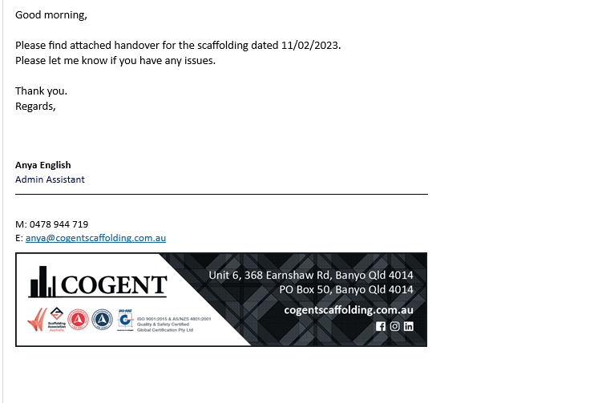
Insert email evidence of the site handover date to client here…
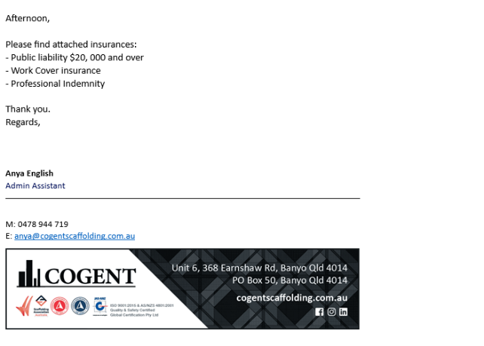
Insert email the established insurance and security requirements to the relevant stakeholders (this can be simulated with your supervisor). Candidate is required to supply the relevant insurance and security documentation to the trainer/assessor here…

Insert email confirmation to the candidate’s supervisor outlining/confirming how they have notified the relevant authorities. Evidence of notification needs to be supplied to the trainer/assessor (e.g signage, email etc.) here…
Work, parking, and other restrictions | Work:  - Site Start time is 6.30am in the morning.  - Any overtime needs to be submitted and approved  Parking:  - Paid parking at grocery store across the street  - Mirvac parking, certain access only, limited amount  - Paid parking under apartments – 5min walk to site  Other Restrictions  - In basement there is limited internet and data access and not very good connection.  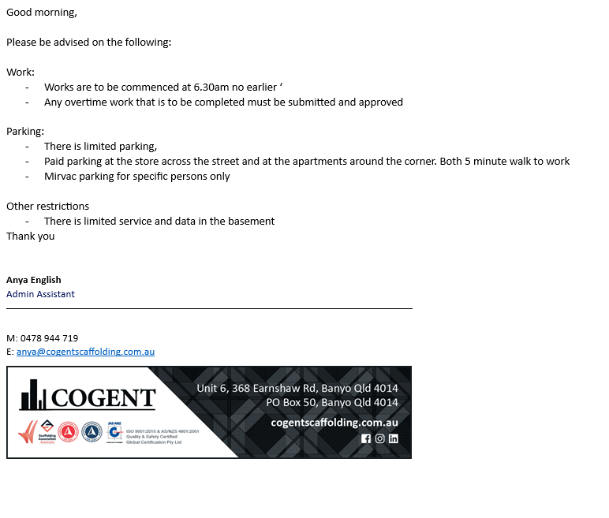
Sign off:
Date:17/7/23

Performance Criteria/Performance Checklist: Activity 1
This task must address the following performance criteria/ performance checklist.
To be assessed as satisfactory (S) in this assessment task, the participant needs to demonstrate competency in the following critical aspects of evidence | S | N/S | Trainer/Assessor to complete  (Comment and feedback to students)
Sourced, read and interpreted relevant project documentation.  - Sourced and read the following project documentation:  - Interpreted project documentation to the relevant project stakeholders.  - Submitted the project documents to the trainer/assessor. | 
Set a site handover date with the client once the appropriate fees have been confirmed paid with the appropriate people.
- Confirmed with internal stakeholders whether appropriate fees have been confirmed paid.
- Set a site handover date with the client.
- Email evidence of the site handover date to client (this can be simulated with your supervisor).
Established insurance and security requirements.
- Check that the insurance and security requirements are met for the building project.
- Email the established insurance and security requirements to the relevant stakeholders (this can be simulated with your supervisor). Candidate is required to supply the relevant insurance and security documentation to the trainer/assessor.
Notified the following authorities of the start of scheduled work.
- electricity authorities
- environmental protection agencies
- local government agencies
- road traffic authorities
- water authorities.
Email confirmation to the candidate’s supervisor outlining/confirming how they have notified the relevant authorities
Note: Where possible, submit the formal notifications or screenshots (some of these may need to be simulated) to the trainer/assessor.
Determined and notified those who need to know about work, parking, and other restrictions.
- Analysed the work, parking, and other restrictions.
- Documented the work, parking, and other restrictions.
Note: Evidence of notification needs to be supplied to the trainer/assessor (e.g signage, email etc.)
The student’s performance was: | - Not satisfactory  - Satisfactory
Feedback to student:

Student signature
Trainer/Assessor signature | 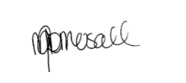

Activity 2: Organise on-site services and facilities.
This activity requires you to collect site measurements and other data for building project assigned.
To complete this activity, you are required to:
- Complete the steps given in the ‘Checklist 2’ provided.
- Access and interpret NCC codes and relevant Australian Standards referenced in the NCC.
- Complete Template 2.
While completing each step, you must place a tick mark against each step given in the checklist once completed.
Instructions for trainer/assessor:
- The student should have access to the following documents:
  - WHS legislation and regulations
    - Model WHS Act (Provide along with this assessment task)
    - Model WHS Regulations (Provide along with this assessment task)
  - Government building and industrial relations legislation
    - https://www.abcc.gov.au/about/what-we-do/overview/legislation
  - Current building and construction codes and standards
    - https://www.abcb.gov.au/
    - https://ncc.abcb.gov.au/editions/2019-a1/ncc-2019-volume-one-amendment-1/contents-and-introduction/introduction-ncc-volume
    - https://ncc.abcb.gov.au/editions/2019-a1/ncc-2019-volume-two-amendment-1/contents-and-introduction/copyright-and-licence
    - https://ncc.abcb.gov.au/editions/2019-a1/ncc-2019-volume-three-amendment-1/contents-and-introduction/introduction-ncc
  - NCC Volume 1 – Volume 3 (Provided along with this assessment)
  - Organisational quality policies and procedures
  - Workplace safety requirements
  - Project plans and specifications
  - Business equipment and technology to facilitate arranging resources and preparing for a construction project.
Instructions for the student:
- The student must:
  - Determine the needs for on-site facilities and services.
  - Set up, receive, and position the site office, storage sheds, and on-site restrooms and facilities.
  - Identify and create processes to protect or make use of existing services on the site.
  - Make arrangements with service providers for temporary power and water connections.
  - Determine and meet the requirements of the council for temporary site setup.
After completing this task, submit the following to your assessor:
- A completed Checklist and Template 2,
- A completed Performance Criteria/Checklist – Activity 2
- Email confirmation of Site office, storage sheds, and on-site restrooms and facilities arranged and received from the Site Supervisor.
- Copies of any emails/screenshots used to make arrangements with relevant service providers for temporary power and water connections.
- Copies of the construction project documents you sourced in completion of this activity.

Checklist 2: Organise on-site services and facilities.
Steps | Tick mark, once completed
Step 1: Determine the needs for on-site facilities and services.
- Conduct online research to determine requirements for on-site facilities and services.
- Document the identified requirements for on-site facilities and services and relevant legislative provisions using Template 2.
Step 2: Set up, receive, and position the site office, storage sheds, and on-site restrooms and facilities.
- Analyse the project drawings and specifications.
- Arrange site office, storage sheds, and on-site restrooms and facilities.
- Receive, and position the site office, storage sheds, and on-site restrooms and facilities.
- Further, document the following using Template 2.
  - Site office, storage sheds, and on-site restrooms and facilities arranged and received. This can be evidence by an email confirmation from the Site Supervisor (this can be simulated with your supervisor).
  - How did you position the site office, storage sheds, and on-site restrooms and facilities?
Step 3: Identify and create processes to protect or make use of existing services on the site.
- Identify and develop processes to protect or make use of existing services on the site.
- Document the identified processes to protect or make use of existing services on the site using Template 2.
Step 4: Make arrangements with service providers for temporary power and water connections.
- Arrange temporary power and water connections with relevant service providers.
Note: Submit the service agreements to the trainer/assessor.
Step 5: Determine and meet the requirements of the council for temporary site setup.
- Research and determine the requirements of the council for temporary site setup.
- Document the requirements of the council for temporary site setup using Template 2.
- Meet the requirements of the council for temporary site setup using Template 2.

Template 2: Organise on-site services and facilities.
Organise on-site services and facilities (300 - 400 words)
Identified requirements for on-site facilities and services and relevant legislative provisions | - Clean drinking water must be provided free of charge and easily accessed to workers and close to straneous work being conducted . Must be below 24 degrees Celsius  - Clean toilets must be provided for all workers, 1 closet pan for every 20 male, 1 urinal for every 25 males and 1 closet pan for every 15 females. They should be designed with fitted and a hinged seat and lif, provide light and ventilation, clearly signposted, fitted with a hinged door capable of locking from inside of each cubicle, allow emergency access, positioned to ensure privacy. They should be supplied with toilet paper, handwashing facilities, rubbish bins and disposal of sanitary items.  - Hand washing facilities must be provided to enable workers to maintain a good standard of personal hygiene.  - Workers musat be provided with access to hygienic facilties for eating and preparing and storing food.  - Workers must be provided secure storage for personal items
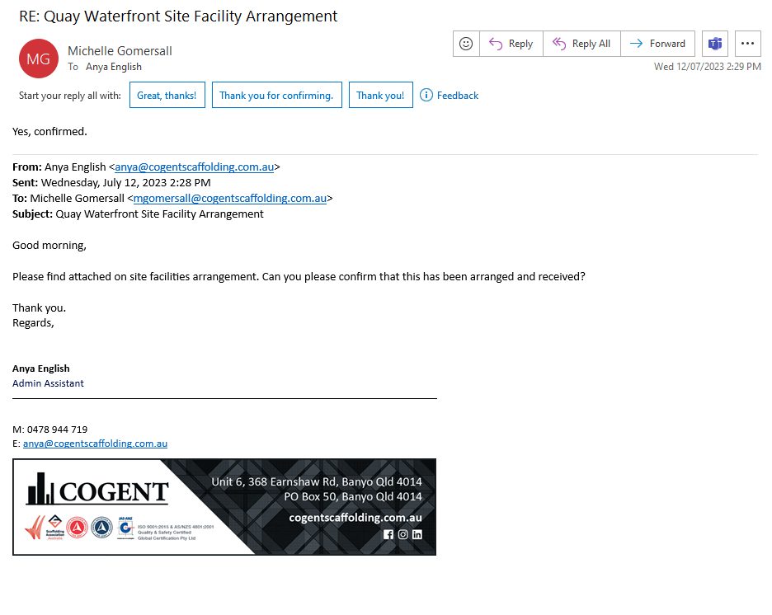
Insert Email confirmation of Site office, storage sheds, and on-site restrooms and facilities arranged and received from the Site Supervisor here…
How did you position the site office, storage sheds, and on-site restrooms and facilities? | I made sure that the toilets, change rooms and water station were all close to both the smoko rooms and the hoist to ensure easy access. I positioned the toilet and access to ensure safe emergency access.
Identified processes to protect or make use of existing services on the site | Ensure that the every site supervisor and persons in charge have a copy of where all site facilities are, so when creating SWMS these can ensure that these facilities will not be affected when any drilling or excavation or the likes that place. This also includes sending out the plumbing and drainage plans to ensure none of these are effected as well.
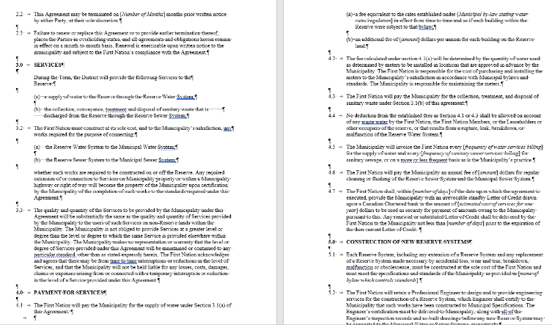
Insert the service agreements for temporary power and water connections here…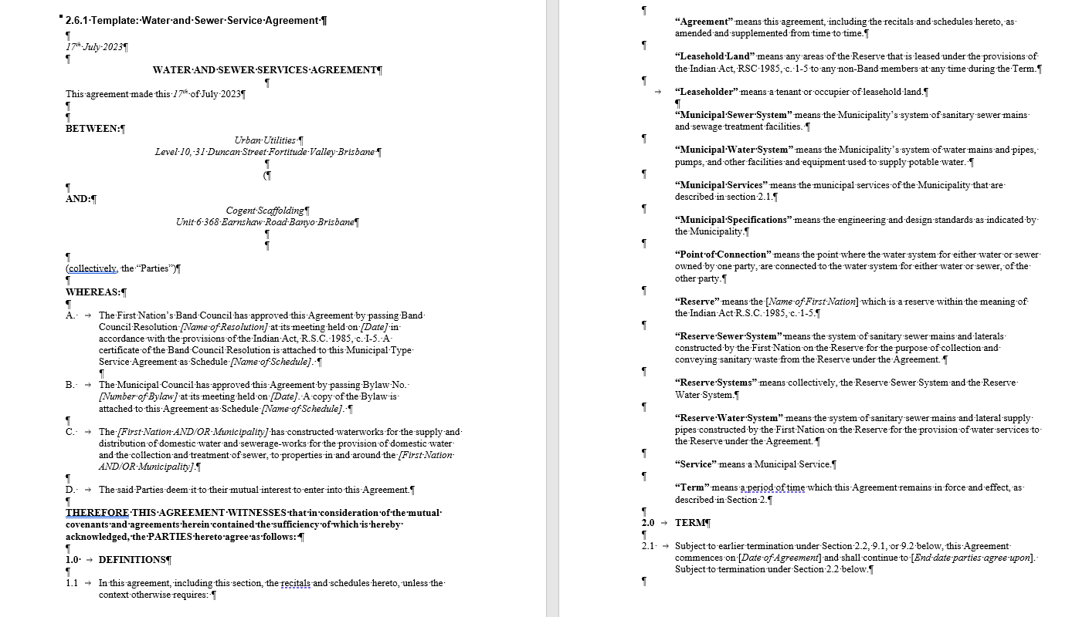
Requirements of the council for temporary site setup | - Carry out regular maintenance  - Only use biodegradable products  - Use water saving devices  - Ensure the disposal area is clearly identified  - Do not let fats, oils, food scraps, chemicals, ammonia, high level phosphorous products, pesticides to discharge into the facility.  - Do not allow roof or surfact water to enter the facility or discharge over the disposal area.
Meet the requirements of the council for temporary site setup | - Monthly inspections to ensure regular maintenance  - Create specification for products, ensuring the products are all biodegradable and all devices are water saving.  - Signage is put all over facility to ensyre disposal area is stated clearly and that what is and is not to be discharged  - The facility is protected by being covered by a scaffolding gantry .
Sign off:
Date: 17/07/2023

Performance Criteria/Performance Checklist: Activity 2
This task must address the following performance criteria/ performance checklist.
To be assessed as satisfactory (S) in this assessment task, the participant needs to demonstrate competency in the following critical aspects of evidence | S | N/S | Trainer/Assessor to complete  (Comment and feedback to students)
Determined the needs for on-site facilities and services.
- Conducted online research to determine requirements for on-site facilities and services.
- Documented the identified requirements for on-site facilities and services and relevant legislative provisions.
Set up, received, and positioned the site office, storage sheds, and on-site restrooms and facilities.
- Analysed the project drawings and specifications.
- Arranged site office, storage sheds, and on-site restrooms and facilities.
- Received, and positioned the site office, storage sheds, and on-site restrooms and facilities.
- Further, document the following.
  - Site office, storage sheds, and on-site restrooms and facilities arranged and received. This can be evidence by an email confirmation from the Site Supervisor.
  - How did you position the site office, storage sheds, and on-site restrooms and facilities?
Identified and created processes to protect or make use of existing services on the site.
- Identified and developed processes to protect or make use of existing services on the site.
- Documented the identified processes to protect or make use of existing services on the site.
Made arrangements with service providers for temporary power and water connections.
- Arranged temporary power and water connections with relevant service providers.
Note: Submit the service agreements to the trainer/assessor.
Determined and met the requirements of the council for temporary site setup.
- Researched and determined the requirements of the council for temporary site setup.
- Documented the requirements of the council for temporary site setup.
- Met the requirements of the council for temporary site setup.
The student’s performance was: | - Not satisfactory  - Satisfactory
Feedback to student:

Student signature
Trainer/Assessor signature

Activity 3: Arrange public protection.
This activity requires you to use measuring devices to collect site information and data.
To complete this activity, you are required to:
- Complete the steps given in the ‘Checklist 3’ provided.
- Access and interpret NCC codes and relevant Australian Standards referenced in the NCC.
- Complete Template 3.
While completing each step, you must place a tick mark against each step given in the checklist once completed.
Instructions for trainer/assessor:
- The student should have access to the following documents:
  - WHS legislation and regulations
    - Model WHS Act (Provide along with this assessment task)
    - Model WHS Regulations (Provide along with this assessment task)
  - Government building and industrial relations legislation
    - https://www.abcc.gov.au/about/what-we-do/overview/legislation
  - Current building and construction codes and standards
    - https://www.abcb.gov.au/
    - https://ncc.abcb.gov.au/editions/2019-a1/ncc-2019-volume-one-amendment-1/contents-and-introduction/introduction-ncc-volume
    - https://ncc.abcb.gov.au/editions/2019-a1/ncc-2019-volume-two-amendment-1/contents-and-introduction/copyright-and-licence
    - https://ncc.abcb.gov.au/editions/2019-a1/ncc-2019-volume-three-amendment-1/contents-and-introduction/introduction-ncc
  - NCC Volume 1 – Volume 3 (Provided along with this assessment)
  - Organisational quality policies and procedures
  - Workplace safety requirements
  - Project plans and specifications
  - Business equipment and technology to facilitate arranging resources and preparing for a construction project.
Instructions for the student:
- The student must:
  - For site setup, adhere to work health and safety (WHS) regulations as well as local authority approvals.
  - Install legal hoardings, fencing, and signage.
  - To meet local authority requirements, arrange for temporary site access and egress.
  - Organise waste disposal and disposal facilities.
After completing this task, submit the following to your assessor:
- A completed Checklist and Template 3,
- A completed Performance Criteria/Checklist – Activity 3
- Copies of any emails/screenshots used for site setup.
- Copies of the construction project documents you sourced in completion of this activity.

Checklist 3: Arrange public protection.
Steps | Tick mark, once completed
Step 1: For site setup, adhere to work health and safety (WHS) regulations as well as local authority approvals.
- Follow the Work health and safety policies and procedures in order to ensure safe environment for site setup.
- Follow local authority authorisations for site setup.
- Document the work health and safety (WHS) and local authority authorisations followed using Template 3.
Step 2: Install legal hoardings, fencing, and signage.
- Check the compliant hoardings, fencing and signage for the site.
- Erect compliant hoardings, fencing and signage. This can be evidence by an email to the site supervisor explaining what has been erected with a reply to outlining that this is compliant.
- Document the compliant hoardings, fencing and signage erected Template 3.
Step 3: To meet local authority requirements, arrange for temporary site access and egress.
Further, document the following using Template 3.
- Local authority requirements related to temporary site access and egress.
- Temporary site access and egress arranged. This can be evidence by an email to the site supervisor explaining what has been arranged with a reply to outlining that this is compliant.
Step 4: Organise waste disposal and disposal facilities.
- Analyse the requirements for waste facilities and waste removal.
- Organise waste disposal and disposal facilities.
- Submit the details of the waste disposal and disposal facilities to the trainer/assessor via email. This can be evidence by an email to the site supervisor explaining what has been arranged with a reply to outlining that this is compliant.

Template 3: Arrange public protection.
Arrange public protection (300-400 words)
Identified requirements for on-site facilities and services and relevant legislative provisions | - Carry out regular maintenance  - Only use biodegradable products  - Use water saving devices  - Ensure the disposal area is clearly identified  - Do not let fats, oils, food scraps, chemicals, ammonia, high level phosphorous products, pesticides to discharge into the facility.  - Do not allow roof or surfact water to enter the facility or discharge over the disposal area.  - A major hazard facility must be licensed  - When a person is conducting business or undertaking ata workplace must ensure that the provision of adequate facilities for workers.  - They must be in a goof working order and clean, safe and accessible.  - The workplace has surfaces designed installed and maintained to allow work to be carried out without risk, lighting enables each worker to carry out work without risk to health and safety and safe evacuation in an emergency.  - Ventilation enables workers to carry out work withour risk to health and safety  - Safe enter and egress is layout by the workplace conducting business to ensure in working conditions and an emergency.
Document the work health and safety (WHS) and local authority authorisations for site setup. | Workplace Health and Safety Regulation 2011  Workplace Health and Safety Act 2011  Brisbane City Council
Insert erect compliant hoardings, fencing and signage. This can be evidence by an email to the site supervisor explaining what has been erected with a reply to outlining that this is compliant here… 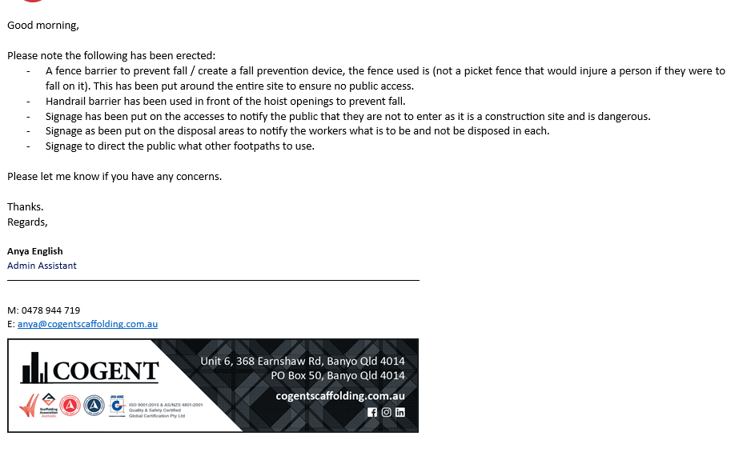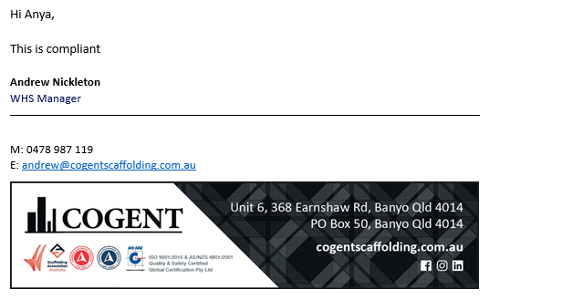
Insert temporary site access and egress arranged. This can be evidence by an email to the site supervisor explaining what has been arranged with a reply to outlining that this is compliant here…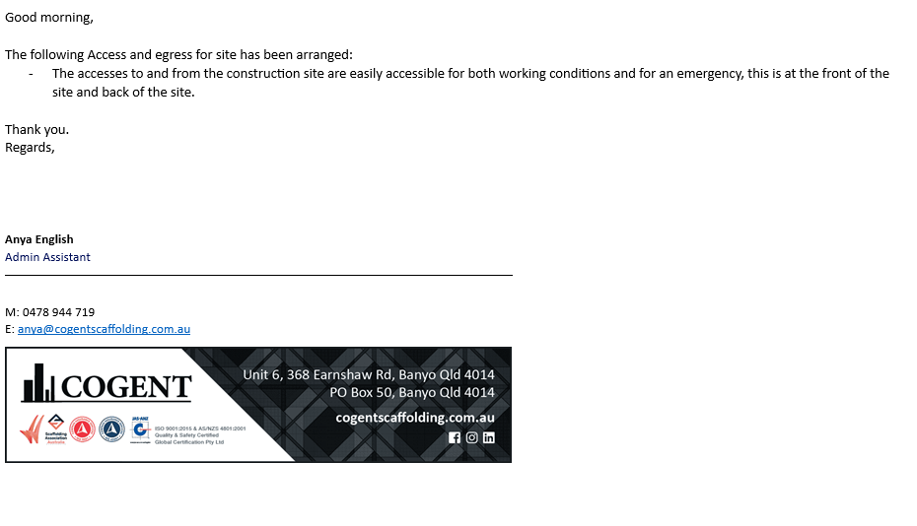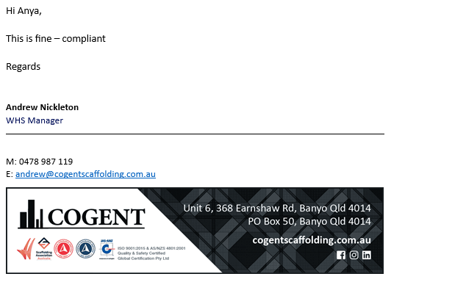
Insert the details of the waste disposal and disposal facilities to the trainer/assessor via email. This can be evidence by an email to the site supervisor explaining what has been arranged with a reply to outlining that this is compliant here…
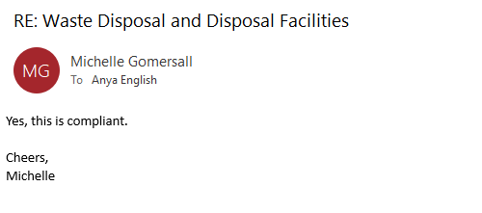
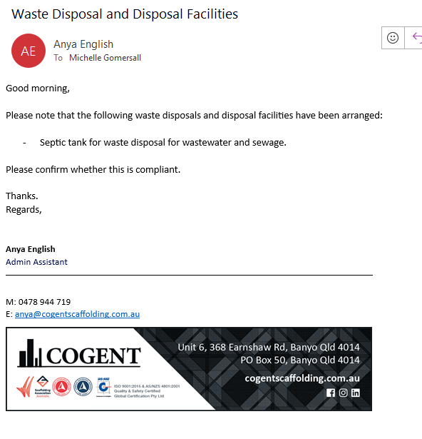
Sign off:
Date: 17/07/2023

Performance Criteria/Performance Checklist: Activity 3
This task must address the following performance criteria/ performance checklist.
To be assessed as satisfactory (S) in this assessment task, the participant needs to demonstrate competency in the following critical aspects of evidence | S | N/S | Trainer/Assessor to complete  (Comment and feedback to students)
For site setup, adhered to work health and safety (WHS) regulations as well as local authority approvals.
- Followed the Work health and safety policies and procedures in order to ensure safe environment for site setup.
- Followed local authority authorisations for site setup.
- Documented the work health and safety (WHS) and local authority authorisations followed.
Installed legal hoardings, fencing, and signage.
- Checked the compliant hoardings, fencing and signage for the site.
- Erect compliant hoardings, fencing and signage. This can be evidence by an email to the site supervisor explaining what has been erected with a reply to outlining that this is compliant.
To meet local authority requirements, arranged for temporary site access and egress.
Further, documented the following.
- Local authority requirements related to temporary site access and egress.
- Temporary site access and egress arranged. This can be evidence by an email to the site supervisor explaining what has been arranged with a reply to outlining that this is compliant.
Organised waste disposal and disposal facilities.
- Analysed the requirements for waste facilities and waste removal.
- Organised waste disposal and disposal facilities.
- Submit the details of the waste disposal and disposal facilities to the trainer/assessor via email. This can be evidence by an email to the site supervisor explaining what has been arranged with a reply to outlining that this is compliant.
The student’s performance was: | - Not satisfactory  - Satisfactory
Feedback to student:

Student signature
Trainer/Assessor signature
Activity 4: Organise on-site delivery.
This activity requires you to complete the monitoring process for a building and construction project assigned.
To complete this activity, you are required to:
- Complete the steps given in the ‘Checklist 4’ provided.
- Access and interpret NCC codes and relevant Australian Standards referenced in the NCC.
- Complete Template 4.
While completing each step, you must place a tick mark against each step given in the checklist once completed.
Instructions for trainer/assessor:
- The student should have access to the following documents:
- WHS legislation and regulations
  - Model WHS Act (Provide along with this assessment task)
  - Model WHS Regulations (Provide along with this assessment task)
- Government building and industrial relations legislation
  - https://www.abcc.gov.au/about/what-we-do/overview/legislation
- Current building and construction codes and standards
  - https://www.abcb.gov.au/
  - https://ncc.abcb.gov.au/editions/2019-a1/ncc-2019-volume-one-amendment-1/contents-and-introduction/introduction-ncc-volume
  - https://ncc.abcb.gov.au/editions/2019-a1/ncc-2019-volume-two-amendment-1/contents-and-introduction/copyright-and-licence
  - https://ncc.abcb.gov.au/editions/2019-a1/ncc-2019-volume-three-amendment-1/contents-and-introduction/introduction-ncc
- NCC Volume 1 – Volume 3 (Provided along with this assessment)
- Organisational quality policies and procedures
- Workplace safety requirements
- Project plans and specifications
- Business equipment and technology to facilitate arranging resources and preparing for a construction project.
Instructions for the student:
- The student must:
  - Confirm and order materials in order to meet delivery deadlines.
  - Examine the availability of physical resources and, if necessary, schedule delivery.
  - Receive, secure and protect materials, plant, and equipment.
After completing this task, submit the following to your assessor:
- A completed Checklist and Template 4,
- A completed Performance Criteria/Checklist – Activity 4
- Copies of any emails/screenshots used to confirm and order materials in order to meet delivery deadlines.
- Copies of the construction project documents you sourced in completion of this activity.

Checklist 4: Organise on-site delivery.
Steps | Tick mark, once completed
Step 1: Confirm and order materials in order to meet delivery deadlines.
- Identify the scheduled delivery dates from project plans.
- Confirm and order materials in accordance with organisational policies and procedures. Candidate to submit any relevant order forms/invoices as evidence.
- Prepare an excel sheet of the ordered materials and their expected delivery dates and submit to the trainer/assessor.
Note: Candidate must provide screenshot/email evidence of confirming and ordering of materials from suppliers to meet delivery deadlines.
Step 2: Examine the availability of physical resources and, if necessary, schedule delivery.
- Check the availability of physical resources with the supplier.
- Schedule the delivery dates in accordance with organisational policies and procedures.
Note: Candidate must provide email evidence of the availability of materials with the supplier and the scheduling of delivery dates (this can be simulated with your supervisor).
Step 3: Materials, plant, and equipment must be received, secured, and protected.
- Receive, secure and protect materials and plant and equipment on the construction site.
- Further, document the following using Template 4:
  - Materials, plant, and equipment received.
  - Procedures implemented to secure and protect materials, plant and equipment.

Template 4: Organise on-site delivery.
Organise on-site delivery (200-300 words)
Insert screenshot/email evidence of confirming and ordering of materials from suppliers to meet delivery deadlines here…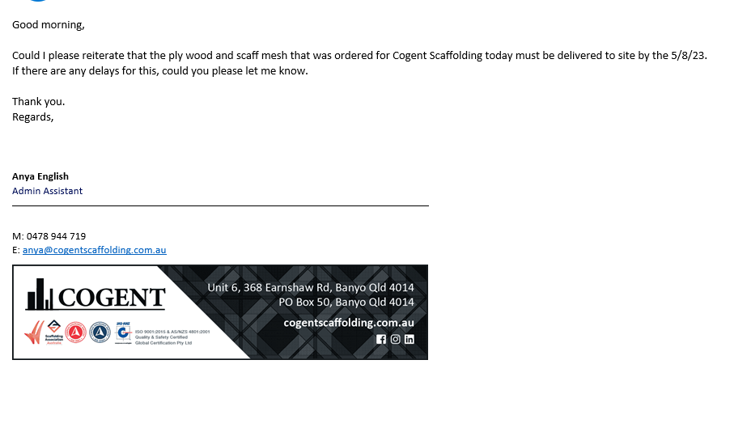
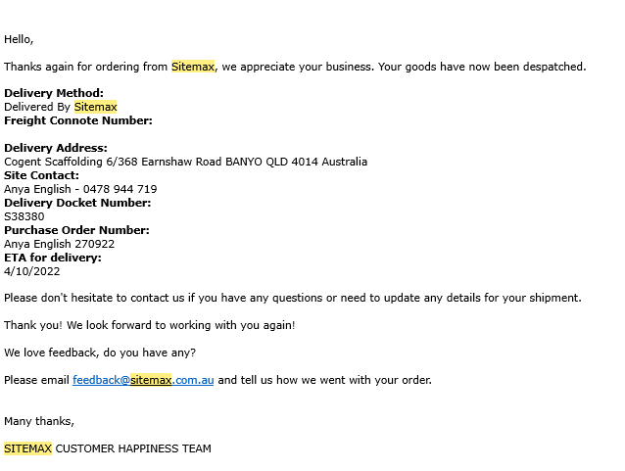
Insert email evidence of the availability of materials with the supplier and the scheduling of delivery dates here…
Materials, plant, and equipment received. | - Plywood / structural wood  - Black scaff mesh
Procedures implemented to secure and protect materials, plant and equipment | - Rain days, the materials are not to be transported to site. Rather to the site office to be in a undercover area until weather is cleared.  - Site basement area for equipment has been cleared for the material to be held until use on site. This area has surveillance camera to protect against theft and is locked up when everyone is gone.
Sign off:
Date:17/07/2023

Performance Criteria/Performance Checklist: Activity 4
This task must address the following performance criteria/ performance checklist.
To be assessed as satisfactory (S) in this assessment task, the participant needs to demonstrate competency in the following critical aspects of evidence | S | N/S | Trainer/Assessor to complete  (Comment and feedback to students)
Confirmed and ordered materials in order to meet delivery deadlines.
- Identified the scheduled delivery dates from project plans.
- Confirmed and order materials in accordance with organisational policies and procedures.
Note: Candidate must provide screenshot/email evidence of confirming and ordering of materials from suppliers to meet delivery deadlines.
Examined the availability of physical resources and, if necessary, schedule delivery.
- Checked the availability of physical resources using template 3.
- Scheduled the delivery dates in accordance with organisational policies and procedures.
Note: Candidate must provide email evidence of the availability of materials with the supplier and the scheduling of delivery dates.
Materials, plant, and equipment received, secured, and protected.
- Recieved secure and protect materials and plant and equipment according to manufacturer’s instructions.
- Further, document the following using Template 4:
  - Materials, plant, and equipment received.
  - Procedures implemented to secure and protect materials, plant and equipment.
The student’s performance was: | - Not satisfactory  - Satisfactory
Feedback to student:
Student signature
Trainer/Assessor signature

Activity 5: Organise on- site human resources.
This activity requires you to complete the monitoring process for a building and construction project assigned.
To complete this activity, you are required to:
- Complete the steps given in the ‘Checklist 5’ provided.
- Access and interpret NCC codes and relevant Australian Standards referenced in the NCC.
- Complete Template 4.
While completing each step, you must place a tick mark against each step given in the checklist once completed.
Instructions for trainer/assessor:
- The student should have access to the following documents:
- WHS legislation and regulations
  - Model WHS Act (Provide along with this assessment task)
  - Model WHS Regulations (Provide along with this assessment task)
- Government building and industrial relations legislation
  - https://www.abcc.gov.au/about/what-we-do/overview/legislation
- Current building and construction codes and standards
  - https://www.abcb.gov.au/
  - https://ncc.abcb.gov.au/editions/2019-a1/ncc-2019-volume-one-amendment-1/contents-and-introduction/introduction-ncc-volume
  - https://ncc.abcb.gov.au/editions/2019-a1/ncc-2019-volume-two-amendment-1/contents-and-introduction/copyright-and-licence
  - https://ncc.abcb.gov.au/editions/2019-a1/ncc-2019-volume-three-amendment-1/contents-and-introduction/introduction-ncc
- NCC Volume 1 – Volume 3 (Provided along with this assessment)
- Organisational quality policies and procedures
- Workplace safety requirements
- Project plans and specifications
- Business equipment and technology to facilitate arranging resources and preparing for a construction project.
Instructions for the student:
- The student must:
  - Address any issues concerning industrial relations and on-site safety that may have an impact on the preparation and human resourcing for building work.
  - Determine and allocate on-site human resource needs.
  - Engage or appoint a construction work supervisor.
  - Engage the appropriate employees or contractors for the project's requirements.
After completing this task, submit the following to your assessor:
- A completed Checklist and Template 5,
- A completed Performance Criteria/Checklist – Activity 5
- Copies of any emails/screenshots used for engaging or appointing a construction project manager and appropriate employees or contractors.
- Copies of the construction project documents you sourced in completion of this activity.

Checklist 5: Organise on- site human resources.
Steps | Tick mark, once completed
Step 1: Address any issues concerning industrial relations and on-site safety that may have an impact on the preparation and human resourcing for building work.
- Document the following using Template 5.
  - Three (3) issues concerning industrial relations and on-site safety.
  - Actions implemented to address any issues identified.
Step 2: Determine and allocate on-site human resource needs.
- Identify the human resource requirements for different stages of the construction project.
- Ensure the allocation of on-site human requirements.
- Detail the human resources allocated for different construction tasks using Template 5.
Step 3: Engage or appoint a construction work supervisor.
Note: Candidate must provide screenshot/email evidence of engaging or appointing a construction work supervisor (this can be simulated with your supervisor).
Step 4: Engage the appropriate employees or contractors for the project's requirements.
- Analyse the project needs from project plans and specifications.
- Engage appropriate employees or contractors as stated for project needs.
- Ensure the employees or contractors are skilful enough to perform the task.
Note: Candidate must provide screenshot/email evidence of engaging appropriate employees or contractors for the building project (this can be simulated with your supervisor).

Template 5: Organise on-site human resources
Organise on- site human resources (200-300 words)
Three (3) issues concerning industrial relations and on-site safety. | - Any injuries that occur on site  - Any occupational illnesses that may arise  - A safety incident that could occur during the construction of the project.
Actions implemented to address any issues identified | - Prestarts every morning, warm ups included in the prestart to minimise shoulder injuries. Tool box talks every week.  - Site safety walks.  - On site training for different types of matters i.e. asbestos training, silica training  - SWMS always updated, signed, shared and followed.  - Everything is reported on.  - Inspections done monthly.  - Tool box talk done after every incident to occur to prevent happening again.  - Communication.
Human resources allocated for different construction tasks | - Erection of scaffold for this particular project – 20 men.  - Safety – 3 guys, leading hand, Health and safety representative, company wide safety manager.  - In charge: leading hand, site supervisor, director.
Insert screenshot/email evidence of engaging or appointing a construction work supervisor here…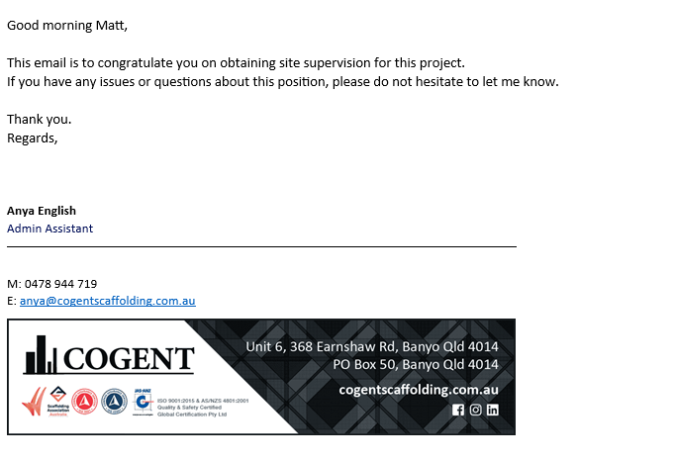
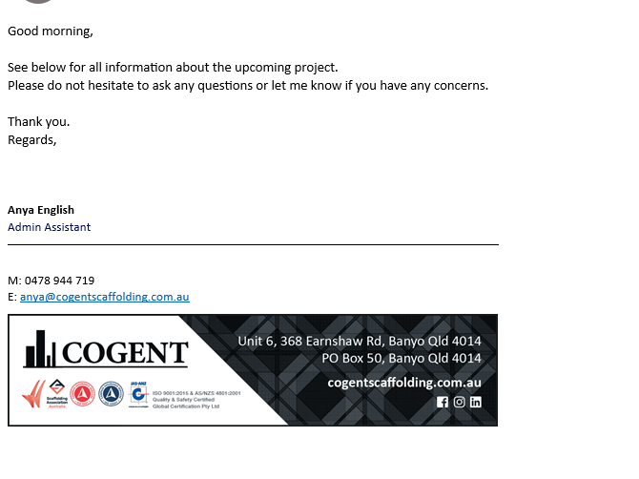
Insert screenshot/email evidence of engaging appropriate employees or contractors for the building project here…

Sign off:
Date:17/07/2023
Performance Criteria/Performance Checklist: Activity 5
This task must address the following performance criteria/ performance checklist.
To be assessed as satisfactory (S) in this assessment task, the participant needs to demonstrate competency in the following critical aspects of evidence | S | N/S | Trainer/Assessor to complete  (Comment and feedback to students)
Addressed any issues concerning industrial relations and on-site safety that may have an impact on the preparation and human resourcing for building work.
- Documented the following.
  - Three (3) issues concerning industrial relations and on-site safety.
  - Actions implemented to address any issues identified.
Determined and allocated on-site human resource needs.
- Identified the human resource requirements for different stages of the construction project.
- Ensured the allocation of on-site human requirements.
Engaged or appointed a construction project manager.
Note: Candidate must provide screenshot/email evidence of engaging or appointing a construction project manager.
Engaged the appropriate employees or contractors for the project's requirements.
- Analysed the project needs from project plans and specifications.
- Engaged appropriate employees or contractors as stated for project needs.
- Ensured the employees or contractors are skilful enough to perform the task.
Note: Candidate must provide screenshot/email evidence of engaging appropriate employees or contractors for the building project.
The student’s performance was: | - Not satisfactory  - Satisfactory
Feedback to student:

Student signature
Trainer/Assessor signature | 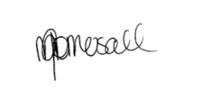

Assessment Results Sheet
Outcome | Outcome (make sure to tick the correct checkbox):  Satisfactory (S) ☐ or Not Satisfactory (NS) ☐  Date: _______(day)/ _______(month)/ ____________(year)  Feedback:  Outcome (make sure to tick the correct checkbox):  Satisfactory (S) ☐ or Not Satisfactory (NS) ☐  Date: _______(day)/ _______(month)/ ____________(year)  Feedback:
  First attempt:
  Second attempt:
Student Declaration | - I declare that the answers I have provided are my own work. Where I have accessed information from other sources, I have provided references and or links to my sources.  - I have kept a copy of all relevant notes and reference material that I used as part of my submission.  - I have provided references for all sources where the information is not my own. I understand the consequences of falsifying documentation and plagiarism. I understand how the assessment is structured. I accept that the work I submit may be subject to verification to establish that it is my own.  - I understand that if I disagree with the assessment outcome, I can appeal the assessment process, and either re-submit additional evidence undertake gap training and or have my submission re-assessed.  - All appeal options have been explained to me.
Student Signature
Date | 11/8/23
Trainer/Assessor Name | Michelle Gomersall
Trainer/Assessor Declaration | I hold:  ☐ Vocational competencies at least to the level being delivered  ☐ Current relevant industry skills  ☐ Current knowledge and skills in VET, and undertake  ☐ Ongoing professional development in VET  I declare that I have conducted an assessment of this student’s submission. The assessment tasks were deemed current, sufficient, valid and reliable. I declare that I have conducted a fair, valid, reliable, and flexible assessment. I have provided feedback to the student.
Trainer/Assessor Signature
Date | 11/8/23
Office Use Only | The outcome of the assessment has been entered into the Student Management System  on _________________ (insert date)  by (insert Name) __________________________________

Appendix A: Reasonable Adjustments
Write (task name and number) where reasonable adjustments have been applied:

Reasonable Adjustments

- Students with carer responsibilities, cultural or religious obligations, English as an additional language, disability etc. can request for reasonable adjustments.
- Please note, academic standards of the unit/course will not be lowered to accommodate the needs of any student, but there is a requirement to be flexible about the way in which it is delivered or assessed.
- The Disability Standards for Education requires institutions to take reasonable steps to enable the student with a disability to participate in education on the same basis as a student without a disability.
- The trainer/assessor must complete the section below “Reasonable Adjustment Strategies Matrix” to ensure the explanation and correct strategy have been recorded and implemented.
- The trainer/assessor must notify the administration/compliance and quality assurance department for any reasonable adjustments made.
- All evidence and supplementary documentation must be submitted with the assessment pack to the administration/compliance and quality assurance department.
Reasonable Adjustment Strategies Matrix (Trainer/Assessor to complete)

Category | Possible Issue | Reasonable Adjustment Strategy  (select as applicable)
LLN | Speaking  Reading  Writing  Confidence | Verbal assessment  Presentations  Demonstration of a skill  Use of diagrams  Use of supporting documents such as wordlists
Non-English Speaking Background | Speaking  Reading  Writing  Cultural background  Confidence | Discuss with the student and supervisor (if applicable) whether language, literacy and numeracy are likely to impact on the assessment process  Use methods that do not require a higher level of language or literacy than is required to perform the job role  Use short sentences that do not contain large amounts of information  Clarify information by rephrasing, confirm understanding  Read any printed information to the student  Use graphics, pictures and colour coding instead of, or to support, text  Offer to write down, or have someone else write, oral responses given by the student  Ensure that the time available to complete the assessment, while meeting enterprise requirements, takes account of the student’s needs
Indigenous | Knowledge and understanding  Flexibility  Services  Inappropriate training and assessment | Culturally appropriate training  Explore understanding of concepts and practical application through oral assessment  Flexible delivery  Using group rather than individual assessments  Assessment through completion of practical tasks in the field after demonstration of skills and knowledge.
Age | Educational background  Limited study skills | Make sure font size is not too small  Trainer/Assessor should refer to the student’s experience  Ensure that the time available to complete the assessment takes account of the student’s needs  Provision of information or course materials in an accessible format.  Changes in teaching practices, e.g. wearing an FM microphone to enable a student to hear lectures  Supply of specialised equipment or services, e.g. a note-taker for a student who cannot write  Changes in lecture schedules and arrangements, e.g. relocating classes to an accessible venue  Changes to course design, e.g. substituting an assessment task  Modifications to the physical environment, e.g. installing lever taps, building ramps, installing a lift
Educational background | Reading  Writing  Numeracy  Limited study skills and/or learning strategies | Discuss with the Student previous learning experience  Ensure learning and assessment methods meet the student’s individual need
Disability | Speaking  Reading  Writing  Numeracy  Limited study skills and/or learning strategies | Identify the issues  Create a climate of support  Ensure access to support that the student has agreed to  Appropriately structure the assessment  Provide information or course materials in an accessible format, e.g. a textbook in braille  Changes in teaching practices, e.g. wearing an FM microphone to enable a student to hear lectures  Supply of specialised equipment or services, e.g. a note-taker for a student who cannot write  Changes in lecture schedules and arrangements, e.g. relocating classes to an accessible venue  Changes to course design, e.g. substituting an assessment task  Modifications to the physical environment, e.g. installing lever taps, building ramps, installing a lift
Explanation of reasonable adjustments strategy used

Trainer/Assessor Name | Michelle Gomersall
Trainer/Assessor Declaration | I declare that I have attached all relevant evidence to provide reasonable adjustment. The training package guidelines and criteria have not been compromised in the process of providing reasonable adjustment to the student. I declare that I have conducted a fair, valid, reliable, and flexible assessment. I have provided explanation of reasonable adjustments strategy used, as required.
Trainer/Assessor Signature | 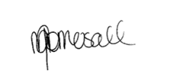
Date | 11/8/23

Appendix B: Third-Party Verification Log
Third-Party Verification Log
Instructions for the Assessor:
You are required to contact all third-party personnel involved in the candidate’s assessment to verify the candidate’s performance and evidence submissions and to confirm with them whether the candidate’s evidence submissions are true and accurate.
Complete this Third-Party Verification Log to document your completion of this process. When completing this log, provide all of the following required information for each third-party personnel:
- Name of third-party personnel contacted
- Relevant qualifications and/or experience of Third-party personnel contacted
- Role in the candidate’s assessment (e.g. workplace supervisor, observer, or candidate)
- Contact details (phone number or email address)
- Date contacted
You must also confirm that third-party personnel have verified the candidate’s evidence submissions are true and accurate.

Contact No.1
Name and job title of Third-party Contacted | Gavin Keeffe
Relevant Qualifications/experience of Third-party | Cert 3 Project Manager
Role in the Candidate’s Assessment | Contact Details  (Phone number or email address) | Date contacted | Third-Party verifies evidence submissions of the candidate are true and accurate?
Over looked | 0420 610 115 gavin@cogentscaffoling.com.au | 11/8/23 | Yes No  Assessor’s Notes

Contact No.2
Name and job title of Third-party Contacted | Michelle Gomersall
Relevant Qualifications/experience of Third-party | Diploma in Business, Human Resources
Role in the Candidate’s Assessment | Contact Details  (Phone number or email address) | Date contacted | Third-Party verifies evidence submissions of the candidate are true and accurate?
Assessor | 0419641053 | 11/8/23 | - Yes No  Assessor’s Notes

Contact No.3
Name and job title of Third-party Contacted
Relevant Qualifications/experience of Third-party
Role in the Candidate’s Assessment | Contact Details  (Phone number or email address) | Date contacted | Third-Party verifies evidence submissions of the candidate are true and accurate?
Yes No
Assessor’s Notes

Assessor Declaration
I declare that the information recorded in this Third-Party Verification Log is true and accurate.
Assessor’s name Michelle Gomersall | Assessor’s signature  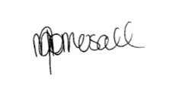
Date signed 11/8/23
End of Third-Party Verification Log (For the Assessor’s Use Only)

