CPCCBC4003A Select and prepare a construction contract,
CPCCBC4016A Administer a construction contract &
CPCCBC4032A Apply contract law to sales processes

The assessment activities for CPCCBC4003A Select and prepare a construction contract, CPCCBC4016A Administer a construction contract & CPCCBC4032A Apply contract law to sales processescover all aspects of the unit of competency required. To demonstrate competence in this unit, a participant must undertake all tasks and complete them satisfactorily and consistently. For Apprentices and Trainees, this includes employer completion of the Employer Record Book (ERB).

Participants must read all the information given before starting any assessment task. The assessment tasks are intended to be equitable, fair and flexible. If a participant has any questions or requires alternative arrangements to be made such requests should be directed to their Trainer/Assessor, who should note such arrangements in the ‘Assessor Comments’ on the affected assessment. If a participant feels they are not yet ready to be assessed, they should discuss their options with their Trainer/Assessor.

To satisfactorily complete the assessment, the participant is required to answer all questions correctly and demonstrate their skills to industry standards. If a participant does not answer some questions or perform some tasks, they will be deemed ‘Not Satisfactory’ for the task and ‘Not Yet Competent’ for the unit of competency. The Trainer/Assessor is able to provide the participant with additional information on interpreting the assessment outcomes and provide guidance on the participant’s options. Should a participant still be deemed ‘Not Satisfactory’ they will have the opportunity to undertake a supplementary assessment or appeal the result.

By signing the cover page for each assessment item, the participant acknowledges they understand the assessment instructions and requirements and consent to being assessed. The participant also verifies and assures the RTO that the work submitted is their own work.

Participant Name | Lauren Wilson

Task | Assessment Results
Theory Exam | Satisfactory | Not Yet Satisfactory
Practical Assessment | Satisfactory | Not Yet Satisfactory
Outcome for CPCCBC4003A | Competent | Not Yet Competent
Outcome for CPCCBC4016A | Competent | Not Yet Competent
Outcome for CPCCBC4032A | Competent | Not Yet Competent

Assessor Name
Assessor Signature | 
Unit Competence Determination Date | Click here to enter a date.

CPCCBC4003A Select and prepare a construction contract,
CPCCBC4016A Administer a construction contract &
CPCCBC4032A Apply contract law to sales processes

THEORY EXAM INSTRUCTIONS

- This exam will occur under standard assessment conditions.
  - An oral examination may be allowed under certain circumstances, whereby the Participant’s answers will be documented by a party other than the Participant. This must be acknowledged in writing (e.g. FT001 and Assessor Comments)
- Participants must provide enough detail in their responses to demonstrate their knowledge and skills.
- Please fill in the details below, providing your name, signature and date of assessment.
  - Your signature acknowledges that this is your own work.
- Assessors are to complete marking in pen of a different colour to the Participant.
- If a Participant initially answers a question incorrectly but modifies their response, they must follow the instructions below:
  - If a Participant changes their response in writing, they must put their initials next to the written change.
  - If a Participant changes their response verbally, this must be noted on the exam paper by the assessor.

Participant name | Lauren Wilson
Participant signature | 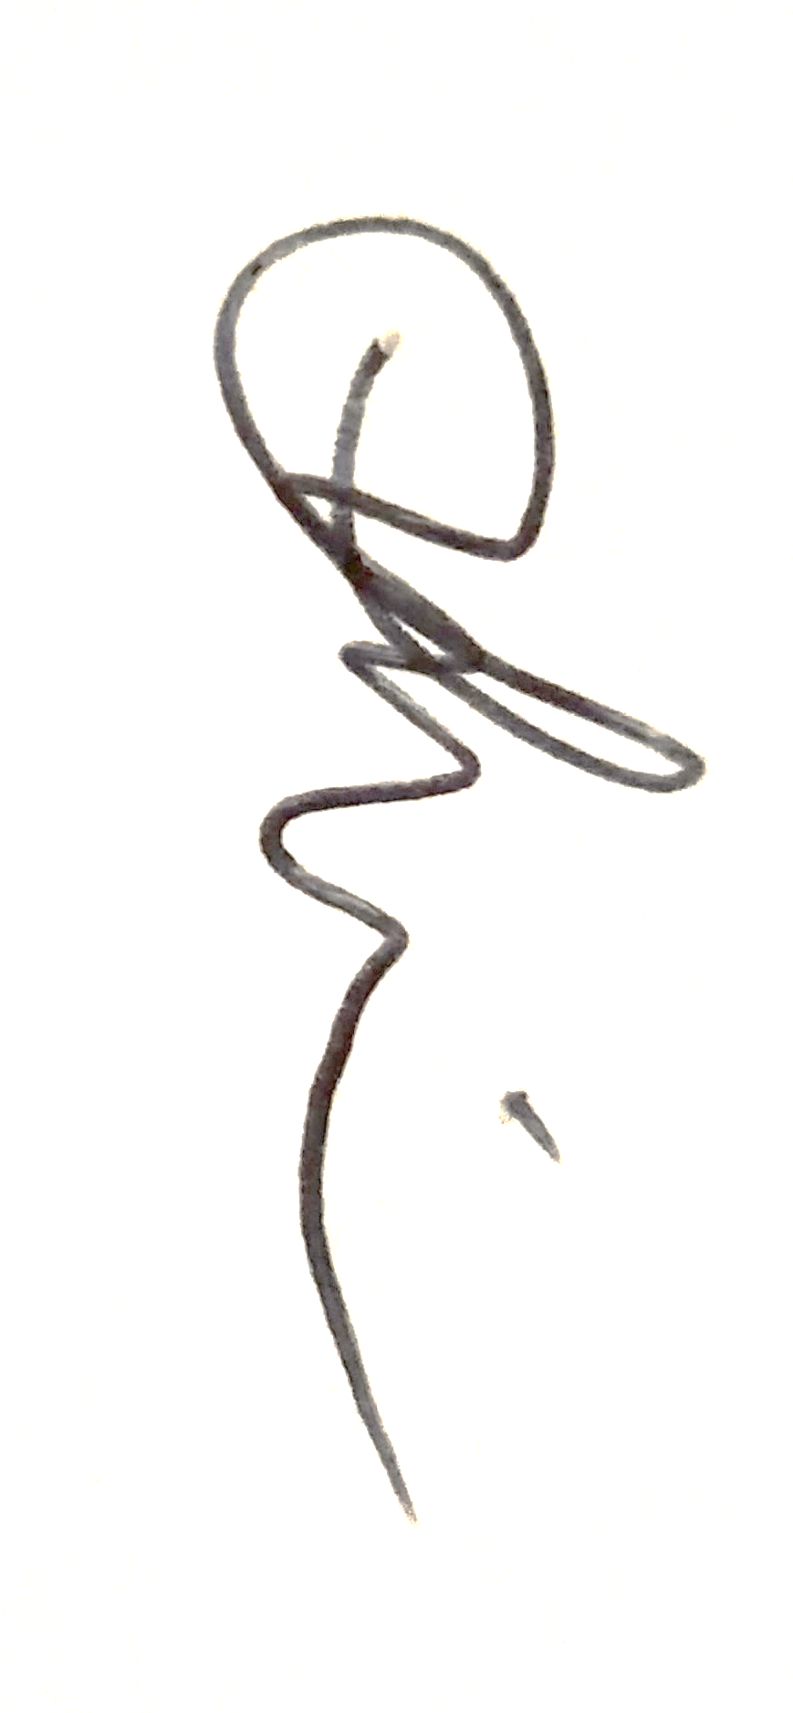
Date | 29/04/2020

Assessor name
Assessor signature
Date | Click here to enter a date.

Number of questions | Number of questions answered correctly | Task outcome (Tick)
51 |  | Satisfactory | Not Yet Satisfactory

ASSESSOR Comments

- Order the following elements of an agreement from 1 to 4.

Answer | Element Number | Element
 | 2 | Acceptance
 | 4 | Consideration
 | 3 | Intention of legal consequences
 | 1 | Offer

- When would an offer be considered to have lapsed?

Answer | When the documented timeframe for acceptance has lapsed

- What happens to the offer if new terms are suggested?

Answer | This is a counter offer where the new terms can be accepted or rejected

- What does it mean when a contract is supported by ‘valuable consideration’?

Answer | One party promises to do something in return for another party  Consideration is the agreement between both parties usually in exchange for monies upon completion of the agreed works

- Identify two (2) parties who may be deemed to not have the capacity to enter into a contract.

Answer | 1 Mentally disabled persons  2 Intoxicated or senile persons

- Outline your understanding of ‘consent’ as it applies to contractual agreements. Identify when ‘apparent consent’ might not actually exist.

Answer | Any person who has the mental capacity to knowingly understand and agree to the contractual documentation they are accepting  Apparent consent may not exist due to mistakes, fraud, innocent misinterpretation, undue influence.

- Identify the building industry regulator in your state and describe its role, particularly with regards to providing advice about contracts.

Answer | Queensland Building and Construction Commission otherwise known as the QBCC – Refer to the Consumer Building Guider which provides relevant information regarding contracts and supporting information. The QBCC also offers a range of contracts depending on the type of work you are going to undertake.  https://www.qbcc.qld.gov.au/contracts-payments/contracts

- Under what laws are domestic building contracts regulated?

Answer | Schedule 1B of the Queensland Building and Construction Commission Act 1991

- Domestic building contracts must be put in writing once the work exceeds what value?

Answer | $3 300.00

- A commercial building contract must be put in writing before the building work is started if the reasonable cost of the work is more than what amount? Identify the relevant law that imposes this requirement.

Answer | $10 000.00  The Queensland Building and Construction Commission Act 1991 imposes this requirement

- Contractors must give the owner a signed copy of the entire contract (including any plans and specifications) within how many days after entering the contract?

Answer | Within 5 business days

- What are the benefits of having a written contract in place between parties?

Answer | To engage both parties into a legal binding agreement which outlines and specifies the amount of monies to be exchanged throughout the construction process for the agreed scope of works.  To ensure both parties have a clear understanding of the legal terms and conditions under the head contract

- Match the common building contract clauses and definitions below by writing the appropriate letter next to each number in the centre column.

Answer | Clauses |  | Answers | Definition
 | 1 | Acceptances | 1 - F | A | Provide specific reasons that allow the contract period to be adjusted
 | 2 | Cost adjustments | 2 - E | B | A provision for which remedies can be sought if breached
 | 3 | Extensions of time | 3 - A | C | Specifically outlines the tasks to be completed as part of the construction work
 | 4 | Payments | 4 - D | D | Outlines the requirements for deposits
 | 5 | Scope of work | 5 - C | E | Address the risk of rise/fall of expenses
 | 6 | Term | 6 - B | F | Require that the contract be accepted or rejected by a certain date, otherwise the contract will not be binding

- Which of the following are preliminary contracts that a builder could ask a client to sign prior to signing the main contract? Tick all that apply.

Answer | Choice | Possible Answers
 |  | Contract estimate
 |  | Contract request
 |  | Preliminary agreement

- True or False (Tick your response): Clauses within pre-contract agreements may carry over into the contract, so it is important to discuss these with the client and come to an agreement.

Answer |  | True
 |  | False

- Identify and explain the purpose of four (4) standardised building construction contracts – two (2) residential and two (2) commercial.

Answer | Contract name | Description
 | Level 2 – Renovation Extension and Repair Contracts | Issued by the QBCC for renovations, repairs or extensions on existing dwellings for contract works over $20 000
 | New Home Construction Contract | Issued by HIA – This is a plain language contract designed for the construction of new homes, it includes both general conditions and relevant schedules
 | Commercial Building Contract | Issued by Master Builders – This is a lump sum contract to be used for the construction only of commercial building works with or without a principal agent
 | Commercial Cost-Plus Contract | Issued by Master Builders – For use on commercial building projects, where a lump sum price can not be established, however a fair and reasonable estimate is given.

- Identify an appropriate standardised contract that would be suitable for a commercial works job up to $100,000.

Answer | Commercial Minor Work Contract – issued by Master Builders for minor commercial works up to the value of $100 000.00

- Identify one (1) standardised residential building contract and explain the maximum value of the work it may be used for.

Answer | Level 1 – Renovation, extension and repair contracts – Issued by QBCC this contract is for renovations, extensions and minor repairs to existing homes for contract prices ranging from $3001 - $19 999.

- Describe the requirements for each of the topics listed below, with regards to residential contracts priced at $20,000.
In Queensland, these are outlined in the QBCC Consumer Building Guide, which the consumer must sign before work is undertaken.

Answer | Topics | Definition
 | Builder’s Licence | You must only engage with any contractor who hold the relevant QBCC Licence. Prior to signing any documentation ensure you check the contractor’s licence and history via the Online Licence Search – https://www.onlineservices.qbcc.qld.gov.au
 | Contract price | For contracts over $20 000 the price should be shown on the first page of the documentation. If not a fixed price, the contract schedule and method of calculating including allowances must be stated on the schedule. Allowances should be kept to a minimum as the final costs usually exceeds the estimated contract price. The contract should also allow state a special condition for any provisions that may alter the contract price
 | Building approvals and inspections | The contractor must engage a building certifier to complete building approvals at relevant stages of construction. Copies of all form 15s and 16 must be provided to the client along with the Final Building Certificate upon completion (Form 21)
 | Practical completion and handover | Final payment does not have to be paid (nor should be requested) until all works under the contract, scope of works and plans(and or any variations works) have been completed. Minor defects must be documented on a form supplied by the contractor.
 | Implied warranties | Section s 19 – 26 of schedule IB of the Act set out statutory warranties deemed to be part of the regulated building contracts, even if not stated in the contract, Warranty period is 6 years from completion, termination or cessation of the works – 1 year for all other breaches.

- Which of the following documents can be referred to as collectively making up a contract? Tick all that apply.

Answer | Choice | Possible Answers
 |  | Engineer specifications
 |  | Plans, drawings and specifications
 |  | Prime Cost Items Schedule
 |  | Processes for applying for extensions of time
 |  | Product catalogues
 |  | Project timelines and schedules
 |  | Provisional Sums Schedule
 |  | Rise and fall calculations
 |  | Site conditions report
 |  | Soil and sedimentation report

- What is the difference between the Prime Cost Item Schedule and the Provisional Sum Schedule in a contract? Provide an example of each type to help explain your response.

Answer | A prime cost item is a monetary allowance within the contract for the supply of necessary items that are not yet selected and finalised – for example tiles, taps, fixtures etc. Should the client go over the allowed amount for the items, a variation for the extra cost is then raised.  A provisional sum is a monetary allowance within the contract to cover works, materials or both for items that the extend of works can not be determined at the time of entering a contract – for example site works ( extra earth works due to rocks underground or council fees for material change of use.

- Cost adjustment provisions under a contract address risk by providing mechanisms for adjusting contract payment to reflect changes in costs. What can cost adjustment apply to?

Answer | This can apply to labour and materials, exchange rates for materials purchased overseas, duties, taxes and shipping.

- True or False (Tick your response): Variations can be requested by both the client and the builder.

Answer |  | True
 |  | False

- How should you deal with a client variation request that consequently requires a time extension? How are time extensions addressed within the contract?

Answer | The client should be advised to put their request in writing  The contractor must issue the client a variation document outlining the works and the cost, the client must also be issued with and Extension of time document advising of the amount of delay days this will cause to the contract.  The client must agree to the above my signing and returning the documents prior to any variation works taking place.

- Name the Fair Trade legislation that applies in your state and identify which persons/bodies it applies to.

Answer | Queensland Fair Trading Act 1989  The act applies to consumers to improve the protection and wellbeing of consumers in everyday dealings with business operations to ensure that both consumers and suppliers trade fairly

- Under the National Consumer Credit Code, before entering into a credit contract, what must the credit provider do?

Answer | Take reasonable steps to verify and investigate the client’s financial situation  Make reasonable enquiries as to why you want to borrow the money  Ensure you have capacity to pay  Assess if the client is able to fulfil the financial requirements and if it will meet the client’s needs  Determine that the credit contract is “not unsuitable “for you

- What does the ‘cooling off’ period refer to when undertaking domestic building work with a total contract price of $20,000 or more?

Answer | The client is allowed a cooling off period of 5 business days to withdraw from the contract under schedule 1B of the QBCC act

- What are the maximum deposits recommended for a residential building project?

Answer | For projects with a contract price $20 000 or more the recommended deposit is 5% of the contract price.

- Throughout the building schedule, progress payments are made when each new stage is ready to commence.
Identify the recommended stages and percentages for these progress payments on a typical new residential housing building project.

Answer | Deposit – 5%  Slab – 15%  Fame – 20%  Enclosed – 25%  Fixing – 20 %  Practical Completion – 15%

- You have been engaged by a client to construct their residential dwelling for $550,000. Your client is pressuring you to accept a $70,000 deposit to get priority on their construction. Should you accept the deposit? Explain your response.

Answer | No, this can not be accepted under the QBCC Act

- Explain the following types of contractual breach and identify the consequences for the contractual arrangement due to each type of breach.

Answer | Breach | Explanation
 | Breach of condition under contract | Should there be a breach under the contract this is known as “Liquidated damages” this means that the client / owner is able to deduct monies owing from the final claim
 | Breach of warranty under contract | If a warranty is not fulfilled, the nature of the contract is not drastically changed. (This definition is not the same as a guarantee)

- What does repudiation of a contract mean?

Answer | Repudiation occurs when a contracted party is not willing to perform their contractual requirements for reasons other than poor performance

- True or False (Tick your response): In the event of repudiation, the injured party has two options:
- Continue with the contract
- Accept the repudiation and move to terminate the contract

Answer |  | True
 |  | False

- Why should you exercise caution, even if you are sure that the other party has repudiated the contract?

Answer | The injured “party must act with caution because if the situation is deemed to be a repudiation, acting to terminate the contract the injured” party may be themselves be repudiating the contract and could therefor be liable to pay damages

- What does ‘abandonment of contract’ mean?

Answer | Abandonment of contract happens when both parties have conducted themselves in such a way that the original contract is no longer valid.

- A contract can be terminated for ‘cause’ or for ‘convenience’.
Explain these two terms.

Answer | Termination of Cause – Occurs when one party has ceased works due to deficiency in performance by the other party. As the contract has been terminated due to poor performance on one party’s behalf, law usually provides the terminated party with little recourse in the event of a termination for cause. For example, Poor workman ship / defective work, failure to perform to the requirements of the contract schedule  Termination for convenience – Occurs when the owner stops works for reasons other than deficiency in performance by the contractor. This clause in a contract must be carefully drafted to prevent either the principal or contractor being subjected to unintended rights or obligations. For example, a client may “terminate the contract for convenience” to avoid paying the final payment claim on the project

- Yes or No (Tick your response): Referring to Section 25 of Schedule 2 of the Competition and Consumer Act 2010 (Cth), would a contract be unfair if it contains a term that permits the builder, but not the client, to terminate the contract?

Answer |  | Yes
 |  | No

- If time is not of the essence for contract completion and one party fails to perform on time, the other party may terminate the contract after serving notice – specifying a time for performance on the first party. What are the requirements of a valid notice to complete?

Answer | A valid notice must stipulate the following items:  1 A time for performance and what must occur as part if this notice  2 The allowable time must be reasonable – certain number of days  3 Consequences of not performing with this notice - The notice must clearly convey either that the time fixed for performance is of the essence OR that the party giving the notice will regard themselves as being entitled to terminate should that notice not be complied with.

- True or False (Tick your response): Where the notice given (as per Q39. ) is deemed invalid, the innocent party must either serve another notice or prove repudiation by the defaulting party, in order to terminate the contract.

Answer |  | True
 |  | False

- When is the client owner required to pay the final contract payment? How might this be affected by defects and omissions?

Answer | The builder can request final payment when all works that are stated in the contract are complete and the building is fit for occupancy.  A practical completion inspection with the client and the building supervisor will take place and any defects will be listed down ( these are minor defects that do no prevent the home from being occupied) The builder had a contractual obligation to repair any noted defects, this may not happen prior to handover though most builders would attempt to do so.

- Explain the concept ‘conditions for completion at the cost of the contractor’.

Answer | Conditions for completion at the cost of the contractor means - Completion of defects after handover  The contractor must attend and make good any listed defects or omissions in the works under the contract which arise within 6 months of the date of practical completion.  The home owner must provide written notice of any defects that require attention with in the 6-month period, they must also provide reasonable access for the contractor to attend the site.  Taking into account that the contractor can access the site – the contractor must attend and rectify the defects with in 28 calendar days during business hours.

- Describe what must be stated in a ‘warranty against defects’ about the person who gives the warranty [as per Section 90 of the Competition and Consumer Regulations 2010 (Cth)].

Answer | What the person who gives the warranty must do so that the warranty may be honoured and  What the consumer must do to entitle the consumer to claim the warranty

- Name one (1) person you should consult if you are considering ousting a contractor from a building site.

Answer | You must seek advice from a lawyer in regards to ousting a contractor from a building site.

- What document should you refer to if you are considering ousting a contractor from a building site?

Answer | You must refer back to your contract if you are considering ousting1 a contractor from a building site

- How should you handle a customer complaint?

Answer | Deal with the complaint and act promptly  Investigate where required to gather the correct information  Stay calm and identify the problems  Decide what can be done prior to contacting the client again  Be compassionate and caring  Arrange for a second opinion to confirm your view  Do what you say you are going to do and don’t make unrealistic promises  Keep records – call then follow up with an email  Fix the problem and keep the client happy

- How do you reduce the risk of dispute?

Answer | Execute the relevant contract to engage with the client or contractor  Clearly stipulate all contract terms, conditions and quoted price detailing inclusions and exclusions.  Prepare the contract for negotiation  Be professional and understand your rights  Seek clarification if required

- What is the process for dispute resolution?

Answer | Seek legal advice  Alternative dispute resolution  Prepare and send a letter of demand  Engage a debt collector  Go to court or tribunal

- During your build the client has emailed you at 7:00pm to say they have been to the premises and noticed the installed bath in the bathroom is the wrong style.
You check the contract and the white goods and chattels list selected by the client. You cross check this with the specifications and your materials order and the receivable order sheets. You establish that the bath, as per these details, is correct and there has been no mistake on your part.
Draft a detailed response email to your client alerting them to the pertinent parts of the contract and specification, cross-referencing the details in regard to this item and its installation.

Answer | Good Morning Mr and Mrs Smith,  Thankyou for your email and query in regards to your bathtub which has recently been installed at your property at Lot 15 (7) Smith Street, Cairns, Queensland 4870.  Upon review of your signed contract dated January 28 2020, which includes your specification outlining your selected bathtub (please reference page 16 of your contract - attached) I note that I have reviewed the purchase order, invoice and delivery docket and can ensure that the bathtub is correct as per the specification.  I have also attached the bathtub specification and some photos of your bath tub that has been installed.  Moving forward, should you not be satisfied with your bathtub as per your original contract I am more than happy to discuss with you the option of a variation which will incur an additional cost depending on the new bathtub style and scope of works to change this.  Should you have any questions or queries please don’t hesitate to contact me at any time to discuss further on 0417 240 07  Have a lovely day.  Many Thanks & Kind Regards  Lauren Wilson

- Where would you find any possible penalties associated with a build?

Answer | Approved documents and permits – architectural plans, elevations and sectional drawings, approved plans  Building contract  Specification  Variations

- Explain the process for obtaining the final inspection certificate.
Explain how such documentation is to be stored/lodged.

Answer | Advise the client that the build is reaching practical completion and arrange a suitable date and time to complete final walk through.  Final walk through – Site supervisor and clients walk through the home and complete a defects list of all agreed items to be rectified. The builder should aim to have all defects finalised prior to handover.  Request form 15’s and 16s’from subcontractors along with all warranty information, maintenance manuals and product guides.  When all form 15’s and 16’s have been received from all contractors submit these to the council or building certifier and request a “Final Building Inspection “at the property.  The inspector may advise of items to be rectified prior to the “Final Building Certificate “being issued.  Prepare the Handover Folder for the clients to include all form 15’s and 16s and Final Building Certificate, warranties, product guides, Subcontractor contacts (Plumber, Electrician etc) general information (wheelie bin application etc) along with any other useful information.  Provide this information to the client as a hard copy folder and also via USB and Dropbox link.  Information should be stored for your records electronically on and off site.

- Select and prepare an appropriate standardised contract for the client in the scenario below.

Mr. and Mrs. Cousins intend to engage your company Resilient Homes Pty Ltd (License 141526) in order to build a new low-rise residential dwelling as their future retirement property. Mid-term of this build the clients intend putting their current home on the real estate market for sale.

Additional details:
  - The land has been secured and paid for by the Clients.
  - Proposed contract amount is $580,000.00 plus $85,000 for a kidney shaped 9m x 6m in-ground swimming pool, landscaping, gardens and lawns.
  - Mr. and Mrs. Cousins have finance approval from the Commonwealth Bank for $390,000.00 and the balance in cash. You have received written assurance from the Clients finance company and bank that their finances for the build are fully secured.
  - Mr. and Mrs. Cousins want to pay you $75,000.00 upon signing of the contract to get their build at the top of your priority list.
  - The residential dwelling will be a low set single skin masonry structure with hip and valley roof using glazed clay tiles, contrast metal fascia and gutters and colour/rendered finish on a 1000m² level block upon which there are three large standing hardwood trees which will need to be fully removed.
  - The Clients want the largest tree wood chipped and the chipped bark retained on site for the future gardens and landscaping.
  - Mr. and Mrs. Cousins operate an aluminium window supply company and have advised they will supply all the windows and shower glass for the build.
  - The dwelling has four bedrooms with built-ins. The master bedroom has ensuite with toilet, spa bath and double shower and walk-in robe and dressing area. There is an office, gourmet kitchen with stone bench tops and butler’s pantry, media room, separate open plan dining adjacent to the kitchen plus slate tiled outdoor entertaining area adjacent to the pool, two living areas (formal and informal), two bedrooms share a bathroom with bath, shower, double vanity and toilet and the guest bedroom is ensuited with shower only, toilet and single vanity, there is a powder room (toilet and vanity only), three car garage (one double and one single) and a store/workshop room at the rear of the double bay garage. A slab is to be put down in the back corner of the allotment for a 5m x 3m garden shed.
  - The council approved building plans have been provided by Mr. and Mrs. Cousins these do not include the garden shed slab.
  - The construction period excluding inclement weather and possible delays is 23 weeks
  - Provisional sums are required for the wet areas, alfresco area and living area tiling. (Only the bedrooms are carpeted).
  - Prime costs are required for the solar hot water system and ducted air conditioning
  - Provide fictitious details for all other sections of the contract.
  - 18 solar panels are to be installed on the roof

Answer

CPCCBC4003A Select and prepare a construction contract
CPCCBC4016A Administer a construction contract

PRACTICAL ASSESSMENT INSTRUCTIONS

- The following practical assessment will require the Participant to complete work related activities.
- The Assessor will conduct observations of the Participant’s work to determine whether they display sufficient practical skills and knowledge.
- Please fill in the details below – providing your name, signature and date of assessment.
  - The Participant’s signature acknowledges that the Assessor provided clear instructions and the Participant understood what was required to complete this assessment.
- The Assessor may substitute a Practical Task with an alternate task of equal value.
  - Alternate tasks must be fully documented by the assessor in the Assessor Comments area.

Participant name | Lauren Wilson
Participant signature | 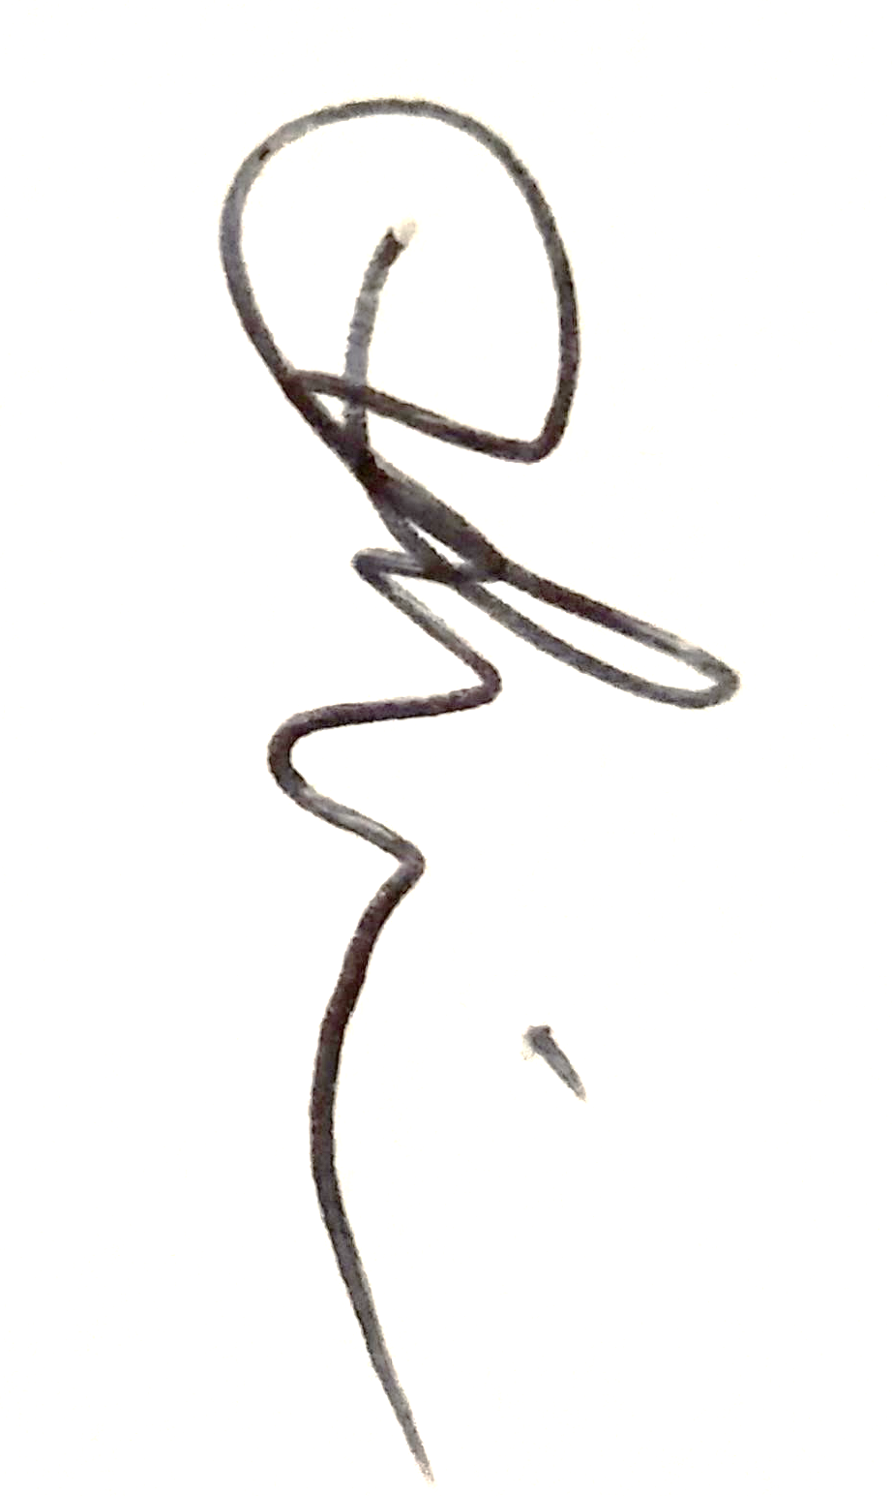
Date | 29/04/2020

Assessor name
Assessor signature
Date | Click here to enter a date.

Task | Task outcome (Tick)
Task | Satisfactory | Not Yet Satisfactory
Task 1 (Occasion 1)
Task 1 (Occasion 2)

Assessor Comments
CPCCBC4003A Select and prepare a construction contract,
CPCCBC4016A Administer a construction contract &
CPCCBC4032A Apply contract law to sales processes

Practical Task 1 (2X)
Description of task:
On two (2) occasions, a suitable observer is to verify the participant’s ability to apply contract law to residential and/or commercial construction sales processes.

The participant is to gather evidence of how they have completed each component of the Practical Task, which is to be submitted with this Practical Assessment sheet. Evidence to be submitted may include:
- Copy of a contract issued to sub-contractor for your project with relevant AS code on the front
- Proof of consultation with sub-contractor regarding contract and contract terms, inclusions and omissions (emails)
- Copy of HSE minimum requirements sent as contract condition
- Construction contracts that have been developed, signed off, or contributed to by the candidate
- Proof of correspondence with client regarding construction contract. Redact sensitive information as required.

The assessor is to verify the observer’s comments and provide the outcome for the practical task on the front cover of the Practical Assessment.
Resources required:
Two (2) pre-contract agreements; two (2) sales contracts (e.g. QBCC contracts), telephone, facsimile machine, computer.
Assessment of task
Name of participant:
Name of observer:
Role of observer
(Confirm suitability to sign)
Email address of observer
Signature of observer:
Date: | Click here to enter a date.
When completing the task, did the participant: |  | Tick if satisfactorily completed.  Provide comments if left unticked.
 |  | 1st  Occasion | 2nd  Occasion
- Explain to the client:
- Essential terms and elements of a valid contract
- Types and purposes of agreements employed with the industry (including sales contracts and pre-contract agreements)
- The range of documents that collectively make up a contract (including construction schedules, reports, specifications)
- The importance of the contract to sales process
- Implications of legislation, regulations and codes of practice (including Australian Consumer Law)
- Discuss and agree upon clauses of a pre-contract agreement, including payment or deposit.
- Ensure the pre-contract agreement is signed and processed according to organisational requirements.
- Select appropriate contract and seek expert advice in the preparation of the contract, considering:
- Contract rise and fall amounts
- Schedule of progress payments
- Processes for applying of extensions of time
- Break down contract clauses/terms/conditions with the client, including:
- Rights, liabilities and potential penalties of parties under the contract
- Definitions of building work, common contract terms and procedures, considering –
  - Practical completion and issuing a final certificate
  - Defects liability and completion at the cost of the contractor
  - Effect of ousting the contractor from the building or site
- Cooling off periods
- Provisional sum and prime cost allowances
- Measures to be taken in the event of an anomaly in the rendering of the contract, considering –
  - Variations
- Circumstances that bring about a breach and termination of contract, considering –
  - Unreasonable/vexatious notice
  - Abandonment of a contract
  - Methods for resolving contractual disputes
- Effectively communicated with clients, subcontractors, colleagues and external parties using the following methods:
- Verbally using language/concepts appropriate to cultural differences
- Non-verbal communication
- Using technology (including telephone, facsimile, email)
- In writing (including drafting responses to queries about contracts)
The participant’s performance was: Satisfactory Not Satisfactory

observer Comments

