BSBITU313
Design and produce digital text documents
Learner Guide


Table of Contents

Unit of Competency 4
Application 4
Performance Criteria 5
Foundation Skills 6
Assessment Requirements 7
1. Prepare to produce documents 9
1.1 – Adjust workspace, furniture and equipment to suit user ergonomic environments 10
Ergonomic requirements 11
Work organisation strategies 14
Activity 1A 16
1.2 – Ensure workspace meets organisational requirements related to work health and safety, and energy and resource conservation, taking into account the type of digital device to be used 17
Using energy and resource conservation techniques 18
Taking into account your device 19
Activity 1B 20
1.3 – Identify document purpose, audience and presentation requirements, and clarify with relevant personnel as required 21
Purpose, audience and presentation requirements 21
Other documents 23
Clarifying with relevant personnel 25
Activity 1C 26
1.4 – Identify organisational and task requirements for text-based business documents to ensure consistency of style and image 27
Organisational and task requirements 27
Activity 1D 31
1.5 – Select most appropriate word processing application to produce document, in accordance with available resources and organisational policies 32
Word processing applications 32
Additional considerations 32
Activity 1E 33
2. Design documents digitally 34
2.1 – Design document structure and layout to suit purpose, audience and information requirements of task 35
Designing the structure and layout of document 35
Activity 2A 40
2.2 – Design document to enhance readability and appearance, and to meet organisational and task requirements for style and layout 41
Enhancing readability and appearance of a document 41
Organisational and task requirements 46
Activity 2B 47
2.3 – Use available application functions to ensure consistency of design and layout, adhering to organisational and task requirements 48
Consistency of design and layout 48
Style sheets 50
Automatic functions 53
Activity 2C 55
2.4 – Insert a standard table into document, changing cells, columns, and rows as necessary to meet information requirements 56
Inserting tables 56
Activity 2D 58
2.5 – Insert and format visual elements (including, for example, images or icons) to meet organisational and task requirements for style and layout 59
Visual elements 59
Formatting 64
Activity 2E 65
3. Produce text documents digitally 66
3.1 – Use intermediate-level application functions to enable efficient production of digital text documents 67
Using advanced software functions 67
Activity 3A 73
3.2 – Enter or import, and edit text and other data to meet task requirements 74
Entering and importing text 74
Editing text 75
Entering, importing and editing other data 75
Activity 3B 76
3.3 – Preview, adjust and prepare documents for delivery in accordance with organisational and task requirements 77
Preview and print 77
Activity 3C 82
3.4 – Name and store document, in accordance with organisational requirements and exit application without information loss/damage 83
Naming documents 83
Storing documents 84
Exiting without information loss or damage 85
Activity 3D 86
3.5 – Deliver document within designated timelines and organisational requirements for speed and accuracy 87
Timelines 87
Time management 87
Activity 3E 89
3.6 – Use relevant help functions to overcome intermediate issues with document design and production 90
Overcoming problems 90
Manuals 90
User documentation 90
Online help 91
Activity 3F 92
Summative Assessments 93

Unit of Competency

Application

This unit describes the skills and knowledge required to digitally design and develop text-based documents using advanced features of word processing applications/platforms.
It applies to individuals who possess fundamental skills in digital device operation, and basic skills in operation of word processing applications. They may work as individuals who provide administrative support within an enterprise, or may be technical/knowledge experts responsible for production of their own digital documents.
No licensing, legislative or certification requirements apply to this unit at the time of publication.
Unit Mapping Information

BSBITU303 Design and produce text documents – Equivalent unit
Unit Sector

Information and Communications Technology – IT Use

Performance Criteria
Element  Elements describe the essential outcomes. | Performance Criteria  Performance criteria describe the performance needed to demonstrate achievement of the element.
- Prepare to produce text documents | - Adjust workspace, furniture and equipment to suit user ergonomic environments  - Ensure workspace meets organisational requirements related to work health and safety, and energy and resource conservation, taking into account the type of digital device to be used  - Identify document purpose, audience and presentation requirements, and clarify with relevant personnel as required  - Identify organisational and task requirements for text-based business documents to ensure consistency of style and image  - Select most appropriate word processing application to produce document, in accordance with available resources and organisational policies
- Design documents digitally | - Design document structure and layout to suit purpose, audience and information requirements of task  - Design document to enhance readability and appearance, and to meet organisational and task requirements for style and layout  - Use available application functions to ensure consistency of design and layout, adhering to organisational and task requirements  - Insert a standard table into document, changing cells, columns, and rows as necessary to meet information requirements  - Insert and format visual elements (including, for example, images or icons) to meet organisational and task requirements for style and layout
- Produce text documents digitally | - Use intermediate-level application functions to enable efficient production of digital text documents  - Enter or import, and edit text and other data to meet task requirements  - Preview, adjust and prepare documents for delivery in accordance with organisational and task requirements  - Name and store document, in accordance with organisational requirements and exit application without information loss/damage  - Deliver document within designated timelines and organisational requirements for speed and accuracy  - Use relevant help functions to overcome intermediate issues with document design and production

Foundation Skills
This section describes language, literacy, numeracy and employment skills incorporated in the performance criteria that are required for competent performance.

Reading
- Recognises and interprets textual information from a range of sources to determine and adhere to requirements.
Writing
- Develops documents using required format, accurate spelling and grammar and terminology specific to requirements
- Organises content to support purpose and audience of material using clear and logical language.
Oral communication
- Uses specific and direct language, and listening and questioning techniques to clarify requirements.
Navigate the world of work
- Recognises and follows explicit and implicit protocols and meets expectations associated with own role.
Interact with others
- Collaborates with others to achieve joint outcomes.
Get the work done
- Uses advanced features within digital applications to address routine and complex work tasks.

Assessment Requirements
Performance Evidence
Evidence of the ability to:
- Follow correct ergonomic and conservation requirements, and relevant organisational policies and procedures
- Design and produce digital text documents that align to document purpose and are appropriate to target audience
- Adhere closely to task requirements and required specifications by:
- following designated timelines
- achieving consistency of style and image
- ensuring correct editing and style requirements
- adhering to designated timelines
- Use application features for intermediate-level document design
- Communicate effectively with relevant personnel
- Overcome problems by referring to application help functions.
Note: If a specific volume or frequency is not stated, then evidence must be provided at least once.
Knowledge Evidence
The candidate must be able to demonstrate the following knowledge to effectively complete the tasks outlined in the elements and performance criteria of this unit, and to manage tasks and reasonably foreseeable contingencies in the context of the work role.
- Key elements of intermediate-level formatting styles and their impact on formatting, readability and appearance of documents
- Key strengths and limitations of various word processing applications
- Key features of organisational requirements for ergonomics, work periods and breaks, and conservation techniques
- Key features relating to purpose and contents of organisational style guide.

Assessment Conditions
Assessment must be conducted in a safe environment where evidence gathered demonstrates consistent performance of typical activities experienced in the information and communications technology – IT use field of work and include access to:
- Office equipment and resources
- Relevant word processing applications
- Relevant organisational policies and procedures
- Examples of correctly formatted text documents
- Relevant workplace documentation and resources including style guides and user manuals.
Assessors of this unit must satisfy the requirements for assessors in applicable vocational education and training legislation, frameworks and/or standards.
Links
Companion Volume implementation guides are found in VETNet - https://vetnet.education.gov.au/Pages/TrainingDocs.aspx?q=11ef6853-ceed-4ba7-9d87-4da407e23c10

1. Prepare to produce documents
1.1. Adjust workspace, furniture and equipment to suit user ergonomic environments
1.2. Ensure workspace meets organisational requirements related to work health and safety, and energy and resource conservation, taking into account the type of digital device to be used
1.3. Identify document purpose, audience and presentation requirements, and clarify with relevant personnel as required
1.4. Identify organisational and task requirements for text-based business documents to ensure consistency of style and image
1.5. Select most appropriate word processing application to produce document, in accordance with available resources and organisational policies


1.1 – Adjust workspace, furniture and equipment to suit user ergonomic environments
By the end of this chapter, the learner should be able to:
- Identify three ways to adjust the workspace, furniture and/or equipment according to ergonomic requirements.
This unit will explore the skills and knowledge required to digitally design and develop text-based documents using advanced features of word processing applications/platforms.
The text documents you are required to produce will differ depending on the nature of your organisation as well as your own role.
For example, documents may include:
- Brochures
- Calendars
- Faxes
- Flyers

- Forms
- Mail merge documents, including labels
- Memos
- Multi-page letters
- Promotional material
- Reports
- Schedules
- Tables.

Ergonomic requirements
When producing your text-based documents, you will need to consider any ergonomic requirements that may be relevant to you. Ergonomic requirements are related to improving visibility and accessibility whilst keeping stress and mental fatigue from sounds, vibration, motion and shock at a minimum.
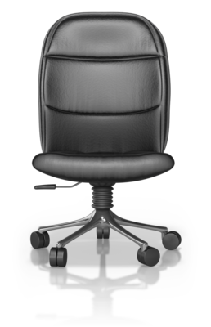
Ergonomic requirements may include:
- Avoiding radiation from computer screens
- Chair height, seat and back adjustment
- Document holder
- Footrest
- Keyboard and mouse position
- Lighting
- Noise minimisation
- Posture
- Screen position
- Workstation height and layout.

Avoiding radiation from computer screens
Tips for avoiding computer radiation include:
- Avoid working in front of your computer for too long
- Use an LED monitor
- Keep a safe distance from your monitor
- Use radiation protection on your computer screen
- Consume plenty of Vitamin A and C (these can help reduce harmful effects of computer radiation)
- Put plants around your computer (they help to absorb some of the harmful radiation)
- Wash your face (particles of radiation can attach themselves to your face)
- Take regular breaks.

Chair height, seat and back adjustment
When you are sat at a desk all day, your chair is a crucial component of your environment. Your chair should allow you to be comfortable whilst accommodating your work surfaces and permitting you to perform your required tasks. The height of your chair is really important; it should adjust to allow you to place your feet on the floor (or footrest) whilst being able to reach your work surface. In order to fully support your back and knees, your chair should allow for the adjustment of the seat or backrest.
Document holder
If required, a document holder should be available for supporting your documents. Depending on how your specific document is going to be used, depends on where you should keep it on your work surface.
Footrest
If you cannot rest your feet comfortably on the floor whilst you are seated, then you should use a footrest.
Keyboard and mouse position
Your mouse and keyboard should be positioned at the same height next to each other, as close as possible in order to minimise reaching. They should both be at a height that allows your forearms, wrists and hands to be parallel to the floor. In order to maintain the best possible posture, your keyboard should be lower than a typical writing surface. If your workspace cannot accommodate a keyboard and mouse, an under-desk support device should be used.
Lighting
Although working at a computer requires a lower overall light level than other tasks, the lighting within your work area should be set up in a way that minimises visual discomfort (e.g. glare).
The glare from natural and overhead light sources should be minimised as much as possible, for example:
- Rather than directly below overhead lights, position the computer between rows of lights
- Have blinds up at any windows in order to control light when necessary
- Tilt monitor downward to reduce any reflection
- If necessary, use a good-quality anti-glare filter on your monitor.
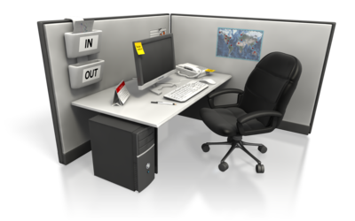
Noise minimisation
Before you start your task, try to identify any distracting noises and think of ways you can reduce these.
For example, use:
- Earplugs
- Headphones
- Soft music
- A quiet fan.
Posture
Key tips for maintaining good posture when sat at your computer include:
- Keep elbows close to waist
- Keep neck and shoulders relaxed
- Keep forearms, wrists and hands parallel to the floor
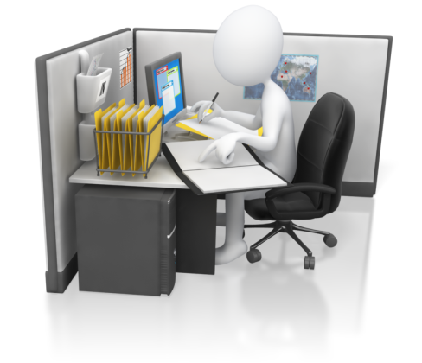
- Keep your mouse close
- Keep your monitor at arm’s length
- Keep your feet rested comfortably on the floor/footrest
- Adjust the backrest of your chair to ensure full support
- Avoid ‘hunching’
- Don’t twist your neck.
You should alternate between different postures regularly but remain in a neutral position at all times.
Screen position
Ideally, the screen of your computer should be at about arm’s length and positioned so that the top of the screen is around eye level.
Workstation height and layout
Your work surface should complement the task that you are performing whilst accommodating your legs when you are sat in your comfortable position.
Other things to consider about your workstation include:
- Is it private?
- Is it isolated?
- Is it an open space?
- Do you have natural or artificial light?
- Is the layout appropriate?
- Can it be personalised?
As well as the points discussed above, there are many other things to think about.
For example:
- The layout of your desk
- The way you use the telephone (if applicable)
- The technique and speed that you use to type.
Although the points discussed above give you a guideline of the ergonomic requirements you should follow when working at your computer to produce text-based documents, it is worth noting that your ideal requirements may differ from someone else’s. You should work in the way that is safe and comfortable for you. More information about safe work practices can be found at www.safeworkaustralia.gov.au.

Work organisation strategies
Prolonged, static postures will take their toll on your body. You need to address work organisation strategies as well as ergonomic requirements in order to avoid injury when working at your computer for long periods of time.
Work organisation strategies may include:
- Exercise breaks
- Mix of repetitive and other activities

- Rest periods.
Exercise breaks
Whilst sat at your computer; you should do small exercises at regular intervals.
These small exercises may include:
- Head rolls
- Shoulder lifts
- Wrist drops.
Mix of repetitive and other activities
Make sure you take time away from your computer. You should avoid long periods of the same activity; do other tasks to give you a little break from your computer. You should alternate between work activities that use different muscles in your body in order to avoid overuse.
Rest periods
When working at your computer, you should remember to take frequent mini breaks in order to refresh and relax your muscles and joints. Have little ‘stretch’ breaks and look away from your screen every now and then to give your eyes chance to rest too. Make sure your ‘lunch break’ actually involves a break; get away from the computer. Remember to keep moving.
Using the information above, make sure you use safe work practices at all times when sat at your computer producing text-based documents. Take into consideration the policies that may be in place within your own organisation.
The process of assessing the ergonomic conditions and work organisation strategies of your workplace may need to be handled by yourself on a daily basis.
For example, before starting your work each day or throughout your day you may ask yourself:
- Am I having regular breaks to keep stress reduced?
- Am I doing exercises at my computer regularly?
- Do I alter my posture often enough?
- Am I using my keyboard and mouse appropriately?
Other areas should be managed under a risk assessment; this is the responsibility of the Human Resources (HR) department within an organisation. A risk assessment allows for the evaluation of potential risks; it is an employer’s responsibility to provide a safe workplace.
The image below summarises the ergonomic issues that have been discussed in this chapter. The image can be found at http://www.ergonomics-info.com/office-computer-ergonomics.html
(Accessed 20.11.2018)
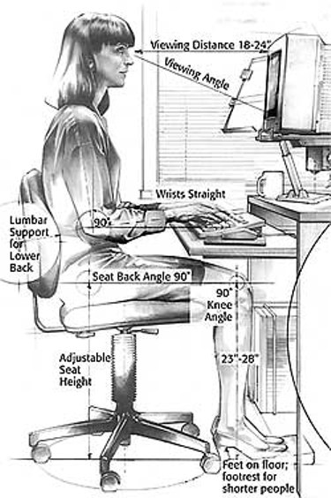


Activity 1A

1.2 – Ensure workspace meets organisational requirements related to work health and safety, and energy and resource conservation, taking into account the type of digital device to be used
By the end of this chapter, the learner should be able to:
- Use one safe work practice for each of the following requirements:
- work organisation
- energy and resource conservation.
During your working practice, you will need to ensure that your workplace is a safe and productive environment. Your organisation is likely to have requirements already in place which you will need to make yourself aware of and follow at all times.
The policies that may exist within an organisation may relate to:

- Regular formal or informal health and safety meetings
- Reporting of potential hazards or risks
- The way to use equipment correctly
- Keeping workspaces clean, tidy and organised
- Legislation that applies to the organisation
- Emergency/accident procedures
- Storage and maintenance guidelines
- Manufacturer instructions
- Use of Personal Protective Equipment (PPE).
Remember that although it is the employer’s responsibility to provide a safe work environment, it is your responsibility to show compliance with the policies that are in place.

Using energy and resource conservation techniques
Within the workplace, it is essential to use energy and resource conservation techniques. Not only does it keep your (or your organisation’s) bills down, it helps to protect non-renewable resources. From simply turning off the lights to recycling every last scrap of paper, conserving energy and resources is a must.
Top areas to consider improving include:
- Heating
- Lighting
- Water
- Paper use.
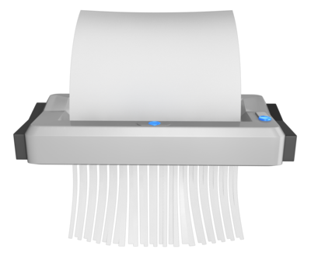
For the production of text documents, the energy and resource conservation techniques you need to consider may include:
- Double-sided paper use
- Recycling used and shredded paper
- Re-using paper for rough drafts (observing confidentiality requirements)
- Utilising power-save options for equipment.
Double-sided paper use
Try and maximise your paper usage by printing double-sided. Most printers will do this nowadays; you just need to adjust the settings. Also, try to get into the habit of using the ‘print preview’ feature (if there is one available) to catch any errors before printing your document. This will help to save paper too; every little thing will make a difference.
Recycling used and shredded paper
Make sure you don’t throw old documents away; recycle them. Use the recycling system that is in place within your organisation. If they don’t have one, make your own system. Aim to only use recycled paper too; think of the trees.
Re-using paper for rough drafts
For documents you have printed one-sided or only used up half of the page; turn this into scrap paper. Use it to jot down your ideas and rough drafts. Remember to recycle when you’re done.
Utilising power-save options for equipment
In order to conserve energy when using your electrical equipment, utilise their power-save options. Most computers, if not all, will have built-in energy saving software. Find out what energy saving mechanisms your own computer has. These options allow you to set your computer to go to ‘sleep’ after periods of inactivity.
Although it will not shut down your computer fully (so you won’t lose anything), it will consume much less energy. It is worth noting that screen savers do not count; they do not reduce the amount of power used by your computer.
Other tips for conserving the energy used by your electrical equipment include:
- Switch them off when you are not using them, even if it’s just a break
- Turn the brightness of your screen down
- Don’t leave your equipment on standby mode
- Use efficiency rated equipment
- Unplug devices (like scanners and cameras) when they are not in use
- Plug your devices into a power strip; unplug it at the end of the day.
In order to minimise waste of energy and resources, supervisors or management should aim to:
- Plan ahead and have realistic expectations

- Prioritise and delegate jobs appropriately
- Discourage multiple drafts
- Use relief staff
- Teach and train where necessary
- Provide support
- Clearly define jobs.

Taking into account your device
When considering the safest way to work, you should consider the type of device(s) which you are going to be using. For example, the most appropriate ergonomic requirements and energy and resource conservation techniques to adopt when using a laptop are likely to differ than when using a static, desktop computer. You will need to analyse your environment in order to select and adhere to the most appropriate health and safety requirements.

Activity 1B

1.3 – Identify document purpose, audience and presentation requirements, and clarify with relevant personnel as required
By the end of this chapter, the learner should be able to:
- Identify the intended purpose and audience of a given document
- Determine whether a finished document meets presentation requirements
- Suggest one way to clarify document requirements with the relevant personnel.

Purpose, audience and presentation requirements
There are many different text documents which you might be required to produce within your role.
To recap, documents might include:
- Brochures
- Calendars
- Faxes
- Flyers

- Forms
- Mail merge documents, including labels
- Memos
- Multi-page letters
- Promotional material
- Reports
- Schedules
- Tables.
Regardless of the type of document you are producing, you will always need to identify the purpose, audience and presentation requirements.
When looking at the purposes of documents, there are four general categories which can be identified:
- To give instructions
- To persuade the reader
- To provide information
- To prohibit something.
Once you know which document you are required to produce, you can determine the tone of the language that you should use. For example, should the document be formal or informal? This will depend on the nature of the document and the audience that it is intended for.
Let’s take a look at some examples of documents and their possible purpose, audience and presentation requirements.
Brochures
Generally, brochures are a standard size piece of paper folded two or three times to create a booklet. They are more complicated to print as each page has its own properties such as margins, headings and images. They are usually produced with the intention that people will keep them and refer to them when necessary. Usually, only the people that are interested in the specific topic of the brochure will pick one up. For example, only an expectant parent would pick up a brochure covering pregnancy from the rack in their doctor’s surgery. Using this example, the presentation requirements would relate to its purpose and the intended audience; providing information for an expectant parent. Consider the best way to present them this information. Should you use images or bullets to keep it as simple as possible?
Flyers
A flyer, also known as a leaflet, is usually only a single piece of paper, often A4 size. It is a relatively cheap way to get information out to a large number of people. The purpose of a flyer is to offer a small amount of information at a low cost, for a limited amount of time. The audience of your flyer will often depend on the purpose. For example, if you were producing a flyer to promote a nightclub opening, your intended audience would probably be young people, maybe students. In turn, the presentation requirements of the flyer will often depend on the purpose and the audience.
When considering the presentation of your flyer, think about:
- Whether you are going to print on one or both sides
- What colours you are going to use
- How to emphasise any important details.
Promotional material
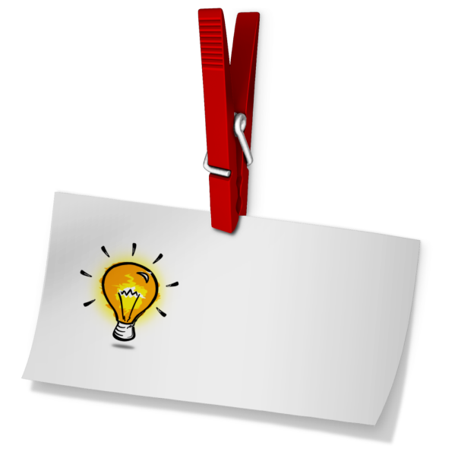
Promotional material can be used by an organisation to market their products and services. Promotions are completely different from advertisements; they are not as expensive and just act as an incentive for your customers. Promotional material can help to increase brand recognition and strengthen customer loyalty.
Examples of promotional material include:
- Keyrings
- Leaflets
- Mugs
- Bookmarks
- Posters
- Pens
- Bags and stickers.
Promotional material can serve many purposes before or after a sale, including:
- Providing product information
- Promoting an organisation
- Reminding your customers about your organisation
- Drawing attention to products.
The audience of your promotional materials will depend on the products and services you offer or your organisation itself.
The presentation of your promotional materials will also depend on your organisation, the products or service you offer, as well as the type of promotional material you are using and your intended audience.
The presentation of your promotional materials should always look professional and may include:

- Company colours
- Different size fonts
- Different materials
- Company logo
- Different backgrounds
- Having important points in bold
- Contact details.

Other documents
Other types of documents include:
- Minutes
- Press release
- Meeting agenda
- Technical/user documentation
- Project proposal.
Minutes
Minutes are part of a meeting that are usually recorded by a professional in order to avoid error. They can be classed as a legal record of what has been said within a meeting.
Depending on the meeting and organisation, minutes can be:
- Handwritten
- Recorded (visual or audio)
- Typed in a Microsoft Word document
- Typed in a Microsoft Excel document
- Scribbled down and typed at a later date.
Press release
A press release is a written communication often composed by marketing staff. Its purpose is to announce something of value to the media. They are created carefully in order to avoid any errors; these errors can be damaging and legally costly. Microsoft Word is usually the choice of program to create a press release and will be reviewed by the relevant people before being released.
Meeting agenda
A meeting agenda will usually be distributed to the people that are involved in the meeting in question. It should consist of a list of topics that are going to be discussed. The way that these agendas are produced will depend on the nature of the meeting; Microsoft Word or as an email (or attachment).
Technical/user documentation
User documentation is often written for a large audience – the users of a particular program or product. On the other hand, technical documentation is usually aimed at the experts within a specific field. The purpose and audience will, therefore, affect the presentation requirements. Depending on their purpose and their audience, these types of documentation are often accompanied by a PowerPoint presentation.
Project proposal

The purpose of a project proposal is to outline and clarify the aim and objectives of the specific project.
It can include many sections, including:
- Budget
- Timetable
- Work plan
- Outcomes.
The sections that are included may depend on the nature of your project or the organisational requirements that are in place.

Clarifying with relevant personnel
Once identified, the purpose, audience and presentation requirements of your document should be clarified by the relevant personnel. This may be your manager or Human Resources manager, for example.
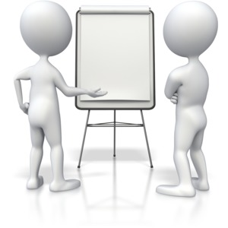
Identifying the relevant personnel will also allow you to identify how best to gain clarification. For example,depending on your relationship with the person(s) you may be able to do this over email, or it may be preferred that discussions take place during a face-to-face meeting.

Activity 1C

1.4 – Identify organisational and task requirements for text-based business documents to ensure consistency of style and image
By the end of this chapter, the learner should be able to:
- Alter the letter provided to be in line with the style requirements.

Organisational and task requirements

When preparing to produce a text-based business document, you should identify any organisational and task requirements that are related to your project. Every organisation will have a set of guidelines (style guide) in place for producing text-based business documents in order to comply with the company image and ensure consistency. Every document that you produce should have the same ‘feel’ and be professional in portraying your organisation.
Organisational requirements may include:
- Company colour scheme
- Company logo
- Consistent corporate image
- Content restrictions
- Established guidelines and procedures for document production
- House styles
- Observing copyright legislation
- Organisation name, time, date, document title, filename, etc. In header/footer
- Templates.
These organisational requirements will apply to all of the document types that were discussed in the previous chapter.
Company colour scheme
Deciding on a company colour scheme is not as easy as it sounds. The human mind is highly responsive to colour. Therefore it should be considered carefully.
Let’s look at the things that can be associated with certain colours:
- Red implies danger, aggression, warmth or passion
- Green implies ethics, growth, freshness and finance
- Purple implies luxury, wisdom, wealth and royalty
- Blue implies seriousness, professionalism, authority and calm
- Yellow implies warning, sun, happiness and friendliness.
Tips for choosing colours schemes for your documents:

- Understand your audience
- Analyse other colour schemes
- Think about how your colours will look using different devices
- Be different
- Think about the psychological responses of your colours
- Do your research.
Regardless of which colour scheme your organisation requires you to use within your text-based business documents, make sure you stick to it. Your chosen colour scheme needs to be appropriate for the document you are creating and its audience whilst sticking to your organisational image.
Company logo
A company logo is a symbol that is used by organisations in order to create and promote recognition. It acts as a visual representation of everything that your organisation stands for.
A good logo can:
- Lead to more business
- Enhance first impressions
- Indicate professionalism
- Build loyalty
- Establish brand identity.
Think about the logos you come across on a daily basis. What makes you look at them? What makes you remember them?
Whatever your company logo is, you should ensure it is included within your text-based business documents wherever necessary. When using your company logo, consider its positioning and size carefully.
Consistent corporate image
In order to maintain your organisation’s image and its branding identity, it is essential that you produce documents that are consistent with your organisation. The lack of consistency will have a negative effect on your organisation’s image and identity.

It may be a good idea to have and refer to guidelines, for example:
- What materials to use
- What fonts to use
- What colours to use and how to use them
- Logo size and positioning
- Spacing usage
- How to use images.
When you are creating text-based business documents, keep your organisation’s image in the back of your mind. If there are templates available; use them. If you don’t have templates to use, make sure your document looks like it belongs to your organisation. Don’t use anything that isn’t consistent with your company’s image or identity.
Content restrictions
When you are planning to produce text-based business documents, you should ensure that there are no restrictions regarding the content you can include.
Established guidelines and procedures for document production
When producing your text-based business documents, you should follow any guidelines and procedures that are in place within your organisation. Doing so will ensure consistency within your documents.
House styles
House styles are the styles of document production that an organisation has developed. There are many advantages of using house styles, including consistency between your documents. House styles should be simple otherwise the document can be confusing and quite difficult to produce.
House styles may include many features, for example:

- Margin size
- Header and footer content
- Font type and size
- Document layout
- Heading style
- Logo position.
Observing copyright legislation
The Australian Copyright Act 1968 outlines the legislation that is in place regarding copyright. You need to be aware of this when producing your text-based business documents.
You can find more information at www.comlaw.gov.au.
Organisation name, time, date, document title, filename, etc. In header/footer
The information you include within the headers and footers of your documents is your decision. It is worth checking to see if there are any guidelines within your organisation as to what you should include. Whether it’s the date, the organisation name or the document title, this should be consistent throughout your documents.
Templates
Within some organisations, there will be existing templates you can use as a starting point when producing your own text-based business documents.
By using a template, you can ensure that all your documents have the same properties, including:
- Styles
- Layouts
- Spacing
- Fonts
- Sizes.
You should consider using the existing templates within your programs and organisations. If there isn’t one or they don’t suit your needs, then think about developing one. It will save you time in the future and will make sure that all of your documents are consistent in style.
These organisational and task requirements need to be identified in order to ensure consistency of the style and image of your text-based business documents. Refer to organisational templates and style guides if you are uncertain of how to keep your documents consistent.

If you are involved in the development of a policy or guideline relating to the standards of documents, consider:
- It's title
- The policy statement
- The purpose of having it
- The scope that it covers
- The objectives of the policy
- The details of the policy.

Activity 1D

1.5 – Select most appropriate word processing application to produce document, in accordance with available resources and organisational policies
By the end of this chapter, the learner should be able to:
- Select the appropriate application to use to produce a range of documents.

Word processing applications
There may be a number of word processing application for you to choose from when producing text documents, and you will need to select the one which is most appropriate for your job.
Some examples of word processing applications include:
- Microsoft Word

- WordPerfect
- Lotus Word Pro
- iWork Pages.
Whilst most applications will work in a similar way, they are likely to have different functions and features which will work better for different purposes.
For example, some functions of Microsoft Word include:
- Spell check
- Headers and footers
- Paragraph styles
- Tables.
The best way to determine the most appropriate application will be to analyse the task at hand. Determining the specific requirements will better allow you to determine your needs and how best to create a successful document.

Additional considerations
When selecting the most appropriate word processing application, you will need to take into consideration the resources which are available to you. Depending on the preferences of your organisation, there may only be one application available, or you may have the option to choose from a number of different ones.
You will also need to consider any policies which are in place within your organisation . For example, these might be related to the specific applications you should use for specific tasks, or the way in which applications should be used.
If you are unsure of the resources available to you or organisational policies in place, it will be a good idea to consult with the relevant person(s) before you begin a task.

Activity 1E

2. Design documents digitally
2.1. Design document structure and layout to suit purpose, audience and information requirements of task
2.2. Design document to enhance readability and appearance, and to meet organisational and task requirements for style and layout
2.3. Use available application functions to ensure consistency of design and layout, adhering to organisational and task requirements
2.4. Insert a standard table into document, changing cells, columns, and rows as necessary to meet information requirements
2.5. Insert and format visual elements (including, for example, images or icons) to meet organisational and task requirements for style and layout

2.1 – Design document structure and layout to suit purpose, audience and information requirements of task
By the end of this chapter, the learner should be able to:
- Identify how to improve the design of a document to suit the purpose, audience and requirements given.

Designing the structure and layout of document
The structure and layout of your document should be designed in a way that suits its purpose, audience and information requirements. This may relate to the requirements of your organisation too.
Although the structure and layout of your documents may vary depending on the type of document you are creating, this chapter will look at some of the best ways to design the structure and layout in a way that suits its purpose, audience and relevant requirements.
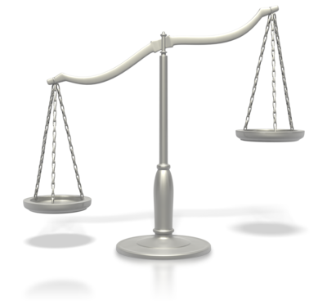
Design may include:
- Balance
- Diversity
- Relative positioning of graphics and headings
- Simplicity
- Text flow
- Typography.
Balance
Within design, balance is the concept of equilibrium within your document. Our sense of balance is innate, and you should aim to develop documents that offer visual stability. When elements aren’t balanced on the page, this can be quite disturbing and uncomfortable. When considering balance, it’s a good idea to imagine an axis. The visual weight should be equal on either side of your imaginary axis.
There are two main ways to achieve a balance within your document: through symmetry or asymmetry.
Symmetry:
- Is a mirror image
- Repeats a reversed design on opposite side of axis
- Is formal
- Is ordered
- Can often be boring.

Asymmetry:
- Achieves balance through contrast
- Is informal
- Involves different elements that have equal visual weight
- Considered more interesting
- Is more dynamic.
By ensuring that your design is balanced, you can be sure that your document will be structured in a way that suits its purpose, audience and requirements.

Diversity
Within your document, aim to demonstrate diversity:
- Use a range of different things
- Give a variety
- Be different
- Strive to be unique
- Don’t be like anything else.
Relative positioning of graphics, headings and white space
The relative positioning of the graphics, headings and white space within your document will ensure that it suits the purpose, audience and requirements of the document.
Relative positioning is a confusing concept and is often misused. The original position of any element is static; this will fall where you expect it to (this depends on the structure of your document). Within relative positioning, you can use top, bottom, left and right to move an object to a specific point on your page. What is unique about this positioning is the starting point; the element’s starting point is the point where it normally is within the flow of the document. It is helpful for when you need to slightly tweak the position of one of your objects, rather than completely resetting it.
Simplicity
Simplicity creates impact, and when used within text-based business documents, it can help keep the structure and layout suited to the purpose, audience and requirements of the document.
There are many ways to ensure the simplicity of your document, including:
- Only use one single typeface design
- Keep your document organised
- Use a straightforward layout
- Keep your structure basic.
Text flow
Text flow is the way in which you allow your text flow from page to page or column to column. The software that you are using will work out when the text will no longer fit on the page and start a new page.
Your software does this using:
- The formatting of your document
- The formatting of your paragraphs
- The margins you have set up
- The size of the paper you are using
- The type of printer that you are using.
Also, within some kinds of documents that you will need to design and produce; you can control how your text flows within columns. It is possible to create a link between the text boxes you wish your text to flow between. In this case, when the first box is full of text, it will automatically flow into the next box; and so on. Text flow can help you structure documents in a way that suits its purpose, audience and requirements.
Typography
Typography is the technique of arranging letters and words in a way that makes written language readable. Within the production of your documents, you will compose your text in a readable, visually satisfying and coherent way. This is typography.
The arrangement of type involves selecting:

- Point size
- Letter-spacing
- Typefaces
- Line length
- Line-spacing.
By considering typography, you can ensure that the structure and layout of your document will suit its purpose, audience and requirements.
When designing the structure and layout of your document, there are many elements that you may need to consider.
The elements within the structure and layout of your design may include:
- Boxes
- Colour
- Columns
- Drawing

- Graphics
- Headings
- Letter and memo conventions
- Page layout
- Photographs
- Typeface
- Whitespace.
These elements should be used in a way that produces a readable and coherent document. The correct use of these elements will ensure that the structure and layout of your document suit its purpose, audience and requirements.
Let’s take a look at a standard document. Although it won’t apply to every type of document, it’s a good place to start.
What is included?
- Title page
- Contents table
- Introduction
- Body text
- Appendices and annexes.
Title page
For any document that is in a report style or format and contains multiple pages, a title page will usually be added. A title page will detail the title of the document, the date and the document number and status.
Contents table
A contents table will usually be included within certain document templates; if not, you can add one. A contents table will contain the headings that are discussed throughout the document and can help a reader locate the relevant information quickly.
Introduction
Your document may require an introduction in order to provide an explanation for why it was designed and produced. An introduction should be written logically and include the scope, background and approach discussed within the document.

Body text
The main section of a document will be the information that is relevant and needs to be included. To ensure that the document can be read with ease, consider using sections, titles, headings and sub-headings. Labelling things numerically or alphabetically can also be helpful.

Headers and footers are often included within a document and can make it easier to navigate through a document. They also make a document look professional. The information within a header or footer should be simple; the date, the file name or a page number perhaps. Too much information in a header or footer is off-putting.
For many documents, it may be necessary to insert extra elements (e.g. images, tables or graphs). These will be discussed later in the unit.
Appendices and annexes
The appendices and annexes within a document will contain any extra material that supports or complements the information discussed in the document itself. The information included in the appendices and annexes are often necessary in order to obtain a full understanding of the document.
Appendices are usually numbered 1, 2, and 3. Annexes are labelled as A, B and C.

Activity 2A

2.2 – Design document to enhance readability and appearance, and to meet organisational and task requirements for style and layout
By the end of this chapter, the learner should be able to:
- Design a document according to requirements given, aiming to enhance readability and appearance.

Enhancing readability and appearance of a document
When designing and producing a text-based business document, it is essential to select the correct layout and style; you need to ensure that it is readable and fit-for-purpose.
Different layouts and styles that you may want to consider include:
- Paper size and page orientation
- Text font, colour and size
- Headings and subheadings
- Paragraphs
- Margins and page breaks
- Headings and footers
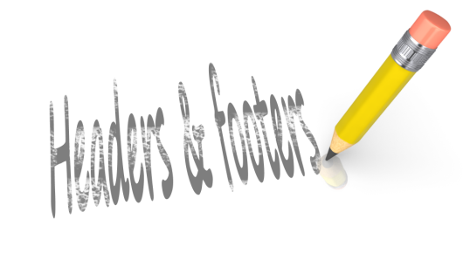
- Justification
- Spacing (line and paragraph)
- Page numbering
- Language
- Underlining, italics and bold
- Tables.
Although the different layouts and styles will depend on the type of document you are producing, the information that is included in the document and the requirements of your organisation, there are basic guidelines that can help you design your documents. Let’s have a look at some examples.
Paper size and page orientation
What size should your document be? A4? A3? That will depend on the document itself.
To adjust the page size of a Microsoft Word document, follow these steps:
- Click the ‘Page Layout’ tab
- Click the ‘Size’ tab
- Use the drop-down menu to select your desired page size.
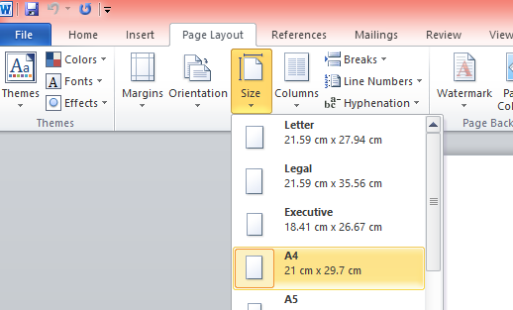
Refer to the image below.

What page orientation should your document include? Landscape or portrait? This will depend on what information is included. Although it is possible to use both, it is not advised; it can get quite confusing.
To adjust the page orientation of a Microsoft Word document, follow these steps:
- Click the ‘Page Layout’ tab
- Click the ‘orientation’ tab
- Choose portrait or landscape.
Refer to the image below.
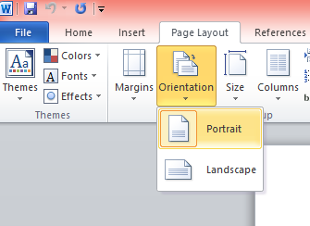

Text font, colour and size
Like everything else, the font, colour and size of your text will depend on the type of document you are producing and the organisational requirements.
Although there isn’t a standard font that is considered to enhance readability or appearance, business documents usually use Arial, Times New Roman or Calibri.
- This is Arial
- This is Times New Roman
- This is Calibri.
Usually, coloured text is not advised within business documents. However, there may be instances that you do need to use coloured text.
Don’t:
- Use neon colours
- Use multiple colours within one word.
The standard text size to use within business documents is size 12.
- This is size 8
- This is size 12
- This is size 18.
You can see why size 12 is more appropriate.
Margins and page breaks
The margin size of your document can be altered to suit your document or your organisational requirements. Margin size is usually 2.54cm.
To adjust the margins within a Microsoft Word document, follow these steps:
- Click the ‘Page Layout’ tab
- Click the ‘Margins’ tab
- Choose margin size or design a custom margin.

Refer to the image below.
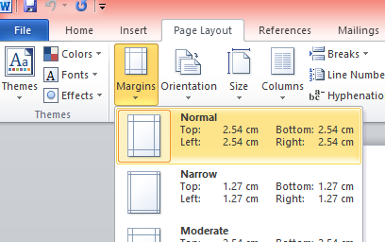
Justification
How should the text within your document be justified? Left or right? Left justification is considered to be easier to read.
To alter the justification of the text within a Microsoft Word document, follow these steps:
- Click the ‘Home’ tab
- Highlight the text you wish to justify
- Click the type of justification you wish to apply.
Refer to the image below.
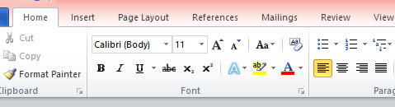

Spacing
The spacing of your document is an important element when thinking of the readability and appearance of your document. Should you use single or double line spacing? Typically, 1.0 or 1.15 spacing is used within business documents.
Refer to the image below to see which button allows you to alter the line spacing within a Microsoft Word document.
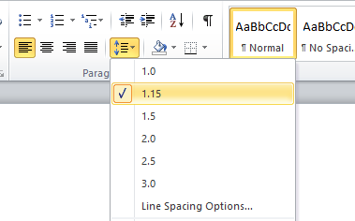
Consider the spacing of your paragraphs too – should you leave a gap between paragraphs?
Language
The language you should use within a document will depend on the type of document and the task requirements. You should consider any relevant cultural aspects. Also, consider the types of words you should use, depending on the purpose of the document. Don’t use unnecessary jargon.
Underlining, italics and bold
Again, the use of underlining, italics and bold type will depend on the document itself.
Typically:
- Underlining can be used to gain attention and clarify
- Italics can be used to emphasise certain words
- Bold can used to identify particular elements
- All three elements can be helpful within headings and subheadings.
Tables
Certain documents will require tables; these will be discussed later in the unit.

There are many different layouts and styles; the one you choose will depend on the type of business document you are developing.

Organisational and task requirements
Your document should be designed in a way that meets any relevant organisational and task requirements with regards to style and layout.
As discussed in Chapter 1.3, organisational requirements may include:
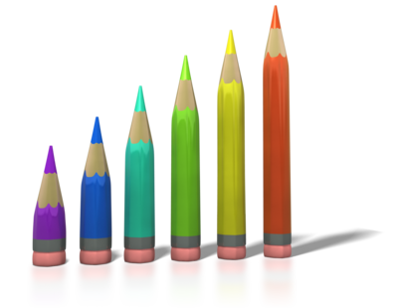
- Company colour scheme and company logo
- Consistent corporate image and content restrictions
- Established guidelines and procedures for document production
- House styles and templates
- Observing copyright legislation
- Organisation name, time, date, document title, filename, etc. In header/footer.
It is important to consider the requirements within your organisation when designing and producing any business document.
The policies and procedures surrounding business documents that exist within your organisation may outline:
- How to develop the documents and any style guides that should be used
- Where to keep copies of the documents and the correct way to store any data
- How much to spend when developing the documents
- Any quality assurance checks that may be required
- Any security issues that should be considered
- Any legal policies or procedures relating to documents.

Activity 2B

2.3 – Use available application functions to ensure consistency of design and layout, adhering to organisational and task requirements
By the end of this chapter, the learner should be able to:
- Outline how functions can be used to ensure consistency of design and layout.

Consistency of design and layout
Each document that you produce for your organisation should have the same ‘feel’. There should be consistency with everything, including the materials and packaging used. When necessary, every document should include a company logo and follow the same colour scheme.
Any templates that are designed and used within your organisation should be consistent and reflect professionalism. Using specific functions within applications will help to ensure consistency throughout the document.
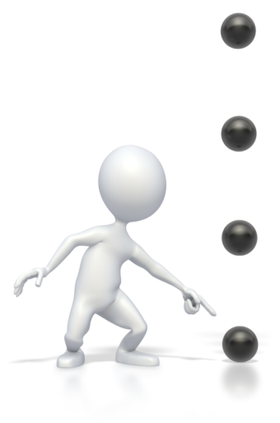
Functions used to ensure consistency of design and layout may include:
- Annotated references
- Borders
- Bullet/number lists
- Captions
- Footnotes/endnotes
- Indentations
- Page numbers
- Spacings
- Typeface styles and point size.
In order to ensure consistency of design and layout, you may need to use style sheets and automatic functions. The specific style sheets and automatic functions that you may be required to use may depend on your organisational style requirements. It is a good idea to develop a checklist to assess your documents against. This checklist should outline the guidelines that exist within your organisation.
For example:
- Balance aspects
- Colour theory aspects
- Visual design aspects
- Depth aspects
- The technical knowledge that you have.
Balance aspects
Using balance within your documents can help to avoid overloading it with information. As well as this, it can help the reader scan quickly through the document or locate their required information swiftly. You should know how to create the appropriate balance for your type of document (discussed more in Chapter 2.1). Whether you use symmetrical or asymmetrical balance may depend on the document, its purpose or your organisational requirements.
Colour theory aspects
This part of your checklist will outline what colours should be used within your documents and will, again, depend on the requirements of your organisation. The different connotations for different colours were discussed in Chapter 1.3. You should know which colours are safe and which can be combined. Think about cultural influences that may affect a colour’s meaning.
Visual design aspects
You should know what looks good for a particular document and why it does look good.
The aspects that should be considered within this part of the checklist may include:
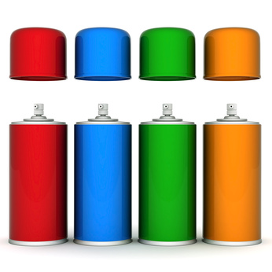
- Whitespace
- Colours
- Fonts
- Grids
- Motion
- Balance.
Depth aspects
When considering the depth aspects of a document, you should think about the content and audience. How many pages should you include? Should you have lots of pages with minimal information on them or a few pages with lots of information on them?
The technical knowledge that you have
Within this section, you should consider the most appropriate tools or software that can be used to create the document in question. You need to know what tools, time and resources that you have available before you start the process.
Once you are aware of the organisational requirements surrounding the development of a document, you should review the needs and wants of the client or customer. You should gather your content, mock up a design and check this with them. Is it good to go? Or does it need re-designing?

Style sheets
Style sheets, also known as templates, are a feature that is used in the production of many types of documents; they allow you to store and apply a specific formatting to your documents. It is a file or a form that defines the layout of a document. Style sheets will only affect the visual layout of a document – not the structure. They are useful as you can have a style sheet for each type of document that you are responsible for creating. For example, you could have a style sheet for all your business letters and a different style sheet for all your personal letters. Although they may have different names, these style sheets exist within many different programs, including QuarkXPress, PageMaker, Adobe and Microsoft Word. When using style sheets to produce text-based business documents, you can specify many things; page size, margins, spacing and text font and colour.
Within a Microsoft Word document, you are able to create a style that can be applied to all of your documents.
To do this, follow these steps:
- Right-click on the style that you wish to modify
- Click the ‘Modify…’ option.
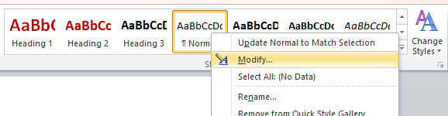

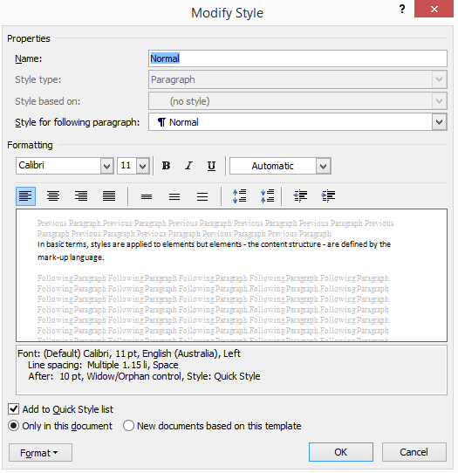
The following box should appear:
This allows you to modify the styles that you wish to use within your documents. As we can see in this example, the ‘Normal’ style contains text that is size 11 and in Calibri font.
Style sheets in HTML documents
Style sheets are commonly used within the design and development of web pages and can expand your ability to improve the appearance of your web pages.
Previous attempts to improve the presentation of web pages have created many issues. For example, the flexibility of these techniques can be limited, they create difficulties for people with a disability, and they increase the complexity of web pages. The techniques within these attempts sometimes work, for some people; but not for everyone, every single time. Whilst superseding the limited range of presentation techniques that are available in HTML, style sheets can solve the problems outlined above.
Style sheets have many benefits, including making it easier to specify:
- The indentation of lines
- The amount of white space between lines
- The colours of backgrounds and text
- The style and size of the text.
Let’s take a look at the www.training.gov.au homepage.

Now let’s look at the Cascading Style Sheets (CSS) for this homepage.
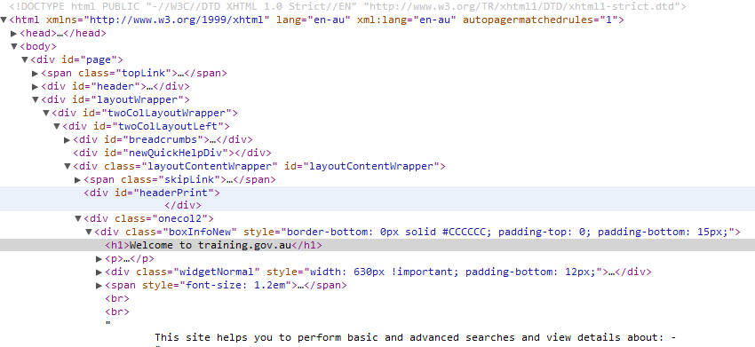
Cascading Style Sheets (CSS)
CSS is a style sheet language that is used for describing the presentation (the look and formatting) of a document.
For example, the following CSS will set the colour of the text within a paragraph as blue and surrounds it with a solid orange border:
P. special {
colour: blue;
border: solid orange;
}
Dos and don’ts
Style sheets dos:
- Do start from the top and work your way down

- Do include the important elements
- Do use other documents for inspiration
- Do markup content instead of using images
- Do use them at every possible opportunity
- Do focus on well-organised layouts that are user-friendly.
Style sheets don’ts:
- Don’t use tables
- Don’t forget to compress any images used
- Don’t have a design that is too busy
- Don’t use text within navigation menus when converting to CSS – use regular text that is readable.
Find more information about style sheets at http://www.w3.org/TR/html401/present/styles.html.

Automatic functions
There are many functions within the programs that you are using to create your documents. These functions allow for consistency within the design and layout.
Automatic functions may include:
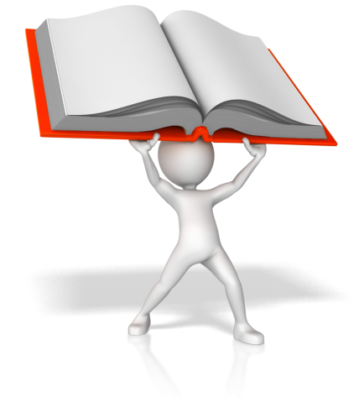
- Autocorrect
- Auto date
- Auto format
- Auto text
- Default settings
- Headers and footers
- Page numbering
- Styles
- Table headings.
Autocorrect
This feature will correct certain spelling mistakes as you type your document. This mainly focuses on common spelling mistakes. For example: if you type ‘adn’ your auto correct feature will change this for ‘and’ without you even realising.
Be careful with words such as ‘from’. If you type ‘form’ instead, it will not change it for you.
It is possible to set your own auto-correct entries; this way, you can replace an entire string of text with another.
Auto date
If you create documents that contain the date, this date will need regular updating. Rather than having to do this manually, and risk forgetting or making mistakes, the programs that you use can do this automatically. For example, you can set Microsoft Word to display a date that will automatically update.
Auto format
In order to keep the format of your documents consistent, you can use the auto format feature within some programs. As well as saving time, the auto format feature can ensure that each of your documents are formatted the same. When using the auto format feature, there are many problems that can occur which can cause frustration when creating your documents. Some aspects of the auto format feature don’t work like they should and sometimes do things irregularly. Therefore, you will need to weigh up the benefits of using an auto format feature against the risks that it imposes.

Auto text
Within Microsoft Word, the auto text feature allows you to store particular parts of your document and re-use them in the future. This can include anything from formatted text or paragraphs, to images, headers and footers. This can be helpful, can save time and can ensure consistency between your documents.
Default settings
When opening a new document, unless you choose otherwise, the program will use a default template. For example, within Microsoft Word, the default template is called ‘Normal.dot’ and unless you select a different one, this is the one that will be used.
Headers and footers

Headers and footers are often included within a document and can make it easier to navigate through a document. They also make a document look professional. The information within a header or footer should be simple; the date, the file name or a page number perhaps. Too much information in a header or footer is off-putting. By creating your own headers and footers and using these in each of your documents, you can ensure consistency of your documents.
Page numbering
By using the page numbering function within the programs that you use to create your documents, you can ensure consistency. By using the existing styles, you can ensure that your documents have the same kind of page numbering (e.g. colour, size, and font).
Styles
Styles are the aspects of document production that already exist within a program or that an organisation has developed. There are many advantages of using styles, including consistency between your documents. Styles should be simple otherwise the document can be confusing and quite difficult to produce.
Table headings
To ensure consistency within your documents, any tables that are used within them should include the same style of headings. For example, the size, font and colour of each of your table headings should be the same.

Activity 2C

2.4 – Insert a standard table into document, changing cells, columns, and rows as necessary to meet information requirements
By the end of this chapter, the learner should be able to:
- Recreate a table and make amendments according to given requirements.

Inserting tables
Tables are used in many text documents for a range of different purposes.
Tables are generally fairly simple to insert into most word processing applications, however, the process might differ slightly between each.
For the purpose of this unit, we will look at inserting tables using Microsoft Word.
First, go the taskbar at the top of the page and select ‘Insert’:
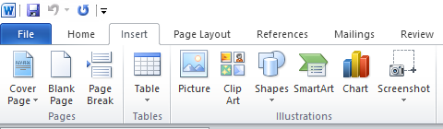
Then you can select ‘Table’ which is just underneath:

Selecting ‘Table’ will bring up your options for the size of the table:
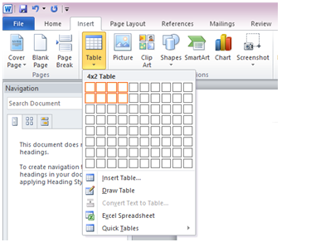
For example, in the image above a table sized 4x2 has been selected.
Note: columns and rows can be added and removed at any point, so don’t worry about getting this right first time.
Once you have selected the size and clicked to confirm, your table will appear in your document:
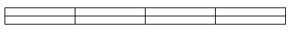
At this point, your table will be a blank canvas.
You can then carry out a variety of functions such as:
- Adding text
- Changing the size of each cell
- Adding/removing rows and columns
- Merging cells
- Amending table spacing
- Changing the colour of the table and the text within it
- Autofill column numbers.

Activity 2D

2.5 – Insert and format visual elements (including, for example, images or icons) to meet organisational and task requirements for style and layout
By the end of this chapter, the learner should be able to:
- Create a poster inclusive of two visual elements according to task requirements.

Visual elements
Visual elements can add a new dimension to your document. Elements such as images, icons and logos can change your plain text document into something more interactive and engaging. There are many different visual elements which can be added to a word document, and we will explore a few throughout this chapter.
Note: for the purpose of the unit we will explore how to insert and format visual elements in Microsoft Word. Different applications may differ, and you will need to identify how to do this according to applications available to you.
Pictures
There are many different pictures which you might be required to insert in a word document. For example, you might add a company logo or a picture of the work team.
Pictures which are saved on to your device can be inserted directly into a word document by simply selecting Insert and then Picture:
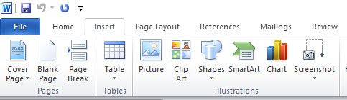
A window will then appear allowing you to select a picture from your device.
Clip Art
Clip Art provides stock images which can be added to your document. These can be a good option for when you want to liven up a document, but you don’t want to add personal images.
To insert a Clip Art image, you would again select the Insert tab followed by Clip Art:
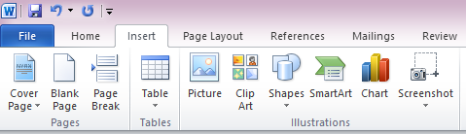
A window will then appear at the right-hand side of window:
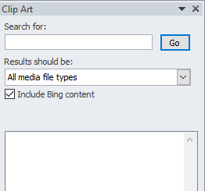
You can then use the search bar to find images related to any topic you wish.
For example, sunshine brings up the following options:
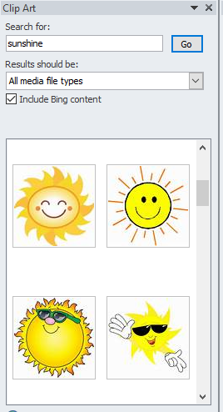
As you can see from the scrollbar, there are a range of different images which you return from this search, giving you the option of lots of styles and impressions.

Smart Art
Smart Art gives you the option of creating and inserting a range of different visual elements into your document.
To do this, you would again select the Insert Tab, followed by Smart Art:
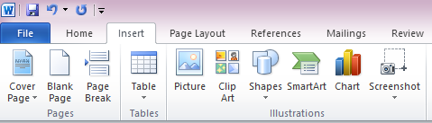
You will then find the following window appears:
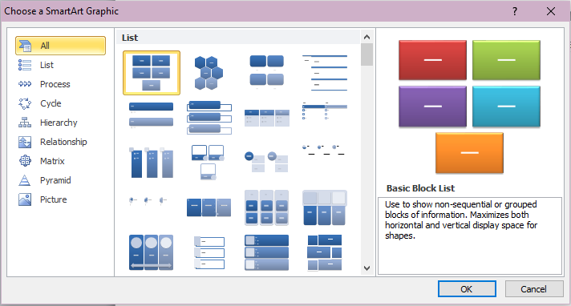
As you can see, you can create the following elements:
- List
- Process
- Cycle
- Hierarchy
- Relationship
- Matrix
- Pyramid
- Picture.
Shapes
As the name suggests, shapes allow you to insert a variety of different shaped into your document.
Select the Insert tab followed by Shapes:
The following window will then appear:
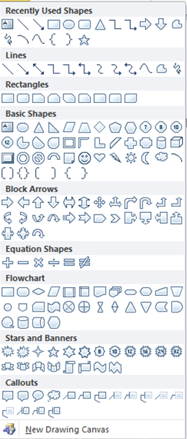
Shapes can be used for many different, creative purposes.

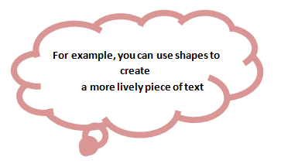
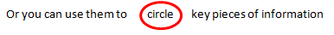
Shapes can be used as simply or creatively as you wish depending on your preferences and task requirements.
Charts
The final visual element to explore is charts.
Again, select the Insert tab followed by Chart:

The following window will then appear:
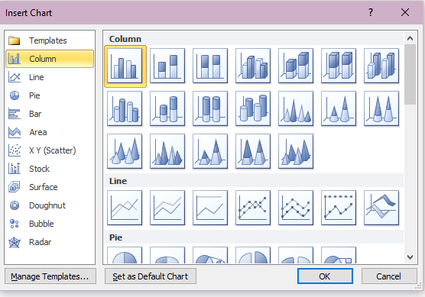
Using this feature will allow you to create professional-looking charts and graphs in a limited amount of time.

Formatting
Once you have inserted the required visual element(s) into a document, you can then format it to look how you want.
Formatting options will differ depending on the specific element at hand, but general formatting features include:
- Colour changes
- Cropping
- Resizing
- Rotation.

Activity 2E

3. Produce text documents digitally
3.1. Use intermediate-level application functions to enable efficient production of digital text documents
3.2. Enter or import, and edit text and other data to meet task requirements
3.3. Preview, adjust and prepare documents for delivery in accordance with organisational and task requirements
3.4. Name and store document, in accordance with organisational requirements and exit application without information loss/damage
3.5. Deliver document within designated timelines and organisational requirements for speed and accuracy
3.6. Use relevant help functions to overcome intermediate issues with document design and production

3.1 – Use intermediate-level application functions to enable efficient production of digital text documents
By the end of this chapter, the learner should be able to:
- Give examples of advanced software functions
- Choose two functions and write step-by-step instructions describing how to complete them
- Complete two functions.

Using advanced software functions
When designing and producing text-based documents your priority should be to ensure that the readers can understand the information in your document. A good design can be the clarity of your communication. In order to ensure efficient production of your documents, you will need to use the range of advanced software functions that are available. When using the advanced software functions, you should keep in mind that to use them efficiently you should only apply the ones that apply to the particular document that you are creating; don’t over-design. Once you have used the advanced software functions that you wish to use you will need to proofread and check all of the elements that you have included. If your document seems too over-bearing and there is too much going on, then you may need to re-think and re-write. The advanced software functions that you need to use may depend on your organisation’s style guide.
Advanced software functions may include:
- Alternate headers and footers

- Drawing tools
- Graphics tools
- Importing data/objects/pictures
- Mail merge
- Newspaper columns
- Sections
- Sort
- Styles
- Tables
- Templates.
Many of the examples above have already been discussed throughout this unit. This chapter will take a look at a few examples of advanced software functions and how they can help to ensure the efficient production of your documents.
Alternate headers and footers
You may wish to have different headers and footers within your document; if so, you will need to divide your document into sections. Remember that headers and footers belong to a specific section; not the document as a whole. Different sections of your document can have different headers and footers. When inserting a section break, confusion may arise as to where to put it. Usually, a ‘Next Page’ section break will be inserted at the bottom of the page that is just before the page where you want the new header or footer to start. For example, if your new header or footer needs to be on page seven, the ‘Next Page’ section break should be inserted at the bottom of page six.
To add a section break, follow these steps:
- Click ‘Page Layout’ tab
- In the ‘Page Setup’ options, click ‘Breaks’ (see image)
- Choose the appropriate break.
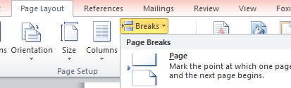
You will then need to break the link between the previous section and the new section.
To do this, follow these steps:
- Double-click in the header of your new section
- Click the ‘Design’ tab
- In the ‘Navigation’ options, click the ‘Link to Previous’ option.
See image below.
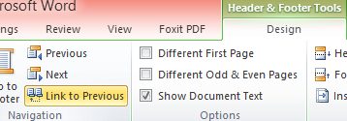
After completing these steps, you’re ready to change your header or footer. It will look as if nothing has changed as breaking the link will not change anything; it allows you to make changes. From this, you can change the header or footer as you normally would.

Drawing tools
When creating your documents, you made need to use the drawing tools. These can be located under the ‘Insert’ tab in ‘Shapes’. See image below. From this, you can choose which shape you wish to insert into your document.
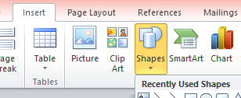
If you need to insert shapes that are connected together, you will need to insert a ‘New Drawing Canvas’ into your document first. This can be found at the bottom of the ‘Shapes’ options. See image below.
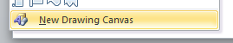
This can be useful for creating things like flow diagrams. See image below.
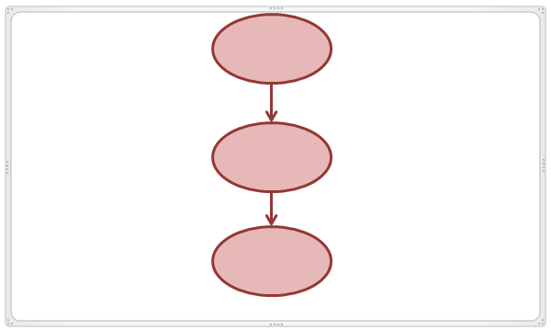
Remember to use your ‘Drawing Tools’ tab to change the format of any shapes that you insert into your document. See image.
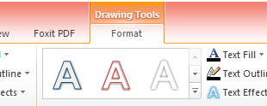
Graphics tools
Although text-based documents should obviously be predominantly text information, illustrations and graphics can help your reader to understand and remember the information within your document better. Normally, manually creating the graphics to include in your document can be time-consuming and quite difficult. As already mentiond, there is a ‘SmartArt’ tool within Microsoft Word that can make this job easier. This tool can be used to create a visual representation of the information and ideas of your document. SmartArt allows you to choose from a variety of different layouts which can communicate your message easily and effectively.
To create a SmartArt graphic, follow these steps:
- Click the ‘Insert’ tab
- ‘Click SmartArt’.
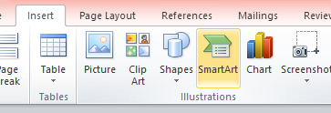
In the window that appears, you can choose the type of graphic that you wish to insert. See image below. Once you have chosen, click ‘OK’.
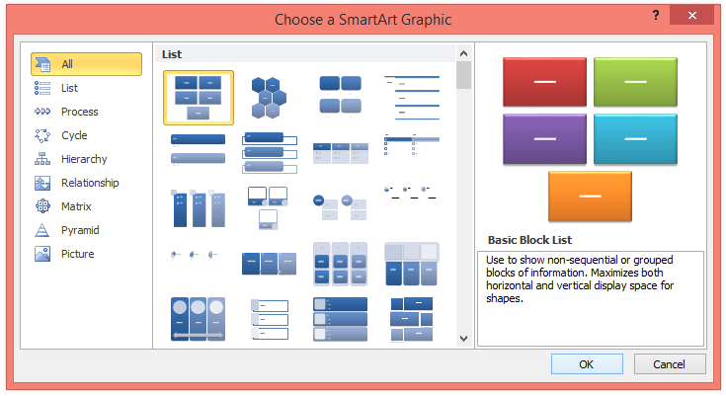

Mail merge
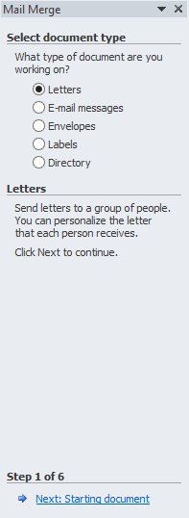
When creating letters in Microsoft Word, you may want to use the Mail Merge feature. This allows you to personalise your letters with names and addresses from a database.
To create a Mail Merge, follow these steps:
- Click the ‘Mailings’ tab
- Click ‘Start Mail Merge’
- Click ‘Step by Step Mail Merge Wizard’ (see image below)
- In the task pane, click ‘Letters’
- Click ‘Next: Starting document’ (see image to the right)
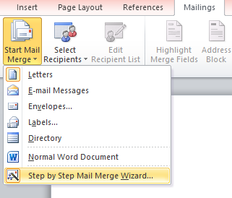

- Select the starting document
- Select your recipients
- Write your letter
- Preview your letter
- Complete the merge.

Newspaper columns
If you wish to apply newspaper style columns to the text within your document, highlight this specific text and apply the column formatting.
Follow these steps:
- Highlight the text that you wish to put into columns
- Click the ‘Page Layout’ tab
- Click the ‘Columns’ button
- Select how many columns you wish to apply
- Extra options can be found in ‘More Columns’.
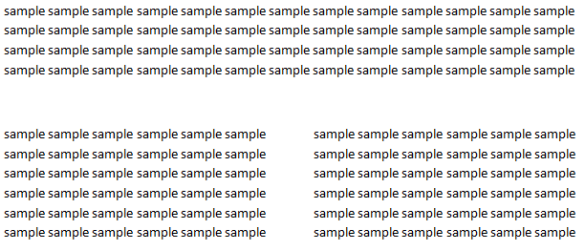
See images below. The image on the right shows the difference between the one column and two columns options.
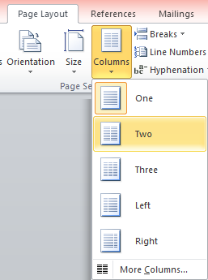

Activity 3A

3.2 – Enter or import, and edit text and other data to meet task requirements
By the end of this chapter, the learner should be able to:
- Enter given textual information into a word document following task requirements
- Edit text following task requirements.

Entering and importing text
Of course, you can simply type the text that you require into your document. But what if you are repeatedly using the same block of text? There must be an easier way. If you have a block of text that is formatted in a particular way and you know you will need this at various points in the future, then you can add your selected text to the ‘AutoText’ gallery. This means that when you need this block of text again, you can select it using ‘AutoText’ from you ‘AutoText’ gallery.
You can also change the ‘AutoCorrect’ settings within Microsoft Word and add text entries that you will be using often. This means that Word will automatically complete this familiar word, phrase or sentence after typing the first few characters.
The data that you wish to use within your document may come from an external source. For example, there may be data in a workbook, database or another text file that you wish to include within your document. This external source is connected to your program through a data connection; information that defines how to locate, log in and access the required external source. This connection information is stored in a connection file; for example, Data Source Name files (.dsn) or Office Data Connection files (.odc). The process of repeatedly copying data is prone to errors and can be very time consuming; connecting to an external data source can eliminate these issues. When using an external data source, you need to ensure that you have authority to access this data and can actually do so. In a Microsoft Word document, you can also import external data using the Mail Merge feature; this was discussed in the previous chapter.
You can also import other files without using a connection. For example, worksheets, Access tables, queries and other text files.
To insert text from another file into a Word document, follow these steps:
- Click in your document where you want to insert the text
- Click the ‘Insert’ tab
- Click the arrow next to ‘Object’
- Select ‘Text from File…’
- Locate the file that you wish to insert
- Double-click the file.
See image below.
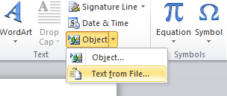

Editing text
Once you have entered or imported the required text into your document, you may need to edit it in order to meet your organisational requirements and specifications.
This may involve changing things like the:
- Size of the text
- Colour of the text
- Font of the text
- Alignment of the text.
You may also want to add headings and sub-headings or format some of your text into columns. All of these examples have been discussed throughout the unit and should be used in order to keep within your required specifications.

Entering, importing and editing other data
Throughout the production of your document, you may need to enter, import and edit other types of data.
For example, you may need to include:

- Watermarks
- Images
- Clipart
- Data from other software applications
- Digital photographs
- Files
- Graphics
- Quotes and references
- Scanned photographs and logos
- Tables, graphs and charts.

Activity 3B

3.3 – Preview, adjust and prepare documents for delivery in accordance with organisational and task requirements
By the end of this chapter, the learner should be able to:
- Preview, adjust and print a document following task requirements.

Preview and print
Before printing your completed document, you will need to preview it and make any necessary amendments.
To preview a Microsoft Word document, follow these steps:
- Click the ‘File’ tab
- Click the ‘Print’ option
- Your preview will appear at the right of your screen.
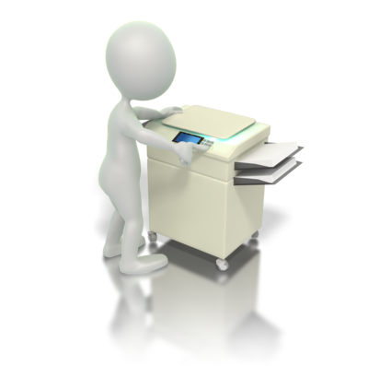
From this, you can assess your document and ensure that it is in accordance with any relevant organisational and task requirements. If necessary, amendments should be made to your document. When any amendments to your document have been completed, reviewed and previewed, it is then time to print your document. The way that you print your document should also be in accordance with any relevant organisational and task requirements.
Printing may include:
- Print merge
- Print to file
- With comments
- With drawing objects
- With field codes
- With hidden text.
Print merge
Print merge can be used in programs such as Corel DRAW and is useful when producing documents with serial numbers (e.g. lottery tickets, certificates or tickets). This process involves the automatic merging of a drawing with the information within a text file. The result of this process is then sent to a printer.
Print to file
When printing to file, the formatting and layout information of your document is saved. This means that the printer can reproduce your document without the computer or program that you used to create it.

This printing option is useful if:
- You want to send your document to a commercial printer
- You don’t have a printer handy, but you want to archive your document and print it later
- You want to send your document to someone that has the same printer, but doesn’t have the program that you used to create your document.
To print to file, follow these steps:
- Click the ‘File’ tab
- Click ‘Print’
- Select the ‘Printer’ drop-down menu
- Tick the ‘Print to File’ box (see image below)
- Click ‘Print’
- If applicable, select a name and location for your document.
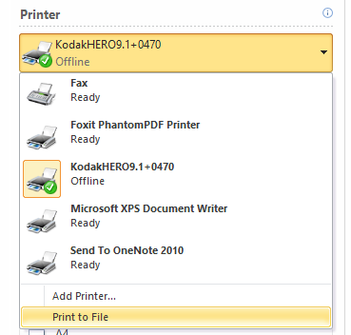
It’s worth noting that printing to file is not supported by all programs and doesn’t work easily on newer printers.
Print with comments
When printing a document such as an Excel workbook that contains comments, you can alter the settings so that these comments are printed; either where they appear on the document itself or at the end of the document.

To display an individual comment, follow these steps:
- Click on the cell that contain the comment
- Click the ‘Review’ tab
- In the ‘Comments’ options, click ‘Show/Hide Comment’.
To display all of the comments within your document, follow these steps:
- Click the ‘Review’ tab
- In the ‘Comments’ options, click ‘Show All Comments’.
See image below.
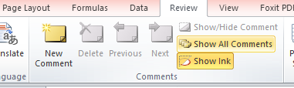
Then:
- Click the ‘Page Layout’ tab
- In the ‘Page Setup’ options, click the dialogue box launcher (see image)
- Click the ‘Sheet’ tab
- Click the arrow next to ‘Comments’
- Choose either ‘At end of sheet’ or ‘As displayed on sheet’
- Click ‘Print’.
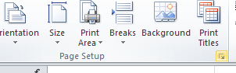
Print with drawing objects
To print with drawing objects in a Word document, follow these steps:
- Click the ‘File’ tab
- Click ‘Options’
- Click ‘Display’
- In the ‘Printing Options’, check the ‘Print drawings create in Word’ box
- Print your document as normal.
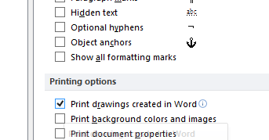
Print with field codes
Field codes are used for creating letters and labels in the mail merge feature and can be used within a document as placeholders for any data that may change.
Fields that are automatically inserted occur when you:
- Insert a page number
- Create a table of contents
- Insert a cover page.
You can also manually insert fields if you wish to automate aspects within your document although this is not normally necessary. To see the codes for a particular field, click the ‘Field’ dialogue box and click ‘Field Codes’.
To insert a field, follow these steps:
- Click where you want to insert a field
- Click the ‘Insert’ tab
- In the ‘Text’ options, click ‘Quick Parts’
- Click ‘Field’
- In the ‘Categories’ list, select a category
- In the ‘Field Names’ list, select a field name
- Format as you wish.
To print with field codes, follow these steps:
- Click the ‘File’ tab
- Click ‘Options’
- Click ‘Advanced’
- Scroll down to the ‘Print’ section
- Check the ‘Print field codes instead of their values’ box
- Click ‘OK’
- Print as normal.
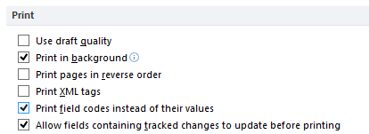
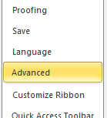
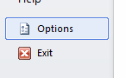
See images.

Print with hidden text
You have the option to hide particular text within your document; although this text will be part of your document, it won’t appear unless you choose to show it. This can be useful if you need to print two different versions of the same document. In one copy, you are able to hide certain parts of the text and have two different documents without having to save two separate copies.
To hide text within your document, follow these steps:
- Highlight the text that you want to hide
- Right click
- Click ‘Font’
- Check the ‘Hidden’ box
- Click ‘OK’.
See image below.
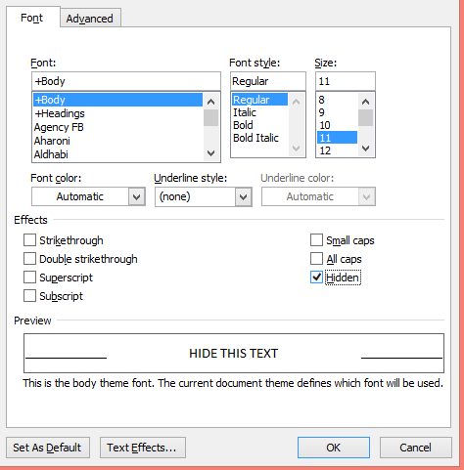
Once you have hidden the parts of text you don’t want to appear on your printed document, you can print as normal.

Activity 3C

3.4 – Name and store document, in accordance with organisational requirements and exit application without information loss/damage
By the end of this chapter, the learner should be able to:
- Name, store and save a document ensuring that no information is lost or damaged.

Naming documents
Naming your documents appropriately will help in the future when you or others need to relocate them. Each of your document names should be clearly different and sorted into the correct order. If necessary, use the date within the names of your documents. Your organisation may have a system in place for naming your documents; make yourself familiar with it. You need to be able to find your document again so don’t worry if the name looks too long. For example, ‘report’ is just not going to cut it. Whichever naming system you decide on, ensure that you are consistent from then on.
File name extensions
The extension of a file name is the set of characters that is added to the end of a file name. This extension determines which program should be used to open the document. For example, myfile.txt has the extension ‘txt’. This indicates that this file can be opened with programs that are associated with that extension (e.g. Notepad or WordPad).
Tips when naming your documents include:
- Use keywords

- Use your name or initials
- Use date
- Use alphabetic codes
- Use version numbers
- Use descriptors
- Use underscores
- Use common names
- Be detailed
- Be consistent.

Storing documents
The efficient storage of your documents is necessary. You should have a good filing system that is relevant to your own needs or your organisational requirements. Whichever storage method you decide to use; be consistent. Remember to keep your document files separate from your program files; this will eliminate any accidental deletions.
Tips when storing your documents include:
- Store similar documents together
- Don’t save unnecessary documents
- Avoid large folder structures
- Use shortcuts rather than having multiple copies
- Colour code your folders
- Think about storing documents online (e.g. MicrosoftSharePoint 2010 or Windows Live SkyDrive)
- Make sure that the documents that you use every day can be accessed easily.
Locating files
You should take advantage of the folders within your computer (e.g. my documents and my library). You can customise these files and add new folders to make it easier to locate your files. Using the ‘Start’ bar or ‘Windows Explorer’ you can search for the file that you need. In Microsoft Word, under the ‘File’ tab, the ‘Recent’ tab holds all the recent documents that you have been working on, making it easier for you to find them.
You can move files or folders to the appropriate locations by ‘cutting and pasting’ or ‘clicking and dragging’.
Naming and storing documents may include:
- Authorised access
- File names according to organisational procedure, e.g. Numbers rather than names
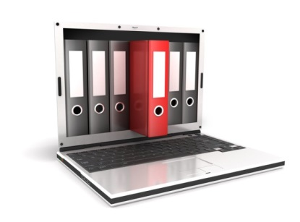
- File names which are easily identifiable in relation to the content
- File/directory names which identify the operator, author, section, date
- Filing locations
- Organisational policy for backing up files, storage in folders/subfolders
- Organisational policy for filing hard copies of documents
- Security/password protection
- Storage on hard/floppy disk drives, CD-ROM, tape back-up.
Issues when naming and storing documents that often arise may include:
- Too many characters (file names can only be up to 260 characters)
- Restricted characters (< > ? \ / ; * are all characters that cannot be used in file names)
- Compatibility issues.
Remember to:
- Regularly back your files up
- Use passwords if necessary
- Follow organisational policies when storing hard copies.

Exiting without information loss or damage
Whilst working on your document, remember to save – often. This will help you to minimise the chance of any information being lost or damaged.
To save a document, either:

- Press Ctrl and S together
- Click the ‘File’ tab and click ‘Save’ or ‘Save as’
- Click the save icon across the top of your document (see image).
Once you know that you have saved your document, you can then close it. If your document does close without saving, you may find that your program recovers the unsaved version.
Damage to a document
Damage to a document usually involves a file corruption or a virus; you should close applications properly to minimise the chance of these occurring. If Windows determines a program holds a security risk, then it will close it and notify you of the risk. If this does occur, it is usually because that program uses your computer’s Random Access Memory (RAM) in a way that may be exploited by a virus. A virus can be harming to your computer. Data Execution Prevention (DEP) is a security feature that Windows uses to track how the programs within your computer use memory. If this feature identifies that the memory is being used incorrectly, it will close the program and notify you. You can add programs that you trust to an exception list to stop this feature from closing it, but you should be sure.
If compatibility issues between documents occur and Windows closes a program, this could be due to the possibility that the program may damage Windows if it is allowed to run.

Activity 3D

3.5 – Deliver document within designated timelines and organisational requirements for speed and accuracy
By the end of this chapter, the learner should be able to:
- Produce a document in a given timeframe.

Timelines
Timelines are where key planned events and tasks are marked in the required sequence of their occurrence on a suitable scale. You need to ensure that the document you are producing is completed within the designated timelines of your organisation. Although timelines can be difficult to meet, it essential you try your best in order to keep your client happy. If you know early on in the process that your timeline is not realistic, then communicate this as early as possible; necessary adjustments can then be made.
Designated timelines may include:
- Organisational timeline, e.g. Deadline requirements
- Timeline agreed with internal/external client

- Timeline agreed with supervisor/person requiring document.
Designated timelines may be:
- Within organisational deadline
- Within an agreed period
- By the end of the month
- Daily
- As requested.

Time management
In order to keep to your designated timeline, it is beneficial to have good time management skills. This involves consciously planning and exercising control over your time and how you use it. For example, in order to increase efficiency and effectiveness when designing and producing your document, you should plan the amount of time you need to spend on individual activities.
Good time management tips may include:
- Recording your deadlines
- Prioritising your tasks
- Keeping track of your progress
- Knowing how to deal with possible problems that may arise.
Recording your deadlines
You need to be aware of any deadlines before starting a task; this allows you to plan your activities carefully. Plan using diaries, schedules or memos; whatever works best for you.
Prioritising your tasks
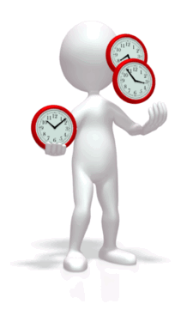
To make sure you use your time in the most efficient way possible, it is essential that you prioritise your tasks. The act of prioritising your tasks allows for the most valuable use of your time. A key thing to remember is to not spend too much time on tasks that are not as important as the other tasks. Make to-do lists and set mini-deadlines to help keep you on track.
Keeping track of your progress
Use the diaries, schedules or memos that you have created to keep an eye on your progress. Are you hitting the deadlines you have given yourself? Should you be doing something differently? You need to check throughout the process that you are on target to meet the final deadline and assess your methods if not.
Knowing how to deal with possible problems that may arise
In order to stick to your plan and timelines, you need to know how to deal with potential problems before they occur. When a problem does occur, and you don’t feel you are able to deal with it; don’t dwell on it. Don’t waste any time; just simply refer to someone who will know. This will keep you on track to meet your deadline.

Activity 3E

3.6 – Use relevant help functions to overcome intermediate issues with document design and production
By the end of this chapter, the learner should be able to:
- Identify one help function which can be used to overcome an issue with document design and production and outline how to use this.

Overcoming problems
When producing text-based documents, you may come across problems with the designing and production process. These can often be overcome by using manuals, user documentation or online help.

Manuals
Manuals are documents that intend to give assistance to a person who is using a particular system. They are often written documents that use accompanying images or diagrams (e.g. screenshots). Manuals aim to use language that the user will understand, and they use jargon minimally. If the use of jargon is necessary, it is usually thoroughly explained. Manuals can usually be found as a hardcopy or as a digital copy on the internet, stored on your computer or stored on CD or DVD.
The things that a manual may include are:

- A cover page, a title page and a copyright page
- Frequently asked questions
- Where to find further help, including contact details
- Information on how to navigate through manual
- A troubleshooting section
- A glossary and/or index.

User documentation
Documentation is the information that is provided to help you use a particular program, including technical manuals and online information. Although manuals are the most common form of documentation, there is a wide variety of forms that they come in. User documentation is a valuable tool for on-the-job training and can range from Installation guides, to How-to guides and Administrator guides.
User documentation is often divided into categories, for example:
- Installation
- Reference
- Tutorial.
User documentation should:
- Use current terminology
- Contain a list of error codes
- Use clear descriptions
- Operate as stated
- Be consistent
- Include relevant references
- Document any differences within program versions.

Online help
There is a wide range of help available online too. A simple search on the internet will provide you with almost anything that you need. Online help is often topic-orientated and delivered through some form of computer software. Most online help provides assistance and can present information surrounding a broad range of topics.
By using an outsourced technical documentation, you can ensure specific knowledge on the particular issue. Although it can be costly, you only pay for the time that you use.
The advantages of using outsourced technical documentation include:

- Time-saving
- High quality
- Good expertise
- Flexible.

Activity 3F

Summative Assessments
At the end of your Learner Workbook, you will find the Summative Assessments.
This includes:
- Skills Activity
- Knowledge Activity
- Performance Activity.
This holistically assesses your understanding and application of the skills, knowledge and performance requirements for this unit. Once this is completed, you will have finished this unit and be ready to move onto the next one – well done!

