BSBITU201
Produce simple word processed documents
Learner Guide

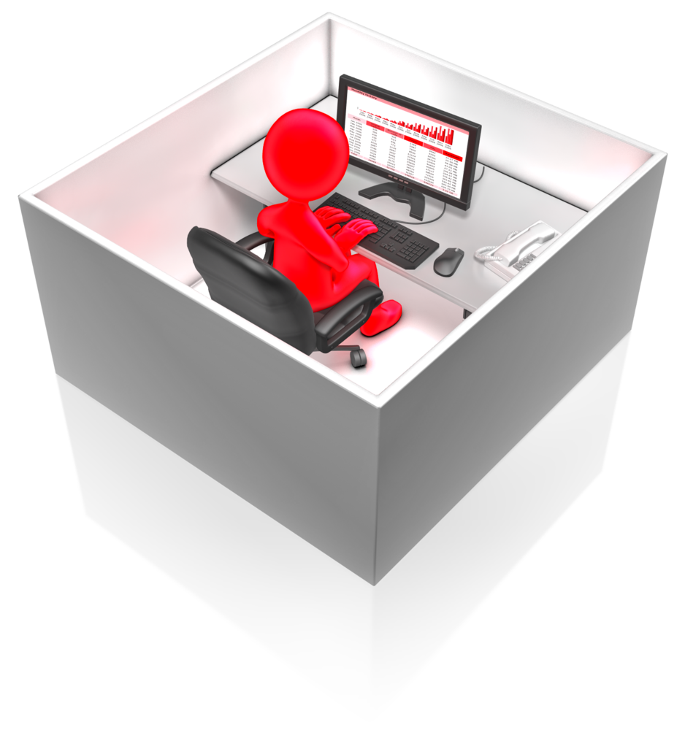

BSBITU201
Produce simple word processed documents

Table of Contents

Table of Contents 2
Unit of Competency 4
Performance Criteria 5
Foundation Skills 6
Assessment Requirements 7
Housekeeping Items 8
Objectives 8
1. Prepare to produce documents 9
1.1 – Use safe work practices to ensure ergonomic, work organisation, energy and resource conservation requirements are met 10
Work Health and Safety Act 2012 (WHS) 10
Ergonomic requirements 12
Work organisation requirements 17
Conservation requirements 19
Activity 1A 20
1.2 – Identify document purpose, audience and presentation requirements, and clarify with relevant personnel as required 21
Documents 21
Purpose of the document 22
Audience 23
Presentation requirements 23
Activity 1B 24
1.3 – Identify organisational and task requirements for document layout and design 25
Organisational requirements 25
Activity 1C 28
2. Produce documents 29
2.1 – Format document using appropriate software functions to adjust page layout to meet information requirements, in accordance with organisational style and presentation requirements 30
Formatting documents 30
Software functions 31
Activity 2A 34
2.2 – Use system features to identify and manipulate screen display options and controls 35
Activity 2B 39
2.3 – Use manuals, user documentation and online help to overcome problems with document presentation and production 40
Manuals and user documentation 40
Online assistance 40
Activity 2C 42
3. Finalise documents 43
3.1 – Ensure final document is previewed, checked, adjusted and printed in accordance with organisational and task requirements 44
Checking and adjusting documents 44
Printing documents 44
Activity 3A 46
3.2 – Ensure document is prepared within designated timelines and organisational requirements 47
Designated timelines 47
Organisational requirements 47
Activity 3B 49
3.3 – Name and store document in accordance with organisational requirements and exit application without information loss/damage 50
Naming and storing documents 50
Security 52
Avoiding loss or damage to documents 53
Activity 3C 54
Skills and Knowledge Activity 55
Major Activity – An opportunity to revise the unit 56
References 58

Unit of Competency

Application

This unit describes the skills and knowledge required to develop basic keyboard skills using touch typing techniques in a broad range of settings.

It applies to individuals who perform a range of mainly routine tasks and generally work under direct supervision using limited practical skills and fundamental knowledge.

No licensing, legislative or certification requirements apply to this unit at the time of publication.

Unit Sector

Information and Communications Technology – IT Use

Performance Criteria
Element  Elements describe the essential outcomes. | Performance Criteria  Performance criteria describe the performance needed to demonstrate achievement of the element.
- Prepare to produce documents | - Use safe work practices to ensure ergonomic, work organisation, energy and resource conservation requirements are met  - Identify document purpose, audience and presentation requirements, and clarify with relevant personnel as required  - Identify organisational and task requirements for document layout and design
- Produce documents | - Format document using appropriate software functions to adjust page layout to meet information requirements, in accordance with organisational style and presentation requirements  - Use system features to identify and manipulate screen display options and controls  - Use manuals, user documentation and online help to overcome problems with document presentation and production
- Finalise documents | - Ensure final document is previewed, checked, adjusted and printed in accordance with organisational and task requirements  - Ensure document is prepared within designated timelines and organisational requirements  - Name and store document in accordance with organisational requirements and exit application without information loss/damage

Foundation Skills
This section describes language, literacy, numeracy and employment skills incorporated in the performance criteria that are required for competent performance.

Skill | Performance  Criteria | Description
Reading | 1.2, 1.3, 2.1, 2.3, 3.1, 3.3 | - Recognises textual information within organisational and task requirements to determine work requirements
Writing | 3.1, 3.3 | - Records numerical and textual information in accordance with requirements of task
Oral Communication | 1.2 | - Participates in a variety of spoken exchanges with relevant personnel in an effort to clarify document purpose, audience and presentation requirements
Navigate the world of work | 1.1-1.3, 2.1, 3.1-3.3 | - Recognises and follows explicit and implicit protocols and meets expectations associated with own role
Interact with others | 1.2 | - May seek guidance from more experienced work colleagues
Get the work done | 2.1-2.3, 3.1-3.3 | - Understands functions and features of specific computer software and uses these to perform work tasks

Assessment Requirements
Performance Evidence

Evidence of the ability to:

- Produce documents following correct ergonomic, conservation requirements and organisational policies and procedures
- Adhere to organisational style manual when formatting documents
- Refer to help function and user documentation to rectify document problems
- Use system features
- Follow designated timelines when preparing documents.

Knowledge Evidence

To complete the unit requirements safely and effectively, the individual must:

- Identify basic formatting styles and their effect on formatting, readability and appearance of documents
- Describe purpose, use and function of word processing software
- Outline organisational requirements for ergonomics, work periods and breaks, and conservation techniques
- Describe what is contained in an organisational style guide.

Assessment Conditions

Assessment must be conducted in a safe environment where evidence gathered demonstrates consistent performance of typical activities experienced in the information and communications technology – IT use field of work and include access to:

- Industry software packages
- Computer user information
- Relevant legislation and codes of practice
- Organisational policies and procedures
- Relevant workplace documentation and resources including a style guide and user manuals.

Assessors must satisfy NVR/AQTF assessor requirements.

Links

Companion volumes available from the IBSA website: http://www.ibsa.org.au/companion_volumes

Housekeeping Items
Your trainer will inform you of the following:
- Where the toilets and fire exits are located, what the emergency procedures are and where the breakout and refreshment areas are.
- Any rules, for example asking that all mobile phones are set to silent and of any security issues they need to be aware of.
- What times the breaks will be held and what the smoking policy is.
- That this is an interactive course and you should ask questions.
- That to get the most out of this workshop, we must all work together, listen to each other, explore new ideas, and make mistakes. After all, that’s how we learn.
- Ground rules for participation:
  - Smile
  - Support and encourage other participants
  - When someone is contributing everyone else is quiet
  - Be patient with others who may not be grasping the ideas
  - Be on time
  - Focus discussion on the topic
  - Speak to the trainer if you have any concerns

Objectives
- Discover how to prepare to produce documents
- Know how to produce documents
- Learn how to finalise documents
- Gain the skills and knowledge required for this unit.

1. Prepare to produce documents
1.1. Use safe work practices to ensure ergonomic, work organisation, energy and resource conservation requirements are met
1.2. Identify document purpose, audience and presentation requirements, and clarify with relevant personnel as required
1.3. Identify organisational and task requirements for document layout and design



1.1 – Use safe work practices to ensure ergonomic, work organisation, energy and resource conservation requirements are met
Every organisation will have procedures in place to ensure the safe working practices of its workers. Some of these procedures will be bound by legislation whereas others will be designed and implemented with regards to best practice and advice from specialists.

Work Health and Safety Act 2012 (WHS)
The WHS Act and WHS Regulations came into effect in January 2012 and were designed to be adopted by each state and territory in Australia to provide a harmonised approach to workplace health and safety. To find out how your state has implemented the law, visit the Safework Australia website at URL:www.safeworkaustralia.gov.au
WHS is quite simply about maintaining the health and safety of employees and anyone directly affected by the activity of a business.
Duty holder
A duty holder is responsible for the management of risks to health and safety in the workplace, so far as is reasonably practicable.
Reasonably practicable means that all reasonable steps have been taken and must take into account:
- The likelihood of the hazard or risk occurring
- The gravity of harm that may result from the hazard or risk
- The knowledge/expected knowledge of the person responsible for health and safety
- Ways in which to eliminate or minimise the risk
- The cost of ways in which to eliminate or minimise the risk.
Primary duty of care
A person conducting or undertaking a business must ensure the health and safety of the workers and those directly affected by the business.

The person with primary duty of care must ensure that they provide and maintain:
- A work environment free of risks to health and safety
- Safe plant and structures
- Safe systems of work
- Safe use, handling and storage of plant, structure and substances.

They must also:
- Provide adequate facilities and access to these facilities for the welfare of workers
- Provide any information, training and instruction or supervision necessary to protect workers from health and safety risks in their work
- Monitor health of workers and the conditions at the workplace in order to prevent illness or injury.
Self-employed workers are responsible for their own health and safety.
There are further more detailed and specific responsibilities in relation to health and safety for businesses involved in the designing, manufacturing, selling and working with plant, substances and structures.
Workers’ responsibilities

As employers have a duty of care for their employees, workers themselves have responsibilities for health and safety in the workplace.
These responsibilities include:
- Taking reasonable care for their own health and safety
- Taking reasonable care that their actions or omissions do not have adverse effects on the health and safety of others
- Complying with work place procedures and instructions regarding health and safety.
General workplace health and safety
All organisations will have their own specific health and safety rules and procedures in place but there are general procedures of good practice that most will follow.
Most organisations will have:
- A written health and safety plan and general risk assessment
- A health and safety manual to which all employees have access and a responsibility to be aware of it
- Health and safety training for all staff including regular updates
- Procedures in place for the regular monitoring of the workplace by designated persons with duty of care. These are often “floor walks” in which the designated person physically walks around the working environment so that potential risks and hazards can be smelled, seen and heard.

These recognisable hazards may include:
  - faulty equipment
  - employees not following health and safety rules, for example not wearing protective clothing
  - blocked corridors/fire exits and general untidiness
  - poor electrical facilities
  - toxic odours
- Procedures in place for reporting hazards, risks, safety concerns, breaches of health and safety policy.
Producing word processed documents
When producing word processed documents there are a number of specific safe work practices that should be adhered to in order to ensure the well-being of workers, adherence to legislation and environmental considerations.
Safe work practices include:
- Ergonomic requirements
- Work organisation requirements
- Conservation requirements.

Ergonomic requirements
Ergonomics is derived from two Greek words; ergon (meaning work) and nomoi (meaning natural laws). It is a scientific discipline that understands how humans interact with the products and systems with which they work. Put simply, ergonomics is making systems of work more comfortable and subsequently more efficient.
The more comfortable a product or system, the more likely it is that an employee will want to use it, and happy employees are more productive than the unhappy and uncomfortable type.
The comfort of the product or system can include:
- Touch and feel

- Aesthetic properties
- Physical comfort to use
- Ease of use, both physically and mentally
- Potentially the odour
- Temperature.
Ergonomic requirements within your role may include:
- Avoiding radiation from computer screens
- Chair height, seat and back adjustment
- Document holder
- Footrest
- Keyboard and mouse position
- Lighting
- Noise minimisation
- Posture
- Screen position
- Workstation height and layout.
Avoiding radiation from computer screens
Computers emit electromagnetic rays and frequencies and carcinogenic substances which can be harmful to your health.
Ways to minimise computer radiation include:
- Locating your computer near a ventilated cooler

- Keeping your eye distance from the screen to no less than 80
centimetres
- Using new computers – through technological advances new computers release less radiation than older models
- Placing a radiation filter plate in front of your screen
- Placing radiation absorbing plants, such as cacti, near your computer
- Eating plenty of foods that are rich in vitamins A and C which include:
  - vitamin A – carrots, sweet potatoes, dark leafy greens, tomatoes
  - vitamin C – chillies, peppers, oranges, spices.

Chair height, seat and back adjustment
The type of chair you use will vary according the period of fixed time for which you use it, the type of flooring in your working environment and your own physical ability and being. It is important that you are comfortable when sitting for prolonged periods of time whilst producing word documents. This is general guidance for how to adjust the height, seat and back adjustments of your chair to suit your body and posture.
Chair height
- Feet should be comfortably flat on the floor with your thighs parallel to the floor
- Do not allow feet to dangle as this can cause numbness or tingling to the legs
- Use a foot rest if necessary.
Seat
- Adjust the depth so that your back rests comfortably on the back rest
- Thighs should be fully supported and the front of the seat should not press into the back of your knees
- If there is a facility for a rocking motion, use it to release pressure when not typing
- Keep the seat horizontal and locked whilst typing for solid back support.
Back rest
- The height of the lumbar support should rest in the small of your back
- Use a small cushion if the lumber support is inadequate
- Use the tilt of the back support to slightly recline your sitting position as opposed to sitting upright.
Extreme use
Specially designed or modified chairs may be required for workers with extreme ranges of height and weight or for those with a disability.
Document holder
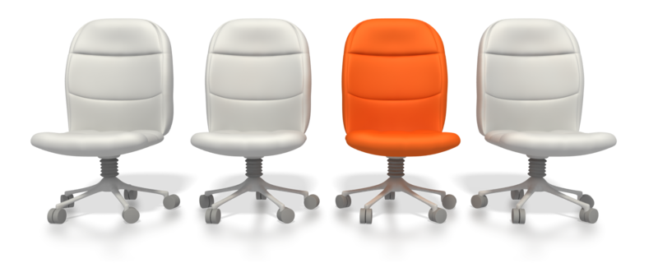
The document from which you are working should not be placed flat on the desk or in a position away from the screen and keyboard that requires constant bending and twisting to access it. Ideally a document holder should be used so that the material is raised in line with the screen and stable to allow making notes on the document.

Footrest
Footrests should be:
- Stable
- Height adjustable
- Large enough to comfortably accommodate both feet.
Keyboard and mouse position
Keyboard
Ideally, the keyboard and screen should be two separate entities so that each can be adjusted according to the needs of the user. There are different types of keyboard including split, compact, internet and ergonomic; the type you use depends upon your individual requirements. The keyboard should be positioned directly in front of the body to avoid twisting and straining.
Using a mouse
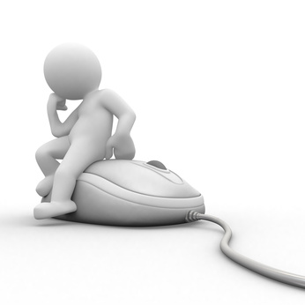
- The shape and slope of the mouse you use should enable your wrist to be aligned with your forearm
- Your wrist should not have to bend up to use the mouse
- The mouse should be positioned as close as possible to the keyboard
- When moving the mouse side to side, use the whole of your forearm and not just your wrist
- Maintain a relaxed grip on the mouse and release it whenever possible.
Screen position
The screen should be above the work station with the top line of text being just below eye level. Adjustable monitor raisers are a useful resource for multiple user work stations.
Workstation height and layout
Desk height
The height of the desk should not be too high as this puts unnecessary strain on the shoulder muscles. The worker should not have to slouch or stretch to reach the keyboard comfortably. Ideally, desks with adjustable height should be used for shared work spaces.
Desk top size
The size of the desk top should reflect the tasks required at that work station and have adequate room for all necessary equipment. A worker who needs to use a computer only will require a smaller desk to one that uses both a computer and clerical materials.

Leg well space
The space underneath the desk should be free from clutter and have ample space for the comfortable positioning of the legs of the worker.
Australian Standard 3590.2-1990 sets out the advised measurements of all desk aspects.
Desk layout
Frequently used items and documents should be placed within easy reaching distance of the worker to avoid stretching and straining. The desk should be free from clutter.
Posture
If you follow all of the advice given above, you should have the perfect posture to maintain a healthy body. Remember that slouching at the computer not only results in daily neck strain but can also cause serious work-related musculoskeletal disorders such as carpel tunnel and tendinitis.
Lighting
Lighting should reflect the requirements of the tasks being carried out within the working environment. The more detailed and complex the task the more light is required, for example, a hospital corridor requires less luminance than an operating theatre.
Lighting can be distracting and irritating if it is too harsh. It can bounce off reflective surfaces, such as computer screens, and cause glare. Thought should be given to the angle of the source of light and whether items such as blinds are needed. Insufficient light within a working environment can cause eye strain.
There are a number of Australian Standards that cover interior and workplace lighting, including:
- AS 1680.1:2006 Interior and workplace lighting – General principles and recommendations
- AS 1680.2.2:2008 Interior and workplace lighting – Specific applications – Office and screen based tasks.
Noise minimisation
Hearing loss can be caused by repeated exposure to excessive noise in the workplace and can also cause tinnitus, a ringing sensation in the ear. Excessive or continuous noise can also be a distraction to workers who require a quieter environment in which to work.

Ways in which to minimise noise might include:
- Limit the time workers spend in noisy areas
- Insist on the use of protective equipment when working in noisy areas
- Replacing noisy machinery/equipment with quieter models
- Redesigning processes to make them quieter
- Introducing engineering controls
- Erecting barriers, screens and enclosures around noisy machinery and processing areas
- Redesign the layout of the working environment to ensure that noisy processes are as far away as possible from areas that require a quieter work space.

Work organisation requirements
Exercise breaks
Breaks are important when exposed to prolonged static posture as they release tension to postural muscles and allow expansion to the compressed musculoskeletal system. It is recommended that you take micro breaks of around 30 seconds every 10 to 15 minutes when working for long periods at a computer.
Simple exercise breaks that could be included in your daily work activities could include:
- Locating your printer in an area that requires you to stand up and/or walk to it
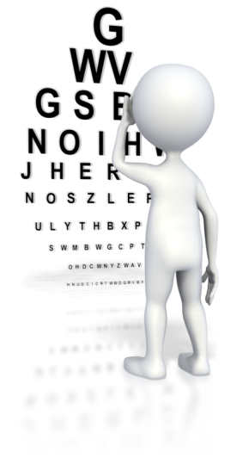
- Standing up when using the telephone
- Walking to the restroom or to get a drink
- Taking the stairs instead of the lift.
Specific workstation exercises
Eyes
- Remove eyes from computer screen and look straight ahead. Without moving your head, move your eyes clockwise in a circle as though looking around the numbers of a clock. Repeat the process anticlockwise
- Close your eyes every now and then for a few seconds.
Shoulders
- Circles – roll your shoulders backwards repeatedly and then forward
- Shrugs – raise your shoulders towards your ears and hold for a few seconds to stretch and repeat as necessary
- Pinches – squeeze your shoulder blades together and hold for a few seconds and repeat as necessary.
Neck
- Turn head to the right and hold for a few seconds before turning to the left, holding, and repeating as necessary
- Tilt head to the right and left and hold and repeat as above.
Hands and wrists
- Clench and release your fists slowly, stretching out your fingers and hold for a few seconds
- Stretch your arms out in front of you, palms facing down, and extend your wrists slowly upwards to stretch them out.
Mix of repetitive and other activities
Try to avoid spending too long on one particular task, or type of task. Mix tasks that require static posture with those that do not. If possible, once you have produced one word processed document, alternate the next one with a task that requires you to move around the work place or change your working position. Not only does this benefit your musculoskeletal system, it also improves concentration and productivity. Regular breaks prevents your mind wandering and increases efficiency.
Rest periods
It is important to ensure that appropriate rest breaks are factored into your working day without compromising or breaching legal requirements such as:
- Working hours
- Rest breaks
- Meal breaks
- Breaks between shifts.
The details vary between industries and Awards and Agreements and you can search for the one applicable to your role on the Fair Work Ombudsman website at: http://www.fairwork.gov.au/Employee-entitlements/hours-of-work-breaks-and-rosters/breaks
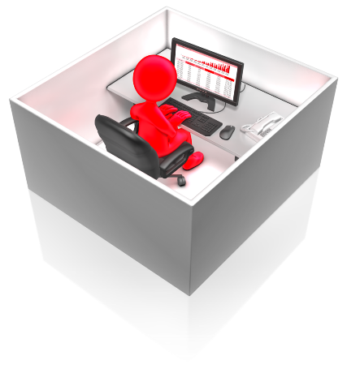

Conservation requirements
Organisations have become increasingly conscious of their corporate social responsibility which includes a desire to contribute to the protection and conservation of the environment. Organisations may have procedures in place for recycling products wherever possible. Not only does it help to conserve the environment, it may also positive implications on the financial costs of the organisation.
Conservation requirements may include:
- Disposing of non-confidential waste paper in recycling bins
- Double-sided paper use
- Re-using paper for rough drafts (observing confidentiality requirements)
- Utilising power-save options for equipment and lighting
- Recycling business equipment such as computers, machinery and ink cartridges.


Activity 1A


1.2 – Identify document purpose, audience and presentation requirements, and clarify with relevant personnel as required

Documents
There are numerous types of documents you may be asked to produce within your role and it may be your decision as to which you use for a specific task, or it may be directed by another member of staff; it may equally be dictated by the nature of the document required.
Types of document may include:
- Agendas
- Briefing papers
- Envelopes
- Faxes

- Labels
- Letters
- Mail merges
- Memos
- Minutes
- Short reports
- Simple one-page flyers
- Standard form letters.

Purpose of the document
When preparing to produce a word processed document, you need to identify a number of factors that will have a bearing on the type, tone, format and length of document you create. The purpose is one of these factors.
Purposes include to:
- Inform – factual information that could include:
  - organisational newsletter
  - changes in organisational policy and procedure
  - information for clients
  - internal memos between departments
  - key performance indicators required for meetings and/or presentations
  - agendas and briefing papers
  - press releases
- Persuade – often sensational and exciting information that could include:
  - advertising and promotional documents
  - testimonials
- Instruct – direct and often formal instructions which could include:
  - minutes from meetings with action points
  - direct instructions to employees and/or management
  - final warning notices to clients with overdue payments
  - purchase order forms
- Describe – a descriptive document that could include:
  - details of an accident or incident in the workplace

  - a witness statement.
- Educate:
  - training documents
  - changes to legislation.

Audience
The document will have an intended audience as well as a specific purpose and it is important to know who the audience is beforehand as the tone and language in which the document is written and its length and format will vary.
An audience may be:
- Internal – for only those inside the organisation
- External – for clients and other people outside the organisation including external bodies
- Formal – in which case organisational procedures and standard practices should be met
- Informal – strict organisational procedures may not be necessary
- Senior management or other superior level of authority.

Presentation requirements
Depending on the type of document you are producing, the way in which it needs to be presented will vary. Your organisation may have standardised procedures and set templates that it uses for specific documentation. For example, a company letter head may always be used for letters sent out to clients, there may be a generic template for minutes of meetings, and specific envelopes and labels may be used for certain mail merges.
Relevant personnel
It is important to familiarise yourself with all of these factors relating to the production of the document before producing it. If you are unsure or do not know, you need to seek clarification from the appropriate member of staff.
Relevant personnel may include:

- Fellow employee
- Supervisor
- Office manager
- Administration department.

Activity 1B

1.3 – Identify organisational and task requirements for document layout and design
We briefly touched upon organisational requirements for the presentation of documents in the last session and we will now go into them in more detail. Each organisation will have its own standardised formats for document layout and design of documents in order to maintain consistency in quality and standards throughout the company. Keeping documentation consistent demonstrates professional, a cohesive work force and attention to detail.

Organisational requirements
Document layout and design may be governed by the following factors:

- Company colour scheme
- Company logo
- Consistent corporate image
- Content restrictions
- Established guidelines and procedures for document production
- House styles
- Observing copyright legislation
- Organisation name, time, date, document title, filename etc. In header/footer
- Templates.
Company colour scheme
The organisation will have specifically selected its colour scheme based upon a number of considerations including:
- The organisation’s audience – stereotypes are often used, such as pastel colours appealing to females
- The corporate image and personality of the organisation – a professional law firm may use bold, cold and traditional colours whereas a holiday theme park wishing to convey a friendly and laid back atmosphere may opt for vibrant, warm colours
- Association or differentiation with competitors in the same industry.
The colour scheme will probably only include three colours at most with one bold accent colour that runs throughout all paraphernalia used by the organisation such as documents, the website, brochures and other marketing and promotional materials, uniform of employees, company vehicles, company sign, and even the interior design within the work premises.

Company logo
The logo is the signature and symbol of your organisation and is a valuable asset. It should be included on all documentation produced by the organisation, especially external documents as it is a subliminal advertising mechanism. People that may not know your organisation may notice it after seeing your logo.

It should be simple and work without colour so that it if sending out black and white documentation it is still instantly recognisable.
Consistent corporate image
It is important to keep the branding of the organisation consistent in all documentation produced. Discrepancies in logo or letter headings, or even type face, make the company look unprofessional and lacking in attention to detail.
When producing your documents you need to be aware of and use the correct documentation for all items produced.
Content restrictions
You need to ensure you are not breaching any privacy laws or using sensitive information in your documents. Your organisation should have in place for procedures relating to the content restrictions.
Established guidelines and procedures for document production
Your organisation will have procedures in place that determine whether templates are used, the quality of paper used to produce specific documents, the size and colour of envelopes used for certain letters and correspondence, and whether or not email signatures may be used on certain documents, or whether hand signatures are essential.
These guidelines and procedures may cover things you had never thought of before.
House styles
The house style of an organisation covers all manner of things including, to name but a few:
- Type face, colour and size of font used for different documents, headings, sub-headings, etc.
- Sentence length
- Reading age of text
- Layout of documents including justification of text and margin widths
- Tone of language
- How numbers are written
- How symbols such as quotation marks are used.

Observing copyright legislation
It is important that you do not infringe the copyright of documentation used by other organisations. This is specifically important with logos and branding but is usually determined at a strategic level.
Organisation name, time, date, document title, filename etc. In header/footer
In specific documents there will be an order in which certain pieces of information appear in a list, a heading or a title page. Again, this is to ensure a consistent approach to all documents produced, to reinforce the professionalism and cohesion of the organisation.
Templates
If your organisation has a template for specific documents you must use them. They have been designed, not only to ensure consistency across the organisation, but also to make the production and completion of the document more efficient.


Activity 1C

2. Produce documents
2.1. Format document using appropriate software functions to adjust page layout to meet information requirements, in accordance with organisational style and presentation requirements
2.2. Use system features to identify and manipulate screen display options and controls
2.3. Use manuals, user documentation and online help to overcome problems with document presentation and production

2.1 – Format document using appropriate software functions to adjust page layout to meet information requirements, in accordance with organisational style and presentation requirements
As with the actual content of documents, your organisation will have specific ways of formatting documents using specific software functions. This ensures that the documents are presented consistently across the organisation, regardless of which employee is producing the document. This is where templates, as introduced in the previous chapter, come in very useful and save time.

Formatting documents
Formatting may include:
- Alignment on page
- Columns
- Company logo/letterhead
- Enhancements to format - borders, patterns and colours
- Enhancements to text - colour, size, orientation
- Headers/footers
- Margins
- Page orientation.
Formatting is included in the house style of an organisation but applies specifically to the way the page looks aesthetically.
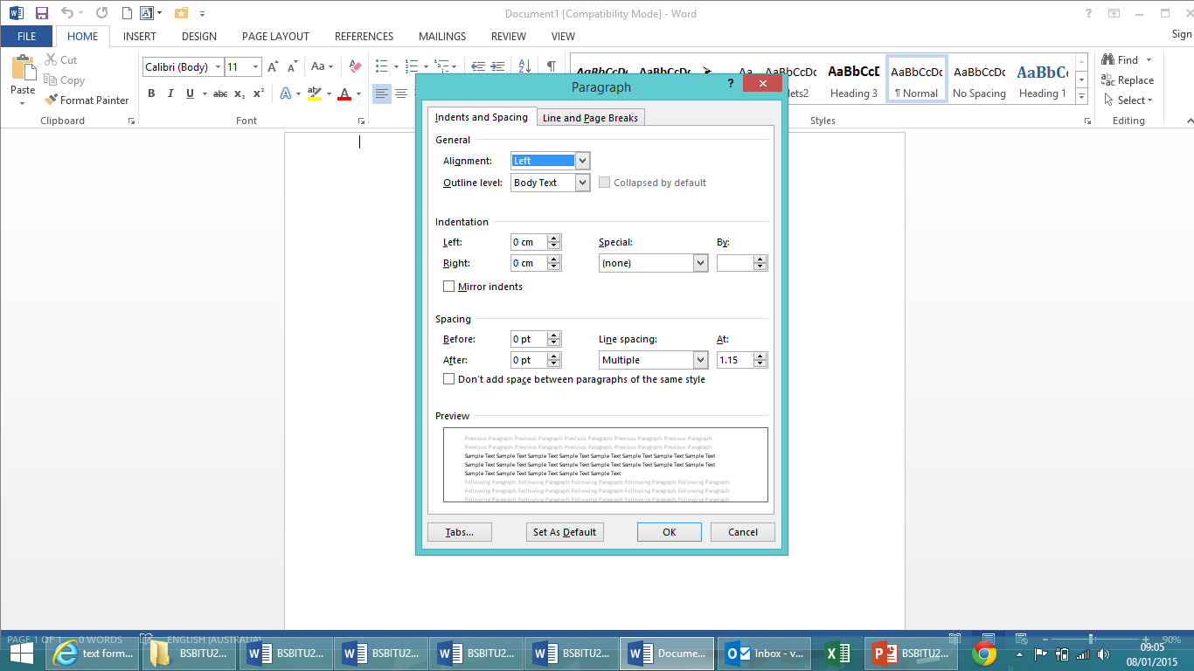

Software functions
Software functions enable you to be consistent in formatting documents as they are pre-programmed to accurate measurements. There are hundreds of different software functions that can be used for formatting.
The most useful and frequently used software functions for producing simple word processed documents include:
- Default settings
- Document protection
- Grammar check
- Headers/footers
- Indent

- Line spacing
- Page numbers
- Page set up
- Paragraph formatting
- Spell check
- Tabs
- Text formatting.
Default settings
These are the original settings that are automatically assigned to a software application, computer programme/system or a device such as a PC, that are beyond the control of the user. Default settings can be restored if files, programmes or software are corrupted.
Document protection
There are several ways you can protect documents including limiting access of users, protecting the format of the document so that only changes can be made to the text, and making them “read only” so that no changes can be made at all.
Grammar and spell check
The spell check and grammar check do exactly that; check the spelling and grammar you have used in your document. These functions are usually active whilst you are writing your document and highlight errors as you are going along by underlining words or phrases with coloured squiggled lines. Whilst these are very helpful functions, you need to make sure that you use the correct national version as there are differences in the spellings of some words between countries, for example the American English spelling of colour is “color”.
Headers and footers
This function allows you to have recurring information, such as the title of the document or the name of the author, at the top and bottom of your pages without having to keep writing it on every page. It also allows you to decide on which pages you want the information to be seen, for example on alternate pages, odd or even pages, or just on specific pages. This function is found in the “insert” menu.
Indent
This allows you to indent your text without having to use the tab key or space bar and ensures all of your indented text is in line. It might be used for quotations or to highlight important information. Indented text looks like this:
Indented text. Indented text. Indented text. Indented text. Indented text. Indented text. Indented text. Indented text. Indented text. Indented text. Indented text. Indented text. Indented text. Indented text. Indented text. Indented text. Indented text. Indented text. Indented text. Indented text. Indented text. Indented text. Indented text. Indented text.
Line spacing
This enables you to decide how much space you want between each line in your text. It enables you to spread the text out or squeeze it together. This spacing between the text in this document is 1.15. In the following paragraph the text is double spaced.
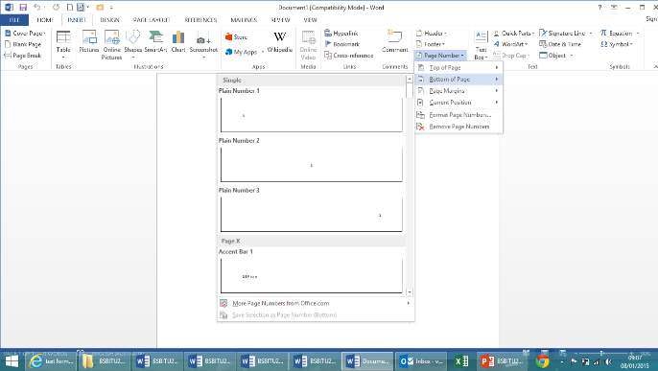
Double spaced text. Double spaced text. Double spaced text. Double spaced text. Double spaced text. Double spaced text. Double spaced text. Double spaced text. Double spaced text. Double spaced text. Double spaced text. Double spaced text. Double spaced text. Double spaced text. Double spaced text. Double spaced text. Double spaced text. Double spaced text. Double spaced text. Double spaced text.
Page numbers
Page numbers are just that. You can choose where they appear on the page, how they are justified, on which pages they appear, and the style and design of the numbers. These are found within the “insert” menu with the header and footer.
Page set up
The set up of the page includes the margins, orientation, line spacing, justification of the text, the font type and size, etc. It is the format that your document will take as a whole.
Paragraph formatting
This controls the alignment and indentation of the text and the spacing between lines. It can be adjusted throughout the document if required.
Tabs
The tab key is used to indent text.
Text formatting
This is used to change the style and size of the text.
Changes to text can include:
- Making the text bold
- Italicising the text
- Underlining text
- Using a different font
- Altering the size of the text
- Making the text a different colour
- Highlighting the text
- Using graphics on the text such as:
  - outline
  - shadow
  - reflection
  - glow
- CAPITALISING THE TEXT.
You can use a combination of any of these formats to make the text look more interesting or to highlight important information.
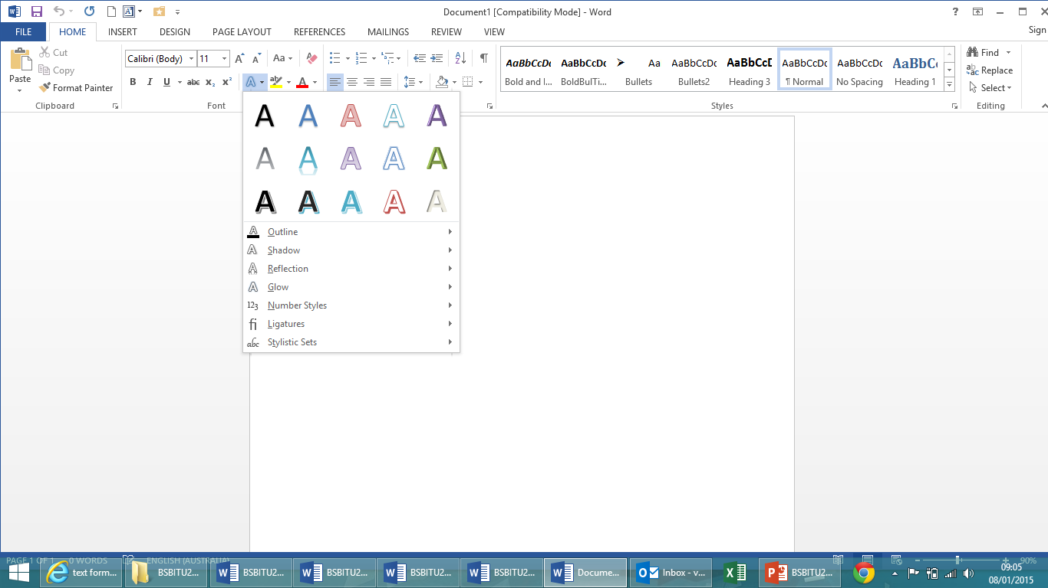

Activity 2A

2.2 – Use system features to identify and manipulate screen display options and controls
When producing documents you may require different views of your document at different times. There are various system features that allow you to change the screen display.
Screen display options include:
- Layout view
- Maximise/minimise
- Normal view
- Page view
- Print preview
- Ruler
- Toolbars
- Zoom percentage.
Layout view
There are various ways you can view your document. Whilst producing your document you will most probably have the editing toolbars in view at all times. However, if you want to read your document without the toolbars you can change the page layout.
Layout views include:
- Read mode – this shows the document as a book with pages next to one another
- Print layout – this shows how the document will be printed
- Web layout – this shows the document as it would appear on a web page and spreads the text across the whole of the screen.
All of these can be found in the “view” menu on the toolbar.
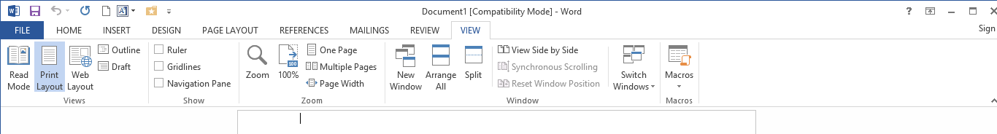

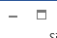
Maximise/minimise
This function is useful when working on a number of documents at the same time or when using multiple programmes. Minimising allows you to shrink the document to a small tab at the bottom of the screen without having to close it. Maximising does the exact opposite, allowing you a full screen view of the document. These functions are found in the top right hand corner of the screen. The minimise function is on the left and the maximise function on the right.
Normal view
Is the default view that is shown when the programme is opened.
Page view
This function allows you to view the pages in different formats. You can view one page or multiple pages at a time. This is found in the “view” menu in the toolbar. Multiple pages look like this on the screen:

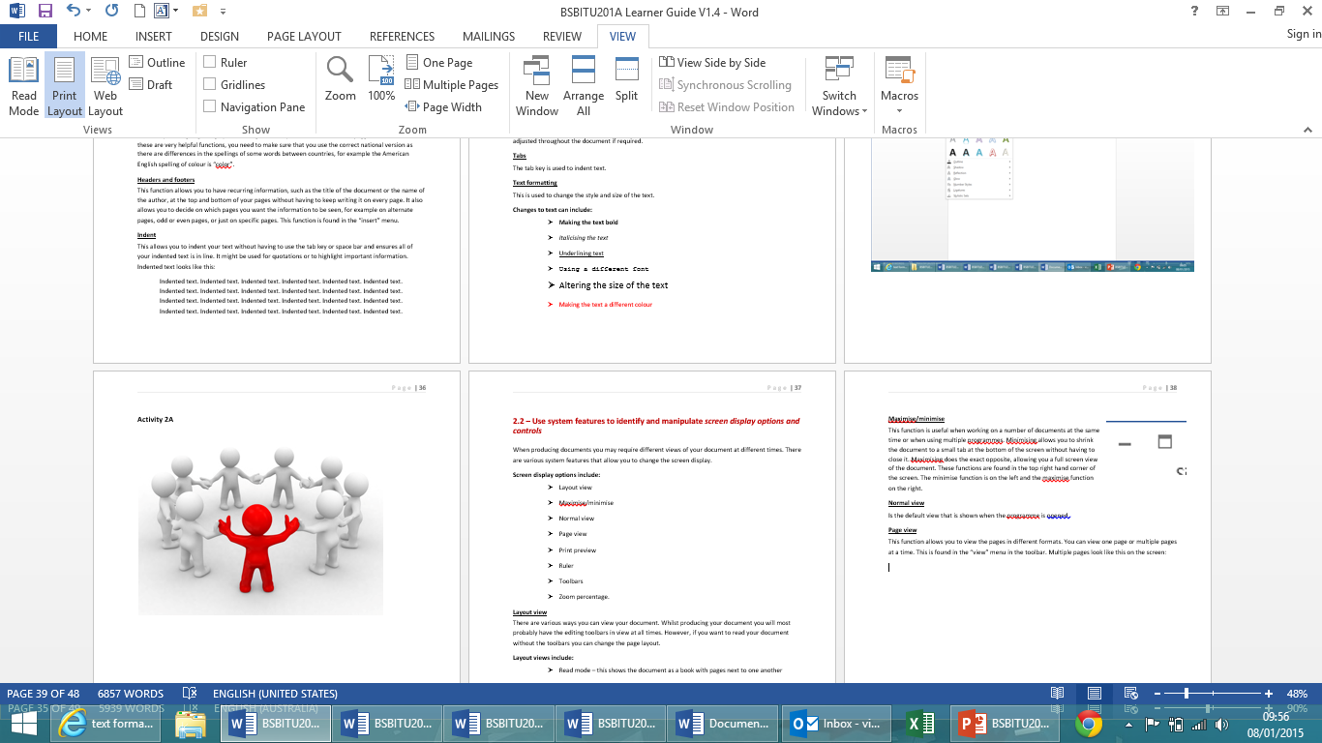

Print preview
This is found in the “file” menu under the printing options and allows you to view the document before you print it to ensure everything is in the right place on the page and correctly formatted.
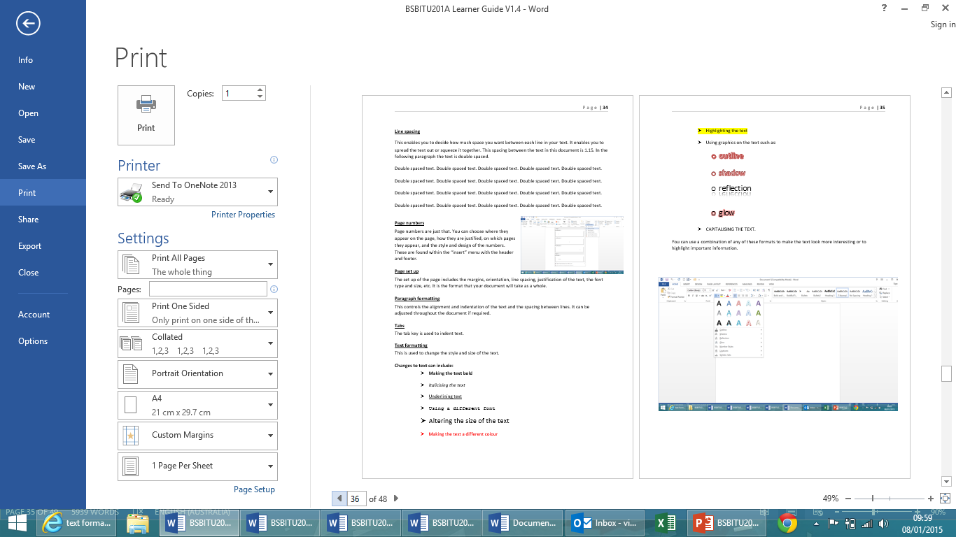
Ruler
The ruler allows you to adjust margins and text boxes accurately. It provides the page with horizontal and vertical rulers. It can be found in the “view” menu in the toolbar.
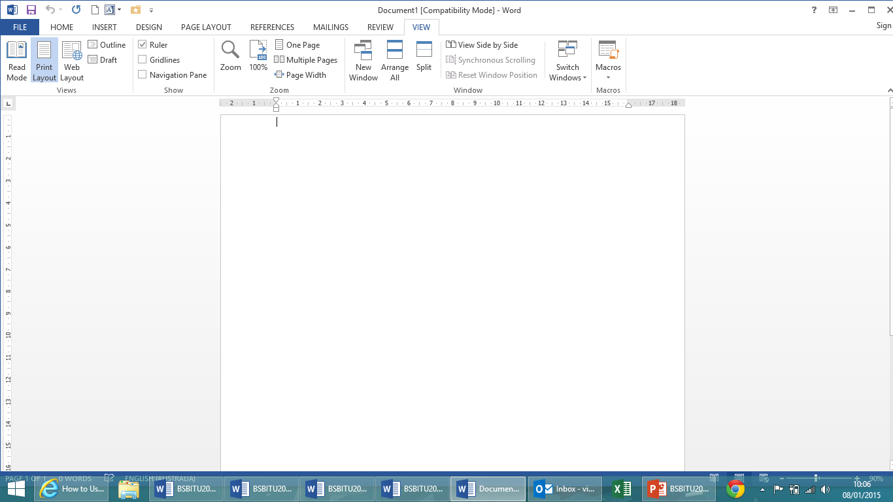

Toolbars
There are numerous toolbars for formatting your document. The functions within each toolbar are related to one another so as to minimise time spent accessing different functions when performing similar operations on the document.
Zoom percentage
This function allows you to enlarge your document and decrease its size when required. It can be found in the bottom right hand corner of the screen on your status bar and also in the “view” menu in the toolbar.
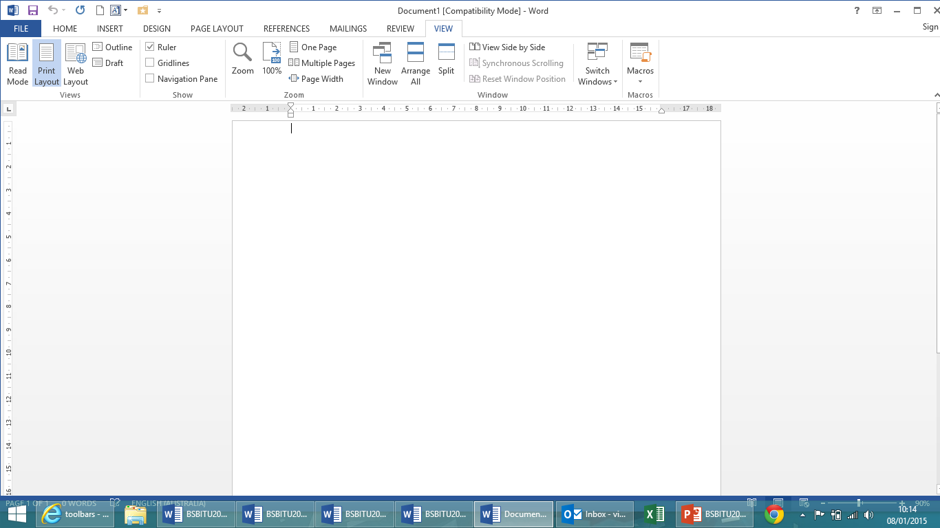

Activity 2B

2.3 – Use manuals, user documentation and online help to overcome problems with document presentation and production
All computer software comes with user documentation to enable the user to get as much out of the product as they require. From basic functions used on a daily basis to advanced presentation and formatting of documents, there will be documentation explaining how to complete whatever action you need.

Manuals and user documentation
Tangible, hard copy user manuals are rapidly becoming a thing of the past as the digital age is quickly taking over due to software being replaced by updated versions seemingly no sooner than their predecessors were launched, rendering the user guide almost obsolete. It is also not as quick to find relevant information in a hard copy of a manual as the human search engine does not work as fast as that of a computer system. However, your organisation may still have a physical copy of the user manual for the software with which you are working.
Software can be sold with user documentation on CD-ROMs which is easier to access than hard copy manuals. Both of these formats can be used to help you overcome problems with document presentation and production.

Online assistance
You will find endless technical support online that is just a click of a mouse away. There are a plethora of websites that provide information to answer every one of your questions however big or small.
Online help comes in many forms including:
- User forums and blogs
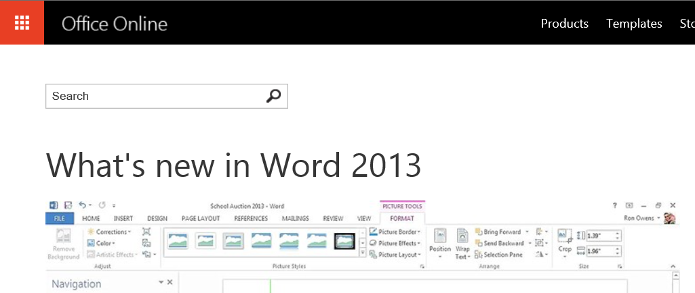
- Manufacturer forums
- Frequently asked questions on manufacturer website
- Live chat with employees of the manufacturer
- Video tutorials
- Manual downloads
- How-to guides.
There is no harm in being stuck and encountering problems, but with so much available information at your fingertips, there is no excuse for staying stuck.

There are even direct links to online support incorporated into the computer programme itself.
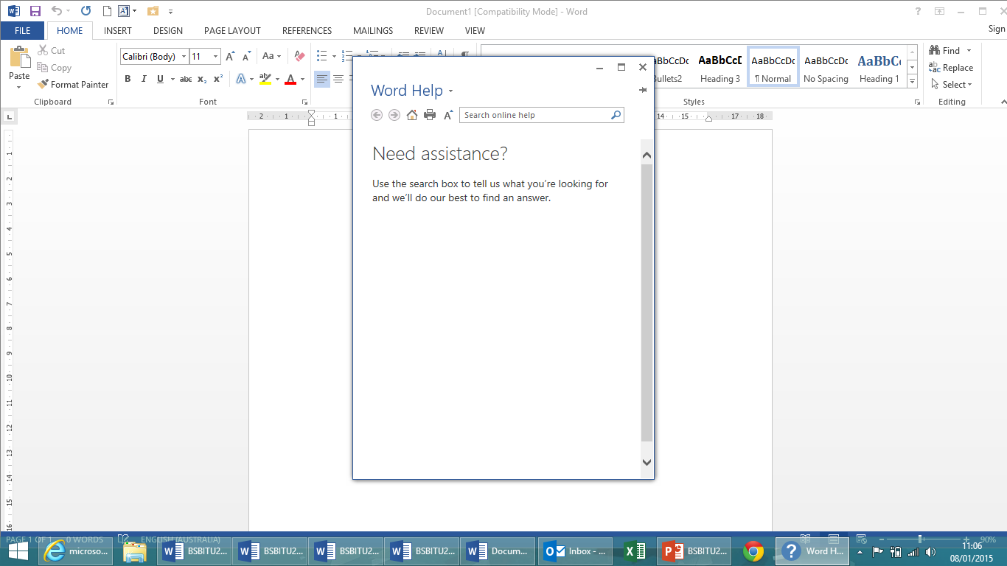

Activity 2C

3. Finalise documents
3.1. Ensure final document is previewed, checked, adjusted and printed in accordance with organisational and task requirements
3.2. Ensure document is prepared within designated timelines and organisational requirements
3.3. Name and store document in accordance with organisational requirements and exit application without information loss/damage

3.1 – Ensure final document is previewed, checked, adjusted and printed in accordance with organisational and task requirements

Checking and adjusting documents
Now you have produced your document you need to put the finishing touches to it. No first draft of a document is ever perfect regardless of how precise you are with your work. When you think it is completed, you need to check through it.
Checking a document may include:
- Accuracy of information
- Consistency of layout
- Ensuring instructions with regard to content and format have been followed
- Grammar
- Proofreading
- Spelling, electronically and manually.
Once you have checked all of these aspects of your document you may need to make adjustments. Adjusting anything within your document, such as the paragraph formatting, line spacing, addition or resizing of images, and corrections to spellings and grammar, may well have a knock on effect to the rest of the document. You may find that minor alterations change the layout elsewhere in the document. It is therefore important after you have made all your adjustments that you check it through again from start to finish to ensure there are no errors.

Printing documents
There are various different ways of printing a document and the way in which you print yours may be determined by who it is printed for, whether or not the whole document needs printing, or the type of paper on which it requires printing.
Ways of printing documents may include:
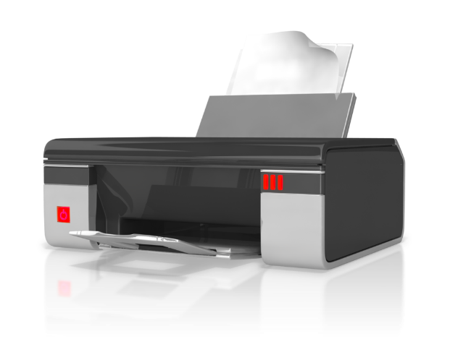
- Basic print settings
- Multiple copies
- Odd or even pages
- Print preview
- Printer setup
- Specified pages
- Whole document.

Basic print settings
Simply selecting the normal print option for your document will print it according to the default settings of the computer software. It gives you no control of the following aspects of printing.
Multiple copies
If your document needs to be printed for numerous people or locations throughout the organisation, printing in volume will save time and will quite possibly save money as the printer will only have to be set up once. You may also need to consider whether your document needs to be printed single or double sided.
Odd or even pages
There may be a requirement to only print odd or even pages, for example if there are graphics on the even pages that are not required by a colleague for which the document is being printed, you may only need to print odd pages.
Print preview
As discussed in chapter 2.2, this is found in the “file” menu under the printing options and allows you to view the document before you print it to ensure everything is in the right place on the page and correctly formatted.
Printer setup
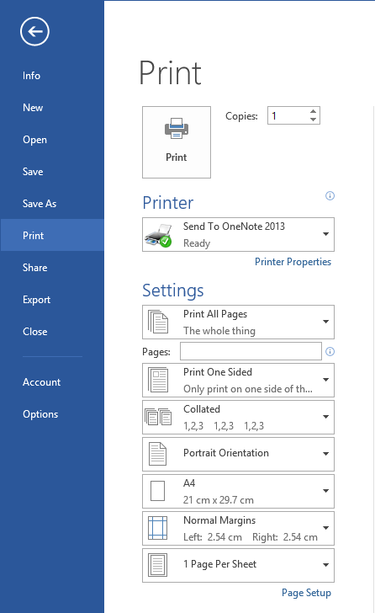
This is not controlled by the word document software but by the actual printer that you will be using. Controls may be on the printer itself, if it is remote, and/or on your computer. Different setups may include whether you wish to print in draft or fine quality, or in black and white or colour. This may be determined by budget costs.
Specified pages
Dependent on what information is required in the print out you may only need to print specific pages. The document may be required by a number of people but who each require different parts of the document.
Whole document
The whole document may need printing.
All of these options can be found in the “file” menu under “print”.
You may find that it is your decision as to how the document is printed but there may also be organisational procedures and guidelines that determine the way in which you print your document.

Activity 3A

3.2 – Ensure document is prepared within designated timelines and organisational requirements

Designated timelines

Whatever document you have been asked to produce you will have most probably been given a submission or completion deadline.
Designated timelines may include:
- Organisational timeline e.g. Deadline requirements
- Timeline agreed with internal/external client
- Timeline agreed with supervisor/person requiring document/s.
It is important that you are certain of the deadline before you begin preparing and producing the document as this will influence how you prioritise your workload. Designated timelines will have been set for a reason and you may wish to consider the following points in relation to your deadline.

Organisational requirements
Business and performance plans
When your work goals are set the timeline given to you will generally be linked to the bigger picture of the organisation. Business plans, whether long or short term, are made and agreed with specific time scales for actions to be completed for genuine reasons. If deadlines are not met this will have a detrimental effect to other areas or departments within the organisation and may result in loss in profits or dissatisfied customers.
If you are repeatedly missing your deadlines your line manager should identify the underperformance and meet with you to ascertain the reason for it. There may be several reasons for underperformance including:
- Lack of knowledge – requires further training or education
- Lack of skill – requires further training, perhaps in the form of a peer coach or mentor
- Poor attitude and work ethic – this would probably be addressed by the implementation of a performance or action plan.
Personal performance plans
A performance plan is a way of addressing an area in an employee’s performance that requires development and is usually quite serious; it could form part of a disciplinary procedure if the employee makes no effort to improve.

Goals, objectives, plans, systems and processes
Business plans are agreed by the senior strategic team well in advance and set out the goals and objectives of the organisation for the forthcoming year, and often beyond. They detail clear timeframes for accomplishing each small and large objective and, whilst there will be contingency plans in place for unforseen hold ups, it is expected that the objectives will be met at the desired time. Managers keep a close track on how fast plans are being progressed and use Key Performance Indicators (KPIs) to measure progress over time. In the retail industry, sales figures will be used to measure progress and in organisations such as supermarkets and restaurants, these figures are measured every hour and adjust staffing levels accordingly. If time limits are exceeded, the management will want to know why, just as it would if tasks were being completed in a significantly shorter amount of time than anticipated.
The systems and processes within an organisation may also have stipulated timelines to complete activities. For example, the accounts section may have a set number of days to dispatch invoices to customers and a subsequent set period of time in which customers have to settle the bill. If these are not adhered to the organisation could face financial problems in the short term and possibly the long term.
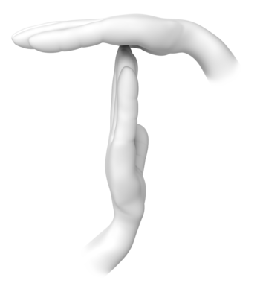
Legal and organisation policies, guidelines and requirements
As discussed in chapter 1.1 it is important to ensure that deadlines are achievable without compromising or breaching legal requirements such as:
- Working hours
- Rest breaks
- Meal breaks
- Breaks between shifts.
In some organisations and industries there are legal time scales attached to certain tasks such as dealing with grievances and redundancy consultation periods. If you are given a task to complete in relation to these sorts of matters it is essential it is completed within the required period.
WHS policies, procedures and programs
The following Safe Work Australia documents detail policies and procedures relating to time scales:
- Dealing with workplace bullying - A worker’s guide – “setting unreasonable timelines or constantly changing deadlines”
- Preventing and managing fatigue in the workplace – “work demands placed on the person (for example, timeframes, deadlines, intensity)”.

Activity 3B

3.3 – Name and store document in accordance with organisational requirements and exit application without information loss/damage

Naming and storing documents
Each organisation will have procedures and systems in place that determine how and where documents are stored. Documents may be stored as hard copies or digital files in specific filing systems; most organisations will use a combination of both.
There will also generally be a member of staff responsible for information systems within the organisation. In large companies there may be a designated records co-ordinator in each department, and a records retention schedule that lists all the records held in each department, with a records manager who oversees the entire information systems of the organisation.

Where information is stored depends upon a number of things:
- How often it is accessed
- Who needs access to it
- The security level with which it is classified
- The physical form of the information
- Who is responsible for managing it.
Things to consider when naming and storing documents may include:
- Appropriate file type – for example whether or not the file needs to be compressed
- Authorised access – not all employees need to have access to all documents and some documents may contain sensitive information. It is important to ensure that files are only accessible by the password of authorised users where appropriate
- File names according to organisational procedure e.g. Numbers rather than names
- File names which are easily identifiable in relation to the content – such as “petty cash receipts 2014”
- File/directory names which identify the operator, author, section, date etc.
- Filing locations – it is important to keep filing systems streamlined and logical. In shared computer systems it is very easy to duplicate file locations; there should be clear guidelines detailed in a user guide as to where specific documents should be stored
- Organisational policy for backing up files – most organisations will have contingency plans and recovery systems in place should information systems fail but it is a good idea to be aware of the policy for backing up files
- Organisational policy for filing hard copies of documents – see below for good practice on managing hard copy filing systems
- Security – see information below
- Storage in folders/sub-folders
- Storage on hard/floppy disk drives, CD-ROM, tape back-up.
Good practice for paper based filing systems:
- Use a logical classification system that best suits the type of records held
- Locate the filing cabinet so it is easily accessible to all colleagues who require access
- If the system needs to be secure, decide whether locked drawers will suffice or whether the cabinet needs to be in a locked room
- Keep up to date indexes of all files held
- Allocate time in your schedule for housekeeping filing systems
- Before filing paper records make sure they are in good order or mended if necessary

- Create new files if existing ones are full to avoid overcrowding and damaging the documents
- Observe workplace health and safety by:
  - closing drawers when not in use
  - using a trolley to move heavy or bulky items
  - using a ladder when accessing items in high locations
  - not storing files on the floor where they could be tripped over.
Good practice for storing electronic files:
- Name documents and folders meaningfully and logically, and consistent with other existing documents, for example “Customer Complaints January 2014”
- Spell words in full rather than using abbreviations, acronyms, or peoples’ initials
- Date your documents and folders
- Do not store the same information in more than one place
- Do not add unnecessary new folders
- Ideally one or two people will be responsible for the housekeeping and maintenance of the system
- If filing versions or drafts, ensure this is included in the name of the document and which particular version or draft it is
- If documents need to be accessed by a number of people in the organisation make sure it is saved to a shared area
- If creating a document in a shared area that is a master copy or something you don’t want to be changed, attach Read Only status to it
- Not all personnel need access to all documents. If documents contain personal information they will need to be password protected.

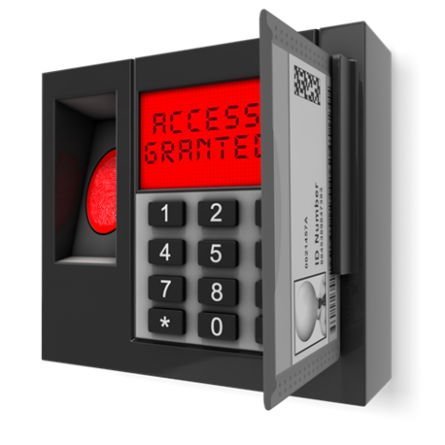
Security
Your organisation should have a security policy that details how documentation, both electronic and hard copy, is managed and secured to protect from breaches in confidentiality across the organisation, and contingency plans should any of the information systems fail or be breached.
Backup systems
Those persons responsible for each information system must ensure appropriate backup and recovery systems and procedures are in place and must meet the needs of the organisation.
Compliance
Terms and conditions of employment and the organisation’s Code of Conduct will clarify responsibilities and limits of employees’ access to and use of information systems. Where appropriate, training will be given on legal compliance.
Outsourcing and third party access
All third parties that have access to the organisation’s information systems must agree to and follow the organisation’s information security policy.
Physical access to information
Areas where confidential and restricted information is held should have the appropriate level of physical access controls and only appropriate and relevant members of staff will have access.
IT operations
Procedures should be in place for reporting security incidents and possible weaknesses in security systems, as well as reporting malfunctions in information systems.
Disposal of information systems
Procedures should be in place for the safe disposal of equipment and/or systems containing confidential information.
Access
Access to information systems for employees should be set accordingly and should be password protected and monitored by the organisation. Each employee should be accountable for their own usage and must not share their password with others.
Confidential or restricted material
Confidential and restricted information should be stored centrally and accessed according to the authorisation levels of each piece of information. Employees should be clear on what constitutes, and the consequences of, breaching confidentiality. Confidential and restricted material should be destroyed by shredding or other similar means when no longer required.

Avoiding loss or damage to documents
It is important when producing documents that you save it regularly. Whilst most systems have autosave recovery in place, it is still a good idea to manually save your work regularly. You can do this by pressing CTRL + S.
If using a generic template it is a good idea to save it as the name of your document in the appropriate location before you start working on it. This will avoid over-writing the template by absentmindedly pressing CTRL + S before saving it as a new document.
You can also back up your documents on data sticks or by emailing them to yourself.

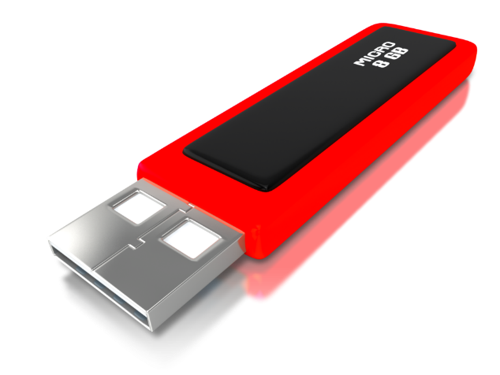

Activity 3C

Skills and Knowledge Activity

Nearly there...

Major Activity – An opportunity to revise the unit

At the end of your Learner Workbook, you will find an activity titled ‘Major Activity’. This is an opportunity to revise the entire unit and allows your trainer to check your knowledge and understanding of what you have covered. It should take between and 1-2 hours to complete and your trainer will let you know whether they wish for you to complete it in your own time or during the sessions. Once this is completed, you will have finished this unit and be ready to move onto the next, well done!

Congratulations!
You have now finished the unit 'Produce simple word processed documents.'


References

These suggested references are for further reading and do not necessarily represent the contents of this Learner Guide.

Australian Government ComLaw
Work Health and Safety Act 2011
Available at URL: http://www.comlaw.gov.au/details/c2011A00137
eHow
How to prevent computer radiation
Available at URL: http://www.ehow.com/how_4995339_prevent-computer-radiation.html
The University of Sydney
Office Ergonomic Guidelines – Equipment Set Up
Available at URL: http://sydney.edu.au/whs/guidelines/ergonomics/ERGO5.shtml
Health and Safety Executive
Human factors: Lighting, thermal comfort, working space, noise and vibration
Available at URL: http://www.hse.gov.uk/humanfactors/topics/lighting.htm#lighting
SAI Global
Info Store
Available at URL: http://infostore.saiglobal.com/EMEA/results2.aspx?sesarchType=power&publisher=All&doctype=Standards&status=Current&sfld1=Keyword+in+title&sval1=lighting&pageNo=2
Stamford University
Work breaks, exercises and stretches
Available at URL: http://web.stanford.edu/dept/EHS/prod/general/ergo/microbreaks.html

All references accessed on and correct as of 06.01.2015, unless other otherwise stated.

