
BSBWHS408
Assist with effective WHS management of contractors

Copyright © 2020 CSTC Pty Ltd

All rights reserved. No part of the contents of this publication may be reproduced or used in any form or by any means – graphic, electronic, or mechanical including photocopying, digitising, recording, or information storage-and-retrieval systems – without the written permission of CSTC Pty Ltd.
ASSESSMENT FOR BSBWHS408

Student name | Kalyn Landman
Date of assessment submission | 9/07/2020

Trainer/Assessor’s name
Date of assessment marking | Click here to enter a date.
Outcome for unit | ☐ Competent  ☐ Not Yet Competent

TASK INSTRUCTIONS

- The assessment for this unit of competency consists of the following:
  - A series of activities: Some of these activities will require you to provide a response within this document, others will require you to gather evidence to demonstrate your knowledge and skills (overview below)
  - Quiz: You will be required to complete a series of questions to demonstrate your knowledge and skills.
  - Practical task: You will be required to have an observer attest to your knowledge and skills and sign a report to this effect.
- At times, you will be provided with a specific business context to which you must respond, otherwise it is anticipated that you will use a workplace of your choosing (your own, or hypothetical) to provide the context to the task.
- At all times, the responses in your assessment must reference Australian (Queensland or Federal) documentation, including legislation, regulations, codes of practice, standards and guidance publications.

ACTIVITY OVERVIEW | REQUIRED FOR SUBMISSION
- Services provided by contractors | - Workbook response (below)
- Policies, procedures, processes, systems, practices and activities | - Workbook response (below)
- Legislative requirements | - Workbook response (below)
- Developing, implementing and evaluating improvements | - Workbook response (below)

ACTIVITIES

For the following activities, name a workplace that you wish to examine.

Name of workplace | Landman Demolition Services

- Identify two (2) on-site services that may be supplied by contractors to your workplace. For example:
- Labour hire and temporary workers
- Cleaning
- Catering
- Security
- Maintenance
- Repairs
- Installations and alterations
- Explain the context, situation and arrangement of how these services are provided.
- Identify one (1) document that would support the contractor’s contract
- Explain where contracts and other relevant contract documentation would be found.

Name of Service 1
Semi Tipper and Driver Hire – Demolition Waste Transport
Context, situation and arrangement of how service is provided
Site requirement for Truck hire to assist with loading out of demolition waste as required.

Subcontractors duty is to attend site with semi tipper and be loaded with demolition waste. They are then to transfer the waste to the appropriate facilities as directed by the site supervisor. Subcontractor will return to site multiple times until no longer needed.

Subcontractor will be engaged by phone and followed up by a purchase order sent via email with details such as the site, date, time, job specific requirements. Site contact and phone number.

Subcontractor will attend the daily site prestart to be debriefed on the requirements. Subcontractor is required to sign off on the talk.

Supporting document and location
Subcontractor will have already completed company Subcontractor Assessment Form followed by company Subcontractor Induction Form. Company will already have copies of appropriate forms such as (Public Liability, Work cover etc.)

All subcontractor documentation is saved electronically under the subcontractor in LDS files clearing labelled.

Purchase order will be raised from company software.

Dump Dockets will be provided to the truck driver at the appropriate facilities. These will be handed in to the site supervisor and filed in the job folder accordingly.

Subcontractor Daily Dockets (provided by the contractor) are signed by the site supervisor and provided daily along with a copy attached to the subcontractor invoice.

All site specific documentation will be saved electronically in the job files as required..

Name of Service 2
Plumber - Sewer Capping
Context, situation and arrangement of how service is provided
Sites requiring a licensed plumber to attend, locate and cap the sewer as per legislative requirements. After work is complete the plumber lodges the appropriate form with council and provides the Form 4 to confirm the work has been completed.

Subcontractor will be engaged by phone and followed up by a purchase order sent via email with details such as the site, date, time, job specific requirements. Site contact and phone number.

On arrival plumber is to see the site supervisor. Carry out a site specific induction if required or attend a toolbox talk to discuss safety requirements.

Supporting document and location
Subcontractor will have already completed company Subcontractor Assessment Form followed by company Subcontractor Induction Form. Company will already have copies of appropriate forms such as (Public Liability, Work cover etc.)

All subcontractor documentation is saved electronically under the subcontractor in LDS files clearing labelled.

Purchase order will be raised from company software.

Plumber to provide Form 4 and invoice for the completed work.

Outcome for Activity 1 | ☐ Satisfactory  ☐ Not satisfactory
Trainer/Assessor comments

Identify and describe the requirements of each of the following within your chosen organisation, with regards to contractor WHS arrangements:
- WHS policy
- WHS procedure
- WHS process
- WHS system
- WHS practice and activity (i.e. common practice that is not outlined in one of the above documents)

Name of WHS policy
Subcontractor Management
Requirements
To ensure full and total compliance to high standards of WHS practices.
The management of all companies providing subcontractor services to LDS.
To provide a safe working environment to all workers, persons, visitors, licensee’, clients needs, regardless of location of work.
The need to examine individual contracts to ensure all equipment, environment, trained personal, work procedures and PPE are provided to complete the jobs safely.
Procedures put in place to manage legal and moral obligations concerning safe working environment for external personnel and endeavour to effectively control the risks associated.
Set responsibilities are allocated to Managers and supervisors, workers, subcontractors.

Name of WHS procedure
Subcontractor Management
Requirements
LDS will ensure contractors are assessed prior to undertaking work and ensure the below are completed:
Ensure compliance with legislations, regulations, codes of practice and standards.
Ensure compliance with WHS policies and procedures.
Contractors have required qualifications, training, experience. Obtaining copies of subcontractor certificates, licences and training register where applicable.
Risk assessment is provided for management of WHS risks.
An appropriate procedure such as SWMS has been completed.
Site specific procedures have been developed and implemented.
Relevant WHS info is provided to the principle organisation when requested.
Subcontractor to completion of LDS site induction and be included in pre-starts and safety orientation.
General Construction Induction training cards are held.
Ensure permits and licences are obtained prior to commencement of subcontractor work.
LDS will supervise their sub-contractors.
Any hazards, incidents, injuries, near misses or non-compliance are reported.
Subcontractors to carry out appropriate consultation, co-ordination and co-operations with LDS on WHS issues.
Regular safety performance review will be undertaken.
Ensure the PPE provided is worn where required.

Name of WHS process
Subcontractor Management – Subcontractor Assessment Form and Subcontractor Induction Checklist
Requirements
It is a process which begins at the commencement of the selection process and continues until the completion of the project/job involved.
An assessment of potential Contractors is to be undertaken using the Subcontractor Assessment Form, together with copies of relevant documentation provided to verify information. Copies of WHS Management System, SWMS/Risk Assessments, Training (including company and individual licences) and Insurances are to be provided for every contractor prior to approval.
Once approved, the contractor is inducted into WHS Management System using the Subcontractor Induction Checklist and listed on the Approved Contractor Register. The assessment must be renewed annually.
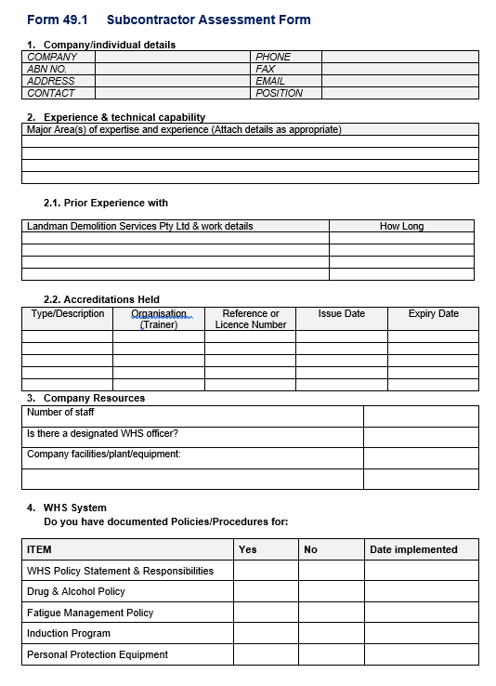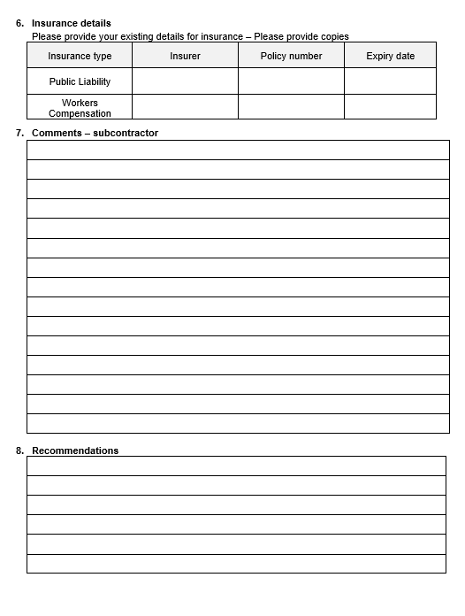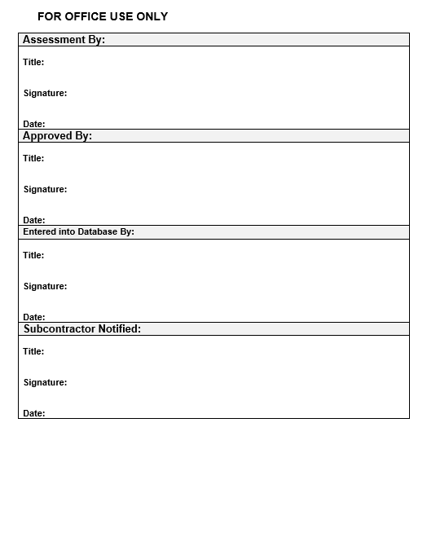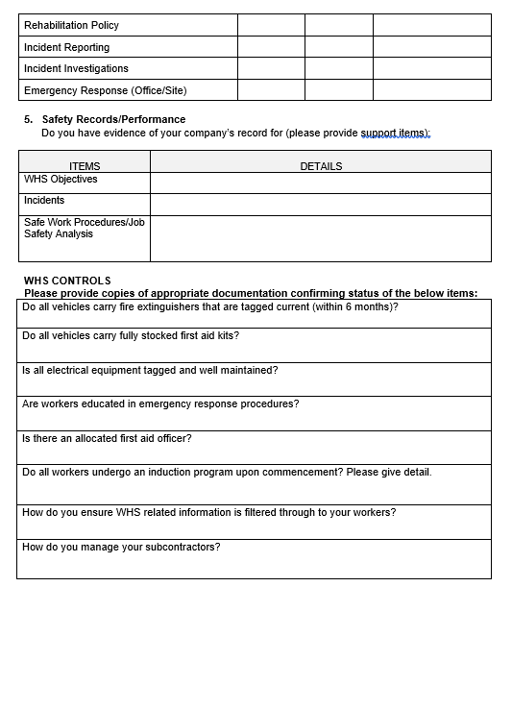

Name of WHS system
Landman Demolition Services – WHS Manual
Requirements
If approved through the Subcontractor Management – Subcontractor Assessment Form, the contractor is inducted into WHS Management System using the Subcontractor Induction Checklist and listed on the Approved Contractor Register. The assessment must be renewed annually. Failure to comply with the Subcontractor Management Policies and procedures will see an issue resolution and non-conformance process activated. If it cannot be resolved the subcontractor will no longer be used and removed from the approved contractors register.
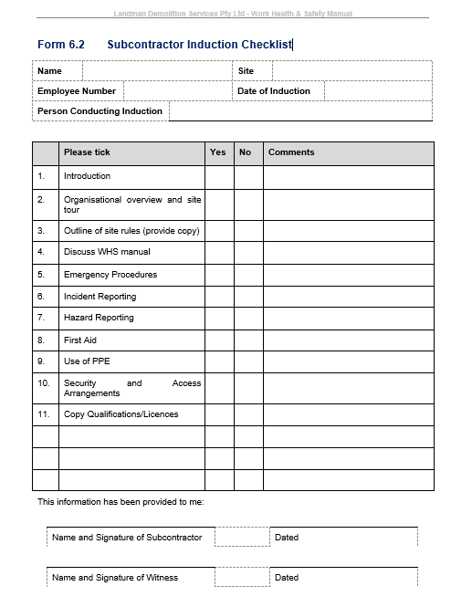.

Name of WHS practice and activity
Asbestos removal air monitoring and independent clearance
Requirements
Upon asbestos removal completion LDS engages a contracted certified hygienist to carry out air monitoring where applicable and provide an independent clearance certificate as per legislative requirements. LDS requires the contractor to pass the subcontractor assessment and provide all relevant licences and documentation as per company polices and procedures.

Outcome for Activity 2 | ☐ Satisfactory  ☐ Not satisfactory
Trainer/Assessor comments

Identify one (1) of each of the following document types which addresses contractor arrangements and where such documents can be found:
- Act
- Regulation
- Code of practice
- Standard
- Guidance publication

Identify a relevant excerpt or requirement from each document that assists with determining whether contractor arrangements within your nominated workplace (i.e. policies, procedures, processes, systems, practices and activities) are compliant.

Example:
Name and location of Legislation (Commonwealth or State)
Work Health and Safety Act 2011 (Qld) found at www.legislation.qld.gov.au
Relevant excerpt/requirement for determining compliance
Section 7: A person is a worker if the person carriers out work in any capacity for a PCBU, including work as a contractor or subcontractor

Name and location of Legislation (Commonwealth or State)
Work Health and Safety Act 2011 (Qld) found at www.legislation.qld.gov.au
Relevant excerpt/requirement for determining compliance
Section 7 – A person is a worker if the person carries out work in any capacity for a person conducting a business or undertaking including work as a contractor or subcontractor, an employee of a contractor or subcontractor.

Name and location of Regulation
Work Health and Safety Regulation 2011 (QLD) found at www.legislation.qld.gov.au

Relevant excerpt/requirement for determining compliance
Part 3.2 General Workplace Management Section 39 – Provisions of information, training and instruction.
(2) The person must ensure that information, training and instruction provided to a worker is suitable and adequate to the nature of the work, the nature of the risk, the control measures implemented.
(3) The person must ensure so far as reasonably practicable that the information, training and instruction is provided in a way that is readily understandable by any person to whom it is provided.

Division 5 Personal Protective Equipment. Section 44 (2) the PCBU who directs the carrying out of work at the workplace must provide the PPE equipment to workers at the workplace, unless the PPE has been provided by another PCBU.

Name and location of Code of Practice
Demolition Work Code of Practice 2013 (Qld) found at https://www.worksafe.qld.gov.au/__data/assets/pdf_file/0020/58160/demolition-work-cop-2013.pdf
Relevant excerpt/requirement for determining compliance
3 Planning the demolition work.
A demolition plan should be prepared for all demolitions where there are a number of other persons conducting a business or undertraining (eg subcontractors) involved. If the demolition contractor is also the principal contractor, the demolition plan should be incorporated as part of the WHS management plan.

Name and location of Standard
Australian Standard – The demolition of Structures AS2601-2001 found at https://www.standards.org.au/
Relevant excerpt/requirement for determining compliance
1.5.2.2 – Personal Protective Clothing and Devices PPE
While on the site, every worker and every visitor shall wear a safety helmet complying with AS/NZS 1801. Also, every worker shall wear protective clothing and wear appropriate, the following protective equipment: Eye protection, Respirators, hearing protection, Safety gloves, safety footwear, highly visible clothing where appropriate to recommended standards as outlined in this standard.

Name and requirement of Guidance Publication
Model COP how to safely remove asbesto - https://www.safeworkaustralia.gov.au/doc/model-code-practice-how-safely-remove-asbestos
Relevant excerpt/requirement for determining compliance
3.10 Clearance Inspection
Clearance inspections must be carried out and clearance certificates issued by:
- an independent licensed asbestos assessor, for work that must be carried out by a Class A licensed asbestos removalist (for example if the removal work involved friable asbestos), or
- an independent competent person, for asbestos work that is not required to be carried out by a Class A licensed asbestos removalist (for example if removal work involved more than 10 m2 of non-friable asbestos).
To be independent, the licensed asbestos assessor or competent person must:
- not be involved in the removal of asbestos for that specific job, and
- not be involved in a business or undertaking involved in the removal of the asbestos for that specific job.

Outcome for Activity 3 | ☐ Satisfactory  ☐ Not satisfactory
Trainer/Assessor comments

For the purpose of improving contractor arrangements in your workplace, you are to develop a report (in the following structure), which evaluates current contractor practices and outlines improvements.

- INTRODUCTION
- Outline the background of your company, its role and purpose
- Briefly identify the role of contractors within the organisation (e.g. services provided)
- Identify what you wish to achieve by conducting a review and evaluation of current WHS arrangements for contractors

- CURRENT PRACTICES FOR CONTRACTORS
- Describe two (2) contractor arrangements in place at your organisation and how/where they are outlined.
- Identify the organisation’s WHS policies, procedures, processes and systems with regards to contractors.

- LEGISLATIVE REQUIREMENTS
- Outline contractors’ WHS duties under the legislation
- Identify contractors’ WHS rights under the legislation
- Explain contractors’ WHS obligations under the legislation

- REFLECTION ON BEST PRACTICE
- Identify examples of best practice in industry
- Compare best practice with current practice
- Identify areas for improvement

- RECOMMENDATIONS
- Propose improvements to address needs, explaining how they would meet best practice and/or legislative requirements
- Identify how proposed improvements could be implemented
- Outline how improvements could be evaluated for effectiveness

- CONCLUSION
- Explain the importance of WHS to your company
- Identify contractors’ varying WHS duties, rights and obligations under the legislation
- Express the importance of improving practices

TIPS:
- Use the report template (below) and elaborate on the points above.
- Write in simple English. Remember that people from a range of backgrounds and abilities would be reading this document, such as health and safety committees, health and safety representatives, managers, supervisors, and PCBUs or their officers.
- Be sure to refer to supportive documents specifically (e.g. section numbers of legislation, reference best practice and WHS information and data) so that the reader could refer to the legislation for more information if they wanted to.

- INTRODUCTION
Landman Demolition Services Pty Ltd is a family owned demolition company which provides Asbestos Removal, Structural Demolition and other associated services for residential and commercial customers within SEQ Queensland.

Landman Demolition Services engages several contractors to complete works on behalf of their company. These services can range from subcontracted Truck Hire, Private Certifiers for demolition approval, Plumbers for sewer capping and storm water disconnection, Arborists for difficult trees, Hygienists for asbestos assessments and independent clearances.

By reviewing and evaluating the current arrangements for contractors we can gather information to help develop improvements by identifying the effectiveness of the systems and practices currently in place whilst also establishing a baseline for which future progress can be measured. We would use the obtained information for continuous improvements within the contractor management procedures to ensure our systems are effective, always up to date, user friendly for both LDS and the contractors and being implemented as effectively as possible.
- CURRENT PRACTICES FOR CONTRACTORS
Two frequently used contractor arrangements in place with LDS are Semi Tipper Hire for carting of demolition debris and a plumber for site specific sewer capping and storm water disconnections.

The procedures utilised to engage these two contractors are outlined in the Landman Demolition Services WHS Manual under section 49 Subcontractor Management. The way in which they are engaged per project is through purchase orders sent via email specifying site details, site contact and work requirements. This form of engagement is based on an administrative procedure.

As per the Landman Demolition Safety Management Manual Subcontractors are engaged and managed through the details outlined under section 49 – Subcontractor Management.

Policy:
The Subcontractor Management Policy is in place to ensure full and total compliance to high standards of WHS practices.
The management of subcontractors may be defined as all companies providing subcontractor services to LDS.
It is a process which begins at the commencement of the selection process and continues until the completion of the project/job involved.
It is Landman Demolition Services Pty Ltd.’s intent to provide a safe working environment and safe systems of work for all workers, persons, including visitors, licensees, and client’s needs, regardless of location of work.
Understand the need to examine individual contracts to ensure all equipment, environment, trained personal, work procedures and PPE are provided to complete the jobs safely.
Procedures have been put in place to manage legal and moral obligations concerning safe working environment for external personnel and endeavour to effectively control the risks associated. Set responsibilities are allocated to Managers and supervisors, workers, subcontractors. See the LDS Management Manual section 49 for further information.

Procedure:

- LDS will ensure the following:
- Contractors are assessed prior to undertaking work and ensure the below are completed.
- Compliance with legislations, regulations, codes of practice and standards.
- Compliance with WHS policies and procedures.
- Contractors have required qualifications, training, experience. Obtaining copies of subcontractor certificates, licences and training register where applicable.
- Risk assessment is provided for management of WHS risks.
- An appropriate procedure such as SWMS has been completed.
- Site specific procedures have been developed and implemented.
- Relevant WHS info is provided to the principle organisation when requested.
- Subcontractor to completion of LDS site induction and be included in pre-starts and safety orientation.
- General Construction Induction training cards are held.
- Ensure permits and licences are obtained prior to commencement of subcontractor work.
- LDS will supervise their sub-contractors.
- Any hazards, incidents, injuries, near misses or non-compliance are reported.
- Subcontractors to carry out appropriate consultation, co-ordination and co-operations with LDS on WHS issues.
- Regular safety performance review will be undertaken.
- Ensure the PPE provided is worn where required.

Process and Systems:

An assessment of potential Contractors is to be undertaken using the Subcontractor Assessment Form, together with copies of relevant documentation provided to verify information. Copies of WHS Management System, SWMS/Risk Assessments, Training (including company and individual licences) and Insurances are to be provided for every contractor prior to approval.
Once approved, the contractor is inducted into WHS Management System using the Subcontractor Induction Checklist and listed on the Approved Contractor Register. The assessment must be renewed annually.
Failure to comply with the Subcontractor Management Policies and procedures will see an issue resolution and non-conformance process activated. If it cannot be resolved the subcontractor will no longer be used and removed from the approved contractors register.

- LEGISLATIVE REQUIREMENTS
Contractors duties as per the Work Place Health and Safety Act 2011 Division 4 - Section 28 – 29. Take reasonable care for their own health and safety and take reasonable care that their acts or omissions do not adversely affect the health and safety of other persons.
Comply with any reasonable instruction that is given by the PCBU to allow the person to comply with the Act.
Co-operate with any reasonable policy or procedure of the PCBU relating to health or safety at the workplace that has been notified to work.
As per Section 46-49 of the WHS Act 2011 – Contractors have the right to be consulted with and have a right to refuse to undertake unsafe work.
As per the Work Place Health and Safety Consultation, Co-operation and co-ordination Code of Practice – 5.1 – Various contractors who are involved in the same work at the same time at a workplace will need to consult, co-operate and co-ordinate activities with each other as they may affect the health and safety of their own workers or the workers of another business or people at or near the workplace. 5.2 Consultation between duty holders should commence as soon as duty holders become aware, they will be involved in the work.

As per the Work Place Health and Safety Act 2011, Contractors for a construction project, as a person who manage or control a workplace have the obligation and specific duties to have arrangements in place for consultation, co-operation and co-ordination of activities between a PBCU and the site. This is also referenced in the Work Place Health and Safety Consultation, Co-operation and co-ordination Code of Practice.

- REFLECTION ON BEST PRACTICE
Best practice is the procedures that are accepted or prescribed as being correct or most effective within the industry.

Best practice for contractor management are things like contractor prequalification, Task and Risk Assessment pre job, providing contractor training, providing contractor orientation and inductions prior to works being carried out. Ensuring effective contractor management and supervision, and post work evaluation to ensure the works are being completed to company and legislative requirements.

Landman Demolition Safety Management Manual appears to have all the correct policies and procedures in place to allow the company to carry out effective contractor management although there are definitely areas for improvement.

The biggest areas that needs improvement is the cultural barrier that see’s the policies and procedures not being implemented as well as they could be or even at all. Employees might feel that following procedures causes lengthy delays in which they do not have time for. In some cases, subcontractors may feel the same way or not understand the importance of the process. They could take too long to provide the appropriate information or be reluctant to complete the forms prior to commencing work.

Another area that could be improved is the company and all employees understanding of the procedure. Ease of access to the documentation could be improved as well as the forms are currently imbedded within the WHS Manual.
- RECOMMENDATIONS
In cases where policies and procedures are not being implement or followed as required, management must lead by example and explain the importance of subcontractor management and how poor implementation can negatively affect various factors such as health and safety, financial implications and legal implication.

All new contracts should be planned in advance and prior to commencement all subcontractors should be engaged and have successfully completed the subcontractor assessment and subcontractor induction.

Training on the subcontractor management procedure should be provided to all staff. Related forms could be moved to an electronic location which is easy to find. They could also be provided in printed form in a central location that is easy to locate. Refresher training should be provided regularly to ensure all staff are up to date with the current policies and procedures.

Allocating the particular duty of subcontractor assessments, pre qualifications and management to certain individuals within the organisation such as a supervisor or manager would be ideal so that the process is completed efficiently and reviewed accordingly.

All improvements should be designed and implemented using information found in relevant Act, Regulation, COP’s and standards. This is to ensure the company documentation remains compliant with current legislations.

Implementation of proposed improvements could be rolled out using tools and resources found in the companies WHS Management System. Using tools that have set milestones and checkpoints to guide the employees with the rollout are useful. Consultation, co-operation and co-ordination are vital for the successful roll out of new processes.

Regular meetings with all parties including workers, supervisors, manager and subcontractors to discuss OH&S performance issues. Minutes are to be recorded and stored according to legislative requirements and company policies and procedures.

Using contractor evaluation tools can help to identify areas that need improvement. They also help to remind the user of required questions to ask that may have slipped the assessors mind at the time.
- CONCLUSION
Landman Demolition Services is committed to providing a safe and healthy workplace for all workers and further recognises the responsibilities to provide a safe and healthy work environment for subcontractors, clients, visitors and the public.

WHS is extremely important as it is critical to the business’s success. There are many benefits to outstanding health and safety within an organisation. The stand out being protecting the health and safety of workers, subcontractors, clients, visitors and the public.

Contractors have varying duties, rights and obligations under the legislation. Some of them being, taking reasonable care for their own health and safety and others they could directly affects health and safety. To comply and co-operate as reasonably practicable with the PCBU’s policies and procedures, Contractors have the right to be consulted with and have a right to refuse to undertake unsafe work, Contractors have an obligation to report any hazards, incidents, injuries, near misses or non-compliance.

It is important to continuously improve business practices. By doing this we minimise errors, boost productivity, enhance processes, ensure efficiency and keep up to date with current legislative requirements.

Continuous improvement within health and safety processes and procedures is essential to the success in actively eliminating workplace injuries, illnesses and fatalities.

Outcome for Activity 4 | ☐ Satisfactory  ☐ Not satisfactory
Trainer/Assessor comments

QUIZ

QUESTIONS | CORRECT
- Which of the following services are more likely to be supplied by contractors? Select all that apply.  ☒ Repair work  ☒ Installation of equipment  ☐ Fire wardens  ☐ Management | ☐
- The definition for ‘worker’ under the Work Health and Safety Act 2011 (Qld) includes contractors.  ☒ True  ☐ False | ☐
- As contractors are not employees, they are not required to be consulted with regards to WHS matters.  ☐ True  ☒ False | ☐
- Due to the different nature of contractor arrangements, contractors may be required to have a separate workplace induction.  ☒ True  ☐ False | ☐
- All information relevant to a contractor must be exclusively included in their contract.  ☒ True  ☐ False | ☐

Outcome for Quiz | ☐ Satisfactory  ☐ Not satisfactory
Trainer/Assessor comments

PRACTICAL TASK

You are required to have a suitable observer verify your ability to complete the following tasks. These tasks may be simulated (using the handouts provided) or real.

TASKS |  | VERIFIED
- Access contracts (and other relevant contract documentation, information and data) to:  - Identify the services supplied by contractors  - WHS arrangements relevant to contractors  - Identify contractor WHS workplace policies, procedures, processes, systems, practices and activities |  | ☒
- Compare contractor WHS policies, procedures, processes, systems, practices and activities with requirements under WHS legislation. |  | ☒
- Consider best practice/legislative requirements and identify any areas of improvement for contractor WHS policies, procedures, processes, systems, practices and activities. |  | ☒
- Develop potential improvements to contractor WHS policies, procedures, processes, systems, practices and activities – outlining requirements for implementation and evaluation of these improvements. |  | ☒
- Develop an electronic presentation outlining your findings, and present this to the PCBU. |  | ☒
Name of observer | JAY LANDMAN
Role of observer  (Confirm their suitability to sign) | ☐ Trainer/Assessor  ☐ Other (specify):
Phone number of observer | 0438 289 047
Email address of observer | jay@landmandemo.com.au
Signature of observer | 
Date | 8/07/2020
Comments | Kalyn created powerpoint presentation which listed all above areas. Kalyn went through the presentation with myself.

Outcome for Practical Task | ☐ Satisfactory  ☐ Not satisfactory
Trainer/Assessor comments

