CPCCBC4010B
Apply structural principles to residential low rise constructions

CPCCBC4011B
Apply structural principles to commercial low rise constructions

THEORY EXAM INSTRUCTIONS

- This exam will occur under standard assessment conditions.
  - An oral examination may be allowed under certain circumstances.
Answers will be documented and FT003 (Oral examination declaration form) must be completed.
- Participants must provide enough detail in their responses to demonstrate their knowledge and skills.
- Please fill in the details below, providing your name, signature and date of assessment.
  - Your signature acknowledges that this is your own work.
- If a participant initially answers a question incorrectly but modifies their response, they must follow the instructions below:
  - If a participant changes their response in writing, they must put their initials next to the written change.
  - If a participant changes their response verbally, this must be noted on the exam paper by the assessor.

Participant name | Justin Skehan
Participant signature | 

Assessor name
Assessor signature | 

Date | 14/01/2018

Number of questions | Number of questions answered correctly | Satisfactory?
134 |  | Yes | No
Assessor Comments
- What are the four (4) primary loads which a structure must resist?

Answer | The 4 primary loads which a structure must resist are force from  - Dead loads  - Live loads  - Negative and Positive Wind Loads  - Hydrostatic Pressure in the ground

Refer to the table shown below to respond to Q2. to Q3.

Live loads for floors as per building usage | Uniformly distributed load (kPa or kN/m²)
Houses | 1.5
Flats, motel bedrooms, apartments | 2.0
Offices | 3.0
Workshops | 5.0
Parking, vehicle >2.5t | 5.0
Hospitals, school assembly areas with fixed seating | 3.0
Dance halls, bars, lounges | 5.0

- Calculate the live load of a dance hall measuring 23m x 8m.
Show your calculations.

Answer | 23 x 8 = 184M2  184m2 x 5 KnM2 = 920 Nm

- Calculate the live load of a commercial office premises floor measuring 33m x 11m. Show your calculations.

Answer | 33 x 11= 363M2  363m2 x 3KnM2 = 1089 Nm

- What happens when wind flows around a building?

Answer | When wind flows around a building it applies a positive pressure to the windward side of the building and on the leeward side of the building it will create a negative pressure area

- Explain the difference in pressure exerted by wind on a building, as compared to a wind vortex.
What must be done to the building structure to prevent it being blown away?

Answer | Wind blowing against the building results in positive pressure which pushes against the building. A vortex which is formed on opposite side results in negative pressure which pulls at the building  Wind acts both on the main structure and on the individual cladding units of a building. The structure must be braced to resist the horizontal load and anchored to the ground to prevent the whole building from being blown away if the dead weight of the building is not sufficient to hold it down. Because of this, careful placement of bracing or other means of maintaining stability is necessary. It is also important to tie the roof materials to the supporting battens or rafters.

- What are some of the factors to be considered for wind loadings?

Answer | Wind loading is dependent on several factors relating to the location of the site and the geometry and orientation of the building. For this reason, wind loading is site and building specific, so must be calculated for each individual building. The main factors that influence wind speed are: Location, Altitude, Distance to sea, Town or country, Topography, Wind direction, Building height, Building shape, Location on the building envelope

- Explain the term ‘load path’ in reference to a building.

Answer | A load path is the direction in which the accumulating load is transferred through the structure to the foundations.  The load is transferred from the highest point down through the structure. A simple scenario would be as follows,  Roof trusses carry the roof cladding and roof loads and transfers these loads onto external wall frames and internal load bearing walls these walls then transfer the load including the load of internal and external wall linings to the floor system. The bearers and joists in the floor system will then transfer the accumulated load through to the columns and from there the load is transferred into the foundations

Please refer to the information below in responding to Q8. to Q14.

There is a building 21 metres long x 10 metres wide x 8 metres high with a 25⁰ pitched gable roof.
The rafter line on the metal clad roof measures 5.5 metres on the rafter line, that is, from the fascia/gutter line up to the ridge line.

The wind load rates are as follows:
- Windward wall is 21 metres long x 8 metres high with a wind load rate of +1.5KN/m²;
- Leeward wall 21 metres long x 8 metres high with a wind load rate of -0.8kN/m²;
- Windward roof with a wind load rate of +0.8kN/m²; and
- Leeward roof with a wind load rate of -1.5kN/m²

- What is the wind load rate for the windward wall? Tick your response.

Answer | Choice | Possible Answers
 | ☒ | +1.5kN/m²
 | ☐ | -1.5kN/m²
 | ☐ | +0.8kN/m²
 | ☐ | -0.8kN/m²

- What is the wind load rate for the leeward wall? Tick your response.

Answer | Choice | Possible Answers
 | ☐ | +1.5kN/m²
 | ☐ | -1.5kN/m²
 | ☐ | +0.8kN/m²
 | ☒ | -0.8kN/m²

- What is the wind load of the windward wall (Area of wall x wind load rate)? Tick your response.

Answer | Choice | Possible Answers
 | ☐ | -252kN
 | ☐ | 134.4kN
 | ☒ | 252kN
 | ☐ | 86.4kN

- What is the wind load for the leeward wall (Area of wall x wind load rate)? Tick your response.

Answer | Choice | Possible Answers
 | ☒ | -134.4kN
 | ☐ | -94.2kN
 | ☐ | 252kN
 | ☐ | 134.4kN

- What is the wind load rate for the windward roof? Tick your response.

Answer | Choice | Possible Answers
 | ☒ | +0.8kN/m²
 | ☐ | -43.2kN/m²
 | ☐ | -1.5kN/m²
 | ☐ | +1.5kN/m²

- What is the wind load for the leeward roof? (Area of roof x wind load rate). Tick your response.

Answer | Choice | Possible Answers
 | ☒ | -173.25kN
 | ☐ | 92.4kN
 | ☐ | 173.25kN
 | ☐ | -134.4kN

- What is the wind load for the windward roof? (Area of roof x wind load rate). Tick your response.

Answer | Choice | Possible Answers
 | ☐ | 252kN
 | ☐ | -92.4kN
 | ☐ | -252kN
 | ☒ | 92.4kN

- What are the main structural principles that apply to residential and commercial low rise structure erection and demolition?

Answer | The main structural principles that apply to residential and commercial low-rise structure erection and demolition are as follows,  - Loads and loading  - Section properties  - Behaviour of structural materials  - Performance of beams  - Performance of columns  - Performance of roof trusses  - Principles of formwork  - Solution of force systems  - Wind bracing

- How is the classification of a building (or part of a building) determined?

Answer | The classification of a building or part of a building is determined by the purpose for which it is designed, constructed or adapted to be used.

- Refer to the BCA A3.2 building classes and give the classification definition for the classes of buildings listed in the table below.

Answer | Class | Classification definition
 | 1 | Class 1a buildings are a detached house or a group of 2 or more dwellings separated by fire walls. Class 1b are boarding houses, guest houses or hostels
 | 2 | A class 2 building is a building containing 2 or more sole-occupancy units each being a separate dwelling.
 | 3 | A class 3 building is a residential building, other than a building of Class 1 or 2, which is a common place of long term or transient living for a number of unrelated persons,
 | 4 | Class 4 is a dwelling in a building that is Class 5, 6, 7, 8 or 9 if it is the only dwelling in the building.
 | 5 | Class 5 is an office building used for professional or commercial purposes, excluding buildings of Class 6, 7, 8 or 9.
 | 6 | Class 6 is a shop or other building for the sale of goods by retail or the supply of services direct to the public, these could include cafes, restaurants, motel kiosk, hairdresser’s laundry, showroom or service station
 | 7 | Class 7a buildings are carparks and Class 7b buildings are for storage, or display of goods or produce for sale by wholesale.
 | 8 | A class 8 building is a laboratory, or a building in which a handicraft or process for the production, assembling, altering, repairing, packing, finishing, or cleaning of goods or produce is carried on for trade, sale, or gain.
 | 9 | Class 9a is health care building including laboratories  Class9b is an assembly building including trade workshop and Labs in primary or secondary schools  Class 9c are Aged care buildings
 | 10 | Class 10a is a non-habitable building being a private garage, carport, shed, or the like; or  Class 10b is a structure being a fence, mast, antenna, retaining or free-standing wall, swimming pool, or the like; or  Class 10c is a private bushfire shelter.

- What is the purpose of understanding loads on a building?

Answer | You need to understand the loads on a building because in a building design the strength and stability of an overall building and its individual components must be considered. To do this you must have an understanding of the loads, so you work out the effects of all the forces acting on any component in the building and on the building overall.

- Forces are represented as vectors and have three (3) properties.
Name these properties.

Answer | The 3 Vector properties are,  - Magnitude – the size of the force  - Direction – the direction of the force  - Position – the body effect by the force

- How can you best visualise where a building’s loads are being transmitted (felt) on the structural elements of the building?

Answer | You can best visualise where a building’s loads are being transmitted through the structural elements of the building by following the load paths

- What do the structural members of a building consist of?

Answer | Structural members consist of,  - Beams  - Bearers and joists  - Columns  - Roof Trusses and Rafters  - Lintels  - Purlins  - Wind bracing  - Retaining Walls  - Studs and Plate

- What are the two (2) main principles of structural effectiveness for structural members when considering the shape and type of material to use?

Answer | The 2 main principles are  Mechanical properties, this includes properties such as strength, toughness, elasticity, plasticity, ductility, malleability, brittleness, hardness  Section properties, are the mathematical properties of different structural shapes

- Explain the beam types listed in the table below.

Answer | Type | Explanation
 | Simply supported beam | Is a beam supported at each end only
 | Continuously supported beam | Continuously supported beams are supported by three or more support points. They deflect less than simple beams of the same span because the positive and negative bending cancel each other out. Generally, 20% more efficient than a simple span
 | Cantilevered beams | Cantilever beams overhang their supports. The cantilever section of the beam cannot support the same loads as the back span which is the section of beam between the supports

- Explain the terms listed in the table below.

Answer | Term | Explanation
 | Strength | Strength is the resistance an object is able to offer to the load that will just cause fracture
 | Hardness | This is the degree of resistance to indentation and abrasion when a force is applied
 | Toughness | The resistance to fracture of a material by repeated bending or twisting after its breaking point has been passed.
 | Elasticity | This is the ability for a material to deform with loading and then returns to its original shape when the load is removed
 | Plasticity | Elasticity is when material deforms when loaded and does not return to its original shape when the load is removed, permanent deformation occurs. This is called 'plastic behaviour'.
 | Ductility | Ductility enables a material to be drawn out in the direction of its length, like wire. It is a valuable property because a ductile material will not fail suddenly or snap off suddenly without giving some warning by lengthening before it fails.
 | Brittleness | Brittleness causes a material to break or snap off without any noticeable lengthening. It is the reverse of ductility - often caused by fatigue.
 | Malleability | Malleable material can be hammered or worked into various shapes. In some ways this property is like ductility.

- Discuss the terms compression, tension and shear forces when applied to materials and structural members of a building.

Answer | Term | Explanation
 | Compression | Compression is when a force is applied to an object causing the reduction in volume (causing an increase in pressure) in the object
 | Tension | Tension is physical strain, the force created by pulling something tight or a straining it, for example the tension in a fencing wire when stained
 | Shear | a strain produced by pressure in the structure of an object, when its layers are laterally shifted in relation to each other.

- What is a column and how does it transmit load forces?

Answer | Columns are vertical support members subjected to compressive loads. They transfer the vertical load of a structure down to the footings and foundations

- Is a column, stump or post in compression, tension or shear?
Explain your answer.

Answer | Columns are generally subjected to compressive loads as they transfer load vertical down through the member

- Explain the letters ‘CHS’ and ‘SHS’ with reference to columns, pillars, posts/stumps and stanchions as vertical (usually steel or concrete pipe) support members subjected to compressive loads.

Answer | CHS is an abbreviation for Circular Hollow Section this section provides the most efficient shape for a column  SHS is an abbreviation for Square Hollow Section this section provides the second most efficient shape for a column

- Explain the terms listed in the table below with relation to structural performance of columns.

Answer | Term | Explanation
 | Axially load column | When the load is central to the centre of gravity axis, it produces a direct compressive stress within the column. Axially loaded columns are sometimes referred to as 'concentric columns'.
 | Non-axially loaded column | When the load is off-centre the column is called an 'eccentric column'. This results in bending and compressive stress being applied to the column.
 | Buckling | Buckling is a major consideration in designing all compression members. Buckling is deformation or deflection at right angles to the direction of the applied load.  Buckling will always occur about the weakest axis unless some form of lateral (sideways) restraint is used to prevent it
 | Slenderness ratio | The maximum load a column can be allowed to support depends on the slenderness ratio and the material from which the column is made. The slenderness ratio involves:  • the column height  • the size and shape of its cross-section  • the way the two ends of the columns are supported or fixed.
 | End fixity and effective length | The way in which a column buckles is affected by how rigidly it is connected to other members at the top and the bottom. The term for the type of end fixing is end fixity and this affects the way a column buckles. The length of a column which may buckle is defined as the effective length.

- How will bearers, joists, lintels, beams or girders transmit load forces?

Answer | - Girders will transmit the roof loads onto the external wall and Internal LBW  - Lintels transfer the roof load over openings like doors and windows into the wall frame  - Joists transfer the wall loads on the bearers  - Bearers transfers the loads down into the footing or foundations

- How do floor boards transmit load forces? Explain with reference to residential and commercial low rise structures.

Answer | In residential and commercial structures engineered floor systems like a bearer and joist system act as horizontal diaphragms which transfer the stiffness from the core to the whole building and act to resist lateral forces applied to the building. A floor board just like structural flooring such as, Plywood and Termiflor flooring add to the structural diaphragm and helps the joist to resist racking forces and helped transfer wind loads to bracing forces. Floor board will also help in the transfer of point loads on the floor system from furniture etc.

- How do walls, floors, and roofs transmit load forces?

Answer | A roof structure either of engineered roof trusses or a coupled roof carries a cumulative load made up of its own weight, roof cladding, services, insulation and ceiling linings. The roof structure transfers this load through its members to the external wall frames and any internal load bearing walls  The wall frame receives the roof load, this load is either transferred directly through the wall frame were a truss or rafter is tied direct to a supporting stud.  The top plate of the wall frame will distribute loads to adjacent studs were a direct tie down is not used.  Lintels will transfer loads that fall over any window or door openings to its supporting studs at either end.  The bottom plate of the wall frame will distribute the load to the supporting joists  Floors receive the load of the roof structure, walls, cladding, flooring, and internal linings. The joist in the floor take the load from the above structure and transfer it to the bearers. The bearers then transfer the load through the supporting posts to the ground

- Explain what load imposition from torsion (twisting) can do to a building’s structure.

Answer | Torsion (Twisting): Created when a moment or "turning force" is applied to a structural member (or piece of material) making it deflect at an angle (twist). A moment that causes twisting is called a twisting or torsional moment. Torsion produces shear stresses inside the material. A beam in torsion will fail in shear; the twisting action causes the molecules to be slid apart sideways (for example, a pole with a sign hanging off one side

- Explain what retaining walls are and what is critical to their sufficiency of structure.

Answer | A retaining wall is a wall built to hold back soil. It is used to support soil where a sloping site is excavated or there is insufficient room, or it is impractical to batter the soil. It is critical the retaining wall must be able to resist the weight of the soil and must be able to resist the hydrostatic force due to the build up of water in the soil, well drained back fill Agi pipe and tanking can be used to help mitigate this.

- Draw two separate hand sketches to explain the difference between a batter and a retaining wall.

Answer
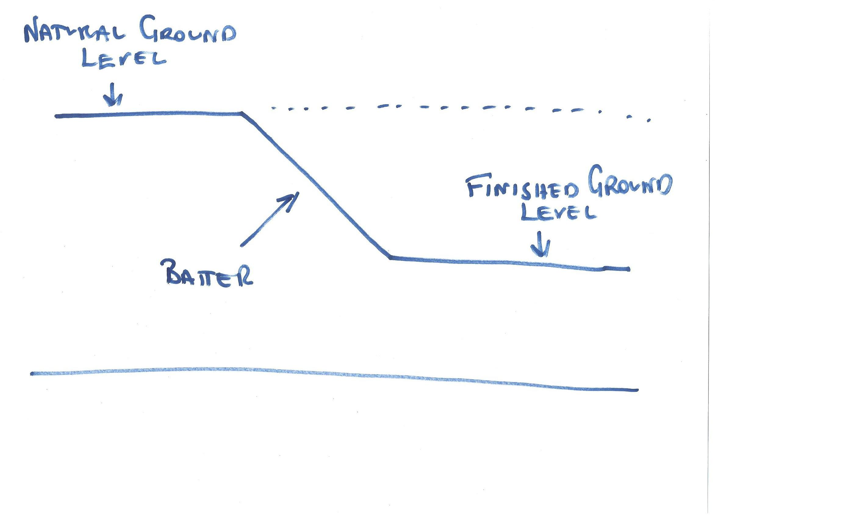

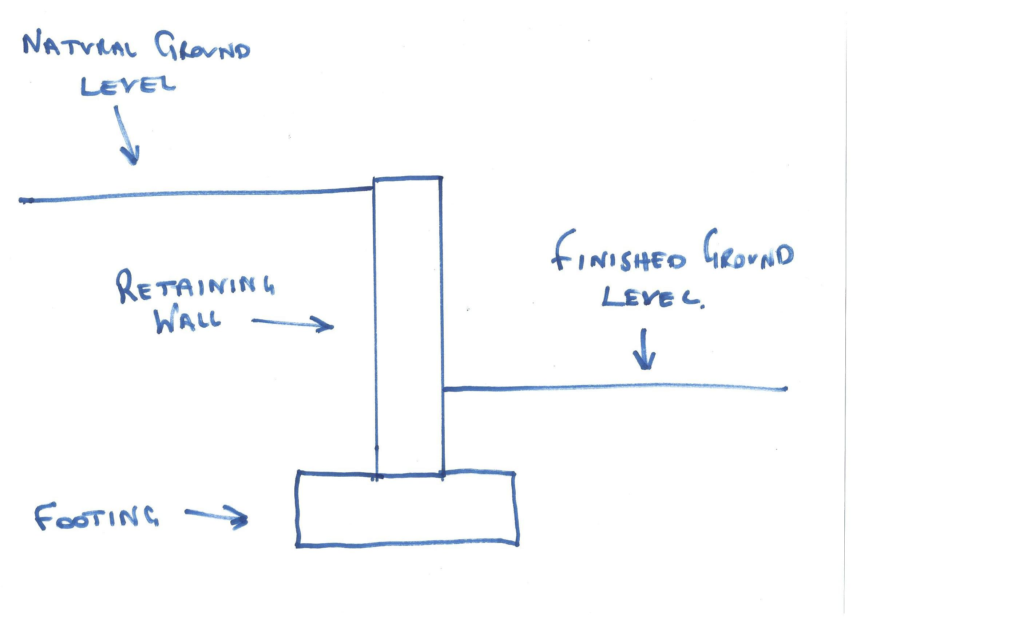

- Explain the differences between an inclined retaining wall, a gravity retaining wall and a cantilevered retaining wall.

Answer | An inclined retaining wall leans into the excavated soil and can be constructed at an angle from 45 to 80 degrees. It can be constructed from brickwork/concrete block, interlocking concrete blocks or rock.  A gravity retaining wall relies on the weight of its own structure to resist the forces in the soil trying to overturn the wall. It is typically constructed of heavy materials such as stone, brickwork or concrete

- What is a ground level concrete slab floor?

Answer | A ground level slab is a large flat stretch of concrete, usually between 100 – 500mm thick which forms the foundation of the structure. The type of slab you use will depend on the nature of the soil on your land and what kind of structure you intend to build.

- What is a slab subfloor made of?

Answer | A Slab subfloor is primarily made of concrete, other materials like steel mesh or rebar are also incorporated to add strength. To improve stability, the slab typically sits on a bedding of building sand and will require a plastic vapour barrier.

- What should you consider when selecting the type of slab floor?

Answer | When choosing the correct slab, you will need to consider the site, soil conditions and has reactive they are. And also, the type of structure you a wanting to build l

- Name and describe each of the general soil classifications that are followed in Australia.

Answer | Class A - This denotes very 'stable' ground - mostly sand and rock, not affected by moisture  Class S - Slightly reactive soil, slight movement due to moisture  Class M - Moderately reactive soil, moderate movement due to moisture  Class H - Highly reactive soil, a high amount of movement due to moisture  Class E - Extremely reactive soil, extreme movement due to moisture  Class P - 'Problem' soil, which experiences land slip, mine subsidence and so forth. If you are building on Class P site, you will typically need to consult an engineer.

- What purpose does the soil report serve? Who prepares a soil report?
Which Australian Standard (AS) will be relevant to the soil report?

Answer | The soil report is produced by a Geo-Technical Engineer, soil samples taken from site will be assessed to determine  - Site soil Classification  - Soil Weight bearing capacity  - Reactivity  This information is very important and is used by a Structural Engineers to design the correct footing and slab for the sight in accordance with AS2870  This information and subsequent design underpins the whole structural integrity of the structure

- There are many different types of on-the-ground concrete slabs. Write a brief description for those listed in the table below.

Answer | Term | Explanation
 | Slab on ground | Slab on the ground is the simplest type of slab. It incorporates stiffening beams made from pre-poured concrete in trenches around the outside of the slab, and often has a slab thickness of 100mm. This type of slab is suitable for Class A and Class S sites.
 | Stiffened raft slab | Stiffened raft slab is similar the slab on the ground, but also has pre-poured concrete beams set in channels through the middle of the slab, creating a kind of supporting grid of concrete on the base of the slab. Most slabs in Australia are stiffened raft slabs. The slabs may also need additional concrete footing embedded in the soil, depending on the soil type, and are generally suited to Class M, Class H and Class E soils.
 | Waffle raft slab  (aka waffle pod slab) | Waffle raft slab/waffle pod slabs are constructed entirely above the ground by pouring concrete over a grid of polystyrene blocks known as 'void forms'. Waffle raft slabs are generally suitable for sites with less reactive soil, use about 30% less concrete and 20% less steel than a stiffened raft slab, and are generally cheaper and easier to install than other types. These types of slab are only suitable for very flat ground. Waffle raft slabs are suited to lightly and moderately reactive clay sites, because they’re not embedded in the ground like stiffened raft slabs. Waffle raft slabs are best suited for Class A, Class S, Class M, Class H and Class E soils
 | Pier and slab | Pier and slab are used on sites with more reactive soils, it's common for concrete piers to be sunken into the soil to improve stability. This is normally done by digging holes at intervals and depths determined by an engineer, then pouring concrete into them and attaching the slab to these piers.

- Briefly explain how a concrete slab sub-floor is installed.

Answer | For a standard slab on ground, first the site is scraped back to the soil, keeping it as level as possible and ridding it of all plant matter. Then, formwork is put up around the edges of the slab to prevent the concrete from spreading. Trenches are dug around the edges for all stiffening beams, and bedding sand is laid down to level things out. A plastic vapour barrier is used to coat the site and prevent dampness from rising through the slab. Rebar or mesh is then spread out to cover the area. In some situations, a layer of gravel may be laid down to provide a solid base. The concrete is then poured on top, spread out and levelled.  Housing slabs should ideally be left for 28 days to cure; this gives the slab extra strength and helps prevent cracking.

- Where are ground-level concrete slab sub-floors used?
What are the advantages and disadvantages concrete slab sub floors over conventional timber or steel sub-floor framing on stumps/posts with strip or sheet flooring?

Answer | Ground slabs are very common these days and can be found almost anywhere in Australia where there is ready access to concrete. These foundations are generally used to support heavier building materials like brick and steel.  Advantages  - Extremely durable and hardy base for a floor  - Good Insulation properties, because the underside of the floor is not exposed  - No maintenance once the concrete has cured  - Termite Resistant  Disadvantages  - Impossible to access piping once the slab has cured  - Cracks can cause major structural damage, and may be unrepairable  - not as good on highly reactive sites  - Moisture issues if membrane underneath is compromised  - Much harder and more expensive to change or add in drainage later

- Explain the terms listed in the table below.

Answer | Term | Explanation
 | Foundation movement | A slab must be designed and constructed to be strong and stiff enough to oppose stresses. It is necessary to have a method of regulating the moisture content of the foundation soils. The more stable the soil is the less movement is able to cause stress on the slab
 | Slab bending | Movement in the foundation because of reactive soils, will cause the slab to bend. The resulting movement is classified as either dishing or doming.  The type of bending will determine where steel reinforcement needs to be placed in the concrete slab.  A ground slab can experience: dishing and doming
 | Stiffening beams | The design of the arrangement of stiffening beams is influenced by the reactivity of the foundation soils.  Ground slabs are typically constructed with stiffening beams which are placed along the perimeter of the slab

- Buildings are usually designed to support the vertical loads created by dead and live loads. They also need to be able to resist lateral loads from wind and vortex loads. In building we use numerous techniques to overcome this problem.
Briefly explain the three common cable bracing techniques and sketch diagrams to explain your answer.

Answer | The 3 cable bracing techniques are  - Knee Bracing  - K Bracing  - Cross Bracing

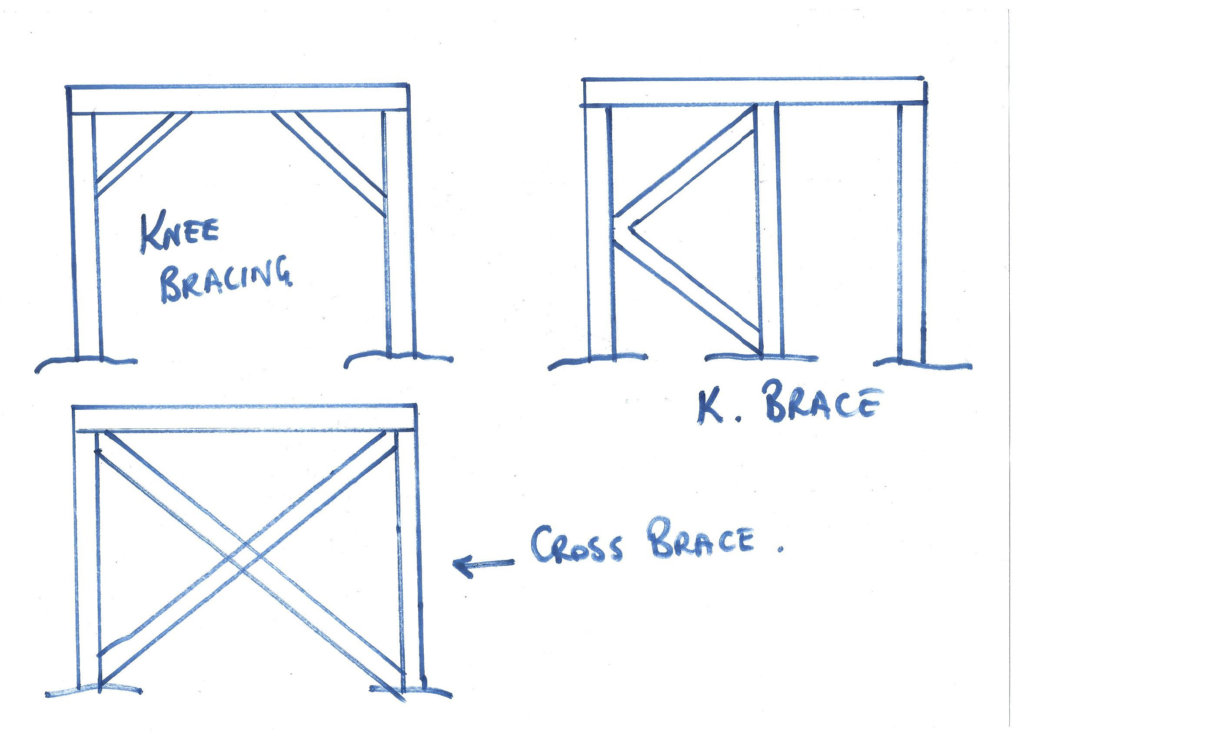

- Different bracing systems are used in residential and commercial construction which when operating together contribute to bracing a building against lateral wind, vortex and other forces.
Explain the bracing systems listed in the table below.

Answer | Term | Explanation
 | Rigid frame | A rigid frame is a steel or reinforced concrete frame with rigid joints that will resist changes resulting from forces in different directions.
 | Shear wall | A shear wall is wood, concrete or masonry wall that will resist changes in shape. The wall will transfer lateral loads to the foundation
 | Braced frame | A braced frame is made from timber or steel and is braced with diagonal members.
 | Horizontal floor | A horizontal floor is a rigid floor structure, it is like a deep flat beam. The floor transfers lateral loads to the shear walls and to the braced or rigid frames.
 | Lift shaft with solid walls | Lift shaft with solid walls are often used in office blocks. They are made stiff by using an internal concrete shaft as a stiff central core to which all the floors are rigidly fixed.  The floors act as horizontal diaphragms which transfer the stiffness from the core to the whole building.
 | Theory of triangulation | Triangulation involves the use of triangular shapes to give stability to structures. It relates particularly to pinned or hinged structures. Usually these types of structures offer no resistance to bending moments when a force is applied.

- What are important considerations when undertaking demolition work?

Answer | It is important any demolition work performed on an existing structure is done in accordance with legislative and planning requirements. Safe work practices are a vital part of the demolition process and all work must comply with the demolition code of practice and AS2601. You must also adhere to all hazardous chemicals, exposure standards must not be exceeded. These are set out in the Workplace Exposure Standards for Airborne Contaminants, and should also be listed in the manufacturer’s Safety Data Sheet (SDS)  The Australian Building Codes Board (ABCB) oversees building legislation, including the Building Act 1993 which details the procedure for demolition:  - You must get a demolition permit  - Assistance to complete the application process by a building surveyor  - Get a planning permit (if within a heritage overlay)

- What must be included in an application for a permit to demolish or remove a building?

Answer | Demolition Permit  An application for a permit to demolish or remove a building must include the following information:  a description of the building  a site plan showing the building in relation to boundaries, other buildings on the site and adjacent sites, streets, footpaths and crossings  structural computations demonstrating the structural adequacy of the building if it is only to be partially demolished  details of protection, hoardings, barricades and protective awnings  a written description of the demolition procedure  evidence that the demolisher has the necessary knowledge, experience, equipment and facilities to properly conduct the demolition operations

- Describe the process of applying for a demolition permit using a simple flow diagram.

Answer
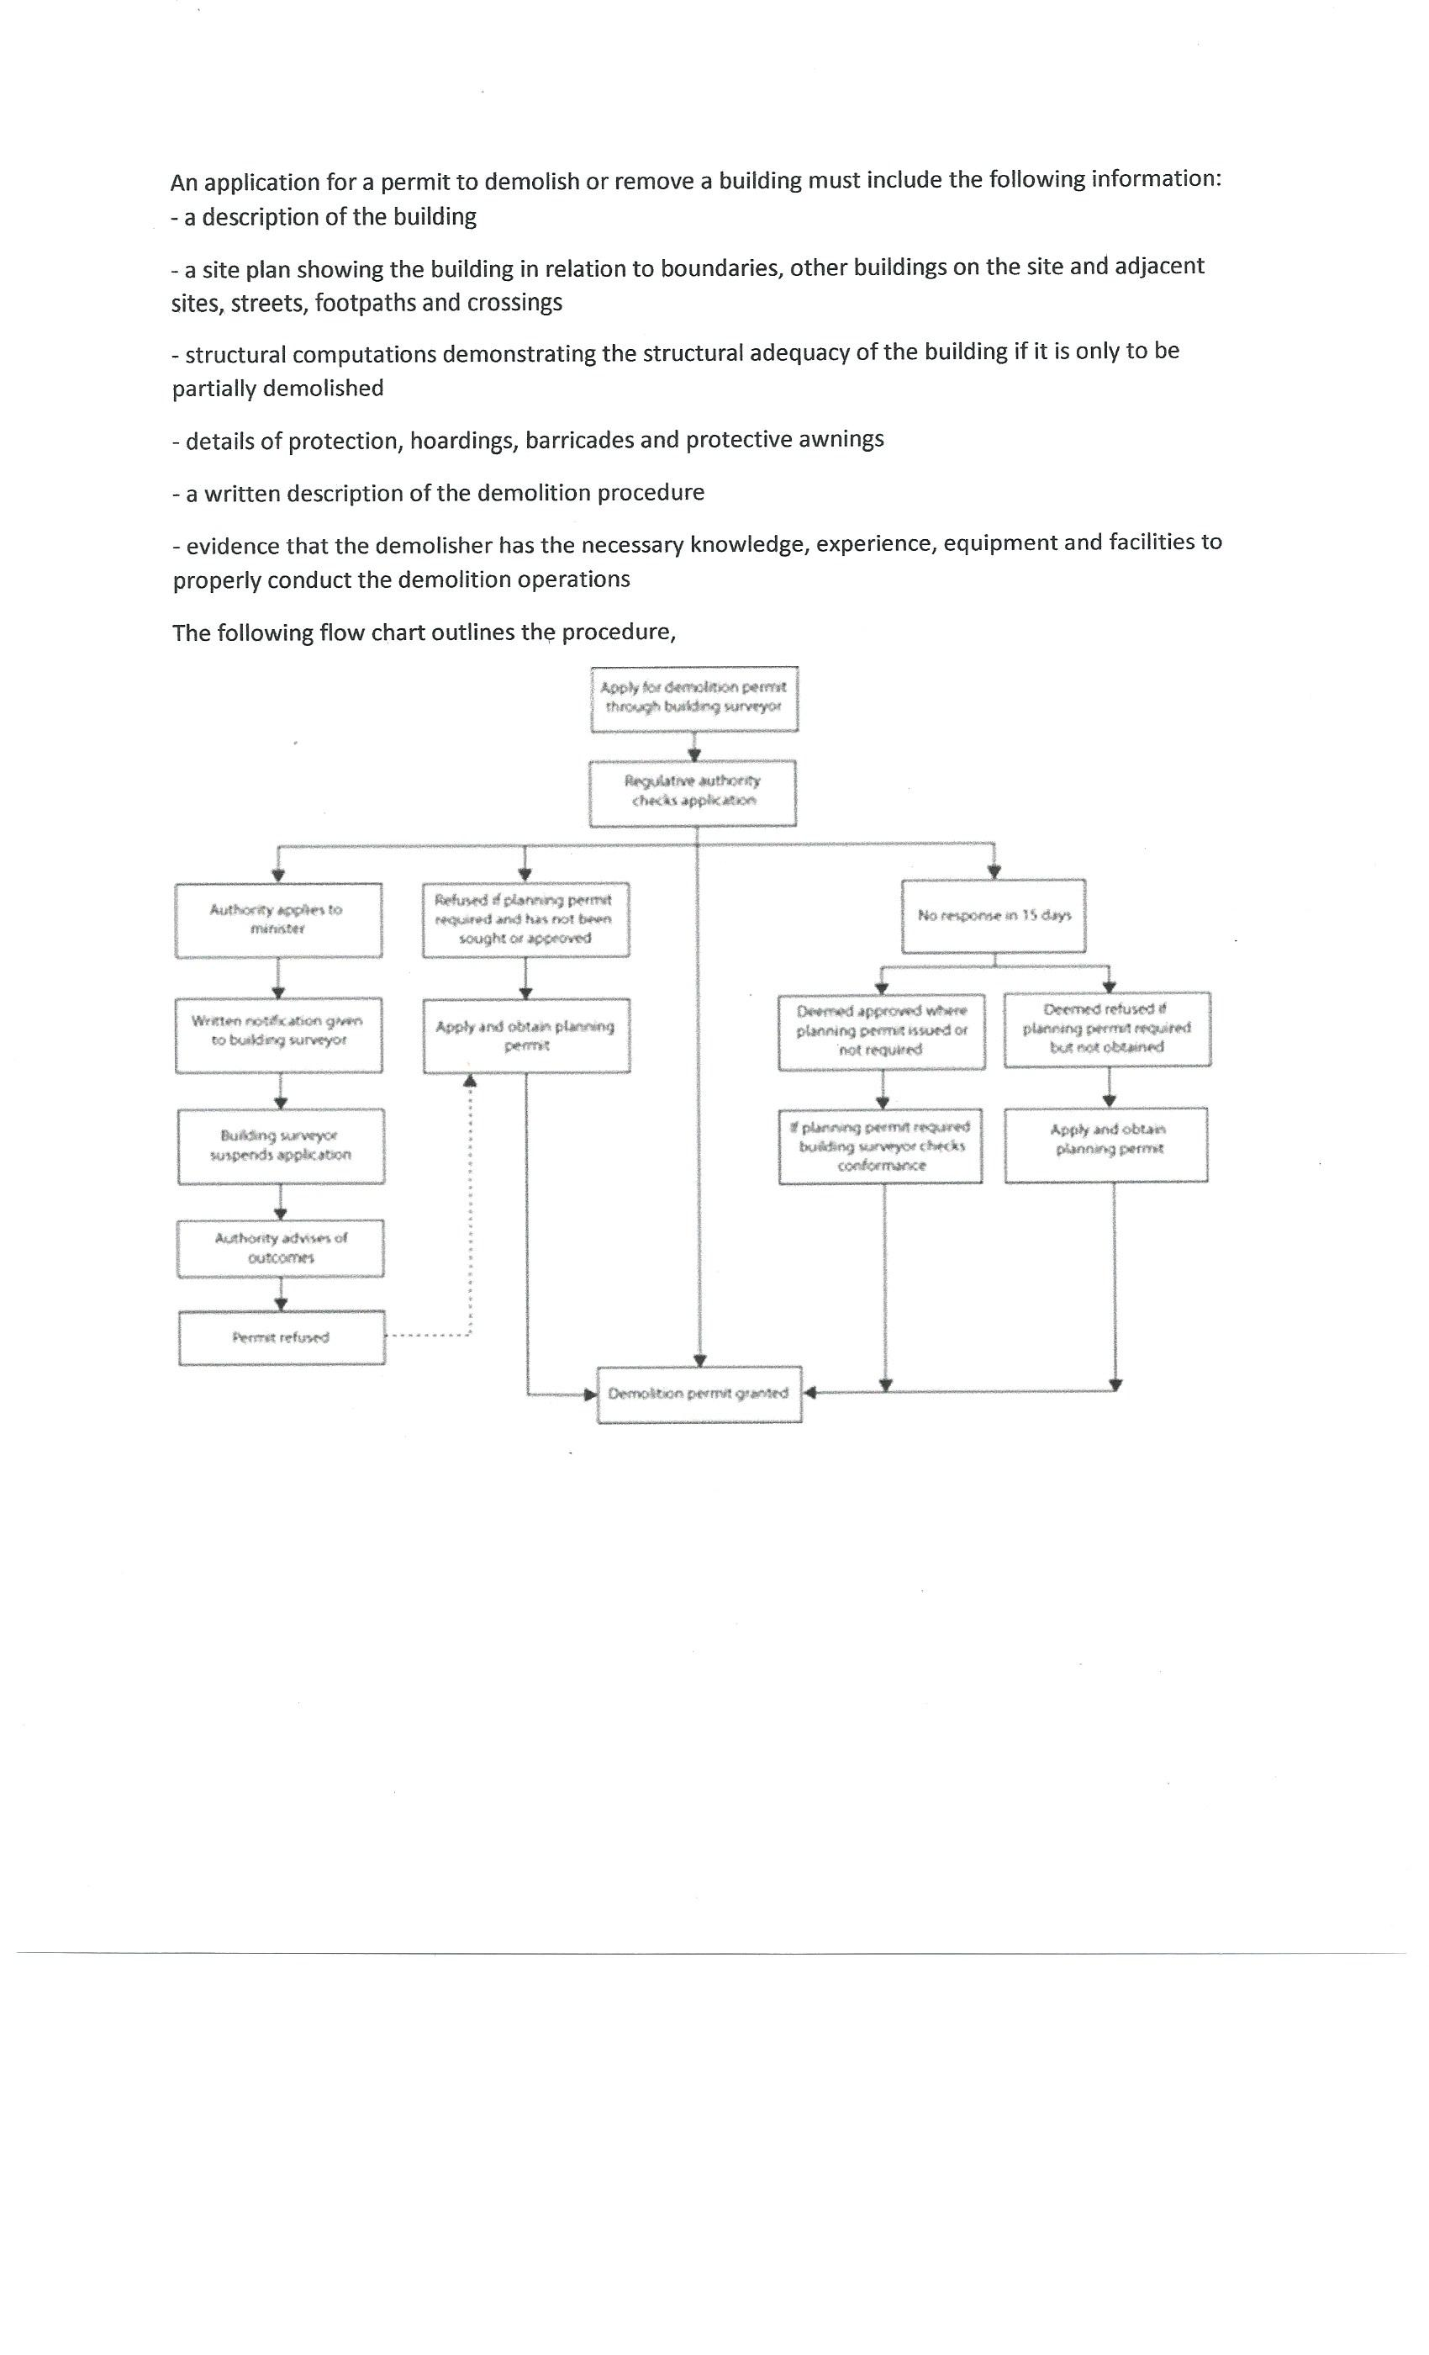

- Name the primary Australian Standard and codes of practice to be followed when performing demolition of structures.

Answer | AS 2601: The demolition of structures  code of practice - Demolition 1991  code of practice for the safe removal of asbestos, second edition 2005.

- When performing demolishing what are some of the agencies which might be accessed for information and guidance?

Answer | Australian Building Codes Board  Local Government  Safe Work Australia  Sire Council  Master Builders Assoc  HIA  State Government

- Name some of the people included in the construction process, from professionals involved in building design to specialist tradespeople.

Answer | There are many professionals involved in building design and a variety of tradespeople responsible for the numerous stages in the construction process, such as:  - Architects  - -Engineers Structural, Efficiency and Geo-Technical  - Drafts people  - Building surveyors  - Land surveyors  - Quantity surveyors  - Estimators  - Carpenters, Tilers, Electricians, Plumbers

- Who would you consult to gain insight to using the right sized and right shaped materials for a project?

Answer | A Structural Engineer would be the best person to consult for advice on the right sized and right shaped materials for a project

- Briefly describe the role of an architect.

Answer | Architects design buildings and in many cases also supervises their construction. They assist to set a viable and realistic budget, guide you through the planning process and obtain competitive quotes and manage consultants. Listed below are some of the tasked performed by an architect,  - Developing a client design brief  - Preparing concept sketches and working out what is possible  - Preparing site analysis reports including documentation of site constraints  - Preparing contract documentation, including the contract, specifications and working drawings  - Organising tendering  - Overseeing contract administration  - Organising design development and permit applications

- Briefly describe the role of a structural engineer.

Answer | Structural engineers design structures such as buildings, bridges, tunnels, etc. A lot of structural engineers work primarily as consultants to architects or design-build contractors. Listed below are some of the tasked performed by a Structural Engineer  - Preparing reports on how to protect neighbouring properties  - Designing the structure of retaining walls, columns, beams and loading walls in building projects  - Preparing reports on the structural adequacy of existing buildings  - Conduct Soil testing  - Write Floor plans  - Design footing systems detailing positions of bearers and joists  - Design concrete slabs

- What is the difference between a building surveyor and a land surveyor?

Answer | The difference between a Building Surveyor and a Land Surveyor is one is involved with actual building or structure and a Land Surveyor is involved in mapping the site. Outlined below is a description of each of their roles.  A Building surveyor provides professional advice on property and construction covering many project types and categories They work on the design and development of new buildings as well as the restoration and maintenance of existing ones. Listed below are some of the tasked performed by a Building Surveyor  - Assess building plans submitted for approval to ensure compliance  - Provide advice/assistance to builders/owners before finalisation/lodging plans  - Pre-purchase inspecting of all types of buildings  - Inspecting buildings during construction to ensure methods and materials Keeping records and writing reports of building progress and instances where regulations have been breached – plans altered  - Giving evidence in court when prosecutions are necessary for breaches of building regulations  - Issuing compliance certificates on completion  A Land surveyor assesses and maps the surrounding terrain and landscape for development. They commonly use specialised technology and equipment to do this as many of today's development, subdivision, building and tunnelling projects are so complex. Listed below are some of the tasked performed by a Land Surveyor  Land surveyors also:  - Taking levels on a site to produce detailed contour plans  - Determining location of existing buildings and other features on a site  - Setting out the building line, marking the location of columns or the external perimeter of a building  - Checking the vertical alignment of a building during construction  - Conducting boundary surveys and re-establishment of survey pegs  - Checking the positioning and overall height of a structure at completion to ensure compliance with the conditions of permits

- What is a quantity surveyor and work do they perform?

Answer | A quantity surveyor is involved with construction costs and contracts. A Quantity Surveyor can provide cost planning and commercial management throughout the entire life cycle of the project from inception to post-completion. Listed below are some of the tasked performed by a Quantity Surveyor,  - Initial cost advice during the pre-contract stage, preparing approximate estimates  - Costing planning information concerned with the development of a design  - Preparing the necessary tender documents, critically examining the tenders and priced bill of quantities when lodged for tender  - Valuing the work during the construction stage at required intervals  - Recommending the amounts to be paid to the main contractors including assessment of any variations  - Controlling costs during the construction stage  - Outlining the economics of alternative methods of construction

- Name some of the building approval plans that will be necessary to see a project through its construction.

Answer | Some of the plans required for a building approval would be,  - Drainage Plans  - Site Plans  - Subdivision Plans  - Construction plans  - Engineering Plans  - Contract Plans  - Specifications

- What is a land title and what would you expect it to contain?

Answer | A land title is an official record of who owns a piece of land. It can also include information about mortgages, covenants, caveats and easements. It contains details such as,  - A Plan with lot number  - Name of owner  - Reference numbers  - Certificate stamp

- Why would you need a construction permit or building permit?

Answer | A construction/building permit is required in most places in Australia for any  new construction, extensions to a pre-existing structure or a major renovation is to occur. Failure to obtain a permit before commencing any works can result in significant fines and penalties, and even demolition of unauthorized construction if it cannot be made to meet code.

- What is a building permit and what does it show and record?

Answer | A building permit is the document which shows that your proposed construction or demolition has been approved by a building surveyor and has been deemed to meet the building regulations. The Permit records the following information,  - Occupation permit  - Progress payments  - Relevant dates  - Building surveyor  - Inspection dates  - Paperwork you are required to comply with

- What other permits could be required? Give two examples.

Answer | Two other permits you may require are  Planning permit  This is a legal document which relates to how certain residential or commercial can be used.  A Planning permit is not required for all projects, you are advised to check with your local council.  Asset Protection permits may be required where a council asset may be affected, this could include a bond being charged to cover potential repairs

- What would be reasonable to expect to see in a project specification?

Answer | A specification is a comprehensive document containing a complete list of materials, fixings, finishes and fittings to be used in the construction it should also contain specific information on Brands, Colours makes and models of appliance.  It will also contain a full description of the work to be done, techniques to be used and standards. It will also contain performance data and material technical data as well as Stress, load and bearing calculations  .

- What is a sub-division plan and what is its purpose?

Answer | A Subdivision plan is that shows how a parcel of land is to be divided up and developed into multiple smaller blocks.  The subdivision plan will need to be prepared and submitted for planning approval prior to the development of the land. It is a good source of information and provides details on,  - adjoining properties  - Streets  - Block Layout  - Sewer Easements  - Storm Water

- What would a site plan tell you?

Answer | A site or block plan is usually drawn in a scale of 1:500 and will include the following information  - A datum - reference height to other site levels  - Building orientation to north  - Contours and slopes  - Depths where they may occur  - Distance from boundaries to the building foot print  - Outline of site boundaries showing location of proposed building and existing dwellings  - Plan page number, client name, project address, scale, reference numbers and dates  - Major geological and topographical features (trees and vegetation)  - Paving  - Retaining walls  - Driveways, stormwater drainage, easements and right of carriage  - Soil and surface water drains, pipe sizes

- Explain what a floor plan will tell you.

Answer | A Floor Plan will provide information on the following,  - Room Setout  - Frame sizes  - Floor finishes  - Service Location  - Appliance locations  - Door and window locations  - Compass direction for building orientation  - Overall should give a detailed overhead view of the floor plan of the building.  - Size and thickness of structural members

- What is the purpose of a cross sectional drawing?

Answer | The section drawing will show a view of the house after it has been cut vertically through at a set point it will show details such as  - Under croft  - Floor Levels  - Top of wall heights  - Type of Roof Construction  - Roof Pitch  - Eave overhangs  - Internal linings  - Flooring Details  - Connections

- What information would you expect Municipal (Council) drainage plans and Water Authority documentation to provide you?

Answer | A council drainage plan will show the mainline sewer and easement including man holes and inspection openings. It will also show the location of the risers for the house connection on each block

- Briefly discuss the purpose of footing design and name the Australian Standard (AS) which applies for low rise commercial building projects.

Answer | Footings are the construction that transfers the load from the building to the foundation. Footings must be designed to withstand the building loads and suit the soil conditions on the site.  They must be designed in accordance and abide by AS2870 2011

- What are contour plans? Describe their purpose in building and construction projects.

Answer | Contour plans are a graphical representation of the lay of the land and show the degree of slope on a site. They typically relate back to a site datum and provide details that can be used to:  - Estimate he extent of excavation and fill needed  - height of retaining walls  - Show finished height of buildings  - Help determine construction method to best suit the site  - Design if the Structure

- What is a site condition report and what is its purpose?

Answer | A site condition report is used to keep a detailed record of the condition of the,  - existing site  - buildings on adjacent boundaries and setbacks of structures  - condition of fences  - vegetation on the site on the boundaries  - location of services. (water, gas, electricity and telephone lines  .

- What does the AS3959 refer to?

Answer | The Australian Standards AS 3959 covers the bushfire safety requirements of building in a bushfire prone area, as well as providing the methodology for calculating your bushfire attack level.

- Australia is zoned into four regions for high winds. What and where are these regions?

Answer | The 4 regions for high wind in Australia as follows,  Region A - Normal  Region B –Intermediate  Region C - Tropical cyclones  Region D - Severe tropical cyclones.

- The acceleration coefficient is a number which indicates the expected severity of the earthquake ground movement. Which Australian Standard should be referenced for this information?

Answer | The acceleration coefficient is determined under AS 1170.4-2002

- What defines an alpine area in Australia?

Answer | Alpine area means land—  (a)  likely to be subject to significant snowfalls; and  (b)  in New South Wales, ACT or Victoria more than 1200 m above the Australian Height Datum; and  (c)  in Tasmania more than 900 m above the Australian Height Datum.

- Where in the Building Code of Australia (BCA) can you find information relating to alpine and sub-alpine areas in which the snow loads could play a significant part in design and construction?

Answer | This information can be found in  Section G4 Ancillary provisions  Construction in Alpine Areas

- What can we reference when intending to use new and emerging building technologies in the construction of a building?

Answer | The BCA has requirements to allow for new and emerging building technologies. Any new technology must satisfy performance requirements, and this can be determined by using the following assessment methods,  - documentary evidence  - verification methods  - expert judgement  - comparison to deemed to satisfy provisions

- What are some of the critical considerations to be made about footings and the transfer of loads from the building to its footing foundations?

Answer | When designing as footing some critical points you will need to consider are,  - All footing designs for residential projects are made to comply with AS 2870 - 2011 Residential slab and footing – construction  - Site Type  - Soil Classification  - Building Design  - Building Loads  - Load Paths  - Termites  - Water Proofing

- What codes and standards should be checked to ensure footings specified within the building plan are compliant?

Answer | - Section 3.2.4.5 for information on strip footing dimensions and reinforcement.  - AS 1684-2010-'Residential timber framed construction'  - AS 2870-2011 'Residential slabs and footings - construction ‘  - AS/NZS 2904:1995 'Damp-proof courses and flashings'  - AS 3660.1 2014 'Protection of new buildings from subterranean termites

- Name the relevant Australian Standard for protection against subterranean termites.

Answer | AS 3660.1 2014 'Protection of new buildings from subterranean termites

- What should be considered when constructing a floor system?

Answer | When constructing a Floor System, the following should be considered,  - Flooring types being used  - Drainage pipes  - Water services  - Electrical services  - Bracing and Reinforcement  - Loads and Load Paths  - Site topography

- When designing and installing a concrete residential slab and footings what Australian Standard applies?

Answer | The relevant standard is AS 2870-2011 'Residential slabs and footings - construction

- What are bearers in a sub floor framing system?

Answer | Bearers are the first of the sub-floor frame members to be installed. They are positioned over stumps, piers or other supports. In most cases they are timber, however, a wide variety of engineered timber products such as LVL, LGL and I beam are available. As well, mild steel and cold-formed steel sections may be used to achieve greater spans.

- What are floor joists in a sub-floor framing system?

Answer | Floor joists are the second series of members for the sub-floor frame. They are supported by the bearers.  Typically, the floor joists run over the tops of bearers, however, they may be attached to the sides of bearers. Like bearers, floor joists may be single span or continuous span. They can be made of timber or steel.

- Sketch free hand compact simple drawing in section to show the following floor system components of the external load bearing wall and bottom plate, joist and bearer to include:
- Wall frame
- Sheet flooring
- Floor joist
- Bearer
- Brick pier with stump cap

Answer
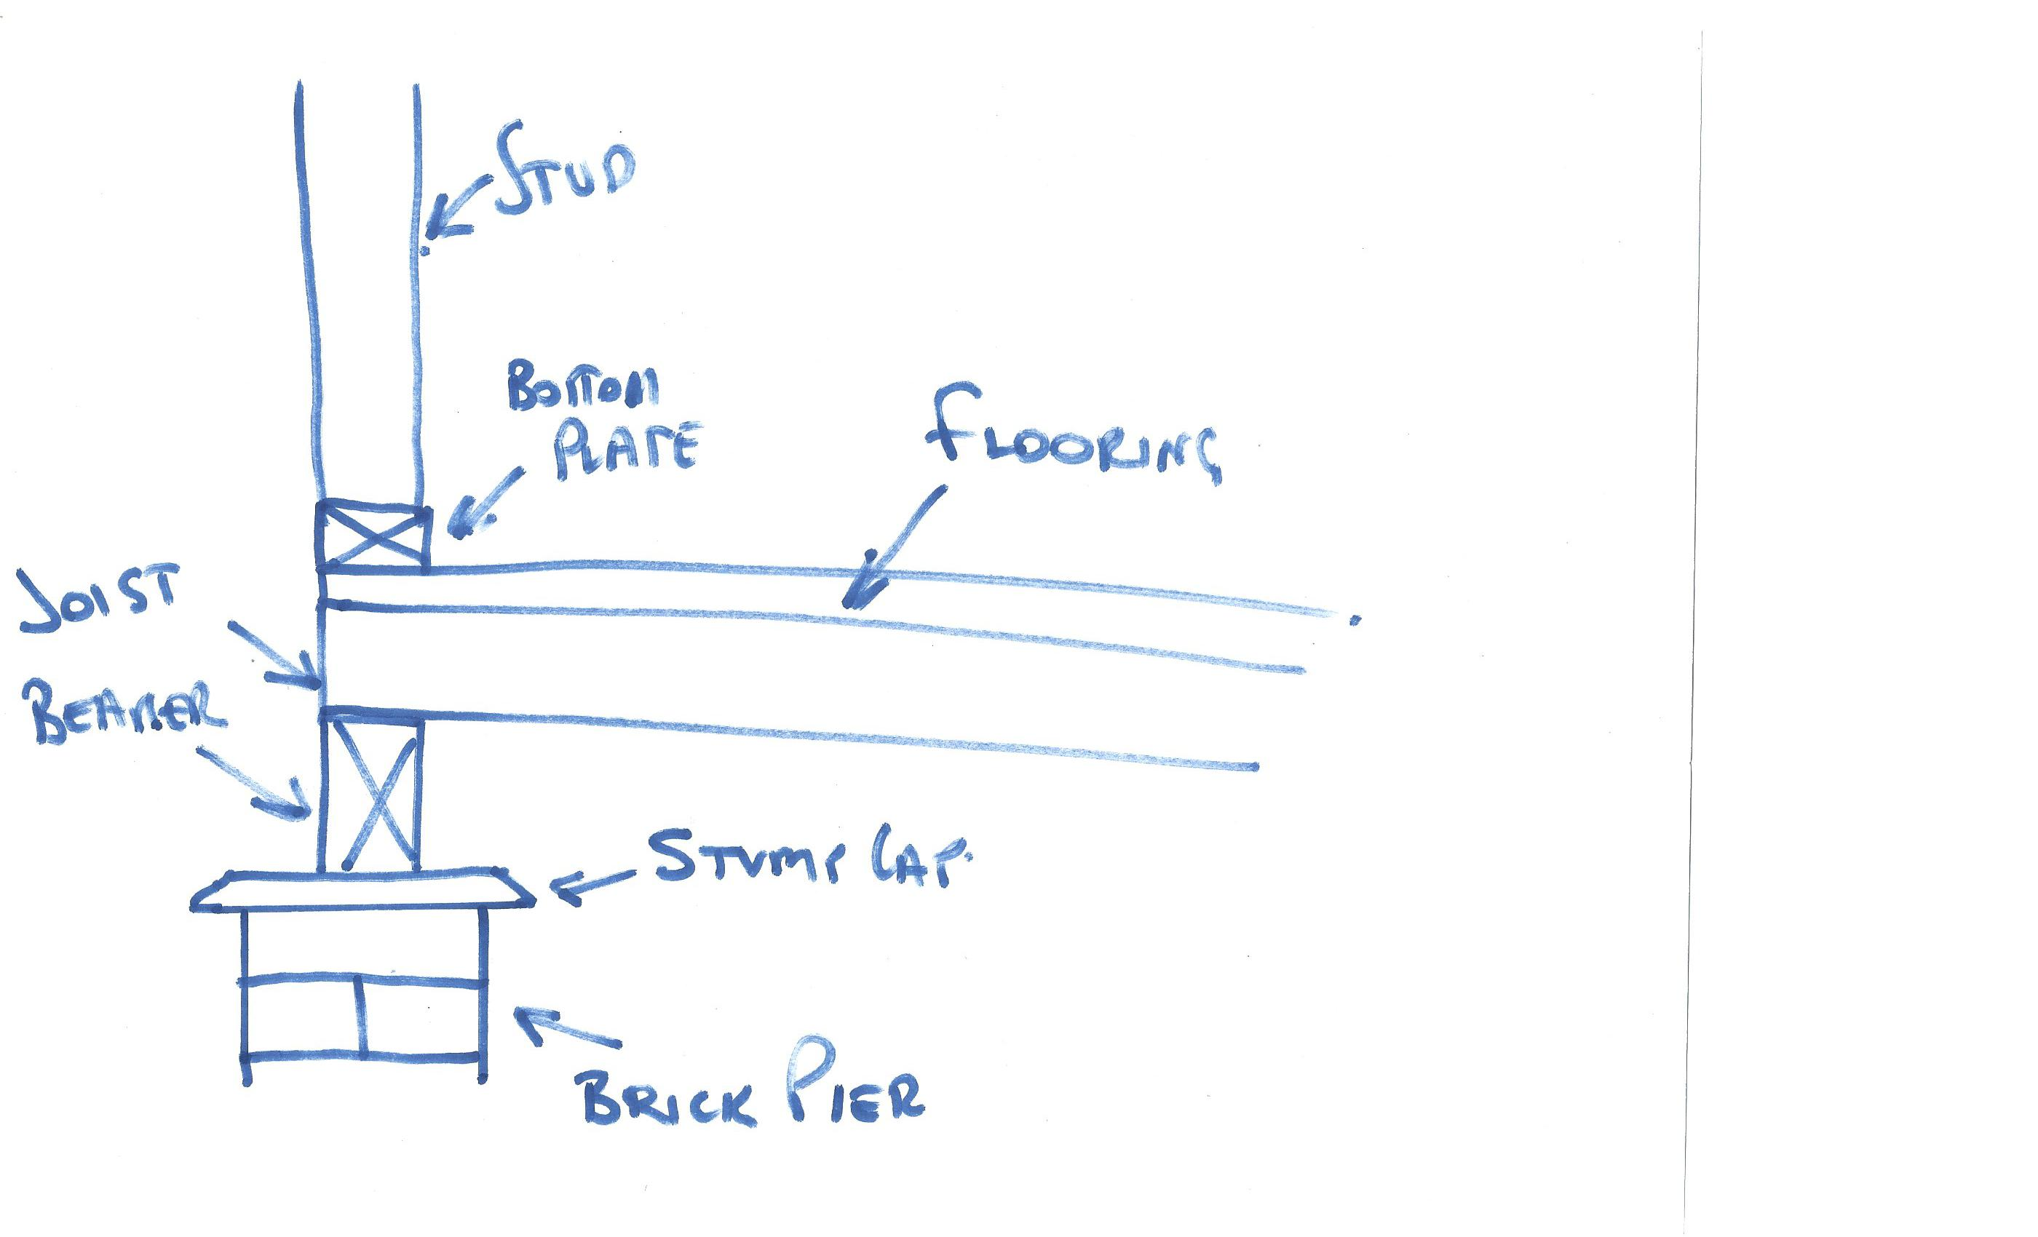

- What is a strip timber flooring system (also sometimes referred to as a fitted floor)?

Answer | Fitted floors or cut-in floors are installed after walls have been erected and after roofing, wall cladding, doors and windows have been installed.  Where boards are laid parallel with walls, a minimum 10 mm gap shall be provided between the board adjacent to the bottom plate and the bottom plate and 12mm for perpendicular boards to allow for expansion  Board must span a minimum of two joist spacings. Hardwood flooring used must be manufactured in accordance with AS 2796 2006.

- Explain the benefit or otherwise of a platform floor.

Answer | The main benefit a platform floor provides is it forms a working platform for the builder as the floor is laid before erecting the wall and roof framing.  The drawback is the platform floor needs to be protected from getting wet by rain and/or wet trades by using a temporary floor covering.  Edges of sheets, unless tongued and grooved, are joined over noggings between joists. Noggings (70 x 35 mm sections) are set flush with the top of the joist.

- Briefly explain drilled or driven piles as a footing system for commercial/industrial type buildings.

Answer | A pile is a vertical structural element of a deep foundation, driven deep into the ground at the building site.  A pile driver is used to drive the pile into place on-site in preformed or pre-drilled holes. Prefabricated piles are often made from wood, reinforced concrete or steel.  Concrete piles are available in square, octagonal, and round cross-sections and are reinforced with rebar and prestressed. Steel piles are either pipe piles or a beam section (like an H-pile).

- Which section of the Building Code of Australia addresses piling as a foundation system?

Answer | Piles as are mention in (2) sections of the BCA B1.4 and 3.2

- Explain the term ‘screw piles’. What must preface to approve the use of screw piles as a foundation system?

Answer | Power driven galvanised steel columns are an alternative pier system. The piles have a helix auger on the ends, which enables the pile to drill itself into the ground.  This engineered system requires an accreditation certificate to ensure acceptance by building authorities.

- What does a concrete pier typically consist of?

Answer | A concrete pier typically consists of a:  - round or square concrete pillar  - footer piece which serves to spread the load carried by the pier  - footer is placed below the frost line and top end above the ground surface  - the concrete pier top is typically equipped with a frame or bracket for the connection of beams etc  - effective for most soil types in areas which have little or no earthquake or hurricane activity

- Where could you use a bulk pier and beam system?

Answer | Bulk pier and beam systems are used to strengthen and support slabs in both residential and commercial applications. Bulk pier and beam systems best suited to sites where good bearing soil is located between 800 mm and 1,200 mm below the NGL

- What is the construction method for bulk pier and beam?

Answer | The first task in constructing a bulk pier and beam system is to excavate the pier holes. The number, location and spacing and size of the holes required will be shown on the design engineer's drawings. The concrete cant then be poured to approximately 500 mm below the NGL or FGL. No reinforcement is required in the pier holes. The concrete would be 20 MPa compressive strength.  Excavate the strip footing. After three days, excavate the strip footing (or concrete beams) between the piers. These concrete beams will be excavated around the entire perimeter of the house.  Position steel reinforcement for the beam.  Pour the beam

- Name the framing system shown below.

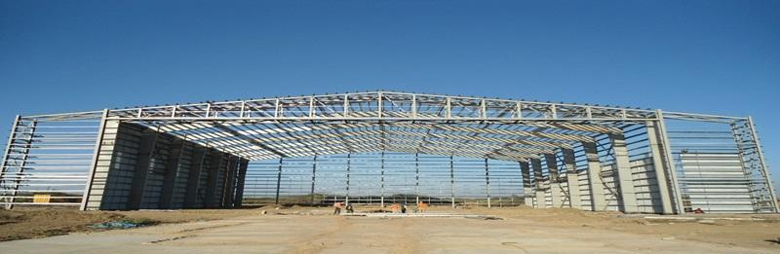

Answer | The above structure is a portal frame system these can be made from both steel and reinforced concrete

- Name the framing system shown below.

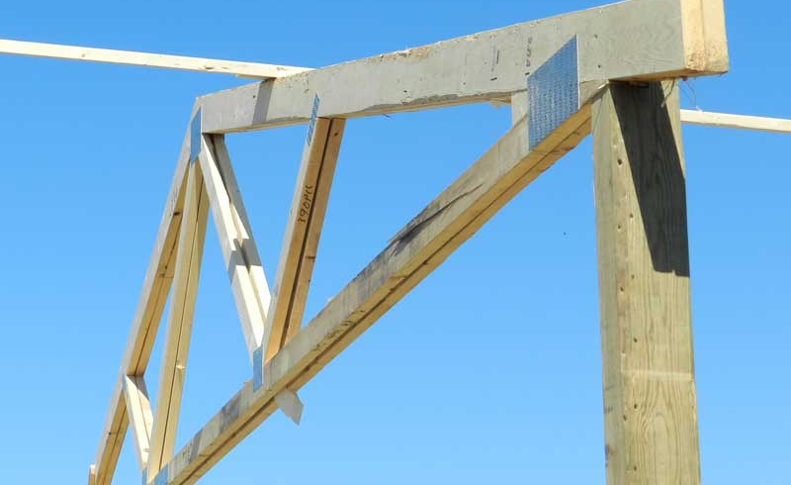

Answer | The above is a post and beam type construction with horizontal and vertical members subjected to loads Pictured is using engineered prefabricated timber truss this particular truss is a double truss and timber posts

- Name the building system shown below.

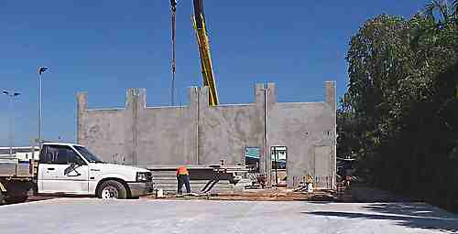

Answer | The above is a precast concrete panel or tilt panel structure.

- Which section of the Building Code of Australia addresses masonry components for a building?

Answer | Information on the masonry components of a building can be found in section 3.3 of the Building Code of Australia

- What are masonry coatings?

Answer | Masonry Coatings is a generic term for any wall or masonry covering. This could be used to describe exterior wall coatings like, masonry paints, wall rendering, textured coatings or even pebble dashing.

- A ‘wythe’ or ‘leaf’ is the building and masonry term given to the width of a single brick or concrete block unit. A brick or block masonry wall might incorporate any of cavity brick, single-leaf masonry (brick or block) or lightweight autoclaved (aerated) concrete block (AAC). The cavity between ‘wythes’ can be anything from 50mm to 110mm.
Draw freehand sketches of the following and label your sketches:
- A single masonry wall founded on a cavity brick base with engaged pier,
- A cavity brick masonry wall with 50mm cavity
- A brick veneer and timber framed wall with 50mm cavity
- A masonry retaining wall one (1) metre high

Answer
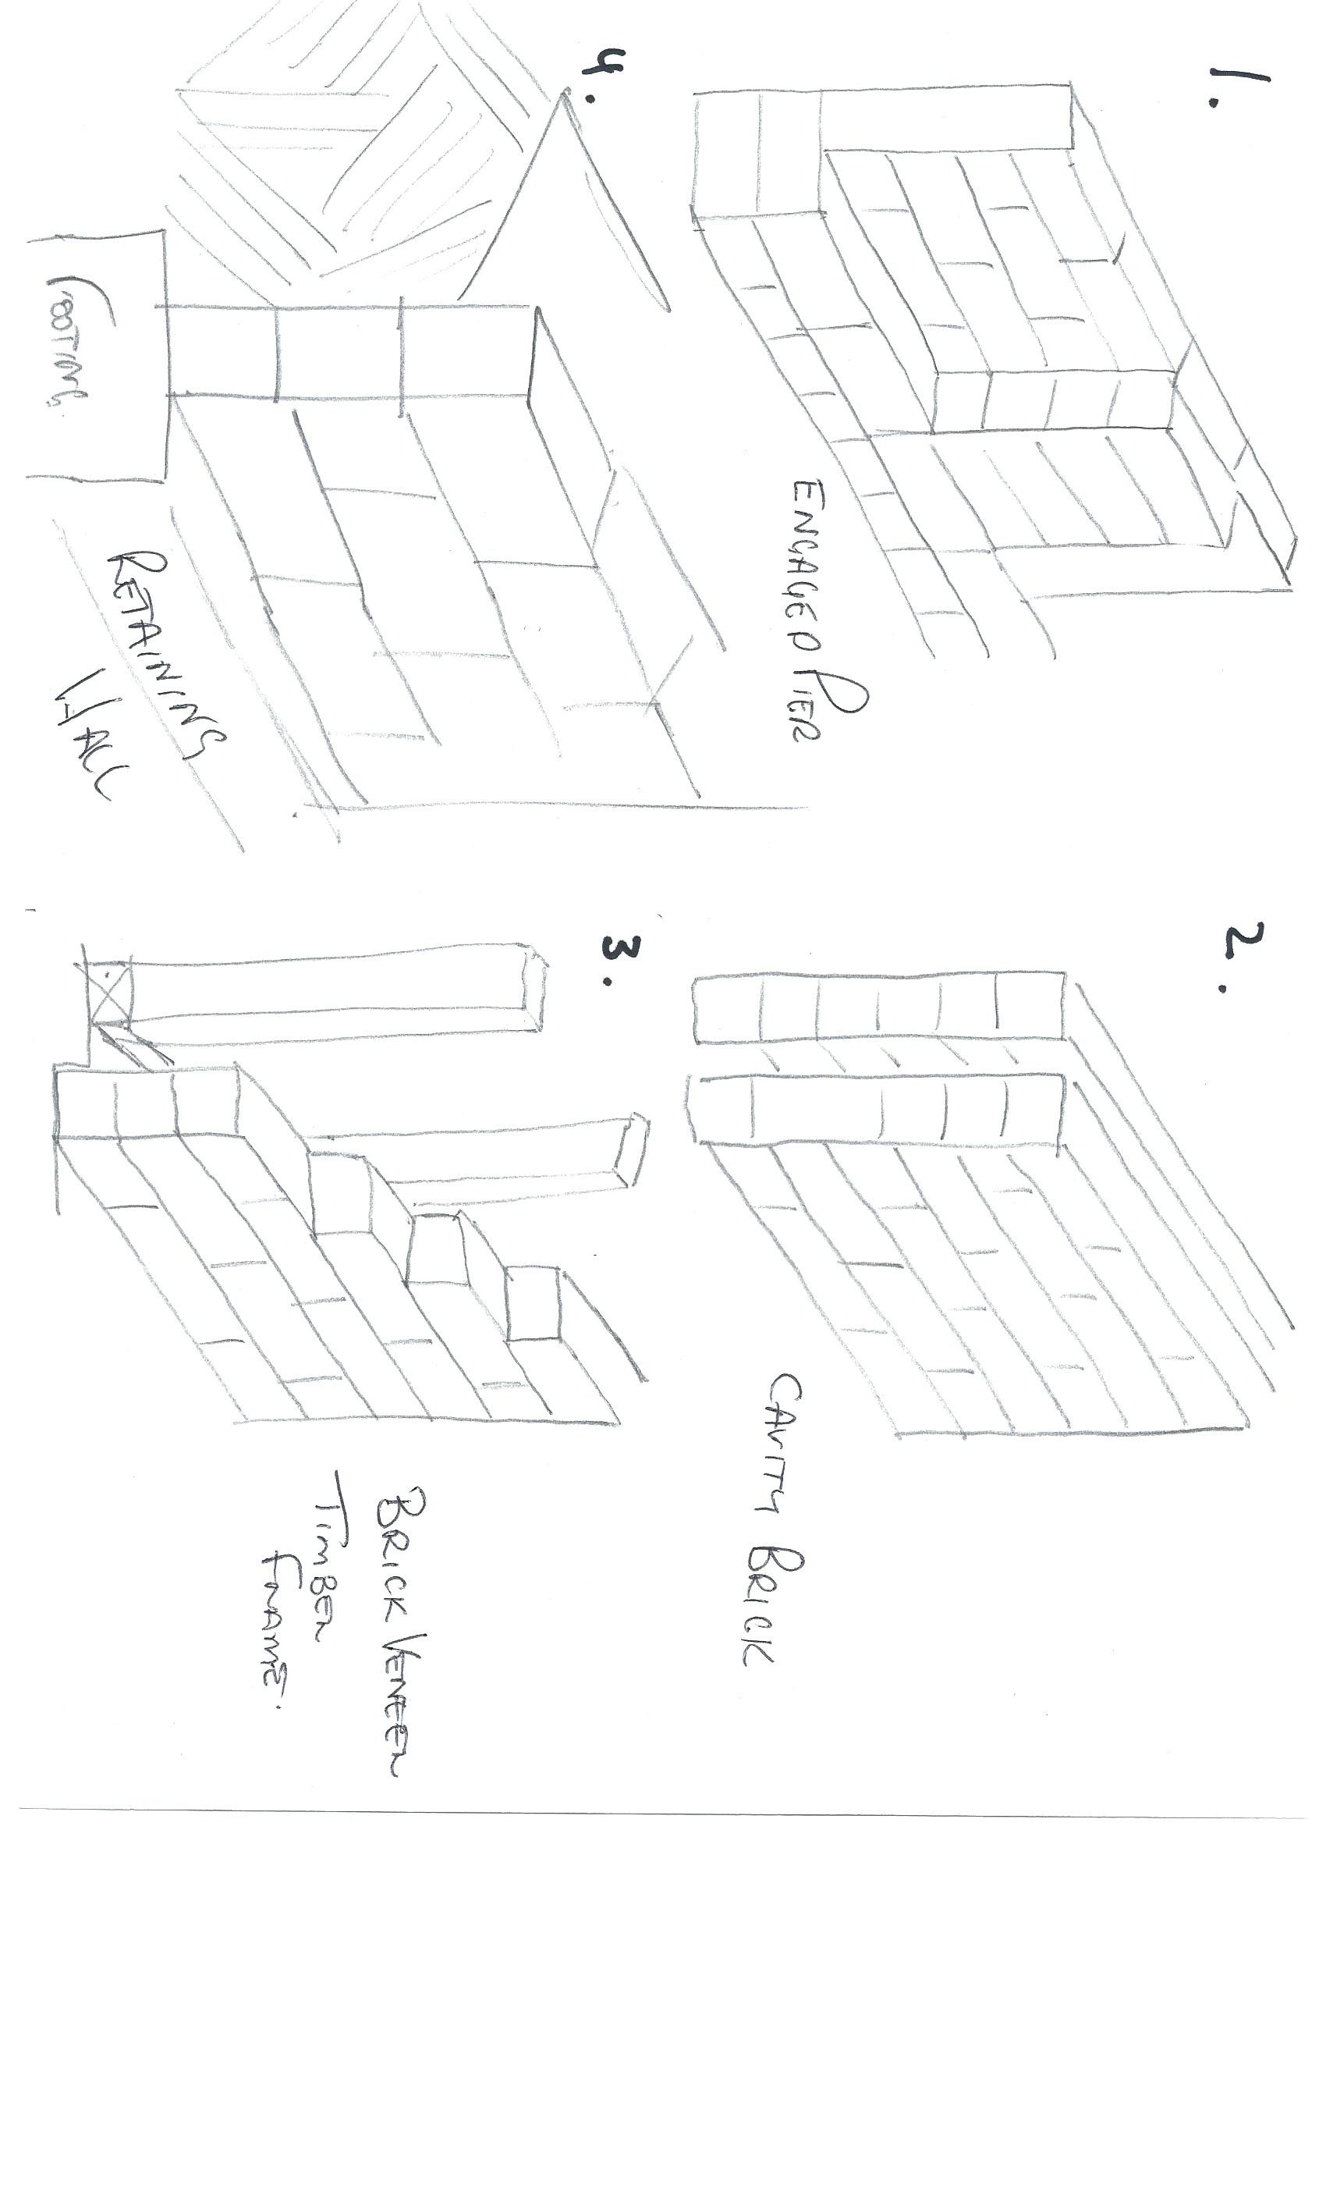

- What is cladding? What BCA section and Australian Standard address specific aspects of cladding?

Answer | Cladding systems are the building envelope. They enclose the building and provide protection from the weather. External cladding contributes to the comfort, structural adequacy and aesthetics of a building. External cladding can be used on timber and steel frames and includes products like brick veneer, Colourbond sheeting, fibre cement, timber and compressed wood products.  The BSA covers wall cladding in section 3.5.3  A number of standards cover different cladding materials,  Hardwood – AS2796, AS2082, AS2083  Preservative treated softwoods - AS1784  Cellulose cement products – AS2908

- Explain timber cladding systems like chamfer boards and weatherboards.

Answer | Timber's natural resilience and high strength-to-weight ratio enables it to withstand far greater stresses and movement than other materials. This gives timber cladding a natural advantage on sites that are subject to high winds, extreme climate, highly reactive soils and subsidence or earth tremors.  Cladding must be watertight with adequate flashing and sisalation in accordance with best industry practice. Special care has to be taken with detailing and protection at ground level and north facing walls and performs best with wide eaves and verandas provides weather protection to walls.

- Describe plywood cladding.

Answer | Plywood cladding is available for both internal and external application in various veneer grades and profiles be sure you select the correct product to suit your application. Plywood should manufactured to comply with AS 2271 2004 'Plywood and Blockboard for Exterior Use'.  If a plywood cladding is structural, the manufacturer will indicate the accredited stress grade. Plywood cladding can also provide structural bracing and roof hold-down resistance.  Plywood has standard tolerances on length, width, squareness, thickness and edge straightness. Plywood can be treated for protection against insect and fungal attacks

- Describe exterior hardboard cladding.

Answer | An exterior grade hardboard (a compressed wood fibreboard) is manufactured in Australia to AS 2858, and is used as an exterior cladding.  It can be used in all exterior cladding applications. The manufacturer should be consulted for guidelines when using hardboard sheet cladding as structural bracing or, for construction details when diagonal or vertical application of the planks is being considered.

- Many additional services can be installed in a building and the building plans and relevant standards and codes must be identified and adhered to ensure appropriate allowances are made for the installation of these services.
Name some of the services that can fall under this scope of additional installations.

Answer | The following services may fall under this scope  - Passive and Active fire detection prevention systems  - Plumbing and drainage  - Powered systems for doors and windows  - Vacuum and air extraction systems  - Communication systems  - Heating and cooling Systems

- What is a roof system? Name some roof types and what a roof might be built from.

Answer | A roof system is the structure that forms the roof of a building.  Most commonly in Australia the roof system may be made up of either one or a combination of the following  - A timber frame roof built on-site  - Prefabricated truss roof in which major components are constructed in a factory and then assembled on-site  - Some builders may use a combination of both were they may use prefabricated trusses for the main part of the house and construct the hip as you would in a timber frame construction  - They can also be built as a light weight steel structure  The selected roof system must comply with all the relevant codes and accepted building principals for your area.  Some roof types include:  - Gable including dual pitch  - Hip  - North light  - Rafter and purlin  - Skillion

- Draw simple line diagrams to represent a gable roof, a hipped roof, hip and valley roof and a skillion roof.

Answer
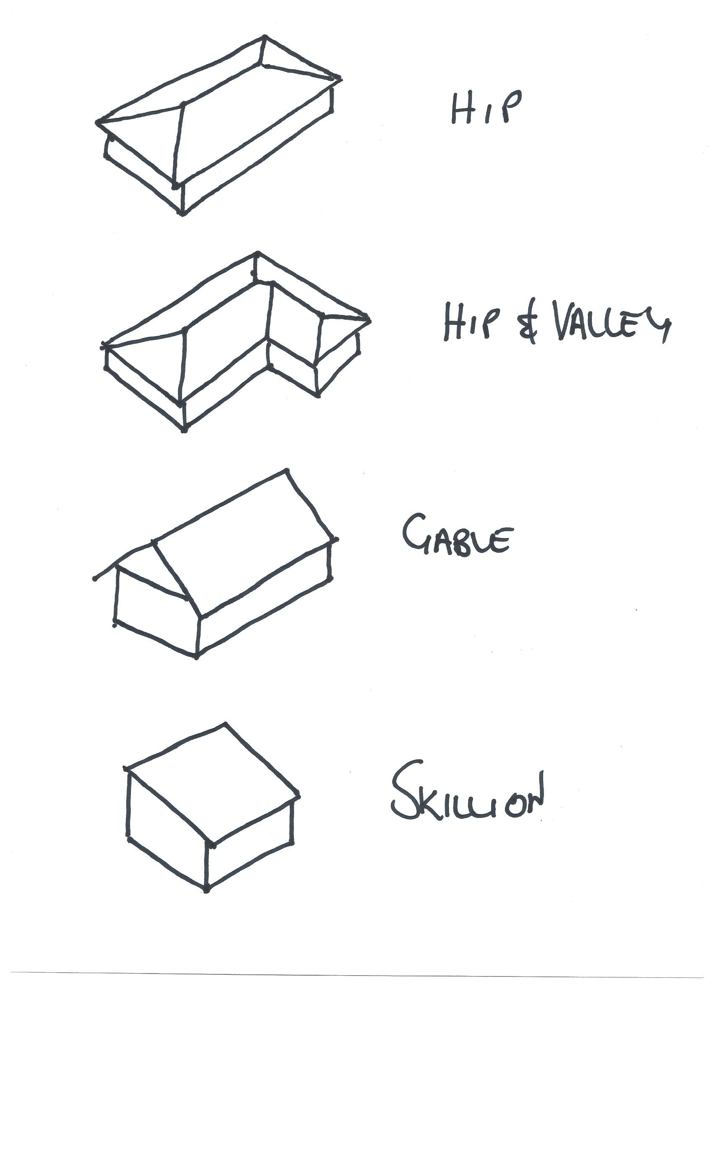

- Name at least eight (8) practical advantages of using prefabricated roof trusses.

Answer | The advantages of trusses include the following:  - They are strong, but light to erect  - They can be made to suit most roof shapes  - There is less on-site fabrication, therefore less site labour is required  - They are less affected by bad weather  - Factory production allows automated production  - Better quality control is possible  - Trusses make maximum structural use of the timber  - Trusses are capable of long spans  - Internal walls are usually non-load bearing, therefore lighter weight internal walls are possible  - Cost effective

- What is roof cladding? What are the two most common materials used in Australia?

Answer | Roof cladding is the material used to protect the building from the effects of the weather. The two most common options are roof tiles and metal roof sheeting.

- What pitch of roof should roof tiles be applied? Are there exceptions?

Answer | Roof tiles can generally be used on roofs of 15º or greater pitch, however, some materials and methods of manufacture require 25º or greater pitch.

- Describe the materials listed in the table below.

Answer | Term | Description
 | Terracotta tile | This tile is formed from wet clay and then fired to provide hard long-lasting tile. They are available in a number of profiles and can last in excess of 50 years
 | Concrete tile | Modelled of the terracotta tile they have similar profiles and similar life span. They are stable and warp free
 | Slate tile | This tile is made from natural slate and used like a shingle
 | Fibre cement shingles | These are made from reinforced fibre cement
 | Timber shingle/shake | A shingle, generated from a sawn piece of timber is characterised by its relatively smooth face and back, while in contrast a shake, essentially a split piece of timber, is dominated by a strongly textured surface.
 | Aluminium or steel pressed tile | These are metal that is shaped to imitate a tile. They are often covered with coloured sand glued to the metal.

- Devise a useful roof framing checklist for ensuring the quality of the roof frame once it is installed.

Answer | The following things should be checked to ensure the quality of construction of the roof frame,  - Rise and pitch of roof matches the plan  - Correct propping of ridge, hips, valleys, rafters and under purlins at correct centres  - Adequate collar ties  - Rafter, hips and valleys lines are straight  - Beams are supported correctly  - Fascia and barge boards are installed  - All tie-downs and fixings are correct and meet requirements  - Ceiling joist and rafters are aligned  - Hanging beam in place  - Trimmers were required  - Ceiling Noggins  - Trimmers to manhole

- Describe the intent of wall systems and the materials they are typically made from.
What part of the BCA and the AS reference wall systems?

Answer | A wall system primary intent is to provide structural support to roof system. it is also used to provide a space for the installation of services such as plumbing and electrical. In a frame type wall, it is also used to support the external cladding  Wall framing is covered in Section 3 of the BCA and AS 1684; or  NASH Standard – Residential and Low-Rise Steel Framing, Part 2.

- Explain the purpose of bracing.

Answer | A bracing system is an essential part of a structure designed to stabilize the main structure, it contributes to the distribution of load effects and to provides lateral support to prevent horizontal collapse due to wind or other racking forces.

- You are to provide a pictorial sketch with labels to show a common timber stud or steel wall and ceiling frame and include the following members:
- Hanging Beam
- Ceiling joists
- Top plate
- Lintel
- Common stud
- Jamb stud
- Jack stud
- Nogging
- Bottom plate
- Timber or metal bracing
- Sheet flooring
- Floor joists
- Bearers
- Stumps

Answer

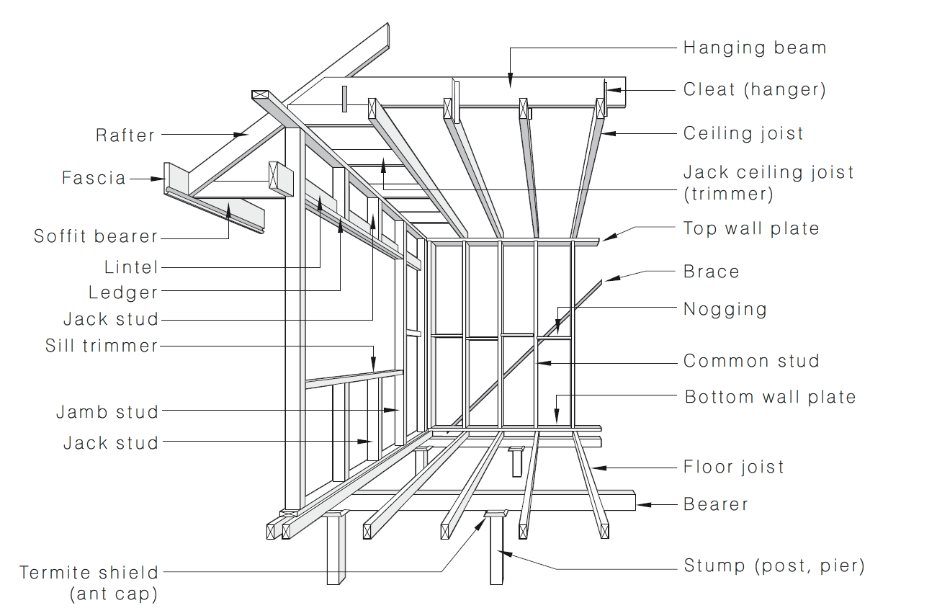

- Name the relevant volume and part in the Building Code of Australia (BCA) as well as the two (2) relevant Australian Standards that apply to the design, application and installation of timber framing for residential housing.

Answer | Information on timber framing can be found in BCA Vol 2 Section 3.4.3 and AS1684.2 AS 1684.2 — Residential timber-framed construction — Non-cyclonic areas.  AS 1684.3 — Residential timber-framed construction — Cyclonic areas  AS 1684.4 — Residential timber-framed construction — Simplified — Non-cyclonic areas.  AS 1720.3:2016 Timber structures Design criteria for timber-framed residential buildings

- What might be a typical checklist to be used for ensuring the quality of the frame members and the frame as a whole?

Answer | Checks for wall framing should include,  - Walls are plumb, square, straight and level  - Top and bottom plates are fitted correctly to studs  - Bracing and tie-downs in accordance with plan and standards  - Noggings at correct centres and in place for fixtures and services  - Corner blocking  - Walls are connected properly  Room sizes and ceiling heights match plan  - Window and door head height and openings  - Jamb studs to all openings  - Load bearing wall are in place  - Lintels for adequate bearing and in correct position  - Block under studs if timber floor  - Excessive notching  - Plumbing and drainage services provided for  - adequacy of temporary bracing

- What is sarking? What purpose does it serve?

Answer | Sarking is a layer of flexible insulation typically installed under external cladding when a home is being constructed. It consists of aluminium foil laminated onto paper or plastic backing with a flame retardant adhesive and fibreglass reinforcing mesh, and is manufactured in sheet form. Sarking performs a dual function, helping to keep your home insulated from the heat of summer whilst retaining warmth in the winter. This thermal lining is a very cost-effective means of insulating a home. It also provides a barrier to moisture coming into the house whilst allowing moisture to exit. The use of sarking can be mandatory or discretionary depending on a variety of local criteria including requirements for bushfire prone areas, wind speed and the specific construction specifications of your cladding.

- What is flashing?

Answer | Flashings are used at corners and vertical joints and around openings to ensure that water is prevented from penetrating the wall or roof frame cavity. As flashing does not extend fully behind the cladding, non-permeable materials may be used.

You are to refer to the roof section diagram below in responding to Q120. to Q126.

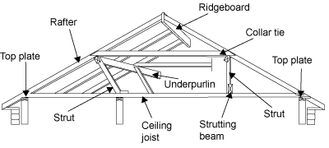

- What is a ceiling joist?

Answer | The ceiling joists have a double function:  they provide the structure onto which the ceiling is fixed  they are the member that connects or ties the lower ends of rafter couples (pairs). Therefore, they prevent the rafters spreading and causing the roof to sag or collapse.

- What is the purpose of a hanging beam?

Answer | Hanging beams are generally a deep timber beam located perpendicular 90º to ceiling joists and directly above them. The function of a hanging beam is to reduce the span of the ceiling joists. This allows for a more economic joist size and consistent section. Hanging beams must only support ceiling joists and the attached ceiling materials.

- What is the purpose of roof struts?

Answer | The struts are needed in the roof frame to transfer the loads from under purlins and other beams to the load bearing walls. Struts should be adequately supported over studs in timber walls. They should have anti-slip blocks, where necessary, to prevent them sliding horizontally. Struts are generally more efficient the closer they are to the vertical. Struts must be either vertical, perpendicular to the rafters or at an angle to the vertical which does not exceed 35o degrees.

- What is the ridge board in a conventional framed roof?

Answer | The ridge board in a conventional framed roof is more of a set-out member rather than a structural member. It makes sure that rafter couples meet at a consistent height giving a horizontal ridgeline free from sags. Ridge boards locate and stabilise rafter ends. Opposing pairs of rafters must not be staggered by more than their own thickness at either side of their ridge junction.

- What function do rafters perform in a roof?

Answer | In a conventionally framed roof, the rafters are fixed on a slope and run in the same direction as the roof slope. Rafters are generally erected in opposing pairs or couples. They meet each other directly at their apex on the ridge of the roof. The rafters give the roof its required slope and provide the structure onto which the roof covering is fixed.

- Explain the role of under purlins in a conventional roof frame system.

Answer | Under purlins are so called because they are fixed under the rafters. They are fixed horizontally and perpendicular to the direction of the roof slope. In a conventional roof frame, the under purlins support the underside of the rafters. This allows for the most economic rafter size and prevents the roof from sagging and collapsing.

- What are collar ties used for in a conventional roof frame system?

Answer | Collar ties must be provided in all coupled roof construction. They supplement the ceiling joists and prevent the rafter couples spreading.  Where the rafter span is such that it requires support from under purlins, collar ties are fitted to opposing common rafters at a point immediately above the under purlins.  Collar ties must be fitted to every second pair of common rafters.

- What advantages can be gained from installing roof trusses as against a conventional stick framed roof?

Answer | The advantages of trusses verse conventional stick frame roof include the following:  - They are strong, but light to erect  - They can be made to suit most roof shapes  - There is less on-site fabrication, therefore less site labour is required  - They are less affected by bad weather  - Factory production allows automated production  - Better quality control is possible  - Trusses make maximum structural use of the timber  - Trusses are capable of long spans  - Less internal load bearing walls  - Lightweight construction  - Cost effective

- What must the design of a timber roof truss adhere to?

Answer | Timber roof truss must be designed in accordance with engineering principles and with AS 1720.1-2010 Timber structures Design Methods This includes the wind design. AS 4440-2004 Installation of nail plated timber roof trusses provides details for correct practices when installing roof trusses.

- Discuss timber cladding and reference the relevant Australian Standard as it applies to the specific cladding. Be sure to name what part of the BCA deals with cladding.

Answer | Timber's natural resilience and high strength-to-weight ratio enables it to withstand far greater stresses and movement than other materials. This gives timber cladding a natural advantage on sites that are subject to high winds, extreme climate, highly reactive soils and subsidence or earth tremors.  Cladding must be watertight with adequate flashing and sisalation in accordance with best industry practice. Special care has to be taken with detailing and protection at ground level and north facing walls and performs best with wide eaves and verandas provides weather protection to walls.

- What must be checked when installing skylights, windows and doors?

Answer | When installing windows, doors and skylights you must always check against the building’s plan and then supervise installation to ensure it is compliant with standards/accepted industry construction.

- What is the relevant Australian Standard to be referenced for glazing of windows and doors?

Answer | The relevant standard is AS 1288.

- Write a descriptive interpretation of the extract of the window schedule shown below.

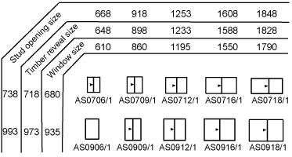

Answer | The above window schedule shows the relevant information to Setout and install the listed window sizes.  The measurements on the left-hand side are relevant to the height of the window and gives you the correct measurements for  - Stud openings  - Timber reveal  - Window size  The measurements across the top provide the correct measurement for the horizontal  Shown in the middle is the actual window size and type

- Illustrate by sketch the correct positioning of flashings and sarking for timber cladding.
Your sketches should reflect the use of weatherboard stops for installation of timber chamfer boards or timber weather boards where the internal and external corner joins has the cladding butting up to the weatherboard stop.
Alternate installations still require flashings and sarking for man-made manufactured boards such as HardiePlank or PrimeLine in which case sketches would reflect the use of internal and external corner jointers supplied by the manufacturer.

Answer

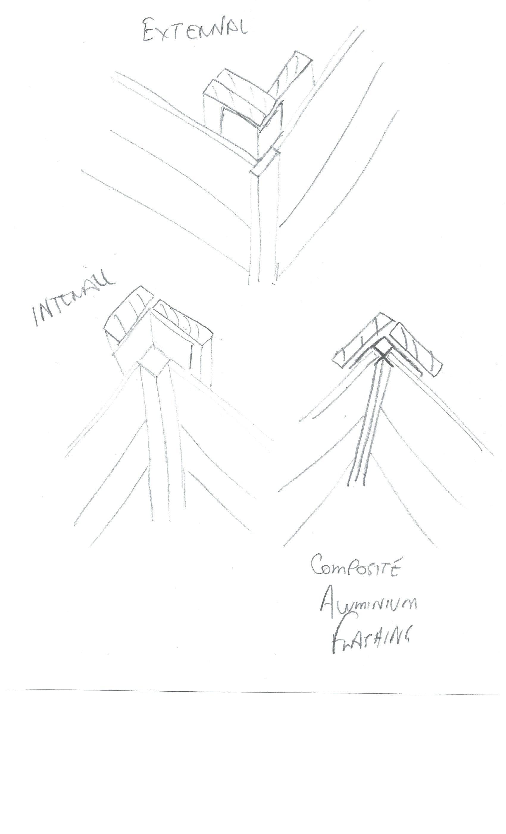

- Briefly describe each of the building materials listed below and outline the related construction methods used for low rise commercial projects.

Answer | Term | Explanation
 | Brick veneer construction | Brick veneer walls consist of a single non-structural external layer of masonry, typically made of brick, stone or manufactured stone. The inner wall is a structural wall, and may consist of concrete masonry, concrete, wood or metal frame. The outer brick veneer wall is tied back to the internal structural wall
 | Cavity brick construction
Cavity walls consist of two 'skins' separated by a hollow space (cavity).]The skins are commonly masonry such as brick or concrete block. Masonry is an absorbent material, and therefore will slowly draw rainwater or even humidity into the wall, as well as from the inside of the house as from outside. The cavity serves to drain water back out through weep holes at the base of the wall system or above windows. The weep holes allow wind to create an air stream through the cavity and the stream removes evaporated water from the cavity to the outside.
 | Earth wall construction | Rammed earth walls are constructed by ramming a mixture of selected aggregates, including gravel, sand, silt and a small amount of clay, into place between flat panels called formwork.  Traditional technology repeatedly rammed the end of a wooden pole into the earth mixture to compress it. Modern technology replaces the pole with a mechanical ram.
 | Autoclaved aerated concrete block construction | Autoclaved aerated concrete, or AAC, is concrete that has been manufactured to contain lots of closed air pockets. Lightweight and fairly energy efficient. Blocks are made to very exacting dimensions and are usually laid in thin-bed mortar that is applied with a toothed trowel, although more conventional thick-bed mortar can be used. Wall panels are storey height, reinforced and mechanically fixed. AAC can also be used in panel form for floor and roof construction. It has a long life and does not produce toxic gases after it has been put in place.
 | Pole frame construction | Pole framing or post-frame construction is a simplified building technique adapted from traditional timber framing techniques. It uses large poles or posts buried in the ground or on a foundation to provide the vertical structural support, along with girts to provide horizontal support.
 | Portal frame construction | Portal frame construction is a method of building and designing structures, using steel or steel-reinforced precast concrete or using laminated timber (such as glulam). The connections between the columns and the rafters are designed to be moment-resistant. Generally portal frames are used for single-story buildings and low-rise buildings
 | Post and beam construction | Post and beam construction is a building method that uses posts or poles and structural beams to create a structural building skeleton. This type of structure reduces the need for load-bearing walls and can provide large open area within the structure and can be fast to erect
 | Post and truss construction | Post and truss structures consist of primary members (posts, beams and single span trusses where all loads are transmitted from the trusses and beams which transfer them to the ground through vertical poles bearing on footings embedded in the soil.
 | Single leaf concrete masonry construction | A single leaf concrete masonry construction consists of hollow concrete blocks laid on top of a slab or strip footing. Structural steel is used to tie the wall to the slab and also to form a bond beam at the top of the wall to take the truss connections and loads. These wall are generally core filled with concrete
 | Tilt panel or tilt slab construction | Tilt panel or tilt slab is a pre-cast concrete panel system for building walls.  Traditional pre-cast concrete products are made in a factory, and then must be delivered to the site. Tilt slabs are poured on site.

