RIIRIS401D
Apply site risk management system

THEORY EXAM INSTRUCTIONS

- This exam will occur under standard assessment conditions.
  - An oral examination may be allowed under certain circumstances.
Answers will be documented and FT003 (Oral examination declaration form) must be completed.
- Participants must provide enough detail in their responses to demonstrate their knowledge and skills.
- Please fill in the details below, providing your name, signature and date of assessment.
  - Your signature acknowledges that this is your own work.
- If a participant initially answers a question incorrectly but modifies their response, they must follow the instructions below:
  - If a participant changes their response in writing, they must put their initials next to the written change.
  - If a participant changes their response verbally, this must be noted on the exam paper by the assessor.

Participant name | Scott Jones
Participant signature | 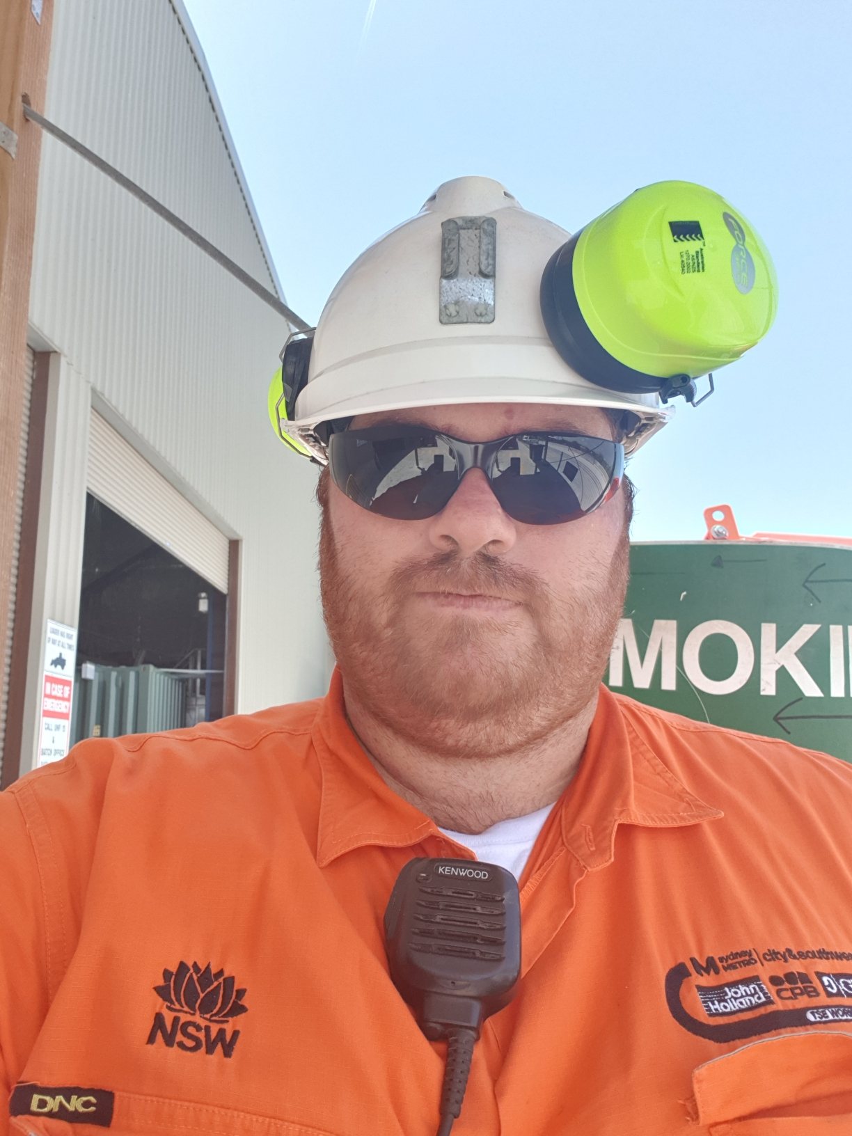

Assessor name
Assessor signature | 

Date | 12/06/2019

Number of questions | Number of questions answered correctly | Satisfactory?
29 |  | Yes | No
Assessor Comments

- Where would you find details of the relevant legislative requirements for risk management?

Answer | The site risk management system, which is based on the organisational risk management system.

- What are the levels of government that can apply legislative requirements affecting business operations on your worksite?
Answer | state/territory and federal

- Why is it important to effectively explain the following to team members?
- Relevant compliance documentation.
- Principles and practices of risk management.
- All identified hazards and the appropriate risk assessment and control measures.

Answer | - You must give detailed and concise information to ensure the team is able to complete all tasks in accordance with site, organisational and legal requirements.  - to reduce or manage the risks when working with a hazard or in a hazardous situation.  - you are ensuring they are aware of what to do when they encounter the risk.

- List 2 responsibilities for each of the following:
- Employers/PCUBs.
- Employees/workers.
- OHS/WHS representatives.

Answer | - Monitor the health of employees/workers to minimise risks and OHS/WHS issues.  - Exchange information about OHS/WHS risks and controls with OHS/WHS representatives and employees/workers.  - Be represented by an OHS/WHS representative when raising OHS/WHS issues or have a defined system so that there is communication with management to resolve issues.  - Follow measures put in place to protect their safety, such as using and caring for Personal Protective Equipment (PPE) or follow safe operating procedures.  - Represent employees/workers in relation to health and safety issues in the workplace.  - Attempt to resolve OHS/WHS issues for those employees/workers they represent.

- What are 4 risk management policies, procedures or programs that you will need to inform work groups of?

Answer | 1-Risk management policy.  2-Site procedures and work instructions for hazard identification, risk assessment, selection and implementing of controls.  3-Site incident and accident investigation, risk audits and reporting requirements.  4-Site consultative arrangements for employees/workers in the work area

- Which risk management policies and procedures in particular need to be site-specific?

Answer | - Risk management policy.  - Site procedures and work instructions for hazard identification, risk assessment, selection and implementing of controls.  - Site incident and accident investigation, risk audits and reporting requirements.  Site consultative arrangements for employees/workers in the work area  - Site fire response arrangements.  - Site OHS/WHS arrangements for on-site contractors, visitors and members of the public.  - Site First Aid provisions, medical practitioner contacts and instructions about medical attention.

- Why is effective consultation important when managing risks?

Answer | Consulting and working as a group will help to design a better risk management system

- How should you treat people from different social, cultural and ethnic backgrounds, or with limited physical or mental abilities?

Answer | Always treat other members of your team equally and in the manner you would want to be treated, regardless of your personal feelings about the individual.

- Why is it important that risk management meetings are conducted and monitored by a supervisor?

Answer | This will ensure participation by all members of your work group is effective and individuals, and parties aren’t being pressured by particular views or people.

- What are 3 characteristics should you look for when developing your risk management work group?

Answer | - Consultative outlook.  - Willingness to participate.  - Commitment to site safety.

- List 4 individuals or parties who might be involved in the consultation process when raising or dealing with risk management issues.

Answer | - Contractors.  - Regulatory authorities.  - Tenderers.  - Project managers.

- What are 3 ways to communicate the outcomes of consultation about risk management issues to the work group?

Answer | presentations, summaries and written reports

- List 4 ways that gaps in training might present themselves.

Answer | Accidents and incidents  Near misses  Licensing requirements  Existing training programs

- What are the 2 main forms of risk management training available to team members?

Answer | Accredited Training  Non-Accredited training

- What are 3 learning opportunities that may be available to team members?

Answer | - Coaching.  - Mentoring.  - Instruction activities.

- What is the difference between coaching and mentoring?

Answer | Coaching is more hands on

- To whom might you be required to report the cost of training or learning opportunities?

Answer | - Site project manager.  - Site training manager.  - Other designated persons.

- List 5 ways that hazards might be identified.

Answer | Workplace Inspections And Observation  Consulting Work Team Members  Housekeeping  Risk Audits And Review Of Audit Reports  Checking Equipment Before And During Work

- What are 3 workplace requirements for reporting hazards?

Answer | - Location.  - The type of hazard.  - Number of people affected by the hazard.

- How are analysis skills used in identifying hazards and assessing risks in the work area?

Answer
  Consequence | What would be the outcome of the event occurring?  How severe would the outcome be?
  Likelihood | What is the chance of the event/consequence occurring?  Has the event happened before?  Is it likely to happen again?
  Risk Level | The combined result of likelihood and consequence.

- List 4 types of prompt action that might be taken after a report of a hazard has been made.

Answer | Act immediately  Act today  Act this week  Act this month

- What are the 6 levels in the hierarchy of hazard controls, starting with the most effective?

Answer | Elimination  Substation  Isolation  Engineering Controls  Administrative controls  Personal protective equipment

- What are 3 resources you might be assessing when controlling risks?

Answer | Time resources  Human resources  Financial resources

- List 3 problems with risk control measures that could make them inadequate.

Answer | - It is inappropriate for the risk.  - It has been out-dated by newer technology.  - It is creating additional risks or hazards that were  unforeseen.

- What is involved in monitoring the outcomes of reported hazards and risks?

Answer | - Repeated reporting of the problem.  - Daily checking for progress.  - Requesting assistance from the OHS/WHS  representative in the workplace.  - Discussing the problem with a supervisor or  manager and gaining support.

- List 5 documents that might be included in risk management records.

Answer | - Induction, instruction, training and assessment.  - Manufacturers and suppliers information.  - Dangerous goods and hazardous substances registers.  - Plant and equipment maintenance and testing reports.  - Workers compensation and rehabilitation records.

- Why are literacy skills important when dealing with risk management records?

Answer | Your language and literacy skills will enable you to read, understand and interpret risk management information as well as to research and review a range of other useful documents.

- List 4 places you could collect information and data from when identifying and monitoring risk control procedures.

Answer | Existing information  Policies and procedures  Site inspections  Interviewing staff members

- Information and data can be used to help analyse the current risk management status of your site.
- What is data analysis?
- What type of information might contain data that needs to be analysed?

Answer | - Data analysis is the process of taking the raw information you have gathered and highlighting the sections that are useful to your purpose.  - Incident monitoring.  - Environmental monitoring.  - Evaluation of the effectiveness of risk  control measures.

