CHCECE018
Nurture creativity in children
Learner Guide



CHCECE018
Nurture creativity in children

Table of Contents

Table of Contents 2
Unit of Competency 5
Performance Criteria 6
Foundation Skills 8
Range Conditions 8
Assessment Requirements 9
Housekeeping Items 11
Objectives 11
National Quality Framework for Early Childhood Education and Care (NQF) 12
National Quality Standard 13
National laws and regulations 14
Guide to the Education and Care Services National Law and the Education and Care Services National Regulations 2011 15
1. Foster creativity through the physical environment 19
1.1 – Select and promote the use of a range of open-ended, natural and found materials and make them available to children 20
1.2 – Choose and promote the use of a range of materials to encourage creative expression and make them accessible to children 20
Creativity from the physical environment 20
Open-ended, natural and found materials 20
Benefits of children using open-ended materials 21
Health and safety 23
Activity 1A 24
1.3 – Introduce children to a range of examples of creative expression in art, architecture, inventions, music and dance, and promote the use of creative expression 25
Creative expression 25
Introducing children to a range of examples creative expression 25
Promoting creative expression 30
Excursions 31
Activity 1B 32
2. Foster creativity through the human environment 33
2.1 – Support children to feel a sense of ownership and responsibility for equipment and materials 34
Ownership and responsibility 34
2.2 – Role-model creativity by improvising with equipment and materials 36
Improvisation 36
Creative improvisation with equipment and materials 36
Activity 2B 38
2.3 – Encourage children to pursue their own original ideas, interpretations and expressions 39
2.4 – Invite children to ask questions and assist them to find their own answers 39
Encourage children to pursue their own original ideas 39
Invite children to ask questions and find their own answers 40
Activity 2C 41
2.5 – Engage children in talking about their creations and ask them open-ended questions 42
2.6 – Share enthusiasm for creative work with children 42
2.7 – Encourage children to respect and appreciate the creative effort of their peers 42
Engage children in talking about their creations and ask them open-ended questions 42
Share enthusiasm for creative work with children 43
Encourage children to respect and appreciate the creative effort of their peers 43
Activity 2D 45
3. Foster creativity through a learning framework 46
Fostering creativity through a learning framework 47
3.1 – Allow time for children to be creative and encourage efforts to extend over days or weeks 50
Specific creative projects and activities 50
Activity 3A 53
3.2 – Teach children techniques when using materials and equipment 54
Creative materials and equipment 54
Creative techniques 55
Other creative techniques 60
Activity 3B 61
3.3 – Plan and create opportunities for children to collaborate creatively with each other 62
Performance collaboration 62
Inventive collaboration 63
Supervision 63
Activity 3C 64
3.4 – Involve children in critical reflection and solving real problems 64
Critical reflection 65
The link between creativity and critical reflection 66
Critical reflection for children 66
Solving real problems 67
Activity 3D 69
3.5 – Display children’s work in meaningful ways 70
Importance of displaying children’s work 70
Meaningful ways of displaying children’s work 71
Activity 3E 72
3.6 – Design a flexible framework that can respond to children’s interests as they arise 73
Framework for learning 73
Respond to children’s interests as they arise 74
Activity 3F 75
4. Provide experiences 76
4.1 – Identify and provide a range of experiences used to nurture creativity 77
4.2 – Provide opportunities for children to practise developing skills in music, movement, construction, visual art and dramatic play in both indoor and outdoor environments 77
Provide children with a range of experiences to nurture creativity and develop skills 77
Indoor and outdoor environments 79
Supervision 80
Activity 4A 81
5. Evaluate experiences 82
5.1 – Use a range of methods to evaluate children’s learning from the implemented creative experiences 83
Assessment of learning 83
Methods of evaluating children’s learning 83
Activity 5A 86
5.2 – Reflect on the evaluations and make ongoing modifications to the curriculum to stimulate interest and involvement in creative activities 87
Critical reflection 87
Modifications to curriculum 87
Activity 5B 88
Skills and Knowledge Activity 89
Major Activity – An opportunity to revise the unit 90
References 92

Unit of Competency

Application

This unit describes the skills and knowledge required to nurture creativity in children.

The unit applies to educators who work with children in a variety of education and care services.

No licensing, legislation or certification requirements apply to this unit at the time of publication.

Unit Sector

None stated

Performance Criteria
Element  Elements describe the essential outcomes. | Performance Criteria  Performance criteria describe the performance needed to demonstrate achievement of the element.
- Foster creativity through the physical environment | - Select and promote the use of a range of open-ended, natural and found materials and make them available to children  - Choose and promote the use of a range of materials to encourage creative expression and make them accessible to children  - Introduce children to a range of examples of creative expression in art, architecture, inventions, music and dance, and promote the use of creative expression
- Foster creativity through the human environment | - Support children to feel a sense of ownership and responsibility for equipment and materials  - Role-model creativity by improvising with equipment and materials  - Encourage children to pursue their own original ideas, interpretations and expressions  - Invite children to ask questions and assist them to find their own answers  - Engage children in talking about their creations and ask them open-ended questions  - Share enthusiasm for creative work with children  - Encourage children to respect and appreciate the creative effort of their peers
- Foster creativity through a learning framework | - Allow time for children to be creative and encourage efforts to extend over days or weeks  - Teach children techniques when using materials and equipment  - Plan and create opportunities for children to collaborate creatively with each other  - Involve children in critical reflection and solving real problems  - Display children’s work in meaningful ways  - Design a flexible framework that can respond to children’s interests as they arise
- Provide experiences | - Identify and provide a range of experiences used to nurture creativity  - Provide opportunities for children to practise developing skills in music, movement, construction, visual art and dramatic play in both indoor and outdoor environments
- Evaluate experiences | - Use a range of methods to evaluate children’s learning from the implemented creative experiences  - Reflect on the evaluations and make ongoing modifications to the curriculum to stimulate interest and involvement in creative activities

Foundation Skills
The foundation skills described those required skills (language, literacy and numeracy) that are essential to performance.

- Oral Communication – in order to facilitate creative discussions and play with children aged birth to 6 years.
- Reading – in order to access and apply relevant pedagogical principles from an approved learning framework.

The remaining foundation skills essential to performance are explicit in the performance criteria of this unit.

Range Conditions
Specifies different work environments and conditions that may affect performance. Essential operating conditions that may be present (depending on the work situation, needs of the candidate, accessibility of the item, and local industry and regional contexts) are included.

The range of experiences used to nurture creatively must include:

- Music
- Movement
- Construction
- Visual art
- Dramatic play

Assessment Requirements
Performance Evidence

The candidate must show evidence of the ability to complete tasks outlined in elements and performance criteria of this unit, manage tasks and manage contingencies in the context of the job role. There must be demonstrated evidence that the candidate has completed the following tasks:

- Planned and provided at least three programs or active learning environments that foster creativity in for children of varying ages, including:
o creative experiences initiated by children
o dramatic and imaginative play opportunities
o creative approaches to routines
o opportunities for each child to develop self-expression and skills
- Facilitated the active participation of at least three children of varying ages through encouragement, appropriate interactions and communications

Knowledge Evidence

The candidate must be able to demonstrate essential knowledge required to effectively do the task outlined in elements and performance criteria of this unit, manage the task and manage contingencies in the context of the work role. These include knowledge of:

- How to access:
o the National Quality Framework
o the National Quality Standards
o the relevant approved learning framework
- How to navigate through framework and standards documents to find areas relevant to this unit of competency
- Stages of children’s development, in planning and delivering a range of appropriate activities to stimulate an interest and love of learning in children
- Music, movement, construction, visual art and dramatic play sufficient to engage children and assist them to implement their ideas
- Aesthetic, safe, interesting, challenging environments to encourage curiosity, experimentation, active learning, literacy and choice
- Organisational standards, policies and procedures

Assessment Conditions

Skills must be demonstrated in a regulated education and care service.

In addition, simulations and scenarios must be used where the full range of contexts and situations cannot be provided in the workplace or may occur only rarely. These are situations relating to emergency or unplanned procedures where assessment in these circumstances would be unsafe or is impractical.

Simulated assessment environments must simulate the real-life working environment where these skills and knowledge would be performed, with all the relevant equipment and resources of that working environment.

Assessment must ensure use of:

- National Quality Framework for Early Childhood Education and Care
- The relevant approved learning framework under the National Quality Framework for Early Childhood Education and Care

Assessors must satisfy the NVR/AQTF mandatory competency requirements for assessors.

Links

Companion volumes are available from the CS&HISC website - http://www.cshisc.com.au/

Housekeeping Items
Your trainer will inform you of the following:
- Where the toilets and fire exits are located, what the emergency procedures are and where the breakout and refreshment areas are.
- Any rules, for example asking that all mobile phones are set to silent and of any security issues they need to be aware of.
- What times the breaks will be held and what the smoking policy is.
- That this is an interactive course and you should ask questions.
- That to get the most out of this workshop, we must all work together, listen to each other, explore new ideas, and make mistakes. After all, that’s how we learn.
- Ground rules for participation:
  - Smile
  - Support and encourage other participants
  - When someone is contributing everyone else is quiet
  - Be patient with others who may not be grasping the ideas
  - Be on time
  - Focus discussion on the topic
  - Speak to the trainer if you have any concerns

Objectives
- Discover how to foster creativity through the physical environment
- Know how to foster creativity through the human environment
- Learn how to foster creativity through a learning framework
- Understand how to provide experiences
- Demonstrate how to evaluate experiences
- Gain skills and knowledge required for this unit

National Quality Framework for Early Childhood Education and Care (NQF)
The NQF was founded in 2012 by the government as a measure to raise the quality and standards of early childhood education and care across the whole of the Commonwealth by introducing consistency in the regulation and assessment of Australian education and care services.

The NQF applies to most of the following services:
- Long day care
- Family day care
- Preschool/kindergarten
- Outside school hours care.
The need for a national approach is to ensure that all children in the early stages of childhood access quality education and care in their formative years in order to give them the best possible start in development and learning. Research shows that the higher the quality of education and care in these early years, the higher the quality of health, educational attainment, and employment in later life.
The NQF focuses on the belief that all children need quality care that is tailored to meet their individual and specific needs.
It aims to raise the quality of education and care services via two methods:
- Improved caregiver qualifications – the higher the qualification of the caregiver, the more in depth their knowledge and understanding of the development and learning of children. These higher qualifications improve the effectiveness of the educator as they take an holistic approach to the education of the whole child
- Lower educator to child ratios – fewer children in an educator’s care allows the educator to spend more time with each child, focusing on their individual learning and development needs and promotes the establishment and reinforcement of positive relationships. Happy children who feel safe are more likely to engage in learning, taking risks to think for themselves and trying new skills without the fear of failure or embarrassment.
The NQF is comprised of three elements:
- National Quality Standard that determines the benchmark for the quality of education and care services across Australia
- National legislative framework that provides a consistent approach to the regulation and assessment of education and child care services
- National quality rating and assessment process that rates education and care providers against the National Quality Standard.
The NQF is overseen by The Australian Children’s Education and Care Quality Authority (ACECQA) which works in conjunction with the regulatory authorities of each state/territory.
More information on the NQF can be found on the government’s website for education and training at: http://education.gov.au/national-quality-framework-early-childhood-education-and-care

National Quality Standard
The NQS is the benchmark for quality in early years education and child care provision. The plan is that every early years education and care service throughout Australia will be assessed against this standard and rated accordingly. The ratings will then be placed on a national register that can be viewed by all.
Each provider will be assessed in seven different areas and also given an overall rating.
The seven areas of assessment are:
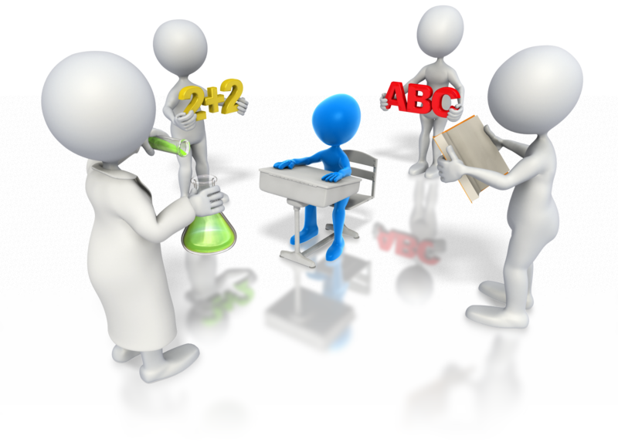
- Educational program and practice
- Children’s health and safety
- Physical environment
- Staffing arrangements
- Relationships with children
- Collaborative partnerships with families and communities
- Leadership and service management.
Each quality area will be rated with one of the five following levels defined by the NQS:
- Excellent rating – awarded by ACECQA
- Exceeding National Quality Standard
- Meeting National Quality Standard
- Working Towards National Quality Standard
- Significant Improvement Required.
More information on the NQS can be found on the ACECQA website at: http://acecqa.gov.au/national-quality-framework/the-national-quality-standard
The assessment criteria of the NQS is intrinsically linked to the two national learning frameworks:
- Belonging, Being and Becoming: The Early Years Learning Framework for Australia – this framework outlines the principles, practices and outcomes for successful development and learning of a child from birth to five years old and includes the transition to school. All education and child care services are expected to use this framework to develop and implement their own provision
- My Time, Our Place: Framework for School Age Care in Australia – this framework supports the continued development of learning and development of children during school age using best practices of learning through play and leisure based activities that are appropriate to the individual’s needs, abilities and interests.
Belonging, Being and Becoming can be found at: http://education.gov.au/early-years-learning-framework
My Time, Our Place can be found at: http://education.gov.au/my-time-our-place-framework-school-age-care-australia

National laws and regulations
The National Quality Framework is governed by a combination of the Education and Care Services National Law and the Education and Care Services National Regulations. The legislation and regulations vary in each state/territory. To find out more information about the legislation in your region visit the links below:
State/territory | Web address
Victoria | http://www.legislation.vic.gov.au/Domino/Web_Notes/LDMS/PubStatbook.nsf/51dea49770555ea6ca256da4001b90cd/b73164fe5da2112dca2577ba0014d9ed!OpenDocument
New South Wales | http://www.legislation.nsw.gov.au/sessionalview/sessional/act/2010-104.pdf
Australian Capital Territory | http://www.legislation.act.gov.au/a/2011-42/default.asp
Queensland | http://www.legislation.qld.gov.au/LEGISLTN/ACTS/2011/11AC038.pdf
Northern Territory | http://notes.nt.gov.au/dcm/legislat/Acts.nsf/5504d78eee675d6e6925649e001bb652/95724bfed2b632c96925792e007cb5c1?OpenDocument
South Australia | http://www.legislation.sa.gov.au/LZ/C/A/EDUCATION%20AND%20EARLY%20CHILDHOOD%20SERVICES%20(REGISTRATION%20AND%20STANDARDS)%20ACT%202011.aspx
Tasmania | http://www.thelaw.tas.gov.au/tocview/index.w3p;cond=;doc_id=48%2B%2B2011%2BAT%40EN%2B20120522120000;histon=;prompt=;rec=;term=
Western Australia | http://www.slp.wa.gov.au/legislation/statutes.nsf/main_mrtitle_12929_homepage.html

Guide to the Education and Care Services National Law and the Education and Care Services National Regulations 2011
The following information is taken directly from the official government Guide to the Education and Care Services National Law and the Education and Care Services National Regulations 2011 and the whole document can be found at: http://files.acecqa.gov.au/files/National-Quality-Framework-Resources-Kit/2014/NQF02%20Guide%20to%20ECS%20Law%20and%20Regs_web.pdf
The objectives of the NQF under section 3(2) of the National Law are to:
- Ensure the safety, health and wellbeing of children attending education and care services
- Improve the educational and developmental outcomes for children attending education and care services
- Promote continuous improvement in the provision of quality education and care services
- Establish a system of national integration and shared responsibility between participating jurisdictions and the commonwealth in the administration of the national quality framework
- Improve public knowledge, and access to information, about the quality of education and care services
- Reduce the regulatory and administrative burden for education and care services by enabling information to be shared between participating jurisdictions and the Commonwealth.
The following guiding principles under section 3(3) of the National Law should be applied when making decisions about the operation of education and care services:

- The rights and best interests of the child are paramount
- Children are successful, competent and capable learners
- The principles of equity, inclusion and diversity underpin the national law
- That Australia’s Aboriginal and Torres Strait Islander cultures are valued
- That the role of parents and families is respected and supported
- That best practice is expected in the provision of education and care services.

The National Law sets out:
- Approval processes for the operation of education and care services

- The assessment and rating system
- Key operational requirements
- Compliance, monitoring and enforcement powers
- Review of decisions made by regulatory authorities
- The functions and powers of the Standing Council
- The functions and powers of the Australian Children’s Education and Care Quality Authority (ACECQA)—the national body that oversees the system
- The functions and powers of regulatory authorities in each jurisdiction
- Creation of a nationally consistent freedom of information and privacy framework to apply to ACECQA and regulatory authorities
- Publication of information, including registers
- Key transitional arrangements.
Services covered by the National Quality Framework
Section 5 of the National Law states that the NQF covers the majority of long day care, family day care, preschool (kindergarten) and outside school hours care services. In Western Australia the NQF also covers home-based care.
Given that the NQF was only introduced in 2012, not all service providers are covered. It has commenced its assessment and quality rating of the services that provide for the largest number of children but the intention is to extend it to all providers of education and care over the forthcoming years.
Services excluded from the NQF under National Law include:
- A school providing full-time education to children, including children in the year before Grade 1, but not including a preschool program delivered in a school or a preschool that is registered as a school (as these are within scope)
- A preschool program delivered in a school if the program is delivered in a class or classes where a full-time education program is also being delivered to school children and the program is delivered to fewer than six children in the school (a composite class)
- A personal arrangement
- A service principally conducted to provide instruction in a particular activity (for example, a language class or ballet class)
- A service providing education and care to patients in a hospital or patients of a medical or therapeutic care service
- Care provided under a child protection law of a participating jurisdiction.
These services excluded by National Law are not likely to be brought into the scope of the NQF in the future.
Services excluded from the NFQ under National Regulations include:
- Disability services defined under state or territory law, and early childhood intervention services for children with additional needs
- Except in WA, education and care in a residence, other than as part of a family day care service
- Occasional care services (for example, offered at short notice or on a casual basis)
- Education and care provided by a hotel or resort to children of short-term guests at the hotel or resort
- Education and care that is provided on an ad hoc basis to children of a guest, visitor or patron where the person who is responsible for the children is readily available at all times
- Education and care where it is primarily provided or shared by parents or family members
- Education and care provided at a secondary school to a child of a student attending the school, where the parent retains responsibility for the child
- Mobile services

- Services that provide education and care for no more than four weeks per calendar year during school holidays
- Transition to school programs provided by a school to orient children to that school
- Budget based funded services, other than where they receive Child Care Benefit
- Playschools licensed in the Australian Capital Territory
- Stand-alone services in Queensland
- Play centres in South Australia
- Services licensed as centre-based Class 4 or 5 services under the Child Care Act 2001 in Tasmania
- Licensed limited hours or short-term services in Queensland or Victoria
- Government-funded services under the Children and Community Services Act 2004 of Western Australia.
Services excluded under the National Regulations may become an inclusive part of the NQF in the future.
Educational program
The National Law and Regulations determine that all approved services provide an educational program that:
- Is based on an approved learning framework:
  - the two nationally approved learning frameworks:
    - Belonging, Being and Becoming—The Early Years Learning Framework for Australia
    - My Time, Our Place—Framework for School Age Care in Australia
  - jurisdiction specific approved learning frameworks:
    - Australian Capital Territory: Every Chance to Learn—Curriculum Framework for ACT Schools Preschool to Year 10
    - Victoria: Victorian Early Years Learning and Development Framework, Department of Education and Victorian Curriculum and Assessment Authority

    - Western Australia: Curriculum Framework for Kindergarten to Year 12 Education in Western Australia
    - Tasmania: Tasmanian Curriculum, Department of Education of Tasmania, 2008
- Is delivered in accordance with that framework
- Is based on the developmental needs, interests and experiences of each child
- Takes into account the individuality of each child.
The educational program must make a contribution to each of the following outcomes:
- Children have a strong sense of identity
- Children are connected with and contribute to his or her world
- Children have a strong sense of wellbeing
- Children are confident and involved learners
- Children are effective communicators.
Further information regarding the National Quality Framework and how it relates to you and your role in education and care provision will be included in the relevant chapters of the unit.

1. Foster creativity through the physical environment
1.1. Select and promote the use of a range of open-ended, natural and found materials and make them available to children
1.2. Choose and promote the use of a range of materials to encourage creative expression and make them accessible to children
1.3. Introduce children to a range of examples of creative expression in art, architecture, inventions, music and dance, and promote the use of creative expression



1.1 – Select and promote the use of a range of open-ended, natural and found materials and make them available to children

1.2 – Choose and promote the use of a range of materials to encourage creative expression and make them accessible to children

Creativity from the physical environment
Creativity is the use of the imagination to create original and innovative ideas and works. Encouraging and nurturing creativity in children in their early years helps them to become independent thinkers and gives them the ability to solve problems more readily than if creativity were discouraged. The physical environment is full of resources and materials that can be used to stimulate thinking, feeling, questioning and reasoning in children as they are tangible and have a context within the child’s environment. Creative inquiry helps children to express their thoughts and feelings through all manner of mediums including music, art, movement, construction and invention.

Open-ended, natural and found materials
These types of materials are all around us and, provided that they are not harmful to use, can be almost limitless.
Examples of open-ended, natural and found materials include:
- Old clothing and other materials such as curtains, carpet off cuts, towels, bedding, cushion covers, wool, leather
- Empty and discarded packaging such as egg boxes, cereal boxes, match boxes, toilet roll tubes, plastic bottles, bottle tops, bubble wrap and other package filling, plastic boxes, take-away packaging, etc.
- Waste paper such as newspapers, magazines, scrap paper, wallpaper leftovers, cardboard boxes, old greeting cards etc.

- Kitchen wares such as tin foil, baking paper, cling film, food bags, food bag ties, tooth picks,
- Adhesives and connecting materials including sticky tape, glue, string, rope, elastic bands, bungee cords, hair accessories
- Natural materials including leaves, feathers, sticks, wood, water, stones and pebbles, etc.
- Dried food substances such as pasta, rice, beans, lentils, candy, rock salt, peppercorns etc.
- Found materials such as buttons, items washed up on beaches, items found in pockets and handbags
- Paints, crayons, clay, plasticine, pencils etc.

Benefits of children using open-ended materials
The first five years of a child’s life are hugely influential in their cognitive development. Learning through play using open-ended materials in these first five years has a number of benefits to the holistic development of the child.
Sense of well-being and competence
Allowing children, and adults for that matter, the opportunity to play with a wide range of materials immediately puts them at more ease than if they were sitting at a desk in a classroom with prescriptive materials such as a pencil, exercise book and a ruler because it relaxes rules and boundaries. Making a number of different materials available to them gives them a choice in selection. It forces them to make their own decisions based upon their own reasoning. It also enables them to learn through trial and error so that perhaps the first material they select does not have the intended effect; rather than viewing this as a failure, it gives them the chance to learn about the properties of the material through their own experience and forces them to try a different option. Without realising it, the child is automatically problem-solving using creative thinking.
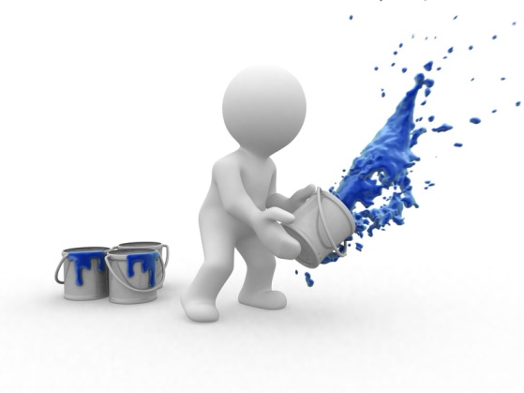
Many adults have a fear of failure or fear of the unknown because as children they were not given the opportunity to think for themselves or try different methods of completing tasks. Encouraging and nurturing children in their early years to take responsibility for their own learning and development helps them to develop a sense of well-being and achievement for the works they create and an ability to solve problems without actually realising it is a problem or a challenge. This independent thinking will help in adulthood, as they will have the ability to work on their own initiative and strive for continuous improvement making them an asset to any employer.
Understanding is enhanced by direct experience
Everyone has different learning styles but it is readily confirmed by research that we gain a deeper understanding of a concept and a greater ability to perform a task if we have hands-on experience of actually doing it. Giving a child the materials to create something allows them to experience all the processes necessary to reach an end product. Children retain more information if they have experienced for themselves what it is they are trying to remember because they can associate it with what they saw, what they smelled, what they touched and how it felt, what they heard, and what they tasted. By directly handling open-ended materials they can experience all of these things.
Creating something themselves also encourages children to invest more care and thought into their product and take ownership of the challenge with which they are faced because it is created by their own ideas, thoughts and desires, not instructions given by somebody else.
Creative group work supports team work and learning from peers
When children are set a task to complete in a group a number of things happen. A leader usually emerges and roles and responsibilities are naturally assigned which gives each member of the group ownership of a particular element of the challenge. Things will not go according to the original plan and errors will be made; often these errors are not spotted by the person making them, rather another member of the team who will suggest an alternative method to complete the task.
In individual tasks, a child may be struggling to solve a problem on their own with their chosen material or method and will see one of their peers succeeding but using a different material or method and will then take their idea to solve the problem.
Working in a group challenge with a wide range of materials also encourages the development of vocabulary that would probably not be encountered or understood without the physical ability to create with such materials. For example, sticky, stiff, shiny, sharp, velvety, soft, smooth, tough, bendy, stretchy, scrunch, tear, balance, heavy, etc.
Children learn literacy, maths and science whilst experimenting with materials

Without realising it, by creating with a wide range of physical materials, natural and man-made, in group and individual settings, they are developing their communication skills, literacy levels, numeracy skills and scientific knowledge. Physically handling and using materials enables children to understand their properties and what each is capable of doing or being, both alone and in conjunction with other materials. It also allows children to appreciate the three dimensional characteristics of materials thus developing their awareness of depth, space, area and weight. This depth of understanding is impossible just by looking at materials.
Using open-ended materials to create tangible things also promotes group discussion during and after the event and encourages children to evaluate and reflect upon their experiences. Using unfamiliar materials and asking children to create unique things naturally instigates new vocabulary and understanding.
Children learn to make their own connections
Skills and knowledge learned during one specific creative play task allows children to transfer this knowledge and experience to other situations and enables them to make connections and reinforce their understanding and learning of a particular concept. For example, a child may discover in one activity that wood floats on water but rocks sink and will be able to apply this understanding to future activities.

Inspiration and satisfaction for educators
To see children enjoying their learning and wanting to learn more on the back of what they have discovered for themselves encourages educators to plan and prepare more innovative tasks for the children in their care. An educator’s role and desire should be to see children making progress in learning and development and inspiring a thirst for more knowledge in all children they teach.

Health and safety
When using open-ended materials it is important to ensure that all materials selected are safe for the use of each child in your care. You should take into consideration any allergies or medical conditions in your cohort, such as allergies to foodstuffs should you intend to use food as a material. You should also ensure that the size and weight of the materials is age appropriate and that edges are not too sharp.
When conducting these types of inter-active tasks, ensure that there are enough educators to adequately supervise the group. The educator to child ratio outlined in the National Quality Standard may not be suitable for this type of hands on activity as there are more materials and activity to supervise than in a routine classroom based lesson.
When determining the correct level of supervision you should take the following considerations into account:
- Number of children
- Ages of children
- Abilities of children
- Skills and experience of educators
- The nature of the activity and the materials being used
- The location of the activity including visibility and access
- Potential risks and hazards of the activity
- Educators’ knowledge of each child’s needs and abilities.

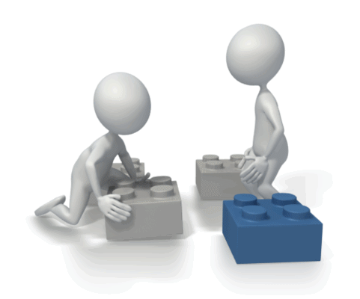


Activity 1A

1.3 – Introduce children to a range of examples of creative expression in art, architecture, inventions, music and dance, and promote the use of creative expression

Creative expression
You may tend to think of education and learning being predominantly about literacy and numeracy and developing the ability to express our thoughts, knowledge and understanding through the written and spoken word, and of course these skills and abilities are absolutely essential for all children to master as soon as possible, but the ability to express themselves through creative mediums is as important to develop their own identity and individualism. Allowing children the opportunity to interpret meaning and convey understanding through creative expression encourages them to think for themselves at an early age so that it becomes second nature in their learning and development.
Promoting the use of creative expression at an early age, particularly through activities such as dance, music and drama, develops an inherent ability to perform and present to others, a skill which many adults find daunting and can cause serious anxiety. If these methods of learning and development are integrated into a child’s educational program from the start the associated skills and abilities become as normal and acceptable as reading and writing. In addition, if these activities are undertaken in mixed gender groups, stereotypes such as it being effeminate for boys to participate in ballet dancing are negated and equal opportunities for all are championed. It also encourages ambition, as children are encouraged to try new experiences and activities

Introducing children to a range of examples creative expression
There are various ways of introducing children to examples of creative expression, ranging from inexpensive and simple to costly and elaborate.
Art
Ways of introducing children to examples of creative expression in art include:
- Showing them examples of art on the internet
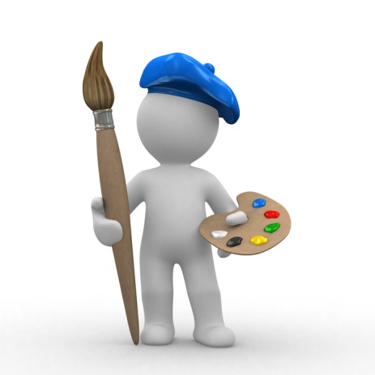
- Displaying art in the educational setting
- Looking at art in books within the library
- Visiting art galleries and museums locally, nationally and internationally
- Inviting artists into the educational setting to exhibit their work.
Examples of art work may include:
- Paintings
- Sketches
- Comic books
- Sculptures in stone, ice, sand etc.
- Decorative textiles including forms of embroidery, printing, patchwork
- Graffiti
- Carvings in wood and stone
- Promotional art such as signs, flyers, branding, logos etc.
- Cover art on books, music albums, films etc.
Architecture
Ways of introducing children to examples of creative expression in architecture include:
- Walking around the building you occupy
- Viewing architectural plans and designs
- Visiting historical monuments and buildings locally, nationally and internationally
- Viewing on the internet well-known international buildings and constructions such as Sydney Opera House, the Houses of Parliament, the White House, the Golden Gate Bridge etc.
- Comparing the architecture of different styles and time periods.

Examples of architecture may include:
- Buildings including houses, religious buildings, castles, palaces, government buildings, office blocks, theatres, cinemas, schools and universities, stadiums, arenas, sporting grounds, leisure facilities, prisons etc.
- Bridges
- Monuments
- Towers
- Stairs
- Industrial architecture such as oil rigs, refineries, wind turbines, mills.
Inventions
Inventions are absolutely everywhere. Every man-made object we see around us has been invented by someone at some point. Some inventions throughout history have changed the way of life for humans and the environment and some have been extremely simple and unassuming. The interesting thing about inventions is the ideas behind them; this is the creativity and innovation that you should try and extract from the children in your care when introducing them to inventions.
When introducing children to examples of inventions you should encourage them to think about the following concepts:
- What is the purpose of the invention?
- Why was it needed?
- What existed before it was invented, if anything?
- How does it benefit humans or the environment?
- Is it harmful to humans and/or the environment and why?
- What is it made of and why?
- What does it do that is different to other similar inventions and how?
This sounds much more complex than it is, and indeed, it certainly could be depending upon the invention you introduce the children to.
The best way to introduce children to inventions is to steer them in the direction of normal everyday objects that they use and with which they are familiar such as:
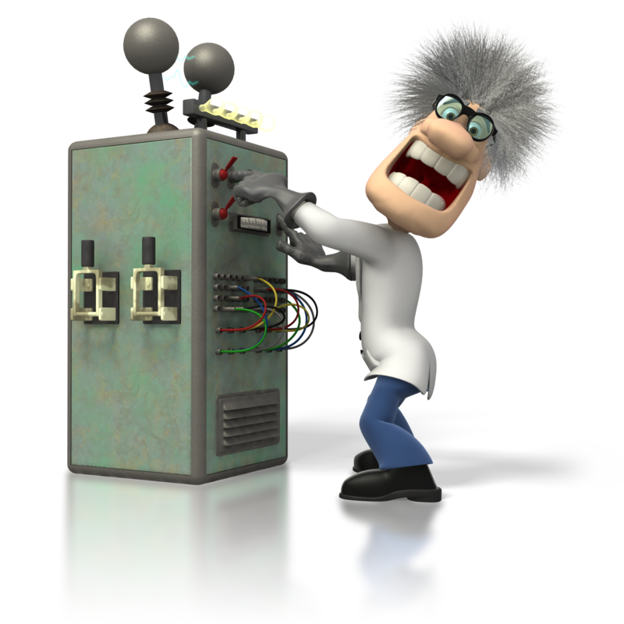
- Toothbrush and toothpaste
- Soap
- Shoes
- Television
- Computers
- Books
- Writing implements
- Sporting equipment
- Cutlery
- Dishwashers
- Cell phones
- Vehicles.
The list is virtually endless and it is a great way of developing their knowledge of many different subject areas. Take the example of the television:

Question | Possible answers | Subject area covered
What is the purpose of the invention? | To provide visual information and entertainment to people | Current affairs and media  Drama and creative writing
Why was it needed? | Cinemas or picture houses were the only places people could watch moving pictures. The television allowed people to watch news and entertainment in their own homes. | Social history  Science
What existed before it was invented, if anything? | Cinemas  Wireless radio | Science  History  Media
How does it benefit humans or the environment? | Allows people to keep up to date with current affairs locally, nationally and globally in real time.  Allows people to be entertained within their own homes.  Allows people to be educated through documentaries, news channels etc.  Inspires ambitions in people | Current affairs  Communication and literacy  Drama and creative writing  Sport  Science  Technology  Numeracy  Modern Foreign Languages  History  Geography  Music  Dance
Is it harmful to humans and/or the environment and why? | Can expose children to upsetting images if allowed to watch age inappropriate programmes.  Disposal of old televisions can be harmful to the environment if not recycled appropriately. | Sustainability
What is it made of and why? | Glass  Gases  Electronics  Plastics  Metals | Technology  Science

Music
There are so many different types of music and musical instruments to which you can introduce children and a number of different ways including:
- Playing recorded music as an audio exercise
- Showing films that are accompanied by music
- Combining dance with music
- Giving them musical instruments to play with
- Teaching them to play musical instruments properly

- Teaching them to read music
- Singing
- Dancing
- Nursery rhymes
- Watching music videos and musicals
- Visiting theatres to watch musical performances
- Listening to the radio
- Advertising jingles
- Using music as part of an activity such as musical chairs, musical statues and musical bumps.
It is important when introducing children to music that you allow them to listen to a wide range of styles and instruments and allow them, where available, the opportunity to use musical instruments or improvised versions of their own to create their own music. They may even want to write their own lyrics.
Types of music may include:
- Popular/chart music
- Opera
- Folk
- Jazz
- Rhythm and blues
- Classical
- Musical theatre
- Spiritual
- Multi-cultural.
When introducing children to music ask them to describe how the music makes them feel, what kind of mood it creates and why. You should encourage them to understand that a piece of music has a purpose and a story behind it, just like art, architecture and inventions.
Dance
Dancing can be introduced to children in a number of ways including:
- Incorporating freestyle dancing into activities such as musical bumps and musical statues
- Teaching them a choreographed dance for them to perform
- Dancing as part of physical activity
- Watching dancers on the television/internet
- Visiting the theatre
- Using computer games that involve dancing.
There are many different styles of dance including:

- Freestyle
- Folk
- Street
- Disco
- Performance/ballroom such as jive, waltz, tango, American smooth, etc.
- Tap
- Ballet.
Try to encourage children to think about how their movements fit with the beat and style of the music to which they are dancing; this can help with their numeracy skills. Dancing also helps children to develop their coordination skills and strengthens their core muscles. It is also a good activity to develop their self-confidence and performance ability. Dancing can be an individual activity or it can be performed in pairs or as a group so supports both independent learning and team work.

Promoting creative expression
Using all of these mediums you can easily promote the use of creative expression in children. Many activities can include a combination of art, architecture, invention, music and dance and can cover a large number of different topics and subject matter. Whilst it is important to allow children to have creative freedom you should also encourage them to think about the meaning and/or message they are trying to convey with their expressive creations.
In order to give the children in your care sustained engagement and pride in their creative work you could use each medium to create a number of different activities on the same theme or project so that they build up a portfolio of work which can then be displayed in the learning environment or even exhibited like an art exhibition within the educational setting to which you could then invite their parents/carers.

Excursions
If you are planning on taking a group of children on an excursion as part of your promotion of creative expression, such as to the theatre or to look around historical buildings, you will need to comply with the procedures set out in the National Laws and Regulations.
You must ensure you complete the following processes in order to undertake an excursion:
- Complete a risk assessment which must include:
  - the proposed route and destination
  - any water hazards and risks associated with water based activities
  - the method of transport
  - the number of adults and children involved
  - the number of educators or other responsible adults needed in relation to the potential risks/hazards and any specialised skills required to ensure children’s safety such as a qualified first aider
  - the proposed activities
  - the duration of the excursion
  - the items that should be taken on the excursion such as first aid kits, packed lunches, waterproof clothing, etc
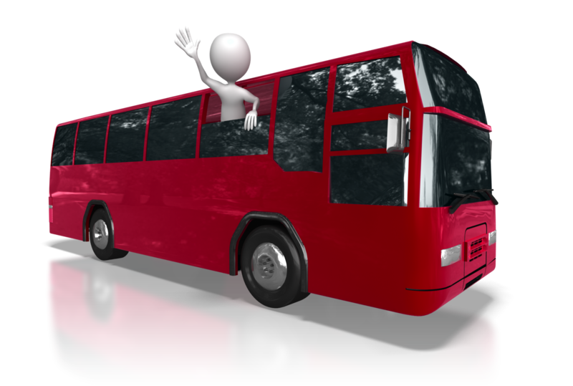
- A written consent from parents/carers to allow their child to go on the excursion
- Consideration of increased educator to child ratio.

Activity 1B

2. Foster creativity through the human environment
2.1. Support children to feel a sense of ownership and responsibility for equipment and materials
2.2. Role-model creativity by improvising with equipment and materials
2.3. Encourage children to pursue their own original ideas, interpretations and expressions
2.4. Invite children to ask questions and assist them to find their own answers
2.5. Engage children in talking about their creations and ask them open-ended questions
2.6. Share enthusiasm for creative work with children
2.7. Encourage children to respect and appreciate the creative effort of their peers

2.1 – Support children to feel a sense of ownership and responsibility for equipment and materials

Ownership and responsibility
As an educator it is obviously your role to teach and impart academic matter to children in your care that they will require in order for them to obtain the best possible employment outcomes in adult life. It is also an essential part of your role to teach children life skills, independence and autonomy. This includes guiding children to take responsibility for the equipment and materials they use within the learning environment so that they feel a sense of ownership and pride.
Encouraging children to select their own choice of materials to create their own piece of work using their own ideas provides a perfect opportunity to demonstrate to them the importance of looking after the materials and equipment they are using for it. If they don’t look after their materials and equipment they will not be able to produce the work to the best of their ability and they may not even be able to finish it at all. Children are more likely to look after their equipment if they need it for something they are enjoying doing that has come from their own desires than if they are completing a task that was set by the educator in which they have had little or no input.
It is particularly important to stress the importance of taking responsibility for equipment and materials that are not disposable and which will be re-used when they have finished using them because the next child who wants to use them will expect them to be in the best possible condition for their project.
Ways of supporting children to take responsibility for equipment in their care include:
- Start young – the earlier children are expected to become independent and given the opportunities to do so the earlier it will become the norm
- Let them help you – let them see you looking after your equipment and materials and where appropriate, invite them to help you. By inviting them to participate, children feel valued
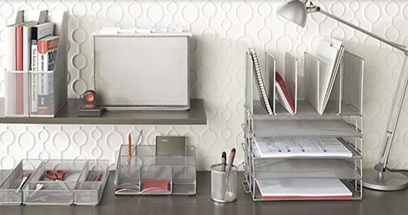
- Demonstrate how they should look after their equipment and materials at their level of ability and skill and use relevant vocabulary such as responsibility and ownership so they know what they are doing
- Model responsibility – if you expect children in your care to look after their equipment and materials then you need to look after your own and the resources of the establishment
- Praise them whenever possible using phrases such as “Well done for keeping your pencil case tidy, I’m proud of you,” and thank them when they complete a task for you or for a peer. We all thrive on praise, especially children, and the more we receive the more we crave because it makes us feel like we’ve done a good job and are valued

- Don’t criticise – children will not always be able to complete tasks to your standard so be appropriate with your expectations
- Avoid rewards – taking ownership and responsibility of their equipment and materials should be expected and therefore nothing out of the ordinary
- Provide a structure and routine – if children know the processes they must go through on a daily basis in order to take responsibility for their equipment and materials it will become engrained and just a part of their basic routine. For example, complete an equipment check with the whole class at the start of the day to ensure that the necessary pieces of equipment are in working order
- Use consistent consequences – make sure that failure to look after their equipment and materials results in the same consequence for all. For example, if a child does not wash out the paint pallet at the end of an art activity, they will not be allowed to participate in the next art activity. Make these consequences known to all children in your care.

2.2 – Role-model creativity by improvising with equipment and materials

Improvisation
Improvisation is using existing materials, equipment, ideas and processes and adapting them to make them into something else in a “make-do” style. For example, a cushion is not a pillow but it could quite easily be used as one although it may not be quite as comfortable.

Creative improvisation with equipment and materials
In chapter one you chose a range of open-ended materials to foster creativity in the children in your care. In this chapter, you will need to use equipment and materials available to you to role model creativity through improvisation. For example, a table may become a vehicle of some description, a chair may become a throne, or a paper towel tube may be used as a trumpet.
You can improvise with equipment and materials in a number of different activities and the following are just a few examples. The more creative you are with the improvisation, the more engaged and imaginative the children in your care will be.

Creative medium | Activity | Example equipment/materials
Art | Potato printing – cut potatoes in half and cut out different shapes in the flat side, dip in paint and print onto paper/cardboard/fabric  Turn a classmate into a robot/spaceman/superhero – put children into groups of five, give them various materials to hand and get them to dress one of the group as a robot/spaceman/superhero or whatever takes your fancy | Potatoes  Paint  Paper/card/fabric  Silver foil  Cling film  Cellophane  Bin liners  Curtains  Straws  Disposable cups  String  Paper/card  Bubble wrap
Architecture | Build a castle – use empty cartons and cardboard boxes to make a castle and task the children to re-enact or tell the story of a historic battle | Cardboard boxes  Egg boxes  Empty cartons  Paints/paintbrushes

Creative medium | Activity | Example equipment/materials
Improvisation | Turn an object into another object – get the children to sit in a circle and place an ordinary object in the middle of the room, such as a tennis racket. Demonstrate how it can be turned into something else with a little imagination such as a guitar, a snow shoe, or a sieve. Ask the children to step into the middle of the circle to turn the object into something of their choosing. Change the object every so often and use multiple objects. | Any object to hand
Music | Create musical instruments – use non-musical equipment to create instruments. For example, use empty ice-cream tubs and fill them with dried rice to make shakers. | Tubs  Dried rice  Tubes  Bells  Whistles

Make sure you demonstrate the improvisation and show the children your own creativity and innovation.

Activity 2B

2.3 – Encourage children to pursue their own original ideas, interpretations and expressions

2.4 – Invite children to ask questions and assist them to find their own answers

Encourage children to pursue their own original ideas
In the technological age in which we live, children are exposed to and engrossed in all manner of screen-based equipment from a very early age, whether it is television, computer games, tablets, smart phones, DVDs etc. Whilst there is a place for this relying on these forms of entertainment can stifle their own creativity and imagination, as it is a passive form of entertainment which does not require them to think for themselves. It is also an artificial world in which much is sensationalised and/or fabricated so can skew their view of the real world. In addition, it can limit their ability to interact with others and to ask questions about what they see before them.
In your learning environment it is important that you occupy children with activities that enable them to form their own creative ideas and develop them during the activity. Using different types of creative activities that don’t follow strict rules gives children the chance to express themselves in their own way and interpret the task as they see fit. Despite being given the same task to complete, if given enough creative freedom, each child will have a different idea or solution, all of which will be valid and when shard with the rest of the cohort can inspire others and help to further develop other ideas and creations.
Activities that encourage children to pursue their own original ideas include:
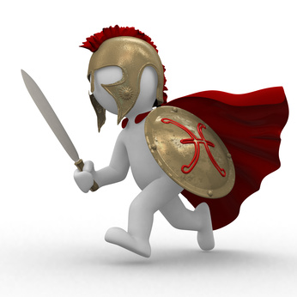
- Role playing and dressing up such as:
  - doctor’s office
  - veterinary clinic
  - medieval times
  - fairy tales
  - outer space
  - restaurant
  - store
- Drama, dance and/or musical performance
- Creating their own town, farm, castle, space, beach etc.
- Create their own game
- Messy play such as:
  - sand pit
  - water activities
  - painting and Playdough (Play-doh)
- Construction.

Invite children to ask questions and find their own answers
In any activity you set for children it is important that you encourage them to ask questions about anything they don’t understand, are unsure of, and if they require more information. You should reinforce to them that there is no such thing as a stupid question and that the quest for more information and knowledge is to be admired. You should also share the questions with the rest of the group to broaden the knowledge and understanding of all the children.
Children should not be spoon-fed answers to their questions but should be guided with your assistance to find the answers for themselves. Sharing questions with the rest of the group can assist in finding the answer and can also create more discussion and thought, perhaps even a debate. Learning should be an active experience in which children think for themselves to pose questions and answer them themselves.


Activity 2C

2.5 – Engage children in talking about their creations and ask them open-ended questions

2.6 – Share enthusiasm for creative work with children

2.7 – Encourage children to respect and appreciate the creative effort of their peers

Engage children in talking about their creations and ask them open-ended questions
Once the children in your group have created something they will usually be rather proud of it if they have put a lot of thought into it and spent a lot of time and effort in making it, and should be given the opportunity to talk about it. Presenting their creation to the rest of the group is a good way to do this as it develops their communication skills, their confidence in presenting and public speaking, and their reasoning skills in terms of why they have created it in their chosen way; this may not be immediately obvious to you as the educator or to the rest of the group but if they explain how and why they have done it in a particular manner, it becomes clear and gives the rest of the group guidance in how they might interpret the creation.
Asking open-ended questions gives the child the opportunity to explain in their own words the ideas and thought processes behind their creation.
An open-ended question is one that requires an explanation rather than a yes or no. Open-ended questions usually begin with:
- What

- Why
- Who
- Where
- When
- How.
Examples of open-ended questions to give children the opportunity to talk about their creations might include:
- What materials did you use to make it?
- Why did you choose those materials?
- Where did you get the idea to make that?
- Who helped you to make it?
- When did you know it was finished?
- How did you make it?
You should encourage the rest of the group to ask the presenting child open-ended questions of their own to get them thinking about how they interpret other people’s creative work. The questions may not be as in depth or complex as those that you ask, but they will be important to them. For example, you might ask a child what inspired them to create a dog in a space suit whereas one of their peers might want to know why they decided to give the dog a blue nose; both are equally valid and will receive an explanation from the creator.

Share enthusiasm for creative work with children
It is really important to be enthusiastic about the creative work of children and encourage their development of ideas. If they do not receive genuine interest in their creations from their educator as the person who set the task they are unlikely to make an effort next time you set a creative activity. Imagine how you would feel if you spent a great deal of time and effort thinking, planning and making a piece of work and then the person that had asked you to do it wasn’t interested in it. You should be enthusiastic and asking questions throughout the whole creative process and where necessary give the children prompts and ideas if they are struggling. Another good way to share enthusiasm for creative work with children is to join in with the activity and complete your own work and share it with them.
Displaying their work is another good opportunity to show your enthusiasm for their creativity. Places to display their work might include:

- On the walls of the learning environment
- In the dinner hall
- In the reception area of the establishment
- In corridors of the establishment
- In public libraries
- Having an exhibition for parents/carers to attend
- Putting on a dramatic/musical performance for peers and/or parents/carers
- Children presenting their own work to their peers.

Encourage children to respect and appreciate the creative effort of their peers
Sharing creative work with peers can be quite a daunting prospect as essentially it is offering a part of oneself for criticism from those whose opinions matter to us. There is the possibility that others will not understand what the artist has tried to create, may not like it, may think it is a poor effort, and may even laugh at it. Whilst it is important to teach children to accept and appreciate developmental criticism it is also as important to teach those giving it to be polite and respectful when doing so. This is not always easy for children to accomplish as they often say exactly what they think without considering the feelings of others. You should encourage the children within your group to think about what they say regarding the creative work of others before they say it and consider how they would feel if someone said the same about their work. You should also ensure that they make both a positive and developmental comment about each piece of work they critique. You should also impress on them that each of us has different talents and abilities and that not everybody is good at the same things.


Activity 2D

3. Foster creativity through a learning framework
3.1. Allow time for children to be creative and encourage efforts to extend over days or weeks
3.2. Teach children techniques when using materials and equipment
3.3. Plan and create opportunities for children to collaborate creatively with each other
3.4. Involve children in critical reflection and solving real problems
3.5. Display children’s work in meaningful ways
3.6. Design a flexible framework that can respond to children’s interests as they arise

Fostering creativity through a learning framework
The National Law and Regulations determine that all approved services provide an educational program that:
- Is based on an approved learning framework:
  - the two nationally approved learning frameworks:
    - Belonging, Being and Becoming—The Early Years Learning Framework for Australia
    - My Time, Our Place—Framework for School Age Care in Australia
  - jurisdiction specific approved learning frameworks:
    - Australian Capital Territory: Every Chance to Learn—Curriculum Framework for ACT Schools Preschool to Year 10
    - Victoria: Victorian Early Years Learning and Development Framework, Department of Education and Victorian Curriculum and Assessment Authority
    - Western Australia: Curriculum Framework for Kindergarten to Year 12 Education in Western Australia

    - Tasmania: Tasmanian Curriculum, Department of Education of Tasmania, 2008
- Is delivered in accordance with that framework
- Is based on the developmental needs, interests and experiences of each child
- Takes into account the individuality of each child.
You will need to determine which approved learning framework applies to your role in your organisation.

The nationally approved learning frameworks include the key elements of belonging, being and becoming and both frameworks are made up of the following holistic approach to learning and development.

The image below is taken directly from the official document, “The Early Years Learning Framework for Australia” which can be found at: http://docs.education.gov.au/system/files/doc/other/belonging_being_and_becoming_the_early_years_learning_framework_for_australia.pdf

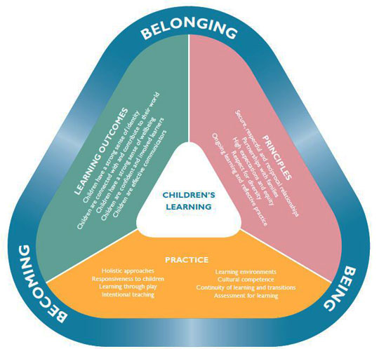

The learning outcomes are:
- Children have a strong sense of identity
- Children are connected with and contribute to their world
- Children have a strong sense of wellbeing
- Children are confident and involved learners
- Children are effective communicators.
The principles are:
- Secure, respectful and reciprocal relationships
- Partnerships with families
- High expectations and equity
- Respect for diversity
- Ongoing learning and reflective practice.
The practice is:
- Holistic approaches
- Responsiveness to children
- Learning through play
- Intentional teaching
- Learning environments
- Cultural competence
- Continuity of learning and transitions
- Assessment for learning.
All of the aspects of these three key elements should be at the heart of the educational program you provide to the children in your care and should be evident in all stages of planning and the provision of learning and development activities. You should keep them in the forefront of your mind during this element of the unit.

3.1 – Allow time for children to be creative and encourage efforts to extend over days or weeks
In every activity you plan for the children in your care you should try hard to incorporate opportunities for them to be creative and to use their imaginations. Try not to be too instructive or specific in the tasks you give them if possible and wherever you can encourage solutions to the challenges or questions you set to come from the children through innovative thinking.

Specific creative projects and activities
In order to give children the opportunity to produce an extensive piece of creative work, schedule in a creative project that will last over a period of days or weeks. For example, each Wednesday and Friday afternoon over the course of six weeks could be dedicated to project work and in each session the child develops their own project either individually or in conjunction with others. The end product could be presented to the group and could form part of assessment, as well as an evaluation completed by the child as a final piece of work.
Giving children the opportunity to develop a creative piece of work over a longer period of time encourages them to invest more thought and care into their work and a bigger sense of pride and satisfaction when it is completed. You could even have prizes for the best projects.
These extensive creative projects make it relatively easy to achieve the key elements of the approved frameworks within your educational program. It also allows you to be creative in your planning and provision. The following creative project is just an example.

Creative project – write a poem inspired by the playground and design and make a picture to illustrate the poem using any available materials and equipment
Activity within the project | Element of approved framework
Observe and make notes, sketches, and/or take pictures of the playground. | Learning outcomes – children are connected with and contribute to their world; children are confident and involved learners.  Practice – holistic approaches, learning through play, intentional teaching, learning environments, cultural competence.
Write the poem including what you see, hear, smell, touch and taste in the playground. | Learning outcomes – children have a strong sense of identity, children are connected and contribute to their world, children are confident and involved learners, children are effective communicators.  Principles – high expectations and equity, ongoing learning.  Practice - holistic approaches, learning through play, intentional teaching, learning environments, cultural competence.
Creative project – write a poem inspired by the playground and design and make a picture to illustrate the poem using any available materials and equipment
Activity within the project | Element of approved framework
Create a picture to illustrate the poem which may include materials found in the playground | Learning outcomes – children have a strong sense of identity, children are connected and contribute to their world, children are confident and involved learners, children are effective communicators.  Principles – high expectations and equity, ongoing learning.  Practice - holistic approaches, learning through play, intentional teaching, learning environments, cultural competence.
Recite your poem to the rest of the group and get peer feedback. | Learning outcomes – children have a strong sense of identity, children are connected and contribute to their world, children have a strong sense of well-being, children are confident and involved learners, children are effective communicators.  Principles – secure, respectful and reciprocal relationships, respect for diversity, high expectations and equity, ongoing learning and reflective practice.  Practice - holistic approaches, responsiveness to children, learning through play, intentional teaching, learning environments, cultural competence, assessment for learning.
Evaluate the poem and the illustration. | Learning outcomes – children have a strong sense of identity, children are confident and involved learners, children are effective communicators.  Principles – high expectations and equity, ongoing learning and reflective practice.  Practice - holistic approaches, responsiveness to children, intentional teaching, learning environments, cultural competence, assessment for learning.
Invite parents/carers in to showcase the project work. | Learning outcomes – children have a strong sense of identity, children are connected and contribute to their world, children have a strong sense of well-being, children are confident and involved learners, children are effective communicators.  Principles – secure, respectful and reciprocal relationships, partnerships with families, respect for diversity, high expectations and equity, ongoing learning and reflective practice.  Practice - holistic approaches, responsiveness to children, learning through play, intentional teaching, learning environments, cultural competence, assessment for learning.

Activity 3A

3.2 – Teach children techniques when using materials and equipment
Dependent upon the materials and equipment being used and the type of expressive art form, there are numerous different creative techniques and processes that you can teach children.

Creative materials and equipment
There are many different materials and equipment that are available for use in art.
Painting supplies | Illustration supplies
Watercolours  Acrylics  Watercolour pencils  Brushes  Sponge applicators  Easels  Mixing palettes  Canvas  Paper  Paint thinner | Graphite pencils  Coloured pencils  Felt tip pens  Crayons  Chalk  Markers  Charcoal  Inks  Erasers  Pencil sharpeners  Paper and sketch pads  Blending stumps
Sculpting and modelling supplies | Craft supplies
Clays  Calipers  Hammers and mallets  Silicone  Casting materials | Scissors  Construction paper  Tape  Glue  Yarn  Felt  Thread  Fabric  Needles  Stencils  Ink pads  Rubber stamps  Glitter  Sequins

Creative techniques
There are more than one hundred different art techniques and many of them are accessible to children from an early age. Teaching children how to hold a paint brush, pencil, and sponge to apply paint and colour as well as using a ruler, pencil sharpener and eraser, are activities that develop their fine motor skills. Many techniques can be used by children to create simple yet effective art work of which they can be proud and can develop into other creative pieces.
Creative techniques include:
- Printing – using a stamp or home-made print (such as a potato) and dipping it in paint or ink and then making a repetitive pattern on paper, card or fabric

- Collages – using open-ended, found and natural materials to build up a picture full of textures and colours by sticking them on top of one another
- Painting – using brush strokes, dabbing and stippling with the end of the brush, watercolour/wash, applying paint with a sponge or a rag to create a textured effect, hand painting
- Stencilling – using a shop bought or home-made stencil to draw shapes and pictures
- Papier-mâché – using glue and newspaper and a mould to create a hard, hollow object to decorate.
Instructions for potato printing:
- Materials needed: paper and pencil, sharp knife – for adult use only, templates, scissors, cereal box and PVA glue, large and small potatoes, paints, paintbrush, plates or something with a flat bottom, paper towels – for wiping the paint off the potato if you want to change the colour of paint you are using, card/paper to print on
- Step one:
  - cut the sides off the cereal box
  - draw the shapes you intend to use on the cereal box and cut them out
- Step two:
  - peel and cut the potatoes into slices about 2cm thick
  - wash and dry the potatoes to get rid of as much of the starch as possible so they are not too wet for marking

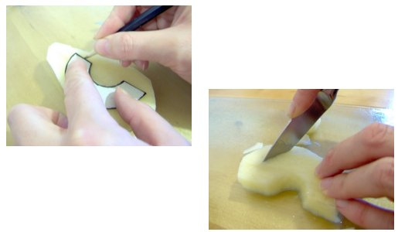
- Step three:
  - place the shiny side of the templates you have made from the cereal box on the potato slices and draw around them with a pencil or a pen
  - cut them out with a sharp knife – adults only
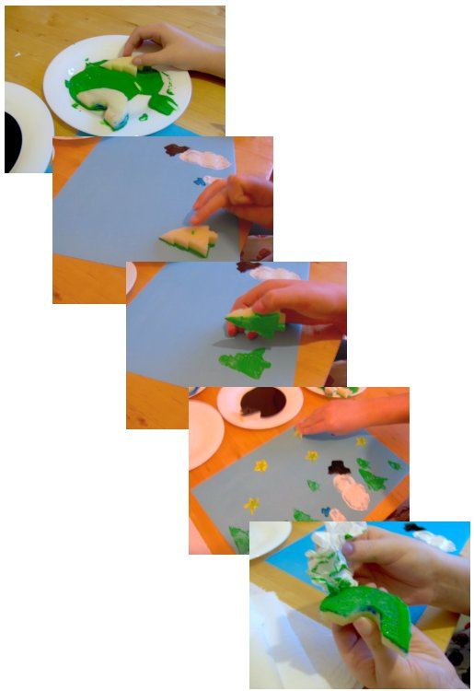
- Step four:
  - pour some paint (tube paint is best) onto a flat surface such as a plate or palette
  - spread the paint out
  - dip the potato shapes into the paint
  - place them firmly in the correct location on the cardboard/paper, press down and lift off
  - to change the colour of the paint, wipe the potatoes with a paper towel and repeat the process.

Images taken from http://www.things-to-make-and-do.co.uk/painting-and-pictures/potato-printing/potato-printing.html

Instructions for making collages:
- Materials needed: fabric, wood, paper (including newspaper, magazines, flyers, catalogues etc.), natural materials (such as leaves and feathers), open-ended materials (such as straws, paper cups, tin foil etc.), glue, paper/card board to glue the collage on, paint brush, scissors, paints
- Step one:
  - spread newspaper or other protective material over your work surface
  - place all the supplies you need on the work surface within easy reaching distance
- Step two:
  - using the materials available, search through them to find colourful and interesting pictures, shapes, designs, etc. and cut them out – you can even choose a theme such as flowers or different shades of the same colour
  - arrange the pictures and shapes you have cut out in a creative manner on the illustration board, leaving gaps in between if you choose so as to add paint or other materials later
  - spread glue on the back of each piece and glue them to the illustration board
  - smooth out the bubbles in the pieces and wipe off any excess glue with a paper towel
  - leave the collage to dry completely
- Step three:
  - once dry, use paint or coloured pencils/pens to add colour in the gaps between the pieces
  - use other open-ended materials such as beads, sequins, feathers etc. to add texture and interest to the collage
- Step four: seal the collage by painting a thin layer of white glue all over the collage with a paint brush and allow to dry.
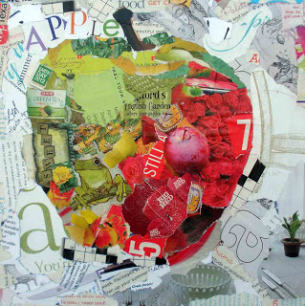
This image opposite is taken from the following web address where many more examples of collages can be found: at http://kaysmithbrushworks.blogspot.co.uk/2012/08/apple-torn-paper-collage.html

Instructions for making papier-mâché:
- Materials needed: paper (newspaper is best), adhesive, paintbrush, plastic table covering, paints, balloon
- Step one: tear the paper into strips approximately 2-3cm wide and 10cm long
- Step two – make/select your adhesive out of the following:
  - flour and water glue
  - wallpaper paste – recommended as it contains a fungicide that prevents mould
  - PVA/white glue
- Step three – select a mould:
  - balloon – recommended as they are inexpensive and will easily burst when the cast needs to be removed
  - bowls and plates – need a release agent applying before the construction in order to remove the cast when dry
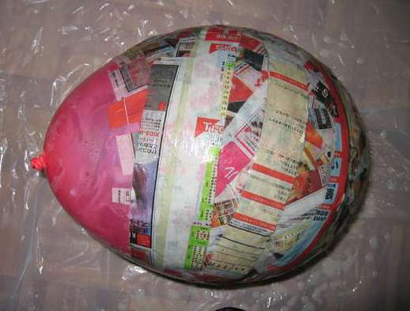
- Step four:
  - Cover your work surface with plastic covering
  - Paste the strips of newspaper on both sides with the glue using a paintbrush
  - Place the strips one at a time over the mould and paste down, smoothing out any air bubbles. Place two to three layers on at a time before leaving to dry
  - Repeat the process when each of the layers is dry to build up the desired thickness
- Step five – to add features to the cast such as handles, ears, beading etc. stick pieces of moulded/shaped cardboard or straws to the mould using masking tape and cover with the newspaper strips in the same manner
- Step six – when completely dry, seal the newspaper print by painting with two coats of emulsion paint
- Step seven – decorate the cast any way you wish.


This image is taken from: https://art4kidzz.wordpress.com/what-well-do/papier-mache-penguin/

Examples of painting

Brush strokes    https://allowrypainting.wordpress.com/2013/08/14/painting-furniture-without-brush-strokes/ | Stippling  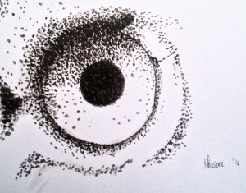  https://noemiepiccioneart.wordpress.com/2014/06/30/52-week-illustration-challenge-week-25-dots/
Sponge painting  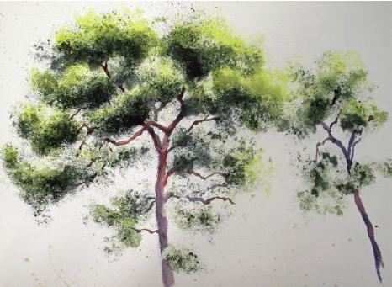  http://www.painters-online.co.uk/userfiles/Image/HS1c.JPG | Ragging  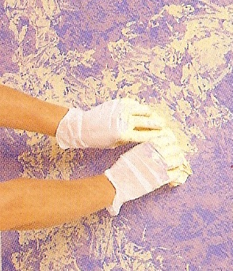  http://www.housepaintingtutorials.com/images/2-color-rag-painting-technique-instructions-21478755.jpg
Water washing  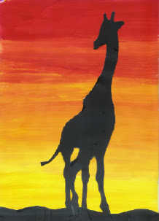  http://3.bp.blogspot.com/__S0xCdOrOOE/RaeVkr5TXZI/AAAAAAAAALc/XaRiZx-1vkQ/s320/primary%2Bmixing.jpg | Hand painting  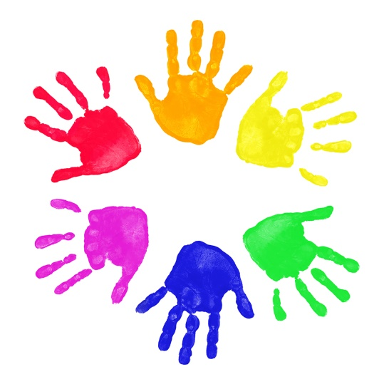  http://www.vietkidsdc.org/wp-content/uploads/painted-hand-prints.jpg

Other creative techniques
Dependent on your own hobbies, interests and abilities, and the facilities to which you have access, you may decide that you want to teach creative techniques other than art.
Other creative techniques might include:
- Textile work such as:
  - embroidery such as cross stitch, tapestry, appliqué, patchwork etc.
  - clothes making
  - knitting
  - braiding
  - rug-making
  - felt work
  - crochet
- Playing musical instruments
- Resistant materials such as wood work, metal work, plastics etc.
- Information and communication technology such as graphic design, website design, publishing etc.
- Cooking.

Activity 3B

3.3 – Plan and create opportunities for children to collaborate creatively with each other
There are many ways in which you can provide opportunities for children to collaborate creatively with each other across all of the expressive art forms.

Performance collaboration
Activities for children to collaborate creatively in music include:
- Singing – example only:
  - give each group a choice of five songs to sing and let them select one as a group
  - give reasons for their choice
  - choose who will sing which part(s) of the song
  - choose whether or not it will be sung to music
  - choose whether or not they will play musical instruments to the song and who will play which
- Composing – example only:
  - put children into pairs/trios/groups
  - give them a selection of musical instruments from which to choose
  - give them a picture/selection of words/poem and task them to compose a short piece of music that represents their interpretation of the stimulus
  - record their performance and play it back to them

- Dancing – example only:
  - teach several different dance moves to the whole group
  - split the cohort into groups of a number of your choosing
  - task each group to use all of the moves that have been taught in a sequence of their choosing to the piece of music you have played them
- Drama – example only:
  - put children into groups of four or five
  - give each group a different object or number of objects
  - give each group the same theme and task them to create a short scene with the object(s) and the theme
  - have each group perform their drama to the rest of the group.

Inventive collaboration
There are numerous ways in which you can create opportunities for children to collaborate on inventions and they may be theoretical and/or practical.
Examples of inventive collaboration may include:
- In groups of five task children to invent a new flavour of ice-cream, the packaging for the ice-cream, and an advertisement for it
- In pairs, task children to invent a new ending to a book or story they have all been reading in class
- In groups of four or five task children to design a new building to replace the existing learning environment

- In groups of six, task children to write their own story based on a theme you give them and ensure the following activities are completed by the group:
  - the characters are created
  - the story has a beginning, middle and end
  - the story is written
  - the story is given a title
  - the story is illustrated
  - the story has a front cover
  - the story is produced in a tangible form.

Supervision
It is important to remember when children work in groups that they will all have their own ideas about how things should be done. It is important that you consider group dynamics when you put them into groups and make sure they are supervised at all times and you intervene at appropriate times to prevent any serious conflict.

Activity 3C

3.4 – Involve children in critical reflection and solving real problems

Critical reflection
Critical reflection is the process of evaluating the actions of ourselves and others to make sense of what has occurred, why it occurred, the positive and negative impact and effect the action produced, and ways in which we can prevent or improve the action in the future. It is an honest and transparent process that requires those reflecting to use emotional intelligence and have the self-awareness to step back from the situation and analyse their own actions and reactions from a balanced perspective.
Emotional intelligence
Emotional intelligence is an individual’s ability to recognise their own emotions and feelings, manage their own behaviour in response to these emotions and make balanced decisions in emotional situations. It is also an individual’s ability to recognise the emotions and feelings of others and interact with them in a way that manages their behaviour and relationships with others. It is the ability to recognise heightened emotions in both yourself and others around you, remove yourself from the stress and manage the situation objectively, taking into account the feelings of those involved, to arrive at a resolution agreeable to all involved.
There are variations in models but it is widely accepted that there are four components to emotional intelligence which are categorised in pairs by both personal and social competence, and recognition and regulation.

 | Personal competence | Social competence
Recognition | Self-awareness  Emotions  Behaviour  Confidence  Accurate, honest and reflective self-assessment | Social awareness  Empathy (recognition and understanding of emotions and behaviours of others)  Awareness and understanding of feelings, emotions and behaviours of the organisation
Regulation | Self-management  Maintaining emotional self-control in emotive or volatile situations  Being honest and transparent  Able to adapt behaviour and approach according to the situation and changes in the situation  Initiative and innovative approach to management  Optimistic – uses every situation as an opportunity | Relationship management  Conflict management and resolution  Inspirational and influential leadership and management style – leads by example and models good emotional intelligence  Collaborative approach to management – involves the team in decision making and resolutions  Develops others
Whilst you should not expect the emotional intelligence in children under six years old to be obvious or in any way developed, you should encourage activities that will help to develop it as they get older. Critical reflection is a good opportunity to teach children how to undertake key processes that will help to develop their emotional intelligence sooner rather than later. The key elements of emotional intelligence in critical reflection for children under six are recognition; self-awareness and social awareness. Reflecting on their own actions and those of others, and recognising errors and ways to improve on these actions, is the first step towards emotional intelligence and the management of their own actions.

The link between creativity and critical reflection
Allowing children to undertake creative activities gives them the freedom to make their own choices based upon their own reasoning and interpretations. Critical reflection is therefore relatively easy for them to undertake because they have already been through the thought processes independently and will be able to answer the reflective questions that are posed, whereas if they were simply given rigid instructions on how to complete a task they will not know why those specific instructions were given.

Critical reflection for children
In terms of children under six years old, the critical reflection should be kept quite simple. It is worth remembering that reflection does not just have to be undertaken after an event or activity, it can also be done during the activity, and more than once at various stages.
Children should be guided to use the following opportunities for reflection:
- Reflect ON action – looking back on a past experience
- Reflect IN action – considering action taken at various stages during the activity
- Reflect FOR action – considering what action they might wish to take in future activities.
At each of these reflective stages, the following questions should be asked and answered:

- The what? – this is a factual description of the activity or incident and includes:
  - who
  - what
  - why
  - when
  - where
  - how

- So what? – this is reasoning and understanding process that requires the significance of the actions taken and includes:
  - impact on others and other things
  - your own feelings and emotions
  - any harm caused
  - positive aspects recognised
- Now what? – this part of the process is about what we can learn from the experience to make improvements and alterations to future actions and activities such as:
  - what you would do differently/the same next time and why
  - lessons learned and how these lessons can be shared with others to prevent them making the same mistakes or to assist in development and improvement
  - how you will change things if they need changing
  - how you can repair any harm caused.
More information on critical reflection can be found on the Victorian government website at: http://www.education.vic.gov.au/Documents/childhood/professionals/support/reffram.pdf

Solving real problems
Those three basic questions can be used in all activities that require real problem solving to encourage children to use their own initiative and innovation from rational and reasoned thought processes in order to come up with a solution to a challenge they face. By incorporating this critical reflection process into every activity the children undertake, it will help them to transfer these skills to other real-life problems or challenges that they may encounter outside of the learning environment.
You can also use critical reflection techniques with children when resolving conflict. For example, if there is an argument or disagreement within the class over something like one child not wanting to share equipment with another, you can sit the two children down together to discuss the matter using these three simple questions:
Question | Answer from child one | Answer from child two
What happened? | He snatched the pencil off me and scratched my hand when there were loads of other pencils in the box. | She wouldn’t let me have the orange pencil so I took it off her.
So what did it happen for? (Why did it happen?) | I didn’t know he needed the orange one otherwise I’d have given it to him. | I needed the orange pencil crayon to finish off the tiger I was colouring in and there wasn’t another one in the box.
Now what do we do to resolve the matter? | Next time I’ll ask why he needs the orange one. | I need to apologise to her and next time I’ll explain why I’m asking for something instead of snatching it.


In this simple example you can see that not only have the two children critically reflected on their actions but they have thought of a solution to the problem themselves and they have reflected on future action in order to manage their behaviour and that of others which is simple but important emotional intelligence in the making.

Activity 3D

3.5 – Display children’s work in meaningful ways
Children, as with adults, feel very proud of themselves when work that they have created is selected for a display for others to view and comment on their work. With this in mind it is important that the ways in which you display their work has purpose and function, and in a way that has meaning to the children themselves.

Importance of displaying children’s work
There are numerous reasons for displaying children’s work which include:
- It is visually appealing to see art work and essays in learning environments and communal areas of the learning establishment
- Communication for:
  - parents – parents like to know what their children are producing and learning about whilst in the care of educators. displaying their children’s work not only evidences the topics covered but also their progress and participation
  - peers – displaying work in communal areas allows others to see what their peers in different areas of the educational establishment are producing and learning about
  - visitors – the display work should depict a story about the learning culture of the whole establishment
- Value:

  - classroom notice boards should focus on the children rather than the educators so that they can learn about one another
  - displaying children’s work fills them and their friends with a sense of pride and achievement and encourages them and others to produce work to the best of their ability in order to have it displayed again or in the future
  - knowing that adults value their work encourages children to work hard and helps to develop their self-esteem
- Processes:
  - whilst it is important to display the finished product it is also important to show the processes the child undertook to achieve the end result, and this is especially so in creative works
  - displaying processes also helps children to see how their peers are learning and can inspire ambition and ideas within them
- Inspiration:
  - displaying children’s work encourages thought and consideration of the work of others and can enhance the social interactions between children as they discuss their opinions of the work of others
  - seeing accomplished work by other children can inspire individuals to achieve the same
  - educators can also be inspired by the work produced by children in the care of their colleagues and can lead to new ways of working.

Meaningful ways of displaying children’s work
There are numerous different ways of displaying children’s work that are meaningful to a number of different people including:
- On the walls of the learning environment
- Notice boards in the learning environment and communal areas
- In the dinner hall
- In the reception area of the establishment
- In corridors of the establishment
- In public libraries
- Having an exhibition for parents/carers to attend
- Putting on a dramatic/musical performance for peers and/or parents/carers
- Children presenting their own work to their peers.
It is important when creating displays of children’s work that you take time and care to make the display aesthetically pleasing and appropriate to the work on display because it shows the children and their parents that you value their work and have thought about how best to showcase it. If there is no thought or consideration to the display and it appears rushed or corners seem to have been cut, the children will think that you do not appreciate their efforts and it will devalue the importance of displaying their work. If something on the display gets damaged it is important that the damage is repaired and if it is intentional that the culprit is reprimanded appropriately.

Activity 3E

3.6 – Design a flexible framework that can respond to children’s interests as they arise

Framework for learning
The learning framework you design for the children in your care should be planned around the appropriate approved and recognised learning framework. It should include activities and assessment modelled on the following elements taken from the “The Early Years Learning Framework for Australia” which can be found at: http://docs.education.gov.au/system/files/doc/other/belonging_being_and_becoming_the_early_years_learning_framework_for_australia.pdf
The learning outcomes are:
- Children have a strong sense of identity
- Children are connected with and contribute to their world
- Children have a strong sense of wellbeing
- Children are confident and involved learners
- Children are effective communicators.
The principles are:
- Secure, respectful and reciprocal relationships
- Partnerships with families
- High expectations and equity
- Respect for diversity
- Ongoing learning and reflective practice.

The practice is:
- Holistic approaches
- Responsiveness to children
- Learning through play
- Intentional teaching
- Learning environments
- Cultural competence
- Continuity of learning and transitions
- Assessment for learning.

Respond to children’s interests as they arise
Within the framework you design, you will need to ensure that the activities you plan can be adapted to respond to children’s interests as they arise. This may require you to be less rigid in the timeline and structure of the planned activities. For example, if there is a notable event in the news, either local national or global, in which children are interested and are asking lots of questions about, you might decide to change the theme of your planned activities to cover the current affairs topic.
When designing your learning framework you therefore need to plan activities that can be easily adapted to other themes and topics when required. Because the emphasis is on encouraging children to ask and answer their own questions you will probably find that you veer off the planned topics and themes at tangents quite frequently. It is your role as the educator to ensure that activities continue to be meaningful as they are adapted.


Activity 3F

4. Provide experiences
4.1. Identify and provide a range of experiences used to nurture creativity
4.2. Provide opportunities for children to practise developing skills in music, movement, construction, visual art and dramatic play in both indoor and outdoor environments

4.1 – Identify and provide a range of experiences used to nurture creativity

4.2 – Provide opportunities for children to practise developing skills in music, movement, construction, visual art and dramatic play in both indoor and outdoor environments

Provide children with a range of experiences to nurture creativity and develop skills
Using all the previous information and guidance within this unit you now need to put into practice what you have learned and provide the children in your care with a range of creative opportunities to develop their skills, learning and development.
You will need to plan and design activities for the following expressive arts:
- Music which can include:
  - singing – solo, duos, trios, quartets, choirs
  - playing musical instruments – drums, xylophone, piano/keyboard, recorder, castanets, shakers, guitar
  - making musical instruments – shakers, drums, horns
  - recording music
  - live performances for peers and parent/carers
  - conducting
  - experimenting with different styles of music such as pop, classical, opera, tribal, multi-cultural etc.
  - Visits to theatres to watch musical performances
- Movement:
  - dancing – individually, partners, groups

  - different styles of dancing such as ballet, tap, ballroom, street etc.
  - choreography
  - puppet shows
  - mime
  - juggling
  - costume design
  - making props for performance
  - live performances for peers and parents/carers
- Construction:
  - planning and design
  - drawing plans
  - measuring
  - calculating resources required
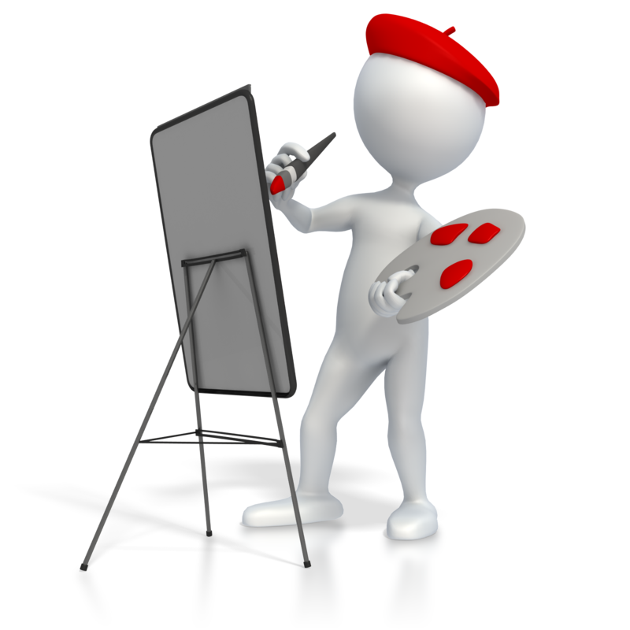
  - building
  - decorating
  - sand sculptures
- Visual art:
  - painting
  - sculpting
  - sketching/drawing
  - collage
  - textile work
  - graphic design
- Dramatic play:
  - Role play
  - Re-enactment
  - Monologue
  - Performance poetry
  - Improvisation
  - Drama sketches
  - Costume design
  - Set design
  - Prop design
The examples above are not exhaustive and are just a number of different ways in which creativity can be nurtured in children.

Indoor and outdoor environments
In order to foster as much creativity and inspiration from the world around them, children should be given as many opportunities to experience as many different learning environments as possible to provoke thought and to allow them to make their own connections with what they learn in a classroom environment to the real world.
Indoor environments include:
- Classroom
- Music room/recording suite
- Theatre/dance studio

- Gymnasium/sports centres and facilities
- Technology work shop
- Kitchen
- ICT suite
- Scientific laboratory
- Museums
- Libraries.
Outdoor environments include:
- Playground
- Parks and woodland areas
- Beach/sandpit
- Swimming pool
- Local community
- Multi-sensory gardens
- Mazes
- Visits to historical monuments
- Field trips.
The following reference is taken from the Guide to the Education and Care Services National Law and the Education and Care Services National Regulations 2011:

The Early Years Learning Framework states that ‘The outdoor space is of equal importance as the indoor space in providing engaging experiences for children. Outdoor learning spaces are a feature of Australian learning environments, and offer a vast array of possibilities not available indoors’ (page 15).
Outdoor environments should offer opportunities for learning through play, access to materials that stimulate investigation and reflection, as well as be enriched by natural resources and opportunities for children to connect with nature.

Outdoor space should be provided for children for releasing energy through physical exercise but also to allow them to explore, raise questions and solve problems, and to express their creativity. Outdoor areas such include a variety of surfaces such as grass, sand, water, mounds, flat areas and hard standings.
Natural elements of the environment
Children should be provided with opportunities to engage with as many natural elements of the environment as possible in order to develop their understanding and appreciation of it.
Natural elements include:
- Vegetable gardens
- Flower/plant/tree gardens
- Sand pits and dirt for digging
- Cultural areas within the local community
- Water courses containing animal and plant life as well as pebbles, gravel and sand
- Plants and trees with edible features
- Plants that encourage wildlife such as birds, butterflies and insects
- Trees to provide shade
- Compost areas
- Water play areas.

Supervision
It is important to maintain adequate supervision over children in all learning environments but particularly so in outdoor environments, especially if they have access to a larger area and are in contact with natural elements such as water, sand and wildlife. You will need to consider whether you will require additional support for outdoor activities when planning the experiences to nurture creativity in the children within your group.

Activity 4A

5. Evaluate experiences
5.1. Use a range of methods to evaluate children’s learning from the implemented creative experiences
5.2. Reflect on the evaluations and make ongoing modifications to the curriculum to stimulate interest and involvement in creative activities

5.1 – Use a range of methods to evaluate children’s learning from the implemented creative experiences

Assessment of learning
The approved national frameworks do not give prescriptive instructions on how to assess children’s learning but state that assessment is a way in which educators can gather information that tells them the extent to which each individual child understands, knows and can do. The information should be used to plan future activities in accordance with the individual needs of each child.
Two different aspects of the child’s learning and development should be assessed:
- The development of the child’s needs, interests, experiences and level of participation in the educational program, or simply the level of engagement they demonstrate
- The academic progress of the child measured against the learning outcomes of the educational program.

Methods of evaluating children’s learning
How you measure the extent of children’s learning from the creative experiences you have implemented will depend very much upon the learning outcomes and objectives that are set out in the educational program, activity undertaken and the subject matter of the activity. For example, a simple papier-mâché activity that required a child to make and decorate a bowl will not have as many aspects of learning to evaluate as a task that required a child to research a historic battle, make a costume in accordance with the time period and the battle, and present the story of the battle orally to the rest of the group.
Evaluation methods
Papier-mâché activity | Historic battle activity
Does the child recognise the difference between normal paper and newspaper? | Did the child accurately research the events of the battle using books and the internet to find a range of sources such as pictures, diary entries, letters, factual accounts etc?
Can the child hold a paint brush appropriately and paste glue on the newspaper strips? | Did the child show an understanding of the battle and the historical context?
Can the child cover the whole area with sufficient newspaper strips as instructed? | Was the costume made by the child in keeping with the historical period?
Can the child follow verbal instructions from the educator? | Did the child use a range of appropriate materials to make the costume such as fabric, paper, cardboard, tin foil etc?
Does the child know when the mould is dry? | What equipment did the child use to make the costume such as scissors, adhesive, sewing equipment?
Can the child design the decoration of the bowl? | Did the child present their account of the battle to the group with confidence?
Can the child apply the decoration to the bowl using appropriate materials? | Did the child present their account with or without memory aids?

You can see from the examples above that different activities require different skills and abilities.
Skills and abilities that could be evaluated include:
- Reading

- Writing
- Oral Communication
- Numeracy
- Independent learning
- Independent thought
- Critical reflection
- Collaboration with others
- Creativity
- Innovation
- Problem-solving
- Ability to use equipment
- Ability to select appropriate materials.
Ways in which learning, development and understanding can be assessed and measured include:
- Written assessments
- Question papers
- Multiple choice tests
- Picture tests
- Oral assessment
- Practical assessment
- Listening tests.
The educational program of your organisation will probably have its own methods of evaluation but they should be in line with the learning outcomes of the national framework which are:
- Children have a strong sense of identity
- Children are connected with and contribute to their world
- Children have a strong sense of wellbeing
- Children are confident and involved learners
- Children are effective communicators.


Activity 5A

5.2 – Reflect on the evaluations and make ongoing modifications to the curriculum to stimulate interest and involvement in creative activities

Critical reflection
In chapter 3.4 you looked at developing the critical reflection of children. Critical reflection is the ability to analyse actions and events in order to determine what worked well and where improvements need to be made. With each evaluation of children’s learning through the creative experiences you engage them in you should be evaluating your own educational program and curriculum and making modifications where necessary.
For each creative activity ask yourself:
- What? – what the activity involved
- So what? – what were the positive aspects, what didn’t go quite so well and why?
- Now what? – what modifications do you need to make to the activity to improve it and how will you do this?

Modifications to curriculum
The curriculum of each organisation will vary according to the ages, abilities, needs, and number of children to whom it provides a service and therefore modifications will be specific to each learner.
Modifications might include:
- Learning environments
- Number of children in a group

- Ratio of educator to child
- Duration of activity
- Difficulty of activity
- Number of elements/tasks within an activity
- Assessment methods
- Materials and equipment used
- Topics and subject matter of activities
- Type of expressive art.
This is by no means an exhaustive list and modifications will be tailored to meet the needs of the children in your care.

Activity 5B

Skills and Knowledge Activity

Nearly there...

Major Activity – An opportunity to revise the unit

At the end of your Learner Workbook, you will find an activity titled ‘Major Activity’. This is an opportunity to revise the entire unit and allows your trainer to check your knowledge and understanding of what you have covered. It should take between and 1-2 hours to complete and your trainer will let you know whether they wish for you to complete it in your own time or during the sessions. Once this is completed, you will have finished this unit and be ready to move onto the next, well done!

Congratulations!
You have now finished the unit 'Nurture creativity in children'.


References

These suggested references are for further reading and do not necessarily represent the contents of this Learner Guide.

Websites:
Australian Children’s Education and Care Quality Authority (ACECQA):
- http://acecqa.gov.au/national-quality-framework/the-national-quality-standard
- http://files.acecqa.gov.au/files/National-Quality-Framework-Resources-Kit/2014/NQF02%20Guide%20to%20ECS%20Law%20and%20Regs_web.pdf
Australian Government Department for Education and Training:
- http://education.gov.au/national-quality-framework-early-childhood-education-and-care
- http://education.gov.au/early-years-learning-framework
- http://education.gov.au/my-time-our-place-framework-school-age-care-australia
Rediscovercentre.org: http://www.rediscovercenter.org/pdf/promoting_creativity1.pdf
Things to do and make: http://www.things-to-make-and-do.co.uk/painting-and-pictures/potato-printing/potato-printing.html

All references accessed on and correct, as of 14/05/15 unless other otherwise stated.

