
BSBRSK401 Identify risk and apply risk management processes

HLTWHS001 Participate in workplace health and safety

SISXFAC001 Maintain equipment for activities

Copyright © 2021 CSTC Pty Ltd

All rights reserved. No part of the contents of this publication may be reproduced or used in any form or by any means – graphic, electronic, or mechanical including photocopying, digitising, recording, or information storage-and-retrieval systems – without the written permission of CSTC Pty Ltd.
ASSESSMENT FOR BSBRSK401, HLTWHS001 & SISXFAC001
Student name | Max Norman
Date of assessment submission | 25/2/21

Trainer/Assessor’s name
Date of assessment marking | Click here to enter a date.
Outcome for units | ☐ Competent  ☐ Not Yet Competent

TASK INSTRUCTIONS

- The assessment for these units of competency consists of the following:
  - Case studies: You are required to provide written responses to a series of case study scenarios to demonstrate your knowledge and skills.
  - Practical tasks: You will be required to put your knowledge and skills into practice, through observed tasks and work experience.
- At times, you will be provided with a specific context to which you must respond, otherwise it is anticipated that you will use a scenario of your choosing to provide context to the task.

CASE STUDIES

Examine the picture below.
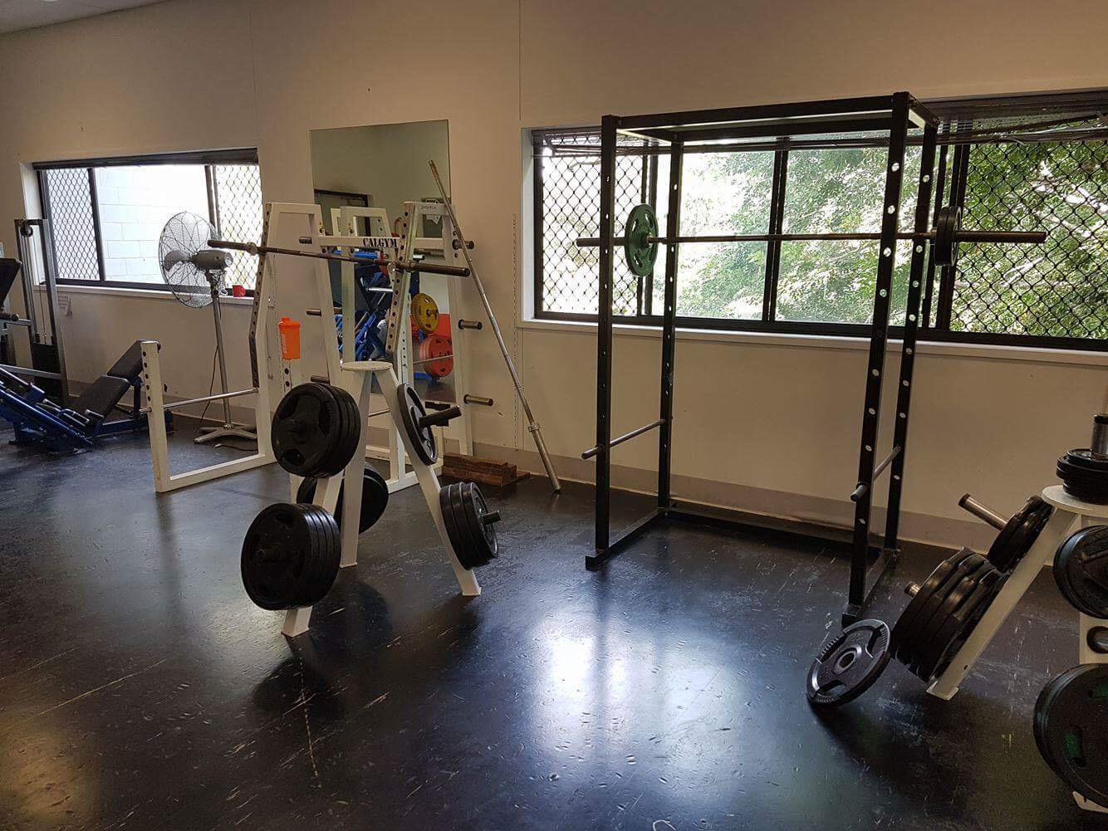

- Identify five (5) hazards present in the picture, completing a risk analysis for each.
- Rank the hazards from 1 to 5 (1 = most serious; 5 = least serious).

EXAMPLE HAZARD
Describe hazard
Dumbbells left on gym floor
Possible consequence(s)
- Trip and fall
- Possible bruising, broken bones, graze, cuts
Control measure(s)
- Erect signs around the gym
- Remind patrons to return weights
- Workers should consistently check gym floor
Determine the level of risk
Matrix | A:  Death or permanent disability | B:  Serious injury | C:  Lost time injury | D:  Casualty Treatment | E:  First Aid
1: Very Likely | E | E | H | H | M
2: Likely | E | H | H | M | M
3: Possible | H | H | M | M | L
4: Unlikely | H | M | M | L | L
5: Very Unlikely | M | M | L | L | L

E: Extreme | H: High | M: Medium | L: Low

Consequence rating: Serious injury (B)
Likelihood rating: Possible (3)
Level of risk: High (H)

HAZARD 1
Describe hazard
Bar leaning on wall
Possible consequence(s)
Bar falling and hitting someone in the head causing injury or death
Control measure(s)
Put it back where it belongs (bar stand)
Determine the level of risk
Matrix | A:  Death or permanent disability | B:  Serious injury | C:  Lost time injury | D:  Casualty Treatment | E:  First Aid
1: Very Likely | E | E | H | H | M
2: Likely | E | H | H | M | M
3: Possible | H | H | M | M | L
4: Unlikely | H | M | M | L | L
5: Very Unlikely | M | M | L | L | L

E: Extreme | H: High | M: Medium | L: Low

Consequence rating: B
Likelihood rating: 2
Level of risk: H

HAZARD 2
Describe hazard
Un even weight bar
Possible consequence(s)
Weights sliding off and hitting someone in the head, causing serious injury or death
Control measure(s)
Even the weights or put them away in the weight stand
Determine the level of risk
Matrix | A:  Death or permanent disability | B:  Serious injury | C:  Lost time injury | D:  Casualty Treatment | E:  First Aid
1: Very Likely | E | E | H | H | M
2: Likely | E | H | H | M | M
3: Possible | H | H | M | M | L
4: Unlikely | H | M | M | L | L
5: Very Unlikely | M | M | L | L | L

E: Extreme | H: High | M: Medium | L: Low

Consequence rating: D
Likelihood rating: 3
Level of risk: M

HAZARD 3
Describe hazard
Weight on ground
Possible consequence(s)
Tripping over it and hitting your head or studding toe causing bad injury
Control measure(s)
Put weight away in the right weight category
Determine the level of risk
Matrix | A:  Death or permanent disability | B:  Serious injury | C:  Lost time injury | D:  Casualty Treatment | E:  First Aid
1: Very Likely | E | E | H | H | M
2: Likely | E | H | H | M | M
3: Possible | H | H | M | M | L
4: Unlikely | H | M | M | L | L
5: Very Unlikely | M | M | L | L | L

E: Extreme | H: High | M: Medium | L: Low

Consequence rating: D
Likelihood rating: 4
Level of risk: L

HAZARD 4
Describe hazard
Uneven bar
Possible consequence(s)
Sliding off and hitting someone in the head, causing injury or death
Control measure(s)
Put the bar in even row
Determine the level of risk
Matrix | A:  Death or permanent disability | B:  Serious injury | C:  Lost time injury | D:  Casualty Treatment | E:  First Aid
1: Very Likely | E | E | H | H | M
2: Likely | E | H | H | M | M
3: Possible | H | H | M | M | L
4: Unlikely | H | M | M | L | L
5: Very Unlikely | M | M | L | L | L

E: Extreme | H: High | M: Medium | L: Low

Consequence rating: C
Likelihood rating: 2
Level of risk: H

HAZARD 5
Describe hazard
Water bottle
Possible consequence(s)
Falling over and spilling, possibly causing people to slip from water which leads to injury
Control measure(s)
Put water bottle in safe area like a bench on the side
Determine the level of risk
Matrix | A:  Death or permanent disability | B:  Serious injury | C:  Lost time injury | D:  Casualty Treatment | E:  First Aid
1: Very Likely | E | E | H | H | M
2: Likely | E | H | H | M | M
3: Possible | H | H | M | M | L
4: Unlikely | H | M | M | L | L
5: Very Unlikely | M | M | L | L | L

E: Extreme | H: High | M: Medium | L: Low

Consequence rating: C
Likelihood rating: 4
Level of risk: L

RANK HAZARDS (1 = most serious; 5 = least serious)
Hazard 1 | 1
Hazard 2 | 2
Hazard 3 | 4
Hazard 4 | 3
Hazard 5 | 5

Outcome for Case Study 1 | ☐ Satisfactory  ☐ Not satisfactory
Trainer/Assessor comments

It is important to maintain items in the gym environment to maintain a safe environment.
  - Create a maintenance schedule for four (4) items regularly seen in a gym environment – one from each of the following categories:
- Gym floor
- Resistance training equipment item
- Cardiovascular machine
- Gym environment
Include daily, weekly and monthly functions, as well as maintenance/repair procedures that may only take place a limited number of times per year.
  - Locate two (2) instruction booklets for common items in a gym. Within each booklet, identify two (2) points with regards to safety and minimising risk for gym patrons.
  - What should an employee do if they cannot repair a piece of gym equipment?
- Who should they report the matter to?
  - Identify three (3) pieces of equipment that are essential to the safety of patrons in an emergency situation.
- For each equipment item, describe the procedures required to check the currency of their servicing history.

Example:
Name equipment item |  | Lat pulldown
Maintenance requirements
Daily | Weekly |  | Monthly | 6+ months | Other
- Check cleanliness  - Ensure security of safety clips  - Wipe down with anti-bacterial | - Ensure pin is safely secured to stack  - Check seats for tearing |  | - Check plate stack for smooth function  - Check smooth rotation of pulleys  - Check cable for signs of fraying | - Check pulleys and cables for major wear and tear | Nil

ITEM 1: GYM FLOOR ITEM
Name equipment item |  | Mat
Maintenance requirements
Daily | Weekly |  | Monthly | 6+ months | Other
Wipe all over mat | Rotate |  | Full clean scrub | Replace mat | Use the floor or Carpet

ITEM 2: RESISTANCE TRAINING EQUIPMENT ITEM
Name equipment item |  | Rubber stretches
Maintenance requirements
Daily | Weekly |  | Monthly | 6+ months | Other
Wipe wash | Use different one |  | Clean and scrub | Replace/repair gear | Use different material

ITEM 3: CARDIOVASCULAR MACHINE
Name equipment item |  | Row machine
Maintenance requirements
Daily | Weekly |  | Monthly | 6+ months | Other
Wipe seat and handle | Clean all parts of machine |  | Check screws and gear if it’s still reliable | Replace/repair | Use the ski machine

ITEM 4: GYM ENVIRONMENT ITEM
Name equipment item |  | Aircon
Maintenance requirements
Daily | Weekly |  | Monthly | 6+ months | Other
Wipe around | Clean/scrub |  | Check if it’s working well and functioning | Replace/repair | Use fans if it doesn’t work

INSTRUCTION BOOKLET 1
Name equipment item | Row machine
Instruction booklet requirements | Always keep it in a straight line. Ignoring this means you are inviting serious injury.
Instruction booklet requirements | Always use both your hands while working out on the rowing machine. Of your hands get sweaty, never try to use of your hands to wipe it down on your shorts.

INSTRUCTION BOOKLET 2
Name equipment item | Bench press
Instruction booklet requirements | Make sure you have the correct grip on the bar, wonky grip could cause unbalance and serious injury
Instruction booklet requirements | Make sure weights are equal so no unbalance and injury

Code of Practice name | Row machine
Requirements | Ask a manger or worker there to see if they can fix it
Requirements | Ask a member there if they can help fix too

EMERGENCY EQUIPMENT 1
Name equipment item | Fire extinguisher
Checking servicing currency | Check if the mechanics work and hasn’t run out, replace if it has

EMERGENCY EQUIPMENT 2
Name equipment item | First aid kits
Checking servicing currency | Check there is full equipment in there, ready for emergency. Also check if its out of date

EMERGENCY EQUIPMENT 3
Name equipment item | Emergency exit sign
Checking servicing currency | Check if it’s working and the light is on

Outcome for Case Study 2 | ☐ Satisfactory  ☐ Not satisfactory
Trainer/Assessor comments

You have received the following the following client complaint via email:

To whom it may concern,

During the last few sessions at the gym, I have noticed a worrying trend. Of an afternoon, the area around the drink tap is becoming increasingly flooded; it is creating a slippery surface that I have very nearly fallen on at least three times. This leaking tap is a health hazard!

The gym floor workers have acknowledged my complaints, however they are yet to rectify the situation. I fear the next time I go to the gym could result in serious injury. It is disappointing that so far my complaints have fallen on deaf ears. I do not want to go to another gym, but if I continue to feel unheard and unsafe I will begin to look at your competitors.

Please tell me what you are going to do about this.

Regards,
Jim Patron

Respond to this client complaint. Ensure your response meets the following requirements:
- Shows empathy
- Acknowledges recording of the incident
- Discusses the duty of care
- Identifies the relevant chain of command in the resolution and reporting process
- Provides a resolution, including an improvement of organisational policies and procedures to minimise the likelihood of this occurring again

Your response
Dear Jim,

We are aware that there is a problem with the leaking of the drinking tap, our gym provides the safest, reliable cleaners and workers, and we try our best to stop this issue by hiring plumbers coming in a few days. We will improve on our organisation and safety policies by giving out free water bottles to gym members. We will take this to the senior manager then to the CEO who will make sure to organise the plumbers and fix the problem

Regards,
Gym Manager

Outcome for Case Study 3 | ☐ Satisfactory  ☐ Not satisfactory
Trainer/Assessor comments

Consider your safety requirements in a gym environment.
  - Describe ways that the following signs could be used in a gym:
- Dangerous goods classification
- Emergency equipment
- Personal Protective Equipment (PPE)
- Hazard
  - Outline the legal requirements with regards to safety
- Identify the legislation that outlines the safety requirements for a gym
- Identify two (2) legal requirements outlined under safety legislation/regulations
- Identify the regulatory authority who would check that legal requirements are being met
  - In situations where an employee cannot repair a piece of gym equipment, who should they refer the repair task to?
  - What role do clients and staff have in reducing or preventing the spread of infectious diseases?
- How can a gym regulate these practices?
  - What reporting processes can be put in place to ensure injuries are appropriately reported?
  - Describe how an employee may reflect on their own levels of stress and fatigue. Who should employees report to?
  - Explain the best process for undertaking hazardous manual tasks.

Safety signs
PPE
Towels
Shoes
Suitable

Hazard
Water spilled signage – out of order
Put equipment back
Use equipment correctly
Legal requirements
1.workplace health and safety ACT QLD 2011
2. Governed by WHA QLD
Referring repair tasks
Replace
Talk to management
Contact supplier
Service person
Call a tradesperson

Infectious diseases
Hand sanitiser
Use towels and suitable clothing
Do not train/work when sick
Use masks
Social distancing
Regulate
Signage
Provide sanitiser
Hire a towel
Removal/fines
Reporting processes
Incident report form
Online system
Follow chain of command
Regular meetings
Encourage wellness and recovery practice – headspace
Wellness app/check in
Diary/have days pff
Stress and fatigue
Regular meetings
Encourage wellness and recovery practice – headspace
Wellness app/check in
Diary/have days off
Hazardous manual tasks
Technique
Equipment – trolleys
Clear path
Hire experts
Have enough help

Outcome for Case Study 4 | ☐ Satisfactory  ☐ Not satisfactory
Trainer/Assessor comments

PRACTICAL TASKS

You are required to have a suitable observer verify your ability to complete the following tasks. These tasks may be simulated or real.

TASKS | VERIFIED
- Conduct a safety inspection of your work area, completing a risk register:  - Identify hazards and associated risks (including hazardous manual tasks)  - Consult with relevant stakeholders to analyse and evaluate risks  - Identify and evaluate control measures  - Develop and implement treatment plans for your area of responsibility  - Report hazards as per workplace procedures  - Refer hazards that are beyond your own area of responsibility  - Maintain risk management documentation  [Evidence: Risk Register] | ☐
- Respond to a (simulated) fire emergency/drill:  - Provide information needs to emergency response personnel during reporting, arrival and in response to emergency  - Checking and accounting for people during an evacuation  - Debriefing with an appropriate person, as per workplace procedures, to identify personal levels of stress and fatigue | ☐
- Over five (5) service periods, safely conduct six (6) of the following minor maintenance tasks on equipment (i.e. equipment used within the facility, participant/client-specific equipment, emergency equipment, large items requiring lifting and assembly):  - Cleaning  - Lubrication  - Reinflating  - Checking for damage  - Restocking or refilling  - Repairing  - Calibration  - Storage (ensuring entry and exit in the case of an emergency situation)  - Completing maintenance records and forms (e.g. logbook) | ☐

Outcome for Practical Tasks | ☐ Satisfactory  ☐ Not satisfactory
Trainer/Assessor comments

