Incident | Injury | Near Miss Report & Investigation Form
To be completed as soon as practicable after the event and provided to
HOMES BY CMA

Injured Persons Details
Person’s Name: Sam Radich |  |  | Contact No: 0455 514 588
Address: 5 Lynette St Kallangur
Employment Details: | ☐ Self | ☒ Employee |  | ☐ Visitor | ☐ Contractor

Person Completing this Form
Name: Sam Radich | Title: Mr
Date: 01/11/2016 | Time: 10:30am

Details of Incident | Injury | Near Miss
Nature: | ☐ Incident | ☒ Injury | ☐ Near Miss
Date of Incident: 31/10/2016 |  |  | Time of Incident: 3:40pm
Address of Incident: Lot 546 Grasstree Pl Ningi
Date Reported: 31/10/2016 |  |  | Reported to: Lisa Pyne
Title: Office Manager |  |  | Contact No: 3188 9324

Names of any Witnesses
Name: NA | Contact No:
Address:

Describe What Happened
Was onsite performing a slab check. Moved to the next area of the slab and got my leg caught on an uncapped star picket which caused a large cut.

Workplace Conditions at the Time?
Sunny and dry. Site was clean.

Injury Details (if applicable)
Nature of Injuries (if any): Wide and deep cut
Part/s of Body Injured (if applicable): Outside of lower left leg
Treatment Received? | ☐ 1st Aid | ☒ Doctor |  | ☐ Hospital |  |  |  | ☐ Ambulance
Please clearly mark on this diagram, the location of any injury/s |  |  | 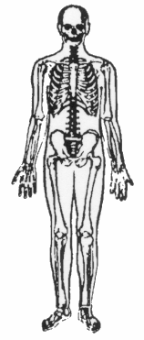 |  |  |  | 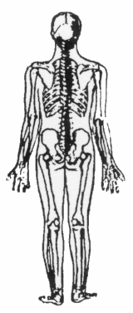
 |  |  | Right |  |  | Left | Left |  |  | Right

Other
Was any Machinery or Scaffolding Involved? |  |  |  |  | ☐ Yes |  |  |  | ☒ No
Were any Photos Taken? |  |  |  |  | ☒ Yes |  |  |  | ☐ No

What Action was Taken Immediately After the Incident?
Put pressure on the cut by tying a rag around it. Went to Ningi Doctors and had the wound cleaned out, stitched up and covered. I also received a Tetanus injection.

Can any Improvements be Made as a Result of this Occurrence?
No | Details | Improvements Completed
1 | Ensure caps are put on start pickets during slab prep

Administration
Will the Injury Result in Lost Time? | ☐ Yes | ☒ No
Will Workers Compensation be Claimed? | ☐ Yes | ☒ No
Has Workplace Health and Safety Queensland Been Informed? | ☐ Yes | ☒ No
Details:

Person Completing this Form
Signature: | Date: 1/11/2016

