CPCCBC4016A
Administer a construction contract

THEORY EXAM INSTRUCTIONS

- This exam will occur under standard assessment conditions.
  - An oral examination may be allowed under certain circumstances.
Answers will be documented and FT003 (Oral examination declaration form) must be completed.
- Participants must provide enough detail in their responses to demonstrate their knowledge and skills.
- Please fill in the details below, providing your name, signature and date of assessment.
  - Your signature acknowledges that this is your own work.
- If a participant initially answers a question incorrectly but modifies their response, they must follow the instructions below:
  - If a participant changes their response in writing, they must put their initials next to the written change.
  - If a participant changes their response verbally, this must be noted on the exam paper by the assessor.

Participant name
Participant signature | 

Assessor name
Assessor signature

Date | Click here to enter a date.

Number of questions | Number of questions answered correctly | Satisfactory?
49 |  | Yes | No
Assessor Comments

- Identify the various types of building and construction contracts and explain when it is appropriate to apply each type of contract.

Answer

Answer

- Use the drawings you completed in the assessment for CPCCBC4014A (from the floor plan below) and the listed task requirements to prepare the new dwelling contract documentation for the client’s signature.

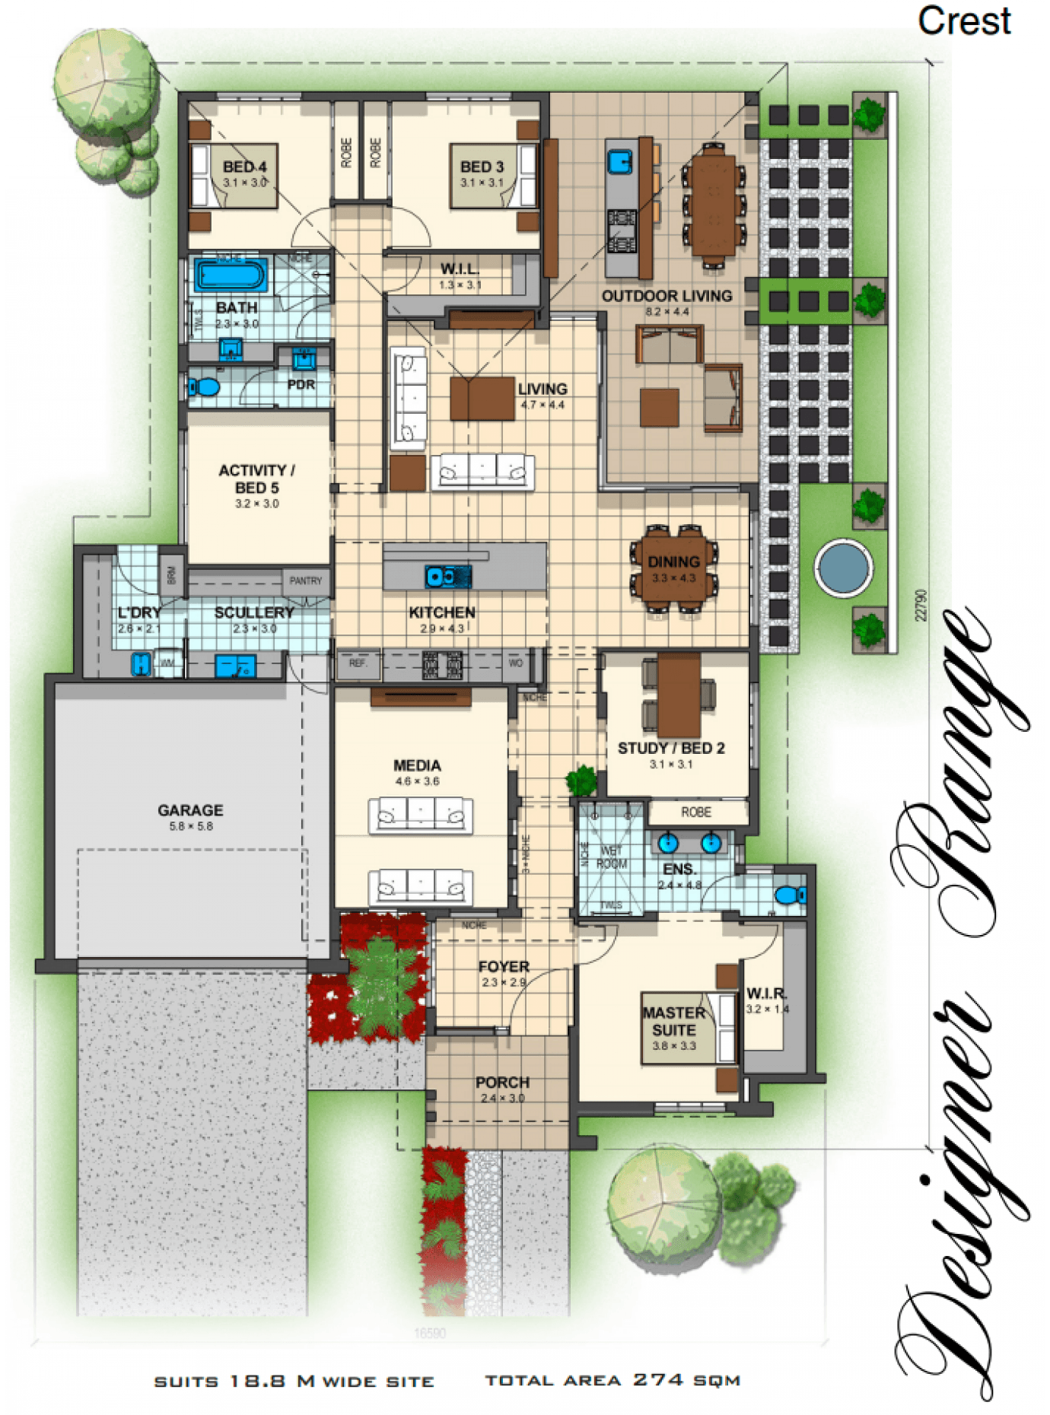
TASK REQUIREMENTS

You are to download the contract documents from the Queensland Building and Construction Commission (QBCC) website at: http://www.qbcc.qld.gov.au/sites/default/files/QBCC_New_Home_Construction_Contract.pdf

Your should:
- Analyse the various types of building and construction contracts you will need and then apply the appropriate application of each type of contract;
- Identify and apply legislative requirements relating to building and construction contracts.
- Identify and apply essential terms and elements of a valid contract;
- Analyse the importance of identifying an intention to create legal relations;
- Identify and analyse rights and liabilities of parties under a contract;
- Identify and apply common building contract terms and procedures;
- Identify and analyse circumstances that bring about a breach of contract;
- Accurately select the contract, appropriate for the type of construction;
- Accurately identify and prepare the range of documents collectively make up a contract;
- Accurately identify and apply requirements associated with an offer and acceptance of a contract;
- Confirm the capacity of the parties to form a binding agreement in the form of a contract; and
- Identify and apply factors associated with the parties' consenting to a contract.

Answer

- How should you handle any customer complaint?

Answer

- What does the ‘cooling off’ period refer to when undertaking domestic building work with a total contract price of $20,000 or more?

Answer

- What are the consequences for a client not using a QBCC licensed contractor?

Answer

- What is the Queensland Home Warranty Scheme?

Answer

- What are the consequences of Cost Plus and Construction Management contracts on Home Warranty Insurance protection?

Answer

- At the commencement of a contract valued over $20,000, what must the contractor give to the owner? What timeframes apply?

Answer

- Where must the total contract price be stated?

Answer

- What are the maximum deposits recommended and how should progress payments be scheduled?

Answer

- Who has responsibility of building inspections and approvals?

Answer

- Identify and describe the term used to describe circumstances such as:
- Where there has been a change to the materials used or
- A change to the scope of the work to be performed under the contract?

Answer

- How do you reduce the risk of dispute?

Answer

- What is the process for dispute resolution?

Answer

- When might an extension of time (EOT) apply? How is it approved?

Answer

- When is the client/home owner required to pay the final contract payment?

Answer

- What are implied warranties?

Answer

- Explain the responsibilities of an Owner Builder.

Answer

Answer

- What is ‘notifiable work’, who is responsible and to whom does it apply?

Answer

Answer

Answer

- What is the difference between the Prime Cost Item Schedule and the Provisional Sum Schedule in a contract? Give one example to help explain your answer.

Answer

- What does Section 109 of the Queensland Building and Construction Commission Act 1991 provide to the consumer/client?

Answer

- What are some of the preliminary contracts that a builder could ask a client to sign prior to signing the main contract?

Answer

- What are liquidated damages in terms of a signed building contract?

Answer

- What contract documentation would you review to identify any unusual aspects related to materials and installations for a low rise construction project?

Answer

- Where would you find any possible penalties associated with a build?

Answer

- What is the Australian Standard Contracts - AS2124 and AS4000 series?

Answer

- How does the Queensland Building and Construction Commission (QBCC) regulate the Queensland building industry?

Answer

- What industry legislation should builders and trade contractors have a good understanding of?

Answer

- What supporting documents should you be aware of and include in your contracts with the consumer?

Answer

- What are the four (4) essential elements of an agreement for it to be regarded as a contract?
What is the consequence if any essential element is missing?

Answer

- When would an offer be considered to have lapsed?

Answer

- What is able to be ‘accepted’? What happens to the offer if new terms are suggested?

Answer

- What does it mean when a contract is supported by valuable consideration?

Answer

- Identify the term for each of the definitions listed in the table below.

Answer | Term | Definition
 |  | Any construction or change to a building or facility that increases its external dimensions and cubic contents.
 |  | A procedure for resolving disputes that involves less formality than a court hearing. An arbitrator’s decision is final and cannot be appealed.
 |  | Assists builders, contractors and owners by ensuring that construction projects meet building regulations and codes of practice. Inspections assess design documentation and make on-site inspections during building work.
 |  | Demonstrates that a building, other than a dwelling has been inspected and passed.
 |  | The achievement of performance criteria described in a regulation or other statutory requirement. This is usually demonstrated by a compliance or approval certificate.
 |  | An agreement entered into between two or more parties that involves an exchange or specified goods and/or services for specified financial reimbursement or other considerations.
 |  | One or more buildings which in association constitute a single dwelling being a detached house or one or more attached dwellings.
 |  | A person who carries out domestic building work on his her own land, who is not in the business of building.
 |  | Independent professionals with the same power to issue building permits and occupancy permits as municipal building surveyors.
 |  | A person accepted by the appropriate authority as qualified to design, construct (or install) or supervise the erection of, buildings or services; usually recognised by a certificate of registration.
 |  | That part of an allotment which is covered by buildings, expressed as a percentage of the area of the allotment.
 |  | A minor clause in a contract the remedy for breach of which is damages for any loss. Also, a promise to repair or replace defective goods.

- Explain the terms listed in the table below.

Answer | Term | Definition
 | Minor breach
 | Material breach
 | Fundamental breach

- Who are the parties that need to be consulted with for binding agreements to be confirmed?

Answer

- What is consent?

Answer

- When might ‘apparent consent’ be negated?

Answer

- A construction contract can be terminated for ‘cause’ or for ‘convenience’. Explain these two terms.

Answer

- What does repudiation mean?

Answer

- Explain the concept ‘conditions for completion at the cost of the contractor’.

Answer

- What does ‘abandonment of contract’ mean?

Answer

- Throughout the building schedule, progress payments are made when each new stage is ready to commence.
Nominate the recommended stages and percentages for these progress payments on a typical new residential housing building project.

Answer

- Which section of the Subcontractors’ Charges Act 1974 (Qld) address vexatious notices of claim?

Answer

- Describe the circumstances in which a person is deemed to give notice of a claim of charge without unreasonable grounds.

Answer

- Who should you consult if you are considering ousting a contractor from a building site?

Answer

- What document should you refer to if you are considering ousting a contractor from a building site?

Answer

- Contract Cost Adjustment Provisions address risk by providing mechanisms for adjusting contract payment to reflect changes in costs.
What can cost adjustment apply to?

Answer

- What document will outline the time extensions you are entitled to over the contract period?

Answer

