CPCCBC4004A
Identify and produce estimated costs for building and construction projects

THEORY EXAM INSTRUCTIONS

- This exam will occur under standard assessment conditions.
  - An oral examination may be allowed under certain circumstances.
Answers will be documented and FT003 (Oral examination declaration form) must be completed.
- Participants must provide enough detail in their responses to demonstrate their knowledge and skills.
- Please fill in the details below, providing your name, signature and date of assessment.
  - Your signature acknowledges that this is your own work.
- If a participant initially answers a question incorrectly but modifies their response, they must follow the instructions below:
  - If a participant changes their response in writing, they must put their initials next to the written change.
  - If a participant changes their response verbally, this must be noted on the exam paper by the assessor.

Participant name | Leilani Kyle
Participant signature | 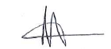

Assessor name
Assessor signature | 

Date | Click here to enter a date.

Number of questions | Number of questions answered correctly | Satisfactory?
37 |  | Yes | No
37 |  | ◻ | ◻

Assessor Comments

Refer to the plans and specifications below to respond to Q1. to Q9.



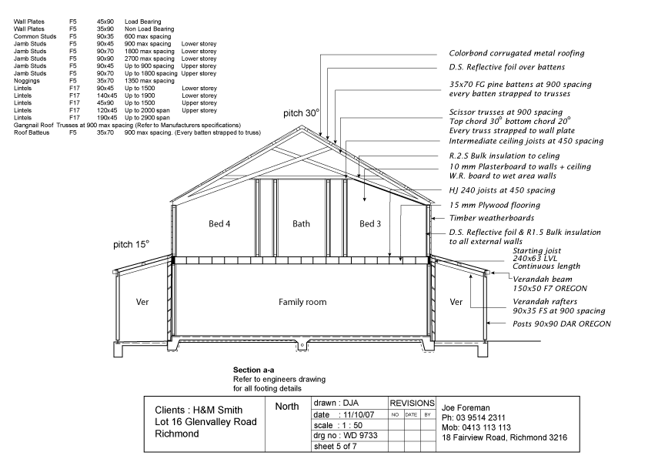


- Match the sheet numbers and document types by writing the appropriate letter next to each number in the centre column.

Answer | Sheet Number |  | Answers | Document Type |  | ◻
 | 1 | Sheet 4 | 1 - A | A | Floor plan
 | 2 | Sheet 5 | 2 - B | B | Section plan
 | 3 | Sheet 6 | 3 - C | C | Site plan

- Which sheet number of Drawing WD 9733 identifies the storm water drainage for the proposed structure? Tick your response.

Answer | Choice | Possible Answers | ◻
 | ◻ | Sheet 4
 | ◻ | Sheet 5
 | x | Sheet 6

- Identify the Volume and Parts of the NCC that outline the requirements for stormwater drainage for Classes 1 and 10, and Classes 2 to 9.

Answer | Classes 1 and 10 | Classes 2 to 9 | ❑
 | NCC 2019 Volume One Section F Health and Amenity Part F1 Damp and weatherproofing (Deemed-to-Satisfy Provisions) | NCC 2019 Volume One Section F Health and Amenity Part F1 Damp and weatherproofing (Deemed-to-Satisfy Provisions)

- Which Australian Standard is referenced in the NCC with regards to storm water drainage?

Answer | HB 114-1998 | ◻

- What is the area of the verandah? Tick your response.

Answer | Choice | Possible Answers | ◻
 | ◻ | 76m²
 | ◻ | 92m²
 | ◻ | 135m²
 | ◻ | 211m²
 | ◻ | 243m²

- What is the pitch of the verandah roof?

Answer | 15 degrees | ◻

- What size are the verandah beams?

Answer | 150 x 50 | ◻

- Which of the following Jamb Studs are to be used for both the upper and lower storeys? Tick all that apply.

Answer | Choice | Possible Answers | ◻
 | x | 90x45
 | x | 90x70
 | ◻ | 90x90

- Identify three (3) subcontractors that may work on this construction project.

Answer | Electrician, Plasterer, plumber | ◻

- Identify three (3) items of plant and/or equipment that may be used on this construction project.

Answer | boom lift, roller, excavator | ◻

- Identify the Volume and Part of the NCC that outlines the requirements for the timber weatherboards identified in Sheet 5.

Answer | NCC 2019 Volume Two Part 3.5 Roof and Wall Cladding Part 3.5.4 Timber and composite wall cladding | ◻

- Which Australian Standard is referenced in the NCC with regards to timber structures?

Answer | AS 1720.2-2006 | ◻

Refer to the contour plan below to respond to Q13. to Q15.

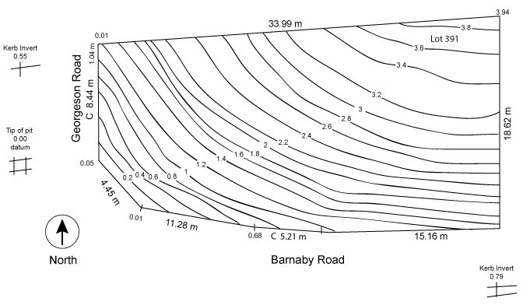

- What is the datum reading at the tip of the pit?

Answer | 3.94 | ◻

- What is the level at the kerb invert?

Answer | 0.79 | ◻

- True or False (Tick your response): The lowest point on the site is found at the northernmost point.

Answer | x | True |  | ◻
 | ◻ | False

- True or False (Tick your response): A Gantt Chart may assist with determining the numbers of on-site personnel required and the time requirements for a project.

Answer | ◻ | True |  | ◻
 | x | False

- Identify labour that may be required for non-contract elements of a construction project.

Answer | Office Administration Staff | ◻

- Explain how the following methods may be used to calculate the costs for on-site work.

Answer | Method | Explanation | ◻
 | Per hour | working out how much it costs per day (or hour) to have your direct employees on the job. Multiply that rate by the time you expect the job to take.
 | Per unit | eg. installation of doors is usually quoted per unit
 | Per metre | the cost of building walls to a specified height such as 2400 mm may be quoted per lineal metre of wall length

- Which of the following documents may you refer to when establishing material quantities for a construction project? Tick all that apply.

Answer | Choice | Possible Answers | ◻
 | x | Plans
 | x | Project contract
 | x | Specifications
 | x | Standard construction contracts

- True or False (Tick your response): The fast way to locate suppliers, such as manufacturers and wholesalers, is to find them online.

Answer | x | True |  | ◻
 | ◻ | False

- Explain how each of the following factors affects supplier selection.

Answer | Factor | Impact | ◻
 | Location | Dealing with distant suppliers might mean longer delivery times and extra freight costs.
 | Price | Affordability is a key factor, but cheap does not always equate with quality.
 | Reliability | Suppliers should be able to delivery the right goods and on time.
 | Stability | Look for experienced suppliers who have been in business a long time. This illustrates financial stability.
 | Supplier groups | While using a single supplier has its advantages, it also has risks. It might be better to use a carefully selected group of suppliers as insurance against any problems occurring.

Read the following information to respond to Q22. to Q27.

The diagram below shows formwork that is required for a concrete slab.


The table below outlines the costs for this task.

Item | Cost
Timber | $2.50 per metre
Concrete | $50.00 per cubic metre (excluding GST)
Labour | $49.50 per hour

- Calculate the lineal meters of timber (150mm wide x 25mm thick) required to form up the edge of a concrete slab which is 6.0m x 2.5m x 150mm. Provide no allowance for waste. Show your answer to two decimal places.

Answer | 562.50 | ◻

- Use your response to Q22. to calculate how much the timber will cost.
Show your workings and answer to two decimal places.

Answer | 562.50 lm x $2.50 per metre = $1,406.25 | ◻

- Calculate how many cubic metres of concrete are required.
Show your workings and answer to two decimal places.

Answer | 6m x 2.5m x 150mm = 22.50 m3 | ◻

- Use your response to Q24. to calculate the cost of the required concrete. Show your answer to two decimal places and ensure it includes GST.
Answer | 22.5m3 x $50 per cubic metre = $1,125.00 | ◻

- Calculate how much the labour will cost if the job takes 6 ½ hours.
Show your workings and answer to two decimal places.

Answer | 6.5 hours x $49.50 per hour = $321.75 | ◻

- Use your responses for Q23. Q25. and Q26. to calculate how much this project will cost. Show your workings and answer to two decimal places.

Answer | timber = $1,406.25  concrete = $1,125.00  labour = $321.75  Total cost = $2,853.00 | ◻

Refer to the electrical plan below to respond to Q28. and Q29.


Source: https://www.dtwd.wa.gov.au/sites/default/files/teachingproducts/BC1944_CCBY.PDF

- Measure the required quantities for the items listed below.

Answer | Quantity | Item | ◻
 | 27 | Ceiling light
 | 1 | Wall light
 | 0 | External light
 | 3 | Exhaust fan
 | 2 | Smoke detector

- The costs for each of the items are provided in the table below.
Cost | Item
$49 each | Ceiling light
$29 each | Exhaust fan
$82 each | External light
$39 each | Smoke detector
$59 each | Wall light

Determine the total costs for each item (using the numbers from Q28. ) and the total cost for all items.

Answer | Cost | Item | ◻
 | $1,323 | Ceiling light
 | $59 | Wall light
 | $0 | External light
 | $87 | Exhaust fan
 | $78 | Smoke detector
 | $1,547 | TOTAL

- Name one (1) organisation that provides workers’ compensation insurance.

Answer | WorkCover Queensland | ◻

- Which of the following environmental costs should be considered when determining project costs? Tick all that apply.

Answer | Choice | Possible Answers | ◻
 | x | Approvals
 | x | Environmental protection
 | x | Permits
 | x | Waste management

- List three (3) statutory costs that should be considered when determining project costs.

Answer | EPA, workers compensation and licences | ◻

- Which two (2) of the following methods are commonly used when determining the profit on a project? Tick all that apply.

Answer | Choice | Possible Answers | ◻
 | ◻ | Double the builder’s cost
 | x | Lump sum based on market conditions
 | x | Percentage on builder’s total cost

- True or False (Tick your response): Usually a percentage is added to the estimate to cover company overheads.

Answer | x | True |  | ◻
 | ◻ | False

- Identify one (1) example of company overheads for each of the listed categories.

Answer | Factor | Impact | ◻
 | Business premises | Rent
 | Staff and professional fees | Wages
 | Transport | Company vehicles
 | Finance | accounting fees

- Fill in the blanks: Complete the following chart to identify what is included in the final cost for a project.


Plant & equipment
Materials
Direct Costs
Builders total cost
Company Overheads

Choose from | Builder’s total cost | Company overheads | Direct costs | Materials | Plant and equipment | ◻

- Which of the following should be included in a letter of quotation?
Tick all that apply.

Answer | Choice | Possible Answers | ◻
 | x | Conditions to your price
 | x | Discrepancies
 | x | Final cost
 | x | Invitation to proceed

