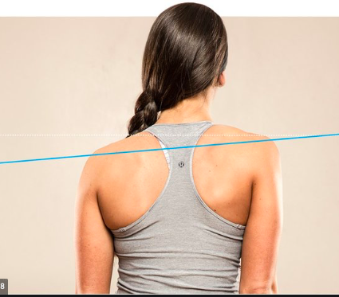

Case Study 1

A 39 year old female client, Janice, has shown indications of scoliosis during her exercise pre-screening. The postural problem is causing problems with her work and has been slowly getting worse since she started playing social tennis three (3) nights a week.

Janice has come to you looking for advice on how to relieve these symptoms and improve her overall strength. She has concerns that lifting weights will make her bulky and put her at risk of further injury.

What anatomical positioning would indicate these symptoms? (30 words)

When looking at Janice in the anatomical position, she could have a postural imbalance. This is seen as one shoulder is higher then the other and obvious tightness in her traps. This is bad for you but is fixable.

Why the factors indicated would make her muscles imbalanced? (50 words)

She has started playing social tennis three times a week. This is causing the muscle imbalance as when she plays tennis the movement of the one particular arm is tightening and growing the trap muscle affecting her imbalance. She also mentions her work posture, if she is at work everyday not sitting upright it can cause a great change in her posture. Another reason for this outcome is genetics because if she has scoliosis, it can be genetically inherited.

Where to access further information to help you prior to writing Janice’s program. Identify 3 websites that give information on scoliosis and muscular imbalances.

- What Causes Muscular Imbalances and How To Fix Them https://www.healthline.com/health/muscle-imbalance#causes
- Why It Matters If One side Of Your Body is Stronger Than The Other- And How To Fix It
https://www.self.com/story/muscle-imbalances
- Scoliosis
https://www.mayoclinic.org/diseases-conditions/scoliosis/symptoms-causes/syc-20350716

Any Allied Health Professionals (AHPs) you would recommend Janice visit prior to commencing her training program with you. Please identify 2 in your local area including phone number and website:

- GenPhysio, Number: 1300 755 072
https://www.genphysio.com.au/mobile-physiotherapy-services/home-visit/?gclid=EAIaIQobChMI5bTV8qfA8AIVTDVyCh37nAXKEAAYASAAEgLUpvD_BwE
- CQUniveristy Health Clinics, Number: 07 3023 4177
https://www.cqu.edu.au/industry-and-partnerships/services/health-clinics/brisbane-health-clinic?gclid=EAIaIQobChMI5bTV8qfA8AIVTDVyCh37nAXKEAAYAiAAEgJaLvD_BwE&gclsrc=aw.ds

Janice has some concerns about what could happen to her in the gym. Explain how both the Golgi tendon reflex and the Stretch reflex will potentially assist Janice. Include a description of how the reflex arc works and the response it will have.

What is the golgi tendon reflex? How could it protect Janice? (50 words)

What is it?
The Golgi tendon reflex is an inhibitory effect on the muscle resulting from the muscle tension stimulating Golgi tendon organs of the muscle, and hence it is self-induced.

How does it protect us in the gym?
Stops the muscle if it is under too much tension, the Golgi tendon reflex operates as a protective feedback mechanism to control the tension of an active muscle by causing relaxation before the tendon tension becomes high enough to cause damage.

What is the stretch reflex? How could it protect Janice? (50 words)

What is it?
The stretch reflex is a muscle contraction in response to the stretch within a muscle. For example, when a muscle lengthens the muscle the muscle fibres and spindles are stretched and the nerve movement amplifies

How does it protect us in the gym?
The first function of the stretch reflex is muscle protection, it prevents strains and tears to the muscles and tendons, when the muscle spindle is excited and being stretched its impulse is to immediately contract therefore protecting our muscles from being forcefully stretched beyond the normal range of motion

What is the reflex arc? (50 words)

What is it?
A reflex arc is a neural pathway that controls a reflex. In vertebrates, most sensory neurons do not pass directly into the brain, but synapse in the spinal cord. This allows for faster reflexactions to occur by activating spinal motor neurons without the delay of routing signals through the brain.

How does it protect us in the gym?
The stretch reflex is designed as a protective mechanism, to prevent strain and tear injuries to the muscles and tendons. When the muscle spindle is excited an impulse is immediately received to contract the muscle, thereby protecting it from being pulled forcefully or stretched beyond a normal range of motion.

What are afferent nerves? (30 words)

What is it?
Nerves that carry signals toward the central nervous system from the periphery. Afferent may also be used generally to describe nerves that are traveling into a nervous system structure - from hand to brain (sensory)

What are efferent nerves? (30 words)

What is it?
Efferent, or motor, nerve fibres carry impulses away from the central nervous system; afferent, or sensory, fibres carry impulses toward the central nervous system. – from brain to hand

