BSBITU301
Create and use databases
Learner Workbook



Table of Contents

Table of Contents 2
Candidate Details 3
Assessment – BSBITU301: Create and use databases 3
Competency Record to be completed by Assessor 4
Observation/Demonstration 5
Activities 6
Activity 1A 6
Activity 1B 8
Activity 1C 9
Activity 1D 10
Activity 2A 11
Activity 3A 12
Activity 3B 13
Activity 3C 14
Activity 3D 15
Activity 3E 16
Skills and Knowledge Activity 17
Major Activity 18

Candidate Details

Assessment – BSBITU301: Create and use databases
Please complete the following activities and hand in to your trainer for marking. This forms part of your assessment for BSBITU301: Create and use databases.
Name: Rani Doyle
Address: 94 Bald Hills Rd
Bald Hills, QLD 4036
Email: rani_doyle@hotmail.com
Employer: Securcom
Declaration
I declare that no part of this assessment has been copied from another person’s work with the exception of where I have listed or referenced documents or work and that no part of this assessment has been written for me by another person.
Signed: ____________________________________________________________
Date: 25/09/2017
If activities have been completed as part of a small group or in pairs, details of the learners involved should be provided below:
This activity workbook has been completed by the following persons and we acknowledge that it was a fair team effort where everyone contributed equally to the work completed. We declare that no part of this assessment has been copied from another person’s work with the exception of where we have listed or referenced documents or work and that no part of this assessment has been written for us by another person.
Learner 1: ____________________________________________________________
Signed: ____________________________________________________________
Learner 2: ____________________________________________________________
Signed: ____________________________________________________________
Learner 3: ____________________________________________________________
Signed: ____________________________________________________________

Competency Record to be completed by Assessor
Learner Name: _______________________________________________________
Date of Assessment: _______________________________________________________
The learner has been assessed as competent in the elements and performance criteria and the evidence has been presented as:
Assessor Initials
Authentic
Valid
Reliable
Current
Sufficient

Learner is deemed: COMPETENT NOT YET COMPETENT (Please circle)

If not yet competent, date for re-assessment: ____________________________________

Comments from Trainer / Assessor:
__________________________________________________________________________________________________________________________________________________________________________________________________________________________________________________________________________________________________________________________________________________________________________________________________________________________

Assessor Signature

Observation/Demonstration

Throughout this unit, you will be expected to show your competency of the elements through observations or demonstrations. Your instructor will have a list of demonstrations you must complete or tasks to be observed. The observations and demonstrations will be completed as well as the activities found in this workbook. An explanation of demonstrations and observations:
Demonstration is off-the-job
A demonstration will require:
- Performing a skill or task that is asked of you
- Undertaking a simulation exercise
Observation is on-the-job
The observation will usually require:
- Performing a work based skill or task
- Interaction with colleagues and/or customers
Your instructor will inform you of which one of the above they would like you to do. The demonstration/observation will cover one of the unit’s elements.
The observation/demonstration will take place either in the workplace or the training environment, depending on the task to be undertaken and whether it is an observation or demonstration. Your instructor will ensure you are provided with the correct equipment and/or materials to complete the task. They will also inform you of how long you have to complete the task.
You should be able to demonstrate you can:
- Create a simple database
- Create queries and reports
- Use database
You should also demonstrate the following skills:
- Reading
- Writing
- Numeracy
- Navigate the world of work
- Get the work done
Activities

Activity 1A
Estimated Time | 30 Minutes
Objective | To provide you with an opportunity to design a simple database, with at least two tables, using a database application, basic design principles, software functions and simple formulae.
Activity | - Explain what the following database elements are and their purpose:  - Tables  Large amounts of information quickly get confusing, so they are arranged in tables to make them easier to understand. Before you start building a database, you should plan which tables will be contained within it, and whether they will need to relate to each other. This will prevent you from deleting redundant tables or creating additional ones later. In a Microsoft Access table, columns are known as fields (or sometimes attributes) and rows are records.  - Forms  Also known as ‘data entry screens’, forms are used to view, enter and edit data in the table. It is possible to work without them by editing data directly on the table datasheets, but most people find a former easier and less confusing to use.  - Queries  Queries are essentially requests for information from the database, which allow you to perform many functions such as adding, changing, reviewing or deleting data. They can also filter or summarise it. They are useful in that they can pull together information from multiple tables.  - Reports  Reports are a way to summarise information in databases that you may have obtained either from tables or queries. These can provide broad summaries of multiple tables or detailed breakdowns of individual records. The purpose of a report is usually to present data in a clearer way which may.  - What expression would you use to find the average age of your customers in an Access database?  =Avg([Order])  - What are the benefits of relational databases?  Often in tables, there will be excess information that is redundant for the purpose. Relational tables divide these into smaller, connected tables that only contain the relevant information.

Activity 1B
Estimated Time | 15 Minutes
Objective | To provide you with an opportunity to develop a table with fields and attributes according to database usage, as well as data considerations and user requirements.
Activity | - What type of fields would the following data best be stored in?  - John Smith  Text Fields  - False  Yes/No fields  - 22nd February 2014  Date and time fields  - £18.99  Currency fields  - What sort of field names would be relevant for a table about available cars in a car dealership’s database?  Cars for sale

Activity 1C
Estimated Time | 20 Minutes
Objective | To provide you with an opportunity to create a primary key for each table, modify table layout and field attributes as required and create a relationship between the two tables.
Activity | - Explain how a one-to-many relationship works in a database. Give an example.  A primary key is a unique piece of information for a record. It acts as an index, giving each record a unique number. For example, there may be several John Smiths in an organisation, but if they were each given a unique Employee number, they would be easily recognised in a database.  - Why does a table need a primary key?  A primary key in one table can be used to create a relationship with another table, where it is called a foreign key. This connects the tables together to share data. A table can have any number of foreign keys.  - Why might AutoNumber be used to generate primary keys?  AutoNumber can be used as a type of primary key in Access 2010 and other programmes

Activity 1D
Estimated Time | 1 Hour
Objective | To provide you with an opportunity to check and amend data entered, in accordance with organisational and task requirements.
Activity | - Create a simple database with at least related two tables using a software of your choice. Use at least one formula.  DATABASE 1:  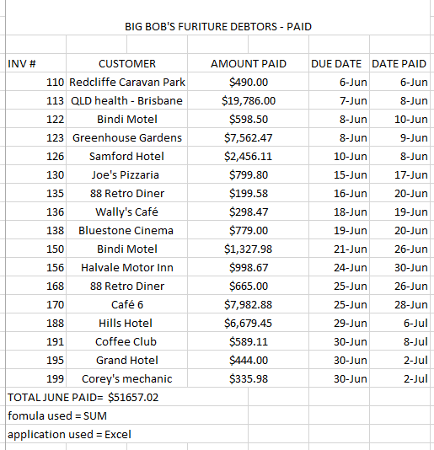  DATABASE 2:  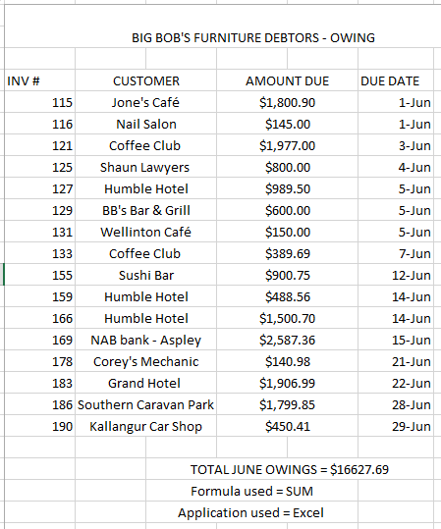

Activity 2A
Estimated Time | 1 Hour
Objective | To provide you with an opportunity to create reports and queries.
Activity | - Run a query on the database you built in Activity 1A to filter a subsection of a data. Sort it by at least one value  Due to not having the appropriate software I could not complete this task.

Activity 3A
Estimated Time | 15 Minutes
Objective | To provide you with an opportunity to ensure data input meets designated timelines and organisational requirements for speed and accuracy.
Activity | - Role play with another learner what you would do if you believed you wouldn’t be able to meet a deadline.  I would inform and explain why to my supervisor that the deadline might not be met and discuss possible solutions.

Activity 3B
Estimated Time | 30 Minutes
Objective | To provide you with an opportunity to use manuals, user documentation and online help to overcome problems with database design and production.
Activity | - Using user manuals or online user documentation, take turns with another learner to look up solutions to problems.  E.g.: “What would you do if the software produced Error Code X?”  I would use provided user manual or online documentation for the software to determine a solution.

Activity 3C
Estimated Time | 15 Minutes
Objective | To provide you with an opportunity to preview, adjust and print database reports or forms in accordance with organisational and task requirements.
Activity | - Prepare your completed document for printing. Apply a theme and make any necessary adjustments.  Data has been formatted into a table and filtered Largest amount descending to smallest amount. Theme has been applied with the company’s heading and colour scheme.  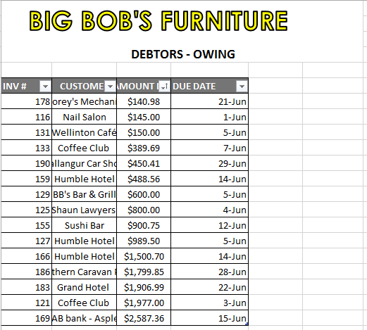  Document Prepared for printing  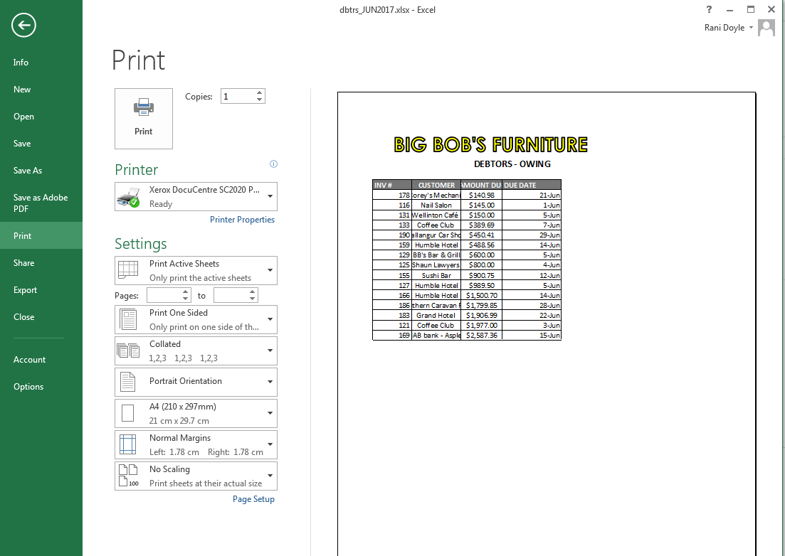

Activity 3D
Estimated Time | 10 Minutes
Objective | To provide you with an opportunity to name and store databases, in accordance with organisational requirements, and exit application without data loss or damage.
Activity | - Save the report in a relevant folder, using Leszynski/Reddick guidelines, and create a backup.  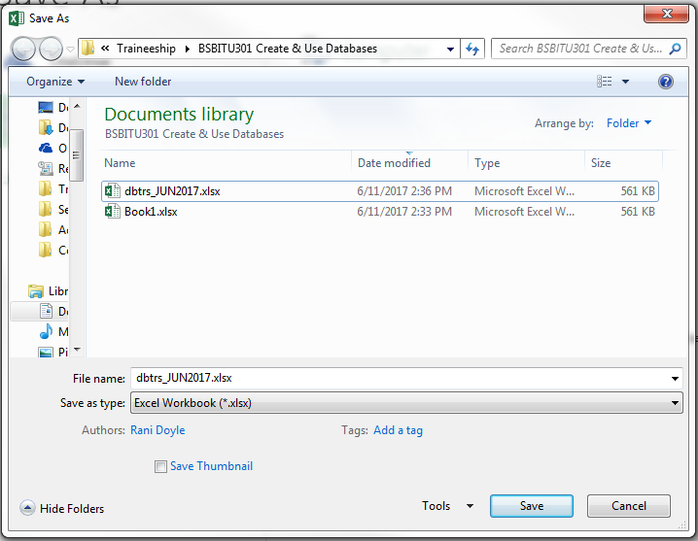  dbrts_JUN2017  Debtors June 2017

Activity 3E
Estimated Time | 15 Minutes
Objective | To provide you with an opportunity to prepare and distribute reports to appropriate person in a suitable format.
Activity | - Use conditional formatting to highlight information.  Conditional Formatting to highlight figures over $1000.  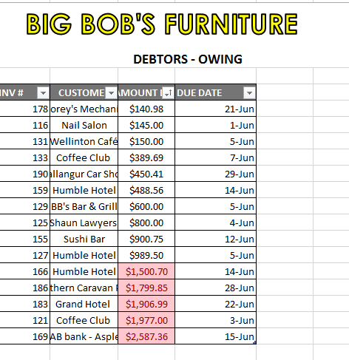

Skills and Knowledge Activity
Estimated Time | 1 Hour
Objective | To provide you with an opportunity to demonstrate your knowledge of the foundation skills, knowledge evidence and performance evidence.
Activity | Complete the following individually and attach your completed work to your workbook.  The answers to the following questions will enable you to demonstrate your knowledge of:  - Reading  - Writing  - Numeracy  - Navigate the world of work  - Get the work done  - Key provisions of relevant legislation, standards and codes that may affect aspects of business operations  - Organisational requirements relating to data entry, storage and presentation  - Using data from your company, create a database with at least three connected tables and a formula. Run a query and a report on it to produce relevant information. Prepare the report up to company standards then print and attach it to the workbook.

Major Activity
Estimated Time | 2 Hours
Objective | To provide you with an opportunity to demonstrate your knowledge of the entire unit.
Activity | This is a major activity – your instructor will let you know whether you will complete it during class or in your own time.  Attach your completed answers to the workbook.  You must individually, answer the following questions in full to show your competency of each element:  - Create a simple database  - Create reports and queries  - Use database  - What things should you consider when planning a database?  - What things should you consider when creating a report?  - What things should you consider when finishing the report?

