
AHCLSC303
Construct brick and block structures and features

Copyright © 2020 CSTC Pty Ltd

All rights reserved. No part of the contents of this publication may be reproduced or used in any form or by any means – graphic, electronic, or mechanical including photocopying, digitising, recording, or information storage-and-retrieval systems – without the written permission of CSTC Pty Ltd.
ASSESSMENT FOR AHCLSC303

Student name | Jack Schaffer
Date of assessment submission | Click here to enter a date.

Trainer/Assessor’s name
Date of assessment marking | Click here to enter a date.
Outcome for unit | ☐ Competent  ☐ Not Yet Competent

TASK INSTRUCTIONS

- As part of the assessment for this unit of competency, you are required to complete a series of activities.
  - Some of these activities will require you to provide a response within this document, others will require you to gather evidence to demonstrate your knowledge and skills.
- At all times, the responses in your assessment must reference Australian (Queensland or Federal) documentation, including legislation, regulations, codes of practice, standards and guidance publications.

ACTIVITIES

Draw a simple concept plan for a proposed landscape design which includes brick/block work.

Response
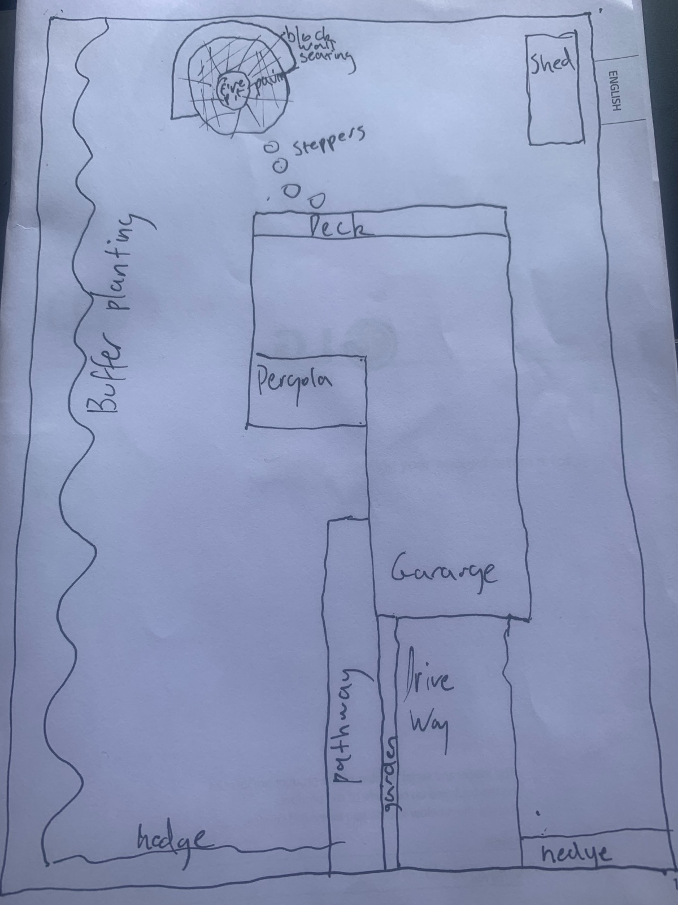

Outcome for Activity 1 | ☐ Satisfactory  ☐ Not satisfactory
Trainer/Assessor comments

Identify/list the detail on the landscape plan shown.

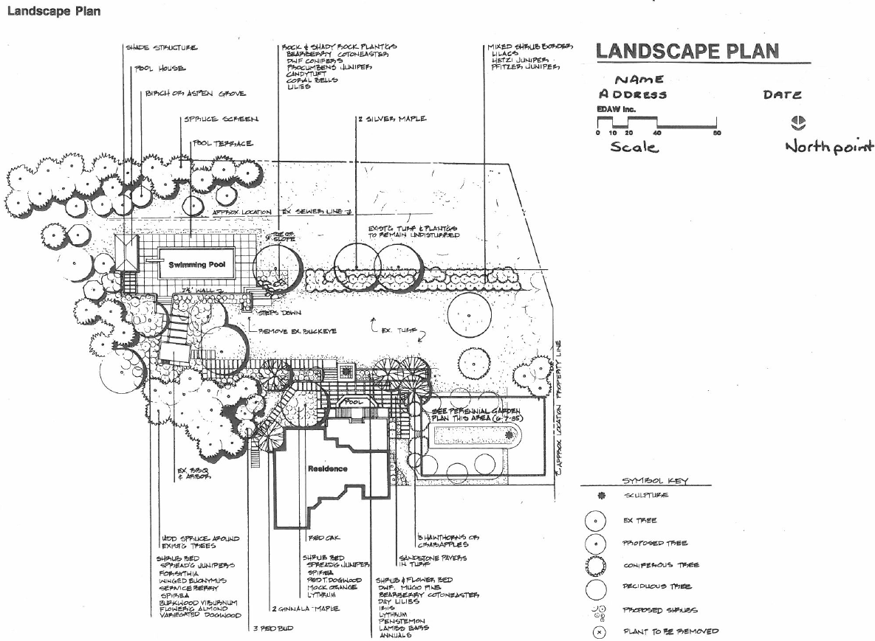

Response
Shade structure pool house, burch/aspen grove/ spruce screen, pool terrace, rock and shady rock planters, mixed shrub border, property line, sewer line, perennial garden, existing turf and plantings, steps, swimming pool , pool, sandstone pavers in turf, existing bbq and arbor,

Outcome for Activity 2 | ☐ Satisfactory  ☐ Not satisfactory
Trainer/Assessor comments

List the materials required for the concrete block retaining wall construction plan shown.

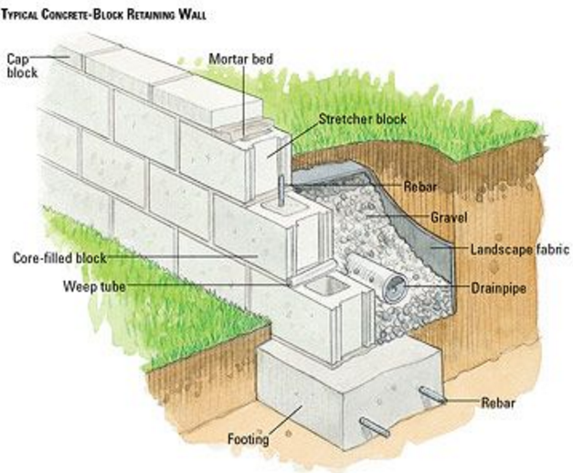

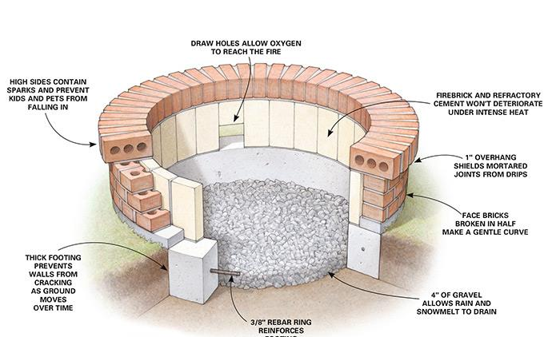

Response
Blocks, cap blocks, mortar, reo bar, gravel, landscape fabric, drainpipe, weep tube, concrete to fill block wall and for footing

Outcome for Activity 3 | ☐ Satisfactory  ☐ Not satisfactory
Trainer/Assessor comments

Research and identify the standard dimensions of brick and concrete blocks.

Response
A standard besser block measures 390mm long x 190mm high x 190mm wide. But when it is laid in 10mm mortar then those dimensions become 400mm long x 200mm high(x 190mm wide)

You can also find Besser block in these sizes:
- 390mm long x 190mm high x 140mm wide. (known as 150 series blockwork).
- 190mm long x 190mm high x 190 wide.
- 390mm long x 190mm high x 290mm wide (300 series blockwork).
- 390mm long x 190mm high x 90mm wide (100 series bricks)
The standard brick size (or the working size) is 76mm high, 230mm long and 110mm wide as per the Australian Standard AS4455. Some bricks are made with different work sizes. 50 mm and 90 mm high bricks, 90 mm wide bricks and 290 mm long bricks are used for different structural and aesthetic effect. Larger bricks are often used for more economical laying and as a design feature either on their own or combined with smaller bricks.

In cyclonic areas larger (140 mm wide x 90 mm high x 290 mm long) hollow bricks are used to allow reinforcement and grouting in the wall. Wider (150 mm wide) bricks can also be used in walls requiring lower sound transmission, higher fire resistance levels and higher load bearing capacity depending on the specific brick properties.

Outcome for Activity 4 | ☐ Satisfactory  ☐ Not satisfactory
Trainer/Assessor comments

List the components for four (4) common surface drainage systems used in landscape construction.

System | Components
- Spoon | Spoon drains are shallow channels that are usually made from concrete and can be installed around the garden to redirect this excess water to other parts of the garden or to inlets for subsoil drainage systems
- Channel and grate | The channel and grate pit is used near the edge of houses or at the bottom of steep driveways to collect a large flow of water. The channel is set in concrete and the water will fall into the grate, The drain consists of a horizontal trench that is open on top; the trench grate covers the top of the trench and allows water to flow into the drain along its entire length
- Pit | A pit may be placed in the low point of a yard so that the water falls into the pit and goes into the drainage and out of the yard.  A stormwater pit is a water collection pit or storage container for stormwater that holds all the runoff before it drains away through the connected drainage pipes. Stormwater pits are made of pre-cast concrete with a number of outlets for drainage pipes
- Contour | Contour banks are surveyed using a slight fall to ensure that water does not pond behind the bank, but runs to a waterway without scouring the bank channel itself. The length and spacing of banks are designed to suit the slopes and soil types

Outcome for Activity 5 | ☐ Satisfactory  ☐ Not satisfactory
Trainer/Assessor comments

List the advantages and disadvantages of drainage behind and through the build wall (as shown).

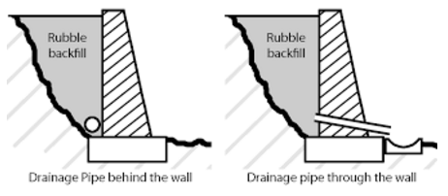

Drainage pipe behind the wall
Advantages
It looks better than having something sticking out of the front of the wall

Disadvantages
It may not drain as well as the pipe through the wall because there is usually only one outlet.

Drainage pipe through the wall
Advantages
Better drainage for the water to get out from behind the wall, can have multiple outlets if wanted.

Disadvantages
It doesn’t look nice with a pipe or conduit coming out of the wall.l

Outcome for Activity 6 | ☐ Satisfactory  ☐ Not satisfactory
Trainer/Assessor comments

Research and list a variety of admixes.

Admix | Description
- Set retarding | To delay the chemical reaction that takes place when the concrete starts the setting process.
- accelerating | Are used to making the concrete go off quicker in colder conditions
- Brickies Mate | Designed to make mortar more workable and reduces segregation and surface laitance.
- Water reducing | When added to concrete can create a desired slump at a lower water slump ratio than what is normally designed

Outcome for Activity 7 | ☐ Satisfactory  ☐ Not satisfactory
Trainer/Assessor comments

Research other methods of damp proofing (excluding DPC and base course) and identify the materials used.

Damp proofing method | Materials
- Integral damp proofing | In the integral damp proofing method certain water proofing compounds are added to the concrete mix, so that it becomes impermeable
- Surface treatment | In the surface treatment method a layer of water repellent substances or compounds are applied on these surfaces through which moisture enters
- Cavity wall construction | In this method the main wall of a building is shielded by an outer skin wall, leaving a cavity between the two. The cavity prevents the moisture from travelling from the outer to the inner wall.
- Guniting | In this method a mixture of cement and water is forced by cement gun on the surface to be made water proof. Later 1 : 3 or 1 : 4 cement mortar is applied to the surface with pressure using compressed air. Thus an impervious layer of mortar is provided

Outcome for Activity 8 | ☐ Satisfactory  ☐ Not satisfactory
Trainer/Assessor comments

Research the suitability of the different types of bonds across various brick/block work projects.

Bond | Brick/block work project suitability
- Stretcher bond | The limitation of stretcher bond is that it cannot make effective bonding with adjacent bricks in full width thick brick walls. Walls constructed with stretcher bonds are not stable enough to stand alone in case of longer span and height, they need supporting structure such as brick masonry columns at regular intervals. These bonds are commonly used in the steel or reinforced concrete framed structure as the outer facing. They are also used as the outer facing of cavity walls. Other common applications are boundary and garden walls.
- Flemish bond | Flemish bonds have better appearance but are weaker than English bonds for load bearing wall construction. If the pointing has to be done for brick masonry walls, then Flemish bond may be used for better aesthetic view. Requires skilled workmanship.
- English bond | This produces a solid wall that is a full brick in depth, is easy to lay and is the strongest bond for a one-brick-thick wall. These bonds are used for load bearing wall construction. The appearance is not as pleasing as Flemish bonds, so if walls have to be plastered, it is better to use English bond. They are a more expensive construction.
- Honeycomb bond | In a brick wall, the omission of some headers or stretchers either to provide ventilation or to serve as a decorative element or provide a screened effect.

Outcome for Activity 9 | ☐ Satisfactory  ☐ Not satisfactory
Trainer/Assessor comments

Research and list the specifications for mortar beds and perpend (perps).

 | Specifications
- Mortar beds | Mortar placed horizontally below or on top of a brick  Mortar joints (both bed and perpend) are usually specified as nominally 10 mm in thickness. Any raking, if specified, should not exceed 10 mm depth and should not penetrate closer than 5 mm to any core or perforation in cored units or to within 20 mm of the cores in hollow units. Tooling of joints is particularly beneficial in improving durability and must always be carried out as specified.  For AAC Block construction a special type of mortar is used, 2-3mm and this is a pre-mis cement based product with higher quality than normal mortar.
- Perpend | Mortar placed vertically between bricks  Mortar joints (both bed and perpend) are usually specified as nominally 10 mm in thickness. Any raking, if specified, should not exceed 10 mm depth and should not penetrate closer than 5 mm to any core or perforation in cored units or to within 20 mm of the cores in hollow units. Tooling of joints is particularly beneficial in improving durability and must always be carried out as specified.

Outcome for Activity 10 | ☐ Satisfactory  ☐ Not satisfactory
Trainer/Assessor comments

Provide a bricklaying definition for a ‘pig in the wall’.

Response
A pig in a wall is when the courses are uneven. Which could end up building in a spiral of brick work on a house. This can be caused by uneven mortar.

Outcome for Activity 11 | ☐ Satisfactory  ☐ Not satisfactory
Trainer/Assessor comments

List environmentally safe products for cleaning.

Response
Oxygen bleach for moulds, mildew and algae.
Rake and brush joints as you go during laying should reduce the need for cleaning
Pressure cleaning ( using appropriate pressure and distance from the wall )

Outcome for Activity 12 | ☐ Satisfactory  ☐ Not satisfactory
Trainer/Assessor comments

Have team members take photos and videos of your involvement with brick/block features.

Identify each photo / video with a letter label and describe each photo / video in the table below. Submit the photo / video files along with this workbook.

Advantages
A | Prepare work site
B | Digging footings using dumpy level for correct levels
C | Pouring concrete footings to string line level.
D | Concrete footings poured.
E | Levelling first course of blocks with level and string line.
F | Levelling first course of blocks with level and string line
G | Levelling of footings
H | Check levels, length and crossways
I | Check level of top course
J | Knock out clear to allow for core fill
K | Core filling with gravel
L | Core filling and back filling with gravel
M | Installing draining pipe
N | Wall ready for caps
O
P
Q
R
S
T
U
V
W
X
Y
Z

Outcome for Activity 13 | ☐ Satisfactory  ☐ Not satisfactory
Trainer/Assessor comments

