Skills and Knowledge
- Create three different documents using two different software applications in each. Ensure these follow any organisational policies or requirements that are in place, are correctly presented and can be printed for presenting at a meeting – write a brief dialogue for your presentation on each document, stating what they are and their purpose.

I have created a PowerPoint that I would use alongside the original document to present in a meeting. The PowerPoint includes 3 parts, 1 for each document. This will be submitted separately

Document 1: Credit Card Policy
Created with Microsoft word
Document objective: letter of agreement between company and employee for an employee to have possession of a company credit card.

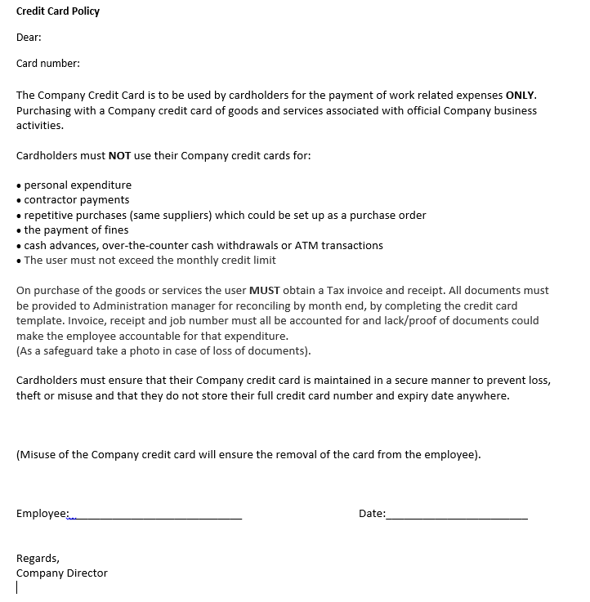

Document 2: Certificate of Practical Completion
Created with Excel
Document objective: Certain sites (such as government sites) that Securcom have done work at distribute a certificate of practical completion to the company. This document lists where we have received a certificate.
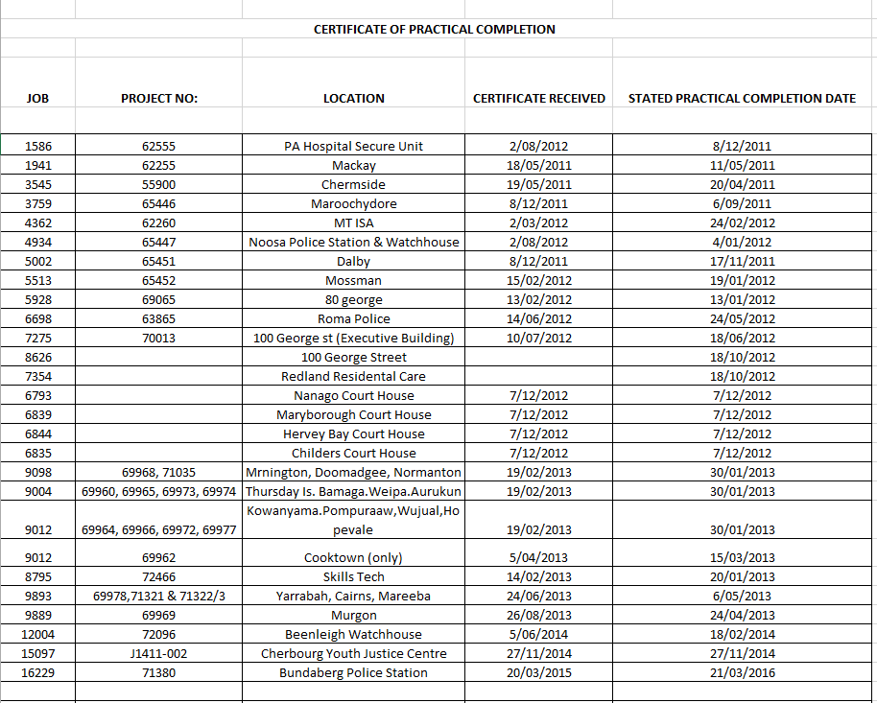

Document 3: General Office procedures
Created with Microsoft word
Document objective: To inform staff of the policies and procedures when working in the office as well as tasks that will be required whilst working in the office.

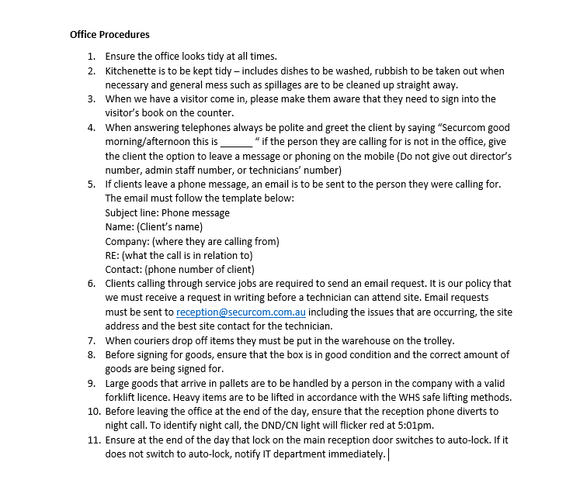

Major Activity

Using one type of business document as an example:

- Select the appropriate technology and software applications to use.
Appropriate Technology and software applications to use to create this business document would be Microsoft word

- Select the layout and style you would use and explain how this related to organisational requirements.
I would follow the organisational exemplar to use decide on an appropriate layout and style.

- Explain how you could use basic design principles to ensure design is consistent with requirements.
Basic design principles I will consider to ensure that my document design is consistent with requirements will include:

Contrasting colours & elements
To highlight key elements and make them stand out. This will guide the reader’s attention and where I want them to notice first. I will create contrast by using different colours as well as lines, shapes and fonts.

Alignment
Each item on the page will have visual connection with something else on the page.

Repetition
Visual elements will be repeated throughout the document to strengthen design, ensure consistency and to connect individual elements.

Proximity
I will ensure to group together related items when creating the business document. This will provide focal points and relationships between elements within groups.

- Say you were to discuss and clarify this with the person that has requested this document; when would you do this? What would you discuss?
I would discuss and clarify this with the person that requested the document during the process of creating the document. I would discuss the how effective the layout and design of the document is and if I should be making any amendments to improve it.

- Identify the files and records you would need to open and/or generate. Briefly describe this process.
I would need to open the company’s Policies and procedures and relevant records relating this. The company policies and procedures are available on the company common drive however to access records I would need to discuss with a manager or director as that is classified information.
- Outline ways in which you would design your document to ensure efficient entry of information.
To ensure that I am efficient in entering information into my business document, I will design the document so that the client needs to fill out the required information by using boxes to tick, dashed lines, etc. By using this design will ensure that correct information has been received from a reliable source.

- Outline the functions that you would use to ensure consistency of design and layout.
Functions to consider to ensure consistency in the design and layout of the document include:
- Alternating headers and footers
- Editing
- Merging Documents
- Spell checking
- Table formatting
- Using columns
- Using styles

- List the input devices that you would need to use in order to develop your document.
Input devices that I would require to develop my document include:
- Keyboard
- Mouse
- Numerical Key Pad
- Scanner

- Describe the techniques you would use in order to meet the designated time line.
Techniques I would use in order to meet the designated time line include:
- Recording deadlines
- Prioritising tasks
- Keeping track of progress
- Ensure I choose the best technology and software
- Knowing how to deal with possible problems that may arise

- List the aspects of the style and layout of your document that you would need to check meet the requirements.
Aspects of the style and layout of my business document that I will need to check to ensure it meets the requirements include”
- Line spacing
- Paragraph spacing
- Margin size
- Justification
- Text size
- Text colour
- Font
- Structure
- Use of bold, italics
- Page numberings
- Page breaks
- Table properties
- Image properties

- Outline how you would save and store your document in order to avoid loss of data.
I would save and store the document both physically and electronically because there is the possibility of the document being lost or damaged either way. So if the document is stored both electronically and physically so in case something does happen to the document, there is a way we can still access it.

- If you were to face basic difficulties, where would you turn?
If I were to face any basic difficulties I would refer to either a manual, training booklet or the help-desk.

- How would you proofread your document?
To proofread my document I would:
- Make sure that I know what I am looking for
- Work from a printout
- Read out loud
- Cover Lines below with a blank sheet of paper
- If you were to find mistakes when proofreading, how would you rectify these?
If I were to find a mistake whilst proofreading, I would underline, highlight or flag the error in some way so once I have finished proofreading I can go back and correct my errors.

- Describe how you would name and store your document.
To name my document I would consider:
- Using Keywords
- Using my name or initials
- Using the date
- Using alphabetical codes
- Using version numbers
- Being detailed
- Being consistent

- Give details on how you would print your document.
To print my document I would follow the below steps
- Click File
- Click Print
- Choose the amount of copies that will be needed
- Alter the setting so that they meet the requirements
- When satisfied, click Print

