CPCCBC4012B
Read and interpret plans and specifications

THEORY EXAM INSTRUCTIONS

- This exam will occur under standard assessment conditions.
  - An oral examination may be allowed under certain circumstances.
Answers will be documented and FT003 (Oral examination declaration form) must be completed.
- Participants must provide enough detail in their responses to demonstrate their knowledge and skills.
- Please fill in the details below, providing your name, signature and date of assessment.
  - Your signature acknowledges that this is your own work.
- If a participant initially answers a question incorrectly but modifies their response, they must follow the instructions below:
  - If a participant changes their response in writing, they must put their initials next to the written change.
  - If a participant changes their response verbally, this must be noted on the exam paper by the assessor.

Participant name | Karl Kain
Participant signature | 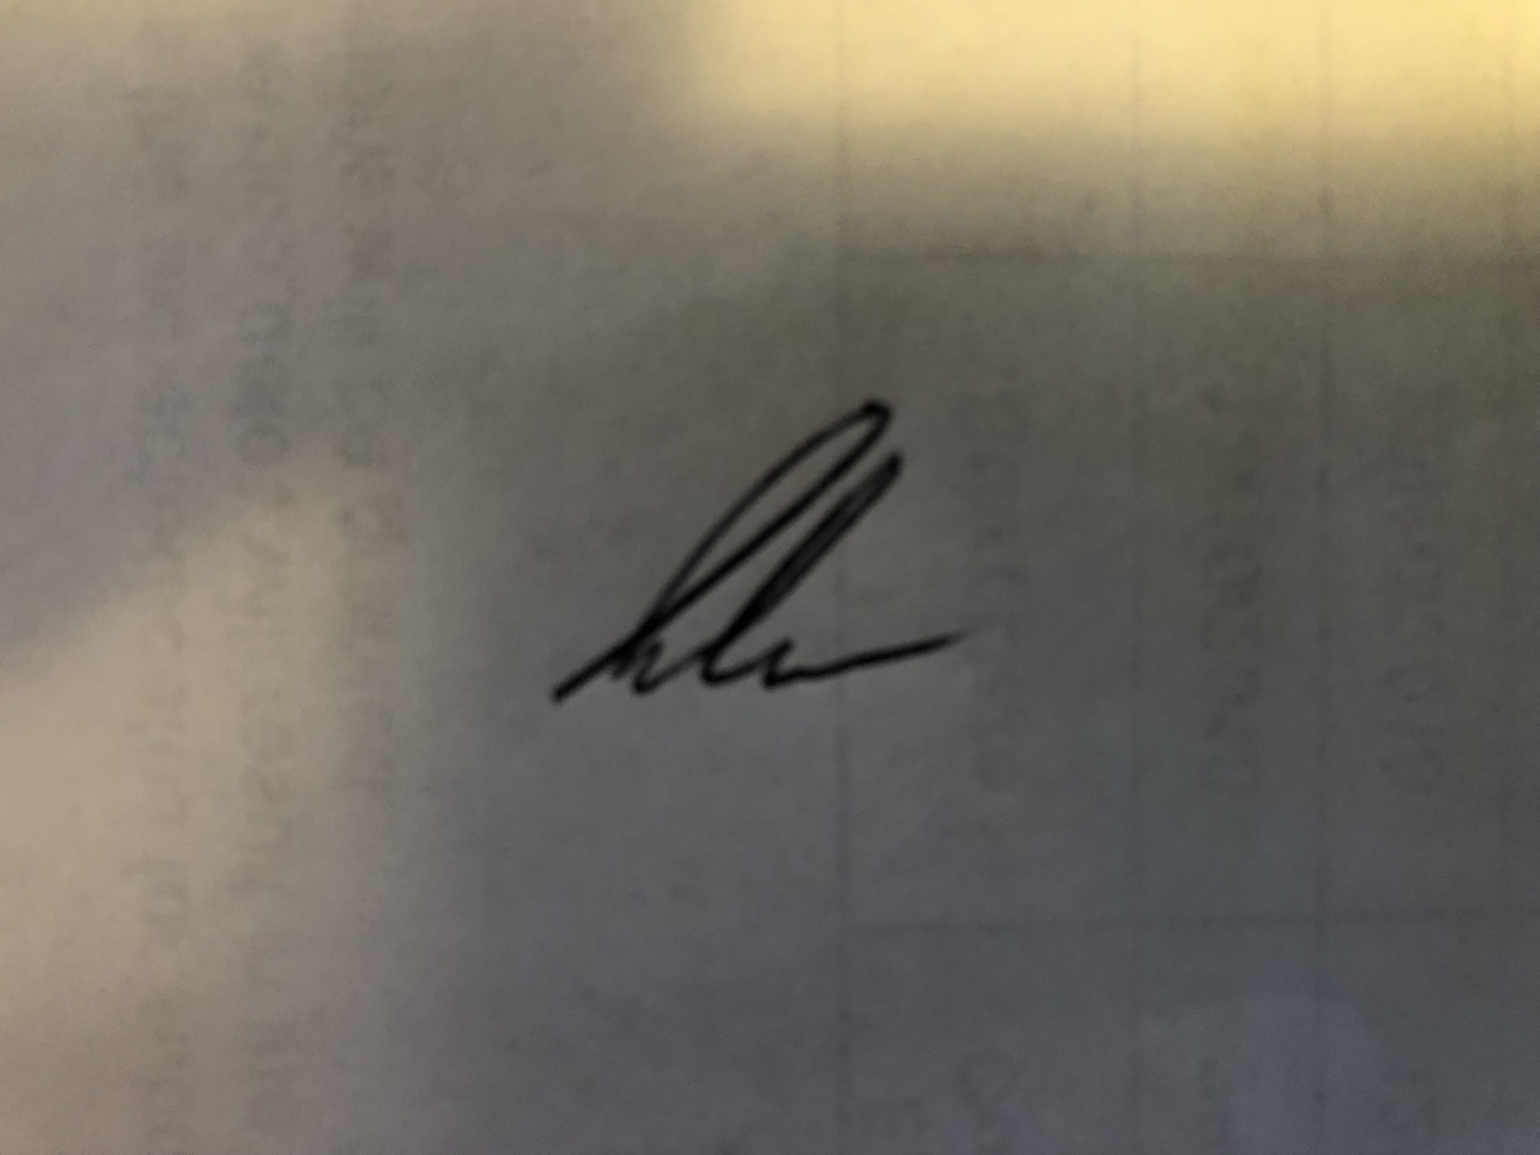

Assessor name
Assessor signature | 

Date | 13/08/2019

Number of questions | Number of questions answered correctly | Satisfactory?
87 |  | Yes | No
Assessor Comments
- Plans and specifications are used to inform which of the following processes? Tick all that apply.

Answer | Choice | Possible Answers
 |  | Building contracts
 |  | Development applications
 |  | Estimation
 |  | Planning
 |  | Supervisory tasks
 |  | Tenders

- Which compass direction is always shown on plans and drawings?

Answer | North

- What information is provided on a location plan?

Answer | A location plan provides an illustration of the proposed development in its surrounding context. This enables the planning authority to properly identify the land to which the application refers, and is typically based on an up-to-date map

- What detail does a site or block plan contain?

Answer | The site plan (also known as a block plan) should be drawn at an identified standard metric scale (typically 1:100, 1:200 or 1:500). It should show the proposed development in relation to the site boundaries and other existing buildings on the site, with dimensions specified including those to the boundaries.

- What do floor plans identify?

Answer | A floor plan is a drawing to scale, showing a view from above, of the relationships between rooms, spaces, traffic patterns, and other physical features at one level of a structure. Dimensions are usually drawn between the walls to specify room sizes and wall lengths, also shows detail of the proposed structure, such as rooms, positions of fixtures, floor coverings

- What is a landscape plan and what information might it provide?

Answer | A landscape concept plan is a scaled drawing of a development conceptually showing the extent, function, context and attributes of areas to be landscaped. The scope of a landscape plan may extend to works outside of the site, such as streetscape works or overhanging vegetation located on adjoining sites, also shows details of plants, paths, garden layouts and retaining walls

- What are elevation views? What do they provide to the plan reader?

Answer | View of the proposed structure from its sides (i.e. from north, south, east and west). Each side is what is called an elevation view.

- What is a section?

Answer | In most cases elevation and plan views cannot show sufficient information to enable a builder or tradesman to see how various structural parts are to be built or assembled. The section is a view of the house after it has been cut vertically at some point. Like the floor plan it shows the size and thickness of structural members and relationships between spaces.

- What are detailed drawings?

Answer | Detail drawings provide a detailed description of the geometric form of a part of an object such as a building, bridge, tunnel, machine, plant, and so on. They tend to be large-scale drawings that show in detail parts that may be included in less detail on general arrangement drawings.

- What are specifications?

Answer | are the details for the work that needs to be completed in a construction project. These details include information such as materials, the scope of work, installation process, and quality of work.

- Explain the meaning of the abbreviations in the table below.

Answer | Abbreviation | Meaning
 | ACRYL | acylic
 | AS | Australian Standard
 | ASSD | Assumed datum
 | B | Basin
 | BN | Bull nose
 | BTH | Bath
 | BWK | Brickwork
 | CB | Concrete block
 | CF | Concrete floor
 | CG | Clear glass
 | CJ | Ceiling Joist
 | CORR | Corrugated
 | CWT | Cold water tank
 | DG | Double glaze
 | DH | Double hung
 | DPC | Damp proof course
 | DSB | Distribution switch board
 | DW | Dishwasher
 | EJ | Expansion Joint
 | FPBD | Fibrous Plaster Board
 | FFL | Finished floor level
 | FHR | Fire hose reel
 | GPO | General purpose outlet
 | HBD | Hardboard
 | HTR | Heater
 | HWD | Hardwood

- Name each of the drawing symbol images shown in the table below.

Answer | Name | Image
 | Wall - Cavity brick | 
 | Wall - Brick veneer | 
 | Wall - Timber stud | 
 | Window - In cavity wall | 
 | Window - In single wall | 
 | Door - Swing single | 
 | Door - Swing double | 
 | Door - Sliding into pocket | 
 | Door - Sliding exposed on wall | 
 | Socket outlet (power) - general | 

- Identify what the following window symbols represent on elevations.

Answer | Item | Drawing
 | Hinged on side | 
 | Hinged on top | 
 | Sliding horizontally | 
 | Fixed | 

- What does a clouded area on a plan indicate?

Answer | A revision cloud is an often-used means to indicate that certain areas of a drawing contain revisions. The cloud draws attention to the revision.

- An amendment to specifications could relate to which of the following? Tick all that apply.

Answer | Choice | Possible Answers
 |  | Contact details of all construction crew members
 |  | Materials or products used
 |  | Methods of carrying out specified work

Refer to the title block below to respond to Q16. to Q18.

Source: http://www.dtwd.wa.gov.au/sites/default/files/teachingproducts/BC1934_CCBY.PDF

- On what date was an amendment made to the window details?

Answer | 05/10/2011

- True or False (Tick your response): Details of the window in Q16. should also be reflected in the specifications and confirmed with the client.

Answer |  | True
 |  | False

- What amendment occurred on 08/11/2011?

Answer | Bedroom 3 robe deleted

Refer to the site plan below to respond to Q19. to Q26.



- What structure is being built on this site? Tick your response.

Answer | Choice | Possible Answers
 |  | Residence
 |  | Road
 |  | Shed
 |  | Water meter

- What is the Lot number of this site?

Answer | Lot 16

- What is the size of this lot?

Answer | 3653m square

- Is the shed at the north-east of the proposed structure to be removed or retained? Tick your response.

Answer | Choice | Possible Answers
 |  | Removed
 |  | Retained

- True or False (Tick your response): The sewer is at the eastern boundary of the property.

Answer |  | True
 |  | False

- True or False (Tick your response): The driveway is located to the south of the proposed property.

Answer |  | True
 |  | False

- What size is the easement on the eastern boundary of the site?

Answer | 5 metres

- True or False (Tick your response): The stormwater drain is constructed from PVC pipe.

Answer |  | True
 |  | False

Refer to the contour plan below to respond to Q27. to Q28.



- What is the level at the northernmost point of the site?

Answer | 3.94

- Which end of the site has the lowest level? Tick your response.

Answer | Choice | Possible Answers
 |  | East
 |  | West

Refer to the sectional drawing below to respond to Q29. to Q49.


- Give a brief description about the building from the detail available in the sectional drawing. Is it the same structure proposed in Q19. to Q26. ?

Answer | It is the same proposed Structure in Q19-Q26.  It is a side elevation cross section of proposed building.  Has details of timbers, sizes and grades to be used.  An centres or spacings

- Who is the client?

Answer | H & M smith

- Where is this project to be built?

Answer | Lot 16 Glenvalley road, Richmond

- What are the contact details for the draftsman?

Answer | Joe Foreman, 03 95142311, 0413 113 113  18 Fairview Road, Ricmond 3216

- What sheet number is this drawing?

Answer | 5 of 7

- What timber is required for loading and non-load bearing walls?

Answer | F5 common studs and Jamb studs in various sizes

- What spacing is recommended for common studs?

Answer | 600 max centres

- What type of roof truss is to be installed?

Answer | Scissor Trusses

- What centres are the trusses positioned at?

Answer | 900 centres

- What size are the veranda posts?

Answer | 90 x 90

- What timber species are the veranda posts to come from?

Answer | DAR OREGON

- What pitch is the roof?

Answer | 30 degees

- What size are the noggings and at what spacing?

Answer | 35 x 70 1350mm max spacings

- What size are the ceiling joists?

Answer | 240mm

- What timber is used for roof battens and what spacing?

Answer | 35 x 70 FG pine battens at 900 centres

- What thickness is the plasterboard sheeting?

Answer | 10mm

- What type of flooring is to be installed?

Answer | 15mm plywood flooring

- What is the roof cladding material?

Answer | Colorbond corrugated metal roofing

- Where will you find information about the footings?

Answer | Section a-a  Refer to engineers drawing for all footing details

- What do the letters ‘DAR’ refer when timber ordering?

Answer | Dressed treated pine (DAR)  DAR indicates that the timber is dressed all round, which means simply that it has been planed smooth on all surfaces. ... This is a machined finish with a finely bevelled appearance on the surface of the timber.

- Explain what ‘240 x 63 LVL’ refers to on the sectional drawing. What do the letters ‘LVL’ refer to?

Answer | Laminated veneer lumber (LVL) is an engineered wood product that uses multiple layers of thin wood assembled with adhesives. It is typically used for headers, beams, rimboard, and edge-forming material  240mm high x 63mm wide Laminated veneer lumber is what that means

Refer to the drawing below to respond to Q50. to Q65.



- What is the number of the drawing?

Answer | 2

- What is the Job Number?

Answer | OOR-112

- What is the scale of the drawing?

Answer | 1:100

- What does the drawing show?

Answer | The proposed buildings Elevations north, south, east and west. Plus Section of a cross section of the house

- Which view shows the front of the house?

Answer | East Elevation

- How many motor vehicles can be parked in the garage?

Answer | 2

- What are the window and doors made from?

Answer | Aluminium Framed windows, Aluminium sliding windows and doors and Timber doors

- What is the size of the eaves?

Answer | 450mm

- What are the eaves lined with?

Answer | Hardfiflex

- What type of roof structure is the roof built from?

Answer | Timber Framed roof Trusses

- Which Part of the NCC should be read for more detail about the requirements for the roof structure in Q59. ?

Answer | Volumne 2  Acceptable Construction Manuals  3.4.3.0

- Which Australian Standard should be read for more detail about the roof structure in Q59. ?

Answer | (b) Design of nailplated timber roof trusses: AS 1720.5.

- What is the roof cladding materials made from?

Answer | Concrete Roof tiles

- Which Part of the NCC should be read for more detail about the roof cladding materials in Q62. ?

Answer | 3.5.1.2 Corrosion protection and compatibility requirements for roofing

- Which Australian Standard should be read for more detail about the roof cladding materials in Q62. ?

Answer | Metal roofing AS 1562.  Plastic sheet roofing: AS/NZS 1562.3.  Roof tiling: AS 2050.  Terracotta, fibre-cement and timber slates and shingles: AS 4597.  the roof tiles comply with AS 2049

- What is the roof pitch?

Answer | 22.5 degrees

- Identify one (1) regulatory body you may need to submit plans to for approval?

Answer | Private building certifiers

- Briefly describe the approval process and timeframes for an approval through the regulatory body in Q66.

Answer | Private certifiers are independent of local government and take full responsibility for the work that they certify. The private certifier will issue the approval and see the project through to its final outcome with no input from council. With every application, you will need to fill out a Notice of Engagement Form. Building approval is generally 4-6 weeks.

- What is a prime cost (PC) item? Give an example.

Answer | If u quote a door for $440 and client wants a $500 door, then a Vartion will be needed to cover the $60

- What is a provisional sum (PS) item? Give an example.

Answer | For example a building site may seem sandy and clean with minimal siteworks required, however, there may be large limestone rocks/tree trunks concealed below the surface which only emerge once siteworks commence, causing cost overrun.

Refer to the Bill of Quantities below to respond to Q70. to Q76.




Source: http://organizedbuilders.com.au/sites/default/files/BOQ-Summary.pdf

- True or False (Tick your response): This Bill of Quantities represents a job for a two-storey house.

Answer |  | True
 |  | False

- Identify two (2) materials being used for the floors?

Answer | Tiles and carpet, vynil and floating floors

- True or False (Tick your response): A landscaper has been contracted for this job.

Answer |  | True
 |  | False

- How much does the contracted plasterer cost?

Answer | $12,900.00

- How much do the kitchen appliances cost?

Answer | $2,700.00

- What percentage of the total cost does the fixing stage represent of the building contract?

Answer | 23%

- What percentage of the total cost does the completion stage represent of the building contract?

Answer | 17%

Refer to the Purchase Order below to respond to Q77. to Q82.


Source: http://organizedbuilders.com.au/sites/default/files/Databuild-Bill-of-Quantities.pdf

- How many Pine F5 90 x 45 studs (2.4m long) are required?

Answer | 100

- If the material in Q77. increased in cost to $2.75 each, what would be the total cost for this material?

Answer | $275.00

- How many sheet of ply are required in total (i.e. all sizes)?

Answer | 13

- What material has the highest total cost?

Answer | Pine 90 x 45 mgp10

- How many metres are required of the material in Q80. ?

Answer | 322.5m

- What beam is identified as being a better option than F17?

Answer | E14 beams

Refer to the labour chart below to respond to Q83. to Q86.


Source: https://www.archsd.gov.hk/media/89170/sor2013_vol1_builders_works_2013_11_04.pdf

- Based on the hourly rates given, which is the least expensive trade to contract?

Answer | Asphalter (road construction)

- If the trade in Q83. were to be contracted for two (2) hours’ work, how much would this cost?

Answer | $214.80

- Based on the hourly rates given, which is the most expensive trade to contract?

Answer | Bar Bender and fixer

- If the trade in Q85. were to be contracted for six (6) hours’ work, how much would this cost?

Answer | $1285.80

- Name the building legislation (Act and Regulations) that apply within your jurisdiction and should be referenced when reading plans and building contracts.

Answer | Queensland Building and Construction Commission Regulation 2018

