CPCCBC6018
Manage processes for complying with legal obligations of a building and construction contractor

ASSESSMENT SUMMARY

The assessment activities for CPCCBC6018 Manage processes for complying with legal obligations of a building and construction contractor cover all aspects of the unit of competency. For Apprentices/Trainees, this includes supervisor completion of the Apprentice/Trainee Record (ATR).

Participants must read all the information given before starting any assessment task. The assessment tasks are intended to be fair, flexible, valid and reliable. If a Participant has any questions or requires alternative arrangements to be made such requests should be directed to their Trainer/Assessor, who should note such arrangements in the ‘Assessor Comments’ on the affected assessment. If a Participant feels they are not yet ready to be assessed, they should discuss their options with their Trainer/Assessor.

To satisfactorily complete the assessment, the Participant is required to answer all questions correctly and demonstrate their skills to industry standards. If a Participant does not answer all questions or perform all tasks, they will be deemed ‘Not Satisfactory’ for the task and ‘Not Yet Competent’ for the unit of competency.

The Trainer/Assessor can provide the Participant with additional information on interpreting the assessment outcomes and guide the Participant’s options. If a Participant is still deemed ‘Not Satisfactory’ they will have the opportunity to undertake a supplementary assessment or appeal the result as per the process in the Student Handbook.

By signing below, the Participant acknowledges:
- They understand the assessment instructions and requirements, and consent to being assessed.
- The work submitted is to be their own work – with the work of/with others needing to be clearly acknowledged and documented.
- They consent to any photo/video recording of their work that occurs during assessment.

Participant name | Brett Eldred
Participant signature | 

Pre-requisite unit(s) to be achieved and authenticated prior to undertaking assessment
Not applicable

Task | Date completed | Assessment Results
Theory Exam | Select Date. | Satisfactory | Not Satisfactory
Workbook | Select Date. | Satisfactory | Not Satisfactory
Practical Assessment | Select Date. | Satisfactory | Not Satisfactory
Outcome for CPCCBC6018 | Select Date. | Competent | Not Yet Competent

Evidence requirements checklist (ticked by assessor and evidence supplied to RTO)
Theory Exam  Workbook  Practical Assessment  Copy of contract reviewed  Screenshot/ doc. of management system introduced and managed | 1 x ea. Policy & procedure - record & legal documents storage  Screenshot/ doc. system managed re: insurance and taxation  1 x ea. Policy & procedure re: payments  Code of conduct developed  Screenshot / copy of EMP compliance actions.

Assessor name
Assessor signature | 

CPCCBC6018
Manage processes for complying with legal obligations of a building and construction contractor

THEORY EXAM

Participant name | Brett Eldred

FOR THE PARTICIPANT
Instructions
- You will complete written questions as outlined on the following pages. You must attempt all questions and provide enough detail in your responses to demonstrate your knowledge.
- It is anticipated that you should complete this assessment within two (2) hours, but additional time may be allowed upon negotiation with the Assessor.
- You must complete all questions unassisted by the Assessor or other personnel but may refer to reference material as needed. All questions must be answered correctly for a ‘Satisfactory’ assessment outcome to be awarded.
  - An oral examination may be allowed under certain circumstances, whereby your answers will be documented by another party.
  - Any written questions that are incomplete, or not answered satisfactorily will need to be completed again after further training support.
    - If you answer a question incorrectly but modify your response, put your initials next to the written change (or the Assessor must initial a verbal change).
Resources required
Pen

FOR THE ASSESSOR
Instructions
- Where oral examination has occurred, ensure that this is acknowledged in writing (e.g. FT001 and Assessor Comments)
- All questions must be satisfactorily demonstrated by the Participant for a Satisfactory determination (indicated by an Assessor tick to the right of the question).
- Assessors are to complete marking in pen of a different colour to the Participant.
- If the Participant verbally modifies their response, write in the modified response verbatim and put your initials next to the written change.

ASSESSOR COMMENTS
As necessary, outline:
- Details on reattempts, alternative arrangements or reasonable adjustments made.
- Where a Participant is deemed ‘Not Satisfactory’, provide recommendations for future training.

- Discuss the following types of building contract and identify provisions relating to these in the State/Territory you are working.

 | State/Territory:
Answer | Contracts | Purpose/requirement
 | Commercial contract | A commercial contract is used exclusively for the construction of commercial buildings. These structures are not for residential use. Building office spaces, stores, hotels, and other enterprises that may require space for a private business are examples of this. Commercial contracts are similar to residential contracts in most cases. Depending on the applicable zoning and other construction rules, additional permissions and paperwork may be required.
 | Residential contract | When constructing a home, a residential contract is required. The Home Building Act governs this form of arrangement. The NSW Home Building Act 1989 lays out the bare minimum of rights for homeowners, builders, and contractors. This includes warranties, payments, deposits, insurance, and other home construction-related issues. This includes the ability to transact with licensed builders, have insurance, and have the requisite warranties in a construction defect. Failure to comply with these has legal ramifications.
 | Lump Sum contract | On a lump sum contract, the customer and the contractor agree on a "fixed fee" for the work to be done before work begins. This contract can be used to build both residential and commercial buildings. A lump sum construction contract is risky because the contractor has fewer options for modifying their price.
 | Sub-contract agreement | A subcontractor agreement between the main contractor and a subcontractor relates to expert work performed on behalf of the main contractor on a construction project.
 | Cost-plus contract | A cost-plus contract specifies that a client agrees to reimburse a construction business for building expenses such as labour, materials, and other costs, as well as an additional payment, commonly expressed as a percentage of the total contract price. Alternatives to lump-sum agreements include this form of a building contract. It allows for flexibility and transparency and lowers a contractor's risk by ensuring a profit. This applies to both residential and business contracts. In a cost-plus arrangement, the customer has the right to see the contractor's expenses in detail. A guaranteed maximum price is also included in some cost-plus contracts.

- Discuss contract terms, conditions, and inclusions you are likely to encounter.

Answer | Contract conditions define the main legal relationship between the parties involved in a building project, influencing risk allocation and, as a result, price. The construction industry has a wide selection of standard contract forms to balance the parties' risks and provide certainty of meaning via extensive and recurrent use. The following are examples of common conditions seen in building contracts:  • Access to the construction site.  • Partial possession.  • Sub-contractors.  • Quality of works.  • Practical completion.  • Insolvency.  • Date for possession, progress, delays, completion date, suspension of works, and termination.  • Sectional completion.  • Joint Fire Code.  • Commissioning.  • Contract sum and adjustment  • Rights of third parties and collateral warranties.  • Contractor's design.  • Dispute resolution procedures and alternative dispute resolution.  • Employer's instructions.  • Information release schedule.  • Force majeure.  • Compensation events  • Injury, damage, and insurance.  • Liquidated damages.  • Net contribution clause.  • Payment, valuation (including off-site materials)  • Certificates, fluctuations, and retention.  • Project management and contract administration.  • Statutory obligations.  • Testing and defects (defects liability period)  • Variations, prime cost sums, and provisional sums.  Specification documents, drawings, bills of quantities, activity schedules, and special conditions must be reviewed with contract conditions. Contract suites containing "back-to-back" subcontracts, consultant appointments, and collateral warranties are common in standard contracts. It's also becoming more common to combine basic conditions with option schedules or extra rules.  Inclusions and variations  A variation is a change to the scope of work in a construction contract that involves adding, substituting, or removing items from the original scope of work.  Almost every construction project deviates from the scope, design, and description given at the start.  Whether small or large, construction projects will almost always diverge from the design team's original tender design, specifications, and drawings.  This can be due to developments in technology, legislation changes or enforcement, changes in conditions, geological anomalies, non-availability of specified materials, or simply the design's ongoing evolution after the contract has been awarded.  Variations may include:  • Alterations to quantities.  • Alterations to working conditions.  • Alterations to the design.  • Alterations to quality.  • Alterations to the sequence of work.  If the contract documents fail to accurately depict the actual works required, variations may be discovered. Because there is no implied ability to seek variations, contracts must include clear language conferring the authority to do so. In the absence of such written terms, the contractor is free to turn down requests for changes without consequence.

- Discuss the importance of adding variation clause to the contract and what you may need to include in the contract documents.

Answer | Almost every construction project deviates from the scope, design, and description given at the start. This can be due to developments in technology, legislation changes or enforcement, changes in conditions, geological anomalies, non-availability of specified materials, or simply the design's ongoing evolution after the contract has been awarded.  Variations may include:  • Alterations to quantities.  • Alterations to working conditions.  • Alterations to the design.  • Alterations to quality.  • Alterations to the sequence of work.  If the contract documents fail to accurately depict the actual works required, variations may be discovered. Because there is no implied ability to seek variations, contracts must include clear language conferring the authority to do so. In the absence of such written terms, the contractor is free to turn down requests for changes without consequence.

- Discuss why builders should keep and maintain records of subcontractors, site supervisors and managers qualifications, competencies, and licences.

Answer | Setting up the correct record-keeping system for your company will help you work more efficiently, meet legal obligations, and improve customer and employee interactions.  Businesses must keep certain records, and there may be additional rules and requirements particular to your industry sector. The laws that apply to your firm dictate the length of time you must keep records. If you are asked to use an electronic record-keeping system, you must produce a hard copy of the record.  Throughout construction projects, appropriate records should be generated and maintained. This produces a real-time record of what happened when and where during the project, which may be referred to if necessary.  This not only creates a project's "memory" or "paper trail," which may be used to assess actions and choices, but it also allows for the reconstruction, examination, and analysis of events and timeframes in the event of a disagreement. Disputes are frequently decided by the records available rather than the facts; therefore, keeping solid records is crucial for the parties involved commercially. There are several reasons to retain records:  - Legal standards must be met.  - Contractual obligations.  - To keep track of the work.  - To provide information for future research.  The amount of record-keeping necessary will vary depending on the project.

- Why would you access the Australian Business Licence and Information Service (ABLIS)?

Answer | It is a resource for existing businesses and those considering launching. ABLIS can help you find applicable state, territory, local, and Australian government licenses, permits, approvals, rules, and codes of practice, so you can get precise information and stay on top of your compliance duties.  With ABLIS:  • Users can quickly find their business activity and location to start a search using intuitive search options.  • A responsive, modern, and user-centred user interface that works on various browsers and devices, including mobile phones and tablets.  • APIs have been built and integrated with the ABLIS user interface to showcase end-user capabilities via traditional web service protocols. Business information and reporting capability that is current, adaptable, and accurate.  • A way for users to provide comments on the ABLIS website.  • These APIs were created to support the ABLIS search capability, which offers users customised lists of government compliance and advisory information based on their business type, location, and responses to questions. The APIs were created to accommodate searches that included:  • All questions and answers.  • All locations in australia  • All types of business activities

- How can you ensure you respond to changes to licensing arrangements in a timely manner?

Answer | You must notify authorities within seven days if your circumstances change and impact your capacity to do the work indicated on your license card. You must apply to vary your license or certificate if you want your license or certificate altered to remove constraints on your employment category.  Consumer and Business Services (CBS) is an Australian government organisation that protects consumers, supports and regulates businesses, and keeps track of major life events for Australians. CBS's actions are customer-focused and adaptable, and it offers easily available services and information.

- Discuss areas of a building contract that may require you to organise professional legal advice.

Answer | • An entity may occasionally have a demand that raises questions, involves risks, or necessitates a certain method. This will necessitate the entity creating a contract that represents these requirements, frequently involving legal, procurement, and technical experts. Typically, these are high-risk or specialised contracts. Specialist advisers may be required to help manage these contracts.  • Legal counsel can assist you in resolving legal concerns arising from your contract. Suppose a situation appears to be escalating into a formal dispute. In that case, if you are considering terminating your contract or need help interpreting the meaning of a phrase in your contract, you should obtain legal advice. They can also help you with any probity concerns you may have.  • If both parties agree on a change in the contract's terms, it should be documented in accordance with its specific criteria. If you have any queries concerning the adjustments or exemptions, please contact your legal counsel or the central procurement department.  • For more sophisticated or strategic contracts, such as long-term contracts, you may want to go over the contract formally (if the contract allows), informally as part of the contract management strategy, or as an independent document. When preparing these documents, make sure you seek help from your central procurement department or a legal expert.  • To fully comprehend the Australian Government's rights under the contract, you may need to seek legal assistance. Avoid doing or doing anything that would jeopardise the Australian Government's rights (e.g., do not pay invoices for goods or services that are defective, undelivered, or unsatisfactory) until you have gotten legal counsel.  • The dispute resolution process may include notice periods, delivery methods, information concerning show-cause notices, and other communication difficulties. Before dealing with any issue that develops, make sure you read and understand the relevant clauses in your contract. If either party invokes the dispute resolution clauses, you should seek legal assistance as soon as possible to safeguard the Commonwealth's interests.  • Arbitration is a formal conflict settlement process in which the parties refer their disagreement to an impartial third party (the arbitrator). The goal of arbitration is typically to obtain a final and enforceable result without the expenses, delays, or formalities associated with litigation. If you're thinking about going to arbitration, seek legal guidance.  • The process of obtaining compensation through the courts or other tribunals is known as litigation. A judge will listen to both parties' testimony and make a binding ruling based on the facts of the case and the application of the legislation. If you're thinking about going to court, you should seek legal counsel beforehand.  • If the goods or services are still required, you may choose to extend the contract for an additional period. If you decide to extend a contract, you must adhere to the contract's extension procedures. Seek legal assistance if you do not meet the requirements for a contract extension.  • You may choose to terminate a contract before it has been finished. This is referred to as contract termination. Early contract termination carries several hazards, including reputational, corporate, financial, and legal problems. If you're considering terminating or cancelling a contract early, you should seek legal counsel before approaching the supplier or taking any action.  • An agreement results in a contract. Even if the deal has not been concluded, the parties to a contract can terminate it at any time if they all agree on the termination. Keep a complete record of the specific provisions of the termination agreement, as well as the rights and obligations of all parties involved. In this circumstance, you should seek legal counsel.  • When a party's contractual rights are transferred to a third party, this is known as novation. This means that the previous contract will be cancelled, and a new one with a third party will be established on the same conditions.  • A supplier selling their firm to a third party during a contract and requesting a novation of the contract to the new business owner is an example of novation. In this scenario, the old contract is transferred to the new business owner (the original contract is terminated, and a new one with the new business owner is established). You will need to get legal advice before novating a contract  • In many Australian Government contracts, the Australian Government can terminate the contract for convenience after giving the provider notice. When this happens, terms that compensate the provider for costs spent or obligations unavoidably committed at the time of termination are frequently included. This is a sophisticated area of law, and the outcome is influenced by the facts of the case and the contract provisions. In this case, you should obtain legal advice.  • If you have a question about these provisions, you should depend entirely on the terms and conditions of your contract and consult with your legal counsel.  • Intellectual property rights are a complicated area of law, and if the contract may entail major intellectual property issues, you should seek separate legal advice.  • In some cases, obtaining a guarantee or security for the supplier's performance may be necessary. This is a complicated area of the law, and you should seek legal counsel before relying on any type of assurance or guarantee.  • It is critical to be informed of the precise clauses of your contract that pertain to confidentiality and exceptions when managing a contract. These laws can be complicated, so if you have any questions, you should seek legal guidance.  • While managing a contract, it is vital to be familiar with the precise clauses in your contract that protect personal information and data breaches. These rules can be complicated, and they frequently allude to the Privacy Act, so it's best to seek legal assistance if you have any questions.

- What processes can you introduce and manage to enable the organisation to obtain effective legal advice relating to contract law?

Answer | Before you sign anything, be sure you properly understand the terms of the agreement. It is advised that you get legal and professional advice beforehand. A contract must contain four key characteristics to be legally binding:  • A proposal  • An acknowledgement  • A desire to establish a legal relationship  • A factor to consider (usually money)  Many facets of running a business may necessitate the hiring of a lawyer for legal guidance, including:  • Analysing, negotiating, and drafting commercial contracts  • Analysing and negotiating a lease for a commercial property  • Deciding on your company's structure  • Purchasing or selling a company.  • Resolving conflicts or disagreements  A legal adviser can assist you in protecting your company's interests while also ensuring that you meet your legal duties. Choose a lawyer who can provide you with the greatest advice and representation by:  • Has dealt with your legal issue before and knows what to do.  • Can convey utilising simple words  • Is simple to find.  • With whom you are at ease.  • Charges you fees that are both reasonable and appropriate.

- Discuss the benefits of having a contract management system in place.

Answer | It's critical that records are preserved to a high standard, or else they won't offer the information that's needed when it's needed. Records should be dated and signed where appropriate (including incoming records), and a document management system should be in place to allow for efficient storage and retrieval.  Information is now commonly managed using specialised software, and some apps make record keeping easier and more dependable. This can allow on-site records to be taken with a mobile phone and then automatically transferred to a project document management system.  A list of documents that may be retained on construction projects is shown below.  - Original contract tender documents.  - Tender negotiations and revisions.  - Sub-contractor tenders, contracts, purchase orders and correspondence.  - Contract administration instructions.  - Contract administration variations and estimates.  - Contractual certificates.  - Contract notices.  - Requests for information.  - Daily time records.  - Daily equipment uses.  - Daily production logs.  - Material delivery and use.  - Labour use.  - Inventories of tools, plants and equipment.  - Asset register.  - Health and safety file.  - Building owner's manual.  - Building log book.  - Building user's guide.  - Testing and commissioning data.  - Certificates and warranties.  - As-built drawings or an as-constructed building information model.  - Statutory approvals, waivers, consents and conditions.  - Equipment test certificates.  - Licences.

- What mechanisms can you put in place to improve communication and dialogue with the client?

Answer | It is possible to learn how to communicate clearly and openly. Some people find it difficult to speak and may require time and support to do so. These individuals may be good listeners, or their actions may speak louder than their words. You may help to improve your communication by doing the following:  - Developing camaraderie: sharing your partner's experiences, interests, and concerns, as well as offering affection and gratitude.  - Sharing closeness: intimacy is more than just a sexual bond. Having moments of feeling close and bonded to your mate creates intimacy. It entails the ability to soothe and be comforted and the ability to be open and honest. Bringing your lover a cup of tea when you notice they are fatigued can be a gesture of intimacy.  - Identifying one or two main subjects on which you can agree, such as how money is distributed, a goal you share, or your parenting techniques or strategies  Begin by asking questions like these to develop your communication skills:  - What are some of the factors that lead you and your partner to disagree? Is it because you're not paying attention to each other?  - What makes you happy and gives you a sense of belonging?  - What disappoints and hurts you the most?  - What topics do you avoid discussing, and what keeps you from doing so?  - What changes would you like to see in your communication with your partner?

- Describe what happens in conciliation.

Answer | Conciliation is one of the many alternative dispute settlements available. Aside from mediation and arbitration, conciliation is a form of alternative dispute resolution. This can be voluntary, court-ordered, or mandated by the construction contract. Conciliation is not a tribunal or a court proceeding. It isn't a public hearing, either. The parties have the option of resolving it in one room with all parties present or separately with the conciliator.  Below are the benefits of Conciliation:  - Faster  - Inexpensive  - Hassle-free  - Efficient  As previously said, this is not a standard legal dispute that is handled in a courtroom. Because conciliation does not include a judge or a lawyer, it appears that it should not be too difficult. More importantly, this method of dispute settlement can help you save a lot of money, time, and effort.  Steps involved in conciliation  - Opening statement  Both parties are given a quick overview of the disputing parties' roles and descriptions. They are also informed about the conciliation rules and the function of the conciliator in the resolution process.  - Each Party's Statement  Each party is supposed to present their side of the argument. The party's interests, arguments, and needs are highlighted and presented to the conciliator in this way. The conciliator will consider all of this to come up with proposals that will satisfy both sides.  - Sessions  The conciliator is supposed to summarise each party's points, as well as their strengths and flaws, at this point. As previously said, the parties are permitted to have joint sessions or dialogues with one another, which the conciliator must strongly encourage both parties to speak directly. They are, however, permitted to meet separately with the conciliator. Additionally, at this stage, the conciliator may offer ideas for resolving the conflict or issues that neither party has considered.  The conciliator is not entitled to make a decision that is legally binding in the case. While resolving the conflict, the conciliator should avoid taking sides. The function of the conciliator is confined to recommending and assisting both sides in getting their points across until they reach an agreement. Furthermore, in most conciliations, lawyers do not represent their clients because the opposing parties are encouraged to resolve the matter themselves. Nonetheless, if one party wishes to be represented by a lawyer, the conciliator must be informed.  - Meetings  Each party is entitled to meet individually with the conciliator to discuss their perspective, including their strengths and flaws. This could also be a time for one of the parties to develop a feasible solution to persuade the other to agree.  - Concluding sessions  At this time, all options have been reduced down, and final agreements have been achieved. If the disputing parties are still unable to agree, the conciliator may advise a next step, in which case both parties must act in good faith.  A construction lawyer can assist you with legal matters. You'll need to discover what conciliation is, what it can do for you, and how to prepare for it, and it's up to a lawyer to tell you what you need to know. A construction lawyer may not be able to defend you, but they can give you the advice you need to ensure you're well-prepared for the conciliation process.

- Why would the builder change/adapt workplace procedures and workplace safety requirements at a new site?

Answer | Specifics of job are unique and hazards & risks identified on a previous site may not be applicable or relevant to another site.  Safety planning and requirements must be considered for each site individually and suit the specifics, hazards and risks applicable each circumstance.

- Discuss strategies you can apply that ensure all workers are inducted, informed, and regularly updated of their on-site safety responsibilities.

Answer | Everybody working on a building site in Australia must attend general construction induction training and obtain a nationally recognised White Card. Once you get this qualification, you can begin working as a basic labourer or apprentice on construction sites to gain experience and learn about all parts of a construction project.  Employees, those working at the workplace, and those who have sufficient control over the workplace are all required by WHS legislation in their respective jurisdictions to protect the health and safety of anyone who their acts or inactions might harm. WHS responsibilities are placed on many duty holders at a construction site because the responsibilities are continuous and overlapping. WHS responsibilities on a building site include:  Under the appropriate WHS Act in each jurisdiction, the responsibility holder is expected to protect the health and safety of those who may be affected as far as is reasonably reasonable. The responsible party must conduct itself under commonly known risk management principles to determine "reasonably possible." The urge to strike a balance is one of them.  - The possibility of the hazard or risk occurring, as well as the severity of the harm that would result if it did.  - The understanding of the hazard or risk and the methods for eliminating or reducing the hazard or risk.  - The expense of removing or lowering the hazard or risk, as well as the availability and acceptability of ways to eliminate or minimise the hazard or risk.  PCBUs are subject to certain general and specialised duties under the model WHS legislation at each stage of the construction process. Consider the following scenario:  - The model WHS Regulations require the person commissioning construction work to speak with the structure's designer about safety issues and provide safety information to the designer and the project's lead contractor.  - A PCBU that performs construction work must manage and control the WHS hazards that come with it. It must also ensure that unauthorised access to a building site is prevented.  - The primary contractor for a construction project is also a PCBU. As such, PCBU must be aware of the WHS obligations that apply to all PCBUs that perform construction work and the unique obligations that apply to principal contractors in that industry.  - The responsibility to be identified by signage posted at the construction site and the need to prepare, review, keep, and tell others about the WHS management plan for the construction project are specific duties that apply to principle contractors.  - As far as is reasonably feasible, the person in charge of a workplace shall ensure that the workplace, the methods of entering and exiting the workplace, and anything resulting from the workplace is all free of risk to any person's health and safety.

- A worker you have employed on the site has been injured and has lodged a request for workers compensation to reimburse their medical expenses. Explain the process you must follow in your State or Territory for claiming on behalf of the worker.

Answer | Every employer is required by law to have:  - Workers compensation insurance.  - Provide adequate work that is (as far as is reasonably practical) the same as or equivalent to the job that was being done at the time of the injury  - Show the poster If you are hurt at work.  - Have a written return-to-work plan that outlines the measures you'll take if a worker is injured.  - Keep track of all work-related injuries.  - All occupational injuries must be reported to your insurance company within 48 hours.  Participate in formulating your insurer's workers' injury management plan and follow the plan's duties. Provide acceptable work (as far as reasonably possible) when a worker can return to work, whether full-time or part-time.  In Qld , Workcover Qld website per following link has step through guide and explanation to assit a injured worker.  https://www.worksafe.qld.gov.au/resources/guides/if-an-injury-or-illness-occurs  Whether you’re an injured worker or an employer, there are steps you must take if a work-related injury or illness occurs. This guide outlines the things you’ll need to do, from seeking medical attention and making sure people are safe, to reporting the injury and making a workers’ compensation claim.  Information in this guide is for both injured workers and employers. Simply explore the section that’s relevant to you.  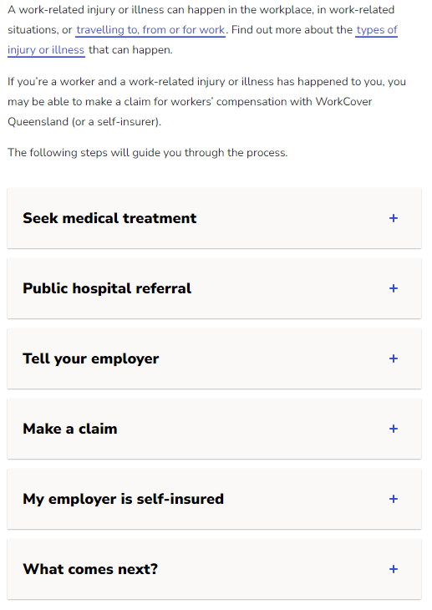

- What is inherent risk in construction? Discuss the factors to be considered in assessing risks inherent in building and construction projects.

Answer | nherent Risk is typically defined as the level of risk in place in order to achieve an entity's objectives and before actions are taken to alter the risk's impact or likelihood

Read the scenario below to respond to Q16. and Q17.

The subcontractor (first-tier subcontractor) you hired for this project is carrying on a business that is primarily in the building and construction industry. He has engaged another subcontractor (second-tier subcontractor) to assist with their current workload.

- What subcontractor payments are you required to report to the Australian Taxation Office (ATO)?

Answer | When you are running a business primarily in the building and construction industry, you must lodge a Taxable payments annual report (TPAR) with the ATO if you:  - Make payments to contractors or subcontractors for building and construction services  - Have an australian business number (abn).  - (payments made to employees are not reported in your tpar.)

- Will the first-tier subcontractor also be required to report to the Australian Taxation Office (ATO)? Explain your answer.

Answer | A first-tier subcontractor works directly for a prime contractor. First tier subcontractors undertaking work individually valued at over $4 million (including GST) for the prime contractor are also required to have a satisfactory tax record.

- As the principal contractor, you will be withholding tax from the payments you make to your workers and contractors through PAYG withholding. Provide the four (4) activities that you must complete in compliance with the Australian Taxation Office’s (ATO) requirements for those who make payments subject to withholding.

Answer  1.  2.  3.  4. | W1 – Total salary, wages and other payments  Amounts withheld from salaries or wages and other payments shown at W1  W4 – Amounts withheld where no ABN is quoted  W3 – Other amounts withheld (excluding any amount shown at W2 or W4)

- Discuss the following types of insurance and the purpose that builders or building companies need to organise them.

Answer | Insurance | Purpose/requirement
 | Workers compensation | Every employer is required by law to have:  - Workers compensation insurance.  - Provide adequate work that is (as far as is reasonably practical) the same as or equivalent to the job that was being done at the time of the injury  - Show the poster If you are hurt at work.  - Have a written return-to-work plan that outlines the measures you'll take if a worker is injured.  - Keep track of all work-related injuries.  - All occupational injuries must be reported to your insurance company within 48 hours.  - Participate in formulating your insurer's workers' injury management plan and follow the plan's duties. Provide acceptable work (as far as reasonably possible) when a worker can return to work, whether full-time or part-time.
 | Contract/Construction Works insurance | Construction insurance (also known as construction all risk insurance, builders’ insurance, or construction works insurance) covers a variety of construction-related risks under one policy, such as:  - Injuries to visitors to the site.  - Damage to the equipment.  - The project has been harmed.  - Profits are lost.  A policy can be adjusted to specific projects to safeguard everyone involved, including the project owner, contractors, and suppliers. It can also be customised for specific projects or long-term contracts.
 | Public liability | Public liability insurance covers you for third party death or injury. It helps protect you and your business when you’re liable for negligence. For example, if your business causes:  - Injury or death, such as your food making a customer sick  - Negligent advice (for some occupations), such as saying a generator can power a business in a blackout and it doesn’t, causing a loss  - Nervous shock, such as emotional distress or a recognised psychiatric illnesses  - Property damage, such as causing a fire  - Consequential loss, which occurs in very rare cases where negligence causes another business to lose expected revenue.
 | Professional indemnity | Professional Indemnity insurance, often known as Professional Liability insurance or Errors and Omissions insurance, protects firms that provide fee-based advice or services. It protects you from claims of negligence or breach of duty stemming from an act, error, or omission while providing professional advice or services.
 | Commercial Motor Vehicle | For business owners, having heavy equipment stolen or destroyed may be disastrous. On the other hand, contractors and fleet owners continue to be precarious due to a lack of sufficient or affordable machinery insurance coverage. Buildings, indoor and outdoor plants, earthmoving equipment, machinery, cranes, bobcats, and tools are examples of property, plant, machinery, and equipment covered by property, plant, machinery, and equipment insurance.

- Discuss how you can improve the organisational industrial relations climate while enforcing the company codes of conduct for employees and subcontractors.

Answer | The essential aspects of our workplace relations framework, as outlined in the Fair Work Act and other workplace regulations, are:  - A safety net of minimal employment terms and conditions.  - Protection of both employers and employees' right to choose whether or not to have a third party represent them in workplace matters and establish laws controlling the rights and obligations of the employer and employee representatives.  - A system of enterprise-level collective bargaining based on bargaining obligations and industrial action procedures.  - Employees are protected from being fired unjustly or illegally.  - Individual flexibility agreements as a means of allowing an individual worker and an employer to develop flexible work arrangements that satisfy their legitimate needs, as long as the employee benefits in the long run.

- What do the basic rights known as ‘consumers’ guarantees’ cover?

Answer | Consumer guarantees, sometimes known as consumer rights, are established by the Australian Consumer Law. These rights include the right to a repair, replacement, or refund, as well as damages and loss compensation and the opportunity to stop using a service that isn't working. When you buy items and services in Australia, you get automatic guarantees that they will operate and do what you asked for under the Australian Consumer Law. You have consumer rights if you buy something that isn't right. Under Australian Consumer Law, you have the right to request a repair, replacement, or refund if a product or service you purchased fails to meet a consumer guarantee. Whether or not you are entitled to a remedy is determined by the severity of the issue.

Read the scenario below to respond to Q22.

A Brisbane consumer hires a builder to undertake repairs on an outdoor patio. The consumer and the builder agree on a cost of $4,200 but don't discuss the completion date. The builder starts the repairs but doesn’t return for a month. The consumer claims that the service hasn’t been supplied within a reasonable time even though heavy rain occurred during one (1) week of the month.

- Discuss the compliance issues related to this activity and how this can be rectified.

Answer | A consideration not outlined in the scenario description is the level of communication between the parties advising the reason for the perceived timeframe for construction. The timeframe for return may have been associated with material or labour shortages and may have been unavoidable. Additionally did the rain cause impacts beyond the exposure to the rain iteslt and effects of rain such as pooling of water and wet surrounding elements that would have unconsidered impacts if the deck was to be built and area covered immediately after the rain.  Essentially the client and the builder did not agree on a completion date nor what is the definition of reasonable. Consideration would need to be given to this important factor.

- Discuss how waste avoidance actions can be encouraged and monitored on-site.

Answer | Waste avoidance could be avoided by defining a date for completion, holding parties accountable for access and completion. These would be agreed and defined within an agreement. Other factors that could be considered to avoid wastage include outlining quantity of materials that will be used on the project.

CPCCBC6018
Manage processes for complying with legal obligations of a building and construction contractor

WORKBOOK

Participant name | Brett Eldred

FOR THE PARTICIPANT
Instructions
- You will complete written activities as outlined on the following pages. You must attempt all questions and provide enough detail in your responses to demonstrate your knowledge.
- The timeframe for these tasks will be established by your Assessor or Training Plan, but additional time may be allowed upon negotiation with the Assessor.
- You must complete all questions unassisted by the Assessor or other personnel but may refer to reference material as needed. All questions must be answered correctly for a ‘Satisfactory’ assessment outcome to be awarded.
  - An oral examination may be allowed under certain circumstances, whereby your answers will be documented by another party.
  - Any written questions that are incomplete, or not answered satisfactorily will need to be completed again after further training support.
    - If you answer a question incorrectly but modify your response, put your initials next to the written change (or the Assessor must initial a verbal change).
Resources required
Pen

FOR THE ASSESSOR
Instructions
- Where oral examination has occurred, ensure that this is acknowledged in writing (e.g. FT001 and Assessor Comments)
- All questions must be satisfactorily demonstrated by the Participant for a Satisfactory determination (indicated by an Assessor tick to the right of the question).
- Assessors are to complete marking in pen of a different colour to the Participant.
- If the Participant verbally modifies their response, write in the modified response verbatim and put your initials next to the written change.

ASSESSOR COMMENTS
As necessary, outline:
- Details on reattempts, alternative arrangements or reasonable adjustments made.
- Where a Participant is deemed ‘Not Satisfactory’, provide recommendations for future training.

NOTE

At times, you will be provided with a specific business context to which you must respond, otherwise it is anticipated that you will use a workplace of your choosing (your own, or hypothetical) to provide the context to the task.

At all times, the responses in your assessment must reference Australian (Queensland or Federal) documentation, including legislation, regulations, codes of practice, standards and guidance publications.

Access the Queensland Building and Construction Commission to respond to the following questions.
- What is required to gain a Builder - medium rise licence?
- What is required to gain a Builder - low rise licence?
- Describe the scope of work for a Builder restricted to special structures (shade sails).

- What is required to gain a Builder - medium rise licence?
This licence requires a diploma, three referee reports from three different builders, and two years of work experience if you hold a Cert III in carpentry or bricklaying.
- What is required to gain a Builder - low rise licence?
You must complete a Certificate IV in Building and Construction to be eligible for a low-rise builders licence. As well as the eligibility requirements for each licence-type, you need to be fit and proper to operate and: have permission to work in Queensland
- Describe the scope of work for a Builder restricted to special structures (shade sails).
- Construction, installation, maintenance or repair of membrane shade structures including metal brackets, cables and structural members for the structures.
- Concreting work for footings for the structures, and
- Prepare plans and specifications for membrane shade structures that are:
  - for the licensee's personal use, or
  - for use in building work to be performed by the licensee personally.
- Incidental work of another class.

Satisfactory Outcome

Access the Fair Work Ombudsman website at https://www.fairwork.gov.au/about-us/legislation#fair-work-legislation and respond to the following questions.
- What is the purpose for the Fair Work Act 2009 and the Fair Work Regulations 2009?
- What actions are taken by the Fair Work Ombudsman in relation to compliance and enforcement?
- Describe the type of issues workers may contact the Fair Work Ombudsman about.

- What is the purpose of the Fair Work Act 2009 and the Fair Work Regulations 2009?
The Fair Work Act (FW Act) protects certain rights, including:
- workplace rights
- the right to engage in industrial activities
- the right to be free from unlawful discrimination
- the right to be free from undue influence or pressure in negotiating individual arrangements.
The Fair Work Act regulates ‘national system’ employers and employees.^{[51]} Employment that is not covered under the national industrial relations system remains regulated by the relevant state industrial relations systems. However, some entitlements under the Fair Work Act extend to non-national system employees.^{[52]} The Act also creates a compliance and enforcement regime and establishes several bodies to administer the Act, including Fair Work Australia (FWA) and the FWO.

- What actions are taken by the Fair Work Ombudsman in relation to compliance and enforcement?
We are responsible for promoting compliance with Australian workplace laws, and educating about rights and responsibilities at work.
We can also help to resolve workplace issues. We don’t investigate every request for assistance made to us. If we decide that a request for assistance involves very serious issues or is in the public interest, we may choose to investigate. If we find that a workplace law has been broken, there are a number of things we can do.

- Describe the type of issues workers may contact the Fair Work Ombudsman about.
FWO are responsible for promoting compliance with Australian workplace laws, and educating about rights and responsibilities at work.
FWO can also help to resolve workplace issues. FWO don’t investigate every request for assistance made to us. If FWO decide that a request for assistance involves very serious issues or is in the public interest, FWO may choose to investigate. If FWO find that a workplace law has been broken, there are a number of things we can do.
Most of the time, breaches of the Fair Work Act 2009 (the FW Act) involve breaches of civil remedy provisions. This means that someone can be penalised or fined by a court if the court determines that they've broken a workplace law. FWO have a range of processes and enforcement options for these kinds of offences which include:
- Workplace investigations
- Compliance notices
- Infringement notices
- Compliance Partnerships
- Enforceable undertakings
- Litigation
Some breaches of the FW Act are criminal offences. This means someone can be fined or even imprisoned if they break these laws. Examples of criminal offences in the FW Act include employer or employee organisations giving, receiving or soliciting bribes.

Satisfactory Outcome

Provide information that you would include in an email or memo to communicate to company employees and contractors:
- licencing and contract requirements for your State or Territory
- the consequences of non-compliance with relevant legal obligations and licensing requirements.

Answer:
Clearly Outline the request you are placing on the party and the reasons for compliance and provision of requested information.
Emphasis the State, territory and local government regulatory need for licensed workers to undertake the works and it is an obligation of undertaking such works for each person to supply an accurate record of compliance to the need.
Outline that failure to comply will result in personal and or business fines for non-compliance and in some instances harsher penalties if negligence is demonstrated. Additionally failure to comply with the request may result in the inability to undertake employment until such times that evidence is supplied.

Satisfactory Outcome

Search the internet to locate information and training that you can organise that provide human resources administration staff information to assist them in understanding their responsibilities in relation to:
- insurance
- taxation matters.

- Insurance
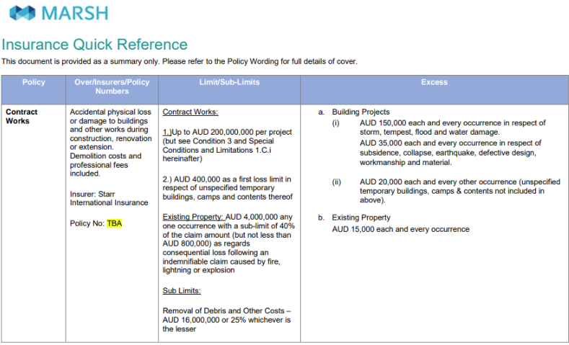
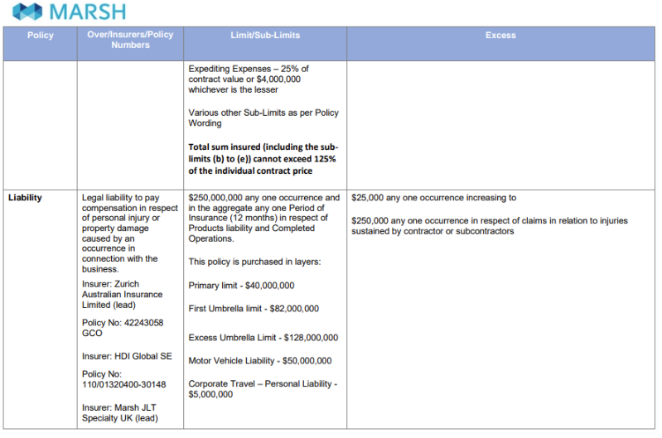
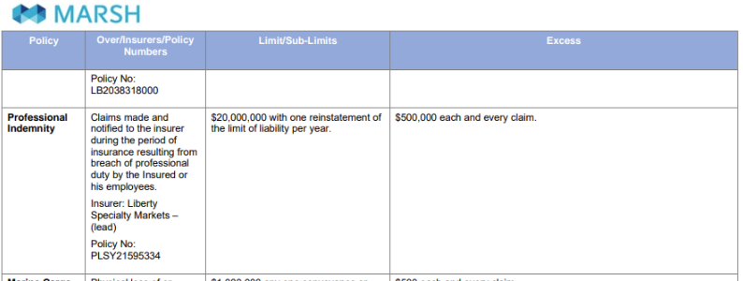
- Taxation matters
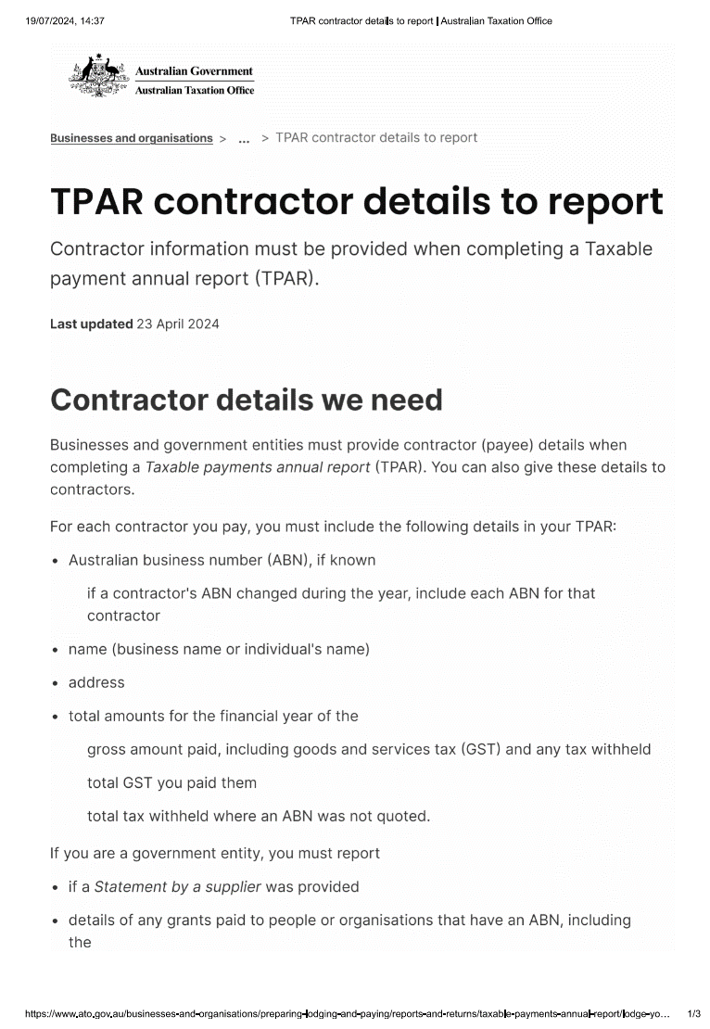

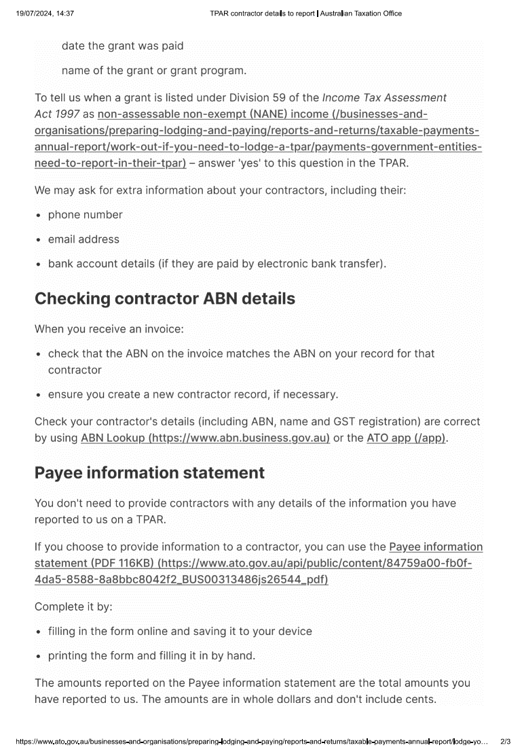


Satisfactory Outcome

Write a Code of Conduct for all employees and subcontractors engaged in a building and construction company that outlines specific principles and standards of behaviour that underpin best practice and co-operation. Use the following headings for your Code of Conduct.
- Objectives
- Responsibilities
- Ethical principles
- Continuous improvement
- Project planning and contract documentation
- Management and administration of contracts
- Environmental management
- Security of payments
- Training and development
- Work health and safety
- Compliance

- Objectives
This Brett’s Construction (thereafter referred to as “Brett’s Construction ' or ‘the Company’) is committed to achieving high standards of ethical behaviour and to conducting business in accordance with Company standards, applicable laws and regulations.
This Code of Business Conduct ancl Ethics (thereafter referred to ‘Code’ or ‘the Code') outlines the standard of behaviour expected by Brett’s Construction . It is designed to assist you in understanding your responsibilities and obligations and to provide guidance on expected behaviour in the workplace including when you may be faced with an ethical dilemma or a conflict of interest in your work.

- Responsibilities
All employees are required to familiarise themselves with the Code and endeavour to ensure that its principles are observed at all times. This document does not seek to cover all possible scenarios which may arise during your employment or engagement with Brett’s Construction , however it provides a set of principles to guide you on acceptable and unacceptable behaviour. Should you disregard or breach the Code and associated policies, disciplinary action may be taken. This may include termination of your employment or your engagement
- Ethical principals
Brett’s Construction has no tolerance for fraudulent or unethical conduct. You are expected to use good judgment in all dealings with individuals, customers or other companies and conduct your business affairs so that BESIX Watpac’s integrity remains unquestionable.
For the purposes of this Policy, fraudulent or unethical conduct is the misconduct by a person associated with Brett’s Construction via their employment or engagement which is:
    - dishonest;
    - fraudulent;
    - corrupt;
    - unethical ;
    - likely to cause financial or non-financial loss to Brett’s Construction or be otherwise detrimental to the interests of Brett’s Construction ;
    - contrary to other policies and procedures of BES IX Watpac or legal requirements, in a material way;
    - any other misconduct of a serious nature (including but not limited to gross mismanagement, the creation or condoning of serious and substantial waste, or failure a to disclose a related party transaction, etc); or
    - delil erately conceals actions or behaviour mentioned above.
Fraudulent or unethical behaviour could include conduct such as stealing company property from BESIX Watpac, receiving undisclosed financial “kickbacks" for facilitating BESIX Watpac’s entry into contracts with suppliers, or receiving cash payments related to work undertaken on I ehalf of BESIX Watpac which has not been disclosed and/or remitted to BESIX Watpac. Fraudulent or unethical behaviour could also include failing to notify and/or attempting to conceal a health, safety or environmental inciclent, in breach of Brett’s Construction and legal reporting requirements.
You are encouraged to report any behaviour or situation which you consider I reaches or Dotentially breaches this Code or the law. Brett’s Construction will not tolerate the victimisation of those who come forwai d to report it.
Reports can be made to any Group Leadership Team member, the People Team or via the Deloitte Whistleblower Service. Details of this service ai e provided in the Fraud or Unethical Conduct Policy or from the People Team.

- Continuous improvement
We are committed to the continual improvement and development of our Staff and the understanding Management System and this is achieved through undertaking regular audits and reviews of the system, procedures and processes.
Bretts Construction provides necessary audit toolkits and opportunities to enable the development of systems and business function. .

- Project planning and contract documentation
The objectives of this plan are to describe the process of Planning and Programming in Bretts Construction, including the methods by which we manage:
- Design, documentation and construction strategies, methods and programmes for Tenders and Cost Plans including contributing to their development and refinement
- Provision of contract and construction planning services for the project delivery team
Monitoring and reporting functions on project progress to the project teams and management
- Management and administration of contracts
Procedures aims to provide direction to the expectations of Bretts Constructions Contracts Administrators and Contracts Managers in performance of their role and responsibilities within BESIX Watpac Construction Projects.
This procedure applies to all employees undertaking the duties of head contract management, procurement and subcontract management during delivery of building construction projects. The procedure aims to ensure that a uniform approach exists in all Bretts Constructions operations regardless of which state or territory those operations are being undertaken.
Project Delivery commences from announcement that Bretts Constructions has been successful in a bid for a project. It assumes that the Pre-contracts Team has received a Letter of Acceptance, and/or that a Head Contract has been (or will be) executed.
All Contracts Administrators shall ensure compliance with this suite of procedures for activities undertaken by the Contracts Administrator at Project Commencement, specifically in relation to the Tender Handover from the Bid Phase to Delivery Phase.

- Environmental management
Brett’s Construction will maintain an Environmental Management System planned and developed in accordance with AS/NZS ISO 14001 to control and minimise environmental impacts, and preserve the environment through the control and minimisation of contaminate discharges, waste, and disturbances to air, land and water.
- Security of payment
Whenever you are assessing a payment claim under the SOP Act, you should determine
whether it is a valid claim in accordance with the SOP Act (jurisdictional) and the relevant
contract (non-jurisdictional). Irrespective of a payment claim being valid, you should
always respond to every payment claim as if it were valid. A key point to remember is that
the non-validity of a payment claim may be used in a response to an adjudication
application.
- Training and development
​​​​The heart of Brett’s Construction success is our great people. Developing our people is an essential part of our success - now and for the future. We seek to achieve this by employing skilled staff who support our values and investing in relevant development programs, processes and initiatives to enable our people to reach their full potential.
Learning and Development can occur from a number of sources including on the job, through relationships (coaching, mentoring and learning from other role models), or formal training. Specific development needs are identified through a number of means including yourself, your manager, or during discussions to review and optimise your performance. At Brett’s Construction , we support training opportunities in a number of areas including a range of safety, technical, behavioural and leadership programs.
The cornerstone to our approach is recognising that:
Everyone has a role to play in driving their own learning and development
Leaders and colleagues have a role to play in supporting you with feedback so you can become better at your job
Brett’s Construction has a role to play in providing opportunities and formal learning to support skills development.

- Work health and safety
At Brett’s Construction the health and safety of our own people and those that carry out work for us is a high priority, and we are continually looking for ways of improving what we do to keep everyone healthy and safe.
This is not about more processes or systems, it’s about how we can align everyone around the important, practical day to day activities that we believe are critical to us becoming a safer place to work.
While we know that everyone shares our goal of getting home physically and mentally well, we wanted to help shift the focus and the conversation to be more about the process than the outcome.​​​​​​​
“A Safe Day” is not about more paperwork, processes, or compliance. it’s about helping us all to be more aligned and focussed on the important things we do every day. It’s about providing a meaningful way of talking about safety that is focussed on the pro-active things we do.
The Safe Day program connects Brett’s Construction ‘s organisational values and work, health and safety objectives, to the day-to-day practices of managing risk. ​​​​​​​
We use the Integrated Safety Model to help show this. Brett’s Construction , already has well established protocols to use for Place and Process. We have a good understanding of our hazards and risks and well developed and embedded systems and process.
A Safe Day tackles the People element of the integrated model, through a focus on culture and leadership

- Compliance
Accurate record-keeping is essential to meeting our financial reporting objectives and is required by law. All of Brett’s Construction funds, assets, commitments, receipts and disbursements must be properly and consistently recorded on our hooks in compliance with all applicable legal requirements or other applicable accounting standards and our system of accounting and internal control over financial reporting.
Records should always be retained or destroyed in accordance with our record retention policies and with appropriate authorization. However, at times we may need to retain documents beyond the period they would normally be retained. The most common reasons are litigation or other legal matters

Satisfactory Outcome

Access the website for your State or Territory environmental regulator and respond to the following questions:
- What environmental authority conditions apply in relation to noise or dust at a sensitive place?
- Discuss guidelines regarding waste and waste avoidance that you can include in the site Environmental Management Plan (EMP).

- What environmental authority conditions apply in relation to noise or dust odour, at a sensitive place?
Environmental nuisance issues, such as noise, dust, light and odour, are covered by environmental authority conditions if there is an environmental authority in place.
For environmental nuisance issues caused by a state or local government entity, or coming from an environmentally relevant activity (ERA) administered by the State you may wish to contact the Queensland Government. Refer to the reporting environmental nuisance issues webpage.
Environmental authority conditions require companies to not cause environmental nuisance from noise at a sensitive receptor (a place where noise is measured to investigate whether impacts are occurring) or from dust, odour, light or smoke at a sensitive place (including for example a dwelling, library, childcare centre, medical centre, or a public park).
https://environment.desi.qld.gov.au/management/activities/non-mining/environment/noise-light-odour#:~:text=Environmental%20authority%20conditions%20require%20companies,a%20dwelling%2C%20library%2C%20childcare%20centre

- Discuss guidelines regarding waste and waste avoidance that you can include in the site Environmental Management Plan (EMP).
1.1.1 Applicant details
1.1.1.1 Provide the applicant’s full name, street and postal address, and Australian Business Number or
equivalent entity registration number, including details of any joint venture partners;
1.1.1.2 Describe the nature and extent of the applicant’s business activities and experience in undertaking the
activity.
1.1.2 Nature of the proposed activity
1.1.2.1 Provide the name or title of the proposed activity or project;
1.1.2.2 Describe the proposed activity’s objectives;
1.1.2.3 Detail the rationale for the proposed activity;
1.1.2.4 Describe the proposed activity in terms of its type or nature, scale and timeline of all proposed activity
components and works (e.g., construction, operation, maintenance, de-commissioning and
reinstatement/rehabilitation phases and their requirements);
1.1.2.5 Detail any pre-construction activities (including vegetation clearing, site access);
1.1.2.6 Detail any interference with watercourses, wetlands and floodplain areas;
1.1.2.7 Detail the sources of any building or foundational materials;
1.1.2.8 Describe whether the proposed activity is a new or an existing activity;
1.1.2.9 Detail any fencing, power, water supply, hazardous materials and waste management requirements;
1.1.2.10 Detail the transport and access requirements for all stages of the proposed activity;
1.1.2.11 Detail the relationship to other major projects, developments or actions of which the applicant should
reasonably be aware.
1.1.3 Location and site description
1.1.3.1 Provide the name and tenure of the affected QPWS managed area/s, name of the activity site or
location (if known), real property descriptions of the proposed activity site and adjacent properties, any
easements, and identification number of any existing underlying resource tenures;
1.1.3.2 Provide facility or construction drawings or plans for the proposed activity, including all infrastructure
elements and showing the proposed footprint or direct impact area;
1.1.3.3 Describe and map the key infrastructure in and around the site, and any other infrastructure in the
region relevant to the proposed activity such as vehicle access tracks, walking tracks and fences;
1.1.3.4 Describe the topography of the proposed activity site and surrounding area, and highlight and identify
any significant features shown on the maps;
1.1.3.5 Describe any special management considerations and legislative requirements that may also apply,
such as World Heritage Area, Ramsar Wetlands, marine parks, declared Fish Habitat Areas, or Special Management Areas under the NCA, FA or the Great Barrier Reef Marine Park Regulations
2019.
1.1.3.6 Describe the condition of vegetation (remnant or disturbed) and history of use (if known) of the activity
site.
1.1.4 Activity approvals
1.1.4.1 List any additional approvals under Commonwealth, State or local legislation that have been obtained
for the proposed activity.
1.1.4.2 Describe any approvals under Commonwealth, State or local legislation that are still required to
enable the proposed activity to be constructed, operated, maintained, de-commissioned and
reinstated/rehabilitated, and note the legislation under which applications are assessed;
1.1.4.3 Describe any special requirements for the proposed activity to proceed lawfully, e.g., access
approvals, landholder consent, etc.
1.2.3 Waste management
1.2.3.1 Describe the quantity and physical and chemical characteristics of each significant waste caused by
the activity, any attributes that may affect its dispersal in the environment, and its associated risk of
causing environmental harm;
1.2.3.2 Define and describe objectives and practical measures for protecting or enhancing environmental
values from impacts from wastes and how any impacts from waste will be reduced or managed.

Satisfactory Outcome

CPCCBC6018
Manage processes for complying with legal obligations of a building and construction contractor

PRACTICAL ASSESSMENT

Participant name | Brett Eldred

FOR THE PARTICIPANT
Instructions
- The tasks outlined on the following pages will require performance of normal workplace activities, as a result of a structured activity set by an Observer in the workplace or a simulated activity set by your Assessor/Observer.
- The timeframe for these tasks will be established by your Assessor/Observer, in consideration of location conditions and industry requirements.
- You must complete all tasks unassisted by the Assessor or other personnel unless the steps note this assistance.
- You must attempt all tasks (and itemised steps) for a ‘Satisfactory’ assessment outcome to be awarded.
  - For any observation conducted that is incomplete, or without satisfactory performance, the observation will need to be completed again after further training support.

FOR THE ASSESSOR/OBSERVER
Instructions
- The following observation record should be used to judge and record your observations of the Participant as they complete the task(s) set. You must record your observations of the Participant’s performance.
  - For each occasion, indicate the task performed and whether it was a simulation or workplace-based task.
    - Any simulated assessment must ensure the Participant still performs under workplace conditions which reflect industry standards.
  - In the comments, provide clear detail regarding the task that the Participant was required to do (e.g. PPE used, materials handled, attachments connected, plant types).
- All steps must be satisfactorily demonstrated by the Participant for a ‘Satisfactory’ determination (indicated by an Assessor tick to the right of each itemised step, or an Observer tick to the right of each itemised step, and confirmation by an Assessor in the Assessor Comments).
  - Where you have determined that one or more task steps have not been satisfactorily demonstrated, provide the Participant with additional support and outline details of such assistance in the Assessor/Observer Comments. Allow the Participant two (2) further opportunities to demonstrate the task again to allow an opportunity for a ‘Satisfactory’ assessment outcome to be achieved.
  - If after three (3) attempts the Assessor determines that the Participant cannot demonstrate the required steps, a ‘Not Satisfactory’ outcome is to be determined.

TASK OUTCOME
Task | Date | Task Type (Tick) | Location | Task outcome (Tick)
 |  |  |  | Satisfactory | Not Satisfactory
Task 1 | 19/07/2024 | Workplace  Simulation

ASSESSOR COMMENTS: GENERAL
As necessary, outline:
- Details on reattempts, alternative arrangements or reasonable adjustments made.
- Where a Participant is deemed ‘Not Satisfactory’, provide recommendations for future training.

ASSESSOR COMMENTS: PRACTICAL TASK 1
Individual student (as named on cover page)
Multiple students [ All from Attendance Report, Specific students involved – identify students]
Task | Provide detail
1.1A. | Specify type of building contract reviewed where provisions of the contract, terms, conditions, inclusions and variations were correctly identified:  Sub Contract Agreement between the builder and sub contractor elected to undertake scoped works
1.1B. 1.1E. | Specify how building contractor licencing and contract requirements were reviewed for compliance:  Supplying licenses for works to be undertaken and ensuring validity of licenses and covers the work being under taken .
1.1C. | Specify how contractor licensing and contract requirements and non-compliance were communicated to workplace employees and others:  After checking the relevant data bases that contains details, a letter was issued asking for clarification
1.1F. | Specify where the application for necessary building or construction licenses was made:  Undertook search on the Qld Building & Construction Commission web page 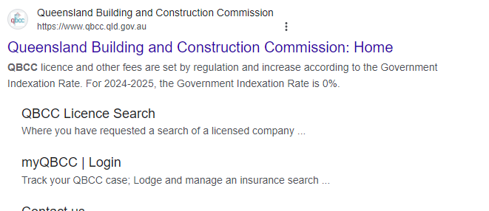 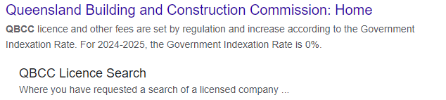
1.2A. | Specify which areas of the contract reviewed required professional legal advice.  Departures from standard conditions within contract
1.2B. | Specify processes managed to enable the workplace to obtain such legal advice.  Contract issued to contractor for review, contractor returns with clauses that needed resolution. Given impact , legal counsel was sought for advice and guidance.
1.2C. | Specify contracts management system introduced and managed:  Aconex doc control , COINS
1.2D. | Specify how the efficiency and performance of the contract management systems and users was maintained:  Being largely automated, records are maintained accurately which ensures that all drawings are maintained, scopes can be viewed easily and all project correspondence between contractor and builder are easily accounted for
1.2E. | Specify mechanisms applied and maintained to facilitate improved communications and dialogue with client:  Again Aconex is the preferred tool to allow communication with the cliient
1.3A. | Specify administration systems developed and managed that facilitate conforming with workplace WHS responsibilities:  Company Intranet captures all WHS obligations and ensures accuracy and upto date documents.
1.3A. 1.3B. 1.6A. | Specify administration systems developed and managed that facilitate conforming with workplace Environmental responsibilities:  Report forms daily and weekly site checks, Prestart meeting s
1.4A. 1.4B. | Specify systems introduced and managed to ensure insurance and taxation requirements are met:  Schedules established to track time frames and expiring certificates, monthly progress claims issued with details for checking
1.4C. | Specify problems, symptoms and causes of non-compliance recognised and solutions generated:  Non compliances found lead to a delivery of products that sit outside the clients brief and expectations. Create additional time and costs to rectify and addressed to compliance.
1.5C. | Specify remedial action undertaken where evidence of non-compliance with consumer protection principles is identified:  Non compliance is recognised and raised with party providing product. IF the party is not getting resolution, the complainant is then raised to the consumer protection organisation that deals with consumer protection (QCAT)
1.6B. | Specify how supply and removal of subcontract works and materials are monitored for compliance with EMP:  Environmental policy outlines daily , weekly checklist. Review of product and materials entering site to be confirmed.
1.6C. | Specify changes to legislation or environmental requirements recorded and relevant organisational activities and systems altered to ensure ongoing compliance:  ISO certified management systems requires systems are monitored and databases are up to date

CPCCBC6018
Manage processes for complying with legal obligations of a building and construction contractor

Practical Task 1
Description of task:
The participant must demonstrate and provide evidence to demonstrate the skills and ability to ensure the compliance of contactor’s legal obligations for one building and construction project including:

- Determine contract compliance and licensing requirements
  - Read the building contract, confirm the type of contract and identify provisions of the contract, terms, conditions, inclusions and variations.(attach copy of contract reviewed)
  - Review and confirm whether building contractor licensing and contract requirements are current and suitable to the work.
  - Communicate contractor licensing and contract requirements to company employees to ensure contract and licensing requirements are met.
  - Inform employees of the consequences of non-compliance with licence and contract requirements.
  - Recognise changes to licensing arrangements in a timely manner.
  - Appy for and take necessary steps to obtain the necessary building or construction licenses.
- Manage relationships on legal matters
  - Determine the areas of the contract requiring professional legal advice.
  - Organise and manage processes to enable workplace to obtain legal advice in relation to contract..
  - Introduce and manage a contracts management system through which legal interpretations of contract or tender documents may be obtained before submission.(screenshot or documentation of management system introduced and managed)
  - Manage the efficiency and performance of the contract management systems and individuals involved in the process
  - Apply and maintain mechanisms to improve communications and dialogue between the workplace and the client to facilitate conciliation.
- Administer organisation’s obligations.
  - Develop and manage administration systems that facilitate conforming with organisation’s obligations and meeting WHS and welfare, workers' compensation, noise abatement and working hours’ regulations.
  - Maintain and manage records demonstrating organisational compliance with legal obligations.
  - Develop and maintain policies, procedures and facilities for the proper and secure storage of organisational legal documentation. .(attach copy of policy and procedure developed)
- Manage compliance with government legislation.
  - Introduce and manage systems that support and maintain organisational capacity to meet legal obligations with regard to insurance and taxation. .(screenshot or documentation of system introduced and managed)
  - Organise training and instruction for relevant personnel regarding insurance and taxation responsibilities.
  - Investigate problems, symptoms and causes of non-compliance and recognise key issues and synthesise information to generate solutions
- Apply and manage consumer protection practices.
  - Develop and implement practices and policies which facilitate the organisation meeting its obligations to its clients, subcontractors and employees. (attach copy of 1 policy and 1 procedure developed)
  - Establish and enforce codes of conduct for all employees and subcontractors. (attach copy of code of conduct developed)
  - Take remedial action where evidence of non-compliance with consumer protection principles is identified.
- Manage compliance with environmental legislation.
  - Develop and manage systems to gather information in relation to the organisational environmental management plan.
  - Manage the supply and removal of subcontract works and materials and constantly scrutinise to ensure compliance with environmental standards.
  - Record relevant changes to legislation or environmental requirements and alter organisational activities and systems to ensure ongoing compliance.
These tasks may be simulated or real. The Participant is to gather evidence of how they have completed each component of the Practical Task, which is to be submitted with this Practical Assessment sheet. The Observer is to provide detailed comments on the tasks completed by the Participant (on the Observer Comments, overleaf). The Assessor is to verify the Observer’s comments, noting their findings in the Assessor Comments (on the back of the Practical Assessment cover page) and provide the assessment outcome.
Resources required:
Residential or commercial worksite; Access to legislation and regulations relating to building and construction contractors; workplace policies, procedures and quality documentation, building and construction contract for project, EMP; business equipment, technology, applications and software systems.
Observer details
Name of observer: | Steve Huber
Role of observer  (Confirm suitability to sign) | Senior Project Manager
Email address of observer | Steve.huber@besixwatpac.com
Signature of observer: | 
Date: | 22/07/2024

When completing the task, did the Participant: | Tick if satisfactorily completed.  Provide comments if left unticked.
1 Determine contract compliance and licensing requirements.
- Read the building contract, confirm the type of contract and identify provisions of the contract, terms, conditions, inclusions and variations.(attach copy of contract reviewed)
- Review and confirm whether building contractor licensing and contract requirements are current and suitable to the work.
- Communicate contractor licensing and contract requirements to company employees to ensure contract and licensing requirements are met.
- Inform employees of the consequences of non-compliance with licence and contract requirements.
- Recognise changes to licensing arrangements in a timely manner.
- Appy for and take necessary steps to obtain the necessary building or construction licenses.
2 Manage relationships on legal matters.
- Determine the areas of the contract requiring professional legal advice.
- Organise and manage processes to enable workplace to obtain legal advice in relation to contract.
- Introduce and manage a contracts management system through which legal interpretations of contract or tender documents may be obtained before submission.(attach screenshot or documentation of management system introduced and managed)
- Manage the efficiency and performance of the contract management systems and individuals involved in the process
- Apply and maintain mechanisms to improve communications and dialogue between the workplace and the client to facilitate conciliation.
3 Administer organisation’s obligations.
- Develop and manage administration systems that facilitate conforming with organisation’s obligations and meeting WHS and welfare, workers' compensation, noise abatement and working hours’ regulations.
- Maintain and manage records demonstrating organisational compliance with legal obligations.
- Develop and maintain policies, procedures and facilities for the proper and secure storage of organisational legal documentation.(attach 1 copy of policy and procedure developed)
4 Manage compliance with government legislation.
- Introduce and manage systems that support and maintain organisational capacity to meet legal obligations with regard to insurance and taxation. .(screenshot or documentation of system introduced and managed)
- Organise training and instruction for relevant personnel regarding insurance and taxation responsibilities.
- Investigate problems, symptoms and causes of non-compliance and recognise key issues and synthesise information to generate solutions.
5. Apply and manage consumer protection practices.
- Develop and implement practices and policies which facilitate the organisation meeting its obligations to its clients, subcontractors and employees. (attach copy of 1 policy and 1 procedures re payments and confidentiality developed)
- Establish and enforce codes of conduct for all employees and subcontractors. (attach copy of code of conduct developed)
- Take remedial action where evidence of non-compliance with consumer protection principles is identified.
6. Manage compliance with environmental legislation
- Develop and manage systems to gather information in relation to the organisational environmental management plan. (attach screenshot / copy of EMP compliance)
- Manage the supply and removal of subcontract works and materials and constantly scrutinise to ensure compliance with environmental standards.
- Record relevant changes to legislation or environmental requirements and alter organisational activities and systems to ensure ongoing compliance.

Observer comments:
1.1A- Read the building contract, confirm the type of contract and identify provisions of the contract, terms, conditions, inclusions and variations.(attach copy of contract reviewed
1.2c-
) 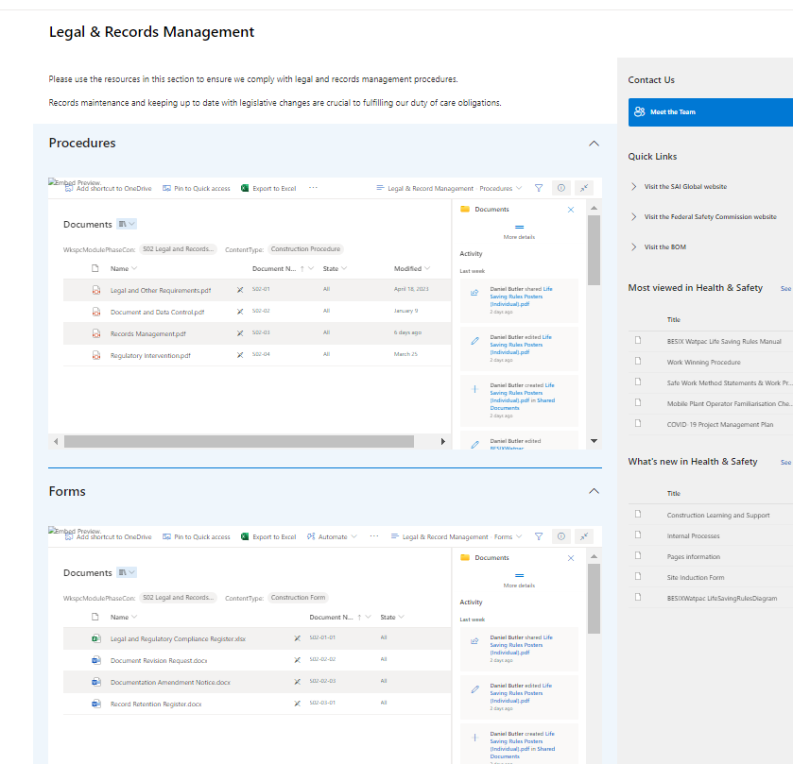

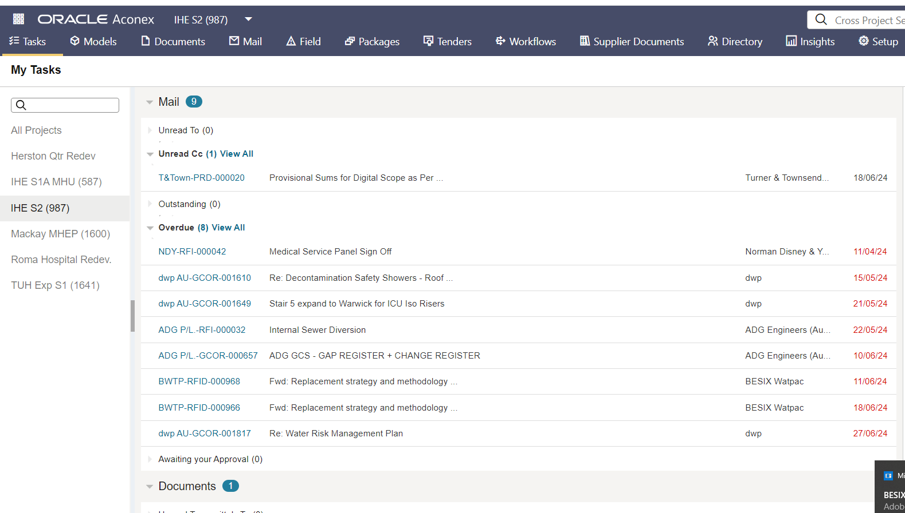

1.4A
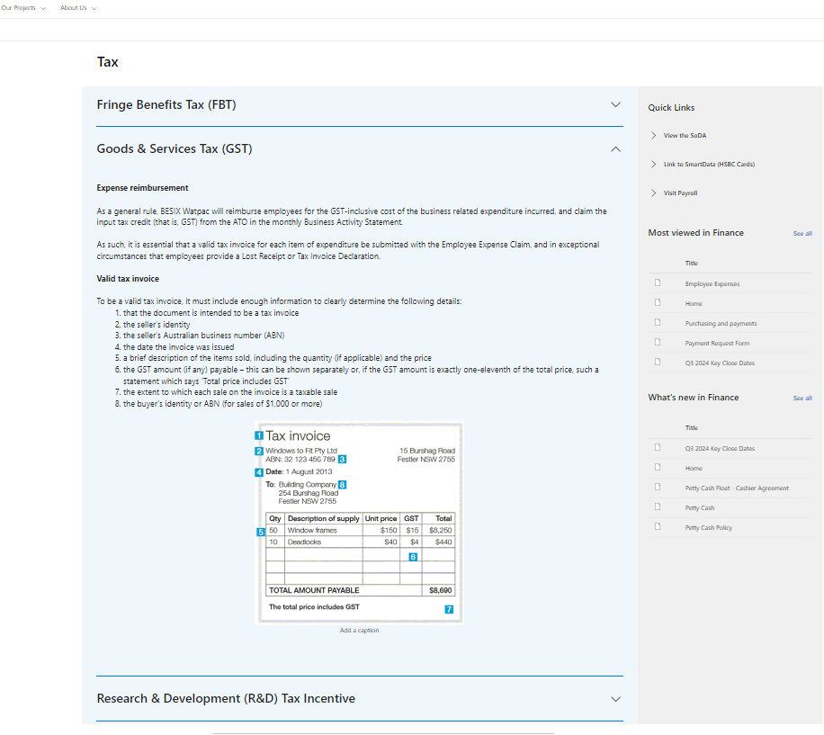

1.5A
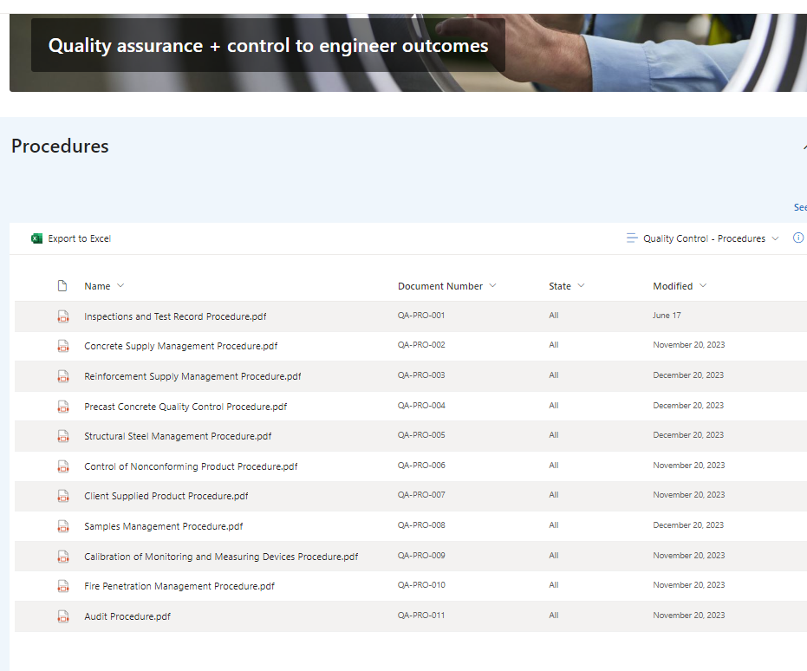

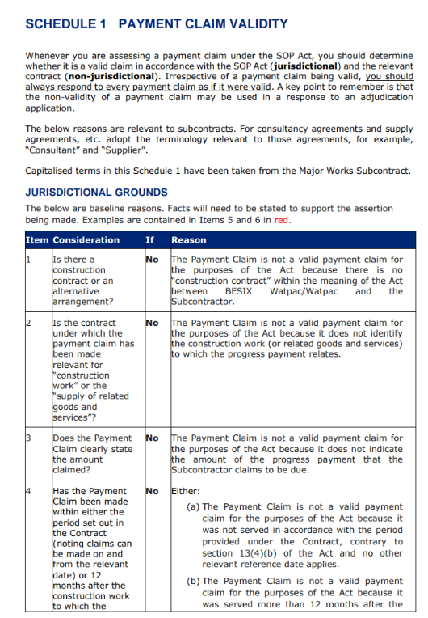

1.6A


